BONDED RETURN OF SERVICE SYSTEM (BROSS)
Participant User Guide

Extension to Bonded Medical Program Timeline
July 2026

Application for an extension of time
You may apply to the Secretary for an extension of time to complete your Return of Service Obligation (RoSO) if you, or a member of your family, has a medical condition that will prevent you from completing their RoSO within the 18-year period required by paragraph 124ZF(2)(a) of the Act.
Sections 11 to 13 of the Health Insurance (Bonded Medical Program) Rule 2020 (Rule) outline the application requirements for an extension of time.
Section 12 of the Rule defines a member of your family as a partner, child, grandchild, parent, grandparent or sibling; or a person who:
- is a relation of the bonded participant
- has significant responsibility for the care of the person
- has no family members (other than the bonded participant) who are able to provide care to the person
- is not on a temporary visa; and
- has not been provided with an assurance of support in relation to the grant of a visa.
An application for an extension of time must include evidence that the family member satisfies the above requirements.
Section 13 of the Rule specifies that the medical condition must:
- not have been reasonably foreseeable when you entered the Program,
- be a life threatening, disabling or chronic illness which creates an insurmountable barrier to working in an eligible location,
- and either:
  - Require treatment or care for which Medicare benefits are payable, or
  - Require treatment of care for which pharmaceutical benefits are payable, or
  - Require treatment of care in a hospital.
You must also upload evidence of the medical condition from a treating practitioner dated within 3 months from the date of your application. The treating practitioner must:
- have sufficient expertise, qualifications and specialist registration to provide the medical evidence; and
- state for how long they have known you or your family member; and
- state that they do not have a personal or professional relationship with you or any potential conflicts of interest; and
- state why you cannot complete your RoSO within the 18 year period.

To submit your request, click on the ‘Manage my agreement’ accordion on the ‘My dashboard’ page.
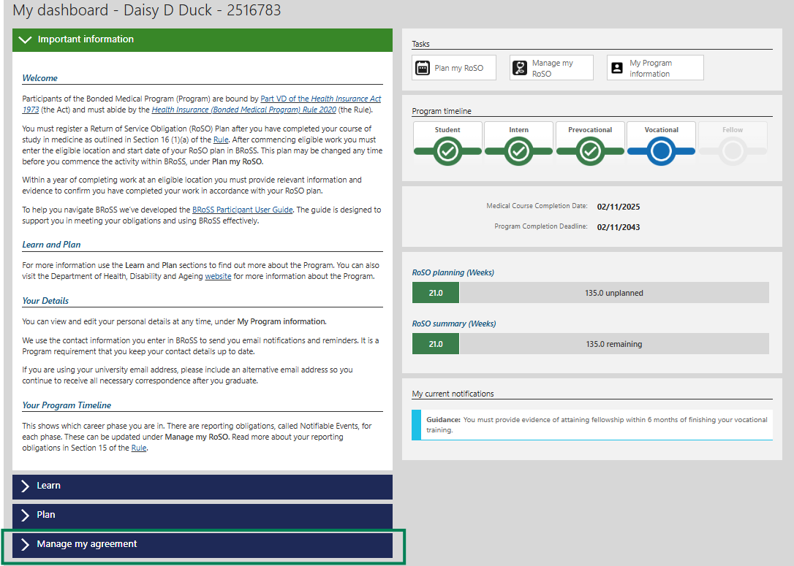
From the expanded ‘Manage my agreement’ accordion click on the ‘Program extension’ button.
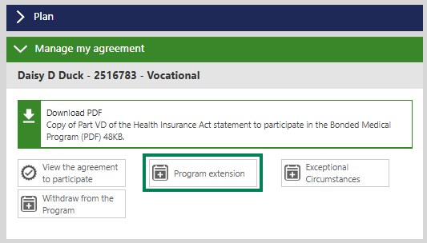
The expanded ‘Program extension’ accordion shows your current Program completion date. Click the ‘Request’ button.
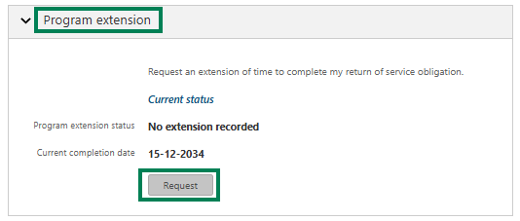
Enter your ‘Proposed completion date’. Please note that the new, proposed completion date should not extend the period to complete your RoSO by more than 2 years. Click on ‘Choose Files’ to upload the required evidence as detailed on page 2 of this guide.
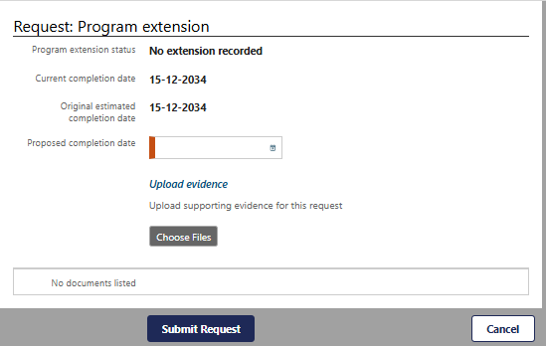
Once you click on the ‘Submit Request’ button, the following ‘Warning’ message will show, click ‘OK’ to continue.
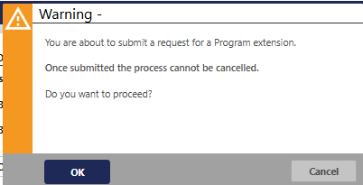
Clicking ‘Cancel’ will take you back to the ‘Manage my RoSO’ page.

Your ‘Program extension’ accordion will update to ‘Pending’ status and show your extension request and ‘Status’. Clicking on the ‘Manage’ button will enable you to amend your request.
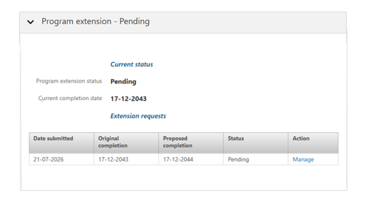
We will review your request for an extension of time and you will be contacted if additional evidence is required. You will receive the outcome by email when a decision has been made.
If you would like to cancel your request, please email the BondedMedicalProgram@health.gov.au providing your details.

