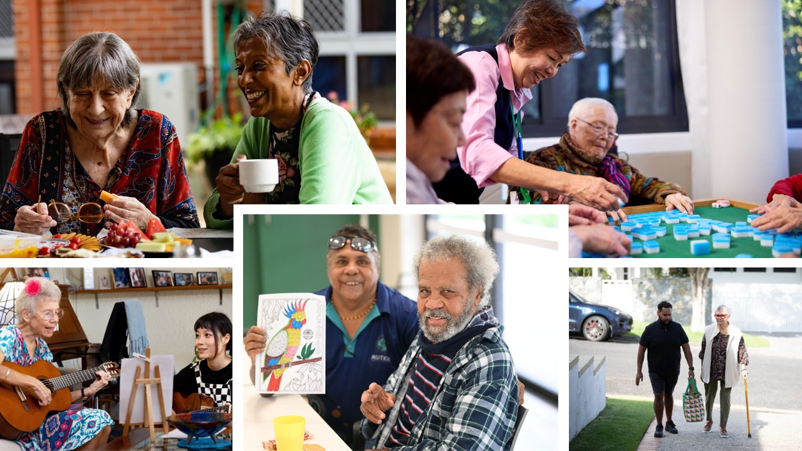
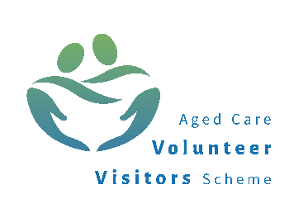
Volunteering in aged care and the Aged Care Volunteer Visitors Scheme (ACVVS)

Contents
About volunteering in aged care 3
Support and training for aged care volunteers 8
Volunteer stories 10
Information for registered providers and volunteer managers 12
The Aged Care Volunteer Visitors Scheme 15
ACVVS volunteer visitor stories 18

This booklet is for people who are interested in volunteering in aged care, current aged care volunteers, registered aged care providers (providers) and volunteer managers. It has two parts:
Part One explains volunteering in aged care generally
Part Two focuses on the Aged Care Volunteer Visitors Scheme (ACVVS).

About volunteering in aged care
Volunteers in aged care help older people stay connected, active and supported in their homes, residential aged care homes, respite care and local communities.
Through everyday support and connection, volunteers bring older people joy and a sense of community, connection, and belonging.
Volunteering can be rewarding for you too. It is a chance to meet new people, share interests, learn new skills and give back to your community in a way that suits your time, strengths and experience.
You do not usually need special qualifications to get started. Many roles simply need people who are reliable, respectful and willing to help.

Under the Aged Care Act 2024, volunteers are considered aged care workers when they deliver, or support the delivery of, funded aged care services on behalf of a provider.

Main types of volunteering:
Volunteering is defined as time willingly given for the common good and without financial gain.
Formal volunteers
Formal volunteering means giving your time through an organisation to help others without being paid.
In this booklet, aged care volunteering means formal volunteering.
Informal volunteers
Informal volunteering includes things like:
- helping out a neighbour

- caring for a family member or friend.
Find information about caring at the Carer Gateway website health.gov.au/our-work/carer-gateway

What aged care volunteers do
There is no single type of aged care volunteer role. Some roles are social, some are practical, and some support the smooth running of aged care programs and services.
Every volunteer role is different. What you do will depend on the role, the setting and the time you have available.
Here are some examples of volunteer roles in aged care:
- spending time with older people through conversation, games, reading, arts and craft or shared interests
- assisting with group activities, outings, social events, music, singing, exercise or walking groups
- supporting meal delivery or morning tea activities
- helping with transport to appointments or social activities
- helping with gardening, shopping, reading, library services or technology support
Volunteers may support older people in:
- residential aged care homes
- respite care
- the Support at Home program
- support under the Commonwealth Home Support Program (CHSP).
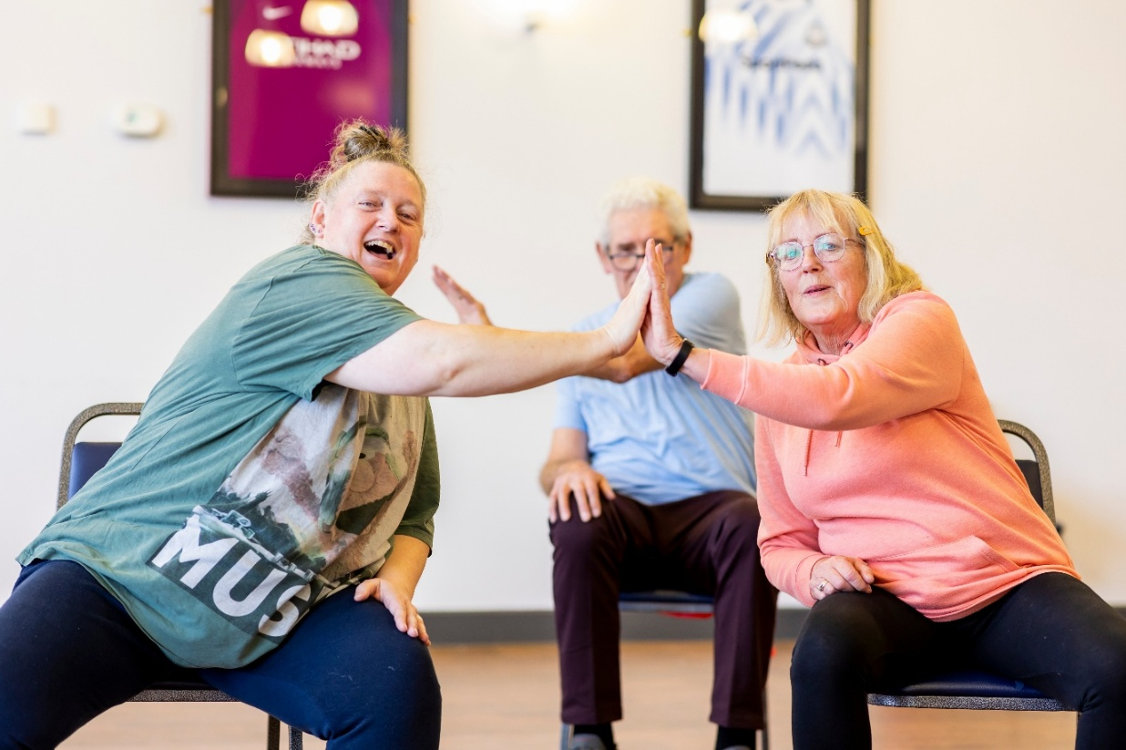
The time you give depends on the role and your availability. Providers will work with you to find a role suitable for your interests, skills and availability.

Who can volunteer in aged care
A volunteer gives their time through a provider to help support older people without being paid. People from all backgrounds and life experiences can volunteer. Your past experiences and knowledge will be valued. What matters most is that you want to support older people and can undertake the role in a safe and respectful way.

Eligibility and requirements
Each provider has its own way of recruiting and managing volunteers. Before you start, they will tell you about any checks, training and other steps you need to complete. Typically, you will need to:
- receive a National Police Check or a National Disability Insurance Scheme (NDIS) Worker Screening Check, depending on the circumstances
- provide evidence of your recent flu or COVID-19 vaccination history, if required
Some states and territories may require volunteers to also have a Working with Vulnerable People Check.
Volunteers must behave in align with the Aged Care Code of Conduct (the Code) and uphold the Aged Care Statement of Rights.
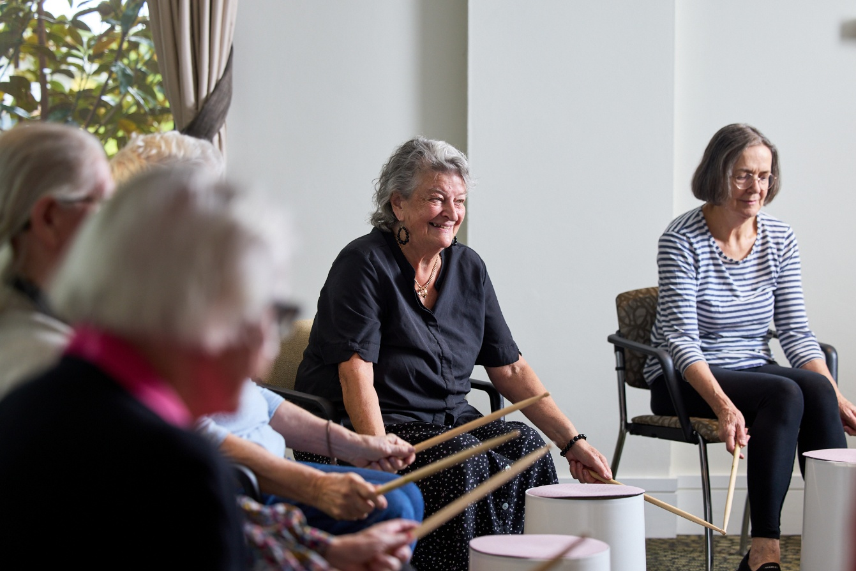
Find more information about eligibility and requirements at the Department of Health, Disability and Ageing (the Department) webpage health.gov.au/topics/aged-care/volunteers/about

How to become an aged care volunteer
There are many different pathways you can take to become an aged care volunteer.

Opportunities in your state or territory
See below or check in with your council for local aged care volunteering opportunities:
Organisations | Website
The Centre for Volunteering NSW | volunteering.com.au
Volunteering Victoria | volunteeringvictoria.org.au
Volunteering SA & NT | volunteeringsa-nt.org.au
Volunteering Queensland | volunteeringqld.org.au
Volunteering WA | volunteeringwa.org.au
Volunteering Tasmania | volunteeringtas.org.au
Volunteering ACT | volunteeringact.org.au
GoVolunteer | govolunteer.com.au/volunteering
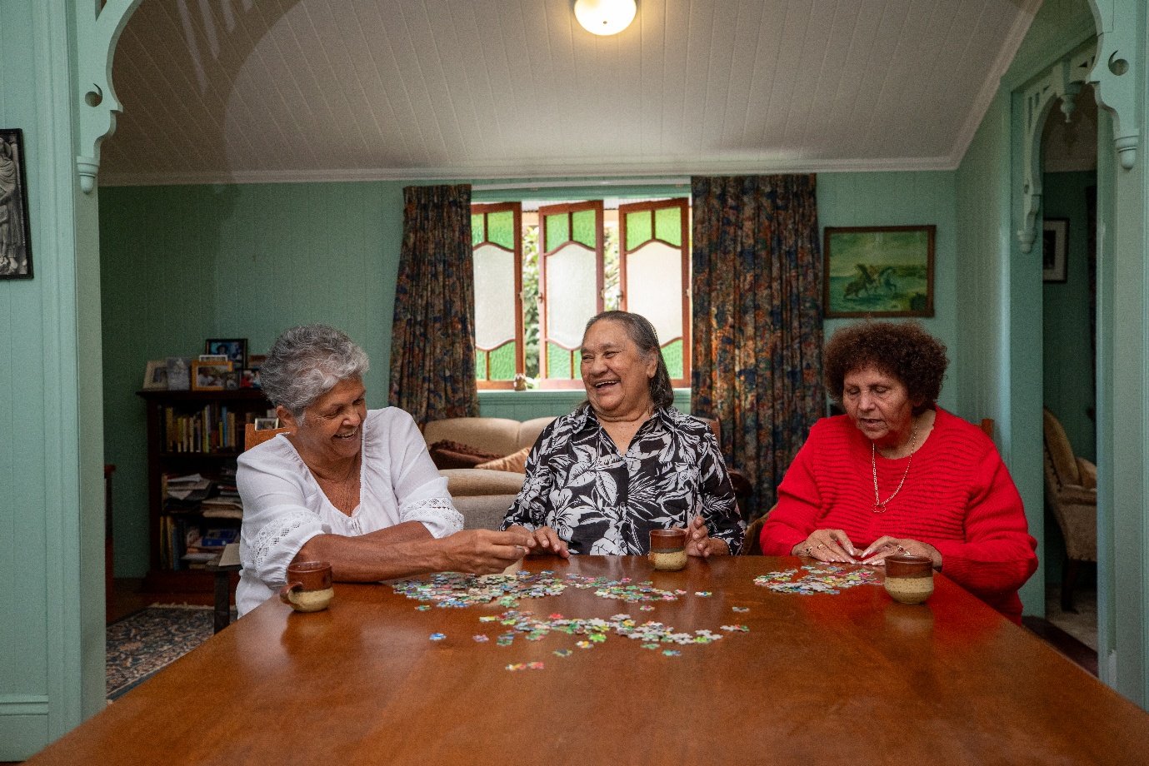
Organisation | Website
Seek Volunteer | volunteer.com.au/seniors-aged-carehttps://www.volunteer.com.au/seniors-aged-care-volunteering
Meals on Wheels™ | mealsonwheels.org.au/get-involved/volunteer
Palliative Care NSW | volunteerhub.com.au
Palliative Care Victoria | pallcarevic.asn.au/page/73/introduction-to-volunteering
Palliative Care QLD | palliativecareqld.org.au/volunteer-village
Palliative Care ACT | pallcareact.org.au/become-a-volunteer
Palliative Care TAS | pallcaretas.org.au/about-palliative-care-and-end-of-life/volunteer-services/
Palliative Care WA | palliativecarewa.asn.au/working-with-the-sector/volunteering-in-palliative-care/
Dementia Australia | dementia.org.au
LGBTIQ+ Health Australia | lgbtiqhealth.org.au/volunteer

Volunteering with a specific provider
Contact providers in your local area to express interest in aged care volunteering.
If you already know of a provider in your area you can contact them directly.
Find your nearest provider and their contact details at My Aged Care webpage myagedcare.gov.au/find-a-provider

The Aged Care Volunteer Visitors Scheme (ACVVS)
ACVVS is an uplifting program supporting regular volunteer visits to provide friendship and companionship to older people.
You can become a volunteer visitor through the ACVVS by visiting health.gov.au/our-work/aged-care-volunteer-visitors-scheme-acvvs/volunteer
Turn to page 15 of this booklet to learn more about the ACVVS

Support and training for aged care volunteers

What to expect
As a volunteer, you should feel supported, respected and valued. Your provider must provide the support, training and supervision you need to undertake your role, confidently, safely and effectively, including:
- a welcoming, inclusive and respectful environment
- appropriate volunteer insurance cover
- a clear role description, including scope and boundaries
- worker screening, where appropriate
- induction and appropriate training for your role
- ongoing support and access to a volunteer manager or coordinator
- supervision, feedback and guidance when needed
- opportunities to provide feedback and raise concerns

Training
Training helps you feel safe, confident and prepared in your volunteer role. It helps you support older people in a safe, respectful and rights-based way.
You may also complete local induction or other training provided by your provider. This might cover where you volunteer, your specific role, safety procedures, privacy, infection prevention or other information you need to volunteer safely.
Your volunteer manager will let you know what training applies to you and support you to complete it in a way that suits your learning needs.
If your volunteer role involves delivering, or supporting the delivery of, funded aged care services, you should complete training on the five core topics.
The five core topics are:
- the Aged Care Code of Conduct (the Code)
- reportable incidents and the Serious Incident Response Scheme (SIRS)
- complaints and feedback
- elder abuse awareness and advocacy pathways
- understanding diversity and inclusion.
Training on these topics will help you:
- understand your role and responsibilities
- support the safety, dignity and wellbeing of older people
- recognise when something may not be right and know who to talk to
- provide respectful, inclusive and person-centred support.
Find the Supporting Older People: Volunteer Learning Guide (the Learning Guide) at the Department’s webpage health.gov.au/topics/aged-care/volunteers/resources


ACVVS volunteer visitors do not undertake this training. ACVVS volunteer visitors undertake separate, program-specific training as outlined in the ACVVS National Guidelines at the ACVVS webpage health.gov.au/resources/publications/aged-care-volunteer-visitors-scheme-national-guidelines?language=en

eLearning and resources
Free eLearning modules and resources are available to support your learning on the five core topics.
Find the eLearning modules and resources at the Commission’s website agedcarequality.gov.au/workers/volunteers-aged-care

Pathways into a career in aged care
You may be considering a transition from volunteering to paid work in the aged care sector. Volunteering can help you build experience, confidence and a better understanding of aged care roles. It can also be a meaningful way to contribute to your community and explore whether aged care work is right for you.
Learn more about careers in aged care, formal qualifications and training options, at the Department’s webpage health.gov.au/topics/aged-care-workforce
This includes information on learning and development opportunities, such as Fee-Free TAFE and other subsidised training places that may be available in your state or territory.
Find more information at the Department’s webpage health.gov.au/topics/aged-care/volunteers/support-and-training

Volunteer stories
Stories can bring the experience of volunteering to life, show what volunteering can be like, and highlight the difference volunteers can make.

Kevin: Volunteering for connection –– Supporting men’s wellbeing in residential aged care
When chronic pain ended Kevin James’ nursing career, he faced isolation and depression.
But volunteering gave him a new mission – to bring social connection and camaraderie to men in aged care.
At Bolton Clarke’s Cazna Gardens in Brisbane, Kevin leads weekly round-table sessions where older men share stories, laugh, and connect. “It’s a safe space where men open up. The connection benefits everyone.”
Now Secretary of Circle of Men Inc., Kevin helps coordinate volunteers across 16 aged care homes, handling everything from compliance to recruitment.
“Volunteering gave me back my purpose. It’s uplifting and mentally rewarding,” Kevin shares.

His message to others: “Just show up. You’ll be amazed at the difference you can make.”

Cherry: The benefits of volunteering as an international student
Cherry began volunteering at Benetas Broughton Hall, Victoria during the university break, hoping to learn more about Australian culture while giving back.
“I loved seeing the residents’ happy faces when they recognised me,” she says. “I heard incredible life stories and formed precious bonds.”
Cherry helped with morning walks, games, tea service, and chats – building friendships and gaining valuable experience.
“As an international student, volunteering helped me feel less lonely and more connected.
I learned so much from the residents’ wisdom.”
She also gained skills in supporting people with dementia.
“It’s a meaningful experience I’d recommend to anyone – especially fellow students.”

Read more stories from volunteers at the Department’s webpage health.gov.au/topics/aged-care/volunteers/volunteer-stories

Information for registered providers and volunteer managers
Providers are responsible for making sure volunteers are safely and properly engaged, trained, supervised and supported.
Volunteer managers help put this into practice. They recruit volunteers, support them in their roles and make sure they know what to do, who to ask for help, and how to raise concerns.
Find aged care volunteering resources at the Department’s webpage health.gov.au/topics/aged-care/volunteers

Planning volunteer roles
Before recruiting volunteers, providers and volunteer managers should:
- understand the rules that apply to volunteers, including the Aged Care Act 2024, the Code, the Statement of Rights, privacy requirements and the Aged Care Quality Standards
- design volunteer roles with clear tasks, limits and responsibilities
- decide whether the role involves delivering, or supporting, funded aged care services
- make sure volunteer roles support, but do not replace, paid workers
- plan how volunteers will be inducted, trained, supervised and supported
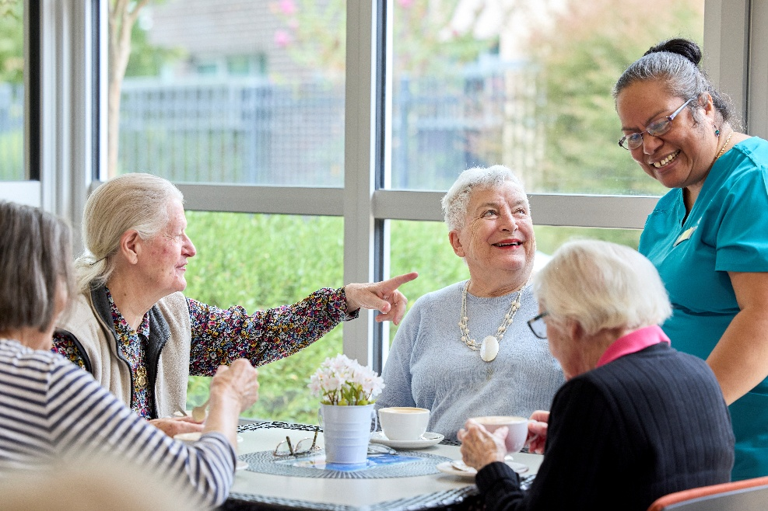
For more information, visit the Department’s webpage health.gov.au/topics/aged-care/volunteers/provider-requirements-and-responsibilities

Supporting volunteers
Providers should make sure volunteers:
- have a clear role description
- understand what they can and cannot do in their role
- complete any checks needed for the role
- receive induction, training and ongoing support
- know who their volunteer manager or coordinator is
- know how to ask questions, raise concerns or give feedback
- are treated with respect and recognised for their contribution.
Volunteers who deliver, or support the delivery of, funded aged care services on behalf of a provider are considered aged care workers under the Aged Care Act 2024.
These volunteers should do training on the five core topics. The training must be recorded by the provider.

Training on the five core topics
Training on the five core topics helps volunteers feel safe, confident and prepared in their role. It gives volunteers a consistent understanding of their responsibilities and how to support the rights, safety, dignity and wellbeing of older people.
Part One of the Learning Guide explains why these topics matter. The topics help volunteers understand their responsibilities, including how to act respectfully, respond to concerns and support older people’s rights.
The core topics cover:
- the Aged Care Code of Conduct (the Code)
- reportable incidents and the Serious Incident Response Scheme (SIRS)
- complaints and feedback
- elder abuse awareness and advocacy pathways
- understanding diversity and inclusion.

Training delivery options
Providers can use the Learning Guide to support training on the five core topics.
The Learning Guide has 3 parts:
- Part One – explains the five core topics and when they apply to volunteers
- Part Two – gives volunteer managers practical tools to deliver training on the core topics and support volunteers
- Part Three – is for volunteers and explains what is covered in the training
For delivery of training on the core topics, providers may use:
- the Aged Care Quality and Safety Commission’s (the Commission) eLearning modules, videos and fact sheets
- their own training materials, if they cover the five core topics and align with the Aged Care Act 2024
- the Learning Guide
- or a combination of these
Find the eLearning modules and resources at Commission’s webpage agedcarequality.gov.au/workers/volunteers-aged-care

Find the Learning Guide on the Department’s webpage health.gov.au/topics/aged-care/volunteers/resources

More support for volunteer managers
The Department also provides the Managing volunteers in aged care – Guidance handbook for volunteer managers.
This handbook includes practical resources on:
- recruiting volunteers
- designing volunteer roles
- onboarding and induction
- supporting and retaining volunteers
- administration and reporting
- understanding the aged care volunteering landscape.
Find aged care volunteering resources at the Department’s webpage
health.gov.au/topics/aged-care/volunteers
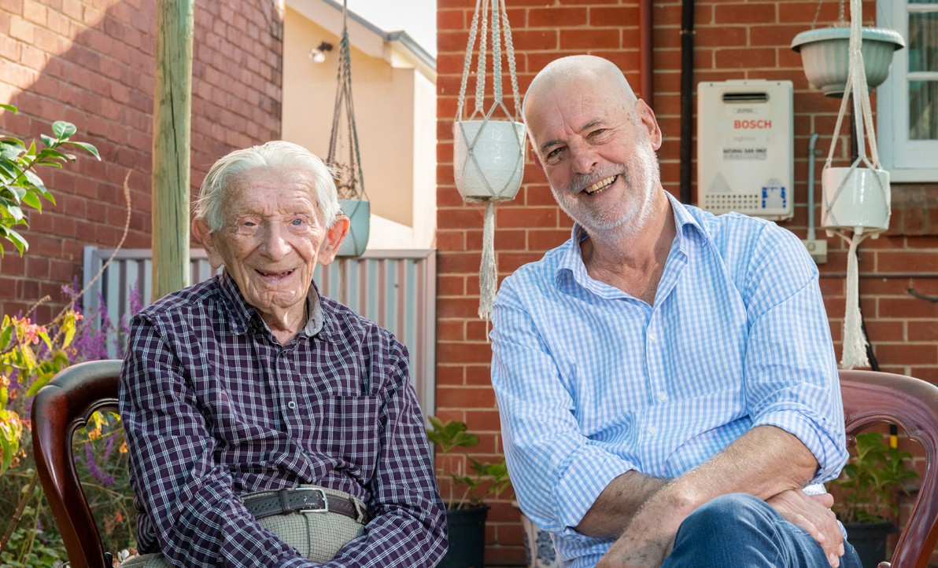
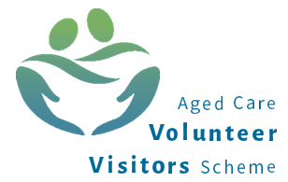

The Aged Care Volunteer Visitors Scheme
The Aged Care Volunteer Visitors Scheme (ACVVS) is a life-changing program that supports regular volunteer visits to give friendship and companionship to older people. It has a particular focus on the needs of older people from linguistic, cultural and complex vulnerability backgrounds who may be at greater risk of social isolation.
The free program commenced on 1 July 2023, replacing the Community Visitors Scheme (CVS) which ran for over 30 years.

How it works
The Department funds around 120 community organisations nationally to recruit, train and match volunteer visitors with aged care recipients in their local area.
The program requires volunteer visitors to make at least 20 visits a year to their recipient which should occur for around one hour a fortnight.
Volunteer visitors can visit their matched older person in:
- their own home
- their residential aged care home
- a public venue, including heading out for a coffee.
Under the Aged Care Act 2024, the ACVVS volunteer visitor is defined as an ‘aged care volunteer visitor’ with their own unique role and purpose.
ACVVS volunteer visitors do not undertake any clinical, personal or home care duties as part of their visits.
All visits are conducted in person, but a virtual visit may occur in exceptional circumstances (e.g., illness or recipient choice). These are one to one, so the recipient and volunteer visitor get to know each other over time.
During the visit, a volunteer visitor and older person can do anything they both feel like doing, such as:
- enjoy a chat over a cup of tea
- take a walk
- work on a joint hobby together.

For volunteer visitors
Becoming a volunteer visitor can be a rewarding and life-changing experience. You will make a friend, share stories and help someone who might be feeling isolated or lonely.

Experience
You don’t need any experience or qualifications to become an ACVVS volunteer visitor, just the capacity to give friendship and companionship to someone who needs it.
Applicants need to be at least 18 years of age.

Become a volunteer visitor
To become a volunteer visitor, go to health.gov.au/our-work/aged-care-volunteer-visitors-scheme-acvvs/volunteer.

For providers
Aged care providers are responsible for identifying and referring eligible aged care recipients to the ACVVS.
Find out more by visiting health.gov.au/our-work/aged-care-volunteer-visitors-scheme-acvvs/resources.

Recipient eligibility
Volunteer visits are available to those who are socially isolated and lonely and are receiving government-subsidised residential aged care or Support at Home services, including recipients approved or on the Support at Home Priority System.
It excludes recipients on the Commonwealth Home Support Program (CHSP).

Residential aged care providers
ACVVS supports residential aged care providers to meet their requirements under the Strengthened Quality Standards for the provision of person-centred care. This includes meeting the older person’s daily living needs and valuing their identity, culture and diversity.

Support at Home providers
Volunteer visits to the Support at Home recipient does not impact their Support at Home services. The ACVVS is designed to complement the services from the Support at Home provider.

Refer an older person
ACVVS accepts referrals from aged care service providers, health professionals, family members or friends, with consent from the older person. Older people can also refer themselves.
To request a volunteer visitor, go to health.gov.au/our-work/aged-care-volunteer-visitors-scheme-acvvs/request.

Contacts and links
The Department’s website provides detailed information including the National Guidelines, volunteer visitor stories and referral pathways at health.gov.au/acvvs
For questions about the program, contact acvvs@health.gov.au.

ACVVS Network Members
There are ACVVS Network Members representing each state and territory. Their role is to:
- support community organisations to deliver the program
- coordinate volunteer visitors and services in each state and territory
- liaise between community organisations and the Department.
To contact your local ACVVS Network Member, visit health.gov.au/our-work/aged-care-volunteer-visitors-scheme-acvvs/contacts

ACVVS volunteer visitor stories

Jacqueline and Monique
When Monique moved into a nursing home, Jacqueline started visiting her as a volunteer visitor through the ACVVS.
For elderly migrants, having a friend that speaks their language can help reduce feelings of isolation. For Monique, it also creates a sense of community.
‘I don’t have the opportunity to speak French with anybody here and when you come, we can speak together. It’s wonderful because I can find myself back in Mauritius.’
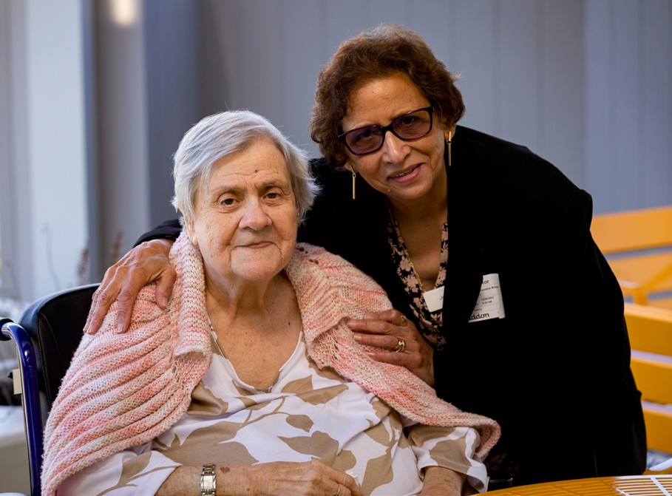

Fergus and Ron
‘I’ve been lucky to befriend someone who’s lived a really positive and fulfilling life.’
Fergus started visiting Ron as a volunteer visitor through the ACVVS while studying for his degree.
‘The reason I started volunteering was because I felt like I’d spent a lot of time thinking a little bit too much about myself.
That was a good motivation to step out of my comfort zone a little bit and explore volunteering. It’s been good fun. I’ve enjoyed it from the get-go.’
Fergus has also struck up a strong friendship with Ron, despite the age gap.

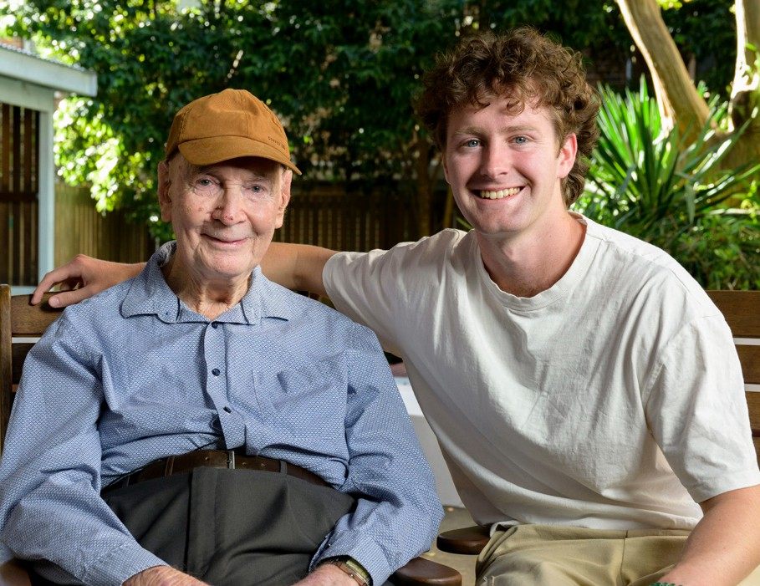
‘You think of making friendships as something that mainly happens when you’re younger, but it’s nice to flip that on its head.’
Watch heart-warming stories of real ACVVS participants by visiting health.gov.au/our-work/aged-care-volunteer-visitors-scheme-acvvs/stories

References:
Aged Care Act 2024
www.health.gov.au/our-work/aged-care-act
Aged Care Code of Conduct (the Code)
www.agedcarequality.gov.au/for-providers/code-conduct
Aged Care Statement of Rights
www.agedcarequality.gov.au/workers/statement-rights
Aged Care Volunteer Visitors Scheme (ACVVS)
www.health.gov.au/our-work/aged-care-volunteer-visitors-scheme-acvvs
Aged Care Worker Screening Guidance Material
www.health.gov.au/resources/publications/aged-care-worker-screening-guidance-material
Commonwealth Home Support Program (CHSP)
www.health.gov.au/our-work/chsp
Residential aged care
www.health.gov.au/our-work/residential-aged-care
Residential respite care
www.health.gov.au/our-work/residential-aged-care/managing/respite-care
Support at Home program
www.health.gov.au/our-work/support-at-home
Volunteering Australia
www.volunteeringaustralia.org/
Images sourced from Department of Health, Disability and Ageing and https://www.agewithoutlimits.org/image-library

Volunteering Australia national guidelines

