Perimenopause and menopause: every experience is different

Symptoms are common and support is available.

What is the menopause transition?
Everyone experiences the menopause transition differently. Some people have no or mild symptoms, while others have symptoms that significantly impact their daily life.
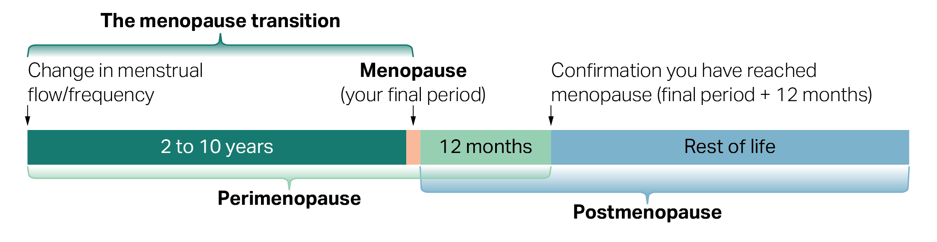
Figure 1: The menopause transition happens over several stages. These stages are based on changes in your menstrual cycle and time since your last period.
- Change in menstrual flow/frequency: the transition begins when your periods start to change.
- Perimenopause (lasts 2 to 10 years).
- Menopause (your final period): the moment when you have your last menstrual period. It is a single point in time, not a long stage.
- Confirmation you have reached menopause: this is your final period plus twelve months.
- Postmenopause: this stage after menopause lasts for the rest of your life.

What is perimenopause and menopause?
- Perimenopause usually starts in your 40s, but it can start earlier or later.
- Perimenopause is the time leading up to your final period (menopause).
- Menopause is your final period, which will often happen between the ages of 45 and 55 years.
- You know you’ve reached menopause when you have not had a period for 12 months, with no other medical reason for it.
- During perimenopause and menopause the levels of hormones produced by your ovaries change. This can cause menopause-related symptoms.

Common symptoms
Everyone will have a different experience and different symptoms.
Symptoms can be physical, emotional, cognitive, or a combination of all.

Physical symptoms might include
- Hot flushes and night sweats
- Trouble sleeping
- Joint and muscle pain
- Irregular periods
- Dry or itchy skin
- Vaginal dryness
- Urinary/bladder problems
- Weight gain/bloating

Mental and emotional symptoms might include
- Low mood
- Mood changes
- Less sexual desire
- Brain fog and forgetfulness
- Anxiety and depression

Symptoms can be different for everyone
- 1 in 2 women experience mild to moderate symptoms.
- 1 in 4 women experience symptoms severe enough to affect their daily activities.
- 1 in 4 women experience few or no symptoms.

You don’t have to manage alone
- Information: Information, support and treatment options are available.
- Managing symptoms: Lifestyle changes and medical treatments may help.
- Medical: Talk to a doctor if symptoms are worrying you or affecting your daily life.
- Learning more can help you feel prepared and in control. Find information and support at health.gov.au/perimenopause

