New regulatory model
  - Guidance for allied health professionals


Version

Disclaimer
The Aged Care Act 2024 governs the delivery of funded aged care services by registered providers, associated providers and aged care workers. The information in this guidance is intended as a general guide on the aged care regulatory model and how it applies to allied health professionals generally.
Allied health professionals are encouraged to refer the Aged Care Act 2024 and Aged Care Rules 2025 to understand the requirements that apply to their delivery of services.
Registered providers are solely responsible for complying with all relevant legislation when delivering funded aged are services. Providers should obtain their own independent legal and professional advice relevant to their specific circumstances to fully understand how to comply with all legislation relevant to their delivery of funded aged care services, especially in relation to requirements and obligations for delivering funded aged care services that may be new or different under the Act and related Rules.
In addition to legislation referred to in this guidance, other Australian Government portfolios and state and territory jurisdictions may have separate legislation relevant to providers’ operations as a registered provider. It is the provider’s responsibility to understand and meet their obligations as they relate to all applicable legislation.
Providers should consider obtaining their own legal or professional advice relevant to their circumstances, especially in relation to requirements and obligations for delivering funded aged care services that may be new or different under the Act and related Rules.
The Department of Health, Disability and Ageing will review and update the information in this guidance as needed. The most up-to-date version of this guidance will be published on the department's website. Please refer to the online version of the guidance to ensure that you have the most recent version. The footer on the front page includes the issue date. If you are reading a printed copy of this guidance, please make sure it is the same as the most up-to-date version published on the department’s website. The revisions and summary of changes made to the manual are outlined at the beginning of the document in the version history. The department does not represent or guarantee the accuracy or completeness of information in this guidance. To the extent permitted by law, the department also does not accept any liability for any loss or damage caused to any person (including providers) resulting directly or indirectly from use or reliance on this guidance or the information it contains.

Contents
Disclaimer 3
Key terms 5
Allied health in aged care 5
How allied health professionals are regulated outside of government-funded aged care 7
Aged care regulatory and governance roles 7
Overview of the new regulatory model 8
How you can deliver funded aged care services 9
Delivery pathways 9
Provider registration 12
Registration categories 12
Aged care service list 13
Overarching requirements of the new Aged Care Act 15
Strengthened Aged Care Quality Standards 16
Aged Care Provider Requirements Search tool 16
Specialist aged care programs 17
Commonwealth Home Support Program (CHSP) 17
National Aboriginal and Torres Strait Islander Flexible Aged Care (NATSIFACP) 17
Multi-Purpose Service Program (MPS) 18
Transition Care Program 18
Support at Home program 19
Self-management under Support at Home 19
Residential care 20
Frequently asked questions 21
Glossary of key terms 24
Resources 26
Contact 26

Key terms
This booklet uses terminology aligned with the Aged Care Act 2024 (the Act) and Aged Care Rules 2025 (Rules). Below are brief definitions of key terms used throughout.
For full definitions and legal references, see the Glossary of key terms on page 24.
Registered provider – an individual or organisation approved by the Aged Care Quality and Safety Commission to deliver government-funded aged care services.
Associated provider – a subcontracted entity engaged by a registered provider to deliver aged care services on their behalf.
Aged care worker – a person employed or engaged by a registered or associated provider to deliver aged care services. An individual who is a registered provider is also considered an aged care worker if they deliver funded aged care services.
Service list – a list of aged care services eligible for government funding, as defined in the Aged Care Rules.
Subcontractors – this refers to entities that are subcontracted by the registered provider to deliver services, some of which may be funded aged care services.

Allied health in aged care
The Rules define an allied health professional as a person who is any of the following:
- a registered health practitioner who:
    - is registered under the National Law to practise an allied health profession, other than as a student (within the meaning of the National Law or
    - holds non-practising registration under the National Law in an allied health profession
- an Aboriginal or Torres Strait Islander Health Worker
- an art therapist
- an audiologist
- a certified practicing nutritionist
- a counsellor
- a dietitian
- an exercise physiologist
- a genetic counsellor
- a music therapist
- an orthoptist
- an orthotist
- a pedorthist
- a prosthetist
- a recreational therapist
- a rehabilitation counsellor
- a social worker
- a sonographer
- a speech pathologist.

These practitioner types are further defined in section 5-5 of the Rules and apply across all aged care programs. Allied health professionals are encouraged to refer to the definitions to understand whether any accreditation, membership or certification requirements apply to their delivery of services in an aged care setting.
It is important to note that funding is tied to approved service types and not professional titles. The profession-based definitions describe who may deliver care, however, service groupings in the aged care service list determine what can be funded and how it must be delivered. The differences in service groupings reflect program design rather than the professional status of different professions. See page 13 for more information on the aged care service list.
Allied health professionals play an important role in maintaining and improving the health and wellbeing of older people accessing aged care. They help older people stay healthy, independent and active longer through the provision of physical, social and daily support and other activities.
Some allied health professionals may be new to the aged care system, while others have provided services in aged care for many years.
Allied health professionals have reached out to the department to understand what the changes in aged care mean for them under the Act. This includes understanding how they can deliver allied health services in a government-funded aged care setting.
This booklet outlines the regulatory changes that came into effect under the Act. It outlines how allied health professionals can provide government-funded aged care services, including information about delivering services as an aged care provider, operating as an associated provider, and being engaged to deliver aged care services as an aged care worker.
This booklet further outlines the roles of the Department of Health, Disability and Ageing (department) and the Aged Care Quality and Safety Commission (ACQSC) and how they intersect in overseeing Australia’s aged care sector.
The new Rules and explanatory statement provide further detail on how the Act works, to ensure care is delivered in a safe, respectful and transparent way for older people.
Definitions and legal references are listed in the Glossary of key terms on page 24.

How allied health professionals are regulated outside of government-funded aged care
The allied health workforce in Australia is regulated by either:
- national regulation by the Australian Health Practitioner Regulation Agency
- self-regulation by a professional association that certifies qualifications, sets and maintains standards and oversees professional development.
Allied Health Professions Australia (AHPA) is the peak advocacy and representative body for allied health professionals in Australia. It covers all health, disability and education systems where allied health services have a role.
Each allied health profession has its own professional association. Most professional associations are members of AHPA.
In addition, some self-regulating professional associations are members of the National Alliance of Self-Regulating Health Professionals (NASRHP). NASRHP provides and maintains a framework of standards for those professions. Professional associations that are members of NASRHP align their regulatory standards with NASRHP’s framework ensuring consistency among members.

Aged care regulatory and governance roles
The Act puts the rights and needs of older people at the centre of aged care. Under the Act, the new regulatory model, the strengthened Quality Standards, feedback and complaints processes, and system governance affect how the department and ACQSC oversee and manage the aged care system.
The aged care regulatory and governance roles document will help you to understand the aged care regulatory and governance responsibilities of the department and ACQSC.
The department develops the laws and policies and seeks to ensure the aged care sector meets community expectations, especially those of older people accessing aged care, their families and carers.
The ACQSC works with aged care providers to make sure quality care is delivered and the laws governing aged care are followed. This includes registering and overseeing providers, monitoring providers, supporting continuous improvement and, when necessary, taking enforcement action.

Overview of the new regulatory model
The new regulatory model sets out the roles and responsibilities of aged care providers under the Act.
The new model introduces:
- universal registration – a single registration for each provider across all aged care programs they deliver
- requirements that reflect the types of services delivered
- more protections that place the rights and needs of older people at the centre of their care to help them feel confident about their care
- ways for providers demonstrating excellence to be recognised, such as longer registration periods and graded audits against the strengthened Aged Care Quality Standards.
It also introduces whistleblower protections which play an important role in identifying and calling out misconduct.
The new model makes it easier for providers to operate across multiple aged care programs by simplifying the arrangements for entry to service delivery.

Individuals and partnerships
One of the changes under the Act is that individuals and partnerships can apply to become registered providers for the first time. Many allied health businesses operate under these models. Individuals and partnerships should consider the requirements of delivering their proposed services before deciding to apply.

How you can deliver funded aged care services
Under the Act, government-funded aged care services must be delivered by:
- registered providers – organisations or individuals directly funded by the Australian Government
- associated providers – entities subcontracted by registered providers
- aged care workers – individuals employed or engaged by registered or associated providers.

Delivery pathways
Allied health professionals can participate in aged care in one or more of the following roles.

Registered provider
An aged care registered provider is an entity that is formally registered with the ACQSC to deliver government-funded aged care services. To put it simply, the organisation that directly receives funding to deliver aged care services from the Australian Government must be a registered provider.
If you meet the requirements, you may apply to become a registered provider and receive direct government funding. This includes individuals and organisations. As a registered provider, you are responsible for ensuring all services—whether delivered directly or by an associated provider on your behalf—meet the requirements under the Act and Rules relevant to your registration category.
Note: Legal responsibilities cannot be contracted out. The registered provider remains accountable for regulatory compliance, even if services are delivered by an associated provider.

Associated provider
Associated provider is a new term introduced by the Act. An associated provider is an organisation that delivers funded aged care services on behalf of a registered provider. This includes organisations delivering allied health services.
The department has published further information on associated providers, which includes example profiles and frequently asked questions.
The ACQSC has also published guidance for associated providers which explains the requirements of registered providers who use associated providers in the delivery of their aged care services.
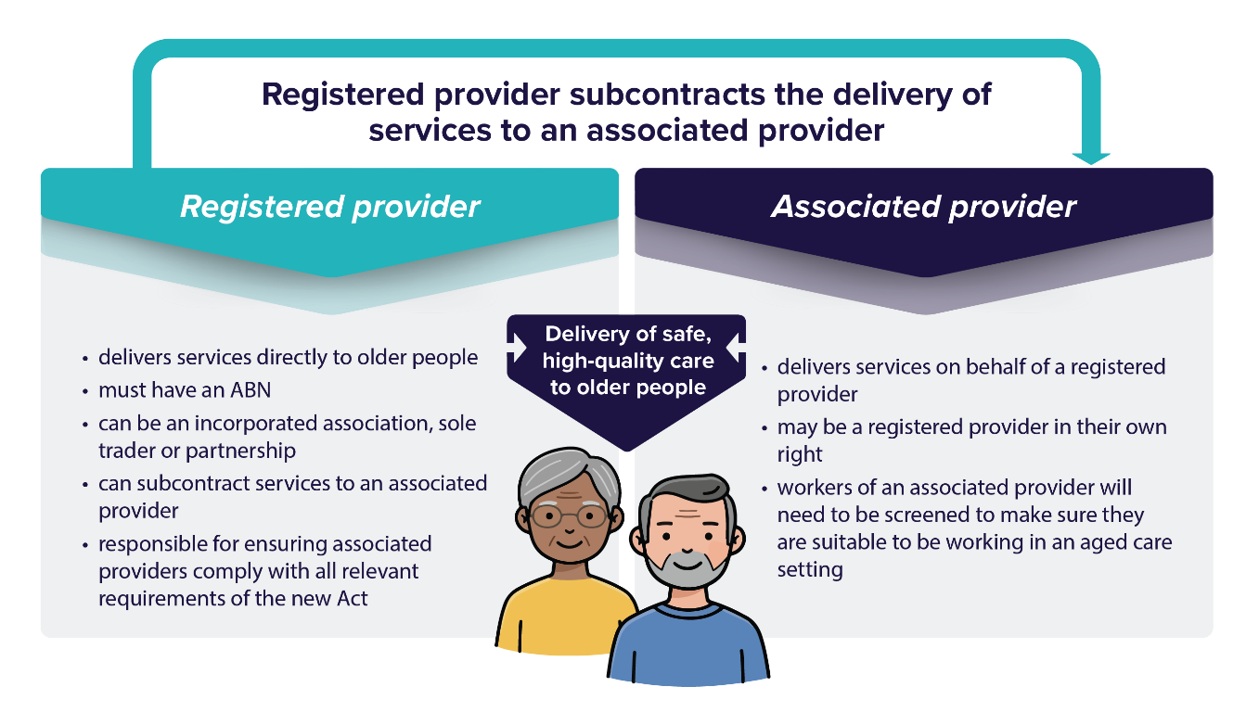
Figure 1: Who can be a registered provider and associated provider.

Aged care worker
If you are employed or engaged by a registered or associated provider, including as a volunteer, you are considered an aged care worker. This includes allied health professionals working within aged care organisations. Under the Act, an individual who is a registered provider is also considered to be an aged care worker.
Important: Worker screening requirementsTraining, and compliance with the Aged Care Code of Conduct are mandatory for all aged care workers.
Note: Allied health services in aged care must be delivered according to your professional training and responsibilities and be aligned with your scope of practice. This includes maintaining accreditation/registration, ongoing professional development and any reporting obligations as required by your professional body.
The Aged Care Rules may also specify accreditation, membership and/or certification requirements for allied health professionals to be able to deliver allied health services in an aged care setting.

Associated provider or aged care worker?
Whether an individual is considered an aged care worker or an associated provider will depend on the context in which services are being delivered and the arrangements involved. One of the key considerations is whether the individual is operating in a similar way to an aged care worker.
In the example of a sole trader, if the business owner has no employees and is directly delivering aged care services on behalf of the registered provider, they are considered an aged care worker. If the sole trader (as the business owner) employs workers to deliver those aged care services and doesn’t deliver those services themselves, they are considered an associated provider.
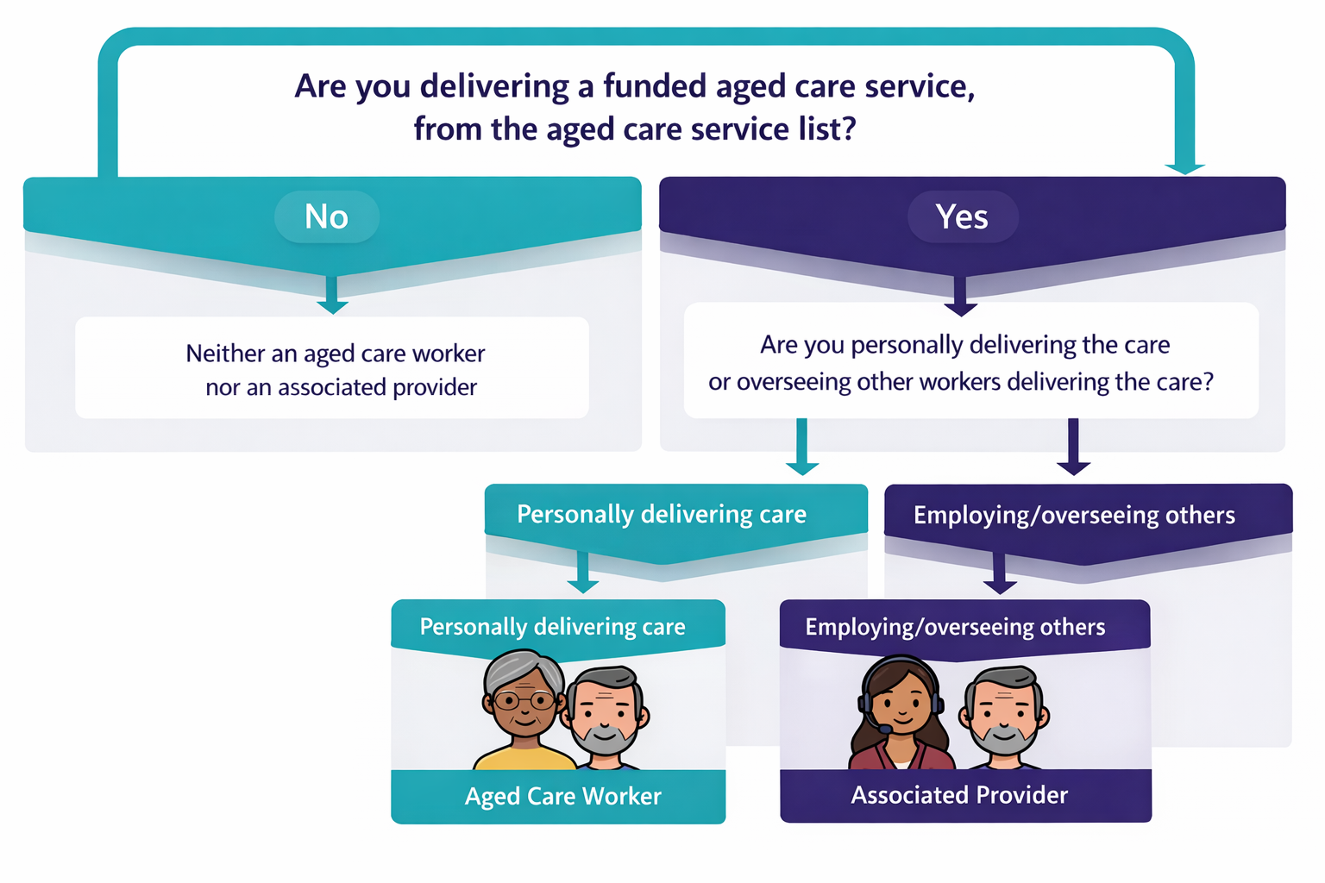
Figure 1: Aged care worker or associated provider?

Example: A registered provider directly employs an occupational therapist to deliver services to Support at Home participants. The occupational therapist would be considered an aged care worker and would need to meet all the requirements of a worker in aged care. The registered provider remains responsible for all regulatory requirements for the delivery of care.
Example: A dietitian operating as a sole trader is subcontracted by a registered provider to deliver services funded under the Support at Home Program. As the dietitian is employed or otherwise engaged by the registered provider to deliver aged care services, the ACQSC considers this arrangement to be that of an aged care worker and not associated provider.
If, on the other hand, a company was subcontracted by the registered provider to deliver funded aged care services, including dietetics, and employed multiple allied health practitioners, this would be considered an associated provider arrangement. Allied health practitioners delivering services under this arrangement would be considered aged care workers.
Example: An organisation delivering a mix of services including allied health is registered with the ACQSC to deliver services funded under the Support at Home program. The organisation is also subcontracted to deliver speech pathology services in residential aged care on behalf of another registered provider. The organisation is considered both a registered provider, and an associated provider delivering services on behalf of the residential aged care provider.

Provider registration
To deliver funded aged care services under the Act, an organisation or person must be registered with the ACQSC. Organisations or people must apply for registration in the categories that match the services they plan to deliver.
Registered providers must have the service types they intend to deliver, or are required to deliver as specified in a funding agreement, under the Act listed on their provider registration.
The ACQSC’s Provider Registration Policy and Registration Model provide more detail on the registration process and guiding principles.
The ACQSC charges fees for assessing applications to:
- become a registered provider
- renew registration
- vary registration.
You can find the registration fees for organisations and people who want to become a registered provider, including registration renewal fees, on their website. New organisations seeking to become a registered provider should consider the upfront and ongoing fees before applying to the ACQSC.

Registration categories
There are 6 registration categories that group service types based on similar care complexity and risk.
Registered providers are not required to deliver all services in the categories they are registered in but should deliver at least one service. All registered providers will need to comply with their requirements and the Aged Care Code of Conduct.
The strengthened Quality Standards apply to registration categories 4, 5 and 6, based on the services being delivered.
Table 1: The 6 registration categories
Provider registration category | Description | Service types
Category 1 | Home and community services | - Domestic assistance  - Home maintenance and repairs  - Meals  - Transport
Category 2 | Assistive technology and home modifications | - Equipment and products  - Home adjustments
Category 3 | Advisory and support services | - Hoarding and squalor assistance  - Social support and community engagement
Category 4 | Personal and care support in the home or community | - Allied health and therapy  - Personal care  - Nutrition  - Therapeutic service for independent living  - Home or community general respite  - Community cottage respite  - Care management  - Restorative care management
Category 5 | Nursing and transition care | - Nursing care  - Assistance with transition care
Category 6 | Residential care | - Residential accommodation  - Residential everyday living  - Residential services  - Residential clinical care

Aged care service list
The aged care service list can be found in the Rules. It prescribes the list of services for which funding may be payable under the Act. Establishing a single service list introduces consistency between funded aged care services. It means that services funded under the Commonwealth aged care system are consolidated into a single service list under the Act. If the service being delivered is not listed in the aged care service list, it is not a funded aged care service under the Act
Services listed in the aged care service list are grouped by service types which are delivered through service groups. The four service groups are home support, residential care, assistive technology, and home modifications. These service groupings determine how individual services are funded, regulated and delivered through the various aged care programs under the Act.
There are a number of service types that may be relevant for the delivery of funded allied health services. These include:
- 8-15 Allied health and other therapy
- 8-110 Equipment and products
- 8-65 Nutrition
- 8-85 Therapeutic services for independent living
- 8-125 Home adjustments
- 8-155 Residential clinical care
Allied health professionals should refer to the aged care service list to understand which services can be delivered under service types and how these align with registration categories. The service list also outlines the requirements that apply to the delivery of services.
Further resources are available regarding the service list for the following aged care programs:
- For the Commonwealth Home Support Program
  - See the CHSP 2025-27 Manual and Inclusions and Exclusions for CHSP Service List
- For Support at Home
  - See the Support at Home service list
- For the Transition Care Program
  - See the Transition Care Program full list of approved service types
- For residential aged care
  - See the residential care service list.

Overarching requirements of the new Aged Care Act
Some conditions of registration will apply to all providers. For example:
- understanding and having systems in place to support the rights of older people receiving aged care services
- continuous improvement
- the Statement of Rights
- the Aged Care Code of Conduct
- incident management and complaints.
Section 142-1 of the Rules provides an outline of the conditions of registration.
Other conditions will be specific to a registration category and only apply to certain providers. For example:
- setting up an advisory board
- meeting financial and reporting requirements
- compliance with the strengthened Aged Care Quality Standards.
Registration requirements, related provider requirements and regulatory oversight are linked to the registration categories and are proportionate to the service types being offered. Aged care providers will need to meet requirements under the Act relevant to their registration category.
All providers will be subject to monitoring and risk surveillance under the ACQSC’s supervision model and risk-based suite of responses. All providers will be given a supervision status based on information the ACQSC has about their capability, capacity and commitment to meet their requirements. This supervision model includes managing risks effectively to prevent harms and to ensure providers uphold the rights in the Statement of Rights.
The four supervisory statuses escalate in terms of the intensity of the ACQSC’s intervention in responding to risk and include:
- Risk surveillance
- Targeted supervision
- Active supervision
- Heightened supervision
You can find more information in the ACQSC’s Regulatory Strategy 2025-26.

Strengthened Aged Care Quality Standards
The previous Aged Care Quality Standards have been strengthened as part of the new regulatory model and are now in place. The strengthened Quality Standards are designed to improve outcomes for older people and set clear expectations for providers in delivering quality aged care.
The strengthened Quality Standards apply to registration categories 4, 5 and 6. The strengthened Quality Standards only apply to services being delivered in those registration categories and not to other services that the provider may deliver.
This means that registered providers delivering allied health services will be regulated by the ACQSC under the strengthened Quality Standards.
It is the responsibility of the registered provider to ensure any associated providers delivering allied health services on their behalf comply with relevant requirements, including the strengthened Quality Standards.

Aged Care Provider Requirements Search tool
To help providers navigate their requirements, an interactive web search tool is available that highlights legislative requirements under the Act and associated Rules. It is called the Aged Care Provider Requirements Search tool.
The term ‘requirements’ means all the conditions of registration, obligations and duties under the Act and Rules. These provider requirements create protections to make sure that aged care in Australia is high quality, continuously improving and safe for older people.
Allied health professionals may also find the search tool useful to understand requirements by selecting the ‘I work with or for a registered provider’ option.
The search tool will return a list of requirements based on responses to questions about your role in the aged care sector, registration categories, services you deliver and how you are or will be funded.
Older people, carers, peak bodies, aged care workers and the wider community can also use the search tool to understand the requirements an aged care provider must meet when delivering care.
Resources on how to use the search tool are available on the new regulatory model resources page on our website.

Specialist aged care programs
Providers deliver most services under the Support at Home Program or through residential aged care, but the Act also allows services to be delivered through certain specialist aged care programs.
Relevant registration requirements are outlined below. Alternately, allied health providers may be subcontracted by a registered provider to deliver allied health services as an associated provider, or they may be employed or engaged by a registered or associated provider as an aged care worker.

Commonwealth Home Support Program (CHSP)
A grant-funded program to support older people to live at home and in the community. Providers can apply to be registered into one or more of the categories relevant to the type of services they provide. Five of the registration categories are relevant for CHSP registered providers:
- Category 1 - Home and community services
- Category 2 - Assistive technology and home modifications
- Category 3 - Advisory and support services
- Category 4 - Personal and care support in the home or community
- Category 5 - Nursing and transition care.
New organisations interested in becoming a registered provider delivering services funded under CHSP should be aware that before they can provide CHSP services, they must:
- Apply and be successful through a CHSP grant opportunity, managed by the department; then
- apply to the ACQSC to become a registered provider.

National Aboriginal and Torres Strait Islander Flexible Aged Care (NATSIFACP)
This program provides flexible and culturally safe aged care to meet the needs of older Aboriginal and Torres Strait Islander peoples, supporting them to remain close to their family, country, island home and community.
New organisations interested in becoming a registered provider delivering services funded under NATSIFACP, will need to apply for registration in the relevant categories (categories 1-6). An organisation must both:
- Apply and be successful through a NATSIFACP grant opportunity, managed by the department; then
- apply to the ACQSC to become a registered provider.
Any NATSIFACP expansion has been paused until after the aged care reforms are fully implemented and Independent Health and Aged Care Pricing Authority review recommendations are delivered to Government in mid to late 2026. You can find more information here.

Multi-Purpose Service Program (MPSP)
This program supports integrated health and aged care in rural and remote communities to offer flexible, community based aged care services. It combines government-funded subsidies with state and territory health services.
New organisations interested in becoming a registered provider delivering services funded under the MPSP, will need to register under the residential care category (category 6) and have the residential care home through which services will be delivered, approved by the ACQSC. They will also need to register in any additional registration categories which correspond to the services they intend to deliver in a home or community setting (if any).

Transition Care Program (TCP)
The TCP is a jointly-funded program between the Commonwealth and state/territory governments to help older people recover after a hospital stay, through the hospital transition classification type. It provides restorative, short-term therapy focused care and services for up to 12 weeks (with a possibility of a six-week extension) immediately following discharge from hospital. It can be provided by registered providers in a home care setting, a residential care setting or a combination of both.
While the overall management and policy design for the program nationally is a Commonwealth Government responsibility, the program is delivered in each jurisdiction by the state and territory governments, who can either be the registered providers of the program or alternately, may nominate other entities (such as their local health networks) to be the registered providers.
The Commonwealth Government allocates TCP places to each jurisdiction under the allocation procedures outlined in the Act, which includes an application process for the states and territories.
The same range of registered health practitioners and allied health professionals can deliver care and services to transition care participants (depending on the care setting – home or residential) as defined in section 5-5 of the Rules, which as noted above, applies across all aged care programs.

Support at Home program
The new Support at Home program replaces the Home Care Packages (HCP) Program and Short-Term Restorative Care Programme. Allied health professionals are likely to have delivered services previously under these programs.
The Commonwealth Home Support Program will transition to the new program no earlier than 1 July 2027.
Allied health professionals seeking to deliver Support at Home services may do so as a registered provider but need to consider whether they can meet all the Support at Home program requirements and legislative requirements for the registration category, or categories, they intend to register in including the obligation to deliver care management to all participants. Alternatively, allied health providers may enter into a subcontracting arrangement with a registered provider to deliver allied health services as an associated provider.
Support at Home operates via a single provider model, whereby all services are managed and overseen by a single registered aged care provider, with some services delivered directly or through contracted third-party arrangements. This means a single provider will oversee and deliver all Support at Home services for a participant, including care management and assistive technology and home modifications (AT-HM) services.
It is a requirement that all participants receive care management services for the Support at Home program.
As a result, registered providers claiming for the delivery of Support at Home services must be registered into (at a minimum) Category 4 - Personal care and care support in the home or community. Support at Home providers must also meet Outcome 5.1 (Clinical governance) of strengthened Quality Standard 5: Clinical care. While this is the minimum requirement, providers should consider if there are additional registration categories they should register in, based on the services their participants will need.
Under the single provider model, providers can engage a third-party to deliver services on their behalf, however, the registered provider remains responsible for delivery of services and compliance with relevant obligations.

Self-management under Support at Home
Support at Home participants may self-manage. This means the participant leads and makes key decisions about the care and services they receive (in accordance with the services they are approved to receive), including management of their budget and in some instances, which organisations and/or workers will provide the services. Self-management is based on the principle that older people, with support from registered carers and supporters, are best placed to make decisions about their own care.
Where participants opt to choose their own workers, they do so with agreement, oversight and support from their provider to ensure quality and safety of service delivery and compliance with legislation and program guidance.
Participants who choose self-management can engage third party workers, including allied professionals directly. The registered provider still has oversight responsibilities for compliance and safety.
Under a self-management approach, participants have the option to select particular aged care workers to meet their care needs and goals (including third-party workers). Under this approach, participants can select workers from different organisations, if the provider is able to support this. The registered provider remains responsible for meeting all regulatory requirements and provider obligations for all services delivered to a participant, including those delivered by third parties.
In some limited circumstances registered providers may reject the third-party service of choice of the participant for compliance reasons, which should be clearly articulated to the participant, including the use of family members.
For more information on engaging third party workers under Support at Home, please refer to the Support at Home manual. You can also find more information in the Support at Home guidance for health professionals.

Residential care
Residential aged care is delivered by providers who are registered in category 6 – residential care.
Residential care providers are required to deliver care and services in accordance with the Residential Care Service List (Service List). This requires providers to ensure residents have access to allied health programs that are designed to maintain or restore the individual’s physical, function and communication abilities to perform daily activities and improve independence (item 8-155(2) of the Rules).
Qualified health and/or allied health professionals are responsible for assessing the resident’s needs for allied health services, and for making recommendations for the allied health services that a resident requires. The required allied health services must be outlined in the care and services plan and delivered by qualified health and/or allied health professionals, acting within their scope of practice. In some cases, services may be delivered by an aged care worker under the direction of a qualified health and/or allied health professional.
Providers are responsible for the design, development, and delivery of therapy programs, including any transport costs if parts of the program are delivered off-site
Intensive, long-term rehabilitation services required following serious illness or injury, surgery or trauma are not considered within scope when developing therapy programs under the Service List. The provider is still responsible for making arrangements for residents to access allied health professionals for assistance in these circumstances. However, the provider can pass on the cost of the appointments or any gap payments charged for the appointments, as well as transport costs.
For more information, please refer to the Residential Care Service List guidance.

Frequently asked questions
I delivered allied health services in an aged care setting under the Aged Care Act 1997; have I been deemed as a registered aged care provider under the Act?
On 1 November, with the start of the Act, government-funded providers were deemed, or transitioned, to the new regulatory model as registered providers based on the services they deliver. If you were not considered a current government-funded aged care provider in the lead up to the Act, you have not been deemed as a registered provider.
If your organisation delivered government-funded allied health services in an aged care setting via a subcontracting arrangement, your organisation will now be known as an associated provider under the Act. Transitioning to the Act will not change any subcontracting arrangements that are currently in place.
Effective from 1 November, if you are an allied health professional employed or subcontracted either by a registered provider or associated provider to deliver allied health services in aged care, you are considered an aged care worker. You must meet aged care worker screening requirements and comply with your employer’s contractual obligations, including working within your scope of practice and professional training.
Requirements of your professional body, including registration and continuing professional development, are unchanged.
What allied health services can be delivered under the service type Allied health and therapy?
The full list of government-funded aged care allied health services that fall under the service type Allied health and therapy can be found under section 8-15 in the Rules.
Will allied health workers need to get a worker screening check?
From 1 November 2025, all workers delivering government-funded aged care services will continue to need a police certificate (not older than 3 years) that does not record certain offences. Alternately, a NDIS worker screening check can be used.
Further information on the screening requirements for the aged care workforce, including the future of screening checks, can be found on our website.
Can I register as an aged care provider and only deliver allied health services under Support at Home?
Organisations providing allied health services can be registered providers. As part of the registration process, overseen by the ACQSC, prospective providers will indicate the service types they intend to deliver as a registered provider.
Under the Support at Home program, it is a requirement that all participants receive care management services for the Support at Home program.
As a result, registered providers claiming for the delivery of Support at Home services must be registered into (at a minimum) Category 4 - Personal care and care support in the home or community. Support at Home providers must also meet Outcome 5.1 (Clinical governance) of strengthened Quality Standard 5: Clinical care.
If an allied health organisation or professional wishes to provide allied health services, they will also need to be registered under Category 4 with the service type Allied health and therapy listed in their registration.
Do registered providers and allied health organisations need to enter into a brokerage agreement?
Registered providers may subcontract the delivery of allied health services through organisations. In these cases, where an arrangement is in place for specified delivery of funded aged care services on behalf of the registered provider, the allied health organisation is considered an associated provider. The registered provider remains responsible for ensuring its associated providers comply with relevant requirements under the Act.
Whether or not to formalise this arrangement through a brokerage or subcontracting agreement is a decision for the parties involved. There is no legislative requirement to enter into a specific type of agreement under the Act.
The registered provider remains responsible for legislative requirements relating to any services delivered by an associated provider. It is up to the registered provider to determine how it will ensure its associated providers meet relevant requirements under the Act, including required standards of care delivery where these apply. This decision should be based on the nature of the services being delivered and the provider’s business practices.
If a registered provider directly employs an allied health professional to deliver funded aged care services, the allied health professional is considered an aged care worker and not an associated provider. Additionally, where an individual, for example, a sole trader, meets the definition of both an aged care worker and an associated provider, the Aged Care Quality and Safety Commission (the ACQSC) has indicated that it will consider that person to be a worker of the registered provider, and not an associated provider. This means the ACQSC, from a regulatory perspective, will engage with the registered provider as if that individual delivering aged care on their behalf is an aged care worker. This supports regulatory clarity and risk management.
Can allied health services be delivered by an allied health assistant or aged care worker under the supervision of an allied health professional?
The Rules define an allied health assistant as a person who holds a Certificate IV in Allied health Assistance from a registered training organisation.
The Rules dictate when a service can be delivered by an allied health assistant or under supervision arrangements. For example, section 8-15(3) of the Rules outlines the parameters for allied health and therapy service delivery. With the exception of Aboriginal or Torres Strait Islander Health Practitioner assistance and Aboriginal or Torres Strait Islander Health Worker assistance, services under this service type can be delivered directly by a registered health practitioner or allied health professional, or by an allied health assistant or aged care worker, under the supervision of a registered health practitioner or allied health professional where safe and appropriate to do so.
I am registered with Ahpra. Does this mean I am already registered as an aged care provider?
No. Registration with Ahpra or with another professional organisation does not automatically register you as an aged care provider under the Act. To become a registered aged care provider you will need to apply to the ACQSC to deliver government-funded aged care services.
Please refer to the information on delivery pathways on page 9.
I deliver allied health services as a registered NDIS provider. Do I need to register as an aged care provider?
Current registered NDIS providers may decide to register with the ACQSC to become an aged care provider. Currently, the processes to become an aged care provider or a NDIS provider remain separate. There is nothing to prevent an organisation from being both.
A registered NDIS provider can also deliver services as an associated provider on behalf of a registered aged care provider.

Glossary of key terms
Term | Definition
Aged Care Quality and Safety Commission (ACQSC) | The national regulator of aged care services, protecting the health, safety and wellbeing of older people.  The ACQSC is responsible for registering, monitoring, and supporting aged care providers under the Act.
Aged care worker | Aged care worker is defined under subsections 11(4) and 11(5) of the Aged Care Act 2024. This refers to an individual who is employed or otherwise engaged (including as a volunteer) by a registered provider or associated provider to deliver government-funded aged care services.  This includes allied health professionals working within aged care organisations.
Allied health professional | Allied health professional is defined under section 5-5 of the Aged Care Rules 2025.
Allied Health Professions Australia (AHPA) | A national peak body for allied health professionals that provides national policy and advocacy to optimise the role of allied health professionals in the Australian healthcare system.
Associated provider | Associated provider is defined under subsection 11(6) of the Aged Care Act 2024. This refers to an entity engaged by a registered aged care provider to deliver government-funded aged care services on their behalf.  Associated providers may be subcontracted organisations or sole traders. While they can deliver services, the registered provider remains legally responsible for ensuring all services meet the requirements of the Act.
Australian Health Practitioner Regulation Agency (Ahpra) | The national agency that regulates registered health practitioners, including many allied health professionals. Ahpra is responsible for implementing the National Registration and Accreditation Scheme in partnership with 15 National Boards, each overseeing a specific health profession.  Ahpra is a statutory authority established under the Health Practitioner Regulation National Law, which is enacted across all Australian states and territories.
National Alliance of Self Regulating Health Professions (NASRHP) | A formal membership body that provides a quality framework to support member organisations of self-regulating health professions. The framework aims to facilitate national consistency in quality and support and satisfy national and jurisdictional regulatory requirements.
NDIS worker screening check | A screening process used to assess whether a person is suitable to work in roles delivering NDIS or aged care services.
Registered provider | Registered provider is defined under subsection 11(2) of the Aged Care Act 2024. This refers to an individual or organisation that is registered with the Aged Care Quality and Safety Commission (ACQSC) to deliver government-funded aged care services.  In the context of this document, a registered provider is directly accountable for meeting all legislative and quality requirements under the Act, including those related to services delivered by associated providers.
Registration categories | Six categories grouping service types by care complexity and risk. Providers must register in relevant categories to deliver specific services.
Service list | A list defined under Chapter 1, Part 3 of the Aged Care Rules 2025, outlining the types of services eligible for government funding.
Strengthened Quality Standards | Updated standards under the new regulatory model that apply to certain registration categories to ensure high-quality care.
Support at Home program | A new aged care program commencing 1 November 2025, replacing the Home Care Packages Program and Short-Term Restorative Care Programme. Operates under a single provider model.

Resources
Aged Care Act 2024 Statement of Rights – A4 Explainer
Aged Care Worker Screening Guidance Material
Becoming a registered provider and renewing your registration video
Code of Conduct for Aged Care
Regulatory Strategy 2025-26
Guidance for associated providers
Guide to Aged Care Law
Provider Registration Policy
Registration Model
Services in the service type Allied health and therapy (Aged Care Rules 2025)
Strengthened Aged Care Quality Standards
Support at Home guidance for health professionals
Support at Home program manual – A guide for registered providers
Working in aged care

Contact
If you have questions related to the delivery of allied health services in government-funded aged care, contact the relevant program areas below:
- Commonwealth Home Support Program at CHSPprogram@health.gov.au
- Support at Home at SAH.implementation@Health.gov.au
- National Aboriginal and Torres Strait Islander Flexible Aged Care Program at NATSIFACP@health.gov.au
- Multi-Purpose Services Program at MPSAgedCare@Health.gov.au
- Transition Care Program at TCP@health.gov.au
- Residential Aged Care at Residentialplaces@Health.gov.au
For any further questions or information about the new aged care regulatory model, please contact AgedCareRegModel@Health.gov.au.

