Securing the NDIS for Future Generations

NDIS Amendment
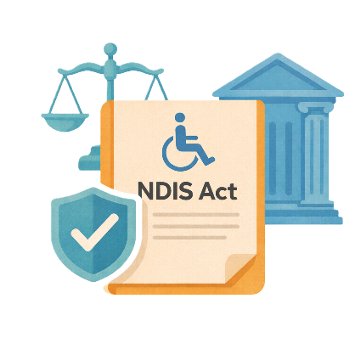
 | The Australian Government Department of Health Disability and Ageing wrote this.  We say DHDA for short.  When you see the word we it means DHDA.
 | We wrote this in an easy to read way.  We use pictures to explain some ideas.
 | We have some words in bold.  This means the letters are thicker and darker.  These are important words.
 | This is an Easy Read summary of another document.  This means it has the most important ideas.
 | You can ask for help to read this document.  You can ask  - A friend  - Family members  - A support person.
 | We recognise Aboriginal and Torres Strait Islander people as the Traditional Owners of the land we live on.
 | They were the first people to live on and use the  - Land  - Waters.

Contents

Changes to NDIS laws | 5
Being able to get NDIS and planning for supports | 8
Stopping fraud | 23
Governance | 30
New Framework planning | 33

Changes to NDIS laws

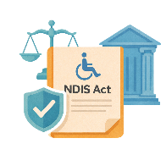 | The government wants to make changes to the NDIS laws.  Laws are rules for how we live.  The changes are called  - Securing the NDIS for Future Generations.
 | Changes to the laws are called amendments.  They help laws  - Change  - Be better.
 | The changes were shared after the government handed down the budget.  Handed down means they shared the information with everyone.
 | Budget is the amount of money the government plans to spend in different areas.
 | The changes to the NDIS law are to 4 main areas.
 | - Being able to get NDIS and planning for supports
 | - Stopping fraud
 | Fraud is when someone tried to get something they should not get.  Like tricking someone to get their NDIS money.
 | - Governance  Governance says how something will work.  They make sure the work is done the right way.
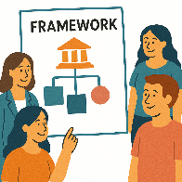 | - New framework planning  A framework is how we will do something.

Being able to get NDIS and planning for supports

 | There are 9 changes in this area.
 | - Make a definition to say what functional capacity means  Definitions explain what a word or idea means.
 | Functional capacity says what you can do in your everyday life.  We will do functional capacity assessments.  Assessments help us work out what support you need.
 | The government will set up a technical advisory group.  A technical advisory group is a group of people who  - Share their expertise  - Go to meetings  - Help make decisions.  Expertise is knowing a lot about something.
 | They will give the government advice about  - Functional capacity assessments.
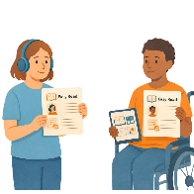 | This will make sure that decisions about who can join the NDIS are  - Consistent  Consistent means doing things the same way each time.
 | - Fair
 | - Using evidence  Evidence is proof that something is true.
 | - Asking for an unscheduled plan reassessment can only be done by  - People with NDIS plans  - Nominee  - Guardian.
 | Unscheduled plan reassessment is when you ask for changes to your NDIS plan.  It is not done at the usual time of your plan review.
 | A nominee is someone you choose to  - Get letters from the NDIA about your NDIS plan  - Write back to the letters if they need to.  Some people do not have a nominee.
 | A guardian is someone who can make decisions for someone else.  There are rules about what decisions they can make.  Some guardians might make  - Lots of decisions  - Some decisions.  Some people do not have a guardian.
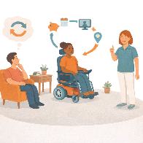 | Unscheduled reassessments can only happen if changes to the support needs of the person are  - Significant  - Ongoing.
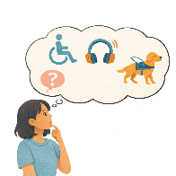 | Significant means a big change to the support a person needs.
 | Ongoing means it does not go away soon.
The changes could be to things they did not know would happen.

Like

- Functional capacity
 | - Where they are living
 | - Learning
 | - Work
 | - Supports that they do not have to pay for like from  - Friends  - Family.
 | - We will make it clearer what supports you can get from the NDIS.
 | People will only be able to get NDIS supports if  - It is for their disability
 | - The Minister can make decisions about changes to funding for types of supports.  Ministers are leaders in an area of the government.
 | Funding is money from the government to take part in the NDIS.
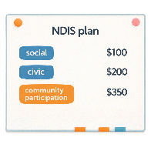 | The Minister will decide to have less money in NDIS plans for supports for  - Social  - Civic  - Community participation  Civic means being part of your community.
- Capacity building for daily activities

Capacity building is teaching you skills to help you do more for yourself.
 | Daily activities are things you do every day.
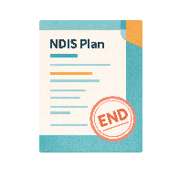 | - NDIS plans will have an end date  The law will say when the plan ends.
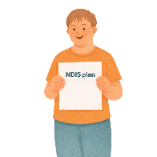 | A new plan will then need to be made.
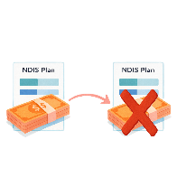 | Any money left in the old plan will not go to the new plan.
 | - The NDIA will decide what supports are  - Reasonable  Reasonable means that it is fair and sensible.
 | - Necessary  Necessary means that it is needed.
 | The NDIA will have to think about different things when they make decisions like  - The NDIS being able to last a long time
 | - People with the same needs can get the same supports.  This is called equity.
 | Equity means that it is fair for everyone.  Sometimes people will need different supports.  This makes it fair.
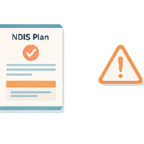 | - The NDIA can suspend NDIS plans  Suspend means not being able to use your NDIS plan.
 | They can do this when you  - Do not respond when they contact you
 | - Have not given them what they need.
 | You can stop being able to get NDIS if  - Your plan has been suspended for at least 90 days
 | - NDIA has not been able to contact you.
 | - A definition for what a permanent disability is.
 | People will only be able to get NDIS if they have  - Got all the treatment they can to help them
 | - No other treatment will help them
 | - Their disability will last for the rest of their life.
 | There will be information to say what you need to do to meet the criteria.  Criteria are rules about NDIS supports.
 | - People who want to apply for NDIS need to say if there are  - Other supports for their disability that they  - Can get  - Are getting.
 | Apply means you send information about  - Who you are  - Your disability  - What supports you need.  This helps us decide if you can get NDIS supports.
 | People applying for NDIS will need to say if they are getting support from  - Compensation scheme
 | Compensation schemes are money someone gives you when something bad happens.  Like a car accident or an accident at work.

Stopping fraud

 | There are 6 changes in this area.
 | - There will be a new definition for what a NDIS provider is  NDIS providers get money from your NDIS plan to help support you.
 | Providers who support people at risk of abuse or exploitation will need to be registered.  Risks are the chance that something bad might happen to you.
 | Abuse is when someone treats you badly.
 | Exploitation is when someone takes advantage of you.
 | Registered means they are  - On a list  - Follow rules of the NDIS Quality and Safeguards Commission  We call it NDIS Commission for short.
 | - NDIA will  - Be able to give penalties to providers  Penalties are the punishments given when someone breaks the law.  They might have to  - Pay money  - Go to court  - Go to jail.
 | - Have regulatory powers under the law  Regulatory powers are special powers the government has to make sure the law is followed.
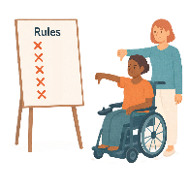 | NDIA can give penalties to providers for not  - Following rules
 | - Giving information to the NDIA when they ask for it.
 | The NDIA will have regulatory powers to help them  - Monitor  Monitor means making sure services are doing the right thing.
 | - Investigate  Investigate is when someone looks at  - Facts  - What happened.  They look more closely to understand.
 | The NDIA must do a  - Risk assessment before using their regulatory powers with a person who gets NDIS.
 | A risk assessment is a way to check if something could cause harm.  Harm means when something bad happens to you.
 | - The NDIA will have stronger ways to get information
 | Getting information needs to  - Follow the law
 | - Be able to be used in different ways  Like in the court when someone has broken the law.
 | - Information about money spent for NDIS supports needs to be kept by  - Providers  - People with NDIS plans
 | If a provider does not keep information about money spent for NDIS supports  - The provider will get a penalty.
 | If a person who gets NDIS does not keep information about money spent for NDIS supports  - They will have to pay the money back to the NDIA.
 | - There will be less time for claims to be made.  Claims are when NDIS providers ask for money for doing a service or support.
 | All claims for NDIS support will need to be made within 90 days of the support happening.
 | - Have clearer rules about registered plan management providers  Plan management is when someone pays for supports from your NDIS plan.  They are called plan managers.  You get to choose who your plan manager is.
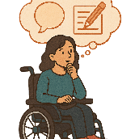 | The rules would say  - A better definition of what plan management providers are
 | - What registration they will need.
 | The government will make a panel of plan management providers  A panel is a group of providers who do certain services.

Governance

 | There are 2 changes in this area.
 | - The Minister for Disability and the NDIS will be responsible for cost decisions for the NDIS  Responsible means the things you need to do.
 | The Minister will decide how much NDIS supports will cost.
 | The NDIA will still be responsible for giving the Minister advice and doing the  - Annual Pricing Review
 | The Annual Pricing Review is a check that gets done every year.  It looks at the cost of NDIS supports.  It helps decide if the cost of supports should go  - Up  - Down.
 | - The NDIA can automate some of the things they do  Automate means to set something up so it runs by itself.
 | NDIA workers will still need to check it is working like it should.
 | Some of the things they can automate will be  - Claims
 | - Payments.

New framework planning

 | The new framework planning will start  - 1 April 2027.
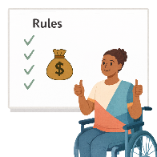 | The changes will  - Have budget rules for how much support is needed  A support needs assessment will say how much support is needed.
- The support needs must be for the persons disability

The person with disability still needs to meet all the rules for NDIS.
 | - Say who can do a support needs assessment
 | - Have rules to say what information an assessor  - Must  - Must not  Think about.
 | An assessor is someone who checks something.
 | - when support needs assessments need to be paused  Like when a participant goes into hospital.
 | - Say what NDIA documents are part of the rules  They can be updated when they need to be.
 | - Have more information about value for money quotes for  - Assistive technology  Assistive technology can be things to help you  - Speak  - Move  - See  - Hear.
 | - Changes to your home.
 | Value for money means a good amount of money for what you get.  It looks at  - Cost  - How good it is  - How well it works.

Some images in this Easy Read were made using AI.
You must not share or copy any of the images without permission.
May 2026.

