

just for you
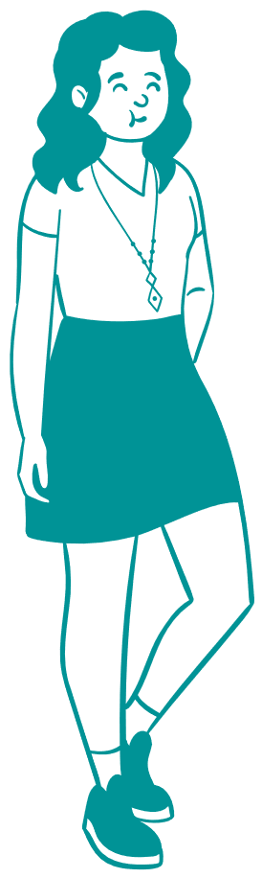
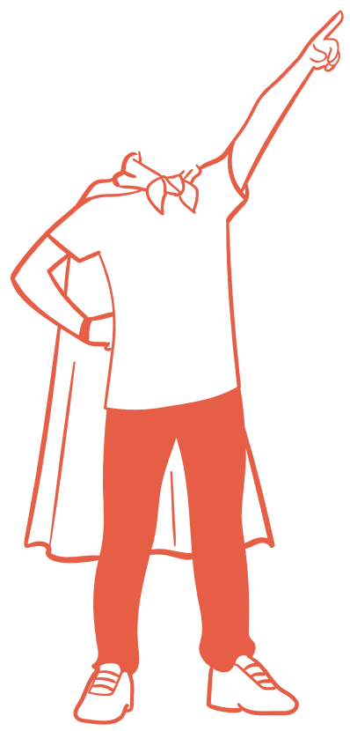


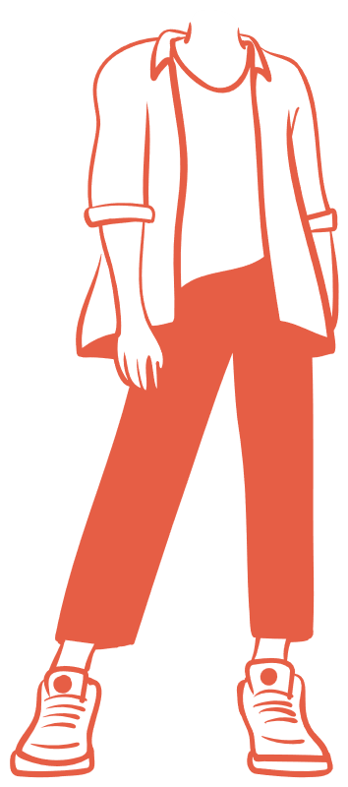


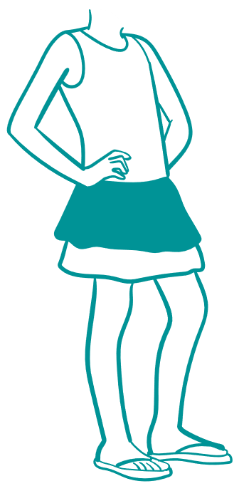




Acknowledgement of Country
The Australian Government acknowledges the Traditional Custodians of Country throughout Australia and their continuing connections to land, water, culture and community. We pay our respects to their Elders past and present and extend that respect to all Aboriginal and Torres Strait Islander peoples.

Acknowledgement of Autistic people and the people who support them
The Australian Government acknowledges Autistic people, and the people who support them who have worked hard for this National Autism Strategy.

About this summary
Hi! We are from the Australian Government. We are excited to show you our plan to make Australia better for Autistic people, it is called the National Autism Strategy.
A strategy is a plan of what we want to do and how we will do it.
The plan can be hard to understand so we made a shorter one just for you!
Section 1: Background explains how we wrote the plan and the rules we will follow when we work on it.
Section 2: The Plan explains the things we will do to make Australia better
If you want to see the full plan it is here: National Autism Strategy 2025-2031
If you want to read the snapshot it is here: National Autism Strategy General Snapshot
You have the right to this information, and you are a key part of achieving the vision of a safe and inclusive society for all Autistic people.

Tricky words

If we have used a word we think might be hard to understand, we have told you what it means next to this symbol.


Section 1: Background

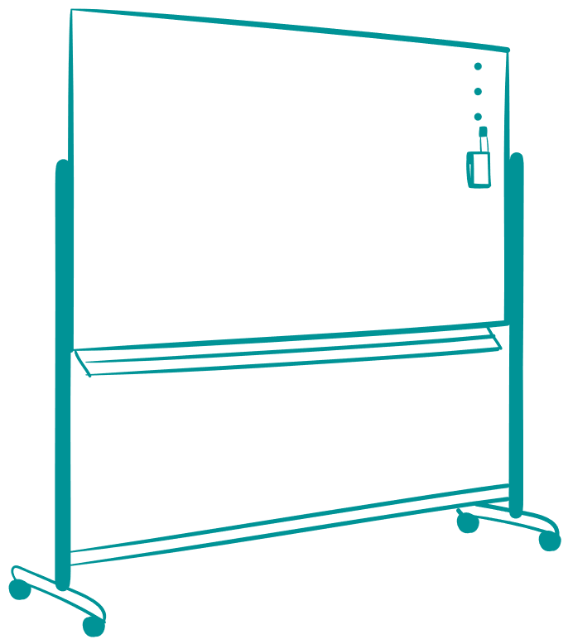
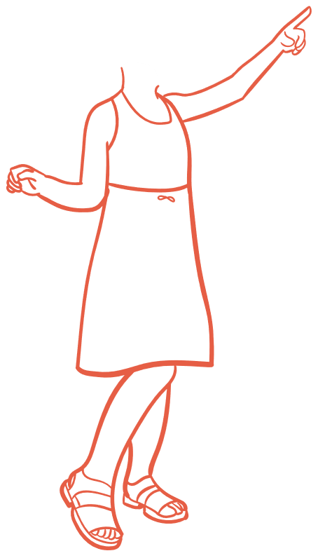

To write this plan we asked Autistic people, including children and young people, what needs to change and what can be done better.
We were told the plan needs to:
- Support all Autistic people to feel included in their communities.
- Make sure everyone understands autism better, so all Autistic people are accepted.
- Celebrate Autistic people’s strengths, ideas and experiences so that they are understood and valued.
- Make sure each Autistic person’s experiences and needs are known,
and they are treated fairly.
- Make sure all Autistic people can get health and mental health services, housing, justice services, education and employment.

How we will talk about autism in the plan
People use different words to talk about their autism. Some people like to say, ‘Autistic person’, and some like to say, ‘person with autism’. Other people will use other words. Some Autistic people identify as having a disability, and others do not.
We use ‘Autistic person’, but support everyone’s choice about the words they like to use.

What we know about autism
Every Autistic person is unique.
 Tricky Words:
Unique – different in their own way.
Autistic people need different support
at different times, or in different places
or situations.
Every Autistic person also has their
own unique abilities.
Autistic people process information and may communicate in different ways.
Other peoples’ attitudes about autism can be unfair and can make life hard. We want all Autistic people to be able to live the life they choose.

Intersectionality
Intersectionality is understanding that each person experiences the world differently. Experiences are different because of things like:
gender
Tricky Words:
Discrimination – treating people badly because they are different.
sexuality,
race
ethnicity
culture
religion
economic status
where you live
body shape/size.
This can lead to challenges and discrimination. We want to stop this by increasing respect, acceptance and appreciation of all Autistic people.

Priority groups:
Autistic people can find it hard to participate in the community because it is not always welcoming. We know some groups of Autistic people can find it extra hard.
These groups are:
First Nations peoples
culturally and linguistically diverse (CALD) people
women, girls and gender diverse people
LGBTQIA+ people
older people
children and young people
people with very high support needs.

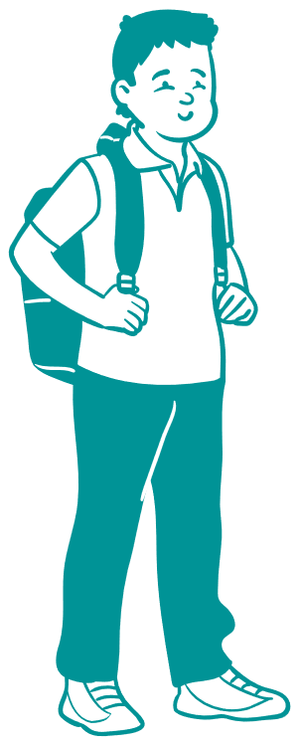

Section 2: Our Plan

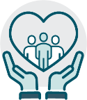
We want all Autistic people to feel safe, supported
and to have their human rights met.

Our goal is to improve the lives of all Autistic people
in the ways they want.

To do this we will
Work with Autistic people, their families and support networks
Make sure everyone can understand what we are doing
Promote the ability of Autistic people to make decisions about their lives
Measure if we are doing a good job or not
Recognise that every Autistic person has unique strengths, abilities and qualities
Teach the community about autism, so all Autistic people feel accepted
Protect the rights of all Autistic people and keep them safe from all physical and emotional violence and abuse
- Celebrate all Autistic people!

Our commitments
By talking with Autistic people, their families and people who support them, we made commitments in 4 key areas:
- Social inclusion
- Economic inclusion
- Diagnosis, services and supports, and
- Health and mental health.
The next sections will explain what these things are and tell you what we promise to do.

Social Inclusion

What we want
Social inclusion is when everyone can learn, work, and connect with others equally.
To do this, we need:
Tricky Words:
Physical accessibility - when spaces are designed to make sure people with disabilities can easily and safely use them.
physical accessibility
people to understand, appreciate
and accept autism
services that all Autistic people
can participate in equally.

Why this is important
Feeling connected is an important part of your health, safety and wellbeing. It supports your mental health, stops isolation and protects you from abuse and discrimination.

What we have now
Autistic people can experience more social isolation, discrimination and abuse than other people. This is because too many people do not understand autism, services can be hard to use and communities can exclude them.

How we will make this better
- Grow understanding and positive attitudes towards all Autistic people
  - Teach people to understand autism better
  - Include more Autistic people in media, sports, the arts and people who work for the government
  - Have more sensory-friendly public spaces, including online and in the media
  - Help organisations reduce bad attitudes about autism in the community and make sure Autistic people know about their rights.
- Create more opportunities for social connections and peer support
- Make services and communication from the government better to meet the needs of all Autistic people
- Ensure Autistic people’s needs are considered in the Disability Discrimination Act 1992 (Cth)
- Help Autistic people feel safer in the community.
Fact box: The Disability Discrimination Act is the law that makes it illegal to treat someone badly, or refuse to let them do something, because they have a disability.

Economic Inclusion:

What we want
An inclusive economy means everyone has a fair chance to work and learn. Education is an important part of this because better education and training can lead to good jobs.

Why this is important
Everyone has the right to safe, secure and fair education and employment that supports their wellbeing.

What we have now
Autistic students can experience bullying in schools and school environments can be really hard. A lot of people said schools often fail to support Autistic students to learn in ways that suit them.
We also know Autistic people can find it hard to get jobs that meet their needs.

How we will make this better
- Increase ways for Autistic people to have jobs (including owning their own businesses and being self-employed)
- Support employers to hire and keep Autistic people by making workplaces accessible, safe and inclusive
- Support Autistic people to have control over their education and careers
- Have more Autistic people as leaders at their jobs and promote Autistic people as role models
- Improve the way schools and other places of education meet Autistic students’ learning and communication needs. Make sure students and their supporters know they can ask for better learning support.

Diagnosis, Services and Supports

What we want
We want diagnosis to be easier and for services to better support Autistic people.
Fact box: Autism is diagnosed by health professionals. They look at things like social communication, behaviours and the interests of an individual.
Early diagnosis and support can make school and work better for Autistic people. It also helps support mental health throughout their lives.

Why this is important
Tricky Words:
Diagnose – when a person has tests to find out if they have a medical condition or disability or not.
Getting a diagnosis needs to be easy so people can get support early. Early support helps people now and into their future.

What we have now
The process of being diagnosed can be difficult. It can take a very long time and can cost a lot of money. Some Autistic people do not have a diagnosis.
Fact box: The average diagnosis age of children in Australia is about 3-4 years of age with the most frequent age being 5 years.
Diagnosis can happen later for some people because of their gender, where they live, or what their autism is like. There are a lot of people who cannot get a diagnosis because there are not enough services, or it is too expensive.

How we will make this better - Diagnosis
- Work with Autistic people and experts so being diagnosed is better for Autistic people.
- Support Autistic people through the diagnosis process.
- Explore ways to make autism diagnosis cost less.
- Consider better ways to diagnose autism when children are very young.

How we will make this better - Services and Supports:
- Make sure all Autistic people can get high quality support.
- Make it easier for more Autistic people to be involved in delivering support to other Autistic people.
- Teach people who provide support to Autistic people to better meet their needs.
- Improve support so Autistic people can make informed decisions about all areas of their lives.
- Work with states and territories to make it easier for Autistic people to get support through the National Disability Insurance Scheme (NDIS).

Health and Mental Health:
Fact box: The plan to improve the health and mental health of Autistic people is led by the Department of Health, Disability and Aged Care. The health and mental health plan was designed separately to the rest of this plan and is called the Autism Health Roadmap. It aims to improve the health and mental health of Autistic Australians.
It focuses on six areas:
- Give better support to Autistic people, their families and carers, in health and mental health services.
- Make autism-affirming health and mental health care safer, higher quality and available during people’s whole lives.
Tricky Words:
Autism-affirming – caring for Autistic people in a way that sees and values their strengths and understands their needs.
- Help health, mental health, and other services, including the National Disability Insurance Scheme work together better.
- Improve autism education and training for people who work in health and disability.
- Do more research on the health and mental health of Autistic people, and
- Report on how the Autism Health Roadmap is going.
Fact box: Autism-affirming care can look like having the lights off at a dentist’s office, turning the music down in the waiting room and being able to wear headphones or stim during appointments.
If you want to see the full Autism Health Roadmap it is here National Roadmap to Improve the Health and Mental Health of Autistic People 2025-2031

How we will be accountable
We will put our commitments into Action Plans, which will be developed with the Autistic community, and we will learn from each plan to make sure the next one is better.

We will:
Tricky Words:
Accountable – being accountable means the people who work on this plan will need to explain to Autistic people and to the government if the plan is working. If it is not working, they must work out how to fix it.

Write a plan to:
Make sure we report on whether we are reaching our commitments, and if not, why.
Work with lots of diverse Autistic people, as well as the people who support them.
Make sure different parts of the Commonwealth Government work together to achieve the commitments.

Commitment on Research
Make sure we learn and improve through good research.

Commitment to Reporting
Work with Autistic people to learn, apply what we learn and measure our success.

This version of the National Autism Strategy 2025-31 Summary was prepared for children and young people in consultation with the ACT Children and Young People Commissioner in partnership with Moss May Consulting, a lived experience disability and Autism advocate.

