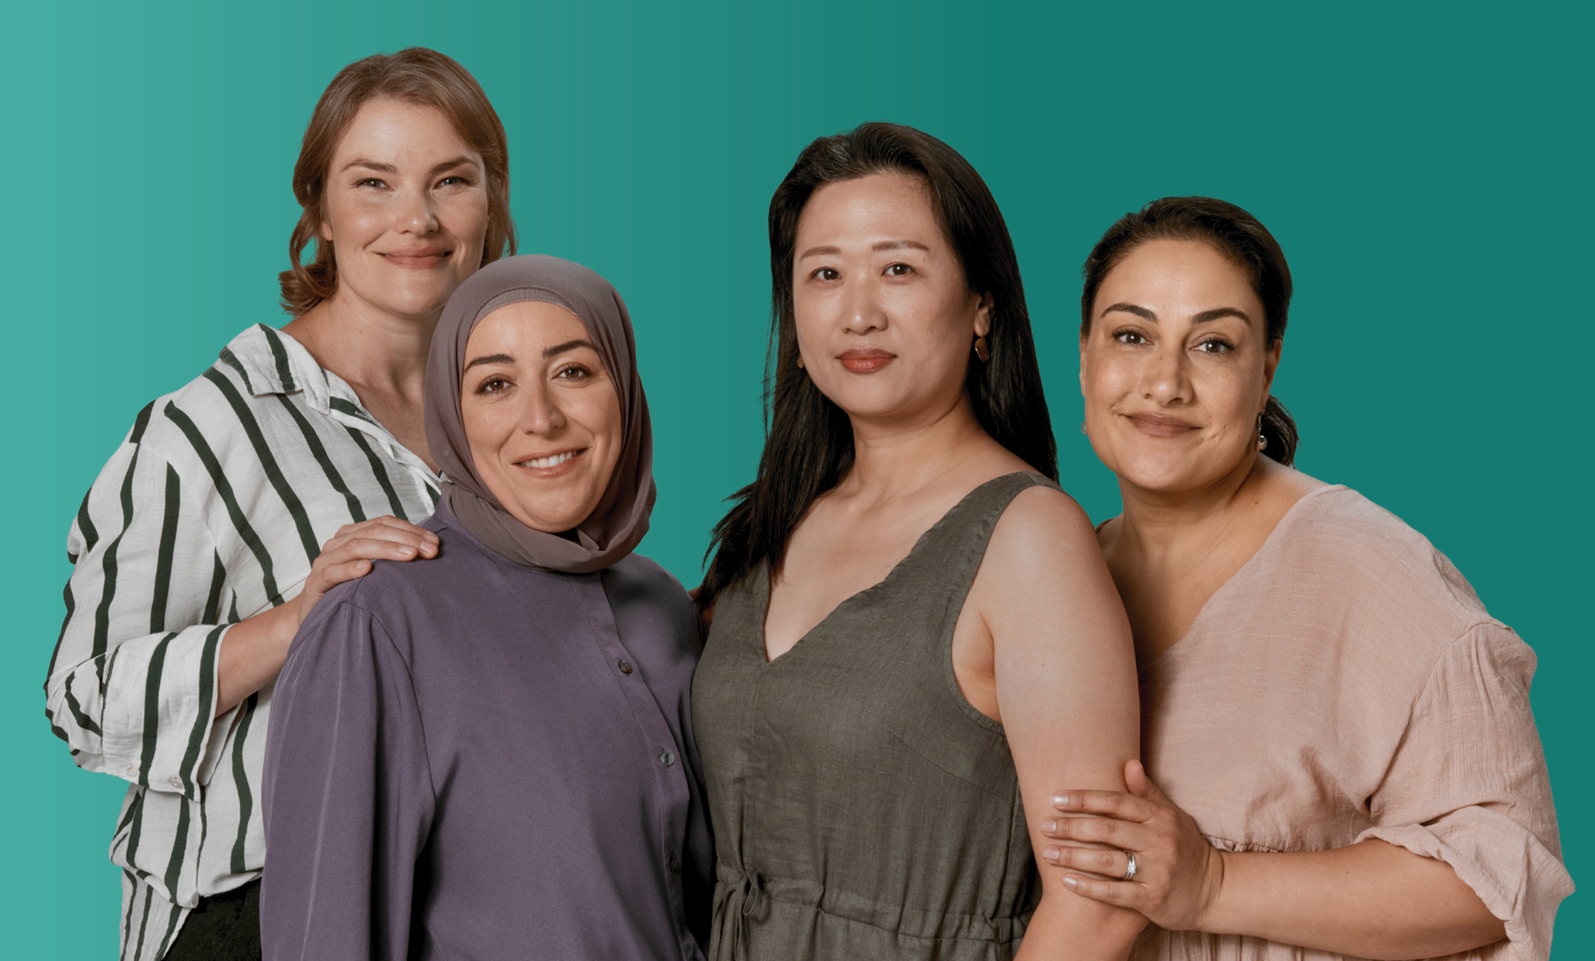
National Menopause and Perimenopause Awareness Campaign Stakeholder kit
May 2026
health.gov.au/perimenopause

About this kit
This kit includes information and resources developed for the National Menopause and Perimenopause Awareness Campaign (the campaign). The campaign delivers
evidence-based information to support women through perimenopause and menopause.
We encourage you to share these resources and promote the website health.gov.au/perimenopause across your channels, networks, communities and workplaces.
By doing so you will be helping to increase understanding, normalise conversations, and support better health outcomes for women through perimenopause and menopause.

What’s in this kit
The kit includes information on:
- Why we need a campaign
- How it was developed
- Key messages
- Campaign materials and resources:
- Videos
- Personal stories
- Resources
- Information for First Nations women
- Translated information
- Auslan
- Links to more information and support.

Find out more
For more information visit health.gov.au/perimenopause.
If you have questions about the information in this kit, please email WomensHealthComms@health.gov.au.

Why we need a campaign
Many women feel unprepared and uninformed about perimenopause and menopause and find it difficult to access evidence-based information on symptoms, treatments and support options.
Women are also at risk of being exposed to misinformation about perimenopause and menopause and feel the impact of stigma and taboo, making it difficult for them to get the care and support they need.
The National Menopause and Perimenopause Awareness Campaign is working to
change this.
The campaign aims to increase awareness and reduce uncertainty around perimenopause and menopause by providing evidence-based information and resources. It encourages women who experience symptoms to recognise them earlier and seek information and support if they need it.
Everyone experiences perimenopause and menopause differently. That is why the campaign also aims to normalise different experiences by featuring stories from a diverse group of everyday women.
While the primary target audience for the campaign is women aged 35-55 years, the campaign provides education and information for partners, family, workplaces and community as well.

Website
The campaign is underpinned by a new website at health.gov.au/perimenopause. The website has been tested with women and developed in partnership with women’s health experts, researchers and doctors. It is a central hub of evidence-based information, resources and support.

How it was developed
The campaign has been developed in consultation with experts and communities and is informed by extensive research with a diverse group of women with lived experience of perimenopause and menopause.
Research has been conducted with more than 2,300 women aged 35-55 years across Australia in metropolitan, regional and remote areas to learn about their understanding, perceptions and communication needs on perimenopause and menopause.
This includes women in regional and rural locations, First Nations and multicultural women, women with disability, and people who identify as LGBTIQA+. Research was also undertaken with health professionals and partners of women.
A summary of the research that informed the campaign is available at health.gov.au/perimenopause.

Key messages
The key messages below are featured in the campaign. If you are communicating about perimenopause and menopause, you can use these messages to develop content.
- Everyone will experience perimenopause and menopause differently.
- Perimenopause is the time leading up to your final period (menopause) and just after.
- Perimenopause usually starts in your 40s, but it can start earlier or later. Perimenopause lasts for 4 to 6 years on average, but it can last from 2 to 10 years.
- Menopause is your final menstrual period. You know you have reached menopause when you have not had a period for 12 months, with no other medical reason for it.
- Menopause usually occurs between the ages of 45 and 55, with the average being 51 years.
- Some women experience early menopause (before age 45) or premature ovarian insufficiency (before age 40).
- Medically induced menopause can happen if you have some cancer treatments, or surgery that removes both ovaries.
- Many women experience a range of symptoms during perimenopause that are related to hormone changes throughout the menopause transition. You might experience a combination of physical, emotional or mental health symptoms, or no symptoms at all.
- About 2 in 4 women report experiencing mild to moderate symptoms, while 1 in 4 women experience symptoms severe enough to affect daily activities. About 1 in 4 women experience no symptoms at all.
- Symptoms might include:
- changes to periods (irregular, lighter or heavier)
- brain fog or forgetfulness
- hot flushes
- night sweats
- sleep problems
- anxiety
- depression
- dry or itchy skin
- less sexual desire
- joint and muscle pain
- vaginal dryness or discomfort
- urinary (wee/bladder) problems
- weight gain around the stomach.
- If you have menopause-related symptoms that are impacting your life or worrying you, it is important to talk to a doctor.
- There are treatment and support options that can help, and your doctor can make sure you receive an accurate diagnosis and appropriate care.
- For information and support visit health.gov.au/perimenopause

Campaign materials and resources
Resources are available to download at health.gov.au/perimenopause

Videos
Video and link | Preview
30 second video – brain fog, insomnia and hot flushes  View here | 
15 second video – insomnia and anxiety  View here | 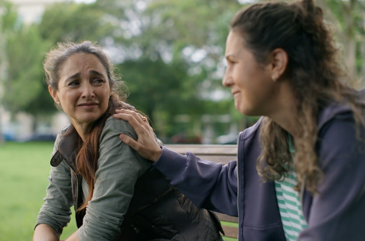
15 second video – brain fog and hot flushes  View here | 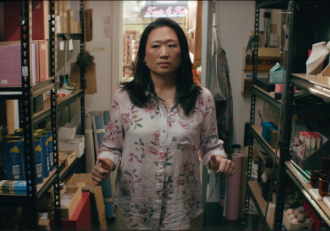
15 second video – insomnia and hot flushes  View here | 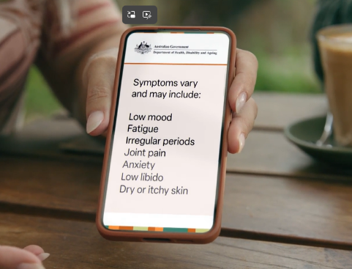
GP video – Dr Ramya Raman provides an overview of perimenopause and menopause, including the symptoms and treatment and support options  View here | 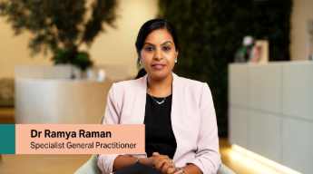

Personal stories
You can find more personal stories on the website at health.gov.au/perimenopause
Name | Preview
Amanda  View here | 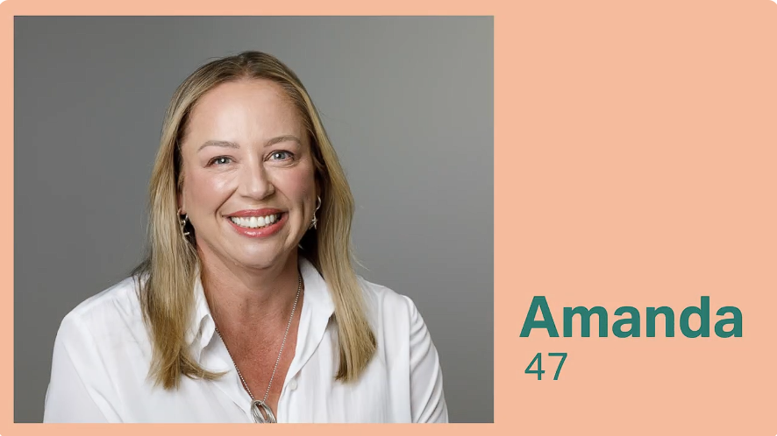 | Amanda initially did not connect her symptoms with perimenopause, but once she sought help from a GP, she learnt that there was a range of treatments that could help her.
Sharon  View here | 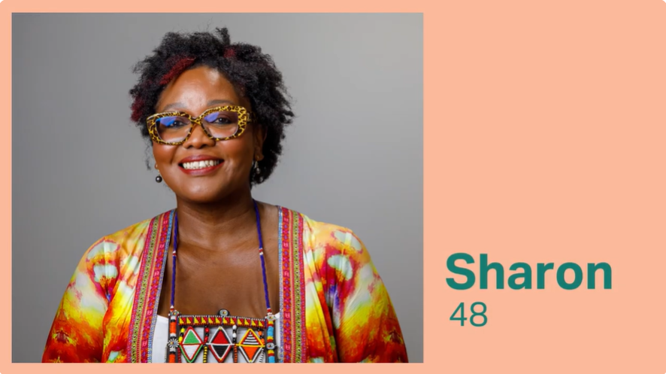 | Sharon shares her personal experience of entering perimenopause in her 40s and the impact it had on her mental health and wellbeing.
Rachel  View here | 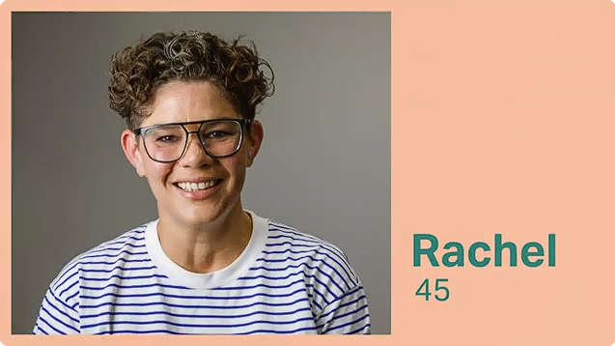 | Rachel shares her experience of navigating perimenopause as a single mum. She speaks about feeling unheard and the importance of finding the right care to feel like yourself again.
Dalene  View here | 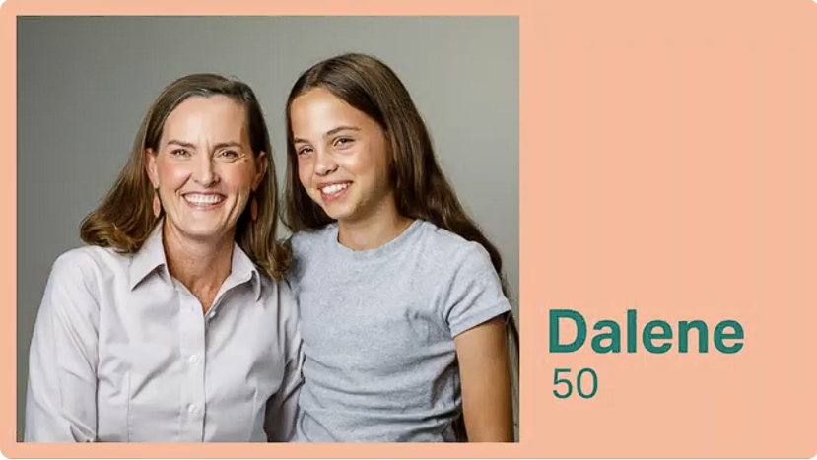 | Dalene shares her experience of early menopause after the birth of her last child and the challenges she faced navigating symptoms and care.
Amrita  View here | 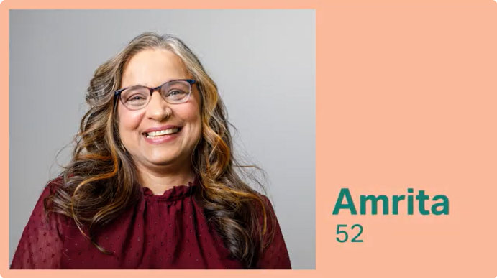 | Amrita describes how perimenopause changed how she felt in her body, and the impact of symptoms like hot flushes and low energy.

Resources
More resources will be published on health.gov.au/perimenopause during the campaign.
Resource | Image
Poster – Wondering if you could be in perimenopause?  Download here | 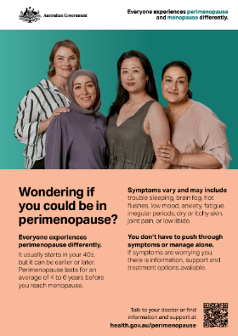
Brochure – About perimenopause and menopause  Download here | 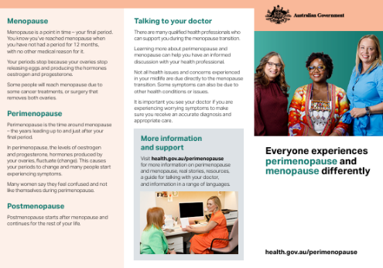
Fact sheet - About perimenopause and menopause  Download here | 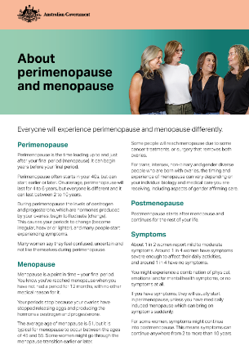
Fact sheet – Managing menopause-related symptoms  Download here | 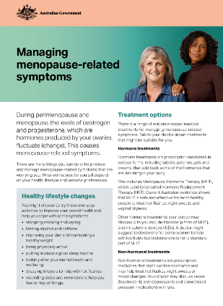
Fact sheet – Supporting someone through perimenopause and menopause  Download here | 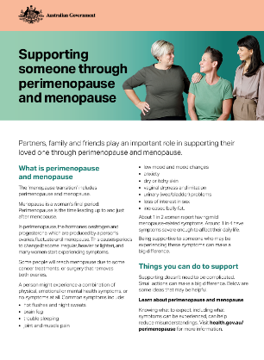

Information for First Nations women
Further information is being developed in partnership with First Nations women and health professionals. It will be published on health.gov.au/perimenopause during the campaign.
Resource | Image
Fact sheet – Women’s business: perimenopause and menopause  Download here | 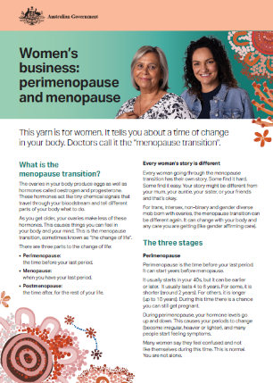
Poster – For doctors/health services waiting rooms  Download here | 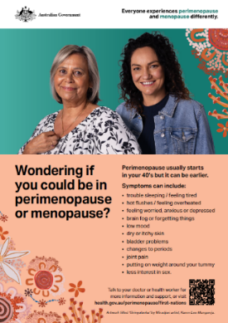

Translated information
More translated information will be published on health.gov.au/perimenopause during the campaign.
Video or resource | Image | Languages
Fact sheet – About perimenopause and menopause  Download here | 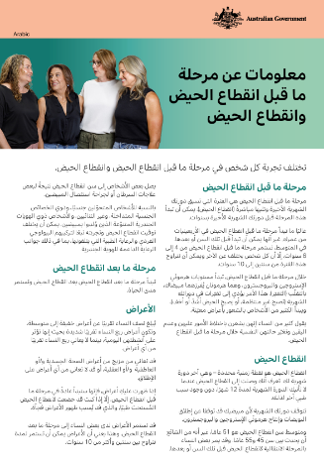 | Arabic  Simplified Chinese  Traditional Chinese  Korean  Thai  Vietnamese
Fact sheet – Managing menopause-related symptoms  Download here | 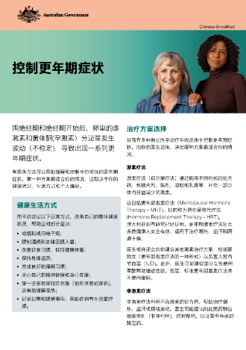 | Arabic  Simplified Chinese  Traditional Chinese  Korean  Thai  Vietnamese
Fact sheet – early menopause  Download here | 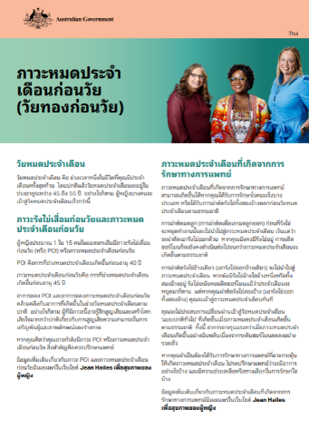 | Arabic  Simplified Chinese  Traditional Chinese  Korean  Thai  Vietnamese

Auslan
Resource | Image
Auslan – Video with Dr Ramya Raman who provides information on perimenopause and menopause, including the symptoms, treatment and support options
View here

Links to more information and support
We worked in partnership with women’s health experts, researchers and doctors to develop the campaign. You can find more information and resources below.
Organisation | URL | Description
Jean Hailes for Women’s Health | www.jeanhailes.org.au/health-topics/menopause/ | Jean Hailes for Women’s Health has information for women at all stages of life, including in perimenopause and menopause.
Australasian Menopause Society (AMS) | www.menopause.org.au/consumer-information/ | The AMS is a professional organisation that supports health professionals who care for women through midlife, menopause and beyond. The AMS also provides information for women about many menopause related topics.
Women NSW | www.nsw.gov.au/departments-and-agencies/women-nsw/toolkits-and-resources/perimenopause-and-menopause-toolkit | Women NSW has a toolkit and provides information to help you learn more about perimenopause and menopause. Women NSW has information in multiple languages and Easy Read.

