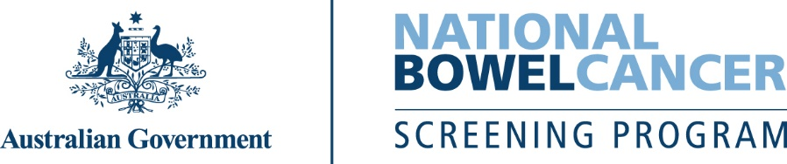
Is bowel cancer in your family?
  - Your screening guide

Why family history matters
If bowel cancer runs in your family, it can change the way you should screen. Your family includes:
- immediate relatives: parents, brothers, sisters, children
- close relatives: grandparents, aunts, uncles, nieces, nephews.
Average risk | Anyone with:  - no family history of bowel cancer or  - 1 immediate relative who had bowel cancer aged 60 or older. | Do the free National Bowel Cancer Screening Program test every 2 years from age 45 to 74.

Moderate risk | Anyone with:  - 1 immediate relative who had bowel cancer before age 60 or  - 2 immediate relatives who had bowel cancer at any age or 1 immediate relative + 1 or more close relatives who had bowel cancer at any age. | Talk to a doctor and consider a colonoscopy every 5 years.  - Start at the earlier age: from age 50 or 10 years before the age an immediate relative was diagnosed.  - Monitoring should continue to age 74.

High risk | Anyone with:  - 2 immediate relatives + 1 close relative who had bowel cancer, with at least 1 diagnosed before age 50 or  - 2 immediate relatives + 2 or more close relatives who had bowel cancer at any age or  - 3 or more immediate family members who had bowel cancer at any age. | Talk to a doctor and consider a colonoscopy every 5 years.  - Start at the earlier age: from age 40 or 10 years before the age an immediate family member was diagnosed.  - Monitoring should continue to age 74.  - You may be referred to a family cancer clinic to check for genetic risks, particularly if all relatives are from the same side of the family.

Not sure what is right for you?
- Ask your doctor about your options and when to start screening.
- If your risk is moderate or high your doctor may recommend you opt out of or defer from receiving the free test. Do this by calling 1800 627 701 or at www.ncsr.gov.au/manage-participation.
www.health.gov.au/nbcsp

