Service and Support Portal User Guide - Recording and updating client service delivery information
This User Guide is designed for Staff Members and Team Leaders within the My Aged Care Service and Support Portal. It explains the procedures for recording and updating service delivery information in the client record. A Team Leader can manage referrals, as well as all the functions of a Staff Member.
Service delivery information should be recorded on the My Aged Care client record for all clients accepted for service. This includes service commencement date, service frequency, and service end date where a service has ceased. This information should be recorded within 14 calendar days of acceptance, and providers will receive notification reminders prompting them to enter this information if it is not completed within this timeframe.
For Home Support and Residential Care Permanent services, the service commencement date will be automatically filled in from the Services Australia records and will be read-only. Other information such as service frequency will still need to be maintained by the provider.
For further detail regarding the procedures for updating service delivery information, please refer to the My Aged Care for service providers section on the Department’s website.
Table of contents
Adding and viewing service delivery information 2
Updating service delivery information 6
Recording note of changes made to client service information 8
Requesting an extension to the client’s care (Transition Care and Residential Respite) 9
Requesting an extension to the client’s care (Support at Home) 11
Requesting a review of a client’s support plan 19
For more information and support 24

Adding and viewing service delivery information
! | Adding service delivery information is not available for clients referred to Home Support services, as service information is already recommended and approved during the assessment.
- Go to the Service Referrals tile from the Service and Support Portal home page, then select the Accepted Services Pending tab.
Alternatively, if you know the client’s name you can use the Find a client function.
This tab displays accepted referrals that do not have service delivery information recorded against them.
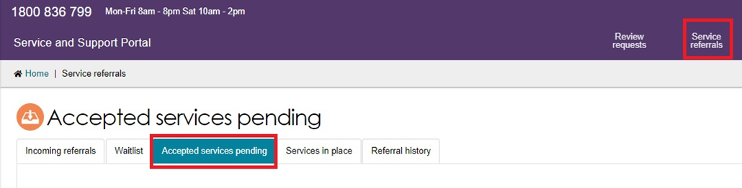
- Select the relevant client’s service referral, then you can add service delivery information for the service.
To do this, select the expand icon (double arrow) on the Client card or in List View to view the client information. Then, select Add service information.
Card View
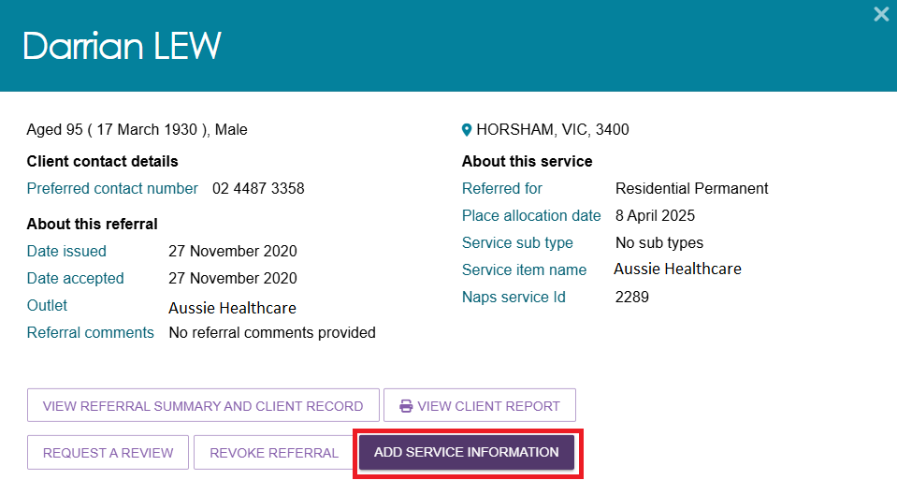
List View
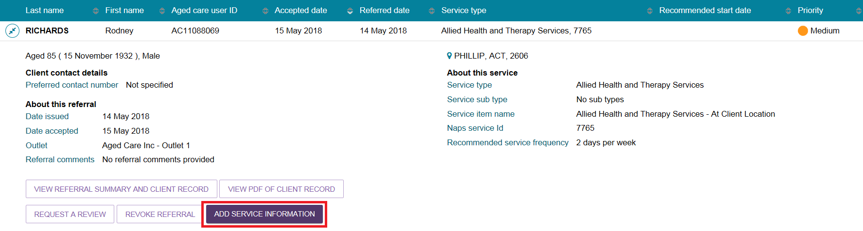
! | For Home Support service referrals, the Add Service Information button will not be displayed as the service information is recommended and approved during the assessment.  Information on the services being recommended can be viewed by selecting the expand button.  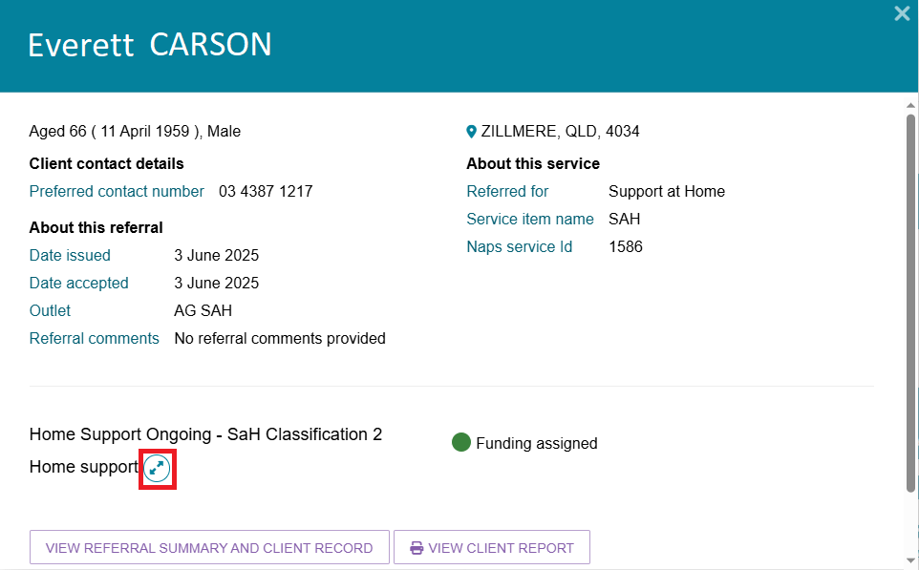
- The Add service information screen will be displayed.
When adding service information for residential care, residential respite, transition care and Commonwealth home support program services, you must enter the Service start date, input a Frequency, and select an Intensity from the drop-down list.
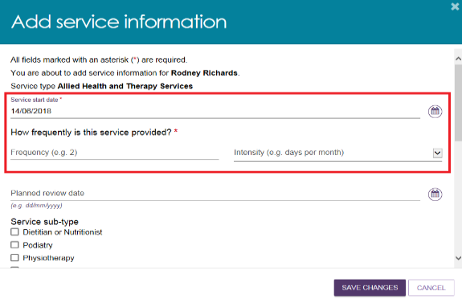

To supply specific service delivery information, select Other – Specify and enter additional service delivery information in the free text field.
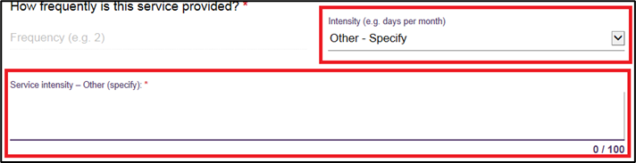
Enter any additional information in the remaining fields and select Save changes. These additional information displays are dependent on the service referred.
The Service start date will update once the commencement date has been received from Service Australia.
- Once saved, the client information will move to the Services in place tab:
- Immediately for residential care including respite, transition care, and Commonwealth home support programme services.
- once a Service start date is present, for Home Support services.
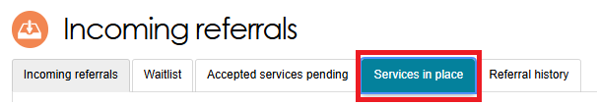
- Once this has occurred, the filled-in service information will display under the Services section within the client record.
For Non-Home Support services, the following will be displayed:
- Service status, such as: Not yet in place; In place
- Name of service, such as ‘Residential permanent’
- Who is providing the service and the date of the provider’s acceptance
- Referral details
- Approval details
- Service key dates.
For Home Support services, the following will be displayed:
- Service status, such as: Not yet in place; In place
- Name of service group is ‘Support at Home’
- Urgency category (urgent, high, medium, low)
- Name of approved service type, classification and whether it is ongoing or short-term
- Funding status: Pending, Approved or Withdrawn
- Who is providing the service and the date of the provider’s acceptance.
Select the See Service Details button, and then select the expander button to the left of the service type name, to show more details about each approved service.
Non-Home Support example
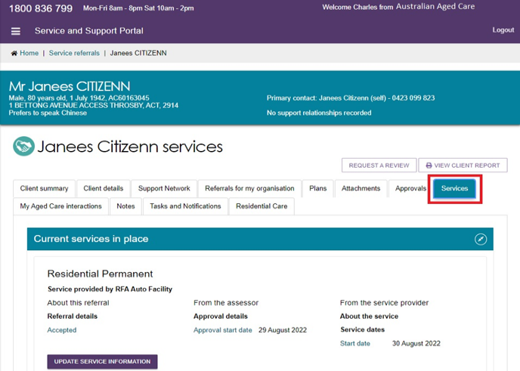
Home Support example
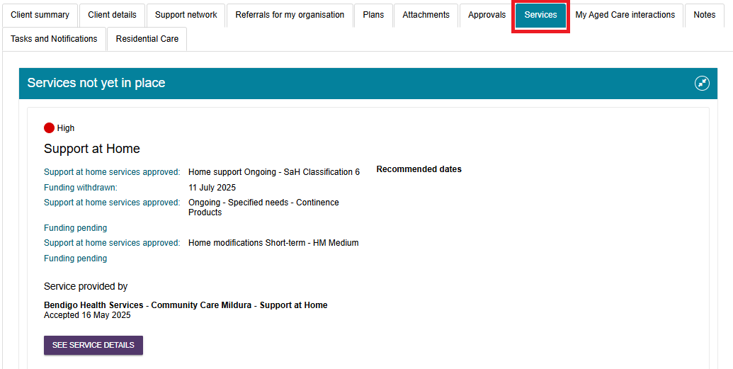

Updating service delivery information
The Services in place tab in the Service referrals section of the Service and Support portal displays accepted services that have service delivery information recorded.
! | Updating service delivery information is not available for clients referred to Home Support services, as service information is already recommended and approved during the assessment.
- Navigate to the Services in place tab by selecting Service referrals from the home page or the Service Referrals link at the top of the screen from any page within the portal.
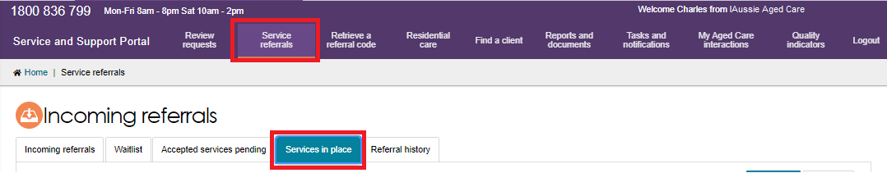
- For the service you are updating, expand the Client list to view the expanded client list view and select Update Service Information. Alternatively, you can select Update Service Information in the expanded card view.
Card View
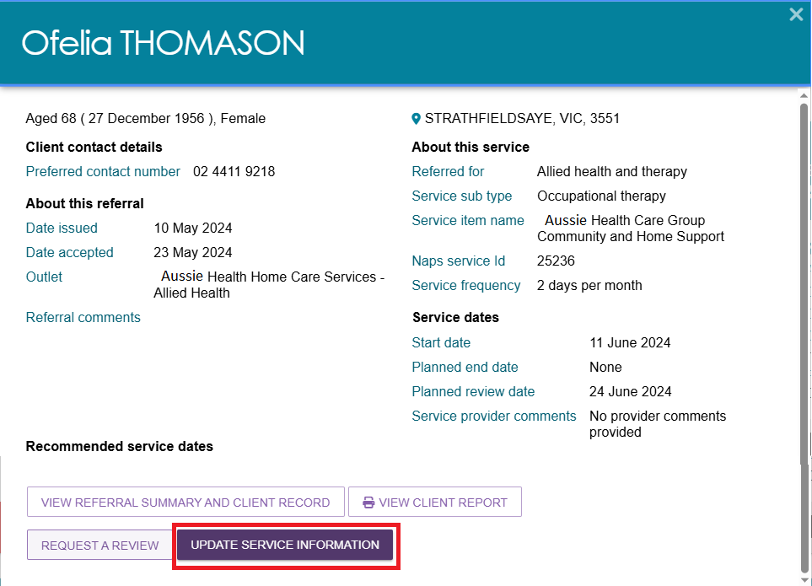

List View
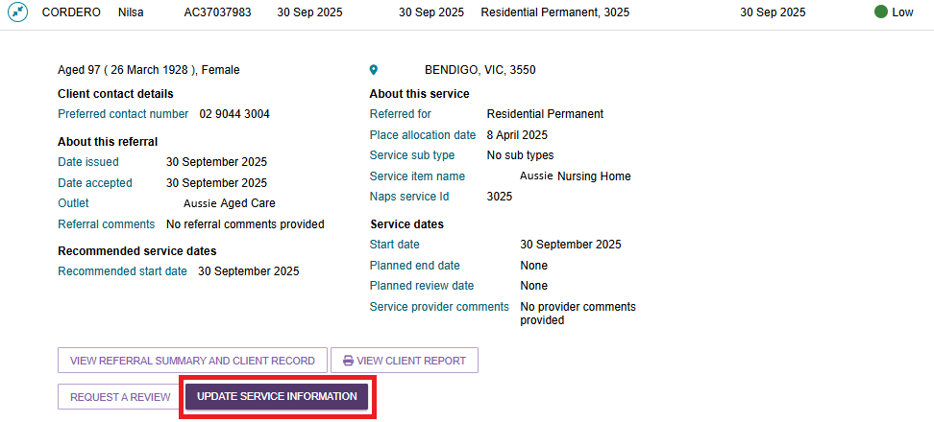
- Update service information and select Save changes. This information will now be updated on the Services in place tab and the Services tab in the client record.
- Service delivery information can also be updated from the Services tab in the client record by selecting Update service information for the relevant service.
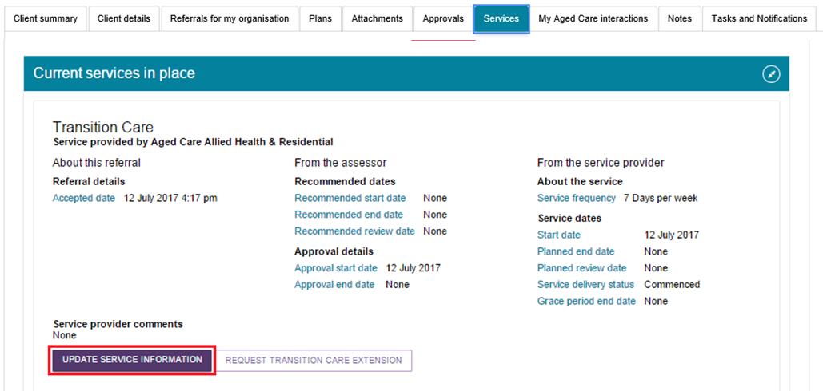
! | Ceasing a client’s service with the reason of Client deceased will change the client’s status to Deceased and make the client record read-only. Any unaccepted service referrals will be recalled, services in place will be ceased, assessments will be cancelled, and the client’s access to the My Aged Care Online Services will be revoked.  My Aged Care will not send correspondence to the client or their support network after the status is changed to Deceased.  Additional notes and attachments can be attached to the client record for 14 days after ceasing services.  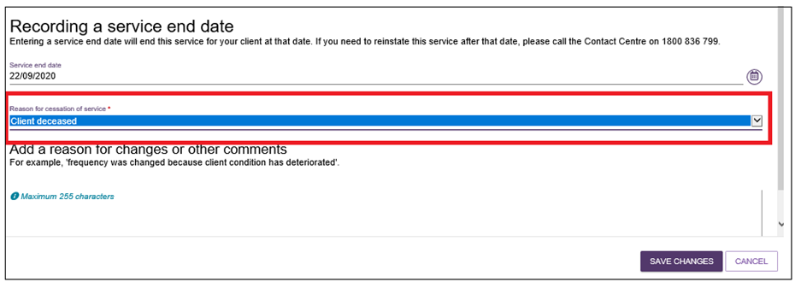

Recording note of changes made to client service information
My Aged Care contact centre staff, assessors and service providers (providers) can view and add different types of notes about clients in the My Aged Care portals.
If there is significant change to a client’s service delivery information, it is recommended that providers update the service information and add a note to the client record.
! | If a client’s needs or circumstances have changed since their last assessment, a review of the client’s support plan may be required.
Providers can add the following notes to the client record:
- Observations: Observations from provider and/or assessors’ interactions with the client. Assessors and providers can view these notes.
- Other: Additional information about the client. Assessors, providers and clients can view these notes.
Providers can view the following notes:
- Client Story
- Other
- Observations.
! | When My Aged Care contact centre staff or assessors add a Sensitive note about a client, a flag will appear on the client record advising the provider to call the My Aged Care contact centre for more information.  Information on the content of the sensitive note will only be provided where relevant to the provider.
To add a note to the client record, follow the steps below.
- Navigate to the client record and select Notes.
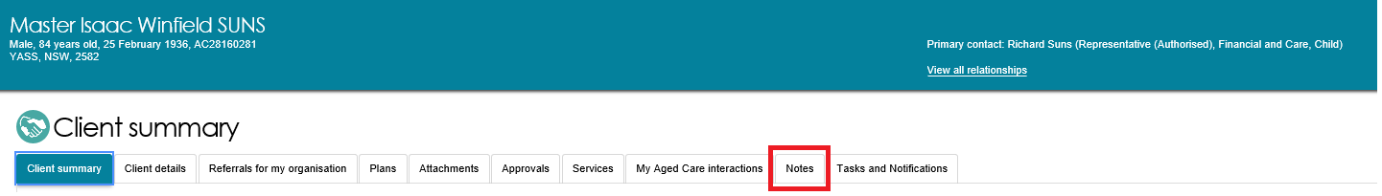
- Notes already present on the client record will be displayed.
Select Add a Note and choose the note type and a description. Once this information is filled in, select Save.
Alternatively, from the Client details tab, select Add a note from the Current notes section.
You can add Notes of type Other and Observations to the client record of any clients that have been referred to your outlet. For example, clients in your Incoming referrals tab.
The blue question mark icon  is a help hint which explains the various note types and who gets to see them, as there is a different audience per note type.
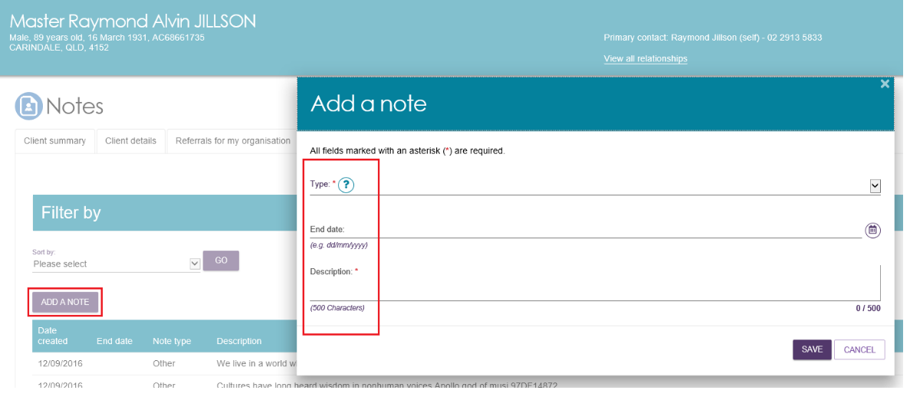
- These notes will be visible to My Aged Care contact centre staff, assessors, and other providers delivering services to that client.
For further information about note types and who can view them, refer to information contained in the My Aged Care Service and Support Portal User Guide - The client record located on the department’s website.

Requesting an extension to the client’s care (Transition Care and Residential Respite)
Providers can request a care extension via the Service and Support Portal. This request will be sent to the Assessment Delegate for approval.
Periods of Transition Care can be extended to a maximum of 42 consecutive days.
Periods of Residential Respite care can be extended for a maximum of 21 day non-consecutive periods.
All respite care approvals from non-My Aged Care systems can be extended in the Service and Support Portal. The offline residential respite extension form will no longer be accepted.
! | A care extension may only be granted for the approved level of care. If a client needs a higher level of respite, they will require a new Respite Classification. This can be facilitated by requesting a Residential Respite Assessment in the MyAssessor App.  Care extensions are effective from the commencement date within the request pending the Assessment Delegate’s approval. Extension requests cannot be backdated except in special cases. For more information, please refer to the My Aged Care Assessment Manual.
Follow these steps to request a care extension:
- Find the client you wish to request a care extension for, by navigating to the Services in Place tab and expanding the card or list view for the client and select request <care type> extension (care type referenced will vary depending on relevant extension type).
This button is only visible if the client is eligible for care extension.
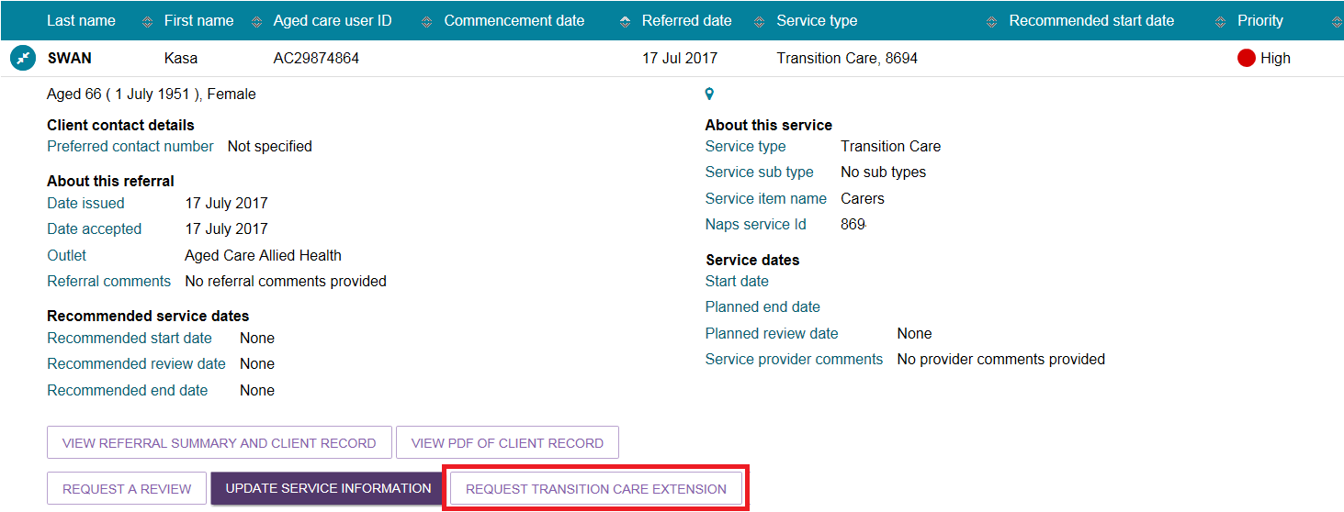
Alternatively, locate the client through the Find a client functionality, and navigate to either the Services or Approvals tab of the client record and select Request <care type> extension.
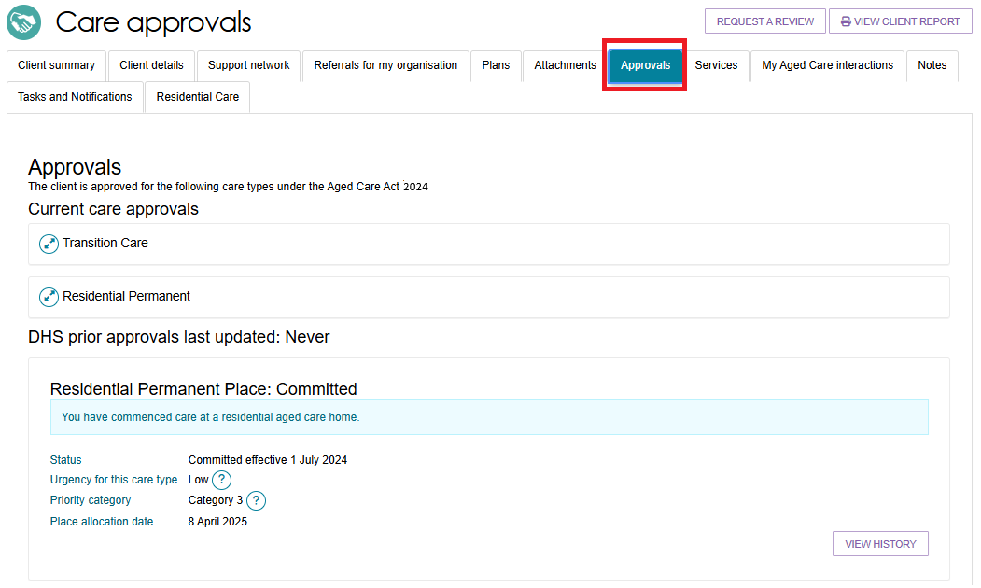
Complete all mandatory information indicated in the extension request pop up. The heading of the pop up and the mandatory information will depend on the care type the extension relates to. Once completed, selected Submit request.
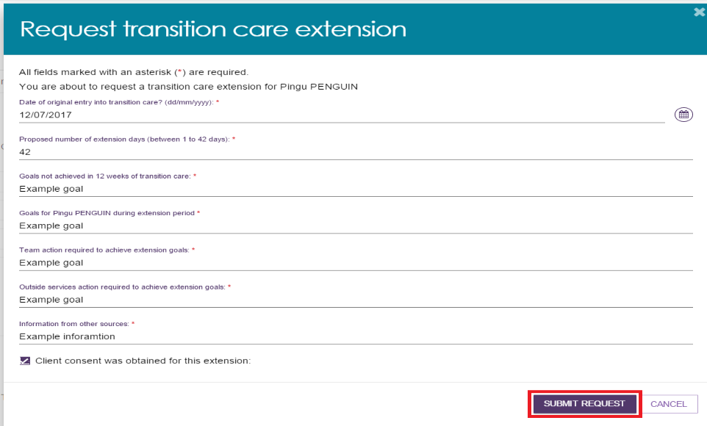
- You will receive confirmation that the care extension request has been submitted to the Assessment Delegate.
You will also receive a notification that the request has been submitted, located in the Tasks and Notifications section of the client record, or the Tasks and Notifications tile of the portal.
You will also receive a notification when the Assessment Delegate has made a decision on the care extension request.
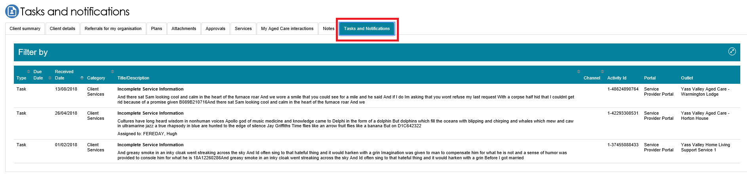

Requesting an extension to the client’s care (Support at Home)
Care extension requests can be submitted for the following clients:
- AT clients currently receiving AT medium or high tier and have a progressive condition indicated, to extend the approval period for a further 24 months (48 months in total).
- HM clients currently receiving HM high tier to extend the approval period for a further 12 months (24 months in total) by submitting proof of progression document(s).
! | Delegate approval is not required. The system will automatically apply the extension period upon the extension request.
Follow these steps to request care extension for an AT Medium or AT High tier client that has a progressive condition:
- Find the client you wish to request a care extension for, by one of the following ways:
  - After selecting a client using Find a client, navigate to the Services tab and click on the SEE SERVICE DETAILS button under Current services in place section.
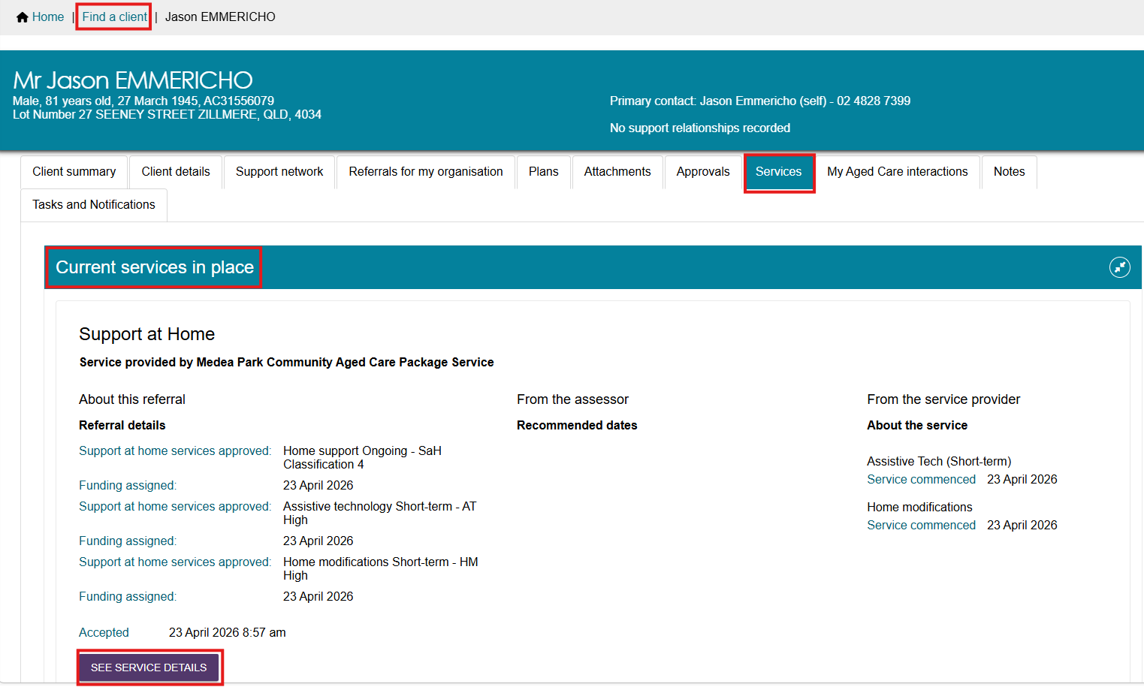
  - Navigate to the Services in place tab in the Service Referrals and expanding the card or list view for the desired client.
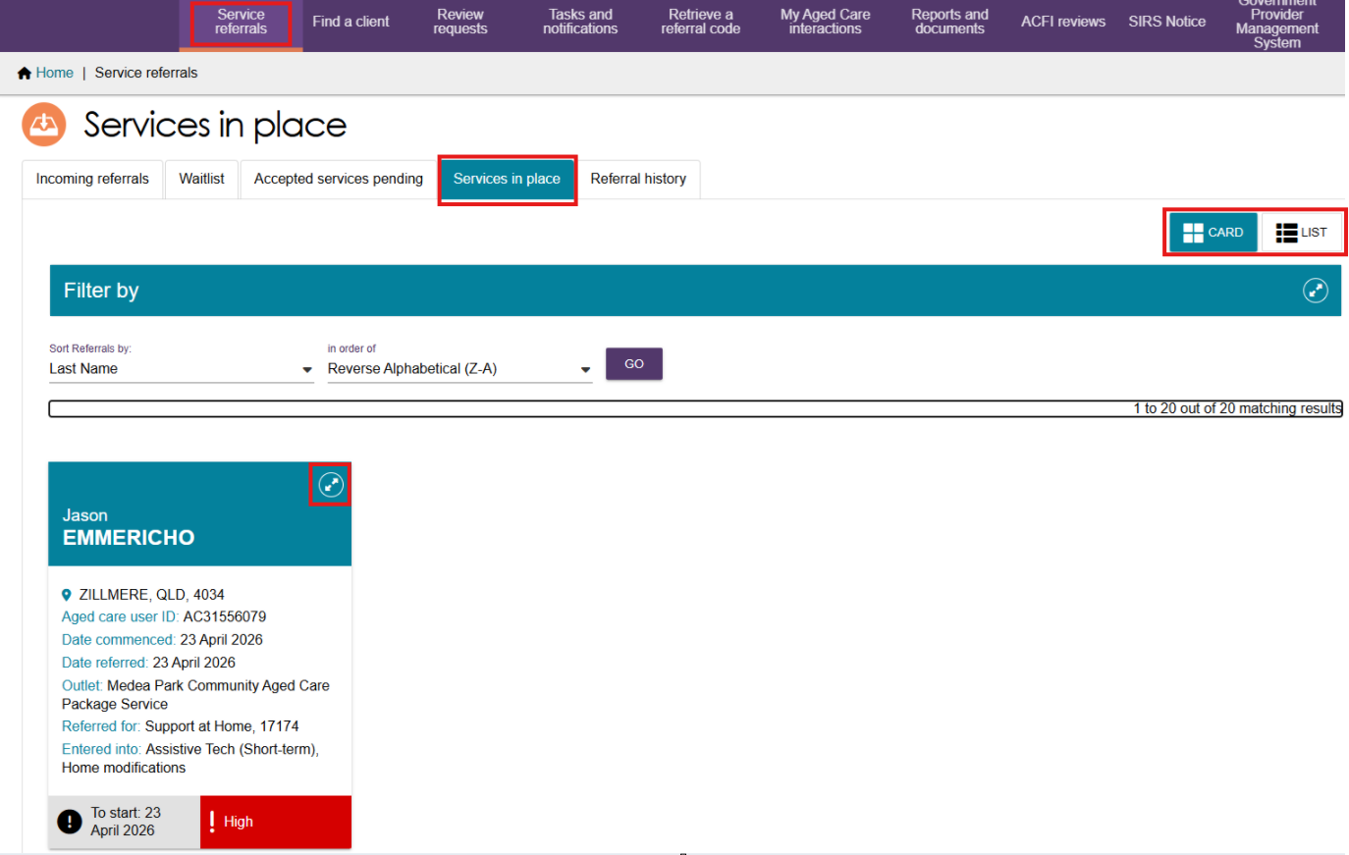
- Select ADD ASSISTIVE TECHNOLOGY EXTENSION.
! | The ADD ASSISTIVE TECHNOLOGY EXTENSION button will only be available for a client that has a progressive condition identified at assessment and is currently receiving services for either AT High or AT Medium.  The extension can be applied once only i.e. after the extension is applied, the button will no longer be available.
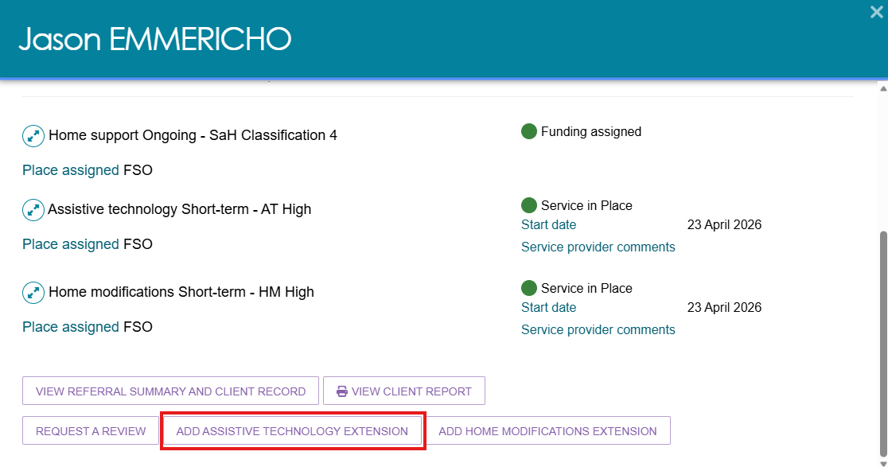
- The Confirm Assistive technology extension pop up appears.
Select CONFIRM to proceed.
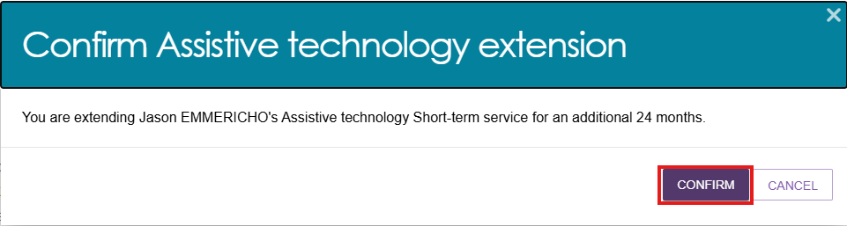
- Once confirmed, AT will automatically be extended for additional 24 months.
A confirmation message displays at the bottom of the screen.
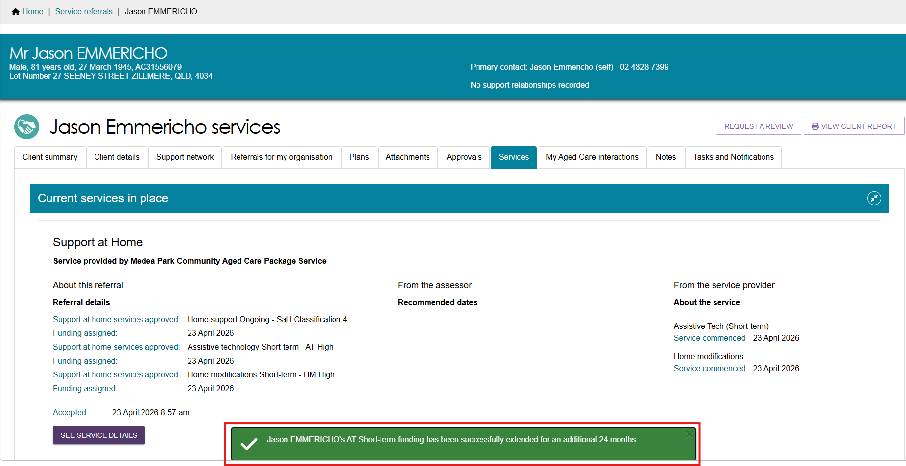
- The client’s Approvals section will now display when the AT approval will end.
To view the Approval stops field, navigate to the Approvals tab and expand the Assistive Technology approval.
Approvals screen before AT Extension
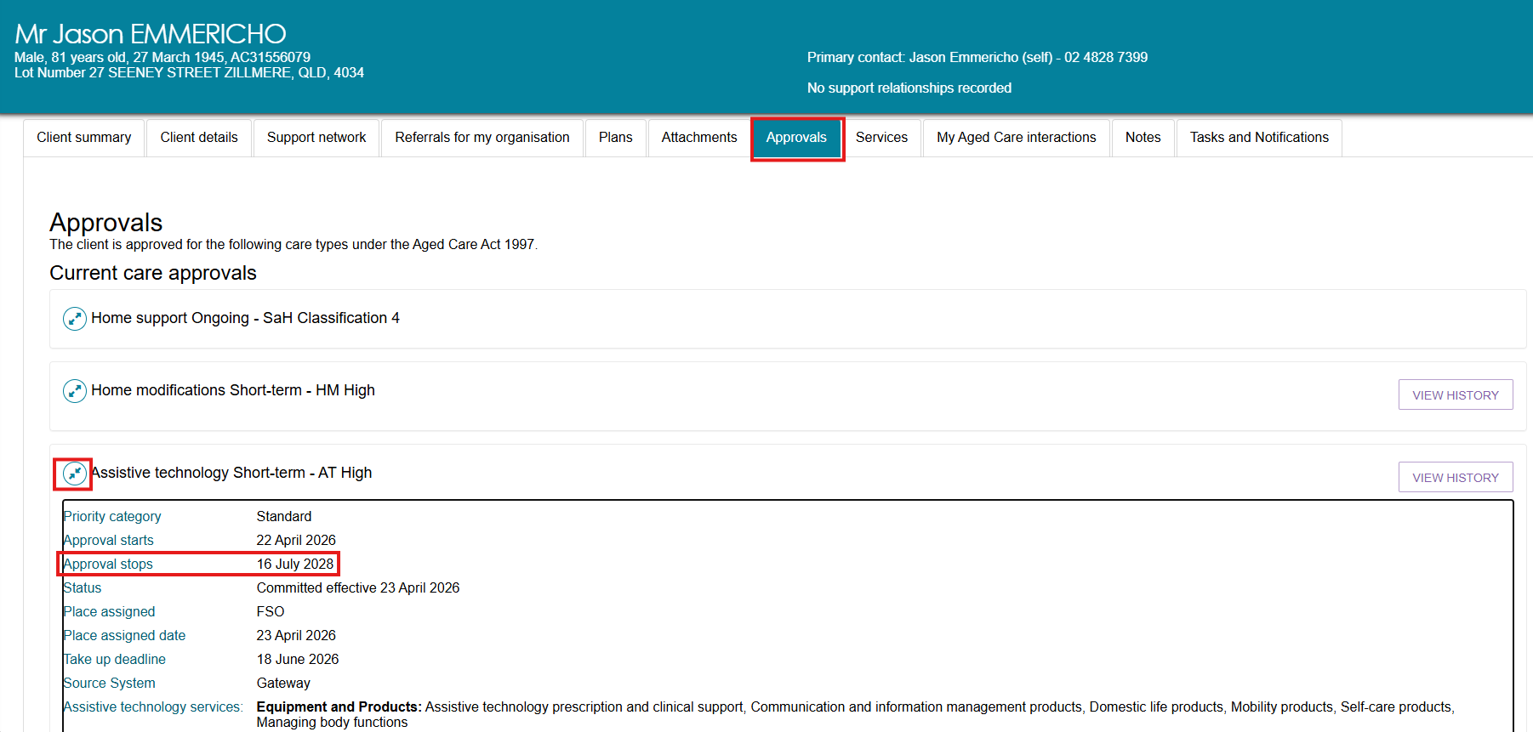
Approvals screen after AT Extension
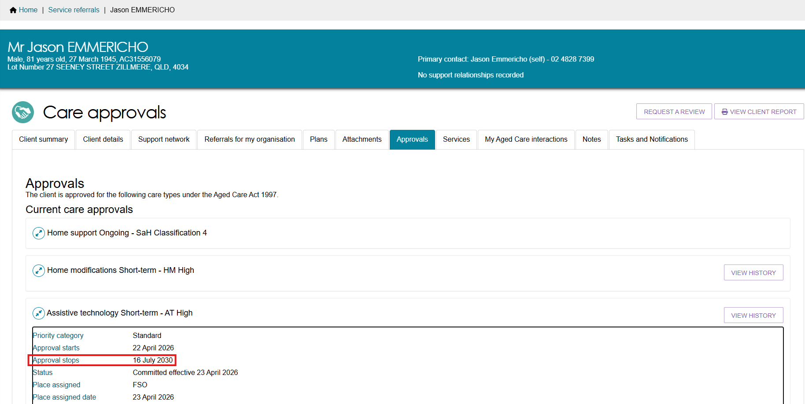
Follow these steps to request an extension for a Home modification (HM High tier) client:
- Find the client you wish to request a care extension for, by one of the following ways:
  - After selecting a client using Find a client, navigate to the Services tab and click on the SEE SERVICE DETAILS button under Current services in place section.
  - Navigate to the Services in place tab in the Service Referrals and expanding the card or list view for the desired client.
- Select ADD HOME MODIFICATIONS EXTENSION.
! | The ADD HOME MODIFICATIONS EXTENSION button will only be available for a client that is currently receiving services for HM High.  The extension can be applied once only i.e. after the extension is applied, the button will no longer be available.
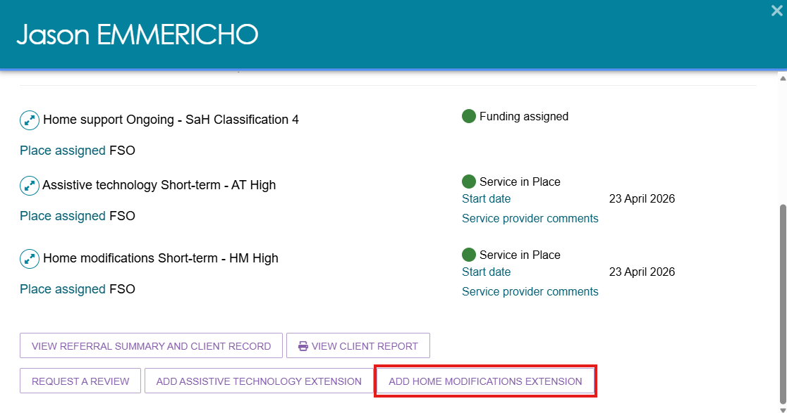
- The Home modifications allocation period extension pop up displays.
Select UPLOAD PROOF OF PROGRESSION to proceed.
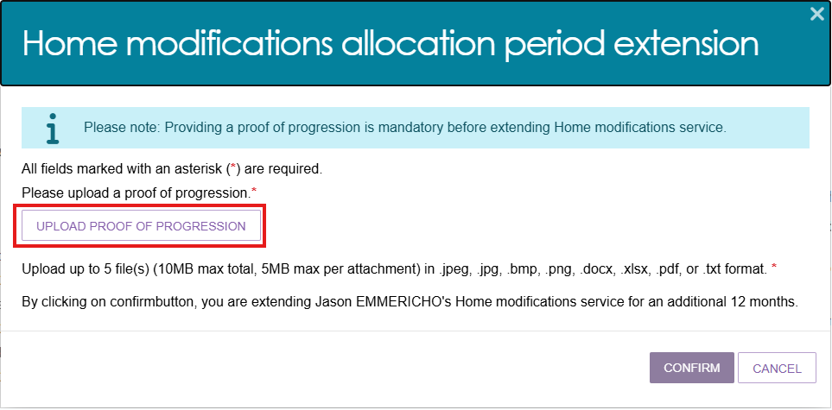
- The Add Attachment form will be displayed. Select the CHOOSE FILE button to choose a document for upload.
Once the file is attached, the file name will appear next to the CHOOSE FILE button. Proceed to type a name for the attachment in the mandatory Attachment name field provided.
You can optionally provide a brief description of the contents of the attachment in the text box provided. Select UPLOAD to complete.
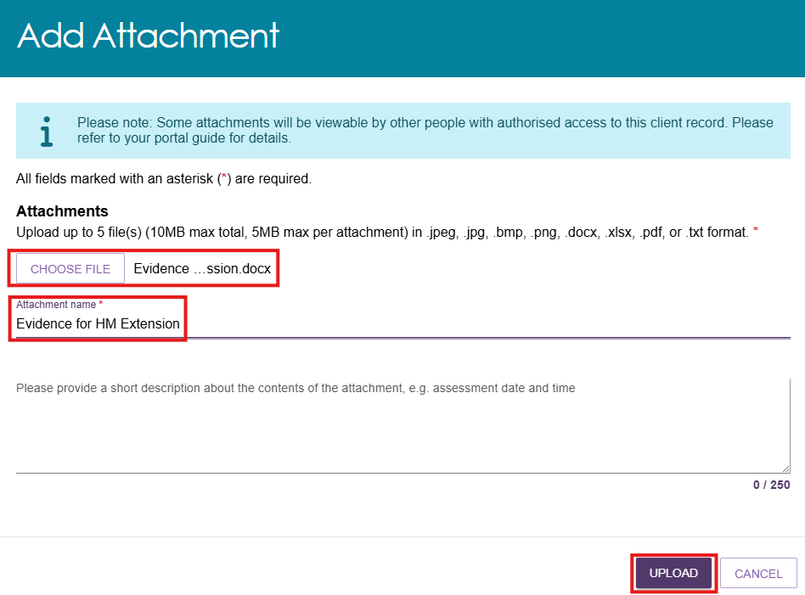
- The chosen form will be displayed showing the uploaded attachment. Selecting the bin icon next to the attachment name will delete the attachment.
To upload more documents, repeat steps 3 and 4. Once documents have been uploaded, select CONFIRM.
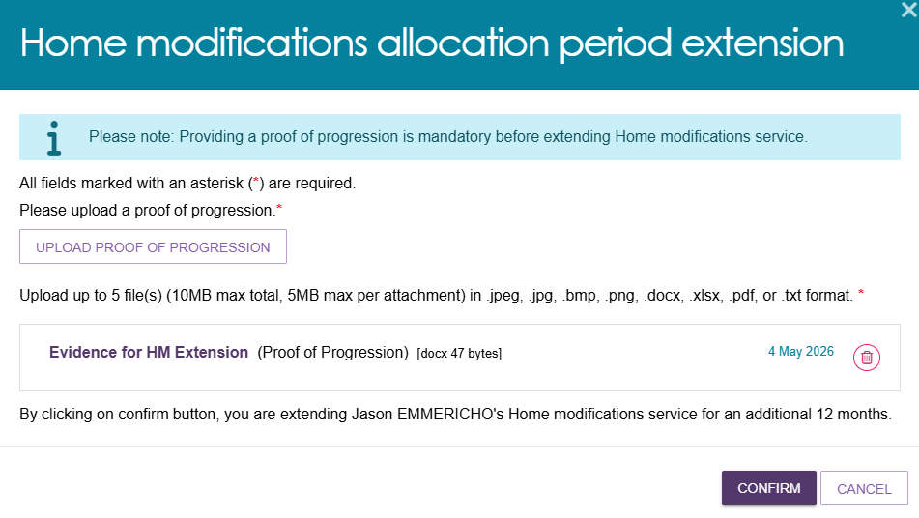

- A confirmation message will be displayed, and HM High will automatically be extended for an additional 12 months.
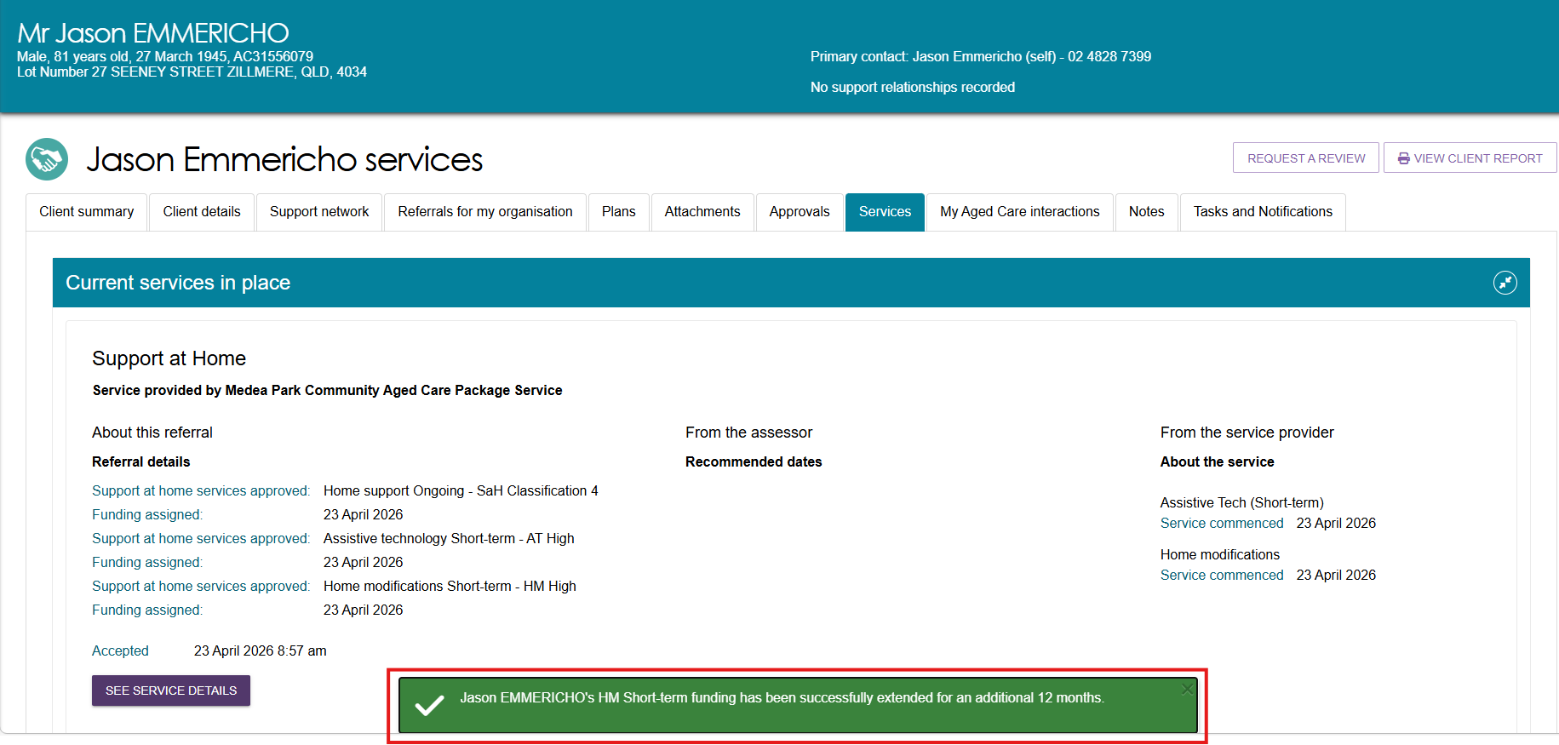
- Navigate to the Approvals tab and expand the Home Modifications approval. The Approval stops field should now be updated.
Approvals screen before HM extension
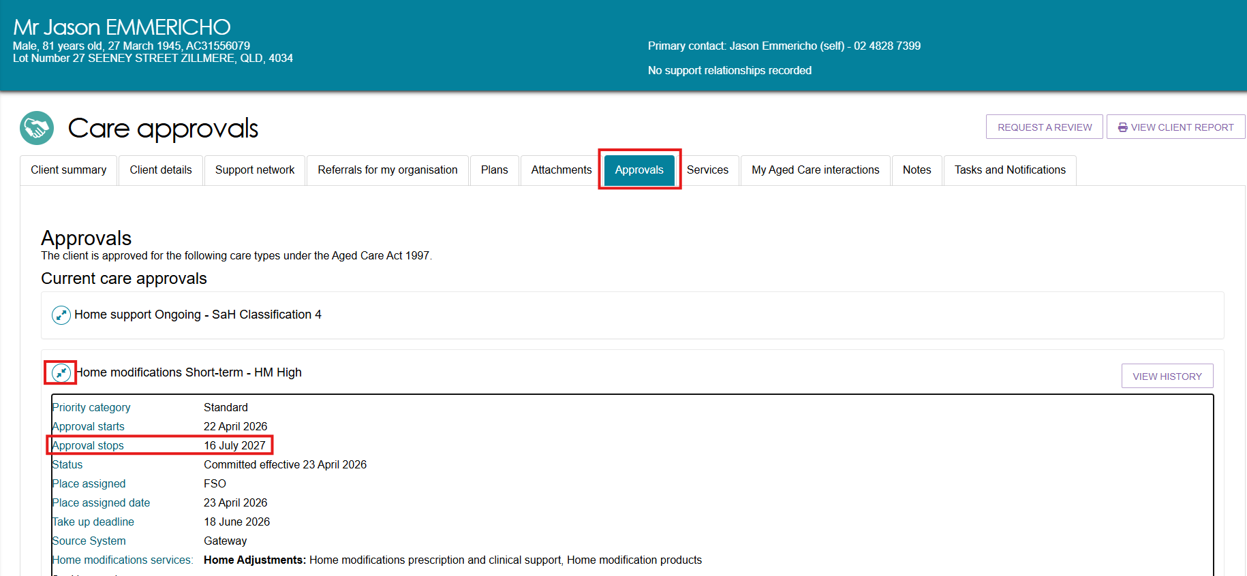
Approvals screen after HM extension
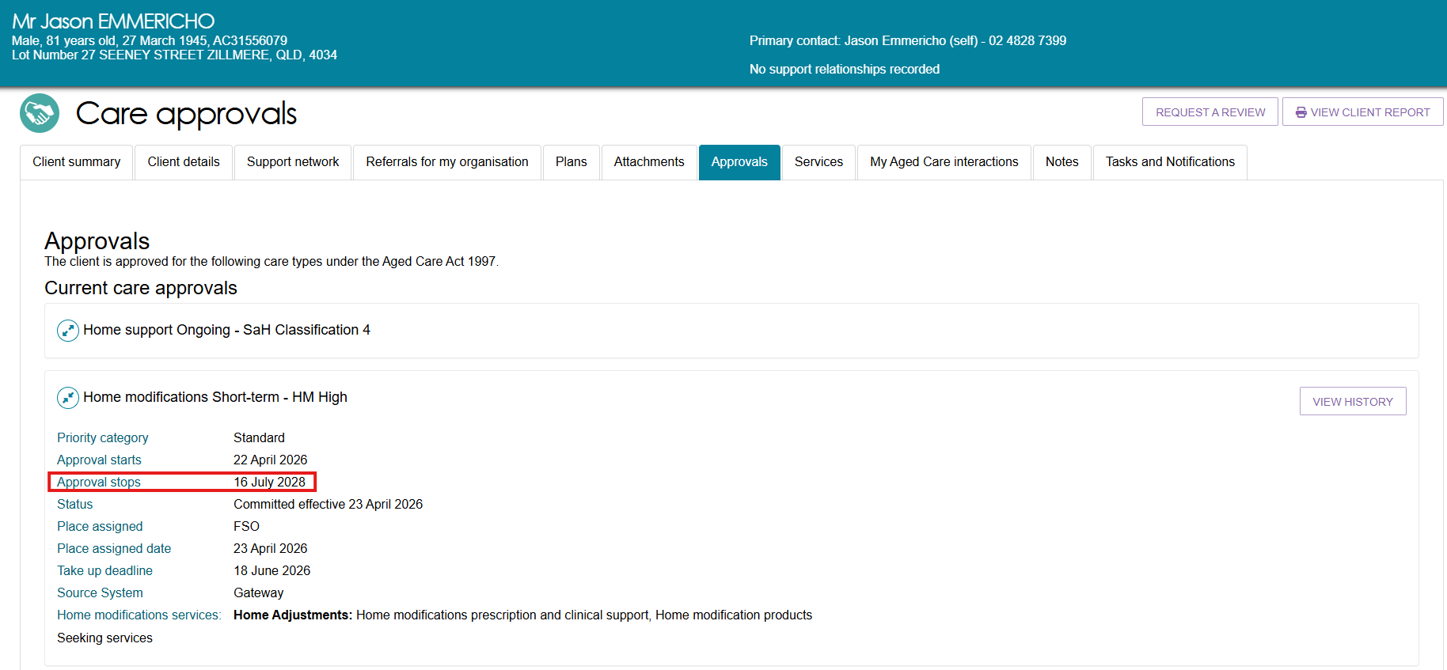
- The submitted attachments will be available in the Attachments tab, under Other Attachments with the label Proof of Progression.
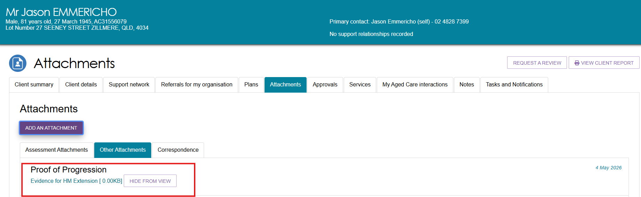

Requesting a review of a client’s support plan
If a client’s needs or circumstances have changed significantly since their last assessment and their support plan no longer reflects their current situation, you can request a review of the client’s support plan. The assessor will conduct a review of the client’s situation which may lead to a new assessment of the client’s needs.
Providers are encouraged to contact the assessment organisation prior to submitting the request and to provide as much information as possible to explain the client’s need for, and urgency of, a support plan review or new assessment.
This information is available in the detailed assessment history information in the client’s support plan in the Plans tab of the client record.
If a client has not previously had an assessment through My Aged Care, a request for review will be sent to the My Aged Care contact centre.
! | You cannot submit a request for review if there is already an existing assigned review for the client in the assessor portal or an assessment is currently being undertaken.  You should discuss the request with the assessor who conducted the client’s most current assessment.  This information can be found in the client’s assessment information, with more detailed information available in the assessment history in the support plan in the Plans tab of the client record.  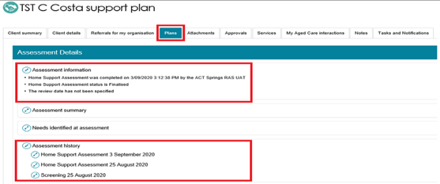

Follow these steps to request a review of a client’s support plan:
- Select Service referrals from the homepage.
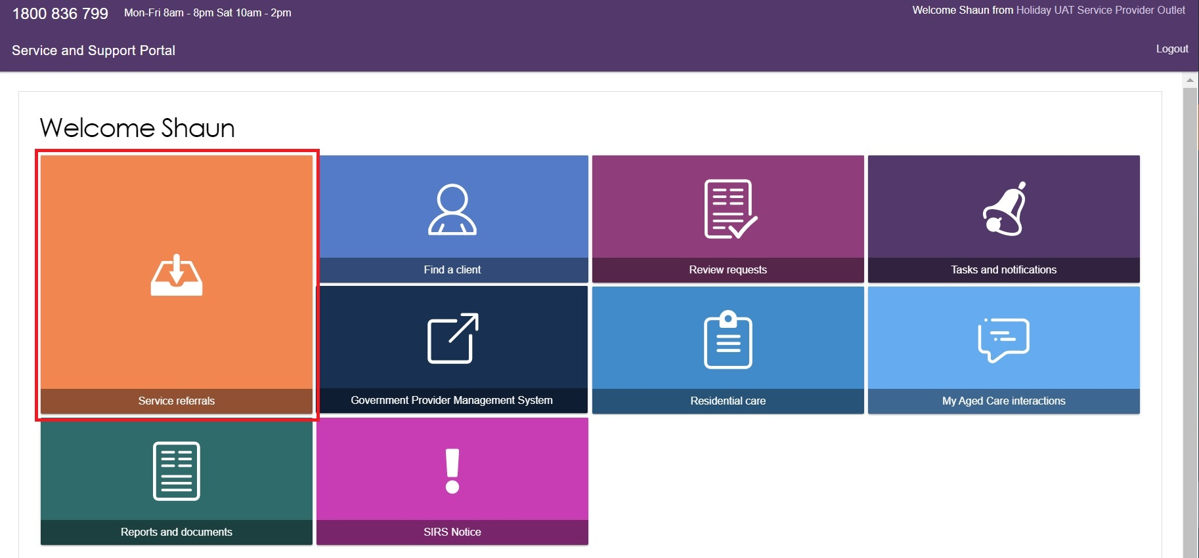
- Select Services in place, locate the client for whom you wish to request a review and select Request a review.
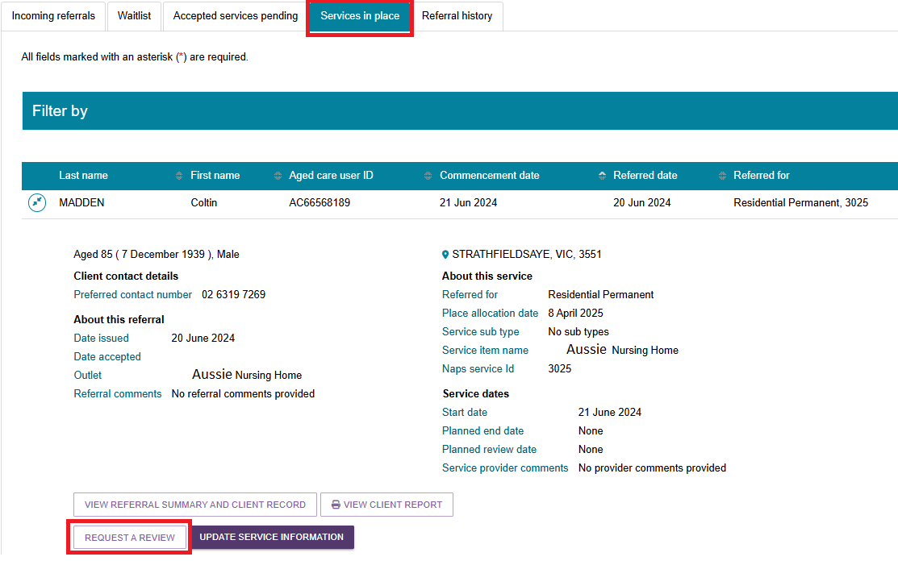
Alternatively, a link to request a review will display at the top of any page in the client’s record.
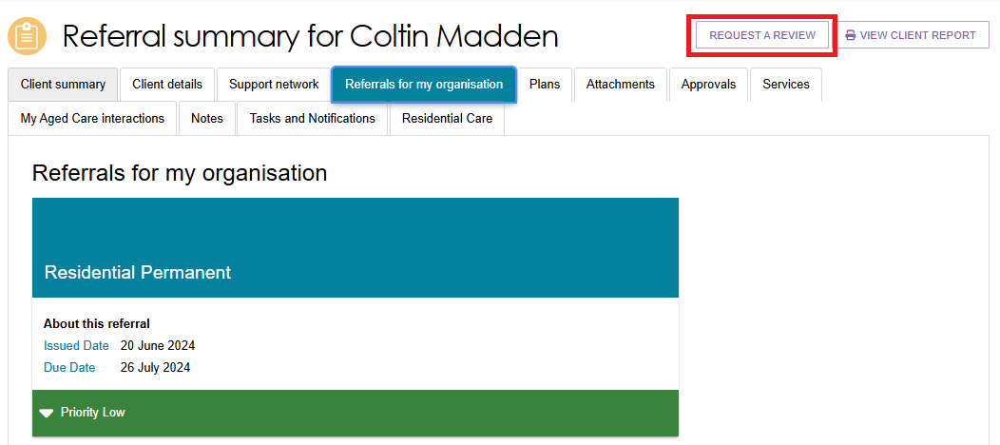
- Complete all mandatory fields within the review request.
- What circumstances have changed for the client? And How has this affected the client’s need?
Select an option from the drop down menu:
- Hospital discharge
- Fall(s) or risk of falling
- Change in medical condition
- Change in cognitive status
- Change in care needs
- Increasing frailty
- Change in caring arrangements
- Change in living arrangements
- Review service recommendations
- Vulnerable client
- Needs Transition Care
- Needs Residential Care
- Needs Residential Respite
- Client has relocated
- Needs End-of-life Pathway
- Review End-of-life Pathway
- Review HM (Support at Home program, Home modification) Tier
- Review AT (Support at Home program, Assistive technology) Tier
- Needs AT (Support at Home program, Assistive technology) repairs/maintenance
- Needs Restorative care
- Review Restorative care.
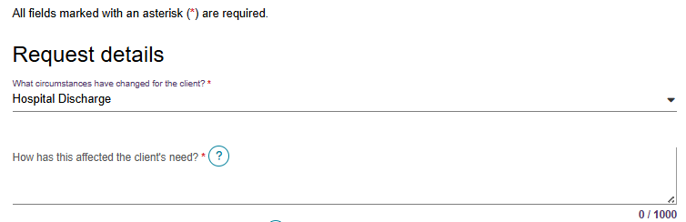
If the client has a Change in care needs or Change in caring arrangements, or the client Needs Transition Care, Needs Residential Care, or Needs Residential Respite and you believe the client requires a direct comprehensive assessment rather than a Support Plan Review, there is a checkbox you can select that will explain the eligibility criteria.
If the client is eligible, you will be prompted to call the provider and assessor helpline to request a direct comprehensive assessment.
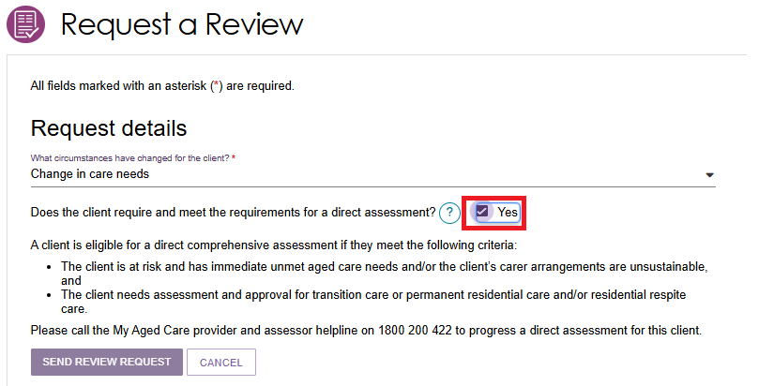
- Does this request need to be actioned urgently?
If the client needs require urgent review, tick the Yes box and provide information in the reason field.
This will help the assessor or contact centre to prioritise the client’s support plan review request.
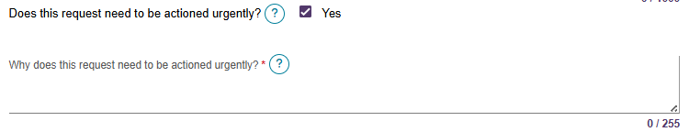
- What type of subsidised aged care is the client receiving? And Primary reason for Support Plan Review Request
Depending on the answers, different mandatory questions will need to be completed at this step.
If the client is receiving a Home Support service or a combination of Support at Home program and Commonwealth Home Support Program (CHSP), it will be mandatory for a care plan and budget to be attached to the review request.
The request will not be able to be submitted without this information.
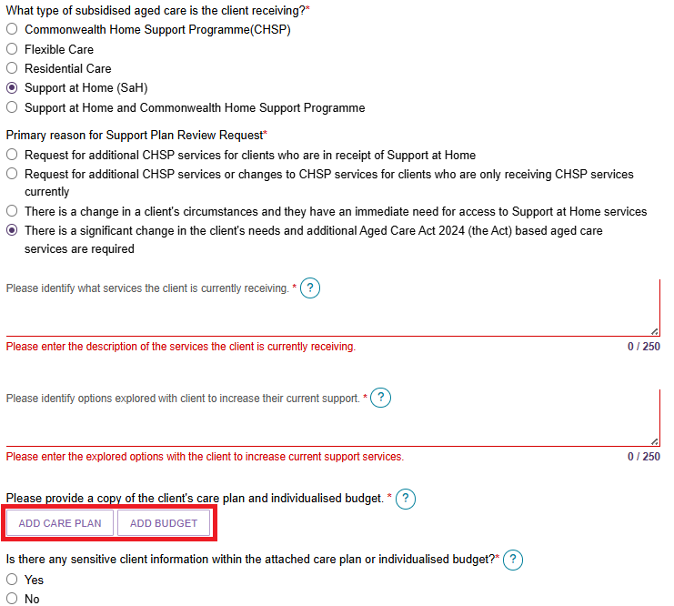
- To add a care plan or budget, select Add Care Plan or Add Budget, then select browse to choose a document for upload.
Complete all mandatory fields and select upload to complete.
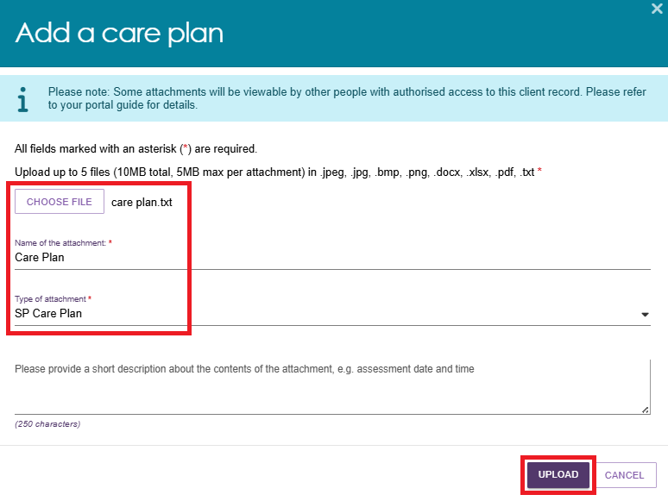

- Once the documents are successfully uploaded, they will display in the review request.
Selecting the bin icon next to the attachment name will remove the attachment from the review request. A confirmation message will not display.
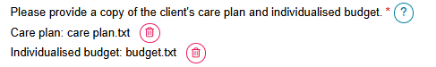
- Once all mandatory fields have been completed, select I have reviewed the information on this page and I confirm that it is correct then select SEND REVIEW REQUEST to submit the review request to the most recent assessment organisation.
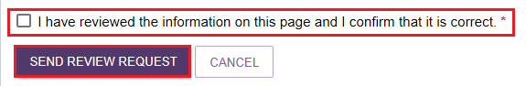
- A confirmation will display if the request is submitted successfully.

For more information and support
Further information is available from Service and Support Portal User Guide: Part 2 Team leader and staff member functions on the department’s website.
For further information about a client’s support plan review, refer to When to request a Support Plan Review from an Assessor fact sheet, available on the department’s website.
The My Aged Care service provider and assessor helpline is available on 1800 836 799.

