Assessor Portal User Guide 9 – Tasks and Notifications
A task is an activity that an aged care needs assessor (assessor) needs to action (finalise/close).
A notification is an activity that informs the assessor of an event. The assessor may need to complete an action as a result of the notification.
The My Aged Care assessor portal (assessor portal) contains notifications and prompts users to action tasks.
Preferences can also be configured by your outlet’s Administrator to enable an email alert to be sent for tasks and notifications.
You can also manage your task and notification preferences.
All staff with access to the assessor portal will have access to view tasks and notifications.
You will receive a notification when a client’s status has changed to ‘Deceased'.
You should review the client record to see if further action is required, for example you may need to close any active referrals or assessment records for the client.
Table of contents
Viewing and actioning tasks 2
Viewing notifications 7
Viewing and reassigning Support at Home notifications 12
Managing task and notification preferences 13
Notification of Support at Home correspondence 17
Notification of Residential Permanent correspondence 19
Confirming client contact information is accurate 22
Creating Reports 23
Support at Home correspondence sent to clients 24
List of Letters 24

Viewing and actioning tasks
Assessors will be able to see all tasks and notifications for clients in the tasks and notifications tab, however service providers will only be able to see tasks and notifications that are associated to their outlet and for clients they are providing services to.
- From the assessor portal homepage select Tasks and notifications.
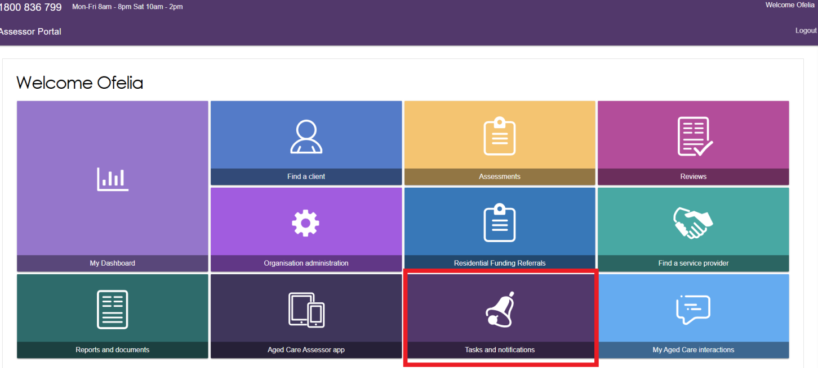
- The Tasks and notifications screen will be displayed as shown below. This layout will be same for all assessor types (i.e. Clinical and Non-clinical).
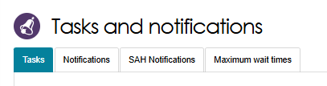
- In the Tasks tab, you will be able to search the tasks by typing either one of the below options.
- Last Name
- First Name
- Aged Care User ID
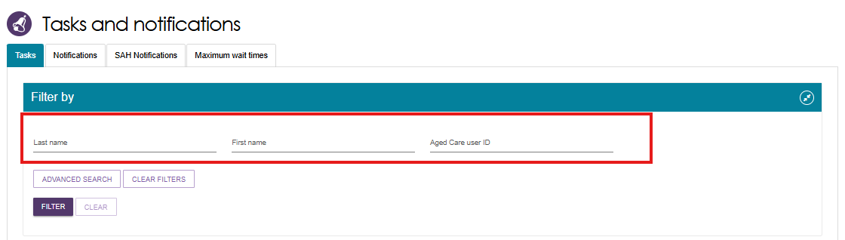
You can further filter the task by selecting the ADVANCED SEARCH button.
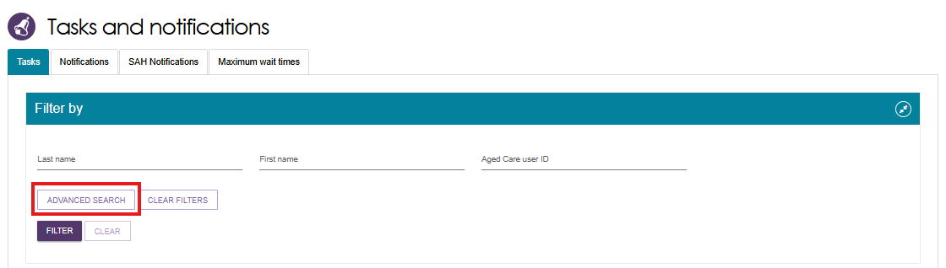
- A pop-up screen will be displayed. To sort the tasks by specific order, choose value from the dropdown list. Select ADD FILTER button.
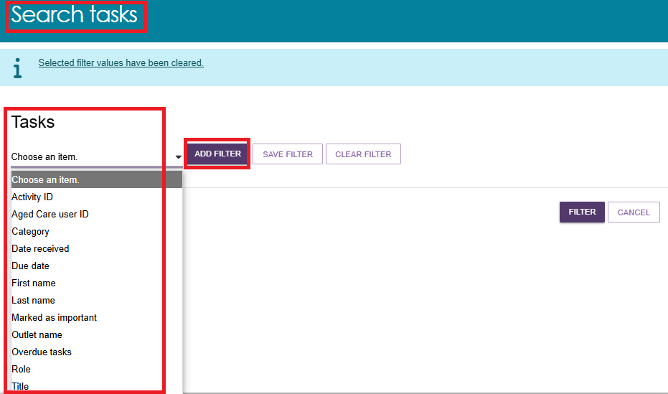
Below example shows the tasks to be sorted by Outlet name, Marked as important, Last Name and First Name. Select FILTER.
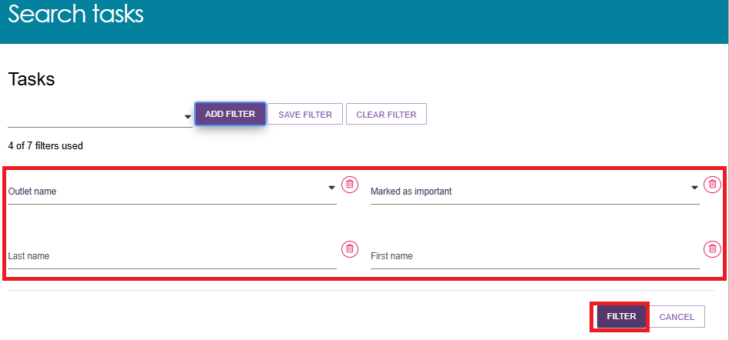
A list of all the tasks as per the requested criteria will be displayed in the TASKS AND NOTIFICATIONS screen.
- You can choose the order to be displayed (i.e. ascending or descending, Category, etc.) by clicking the UP/DOWN  arrow next to each column title.
! | Certain types of tasks can be marked as important for your outlet by your outlet administrator.  When these tasks are created, they will be displayed with a visual indicator. The Managing task and notification preferences section in this guide explains how to set tasks as important.  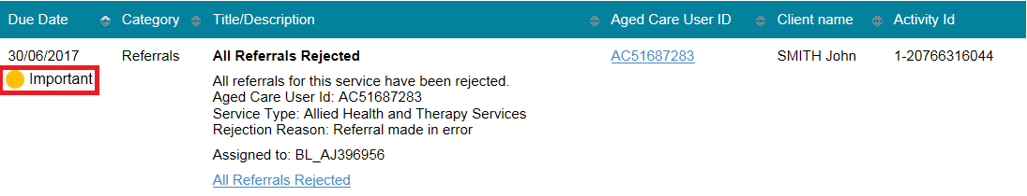
- Alternatively, if you want to see all tasks and notifications for a single client, navigate to the Tasks and Notifications tab in the client’s record to see all relevant tasks and notifications for that client.
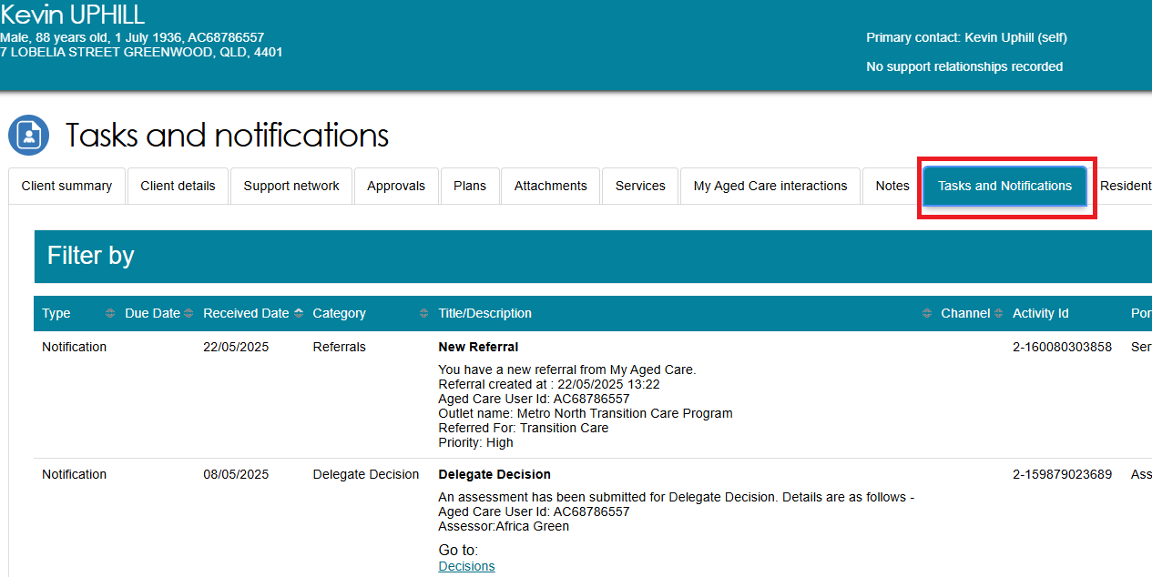
- The hyperlink under the task description will take you directly to the individual record and the section of the portal where you can action the task.
Alternatively, you can navigate to the client’s record by selecting the client’s Aged Care ID from the tasks list.
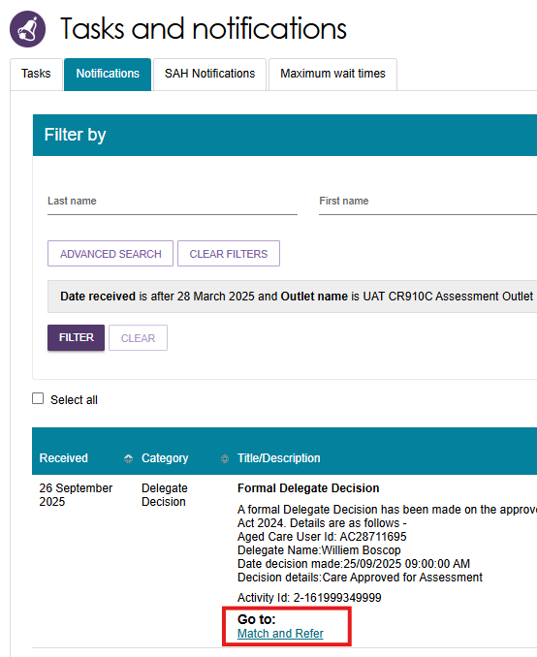
- Selecting the hyperlink will take you directly to the client’s support plan where you can review the referral and take further action as required.
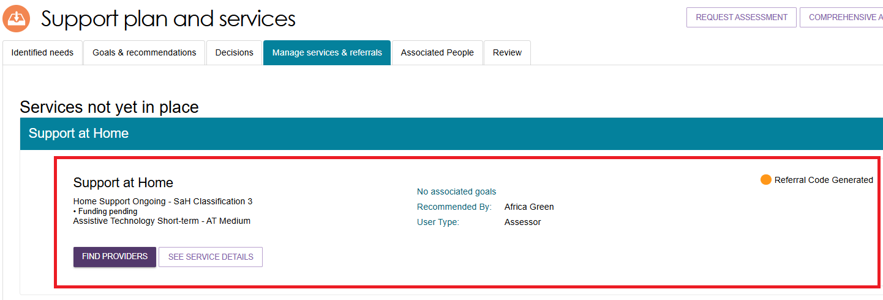
- Once the action required from the task has been completed, the task will be removed from your task list.
Certain tasks may close automatically once an action has been taken by another My Aged Care user (e.g. when a service provider accepts a referral that has triggered a task for assessor to follow up, the task is automatically closed in the assessor portal).
! | If you believe you have completed a task and it has not been removed from your portal, please call the My Aged Care Service Provider and assessor helpline on 1800 836 799  who will be able to assist in completing the task.

- Assessors can also change the client’s status to deceased by opening the Client details tab and selecting NOTIFY MY AGED CARE OF A DEATH.
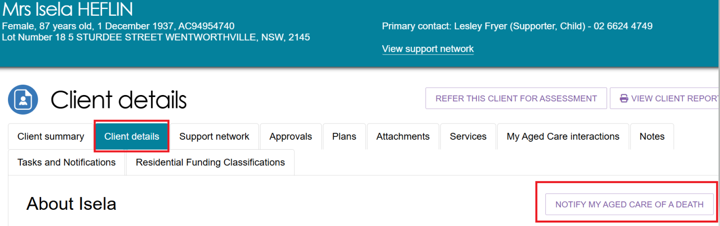
- When NOTIFY MY AGED CARE OF A DEATH is selected you will be taken to Notify My Aged Care that person is deceased screen where you will have to complete relevant information.
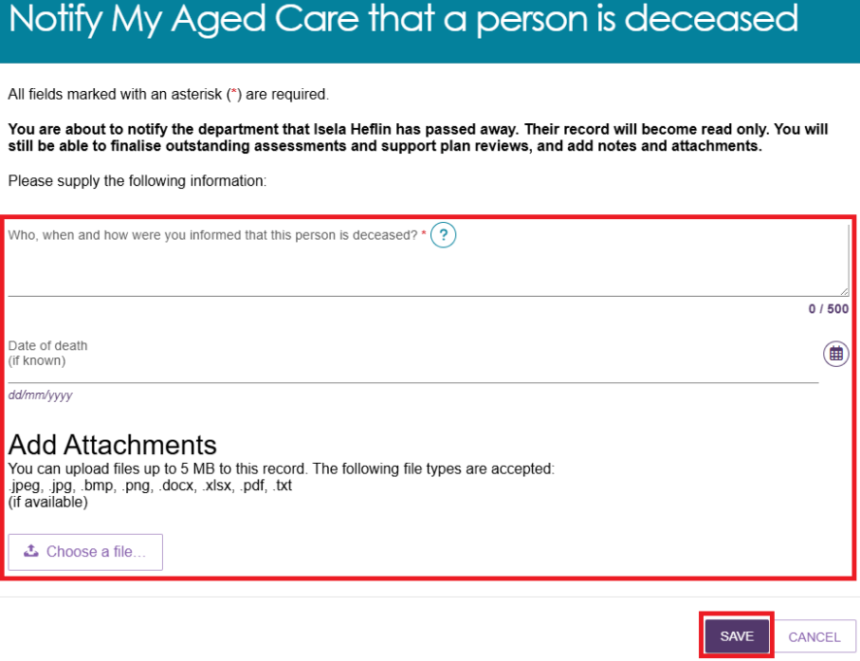

A dialogue box will be displayed. To confirm, select OK.
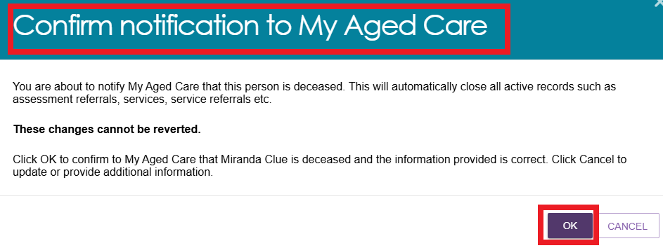
You will be directed to the CLIENT DETAILS page where the following banners will be displayed.
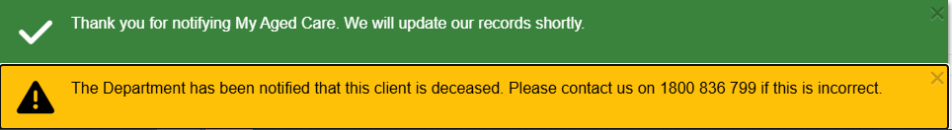
The client status will be updated to Deceased on the records. The client card will appear as shown in the example below. If there are any in-progress assessments for the client, a notification will be sent to the associated assessor and provider advising them to close or finalise the in-progress tasks.
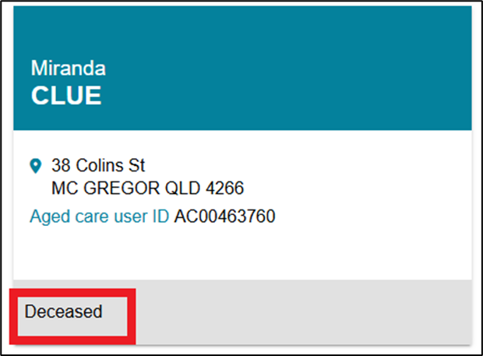

Viewing notifications
Assessors will be able to see all tasks and notifications for clients, however service providers will only be able to see tasks and notifications that are associated to their outlet and for clients they are providing services.
- From the assessor portal homepage select Tasks and notifications and select the Notifications tab.
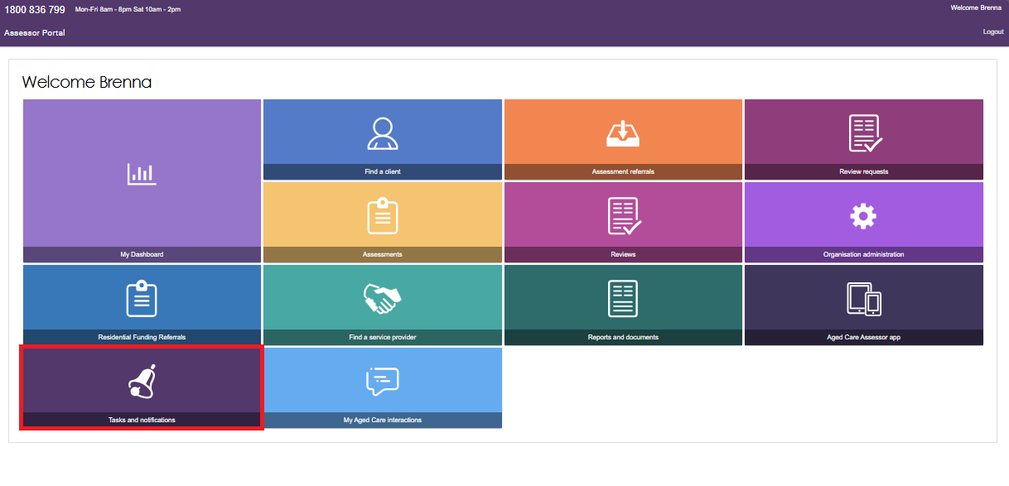
In the Notifications tab, you will be able to view all notifications relevant to your role.
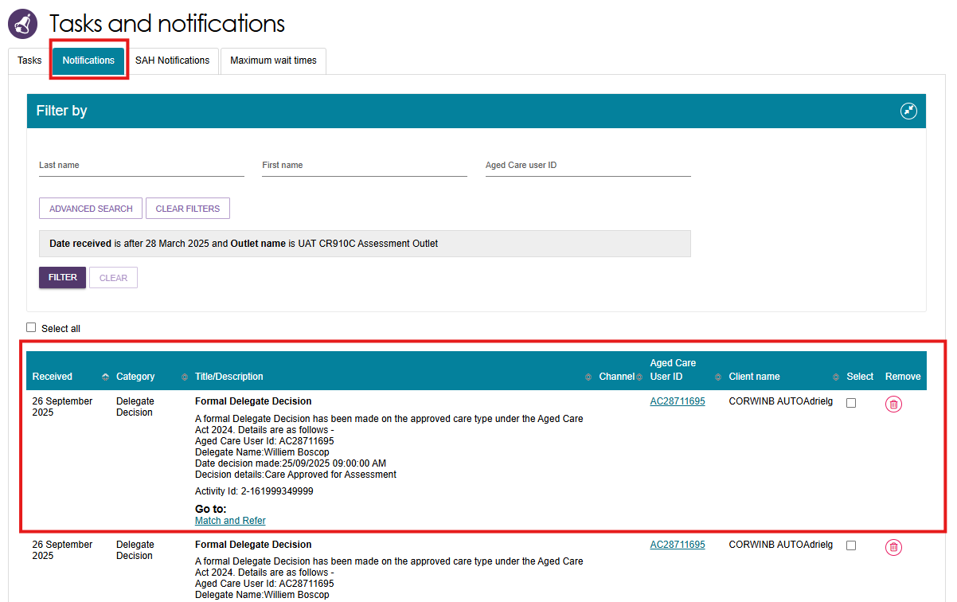
- Alternatively, if you want to see all tasks and notifications for a single client, navigate to the Tasks and Notifications tab in the client’s record to see all relevant tasks and notifications for that client.
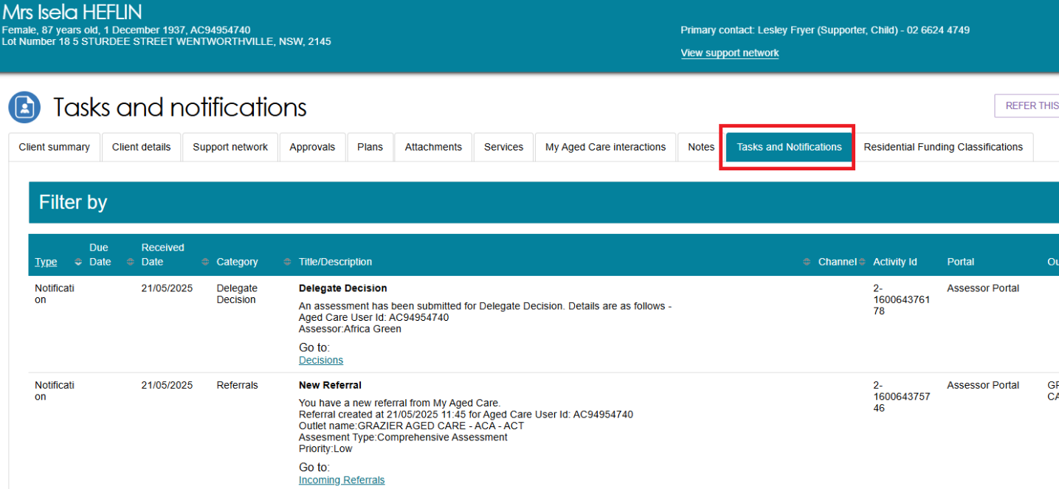
- In the Notifications tab, you can sort notifications by any of the columns on the table by selecting the UP/DOWN arrow next to the column title.

! | As with tasks, certain types of notifications can be marked as important for your outlet by your outlet administrator.  When these notifications are created, they will be displayed with a visual indicator. The Managing task and notification preferences section in this guide explains how to set notifications as important.  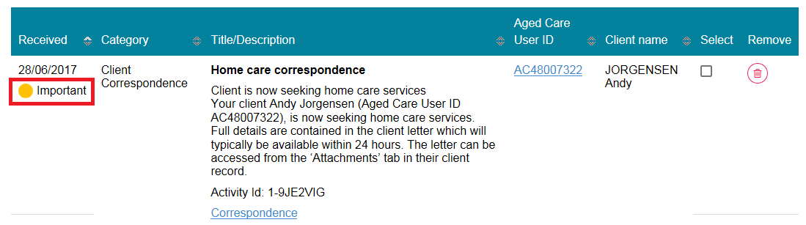  Home Support notifications will display in the Notifications tab if enabled in the client’s support plan or on the Approvals tab in the client record.
- You can also remove individual or bulk notifications from your portal by selecting the Remove icon or Select all checkbox.
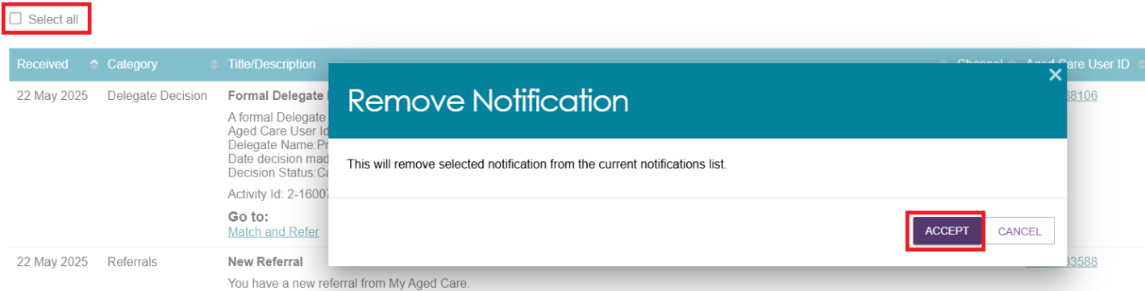
- You can search for specific notifications using the filter options or using custom filters in Advanced Search. Select the arrows to the right to expand or collapse the filter options.
- To apply custom filters, select ADVANCED SEARCH and choose filters from the drop-down menu and select ADD FILTER for each filter you want to apply.
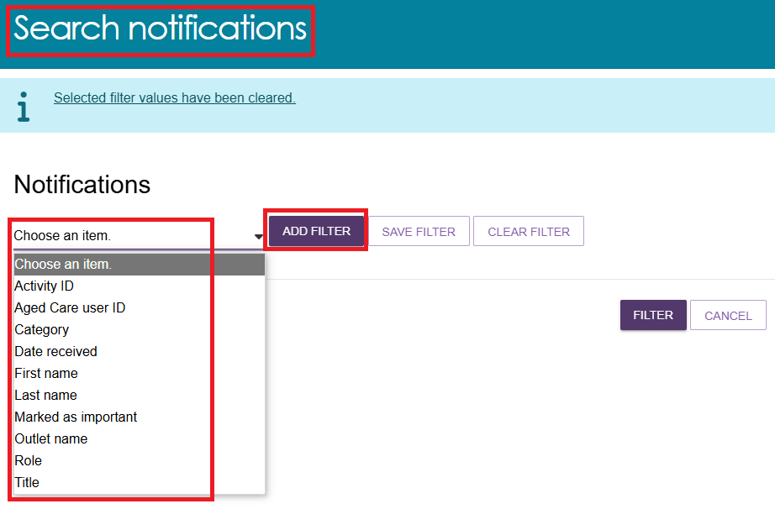
Below example will sort all notifications received between 01/01/2025 to 22/05/2025.
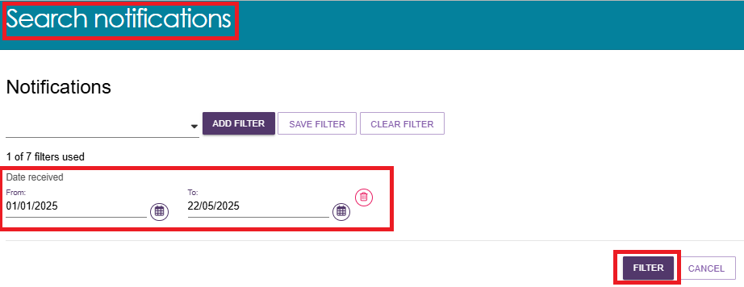

- The list of all notifications meeting the above criteria will be displayed under the NOTIFICATIONS tab as shown in the example below.
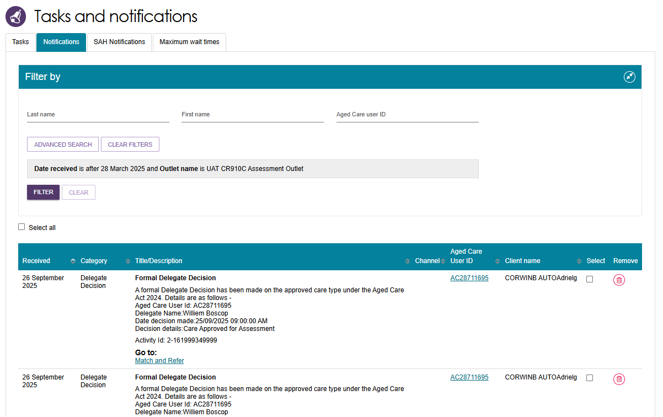
- The hyperlink under the notification description will take you directly to the individual record and the section of the portal where you can view more information about the notification or complete any action that may be required.
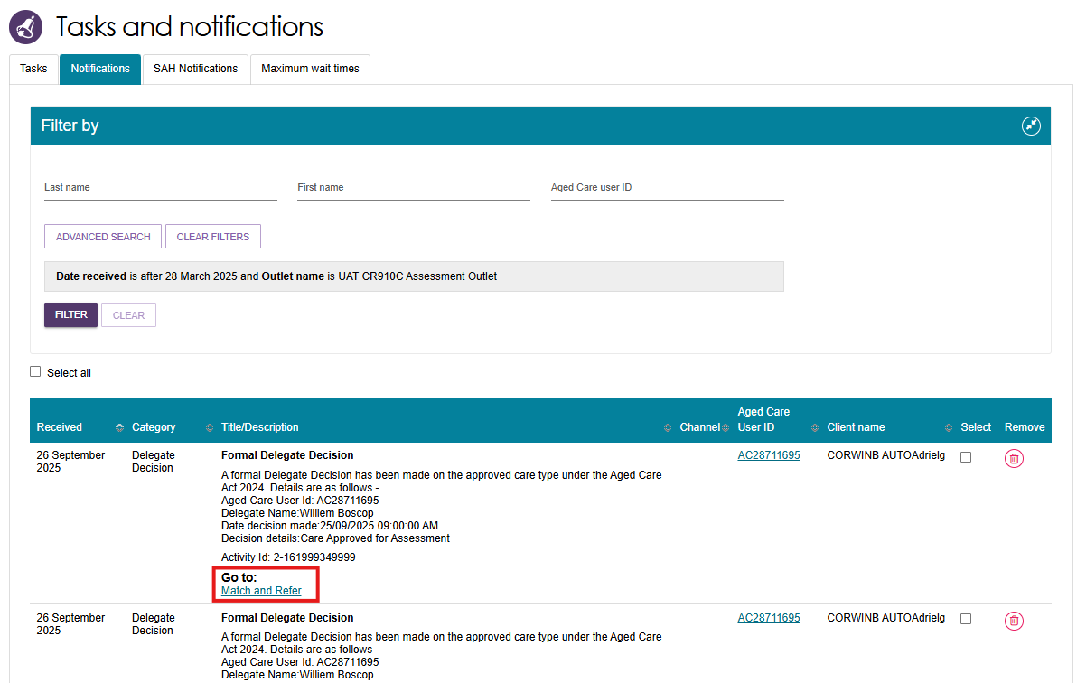

- For example, selecting the link in a Formal Delegate Decision notification will take you directly to the client’s support plan where you can match and refer for the recently approved care type.
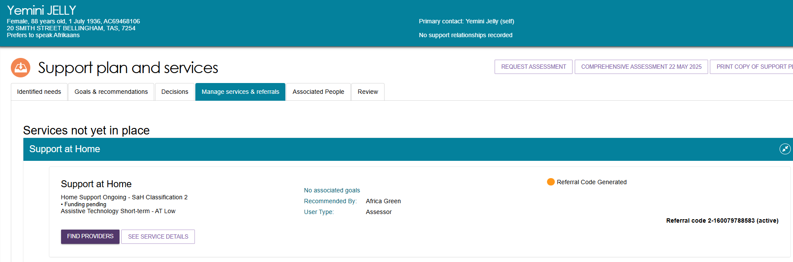

Viewing and reassigning Support at Home notifications
You must be assigned in the team leader role to view which assessor or delegate is currently receiving the client’s Support at Home correspondence notifications.
You will also have the ability to reassign a client or an individual or make bulk reassignment changes to a different assessor or delegate within an outlet.
- In the Tasks and Notifications tab select SAH Notifications tab.
If you manage more than one outlet you may choose which outlet to view from the dropdown.
Select GO after choosing the outlet.
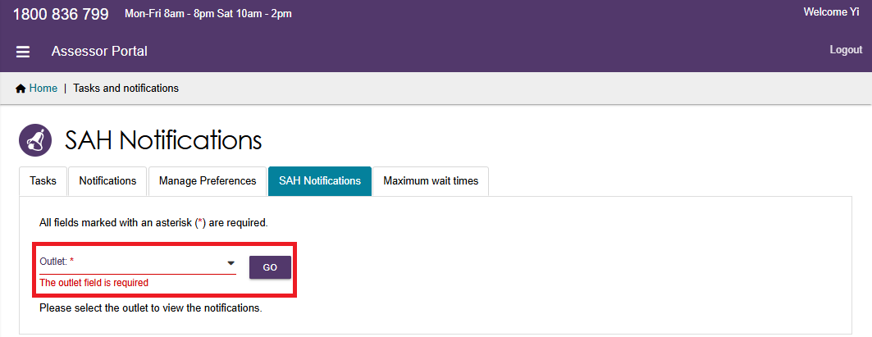

- The last column is a select tick box which allows the team lead to complete individual or bulk reassignments:
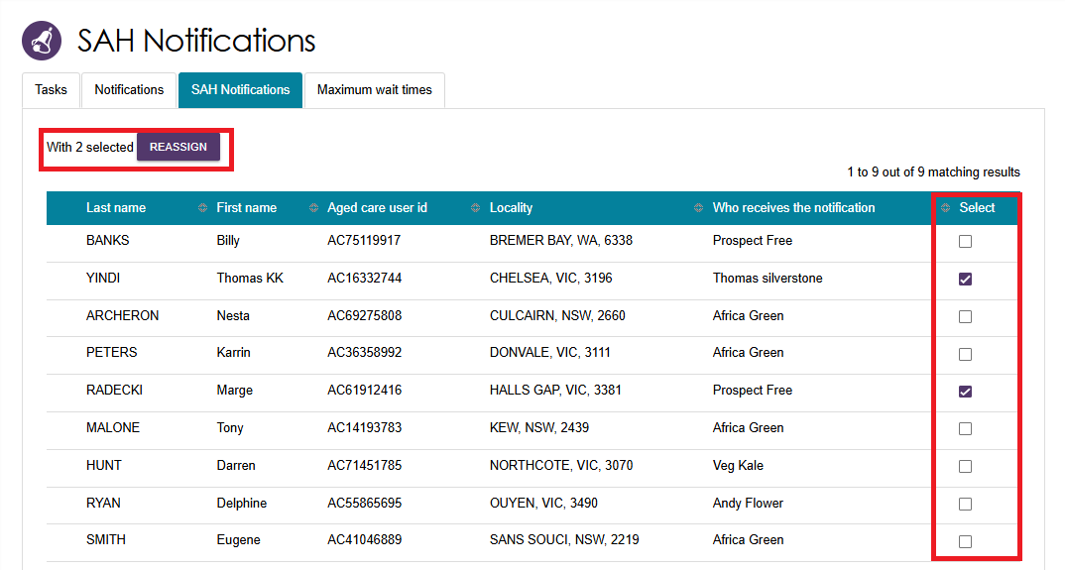
By selecting the REASSIGN button, the Re-assign Home Care correspondence notifications pop up will be displayed where you can select the new recipient and finalise by clicking the SAVE button.
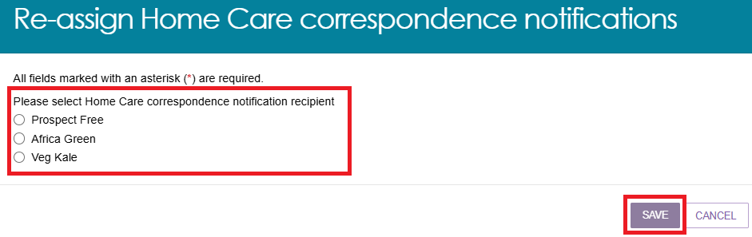

Managing task and notification preferences
You must be assigned an administrator role to manage task and notification preferences for your organisation or outlet.
If you need to add this role to your user account, please see your organisation administrator.
As an administrator, you will be able to:
- edit email address and email frequency for new task and notifications
- turn off visibility of notifications in the assessor portal
- view description of each task and notification, including which user types will be able to see them
- edit individual task and notification preferences
- mark a task or notification as important to your outlet.
These settings will affect all staff assigned to your outlet, so please ensure all staff are made aware of any changes you make.
- From the assessor portal homepage select Tasks and notifications.
- Select the Manage Preferences tab.
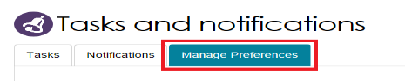
- If you are the administrator for your organisation, you will be able to select which outlet you want to configure task and notification preferences for. Select CHANGE PREFERENCES.
If you are the administrator for your outlet, you will only be able to see your outlet’s preferences.
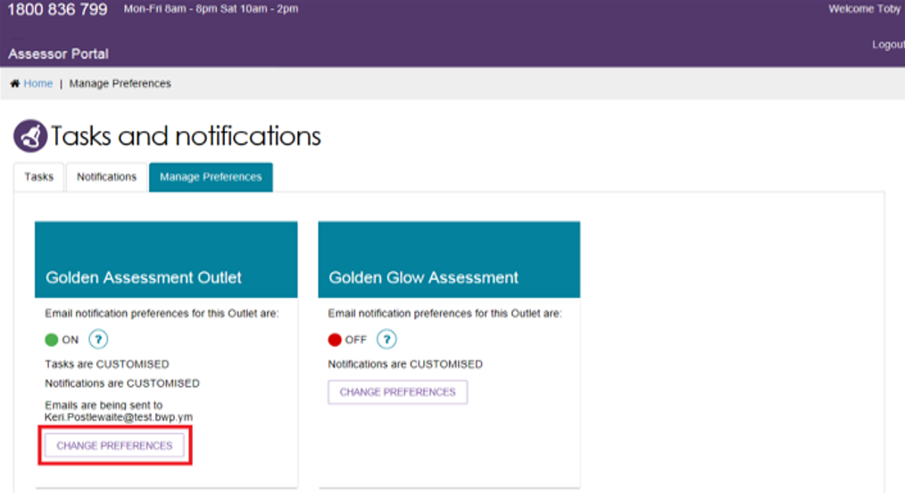

- The preferences page for the outlet will open. At the top of the page, you can configure the overall preferences for email preference, email address, email frequency and notification visibility in the portal.
You can choose to hide all notifications or hide individual notification types for the outlet.
Selecting No to hide all means that no notifications for the outlet will be visible to staff associated with the outlet.
Selecting No for an individual notification type means that only notifications of that type will be hidden for staff associated with the outlet.
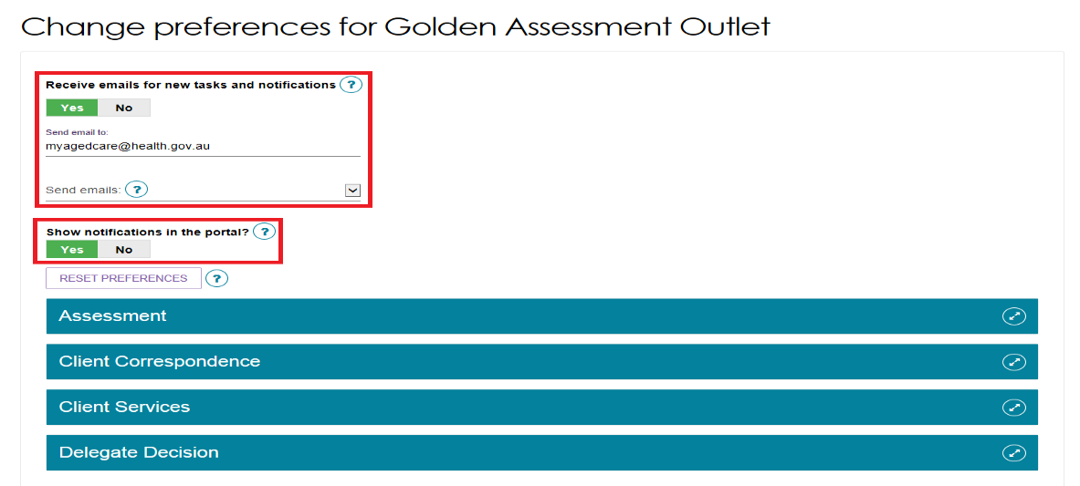
Tasks and notifications are sorted by category. Select the Expand (double arrow) icon to expand/collapse each category.
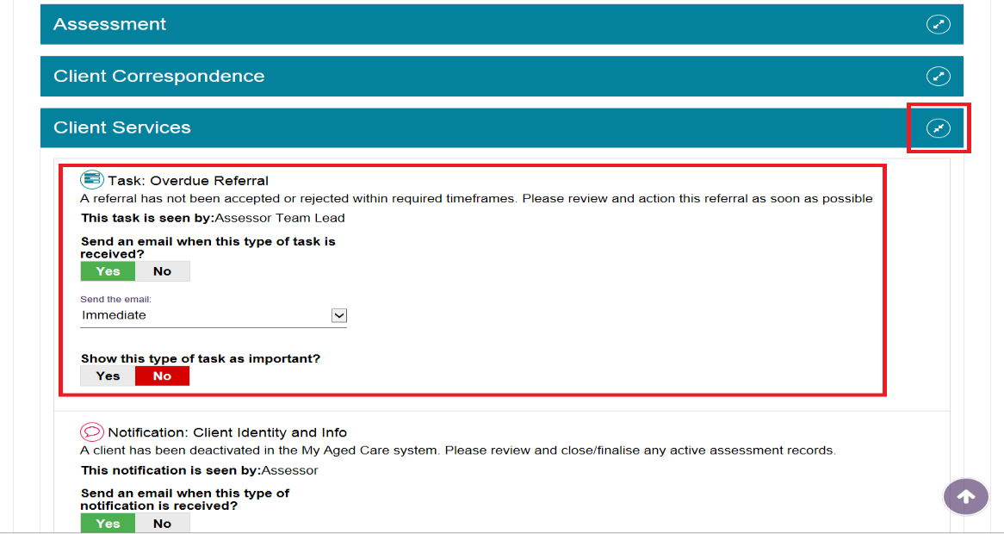

For each task or notification you will be able to view:
- Type (e.g. task or notification)
- Title and brief description of the why the task or notification has triggered
- User type who can view or action the task or notification.
For each task or notification you will be able to individually configure:
- Whether to send an email when a task or notification generates
- Frequency of email notification, if enabled
- Whether to display a task or notification as important in the portal.
! | If you choose to mark a task or notification as important, staff within your outlet who can view that particular task/notification will see a visual indicator in their portal.  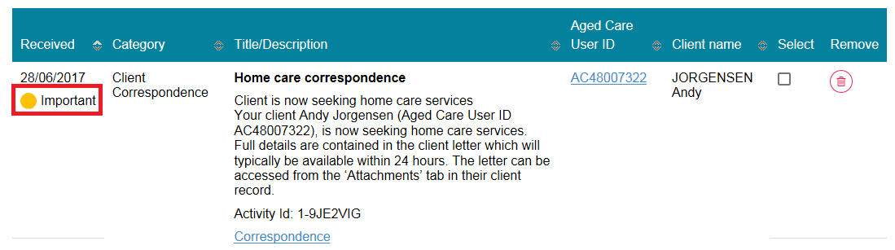
- Select SAVE when all changes have been made. You can reset the preferences by selecting RESET PREFERENCES at the top of the page.
Selecting the arrow in the bottom right of the screen will automatically take you to the top of the page.
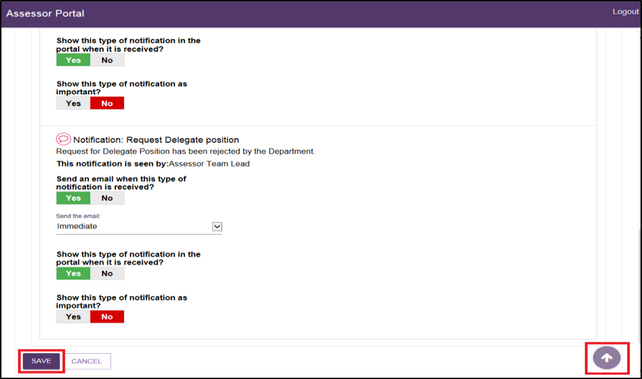

Notification of Support at Home correspondence
For those clients that a clinical assessor wishes to monitor more closely, clinical assessors can elect to be notified of Support at Home correspondence sent to the client.
This notification can be enabled from any tab in the clients support plan or on the Approvals tab in the client record. This option is only visible if there is a recommendation for Support at Home services.
The notification link will only be enabled if the client has been marked as Seeking services or a Support at Home recommendation has been made.
This is also available when viewing Home Care Approvals in the client record, as shown below.
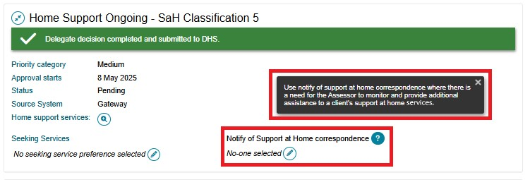
Only one person from an outlet can be selected to receive this notification. The preference is shown below.
All clinical assessors and assessment delegates from the assessment outlet will be displayed in a drop-down menu.
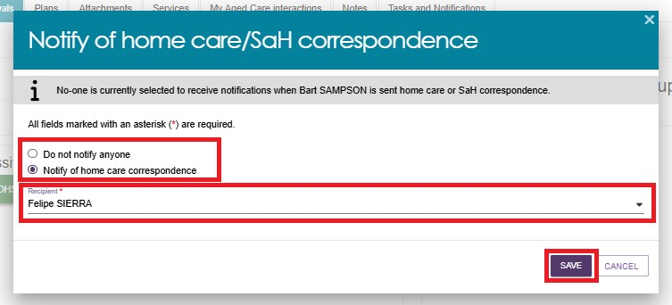

Team Leader role
In the team leader role, you can view which clinical assessor or Assessment Delegate is currently receiving the client’s Support at Home correspondence notifications.
You will also have the ability to reassign a client or an individual or make bulk reassignment changes to a different clinical assessor or Assessment Delegate in an outlet.
In the Tasks and Notifications tab select Notifications tab. If you manage more than one outlet you may choose which outlet to view from the dropdown.
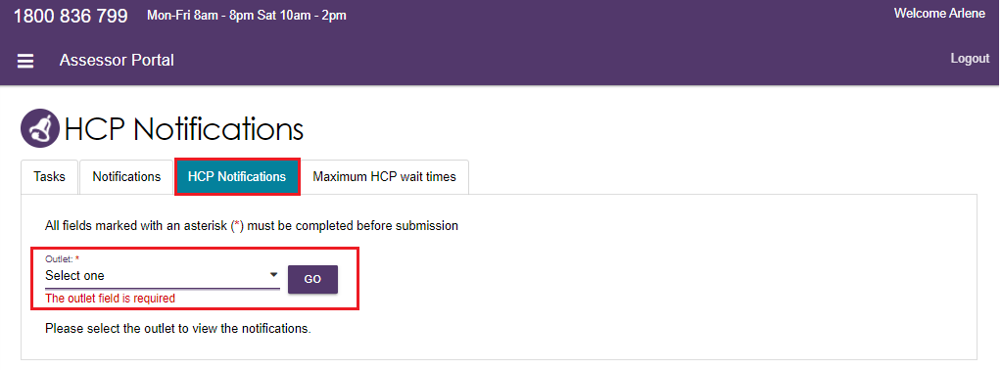
- Once you have chosen the outlet to view you will see the following details:
- Last Name
- First Name
- Aged Care User ID
- Locality
- Who receives the notification (First name, Last name)
- tick box which allows the team lead to complete individual or bulk reassignments.
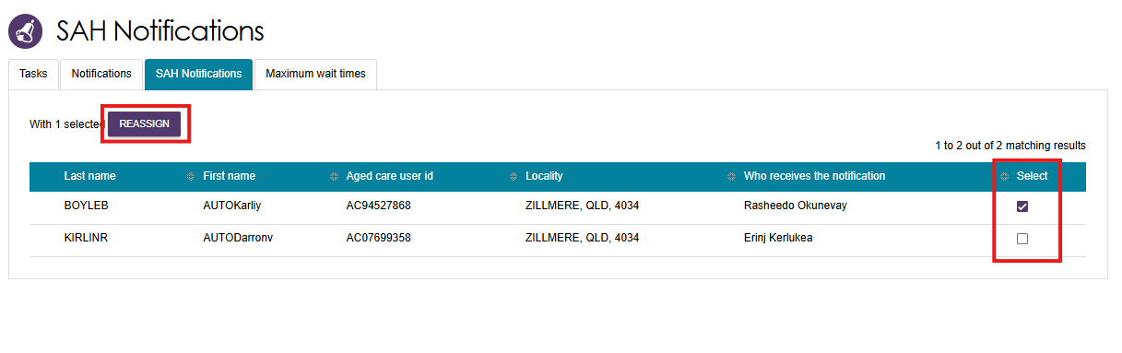

- By selecting the REASSIGN button, the Re-assign Home Care correspondence notifications pop-up will be displayed where you can select the new recipient and finalise by clicking the SAVE button.
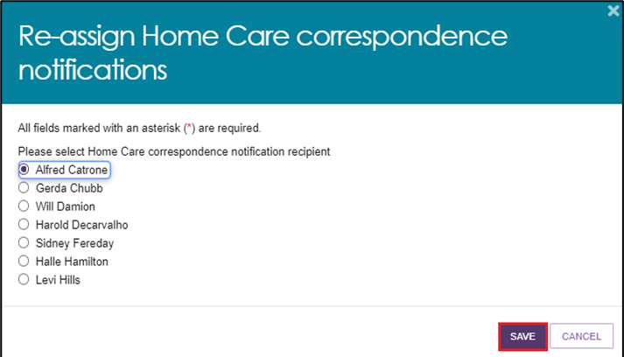
! | Refer to the Support at Home correspondence sent to clients section for actual letter templates.

Notification of Residential Permanent correspondence
Clients and/or their registered supporters will be notified about their Residential Permanent place allocation, including waiting for a place, and being allocated a place. These notifications are sent by email, SMS and mail.
If nominated, the assessor can also receive system notifications on behalf of the client.
Notifications of residential care correspondence for assessors can be set during the Delegate Decision stage. Alternatively, go to the client’s profile and select the Approvals tab.
For each residential care approval, select the Edit (pencil) icon under the Notify of Residential care correspondence section.
Select the assessor to be notified in the pop up and then select Save.
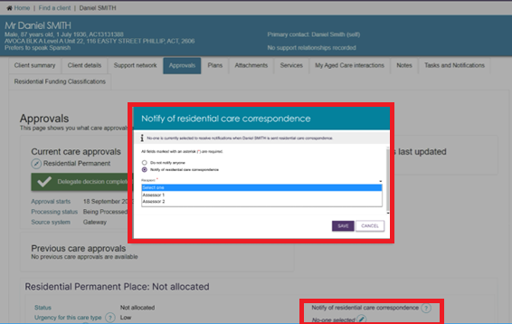
Outlet administrators can manage Residential care correspondence preferences.
To manage preferences:
- select the outlet, then go to its Tasks and Notifications tile, then the Manage Preferences tab. Select Change Preferences inside the pop up.
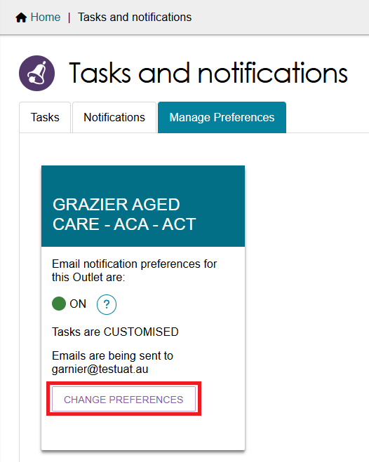
- Scroll down to the relevant section and adjust the settings by selecting the Yes/No toggles. The following shows an example of the RAC Place Restriction notification underneath the Delegate Decision heading. Toggles available are:
- Send an email when this type of notification is received?
- Show this type of notification in the portal when it is received?
- Show this type of notification as important?
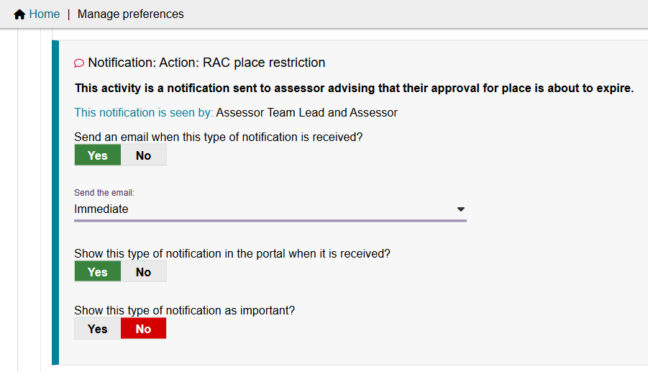
To view Residential Permanent correspondence notification for a client, go to the Tasks and Notifications tile, then go to the Notifications tab.
The below screenshot shows an example of a RAC Place Restriction notification.
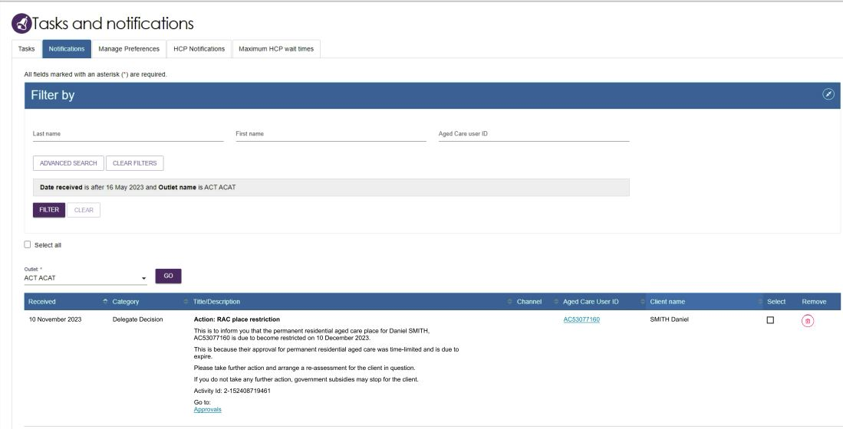

Confirming client contact information is accurate
To ensure correspondence is received, the client’s address details need to be correct. This is particularly important for Support at Home participants as they have 56 days in which to enter a Support at Home Service Agreement, with an additional 28 days if required.
To view and edit client’s contact details within the assessor portal follow the below instructions.
- From the client card, select Client Details.
- At the bottom of the client details page, select the pencil (edit) icon to then edit the client’s home and/or correspondence address.
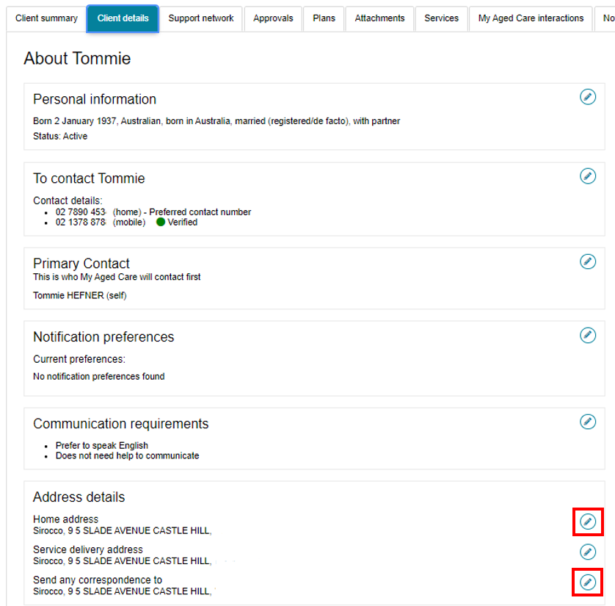

Creating Reports
Clinical assessors and assessment delegates and are able to create a report at the outlet level. The report will display the list of clients who have been nominated either by clinical assessors or assessment delegates and wish to receive notifications related to Support at Home.
- This report is accessed in Reports and documents tab.
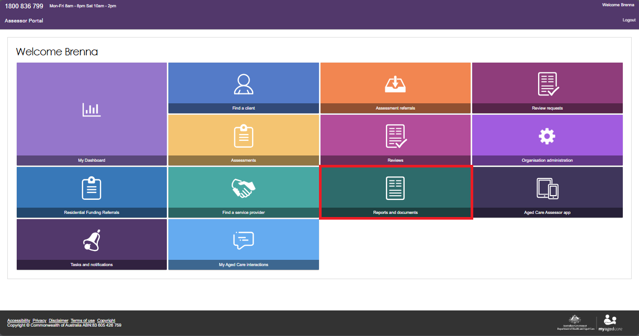
- Select the BIP Home Care Correspondence Notifications Report.
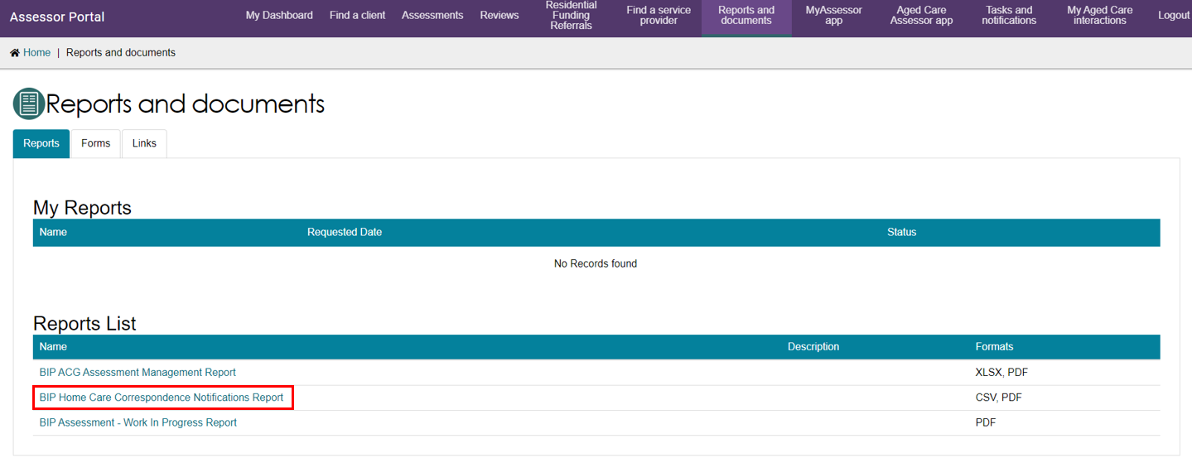
Select the Outlet, Recipient and Output Type being either CSV file (comma separate values) or PDF (portable document format).
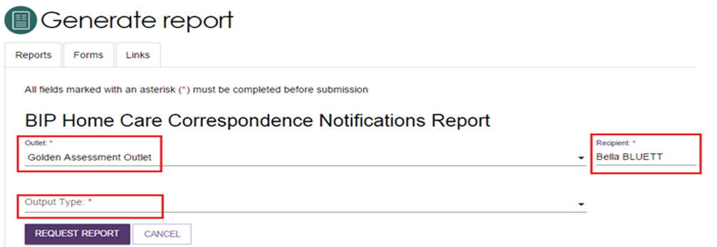

Support at Home correspondence sent to clients
There are a number of letters sent to clients related to Support at Home at different stages. Copies of these letters will also be sent to their supporter/s. Full details are contained in the client letter which will typically be available within 24 hours. The letter can be accessed from the Attachments tab in their client record.

List of Letters
Welcome Letter – This ‘Welcome’ letter is sent to newly registered participants*. The letter confirms their registration with My Aged Care, includes their unique Aged Care Id number and provides an overview of the next steps to progress through My Aged Care and other general information to support them. It also includes a brochure, magnet and TIS factsheet.
Not eligible for assessment Notice – The letter is sent to the participant* when the participant is found not to be eligible for an assessment.
Notice of Decision (Approval) – The letter is sent to the participant* after an assessment/re-assessment/Support Plan Review has been approved. This letter may include reasons for non-approval if specific services were requested and not approved. If ongoing Support at Home (SaH) – this letter does NOT mean that funding is available immediately.
Notice of Decision (Non-Approval) – The letter is sent to the participant after the initial assessment, when the older person is not approved to access any services; or following a reassessment or Support Plan Review where the older person is not approved to access any additional services.
Restorative Care Pathway (RCP) – Approval of 2nd unit of funding – The letter is sent to the participant* when a 2nd concurrent unit for the Restorative Care Program is approved by the delegate following a Support Plan Review.
Seeking Services Confirmation – The letter is sent to the participant* as part of the funding allocation process when they previously informed the department, they are not seeking services (for whatever reason, e.g. travelling) and now decide they are ready and are put back in the priority queue.
Funding Assignment Notice – This letter is sent to the participant* when funding becomes available for them to start receiving services after approval of their assessment. This offer can either be for some of their funding (60%) or all their funding.
Withdrawal Notice – sent to the client to inform the client when the funding for their approved aged care services has been withdrawn
Extension Confirmation Notice – The letter is sent to the participant* when they requested for an extension to start services with a service provider. They will get an additional 28 days to start services with a Service Provider (SP).
Upgrade Notice – This letter is sent to the participant* when funding becomes available after their reassessment for a higher classification and they are already receiving services. This can be for part of the increase or all the increase in funding.
Funding Assignment Consecutive – This letter is sent to the participant* when funding becomes available to start receiving services after delegate approval on their reassessment and they hadn't started services from their previous assessment/reassessment.
Withdrawal Notice – The letter is sent to the participant* when funding has been withdrawn. This can occur upon entry into Permanent Residential Care, when services did not start within the required timeframe, the participant advised they do not want services or when services were not recommenced within the required timeframe after previously exiting a SP.
Reinstatement Notice – The letter is sent to the participant* when their funding is reinstated. The funding was previously withdrawn and now has been reinstated.
Referral Code Reactivation – This letter is sent to the participant* when the referral code has been reactivated via the Assessor Portal, Client Portal and Contact Centre.
Reminder to Re-enter Support at Home – This letter will be sent to the participant* 270 days from the exit date from the Service Provider (SP) to notify them that they have until x date (last quarter of SP exit + 4 quarters) before their funding is withdrawn and thus, should start services with a SP.
Remaining funds released letter – The letter will be sent to the participant* when they were accessing MSO (Minimum Funding Offer – 60%) and now the remaining funding (40%) is available to receive more services.
* All letters will also be sent to Supporters if they are authorized to receive the participants correspondence.

