Assessor Portal User Guide 8 – Referring for services
A client may require services to support their needs as a result of an assessment.
Assessors may refer the client (with consent) for service recommendations made in the client’s support plan, based on the client’s preferred service provider (or prioritised list of service providers) and location preferences.
Table of Contents
Referral types 2
Sequential mode 2
Broadcast mode 2
Referral codes 2
No Care Approval 3
Urgent Referrals 3
Searching for service providers using the Find a Service Provider tile 3
Searching for service providers using the Service Finder in the Support Plan 12
Assessments tile 12
Find a Client tile 13
Tasks and Notifications tile 15
After support plan completion 16
Searching by map location 22
Referring for Help at Home and Aged Care Homes services 23
Issuing a referral for service 23
Recalling a referral 28
Issuing a referral code 30
Referring for Support at Home services 33
Support at Home Priority System and allocation of funding 33
Issuing a referral for service 33
Recalling a referral 37
Issuing a Support at Home referral code 39
Managing rejected service referrals 40

Referral types
! | Consent  You must obtain consent from the client and/or their supporter guardian prior to issuing a referral. This is complete by using the referral for services components of the My Aged Care Assessment Consent Form, which is available for download in the Documents & Reports tile in the My Aged Care assessor portal (assessor portal).  Refer to the Assessment Manual for more information about consent during referral generation.
For service recommendations made in the client’s support plan, you can search for and match a client to a preferred service provider (or prioritised list of service providers) based on the client’s preferred location and/or preferences, and service availability.
There are three types (modes) of referrals. You can:
- send a Sequential referral for service
- send a Broadcast referral for service, or
- provide the client with a referral code that allows them to visit providers prior to selecting their preferred provider.
You can also decline to refer, by issuing a “No Care Approval”.
! | For CHSP only: From 23 Feb 2026 for a Comprehensive Assessment, when a CHSP service is recommended, No Care Approval cannot be recommended and an error message will be displayed.  If No Care Approval is recommended, CHSP services cannot be recommended so the button to add CHSP services will not be displayed.

Sequential mode
The assessor will send the client’s referral to their chosen provider/s in the order of their preference. The client can limit their preference to one or more providers. If their first preference is not available, the referral is automatically sent to the next preference.
! | From 1 November 2025, All Residential Permanent service referrals are only sent via Broadcast mode.

Broadcast mode
The assessor will send the client’s referral to all available providers. In agreeing to a broadcast referral, multiple providers could contact the client to see if they can provide them with the service/s. If a provider accepts their referral, the other provider/s will no longer see their information.

Referral codes
For residential aged care services, assessors will normally generate a referral code for the client rather than issuing an electronic referral for service through the assessor portal. If a client has indicated preference or has been in discussions with particular provider/s, assessors can issue an electronic referral.
For Support at Home, once a client is allocated funding, they will also be assigned a referral code. This code will be mailed to the client with their funding allocation letter/upgrade letter or included in their support plan. Alternatively, assessors can provide this code (available in the client’s support plan) to the client to allow them to visit Support at Home program providers prior to selecting their preferred provider. In addition, where the client has indicated a preference or discussed options with a Support at Home provider, assessors can issue an electronic referral.

No Care Approval
If you have recommended ‘No Care Approval’ due to the client withdrawing their application for care or not wishing to apply for care under the Act, you can select COMPLETE SUPPORT PLAN AND CONTINUE TO MATCH AND REFER from any tab in the client’s support plan.

Urgent Referrals
Home support assessors, Comprehensive assessors and Triage delegates are able to send urgent service referrals to providers, regardless of delegate approval.
Urgent referrals can only be recommended during a client’s assessment. It cannot be recommended during the period of support, or during Support Plan Review. Urgent referrals to MPSP or NATSIFACP services can only occur if the client already has an active care type approval for a service other than these programs.

Searching for service providers using the Find a Service Provider tile
- You can search for service providers without going through the match and refer process by selecting the Find a service provider tile from the Assessor portal’s home page.
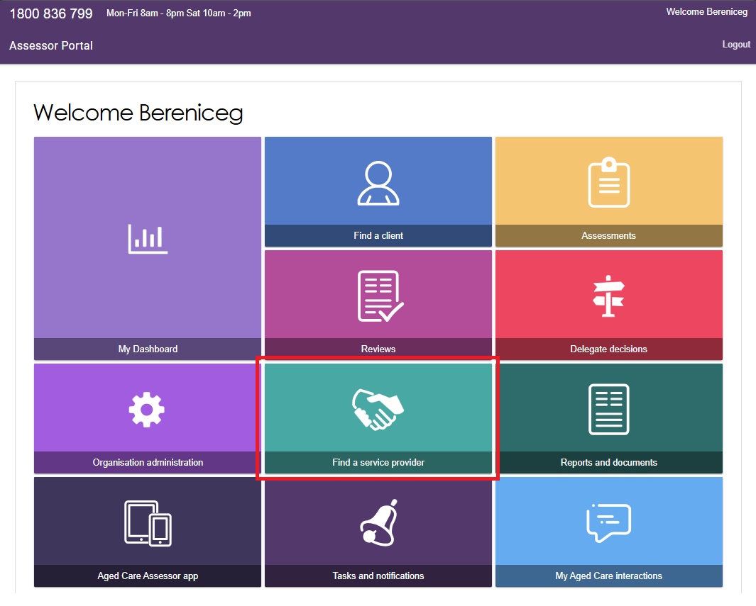
- The Find a service provider page appears.
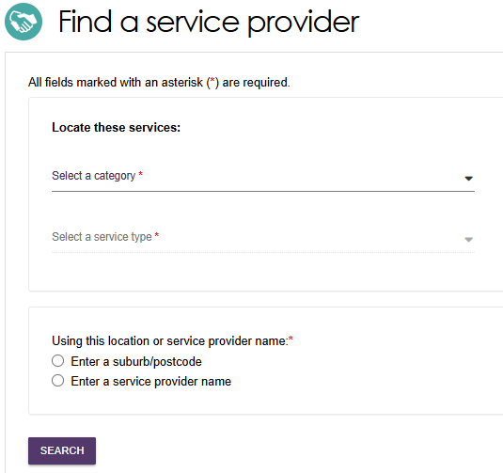
Select the service category from the drop down: Aged Care Homes, Help at Home, or Support at Home.
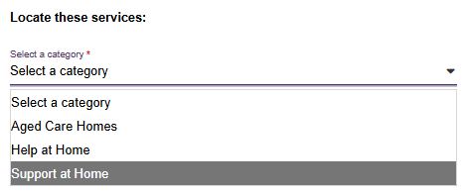
For Aged Care Homes, choose between Residential permanent, Residential Respite care, or Services under the MPSP (Multi-purpose service program).
Residential Respite High Care and Residential Respite Low Care are for historical searches only. These services are no longer offered.
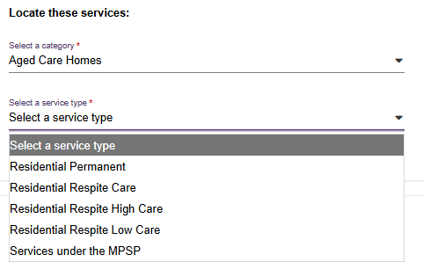
Help at Home services include:
- those that fall under the Commonwealth Home Support Program
- hoarding and squalor assistance
- services under the NATSIFACP (National Aboriginal and Torres Strait Islander Flexible Aged Care Program)
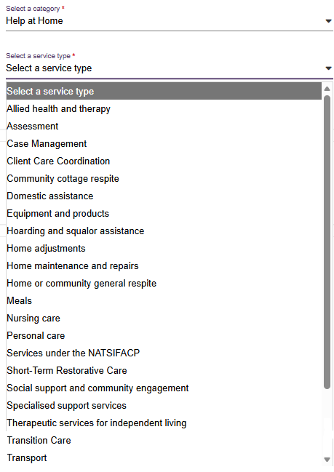

For Support At Home, you can select one or more service groups – Home modifications, Assistive technology, or Home support – then select one or more service types.
For Home modifications, only Home adjustments can be chosen.
For Assistive technology, only Equipment and products can be chosen.
For Home support, the dropdown shows the following available service types:
- Home or community general respite
- Nutrition
- Therapeutic services for independent living
- Domestic assistance
- Home maintenance and repairs
- Meals
- Social support and community engagement
- Transport
- Care management
- Restorative care management
- Personal care
- Nursing care
- Allied health and therapy.
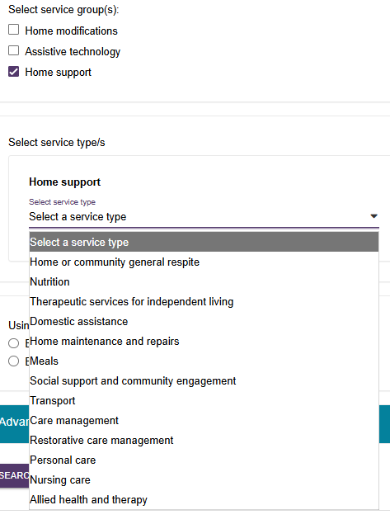

Some service types allow you to further select individual services.
In the Transport example below, select ADD/REMOVE SERVICES, then select Direct transport and/or Indirect transport.
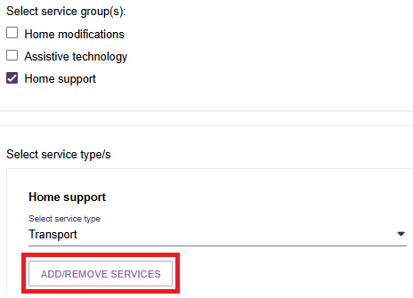
Be sure to select SAVE when complete.
This will take you back to the Find a service provider page.
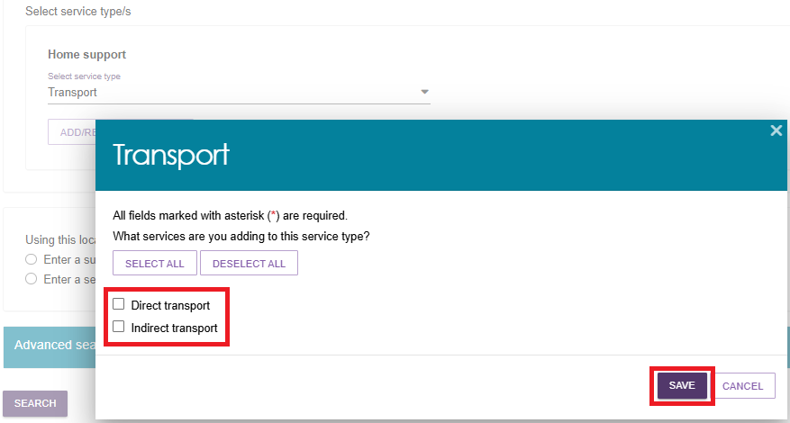

- Once your Help at Home, Aged Care Home, or Support at Home service is selected, you can either enter a suburb or postcode and then select from the drop down that appears, or enter a service provider name.
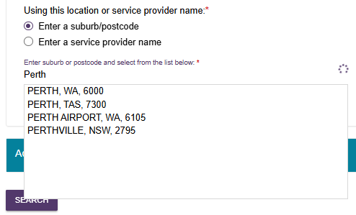
- Optionally you can expand to open the Advanced search section, and search for providers by their Diverse needs criteria, Specialised services, Language/s, Culture, Religion, or search by Keyword.
The Expanded Advanced search section
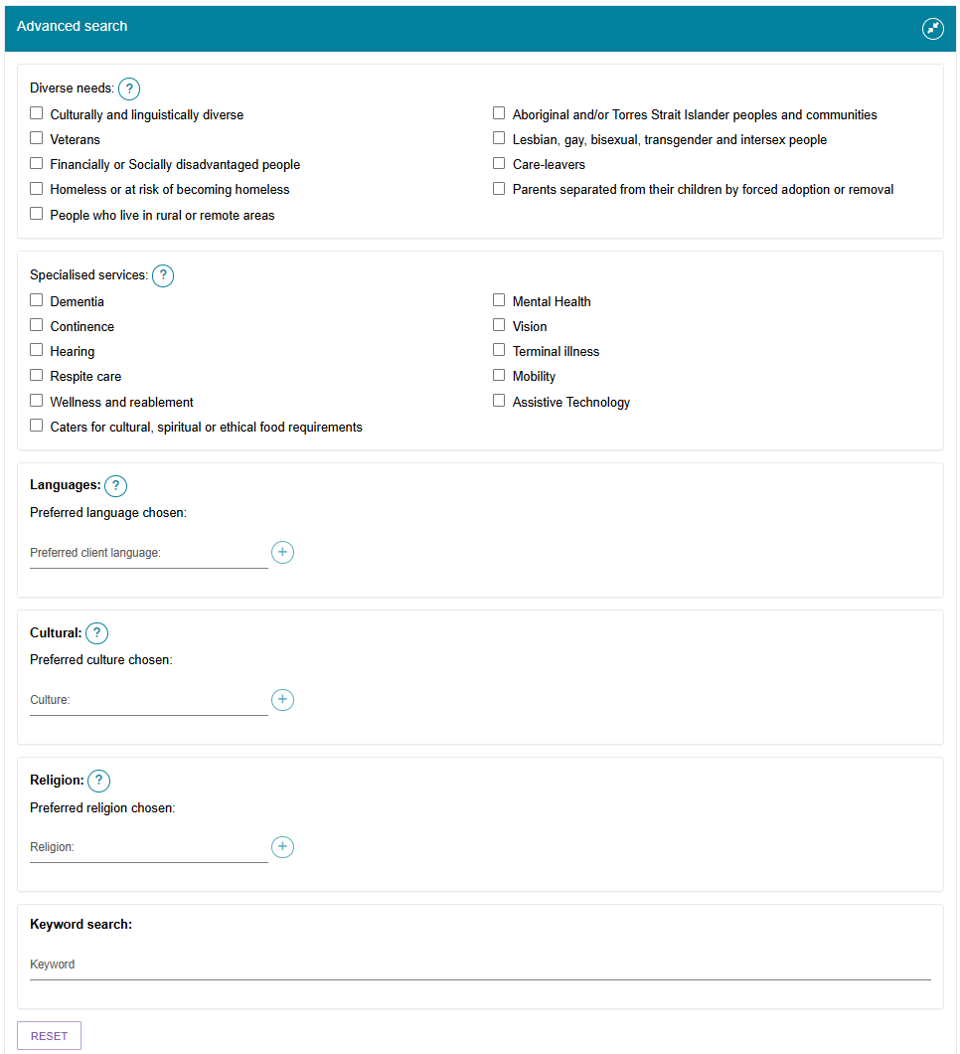
- Select SEARCH.
A list of matched providers appear. This example shows three out of the 40 providers that matched criteria. Each entry shows the provider’s name, location, phone number and service/s from the search that are supported.
Select the magnifying glass icon at the top right of the entry to view more information about the provider.
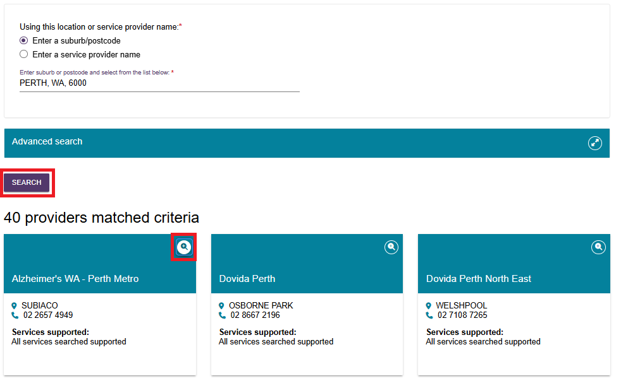
- The provider’s information appears in a separate page of the internet browser. The information shown include:
- Whether it is a Commonwealth Government recognised organisation
- A link to regulatory decisions information
- A list of service groups and types that are offered, service availability, classification type, and more information about each service
- Contact information
- (Support at home only) Pricing information including the full price list, website, and pricing schedule
- Any specialisations such as Diverse needs, Specialised services, Languages etc.
The example on the following page is a truncated view of a Support at Home service provider.
It offers services in three service groups: Assistive technology, Home modifications, and Home support.
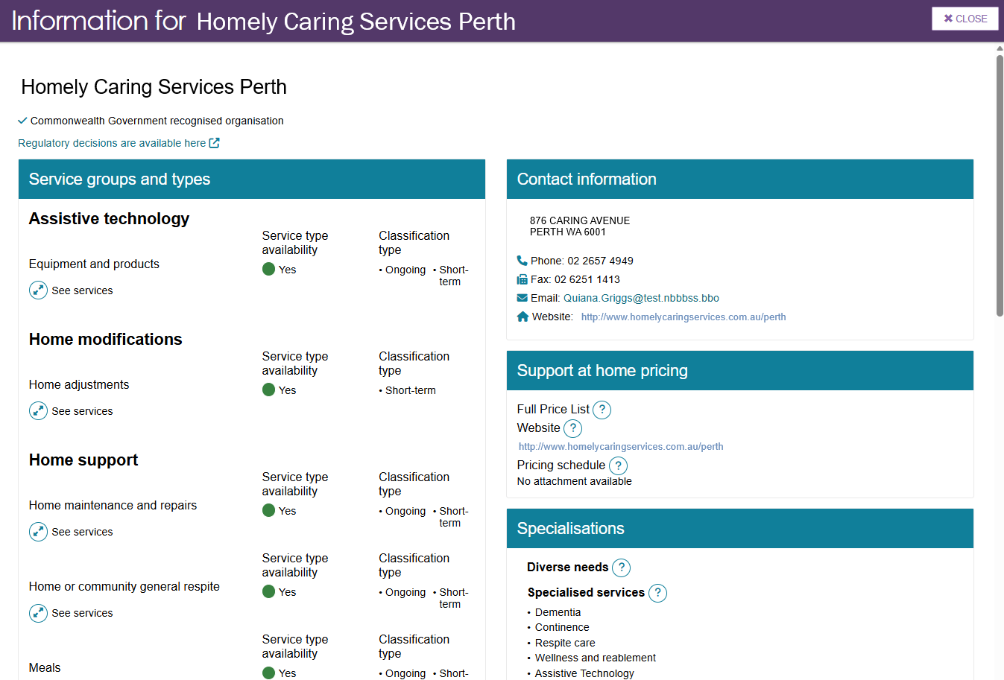
- Select the Question mark icon to show more information about the topic (help text).
This example shows the help text associated with the Support at Home Full Price List.
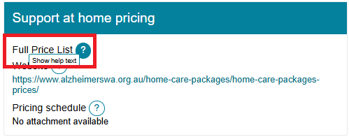
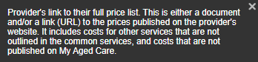
Select ‘See services’ to expand and ‘Hide services’ to hide the expanded view.
This image shows the expanded view of the Home support – Home maintenance and repairs section of the provider’s listing.
Select the Magnifying glass icon for more information on the service’s delivery hours and pricing.
These images below shows Gardening as an example.
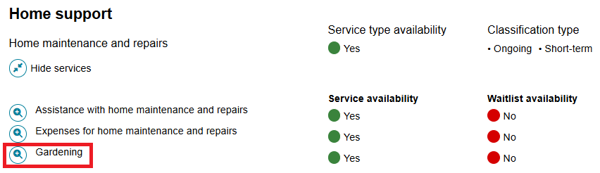
Gardening Service Details and Service Pricing
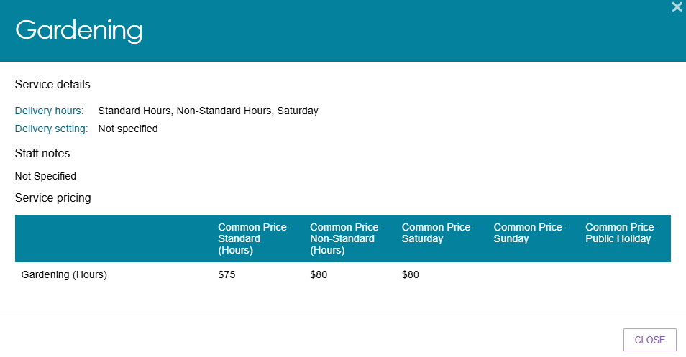

Searching for service providers using the Service Finder in the Support Plan
- To refer for services, you will firstly need to go to your client’s Support Plan and Services record. You can do this in 4 ways:
- via the Assessments tile
- Find A Client tile
- the Tasks and Notifications tile, or
- straight after completion of a support plan with the client.

Assessments tile
Select the Assessments tile from the assessor portal home screen.
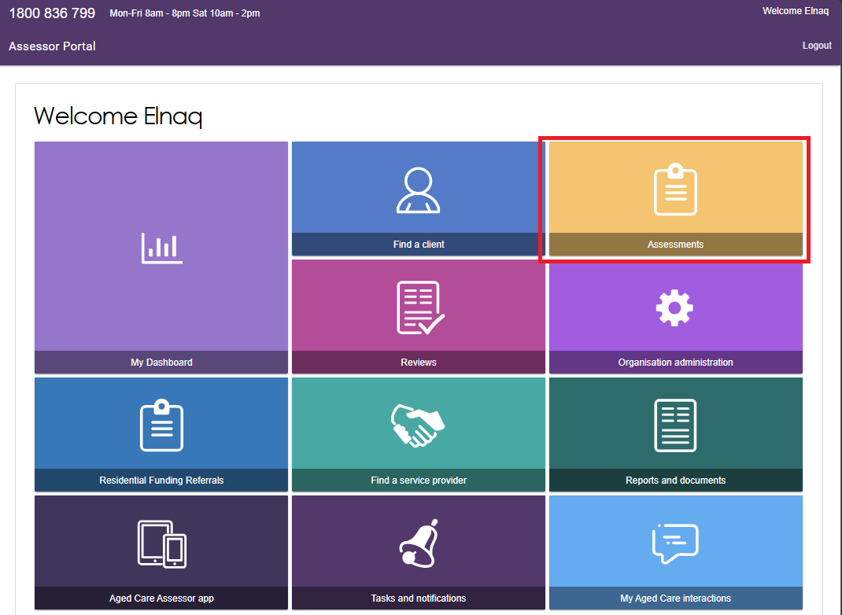
Select a client within the Current assessments tab.
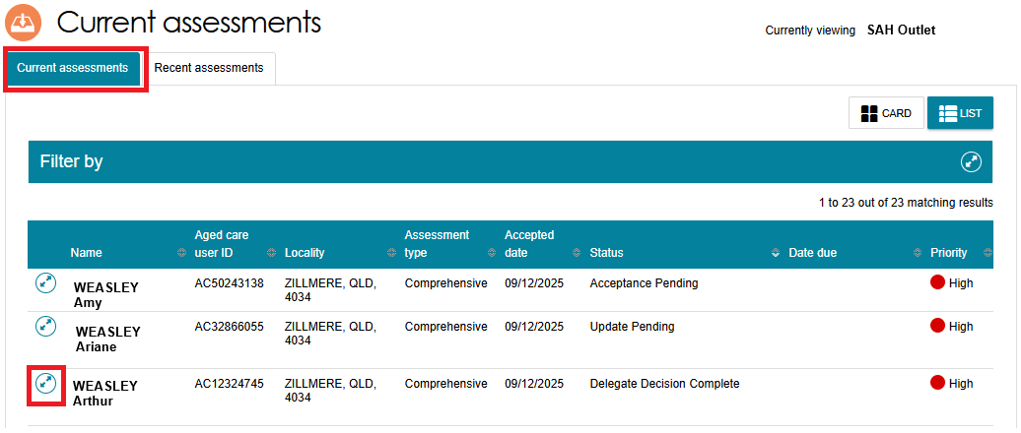
Then, select the client’s support plan link.
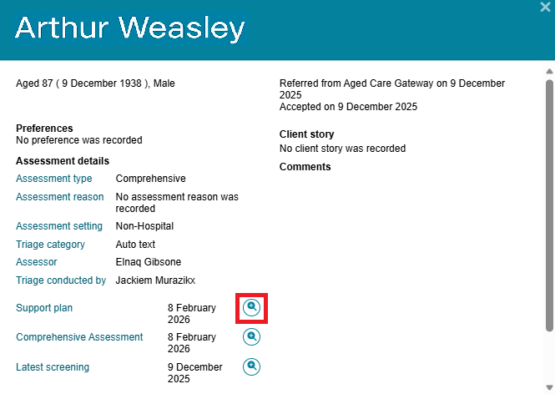

Find a Client tile
Select the Find a Client tile from the Assessor portal homepage.
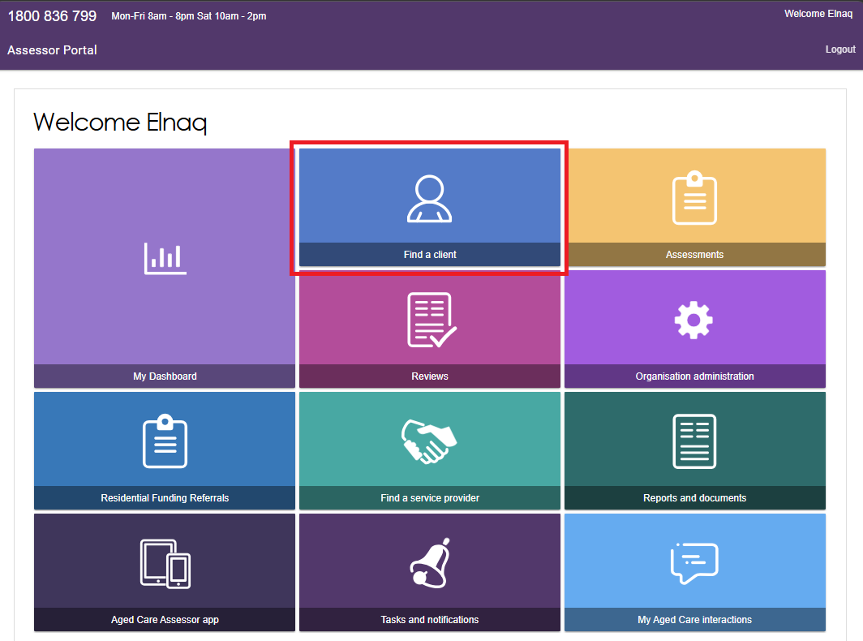

Search for your client directly using Last Name, First name, Aged Care user ID and/or Advanced Search functions.
Or you can select the client’s link if it is in the Recently Viewed Persons section.
Then, select the client’s listing.
Find a client page, searching by Last name and First name
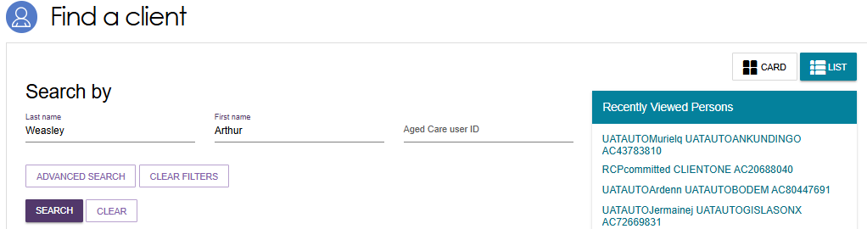
Find a client page with search results
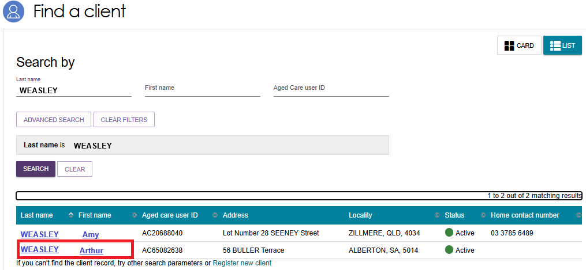

Tasks and Notifications tile
Select the Tasks and Notifications tile from the Assessor portal homepage.
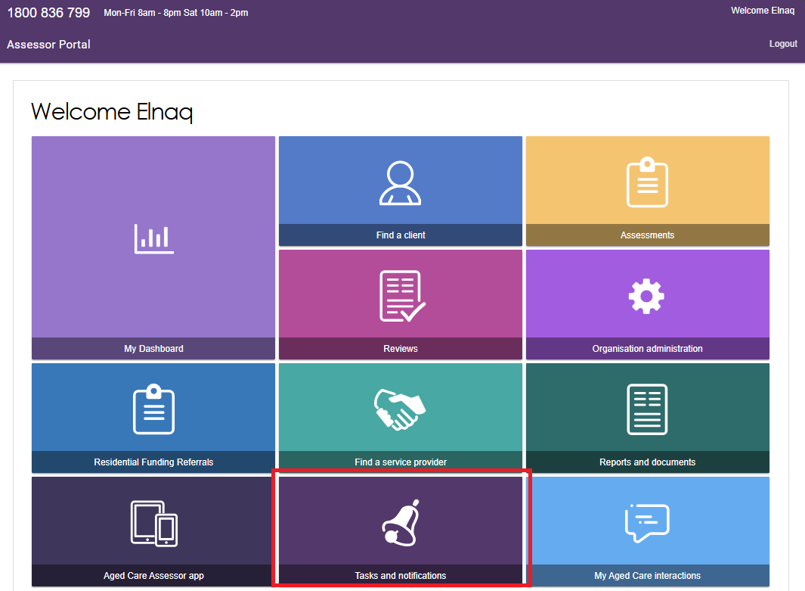
Go to the Notifications tab, then search for the client.
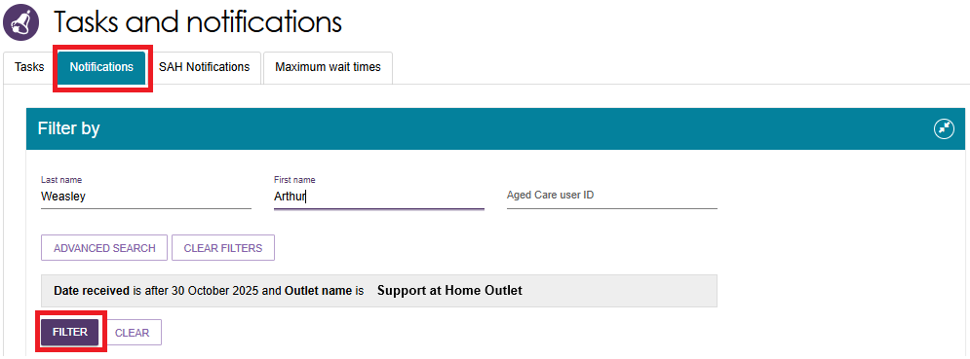
Select the Match and Refer link.
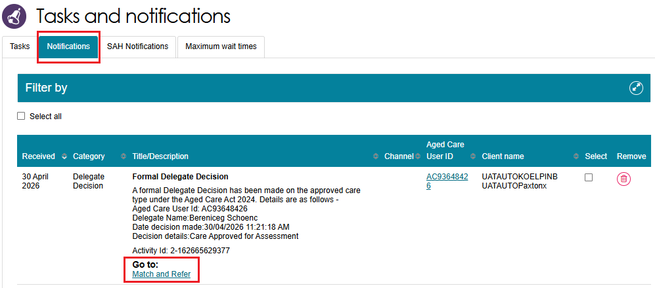

After support plan completion
- When you have finished developing the support plan with the client, you can select COMPLETE SUPPORT PLAN AND CONTINUE TO MATCH AND REFER.
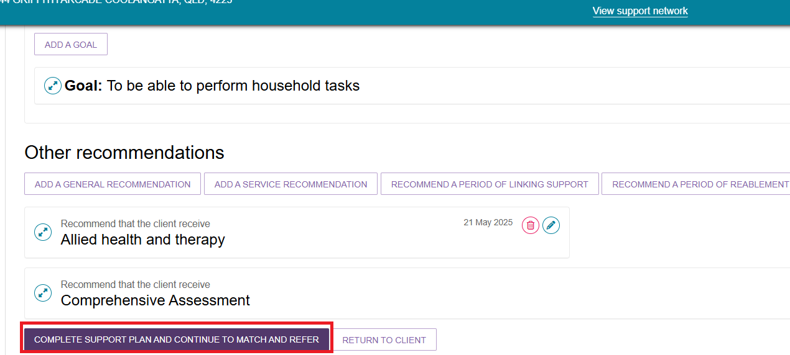
- You will be taken to the Manage services & referrals tab.
The services added in the Goals and recommendations tab of the support plan will be displayed under Services not yet in place.
Select FIND PROVIDERS to search and create electronic referrals for services.
Where available, you can also select multiple services.
In the below example, you can Select all Help at Home services, then select FIND HELP AT HOME PROVIDERS.
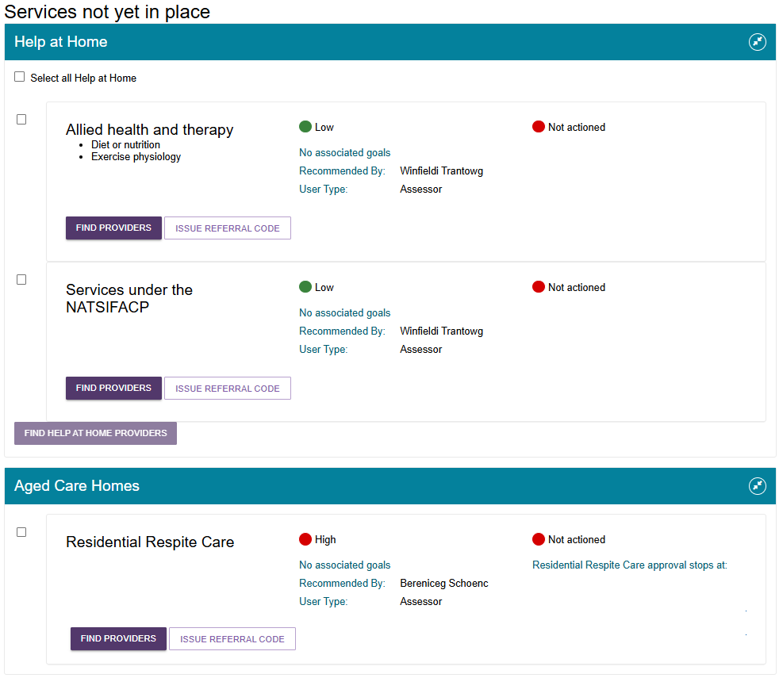

In the below example, all Aged Care Homes are already pre-selected, then you can select FIND AGED CARE HOMES PROVIDERS.
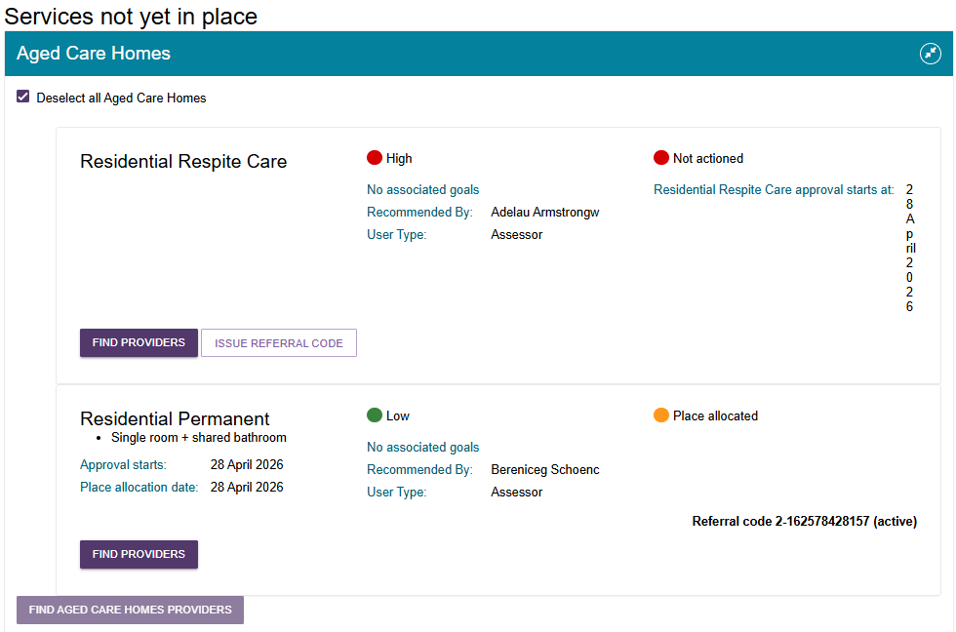
Below is an example of a client assessed for Support at Home services.
The FIND PROVIDERS button is only visible when Support at Home funding is available.
For more information refer to Referring for Support at Home services.
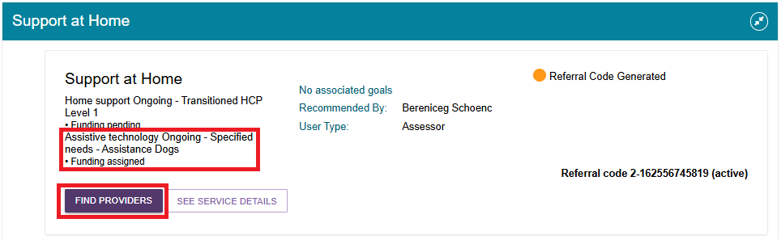
- The Service Finder page appears and displays the service/s you ticked in the previous step. It allows you to enter the search criteria for the service. Depending on the service type you are searching for, the search criteria may include, but not necessarily be limited to, the following:
- The list of services that are available for the service type selected, to further refine the search for a specific client need. For example, the ‘shopping assistance’ service under the ‘Domestic assistance’ service type.
- The client’s service delivery address for location-based searches
- Preferred service delivery setting: client location or service provider location
- Direct search for service providers by name or by proximity on a map.

Depending on the service selected, a location search may either be region/area based (for example: domestic assistance services delivered to the client’s home) or proximity based (for example: a centre or facility).
Detailed search options are available, including whether the client has previously received services with the service provider, or any specialisations required to cater for a client’s diverse or specialised needs.
The below image shows an example of the Service Finder page for two types of Help at Home services – Allied health and therapy, and Services under the NATSIFACP.
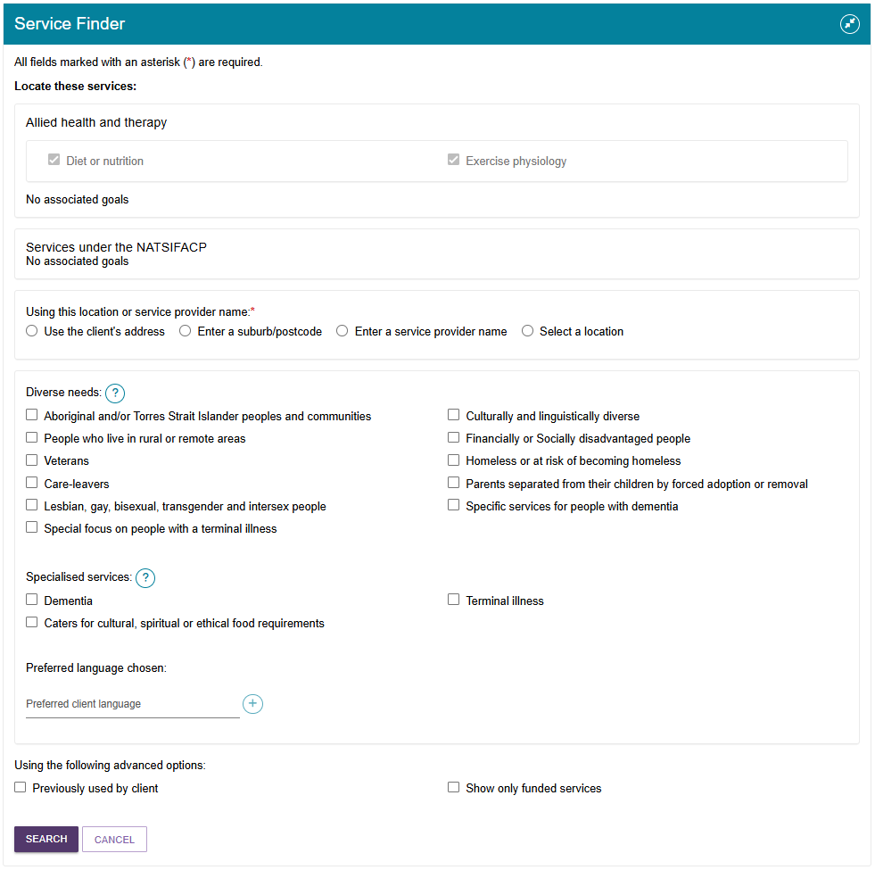
The image on the following page shows an example of the Service Finder page for three Support at Home services under Domestic assistance – Shopping assistance, General house cleaning, and Laundry services. The ‘General house cleaning’ option is ticked.
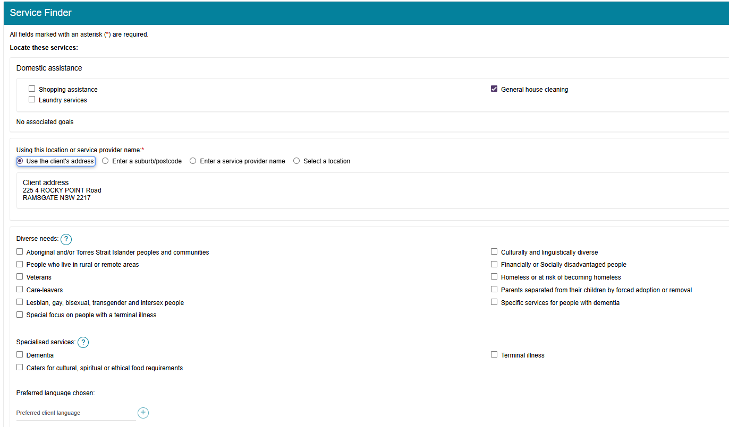
- Enter the search criteria. You can search by client’s address, suburb/postcode, map location, service provider name, diverse needs, specialised services, language etc.
For detailed information on searching by map location refer to this topic below.
Some further criteria display, depending on previous selections, such as how a service is delivered.
Then, select the SEARCH button.
- The search results will display in the following configuration depending on the criteria used when searching for services.
Search method | Service delivery location | Map View | List View
Client Address; or  Suburb/Postcode | At Client Location | Outlet Address | Outlet Address
Client Address; or  Suburb/Postcode; or  Select A Location | At Provider Location | Address where services will be delivered | Outlet Address and service delivery address (under the individual service)
Service provider name | N/A | Map will be hidden for all services except Residential Care services | Outlet Address and service delivery address (under the individual service)
As services can be offered at both provider and client location in a service delivery outlet (with the exception of residential care services) the map will be hidden when searching by service provider name, as these results will not display consistently on the map.
For more information on how to refer services from the Service Finder page, refer to:
- Referring for Help at Home and Aged Care Homes services
- Referring for Support at Home services.
Non-Support at Home Service Finder results page
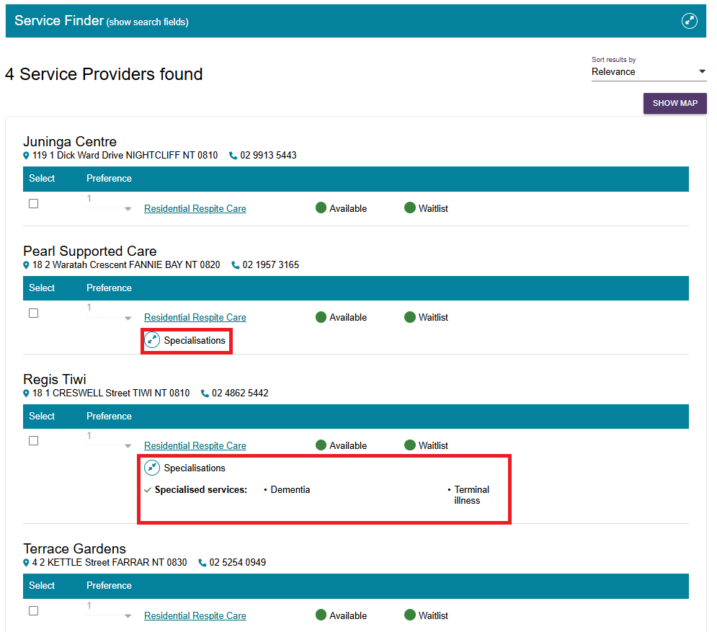
Support at Home Service Finder results page
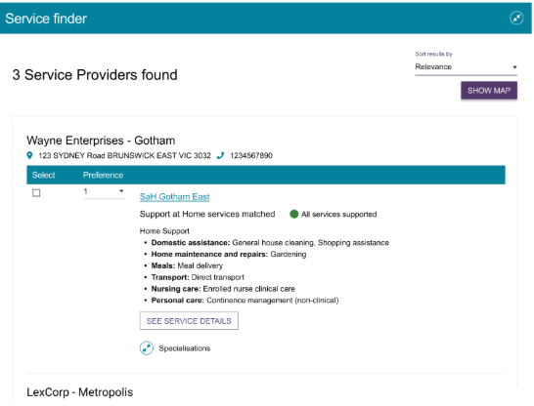

- Select the link in the provider’s listing to open a page containing more information about the provider.
Assessors can view any regulatory decisions made against the provider by selecting the Regulatory decisions are available here hyperlink under the provider’s contact details.
For care types under the Act, this page will also include information around the status of the service, costs of service etc.
For example, Residential Permanent services outline information around the facility’s accreditation and costs for different room types.
Information details page for a Residential Permanent provider
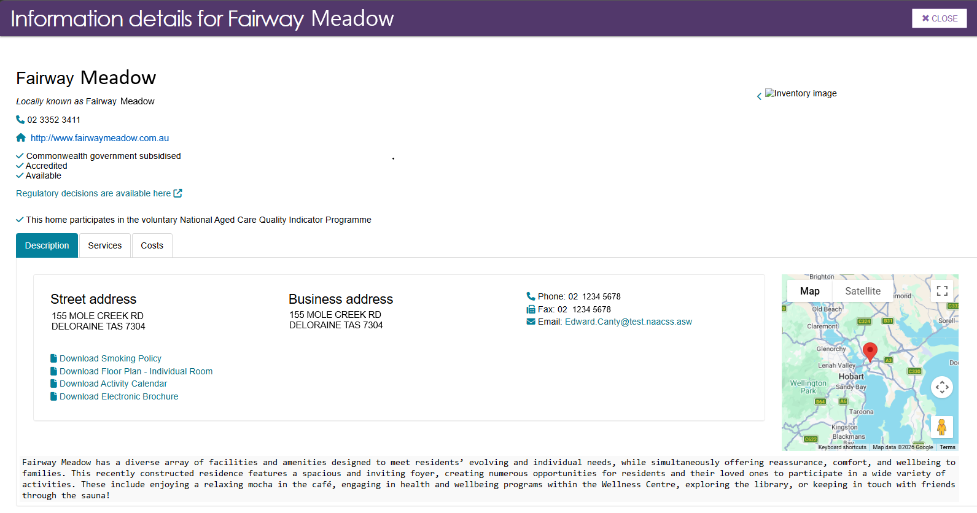
Information Page of a Support at Home provider (truncated example)
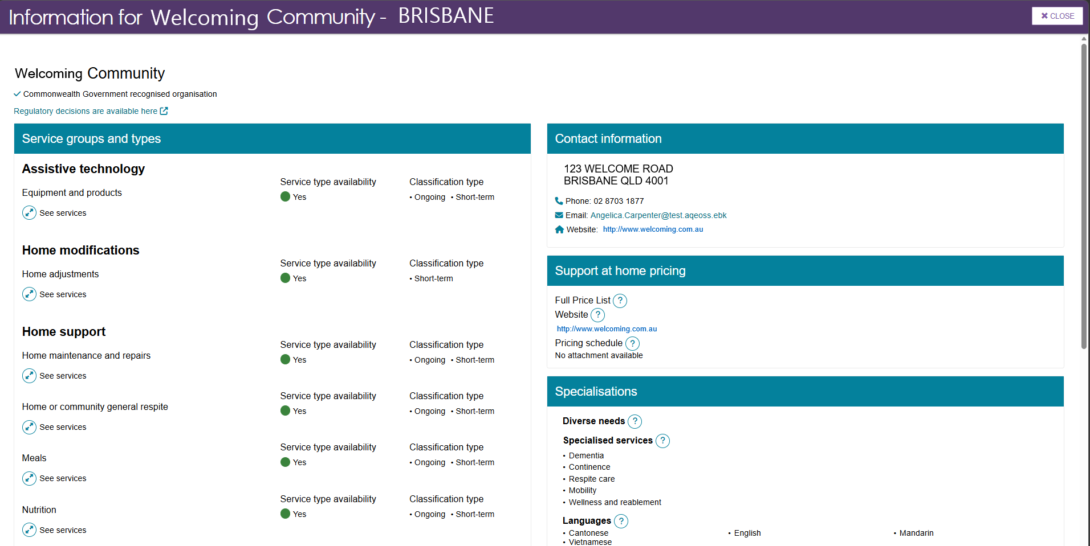

Searching by map location
- To search by map location, choose Select a location.
Select a location on the map by placing a pin with a mouse. Move the pin to select a different location. You can navigate around the map to view areas adjacent to the one currently displayed, by clicking and dragging the mouse. Then, enter the kilometre radius (such as 100km).
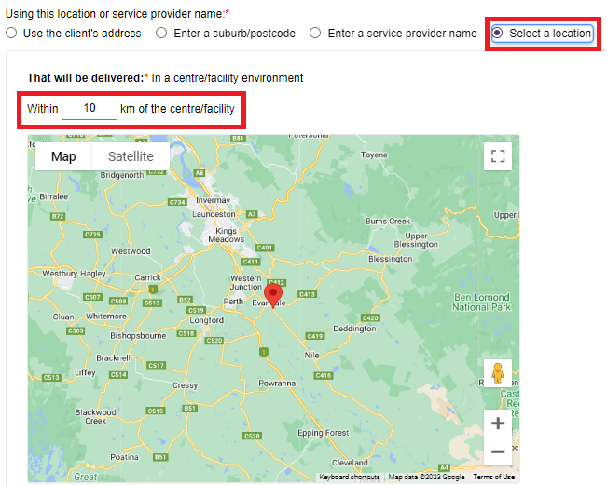
- The search results displayed will contain a list of service providers who provided services at a service delivery address within the search radius entered. In this example there are three providers (Pins 1, 2 and 3) that are within the search radius of the searched for location (Pin with no number).
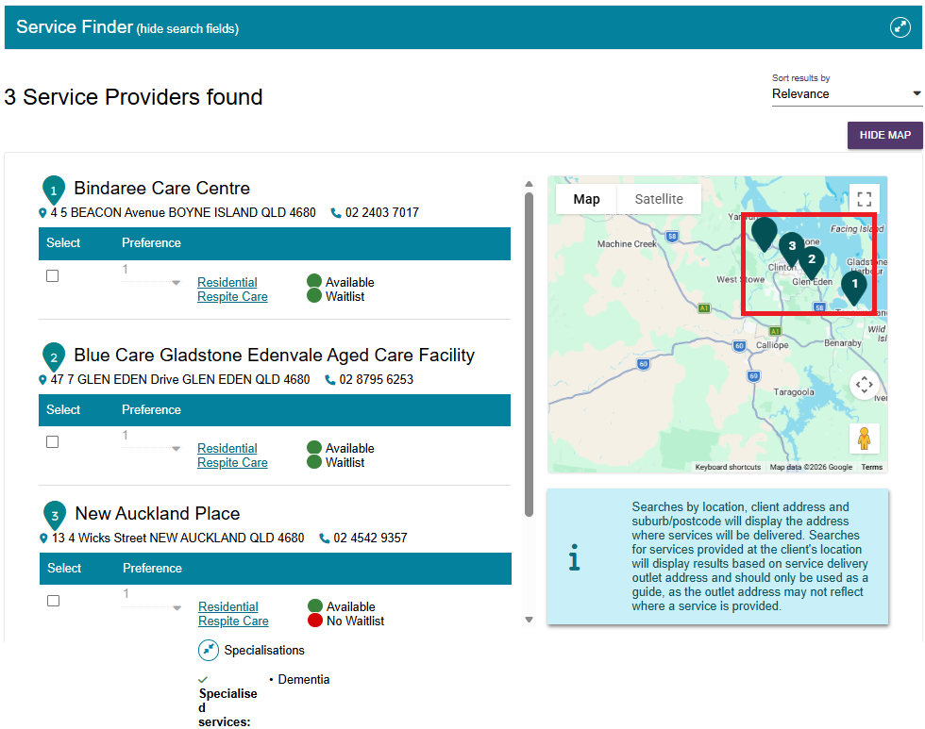

If there are no search results, there will be an information banner that shows which service/s you were searching for, and that ‘there were no providers found matching all of your applied search criteria. You may wish to revise your search criteria before searching again’.
- The search results will be sorted to display the most relevant service providers first or randomised in the case of equal relevance.
You can select Hide Map to switch to the list view and select Show Map when in the list view to revert to the map view.
Map view (truncated example)
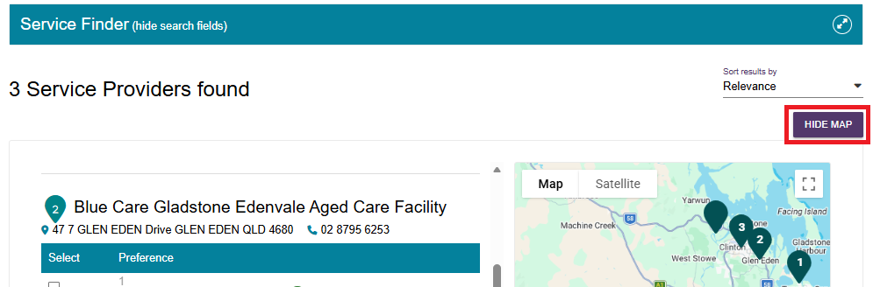
List view (truncated example)
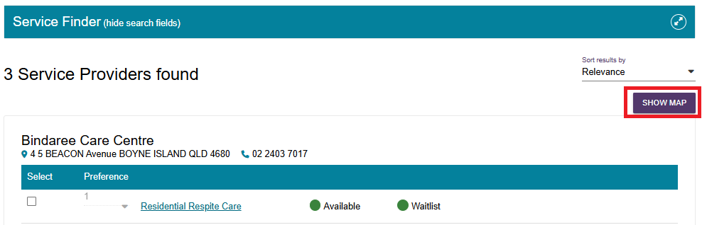

Referring for Help at Home and Aged Care Homes services

Issuing a referral for service
! | Prior consent required  You must obtain consent from the client or their supporter guardian in their support network prior to issuing a referral.  You should use the My Aged Care Assessment Consent Form.  The Consent Form includes the consent scripts and fields to record the consent for service referrals. It is located via the Reports and Documents tile within the assessor portal.

- After you have searched for Help at Home or Aged Care Home service providers (either via Find A Service Provider tile or using the Service Finder in the support plan), the Service Finder page now displays a list of service providers found.
Each provider listing includes a link named after the service that they provide (for example, ‘Residential respite care’.) The availability of services and waitlist options are displayed for each service provider.
Select the expand icon to view more information about the services (including availability and wait list availability) and specialised service offerings of each service provider. For Diverse Needs, only verified diverse needs specialisations will be shown.
Select ‘Hide services’ to hide the expanded view.
- Select the client's preferred service provider(s), ensure that you have the client’s consent to send the referrals, and select SAVE SELECTION AND CONSENT.
- For broadcast referrals, set preferences for all service providers to 1st. In agreeing to a broadcast referral, the client needs to be aware that multiple providers could contact them about their service referral.
- For sequential referrals, set preferences for service providers in order of the client’s preference.

This example below shows three Residential Permanent providers selected as broadcast referrals.
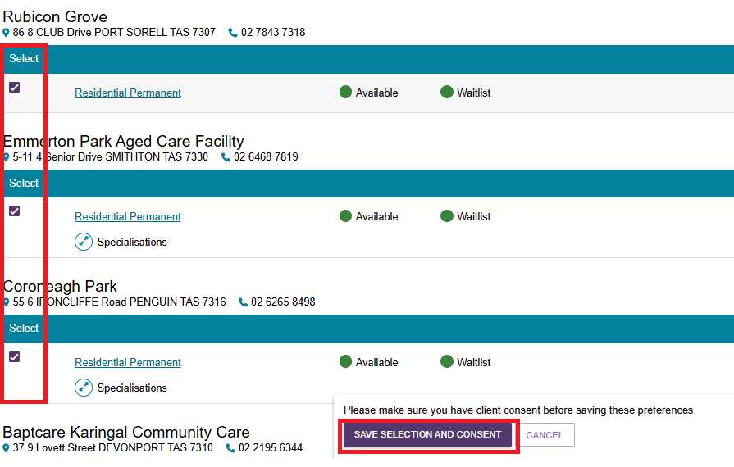
This example below shows three Residential Respite Care providers selected as sequential referrals.
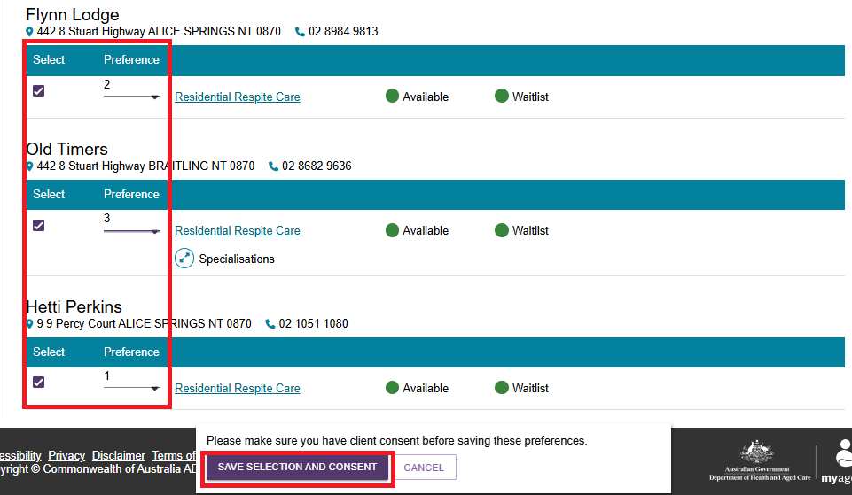

! | Waitlisting  If none of the client’s preferred service providers are available, they may wish to be placed on a waitlist. The search results will indicate whether a service provider has a waitlist available.  When referrals are sent sequentially and a provider accepts a client on to a waitlist, this will automatically trigger a referral to be issued to the next preference.  Clients may choose to be on multiple waitlists at the same time.  Clients will remain on a provider’s waitlist until the provider indicates services are available and accepts the client referral.  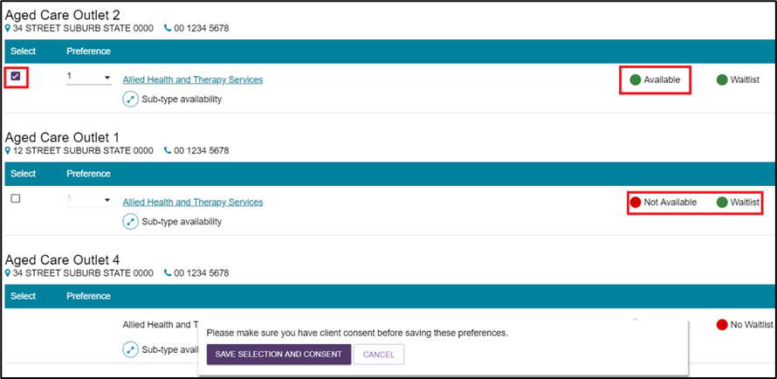
- The selected service provider(s) will now display as saved against the recommended service. Select CHANGE THIS SELECTION to choose additional provider preferences.
To edit or remove existing provider preferences, select EDIT PREFERENCES.
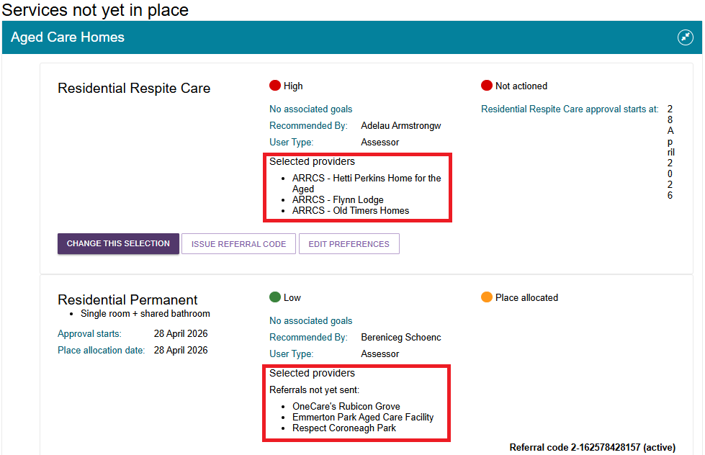
- To issue electronic referrals, select SEND REFERRALS.
! | The SEND REFERRALS button only appears under the following circumstances:  Non-urgent CHSP services: after delegate approval  Non-urgent MPSP or NATSIFACP services: client also has an active approval for residential care, transition care, home support, Assistive technology or Home modifications service/s.  All Urgent referrals (except for CHSP urgent referrals that are past the approval cease date)
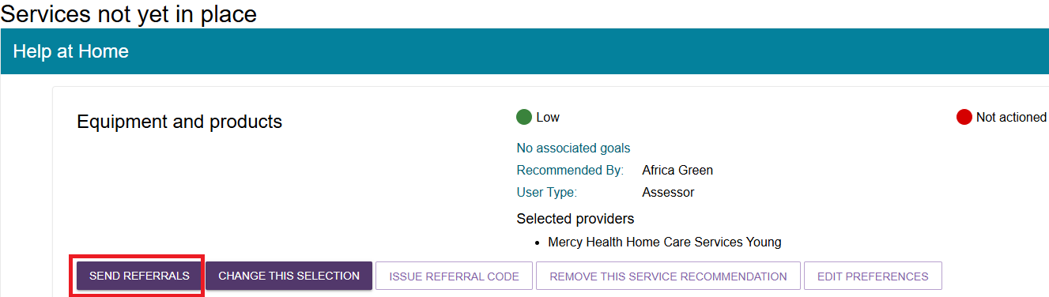
The Send Referrals screen then displays for you to review preferences and capture any other information relevant to the service provider prior to issuing the referrals. You can also REMOVE a service provider in this screen by ticking the relevant checkbox.
Once all information has been reviewed, select SEND REFERRALS.
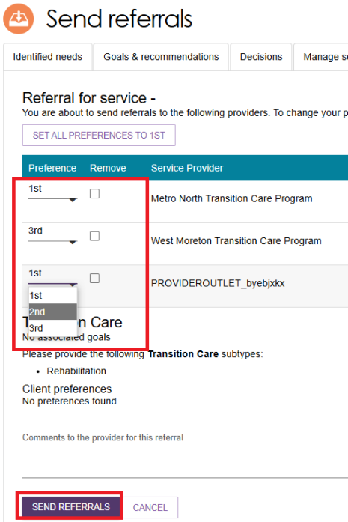
- You will receive a confirmation message that referrals have been sent. You will also be able to see a visual indicator of the status of the referrals.
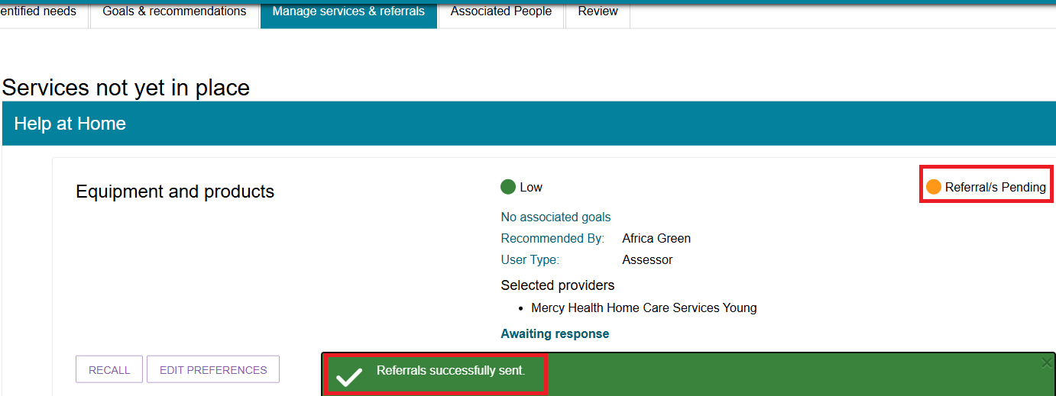
- Once the referral has been accepted, the service will be displayed under Services in place.
The referral statuses that will display are:
Category | Status
Service not yet in place | Not actioned, Rejected referral, Recalled referral, Referral/s pending, Accepted to waitlist
Services pending | Referral code generated, Referral accepted but services have not commenced
Service in place | Services are being provided

Recalling a referral
When a referral for a Help at Home or Aged Care Home service is issued, it is expected that the service provider will action the referral by accepting or rejecting it.
You can recall the referral before the service provider actions it.
- On the Manage services & referrals tab, select the RECALL button to recall the referral.
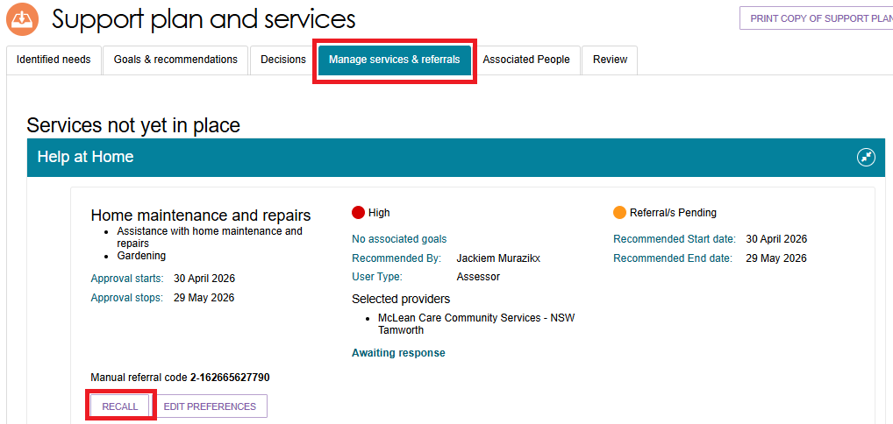

A pop-up box displays.
Select which provider to recall the referral from and select RECALL REFERRALS.
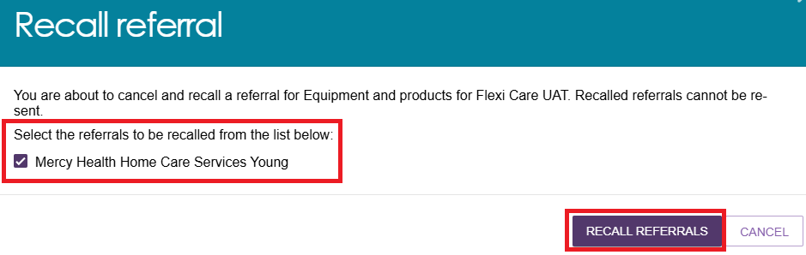
- You will receive a banner confirming that the referral/s are successfully recalled.
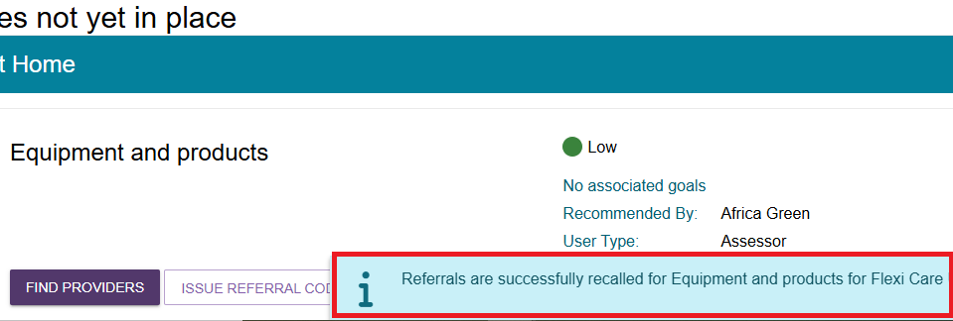
- The referral status will be updated to Recalled Referrals.
In the case of sequential preference referrals, the status of the referral will not change to Recalled Referrals until the final preference has been recalled.
If you recall a referral, you cannot send it to the same provider again. You can send referrals to different providers for that service.
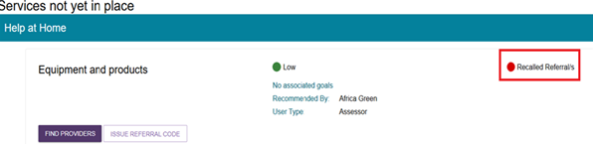

Issuing a referral code
! | Assessors cannot issue referral codes to the older person or service providers for all service referrals (including for CHSP) until after the Assessment Delegate has completed and signed a Notice of Decision.  For more information, please refer to Chapter 9: Finalising the Assessment and Service Referral of My Aged Care Assessment Manual.  The ISSUE REFERRAL CODE button only appears under the following circumstances:  All CHSP services: after delegate approval  Non-urgent MPSP or NATSIFACP services: client also has an active approval for residential care, transition care, home support, Assistive technology or Home modifications service/s.  All Urgent referrals (except for CHSP urgent referrals that are past the approval cease date)
- Select the Manage services & referrals tab from the client’s Support Plan and select ISSUE REFERRAL CODE for the service.
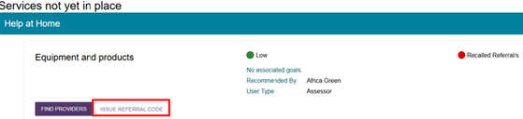
- A confirmation message will be displayed. Select ISSUE REFERRAL CODE.
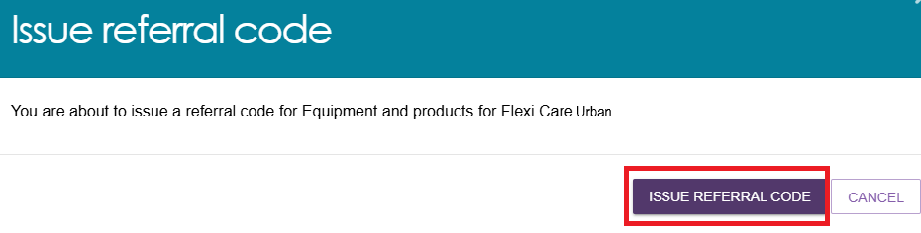
- You will receive a confirmation message that the referral code has been generated, and the details of the referral will appear under the Services pending section.
The referral code will be displayed on the referral list, and the referral code letter should be printed and provided to the client.
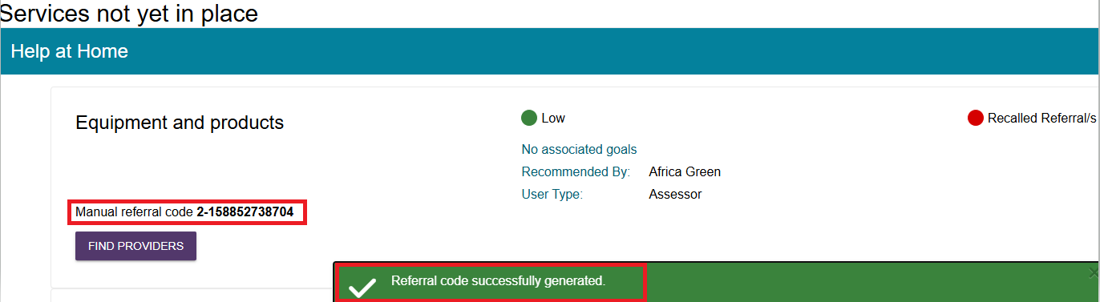

- Select GENERATE REFERRAL CODE LETTER to print the referral code letter.
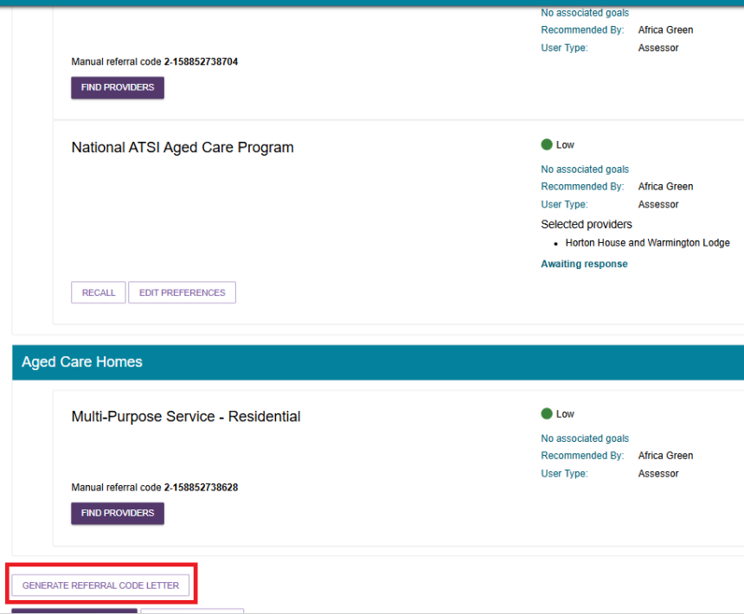
- A processing window will be displayed indicating the letter being generated.
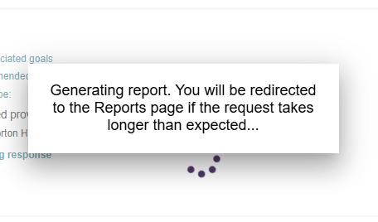

- The generated report (letter) will be available under the REPORTS AND DOCUMENTS page ready to be downloaded.
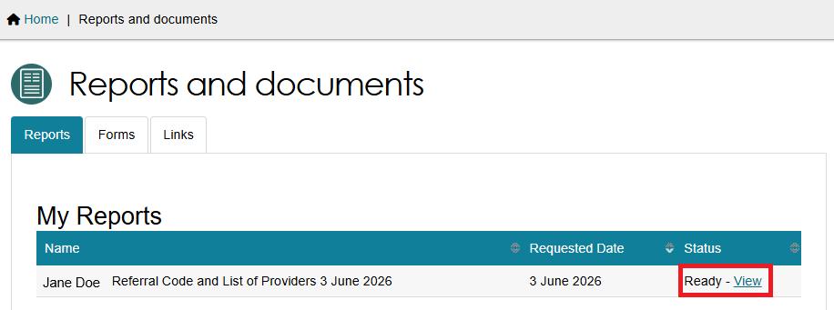
- Below is an example copy of the generated referral code letter.
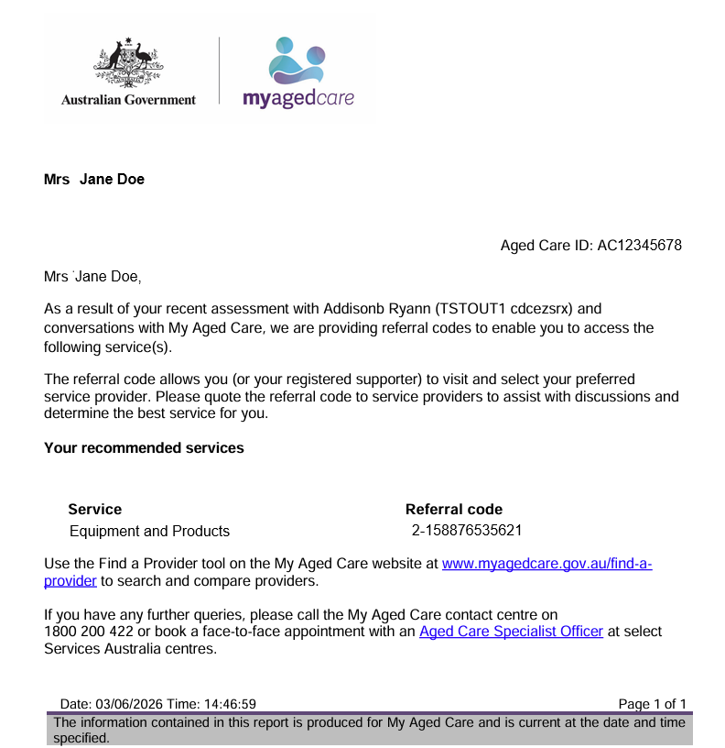

Referring for Support at Home services
! | Prior consent required  You must obtain consent from the client or their supporter guardian in their support network prior to issuing a referral.  You should use the My Aged Care Assessment Consent Form.  The Consent Form includes the consent scripts and fields to record the consent for service referrals. It is located via the Reports and Documents tile within the assessor portal.

Support at Home Priority System and allocation of funding
For Home Support services, you will be able to match and refer for a service provider when the client has been allocated ongoing classification funding from the Support at Home Priority System or immediately following approval for the Restorative Care Pathway or End-of-Life Pathway.
On allocation of ongoing classification funding, a referral code is generated, and a letter is sent to the client, with a copy to their supporter/s, instructing them that they can use the referral code to start services prior to the take-up deadline.
For the Restorative Care Pathway or End-of-Life Pathway, a referral code is generated in the client’s support plan (if no service referral has been made and the older person has not been approved for an ongoing Support at Home classification previously). The Notice of Decision will advise the client to start services prior to the take-up deadline and what to do if their current provider does not provide Restorative Care.
If the client and/or their supporter has elected to receive email notifications, they will also receive an email notification on assignment of their classification funding.
For more information about setting up and configuring email notifications for clients and/or their supporters, refer to My Aged Care - Assessor Portal User Guide 2 - Registering support people and adding relationships.
If you have elected to receive notification of Support at Home correspondence for the client, you will receive a notification of this and you can proceed to matching and referral if you wish. All electronic referrals should be issued in the client’s support plan under Manage services & referrals.

Issuing a referral for service
- After you have searched for Support at Home service providers (either via Find A Service Provider tile or using the Service Finder in the support plan), The Service Finder page now displays a list of service providers found.
Each provider listing includes a link named after the organisation’s outlet name. More than one outlet from the same organisation may be displayed. The providers are ranked in the order of highest number of matching Home Support services to the lowest.
Each listing also contain a visual indicator to let you know that the outlet has All services supported, Partial services supported, or No services supported. A list of actual Home Support services matched will display underneath the visual indicator.
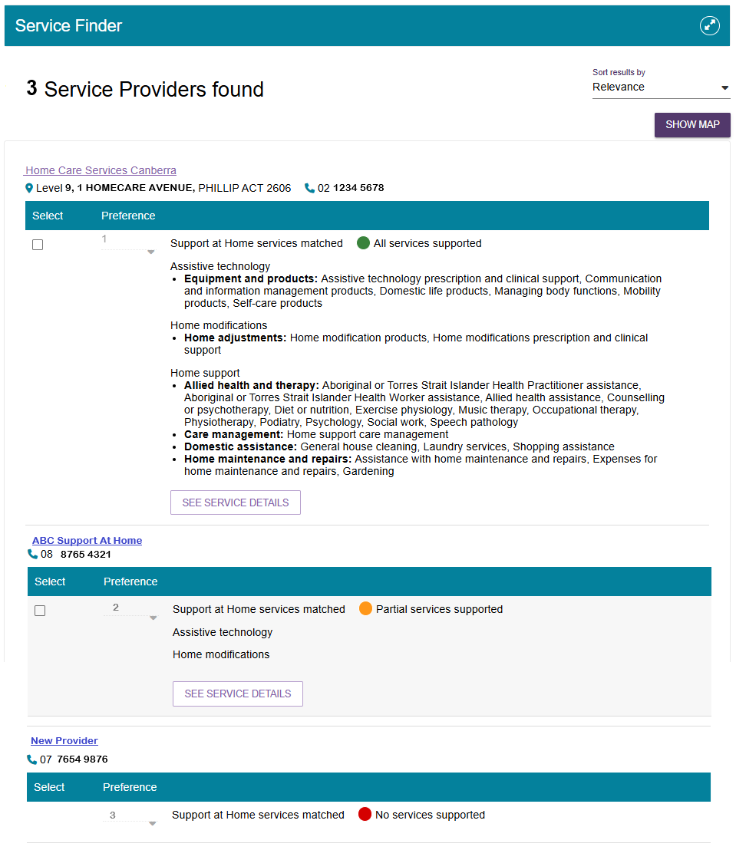
Finally, select SEE SERVICE DETAILS to view more information about the service, including service availability and waitlist options.
Select the expand icon or ‘See services’ to view more information about the services (including availability and wait list availability) and specialised service offerings of each service provider.
For Diverse Needs, only verified diverse needs specialisations will be shown.
Select ‘Hide services’ to hide the expanded view.
Service Details pop up
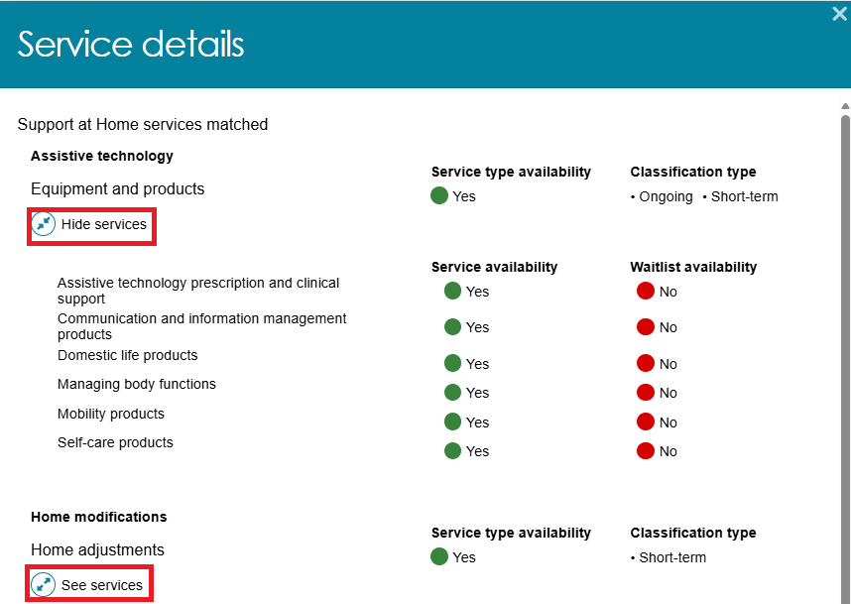
- To select Providers, select the tickbox next to the providers’ listings, then select the preference from its drop down. 1 indicating the top preference, 2 indicating the second preference and so on.
Finally, select SAVE SELECTION AND CONSENT from the bottom of the screen.
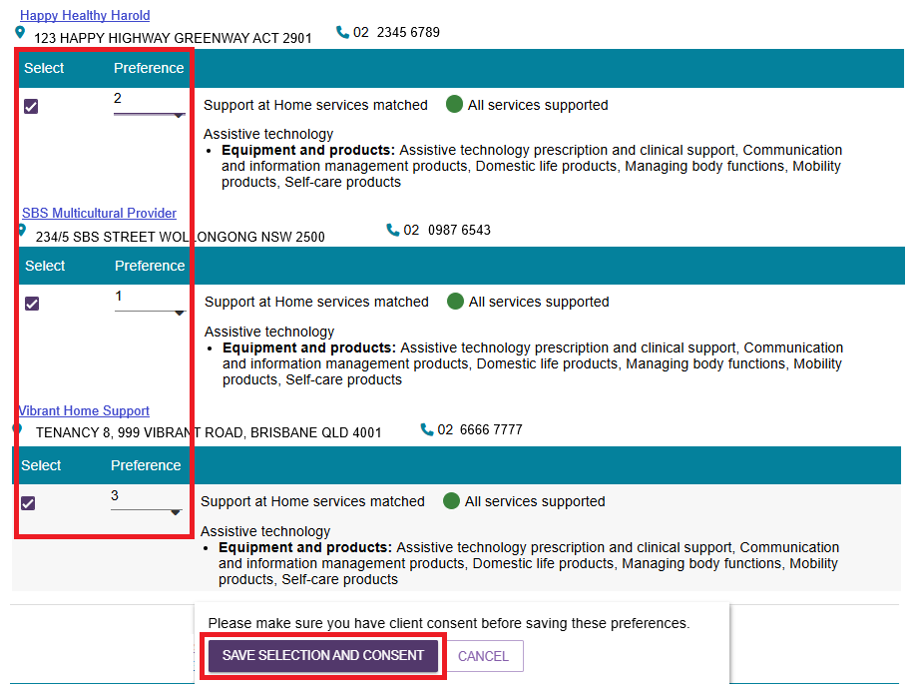
If successful, a green banner displays: ‘You have successfully saved your referral selection(s) and associated preferences.

- The client’s Manage Services & Referrals tab now shows the list of selected providers.
Select SEND REFERRALS.
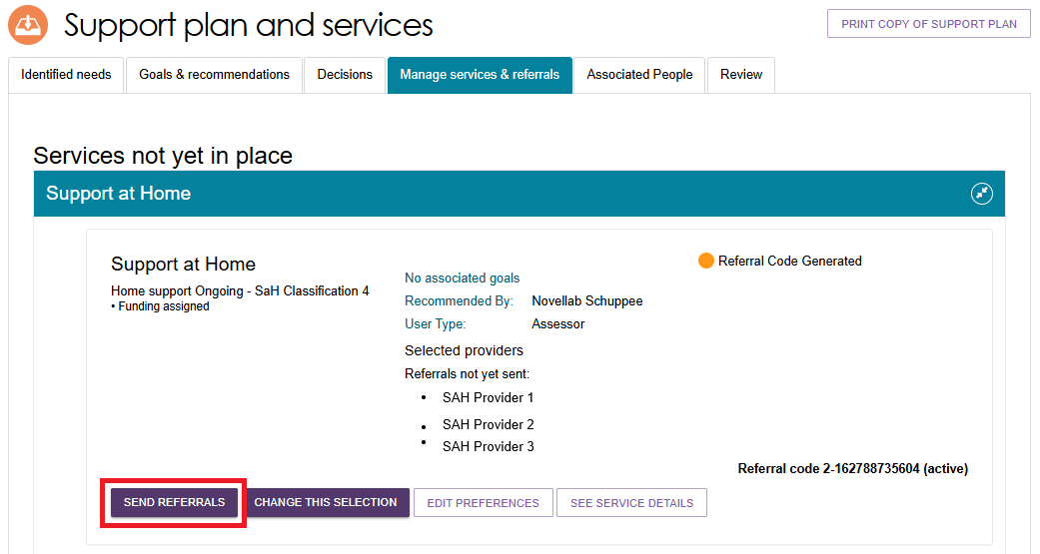
- The Send Referrals page appears.
This gives another chance to edit your preferences – you can:
- Set all preferences to First – select SET ALL PREFERNECES TO 1st
- Remove a selection by ticking the checkbox next to the provider in the Remove column
- Change the preference by selecting the current preference in the Preference column, then select the new preference in the drop down that appears.
Optionally, you can write some comments to the prospective provider in the text box labelled Comments to the provider for this referral.
Then, select SEND REFERRALS.
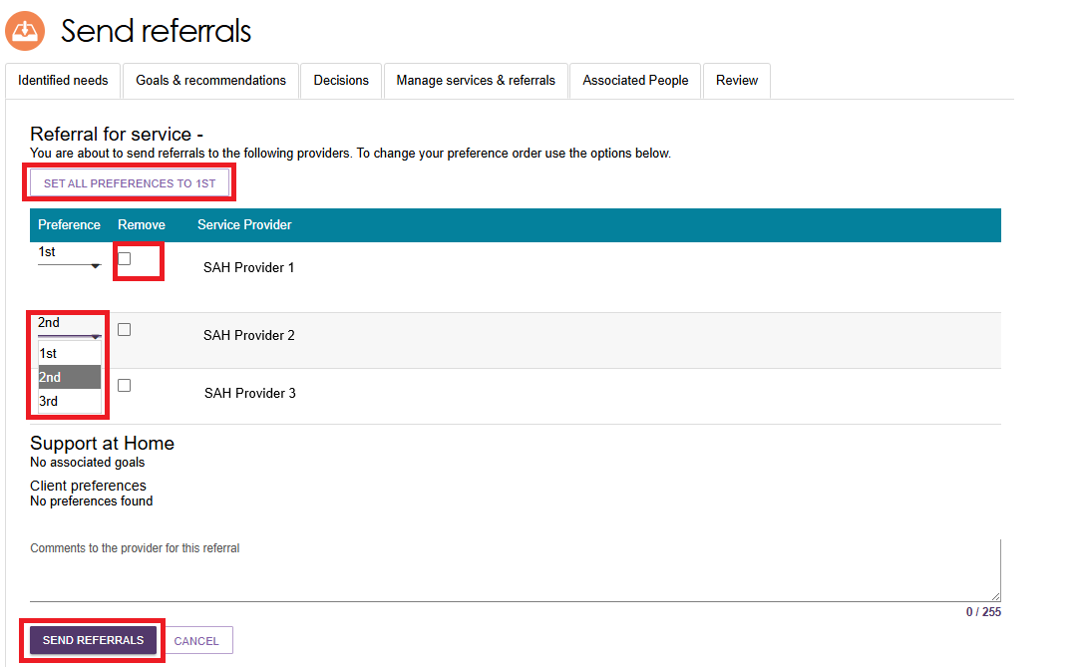

- The client’s Manage Services & Referrals tab now shows a status of Referral/s Pending for Support At Home services.
It also shows the list of selected providers in order of Referral status.
For a sequential referral, the top preference is sent first. Any other providers will have a status of Awaiting Response.
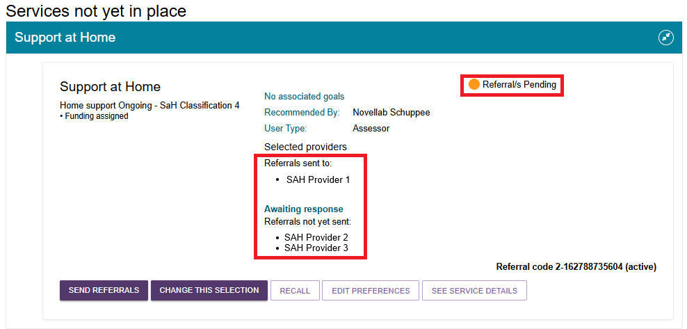
You can now also:
- SEND REFERRALS for the referrals that are not yet sent.
- CHANGE THIS SELECTION which will open the Service Finder.
- RECALL one or more referral/s.
- EDIT PREFERENCES, which will also show you current waitlist status and availability of your providers.
- SEE SERVICE DETAILS.

Recalling a referral
- To recall a Support at Home service referral, select RECALL from the Support at Home Referral listing.
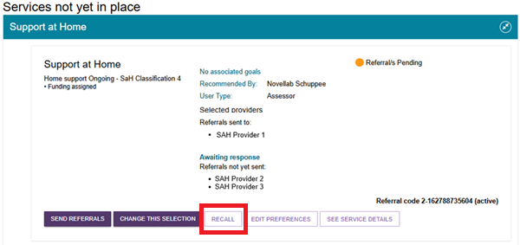
- The Recall Referral pop up appears. Select the referral/s from the list by ticking its checkbox, then select RECALL REFERRALS.
In this example, the Top preference is being recalled.
Recalled referrals cannot be re-sent.
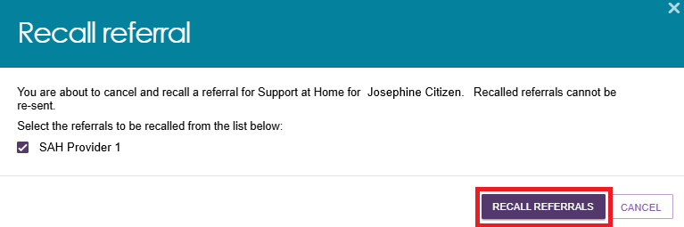
- If successful, an information banner appears: ‘Referrals are successfully recalled for Support at Home for [Client’s name]’.
- The client’s Manage Services & Referrals tab now reflects the cancellation of the referral.
In a Sequential referral scenario, the Referrals Sent To section now shows the second preference.
The Referrals not yet sent section now reflects the third preference.
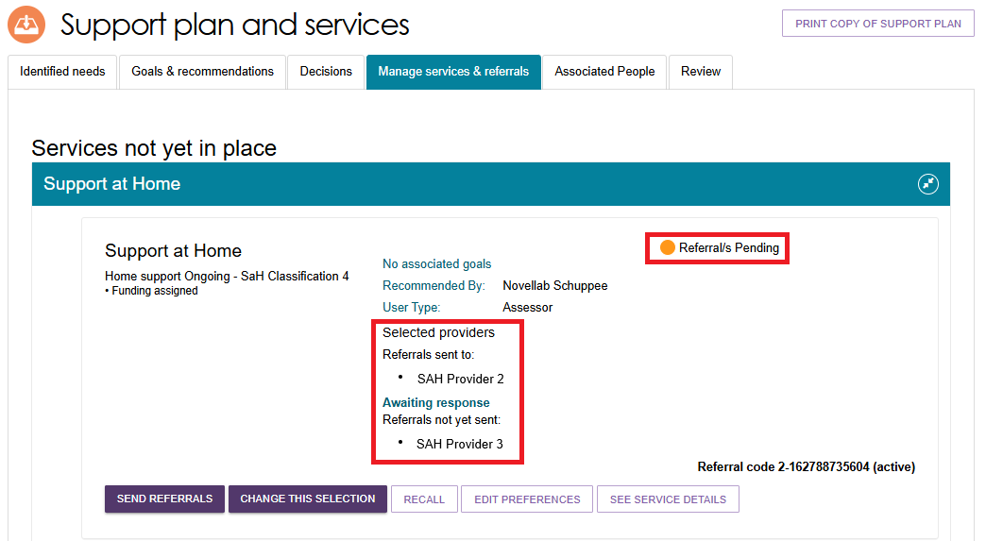

Issuing a Support at Home referral code
A client can change providers without changing their referral code.
You can view the referral status of a Support at Home service in the client’s Manage Services & Referrals tab.
It is located in the top right corner of the service listing and it can be one of the following:
- Active – a client is assigned a Support at Home classification, and the referral code can be used.
- Used – an old referral code for a previous approval that can no longer be used by the client or the service provider for referrals.
- Inactive – this status will display if a client has notified that they are not seeking services and/or has had an assigned Support at Home classification withdrawn and not replaced or upgraded.
- Disabled – this status will display once a service referral is accepted. The referral code is disabled and unable to be used by other providers until it is reactivated.
If a client wishes to reactivate their referral code, for example they might be changing providers, a client or supporter can do this via the My Aged Care online account or by contacting the My Aged Care contact centre.
Assessors can also perform this function in the Manage Services & Referrals tab of the support plan.
The following screenshot shows a disabled referral code, and the REACTIVATE REFERRAL CODE button highlighted.
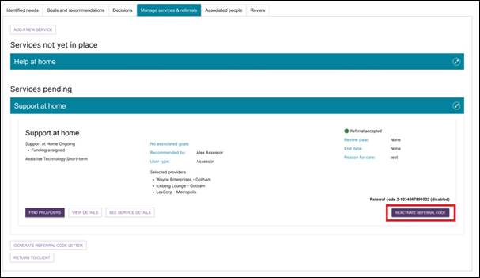

Managing rejected service referrals
To connect clients to appropriate service providers and ensure consistency for clients, any referrals sent by you will be returned to you for actioning if they are rejected and there are no referral preferences for the client remaining.
Where a referral for service is rejected, and it is the client’s final preference, assessors will:
- Receive a notification that the referral was rejected (an All Referrals Rejected task); and
- Be able to reissue referrals to different providers or accept a provider’s offer to waitlist, based on discussion with the client.
Follow these steps to follow up a rejected referral:
- Navigate to the Tasks tab in the Tasks and notifications section and select the All Referrals Rejected link to navigate directly to the client’s support plan or the Aged Care User ID link to navigate to the client record.
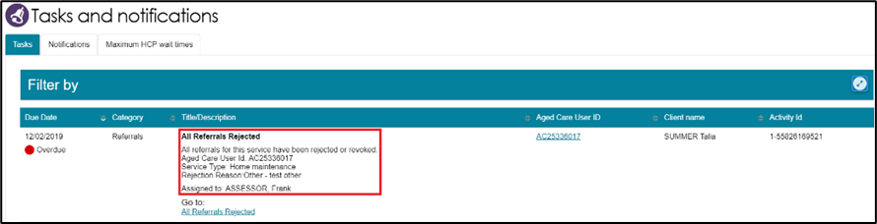
Alternatively, if you know the client’s name you can view all tasks and notifications for an individual client in the Tasks and Notifications tab in the client record.
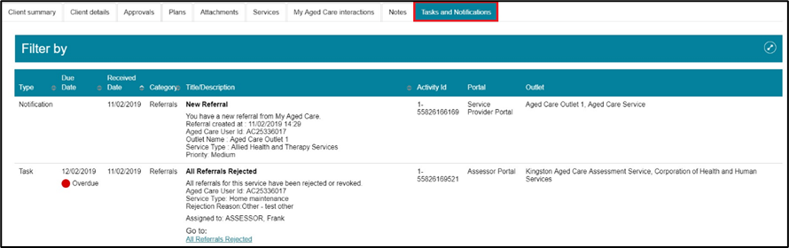
- If navigating directly from the notification, the Manage services & referrals tab in the client’s support plan will open, where the rejected service type will be displayed with Rejected Referral/s on the recommendation.
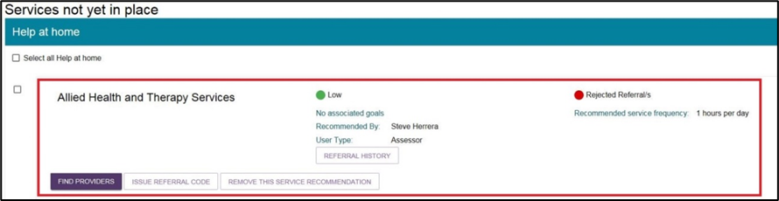

You will also be able to see the status of any other of the client’s referrals.
- Navigate to the Manage services & referrals tab to see the status of the client’s referrals.
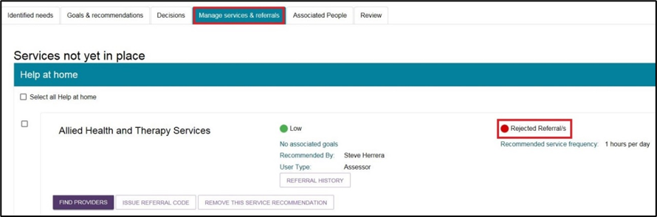
For Rejected Referrals, select Referral history to see the further detail about the reason the referral was rejected.
- You can now send referrals to new providers or generate a referral code for the client, following the steps described earlier in this guide.
Based on the referral rejection reason, you may be required to add further information to a client’s referral or need to discuss alternative options with the client prior to issuing another referral.

