Assessor Portal User Guide 2 - Registering Support people and adding Relationships
This user guide is for aged care needs assessors (assessors) who need to register support people or administer their relationships with clients.
This is usually done through the My Aged Care assessor portal (assessor portal), though some aspects may be completed through the Aged Care Assessor App (the App).
A client can have a support network of Registered Supporters, other individuals, agents, organisations and particular staff members of approved organisations.
Registered Supporters consists of three types: Supporter, Supporter Lite, and Supporter guardian.
The support network will support the clients in their interactions with My Aged Care, including talking to assessors, service providers, the My Aged Care contact centre.

Table of contents
Types of support for clients 3
Supporter 3
Supporter Lite 4
Supporter Guardian 4
Supporter Organisation and Organisational Supporters 5
Supporter Guardian Organisation and Organisational Supporter Guardians 5
Agent Organisation and Organisational Agents 5
How can I nominate/request to register a person or organisation as a registered Supporter or agent? 6
Viewing my client’s relationships 6
Creating a Supporter relationship 8
Creating a Supporter Lite relationship 17
Activating a Supporter Lite relationship 20
Creating a Supporter Guardian relationship 23
Creating a Supporter Organisation relationship 32
Creating a Supporter Guardian Organisation relationship 38
Creating an Organisational Agent relationship 43
Creating a Carer, Emergency Contact, GP, or Support Person relationship 47
Registering a new person for a support relationship 50
Activating a pending relationship 55
Via Assessment Referrals 55
Via Support Network Tab 57
Removing a relationship 61
Viewing Suspended Relationships 64
Viewing Declined, Ended and Cancelled relationship 66
Configuring notification preferences for clients and their support people 67
Verifying Mobile Phone Number 68
Configuring Notification Preferences 69
Requesting a call back from Carer Gateway or National Dementia Helpline 71
Viewing call back and consent history 72
More information 73

Types of support for clients
The following types of support are available for older Australians (known as ‘clients’ in the Assessor Portal):
- Supporter.
- Supporter Lite.
- Supporter Guardian.
- Supporter Organisation.
- Agent Organisation.
Along with the client’s General Practitioner, emergency contacts and carer (if applicable). This forms the client’s Support Network for accessing My Aged Care services.
! | Aged Care Act (2024) and Registered Supporters  The Aged Care Act (2024) is in effect from 1 November 2025.  Registered Supporter is an umbrella term used in policy to refer to any person registered as a Supporter under section 37(1) of the Act. There are three labels used to describe registered Supporters: Supporter, Supporter Lite, or Supporter Guardian.  Registered Supporters are responsible for understanding their role and duties and acting in line with the will and preferences of the older person they are supporting.  A registered Supporter is a person who must have a record in My Aged Care, and who is likely to be a trusted person of the client, such as neighbours, friends or family members.  Only the terms Supporter, Supporter Lite and Supporter Guardian appear In the Assessor Portal and others in the My Aged Care system.

Supporter
A Supporter (previously known as ‘regular representative’) can request, access and communicate information in line with a client’s will and preferences. This includes conveying the client’s decisions such as their consent.
For Supporter relationships, both the Supporter and the client must consent to the relationship before it becomes active. The client must also consent to information being shared automatically (‘data sharing’). This is information that may or must be given to the client under the Act. The Supporter must also complete a mandatory Conflict of Interest (COI) declaration.
The Supporter may:
- receive copies of the client’s correspondence (including Support at Home letters) – if the correspondence is information that may or must be provided to the client under the Act, the Supporter receives this information by virtue of the client’s consent at the point of registration. If not, the Supporter may request the information in line with the client’s will and preferences.
- convey the decisions of the client to others (such as their consent) in line with the client’s will and preferences in My Aged Care.
- be the client’s primary contact, if directed by the client (or client’s Supporter Guardian).

Supporter Lite
A Supporter Lite differs from a Supporter in that the client has not consented to information being shared automatically (‘data sharing’). This is information that may or must be given to the client under the Act. This means that the Supporter Lite will not be getting all the documents and communications intended for the client under My Aged Care.
For Supporter Lite relationships to become active:
- both the Supporter Lite and the client must consent to the relationship
- the Supporter Lite must complete a mandatory Conflict of Interest (COI) declaration
- the COI declaration and the relationship needs to be approved by the System Governor.
The Supporter Lite may:
- request and communicate information for the client in line with the client’s will and preferences, including in My Aged Care
- convey the decisions of the client to others in line with the client’s will and preferences including My Aged Care
- be the client’s primary contact, if directed by the client (or client’s Supporter Guardian), although this will be rare.

Supporter Guardian
A Supporter Guardian (previously known as ‘authorised representative’) is a registered Supporter who may act and make decisions on behalf of the client, provided they also have decision-making authority and that authority is active.
This relationship requires proof of legal decision-making authority recognised under the Aged Care Act (2024). Any supporting documents (legal or medical) demonstrating that decision-making authority must be uploaded to My Aged Care, for consideration by the System Governor.
The type of legal document depends on the relevant Commonwealth state and territory decision-making arrangements. In some cases, medical evidence (such as a letter from a medical practitioner) may also be required to show the client has lost decision-making capacity.
The Supporter Guardian must:
- receive copies of the client’s correspondence (including Support at Home letters) – if the correspondence is information that may or must be provided to the client under the Act, the Supporter Guardian receives this information by virtue of being an active, appointed decision maker. If not, the Supporter Guardian may request the information in line with the client’s will and preferences
- request and communicate information for the client in line with the client’s will and preferences, including in My Aged Care
- convey the decisions of the client to others in line with the client’s will and preferences including My Aged Care
- when acting as an appointed decision maker, make decisions on behalf of the client, if the decision is within the scope of their authority and that authority is active
- be the client’s primary contact, if directed by the client (or in their authority as an active, appointed decision maker).
The Supporter Guardian relationship requires System Governor approval, with proof of the appointed decision maker’s active, legal authority to make decisions on behalf of the client. The relationship can only be ended by the Supporter Guardian or the System Governor. However, the client may request that the relationship be ended, for consideration by the System Governor.
Assessors can create the relationship (that is, a request to register a Supporter guardian relationships), but it will remain in Pending status until registered by the System Governor. A notification will be sent to parties once approved. Legal documentation can extend an existing arrangement without re-submitting a registration form.

Supporter Organisation and Organisational Supporters
An Organisational Supporter is a member (such as staff, employee) of an organisation recognised by the department as a client’s registered Supporter (Supporter Organisation), such as a public guardian or state trustee.
An Organisational Supporter is a Registered Supporter where the role is performed by an organisation rather than by a person.
By default, all members of a Supporter Organisation can support the client. These employees can also be labelled as Supporters or Supporters Lite.
The client is also able to nominate one particular member of the Supporter Organisation to be their only Supporter or Supporter Lite.

Supporter Guardian Organisation and Organisational Supporter Guardians
A Supporter Guardian Organisation is an organisation legally appointed to make decisions for the client.
By default, all members (such as staff, employee) of a Supporter Guardian Organisation are able to support the client. These members will all be Supporter Guardians.

Agent Organisation and Organisational Agents
An Organisational Agent is a member (such as staff, employee) of an organisation approved by the department to support clients in My Aged Care (Agent Organisation), such as advocates, Indigenous facilitators, and care finders.
! | From 1 November 2025, individual agent relationships will not be supported in My Aged Care. All agents must be part of an Agent Organisation.
By default, all employees of an Agent Organisation are able to support the client. These employees will all be Agents.
The client is also able to nominate one particular member of an Agent Organisation to be their only Organisational Agent.

How can I nominate/request to register a person or organisation as a registered Supporter or agent?
Assessors can nominate, or request to register, a person or organisation for a client’s support network via the assessor portal by following the processes described in this guide.
Assessors can also create relationships through the Aged Care Assessor App. For further information about the Aged Care Assessor App, refer to the Aged Care Assessor Application User Guide.
The Registration of a Supporter form available from the My Aged Care website can be uploaded as part of these processes.

Viewing my client’s relationships
- Select the Find a client tile from the assessor portal homepage.
Alternatively, click on the Find a client tab from any page within the portal.
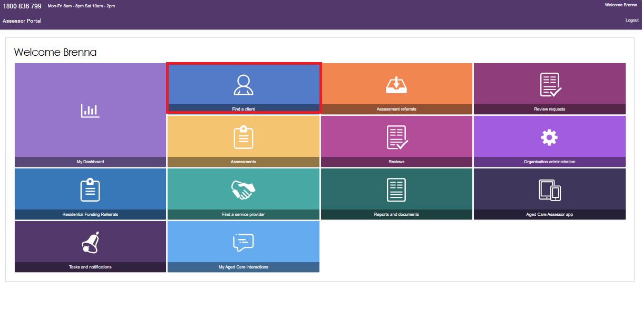
- This will take you to the Find a client page.
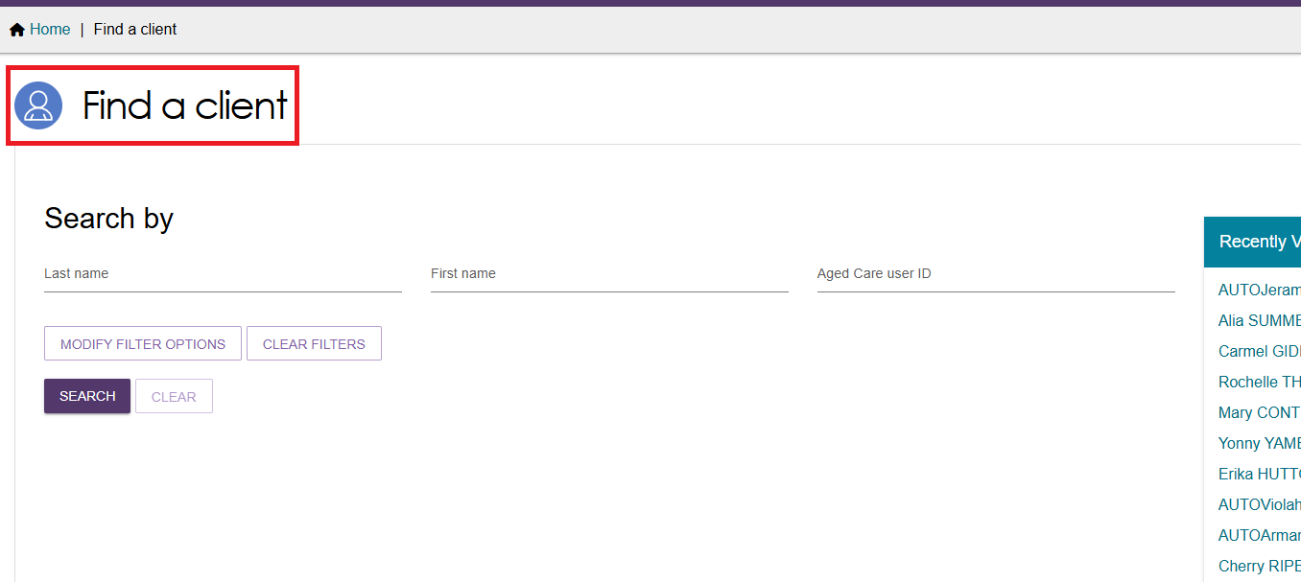
- Search for the client that you are creating a support relationship for. Once you have found the client, open their client record. This can be done in card view or list view.
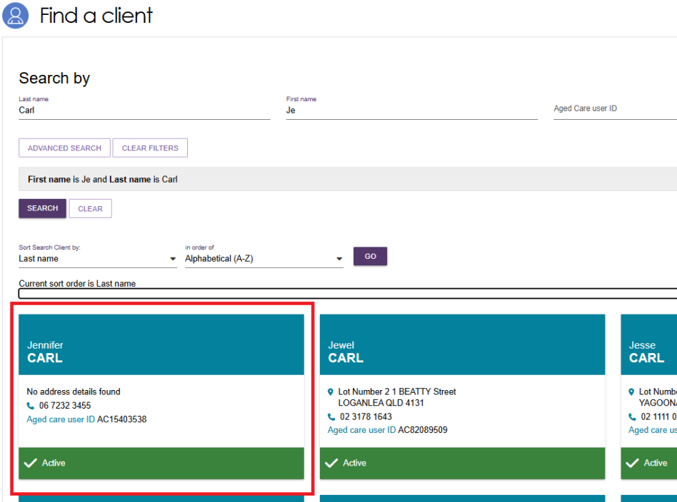
- If there is already a support relationship it will be shown underneath the Primary contact details in the heading banner. Select the View support network link to go to the Support network tab of the client’s record.
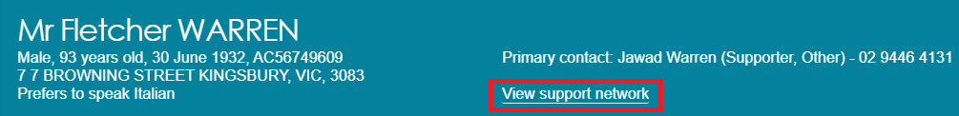
If there is not already a support relationship, No support relationships recorded is displayed.
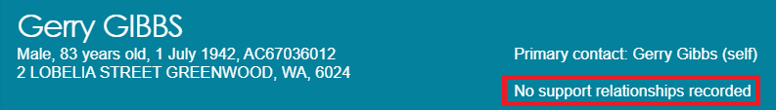
- Client relationships can be viewed in the Support network tab. Within this tab, assessors can view four sub-tabs:
- A client’s support network shows people, organisations and other relationships who provide support to the client.
- People client supports shows any people or other relationships which the client directly supports.
- Pending documents show any documents that are pending with My Aged Care and require action to establish a relationship.
- Declined, Ended and Cancelled relationships shows the relationships which any party declined, ended or cancelled, as well as registered Supporter relationships cancelled by the System Governor.
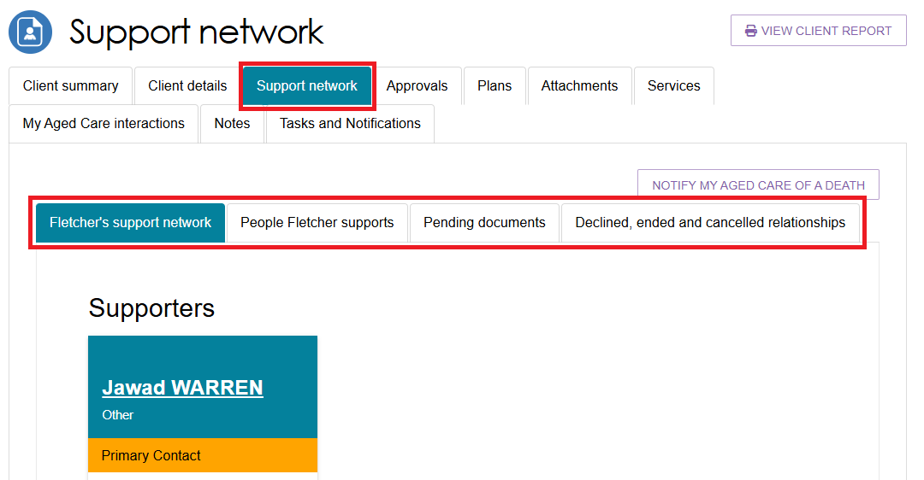

Creating a Supporter relationship
You will need to ensure that there is no duplicate clients or relationships in the My Aged Care system prior to creating a new relationship. This can be done by searching for the client and viewing their current support relationships. Further information on this can be found in the My Aged Care – Assessor Portal User Guide 1 – Registering and referring clients for assessments.
Once you have made sure that there will be no duplicates, you can create a relationship for the client with a prospective Supporter.
! | If a new Supporter relationship exceeds the maximum number allowed, the request is sent to the System Governor for consideration and action.
- From the client’s Support network tab, select CREATE RELATIONSHIP.
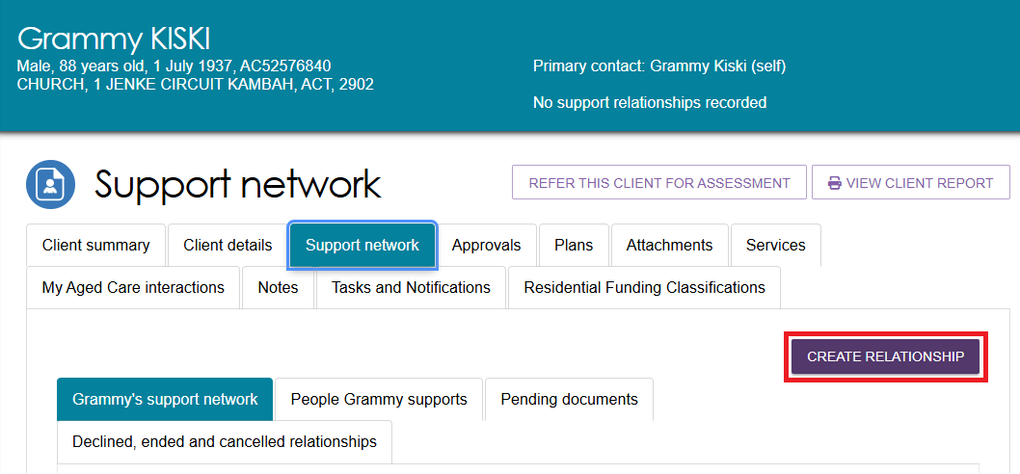

- The Create relationship for client page will be displayed. In section 01 About client’s relationship, select Supporter.
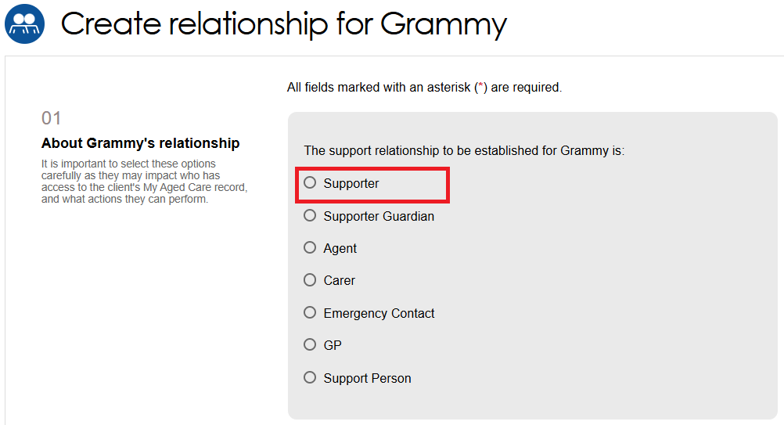
- You will then need to provide a response for Is the support relationship with a Person or an Organisation, as you are creating a relationship for an individual, select Person.
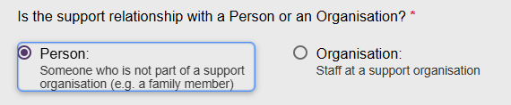
- To proceed with creating a relationship, both of the following conditions must be met: the person must be present with the client (either in person or via phone/video call), and the client must have a completed ‘Registration of Supporter or organisation’ form with them.
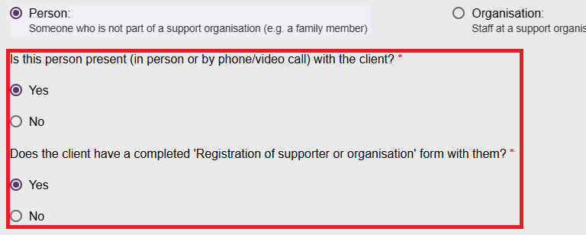
If both answers are No, an error message will occur, and you will not be able to continue.
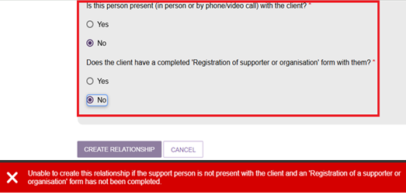
- In section 02 Add support person details, enter the First name and Last name of the new Supporter, and select Search. This is to ensure that there are no duplicate records being accidentally made in My Aged Care.
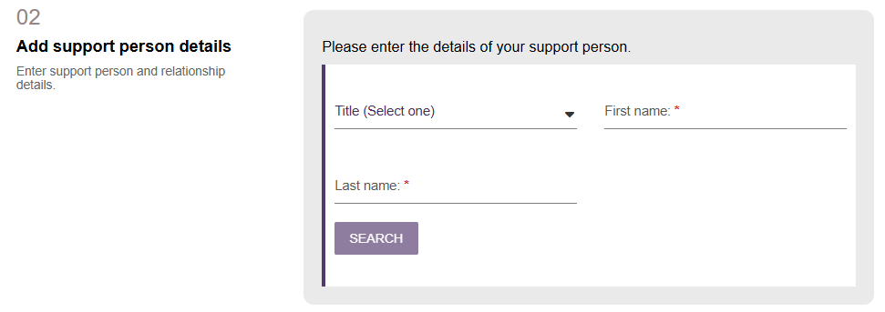
- If there are no records found, you can continue. Select CONTINUE TO REGISTER, then go to the Registering a new person for a support relationship section to continue to register.
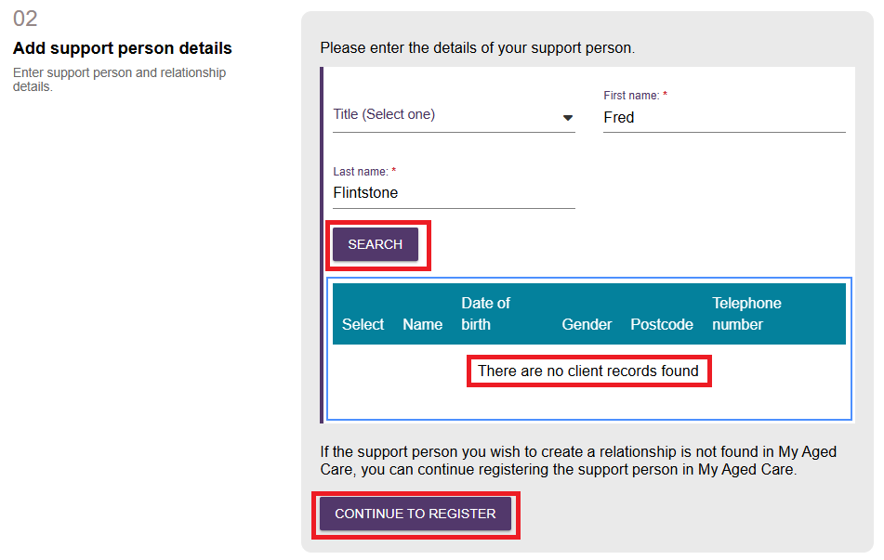

If a matching record is found, select the correct matching record, and then tick the checkbox that appears, to acknowledge that you are selecting the correct record.
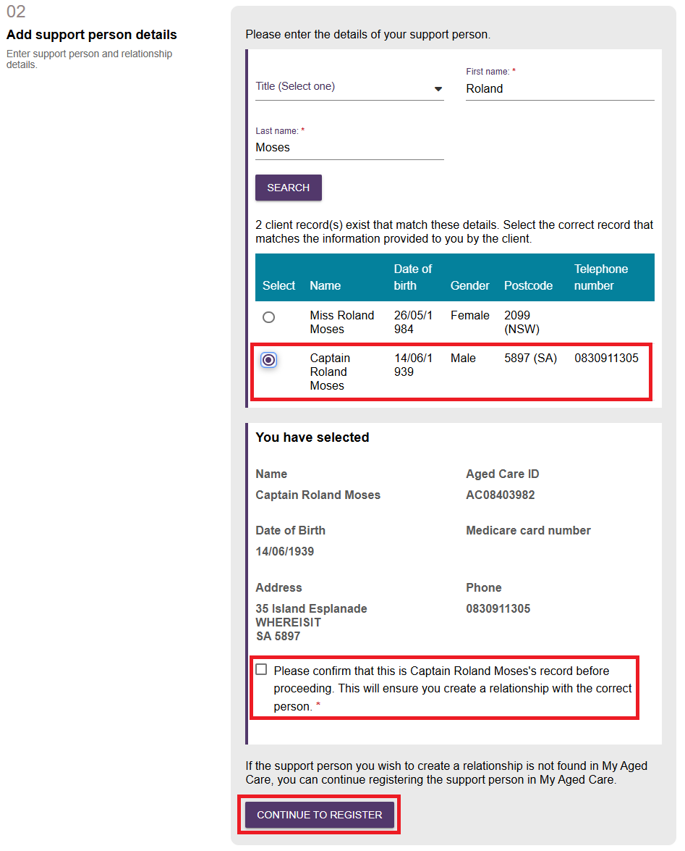
- Once confirmed you need to select the Relationship to the client, and Relationship start date. The Relationship end date is optional.
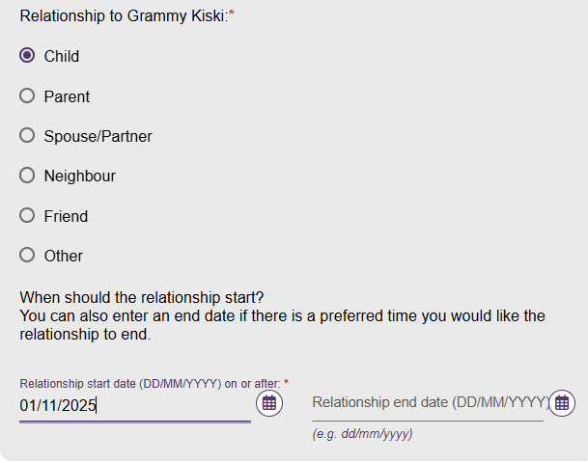
- The section 03 Registration of Supporter or organisation form appears. You will need to attach the Registration of a Supporter form by selecting the CHOOSE FILE button.
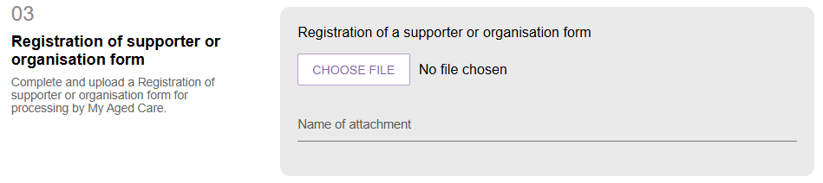
- Once the file is attached, the file name will appear. Enter the name of the attachment.
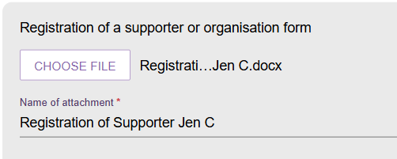
- In the section 04 Add documentation, you will need to attach any relevant documentation to support adding this relationship by selecting the ADD AN ATTACHMENT button.
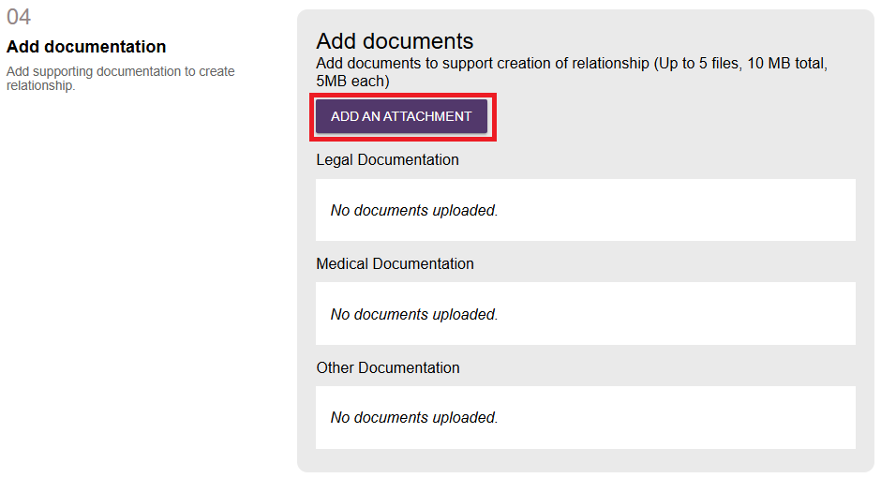
- Continue to add relevant documentation by choosing the files and Select UPLOAD. Please ensure the documents meets the required criteria as mentioned on the screen.
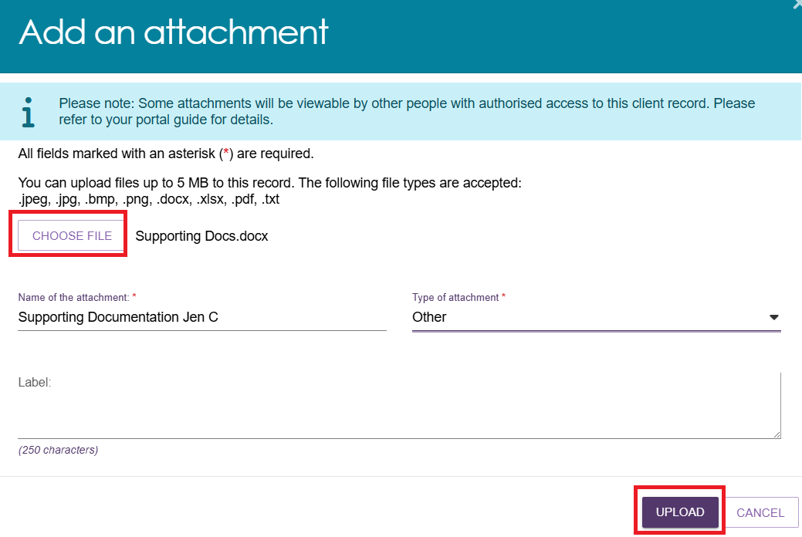
- Continue the above step until all the documentation is uploaded.
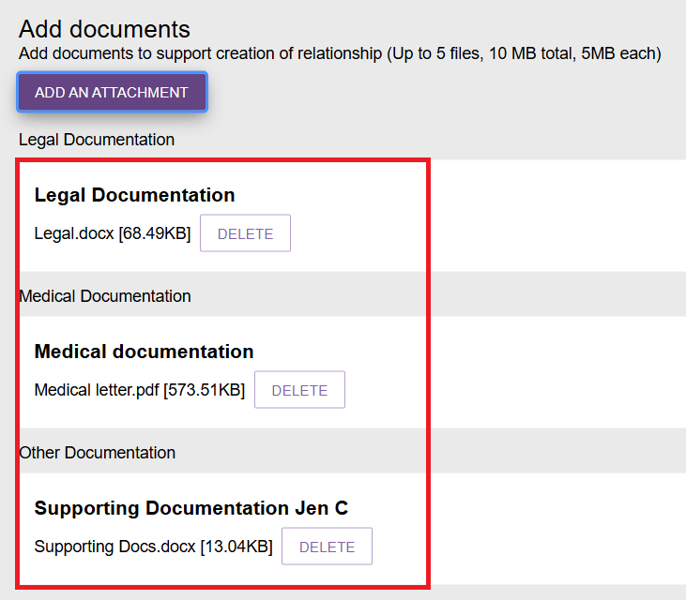
- In the section 05 Consent, it shows the prospective Supporter’s consent declaration, then the prospective Supporter’s conflict of interest declaration, followed by the client’s consent declaration and consent to access information. The Terms and Conditions and duties of a Supporter are also displayed. Read them before completing the declarations.
- Select Yes or No under the Supporter’s consent declaration. This can be done by the Supporter or by the assessor on behalf of the Supporter.
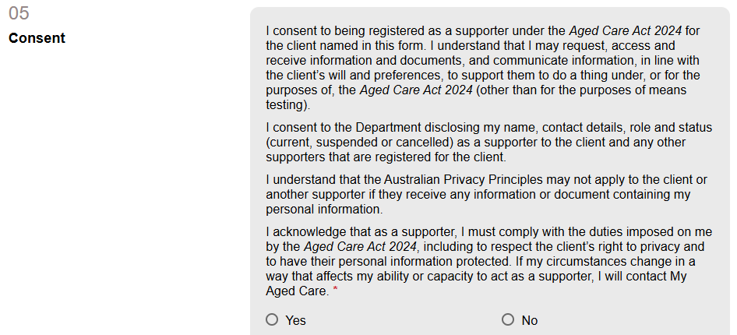
If the answer to the above is No, the rest of the Supporter’s declaration appears, followed by the client’s consent declaration. Proceed to Step c).
If the answer to the above is Yes, the Conflict of Interest declaration appears, followed by the final two consent declaration clauses, as per the screenshot below.
Select the View Details hyperlinks to view the duties of a Supporter, and the terms and conditions of registering in My Aged Care.
- Select Yes or No under the Supporter’s Conflict of Interest declaration. This can be done by the Supporter or by the assessor on behalf of the Supporter.
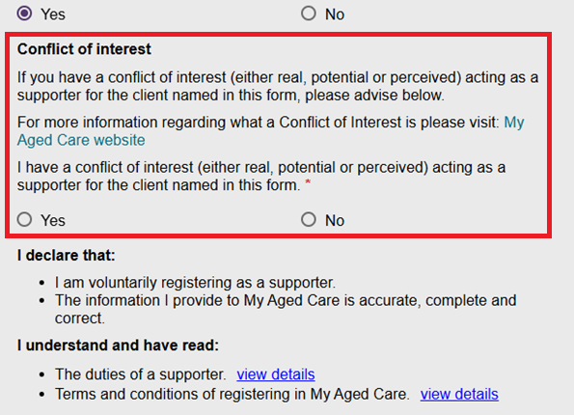
If the answer to the Conflict of Interest declaration above is Yes, enter the Supporter’s conflict of interest details in the text box, then proceed to Step c).
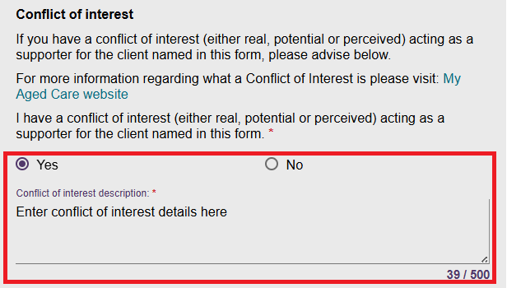
If the answer to the Conflict of Interest declaration above is No, the client’s consent declaration appears. Proceed to step c).
- Select Yes or No under the client’s consent declaration. This can be done by the client or by the assessor on behalf of the client.
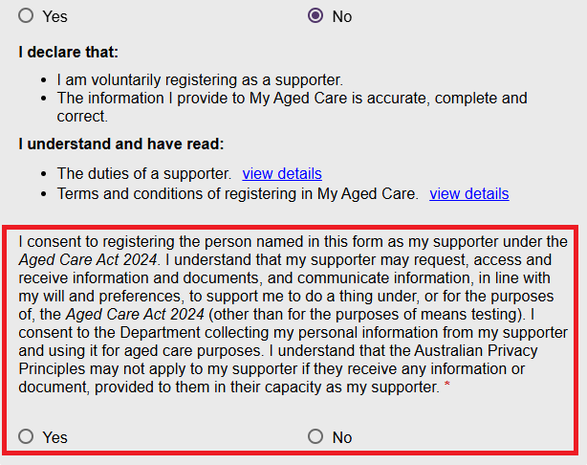
If the answer to the above client’s consent declaration is No, an error message appears that the relationship request cannot continue in the Assessor Portal, because the client has not given consent to registering the Supporter. The Assessor may contact the My Aged Care Contact Centre on 1800 200 422 to discuss this further.
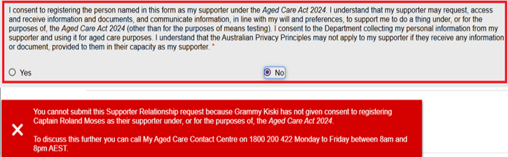
If the answer to the above client’s consent declaration is Yes, a further declaration question appears, followed by the last two clauses of the client’s declaration, as per the below screenshot.
- Select Yes or No under the client’s final declaration. If Yes, the CREATE RELATIONSHIP button is active. Select the button to finish creating the relationship.
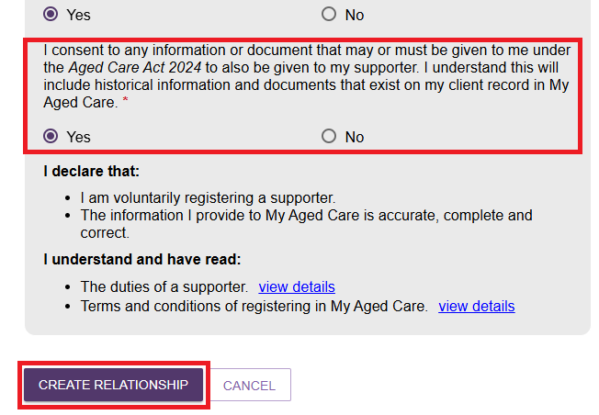
- If the answer to the client’s declaration about information sharing is No, a Supporter Lite relationship can be created.
! | - If all answers to consent are Yes, the relationship can be created immediately.  - If any answers to consent are No, the relationship will be put into a Pending status. Further information is available from the My Aged Care Assessment Manual.
- You will be taken to the client’s Support Network screen where the Supporter details will be displayed in a tile with a green banner confirming successful creation of the support relationship.
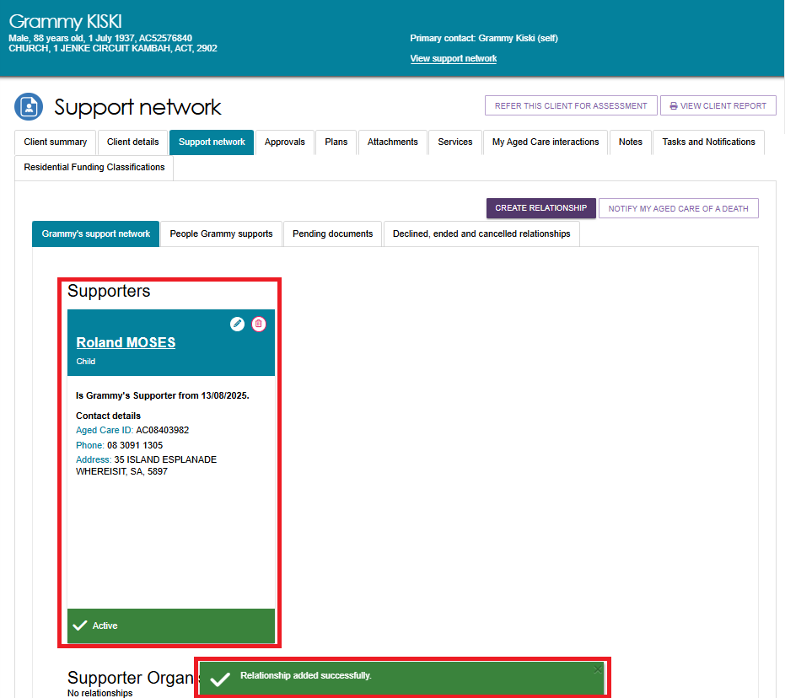

Creating a Supporter Lite relationship
Steps to create a Supporter Lite relationship are the same as a Supporter relationship. However, the difference is in selecting the consent checkbox as shown in the following steps.
- From the Support Network screen, Select CREATE RELATIONSHIP button.
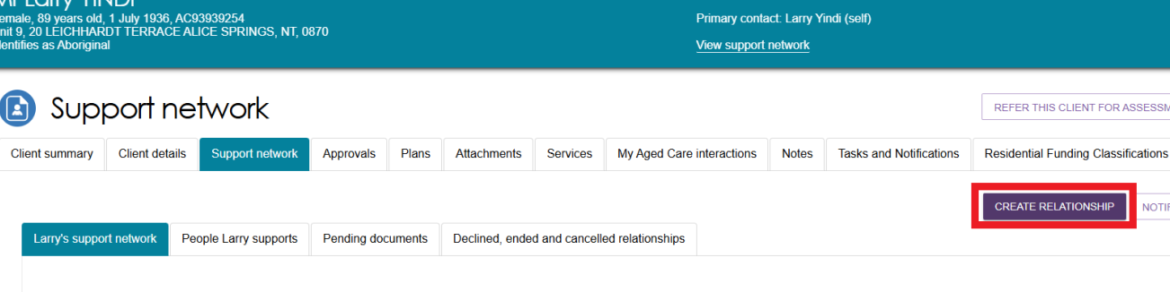
- Complete sections 01 through to 04 with relevant information as required.
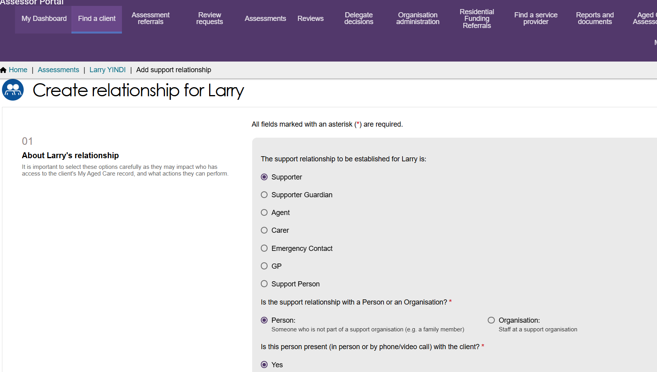
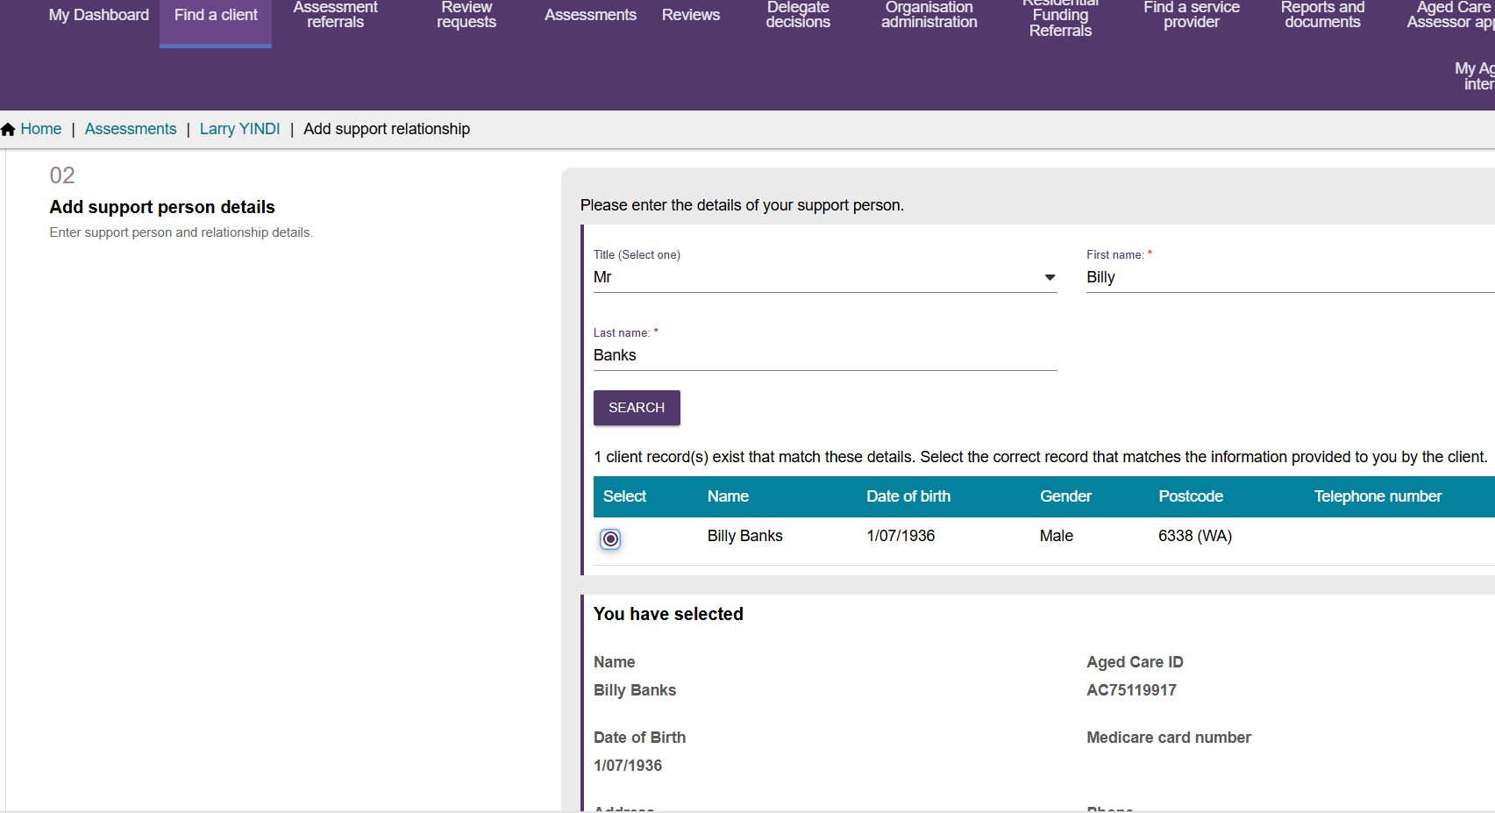
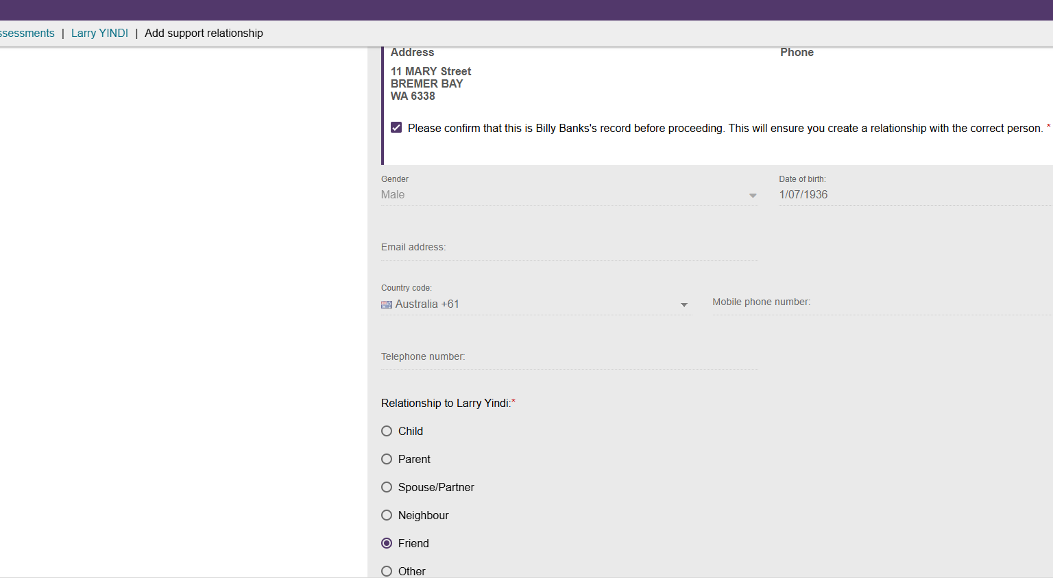
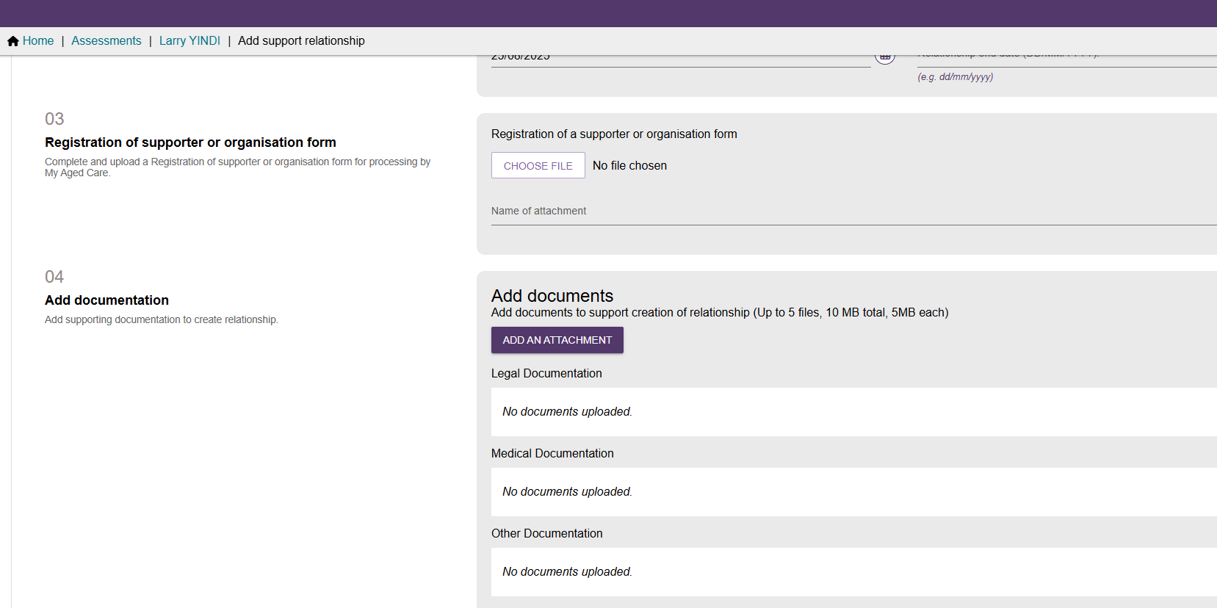

- Complete Section 05 Consent, with the initial declaration as Yes.
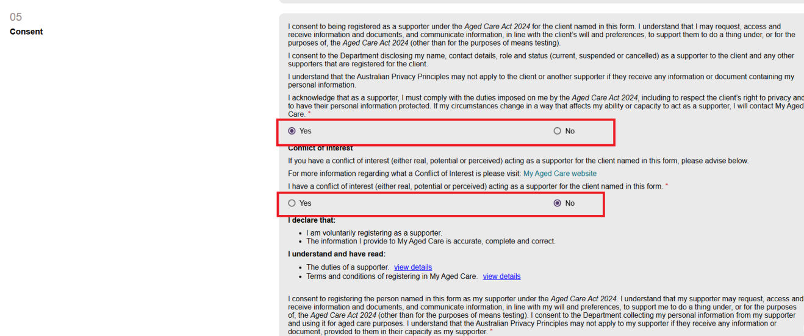
- This will then open up the second consent question. Select No.
An Information banner will appear on the section advising that the client has chosen not to consent to sharing certain information with their prospective Supporter, as shown in the example below.
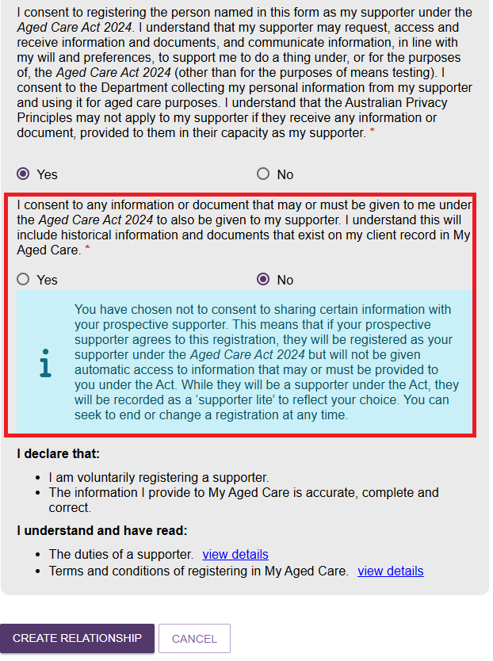
- Check all the details and confirm by selecting CREATE RELATIONSHIP button.
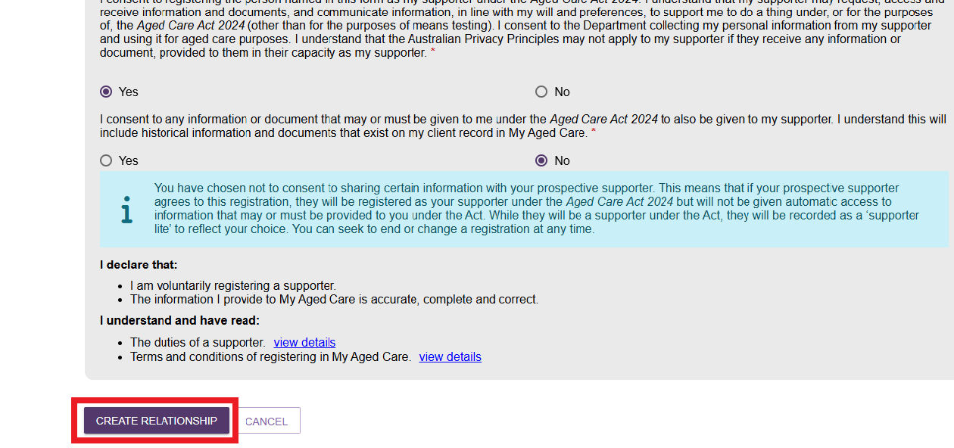
- A green banner will appear at the bottom of the screen confirming successful addition of the relationship.
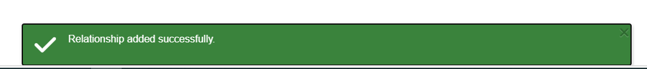
- The newly created relationship will appear on the Support Network screen under the SUPPORTERS tab. The tile will also display the date when the relationship is active (as entered by the assessor at the time of creating the relationship).
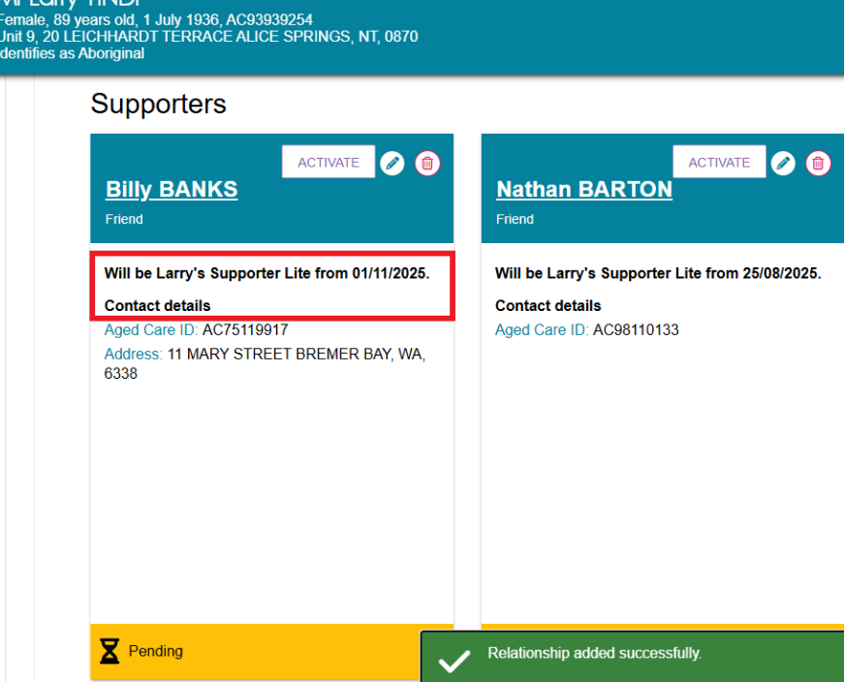

Activating a Supporter Lite relationship
Once a Supporter Lite relationship is added, it will appear under the Support Network tab in the Client’s record with an ACTIVATE button attached with a Pending status highlighted in yellow at the bottom of the tile. The Supporter Lite will also see the relationship under their own account once it is active.
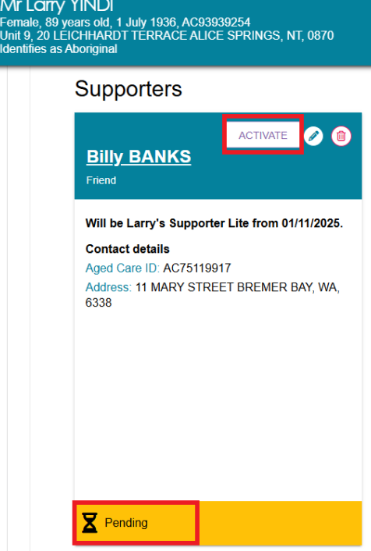
- To change the relationship status to active, select the ACTIVATE button from the relevant Supporter’s tile. A pop-up window will open where the user will be prompted to select the responses to consent.
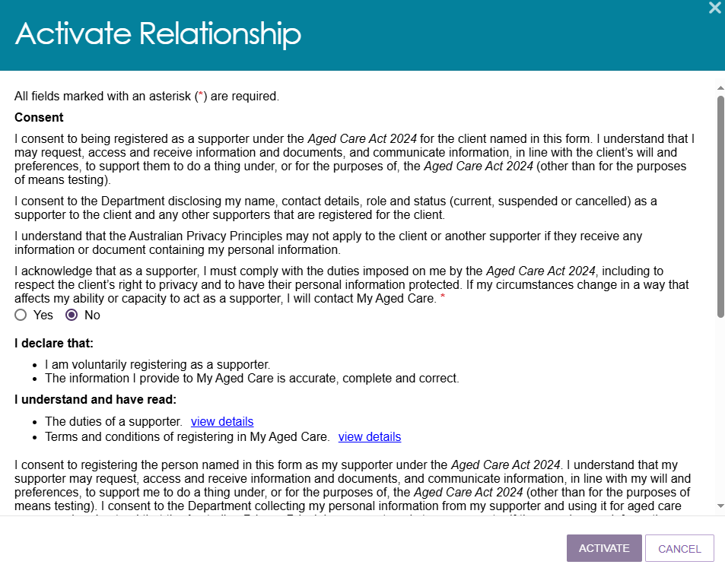
- Navigate through all the information in the pop-up window and select ACTIVATE.
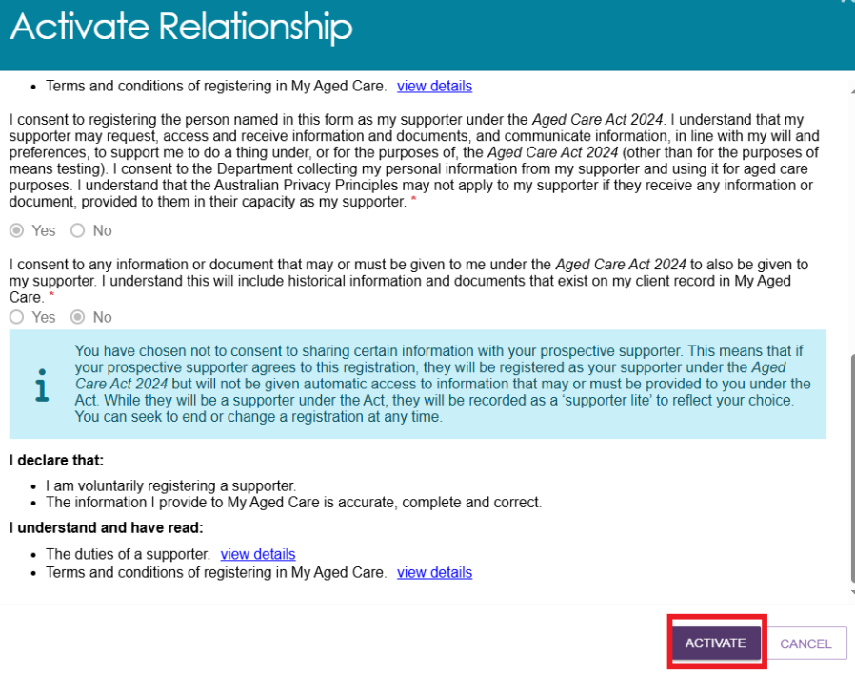
- A green banner will appear at the bottom of the screen to confirm the relationship activation.
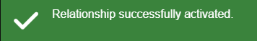
- The user will be able to see the status changed from Pending to Active on the relevant Supporter tile.
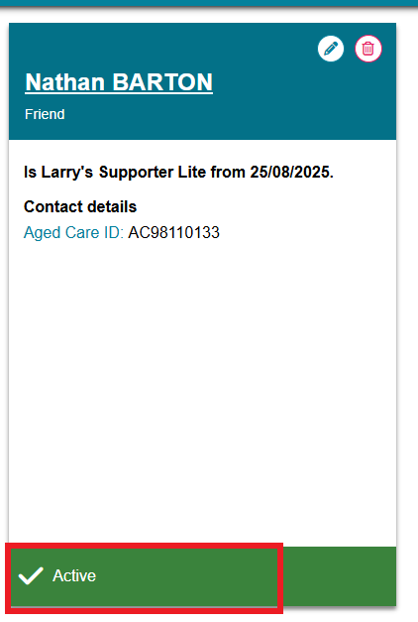
- In case of any relationship set to be active from a future date by the user, the status will appear as Pending until the respective date. However, a message will appear on the Supporter Lite tile advising the relationship will be active on the date set by the user.
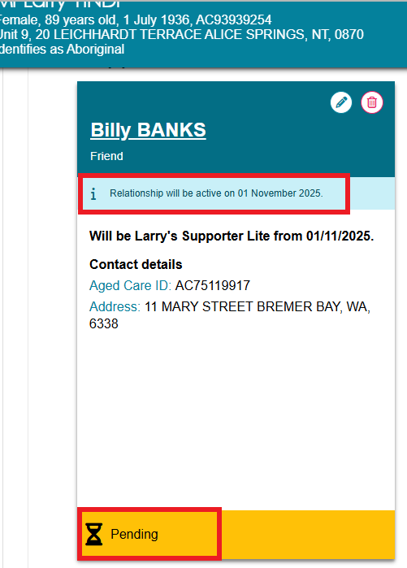

Creating a Supporter Guardian relationship
You will need to ensure that there is no duplicate clients or relationships in the My Aged Care system prior to creating a new relationship. This can be done by searching for the client and viewing their current support relationships. Further information on this can be found in My Aged Care – Assessor Portal User Guide 1 – Registering and referring clients for assessments.
Once you have made sure that there will be no duplicates, you can create a relationship for the client with an individual Supporter Guardian.
- From the client’s Support network tab, select CREATE RELATIONSHIP.
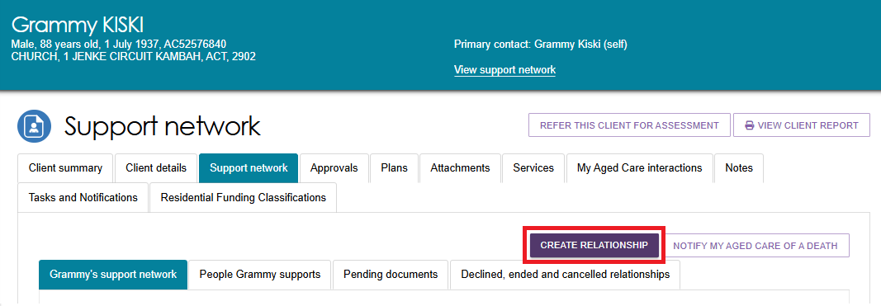

- The Create relationship for client page will be displayed. In section 01 About client’s relationship, select ‘Supporter Guardian’, and then at the next question: ‘Is the support relationship with a Person or an Organisation?’ select Person.
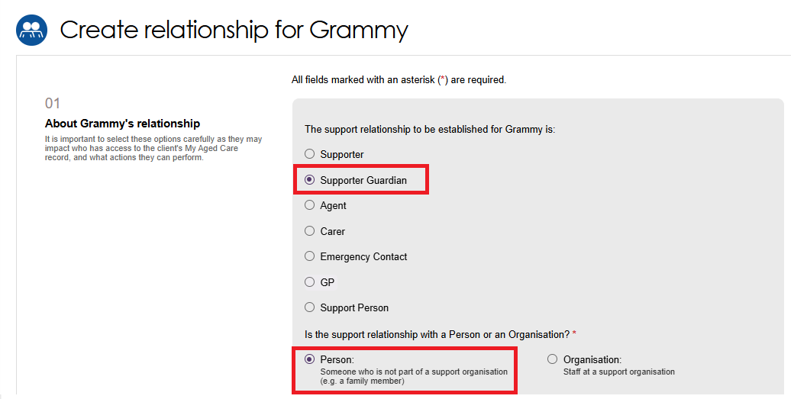
- You will then be asked Is this person present (in person or by phone/video call) with the client and Does the client have a completed ‘Registration of support person or organisation’ form with them. To continue with creating a relationship, one or both questions must be Yes.
- If both answers to the questions in the above shown screen are No, an error message will occur as shown in the following example and you will not be able to continue.
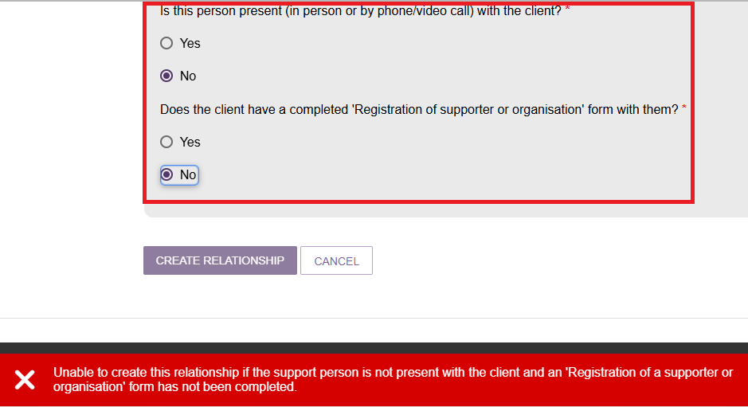
In section 02 Add support person details, enter the First name and Last name of the prospective Supporter Guardian and then select SEARCH. This is to ensure that there are no duplicate records being accidentally made in My Aged Care.
- If there are no records found, you can still continue. Select CONTINUE TO REGISTER, then go to the Registering a new person for a support relationship section to continue to register.
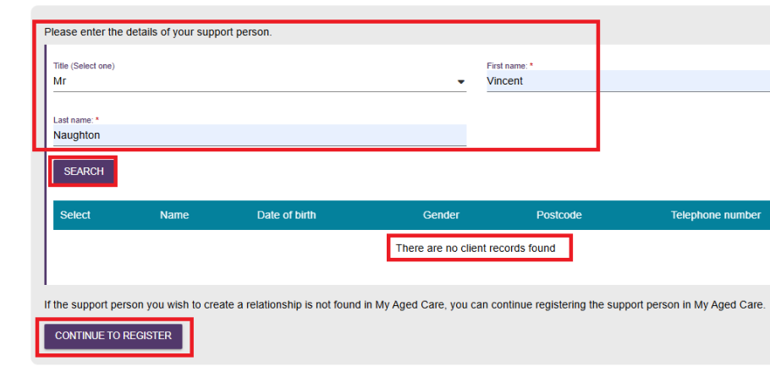

- If a matching record is found, select the correct matching record, and then tick the checkbox that appears, to acknowledge that you are selecting the correct record.
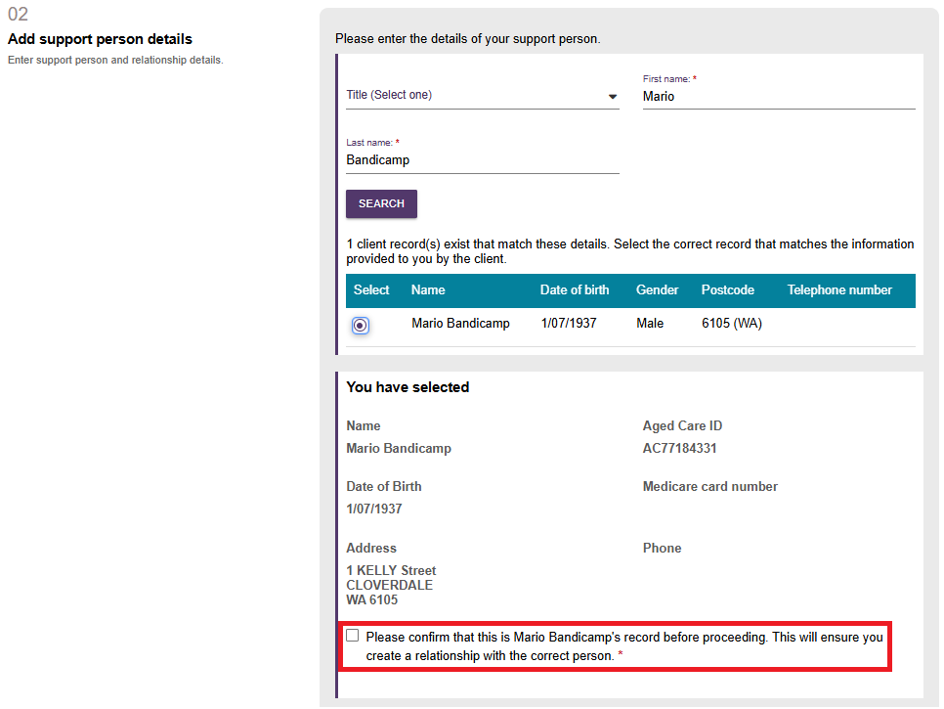
- Once confirmed you need to select the Relationship to the client, and Relationship start date. The Relationship end date is optional.
! | The Relationship end date must match the end date given in the Legal documentation, if there is one.
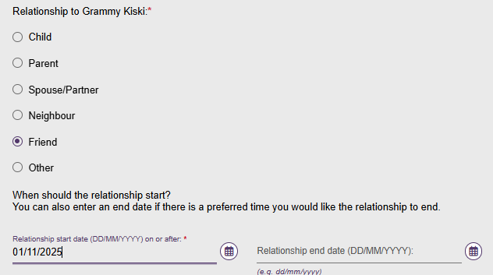

- In section 03 Registration of Supporter or organisation form, you will need to attach the registration form and enter the name of the attachment.
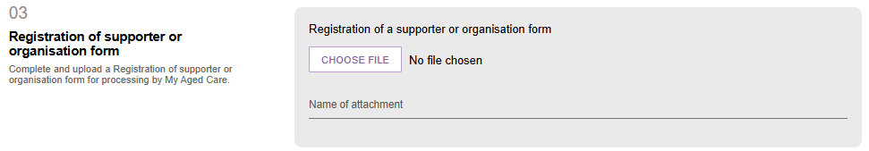
- In Section 04 Add documentation, select whether you (the assessor) can verify the Supporter Guardian documents to act on the client’s behalf as a Supporter.
! | - If you can verify the provided legal documentation, select Yes and upload the verified legal documents.  - If you are unable to verify the documents provided, select No and upload the documents and select the Submit to My Aged Care button. This will create a pending relationship and submit the documents to the My Aged Care contact centre to verify the documents and create the relationship.  - If you have not provided any legal documents, you will need to advise the prospective Supporter Guardian that you can progress the relationship request to the System Governor for review, but to be registered a Supporter guardian, they must submit proof of their legal decision-making authority. This can be done by submitting any documentation to the My Aged Care contact centre or from their online account.
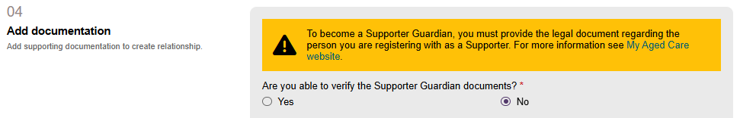
- Attach the required legal and/or medical documentation by selecting the ‘Add an Attachment’ button.
A legal document (such as guardianship orders, enduring power of attorney etc.) regarding the person registering as a Supporter guardian MUST be attached. Then, input a document name.
If necessary, upload a medical practitioner letter to support the client’s need for the Supporter guardianship, and input a document name.
If you have a combined legal and medical document, upload it into the Legal Documentation section.
Further information is available from the My Aged Care Assessment Manual.
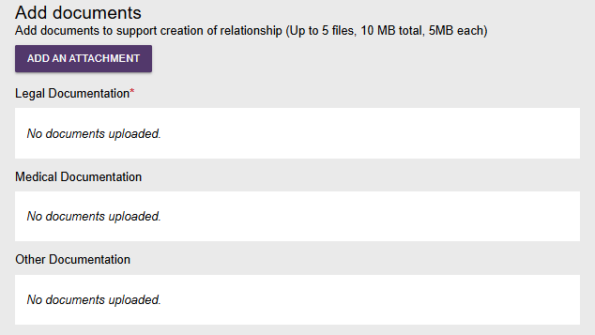
- If you have more than one piece of documentation, continue to add relevant documentation by choosing the files and Select UPLOAD. Please ensure the documents meets the required criteria as mentioned on the screen.
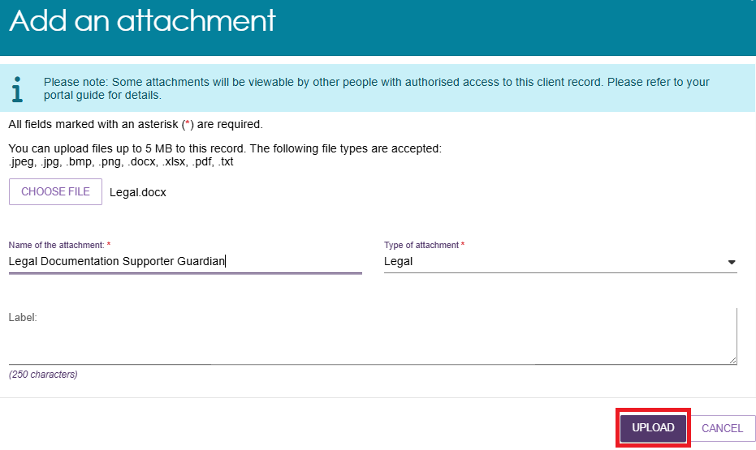
This example screenshot shows one of each type of documentation (Legal, Medical, Other) uploaded in the Add Documents screen. To delete, select Delete next to the relevant type.
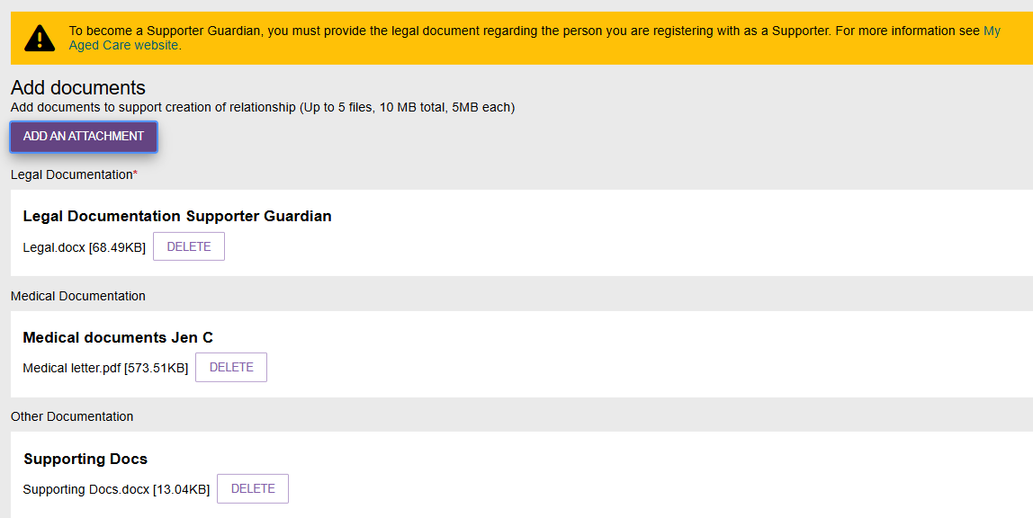
- In the section 05 Consent, it shows the prospective Supporter Guardian’s consent declaration.
The Supporter Guardian must select Yes for the relationship request to continue.
If No is selected, the relationship request cannot be completed.
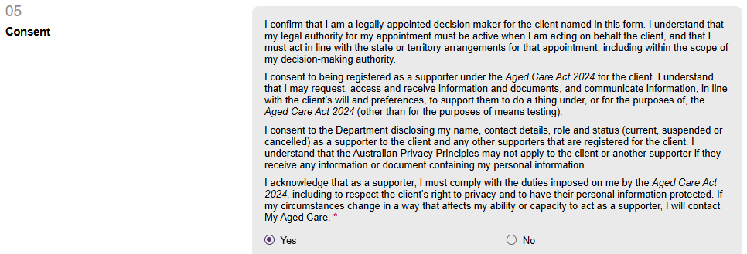
- After selecting Yes to the Supporter guardian’s consent declaration, the Conflict of Interest declaration appears. Select Yes or No.
If Yes is selected, input the conflict of interest details in the text box.
Select the View Details hyperlinks to view the duties of a Supporter, and the terms and conditions of registering in My Aged Care.
Finally, select Submit to My Aged Care.
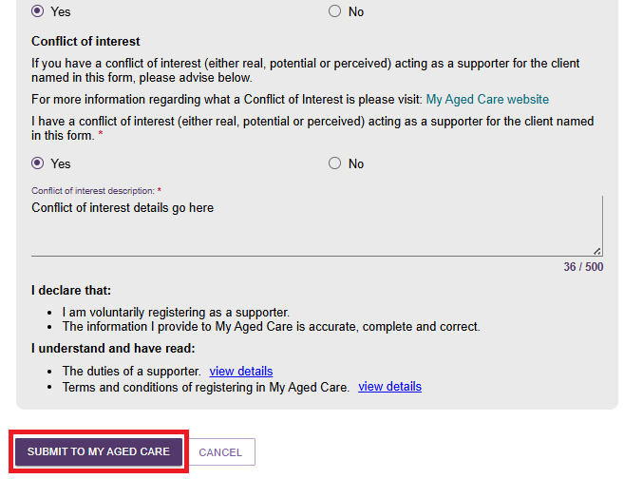
- You will be taken to the client’s Support Network screen where the Supporter guardian details will be displayed in a tile. It will either be:
- with a green banner confirming successful creation of the support relationship, or
- With a yellow Pending banner, and/or
- With an Information banner advising delegate approval is required before the relationship is approved.
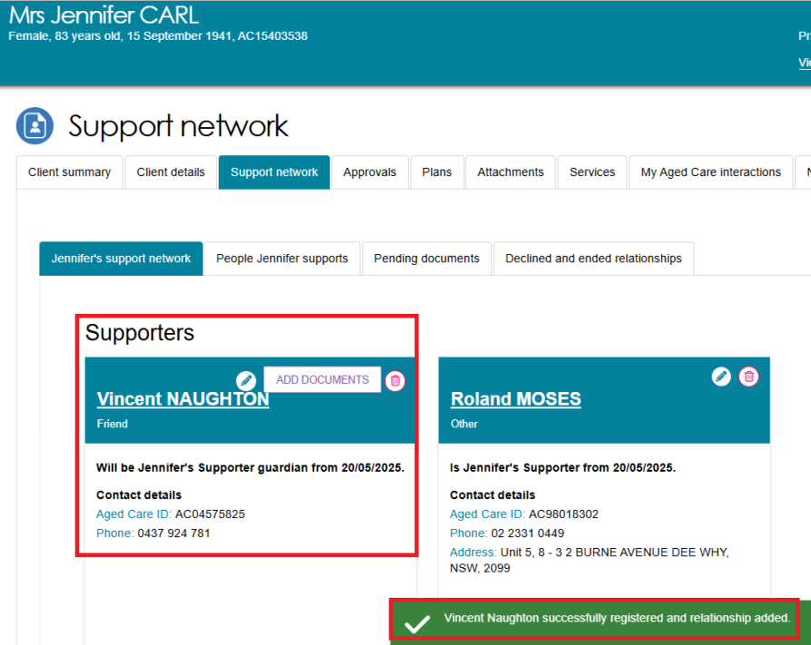
When a Supporter Guardian relationship request has a Status Reason of Pending Delegate Decision, the corresponding relationship card will display the Status as Pending. Additionally, an informational message will appear at the top of the card stating:
Relationship undergoing delegate approval, indicating that the relationship is currently awaiting a decision from the delegate.
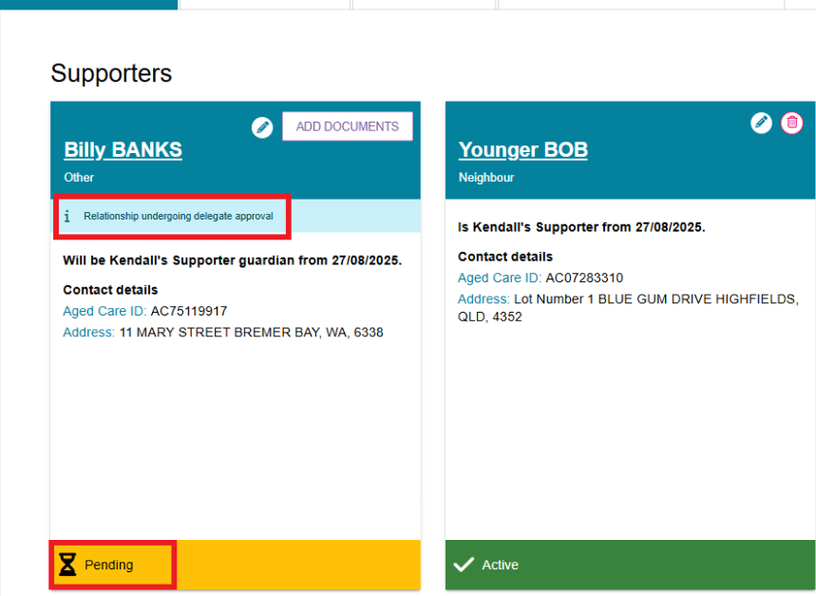

- More documents can be added regarding the Supporter Guardian from the tile on the clients support network by selecting the ADD DOCUMENTS button.
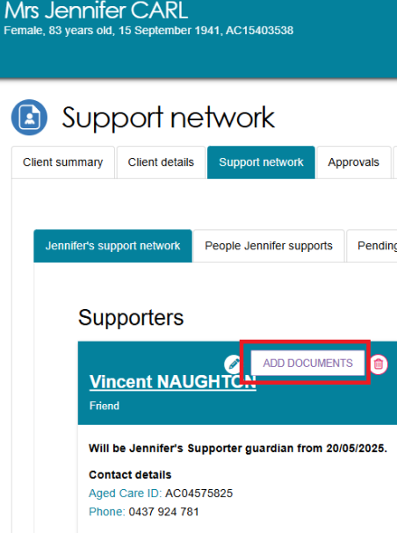
- If there are any pending documents to be attached, a yellow banner will be displayed below the relevant Supporter relationship tile.
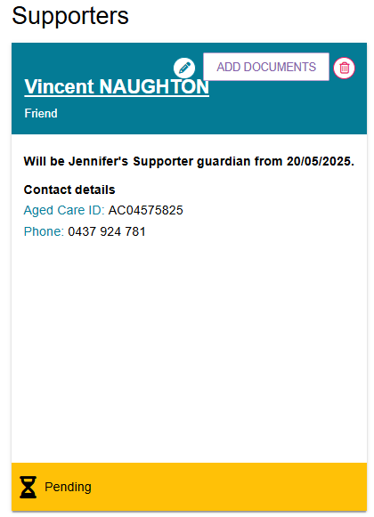

Creating a Supporter Organisation relationship
Prior to creating a new Supporter Organisation relationship, ensure that:
- There is no duplicate organisations or relationships in the My Aged Care system
- There are no previously cancelled Supporter Organisation relationships
- The Supporter Organisation can also comply with the duties of a Supporter.
This can be done by searching for the organisation and viewing their current support relationships. Further information on this can be found in the My Aged Care – Assessor Portal User Guide 1 – Registering and referring clients for assessments.
Supporter Organisation relationship requests are subject to delegate approval.
- From the client’s Support network tab, select CREATE RELATIONSHIP.
- The Create relationship for client page will be displayed. In section 01 About client’s relationship, select SUPPORTER and the type as ORGANISATION as shown in the example below.
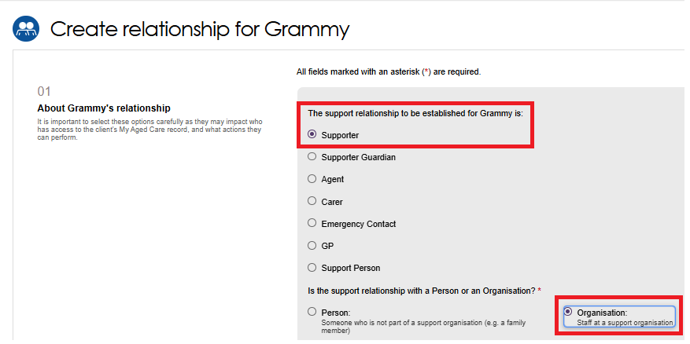

- In section 02 Add support organisation details, search for the support organisation by either entering its name or the suburb or postcode, then press SEARCH. Optionally you can also specify to search within a kilometre range of the suburb or postcode.
Suburb or Postcode search example
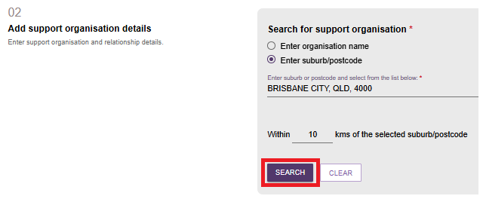
Organisation name search example
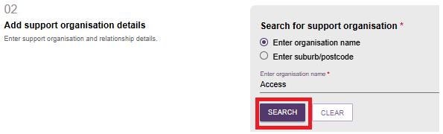
! | Only recognised support organisations are available. If an organisation cannot be found, try refining your search terms or searching on the My Aged Care website.
Once you have found your organisation, select it from the list, and respond to When should the relationship start.
You will have the option to record the relationship end date, and/or the full name of one support person within the organisation that the client wants to only work with.
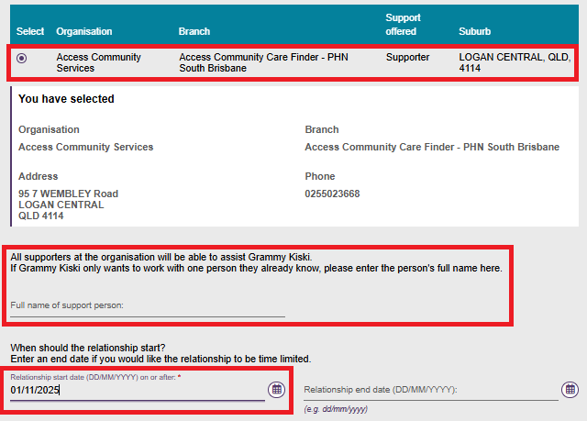
- In Section 03 Registration of Supporter or organisation form, upload the relevant registration form by selecting CHOOSE FILE button and enter the name of the attachment.
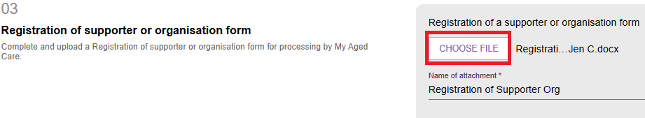
- In Section 04 Add documents, add relevant documentation in relation to the support organisation registration. Select ADD AN ATTACHMENT
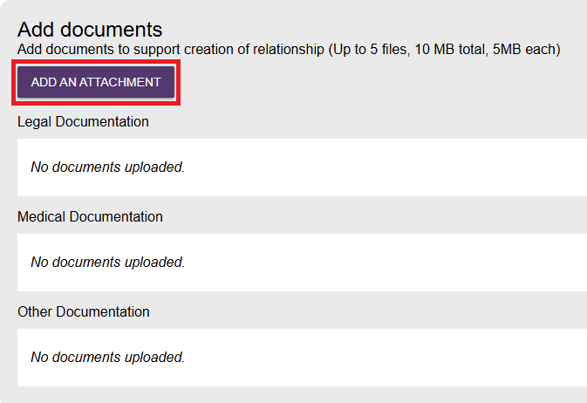
- On the Add an attachment screen choose the file to be uploaded and select UPLOAD.
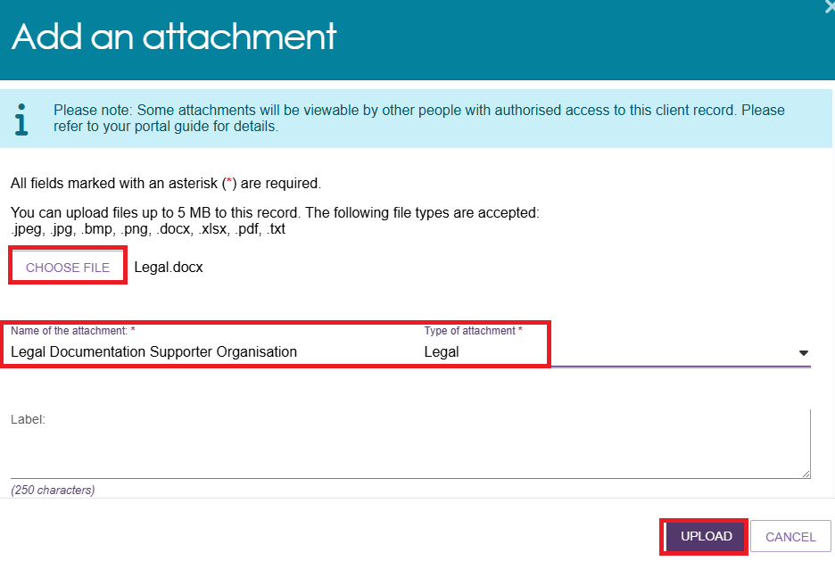
- In the 05 CONSENT section, the Supporter Organisation's consent declaration appears. Complete the declaration by answering YES or NO.
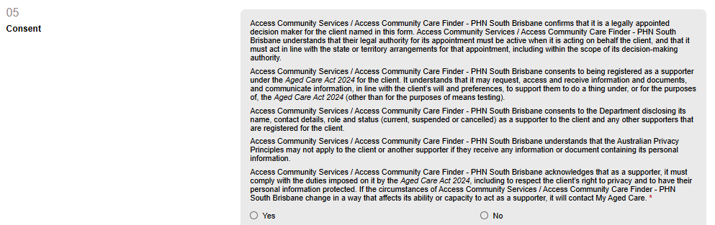
- If the answer to the Supporter Organisation’s consent declaration is No, the relationship creation process cannot continue, and the Submit to My Aged Care button is greyed out.
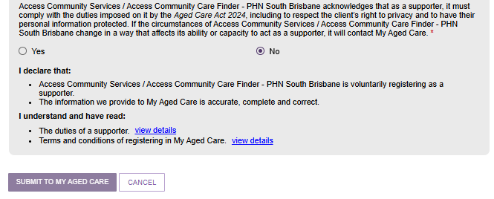

- If the answer to the Supporter Organisation’s consent declaration is Yes, the Support Organisation’s conflict of interest declaration appears. Complete the declaration by answering Yes or No.
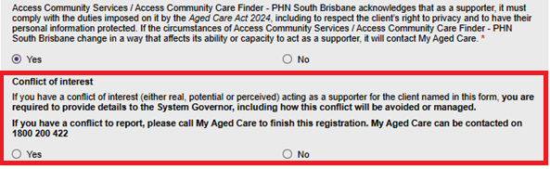
- If the answer to the Supporter Organisation’s conflict of interest declaration is Yes, enter the details in the text box, as shown in the screenshot below.
! | The Conflict of Interest details text needs to be in the words of the prospective Supporter Organisation, and agreed by the prospective Supporter Organisation.
Read the last two clauses of the Supporter Organisation declaration.
Select the View Details hyperlinks to view the duties of a Supporter, and the terms and conditions of registering in My Aged Care.
Finally, Select the SUBMIT TO MY AGED CARE button.
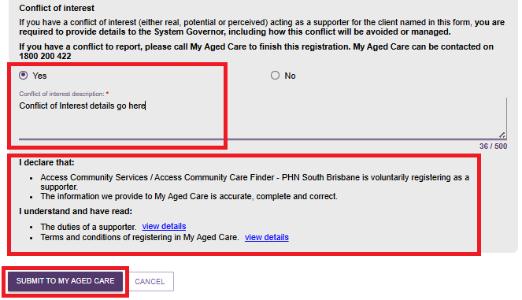

- The newly created Supporter Organisation will be displayed on the client’s SUPPORT NETWORK screen with a green banner confirming the successful addition of the relationship.
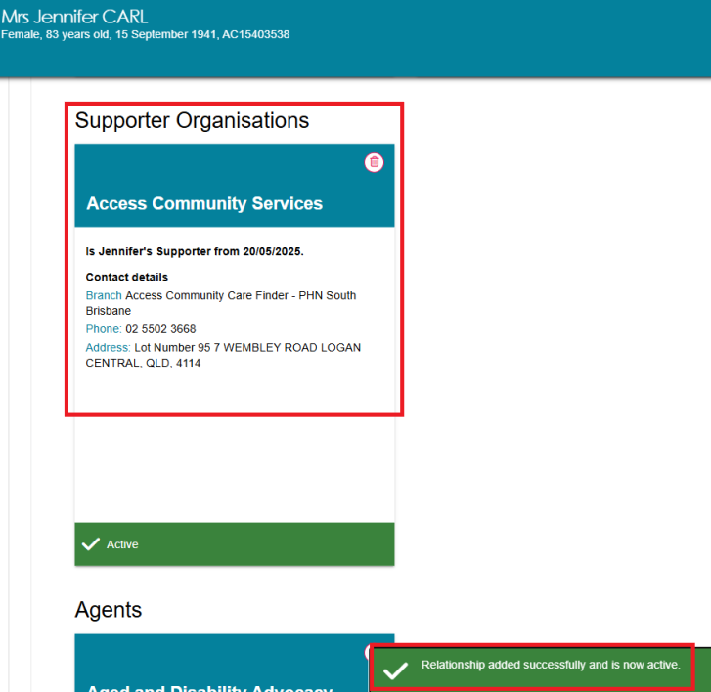

Creating a Supporter Guardian Organisation relationship
You will need to ensure that there are no duplicate Supporter guardian organisations or relationships in the My Aged Care system prior to creating a new relationship. This can be done by searching for the organisation and viewing their current support relationships. Further information on this can be found in the My Aged Care – Assessor Portal User Guide 1 – Registering and referring clients for assessments.
Once you have made sure that there will be no duplicates, you can create a relationship request for the client with a Supporter guardian organisation.
Supporter Guardian Organisation relationship requests are subject to delegate approval.
- From the client’s Support network tab, select CREATE RELATIONSHIP.
- The Create relationship for client page will be displayed. In section 01 About client’s relationship, select Supporter Guardian, and the relationship type as ORGANISATION as shown in the example below.
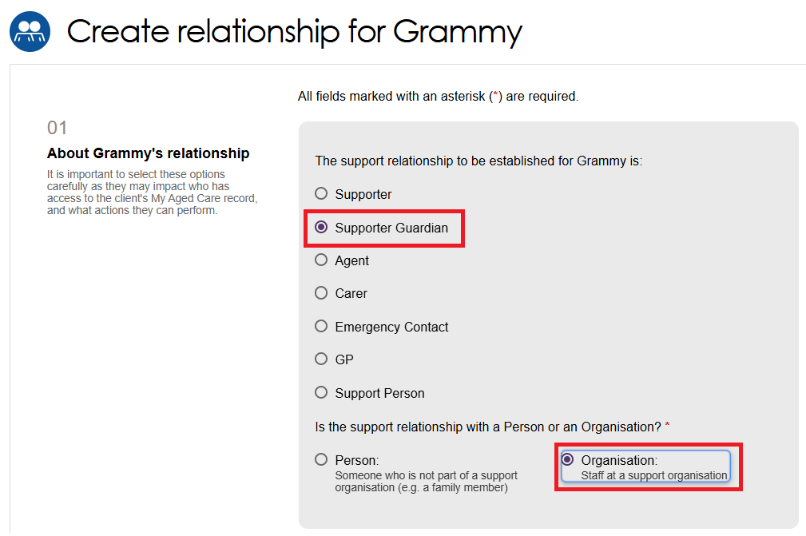
- In section 02 Add support organisation details, search for the support organisation by either entering its name or the suburb or postcode, then press SEARCH. Optionally you can also specify to search within a kilometre range of the suburb or postcode.

Suburb or Postcode search example
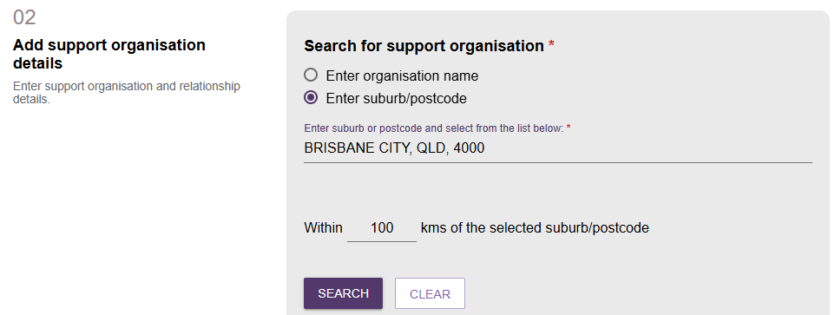
Organisation name search example
- Once you have found your organisation, select it from the list, and respond to When should the relationship start. You will have the option to record the relationship end date, and/or the full name of one Support Guardian within the organisation that the client wants to only work with.
! | The Relationship end date must match the end date given in the Legal documentation, if there is one.
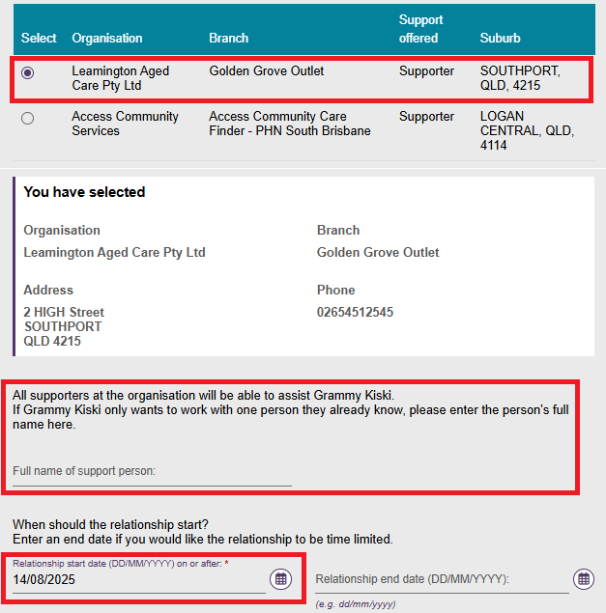
- In Section 03 Registration of Supporter or organisation form, upload the relevant registration form by selecting CHOOSE FILE button and enter the name of the attachment.
- In Section 04 Add documentation, select whether you (the assessor) can verify the Supporter Guardian Organisation’s documents to act on the client’s behalf.
! | - If you can verify the provided legal documentation, select Yes and upload the verified legal documents.  - If you are unable to verify the documents provided, select No and upload the documents and select the Submit to My Aged Care button. This will create a pending relationship and submit the documents to the My Aged Care contact centre to verify the documents and create the relationship.  - If you have not provided any legal documents, you will need to advise the Supporter to establish the relationship by submitting their documents to the My Aged Care contact centre or submit from their online account.
- Attach the required legal and/or medical documentation by selecting the ‘Add An Attachment’ button.
! | - A legal document (such as guardianship orders, enduring power of attorney etc.) regarding the person registering as a Supporter guardian MUST be attached. Then, input a document name.  - If necessary, upload a medical practitioner letter to support the client’s need for the Supporter guardianship, and input a document name.  - Further information is available from the My Aged Care Assessment Manual.
- Continue to add relevant documentation by choosing the files and Select UPLOAD. Please ensure the documents meets the required criteria as mentioned on the screen.
- Repeat the above step until all the documentation is uploaded.
- In the section 05 Consent, it shows the prospective Supporter Guardian Organisation’s consent declaration.
The Supporter guardian organisation, or the assessor on behalf of the Supporter guardian organisation, must select Yes for the relationship request to continue.
If No is selected, the relationship request cannot be completed, and the Submit to My Aged Care button will be greyed out.
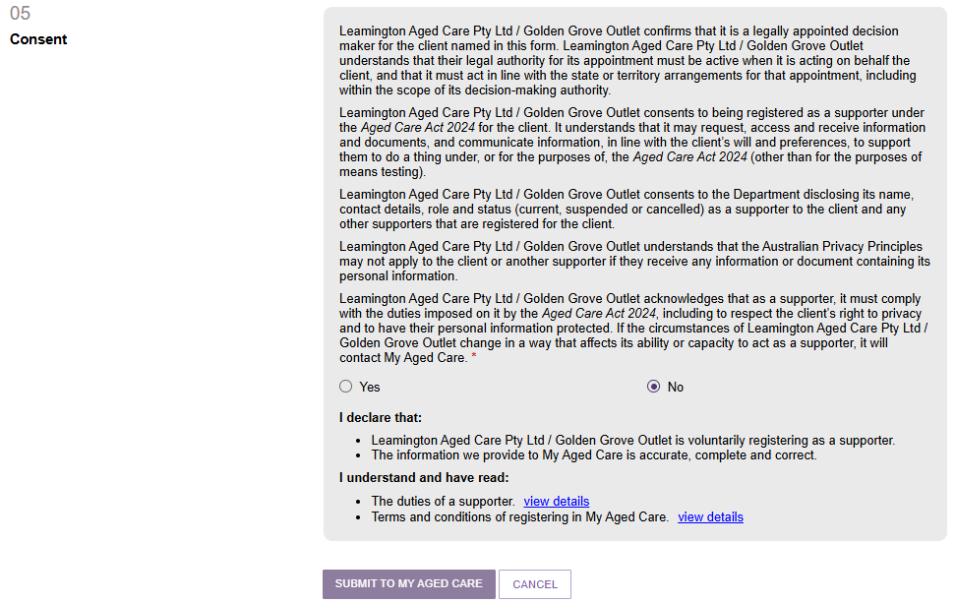
- After selecting Yes to the Supporter guardian’s consent declaration, the Conflict of Interest declaration appears. Select Yes or No.
If Yes is selected, input the conflict of interest details in the text box.
Select the View Details hyperlinks to view the duties of a Supporter, and the terms and conditions of registering in My Aged Care.
Finally, select Submit to My Aged Care.
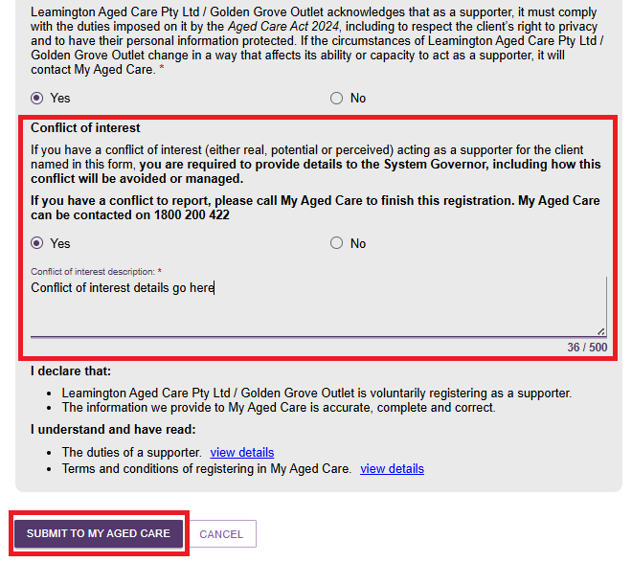

- You will be taken to the client’s Support Network screen where the Supporter guardian details will be displayed in a tile. It will either be:
- with a green banner confirming successful creation of the support relationship, or
- with a yellow ‘Pending’ banner, and/or
- with an Information banner advising that delegate approval is required before the relationship is approved.
Pending banner, Pending delegate approval example
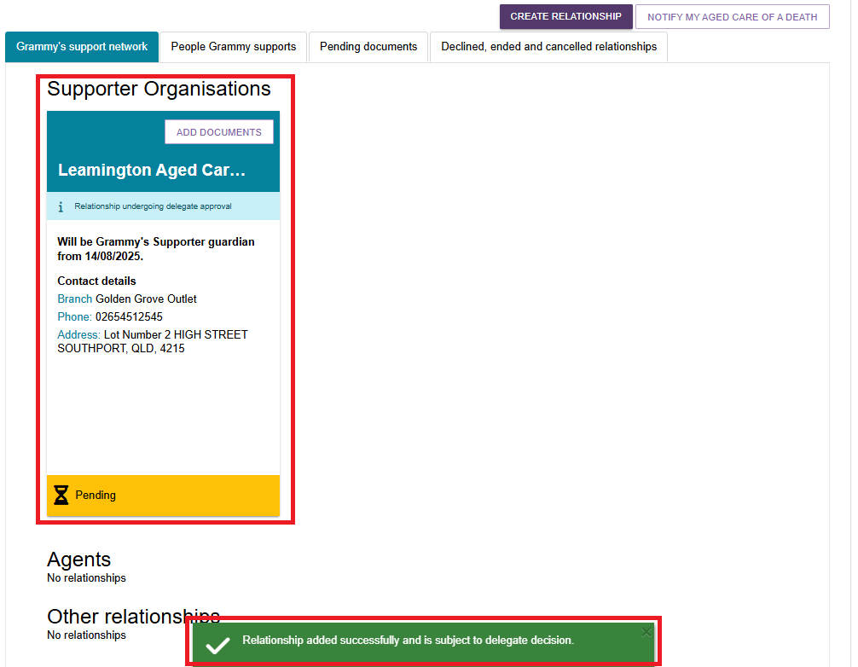

Creating an Organisational Agent relationship
You will need to ensure that there are no duplicate clients or relationships in the My Aged Care system prior to creating a new relationship. This can be done by searching for the client and viewing their current support relationships, further information on this can be found in the My Aged Care – Assessor Portal User Guide 1 – Registering and referring clients for assessments.
Once you have made sure that there will be no duplicates, you can create a relationship for the client with an Organisational Agent.
- From the client’s Support network tab, select CREATE RELATIONSHIP.
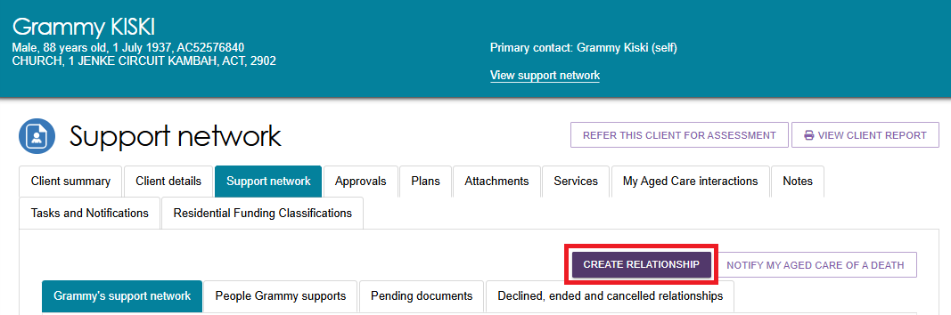
- The Create relationship for client page will be displayed. In section 01 About client’s relationship, select Agent from the list.
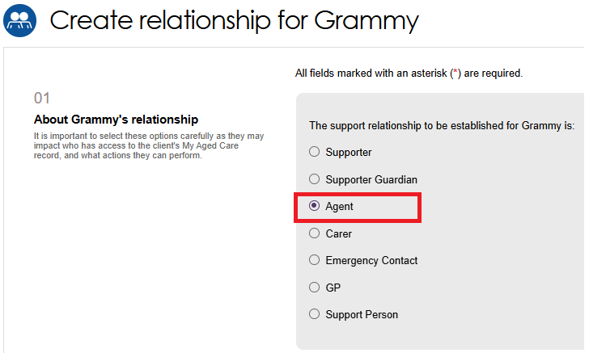
- In section 02 Add support organisation details, search for the support organisation by either entering its name or the suburb or postcode, then press SEARCH. Optionally you can also specify to search within a kilometre range of the suburb or postcode.
Suburb or Postcode search example
Organisation name search example
! | Only approved Agent Organisations are available in My Aged Care. If an organisation cannot be found, try refining your search terms or searching on the My Aged Care website.
- Once you have found your organisation, select it from the list.
! | Agent Organisations may offer more than one type of support. It may display as Advocate, Care finder, or Indigenous facilitator, under the ‘Support Offered’ column.
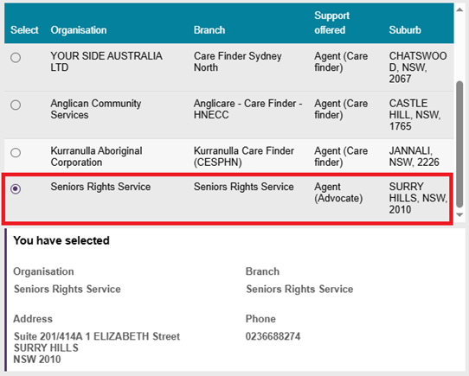
- Specify when the relationship should begin. You may also choose to record an end date for the relationship and, if applicable, include the full name of a specific agent within the organisation whom the client prefers to work with exclusively. Based on the organisation’s support type, this agent will be designated as the client’s Advocate, Care finder, or Indigenous facilitator.
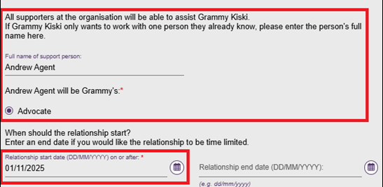
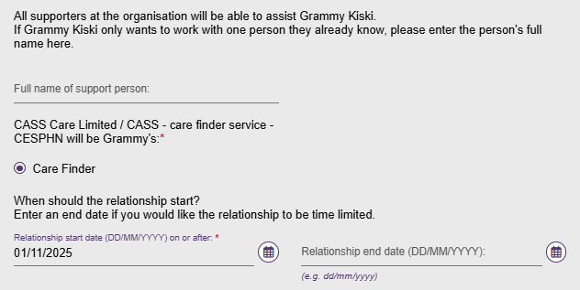
- In Section 03 Registration of Supporter or organisation form, upload the relevant registration form by selecting CHOOSE FILE button and enter the name of the attachment.
- In the 04 Consent section, confirm the client’s consent for the Agent Organisation to assist them in making decisions as their agent by selecting Yes or No. If No is selected, the relationship cannot be created, and the Create Relationship button will be disabled. If Yes is selected, proceed by clicking CREATE RELATIONSHIP to finalise the process.
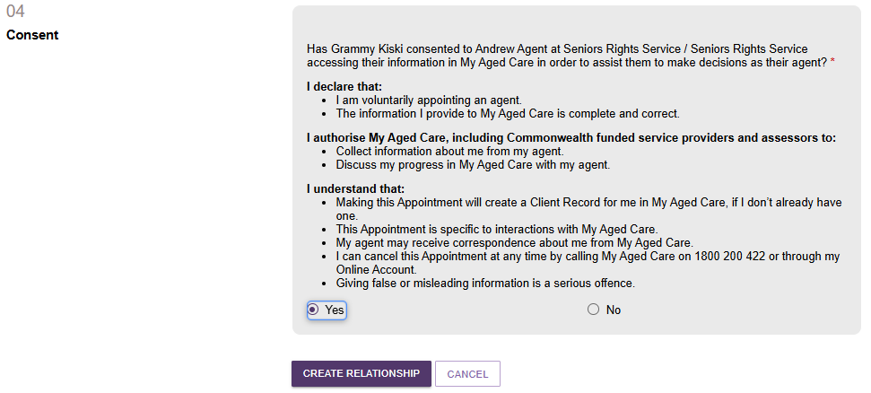

- Once ‘Create Relationship’ is selected, you will be directed to the client’s Support Network screen where the Agent Organisation will be displayed with a green banner confirming successful creation of the support relationship. However, the relationship will be in a Pending status. Go to ‘Activating a pending relationship’ for more information.
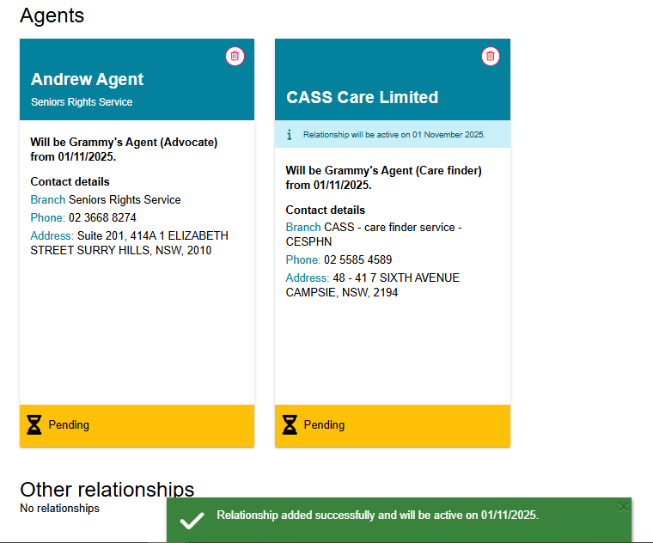

Creating a Carer, Emergency Contact, GP, or Support Person relationship
You will need to ensure that there is no duplicate clients or relationships in the My Aged Care system prior to creating a new relationship. This can be done by searching for the client and viewing their current support relationships, further information on this can be found in the My Aged Care – Assessor Portal User Guide 1 – Registering and referring clients for assessments.
Once you have made sure that there will be no duplicates, you can create a relationship for the client with a carer, emergency contact, General Practitioner or support person.
The steps involved in creating these relationships are the same.
- From the client’s Support network tab, select CREATE RELATIONSHIP.
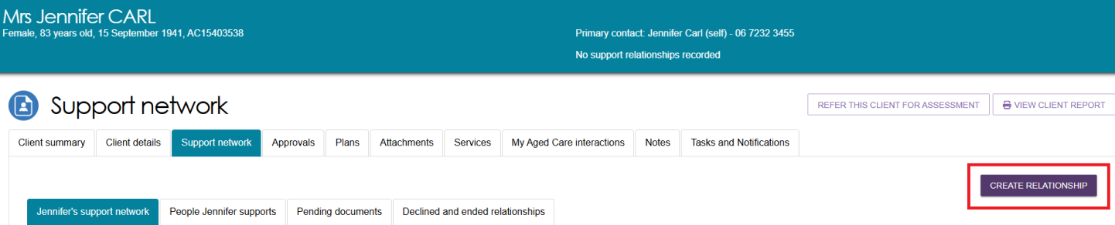

- The Create relationship for client page will be displayed. In Section 01 About client’s relationship, select the relationship to be created.
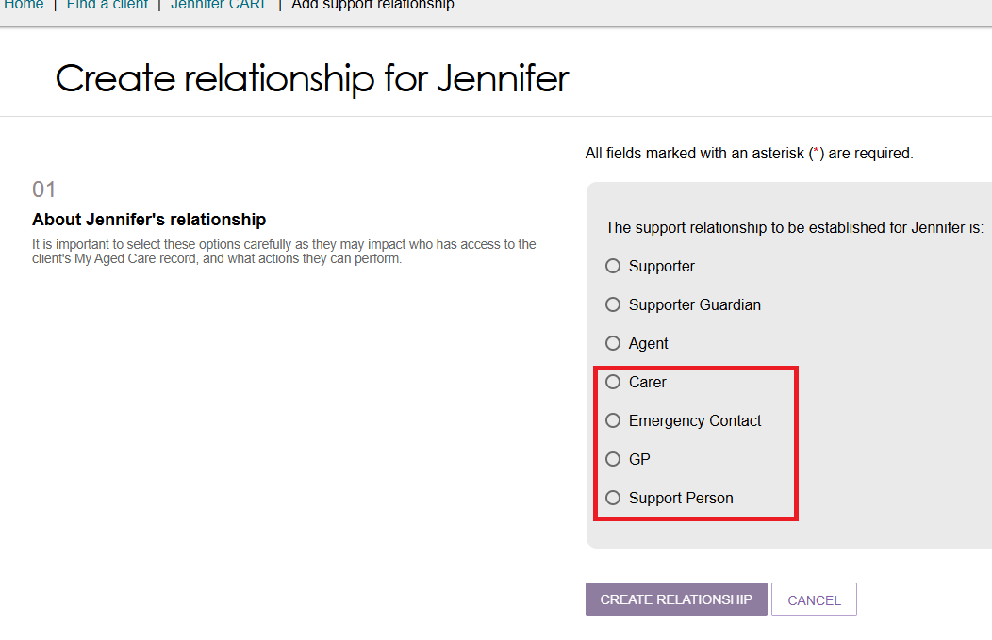
- In section 02 Add support person details, enter the First name and Last name of the new support, and select SEARCH. This is to ensure that there are no duplicate records being accidentally made in My Aged Care.
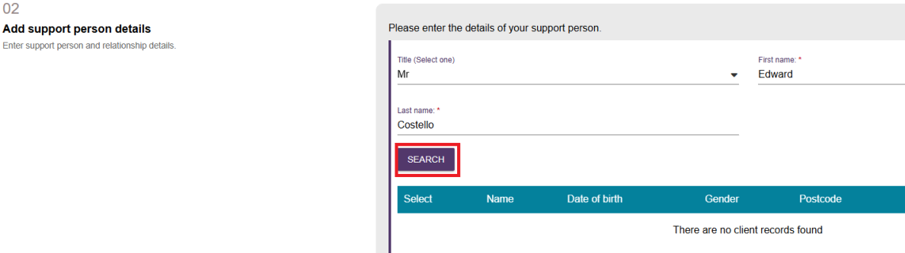
- If there are no records found, you can continue. Select CONTINUE TO REGISTER, then go to the Registering a new person for a support relationship section to continue to register.
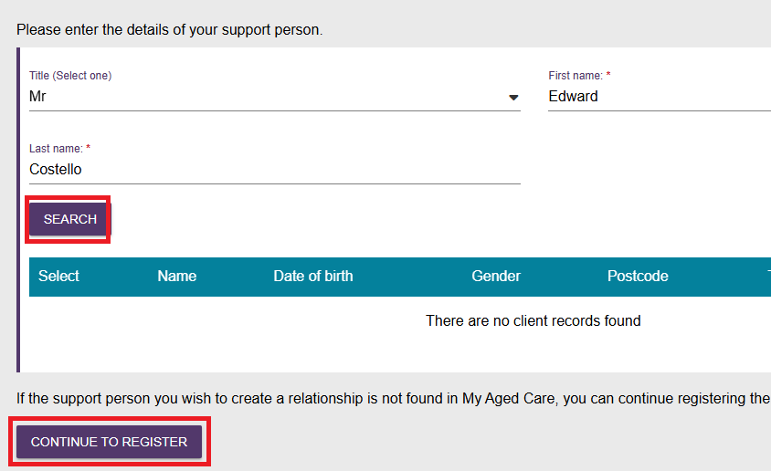
- If the support person’s name is known and they are registered in the system, search by entering their first and last name. From the list, select the correct matching record, and then tick the checkbox to acknowledge that you are selecting the correct record.
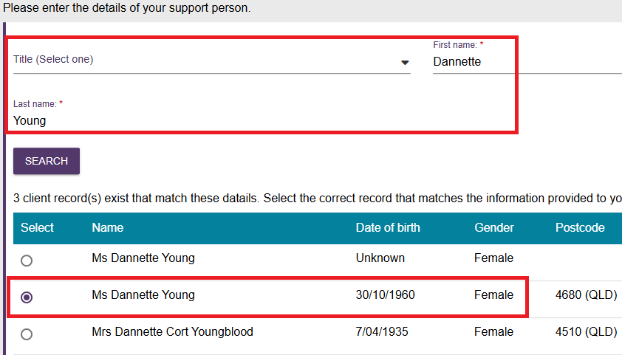
- Once confirmed you must respond to, the Relationship to client section. Choose the closest option and select CREATE RELATIONSHIP.
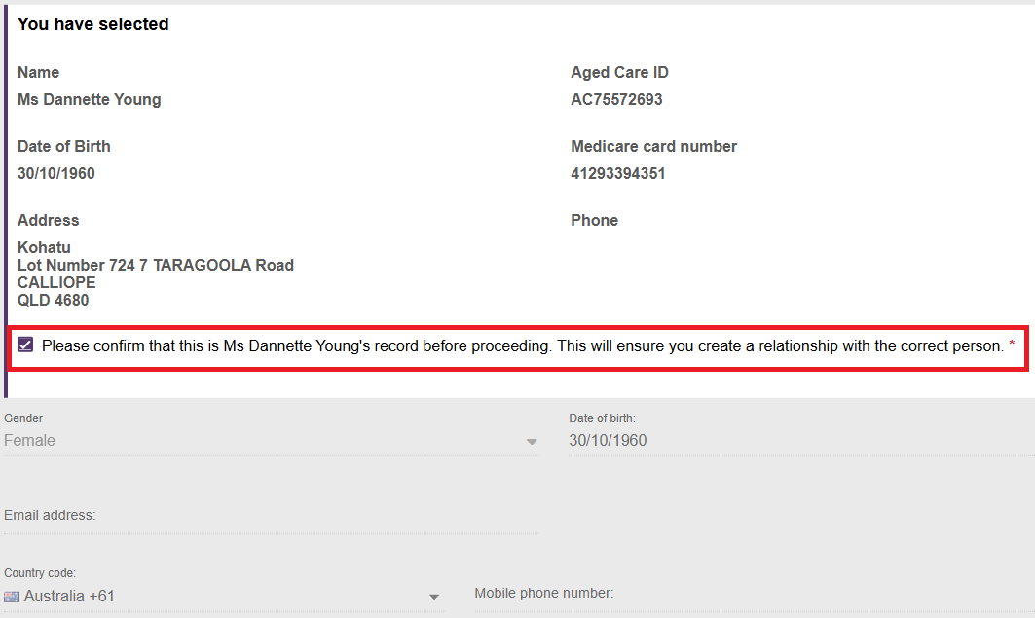
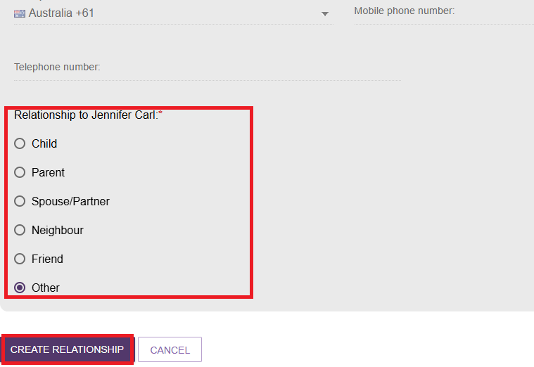
! | Once a carer relationship is successfully added, an option to REQUEST CALL BACK will be available and can be seen on the relevant carer tile as shown in the below example.  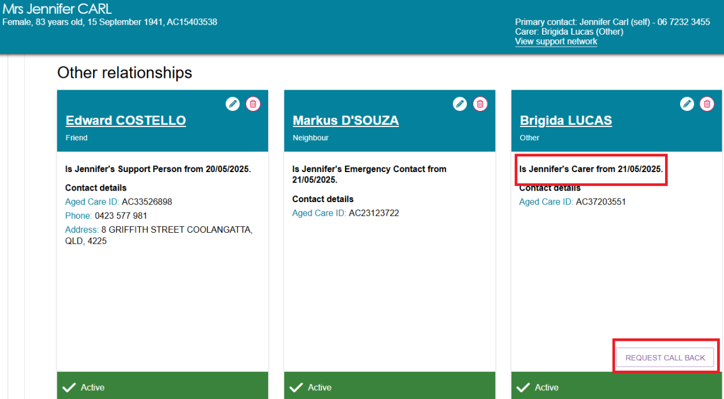

Registering a new person for a support relationship
- If there are no existing details of the person to be added as a relationship, you can register a new support relationship by following the below steps. This begins at the 02 Add support person details section, select the CONTINUE TO REGISTER button.
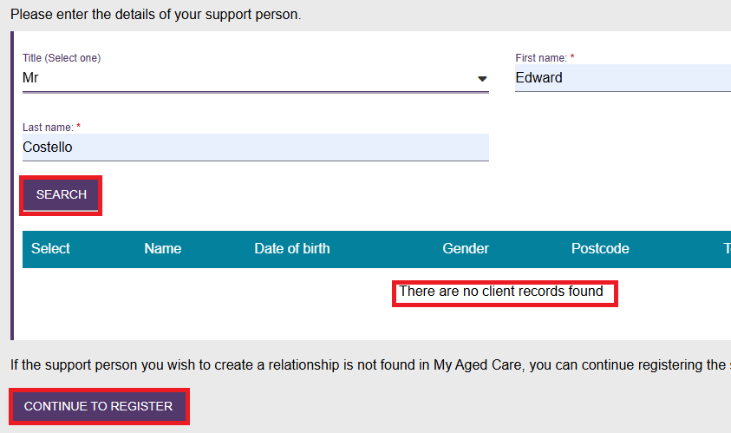

- The section will expand, and you will need to enter the new support person’s details. This includes:
- Title
- First name
- Last name
- Gender
- Date of birth or age if it is an estimate
and for SMS and email notification preferences:
- Email address
- Mobile phone number or contact phone number (including country code), to set up SMS and email notification preferences.
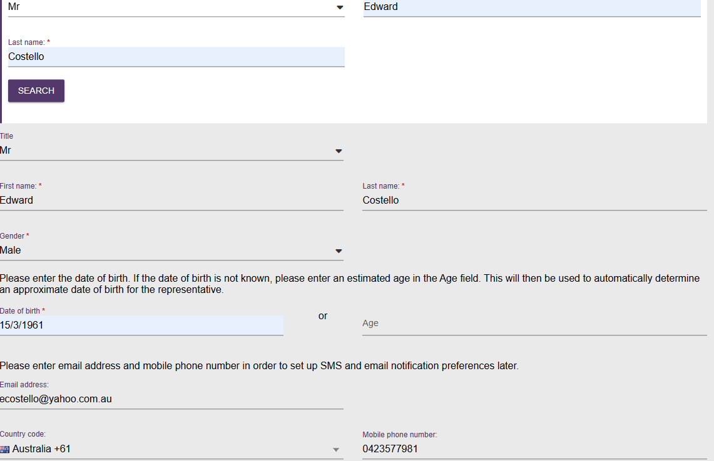

- Select support person’s relationship to the client.
If you are adding a home address for the support person, select Add home address for relationship.
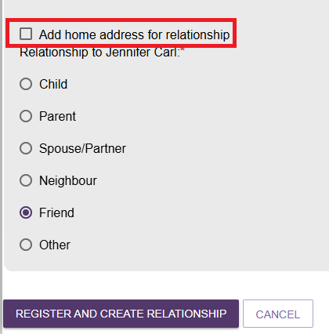
- The screen will expand prompting you to enter the address. You will need to enter the Street number, Street name, Street type and Enter Suburb and postcode and select from the list below. The address you are searching for will appear below, if it does not appear, select SUBURB IS NOT LISTED, CLICK HERE to enter the details manually.
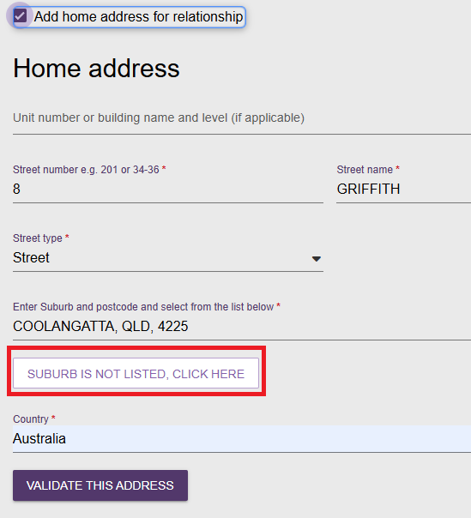

- Enter the country and then select VALIDATE THIS ADDRESS.
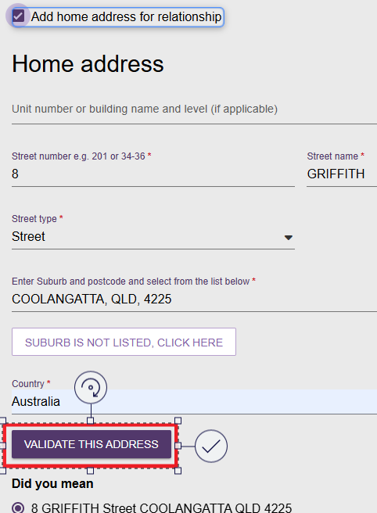
- If the address cannot be validated, check that it is correct and if so, select Not found, use entered address anyway. Additional address instructions can be provided in the free text box Special instructions.
- Select REGISTER AND CREATE RELATIONSHIP button.
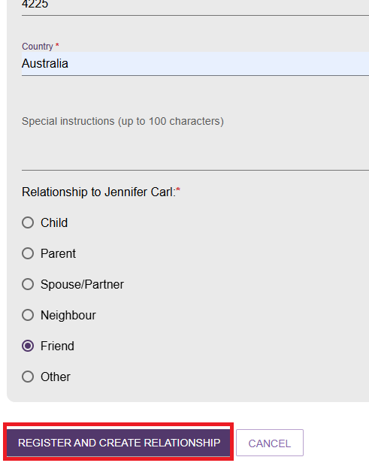

- You will be taken to the client’s Support Network screen where the Agent Organisation will be displayed with a green banner confirming the support relationship was created.
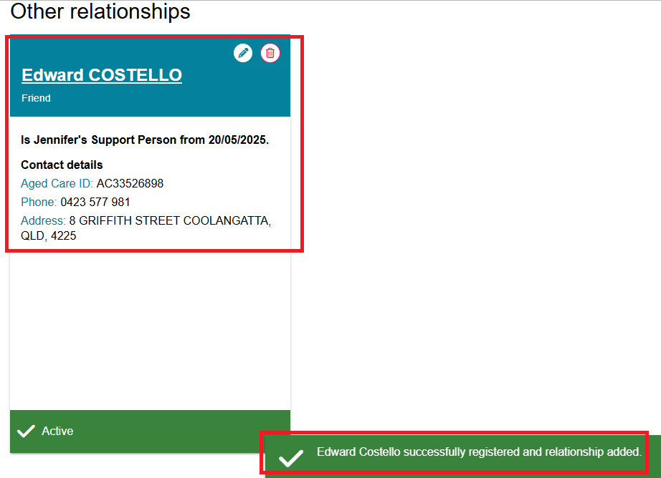
! | This relationship can also be viewed on the Supporter’s SUPPORT NETWORK tab.  - Click the Supporter’s name on the tile.  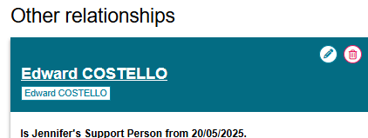  - You will be taken to the client details page of the Supporter. Navigate to SUPPORT NETWORK tab and select PEOPLE “SUPPORTER” SUPPORTS.  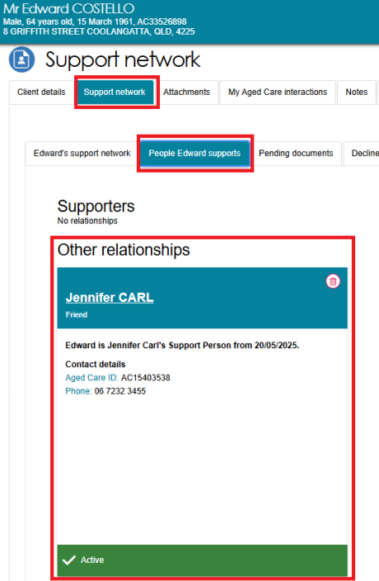

Activating a pending relationship
! | This function do not apply to Supporter Guardian relationship requests.
When either party in a Supporter relationship has not given their consent yet OR IF NEEDING DELEGATE APPROVAL, MISSING DOCUMENTATION, the registered Supporter, agent or organisation relationship becomes pending.
Pending relationships do not apply to carer, emergency contact, GP (General Practitioner), or support person relationships.
! | Supporters and Organisational Agents can be nominated through the My Aged Care website’s Apply for an assessment online form. In these cases, pending relationships will be created, and these pending relationships must be activated before a support person or organisation can assist a client. An assessor or team leader can seek the missing consents and activate a relationship for a client.
There are two methods available to activate a pending support relationship.

Via Assessment Referrals
You can view pending registered Supporters and other support people on assessment referrals in your Current assessments.
- Go to the Assessments tab in the assessor portal and select the client by clicking on the Expand (double arrow) icon in card view or list view.
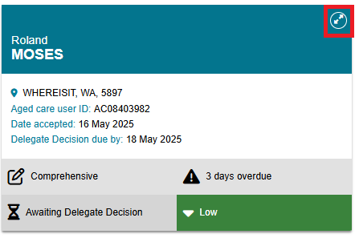

- A notification banner will be displayed at the client’s tile saying that the client has pending support relationships. Click on the support relationships link to display the client’s Support Network tab. Team leaders will also be able to view this banner on assessment referrals and reviews, and can follow the steps below to activate pending support people.
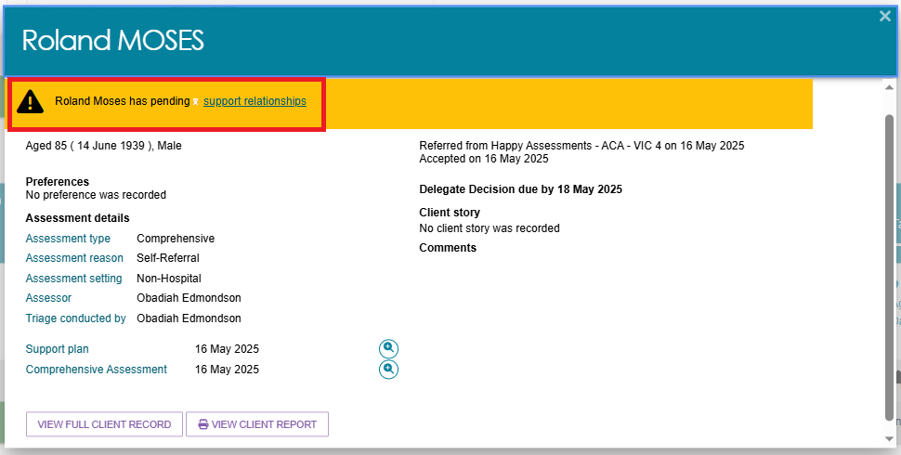
- Find the pending support person’s tile and continue with Step 3 of the Via Support Network tab section.
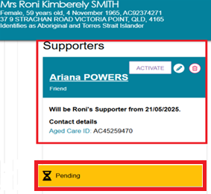
! | If a client’s registered Supporter has died, it is important to notify My Aged Care as soon as possible to ensure the client’s records are updated and appropriate support arrangements can be reviewed. The notification can be made by the client, a registered Supporter, or an authorised individual by contacting the My Aged Care contact centre. Relevant documentation, such as a death certificate, may be requested to verify the update. This helps maintain accurate records and ensures continuity of care planning.  To update the death of a client’s nominated Supporter, search the nominated Supporter using the FIND A CLIENT tile, navigate to the CLIENT DETAILS page and select the NOTIFY MY AGED CARE OF A DEATH button.

Via Support Network Tab
- Navigate to the record of the client who would like to establish a support relationship. If there is a pending support relationship, it will be displayed on the client summary page as shown in example below.
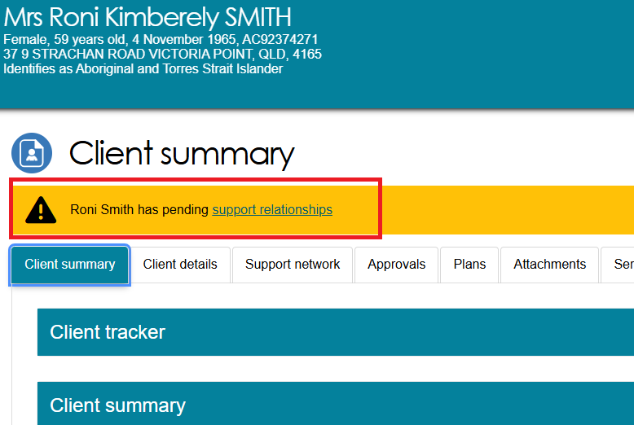
- On the client’s Support Network tab, the first sub-tab on the left Client’s support network displays as the default. These are the people and organisations with pending or active relationships to support the client.
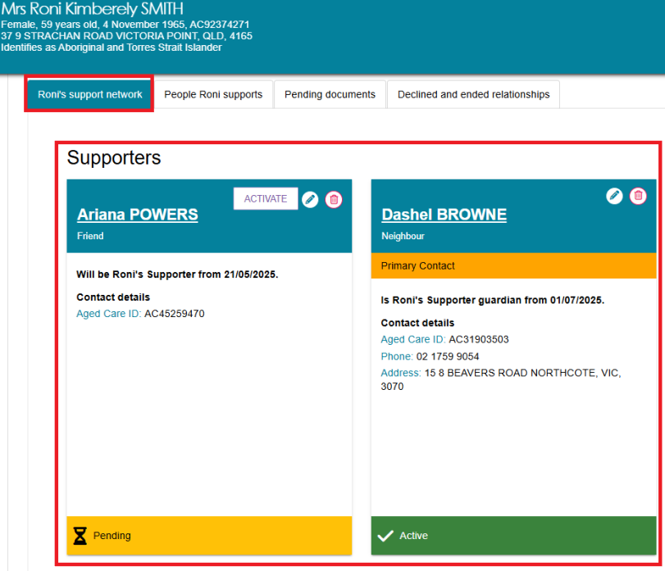

- To activate a relationship, select the ACTIVATE button on the card.
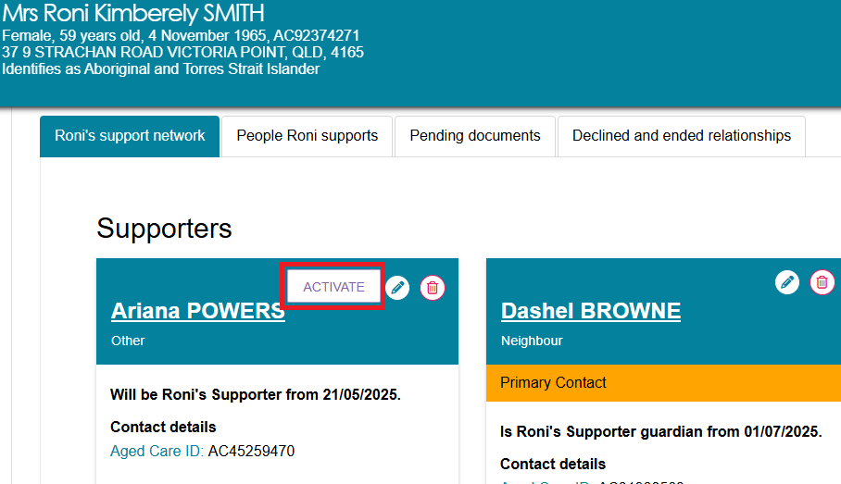
! | For relationships undergoing delegate approval, it cannot be activated in the Assessor Portal.  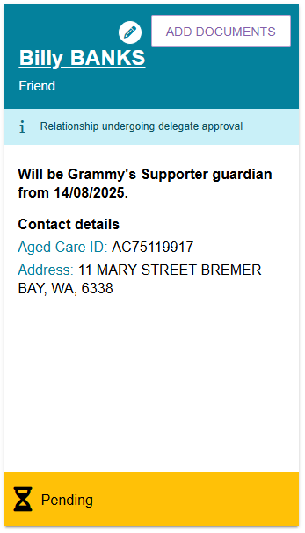

- The next pop up will depend on the status of the consents and/or supply of documents already submitted in the creating relationship process. Follow the prompts to record the consent of both parties, regardless of which party has already consented.
  - For each party, ensure they understand the declaration they are making and agreeing to, and the implications of the consent they are providing, then record their consent by selecting YES.
  - Both parties’ consent must be recorded by selecting Yes to both questions before the relationship can be activated. For Supporter Guardian relationships, only the prospective Supporter Guardian’s consent is required.
  - Upload documentation if required.
  - Select ACTIVATE.
- The following screenshot shows the Activate Relationship pop-up for a registered Supporter relationship.
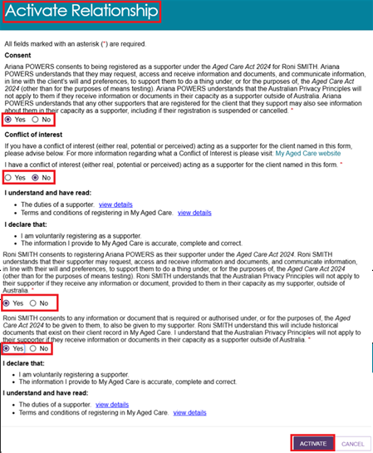

- The relationship will display as active with a tick in the support network tab. The card displays the name of the support person or organisation, their contact details, primary contact status (if applicable), and type and duration of the relationship.
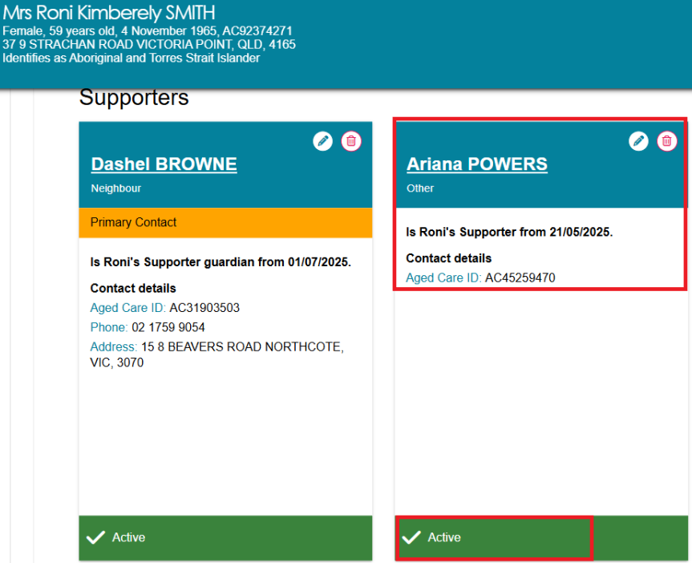
! | A lapsed status will activate if you have not activated a relationship awaiting consent from a party but has exceeded a 30-day time limit.  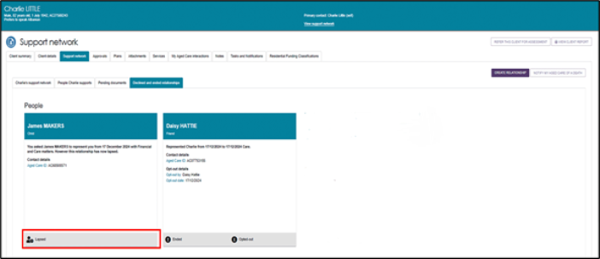

Removing a relationship
Most relationships can be removed, with some exceptions such as that a client cannot request the removal of a Supporter Guardian relationship.
- To remove a relationship, select the rubbish bin icon  on the relevant Supporter relationship.
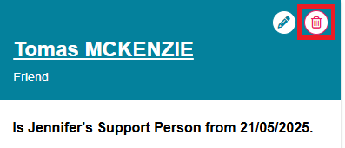
- Select the reason for removal.
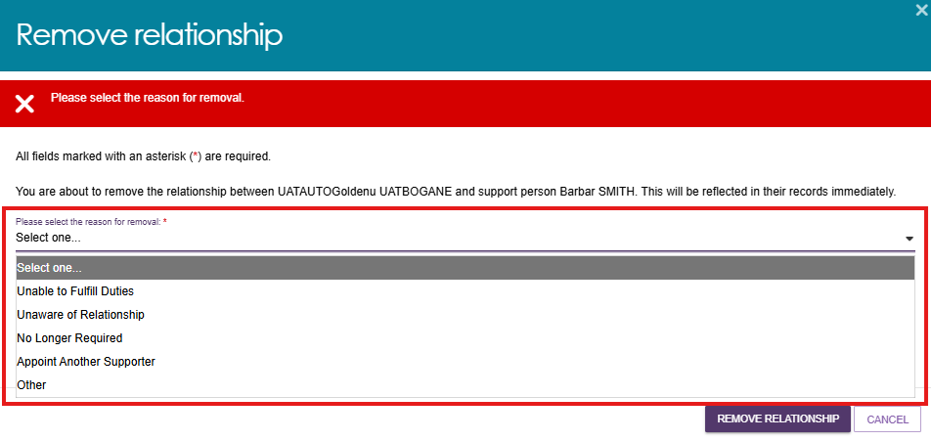
- A pop-up screen will be displayed to confirm removal of the relationship. Select REMOVE RELATIONSHIP.
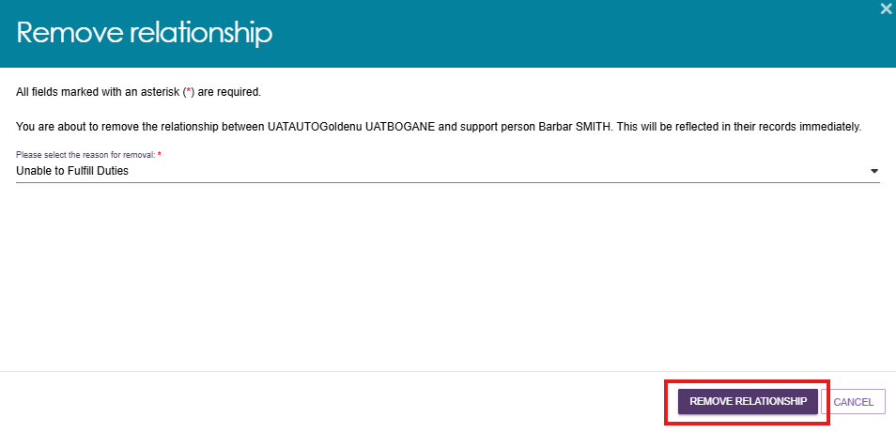

- The Supporter relationship will disappear from the client’s SUPPORT NETWORK tab and will be displayed under the DECLINED AND ENDED RELATIONSHIPS tab.
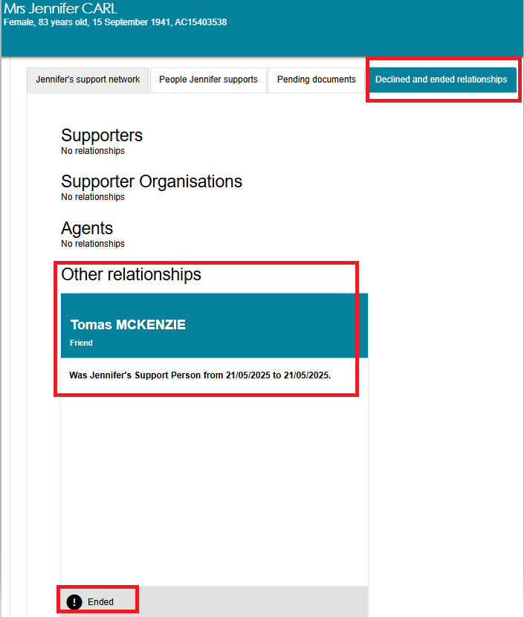

- A person who is chosen as a registered Supporter of the client can choose to remove relationships through the People [the client] supports tab by following the steps below. From the Support Network screen, Select People [client] supports tab which displays the people the client supports.
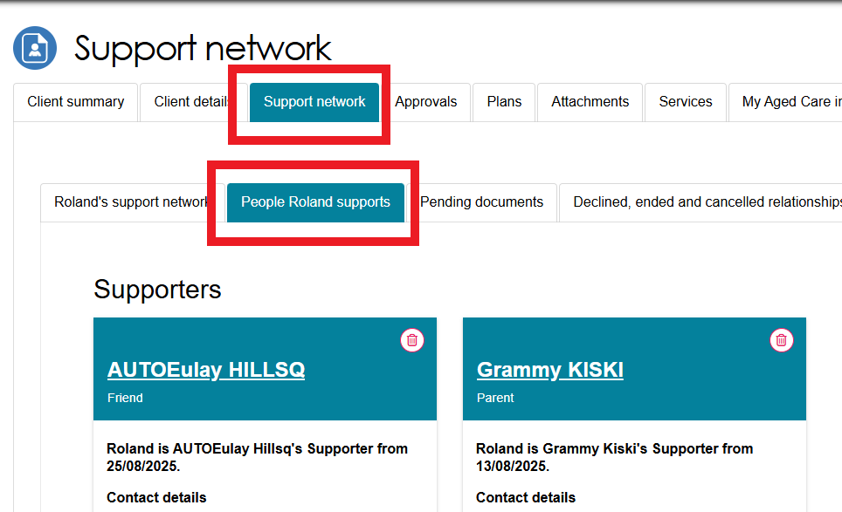

- Identify the relevant individual’s client card from the SUPPORTERS section and press the red bin icon.
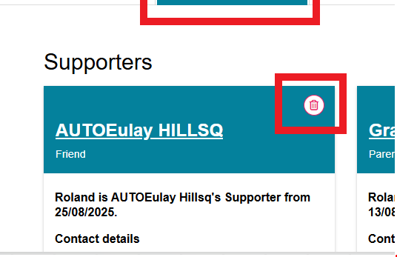
- A REMOVE RELATIONSHIP pop-up window will be displayed prompting the user to select the reason for removal.
These are:
- Unable to fulfill duties
- Unaware of relationship
- No longer required
- Appoint another Supporter
- Other.
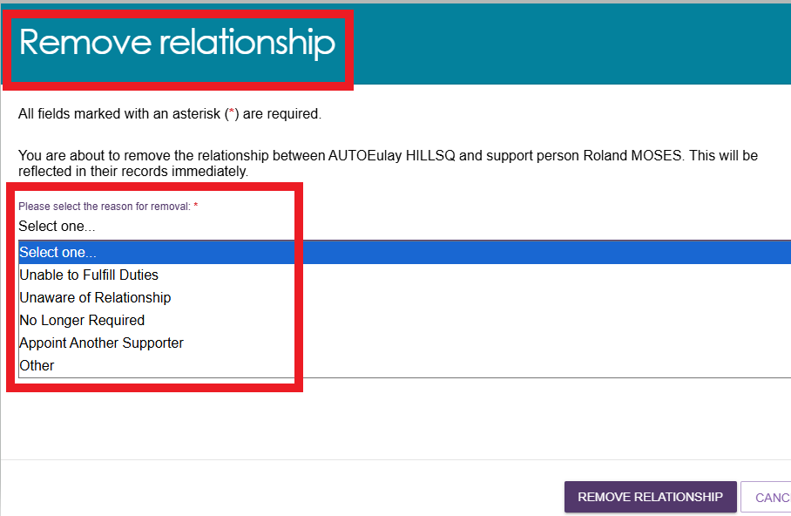

- Select REMOVE RELATIONSHIP.
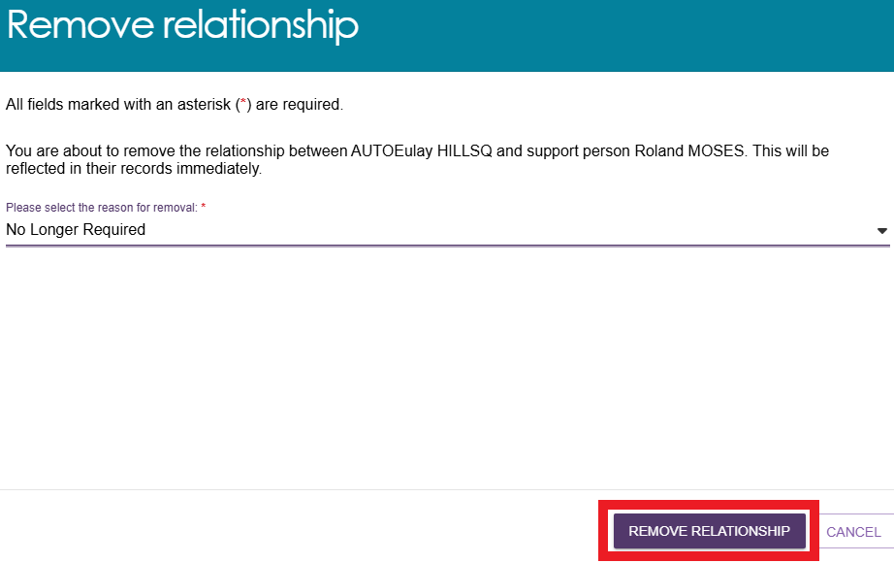
- A green banner will be displayed at the bottom of the screen confirming the removal of relationship.
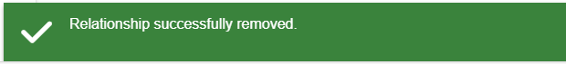

Viewing Suspended Relationships
A relationship is suspended when the System Governor has information to suspend the relationship. The Supporter, Supporter Lite or Supporter Guardian is notified and provided pathways to respond before a decision by the System Governor to either revoke the suspension or cancel the relationship. During the suspension a Supporter cannot receive information, or act as a Supporter for the older person (client).
Suspended relationships for the roles Supporter, Supporter Guardian, and Supporter Lite are displayed under the client’s SUPPORT NETWORK tab with a SUSPENDED status. .
! | The suspend action is initiated in the Staff Portal. Once initiated, the suspension status is propagated to all other My Aged Care portals.
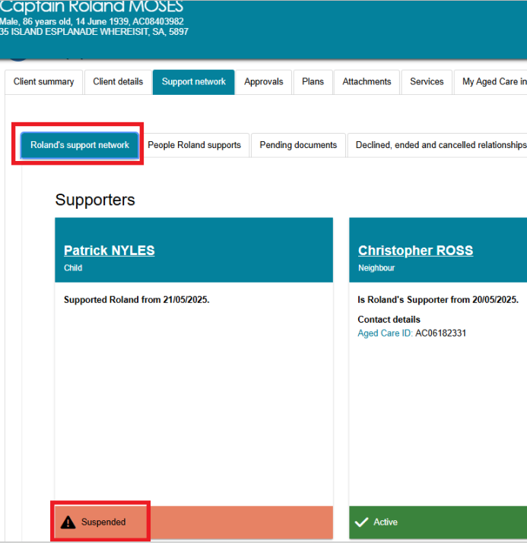

Viewing Declined, Ended and Cancelled relationship
A relationship can be CANCELLED and/or DECLINED in agreement with the individual / their authorised representative who provides support for a client.
The Declined process applies only to individuals who currently hold a Supporter role for the client, and occurs when the nominated Supporter chooses not to accept the role or relationship request initiated by the client or an assessor.
The System Governor can also Decline a relationship if a Conflict of Interest cannot be managed, or has information that supports declining a relationship, for example: previous cancellation of a relationship between the parties.
The Cancelled process is started by the System Governor.
! | These actions are initiated in the Staff Portal. Once initiated, the suspension status is propagated to all other My Aged Care portals.
An ENDED relationship means the Supporter can no longer view or act on the client’s behalf. This status appears when the relationship is removed by the user in the assessor portal as mentioned in the Removing a relationship process.
These relationships are viewable under the Declined, Ended and Cancelled relationship tab.
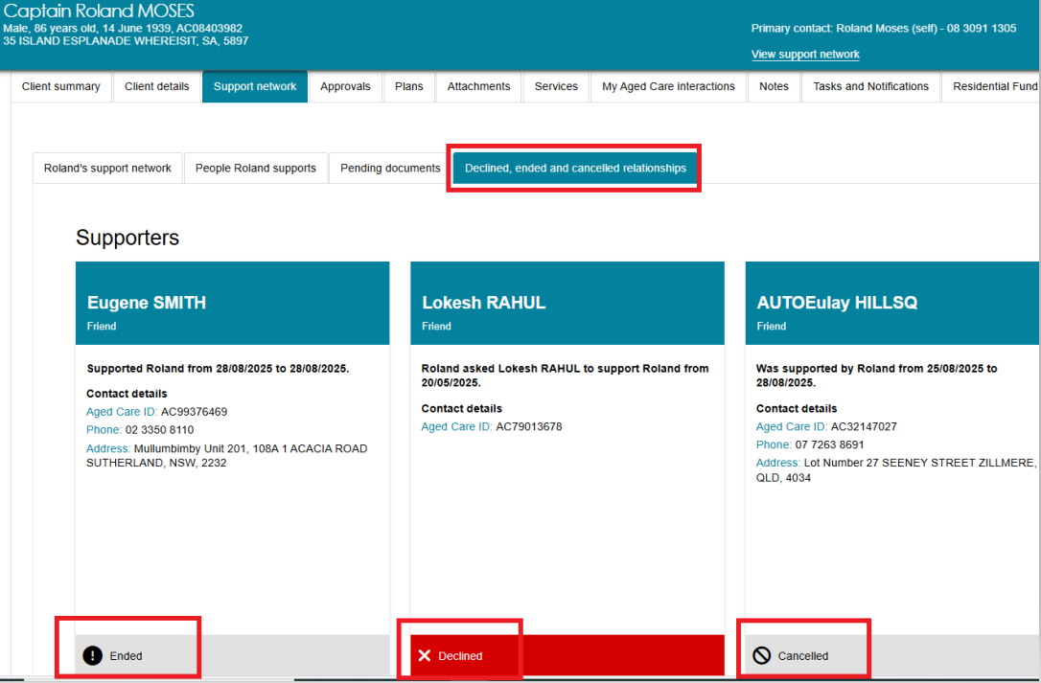

Configuring notification preferences for clients and their support people
My Aged Care clients and people who assist them (agents, registered Supporters, their organisations, carers, and other support people) can choose to receive email and/or SMS notifications when a client reaches the following key stages of their My Aged Care journey:
- client registration is complete
- the client’s assessment is finalised
- the client is approved for care after a home support or comprehensive assessment
- a client is assigned Support at Home funding, and at all stages where a Support at Home letter would be generated, such as assignment letter or withdrawal letter
- a client is assigned permanent Residential Care, and at all stages where a Residential Care letter would be generated, such as assignment letter or withdrawal letter
- a Support Plan Review request has been submitted
- a support relationship is activated, declined, inactivated or expiring, and submission or actioning of documents relating to support relationships.
Support organisations (for agents, Supporter and Supporter Guardian) will automatically receive email notifications and cannot select SMS notifications, if the information may or must be provided to the client under the Act. Supporter Lite roles will only receive notification of a change to their record. No other automated information is sent to this role.
New clients can opt in to receive email and/or SMS notifications at registration (refer to My Aged Care – Assessor Portal User Guide 1 – Registering and referring clients for assessments). Existing clients and support people can opt in to receive email and/or SMS notifications via the assessors (assessor portal), client’s online account, or by calling the My Aged Care contact centre on 1800 200 422.
The client or support person must have a verified mobile number for SMS notifications to be sent.
The client or the person in the support network’s phone number needs to be verified first, then notification preferences can be configured.
The below instructions are written in the client’s perspective, however the same process applies for other people in the support network, by accessing the support person’s client details tab.
Follow the steps below to set up and configure email and/or SMS notifications.

Verifying Mobile Phone Number
- Select the Client details tab on the client record. If the client has a mobile number on record that is not verified, a notification banner will display on the client details. In this banner, a message will ask the assessor to verify their mobile number.
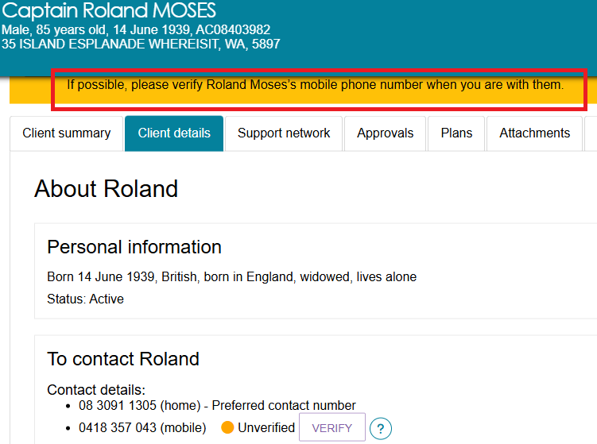
- To verify a client’s mobile number, select the VERIFY button.
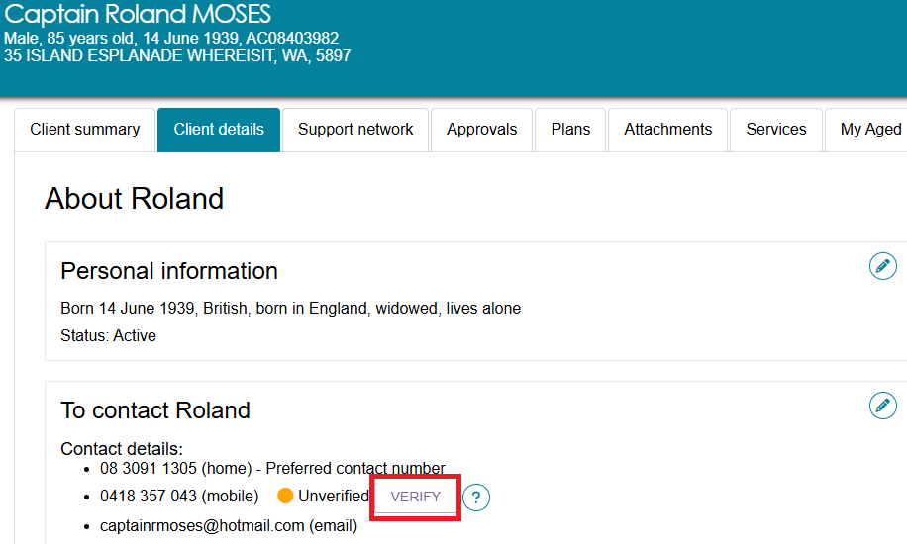
- A 6-digit verification code will be sent to the client’s mobile number. Enter the verification code and click VERIFY.
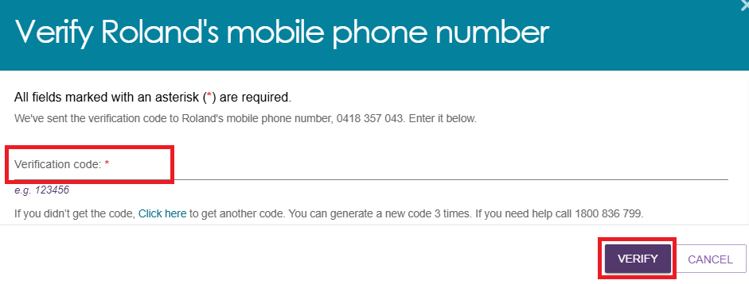
- After entering the code, the Unverified number will change to Verified and a confirmation message will display on screen.
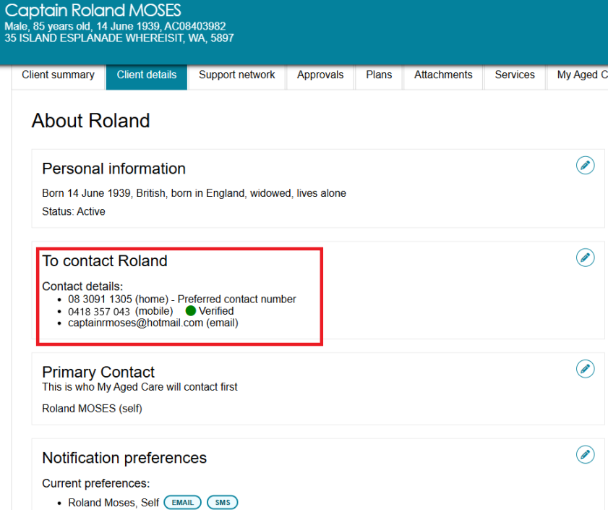

Configuring Notification Preferences
! | SMS notifications will only be sent to verified mobile numbers. Refer to Verifying Mobile Phone Number.
- To configure notifications, in the Client details section, select the edit icon on the right of the Notification preferences heading.
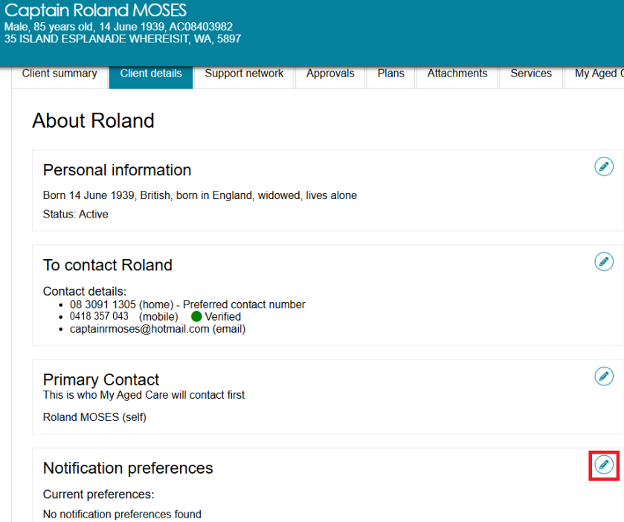
- In the pop-up box, you can configure who will receive email and/or SMS notifications from My Aged Care.
- To enable email and/or SMS notifications about a client, tick Consent to send SMS and emails about [client’s name] checkbox.
- To configure the notification preferences, tick each of the people listed who are to receive the notifications (‘Self’ for the client, and/or any of the listed support people).
- Email and/or SMS notifications can be disabled by unselecting the corresponding checkbox.
- After selecting who will receive Email and/or SMS notifications, click SAVE CHANGES.
! | Email notifications to support organisations appears for your information and cannot be removed.
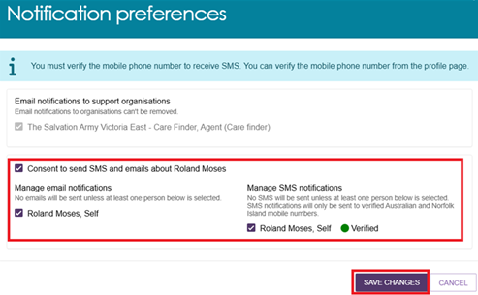
! | Both clients and people in their support network must provide an email address and/or mobile phone number and consent to receive email and/or SMS notifications from their respective records.  Email and/or SMS notifications will not be sent to an individual if a valid email address or verified mobile phone number has not been provided and/or if the client has not selected consent to send SMS and emails about [client’s name].  Where a client and a support person share the same mobile number and it is verified on both records, they will only be sent one SMS notification.
- Your preferences will appear in the Notifications Preferences section as a list of the name of the support person or organisation, followed by an EMAIL icon or SMS icon.
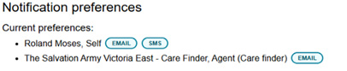

Requesting a call back from Carer Gateway or National Dementia Helpline
A carer that is registered in the My Aged Care system can access support services for themselves. Help for carers is available from Carer Gateway and the National Dementia Helpline.
The assessor can register the client and their carer’s consent in the assessor portal to request a call back from Carer Gateway, and/or National Dementia Helpline.
- Find the client who has a carer by viewing my client's relationships.
- Find the carer under the Other Relationships section and select REQUEST CALL BACK.
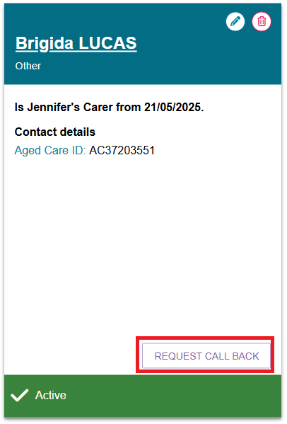
- The Request Call Back screen will display. This screen explains how sharing the client’s and/or carer’s personal information will work, and the types of services Carer Gateway Service Providers and the National Dementia Helpline offer.
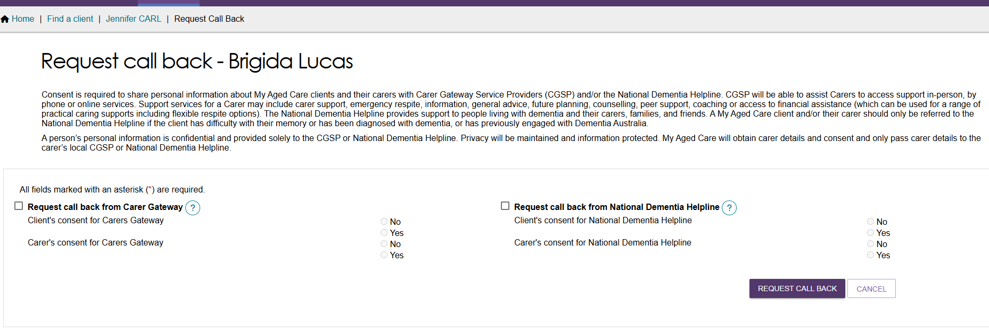

- To indicate consent, tick Request call back from Carer Gateway and/or Request call back from National Dementia Helpline. Then you can indicate the client’s consent and/or the carer’s consent for each service, by selecting the appropriate radio button. Fill out or edit the carer’s and/or client’s contact details. Select the REQUEST CALL BACK button
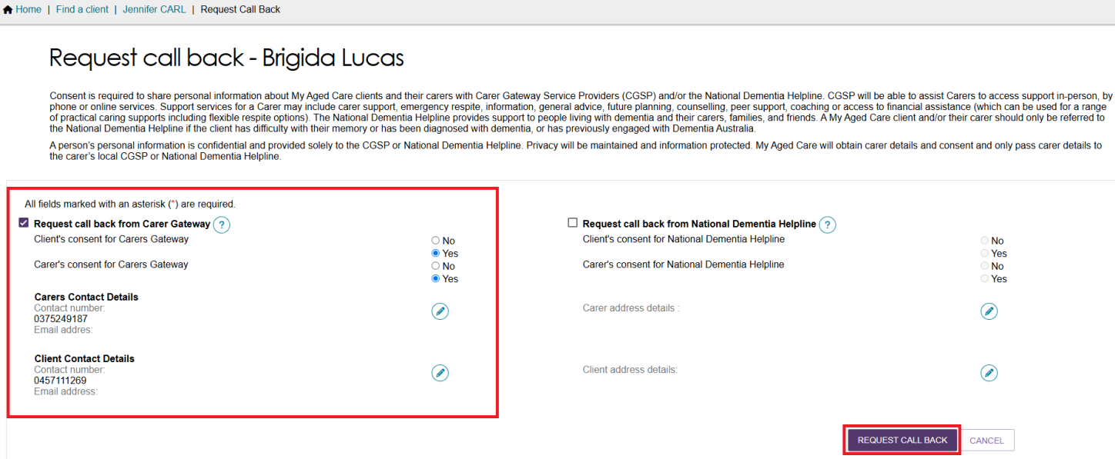
! | To successfully request a call back:  - the Carer’s consent must be yes  - both the client and carer’s home addresses must be provided  - if the client or carer has put in a corresponding phone number in their profiles, then the contact number must also be filled in.

Viewing call back and consent history
Call back requests and consent are recorded in the My Aged Care Interactions tab.
- To access the tab, navigate to the client’s record and Select the My Aged Care Interactions tab.
- In the View Interaction drop down menu, select Call Back Requests and then select GO.
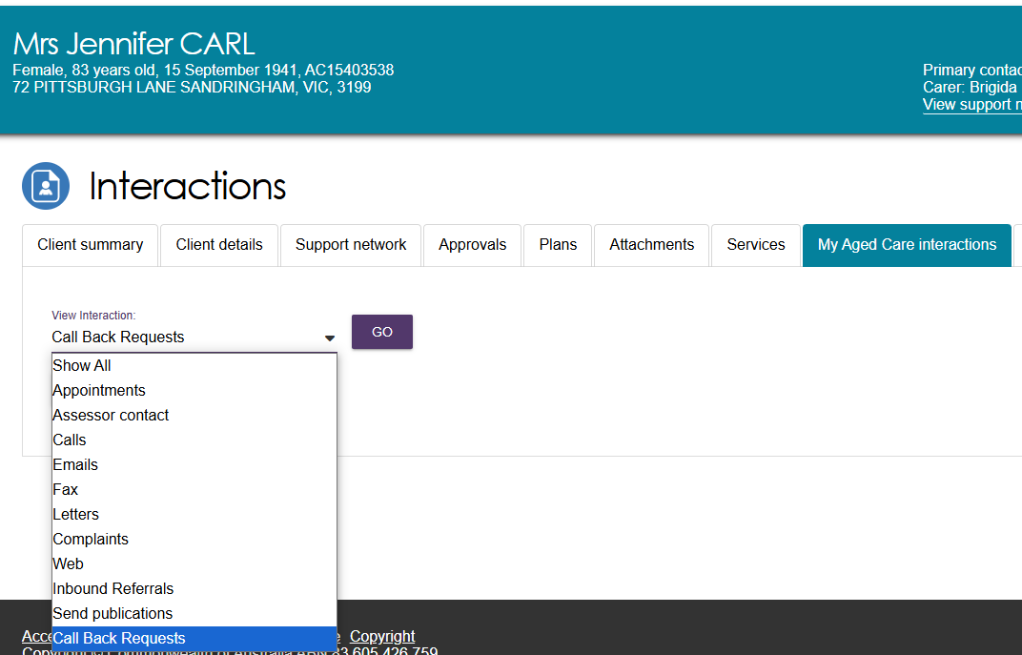
- Carer Call Back Requests will then display.
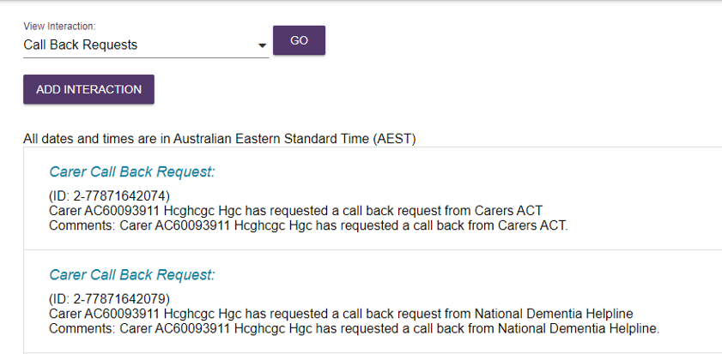

More information
For further assistance, you can call the My Aged Care service provider and assessor helpline on 1800 836 799.

