Assessor Portal User Guide 12 – Managing Delegate Roles
This user guide aims to support needs assessors, Team Leaders and Operational Managers to add, delete, or replace Delegate roles within the My Aged Care Assessor portal.
These Delegate roles include:
- Triage Delegates
- Clinical Assessment Delegates
- Non-clinical Assessment Delegates.
Table of contents
Delegate Roles 2
Triage Delegates 2
Clinical Assessment Delegate 2
Non-clinical Assessment Delegate 3
Viewing assessment delegates 3
Adding a Delegate role 4
Ceasing a Delegate role 7
Replacing a Delegate role 9
Approving Delegate roles 12
Team Leader verification of application 12
Operational Manager support of application 16
Returning Delegate applications 18

Delegate Roles
Assessors, Team Leaders and Operational Managers can submit applications to add, cease and replace Delegate roles within the My Aged Care assessor portal.
The Delegate role they can apply for include:
- Triage Delegate
- Clinical Assessment Delegate
- Non-Clinical Assessment Delegate.
The Triage Delegate and Assessment Delegate (Clinical and Non-Clinical) positions hold powers as the System Governor under the Aged Care Act 2024 that is delegated by the Secretary of the Department within an assessment organisation.
An assessment organisation member can only hold a Delegate role if their application to occupy one of the delegate positions within the assessment organisation has been approved by the department.

Triage Delegates
The Triage Delegate role enables users to:
- view incoming, accepted, assigned and triaged referrals
- assign an accepted assessment referral
- complete triage
- assign assessment to an aged care needs assessor once triage is completed.
Users applying for a Triage Delegate role must:
- hold a clinical status
- have a tertiary qualification
- have completed the Triage Delegate Training and have recorded their completion date.
! | Triage was previously completed by users with a Team Leader role, however users will now need to hold the Triage Delegate role to complete triage.

Clinical Assessment Delegate
The Clinical Assessment Delegate role enables users to:
- assign an item for Delegate decision
- record Delegate decisions
- agree or disagree with recommendations
- request and approve care extensions.
Users applying for a Clinical Assessment Delegate role must:
- hold a clinical status
- have a tertiary qualification
- have completed the Assessment Delegate Training and recorded their completion date.

Non-clinical Assessment Delegate
Non-clinical Assessment Delegates are delegated the authority under the Act to approve entry-level home support services only, including Assistive technology or Home Modifications under CHSP. This means they are restricted to approving the following classification levels only:
- CHSP Class
- AT CHSP (assistive technology under CHSP)
- HM CHSP (home modifications under CHSP).

Viewing assessment delegates
- To view staff who are currently assigned a Delegate role, select the Organisation administration tile from the homepage.
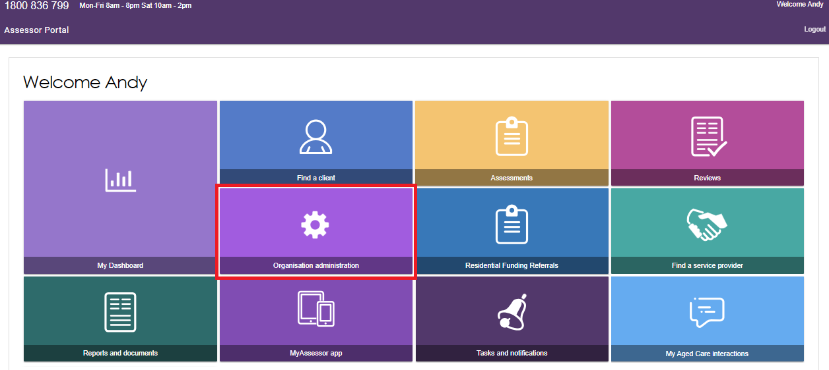
- In the Delegate Positions tab, select the VIEW DELEGATE POSITIONS.
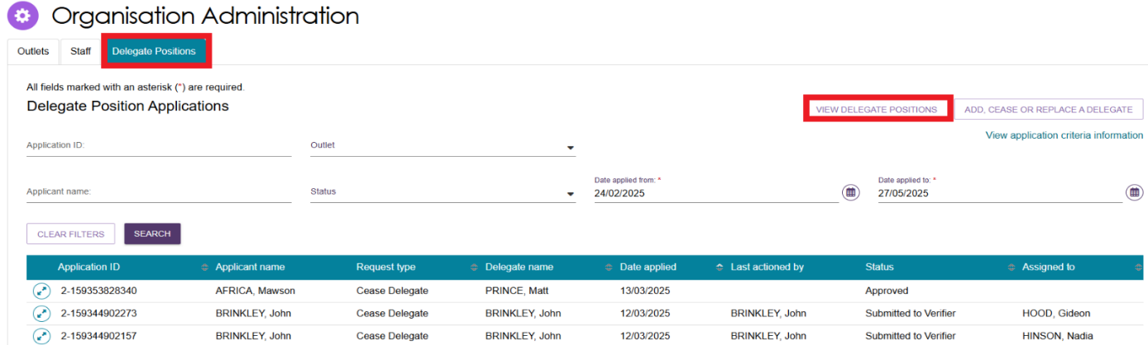
- The Delegate Positions pop-up will display. Select the Outlet from the drop-down menu which you wish to view delegates for and then click SEARCH.
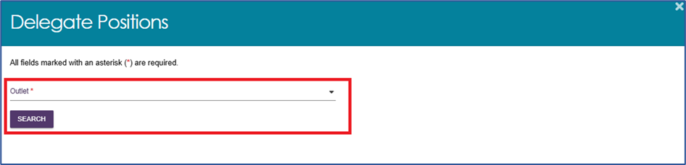
- All those who hold a Delegate role within the outlet will then display.
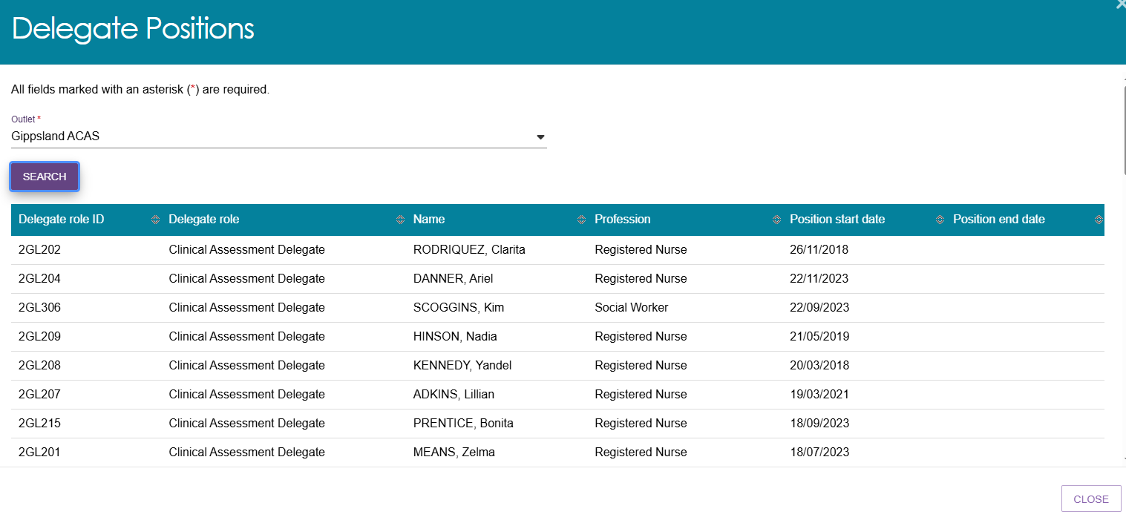

Adding a Delegate role
Individuals can submit applications for themselves, whilst those with either the Team Leader or Operational Manager roles are able to submit applications on behalf of others.
- From the My Aged Care assessor portal home screen select the Organisation administration tile.
- Select the ADD, CEASE OR REPLACE A DELEGATE button.
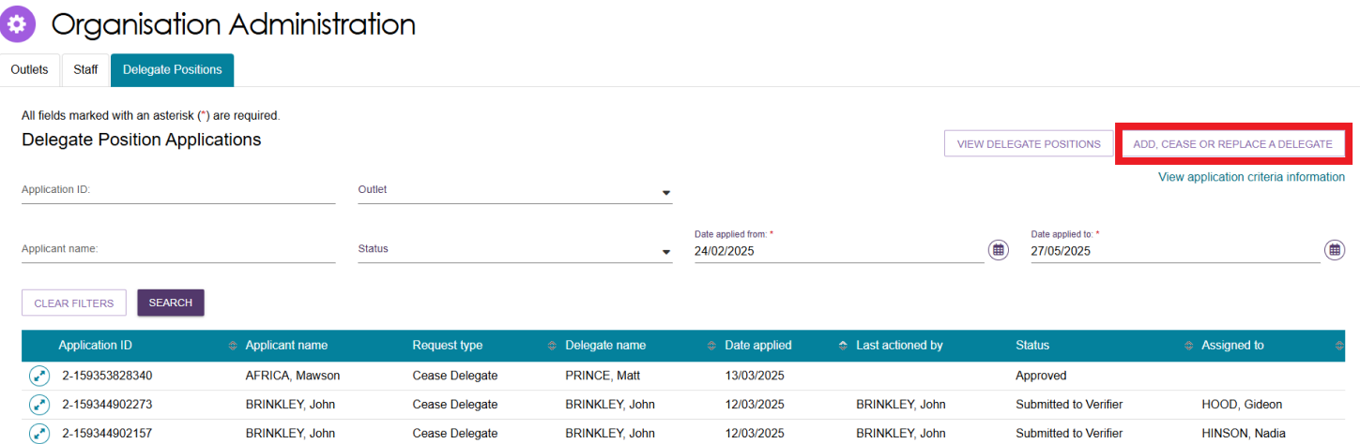
- From the pop-up choose the applicant. Select ADD A DELEGATE and CONTINUE.
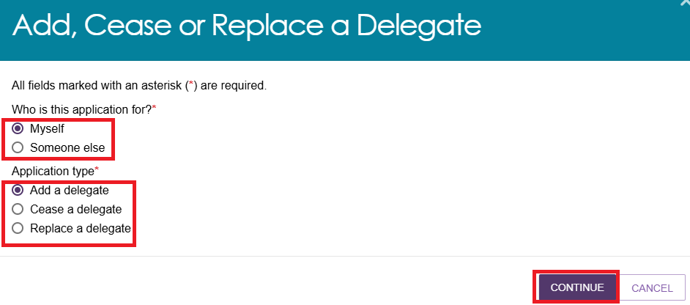
! | If you hold a Team Leader or Operational Manager role, the option to submit an application for someone else will display within this pop-up.
- Complete step 01 – Proposed Delegate Details of the application process by completing the relevant fields and select the confirmation check box.
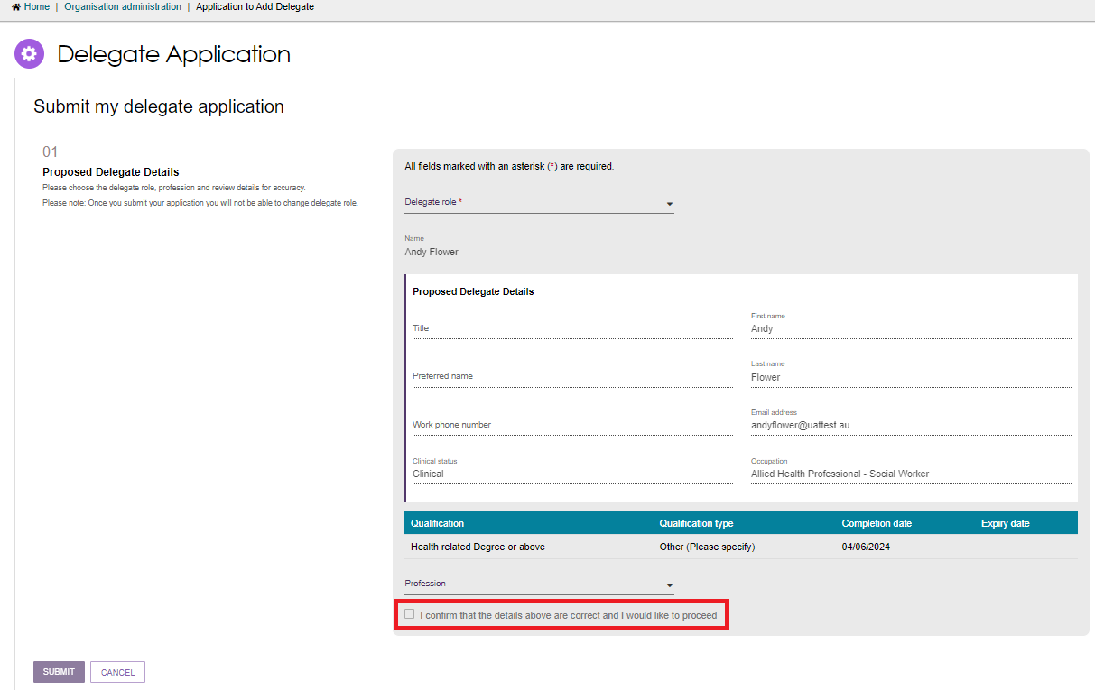
! | Banners will display if information is missing. If a red banner displays, you will not be able to progress the application.  If an amber banner displays, you will still be able to progress your application, but additional information will be required later.  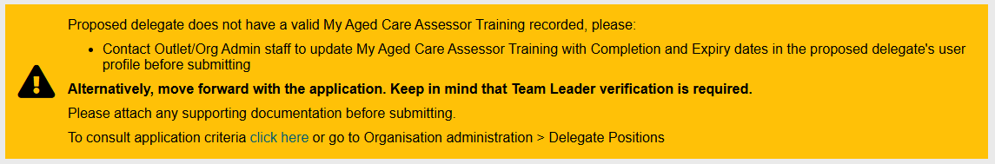
- Step 02 – Delegate Position/s will then display. Select ADD OUTLET POSITION.
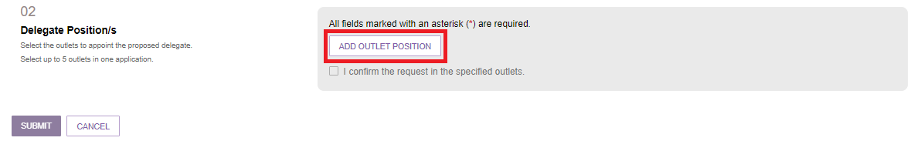
The Outlet position details will then display. Select the outlets the Delegate position will relate to from the drop-down list of Outlets. Applicants can select up to twenty Outlets per application.
Select the confirmation checkbox to progress to the next step.
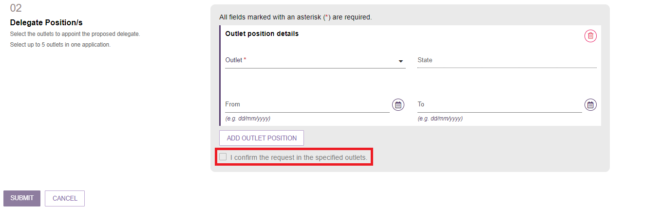
- In step 03 – Application Verifier Details select the Team Leader who will verify your application from the drop-down menu.
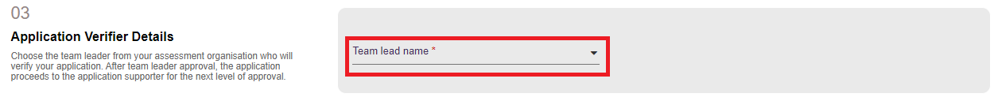
- In step 04 – Application supporter details select the Operational Manager who will be supporting your application from the drop-down menu.
Please note if an Operational Manager is not present you will not be able to progress with your application. If this is the case, contact your Organisation.
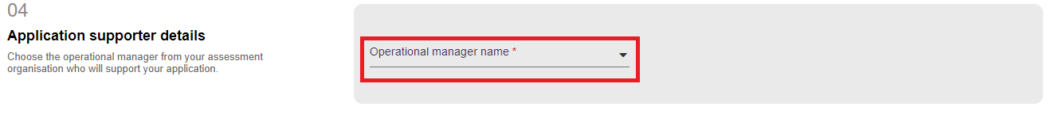

- Submit any support documentation by selecting UPLOAD SUPPORTING DOCUMENTATION in step 05 – Attachments. Then select SUBMIT.
Your application will then be sent to the nominated Team Leader for reviewing and actioning.
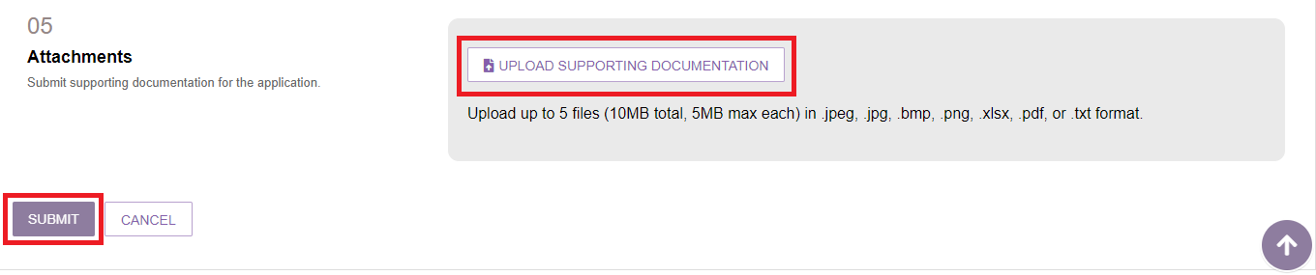
Once the application is submitted, a green pop-up will display that contains the application ID.

Ceasing a Delegate role
- From the Organisation Administration page select ADD, CEASE OR REPLACE A DELEGATE.
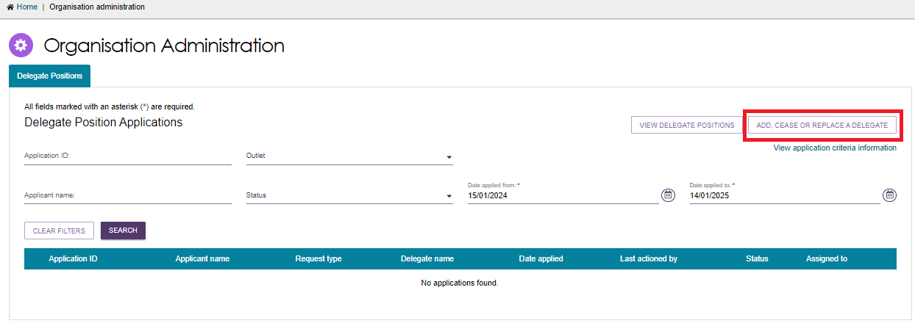
- Select Cease a Delegate and continue. If you hold a Team Leader or Operational Manager role, the option to submit an application for someone else will display within this pop-up.
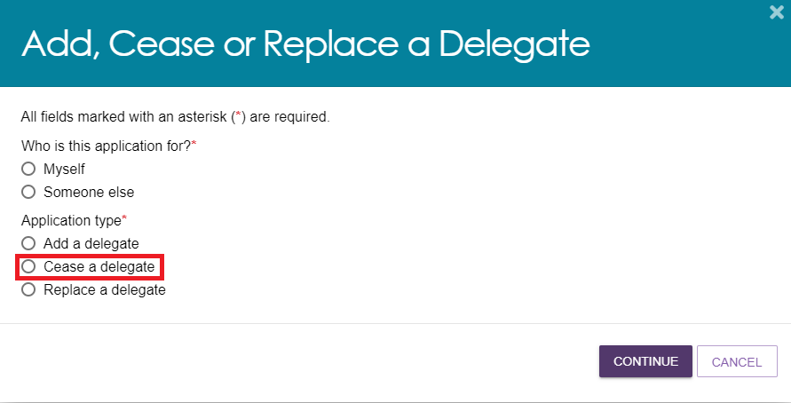
- In step 01 – Current Delegate select the Delegate role from the drop-down menu you wish to cease, then select the confirmation checkbox to progress.
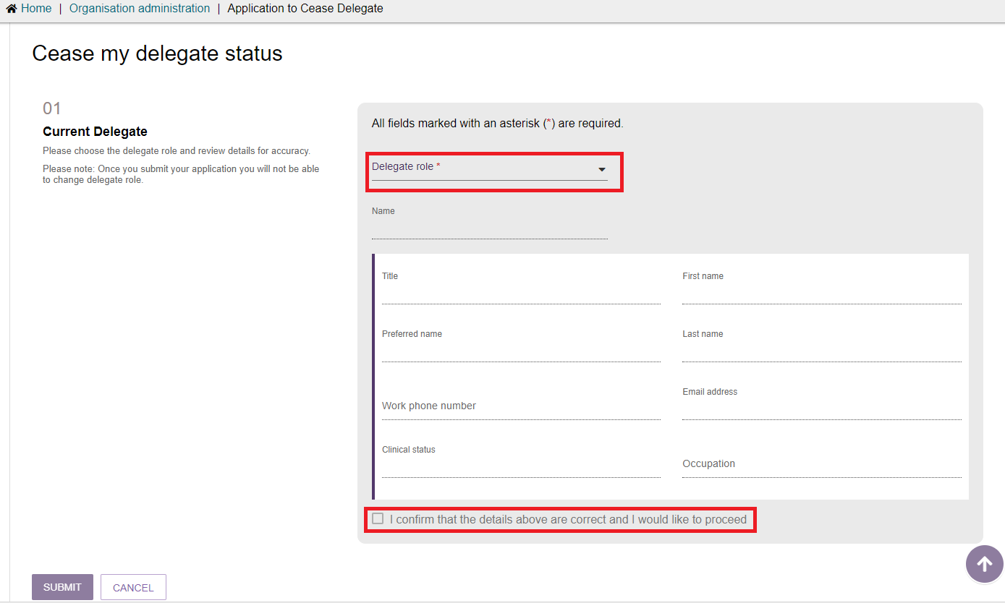
- Step 02 – Delegate Position/s will display. Select the outlets you wish the Delegate role to be ceased for and add the relevant start date. Select the confirmation checkbox to continue.
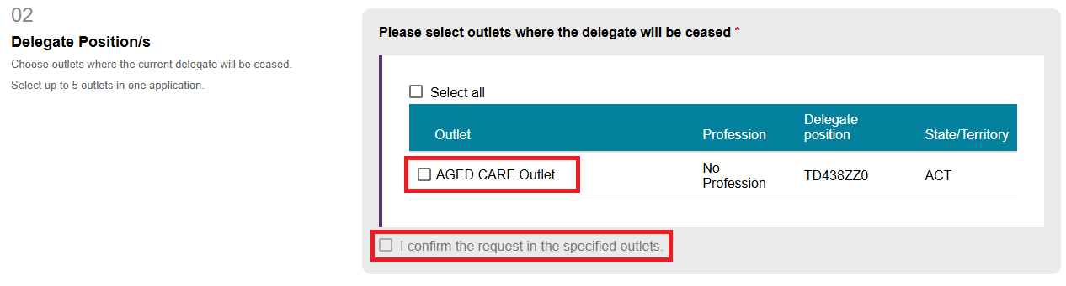
- In step 03 – Application Verifier Details select the Team Leader who will verify your application from the drop-down menu.
- In step 04 – Application supporter details select the Operational Manager who will be supporting your application from the drop-down menu.
Please note if an Operational Manager is not present you will not be able to progress with your application. If this is the case contact your Organisation.

- Finally, submit any support documentation by selecting UPLOAD SUPPORTING DOCUMENTATION in step 05 – Attachments.
Then select SUBMIT. Your application will then be sent to the nominated Team Leader for reviewing and actioning.
A green banner will display confirming the application to cease has been submitted and an Application ID provided.

Replacing a Delegate role
- From the Organisation Administration page select ADD, CEASE OR REPLACE A DELEGATE.
- Select Replace a Delegate and continue. Please note if you hold a Team Leader or Operational Manager role, the option to submit an application for someone else will display within this pop-up.
When applying to replace a Delegate for yourself, you will also be required to select whether you will replace another Delegate or if another Delegate will replace you.
Select CONTINUE.
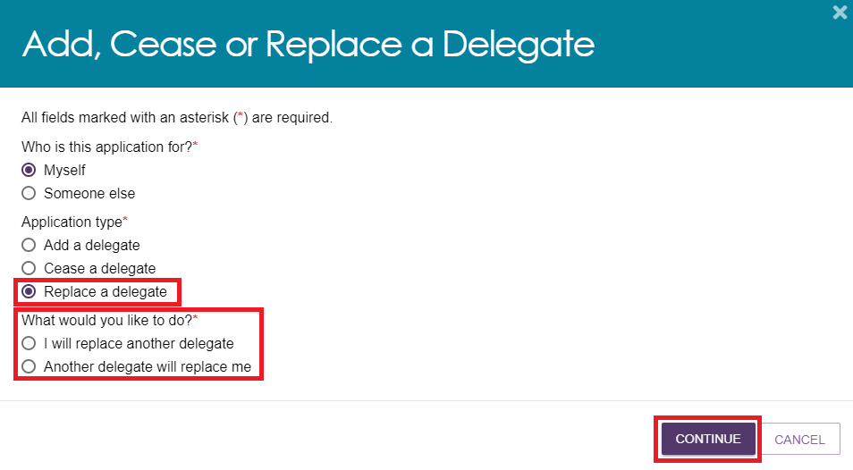
- Step 01 – Proposed Delegate Details will display.
From the drop-down menu select the Delegate role you wish to replace, ensure your details are correct and then select your relevant profession.
Confirm the details via selecting the checkbox and then select SUBMIT to continue.
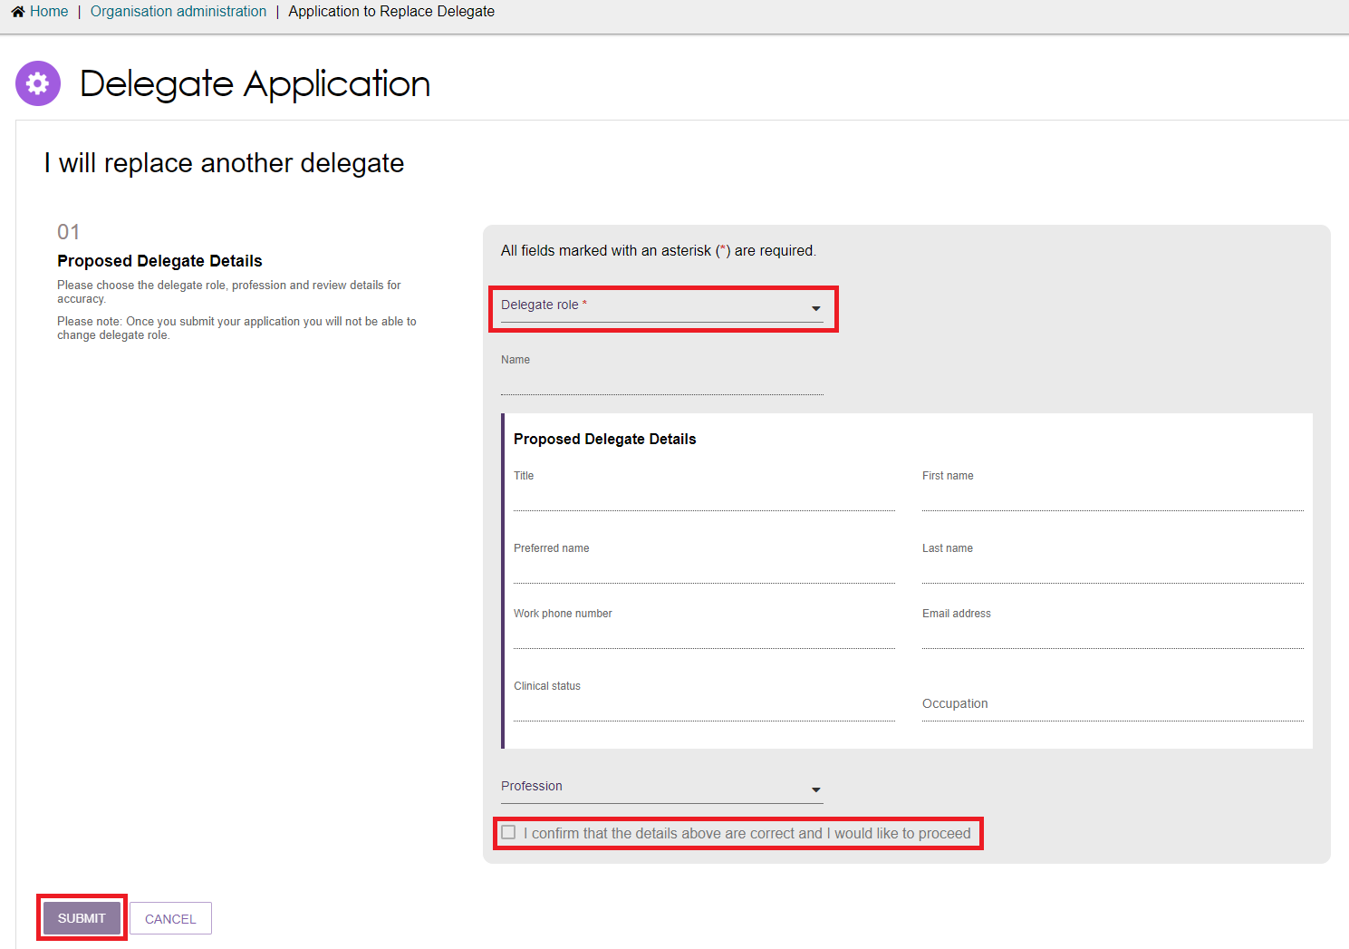

- In Step 02 – Current Delegate enters the name of the Delegate you are applying to replace. Note, the system will display the current Delegates in a drop-down menu as you type their name in.
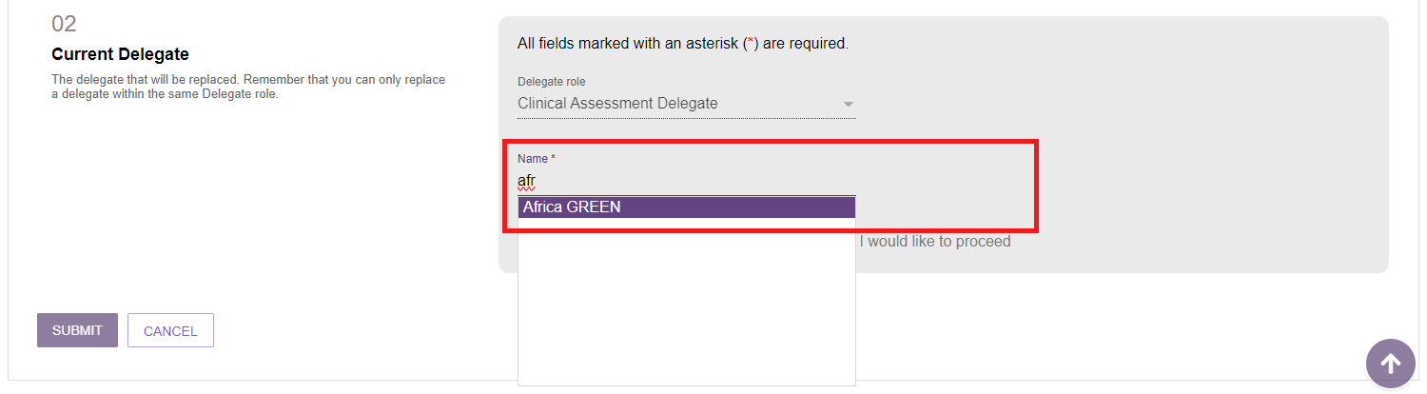
The Delegates details will then display. Select the checkbox to confirm the details are correct to continue.
- In step 03 – Delegate Position/s select the outlets where the current Delegate will be replaced. You may also enter a start and end date.
Select the confirmation checkbox to continue.
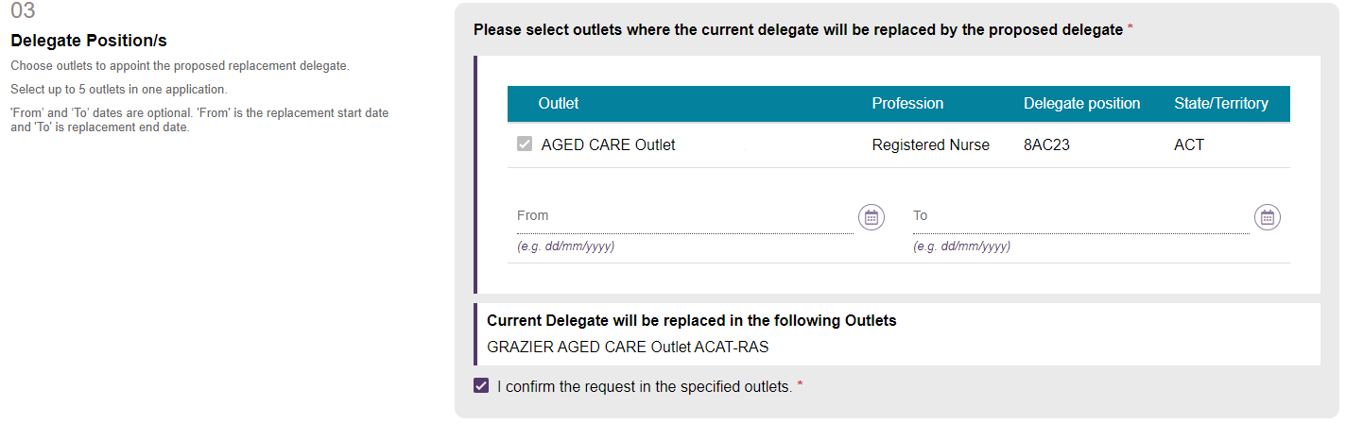
- In step 04 – Application Verifier Details select the Team Leader who will verify your application from the drop-down menu.
- In step 05 – Application Supporter Details select the Operational Manager who will be supporting your application from the drop-down menu.
Please note if an Operational Manager is not present you will not be able to progress with your application. If this is the case contact your Organisation.

- Finally, submit any support documentation by selecting UPLOAD SUPPORTING DOCUMENTATION in step 06 – Attachments.
Then select SUBMIT. Your application will then be sent to the nominated Team Leader for reviewing and actioning.
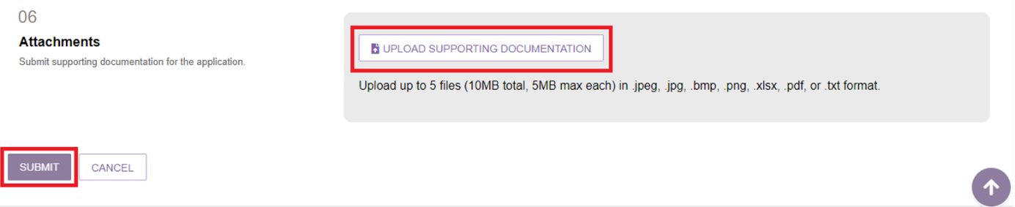
A green banner will then display confirming the application has been submitted and outlining the application ID.

Approving Delegate roles
Once an application to add, cease or replace a Delegate has been submitted, a Team Leader and Operational Manager will be required to verify and support the application.

Team Leader verification of application
For a Team Leader to verify a Delegate’s application follow the steps below.
- From the homepage, select the Organisation administration tile.

- From the Delegate Positions tab, Team Leaders will be able to view all Delegate applications and their current status.
The nature of the request (adding, ceasing or replacing a Delegate) will display in the Request type column.
Expand the application you wish to verify by selecting the arrow icon and then select VERIFY APPLICATION.
Please note, applications that require verifying will be marked with a red exclamation mark next to the Application ID.
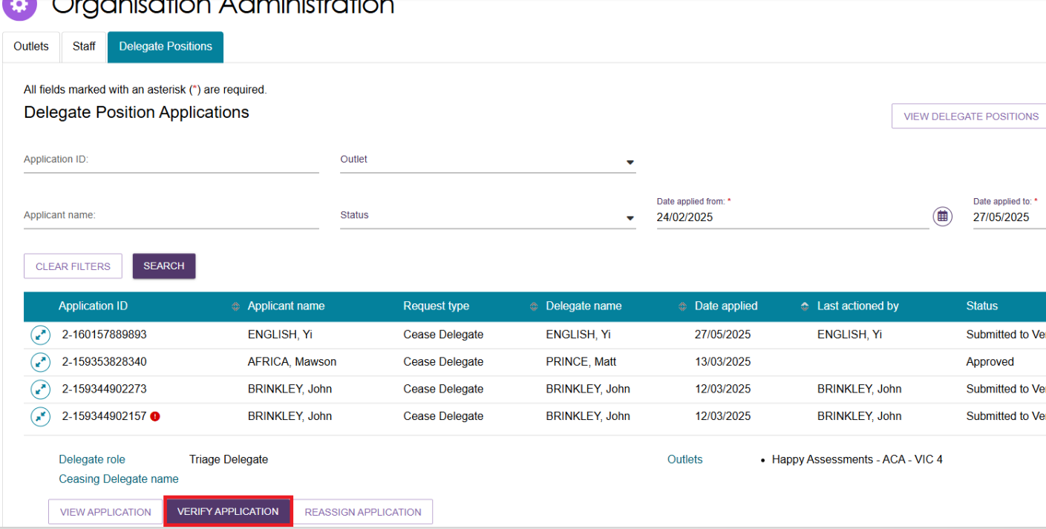
! | You can also reassign the application to another Team Leader to verify by selecting REASSIGN APPLICATION.  A pop-up will display asking you to select the Team Leader you wish to reassign the application to before selecting the RE-ASSIGN button.  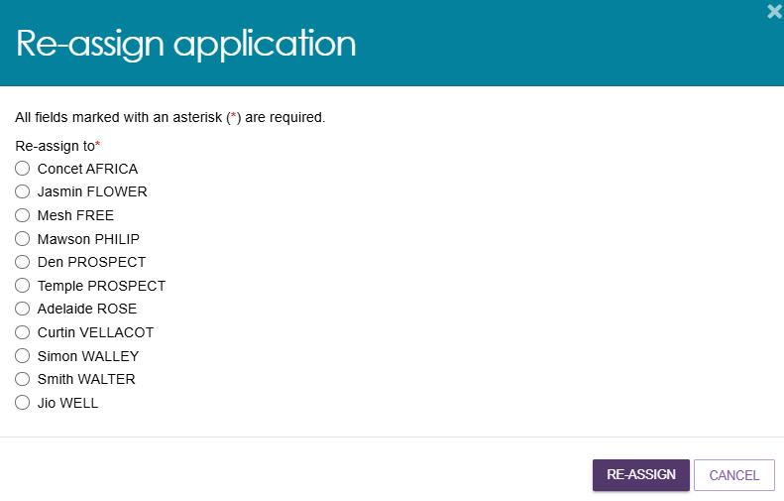
- The Delegates application will then display.
If verifying an application to cease a Delegate review the application in full then continue to the next step.
If verifying an application to add a Delegate or replace a Delegate, review the application in full before completing the Complete Verification section (step 05 for adding a Delegate and step 06 for replacing a Delegate).
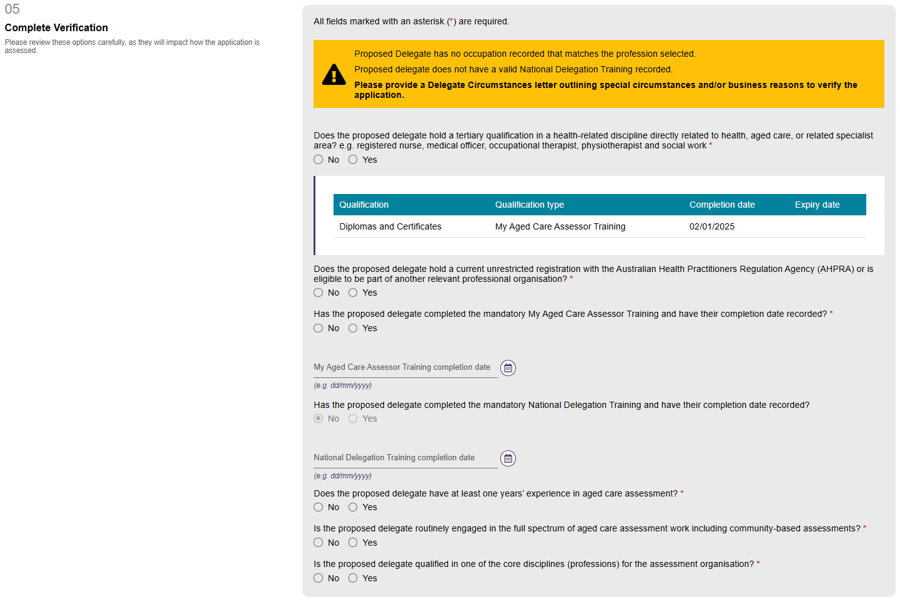
In the Attachments section (step 06 for adding a Delegate and step 07 for replacing a Delegate) upload the Delegate circumstances letter by selecting the UPLOAD DELEGATE CIRCUMSTANCES LETTER.
You can also upload additional support documentation as part of this step.
A Delegate Circumstances Letter must be uploaded if there are any amber warnings against the application.
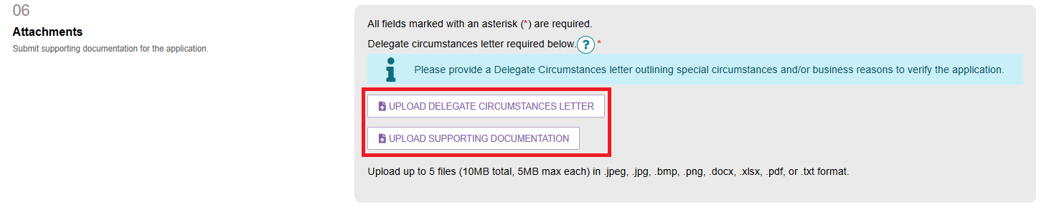

- To verify the application, select the relevant acknowledgement tick boxes and then click VERIFY APPLICATION.
Please note, the acknowledgements displayed differ depending on the type of application as well as the individual’s circumstances (e.g. if the proposed Delegate does or does not meet the criteria).
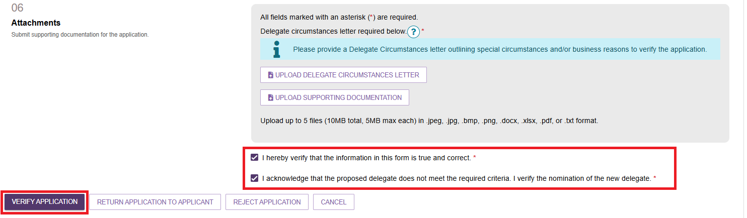
A green banner will then display confirming the application has been submitted to the Supporter.
! | If you wish to reject the application select REJECT APPLICATION. Enter the reason for rejection and select REJECT.  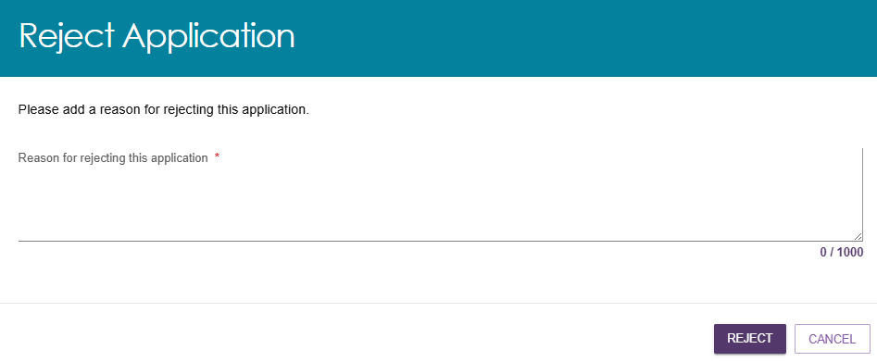

Operational Manager support of application
For an Operational Manager to support a Delegate’s application follow the steps below.
- From the homepage, select the Organisation administration tile.
- From the Delegate Positions tab Operational Managers will be able to view all Delegate applications and their current status.
Expand the application you wish to verify by selecting the arrow icon and then select SUPPORT APPLICATION.
Applications that require verifying will be marked with a red exclamation mark next to the Application ID.
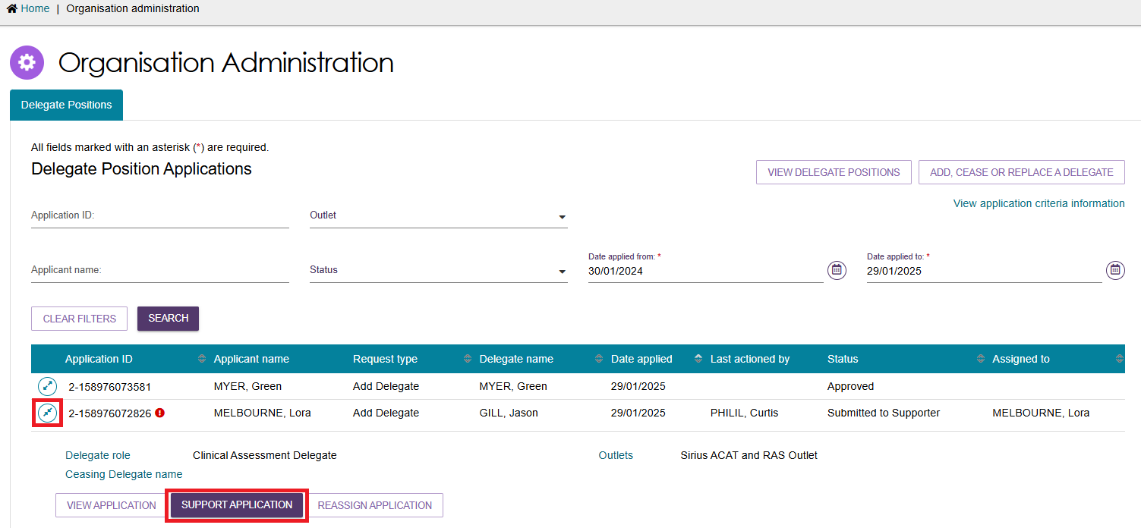

! | You can also reassign the application to another Operational Manager to support by selecting REASSIGN APPLICATION.  A pop-up will display asking you to select the Operational Manager you wish to reassign the application to before selecting the RE-ASSIGN button.  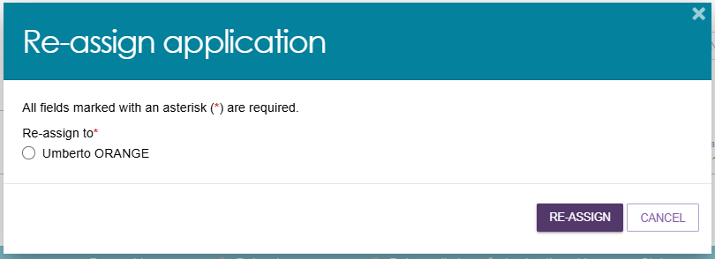
- The Delegate’s application will then display. Review the application in full. You have the option to upload additional supporting documentation in step 06 – Attachments.
- At the bottom of the page, select the acknowledgement tick boxes and then click SUPPORT APPLICATION.
The acknowledgements displayed differ depending on the type of application as well as the individual’s circumstances (e.g if the proposed Delegate does or does not meet the criteria).
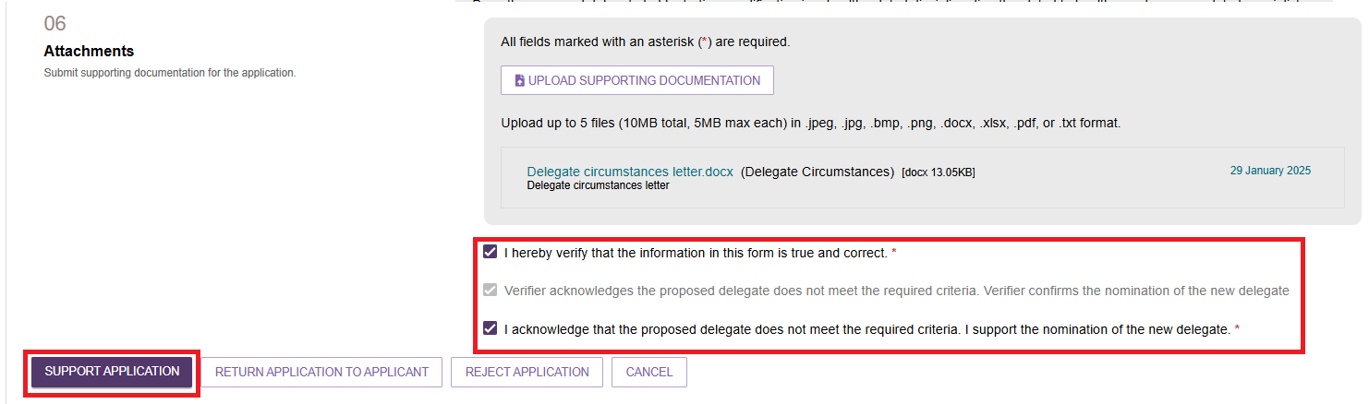
A green banner will then display confirming the application has been submitted to the department.
! | If you wish to reject the application select REJECT APPLICATION. Enter the reason for rejection and select REJECT.

Once the department has actioned the application an email will be sent to the Operational Manager.
Application outcomes will also display in the Tasks and Notifications tile as well as displaying in the Delegate Positions page under Status.
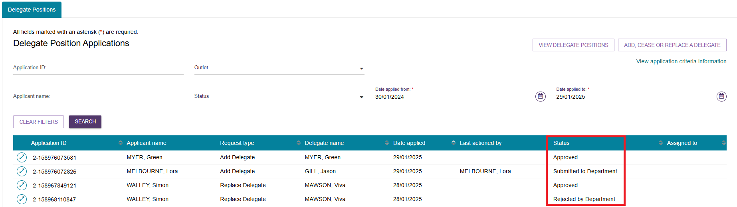
If an application is rejected by the department, the reason will be displayed in the View application page.
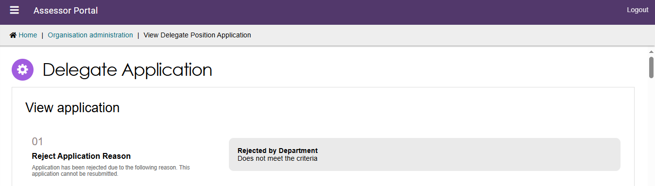

Returning Delegate applications
Operational Managers and Team Leaders are able to return applications to the applicant if needed.
- From the Delegate positions page open the application you wish to view.
If you need to return the application, select RETURN APPLICATION TO APPLICANT at the bottom of the page.
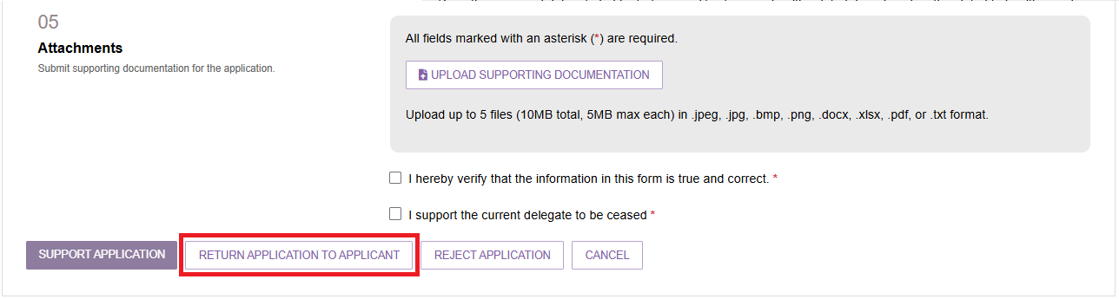

- A pop-up will display. Enter the reason for returning the application then select RETURN APPLICATION.
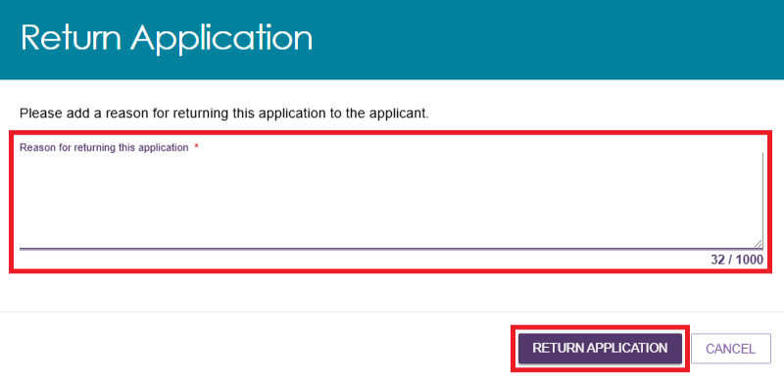
- The application will then return to the staff member who submitted the application for resubmission. To resubmit the application, select RESUBMIT APPLICATION from the Delegate Positions page.
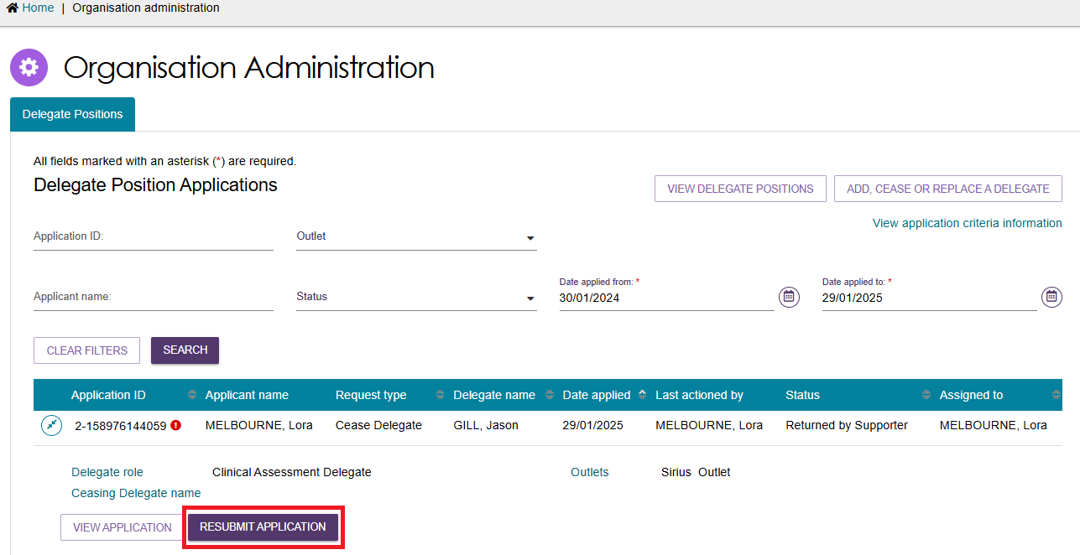
- Update the application as required then select the tick box verifying the information is correct and click RE-SUBMIT.
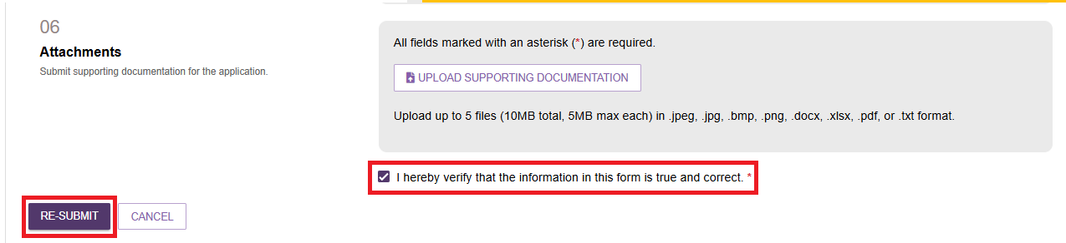
The application will then be submitted to be verified.

