Assessor Portal User Guide 11 – Assessment Delegate Support Role
The Delegate Support role in the My Aged Care assessor portal (assessor portal) enables anyone assigned the role to perform administrative functions to support the Assessment Delegate. For example, the Assessment Delegate Support will be able to print support plans, as well as generate, print and upload referral code letters and approval letters.
The Assessment Delegate Support operates under the instructions of the Assessment Delegate.
Clinical Assessment Delegates are able to approve an older person for all service groups, classification types and classification levels under the Aged Care Act 2024.
Non-clinical assessment delegates are restricted to approving entry level home support, Assistive Technology (AT) or Home Modification (HM) services (i.e. with classification levels of CHSP class, AT CHSP or AT-HM).
Table of contents
Accessing client information 2
Printing the support plan 4
Generating referral code letters 6
Notice of Decision Letters 8
Generating Approval Letters 8
Uploading Approval Letters 10
Generating Non-Approval Letters 16
Uploading Non-Approval Letters 18

Accessing client information
- To locate information about a client and print a copy of the client record, select the Find a client tile from your homepage.
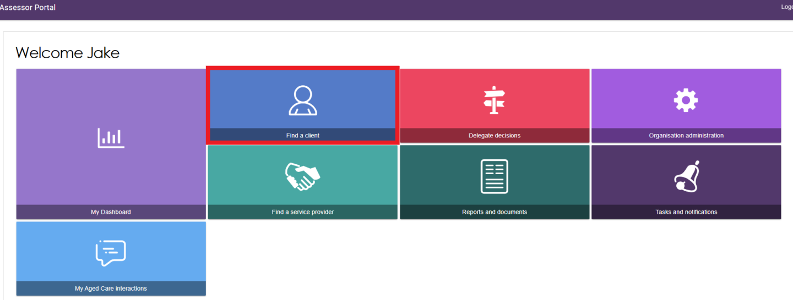
- Use the Find a client function to search for the client. Client records you have recently viewed will appear in the Recently Viewed Persons section, and depending on your browser, this will either appear on the right side or the bottom section of the page.
The ADVANCED SEARCH functionality allows you to search by additional fields. Refer to the My Aged Care – Assessor Portal User Guide 1 – Registering and referring clients for assessments for more information on using this functionality.
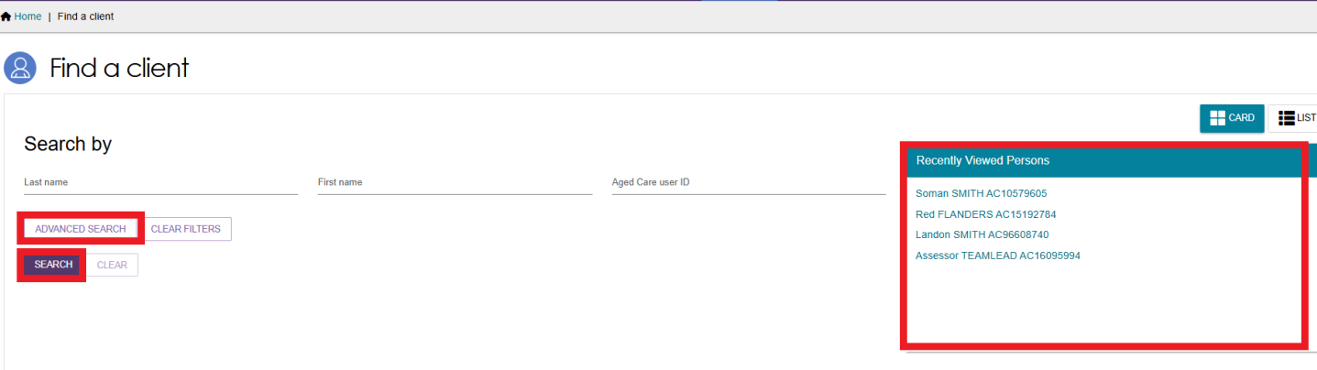
- Any matching search results will be displayed. Select the client’s name.
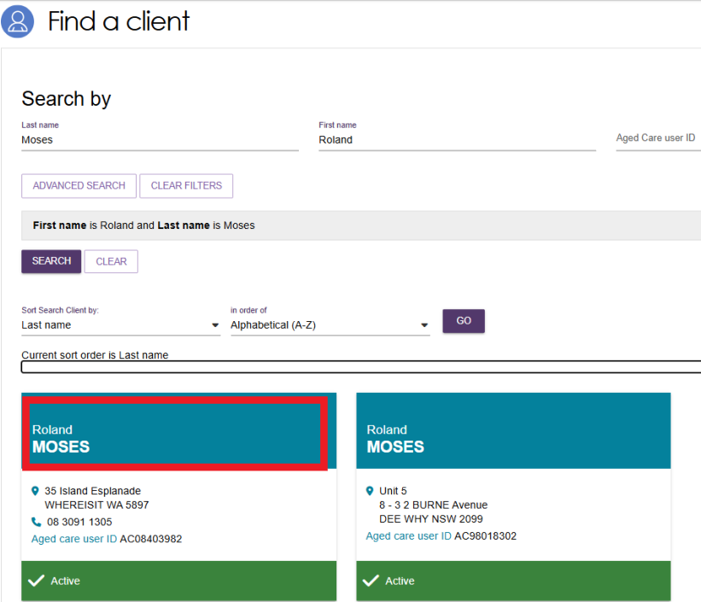
- You will be able to sort the matching results by a number of criteria including last name, first name, Aged Care User ID, suburb, state, post code, date of birth and more. Select the criteria, the order of display as required and select GO.
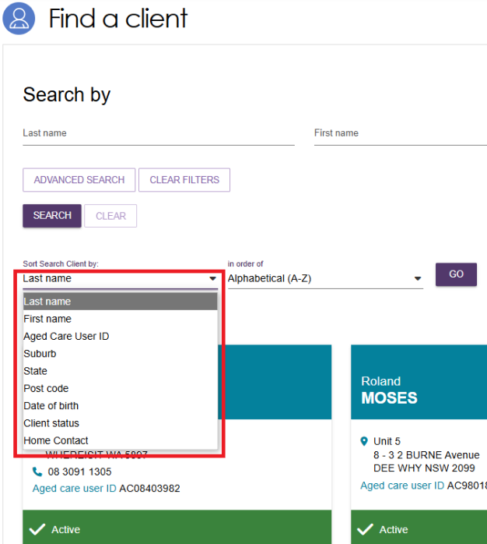
- Selecting the client’s name tile will take you to the Client Summary. You can view and print a RTF (Rich Text File) of the client record by selecting the VIEW CLIENT REPORT button.
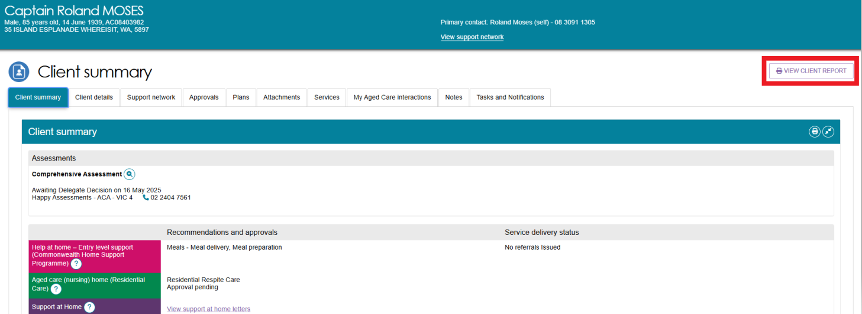
- A Generating Report pop up appears, then the Rich Text File (RTF) appears on your browser ready to be downloaded or opened.
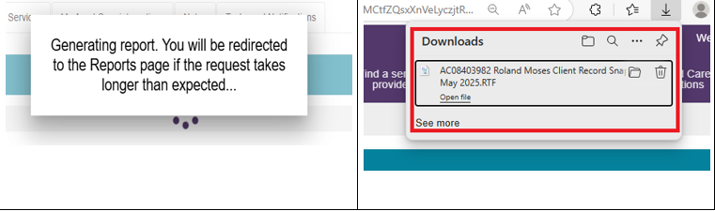
- Opening the RTF shows a Copy of the Client Record.
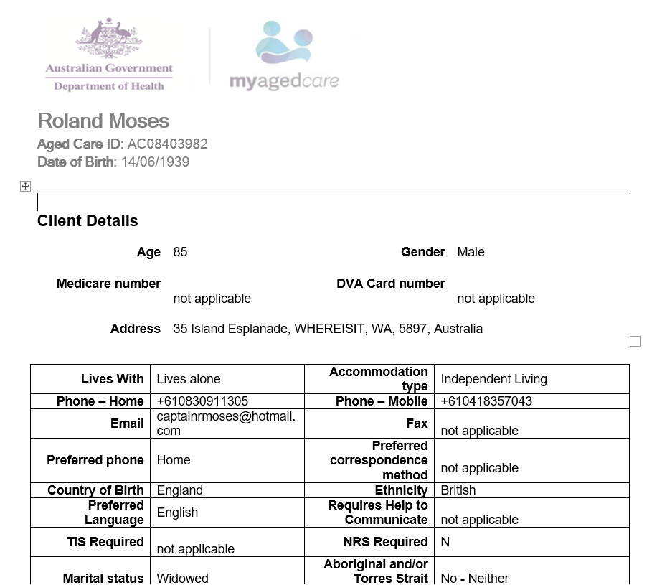

Printing the support plan
- To view and print the support plan, navigate to the Plans tab in the client record. From here, select SUPPORT PLAN.
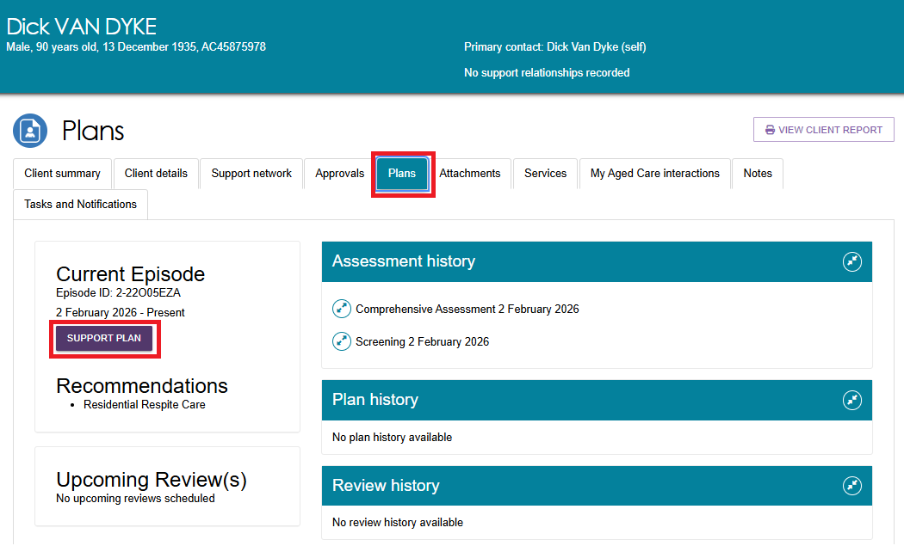
- The Goals & recommendations tab will be displayed. You can print a copy of the support plan by selecting PRINT COPY OF SUPPORT PLAN.
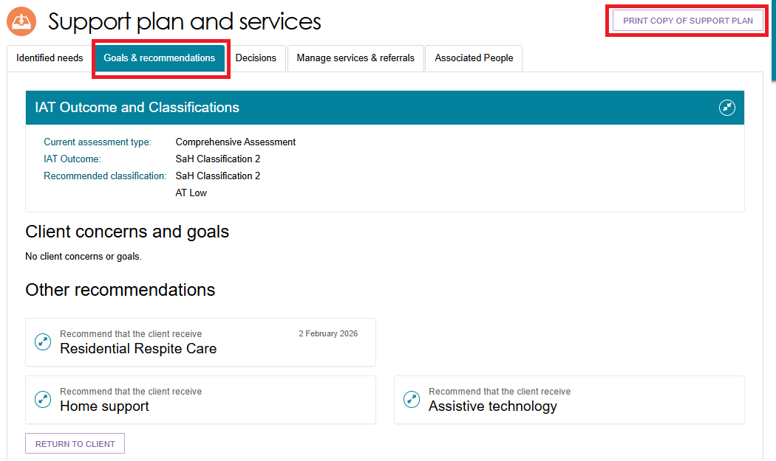
- If the report is taking longer than usual, you may receive an information message at the bottom of the screen with a hyperlink to the Reports page.

- The support plan is available in the Reports page. Select the View link to view the support plan. You can also access this page by going to the Reports and Documents tile from the Assessor portal home page.
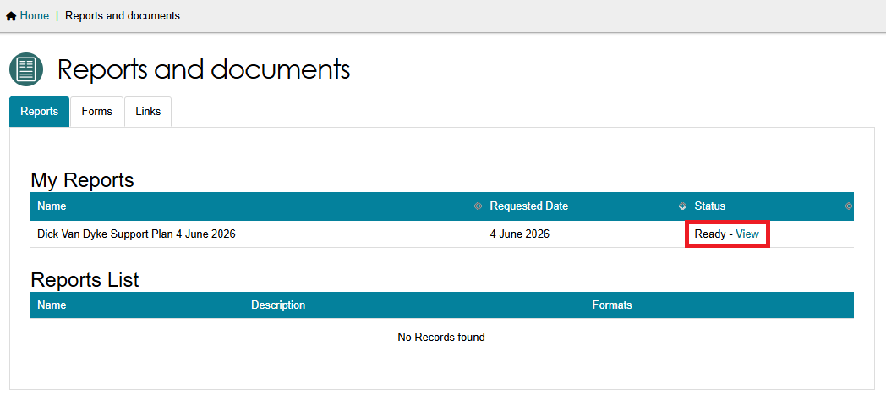
- The Support Plan is now ready to be downloaded from your browser then printed from your computer or device.
The below example shows a support plan in the Downloads section of the Microsoft Edge browser.
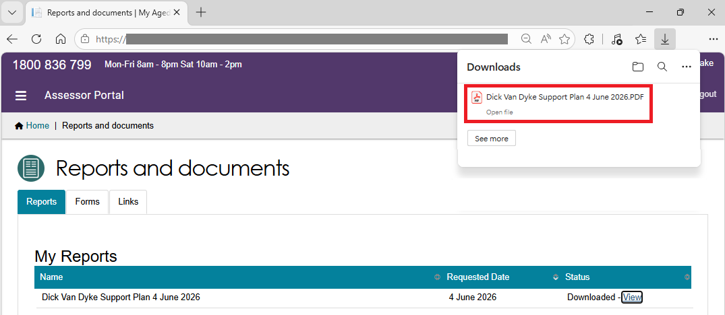

Generating referral code letters
- Go to the client’s support plan by going to the Plans tab in the client record, then select SUPPORT PLAN.
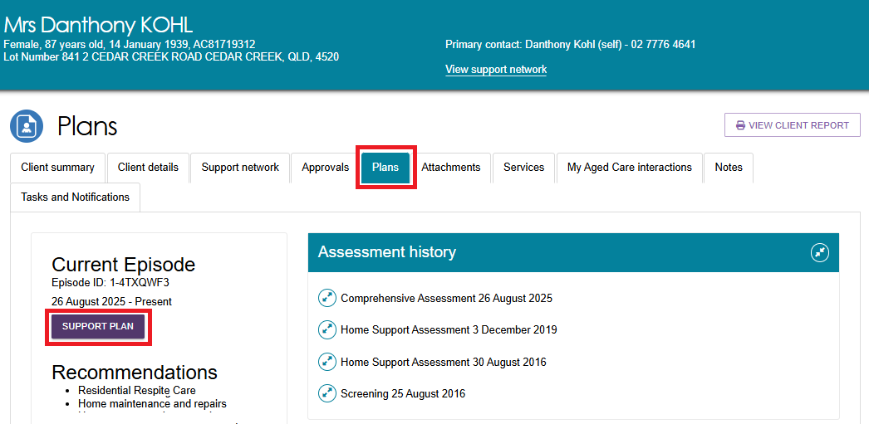
- Go to the Manage services & referrals tab. From here, you can view the client’s service referrals and generate a copy of the referral code letter.
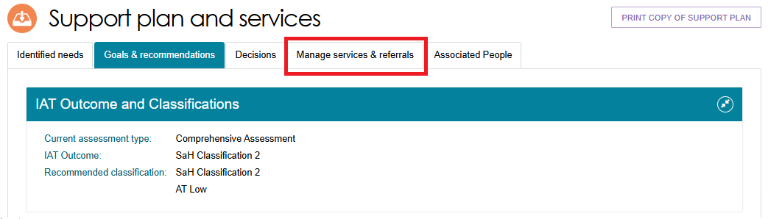

- Select GENERATE REFERRAL CODE LETTER at the bottom of the page.
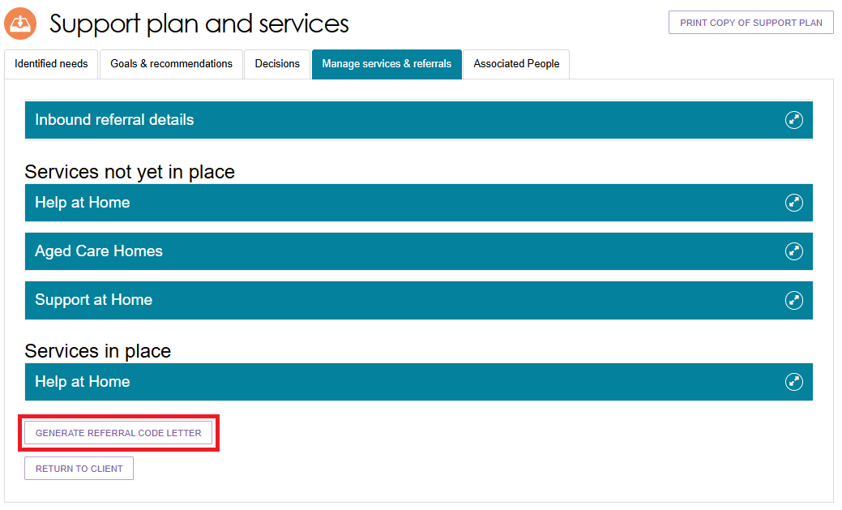
- The Referral Code Letter is available in the Reports page. Select the View link to view the letter. You can also access this page by going to the Reports and Documents tile from the Assessor portal home page.
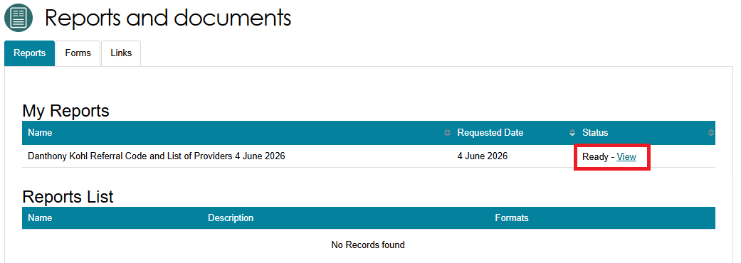
- The Referral Code Letter is now ready to be downloaded from your browser then printed from your computer or device.The below example shows the letter in the Downloads section of the Microsoft Edge browser.
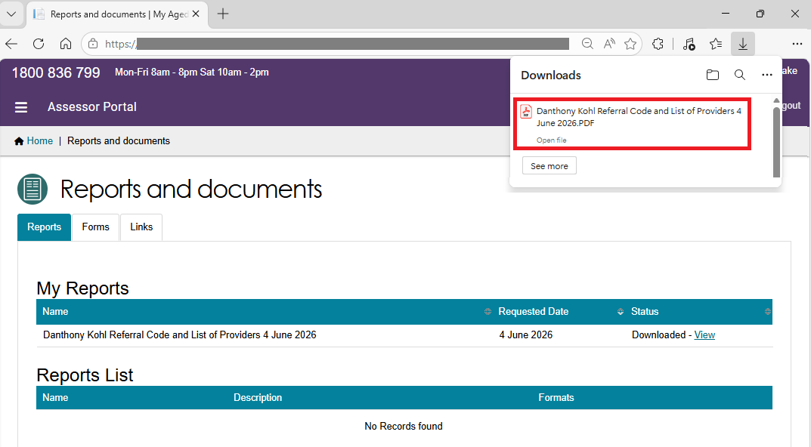

Notice of Decision Letters
The Delegate Support can generate and upload the Notice of Decision (NoD) letter, after the delegate decision is completed. This applies to both Approval letters and non-Approval letters.
NoD Letters are also sent to any of the older person’s registered supporters (except for supporters-lite). Refer to My Aged Care – Assessor Portal User Guide 2 – Registering support people and adding relationships for more information.

Generating Approval Letters
- Go to the Delegate Decisions tile from the home page and select the client card or listing from the Decision History tab.
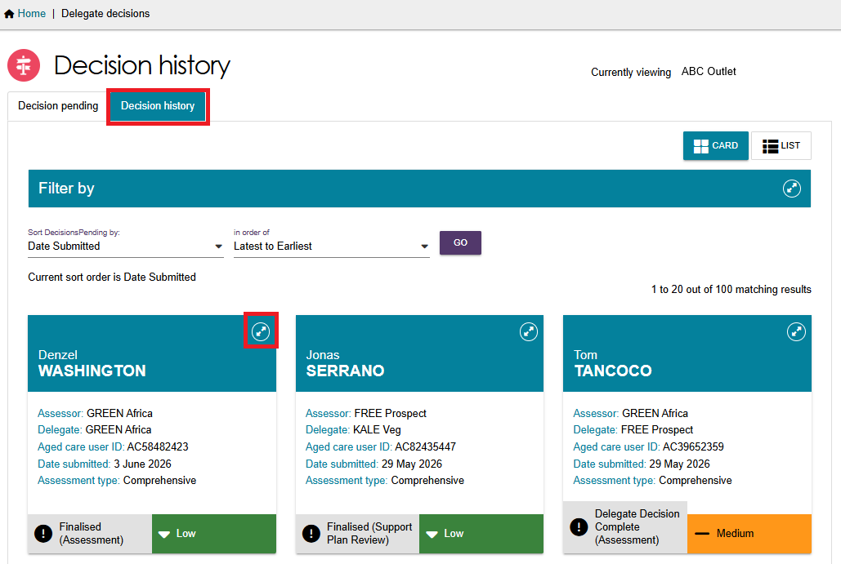
- Select VIEW SUPPORT PLAN
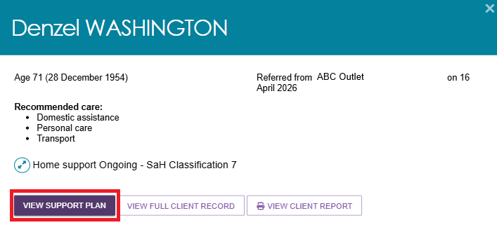
- This will then take you to the client’s Decisions tab of the Support Plan and Services page.
Select GENERATE APPROVAL LETTER at the bottom of the page.
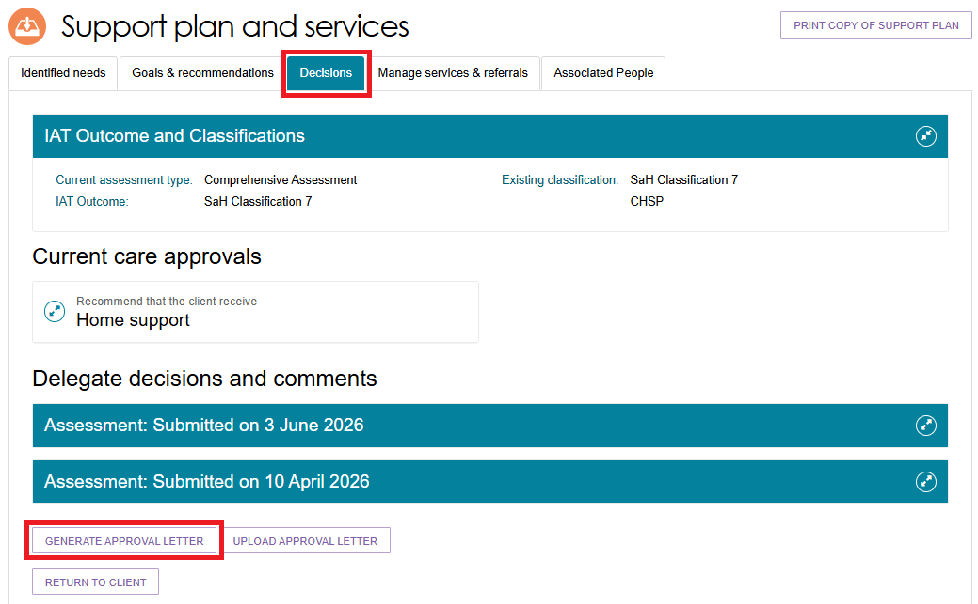
- Confirm the client, then select GENERATE APPROVAL LETTER.
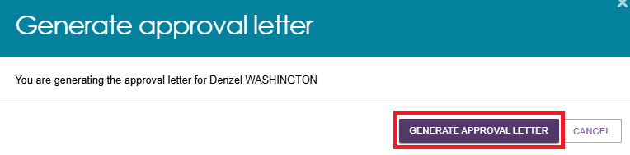
- The letter will be shown in the Reports and Documents tile of the portal, with a status of Processing.
When ready, the Status will display a View link for you to select.
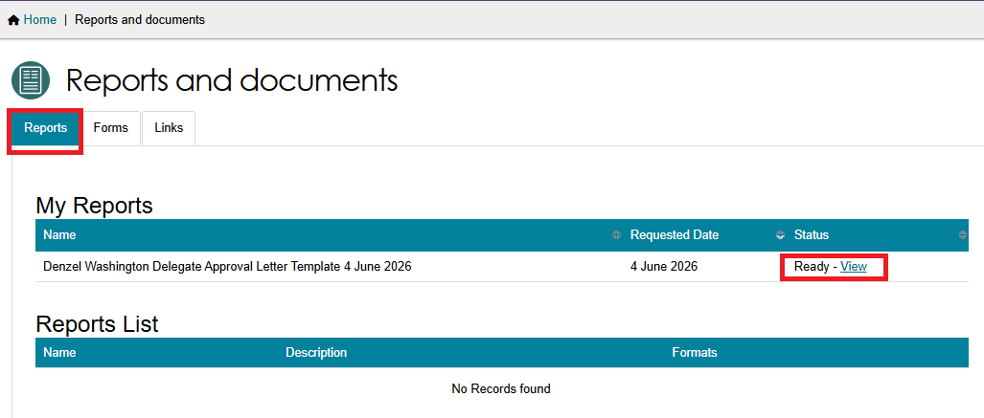
- The letter will be downloaded from the browser to your computer or device, as a .RTF (Rich Text Format) document. You can now print it for your Delegate to sign.
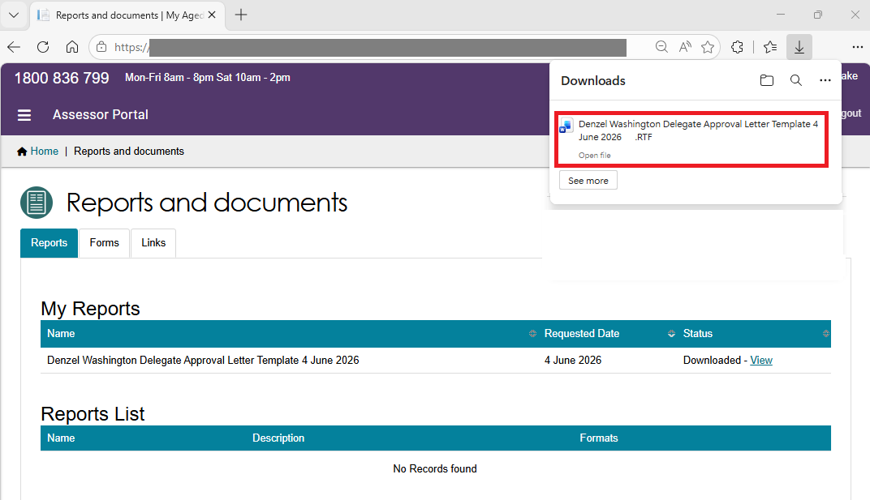
! | All NoD Letters needs to be signed by the Delegate, and converted into PDF format, before uploading to the portal.

Uploading Approval Letters
Once the Assessment Delegate has signed the letter, you can use the Upload approval letter button in the Decisions tab of the support plan to upload the letter to the client’s record.
Alternatively, you can upload this by using the Add An Attachment button in the Attachments tab on the client record.
For CHSP only recommendations, NoD letters can also be uploaded from the Goals & Recommendations tab.
For Second unit of Restorative Care Pathway (RCP) approval letters, please complete the template ‘Second concurrent unit of RCP funding – Approval or Non-approval’, in the Reports and Documents tile of the Assessor Portal.
Then, use the Upload Approval Letter button to upload this letter.
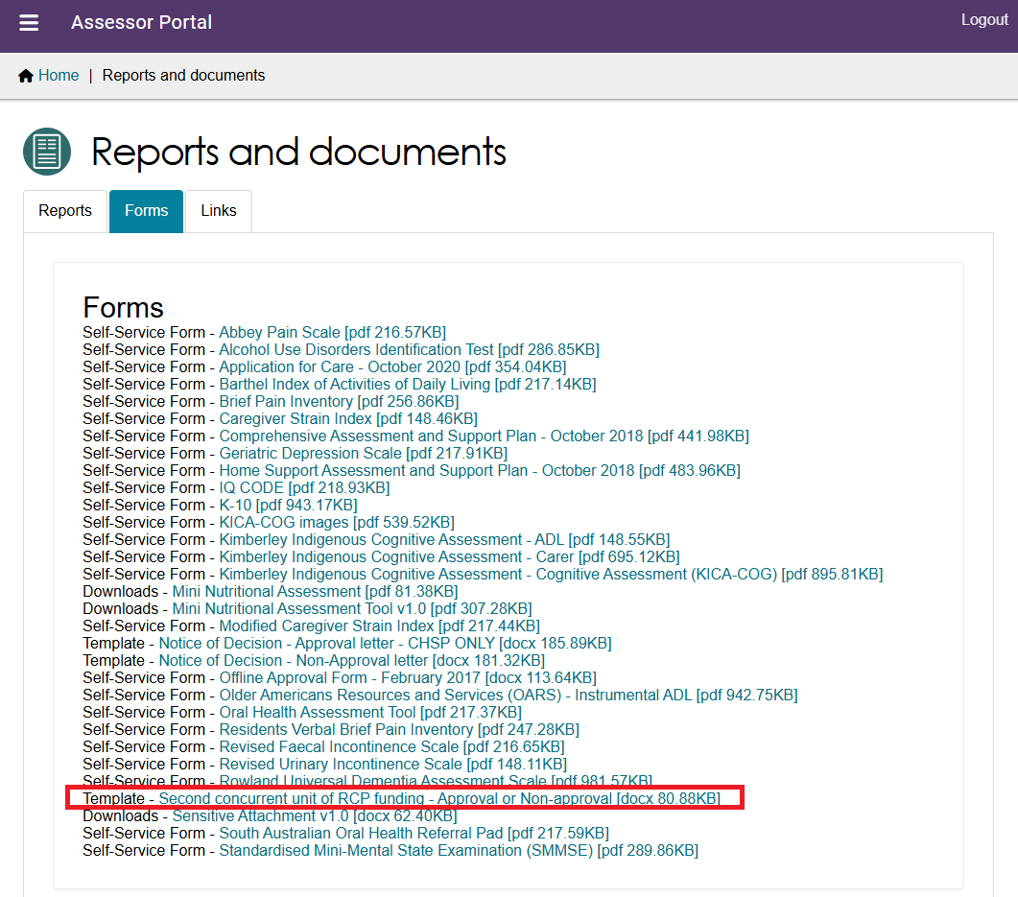

From the support plan
- Go to the Client’s profile and select the Plans tab. In the Plans page select the Support Plan button.
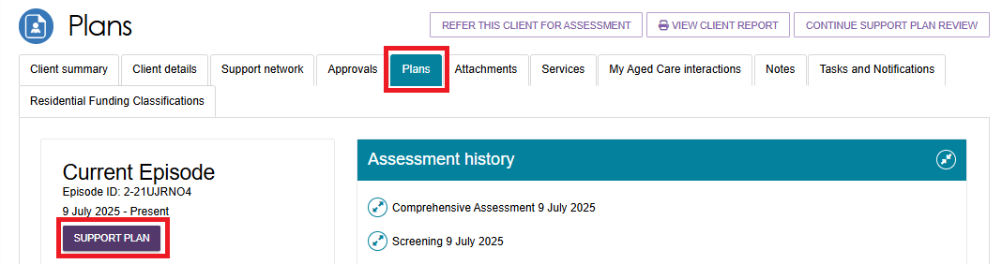

- The Support Plan and Services page appears.
Select the Decisions tab, then Select Upload Approval Letter from the bottom of the page, underneath Delegate decisions and comments.
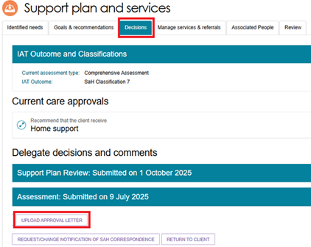
- The Upload Approval Letter pop up appears. Choose the approval letter file to upload. Enter the name of the attachment. Ensure the attachment type is ‘Approval letter sent to client’. Optionally provide a short description about the contents of the attachment.
Finally, select UPLOAD.
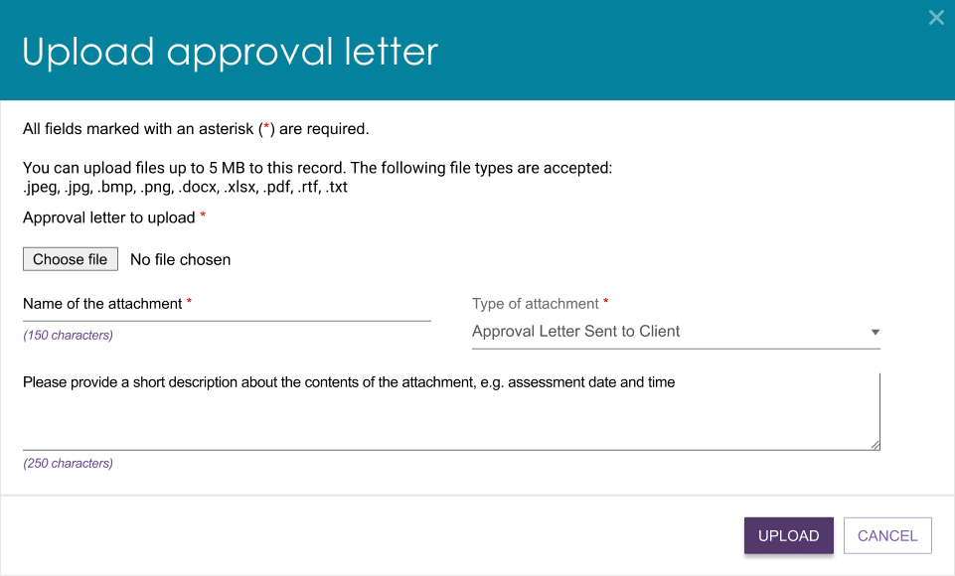

- Choose the letter and then select Open.
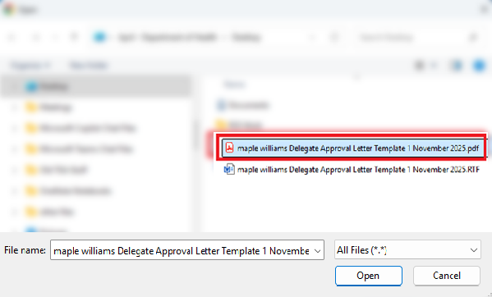
- The letter name will appear next to the Choose File button.
Select Upload.
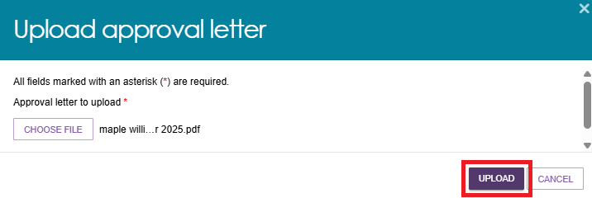
- A success message appears saying that the attachment is now uploaded onto the Attachments page of the client record.


From the attachments tab
Alternatively, you can upload the letter by using the Add An Attachment button in the Attachments tab on the client record:
- Select the client’s record and go to the Attachments tab. Then, select Add An Attachment.
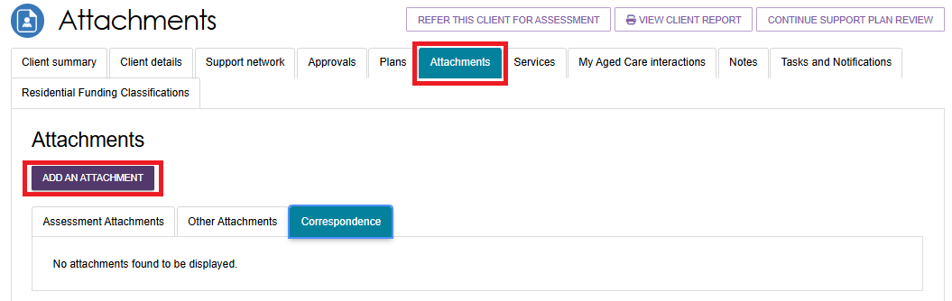
- Select Choose File
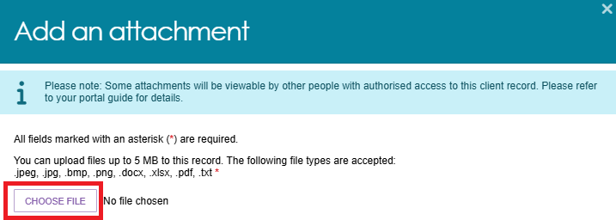
- Select the approval letter and then select Open.
- The attachment’s name will display next to the Choose File button.
Enter the Name of the attachment and select the Type of attachment as Approval Letter Sent to Client. Optionally you can provide a short description about the contents of the attachment such as assessment date and time. Then, select Upload.
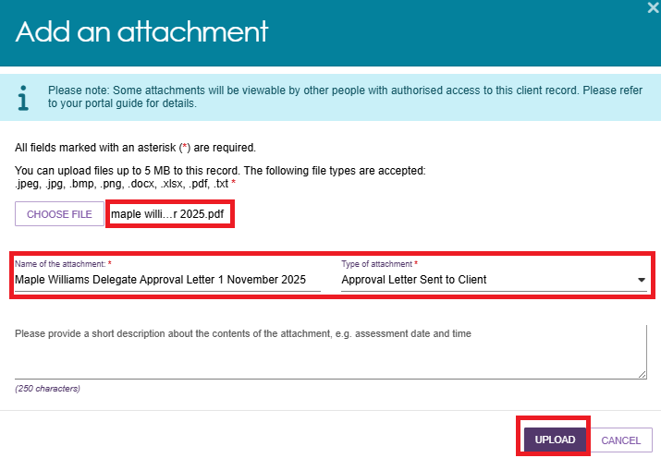
- The letter now appears under the Assessment Attachments tab of the Attachments page.
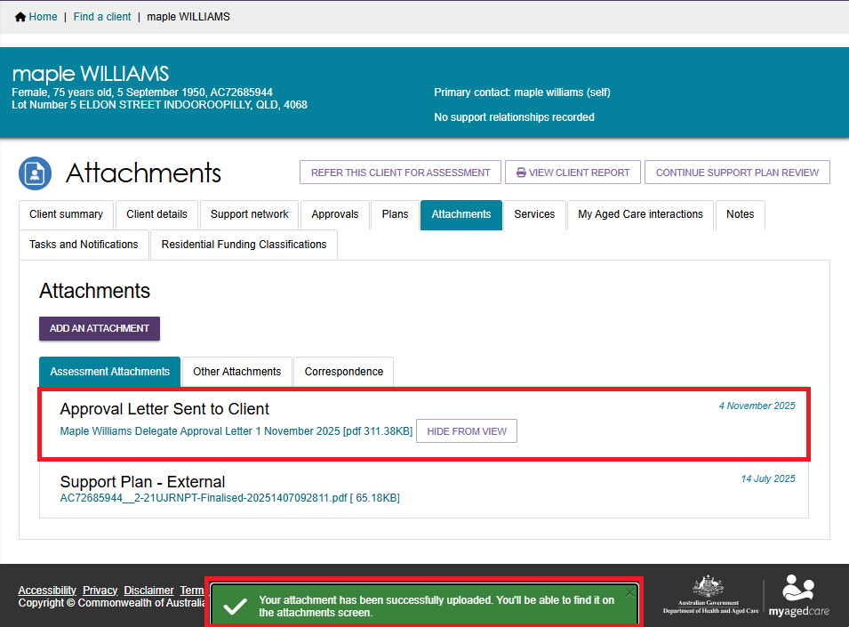

Generating Non-Approval Letters
- Go to the Delegate Decisions tile from the home page and select the client card or listing from the Decision History tab.
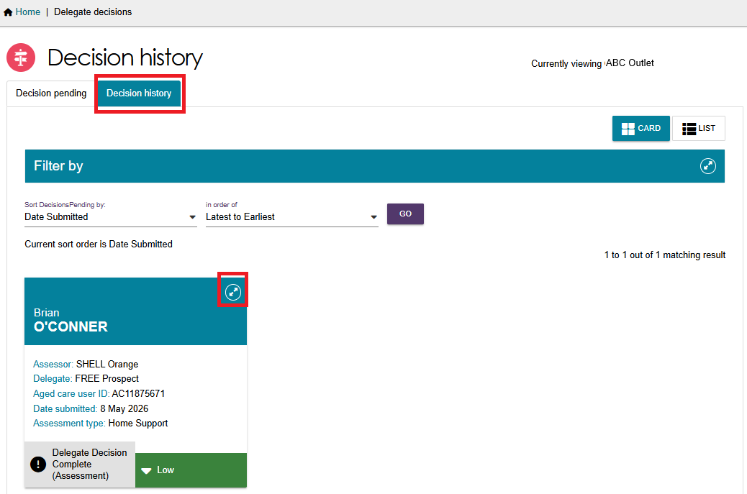
- Select VIEW SUPPORT PLAN
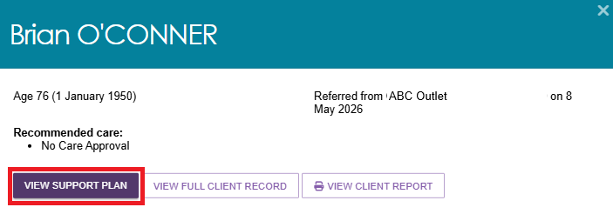

- This will then take you to the client’s Decisions tab of the Support Plan and Services page. Select GENERATE NON-APPROVAL LETTER at the bottom of the page.
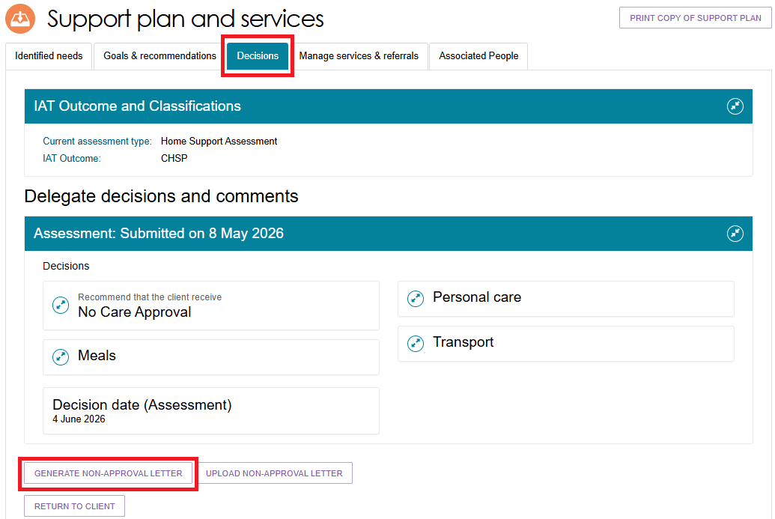
- The Non-approval letter automatically starts to process in the Reports and Documents section of the portal. When ready, the Status will display a View link for you to select.
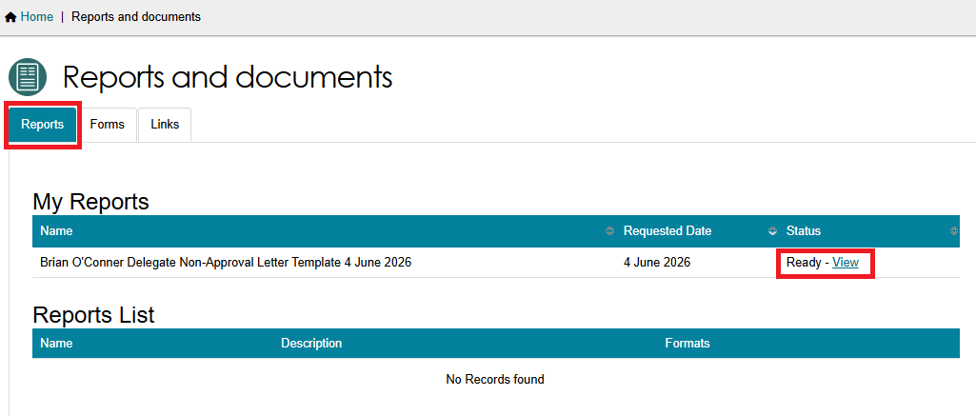

- The letter will be downloaded from the browser to your computer or device, as a .RTF (Rich Text Format) document. You can now print it for your Delegate to sign.
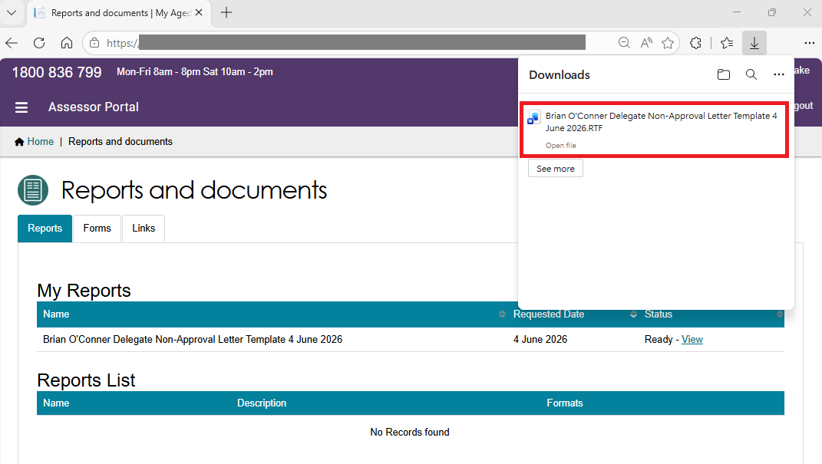
! | All NoD Letters needs to be signed by the Delegate, and converted into PDF format, before uploading to the portal.

Uploading Non-Approval Letters
Once the Assessment Delegate has signed the letter, you can use the Upload Non-Approval letter button in the Decisions tab of the support plan to upload the letter to the client’s record.
Alternatively, you can upload this by using the Add An Attachment button in the Attachments tab on the client record.
For Comprehensive assessments, uploading non-approval letter buttons are only available for No Care Approval (or similar).
For CHSP only recommendations, NoD letters can also be uploaded from the Goals & Recommendations tab.
For Second unit of Restorative Care Pathway (RCP) non-approval letters, please complete the template ‘Second concurrent unit of RCP funding – Approval or Non-approval’, in the Reports and Documents tile of the Assessor Portal.
Then, use the Upload Non-Approval Letter button to upload this letter.

From the support plan
- Go to the Client’s profile and select the Plans tab. In the Plans page select the Support Plan button.

- The Support Plan and Services page is displayed.
Select the Decisions tab, then Select Upload Non-Approval Letter from the bottom of the page, underneath Delegate decisions and comments.
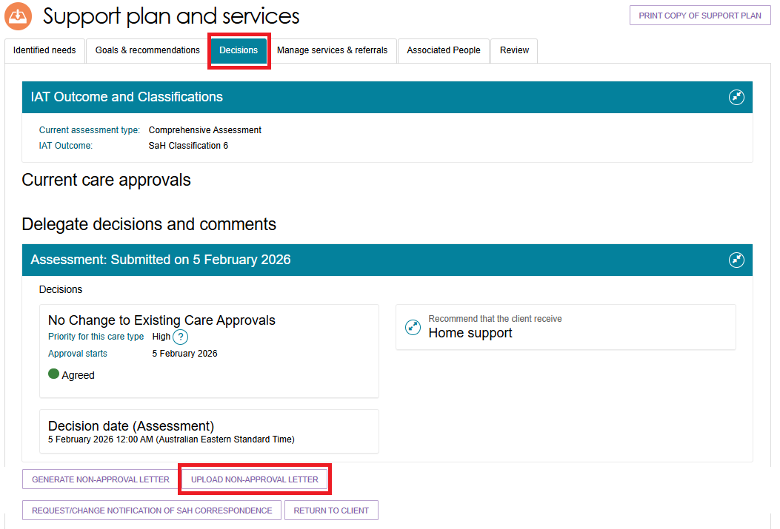
- Select Choose File at the pop up that appears.
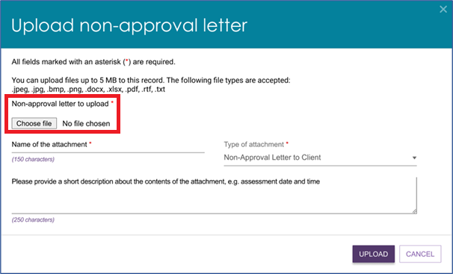

- Choose the letter and then select Open.
- The letter name will appear next to the Choose File button.
Enter the name of the letter. Ensure the type of attachment is ‘Non-Approval Letter to Client’.
Optionally you can provide a short description about the contents of the letter.
Finally, select UPLOAD.
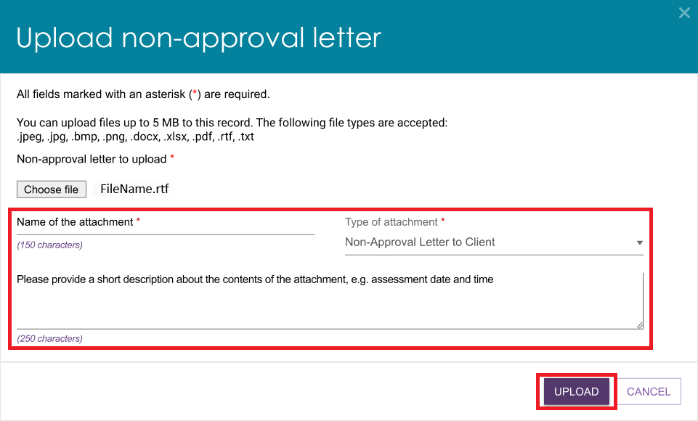
- A success message appears saying that the attachment is now uploaded onto the Attachments page of the client record.

From the attachments tab
Alternatively, you can upload the letter by using the Add An Attachment button in the Attachments tab on the client record:
- Select the client’s record and go to the Attachments tab. Then, select Add An Attachment.
The Add an attachment pop up appears. Select Choose File.
- Select the approval letter and then select Open.
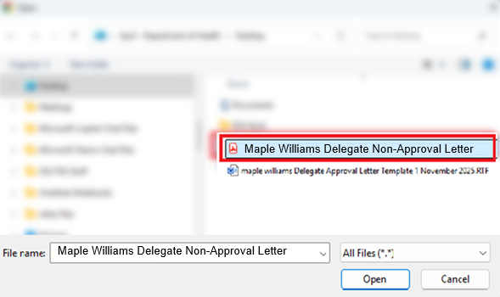
- The attachment’s name will display next to the Choose File button. Next, enter the Name of the attachment, and select the Type of attachment as Non-Approval Letter Sent to Client.
Optionally you can provide a short description about the contents of the attachment such as assessment date and time.
Then, select Upload.
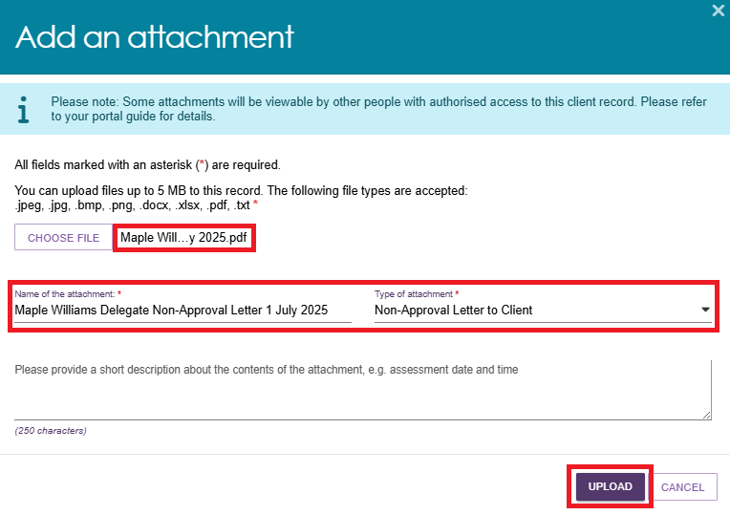
- The letter now appears under the Assessment Attachments tab of the Attachments page.
