Assessor Portal User Guide 10 – Assessment Delegate Processes
This user guide is to assist Assessment Delegates in performing and range of functions in the My Aged Care assessor portal (assessor portal) that relate to the requirements set out in the Aged Care Act 2024 as the role of System Governor.
This includes viewing and actioning delegate decisions, as well as requesting corrections to care approval decisions and care extensions.
Clinical assessment delegates can approve an older person for all service groups, classification types and classification levels under the Aged Care Act 2024.
Non-clinical assessment delegates are restricted to approving entry level home support, Assistive Technology or Home Modification services (i.e. with classification levels of CHSP class, AT CHSP or AT-HM).
! | To understand Clinical and Non clinical assessment delegate responsibilities under the Aged Care Act 2024, refer to ‘Chapter 7: Delegations and Approvals under the Act’ of My Aged Care Assessment Manual.  From 29 June 2026, the offline workaround for Non-clinical Delegate decisions will be replaced by a full in-system workflow.

Table of Contents
The Assessment Delegate home screen 3
The Assessment Delegate + Assessor dual role home screen 4
Assessment history 4
Viewing an item for decision 5
Assigning an item for decision 7
Reassigning for decision 10
Recording a delegate decision 11
Viewing decisions information 11
Editing a recommended classification 14
Viewing details about existing approvals 16
Returning an assessment to an assessor 17
Receiving reviewed IAT from assessor 20
No Care Approval and No Change to Existing Care Approvals 22
Clinical Delegate workflow process 23
Agreeing with recommendations 24
Disagreeing with recommendations 25
Agreeing or disagreeing with a Support at Home Recommendation 28
Editing a recommendation 32
Adding a care type 34
Recommending a Home Modification Service under Support at Home 35
Recommending an Assistive Technology Service under Support at Home 36
Recommending a second Restorative Care Pathway unit 39
Changing a decision 41
Editing a recommended classification 42
Finalising your decision 44
Non-Clinical Delegate workflow process 46
Agreeing with recommendations 46
Disagreeing with recommendations 47
Editing a recommendation 50
Changing a decision 51
Adding CHSP services by a Non-Clinical Assessment Delegate 52
Finalising your decision 53
Correspondence Notifications 54
Notice of Decision (approval or non-approval) letter and SaH Restorative Care Pathway (Second Unit) approval and non-approval letter 58
Approval Letters 58
Non-approval Letters 62
Manage service and referrals 65
Requesting correction to care approval decision 65
Making changes to the Decision Date of the delegate decision 67
Requesting the removal and addition of different care classification within a care type within the same correction request 68
Requesting and Approving Care Extensions 74

The Assessment Delegate home screen
Both the Clinical assessment delegate and the Non-clinical assessment delegate can view the same tiles in the Assessor Portal home page. The only difference is the extent of assessment types that each role can approve.
Clinical assessment delegates can approve an older person for all service groups, classification types and classification levels under the Aged Care Act 2024. They can assign and initiate corrections on Comprehensive and Home support assessments.
Non-clinical assessment delegates are restricted to approving entry level home support, Assistive Technology or Home Modification services (i.e. with classification levels of CHSP class, AT CHSP or HM CHSP). They can decide and initiate corrections on Home support assessments only.
Both Clinical and Non-clinical assessment delegates can add recommendations of No Care Approval or No Change to Existing Care Approvals.
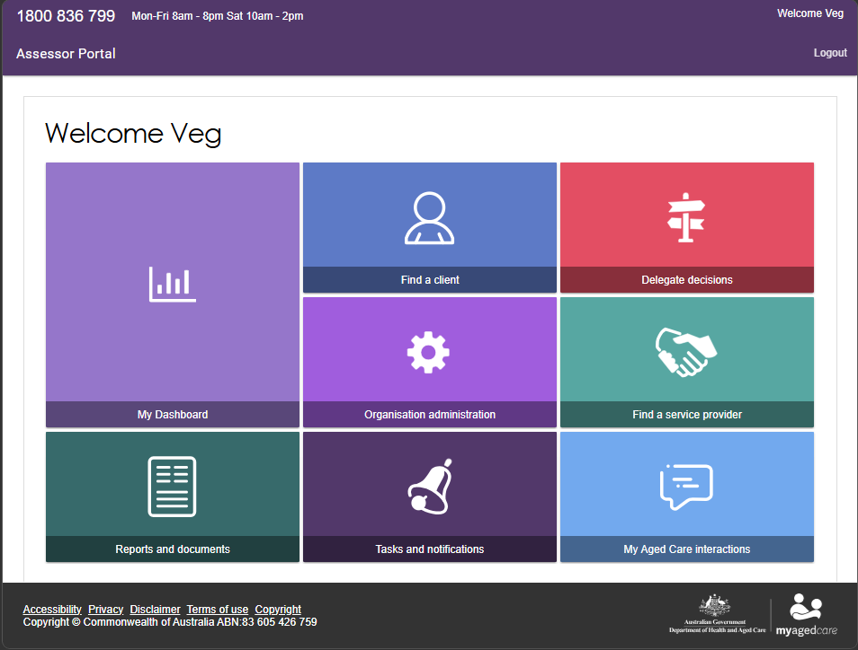

The Assessment Delegate + Assessor dual role home screen
If you are both an aged care needs assessor (assessor) and an Assessment Delegate in the Assessor portal, your home screen will look like the following.
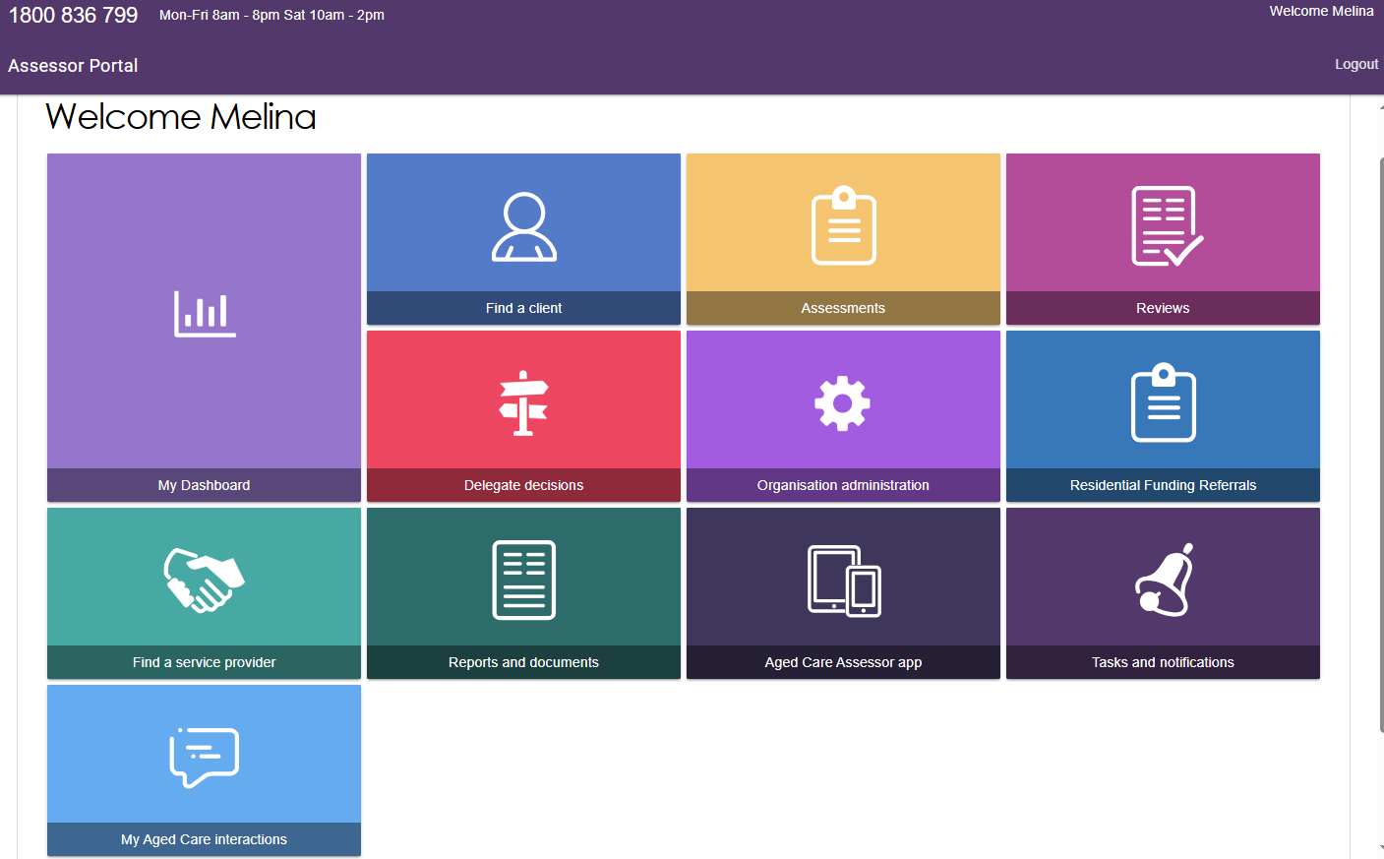
For more information regarding applying to be an Assessment Delegate please refer to the My Aged Care – Assessor Portal User Guide 12 – Managing delegate roles.

Assessment history
To assist Assessment Delegates with understanding and actioning delegate approvals, Assessment Delegates can view a client’s assessment history via the Plan tab of the client record. Within the Assessment history section, it will outline key information such as if the assessment has been completed by a non-clinical needs assessor who then converted the assessment from a home support assessment to a comprehensive assessment, as well as the details of the clinical supervising assessor.
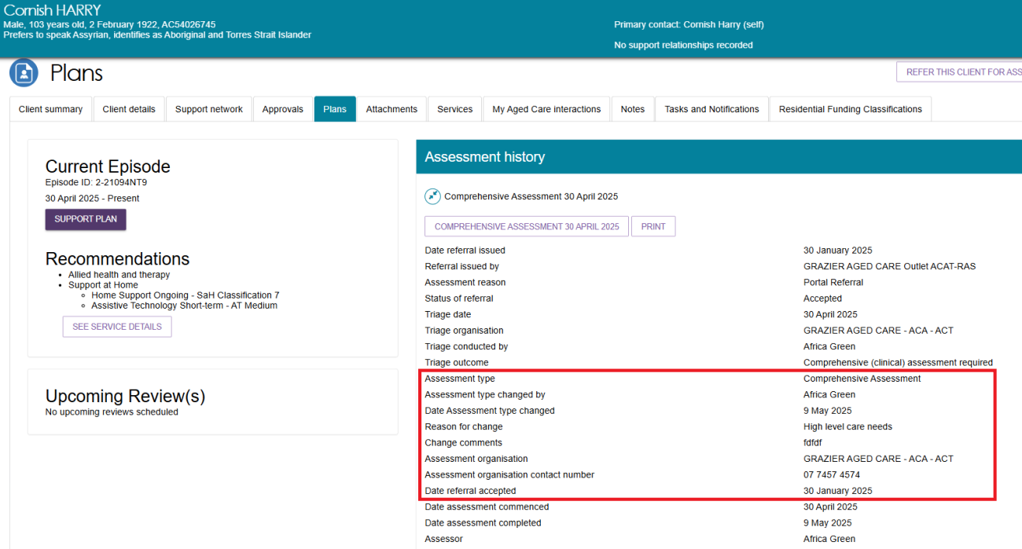

Viewing an item for decision
Clinical and Non-clinical assessment delegates are able to access the Delegates Decision tile from the Assessor portal home page, the Decision Pending tab and then Decision History tab.
Delegates can get a quick overview of how many delegate decisions are in the delegate’s outlet, how many are assigned to them, and how many are unassigned, by going to the My Dashboard tile of the Assessor portal:
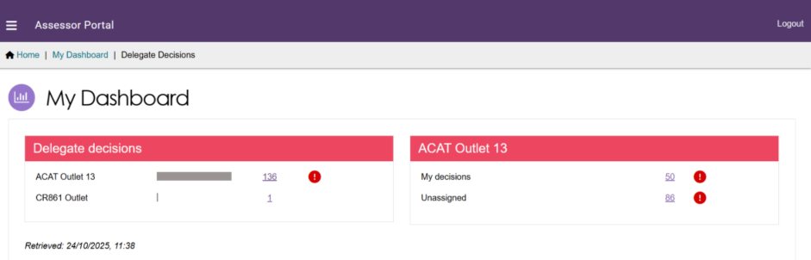
Follow the steps below to view items for decision via the Delegate Decisions tile.
- Select Delegate decisions from the homepage.
- The queue containing assessments awaiting Delegate decision will be displayed in the Decision pending tab.
You can use the filter options (First Name, Last Name, and Aged Care User ID) to refine your results. To show additional filter options select Advanced Search.
You can also use the sort function to sort by assessment status, as well as other categories such as last name, first name, Aged Care ID, date submitted, priority (or urgency), assessor and delegate names and due date. The order in which the results are displayed can also be set.
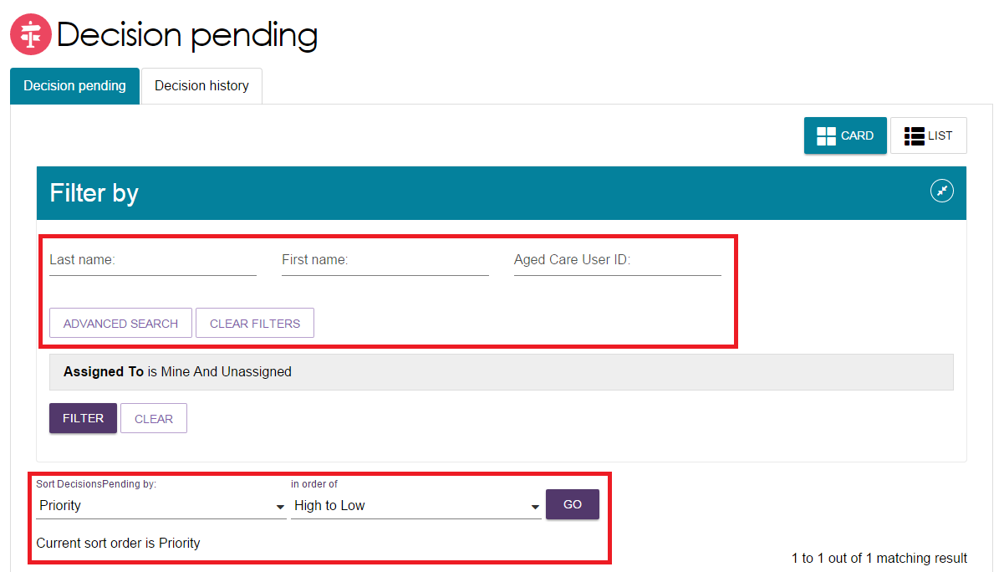

Each Card or Listing shows the Assessment status – at the bottom of the client card or at the right side of the client listing, under the Assessment status column.
The due date against each assessment waiting for delegate decision will be visible to the Delegate in both the Card and List View. The pending decisions can be sorted and filtered by date due.
Decisions Pending tab - Card View
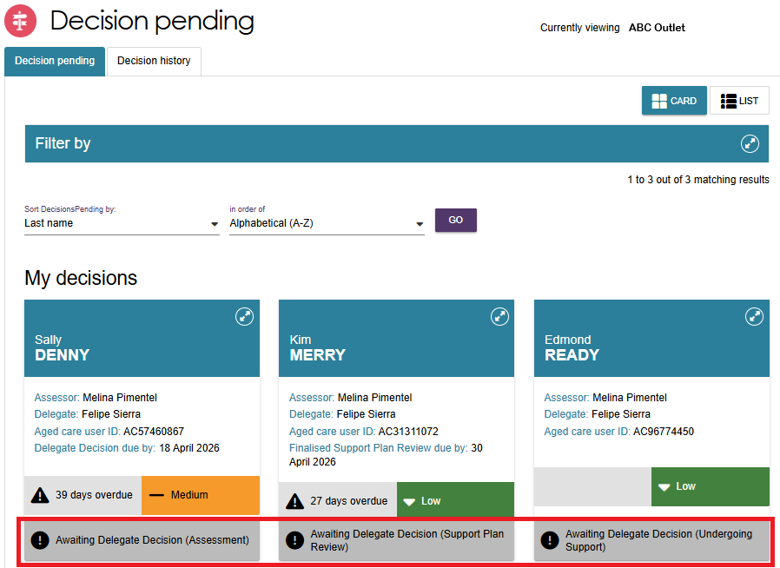
Decisions Pending tab - List View
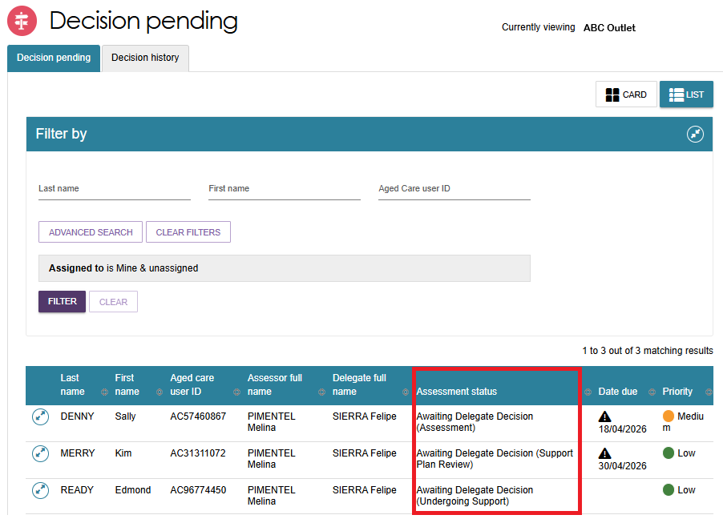

- Also on this page is the Decision history tab, which will display decisions that you have made previously.
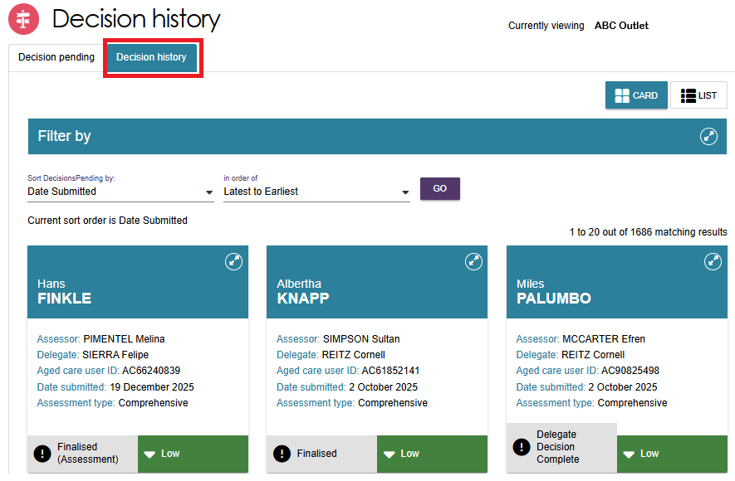
- For both the Decision Pending and the Decision History tabs, you can toggle between the card view and the list view (shown below) to display the clients.
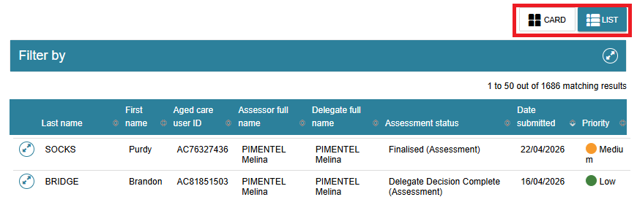

Assigning an item for decision
A Clinical assessment delegate can assign Comprehensive assessments and Home support assessments to themselves. They can also assign a Home support assessment to other Clinical assessment delegates or Non-clinical assessment delegates within their outlet.
A Non-clinical assessment delegate can assign Home support assessments to themselves or other Non-clinical assessment delegates within the same outlet.

To assign a client:
- If using the Card view, select the expand arrows on the Client card to display a summary of the client’s information in a pop-up. Select ASSIGN.
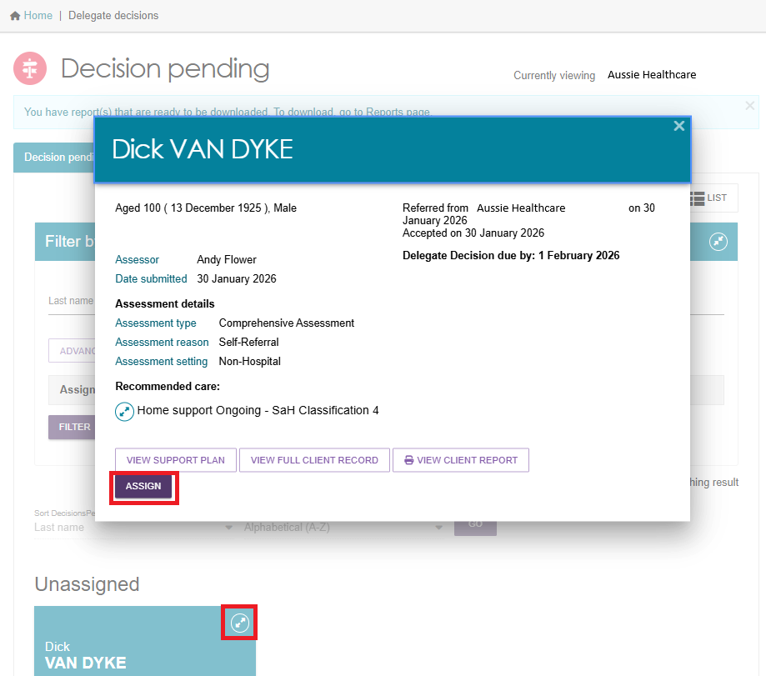
If using the List view, select the expand arrows for the client to display a summary of the client’s information in an expanded view.
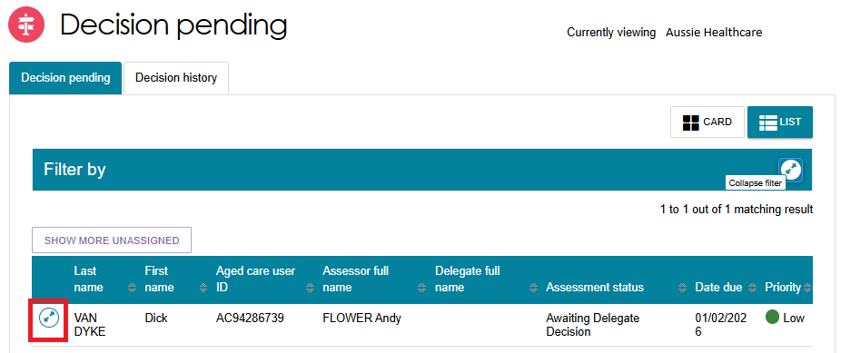

- Select ASSIGN to allocate that item to yourself or to another Delegate.
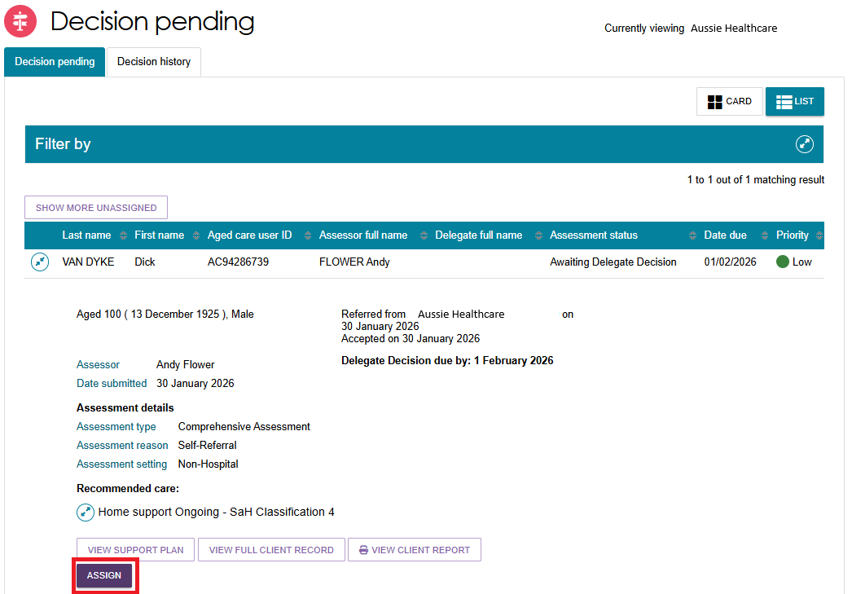
- In the pop-up box, select another Delegate (or yourself – ‘me’), and select ASSIGN.
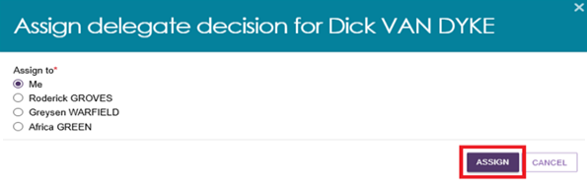
- A confirmation message will appear. The client will appear in the queue of the Delegate they were assigned to, or under My Decisions if assigned to yourself.
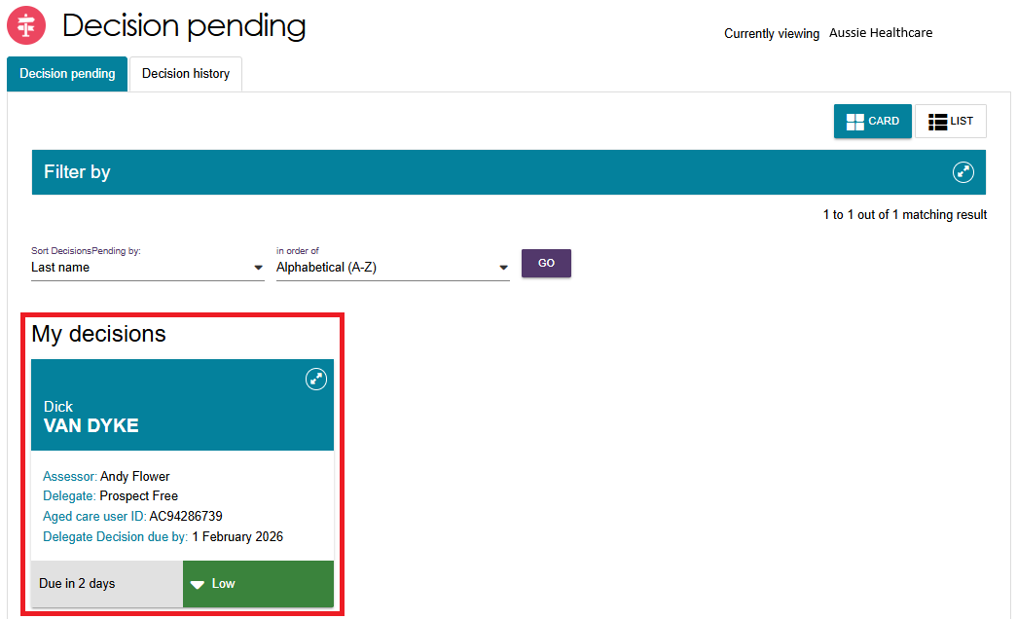

Reassigning for decision
Follow these steps to reassign an item for decision:
- Select the expand arrow on the Client card to display a summary of the client’s information. Select REASSIGN.
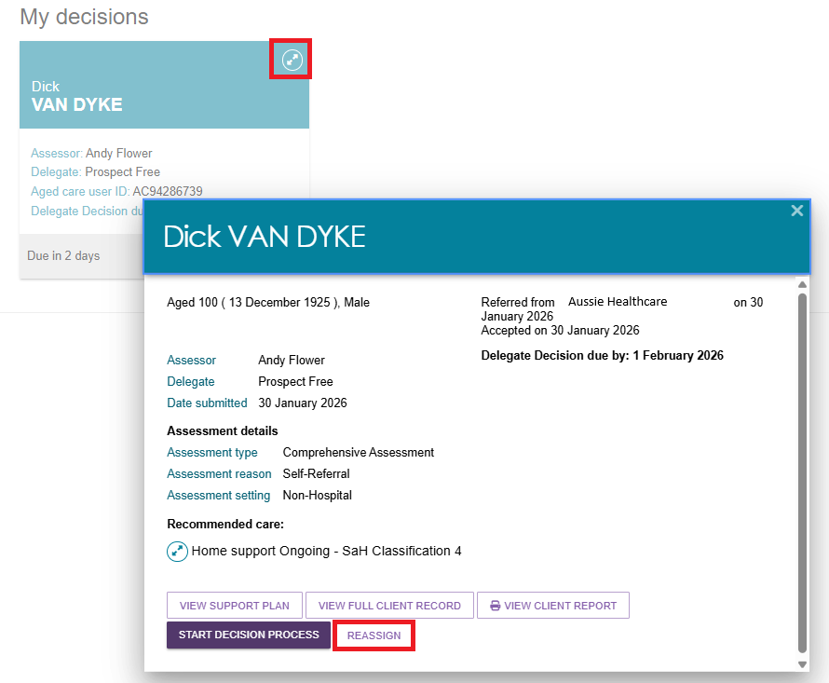
If using the list view, select the expand arrow next to the client’s name to see more information, and select REASSIGN.
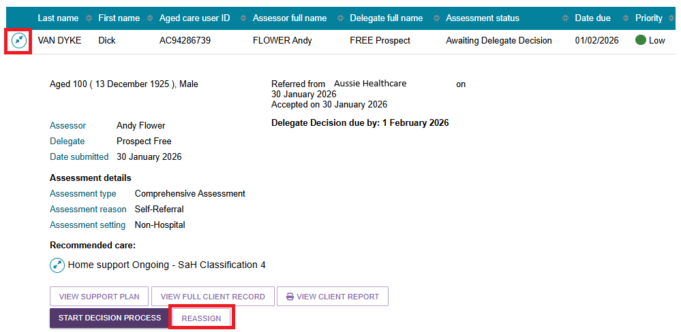
- Nominate another Delegate to assign the item to or select the option Place back in delegate queue if you want to un-assign it. Select REASSIGN.
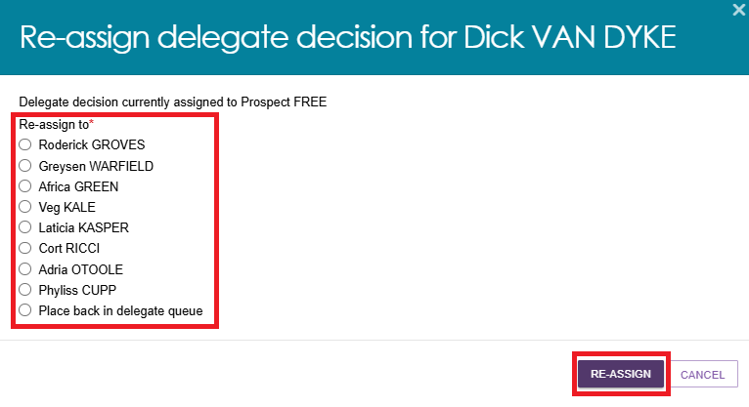
- You will receive a confirmation message that you have either re-assigned or un-assigned the queue item.

Recording a delegate decision
Prior to making any delegate decisions you must view the entire client record, assessment and support plan and attached information to ensure you have all the necessary evidence to support your decisions. For example:
- The assessment summary prepared by the assessor can be accessed through the Identified needs tab of the support plan.
- Information banners may appear in the Client Summary to remind you that the client is approved to access certain services.
Follow these steps to record your delegate decision:

Viewing decisions information
- Go to the Delegate Decisions tile from the home page and select the Decision Pending tab.
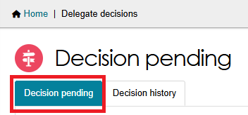
- From the Decision pending tab, select the expand arrow on the Client card to display a summary of the client’s information. I
Select START DECISION PROCESS. If using list view, this option is available from the expanded client information section. Select START DECISION PROCESS in the pop-up box.
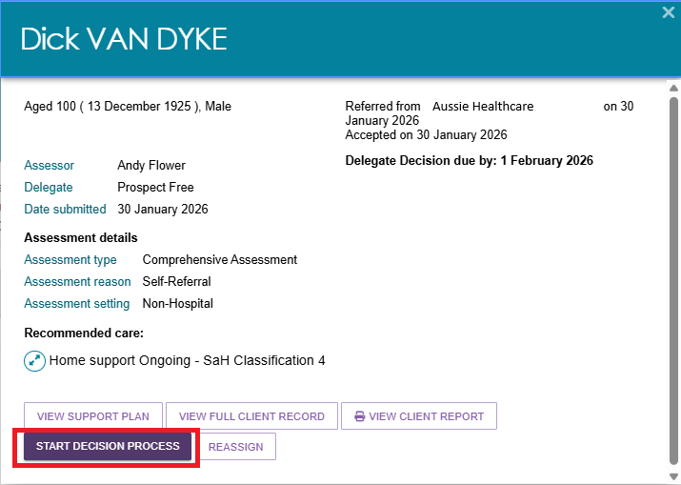
[Clinical Assessors only] If you as the delegate is also the same person who conducted the client’s assessment or support plan review, then this error message will appear:
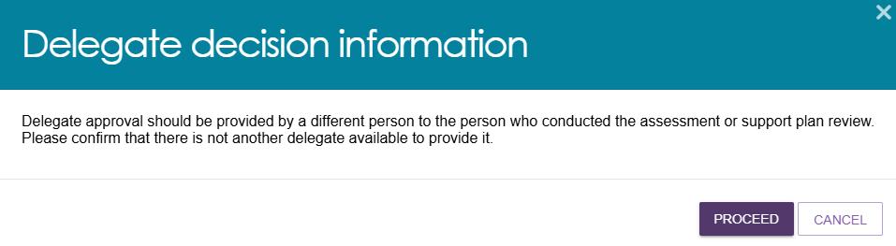

- You will be taken to the Decisions tab on the client’s support plan. The recommendations made by the assessor will be displayed for your review.
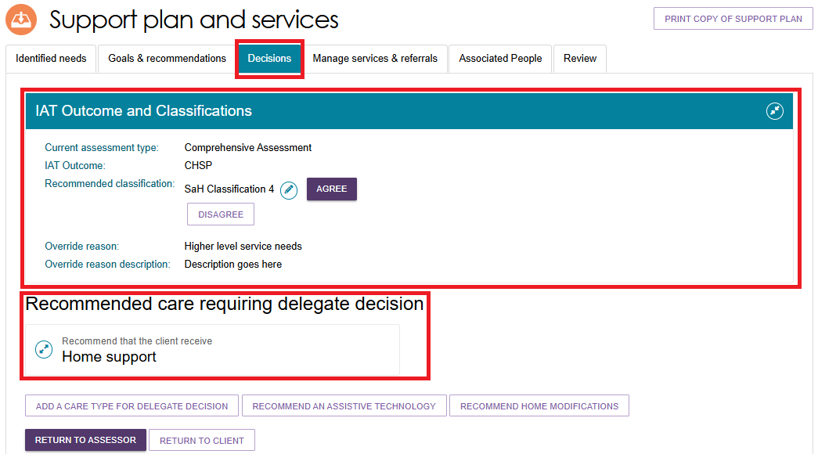
If you have also asked the assessor to review the IAT questionnaire, at this point you may also receive an information message saying that the Assessor has reviewed the IAT as per your request, and that you can review the IAT review via the hyperlink attached.
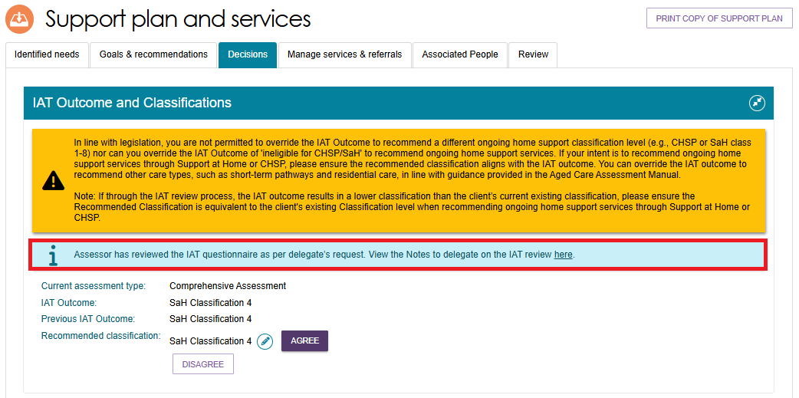

Editing a recommended classification
- Go to the Delegate Decisions tile, and select the client’s card or listing as per the process in Viewing Decisions information.
- Select on the pencil (Edit) icon next to the current recommended classification.
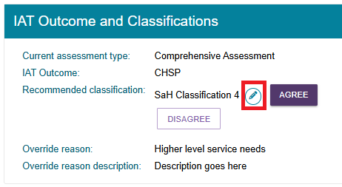
- The Edit Recommended Classification pop up appears.
! | An ongoing Support at Home classification outcome cannot be overridden to an ongoing lower or higher SaH classification outcome (in line with section 81-10 of the Aged Care Rules). Assessors must not undertake this action and delegates must not approve assessments where this occurs, or override and select a lower or higher classification.
Select the new recommended classification, along with the override reason and description.
Pay attention to any warning messages that may appear. Complete any other mandatory fields that appear, for example the client’s preference for seeking Home support services.
Finally, select SAVE TO PLAN.
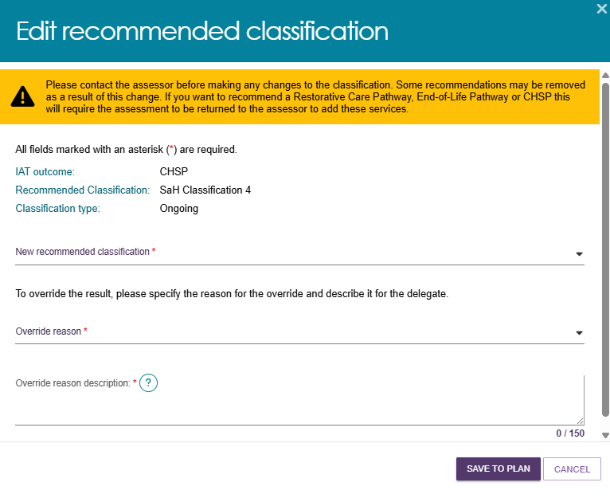

- For Support at Home classifications, the Edit Home Support Services Screen displays. A truncated version of this page is shown below.
The default services for your edited classification appear on this page.
Confirm or change the service, frequency and intensity details.
Then, select SAVE TO PLAN at the bottom of the page.
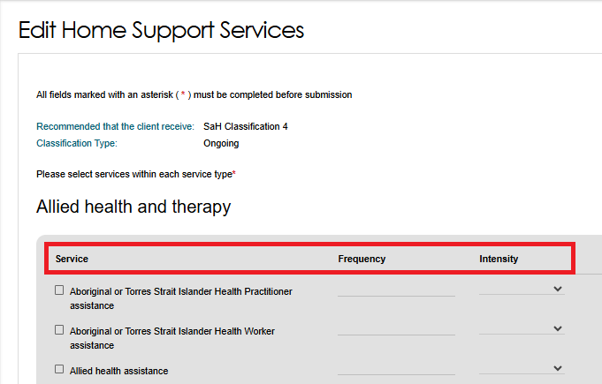
- The screen under the decisions tab will show the updated Recommended classification under IAT Outcome and Classifications. It can take up to 60 seconds for the update to take effect.
- For Residential Permanent recommendations, a Clinical Assessment Delegate can make corrections to their decisions within 43 days. During the correction you can:
- add a residential permanent recommendation
- remove a residential permanent recommendation
- update urgency
- update approval expiry date
- update emergency needs
- update Delegate date (approval start date).

Viewing details about existing approvals
- To view details and status of the decision for a recommended service, navigate to the Decisions tab and scroll to the Current care approvals section.
Select the expander icon next to the service and select the blue magnifier icon to view.
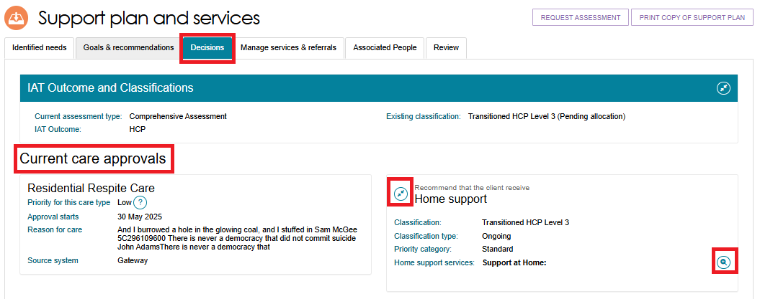
- A pop-up screen will open listing the classification and the type along with the list of all approved services.
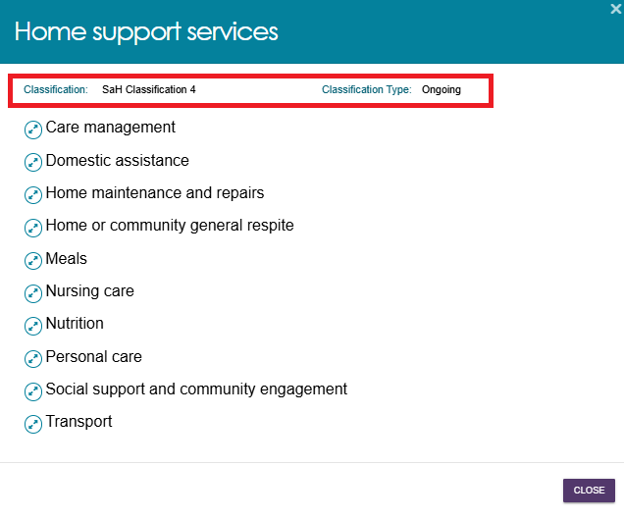
- Select the expander icon to view the details such as services included, approval start date and ceasing date.
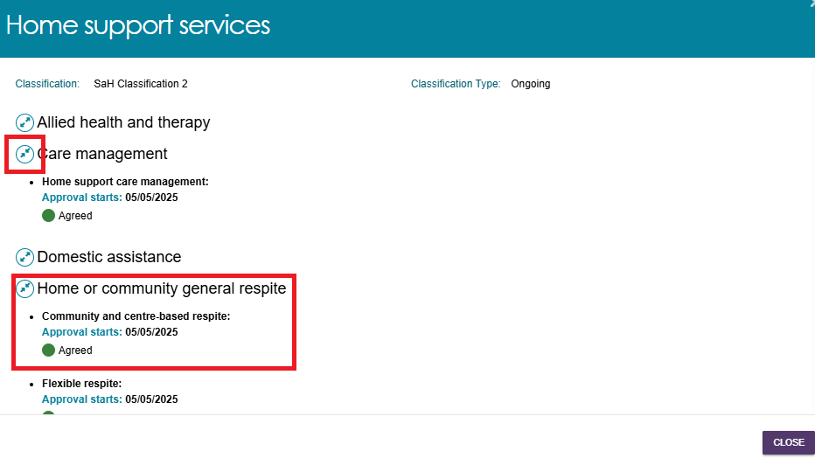

Returning an assessment to an assessor
There are circumstances in which you may wish to send the client’s assessment back to the assessor. For example:
- more evidence is required
- the care level is not appropriate or sufficient
- amendments needed to be made (such as to correct spelling errors)
- if the Integrated Assessment Tool (IAT) data needs to be reviewed for both Comprehensive and Home Support Assessments
- accidental errors with service approvals in the support plan
By selecting RETURN TO ASSESSOR, the original assessor can then make necessary changes to the support plan or IAT before re-submitting for decision.
You can only return the assessment to the assessor prior to agreeing or disagreeing to any recommendations.
If you select RETURN TO CLIENT, you will navigate back to the client’s record.
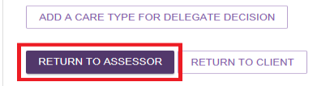
Follow these steps to return the assessment to the assessor:
- From the Delegate Decisions tile, Go to the Decisions tab of the client’s Support Plan and Services page. Select RETURN TO ASSESSOR at the bottom of the page.
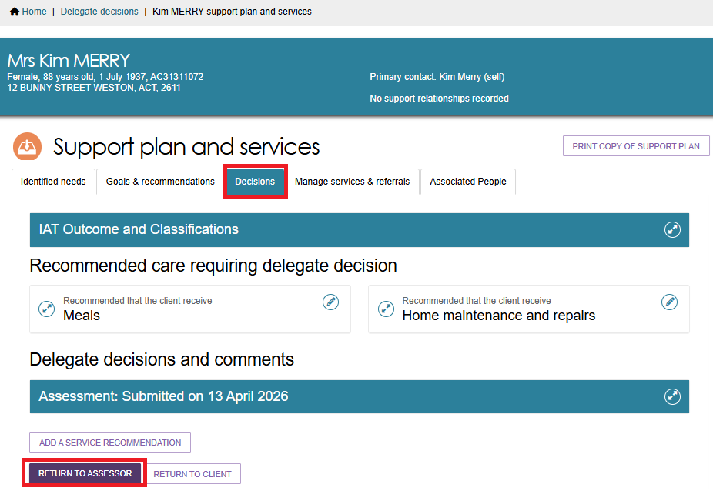
- The Return to assessor pop up appears.
If you are returning the assessment to the assessor to review and update the support plan only, select Return Assessment. You can return to assessor for support plan amendments multiple times.
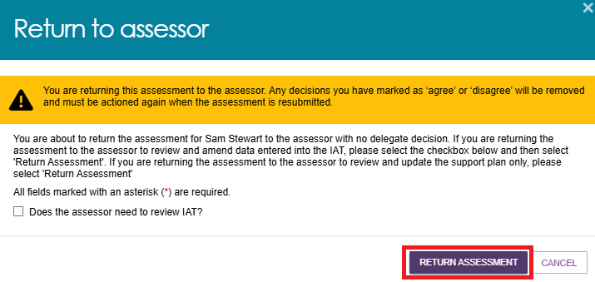
A green banner appears stating that the support plan has been returned to the assessor. The client’s card or listing disappears from your Decision Pending page.
- To ask the assessor to review the IAT, select the tick box next to Does the assessor need to review IAT?. It will display a warning that decisions will be cleared.
You can only request an IAT review once.
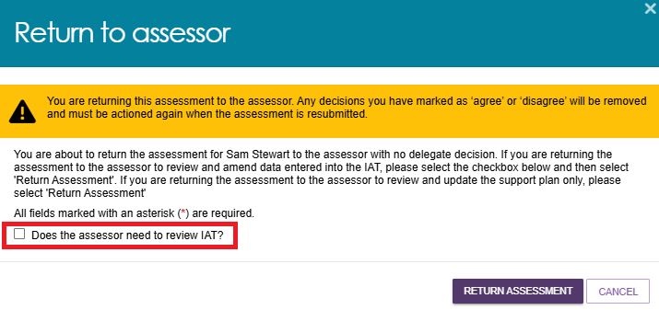

- The pop up expands to display a section to complete your IAT review notes to the assessor.
The IAT domain names are pre-filled for your convenience.
You can type in any text up to 2500 characters against the relevant IAT domains as per the example below.
Then, select RETURN ASSESSMENT.
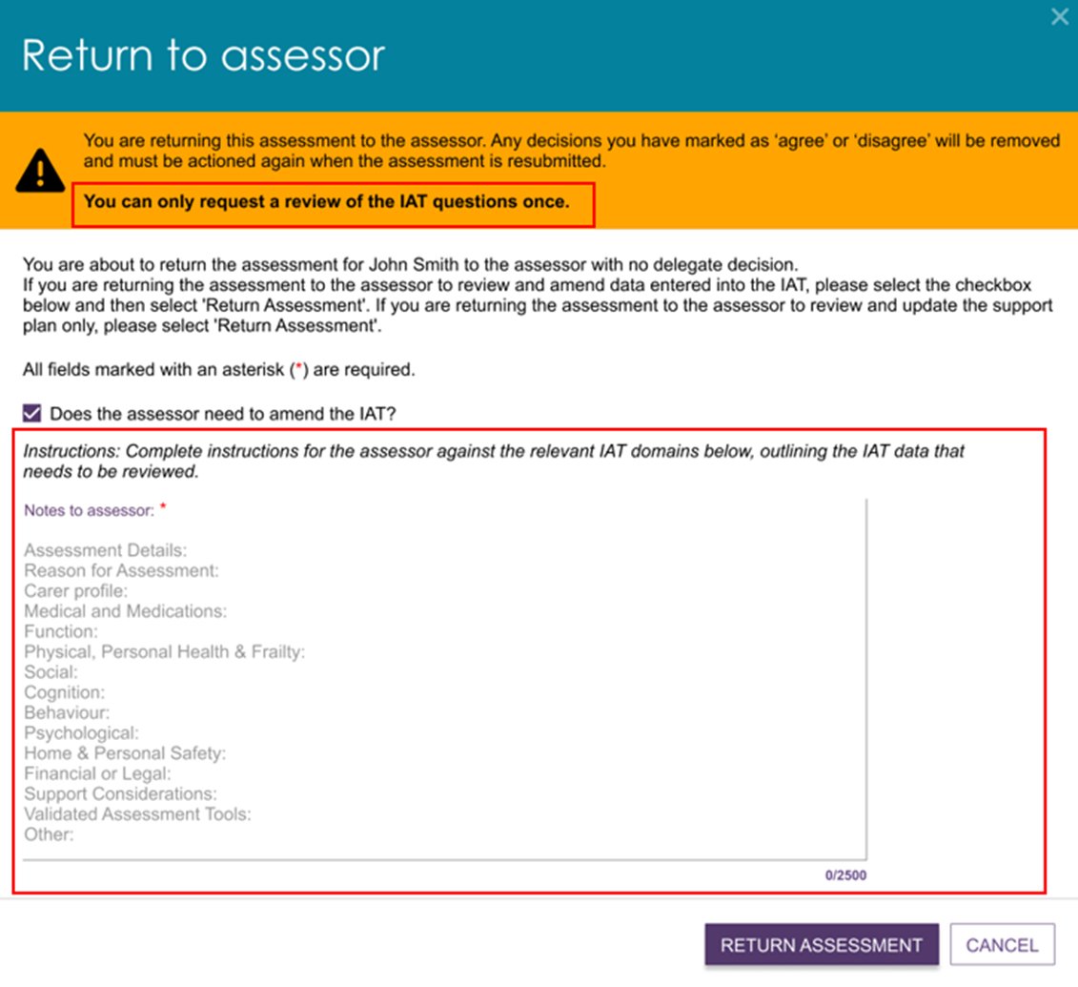
- A green banner appears stating that the support plan has been returned to the assessor.
The client’s card or listing disappears from your Decision Pending page.

- If the assessment has already been returned for IAT amendment, the modal will display as below:
- Warning that decisions will be cleared
- Text only mentions returning for Support Plan amendment. Click ‘Return Assessment’ to request support plan amendments
- Checkbox no longer displays.
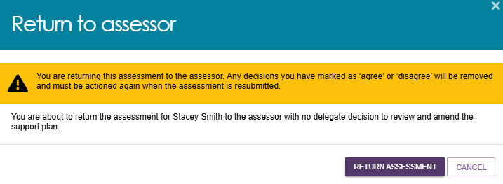

Receiving reviewed IAT from assessor
Once the assessor completes the requested changes from the returned IAT, re-finalises the IAT, and resubmits the support plan, the delegate then is able to view any notes that the assessor made before restarting the decision process.
- Find the client from the Delegate Decisions tile, then the Decision pending tab. Select the client’s card or listing.
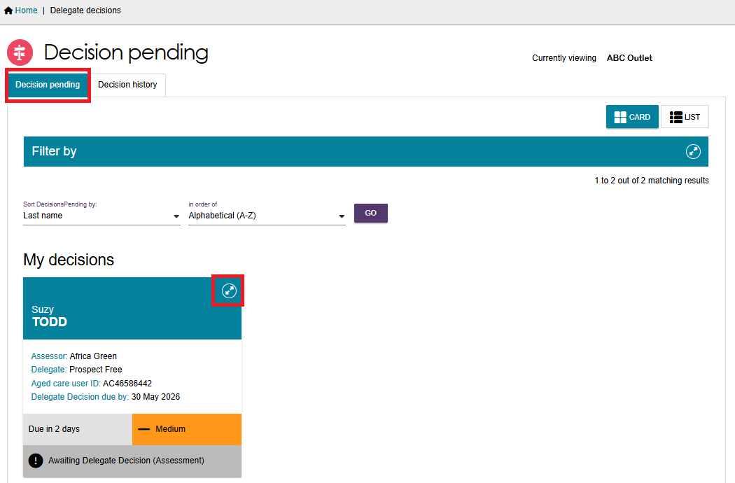
- An Information message appears: ‘Assessor has reviewed the IAT questionnaire as per delegate’s request. Please refer to the Notes to delegate on the IAT review below for details’.
Select VIEW DETAILS below Notes to delegate on the IAT review.
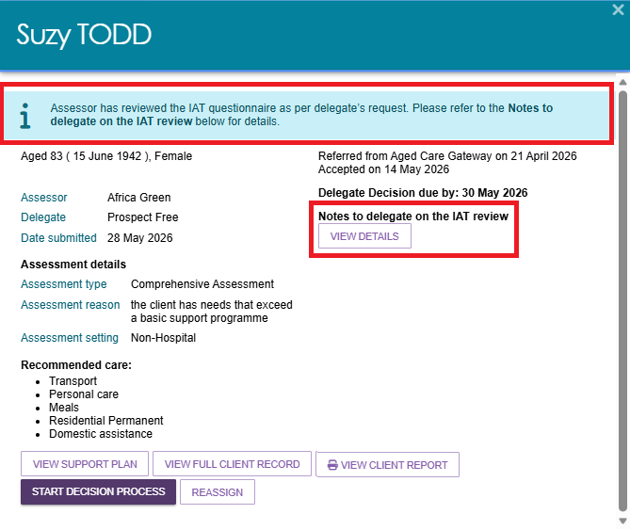
- The Notes to delegate on the IAT review pop up appears. You can view the assessor’s notes to the delegate at the top, and the original delegate’s notes to the assessor below.
Select the expander icon to expand or close each section.
Select CLOSE to return to the client’s record.
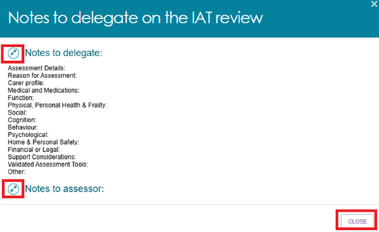
- From the client’s card or list view, select START DECISION PROCESS to start/restart the decision process.
The Decisions page appears. This time it displays the updated support plan (if completed), the updated IAT outcome, and the previous IAT outcome (if applicable).
You can also view the assessor’s IAT Notes from here. Select the hyperlink in the Information message: ‘Assessor has reviewed the IAT questionnaire as per delegate’s request. View the Notes to delegate on the IAT review here’.
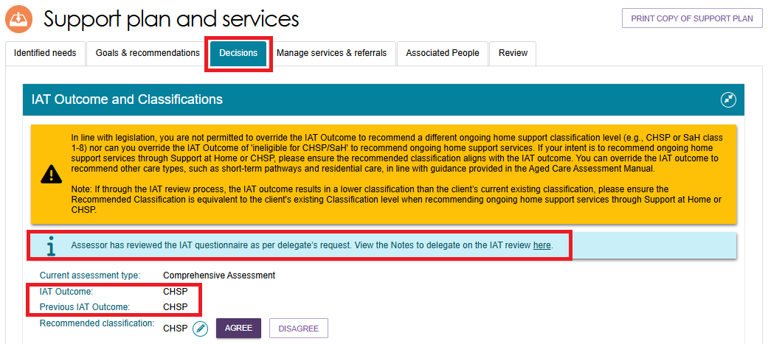

No Care Approval and No Change to Existing Care Approvals
No Care Approval and No Change to Existing Care Approvals are available as buttons, for both Home Support Assessments and Comprehensive Assessments. These buttons are available in the client’s Goals & Recommendations tab of the Support Plan and Services page. They can also appear whilst adding a Goal.
No Care Approval appears if the client has no previous approval records. No Care to Existing Care Approvals appears if the client has previous approval records.
This image below shows the Add No Change to Existing Care Approvals button, in the Other Recommendations section of the client’s Goals & Recommendations tab.
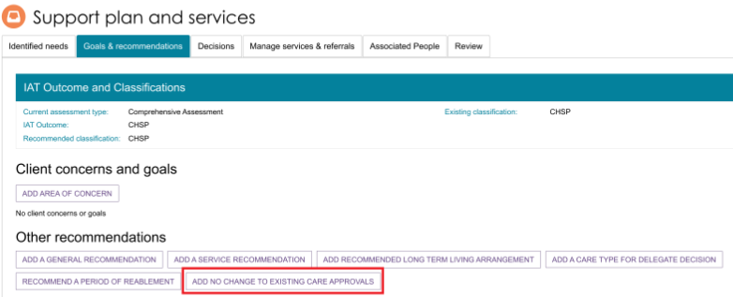

This image below shows the Add No Care Approval button, in both the Goal section and in the Other Recommendations section of the client’s Support Plan and Services page.
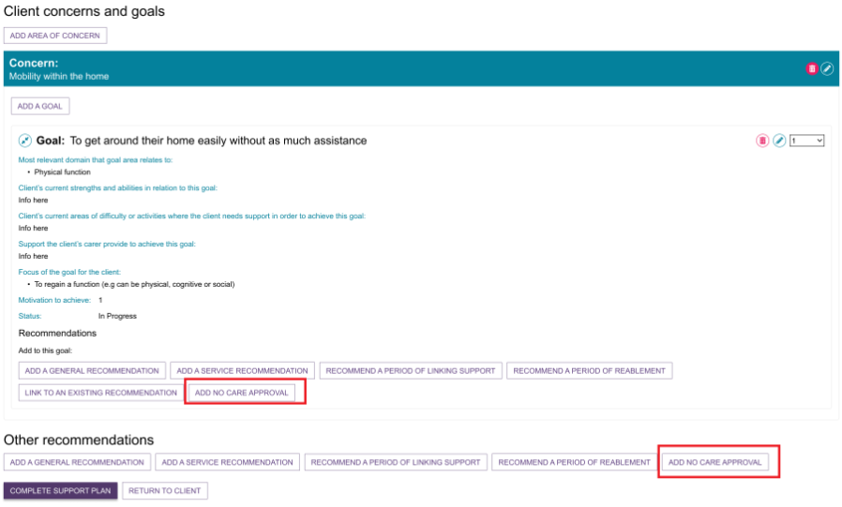
Assessors are able to recommend No Care Approval or No Change to Existing Care Approval during the assessment period. These will require delegate decision. No Care Approval or No Change to Existing Care Approvals are not available during the support period or the support plan review.

Clinical Delegate workflow process
Clinical assessment delegates are delegated the authority under the Act to approve an older person for all service groups, classification types and classification levels.
! | Clinical Delegate requirements for Comprehensive (CHSP only) assessment outcomes  When a comprehensive assessment results in a CHSP only outcome, the approval must be completed by a clinical delegate who is different to the clinical assessor.  A clinical assessor must not approve their own comprehensive assessment.  All comprehensive assessments - regardless of the outcome - require separation between the assessor and delegate roles. This ensures that appropriate clinical governance and oversight for comprehensive assessments is maintained.  The only situation where an assessor may also be the delegate is when completing a Home Support Assessment that results in a CHSP only recommendation.
! | Clinical Assessment Delegates can approve entry-level home support services (as non-clinical assessment delegates do) if assessment organisations have chosen to allocate home support assessments to clinical assessment delegates.

Agreeing with recommendations
- To agree with the clinical assessor’s recommendation for a non Support at Home (Residential Care, TCP, CHSP etc.) recommendation, select AGREE below the recommended care type. If multiple care types were recommended, you will need to repeat this process for each care type.
To agree with a Support at Home service recommendation, refer to Agreeing or disagreeing with a Support at Home Recommendation.
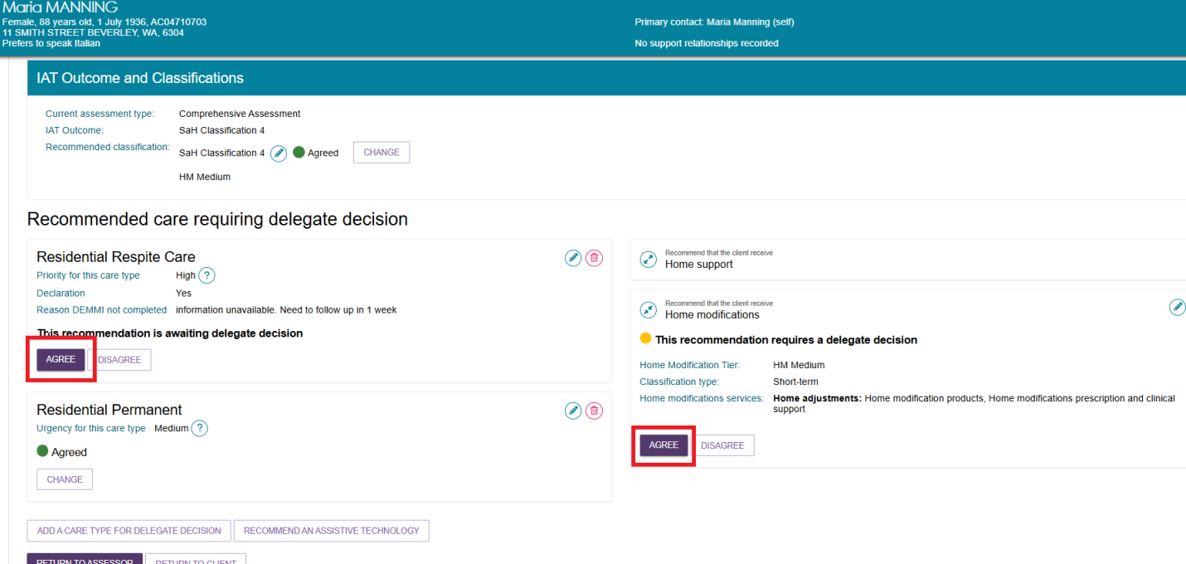
- You will be asked to confirm that you agree with the recommendation in a pop-up box. If required, you can enter an approval cease date and add comments.
Select AGREE.
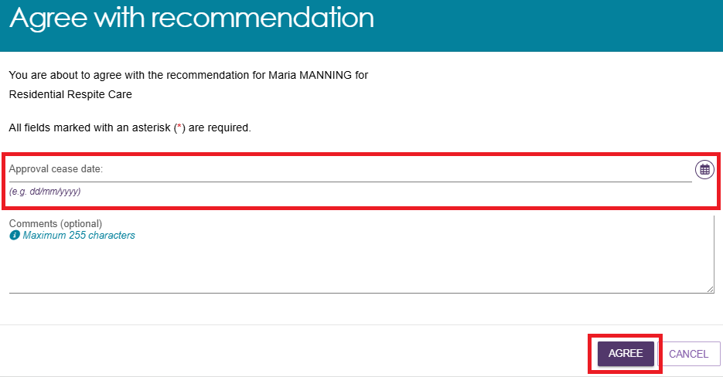

- A confirmation message will display, and the status of the recommendation will display as Agreed.
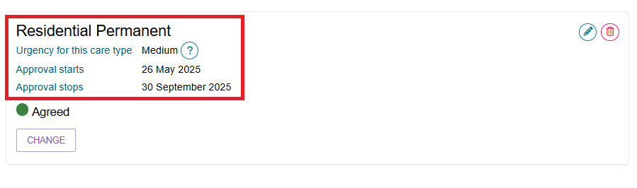
! | Reissuing CHSP Referrals – Urgent Services  All clients who have accessed urgent services are required to complete an assessment, and new referrals must be generated for any approved ongoing CHSP services.  - CHSP providers will continue to deliver urgent services until an assessment is completed.  - When ongoing CHSP services are approved, the urgent service referral should end.  - New CHSP referrals are required for the provider to continue delivering services on an ongoing basis.  - Where a delegate does not approve the urgent service:  - If the service has not commenced, the direct-to-provider referral will be recalled.  - If the service has commenced, the provider will be notified that the urgent service is not approved and should cease urgent service provision.

Disagreeing with recommendations
Disagreeing with a recommendation will result in a non-approval of that recommended care type.
If a recommendation is mistakenly added by the assessor, the delegate can disagree with the assessor’s recommendation, and/or add their own recommendation.
! | An ongoing Support at Home classification outcome cannot be overridden to an ongoing lower or higher SaH classification outcome (in line with section 81-10 of the Aged Care Rules). Assessors must not undertake this action and delegates must not approve assessments where this occurs, or override and select a lower or higher classification.
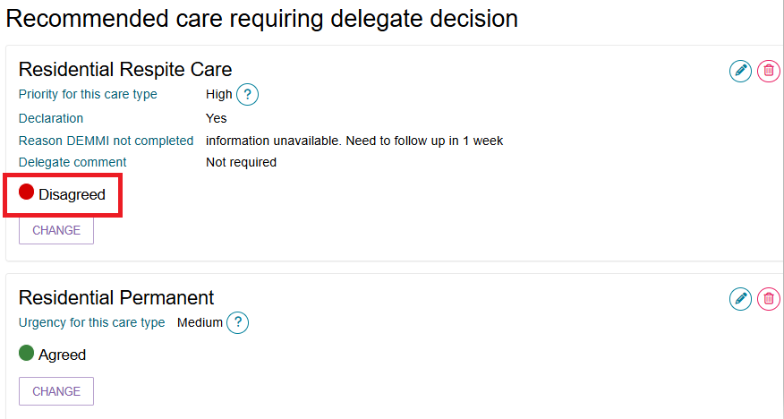
Follow the steps below to disagree with a recommendation:
- Select the expander button to show the recommended care type for approval.
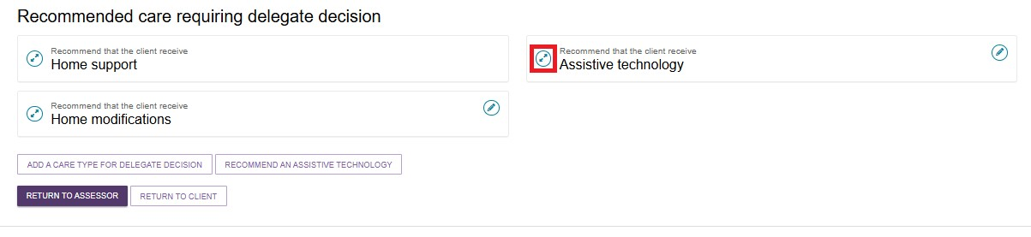
- Select DISAGREE below the recommended care type.
You will need to repeat this process for each care type that you disagree with.
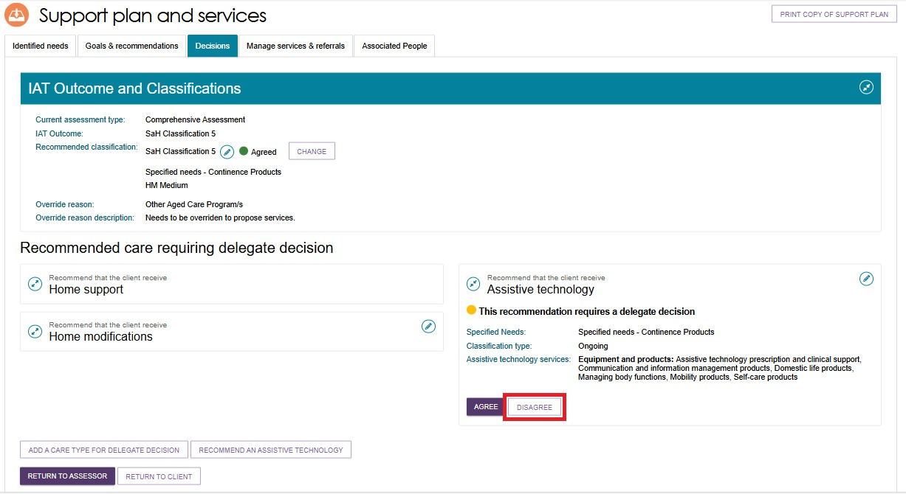
- You will need to provide a comment about your reason for disagreeing with the recommendation, then select DISAGREE.
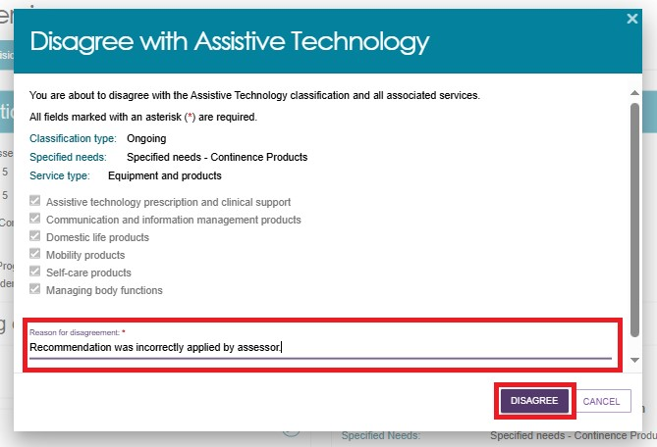

- A confirmation message will display, and the status of the recommendation will change to Disagreed.
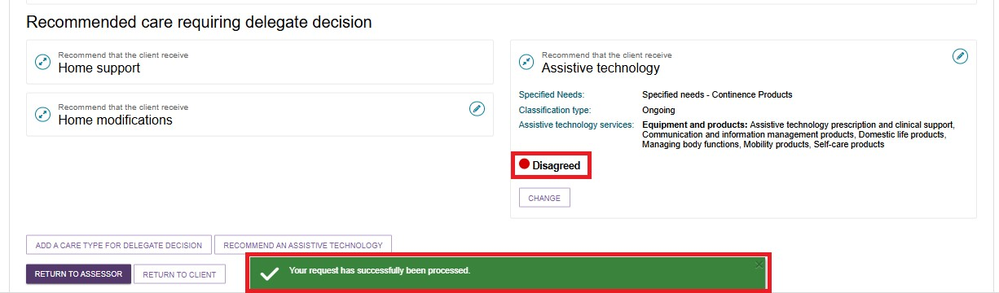
- If you need to change your decision, you can select CHANGE. This option will only be available prior to saving and completing the approval process by selecting Save and Delegate. Refer to the Changing a Decision section for more details.
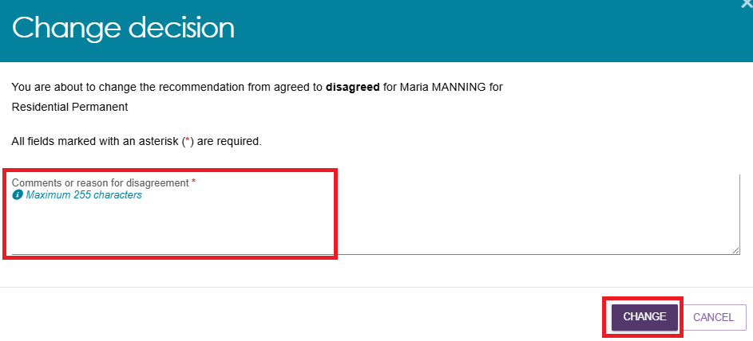
- If you disagree with all recommendations and you do not add any new approval decisions, you may be prompted to select No Care Approval as a service type during the Save Decision and Delegate pop-up in order to complete the delegate decision.
Go to No Care Approval and No Change to Existing Care Approvals for more information.
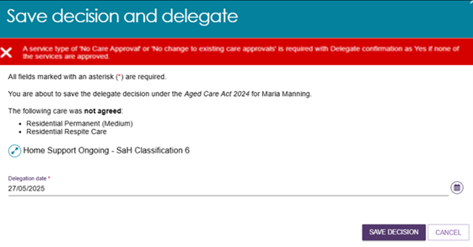

Agreeing or disagreeing with a Support at Home Recommendation
- For a client that has been recommended for an ongoing Support at Home classification, you will be required to select APPLY DELEGATE DECISION to the assessor’s recommended Home support services.
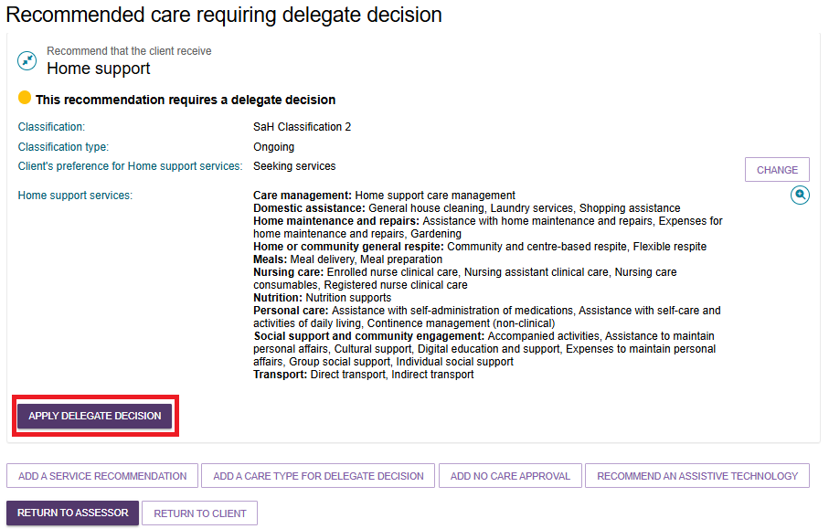
- You will be shown all the assessor’s recommended service type/s, service/s, frequency and the intensity of the services.
You can either agree or disagree by selecting individual service/s, multiple services, or selecting the Select all toggle, then select AGREE WITH SELECTED SERVICES, or DISAGREE WITH SELECTED SERVICES.
The below image shows a truncated example of Home support services available.
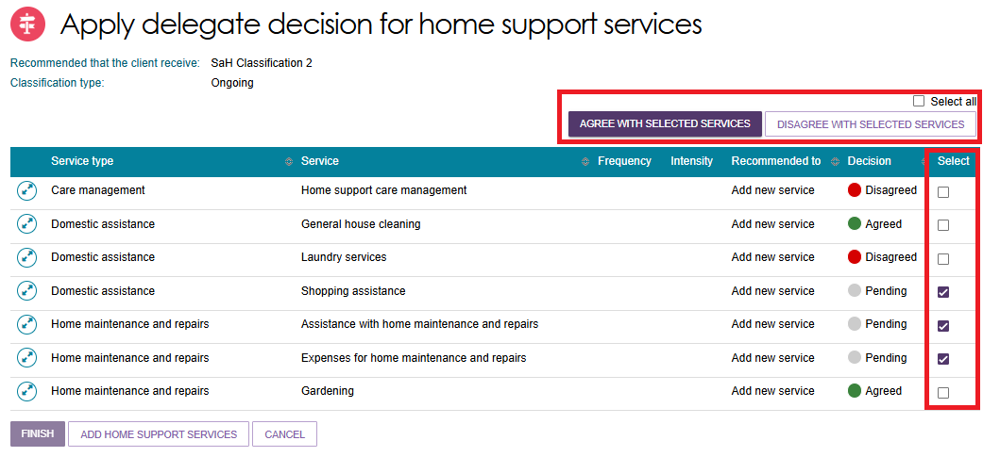

- To individually agree, disagree or update a service, select the expander icon and then select AGREE, DISAGREE, or UPDATE SERVICE.
In the Update service pop up, you can enter or update a service frequency or intensity.
Select UPDATE to save the service.
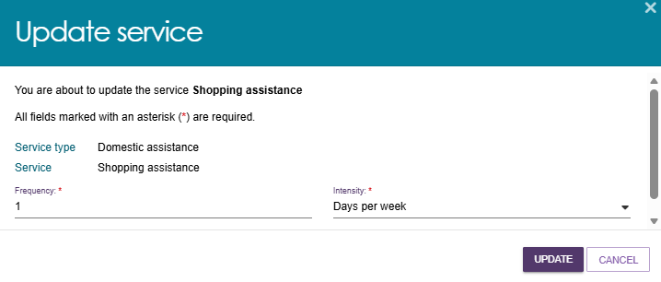
The updated frequencies and intensities are shown at the Apply delegate decision for home support services page.
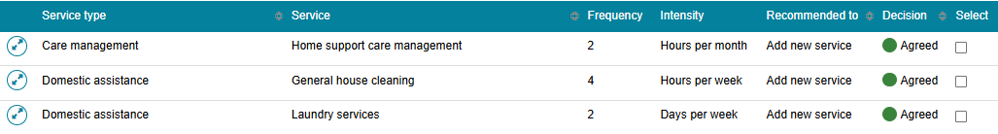
- If you disagree with the service/s that the assessor has recommended, after selecting DISAGREE WITH SELECTED SERVICES, you will be asked to provide the reason for your disagreement. Then, select DISAGREE.
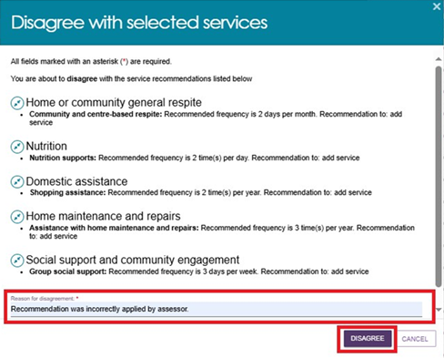
- If you are agreeing with the recommendations by the assessor, tick the services’ checkbox and select AGREE WITH SELECTED SERVICES button. These services will include any frequencies and intensities added by you.
It should be noted that if you select a service that you have previously disagreed with, it will override your decision.
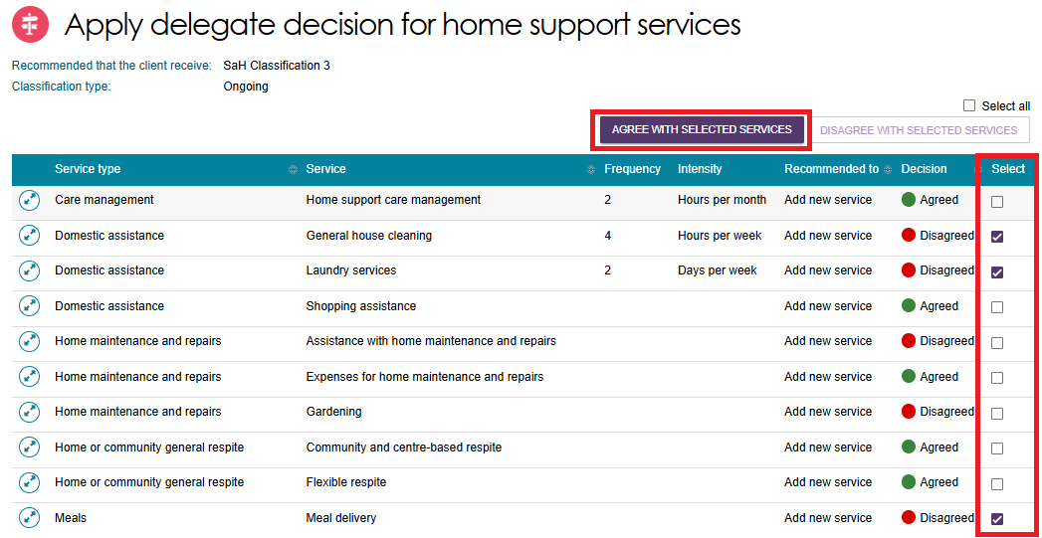
Then, you will be asked to confirm by selecting the AGREE button.
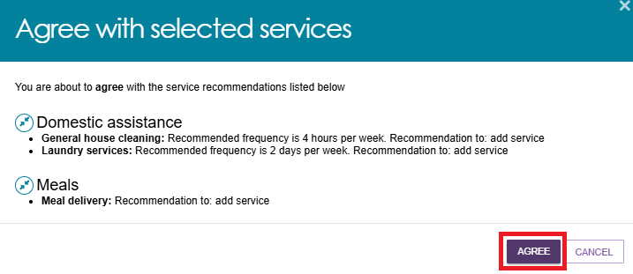
- During this process, you can add additional Support at Home services that are not already listed on the page by selecting the ADD HOME SUPPORT SERVICES button at the bottom of the page.

- The Add Home Support services page appears, where you can add additional Support at Home service/s, frequency and intensity. When finished, select the SAVE TO PLAN button.
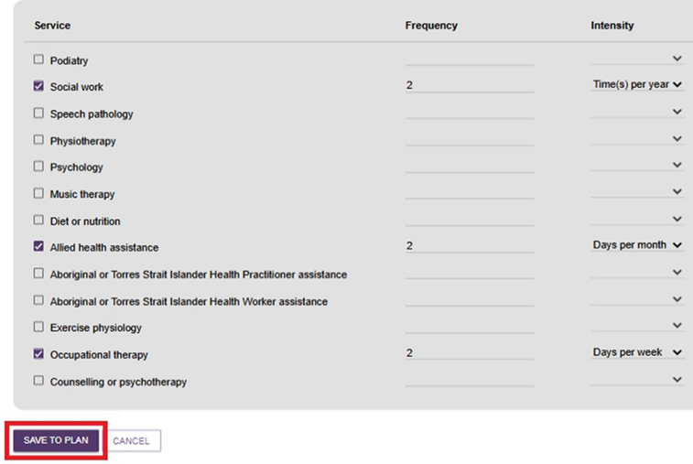
- Review the services you have added and select FINISH once you are ready to proceed to delegate.
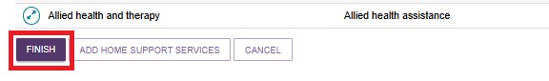
- You will be taken back to the Decisions tab of the client’s Support Plan and Services page.
At this point in time, the list of Home Support services are still reflecting the intended recommendation from the assessor, prior to delegate decision.
To view what you have decided, select the Magnifying Glass (view) icon on the right hand side of the Recommend that the client receive Home support section.
Select SAVE AND DELEGATE at the bottom of the page, to finalise your delegation.
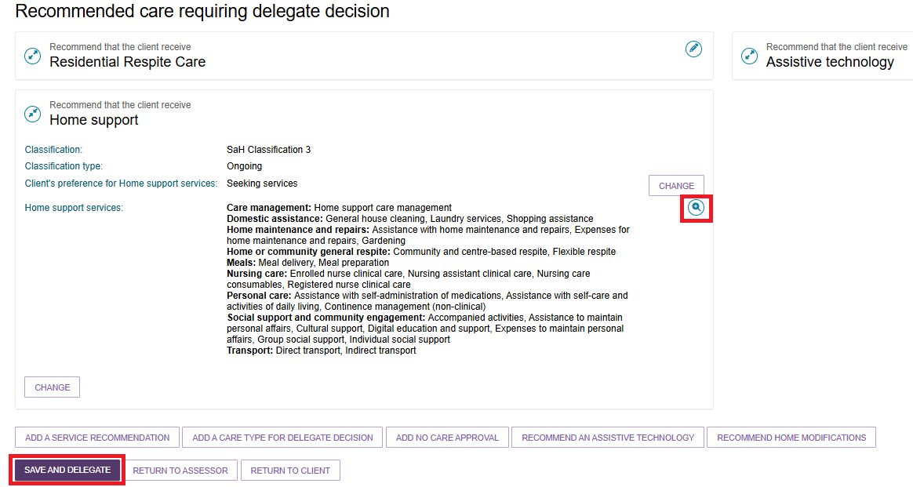
- The Save decision and delegate pop up appears.
It will list all services that are agreed by you, including any frequencies and intensities that were updated by you. It will also list all the services that are not agreed.
Enter the delegation date, and then select SAVE DECISION.
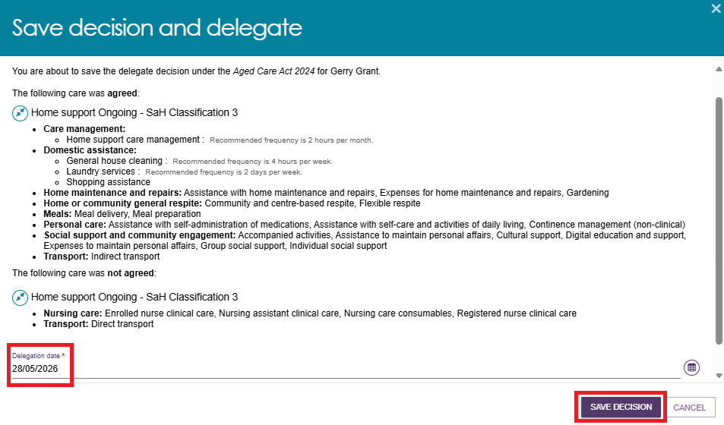
- The client’s Support Plan and Services page now shows the approval start date.
You can now generate Notice of Decision letters, and Request/change notification of Support at Home correspondence.

Editing a recommendation
- To edit a care type or level of care recommended by an assessor, select the Edit icon to the right of the recommendation.
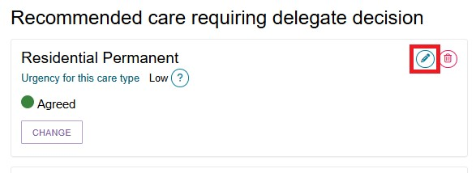

- The Edit a care type pop up will be displayed, and you will be able to make any changes required. Select SAVE TO PLAN to save the changes.
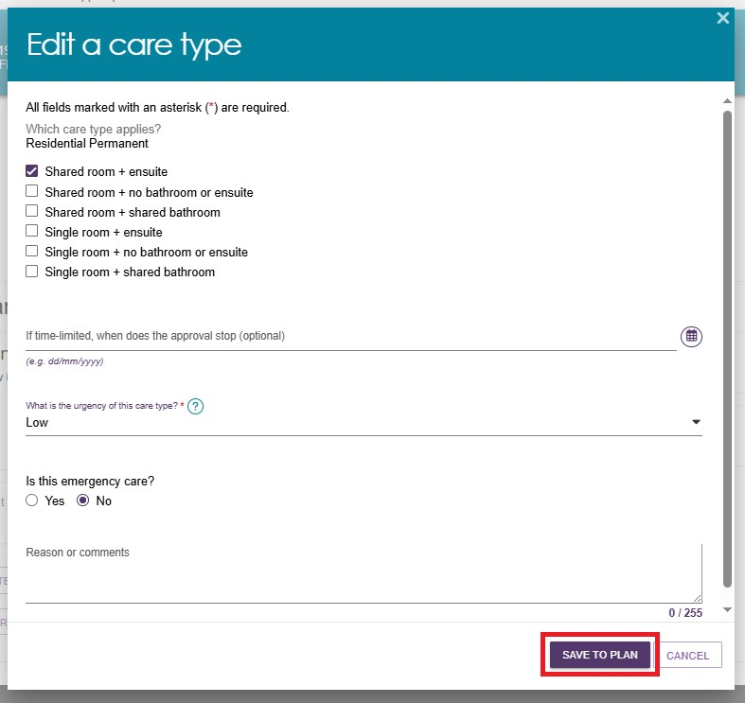

Adding a care type
Assessment Delegates can add another care type for delegate decision for the client, if required.
- At the bottom of the client’s Decisions tab of the Support Plan and Services page, select ADD A CARE TYPE FOR DELEGATE DECISION.
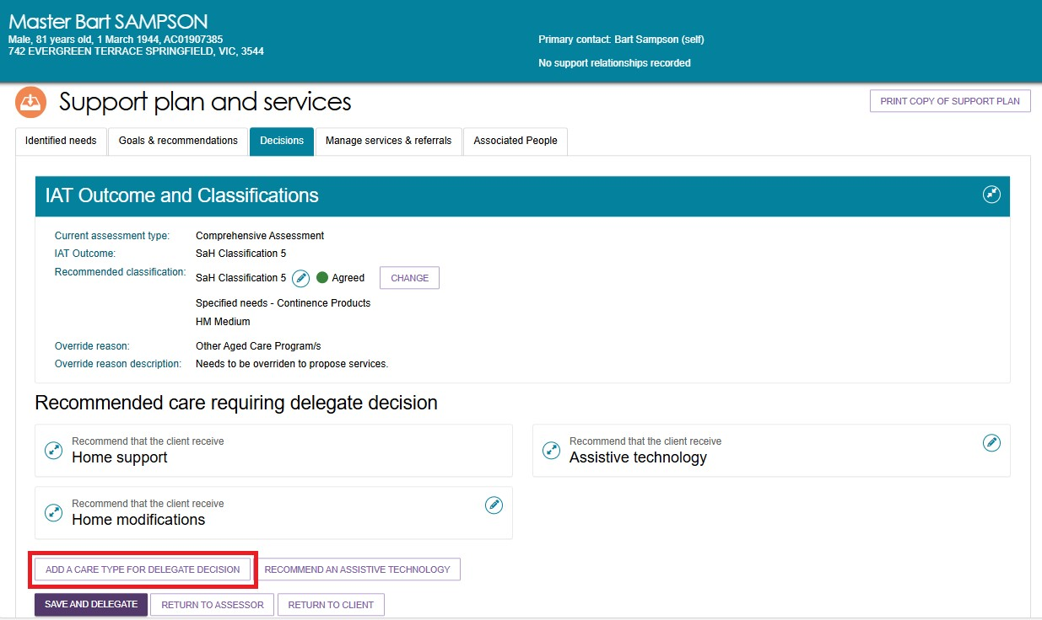
- In the pop-up box, select the care type that applies from the drop-down box. You will need to select the priority for the care type.
Please note that there are historical care types in this section, which should only be used in prescribed situations.
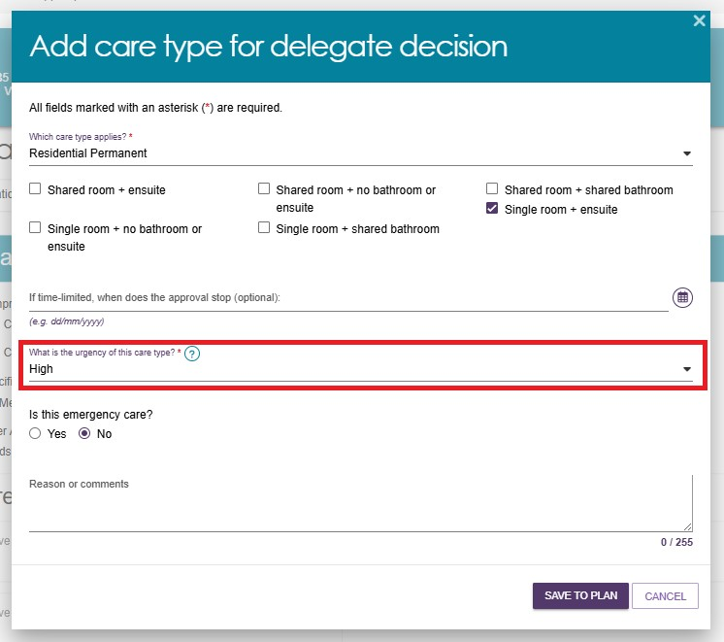
- The care type will be added to the Recommended care requiring delegate decision list with a decision of Agreed.
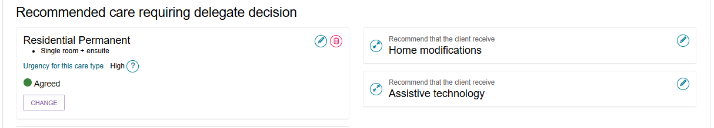

Recommending a Home Modification Service under Support at Home
! | When considering adding/editing Home modifications care recommendations, refer to:  - Support Plan section of My Aged Care – Integrated Assessment Tool (IAT) User Guide  - Approving AT and HM under Support at Home and Approving AT and HM under CHSP sections under Chapter 8 of the My Aged Care Assessment Manual  - Delegate training.
As a delegate you can recommend a Home modification (HM) service when the assessment identifies that changes to the client’s living environment are necessary to support their safety, independence, or ability to remain at home.
- From the Decisions tab, select the RECOMMEND HOME MODIFICATIONS button.
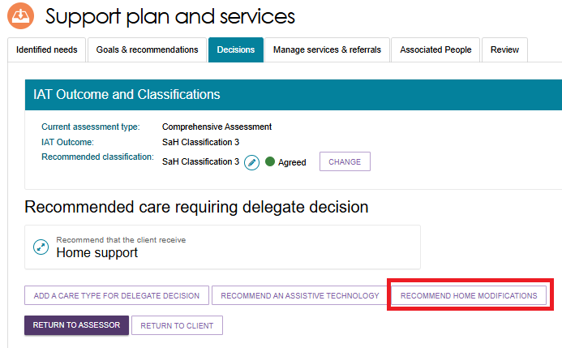

- The ADD HOME MODIFICATIONS RECOMMENDATION screen appears. Select the home modification tier (Low, Medium, or High) from the drop-down list.
The Service Type section will be pre-filled and greyed out.
Choose whether the client want to seek Home modifications services through the Support at Home program.
Then, select SAVE TO PLAN.
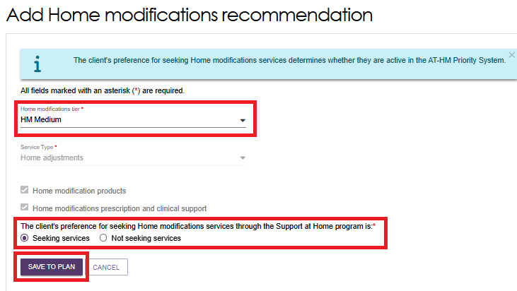

Recommending an Assistive Technology Service under Support at Home
! | When considering adding/editing Assistive technology care recommendations, refer to:  - Support Plan section of My Aged Care – Integrated Assessment Tool (IAT) User Guide  - Approving AT and HM under Support at Home and Approving AT and HM under CHSP sections under Chapter 8 of the My Aged Care Assessment Manual  - Delegate training.
As an assessment delegate, you can recommend an Assistive technology service when the client’s assessment indicates a need for equipment or devices that support daily living, safety, or independence to ensure the right equipment is provided to enhance the client’s ability to live safely and independently at home.
Please note that Assistance dogs are classified under the Ongoing classification type of assistive technology.
It is known as ‘Specified Needs – Assistance Dogs’.

- From the Decisions tab, select the RECOMMEND AN ASSISTIVE TECHNOLOGY button.
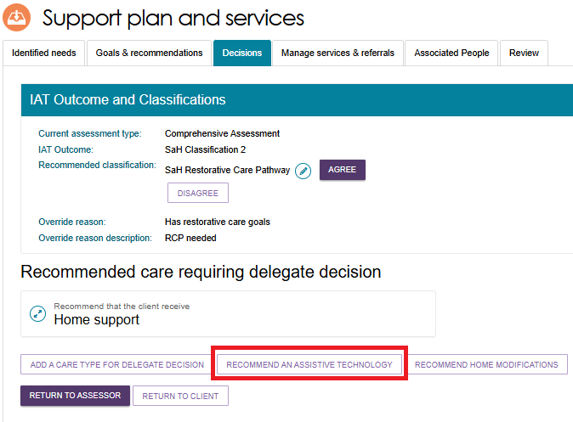
- The Add Assistive technology recommendation screen appears.
Select the classification type from the drop down list.
If the classification type is Short-term, select the technology tier from the drop-down list. If it is Ongoing, assistance dogs is available under the Specified Needs section.
Choose whether the client want to seek Assistive technology services through the Support at Home program. Then, select SAVE TO PLAN.
Assistive Technology Short Term example
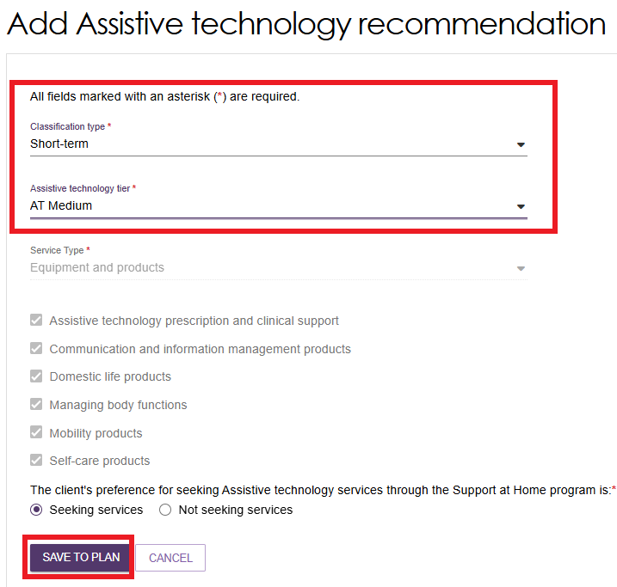
Assistive Technology Ongoing example
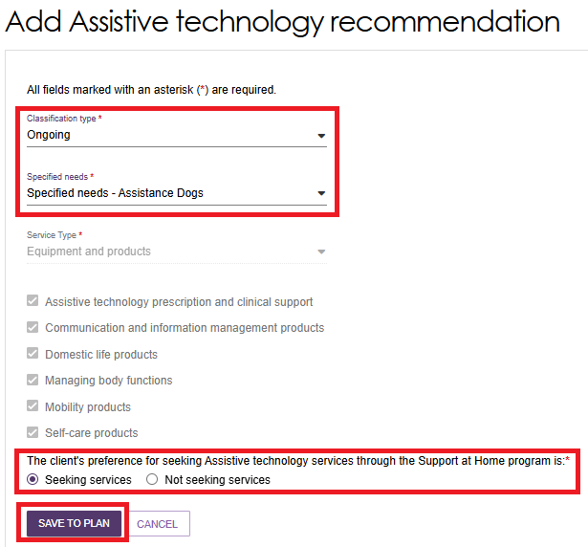
- The recommendation will be displayed within the Decisions tab under Recommended care requiring delegate decision section. Expand the item to view the details. Select AGREE or DISAGREE. You can also edit the recommendation using the Edit (Pencil) icon as shown in the example below.
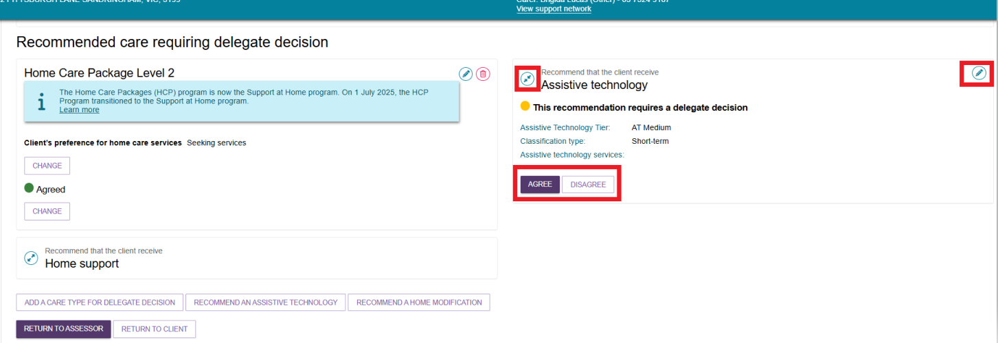

Recommending a second Restorative Care Pathway unit
! | The same delegate cannot approve a client’s Restorative Care Pathway (and associated AT-HM recommendations) and their support plan review, unless the delegate can confirm that there is not another delegate available to provide the approval/s.
Clinical Delegates can add a second unit of Restorative Care Pathway (RCP) during the Decision process during a Support Plan Review where a current Restorative Care episode is in effect. There are certain number of places available during the financial quarter for RCP units. Assessors and delegates should monitor departmental communications regarding RCP unit availability, particularly where a second unit is being considered.
! | Delegates must not add a second unit of Restorative Care where a participant has not commenced their first episode of Restorative Care.
- Go to the Delegate Decisions Tile from the assessor portal home page.
- Select the client to add the second unit. This client must already have RCP approved and active.
- Go to the client’s support plan, then the Decision tab, then the IAT Outcome and Classification section.
- Select ADD SECOND UNIT OF RESTORATIVE CARE PATHWAY.
- The ‘Add second unit of Restorative Care Pathway’ pop up appears. Read the confirmation text, then select ADD SECOND UNIT.
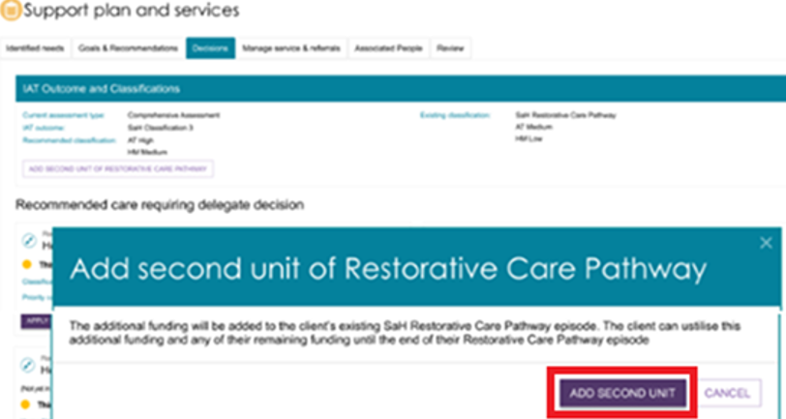

- The second unit now displays under the client’s Current Care Approvals.
The Delegate’s decision appears under the Delegate’s Decisions and Comments section.
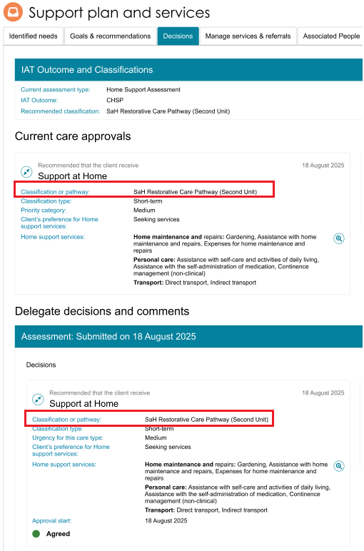

Changing a decision
- If you need to change your decision from Agreed to Disagreed, or Disagreed to Agreed, you can select the CHANGE button.
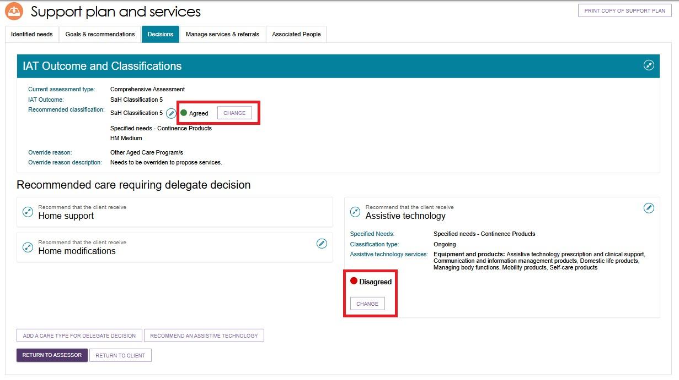
- You will be able to add approval cease dates and comments where appropriate in the pop-up.
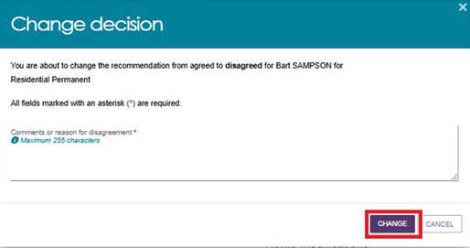
- If you are changing the decision from Agreed to Disagreed, you will need to provide a reason for the change.
Please note, this option will only be available prior to saving and completing the approval process.
- A confirmation message will display.


Editing a recommended classification
- Go to the Delegate Decisions tile, and select the client’s card or listing as per the process in Viewing Decisions information.
- Select on the pencil (Edit) icon next to the current recommended classification.
- The Edit Recommended Classification pop up appears.
! | An ongoing Support at Home classification outcome cannot be overridden to an ongoing lower or higher SaH classification outcome (in line with section 81-10 of the Aged Care Rules). Assessors must not undertake this action and delegates must not approve assessments where this occurs, or override and select a lower or higher classification.
Select the new recommended classification, along with the override reason and description. Pay attention to any warning messages that may appear. Complete any other mandatory fields that appear, for example the client’s preference for seeking Home support services.
Finally, select SAVE TO PLAN.
- For Support at Home classifications, the Edit Home Support Services Screen displays. A truncated version of this page is shown below.
The default services for your edited classification appear on this page. Confirm or change the service, frequency and intensity details. Then, select SAVE TO PLAN at the bottom of the page.
- The screen under the decisions tab will show the updated Recommended classification under IAT Outcome and Classifications. It can take up to 60 seconds for the update to take effect.
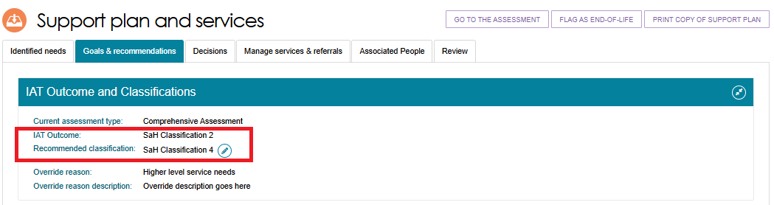
- For Residential Permanent recommendations, a Clinical Assessment Delegate can make corrections to their decisions within 43 days. During the correction you can:
- add a residential permanent recommendation
- remove a residential permanent recommendation
- update urgency
- update approval expiry date
- update emergency needs
- update Delegate date (approval start date).

Finalising your decision
- Once the decision has been made, select SAVE AND DELEGATE.
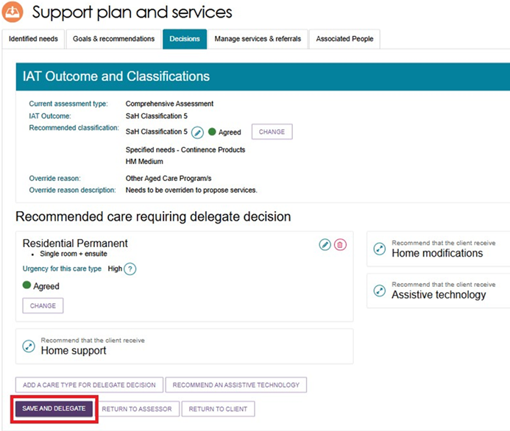
- A pop-up will display, confirming the care types that were agreed and not agreed. If you need to make any changes to your decision, select CANCEL. Ensure the date of the delegation is correct. For certain types of care, you can expand to see more information by using the expander button.
If you are satisfied with the decision and the date, select SAVE DECISION.
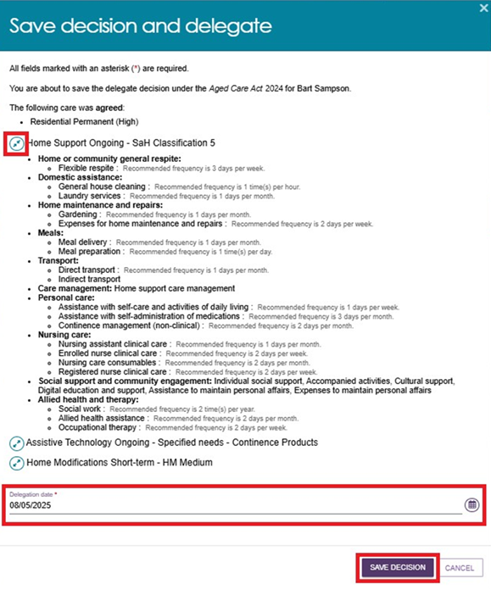
! | If the approval was actioned off-system earlier than the day that the delegation is completed via the portal, you can set the date of delegation to the earlier date as reflected on the Approval Form.  It is available for download from the Reports and Documents tile of the assessor portal. This form is evidence that you made the approval decisions prior to the date you are making the entry on the system.  You must attach the Approval Form to the Attachments tab.  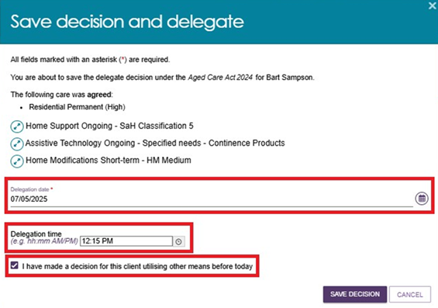
- A confirmation message will display stating that the approvals have been submitted to Services Australia to process, and that the decision has been recorded and sent to the clinical assessor to finalise the client’s support plan and match and refer for service.

Non-Clinical Delegate workflow process
Non-clinical Assessment Delegates are delegated the authority under the Act to approve entry-level services arising from a home support assessment.
This means they can only approve access to the Commonwealth Home Support Program (CHSP), Assistive technology (AT) and/or Home modifications (HM) under CHSP
(not under the AT-HM scheme).
If any approvals other than those listed above are required, the assessor must convert the assessment to a comprehensive assessment. Once an assessment is converted to a comprehensive assessment, the approval will flow to a Clinical Assessment Delegate. Clinical Assessment Delegate approval is required for all other approvals as outlined in detail in the next section.

Agreeing with recommendations
- To agree with the assessor’s recommendations, select AGREE below the recommended service.
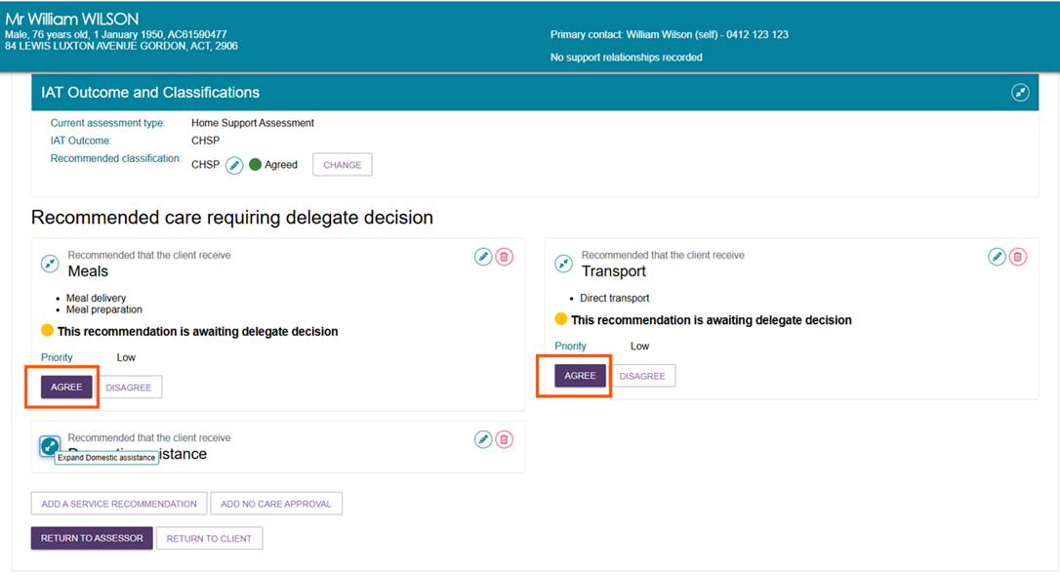
- You will be asked to confirm that you agree with the recommendation in a pop-up box. Select AGREE.
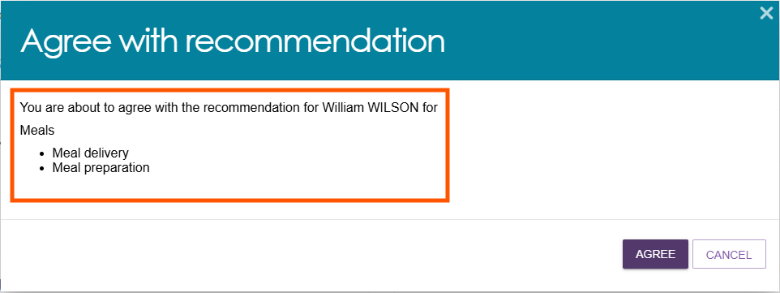

- A confirmation message will display and the status of the recommendation will display as Agreed.
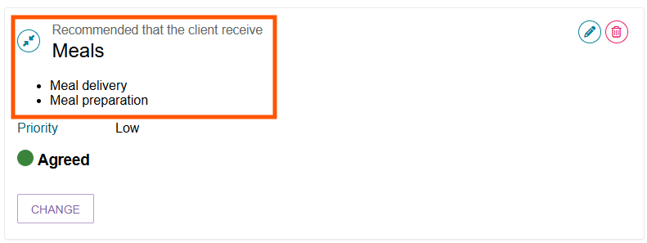
! | Reissuing CHSP referrals – Urgent services  All clients who have accessed urgent services are required to complete an assessment, and new referrals must be generated for any approved ongoing CHSP services.  - CHSP providers will continue to deliver urgent services until an assessment is completed.  - When ongoing CHSP services are approved, the urgent service referral should end.  - New CHSP referrals are required for the provider to continue delivering services on an ongoing basis.  - Where a delegate does not approve the urgent service:  - If the service has not commenced, the direct-to-provider referral will be recalled.  - If the service has commenced, the provider will be notified that the urgent service is not approved,and should cease urgent service provision.

Disagreeing with recommendations
Disagreeing with a recommendation will result in a non-approval of that recommended service.
If a recommendation is mistakenly added by the assessor, the delegate can disagree with the assessor’s recommendation, and/or add their own recommendation.
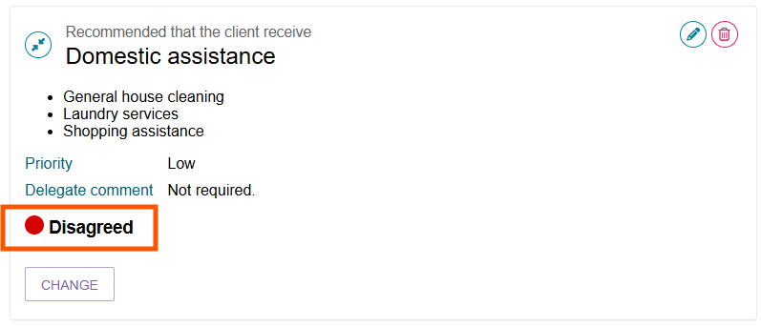

Follow the steps below to disagree with a recommendation:
- Select the expander button to show the recommended service for approval.
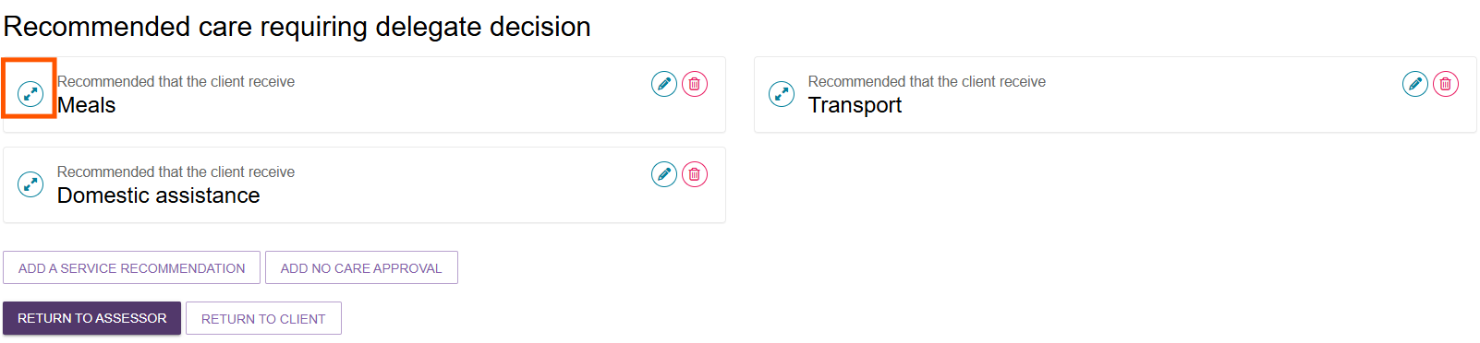
- Select DISAGREE below the recommended service. You will need to repeat this process for each service that you disagree with.
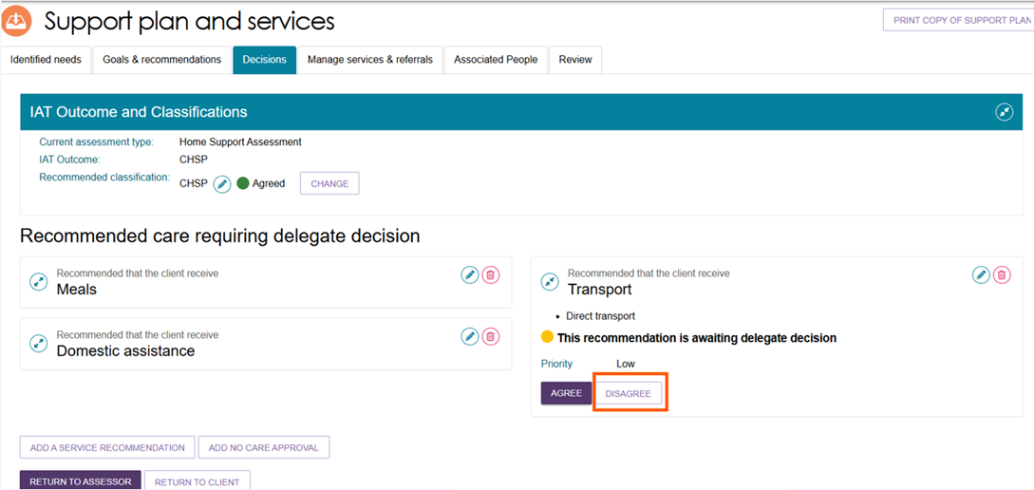
- You will need to provide a comment about your reason for disagreeing with the recommendation, then select DISAGREE.
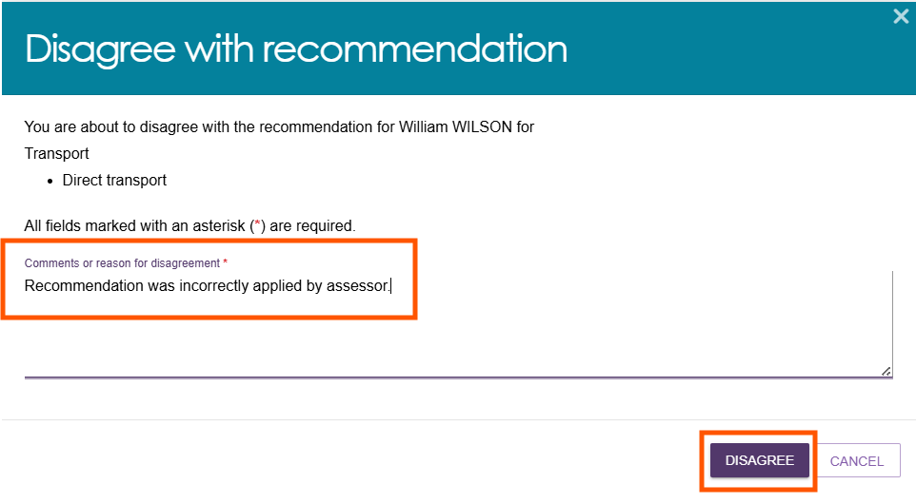

- A confirmation message will display, and the status of the recommendation will change to Disagreed.
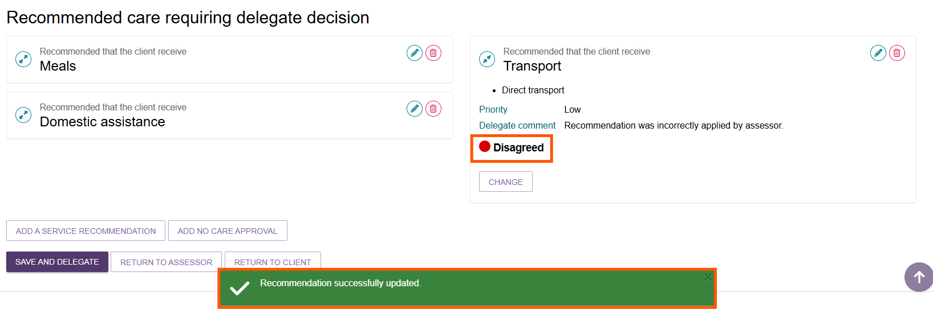
- If you need to change your decision, you can select CHANGE.
This option will only be available prior to saving and completing the approval process by selecting Save and Delegate.
Refer to the Changing a Decision section for more details.
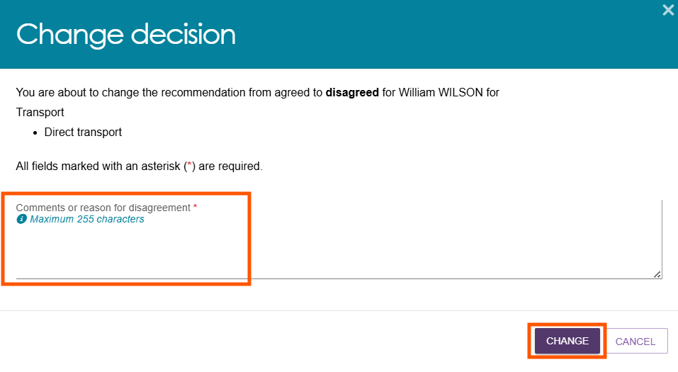

Editing a recommendation
- To edit a service recommended by an assessor, select the Edit icon to the right of the recommendation.
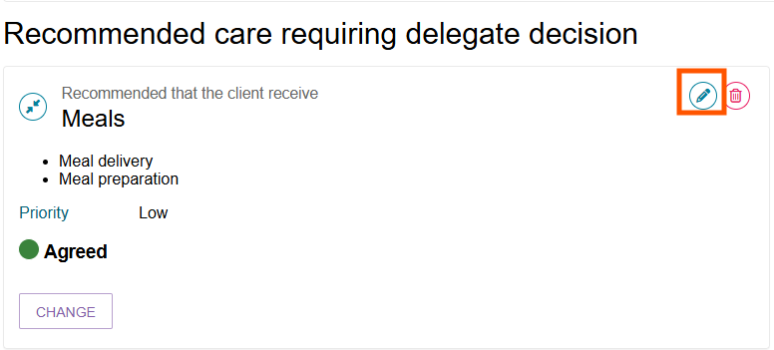
- The Edit a care type pop up will be displayed, and you will be able to make any changes required. Select SAVE TO PLAN to save the change.
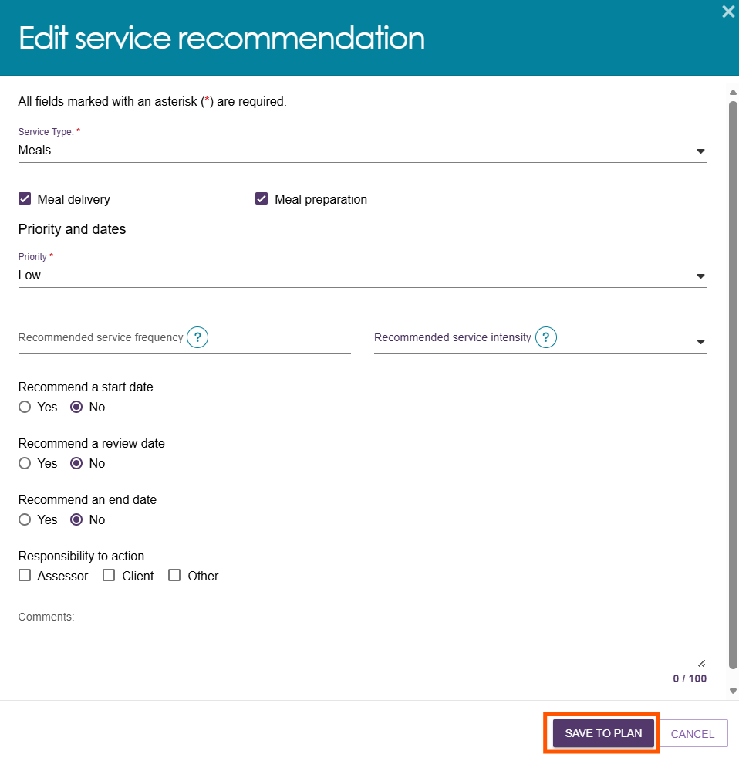

Changing a decision
- If you need to change your decision for a service from Agreed to Disagreed, or Disagreed to Agreed, you can select the CHANGE button.
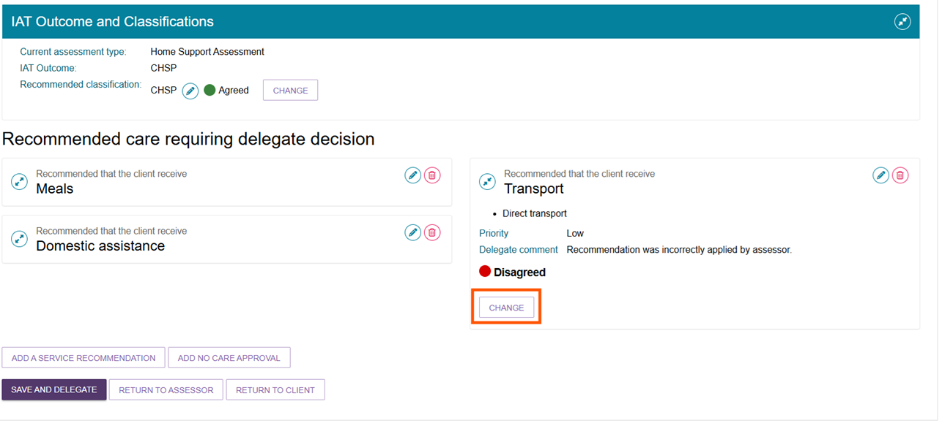
- You will be able to add approval cease dates and comments where appropriate in the pop-up.
- If you are changing the decision from Agreed to Disagreed, you will need to provide a reason for the change.
Please note, this option will only be available prior to saving and completing the approval process.
- A confirmation message will display.

Adding CHSP services by a Non-Clinical Assessment Delegate
Non-Clinical Assessment Delegates can add services for the client, if required.
- Select ADD A SERVICE RECOMMENDATION.
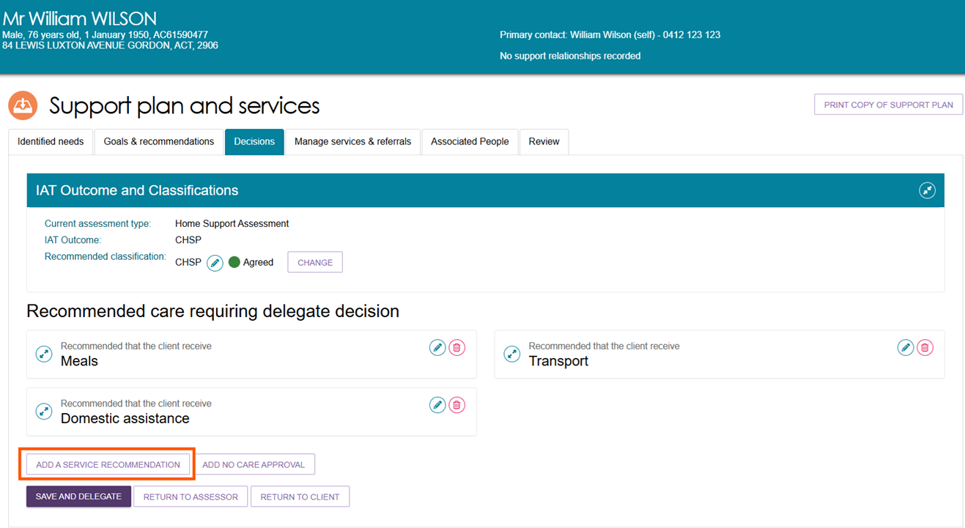
- In the pop-up box, select the service that applies from the drop-down box.
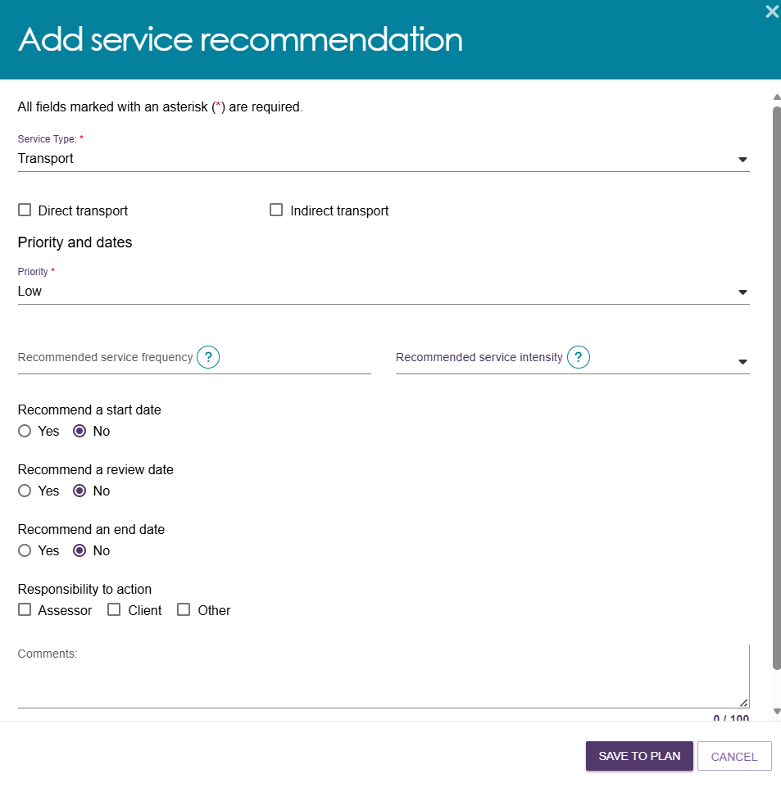

- The services will be added to the Support Plan with a default decision of Agreed.
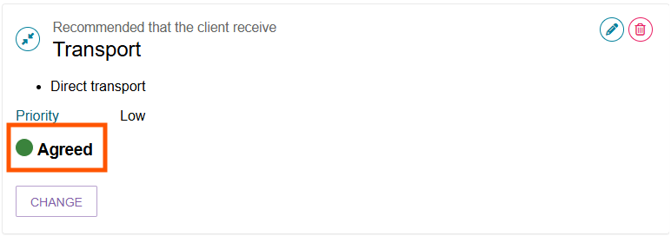

Finalising your decision
- Once the decision has been made, select SAVE AND DELEGATE.
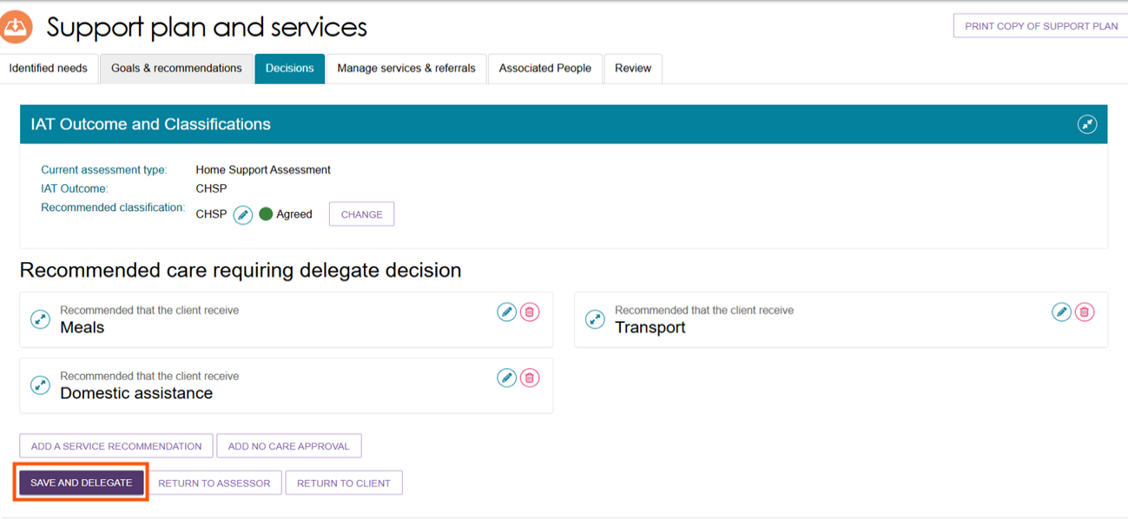
A pop-up will display, confirming the services that were agreed and not agreed. If you need to make any changes to your decision, select CANCEL. Ensure the date of the delegation is correct. For certain types of services, you can expand to see more information by using the expander button. If you are satisfied with the decision and the date, select SAVE DECISION.
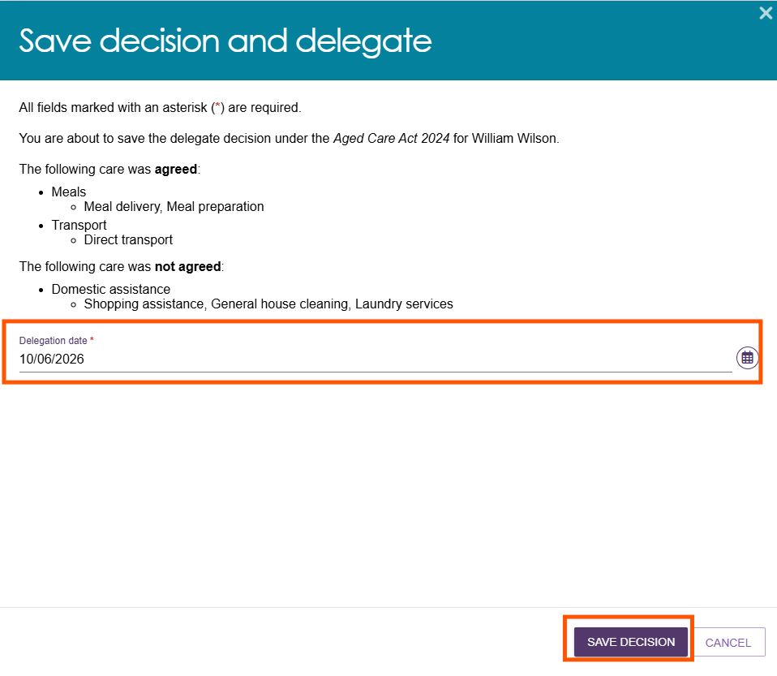
! | If the approval was actioned off-system earlier than the day that the delegation is completed via the portal, you can set the date of delegation to the earlier date as reflected on the Approval Form.  It is available for download from the Reports and Documents tile of the assessor portal. This form is evidence that you made the approval decisions prior to the date you are making the entry on the system.  You must attach the Approval Form to the Attachments tab.

Correspondence Notifications
If you have approved a Support at Home Classification or a Residential Care classification, you can request to receive notifications of any Support at Home or Residential Care correspondence received by that client from the department.
For Support at Home, this may be required in circumstances where the client is considered to be a vulnerable client that may require assistance from a clinical assessor to link to Home Support services.
Examples of Residential Care correspondence include:
- permanent residential care is allocated
- approval about to expire.
For general information about notifications and tasks in the assessor portal, please refer to My Aged Care – Assessor Portal User Guide 9 – Tasks and notifications.

- To receive notifications, go to the Approvals tab in the client record under the Current care approvals section by selecting the expand button next to the Support at Home or Residential Care classification name. You can select one person from an outlet to receive this notification.
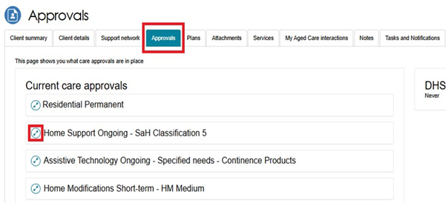
- The below screenshot shows the expanded view – Select the edit button underneath Notify of [Program] Correspondence to specify the staff member and refer to the help text for guidance.
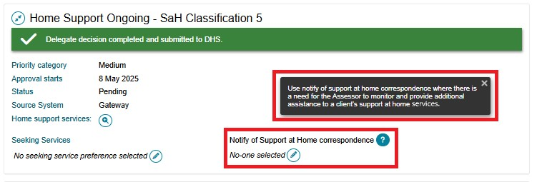
- Complete the information required and choose a Recipient from the list of staff members in the outlet. Select SAVE to return.
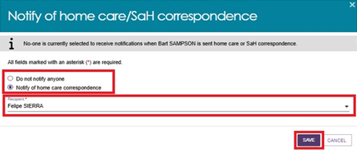
- You should be able to see your nominated Recipient of the notification on the Approvals tab.
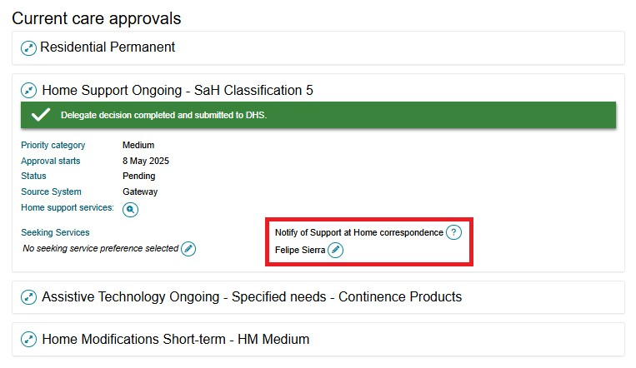
- The delegate will be able to view the client’s record under the Delegate decision complete section of their Current assessments tab.
The assessor will then need to match and refer for services and finalise the support plan.
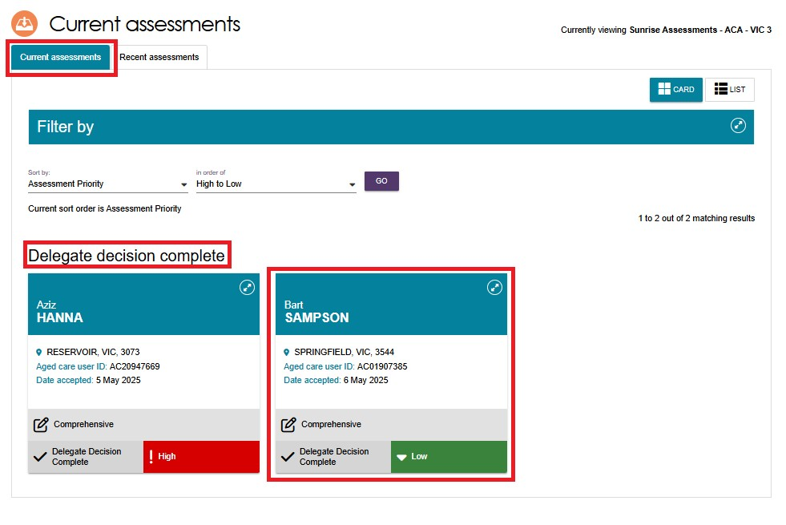

- The assessor will receive a notification in the Task and notifications page that the delegate has completed their decision, and they will be able to navigate to the client record and directly to match and refer for services from this page.
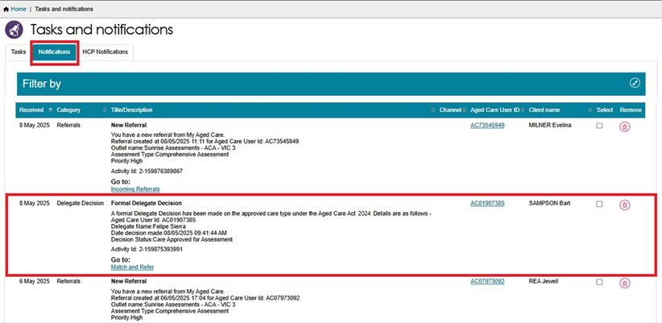

Notice of Decision (approval or non-approval) letter and SaH Restorative Care Pathway (Second Unit) approval and non-approval letter
The assessment delegate can generate and upload the Notice of Decision (NoD) letter and SaH Restorative Care Pathway (second unit) approval letter, after the delegate decision is completed. This applies to both Approval letters and non-Approval letters.
To generate, print and upload approval or non-approval letters, navigate to the client’s support plan, then the Decisions tab.
You will be able to generate and upload letters appropriate to the client’s circumstances. The buttons on the Decisions tab and the options within the pop-up will reflect the available letter types.
You can also upload NoD letters via the Attachments tab.
If you have agreed to more than one care type recommendation for the client, you only need to generate, upload and print one approval letter to send to the client. The information about all agreed care types will appear on this letter.
A person assigned the Delegate Support role will also be able to print and upload these letters.

Approval Letters
! | For approval decisions, the Notice of Decision must contain the following: :  - the approved service groups (and service types and services, where applicable)  - the approved classification type for each service group  - the approved classification levels (which can indicate the level of funding)  - the approved priority category (where applicable)  - the reasons and evidence supporting the delegate’s decision  - the older person’s rights of review, should they wish to query or dispute the decision.  This is to ensure high quality and consistency in letters that clients receive.
- Go to the Client’s profile and select the Plans tab. In the Plans page select the Support Plan button.
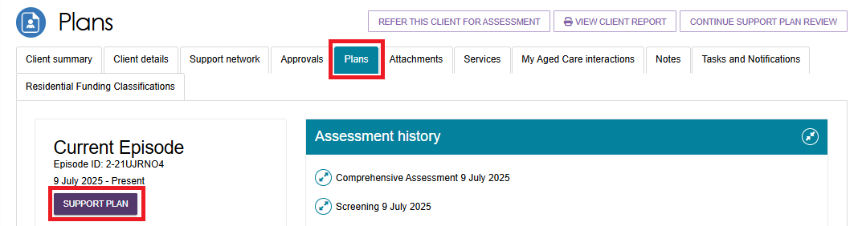

- The Support Plan and Services page appears. Select the Decisions tab. At the bottom of the page, you will be able to select GENERATE APPROVAL LETTER.
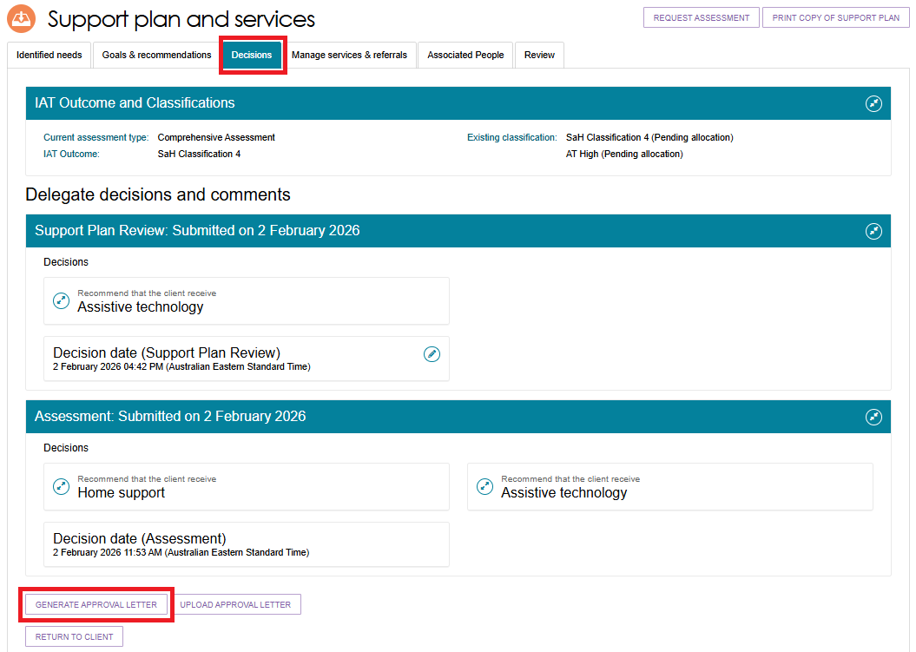
- The Generate Approval Letter pop up appears. Ensure you are generating the letter for the correct client, then select GENERATE APPROVAL LETTER.
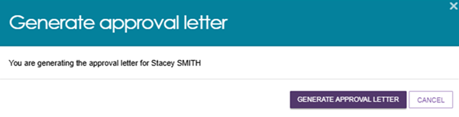
The Approval for RCP 2nd unit of funding letter can be generated via the portal the same way as the NoD Approval and Non-approval letters are generated.
The below image shows the option to select to generate the approval letter, and/or the SaH Restorative Care Pathway (Second Unit) approval letter.
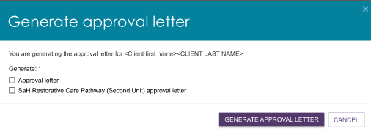

- If the Approval letter takes too long to generate, you will be re-directed to the Reports tab where you will be able to select View to open a copy of the letter. The NoD letters and Referral Code letters will be retained in Recently Requested Reports for seven days, after which they will be cleared from this screen. They can be regenerated per the original process.
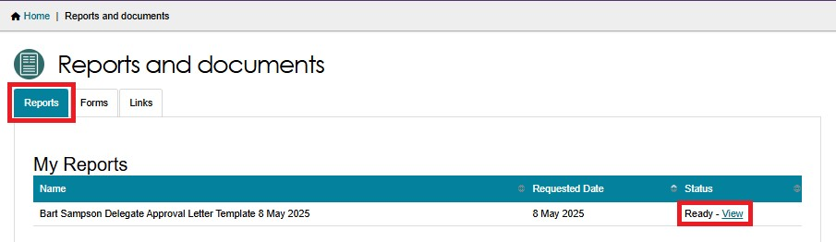
- When you have signed the letter, you can use the UPLOAD APPROVAL LETTER button in the Decisions tab of the support plan to upload the letter to the client’s record. Alternatively you can upload it via the Attachments tab.
Decisions Tab
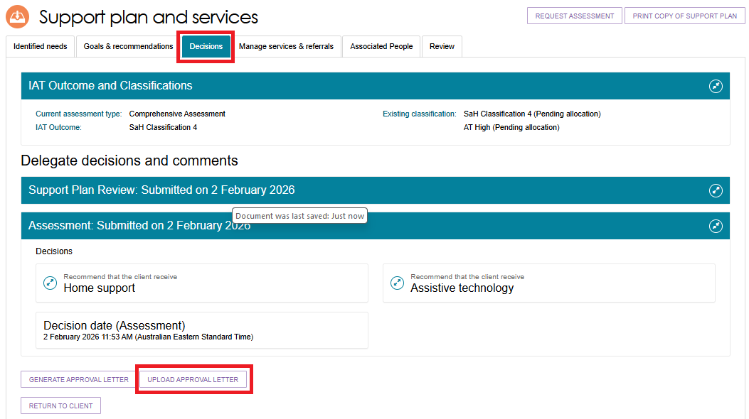
Attachments Tab
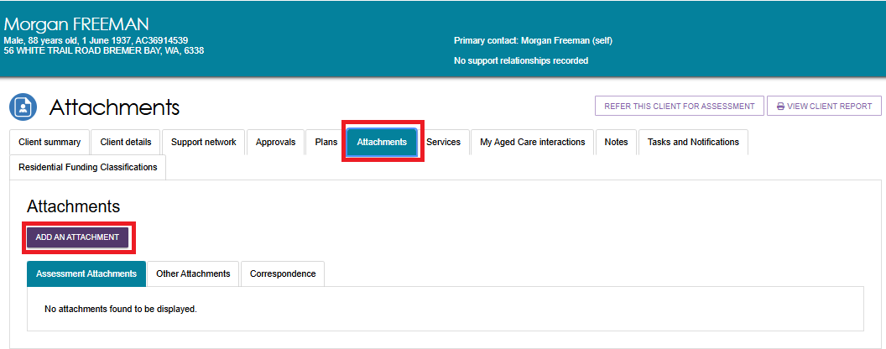
- The Upload approval letter, or the Add an Attachment pop up appears. Choose the approval letter file to upload.
NoD Letters are defaulted to the Rich Text Format (.rtf) when being generated. This format is not accepted when uploading. Approval letters must only be uploaded to the portal in PDF format. Word documents must not be uploaded as the formal approval letter. PDF ensures the document cannot be altered after finalisation.
Enter the name of the attachment. If you are attaching the letter, ensure the attachment type is Approval letter sent to client. Optionally provide a short description about the contents of the attachment. Finally, select UPLOAD.
UPLOAD APPROVAL LETTER EXAMPLE
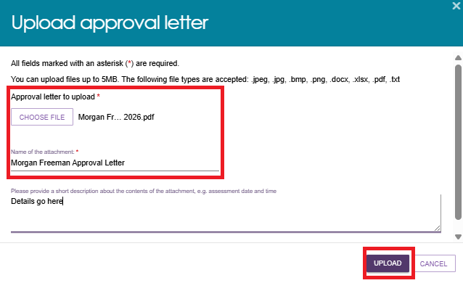
ADD AN ATTACHMENT EXAMPLE
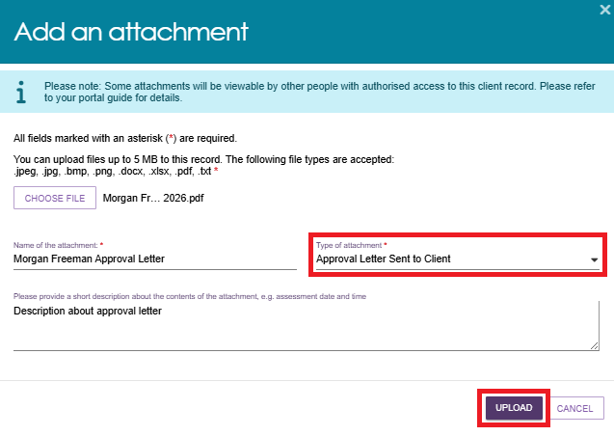

- The uploaded letter will display in the Attachments tab.
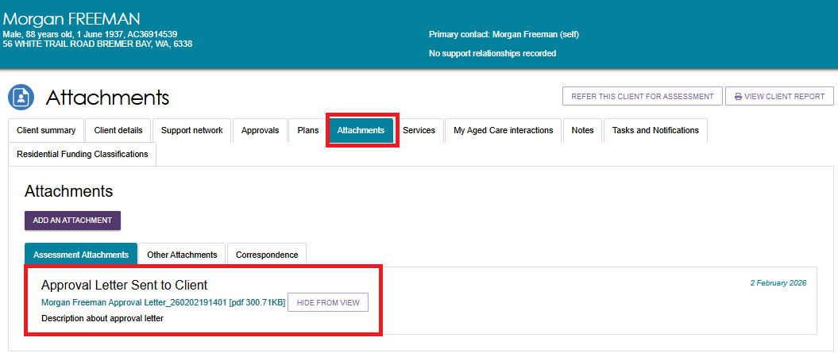

Non-approval Letters
Delegates can only generate non-approval letters when the delegate decision contains ‘No care approval’ or ‘No change to existing care approvals’.
      - Go to the Client’s profile and select the Plans tab. In the Plans page select the Support Plan button.
      - Navigate to the Decisions tab of the support plan. At the bottom of the page, you will be able to select GENERATE NON-APPROVAL LETTER.
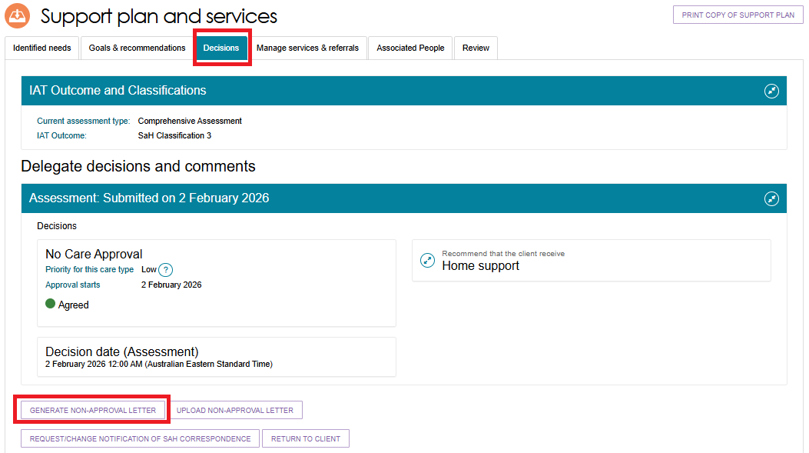

If the Non-Approval letter takes too long to generate, you will be re-directed to the Reports tab where you will be able to select View to open a copy of the letter.
Certain user generated documents, including NoD letters and Referral Code letters, will be retained in Recently Requested Reports for seven days, after which they will be cleared from this screen. They can be regenerated as per the original process.
When the 2nd concurrent unit of Restorative Care Pathway funding is not approved, the offline template needs to be used. The template is titled ‘Letter template – Second concurrent unit of RCP funding’ (or similar) in the Assessor Portal ‘Reports and documents’ under the Forms tab.
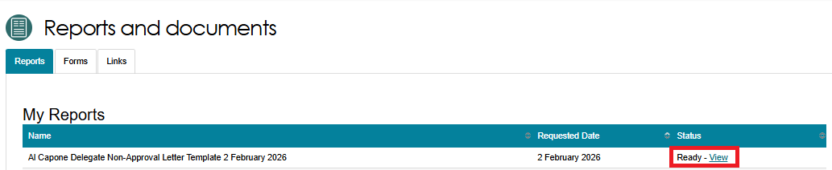
      - When you have signed the letter, you can use the UPLOAD NON-APPROVAL LETTER button in the Decisions tab of the support plan to upload the letter to the client’s record.
Alternatively, you can upload this through the Attachments tab on the client record.
Decisions tab of the Support Plan
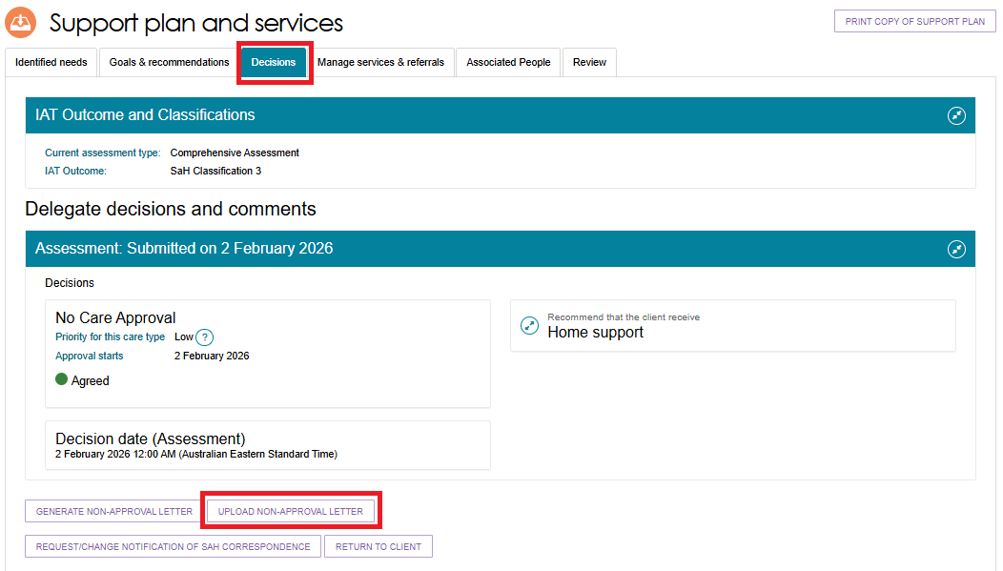
Attachments Tab of the Client Record
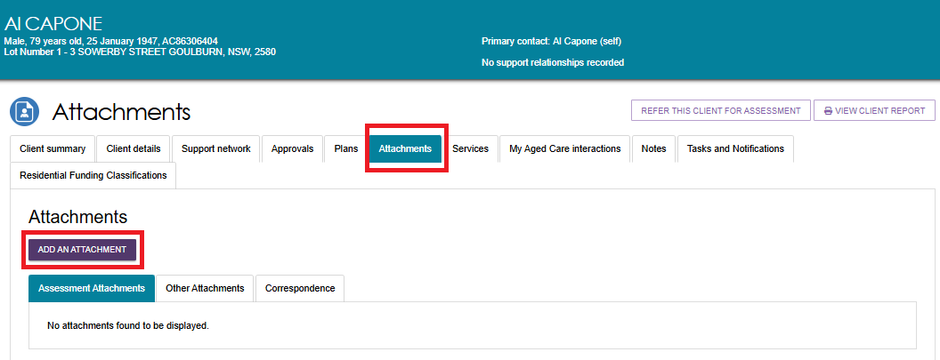

      - The Upload non-approval letter pop up, or the Add an attachment pop up appears. Choose the Non-approval letter file to upload or attach.
NoD Letters are defaulted to the Rich Text Format (.rtf) when being generated. This format is not accepted when uploading. Non approval letters must only be uploaded to the portal in PDF format. Word documents must not be uploaded as the formal non-approval letter. PDF ensures the document cannot be altered after finalisation.
Enter the name of the attachment.
If you are attaching the letter, ensure the attachment type is Non-approval letter sent to client. Optionally provide a short description about the contents of the attachment.
Finally, select UPLOAD.
Upload Non-approval letter pop up example
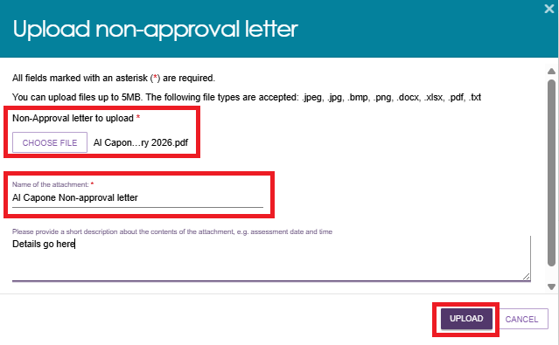
Add an attachment example
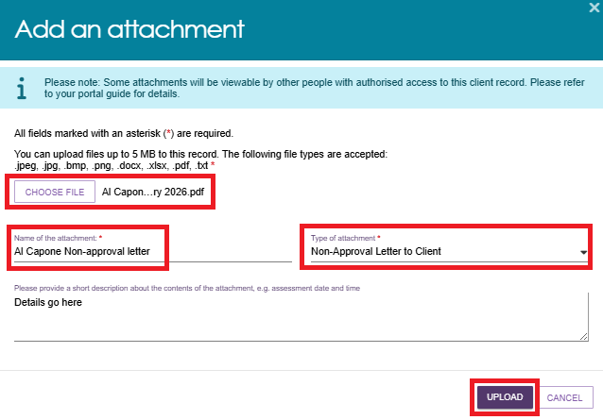
The uploaded non-approval letter will display in the Attachments tab.
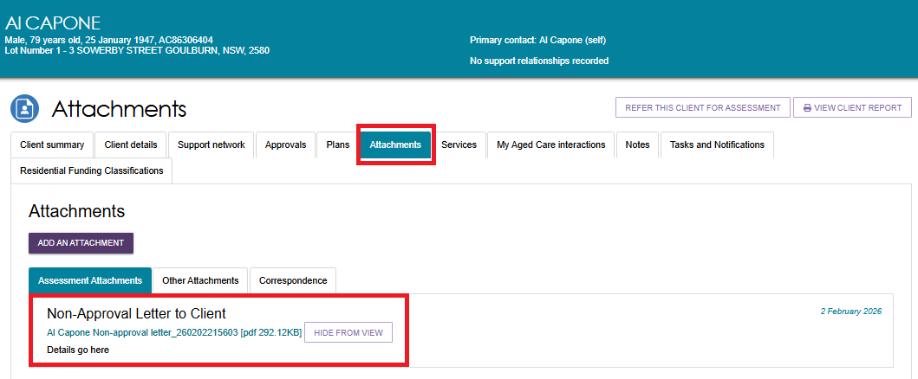

Manage service and referrals
You must ensure the completion of the Notice of Decision for a Home Support Assessment before you continue to manage services and issue referrals.
Please refer to Assessor Portal User Guide 8 - Referring for Services for further information on this process.

Requesting correction to care approval decision
A corrections process is available where you have made an error in recording a decision.
Correction requests can be submitted up to 42 days after initial delegation, where there are no active or commenced service referrals.
Follow these steps to request a correction to care approval decisions:
- In the Delegate Decisions tab of the portal, navigate to the Decision history tab.
Select the expand arrow on the client card to display a summary of the client’s information in the pop-up.
Select REQUEST CHANGES TO CARE APPROVAL DECISION.
If you are using list view, this option will be available from the expanded client information section.
Card View
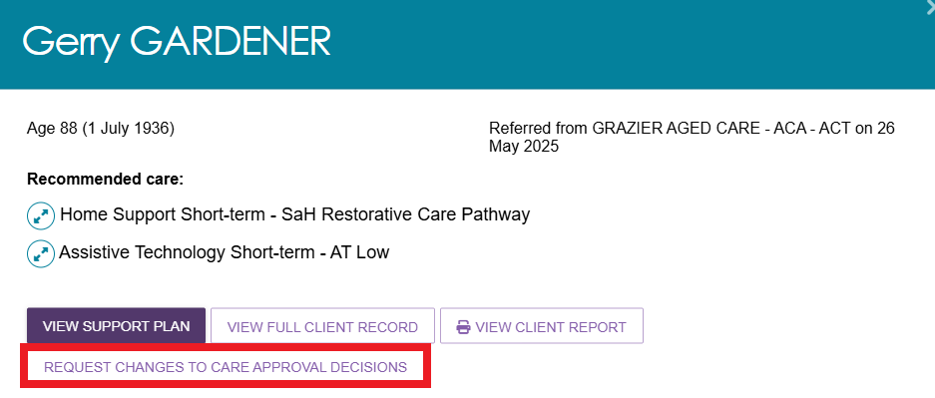
List View
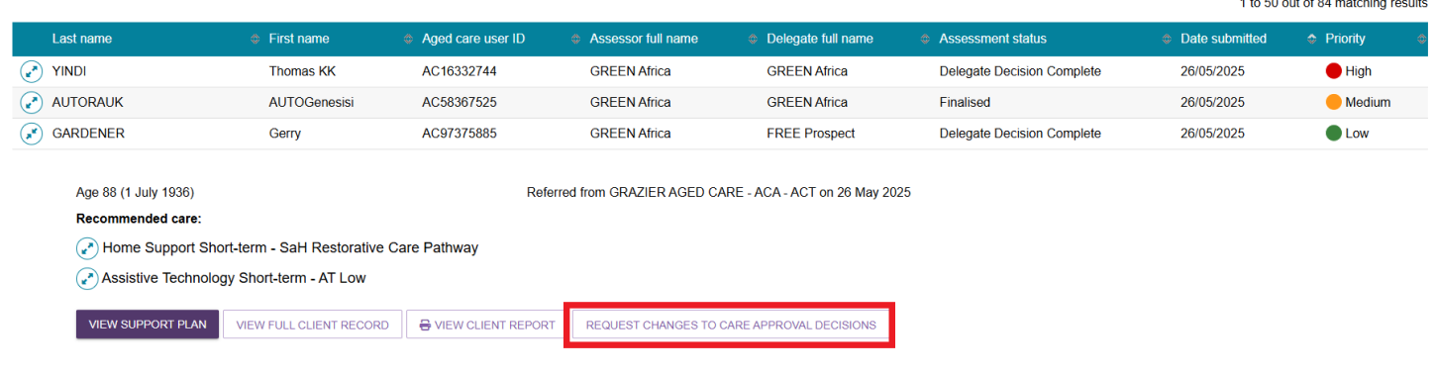
- Record a reason for the change and provide appropriate reasons for the request, then select OK, START CHANGES. Your reasons need to be consistent with the assessment information on the client record.
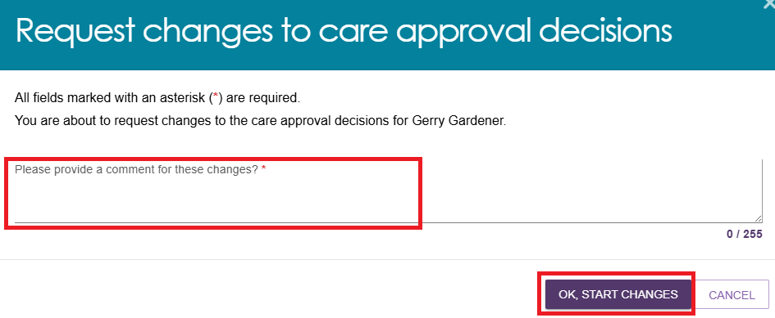
- You will be redirected to the client’s support plan and services page, where you will receive a confirmation message of your change request, and that the correction is in progress.
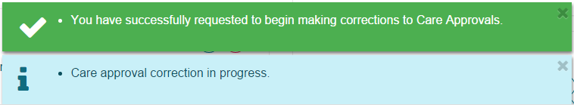
- While on the same screen, you will be able to make edits to remove and/or add care types, including:
- making changes to the commencement date of the delegate decision
- requesting the removal and addition of different care classification within a care type within the same correction request.
- You can view the client’s history of corrections by going to the Decisions History tab and then select VIEW CORRECTIONS HISTORY.
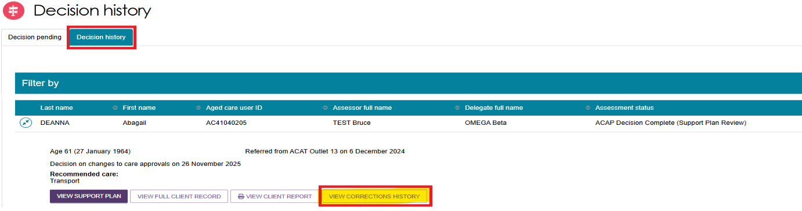

Making changes to the Decision Date of the delegate decision
The Delegate can make changes to the Decision Date (commencement date) of the delegate decision. This applies to both Comprehensive assessments and Home support assessments, and all three decision periods (Assessment, Support Period, and Support Plan Review). However, changes to Residential Permanent, Residential Respite or Transition Care cannot occur during Support Period and Support Plan Review.
If a client’s record currently contain multiple decision dates, then the Delegate can only make changes to the latest decision date.
- Before making changes to the start date of the delegate decision, the declarations must be ticked and the Offline approval form must be attached.
- Go to Delegate Decisions and Comments and select the listing to be changed, then select the Edit (pencil) button next to the Decision Date section.
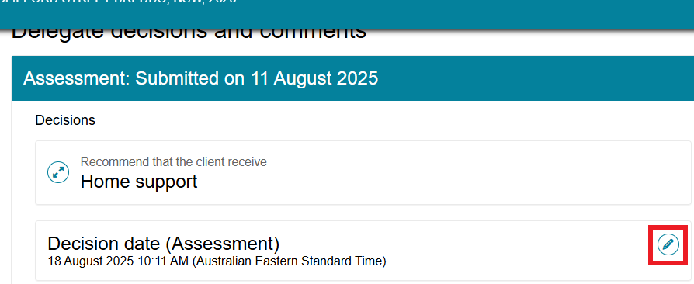
- A Pop-up screen prompting to Edit delegation date will appear. Enter all the required information. For your convenience , choose the date picker to enter the Delegation date and the Time Picker (clock) to enter the Delegation time. Select SAVE TO PLAN.
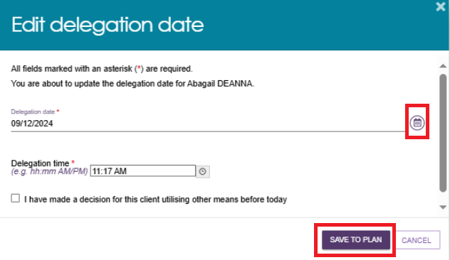

- You will notice two banners (Green and Blue) confirming the action and status.
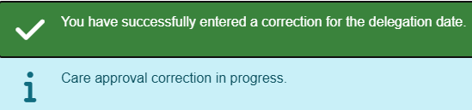
- Select SUBMIT FOR AGED CARE ASSESSMENT (ACAP) PROGRAM.
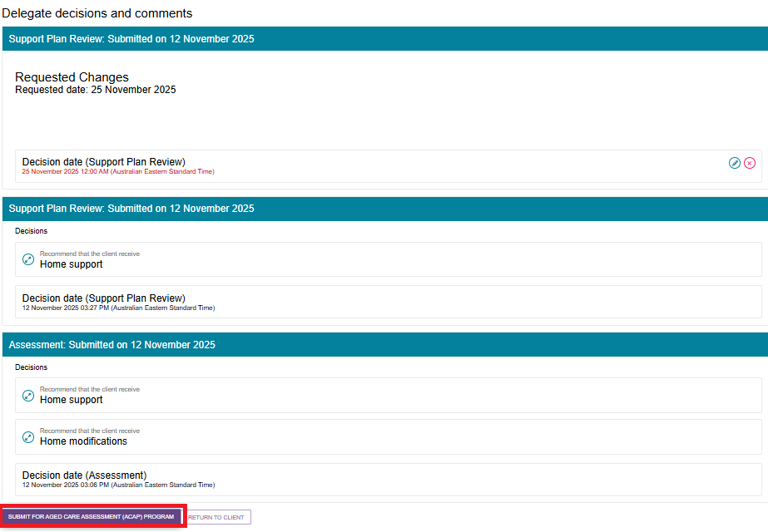

Requesting the removal and addition of different care classification within a care type within the same correction request
- To request to remove a classification or service approval that you have entered incorrectly, select the remove (bin) button next to the decision.
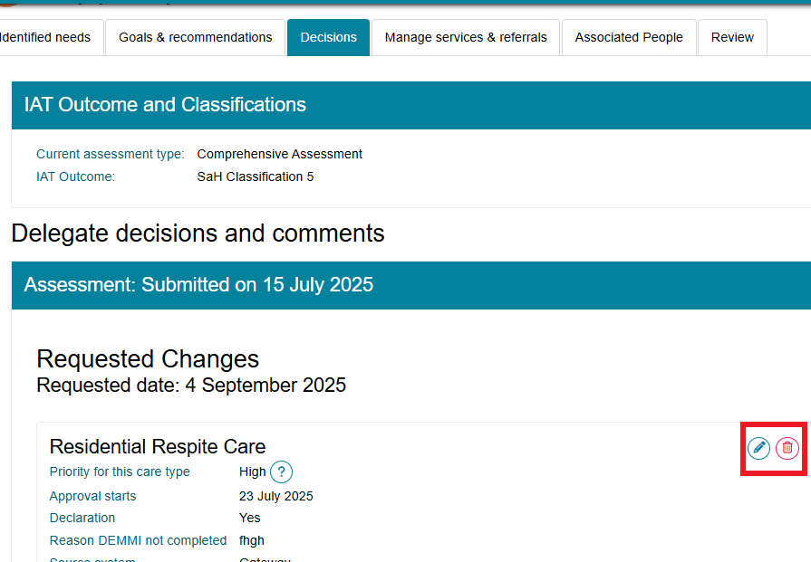
- A pop-up will display. Confirm your request to remove the incorrect record by selecting REMOVE RECOMMENDATION.
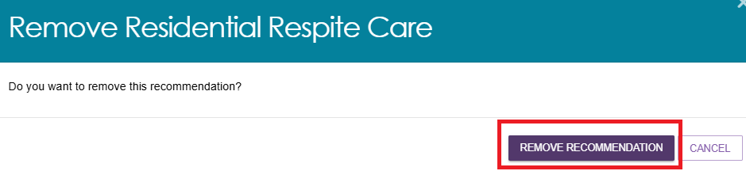
- A green banner will then display to confirm that the care approval has been successfully removed.
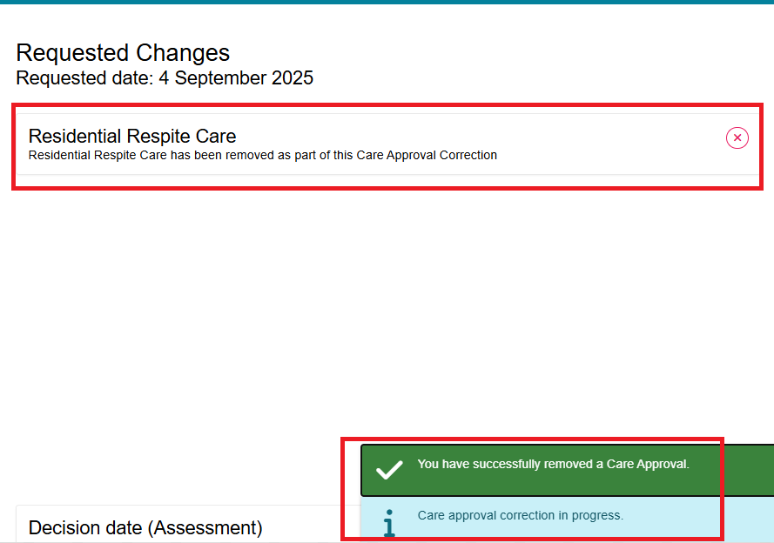
- To then add the correct program or service approval as intended by the clinical assessor and the Clinical Assessment Delegate, select ADD A CARE TYPE FOR DELEGATE DECISION.
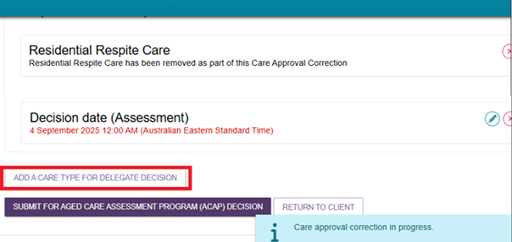

- In the pop-up, add the care type, including the correct service level and priority for the Clinical Assessment Delegate decision. Once you have successfully completed the required fields (marked by an red asterisk *) select SAVE TO PLAN.
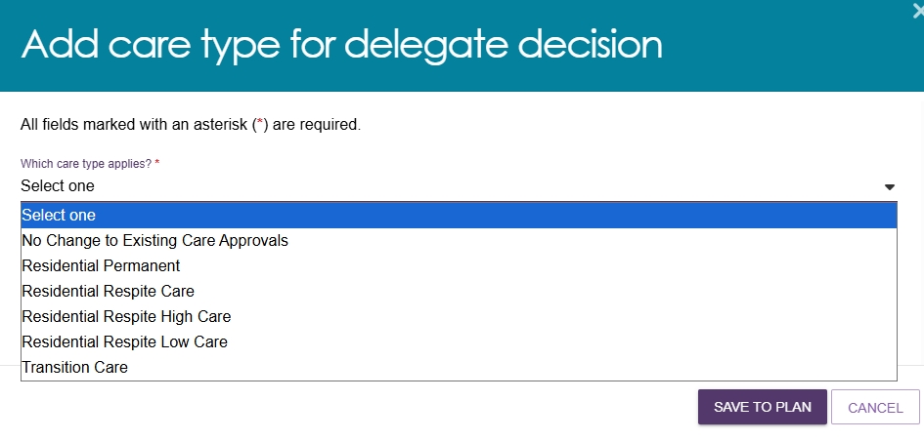
- After successfully saving the changes to the approval, a blue banner will apply outlining that the care approval correction is in progress.
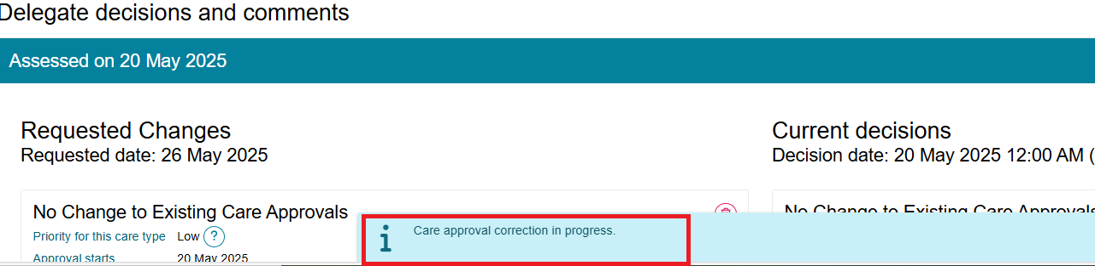
- If you had to exit the correction screen before submitting for decision, you can navigate back to the DECISION HISTORY tab under Delegate Decisions and select the client.
The client will have an UPDATE PENDING status.
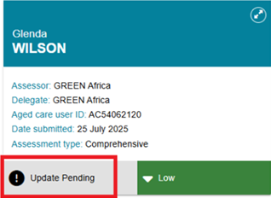

- Select CONTINUE MAKING CHANGES TO CARE APPROVAL DECISIONS button in the expanded client card on the Decision History page.
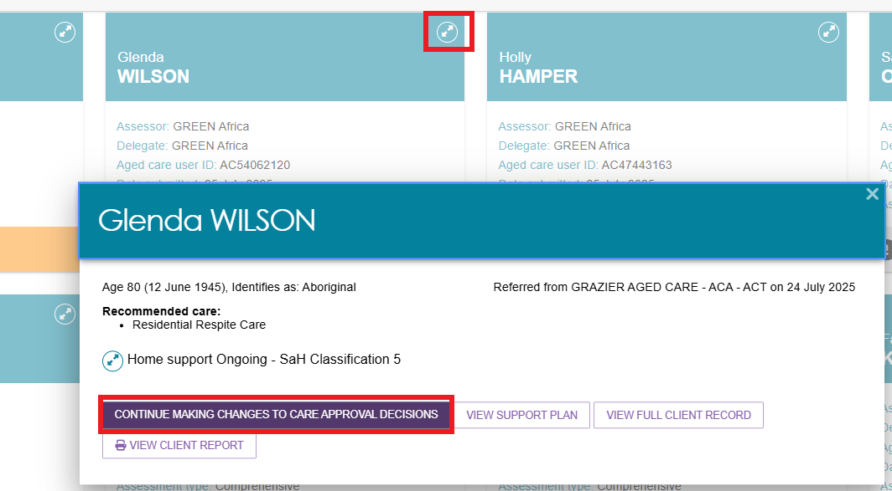
- You will be able to see the requested changes displayed. When you have made the required changes to the care approval decisions, select SUBMIT FOR AGED CARE ASSESSMENT PROGRAM (ACAP) DECISION.
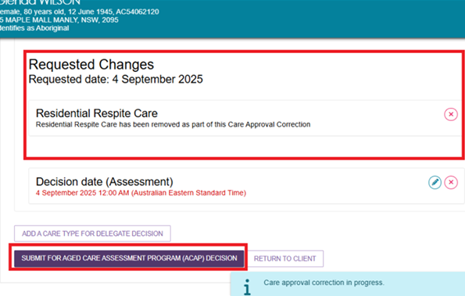
A pop-up message will display requesting confirmation to proceed. Select SUBMIT.
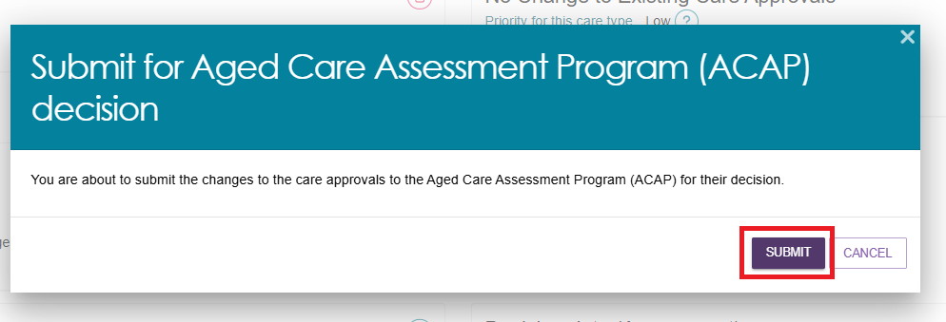
- You will receive a confirmation message that the correction of the request will be received by the Department’s Aged Care Assessment Program (ACAP) delegate.
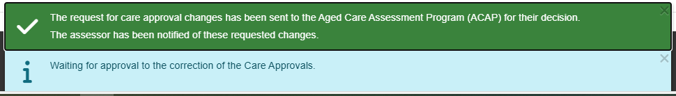
- The client will be displayed in the Decision history tab with a status of ACCEPTANCE PENDING.
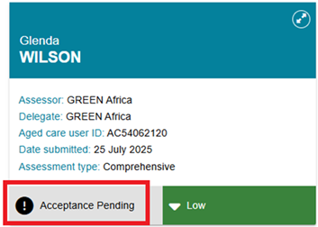
- Once the AGED CARE ASSESSMENT PROGRAM (ACAP) decision has been actioned and finalised by the delegate (in staff portal), the status will be updated accordingly.
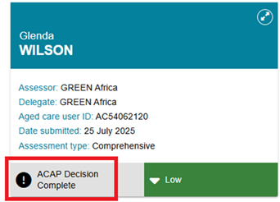

- There will also be a notification advising of the decision in your Tasks and notifications page. You will be able to filter by last name, first name and Aged Care User ID as well as use Advanced Search functionality to help you find notifications for certain clients.
The notification itself will contain links back to the client record and the correction request. It will also allow you to remove the notification from the page.
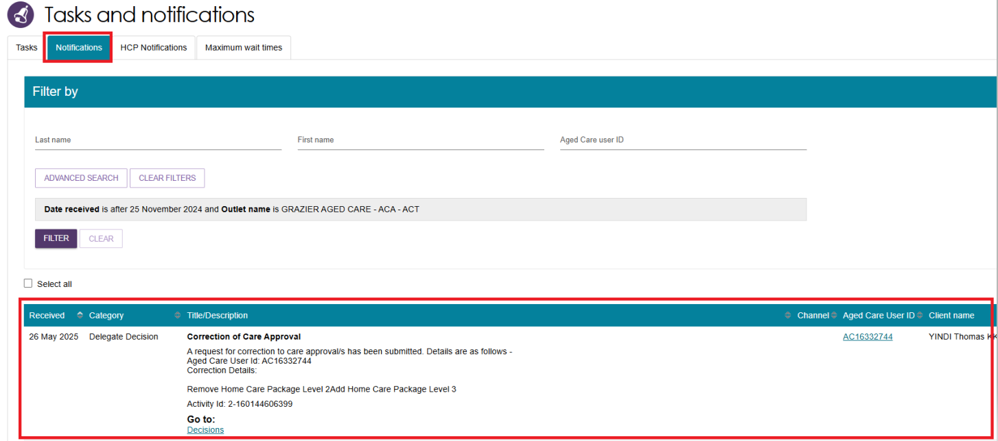
- Once the Clinical Assessment Delegate has made their decision on the correction, you will receive another notification advising that the correction has been completed.
- You will also be able to see the assessment status reflect this when it changes to ACAP Decision Complete in your Decision history tab. Additional information regarding the correction decision will be visible by selecting the expand arrow, including the date and details of the correction.
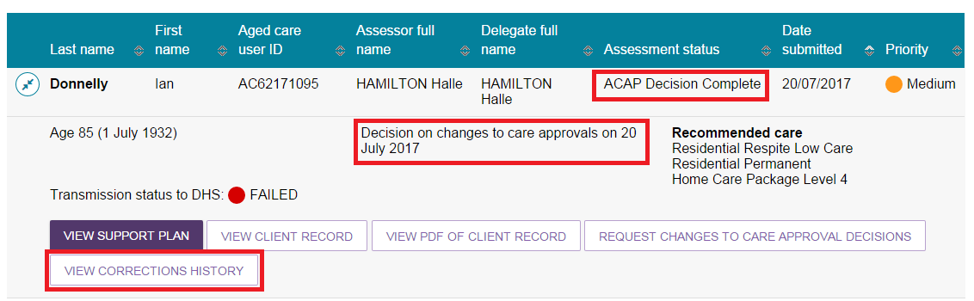
- A record of the corrections history for the client can be viewed by selecting VIEW CORRECTIONS HISTORY.
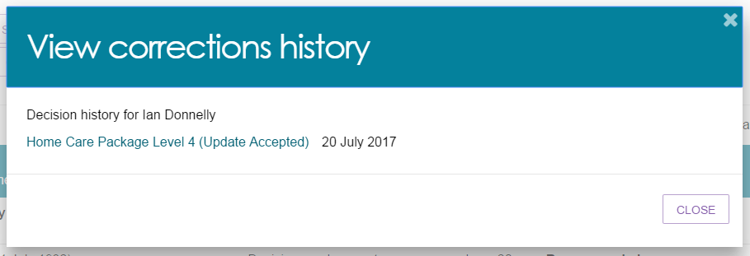

Requesting and Approving Care Extensions
Care extensions can be requested by clinical assessors or service providers as follows:
- For Residential Respite Care and Transition Care approvals, service providers can request care extensions on behalf of the client through the My Aged Care Services and Support Portal.
- For Residential Respite Care, clinical assessors can also generate a care extension for a person living in the community who requires additional respite through the assessor portal.
In cases where a client has a valid Residential Respite Care approval and requires additional Residential Respite days but is currently living at home and not currently receiving residential aged care services, a service provider will not be able to request an extension on behalf of the client. The Clinical Assessment Delegate will instead be able to initiate the care extension on behalf of the client.
If you are unable to complete a care extension request for a client via the assessor portal, you should call the Aged Care Service Provider and assessor Helpline on 1800 836 799.
To make a decision about care extensions, follow the steps below.
- The extension request will appear in the Decision pending tab under unassigned. It will have a status of Acceptance Pending. Open the client’s card in card or list view by selecting the Expand icon.
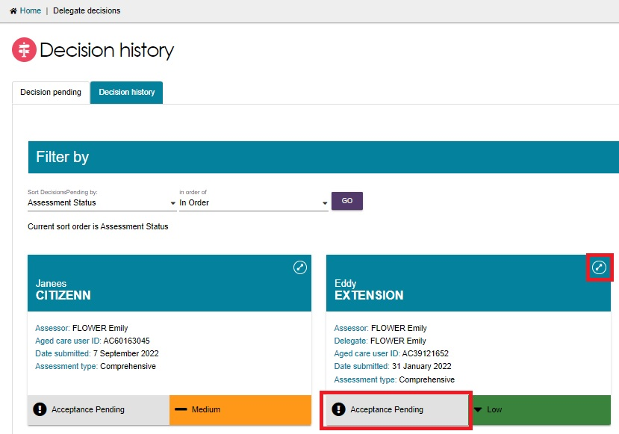
Assign the client to yourself if not already done, then the client will now appear under My Decisions. Select START DECISION PROCESS.
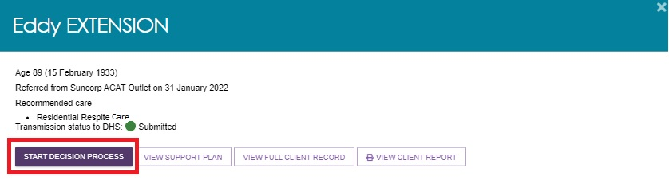
- You will see the care extension request. Review the information and select MAKE EXTENSION DECISION.
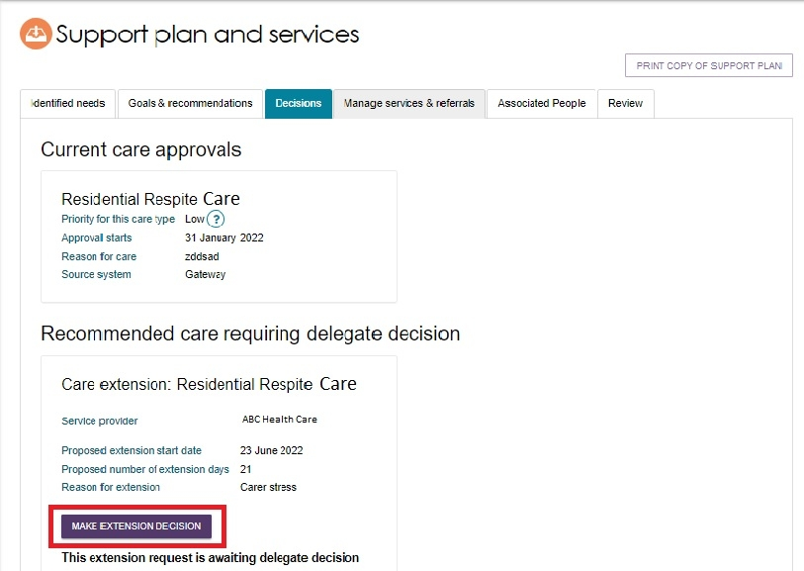
In the pop-up, select Yes or No with regards to granting the extension, and fill out the other fields.
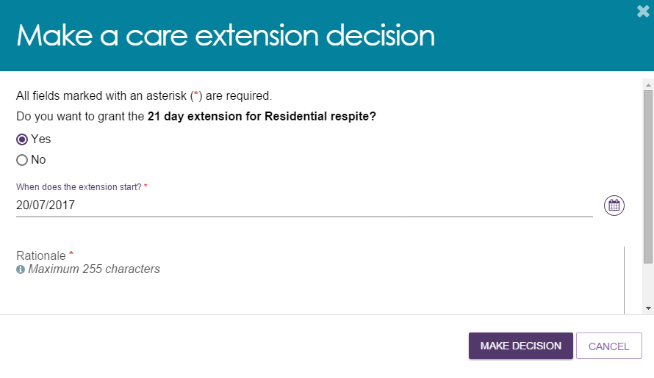

- A notification will be displayed, and the extension request will show with a status of Granted or Not Granted.
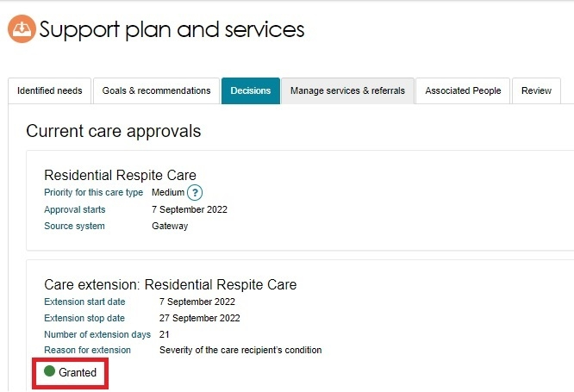
- If the service provider requested the extension, they will receive a notification advising them of the decision in their Tasks and Notifications in the Services and Support Portal.
