My Aged Care Assessor Portal – Organisation Administrator User Guide
Table of contents
1. Background and Overview of the Assessor Portal 2
1.1 Purpose of the Guide 2
1.2 Privacy Requirements 2
1.3 Introduction to Using the Assessor Portal 3
1.4 How and when to direct people to My Aged Care 4
2. Assessor Portal Access 4
3. Assessment Organisation Configuration in the Assessor Portal 4
3.1 Overview 4
3.2 Activating Outlets 6
3.3 Staff Roles 7
3.4 Homepage Views by Role Type 7
3.4.1 Administrator Homepage 8
3.4.2 Team Leader Homepage 8
3.4.3 Needs assessor Homepage 9
3.4.4 Triage Delegate Homepage 10
3.4.5 Assessment Delegate Homepage 10
3.4.6 Assessment Delegate Support Homepage 11
3.4.7 Residential Funding Assessor Functions 12
3.4.8 Residential Funding Team Lead Functions 13
4. Key Functions by Role Type 13
4.1 Creating New Staff Accounts and Assigning Roles 16
4.2 Deactivate a Staff Account 19
4.3 Removing and reactivating a Staff Account 20
4.4 Edit a Staff Account 22
4.5 Find A Service Provider 24
4.6 End of Month (EOM) Reporting 26

Background and Overview of the Assessor Portal

Purpose of the Guide
The My Aged Care Organisation Administrator User Guide outlines how assessment organisation administrators as part of the Single Assessment System interact with the My Aged Care assessor portal (the assessor portal).
The Administrator User Guide is for assessment organisations that conduct aged care needs assessments and/or residential aged care funding assessments.
The Administrator User Guide provides an overview of the portal and describes the functions that an individual with the Administrator role in the assessor portal can perform. This includes:
- Managing outlet information
- Creating and maintaining staff accounts
- Requesting changes to contractual information.
The Administrator User Guide does not cover:
- Detailed instructions on how to set up organisations in the Relationship Authorisation Manager, which can be found on the RAM website.
- Detailed instructions on functions that an individual with the Team Leader, Assessor, Delegate or Delegate support role in the assessor portal can perform, which can be found on the Department of Health, Disability and Ageing’s My Aged Care - Assessor Portal Resources webpage.
- For detailed instructions on functions that residential funding assessors perform, refer to the dedicated Aged Care Assessor Application User Guide.

Privacy Requirements
Assessment organisations are required to comply with the legislative requirements under the Privacy Act 1988 (Privacy Act), including the Australian Privacy Principles (APPs) when handling personal information in the assessor portal.
The Privacy Act regulates the handling of personal information about individuals, including the collection, use, storage and disclosure of personal information, and access to and correction of that information.
Aged care needs assessors are also required to comply with Section 534 of the Aged Care Act 2024 (Aged Care Act) when using the assessor portal.

Introduction to Using the Assessor Portal
The assessor portal is used to:
- Create and manage staff records
- Activating the Aged Care Assessor App
- Manage referrals for assessments issued by the My Aged Care contact centre, Aged Care Specialist Officers, through the My Aged Care website or via the General Practitioner (GP) e-Referral form
- Create, access and update client records, including setting up supporters and others in the client’s support network
- Conduct Triage and assessments using the Integrated Assessment Tool (IAT)
- Develop client support plans
- Support Delegation processes (after home support and comprehensive assessments)
- Refer clients for aged care services or further assessment
- View the progress of Residential Aged Care (RAC) Funding Assessments
- Access forms and reports
- View and manage tasks and notifications, including from other My Aged Care portals
- Find a Service Provider and view their information.
Assessment organisations can also use the offline Aged Care Assessor App or a printed version of the IAT to support aged care needs assessments conducted in circumstances where the assessor does not have access to the internet.
For further information about the Aged Care Assessor App please refer to the Aged Care Assessor Application User Guide.
The printed version of the IAT can be downloaded from the Reports and documents tab in the assessor portal.
! | myID is the primary login option for assessors to securely access and use the assessor portal.  To access the assessor portal, staff must have an individual myID and be authorised to act on behalf of their organisation through the Relationship Authorisation Manager (RAM) service.  VANguard Federated Authentication Service (VANguard FAS) is an alternative login option for organisations with corporate network structure that includes a Single Sign On System (e.g. Active Directory Federation Service).  For more information regarding accessing the assessor portal please visit Logging in to the Aged Care Systems.

How and when to direct people to My Aged Care
To access government funded aged care services, a person must have a client record on the My Aged Care system. Clients can create their own My Aged Care record. The My Aged Care contact centre, Aged Care Specialist Officers (ACSOs) and assessors can help create client records for people seeking aged care services.
Aged care needs assessors (needs assessors) and RAC funding assessors can register clients in My Aged Care if approached and the client does not have a client record.
Assessment organisations cannot receive assessment referrals for a client not registered in My Aged Care. This could occur in a variety of circumstances. For example, a needs assessor is in a client’s home undertaking an assessment, and they determine that their partner, who is not registered with My Aged Care, also requires an assessment.
Needs assessors and RAC funding assessors can register and self-refer clients for assessment in the assessor portal.
These processes are described in My Aged Care – Assessor Portal User Guide 1 – Registering and referring clients for assessments.

Assessor Portal Access
To access the assessor portal, each staff member must have a My Aged Care portal user account linked to a supported third-party authentication service.
For more information regarding setting up users and logging into the system please refer to Logging in to the Aged Care Systems.

Assessment Organisation Configuration in the Assessor Portal
People with the Organisation Administrator role in the assessor portal are responsible for ensuring that the information about the assessment services their organisation delivers is accurate.

Overview
! | The department will create and manage outlets on behalf of Assessment Organisations.  It is recommended that you contact the department for any changes to your assessment organisation structure.
Multiple Aged Care Planning Regions (ACPR) make up a designated Service Area.
For example, if an organisation operates in Service Area - NSW 1 - they will be responsible for three outlets (Northern Sydney, Western Sydney and Inner West) reflecting the three ACPRs that are in the NSW 1 make up the relevant Service Area.
Following are the examples of an organisation structure in My Aged Care.
Example 1: If an organisation called ABC Ltd. providing Aged Care needs assessment (Home Support Assessment & Comprehensive Assessment) operates in the Service Area - NSW 1 - they will have three outlets (Northern Sydney, Western Sydney and Inner West) reflecting the ACPRs (Aged Care Planning Regions) that make up that Service Area as depicted in the image on the following page.
An organisation with three outlets
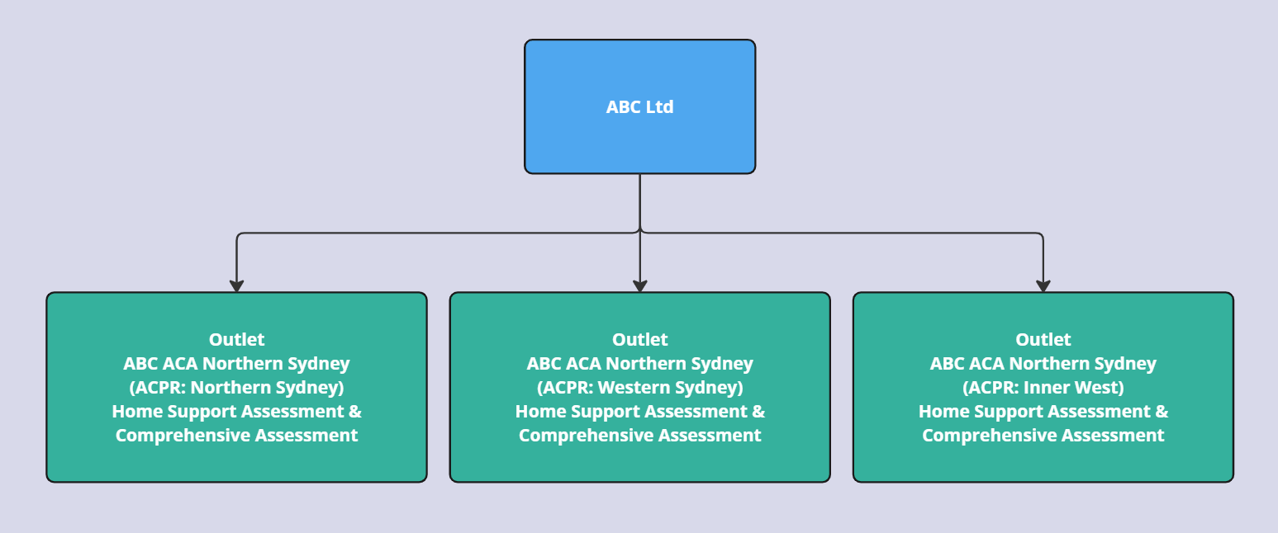
Example 2: If an organisation called ABC Ltd. providing Aged Care needs assessment (Home Support Assessment & Comprehensive Assessment) and Residential aged care funding assessment operates in the Service Area - VIC 4 - they will have four outlets with two outlets for Aged Care needs assessment (Home Support Assessment & Comprehensive Assessment) and two outlets for Residential aged care assessment services (Hume and Gippsland) reflecting the ACPRs (Aged Care Planning Regions) that make up that Service Area as depicted in the image below.
An organisation with 2 Aged Care needs assessment outlets and 2 Residential aged care assessment outlets
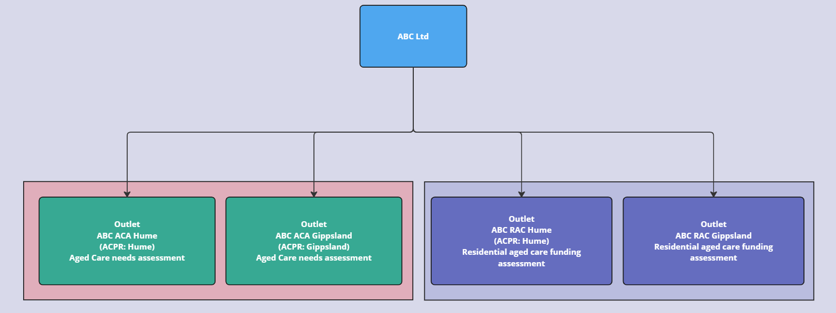
Outlet name: The department will establish consistent naming for the outlets. The organisation administrator should not change the outlet names.
One Outlet per ACPR with assessment services for aged care needs assessments (ACA) i.e. (home support and comprehensive assessments): “Organisation name - ACA - ACPR region”.
One Outlet per ACPR with assessment services for Residential aged care funding Assessments (RAC): “Organisation name - RAC - ACPR region”.

Activating Outlets
Follow these steps to activate an outlet:
- From the homepage, select Organisation administration.
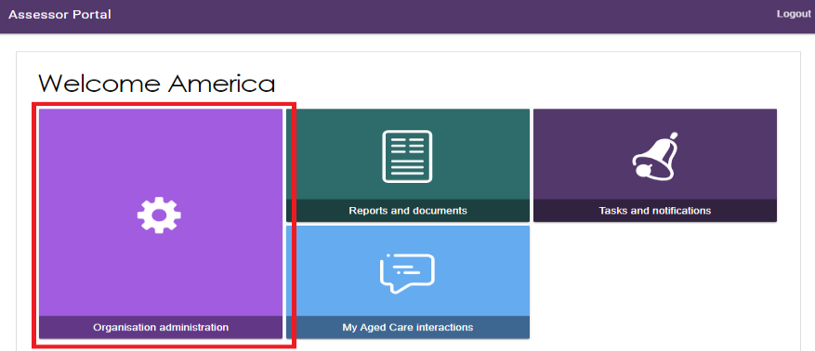
- Your inactive outlet is displayed. To activate an outlet, select the name of the outlet on the Outlet card.
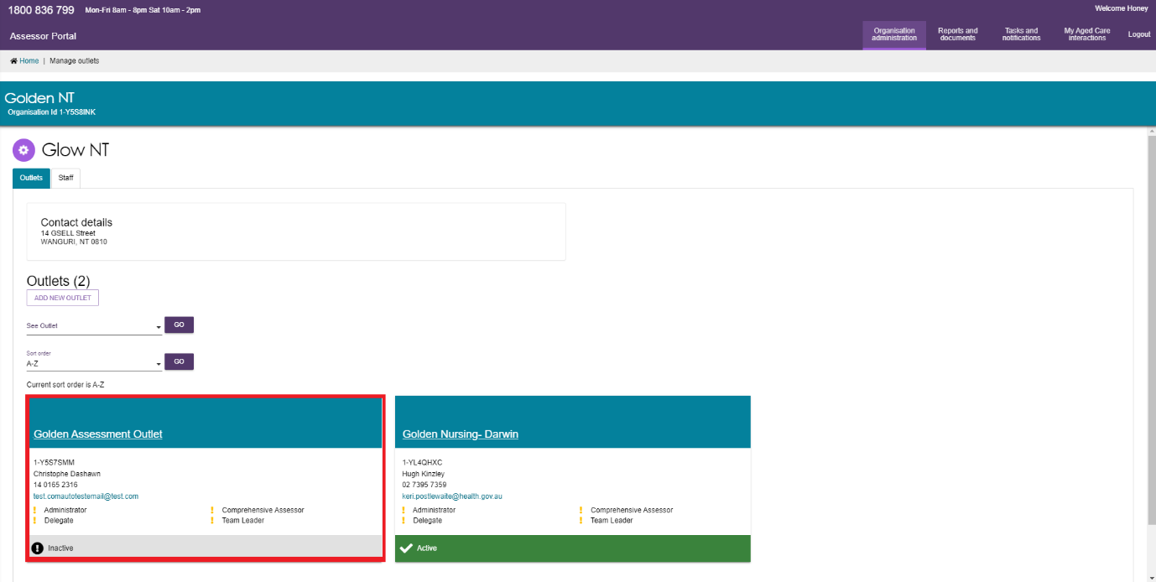
- Select ACTIVATE OUTLET and then again at the warning pop-up.
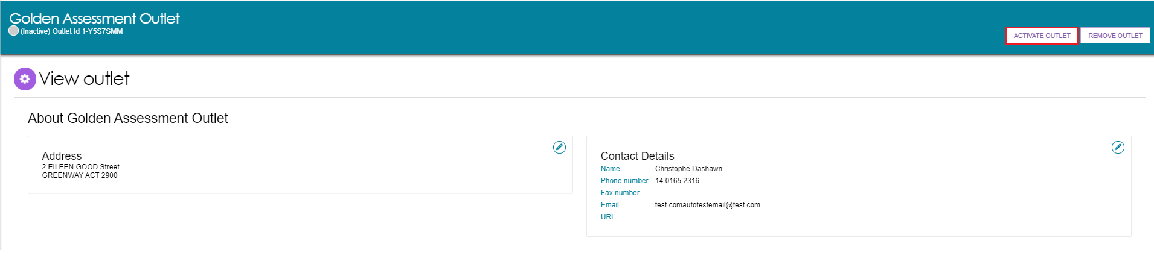
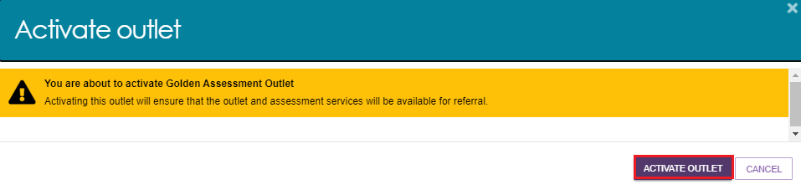
Your outlet is now active. This can be seen on the View outlet page, and the Outlet administration page. Your information will be displayed in the service finders on the My Aged Care website and contact centre staff can send referrals for assessment.
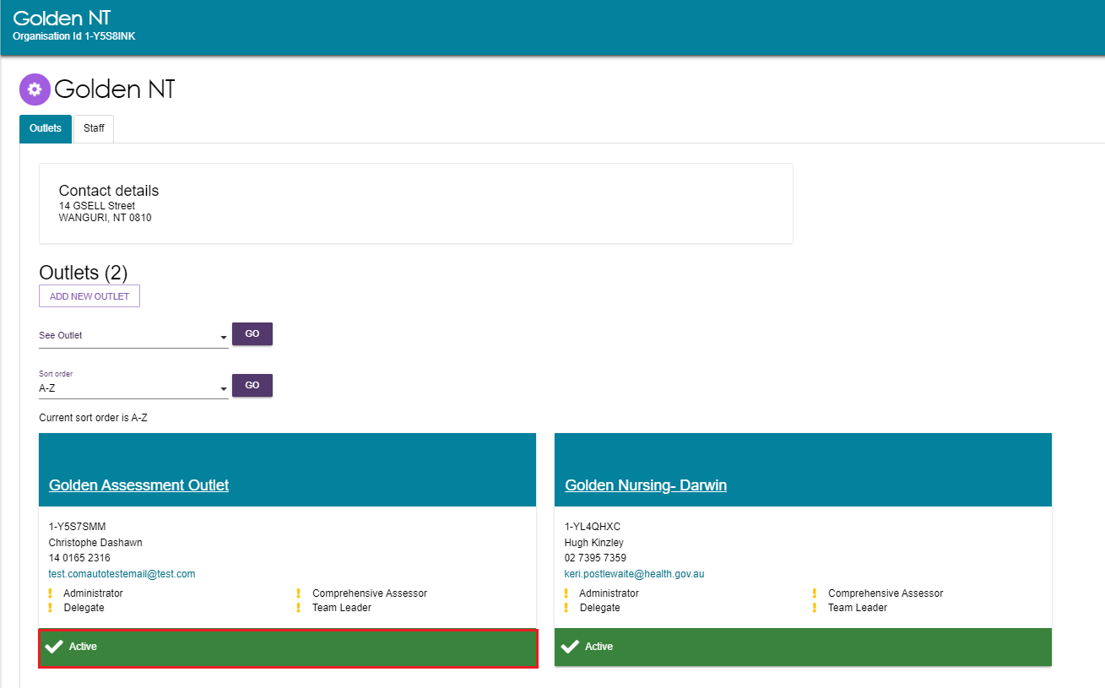

Staff Roles
Refer to section Nominating An Organisation Administrator in Aged Care Systems in the Logging in to Aged Care Systems guide for more details.
The organisation administrator will be responsible for assigning roles to other staff. This can include assigning other staff the administrator role to help set up and maintain information about your organisation in the assessor portal.
Roles should be assigned in accordance with the duties the person performs within your organisation, and with completion of all required training.
! | If you are assigned more than one role, this access will apply across all outlets you have been granted access to in the assessor portal.

Homepage Views by Role Type
The options displayed on the assessor portal homepage vary depending on your role(s).
If you are assigned more than one role in the assessor portal, you will see the functions for all the roles you are assigned on your homepage.

Administrator Homepage
People assigned an Administrator role at an organisation level can view and manage information for the entire organisation in the portal.
People assigned an Administrator role for one or more outlet(s) in the organisation will only be able to view and manage information for the outlet(s) they have been assigned.
If you log in to the assessor portal as an Administrator, you will see the following tiles on your homepage:
- Organisation administration
- Reports and documents
- Find a service provider (will not display for residential funding assessment organisations)
- Find a client (will not display for residential funding assessment organisations)
- Tasks and notifications
- My Aged Care interactions.
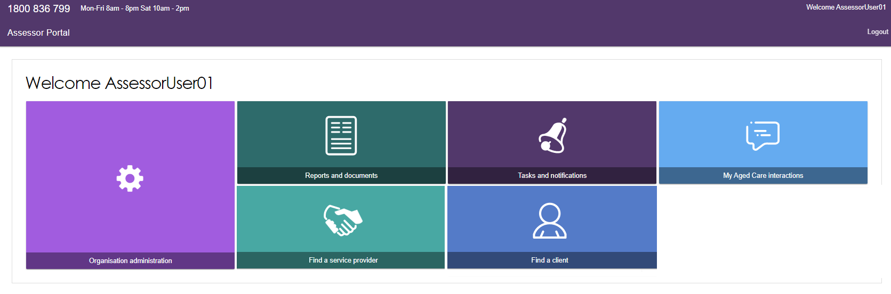

Team Leader Homepage
People assigned the Team Leader role in the assessor portal are responsible for managing referrals for assessment(s) and assigning assessment reviews.
If you log in to the assessor portal as a Team Leader, you will see the following tiles on your homepage:
- My Dashboard
- Find a client
- Assessment referrals including Residential Funding Referrals
- Review Requests
- Organisation administration
- Find a service provider
- Reports and documents
- Tasks and notifications
- My Aged Care interactions.
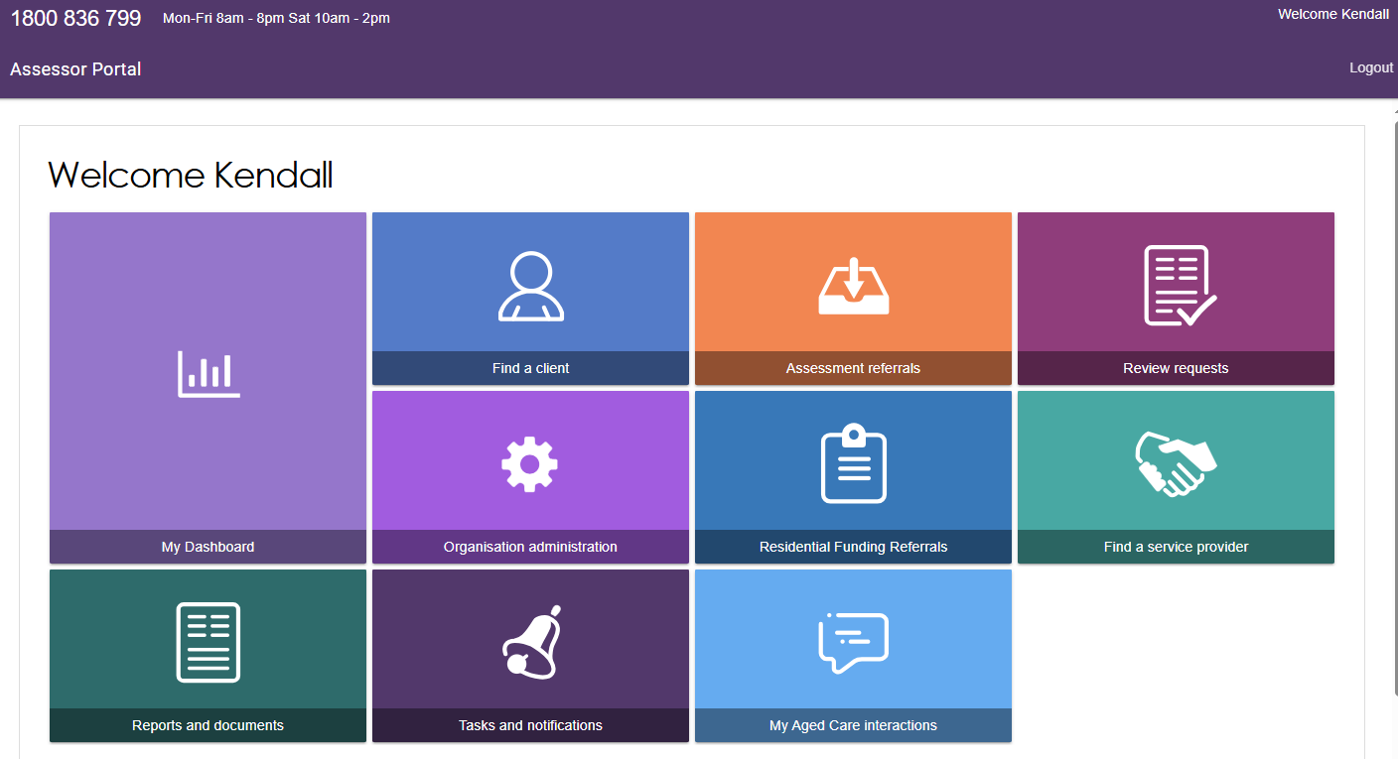

Needs assessor Homepage
People assigned a needs assessor role are responsible for registering new clients and conducting client assessments. If you log in to the assessor portal as a needs assessor, you will see the following tiles on your homepage:
- My Dashboard
- Find a client
- Assessments
- Reviews
- Find a service provider
- Reports and documents
- Aged Care Assessor App
- Tasks and notifications
- My Aged Care interactions.
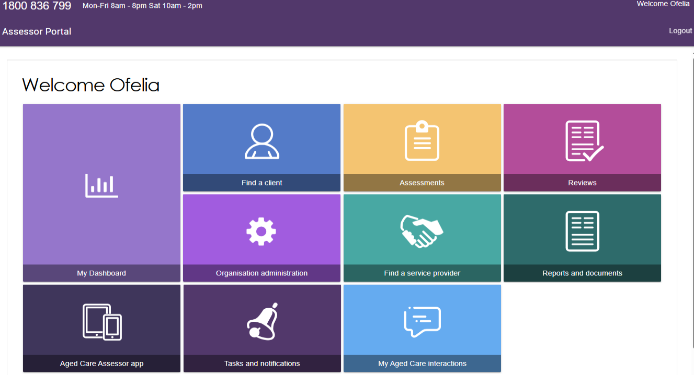

Triage Delegate Homepage
! | Delegate roles cannot be assigned by Organisation Administrators and instead require needs assessors, Team Leaders or Operational Managers to submit an application.  For more information regarding the application for delegate roles please refer to My Aged Care Assessor Portal User Guide 12 – Managing delegate roles.
People assigned a Triage Delegate role in the assessor portal will be able to complete triage. If you log into the assessor portal as a Triage Delegate you will be able to see the following tiles on your homepage:
- My Dashboard
- Find a client
- Assessment referrals
- Organisation administration
- Reports and documents.
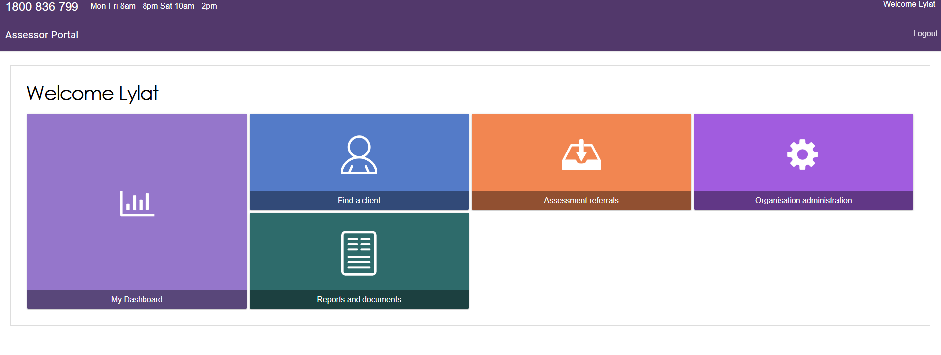

Assessment Delegate Homepage
! | Delegate roles cannot be assigned by organisation administrators and instead require needs assessors, Team Leaders or Operational Managers to submit an application.  Clinical assessment delegates are able to approve an older person for all service groups, classification types and classification levels under the Aged Care Act. Non-clinical assessment delegates are restricted to approving entry level home support, Assistive Technology or Home Modification services (i.e. with classification levels of CHSP class, AT CHSP or HM CHSP). They can decide and initiate corrections on Home support assessments only.  To understand Assessment Delegate changes, refer to ‘Chapter 7: Delegations and Approvals under the Act’ of the My Aged Care Assessment Manual.  For more information regarding the application for delegate roles please refer to My Aged Care Assessor Portal User Guide 12 – Managing delegate roles.

People assigned an assessment delegate role in the assessor portal will be able to make Delegate decisions for services requiring approval under the Aged Care Act.
If you log into the assessor portal as an assessment delegate, you will see the following tiles on your homepage:
- Delegate decisions
- Find a client
- Find a service provider
- Reports and documents
- Tasks and notifications
- Organisation administration
- My Aged Care interactions.
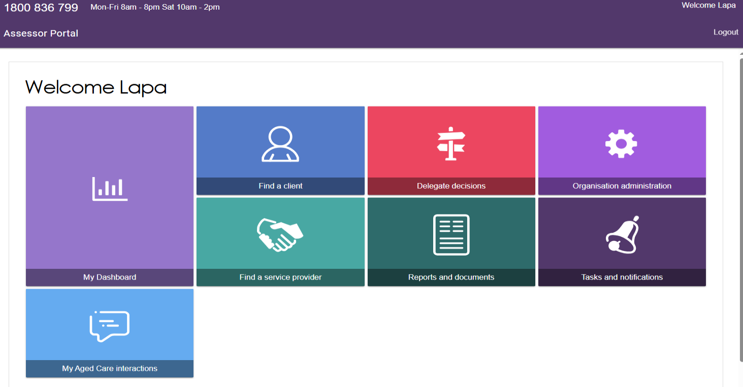

Assessment Delegate Support Homepage
People assigned the Assessment Delegate Support role in the assessor portal can support the Delegate by generating, uploading and/or printing Notice of Decisions (Approval/Non-Approval Letters) and Referral Code Letters. They can also print client information in support plans and client records.
If you log in to the assessor portal as an Assessment Delegate Support, you will see the following tiles in your homepage:
- Delegate decisions
- Find a client
- Organisation administration
- Find a service provider
- Reports and documents
- Tasks and notifications
- My Aged Care interactions.
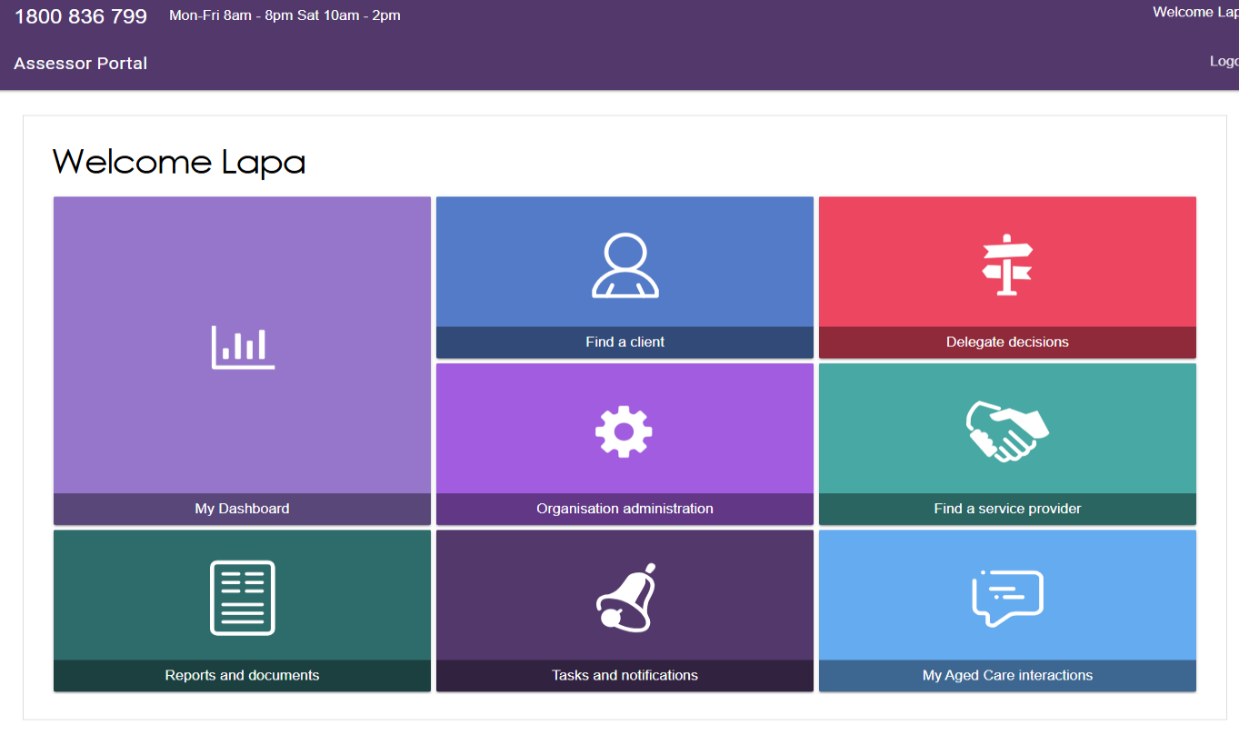

Residential Funding Assessor Functions
People assigned the Residential Funding Assessor role will have the below view in the My Aged Care Assessor Portal. From here, they can view the assessment referrals they have been assigned to undertake, and the assigned referrals that have been closed. They can also accept and assign referrals.
If you log in to the assessor portal as a RAC funding assessor, you will see the following tiles in your homepage:
- Find a client
- Residential Funding Referrals
- Find a service provider
- Reports and documents
- Aged Care Assessor app
- Tasks and notifications
- My Aged Care interactions.
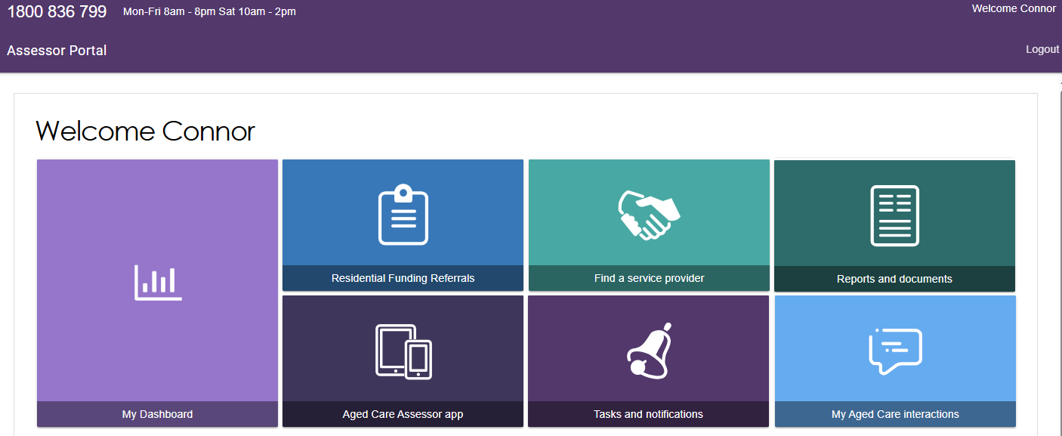

Residential Funding Team Lead Functions
Residential Funding team leads will have the following view in the My Aged Care Assessor Portal.
From here team leads are able to view Residential Funding Referrals, generate reports and documents, find service providers and conduct other functions in their role.
If you log in to the assessor portal as a RAC funding assessor, you will see the following tiles in your homepage:
- Residential Funding Referrals
- My Aged Care interactions
- Find a service provider
- Reports and documents
- Tasks and notifications.
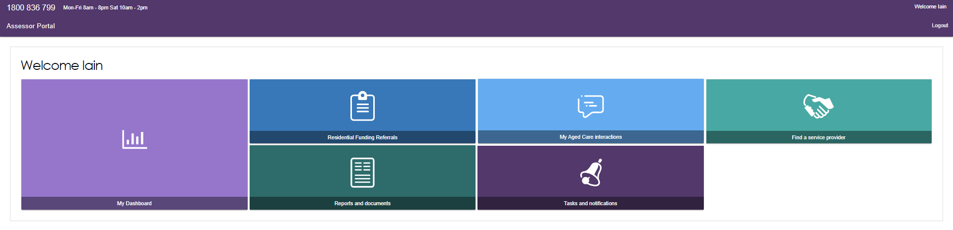

Key Functions by Role Type
Administrators will create and maintain staff accounts in the assessor portal.
Staff can be allocated more than one role (Administrator, Team Leader, Needs assessor, Residential Funding Assessors, Residential Funding Assessor (Restricted), Triage Delegate, Clinical Assessment Delegate, Non-clinical Assessment Delegate, and Assessment Delegate Support) at the same time in the assessor portal.
The following tables outline the key functions for roles within the assessor portal, as well as the roles that others, such as the contact centre, play in the client’s aged care journey.
They include both client focused, and organisation focused tasks.

Client Focused Roles and Functions
Key Functions | Contact Centre | Administrator | Team Leader | Triage Delegate | Needs Assessor | RAC Funding Assessor | Assessment Delegate (clinical and non-clinical) | Assessment Delegate Support
View reports and documents |  | ü | ü | ü | ü | ü
Manage staff accounts |  | ü
Activate Aged Care Assessor app |  |  |  |  | ü | ü
Provision of aged care information | ü | ü | ü | ü | ü | ü | ü | ü
Register a client or support person | ü |  |  |  | ü excluding Residential funding assessors)
Self-Refer a client |  |  |  |  | ü (limited)
Search for and view a client record |  |  | ü | ü | ü |  | ü | ü
Screening | ü |  |  |  | ü*
Complete triage |  |  |  | ü | ü**
Referral for assessment | ü |  |  |  | ü
Conduct assessment |  |  |  |  | ü
Enter assessment information on the client record (including completing the support plan) |  |  |  |  | ü |  | ü
Service matching and referrals | ü |  |  |  | ü
Management of assigned of Residential referrals |  |  | ü Residential Funding Assessor Team Leads only)
Action referral & deliver services
Accept and reject assessment referrals |  |  | ü
View tasks and notifications |  | ü | ü | ü | ü | ü | ü | ü
Manage task and notification preferences |  | ü

Client Focused Roles and Functions continued…
Key Functions | Contact Centre | Administrator | Team Leader | Triage Delegate | Needs Assessor | RAC Funding Assessor | Assessment Delegate (clinical and non-clinical) | Assessment Delegate Support
View and Reassign SaH notifications |  |  | ü
Record completed tasks in the portal |  |  | ü |  | ü
Approve Delegate decisions |  |  |  |  |  |  | ü
Print client information for the Delegate |  |  |  |  |  |  | ü | ü
Assign & transfer support plan reviews |  |  | ü |  | ü
Conduct Support Plan Reviews |  |  |  |  | ü
*A needs assessor who self refers will complete the screening component.
**A needs assessor can complete Triage if supervised by a Triage Delegate.
*** A Delegate can edit decisions within 43 days.
Organisation Focussed Roles and Functions
Key Functions | Administrator Role | Team Leader Role | Needs assessor Role | Triage Delegate | Assessment Delegate Role (clinical and non-clinical) | Assessment Delegate Support Role | RAC funding assessor
View My Aged Care interactions | ü | ü | ü | ü | ü | ü | ü
Request a change to contractual information | ü
Manage staff accounts: add, edit, deactivate and remove | ü

Creating New Staff Accounts and Assigning Roles
The first time each staff member logs into the assessor portal, they will need to follow the steps outlined in Logging in to the Aged Care Systems on the department’s website.
Follow these steps to create a new staff account:
- From the Staff tab in the Organisation administration page, select ADD NEW STAFF.
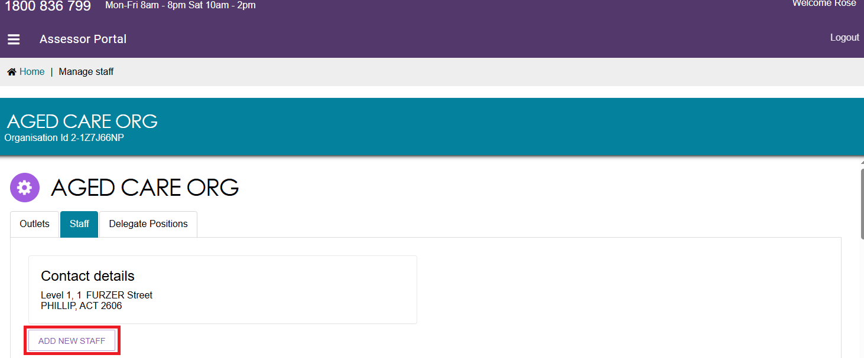
- Enter staff details (First name, last name, unique email address and a contact number).
Select whether they are accredited, then assign role(s) to staff under the Manage Roles section. Refer to the next step for managing roles.
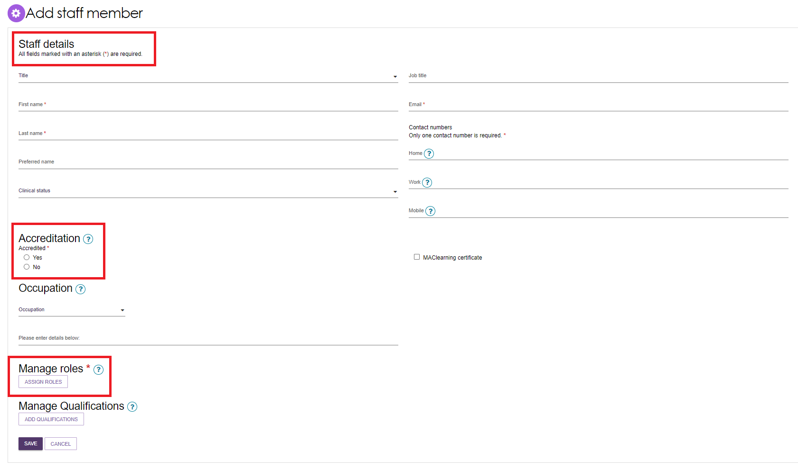

- To Manage Roles, select the role you wish to assign to that staff member and select SAVE.
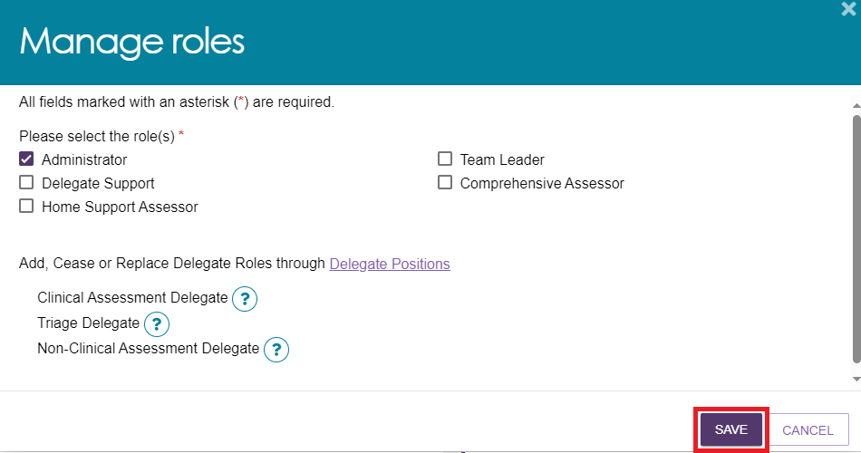
! | Delegate roles cannot be assigned by organisation administrators and instead require needs assessors, Team Leaders or Operational Managers to submit an application. For more information regarding the application for delegate roles please refer to My Aged Care Assessor Portal User Guide 12 – Managing delegate roles.

! | - Either the Residential Funding Assessor or Residential Funding Assessor (Restricted) role can be selected for each staff. That is, they cannot be assigned both roles.  - A Residential Funding Assessor or Residential Funding Assessor (Restricted) can also be a Residential Funding Team Lead.  - As per the Statement of Requirements for the Single Assessment System workforce, if the assigned role is Residential Funding Assessor, Residential Funding Assessor (Restricted), clinical needs assessor (Comprehensive Assessor) or Team Leaders the Australian Health Practitioner Regulation Agency (AHPRA) ID and the Discipline of the assessor needs to be recorded at the Accreditation section of the Add Staff Member page.  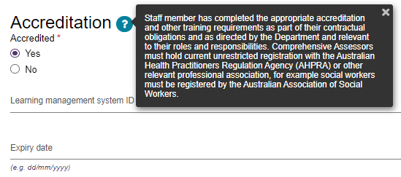
To assign an Administrator role at the organisation level, select Organisation Level button, then SAVE ROLES. Any staff roles that are assigned at this level are automatically replicated across all outlets.
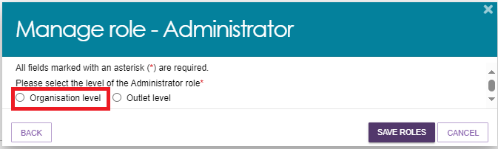
If you wish to limit an employee role to one or more outlets, select the Outlet Level option instead, then SAVE ROLES.
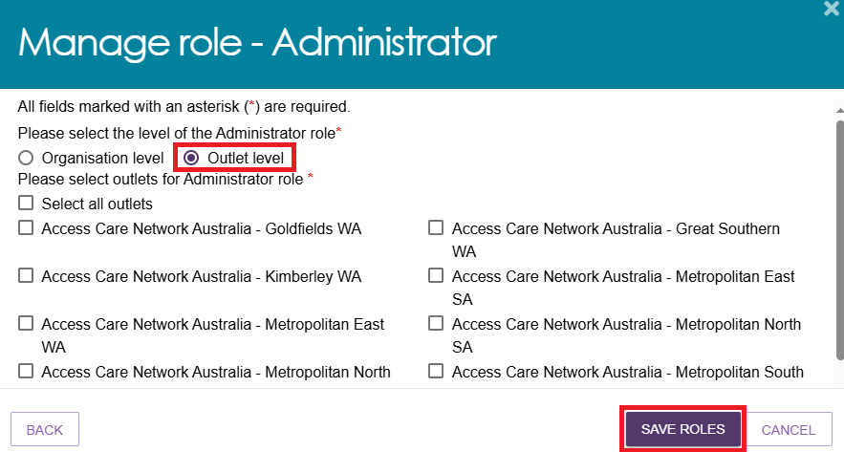
- A green banner appears when the role/s are saved successfully. It will display under the Manage Roles section, along with any assigned outlets.
Select SAVE to continue.
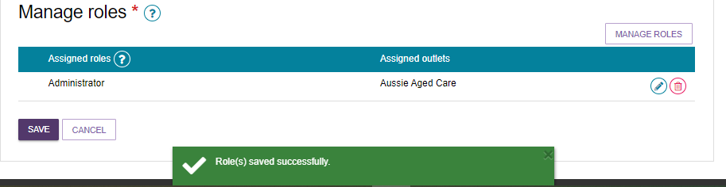

- The new Administrator is now displayed under the Staff section of your organisation.
The Staff Card contains the accreditation status and the role/s.
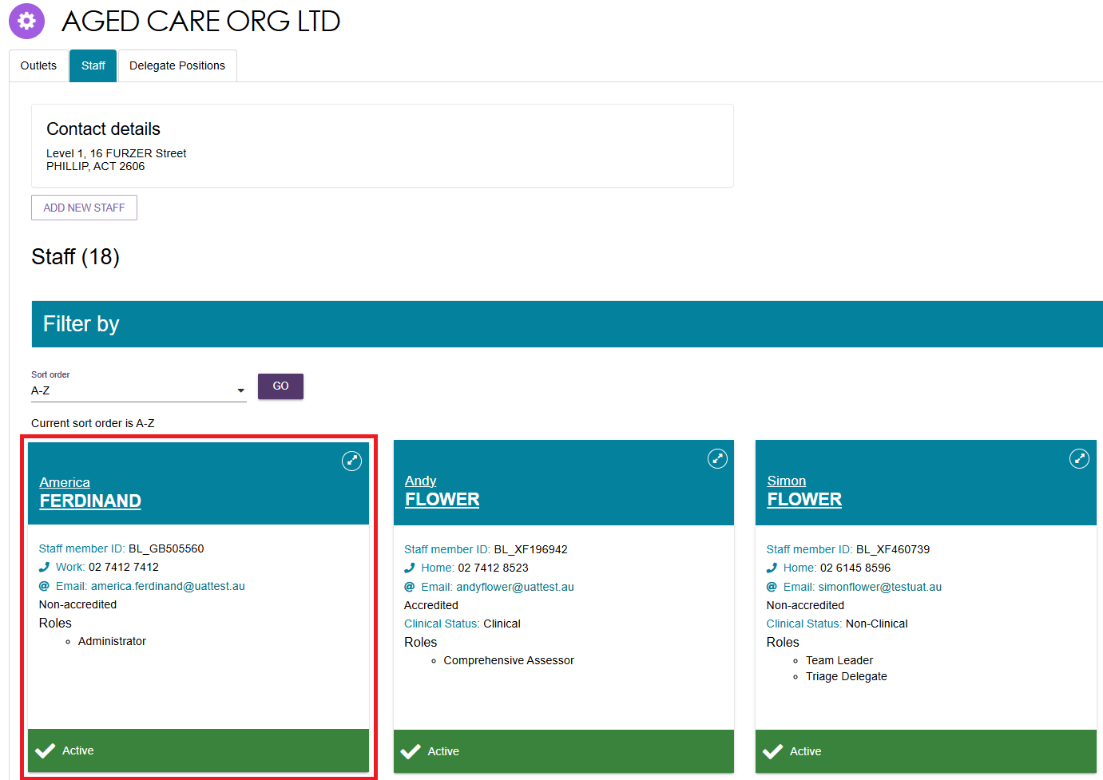

Deactivate a Staff Account
Follow these steps to deactivate a staff account:
- From the Staff tab on the Organisation administration page, select the name of the staff member on the Staff card that you want to deactivate.
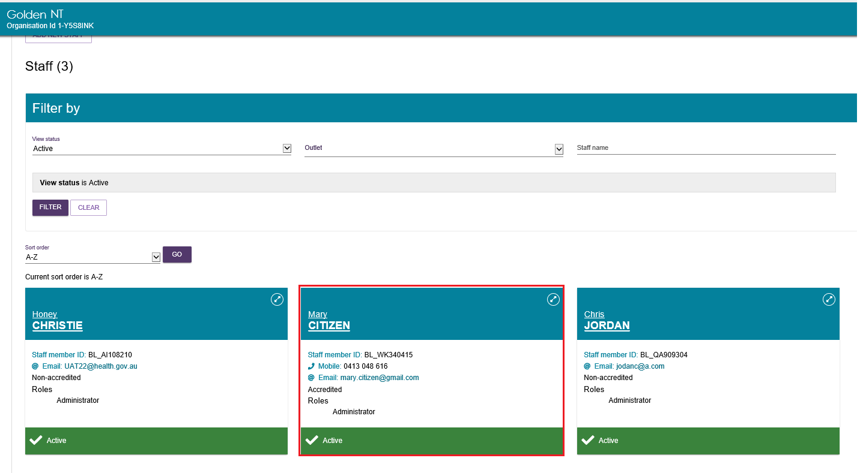

- From the View staff member page, select DEACTIVATE.
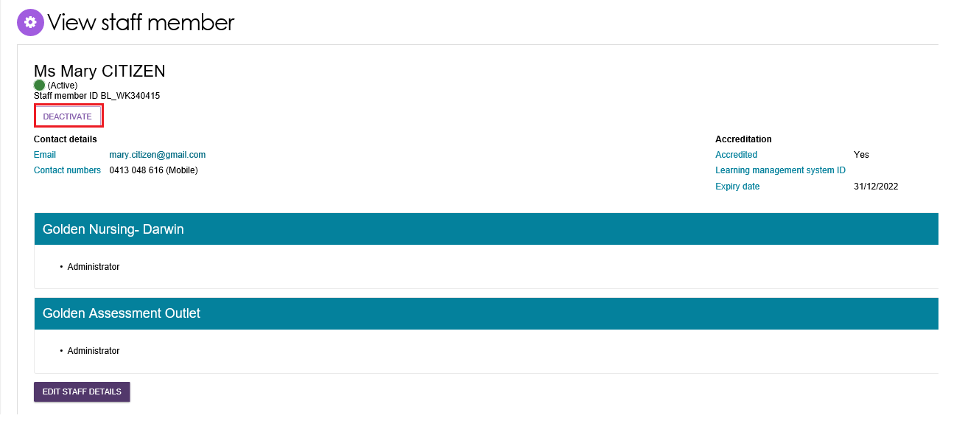
- Select DEACTIVATE ACCOUNT to confirm. If the assessor you’d like to deactivate has any assigned assessments assigned, these will be shown to you in the confirmation pop up.
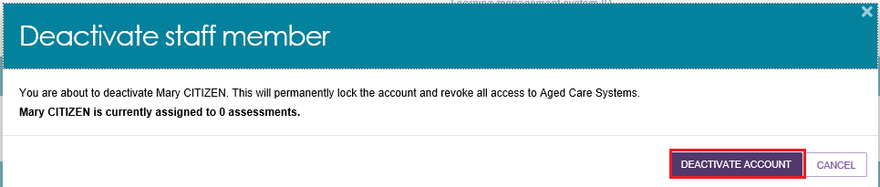

Removing and reactivating a Staff Account
Inactive staff (that have previously been deactivated) can be removed from organisations and outlets and will no longer display in the assessor portal.
- From the Staff tab of the Organisation administration page, select Inactive from the View Status drop down menu to view inactive staff.
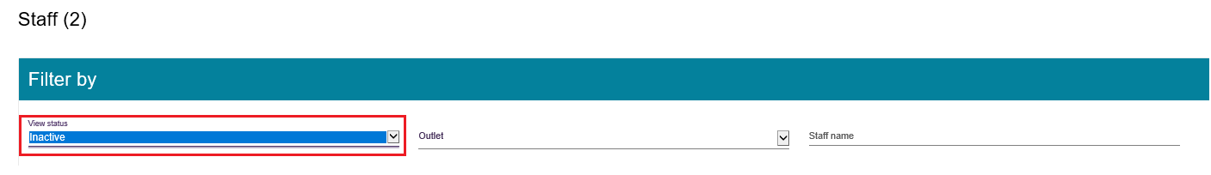
- Select the name of the staff member on the Staff card that you wish to remove.
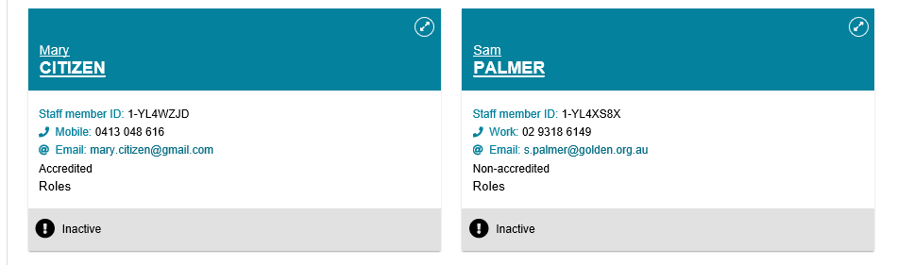

- From the View staff member page, select REMOVE or REACTIVATE.
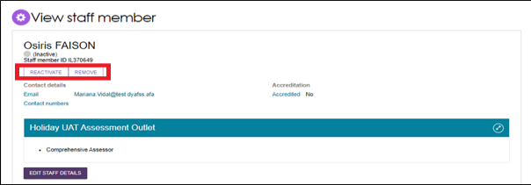
- Select REMOVE to remove the staff member from your staff list.
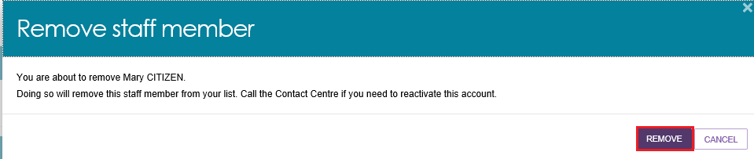
! | If you need to restore access for a staff member who has been removed, call the My Aged Care Provider and Assessor Helpline at 1800 836 799.  You cannot re-create a portal user account using the same email address.

Edit a Staff Account
Follow these steps to edit a staff account:
- From the Staff tab of the Organisation administration page, select the name of the staff member on the Staff card that you want to edit.
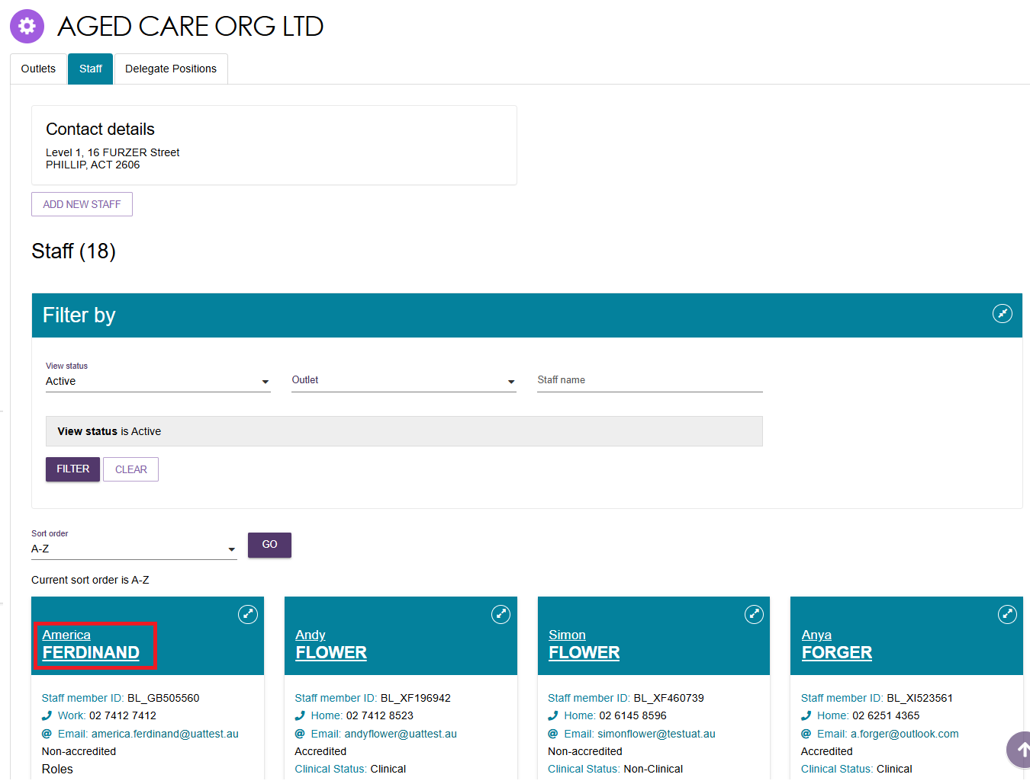
- From the View staff member page, select EDIT STAFF DETAILS.
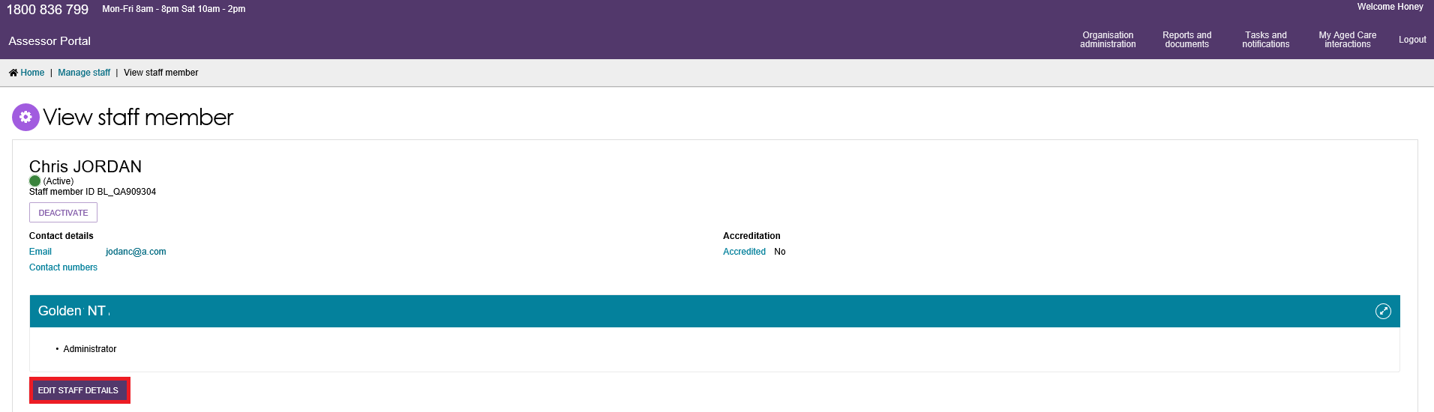
- Staff details and roles can be updated at any time.
To edit roles, select Manage Roles or the Edit (pencil) icon, and revise staff roles in the pop up/s that appear, then select Save.
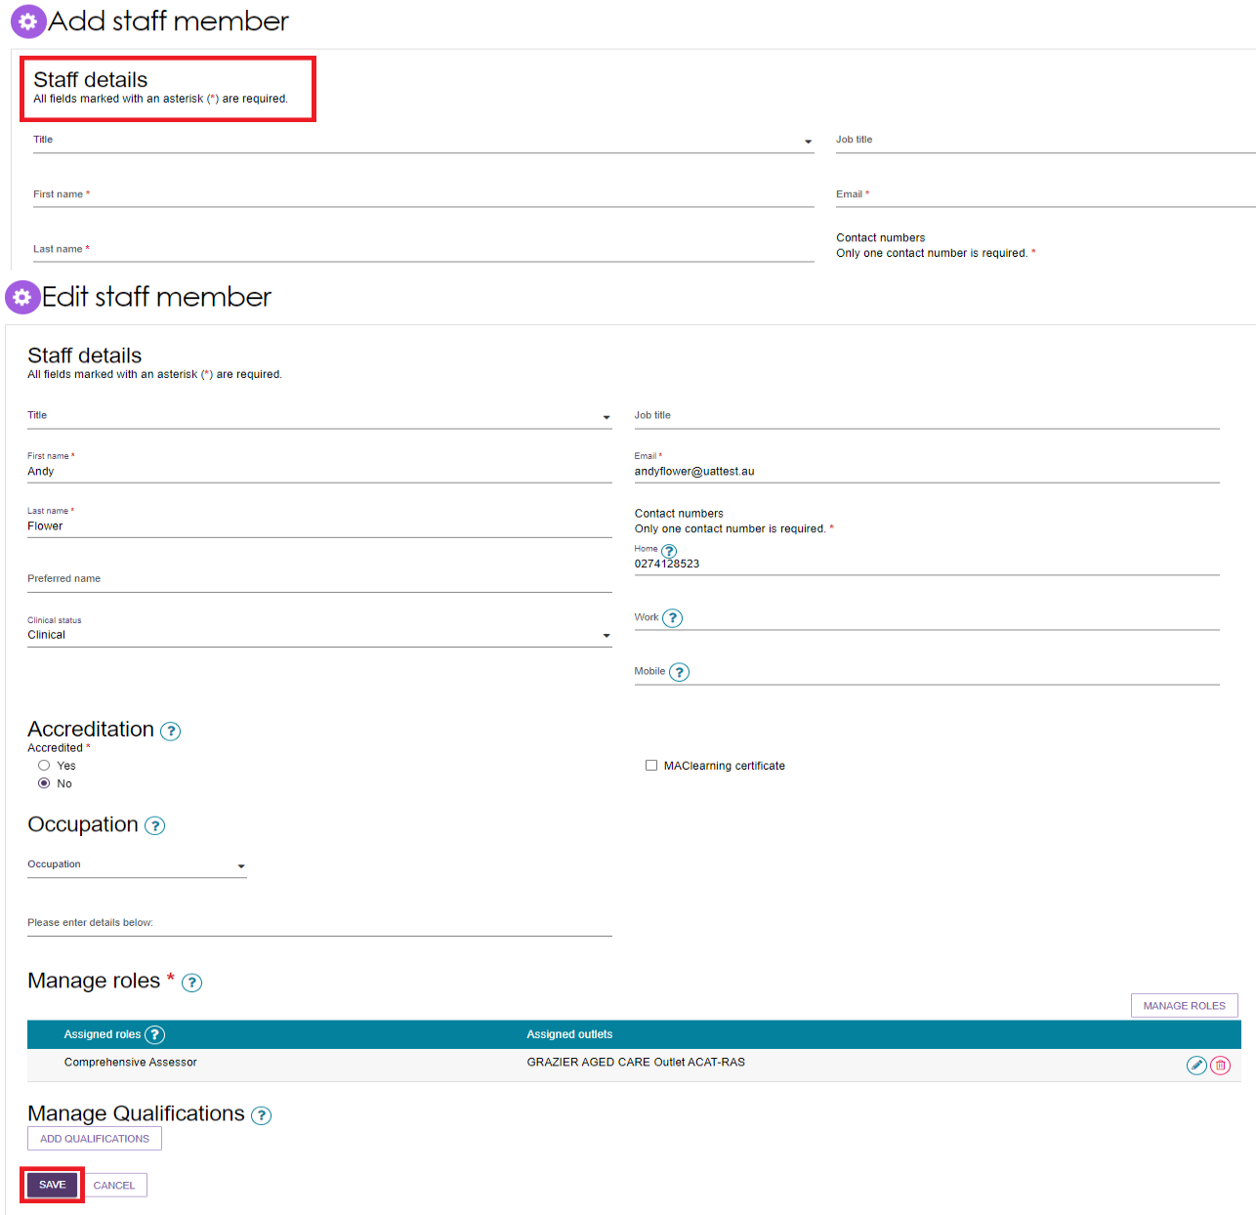

Find A Service Provider
Needs assessors, Team Leaders, Triage Delegates, Clinical Assessment Delegates, Non-clinical Assessment Delegates and Assessment Delegate Support roles have access to the Find a Service Provider function in the assessor portal.
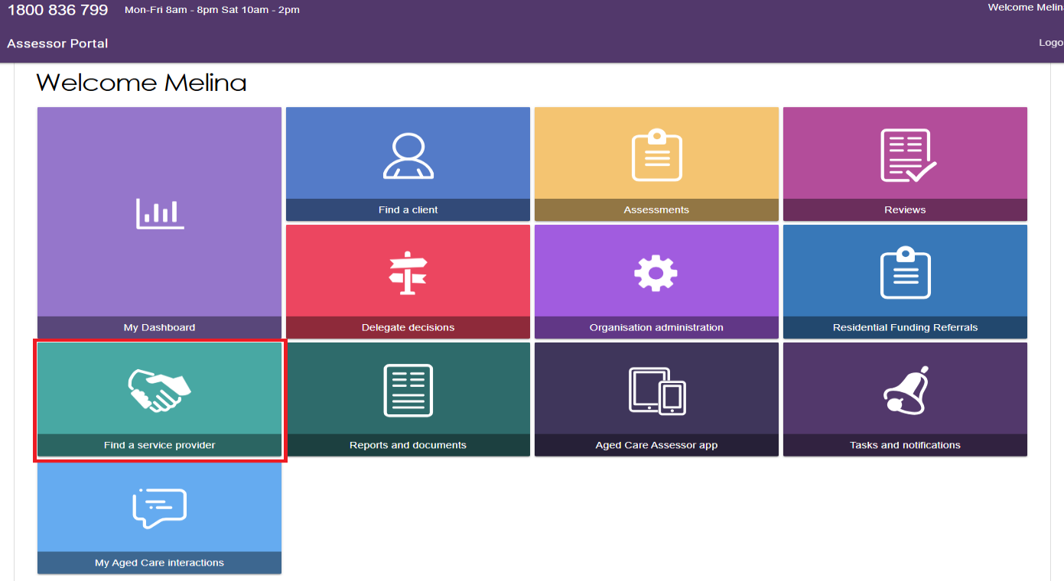
Users can search for providers by entering the category, service type, location and diverse needs.
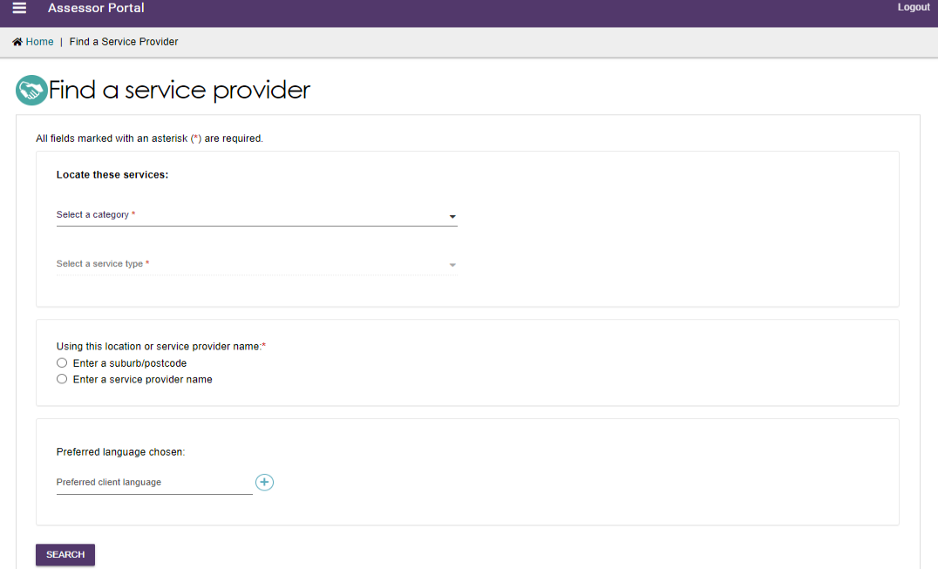
The results will then display below your search. Under each service provider’s service card, there is information such as the provider’s suburb, phone number, whether they are services available and whether there are waitlists available.
A link to the My Aged Care website is also listed which is where additional information such as the provider’s compliance information can be found.
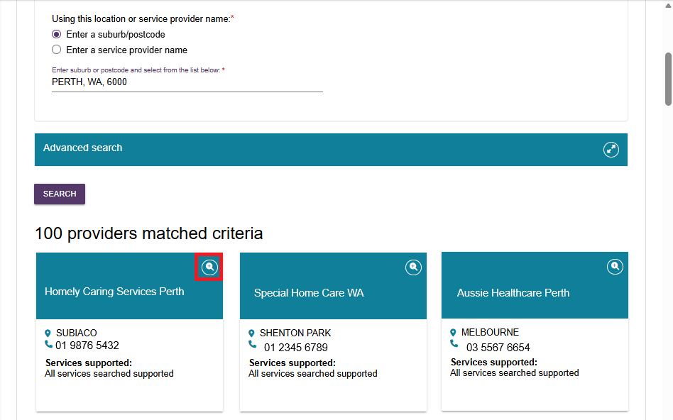
Expand the service card to view more information about the service provider.
The information details for the provider will then appear in a new page. You can also hover over any help (question mark) icon to reveal more information on a particular topic.
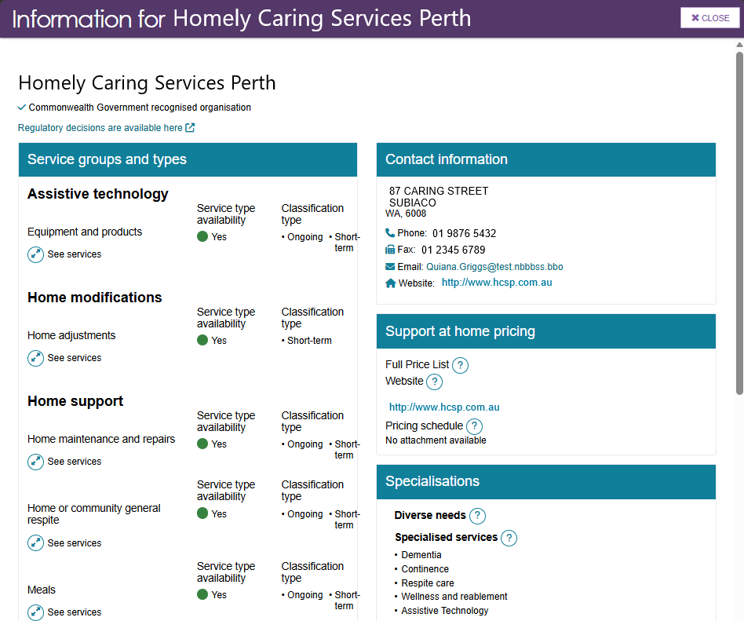

End of Month (EOM) Reporting
Organisation Administrators and Team Leaders for assessment organisations have the option to send the department a copy of their BIP EOM Preparation Invoice Report at the end of each month as a supporting document to their EOM Assessment invoice. To do this:
- Select the Reports and document tile from the assessor portal homepage.
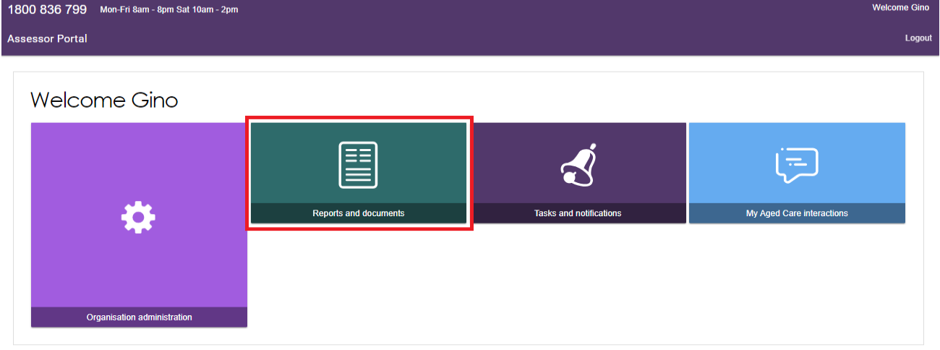
- Select the BIP EOM Preparation Invoice Report
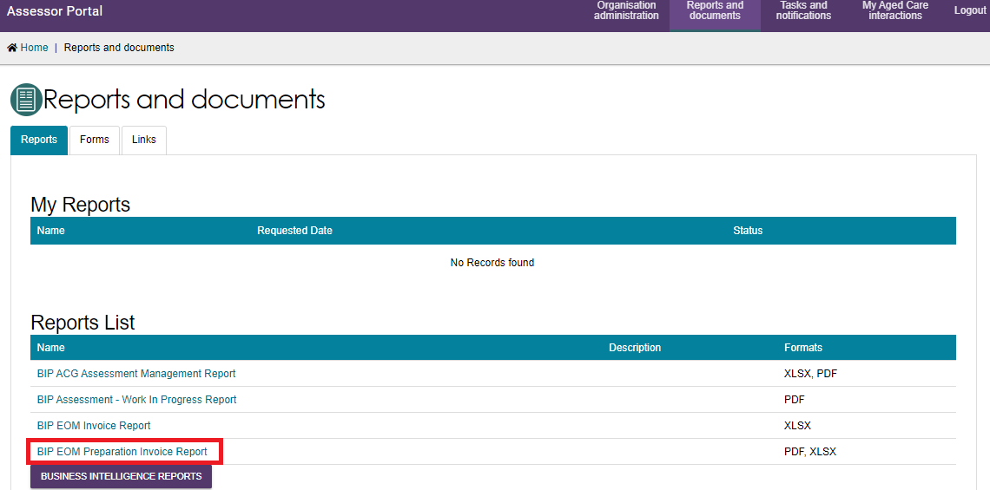
- The Generate report page will display. Select the correct Outlet ID and enter the start and end date for the month you are reporting on. Next, select XLSX from the drop-down menu under Output Type. Then select REQUEST REPORT.
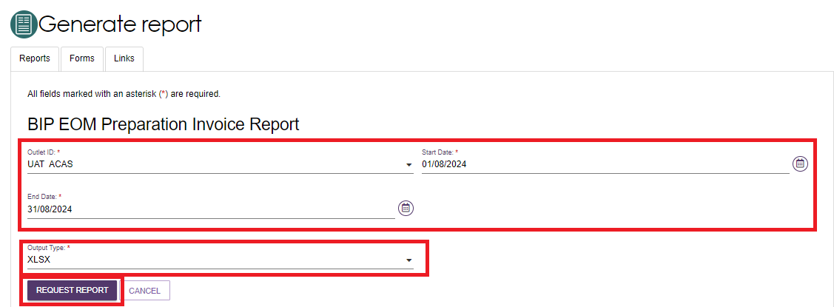
You will then be re-directed back to the Reports and documents page where the BIP EOM Preparation Invoice Report will display under My Reports. Select View to open the report.
The status of the report will display as Processing initially but will change to Ready – View once the report has been generated.
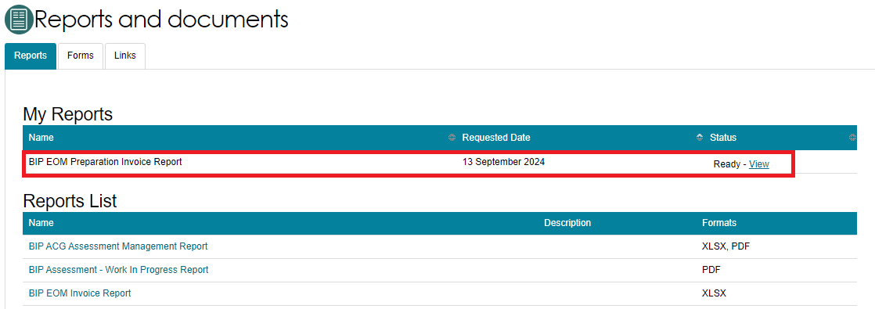
- The report will then download to your computer as an Excel file. Select the Open file link from the Downloads pop up box, on the top right of your web browser page.
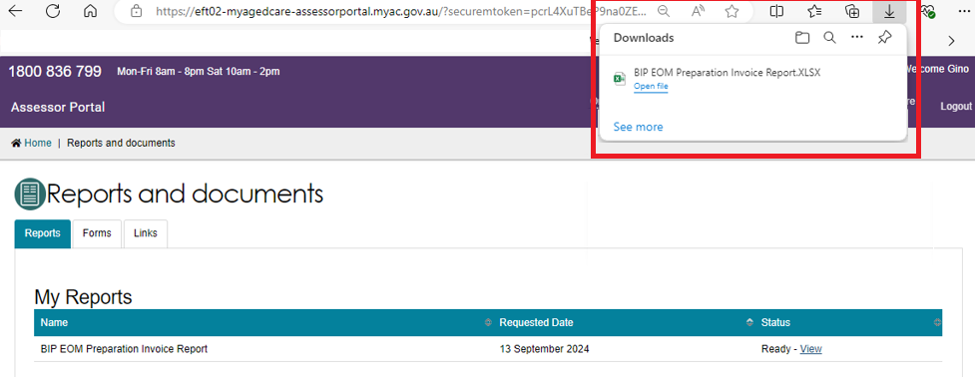
- The report will then display in Excel.
The report will show the total number of assessments, along with information relating to each individual assessments including:
- the unique assessment ID (Event ID column)
- who completed the assessment
- the unique client ID (to help preserve a level of privacy)
- date the assessment was completed
- the assessment type at the triage stage
- if the assessment was complete in-hospital.
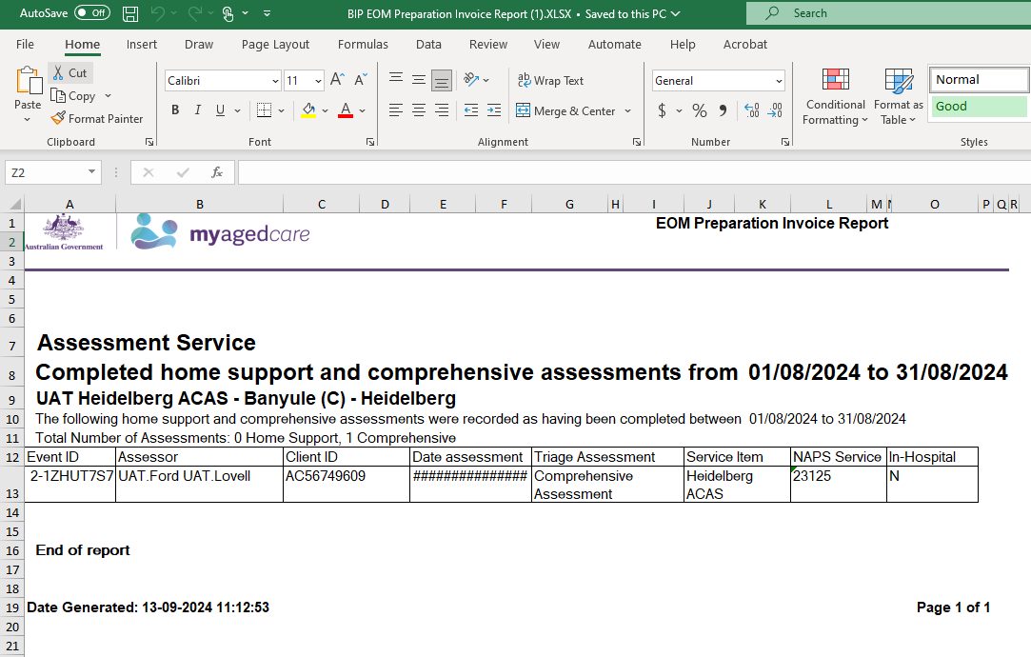
For more information regarding reporting, refer to the My Aged Care Assessment Manual.

