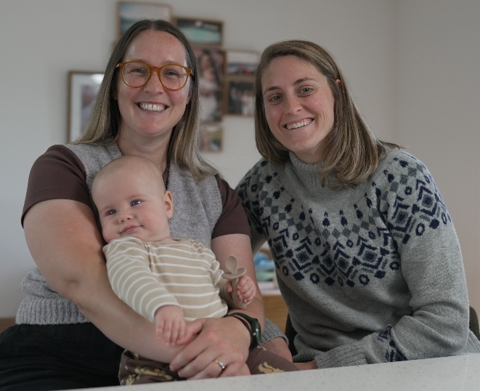
Protected from the start: Eliza, Shannon and Artie’s maternal RSV vaccination story
When Eliza and her wife, Shannon, found out they were pregnant, they were excited to be growing their family.
“I was expecting the worst, but I loved being pregnant,” Eliza says.
As they prepared to welcome their first baby, respiratory syncytial virus or RSV was one of the health risks Eliza and Shannon were aware of.
They knew RSV was a respiratory infection anyone could get and that it could be serious for babies, particularly newborns.
When their GP recommended the maternal RSV vaccine during pregnancy, the decision was easy.
“She made it pretty clear to us that was the right choice for us and our family,” Eliza says.
“We were happy to go with whatever she suggested. It was really straightforward.”
Eliza received the maternal RSV vaccine at her GP clinic, along with the other vaccines recommended during pregnancy, influenza (flu) and whooping cough.
For Eliza and Shannon, the main benefit of receiving vaccines during pregnancy was peace of mind once baby Artie arrived.
“We’re very social people, so we had lots of friends and family come over after he was born,” Shannon says.
“Just knowing that he was protected from getting really sick, knowing that he wouldn’t end up in hospital, that was our main concern.”
Now 7 months old, Artie is thriving. Looking back, Eliza says getting vaccinated was simple and something they would choose to do again.
“The protection is so important. It’s something that we would do over and over again,” she says.
Their advice to other expecting parents is to speak with their trusted health professionals.
“Listen to your GP and midwife, they have you and your baby’s best interests at heart,” Eliza says.
Shannon agrees, “If they’re suggesting something, they’re suggesting it for a reason.”
For more information visit health.gov.au/maternalvaccinations

