Uncle Joseph’s aged care support helps him remain at home
In our culture and family, caring has always been reciprocal. It’s not something we see as a duty, it is simply part of our way of life.
We are a Torres Strait Islander family living in the remote community of Seisia in Cape York. Like many families across our region, we live in a multigenerational household. Our grandparents, parents, children and grandchildren look after and out for one another.
My father, Dr Joseph Elu AO, is almost 72 years old. He spent his working life serving community, travelling across Australia and overseas and contributing to Indigenous economic development across Australia. He always knew he would return home to Seisia to retire.
"Home is where I feel comfortable," Joseph says. "I grew up here with my family. It has changed over the years, but it is the place I know best."
Aged care support here in the Northern Peninsula Area helps him remain exactly where he wants to be—at home, in Seisia, surrounded by family and community. Where in previous decades, aged care services were more available in places further away like Cairns, today, aged care support here in the Northern Peninsula Area helps him remain exactly where he wants to be as a retiree - at home, in Seisia surrounded by family and community.
Through our local Indigenous-led aged care service, meals are delivered daily on weekdays, medication is collected from the pharmacy in another community and brought to him, and staff assist with household cleaning twice weekly. These practical supports make a real difference to him, our family and our care network. For my mother Dituni as his primary carer, the support eases her daily workload. It saves her regular trips around community and gives her more time to focus on caring for her husband.
On having aged care services at home, Joseph says, "I get to stay here in Seisia, my home, close to my family."
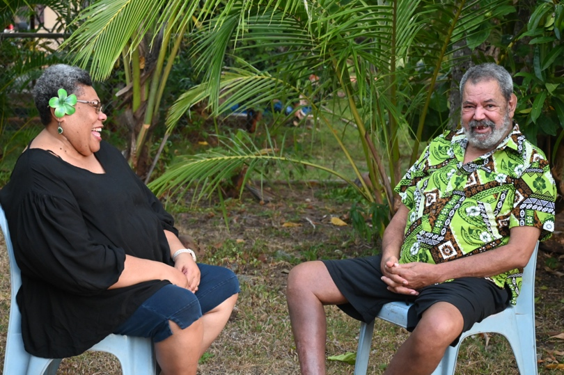
Having a local, Indigenous-led service means that some people providing care are our relatives or people we have known our whole lives. The service feels comfortable, it has never felt clinical or unfamiliar.
"For me, the services here are run and staffed by people who I know, or they know me, or they are my relatives," Joseph explains.
What makes the service special is the connection with people. It’s the conversations that happen when staff arrive with meals. It’s hearing language spoken at home. It’s the laughter shared over old stories and community memories between the staff, my dad and my mum. It is the passing on of messages from relatives living elsewhere when a staff member arrives and says, “Aye, this Aunty be spik for say hello and em send em love."
Those moments matter to him and to us. They are real moments that are not part of service reports or statistics but are deeply felt in the heart.
They are small things, but they are the things that make us feel connected, valued and seen.
Dituni says they are not strangers to one another. "They are part of our care network. The staff know our family history. They understand culture. They know who belongs to who. There is no need to explain the importance of language, culture or community because they already live it,” she says.
That cultural understanding creates trust and makes it so much easier.
Our local provider offers services to Aboriginal and Torres Strait Islander people from the age of 50. We didn't know that before we started looking into aged care support when Dad was approaching 70.
Looking back, we wish we had known and understood sooner what support was available for both him and us as carers.
For anyone unsure about seeking assistance, my dad Joseph has a simple message:
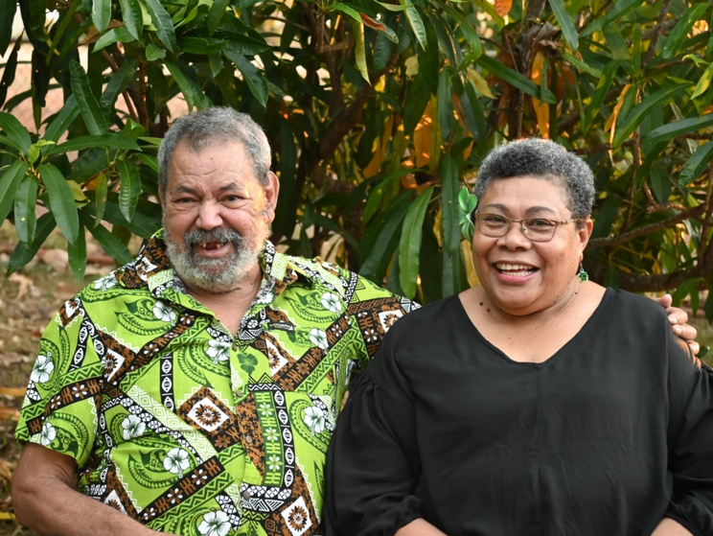
"We Indigenous people deserve this support. Each of us may have faced some hardship at some point in our lives. Now we have services like this that can support us as we age, we should use it."
Receiving aged care services does not mean losing independence. For our family, it has meant preserving it.
It means our Elders can continue living at home. It means carers receive a helping hand from people they know and trust. It means language continues to be spoken in the home. It means stories continue to be shared. It means family and community continue doing what they have always done – looking after one another.
For us, aged care is more than just a service, it is community caring for community.
- Talei Elu.
Get the support you need to age well – online, by phone or in your community.
- Speak with your local health service or Elder Care Support worker
- Visit MyAgedCare.gov.au
- Call My Aged Care on 1800 200 422
- Visit a Services Australia office

