About this toolkit
This toolkit has information and resources to help Aboriginal and Torres Strait Islander people access and navigate aged care.
For many people, accessing aged care services can be a difficult time. Community groups and organisations, including Aboriginal community-controlled organisations and health services, play an important role in connecting people to the right information, when they need it. This toolkit is designed to support community groups and organisations with the information needed to help people make informed aged care decisions.
How to use this toolkit
These resources can help people understand what aged care is, how to access services and where to find more information.
You can use the toolkit to:
- yarn with community about aged care
- share information at community events or groups
- share digital content through your social media accounts or digital newsletter
- show the videos to community members at gatherings or information sessions.
Contents
- Key messages
- Fact sheets
- Checklist
- Posters
- Aged care journey
- Videos
- Social media tiles
- Case studies
- Other useful information and links.

Access the resources
Download and print the toolkit resources by scanning the QR code below, or visiting: health.gov.au/resources/collections/lets-yarn-about-ageing-well-community-resource-toolkit
Key messages
Use this information to share the facts about aged care.
Topic | Key messages
What is aged care | - Aged care helps you stay strong, safe and living life your way.  - Aged care services can help at home, in the community or at an aged care home.
Eligibility | - Aged care helps you stay at home and close to your family, culture, Country, Island Home and community.  - Aboriginal and Torres Strait Islander people can apply for government-funded aged care services from age 50.  - Registering with My Aged Care is free.  - You don’t need to be receiving a pension to access aged care.  - Many services are free or low cost.  - You don’t need to be sick or wait for an emergency to get care.
Access | - To get started, you need to register with My Aged Care and have an assessment.  - You don’t have to register for aged care on your own.  - You can get help to register for aged care online, by phone or in person.  - Speak with your local health service or an Elder Care Support worker  - Visit MyAgedCare.gov.au  - Call My Aged Care on 1800 200 422  - Visit a Services Australia office.
Planning | - Learning about aged care now helps you plan for the future.  - It’s OK to ask questions early, you don’t have to sign up to get information about aged care services.  - Support is there to help you age well when or if you need it.
Cost | - Many of the services through My Aged Care are free or low cost. There may be some out-of-pocket costs. Providers need to let you know about any costs before you agree.  - You don’t need to be receiving a pension to access aged care.  - It is free to register with My Aged Care, and access information.
Trust and Safety | - Your culture, family and community matter. You can have family involved in decisions.  - You can speak up if something doesn’t feel right. You have the right to culturally safe assessments and care.

Community resources
Fact sheets
These fact sheets help give people information about aged care.
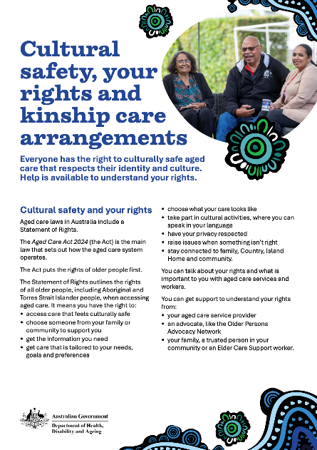
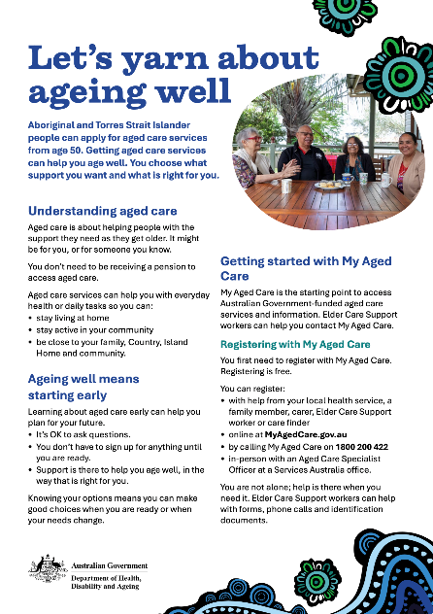

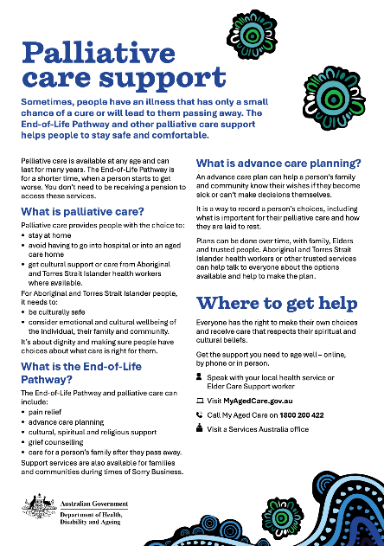
Community resources
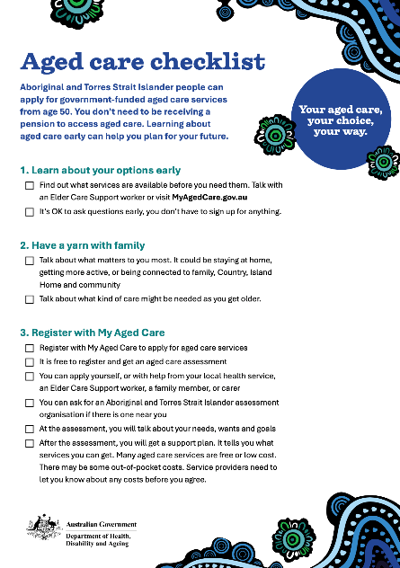
Checklist
Posters
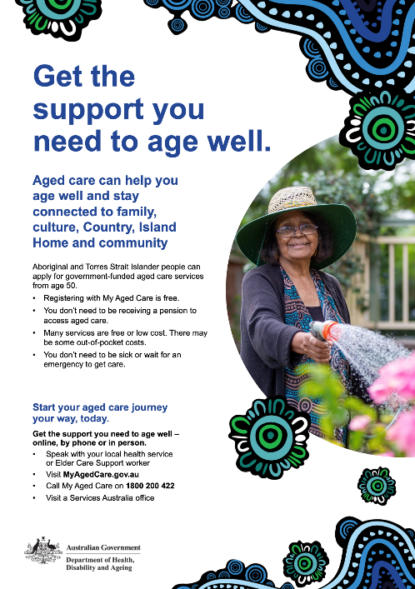
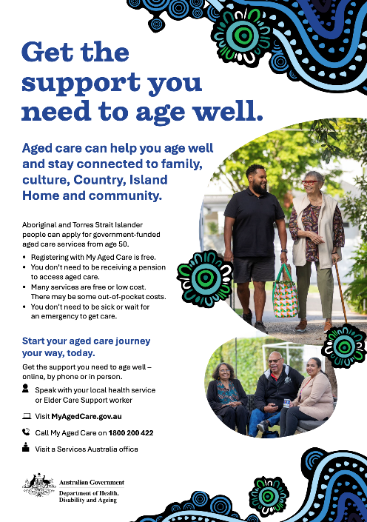
Share this poster in community or use the template to add your own photos and contact details.

A3 Poster (PDF) 3 Poster template (editable)
Community resources
Visual storyboard
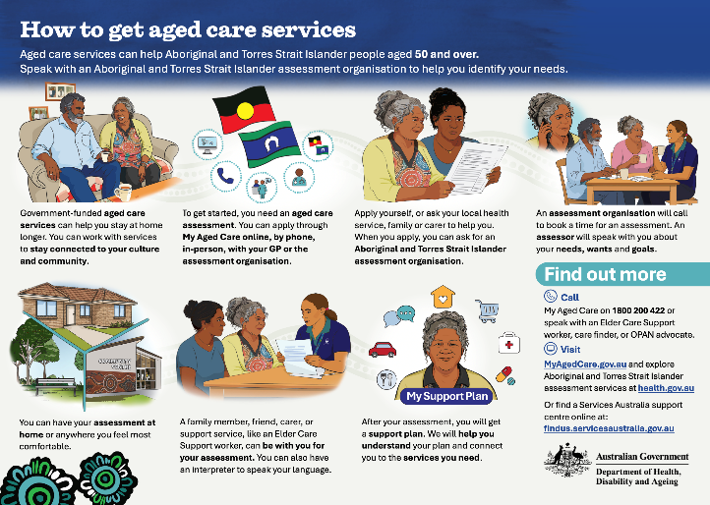
This visual storyboard helps people understand the aged care assessment process with Aboriginal and Torres Strait Islander assessment organisations.
Aged care journey
This visual map of the aged care journey helps people to navigate through the steps to access and receive aged care services and get information they need along the way.
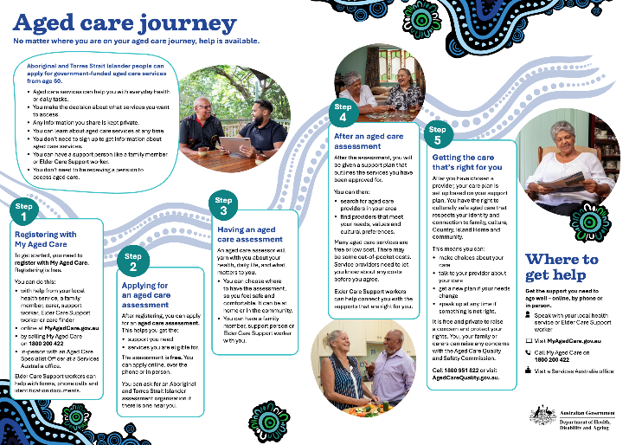
Videos
View these videos online and share with community members.
Image from video | About the video
 | Improving aged care quality  The Aged Care Quality Standards make sure older Aboriginal and Torres Strait Islander people receive care and services that is respectful, and your culture and language are respected.
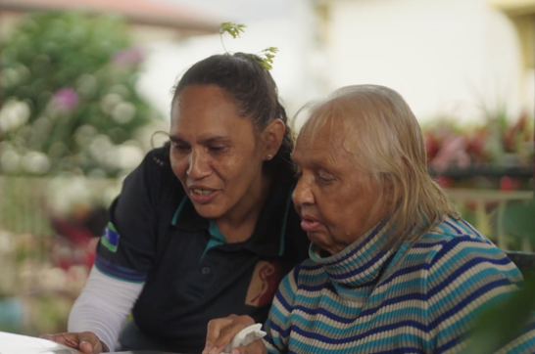 | Aged care you can trust  The new Aged Care Act makes sure the people looking after older Aboriginal or Torres Strait Islander people in aged care are respectful of your cultural needs.
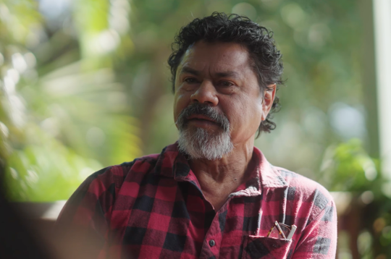 | Putting your aged care rights first  The Statement of Rights means aged care providers of Aboriginal and Torres Strait Islander people must treat you with dignity and respect.
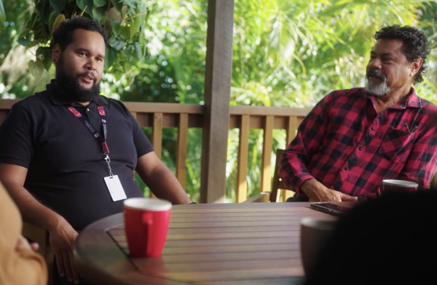 | Supporting your rights and decisions  Help is available for older Aboriginal and Torres Strait Islander people who need support to make aged care decisions.

Social media
Share this content to your social media channels and encourage community members to share or yarn with family and Elders.
Topic and graphic | Post copy
Where to start  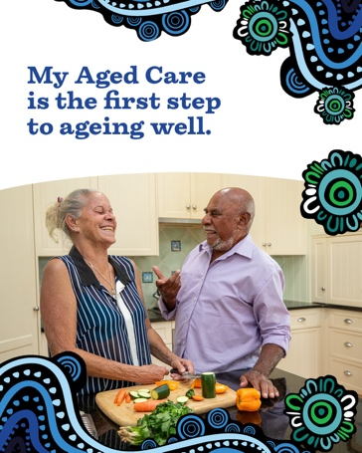 | Aboriginal and Torres Strait Islander people aged 50 and over can apply for aged care services funded by the government. Aged care can help you age well.  Get started by registering with My Aged Care. It’s free to register and ask questions.  You can learn about:  - aged care services  - registering for support  - applying for an assessment  finding service providers in your area.  Talk about ageing well with an Elder Care Support worker, your local health service, or at a Services Australia office.  Or visit MyAgedCare.gov.au or call 1800 200 422.
Eligibility  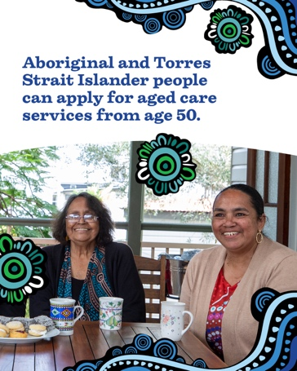 | Aboriginal and Torres Strait Islander people can register for aged care services from age 50. Many of the services are free or low cost. There may be some out-of-pocket costs.  Aged care helps keep mob living healthy and strong.  Start your aged care journey your way, today.  Talk with an Elder Care Support worker to register with My Aged Care.  Or visit MyAgedCare.gov.au or call 1800 200 422.
Cultural safety  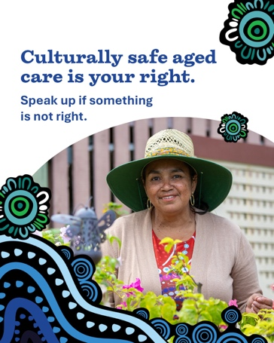 | Everyone has the right to culturally safe aged care that respects your culture and identity. It’s OK to speak up if something is not right.  Talk with an Elder Care Support worker to find out more, or call 1800 951 822 or visit AgedCareQuality.gov.au
Access support  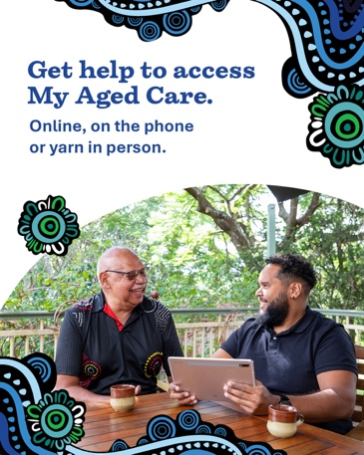 | You don’t have to apply for aged care services on your own. Support is available online, by phone, or in person.  If you don’t have all your ID, you can get help with forms and phone calls.  Talk about ageing well with an Elder Care Support worker, your local health service, or at a Services Australia office.  Or visit MyAgedCare.gov.au or call 1800 200 422.
Costs  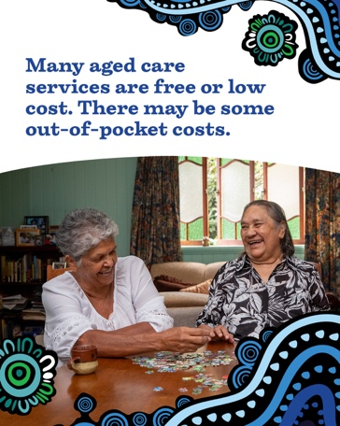 | Did you know many aged care services are free or low cost? It’s free to register for aged care and get information.  Service providers need to let you know about any costs before you agree.  Talk with an Elder Care Support worker for more information.  Or visit MyAgedCare.gov.au or call 1800 200 422.
Sharing stories from community
Community members have told us that it helps them to see real stories from people who are using aged care services.
These stories can help encourage people to take the first step, or to feel reassured about asking questions about aged care.
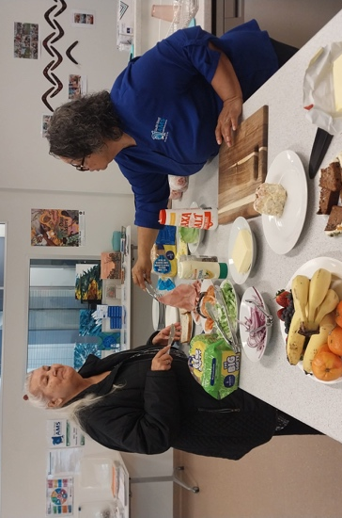 | Aunty Maria found her family through Bindjareb Aged Care  For Aunty Maria, aged care services have not only helped her at home, but it’s also reconnected her to family and loved ones.
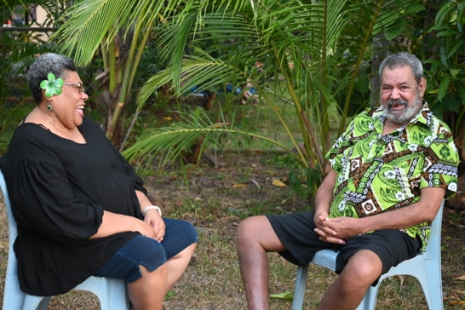 | Uncle Joseph’s aged care support helps him remain at home  In our culture and family, caring has always been reciprocal. It’s not something we see as a duty, it is simply part of our way of life.
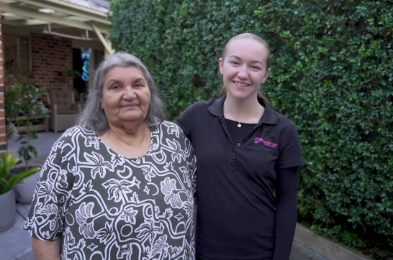 | Aunty Jenni lives independently with aged care services  For proud Bundjalung woman, Aunty Jenni it’s important she feels comfortable with people coming into her home. Aunty says the care she receives is culturally safe and supported and means she can live her life independently.

Other useful information and links
Australian Government – My Aged Care
- Information for Aboriginal and Torres Strait Islander people:
MyAgedCare.gov.au/support-aboriginal-and-torres-strait-islander-people
- Elder Care Support workers help Aboriginal and Torres Strait Islander people to get information about and access aged care services.
Visit MyAgedCare.gov.au/elder-care-support-program
- Care finders is a free service to support vulnerable people to learn about, apply for and set up support services.
Visit MyAgedCare.gov.au/help-care-finder
Australian Government Aged Care Quality and Safety Commission (ACQSC)
The ACQSC aims to protect and improve the safety, health, wellbeing and quality of life for people receiving aged care services. First Nations resources are available at AgedCareQuality.gov.au/FirstNations
National Aboriginal and Torres Strait Islander Ageing and Aged Care Council (NATSIAACC)
NATSIAACC works to ensure Elders can access support and care that is culturally safe, trauma-aware and healing-informed, and recognises the importance of their personal connections to community and Country.
Visit natsiaacc.org.au
National Aboriginal Community Controlled Health Organisation (NACCHO)
- National peak body for Aboriginal Community Controlled Health organisations across Australia. Visit naccho.org.au
- Community-led Pathways to Care and Support for Elders and older Aboriginal and Torres Strait Islander people. Visit naccho.org.au/aged-care

Older Persons Advocacy Network
- The Aged Care Advocacy Line provides free, confidential and independent support. Visit opan.org.au or call 1800 700 600.
- Aboriginal and Torres Strait Islander Legal Services (ATSILS)
- If you need it for your aged care rights or other concerns, you can get help with legal support with ATSILS. They provide free, culturally appropriate legal assistance and advice to Aboriginal and Torres Strait Islander people. Visit atsils.org.au or call (07) 3025 3888.
We welcome your feedback on these resources and their use.
You can contact us at healthcommunications@health.gov.au.

