Aunty Maria found her family through Bindjareb Aged Care
For Aunty Maria, aged care services have not only helped her at home, it’s also reconnected her to family and loved ones.
Born in Northam, Western Australia, Aunty was only 12 years old when she was forcibly removed from her family, becoming an unwilling member of the Stolen Generations. She was taken to Geraldton orphanage and then to the Home of the Good Shepherd. Aunty married the father of her four children and later remarried. When her husband passed away, she lived with her son in Pinjarra and then in Margaret River with her daughter and her family.
It was when she moved back to her ‘beloved Mandurah” that Aunty realised she might need some extra help at home. She reached out to South West Aboriginal Medical Service (SWAMS) to find out about aged care.
“I started coming into programs at SWAMS, as I knew some of the team here. Then I got an aged care assessment, and it was a bit of a wait but now I get help with things at home like cleaning, shopping and getting to appointments,” says Aunt.
“I don’t know where I’d be without the support, it’s just changed my life and brought me back to my family.”
“Getting these services makes a big difference for me. It’s a bit of a struggle to vacuum and mop. I’m on dialysis twice a week so doing things like that or doing shopping on my own, it can take it out of you. I’m so grateful for what SWAMS provides.”
It was during an aged care activity around 18 months ago when her life suddenly changed. Kerry, an Aboriginal Senior Community Support Worker at SWAMS was helping Aunty find her family members.
“It had been over 30 years since I’d seen or heard from anyone. Then, I had the biggest shock, I met one of my family members at a group session right here in the centre. We discovered that our mothers were sisters, and I got to meet four family members I’d never even met before!
“Getting aged care has brought me back to my family. Kerry and the team have helped me put my family tree together and trace my family history. It’s been a place for me to bond, and find out who I really am.”
Aunt says that she gets information when she needs and is supported to ask questions if she has any concerns.
“One of the great things about being part of aged care is getting information. I like being connected and receiving information about what is going on. If I have any trouble, I can just ring them up and they help me out.”
For many people like Aunty Maria, aged care is a place of connection and social interaction while keeping independence.
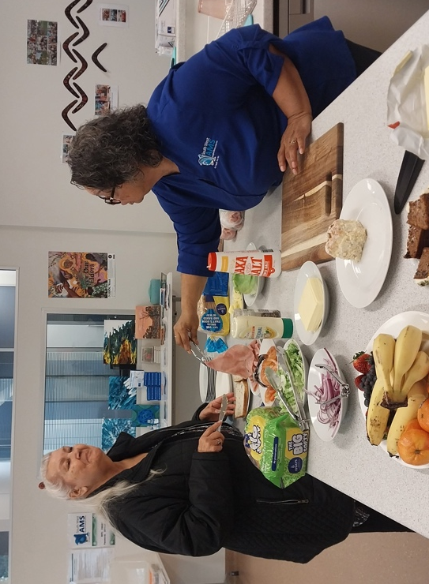
“It’s hard when you know you’re growing older, especially having dialysis and my health isn’t great. I am worried about ageing and becoming dependent on people; I’ve been independent all my life. But I wake up every morning and say my prayers. I’m a proud spiritual person, and a proud Aboriginal person. I’m doing pretty good.”
Aunty Maria is grateful for the support from aged care staff who help her along her journey.
“The staff help us so much. We have a laugh together. When something goes wrong, Kerry sings me the song, ‘how do you solve a problem like Maria?’”
For staff like Kerry, the feeling is mutual.
“We just learn so much from each other. We learn from Aunty and she learns from us,” says Kerry. “Our other clients look to Aunty for advice and help along their way. For us it’s a privilege to have Aunty here, we love it.”
Aunty Maria is encouraging mob aged 50 and over to reach out for an aged care assessment if they need support.
“If mob need some help, just ask to be assessed. Just call My Aged Care, they can come out to you at home. If there are any concerns for you, or even for your elderly parents, call them up and get an assessment. They’ll get back to you with what services you can get,” says Aunty Maria.
“I don’t know where I’d be without the support, it’s just changed my life and brought me back to my family.”

Get the support you need to age well – online, by phone or in your community.
- Speak with your local health service or Elder Care Support worker
- Visit MyAgedCare.gov.au
- Call My Aged Care on 1800 200 422
- Visit a Services Australia office

