Indigenous Australians’ Health Programme (IAHP) Primary Health Care Funding Distribution Model – Factsheet

Purpose
From 2024-25 Aboriginal Community Controlled Health Services (ACCHSs) funded through the IAHP to deliver comprehensive primary health care (CPHC) have four-year rolling funding agreements. Every two years, the department reviews each ACCHS’s funding using the Funding Distribution Model. After each review, the agreement is extended by another two years, providing longer-term funding certainty.
This factsheet explains how the Funding Distribution Model works and how the department calculates funding for each ACCHS under these rolling agreements.

Model structure
The Funding Distribution Model shares IAHP comprehensive primary health care grant funding between ACCHSs based on their level of service activity. Activity is measured using two main indicators reported each year through the Online Services Report (OSR): client numbers and episodes of care. These figures are then adjusted to reflect the cost of delivering services in different locations and the relative health needs of communities. These key terms are described in Table 1.
Table 1. Definition of Funding Distribution Model terms
Client numbers | This refers to how many individuals received health care from the ACCHS during the collection period. 1 July to 30 June would constitute one collection period. Each individual is counted as a client once regardless of how many times they are seen. Visitors and transient clients are included in client counts, but clients attending group activities only (and who do not receive individual care) are excluded. This method of counting clients is collected in the OSR.  While the IAHP’s purpose is to support ACCHSs to deliver CPHC tailored to the health needs of Aboriginal and Torres Strait Islander people, ACCHSs also deliver CPHC to non-Indigenous people. For the purposes of the Funding Distribution Model, the total number of clients that will be counted towards an ACCHS’s activity levels will be the sum of Aboriginal and Torres Strait Islander clients plus up to 15% of the overall client number (including non-Indigenous clients). The final figure will not exceed the overall number of clients reported by an organisation.  The following example uses a hypothetical ACCHS (‘ACCHS A’) to illustrate how client numbers are calculated.  Example: ACCHS A delivered care to 100 clients, comprising 79 Aboriginal and Torres Strait Islander clients (79%) and 21 non-Indigenous clients (21%). For modelling purposes, 15 of the 21 non-Indigenous clients will be added to ACCHS A’s Aboriginal and Torres Strait Islander clients, meaning ACCHS A’s total number of clients for the purposes of the Model is 15 + 79 = 94 clients.
Episode(s) of care | An Episode of Care (EoC) is a contact between an individual client and a service, with one or more staff, to provide health care within one calendar day. All contacts on the one day are treated holistically as an EoC. This is the method of counting EoC collected in the OSR.  As with the treatment of an ACCHS’s client numbers, the total number of EoC that will be counted towards the Funding Distribution Model will be the sum of Aboriginal and Torres Strait Islander EoC plus up to 15% of the overall EoC (including non-Indigenous EoC).
Adjustments | Weighting adjustments made to the client numbers and EoC to account for the cost of CPHC service delivery depending on remoteness and relative health needs of individual communities across Australia.  For remoteness, the Funding Distribution Model uses the location of service delivery based on the Remoteness Structure component of the Australian Bureau of Statistics’ Australian Statistical Geography Standard.  To estimate the relative health needs of individual communities, the Funding Distribution Model uses the service delivery location’s Indigenous Relative Socioeconomic Outcomes (IRSEO) index as a proxy. For more information see the IAHP Primary Health Care Funding Model Technical Factsheet on Location and Health Care Need.
Available grant funds | The funding distribution model distributes the IAHP grant funds available to ACCHSs funded under the rolling agreements to deliver CPHC under the Grant Opportunity GO6742. Up to $2.697 billion (GST exclusive, indexation inclusive) is available under GO6742 over four years from 2024-25.
  2024-25: | 2025-26: | 2026-27: | 2027-28: | Total
  $600.9M | $648.93M | $698.39M | $749.35M | $2.697B
Allocated funding | The actual amount of IAHP CPHC grant funds allocated to each individual ACCHO under the rolling funding agreements each year.
Model-calculated funding | An ACCHS’s model-calculated funding is determined by splitting the total funding pool for the year into two equal parts: one based on adjusted client numbers and the other on adjusted Episodes of Care (EoC). An ACCHS’s allocated funding may sit above or below this model-calculated amount.  For the first two years of the rolling agreements (2024–25 and 2025–26), the department used averaged OSR data from 2021–22 and 2022–23 to account for past COVID-related data impacts. During these years, a ±25% threshold was applied when comparing an ACCHS’s model-calculated funding to its allocated funding.  From 2026–27 onwards, the above-or-below threshold is set at 0%.

How funding is calculated under the four-year rolling agreements

Year 1 – 2024-25
Each ACCHS received its 2023-24 CPHC funding amount plus a one-off increase of 5%.

Year 2 – 2025-26
Each ACCHS received its 2024-25 funding amount, plus an additional percentage increase worked out using the Funding Distribution Model.

Years 3 and 4 – 2026-27 and 2027-28
Funding for 2026-27 and 2027-28 starts with each ACCHS’s 2025-26 funding amount. Any additional funding is pooled together as “growth” and distributed proportionally according to the Funding Distribution Model. Additional growth funding was determined during the first funding review in 2025-26.
- Where an ACCHS’s model-calculated funding is lower than its allocated funding, its funding for the next period equals is its current allocated funding plus a 1% increase.
- Where an ACCHS’s model-calculated funding is higher than its allocated funding, its funding for the next period is its current allocated funding plus a 3% increase, plus their share of growth funding.
- The size of each ACCHS share is calculated using the Funding Distribution Model and is based on adjusted client numbers and adjusted episodes of care, as described in Table 1. Definition of Funding Distribution Model terms.

Treatment of indexation under the rolling agreements
Indexation is applied to the IAHP CPHC funding pool for ACCHSs with rolling funding agreements. This is consistent with the Government’s commitment to increase the funding pool by 3% each year, including indexation.
In practice, indexation is built into ACCHSs annual funding through the 1% or 3% increase and any additional funds distributed through the model. It is not paid as a separate extra grant amount. This approach is intended to provide greater funding certainty and reduce administrative burden.

How the model is applied

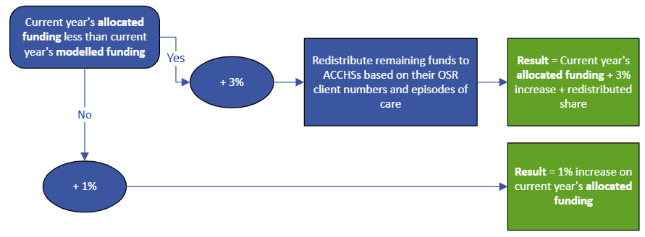
Figure 1 Illustration of the Funding Distribution Model
This figure shows how the department compares an ACCHS’s allocated funding with its model-calculated funding. ACCHSs are then grouped according to whether their allocated funding is above or below their model-calculated amount to decide the percentage increase that applies.
After the percentage increases are applied, any remaining funding is distributed only to ACCHSs whose allocated funding is below their model-calculated funding and shared between them in proportion to their model-calculated funding.
The example below shows how the Funding Distribution Model works using three ACCHSs: Orgs A, B and C. It compares each organisation’s allocated funding with its model-calculated funding.

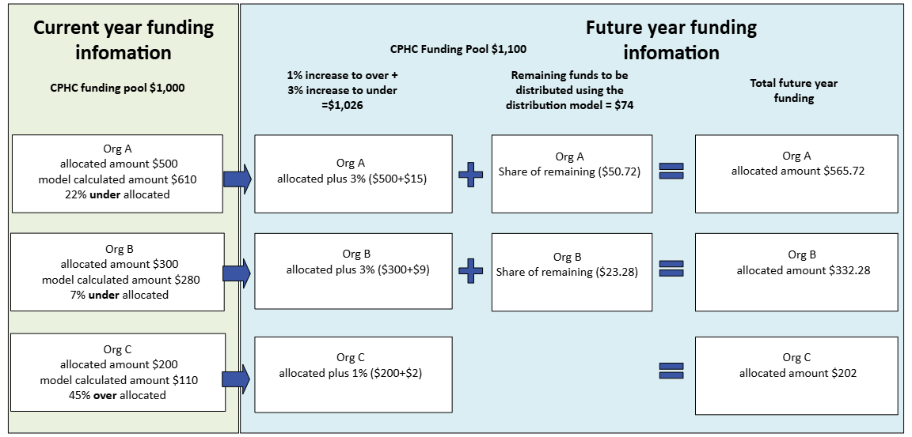
- Figure 2 Illustration of how an ACCHS’s distributed share is determined by its model-calculated funding amount ACCHS’s that are below their model-calculated funding receive a larger increase (3%) and a share of additional funding. ACCHS that are already funded above the model receive a smaller increase only (1%).
- To decide whether a 1% or 3% increase applies, the department compares each ACCHS’s allocated funding amount with its model-calculated funding:
- If an ACCHS’s model-calculated funding is lower than its allocated funding (for example Org C), its funding for the next period is its current allocated amount plus a 1% increase.
- If an ACCHS’s model-calculated funding is higher than its allocated funding amount (for example Org A and Org B), its funding for the next period is its current allocated amount plus a 3% increase, as well as a share of any remaining funds in the pool.
- In this example, the total IAHP CPHC funding available to the three ACCHSs is $1,000 in the current period and $1,100 in the next period. The funding is then worked out as follows:
  - Org A receives $500 + ($500 x 3%) + a share of the remaining funds = $515 + share
  - Org B receives $300 + ($300 x 3%) + a share of the remaining funds = $309 + share
  - Org C receives $200 + ($200 x 1%) = $202
- After these percentage increases are applied, $74 remains in the funding pool for Orgs A and B ($1100 – $515 – $309 – $202 = $74). Org C does not receive a share of the remaining funds because its model-calculated funding is lower than its allocated funding.
- The steps below show how the model calculates Org A and Org B’s shares of the remaining $74.
Org A’s share = $\frac{A^{'}s Model Calc. Amount}{A^{'}s Model Calc. Amount+B^{'}s Model Calc. Amount}× \$74=\frac{610}{610+280}×\$74=\$50.72$
Org B’s share =$\frac{B^{'}s Model Calc. Amount}{{A^{'}sModel Calc. Amount+ B}^{'}s Model Calc. Amount}× \$74=\frac{280}{610+280}× \$74=\$23.28$
- After determining Orgs A and B’s shares, the below shows their allocated funding in 2025-26:
Org A’s allocated funding = $\$500+ \left(\$500 ×3\%\right)+\$50.72=\$565.72$
Org B’s allocated funding = $\$300+\left(\$300 ×3\%\right)+\$23.28 =\$332.28$
For more information about the IAHP Funding Distribution Model, please email indigenousphcpolicy@health.gov.au

See GrantConnect GO8115
See AIHW Online Services Report

