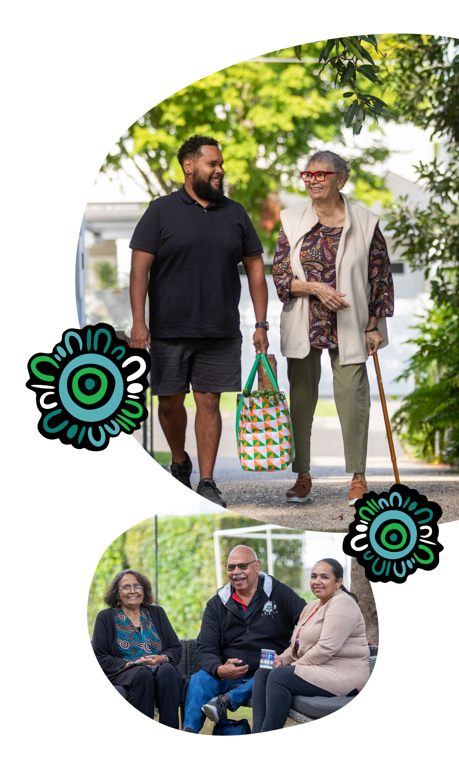
Aged care can help you age well and stay connected to family, culture, Country, Island Home and community.
Aboriginal and Torres Strait Islander people can apply for government-funded aged care services from age 50.
- Registering with My Aged Care is free.
- You don’t need to be receiving a pension to access aged care.
- Many services are free or low cost. There may be some out-of-pocket costs.
- You don’t need to be sick or wait for an emergency to get care.
Start your aged care journey your way, today.
Get the support you need to age well – online, by phone or in person.
- Speak with your local health service or Elder Care Support worker
- Visit MyAgedCare.gov.au
- Call My Aged Care on 1800 200 422
- Visit a Services Australia office

