Financial Report on the Australian Aged Care Sector

2024-25

Contents
Introduction 3
Aged care reform priorities 4
Report summary 9
1 Residential care 17
1.1 Residential care landscape 17
1.2 Capital investment 24
1.3 Financial performance 27
1.4 Financial position (balance sheet) 47
2 Home care 64
2.1 Home care landscape 64
2.2 Financial performance 66
3 Commonwealth Home Support Program (CHSP) 83
3.1 CHSP landscape 83
3.2 Financial summary 84
4 Future trends in aged care 87
4.1 Demand for aged care 87
5 Glossary 92
6 Appendices 97

Introduction
The Department of Health, Disability and Ageing (the department) is committed to transparency in aged care. The publication of financial and operational information gives valuable insights into the aged care sector.
The department publishes the Financial Report on the Australian Aged Care Sector (FRAACS) using financial information submitted by aged care providers through the Aged Care Financial Report (ACFR).
The FRAACS:
- provides transparency about the aged care sector’s finances and operations
- provides information for aged care providers to compare and benchmark their performance with sector-level results
- supports the monitoring of critical financial metrics across the aged care system
- complements other publications such as:
  - the Quarterly Financial Snapshot (QFS) of the aged care sector
  - the General Purpose Financial Report (GPFR) published by non-government residential providers (within five months of the end of their financial year)
  - registered nurse coverage in residential aged care dashboard
  - care minutes in residential aged care dashboard
  - the reporting of service-level financial and operations information on My Aged Care through the ‘Find a Provider’ tool.
The appendices in this report contain the data sources and methodology for the FRAACS. An Excel data extract containing headline figures from FRAACS reports is available on the department’s website. This extract is updated annually.
The department would like to thank aged care providers that completed the ACFR and helped to inform this FRAACS.

Aged care reform priorities
The Australian Government is continuing to develop programs and initiatives that underpin high quality and safe aged care for older people in Australia. These reforms strengthen choice and transparency for older people, their families and carers. They also improve the sustainability of the aged care sector.
Data reference: Timeframes and acronyms used in this report
Report timeframes
- Financial results presented in this report cover 1 July 2024 to 30 June 2025.
- This is the final year of aged care financial reporting prior to the commencement of the Aged Care Act 2024 (Cth) on 1 November 2025.
- Terminology in this report therefore reflects operations of residential and home care providers under the Aged Care Act 1997 (Cth).
Acronyms
- prpd (residential aged care) refers to ‘per resident per day’. Dividing sector results by the total number of residents and days allows the data to be standardised. This is calculated by the total dollar amount divided by the care payment entitlement days (as reported by Services Australia).
- pcrpd (home care) refers to ‘per care recipient per day’. This standardised result is derived by dividing sector results by the total claim days. This is calculated by the total dollar amount divided by the care payment entitlement days (as reported by Services Australia).
- pp refers to ‘percentage point’. This is the difference between two percentages, used to avoid confusion with a relative percentage change. For example, a 0.3 percentage point change is observed when a value moves from 2.0% to 2.3%.

Reform impacts on 2024-25 results
The financial and operational results published in this FRAACS show the impact of the following reforms and initiatives on aged care providers:
- Increased funding for residential aged care and in-home aged care providers to implement Fair Work Commission (FWC) decisions in the Aged Care Work Value Case (ACWVC):
  - $3.8 billion from 1 January 2025 for the Stage 3 decision, which increased the award wages for approximately 340,000 aged care workers.
  - $2.6 billion from 1 March 2025 for the aged care nurses decision, increasing award wages for approximately 60,000 enrolled and registered nurses employed in aged care.
- Consecutive increases in the Australian National Aged Care Classification (AN-ACC) price, from $253.82 to $280.01 from 1 October 2024, and to $282.44 from 1 March 2025.
- Consecutive increases to the hotelling supplement from $11.24 to $12.55 from 20 September 2024, and to $13.46 from 20 March 2025.
- An increase in mandatory care minutes responsibility requiring providers to deliver an average of 215 care minutes prpd, from 1 October 2024. This includes 44 minutes of registered nurse care, of which up to 10.0% of the registered care target can be delivered by enrolled nurses.
- An increase to the maximum room price a provider can charge without approval from the Independent Health and Aged Care Pricing Authority (IHACPA) from $550,000 to $750,000 on 1 January 2025 (with indexation to be applied annually on 1 July).
- The release of an additional 31,715 HCPs in 2024-25.
- Investment of $88.4 million in programs and initiatives from 2024-25 to attract and retain the aged care workforce. These programs focus on growing the home care workforce in regional, rural, and remote areas and supporting better pathways for nurses in aged care.

Reform impacts on future results
The department expects the following reforms and initiatives will have impacts on the financial and operational results of aged care providers in future FRAACS:
- Measures announced in response to the Aged Care Taskforce recommendationsgovernment response to the Aged Care Taskforce. They include:
  - requiring providers to retain 2.0% per year of refundable accommodation deposits (RAD) and refundable accommodation contributions (RAC) for up to five years for residents that enter care on or after 1 November 2025
  - requiring providers to index daily accommodation payments (DAP) twice per year by the consumer price index for residents that enter care on or after 1 November 2025.
- The government’s initial response to the Independent Review of Residential Aged Care Accommodation Pricing (Review). These measures will strengthen the capacity of providers to make capital investments that improve facilities for older people and respond to the growing demand for residential care. They include:
  - new capital subsidies payable to new homes and homes that significantly increase their bed numbers
  - changes to the aged care accommodation supplement, which will increase the base and higher accommodation supplements, remove base accommodation supplement tiering, add new higher accommodation supplement tiers
  - a new top up payment for homes with a 60.0% or higher supported resident ratio
  - the expansion of the Hospital to Aged Care Dementia Support program from 11 to 20 locations nationally and up to 20 additional Specialist Dementia Care Program units, and
  - greater flexibility for providers in how room prices are set.
- The implementation, from April 2026, of the new care minutes supplement, which means non-specialised residential aged care services in metropolitan (Modified Monash 1) areas only receive their full care minutes funding if they meet their care minutes targets (from quarter 2 2025-26). This change is intended to incentivise providers to meet their care minutes targets.
- Annual pricing decisions, which take account of advice from IHACPA. Consistent with government policy, AN-ACC funding and the hotelling supplement, which supports everyday living costs, will continue to be funded based on actual costs (cost-based funding model).
  - An estimated 3.3% increase in average AN-ACC funding, with the price rising to $295.64 on 1 October 2025, and adjustments to the class and base care tariff weights.
  - Increases to the hotelling supplement from 1 July 2025 to $15.60, with the hotelling supplement to be indexed annually on 20 September, following consideration of pricing advice.
- Provider preparations for the commencement of the Aged Care Act 2024 and regulatory model.
More information on aged care reform is available on the department’s website.

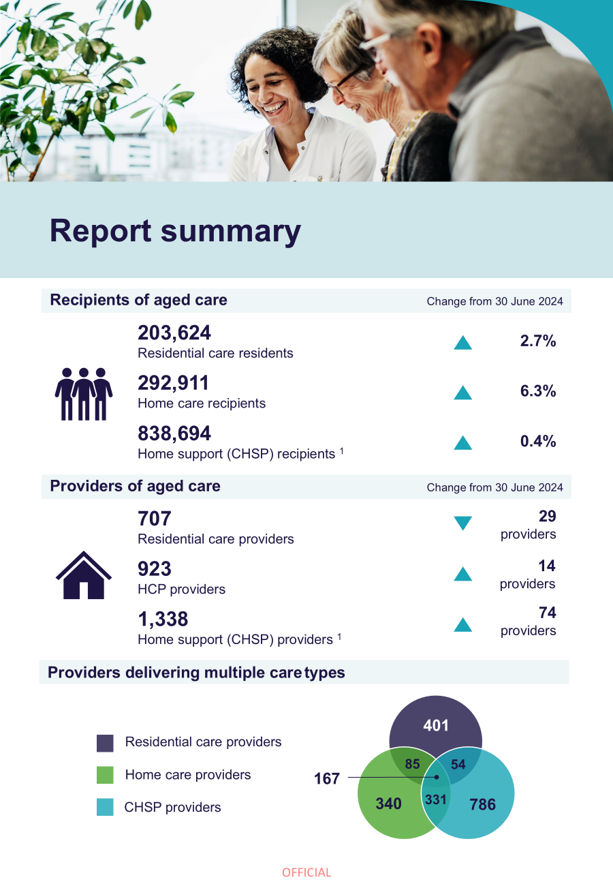
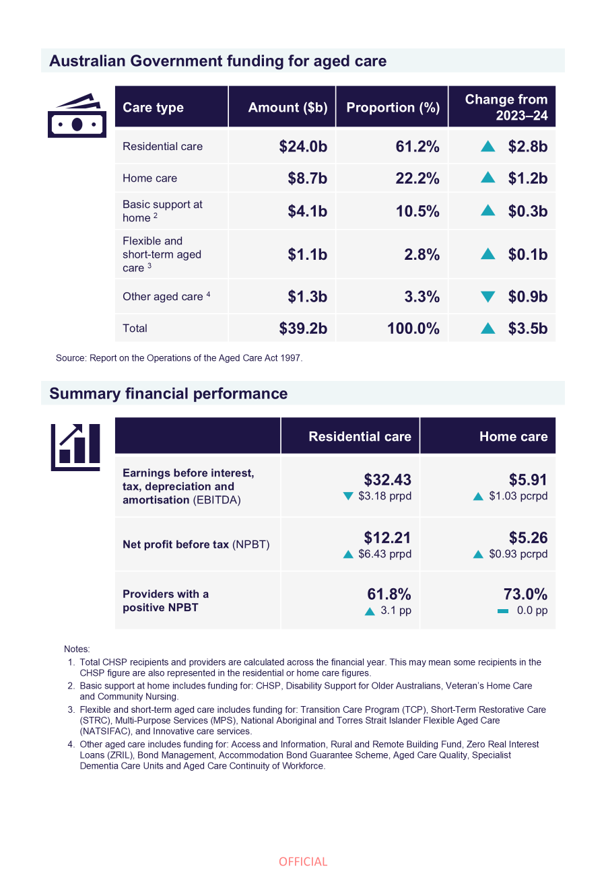

Report summary

Residential aged care

Overview of financial performance
The residential aged care sector recorded a decline in the EBITDA margin in 2024-25 when compared to 2023-24 but recorded an improvement in the NPBT margin over the same period. This was driven by a sharp decline in the sector’s non-operating (and non-recurrent) bed license amortisation expenses (explained below).
Key results include:
- EBITDA decreased by $3.18 prpd, totalling $32.43.
  - The proportion of providers reporting a positive EBITDA position was 79.6%, up 2.9 pp.
  - The EBITDA margin was 6.9%, down 1.2 pp. This means an EBITDA return of $6.90 for every $100 of revenue earned.
- NPBT performance improved by $6.43 prpd, totalling $12.21.
  - The sector NPBT was a profit of $891.5 million, up from $410.9 million.
  - The proportion of providers reporting a positive NPBT position was 61.8%, up 3.1 pp. These providers represent 66.2% of operational beds in the sector, up 14.5 pp.
- Average occupancy was 89.9%, up 1.9 pp.
- Residents received an average of 213.74 total care minutes per day in 2024-25 (0.79 minutes higher than the average target of 212.95 in 2024-25, and up 10.33 minutes from 2023-24).
- Total RADs/RACs held by providers increased from $42.2 billion at 30 June 2024 to $48.4 billion at 30 June 2025.

Key insights include:
- The sector recorded an improvement in net profit, when compared to 2023-24, due to a decline in bed license amortisation (non-recurrent) expenses. When excluding the impacts of these bed license amortisation expenses, analysis shows there would have been a decline in net profitability between 2023-24 and 2024-25.
The residential aged care sector reported a $480.6 million increase in NPBT from 2023-24 to 2024-25. This was due to the growth in sector income (9.8%) over this period exceeding the growth in expenses (8.4%), influenced by a significant decline in providers’ bed license amortisation expenses.
The increase in sector income was driven by:
- a 13.4% increase in care income on the prior year, driven by the increase in the AN-ACC price (from $253.82 to $280.01 in October 2024, and to $282.44 in March 2025)
- consecutive increases to the hotelling supplement (from $11.24 to $12.55 from 20 September 2024, and to $13.46 from 20 March 2025).
Growth in operating expenses was driven by a 13.6% increase in labour costs, and a 24.9% increase in other care expenses. Labour costs (wages and time) increased, driven by an increase in:
- wages for staff following the FWC ACWVC decisions
- direct care staff time, largely driven by care minutes requirements increasing to a sector average of 215 minutes per resident per day from October 2024 and providers’ increasing their compliance with these care minutes requirements in the second half of 2024-25.
The growth in operating expenses was offset by a decline in sector non-operating expenses. In line with the government’s decision to assign residential aged care places directly to people, since 2022-23, providers have been readjusting their treatment of bed licences as intangible assets. Most of these amortisation expenses were recorded in 2023-24 (having a larger impact on the NPBT result), with little value recorded in 2024-25 (and little impact on the NPBT result). Analysis shows that when excluding the impact of bed license write-offs, the NPBT results would have declined between the two years ($17.32 prpd in 2023-24 and $13.18 prpd in 2024-25). With bed licenses now having been amortised, future results will not be impacted by these expenses.
- Providers’ performance in accommodation and everyday living results must improve to strengthen profitability while ensuring care funding is spent on care delivery.
While the residential aged care sector’s NPBT result improved significantly in 2024-25, this was mostly attributed to an increase in government care funding and a decline in non-recurrent expenses (as above). After the apportionment of administration costs, the sector recorded a positive care result (profit of $22.34 prpd). However, the sector continued to report losses in everyday living (loss of $7.55 prpd) and accommodation (loss of $9.19 prpd).
In parallel, while there were increases to the average total care minutes and registered nurse minutes delivered across the sector in 2024-25, improvements are required to ensure compliance at the service-level. Across the sector, residents received an average of 213.74 total care minutes prpd in 2024-25 (0.79 minutes prpd higher than the target, and up 10.33 minutes from 2023-24). This included 43.10 minutes prpd delivered by a registered nurse (consistent with the target, and up 3.65 minutes from 2023-24). However, across the four quarters of 2024-25, the proportion of services who met both their total care minutes and registered nurse minutes ranged from 44.0% - 54.0%.
Together, these results indicate that care is fully funded, and providers are continuing to use care funding to cover losses in accommodation and everyday living. Going forward, it is important that providers appropriately price and earn a return from accommodation and, where applicable, everyday living services, to improve overall profitability. This will become increasingly important as AN-ACC funding is better aligned to care costs (in line with IHACPA’s cost-based funding approach).
Government reforms, including increases to the hotelling supplement and the commencement of RAD retention and DAP indexation on 1 November 2025, will support providers to improve these results in 2025-26.
- There was an increase in the average agreed room price and sector RAD holdings, driven by strong demand and supported by the increase in the maximum room price.
On 1 January 2025, there was an increase to the maximum room price that could be advertised and agreed without approval from IHACPA, from $550,000 to $750,000. This contributed to:
- an increase in the average agreed room price for new residents by 4.2%, from $451,000 in 2023-24 to $470,000 in 2024-25
- a higher increase in the total value of RADs held in the sector at 30 June 2025 (up $6.2 billion from 30 June 2024) compared to the increase in 2023-24 (up $4.6 billion from 30 June 2023).
The department will continue to measure the impacts of Taskforce reforms, including the RAD retention policy and DAP indexation policy, which came into effect on 1 November 2025.

Data reference: Residential care results in this report differ to results published in the QFS quarter 4 2024-25 due to end of year adjustments
In the Quarterly Financial Report (QFR) for quarter 4 2024-25 (which underpins the QFS report for the same period), providers reported a NPBT result of $1.1 billion ($16.04 prpd). This differs from the NPBT result reported by providers in the ACFR and presented in this FRAACS of $891.5 million ($12.21 prpd).
This difference is due to a combination of factors, including:
- end of year adjustments that were not posted at the time providers submitted their QFR (35 days after 30 June) but were posted prior to ACFR reporting (four months after 30 June).
- QFR data being prepared predominantly using data from management accounts which are unaudited (but approved by the provider’s Board). Using management accounts to inform the QFS provides a timely snapshot of the sector to support the ongoing monitoring and transparency of the sector's financial performance. The end of financial year position reported in the FRAACS captures the audited position, which takes additional time to generate but provides a fuller picture.
- the FRAACS results including the financial results of local, state, and territory (LST) government providers (who are not captured in the QFS results and on average record poorer results than for-profit and not-for-profit providers).
- the FRAACS results accounting for mergers and acquisitions between providers and the adjusted financial results for entities that report using a different financial year.

Home care

Overview of financial performance
The financial performance of the home care sector improved, with increases in both the EBITDA and NPBT margins, driven by the growth of 18.7% in income exceeding the growth of 18.2% in expenses.
Key results include:
- EBITDA increased by $1.03 pcrpd, totalling $5.91.
  - The proportion of providers reporting a positive EBITDA position was 74.9%, down 0.9 pp.
  - The EBITDA margin was 6.9%, up 0.5 pp. This means an EBITDA return of $6.90 for every $100 of revenue earned.
- NPBT performance improved by $0.93 pcrpd, totalling $5.26.
  - The total NPBT for the sector was a profit of $540.7 million, up from $423.0 million.
  - The proportion of providers reporting a positive NPBT position was 73.0%, consistent with 2023-24.
Key insights include:
- Between 2023-24 and 2024-25, growth in income exceeded growth in expenses, generating a profitable result for the home care sector.
The NPBT result for the home care sector improved for the second consecutive year in 2024-25. This follows a moderate decline in profitability between 2020-21 and 2022-23. This increase in profitability in 2024-25 was a result of growth in sector income from 2023-24 (18.7%) exceeding the growth in expenses (18.2%).
The increase in sector income was driven by a:
- 5.3% increase in claim entitlement days from 2023-24 to 2024-25, which reflects an increase in allocated HCPs
- 3.7 pp increase in use of HCPs from 82.7% in 2023-24 to 86.4% in 2024-25, which measures the proportion of the HCP entitlement used by each recipient
- 3.1% increase in the home care subsidy from 1 July 2024.
In line with this, there was a 15.0% increase in government expenditure on home care ($7.5 billion in 2023-24 to $8.7 billion in 2024-25).
The growth in expenses was primarily driven by growth in labour costs due to the associated increase in labour hours (higher claim days and utilisation) and hourly pay rates for home care workers following FWC ACWVC decisions.
- At a sector-level, income generated from delivering care management services continued to exceed care management expenses.
In 2024-25, income from care management fees represented 17.3% of total income for the sector (a small decrease from 17.7% in 2023-24). However, the sector-level cost to providers of delivering care management was only 9.6% (a decrease from 10.5% from 2023-24). These results indicate that providers may be using margins on care management services to cross-subsidise losses in other services.
Under the Support at Home program, which commenced on 1 November 2025, 10% of each participant's ongoing quarterly budget for ongoing services is allocated to the provider's care management account to fund care management. Care management funding is pooled at the service delivery branch level (place of business through which a registered provider under the Aged Care Act 2024 delivers services to an individual), together with care management funding from other participants in the same branch. This fixed 10% on care management income is intended to optimise outcomes for home care participants while ensuring every dollar is maximised to the delivery of care. It will mean providers will need to price all services reasonably, as they will no longer be able to use margins on care management to cross-subsidise losses in other services.
- The net profit results of providers who were more reliant on external care services (sub-contracted or brokered client services) continued to be impacted by poor margins on these services.
In 2024-25, the previously reported trends of increasing use of external care services and decreasing use of internal (direct care) care services, continued. This has been driven by factors including workforce shortages. Despite improving over time, the margins on the delivery of external care services have continued to run at a loss, while margins on internal (direct care) services have held broadly steady (around 27.0% - 32.0%). This means that providers who are reliant on external care services are disproportionately impacted, on average. In 2024-25, for-profit providers, who are most reliant on external care services, reported a smaller increase in NPBT results. There was a smaller impact on not-for-profit and LST government providers.
Data reference: Home care results in this report differ to results published in the QFS quarter 4 2024-25 due to end of year adjustments
In the QFR for quarter 4 2024-25, providers reported a NPBT result of $553.1 million ($5.71 pcrpd). This differs from the NPBT result reported by providers in the ACFR and presented in this FRAACS of $540.7 million ($5.26 pcrpd). This difference is due to end of year adjustments that were not posted at the time providers submitted their QFR but were posted prior to ACFR reporting. The FRAACS results also include financial results of LST government providers (who are not captured in the QFS results), account for mergers and acquisitions between providers, and adjust financial results for entities that report using a different financial year.

Commonwealth Home Support Program
Government funding for CHSP was $3.3 billion in 2024-25, an increase from $3.0 billion in 2023-24. The number of CHSP recipients increased slightly to 838,694 in 2024-25 (up from 834,981 in 2023-24), and the number of CHSP providers increased to 1,338 providers (up 74 providers from 2023-24).
CHSP providers are not required to complete the ACFR, so the FRAACS does not provide analysis on the financial performance of CHSP providers. The information in this report supports the monitoring of the CHSP market and funding only.

Future trends in aged care
Demand for aged care services continued to increase, driven by an ageing population, changes in the complexity of care needs, and economic factors.
Between 2025 and 2045, there is expected to be an increase in:
- the number of people aged 70 years and over in Australia by approximately 2.2 million people (an increase of 62.4%). During this time, the proportion of people aged 85 years and over in this cohort will increase by approximately 7.1 pp (from 17.4% in 2025 to 24.5% in 2045).
- residential aged care (permanent and respite) demand of approximately 10,400 residents per year, resulting in 412,000 people in residential aged care by 2045 (average annual growth rate of 3.6% over this time).
- home care demand of approximately 30,800 care recipients per year, resulting in 1,800,000 people seeking access to home care by 2045 (average annual growth rate of 2.1% over this time).

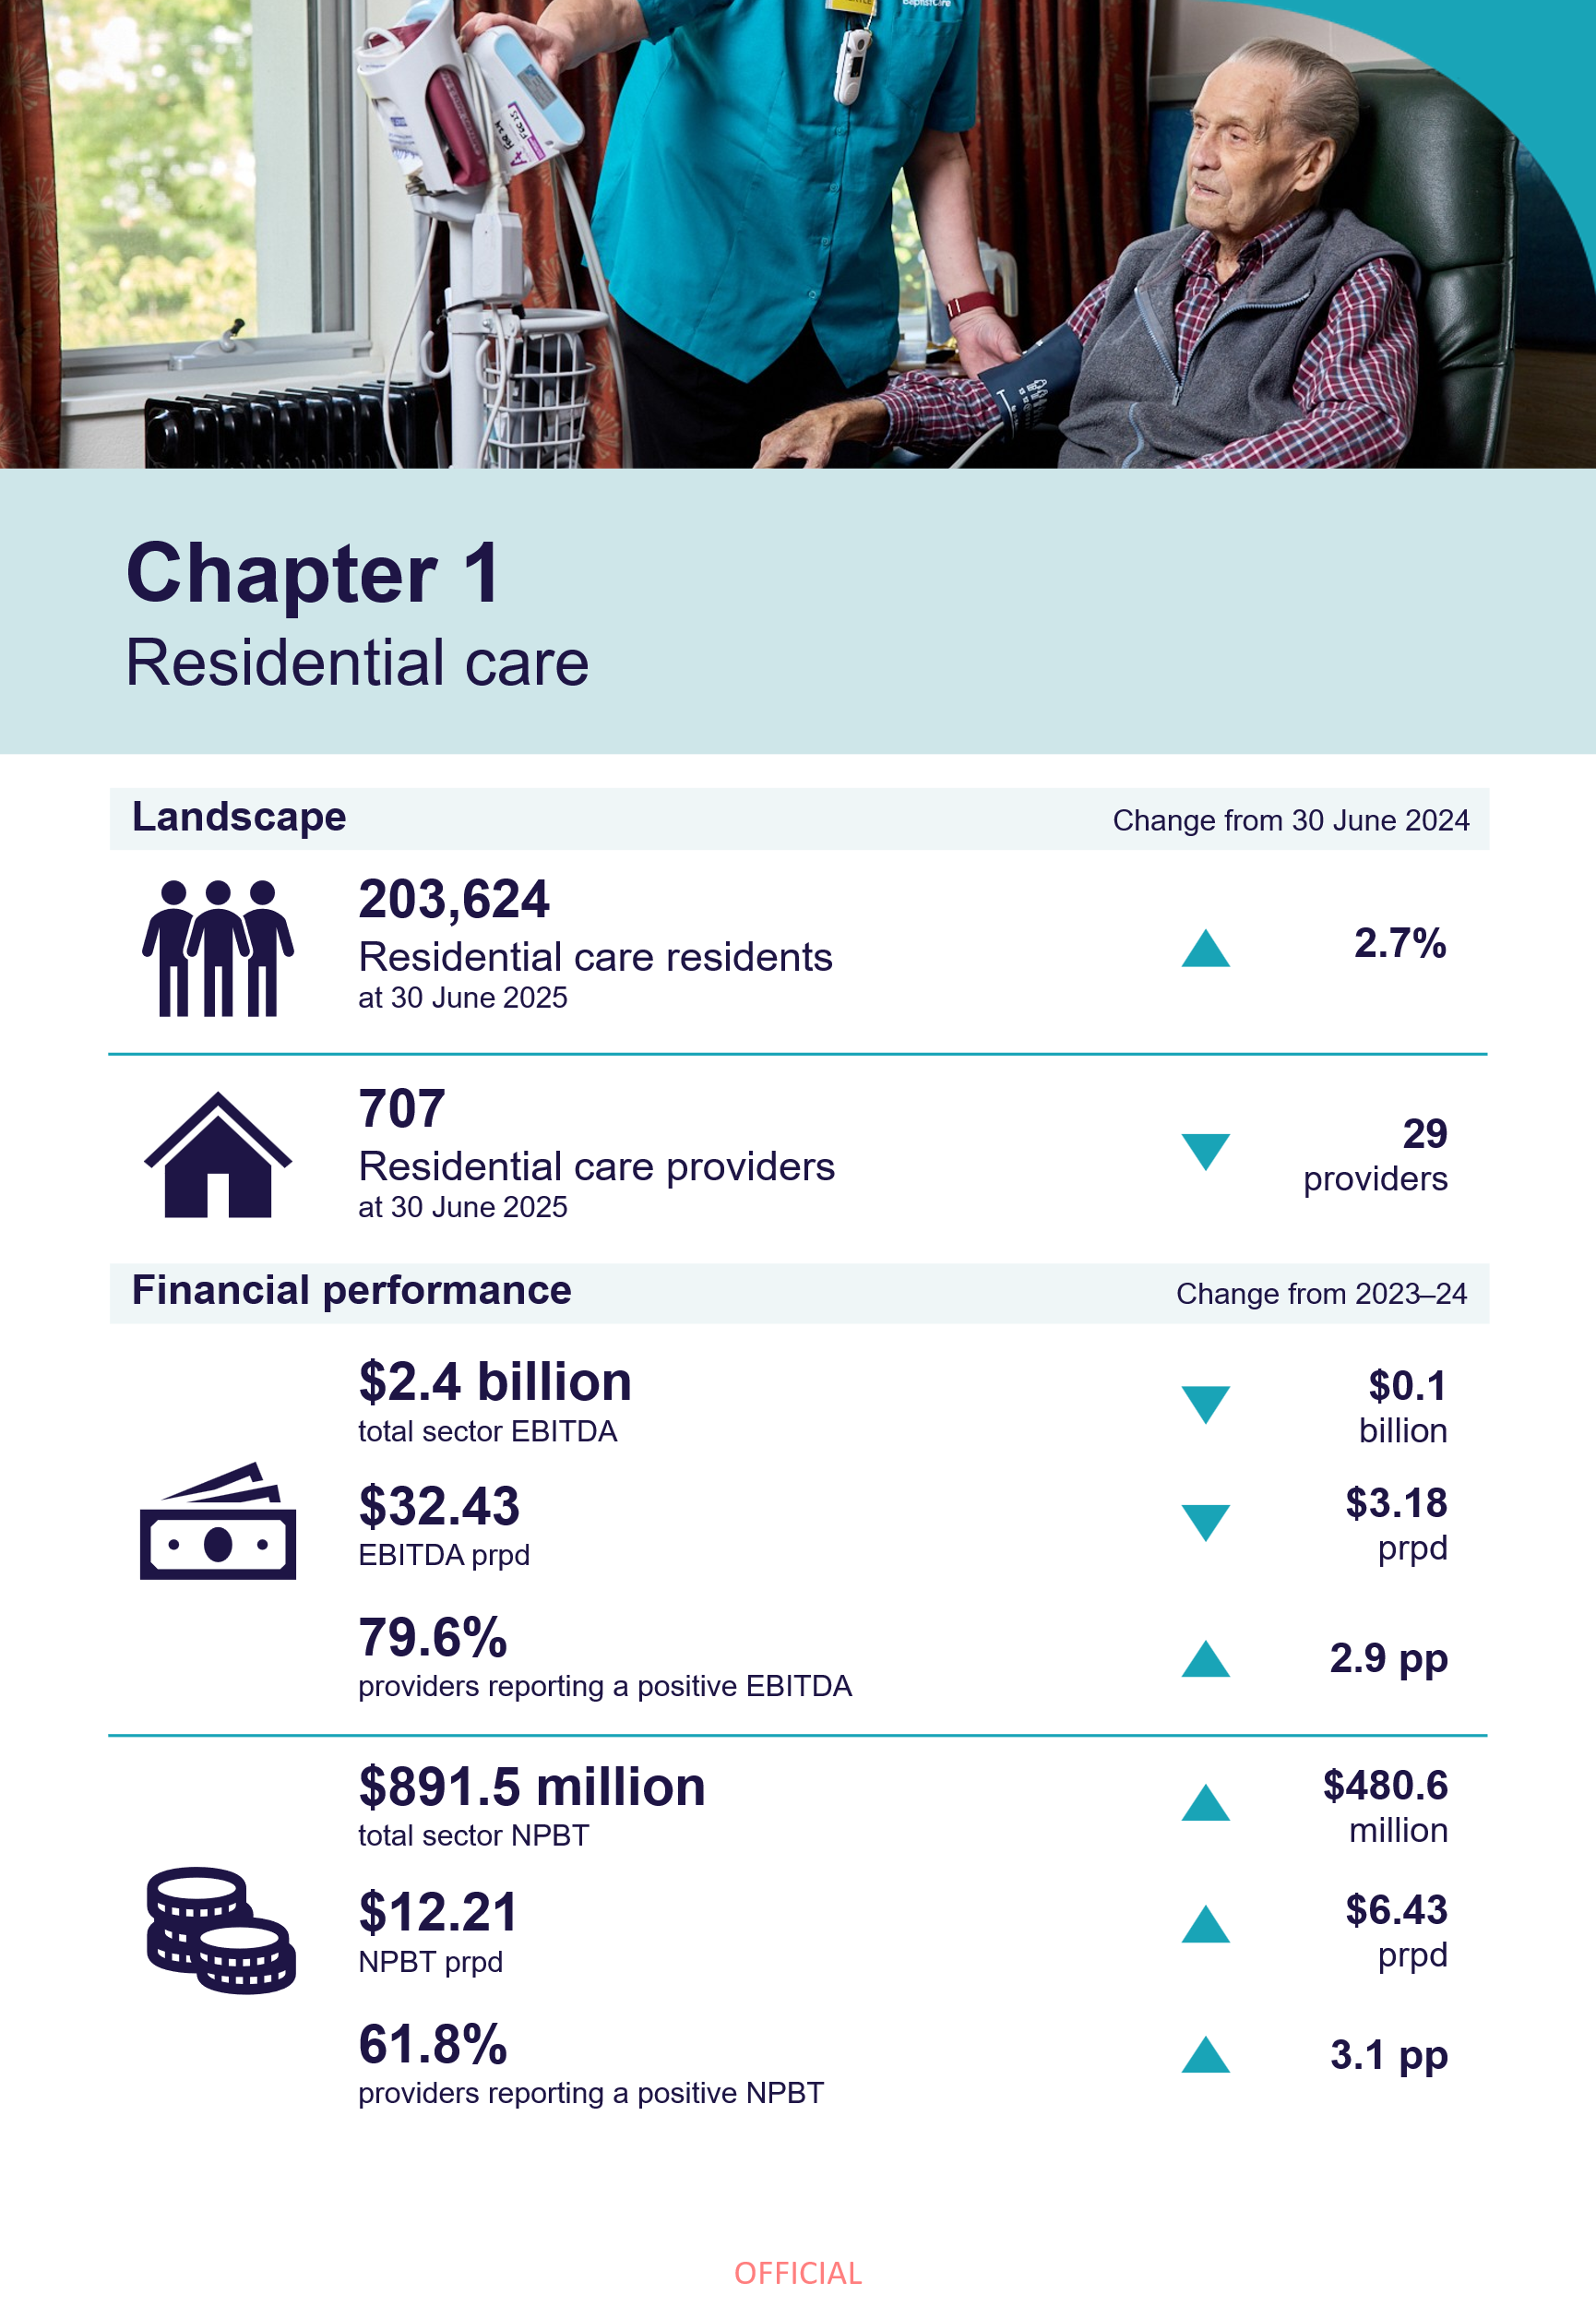

Residential care

Residential care landscape

Residential aged care residents and providers
Trends in the demographic landscape of residential aged care residents and providers, as reported in FRAACS reports from 2021-22 onwards, remained consistent in 2024-25.
These included:
 | - an increase in residential aged care resident numbers, from 198,362 residents at 30 June 2024, to 203,624 residents at 30 June 2025 (Table 1.1).
 | - a decrease in the proportion of residents who entered permanent residential care after leaving home care, from 54.4% in 2023-24, to 52.8% in 2024-25.
 | - the average length of stay in residential aged care remained consistent at 2.8 years in 2023-24 and 2024-25. The average length of stay in residential respite care was 30.9 days in 2024-25, a small increase from 30.6 days in 2023-24.
 | - a decrease in the number of residential aged care providers, from 736 at 30 June 2024, to 707 at 30 June 2025 (Table 1.2).
Data reference: Length of stay and resident exits
Refer to the 1.1 RC landscape tab in the FRAACS data extract for data on:
- average length of stay in residential aged care by gender and year of entry
- average length of stay in residential respite care
- proportion of residents that exit within 3, 6 or 12 months of first entry.

Table 1.1: Number of people in residential aged care, 30 June 2022 to 30 June 2025
 | 30 June 2022 | 30 June 2023 | 30 June 2024 | 30 June 2025
Total residents | 188,208 | 193,242 | 198,362 | 203,624
Permanent residents | 180,750 | 185,127 | 189,884 | 196,313
Respite residents | 7,458 | 8,115 | 8,478 | 7,311
Culturally and Linguistically Diverse residents | 36,192 | 37,207 | 38,968 | 40,571
Aboriginal and Torres Strait Islander residents | 2,130 | 2,235 | 2,316 | 2,409
Table 1.2: Number of providers, services, places and residents in residential aged care, by ownership, location and scale, 30 June 2025
 |  | Ownership type |  |  | Provider location |  |  | Provider scale
 | Total sector | For-profit | Not-for-profit | LST gov. | Metropolitan | Regional | Metropolitan and regional | Single services | 2 to 6 services | 7 to 19 services | 20 or more services
Total providers | 707 | 224 | 404 | 79 | 393 | 276 | 38 | 452 | 182 | 48 | 25
Services | 2,590 | 853 | 1,541 | 196 | 1,474 | 538 | 578 | 452 | 540 | 545 | 1,053
Operational places | 224,493 | 85,326 | 131,591 | 7,576 | 141,227 | 33,167 | 50,099 | 37,926 | 43,608 | 45,731 | 97,228
Total residents | 203,624 | 77,096 | 120,092 | 6,436 | 129,266 | 29,637 | 44,721 | 33,992 | 39,498 | 41,231 | 88,903
Permanent residents | 196,313 | 73,788 | 116,357 | 6,168 | 124,369 | 28,359 | 43,585 | 32,595 | 37,931 | 39,877 | 85,910
Respite residents | 7,311 | 3,308 | 3,735 | 268 | 4,897 | 1,278 | 1,136 | 1,397 | 1,567 | 1,354 | 2,993

Insights: Market consolidation in the residential care sector
Between 30 June 2024 and 30 June 2025, the number of providers in the residential aged care sector decreased by 29 (36 exits and seven entries).
Despite this decrease, service delivery increased with total claim days rising from 71.1 million to 73.0 million over the same period.
This is because the market movements were driven largely by provider consolidation, rather than true exits from the market.
The analysis of the data shows that of the providers that exited:
- 6 (16.7%) were associated with providers who had a name change between the two financial years
- 27 (75.0%) were associated with market consolidation (i.e. aged care services were transferred between existing providers)
- 3 (8.3%) were associated with market exit of a provider (i.e. aged care service is not operational).
The analysis further showed that:
- consolidation was predominantly concentrated in metropolitan areas, accounting for 66.7% of all activity
- most transactions involved services changing ownership from one for-profit provider to another for-profit provider.

Occupancy
The average occupancy rate across all residential aged care places was 89.9% in 2024-25, up from 88.0% in 2023-24 (Table 1.3). There also remained variation in occupancy levels based on the ownership type and location of providers.
LST government providers and providers in South Australia, Northern Territory, Queensland, Western Australia and Australian Capital Territory recorded occupancy levels above the average for all providers. All eight states and territories had an increase in occupancy between 2023-24 and 2024-25.
Occupancy was higher in major cities (90.4%) and decreased with rurality (76.3% in remote areas). However, providers in very remote locations experienced a large increase in occupancy, up 9.5 pp.

Table 1.3: Occupancy rates, by ownership type and geography, 2021-22 to 2024-25, with comparison to 2023-24
 | 2021-22 | 2022-23 |  | 2023-24 |  |  | 2024-25 | Change from 2023-24 (pp)
All providers | 86.2% | 86.1% |  | 88.0% |  |  | 89.9% | ▲ 1.9 pp
Ownership type
For-profit | 84.5% | 84.1% |  | 89.2% |  |  | 89.2% | ─ 0.0 pp
Not-for-profit | 87.5% | 87.8% |  | 86.7% |  |  | 85.1% | ▼ 1.6 pp
LST gov. | 84.8% | 82.7% |  | 83.7% |  |  | 90.8% | ▲ 7.1 pp
State / territory
New South Wales | 85.2% | 85.0% |  | 87.3% |  |  | 89.1% | ▲ 1.8 pp
Victoria | 83.3% | 82.8% |  | 85.5% |  |  | 88.1% | ▲ 2.6 pp
Queensland | 88.0% | 88.6% |  | 90.5% |  |  | 91.6% | ▲ 1.1 pp
Western Australia | 88.1% | 88.0% |  | 89.0% |  |  | 92.0% | ▲ 3.0 pp
South Australia | 92.2% | 92.0% |  | 92.0% |  |  | 93.1% | ▲ 1.1 pp
Tasmania | 89.2% | 88.5% |  | 88.0% |  |  | 89.1% | ▲ 1.1 pp
Australian Capital Territory | 85.3% | 87.7% |  | 89.7% |  |  | 91.4% | ▲ 1.7 pp
Northern Territory | 89.8% | 91.8% |  | 92.2% |  |  | 95.8% | ▲ 3.6 pp
Remoteness
Major cities | 85.9% | 86.2% |  | 88.3% |  |  | 90.4% | ▲ 2.1 pp
Inner regional | 87.3% | 86.0% |  | 87.7% |  |  | 89.2% | ▲ 1.5 pp
Outer regional | 86.6% | 86.5% |  | 87.5% |  |  | 88.7% | ▲ 1.2 pp
Remote | 80.3% | 77.6% |  | 78.5% |  |  | 76.3% | ▼ 2.2 pp
Very remote | 77.6% | 76.8% |  | 73.5% |  |  | 83.0% | ▲ 9.5 pp
Note: The occupancy rate is calculated by dividing the number of days of government subsidised residential care delivered in the year (as per claim entitlement days submitted to Services Australia by providers) by the number of days that government-funded aged care places were available and operational for use in the year.
The occupancy rates above are for mainstream (permanent and respite) residential aged care services only. They exclude flexible places under the National Aboriginal and Torres Strait Islander Flexible Aged Care (NATSIFAC) Program and care provided by Multi-Purpose Services (MPS). They also exclude allocated places that are not operational (due to factors including workforce shortages or redevelopments).

Care minutes
On 1 October 2024, the mandatory sector care minutes targets for residential aged care increased to an average of 215 care minutes prpd (from 200 minutes prpd), including 44 registered nurse minutes (from 40 minutes prpd). As the increases occurred after the first quarter of 2024-25, the average sector targets for 2024-25 were 212.95 total care minutes prpd and 43.10 registered nurse minutes prpd.
In 2024-25 (Chart 1.1):
- at the sector level, residents received an average of 213.74 total care minutes prpd (0.79 minutes prpd higher than the target, and up 10.33 minutes from 2023-24). This included 43.10 minutes prpd delivered by a registered nurse (consistent with the target, and up 3.65 minutes from 2023-24).
- not-for-profit providers delivered 3.22 average total care minutes prpd more than for-profit providers (214.02 and 210.80 care minutes, respectively).
- LST government providers were also considerably higher in their average care minutes delivered (243.71). These providers are also likely to have other non-Australian Government funding sources that contribute towards care delivery.
Chart 1.1: Average care minutes delivered prpd, by ownership type, 2024-25
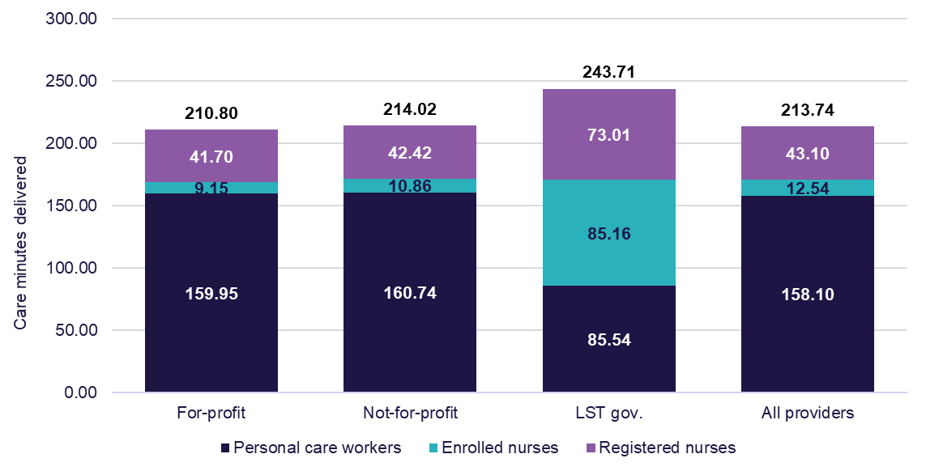
Note: Annual average care minutes reported in Chart 1.1 will differ from the published care minutes in the QFS and the Care minutes dashboard due to timing of data extraction. Quarterly data is collected at a point-in-time and is the average of the quarter. The data presented in the chart was extracted on 20 February 2026.
Insights: Care minutes compliance and new policy changes
Care profits and cross-subsidisation
Analysis of 2024-25 data, as detailed further in the Financial results by funding stream section, shows providers continued to use care margins in 2024-25 to cross-subsidise losses in everyday living and accommodation funding streams.
Chart 1.2 shows the care profit for 2024-25 based on how many quarters a service met their total care minute target in the year. These results demonstrate that services who met their total care minutes targets in all quarters still recorded a care profit, but that those who did not meet their total care minutes targets in one or more quarters recorded higher care profits. These results indicate care minutes non-compliance is a driver for funding cross-subsidisation. As AN-ACC funding is better aligned to care costs (in line with IHACPA’s cost-based funding approach), it will be critical that providers use care funding for care delivery and reduce reliance on care margins to strengthen overall profitability.
Chart 1.2: Care result prpd for services by quarterly total care minutes (CM) compliance (number of services in parentheses), by ownership type, 2024-25
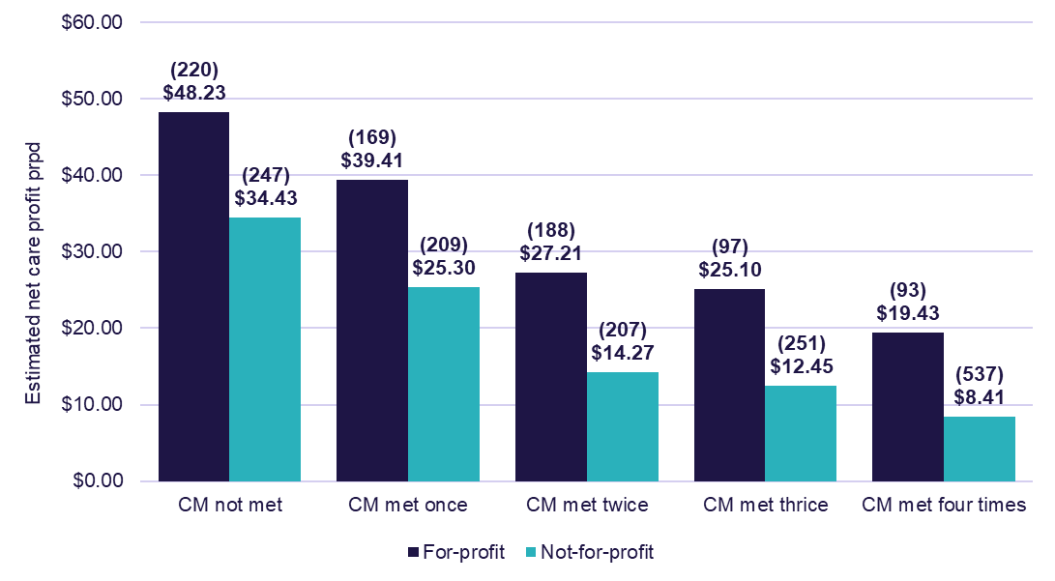
Note: Results exclude services that did not have care minutes targets and reporting for all quarters of 2024-25, such as new services, services transferred between providers, and services that went offline in 2024-25.
Care minutes policy changes
On 1 April 2026, the government formally linked care funding to the delivery of mandated care minutes for non‑specialised residential aged care homes in metropolitan areas (based on care minutes delivered from October 2025).
For‑profit providers recorded a disproportionate increase in operating expenses compared with not‑for‑profit providers in 2024-25, especially in metropolitan areas. This may indicate providers have started increasing direct care staff time to meet care minutes targets, in preparation for the commencement of this new policy.
In the 2025-26 FRAACS, the department will review the impacts of the ‘linking funding to care’ policy on provider’s compliance with care minutes requirements.

Capital investment
Monitoring expenditure on building works and capital investment in the residential aged care sector supports an understanding of the supply of residential aged care beds in the future. Capital works can be funded through multiple sources including:
- equity, including retained earnings
- loans from financial or other institutions
- interest free loans from residents in the form of RADs
- capital investment support from the government by way of capital grants
- capital endowments.
Data reference: Residential aged care building activity sources and coverage
- Data presented in the charts on the following two pages are collected from the ACFR and building approvals data from the Australian Bureau of Statistics (ABS) (Chart 1.4 only).
- Only 26.4% of residential aged care providers responded to at least one building and capital investment question in the 2024-25 ACFR.
- Additionally, categories presented are not mutually exclusive and providers may sit across categories. For example, a provider may have one service undertaking upgrades and another undertaking a rebuild.
Refer to Appendix D for the complete building activity report.

Insights: Trends in residential aged care building activity
The magnitude of capital investment in residential aged care has fluctuated over time, driven by changes in funding, sector reforms, and external events (e.g. the COVID-19 pandemic). In 2024-25, there was a 2.3% decrease in capital works completed or in-progress, compared to 2023-24 (Chart 1.3).
However, data shows that over the same period, there was a 22.8% increase on building approvals for future works (Chart 1.4). The 285 approvals is the largest figure observed over the past five years of FRAACS reporting.
Additionally, ACFR data on intentions around capital investment show that these approvals are likely focused on new builds and rebuilds (which both increased, compared to 2023-24) (Chart 1.5).

Capital works in progress or completed
In 2024-25, expenditure on completed or in-progress capital works was $4.1 billion, down 2.3% from 2023-24 ($4.2 billion) (Chart 1.3). This included expenditure on:
- new buildings of $2.5 billion (down 4.9% from 2023-24)
- rebuilds of $547.9 million (down 16.7% from 2023-24)
- upgrades of $1.1 billion (up 14.9% from 2023-24).
However, the total number of building approvals increased from 232 in 2023-24 to 285 in 2024-25 (Chart 1.4).
Chart 1.3: Building activity (completed or in-progress), 2021-22 to 2024-25
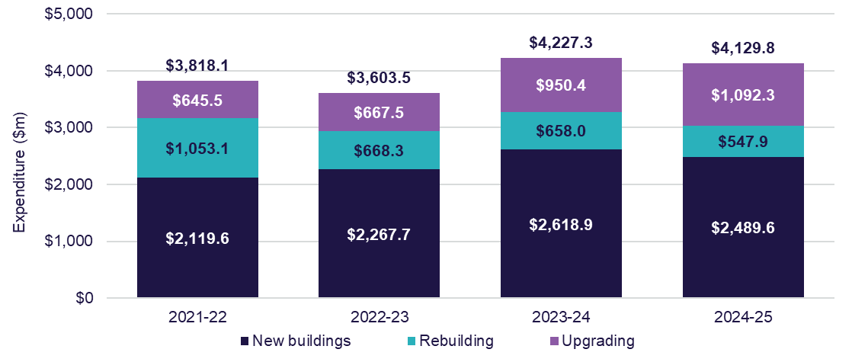
Chart 1.4: Number of building approvals, by value of work, 2021-22 to 2024-25
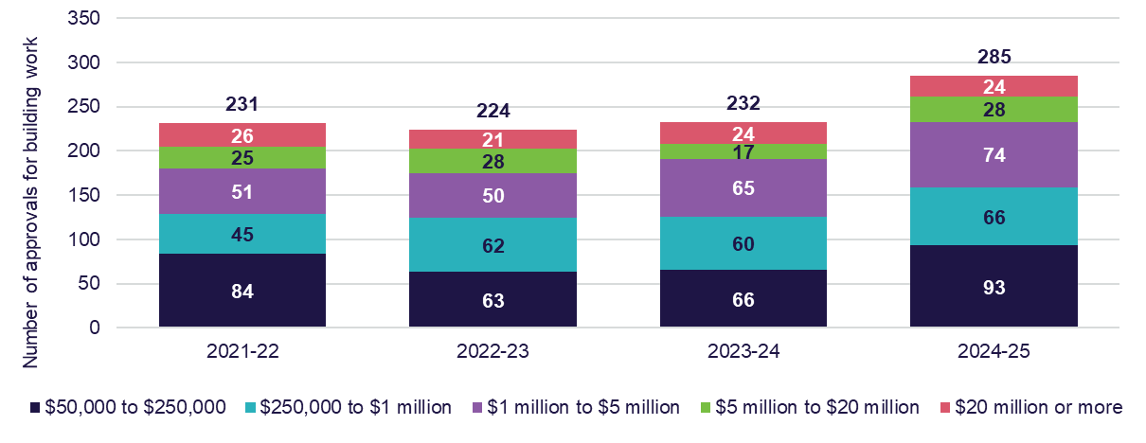

Intention to undertake capital works in the future
In 2024-25, there was an overall decline in the proportion of services planning to upgrade existing services, with 1.7% looking to do so, down 0.6 pp from 2023-24 (Chart 1.5). However, the proportion of services planning for new buildings or rebuilds increased.
Chart 1.5: Proportion of services planning to build, rebuild, or upgrade, 2021-22 to 2024-25
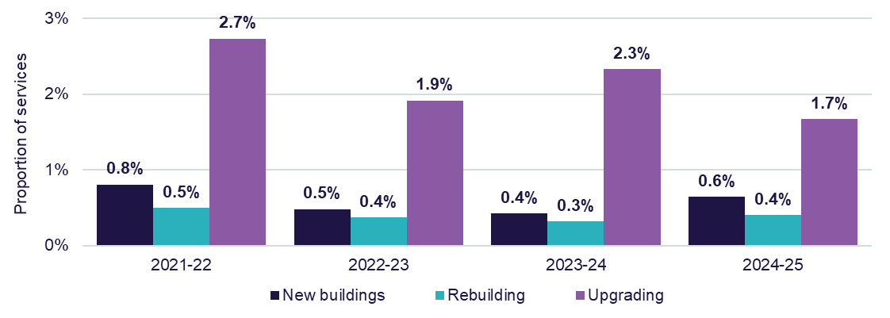

Financial performance

Sector results
After recording net losses before tax results from 2020-21 to 2022-23, the residential aged care sector recorded improvements in the NPBT results in 2023-24 and 2024-25 (Table 1.4 and Table 1.5). At a sector level:
- total income was $34.3 billion, up 9.8% from 2023-24 ($31.2 billion).
  - This was equivalent to $469.51 prpd, up 7.0% from $438.97 in 2023-24.
- total expenditure was $33.4 billion, up 8.4% from 2023-24 ($30.8 billion).
  - This was equivalent to $457.30 prpd, up 5.6% from $433.20 in 2023-24.
- total EBITDA was $2.4 billion, down 6.5% from 2023-24 ($2.5 billion).
  - This was equivalent to $32.43 prpd, down 8.9% from $35.61 in 2023-24.
  - The EBITDA margin at the sector level was 6.9%, down 1.2 pp from the 2023-24 result (8.1%).
- the NPBT result was $891.5 million, up 117.0% from 2023-24 ($410.9 million).
  - This was equivalent to $12.21 prpd, up 111.2% from $5.78 in 2023-24.
  - 61.8% of residential aged care providers reported a positive NPBT, up 3.1 pp from 58.7% in 2023-24. These providers serviced 66.2% of residents in 2024-25, up 14.5 pp from 51.7% in 2023-24.
Table 1.4: Summary of financial performance of residential aged care providers, 2021-22 to 2024-25, with comparison to 2023-24
 | 2021-22 | 2022-23 | 2023-24 | 2024-25 | Change from 2023-24
Total income ($m) | $22,074.5 | $24,239.7 | $31,216.3 | $34,282.0 | ▲ 9.8%
Total expenses ($m) | $24,338.6 | $25,976.8 | $30,805.3 | $33,390.6 | ▲ 8.4%
EBITDA ($m) | ($8.7) | $519.8 | $2,532.1 | $2,367.7 | ▼ 6.5%
NPBT ($m) | ($2,264.1) | ($1,737.1) | $410.9 | $891.5 | ▲ 117.0%
EBITDA (prpd) | ($0.13) | $7.57 | $35.61 | $32.43 | ▼ 8.9%
NPBT (prpd) | ($32.97) | ($25.31) | $5.78 | $12.21 | ▲ 111.2%
EBITDA margin | 0.0% | 2.1% | 8.1% | 6.9% | ▼ 1.2 pp
NPBT margin | (10.3%) | (7.2%) | 1.3% | 2.6% | ▲ 1.3 pp

Table 1.5: Income and expense statement prpd, 2021-22 to 2024-25, with comparison to 2023-24
 | 2021-22 | 2022-23 | 2023-24 | 2024-25 | Change from 2023-24 (%)
Income
Recurrent income
Care income | $197.80 | $219.29 | $273.39 | $301.90 | ▲ 10.4%
Everyday living income | $68.37 | $64.08 | $76.74 | $81.30 | ▲ 5.9%
Accommodation & finance income ¹ | $36.33 | $42.79 | $51.45 | $53.90 | ▲ 4.8%
COVID-19 income ² | $4.46 | $7.50 | $7.27 | - | N/A
Total recurrent income | $306.96 | $333.66 | $408.84 | $437.10 | ▲ 6.9%
Total non-recurrent  income ³ | $14.50 | $19.51 | $30.13 | $32.41 | ▲ 7.6%
Total income | $321.46 | $353.17 | $438.97 | $469.51 | ▲ 7.0%
Expenses
Recurrent expenses
Care expenses
Labour costs | $163.40 | $175.70 | $216.00 | $238.92 | ▲ 10.6%
Resident expenses ⁴ | $7.44 | $7.16 | $7.49 | $8.14 | ▲ 8.7%
Other care expenses ⁵ | $7.61 | $8.32 | $10.80 | $13.13 | ▲ 21.6%
Total care expenses | $178.44 | $191.19 | $234.28 | $260.20 | ▲ 11.1%
Everyday living expenses
Catering | $34.48 | $37.14 | $40.45 | $41.74 | ▲ 3.2%
Cleaning | $10.48 | $10.72 | $11.24 | $12.17 | ▲ 8.3%
Laundry | $4.53 | $4.64 | $5.07 | $6.12 | ▲ 20.6%
Other everyday living expenses | $8.71 | $9.35 | $10.09 | $10.53 | ▲ 4.4%
Total everyday living expenses | $58.20 | $61.85 | $66.86 | $70.56 | ▲ 5.5%
Accommodation & finance expenses
Routine maintenance | $9.50 | $11.24 | $11.83 | $12.38 | ▲ 4.6%
Financing interest | $1.30 | $1.58 | $1.39 | $1.81 | ▲ 29.9%
Depreciation, rent & others | $40.39 | $31.17 | $30.91 | $32.53 | ▲ 5.3%
Total accommodation & finance expenses | $51.19 | $43.99 | $44.12 | $46.72 | ▲ 5.9%
Administration expenses
Corporate recharge | $22.27 | $23.74 | $24.89 | $27.81 | ▲ 11.7%
Labour costs | $11.41 | $11.57 | $13.28 | $13.57 | ▲ 2.2%
Other administration | $9.34 | $10.28 | $12.16 | $12.64 | ▲ 4.0%
Total administration expenses | $43.02 | $45.59 | $50.32 | $54.03 | ▲ 7.4%
COVID-19 expenses ² | $10.83 | $6.69 | $3.15 | - | N/A
Total recurrent expenses | $341.68 | $349.30 | $398.74 | $431.50 | ▲ 8.2%
Total non-recurrent expenses ³ | $12.75 | $29.17 | $34.46 | $25.80 | ▼ 25.1%
Total expenses | $354.43 | $378.47 | $433.20 | $457.30 | ▲ 5.6
Recurrent result | ($34.72) | ($15.65) | $10.11 | $5.60 | ▼ 44.7%
Non-recurrent result | $1.75 | ($9.66) | ($4.33) | $6.61 | ▲ 252.7%
NPBT | ($32.97) | ($25.31) | $5.78 | $12.21 | ▲ 111.2%
Notes:
- The respite supplement was re-classified from care to accommodation from 2023-24 to align it with its purpose of funding accommodation costs.
- From 2024-25, income and expenses associated with COVID-19 or other outbreaks have been removed as standalone items in the ACFR. Associated income and expenses are captured across remaining items as appropriate. AN-ACC funding will include outbreak management funding from 1 October 2025.
- Non-recurrent income and expenses are those which are not related to core business activities and occur irregularly. Examples of non-recurrent income include gains from the sale of assets, asset revaluations, and donations. Examples of non-recurrent expenses include fair value losses on assets and amortisation or impairment of bed licenses.
- Resident expenses include items such as resident medication, oxygen and related equipment, treatments and procedures, incontinence aids, items that assist mobility, recreation and social activities, rehabilitation support, personal grooming and specific cultural and social events.
- Other care expenditure relates to the direct costs incurred in providing care for residents within residential care services. Labour costs include payments made to nurses, therapists, nutritionists, care managers, health assistants and support staff.
Data reference: Residential aged care income statement
Refer to 1.3 RC results (sector) tab in the FRAACS data extract for the complete income statement for the residential aged care sector.
Insights: Profit measures for the sector
EBITDA, NPBT, and recurrent margins are all profitability measures, which can be used to answer different questions about financial performance.
Unlike the home care sector, residential aged care providers operate in a capital-intensive environment, which can result in large impacts on their non-recurrent and non-operating costs, and consequently, their profitability measures.
- EBITDA margin shows how profitable a residential aged care provider’s core operations are before the effects of financing, tax, and capital structure. It focuses on whether the day-to-day delivery of care and services is generating sufficient operating cash, making it useful for comparing providers with different property ownership models, debt levels, or RAD/DAP mixes. In aged care, EBITDA margin is often used by operators, lenders, and valuers to assess operational performance independent of how the business is funded.
- Recurrent margin represents the underlying or ongoing profitability of a provider by excluding one-off or abnormal items such as donations or asset revaluations. In residential aged care, recurrent margins are used to understand what the business is likely to earn in a typical, steady-state year, once short-term funding changes and unusual events are stripped out. This margin helps boards, investors, and policymakers assess ongoing sustainability rather than short term volatility.
- NPBT margin reflects the provider’s overall accounting profitability before tax after all costs are considered, including depreciation of buildings and equipment and interest on borrowings. In the residential aged care sector, this margin indicates whether the business is economically viable in the long term, as it captures the full financial impact of asset intensity and financing decisions. Because aged care involves significant property costs, NPBT margins are often much lower than EBITDA margins and can be negative even when operations appear sound.
Table 1.6 below shows the EBITDA, NPBT, and recurrent margins for the residential aged care sector from 2021-22 to 2024-25. Calculation methods for these measures can be found in the Glossary.
Table 1.6: EBITDA, NPBT, and recurrent margins, 2020-21 to 2024-25
 | 2021-22 | 2022-23 | 2023-24 | 2024-25
EBITDA margin | 0.0% | 2.1% | 8.1% | 6.9%
NPBT margin | (10.3%) | (7.2%) | 1.3% | 2.6%
Recurrent margin | (11.3%) | (4.7%) | 2.5% | 1.3%

Insights: Drivers of improved profitability
In 2024-25, overall sector profitability improved due to continued increases in income (9.8%) exceeding increases in expenses (8.4%).
Growth in income was driven by:
- a 13.4% increase in care income on the prior year. Care income increased due to the change in AN-ACC subsidies (from $253.82 to $280.01 in October 2024, to $282.44 in March 2025)
- consecutive increases to the hotelling supplement (from $11.24 to $12.55 from 20 September 2024, and to $13.46 from 20 March 2025).
Growth in expenses was driven by a 13.6% increase in labour costs, and a 24.9% increase in other care expenses. Labour costs (wages and time) increased following the FWC ACWVC decisions and increasing compliance with care minutes and 24/7 registered nurse requirements.

Financial results by funding stream
Methodology: Apportionment of administration expenses
From the 2023-24 FRAACS, administration expenses incurred by providers have been apportioned (split) by funding stream (care, everyday living, and accommodation).
The costs have been apportioned at service (facility) level in a method consistent with that adopted by IHACPA in its costing studies and then aggregated to the sector level. The method involves apportioning:
- corporate recharge costs to the care, everyday living and accommodation streams (with allocation based on the proportion of these expenses of the total care, everyday living and accommodation expenses)
- remaining administration costs are split equally into everyday living and accommodation streams.
All previous figures are available in the 1.3 RC results (sector) tab in the FRAACS data extract.

In 2024-25, residential care providers reported an average net profit of $12.21 prpd, an improvement from 2023-24 ($5.78 prpd). The sections below report the financial results by funding stream for 2024-25, with detail provided in Figure 1.1. The total administration cost was $54.03 prpd in 2024-25 (up from $50.32 in 2023-24).
The results demonstrate that the cost of delivering care is fully funded, and providers are continuing to use care margins to offset losses in everyday living and accommodation. Going forward, it is important that providers appropriately price and earn a return from accommodation to improve overall profitability. This will become increasingly important as AN-ACC funding is better aligned to care costs (in line with IHACPA’s cost-based funding approach).

Care result
The sector care result in 2024-25 was a profit of $22.34 prpd (up from $22.03 in 2023-24), which results in a profit margin of 7.4% (down from 8.1% in 2023-24). This includes administration allocation of $19.36 prpd (up $2.28 from 2023-24).
The main driver for growth in the care result was the growth in care income (up $28.51 prpd from 2023-24), which outgrew care expenses (up $25.92 from 2023-24). Growth in care income was mainly attributed to the increase in AN-ACC funding. Conversely, the growth in care expenses is mainly driven by increases in labour costs following the FWC ACWVC decisions and increase in care minute targets.
While the care result improved, the care margin declined slightly due to the growth in care expenses (as above) and an increase in the administration cost allocation in 2024-25.

Everyday living result
The sector everyday living result in 2024-25 was a loss of $7.55 prpd (up from a loss of $7.61 in 2023-24), which results in a loss margin of 9.3% (up from 9.9% in 2023-24). This includes administration allocation of $18.29 prpd (up $0.80 from 2023-24).
The main driver for growth in the everyday living result (without administration allocation) was the growth in everyday living income (up $4.56 prpd from 2023-24), which outgrew everyday living expenses (up $3.70 from 2023-24).

Accommodation result
The sector accommodation result in 2024-25 was a loss of $9.19 prpd (down from a loss of $8.44 in 2023-24), which results in a loss margin of 17.1% (down from 16.4% in 2023-24). This includes administration allocation of $16.38 prpd (up $0.62 from 2023-24).
The main driver for the decline in the accommodation result (without administration allocation) was the growth in accommodation expenses (up $2.60 prpd from 2023-24), which outgrew accommodation income (up $2.45 from 2023-24).

Non-recurrent income and expenses
The average sector non-recurrent result in 2024-25 was a profit of $6.61 prpd (up from a loss of $4.33 in 2023-24). There was no allocation of administration expenses for this category. Non-recurrent expenses include bed license amortisation, of which there were expenses of $0.97 prpd in 2024-25 (down from $11.54 in 2023-24).
Insights: Impact of bed license write-off expenses on NPBT
In line with the government’s decision to assign residential aged care places directly to people in the May 2021 Federal Budget, residential aged care providers were required to amortise all bed license assets by 1 July 2024. This ‘places to people’ policy aims to give older people increased choice and control over which residential aged care home delivers their services.
Providers were originally required to amortise bed licenses by 1 July 2024, with a deferral to 1 July 2025 later announced to support alignment with the implementation of the Aged Care Act 2024. This shift in timing meant that most providers wrote off the bulk of their bed licenses in 2023-24 ($820.8 million or $11.54 prpd), which left limited additional write-offs in 2024-25 ($70.6 million or $0.97 prpd). As bed license amortisation expenses are non-operating expenses, the greater expense impacts (decreases) the sectors NPBT result.
Provider reporting shows that NPBT results were largely written down in 2023-24, with minimal impact on the 2024-25 results (NPBT of $5.78 prpd in 2023-24, compared to $12.21 in 2024-25). However, when excluding the impact of bed license write-offs, the NPBT results would have declined over the two years ($17.32 prpd in 2023-24, and $13.18 in 2024-25). With all bed licenses now having been amortised, future net profit results will not be impacted by these expenses, though comparisons to 2024-25 results will be impacted to a small extent.

Figure 1.1: Summary of financial performance, income and expense category comparison, prpd, all providers, 2024-25
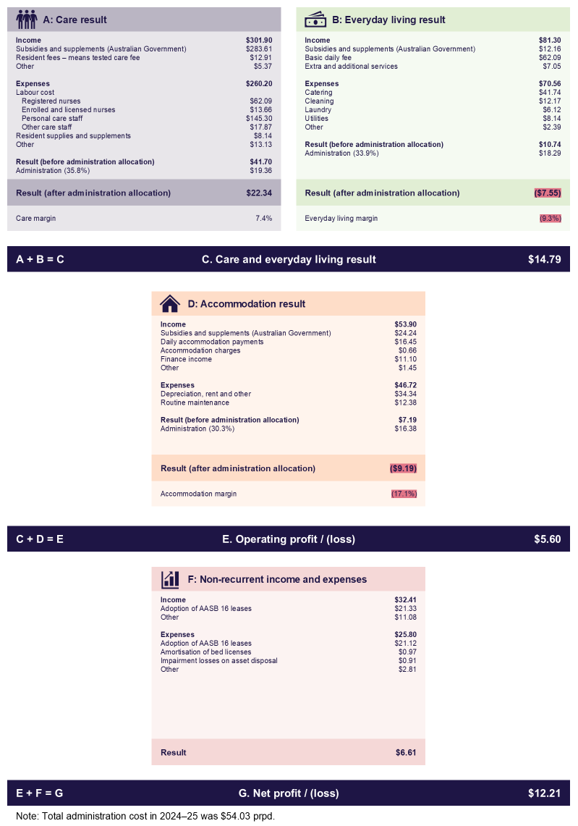

Revenue by funding source
Residential care provider revenue is predominantly received in the form of government subsidies and supplements and resident contributions. Of sector revenue in 2024-25 (Table 1.7):
- 68.6% was from the government (up 0.5 pp from 2023-24).
- 21.4% was from resident contributions (down 0.4 pp from 2023-24).
- 10.0% was from other income sources (including financing income, imputed interest on RADs, and asset revaluation).

Table 1.7: Residential aged care provider income sources, 2021-22 to 2024-25, with comparison to 2023-24 ¹
 |  | 2021-22 ($m) | 2022-23 ($m) | 2023-24 ($m) | 2024-25 ($m) | Change from 2023-24 (%)
Australian Government funding |  | $14,961.5 | $16,047.2 | $21,276.8 | $23,521.5 | ▲ 10.5%
Care | Basic care subsidy | $11,883.4 | $13,038.8 | $17,068.6 | $19,503.4 | ▲ 14.3%
Care | Respite subsidy | $501.0 | $681.5 | $692.9 | $790.2 | ▲ 14.0%
Care | Other supplements | $138.6 | $121.3 | $358.9 | $390.7 | ▲ 8.9%
Everyday living | Hotelling supplement ² | $661.0 | $165.3 | $751.3 | $887.9 | ▲ 18.2%
Everyday living | Other supplements | $16.6 | $17.2 | $19.8 | $24.0 | ▲ 21.2%
Accommodation | Accommodation supplement | $1,323.2 | $1,394.3 | $1,526.2 | $1,576.1 | ▲ 3.3%
Accommodation | Respite supplement ³ | - | - | $188.4 | $194.0 | ▲ 3.0%
Accommodation | Capital grants | $131.7 | $114.1 | $153.7 | $155.2 | ▲ 0.9%
Other | COVID-19 funding ⁴ | $306.1 | $514.7 | $517.0 | - | N/A
Resident contributions |  | $5,578.5 | $6,135.2 | $6,812.1 | $7,334.5 | ▲ 7.7%
Care | Means tested care fees | $678.6 | $793.1 | $893.7 | $943.0 | ▲ 5.5%
Care | Resident other care fees | $113.7 | $143.1 | $159.7 | $131.9 | ▼ 17.4%
Accommodation | Resident accommodation payment | $833.5 | $1,019.5 | $1,112.1 | $1,250.0 | ▲ 12.4%
Everyday living | Resident basic daily fee | $3,651.1 | $3,853.9 | $4,238.2 | $4,533.7 | ▲ 7.0%
Everyday living | Additional services fee | $176.0 | $200.9 | $267.9 | $324.2 | ▲ 21.0%
Everyday living | Extra services fees | $125.6 | $124.7 | $140.5 | $151.8 | ▲ 8.0%
Other income sources |  | $1,534.5 | $2,057.3 | $3,127.4 | $3,426.1 | ▲ 9.5%
Other | Other funding sources ⁵ | $1,534.5 | $2,057.3 | $3,127.4 | $3,426.1 | ▲ 9.5%
Total | Total income | $22,074.5 | $24,239.7 | $31,216.3 | $34,282.0 | ▲ 9.8%

Notes (Table 1.7):
- Figures published in the table are from the 2024-25 ACFR and may vary from those published in the 2024-25 Report on the Operations of the Aged Care Act 1997.
- The hotelling supplement replaced the Basic Daily Fee supplement from 2021-22.
- Respite supplement was re-classified from care to accommodation from 2023-24.
- From 2024-25, income and expenses associated with COVID-19 or other outbreaks have been removed as standalone items in the ACFR. Associated income and expenses are captured across remaining items as appropriate. AN-ACC funding will include outbreak management funding from 1 October 2025.
- Other funding includes finance income, subsidies and supplements from state/territory governments, interest from accommodation bonds, and non-recurrent income.
In 2024-25, the average NPBT result prpd continued to vary considerably across the sector, with results in all four quartiles improving from 2023-24. The average NPBT for providers in the top quartile was $101.64 prpd, up 24.3% from $81.77 in 2023-24 (Chart 1.6). These providers serviced 11.4% of residents in 2024-25. Comparatively, in 2024-25, the average NPBT for providers in the bottom quartile was a loss of $42.54 prpd, up 22.4% from a loss of $54.79 in 2023-24. These providers serviced 17.9% of residents in 2024-25.
Chart 1.6: Residential aged care average NPBT prpd, by quartile (number of providers in parentheses), 2021-22 to 2024-25
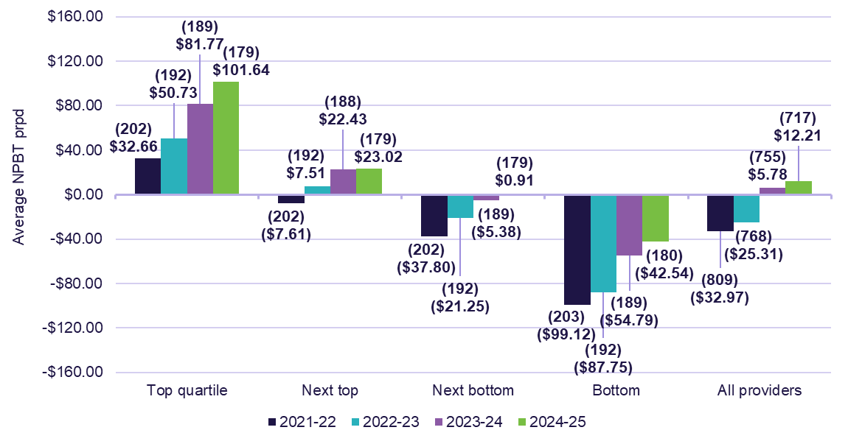
Data reference: Residential aged care income statement
Refer to 1.5 RC results (quartile) tab in the FRAACS data extract for the complete income statement for the residential aged care sector by quartiles.

Results by provider ownership type, location, and scale
Data reference: Impacts of bed license amortisation expenses on results by ownership type, location, and scale
The results for residential aged care providers by ownership type, location, and scale, as presented in the tables and charts below, have been impacted by bed license amortisation expenses.
As outlined in the insight box on page 33, these expenses predominantly impacted NPBT results in 2023-24, with minimal impact in 2024-25. This can be seen in the change in results between the two years in the charts.

Provider ownership type
NPBT results continued to vary by provider type, driven by differences in expenses (noting that all providers experienced improvements in AN-ACC income). For-profit providers, who experienced a net loss in 2023-24 due to significant non-recurrent expenses (bed license amortisation expenses), recorded an improvement in NPBT. In comparison, not-for-profit and LST government providers saw a decline, due to comparatively lower non-recurrent expenses in 2023-24. The decline in NPBT result for LST government providers was also affected by a one-off $75.3 million asset revaluation increase on aged care buildings from a provider (conducted by an external valuer) in 2023-24, giving the appearance of a decline in 2024-25, as there was no further fair value gain and asset revaluation.
When reviewing NPBT results by ownership type (Table 1.8 and Table 1.9):
- for-profit providers reported a significant increase in profitability, up from a loss of $2.27 prpd in 2023-24, to a profit of $22.44 prpd in 2024-25 (up $24.71).
- not-for-profit providers reported a decrease in NPBT, down from $9.95 prpd 2023-24, to $6.35 in 2024-25 (down $3.60).
- LST government providers reported a large decrease in NPBT, down from $31.62 in 2023-24 to $1.69 in 2024-25 (down $29.93).
  - LST government providers reported a significantly higher care income than for-profit and not-for-profit providers. This is mainly due to LST government providers receiving more funding ($93.18 prpd) from state and territory governments, while for-profit providers received $0.08 prpd, and not-for-profit providers received $0.90.
Table 1.8: Financial performance of residential aged care providers, by ownership type, 2024-25
 | Sector | For-profit | Not-for-profit | LST gov.
Total income ($m) | $34,282.0 | $12,897.8 | $19,979.6 | $1,404.7
Total expenses ($m) | $33,390.6 | $12,285.8 | $19,704.0 | $1,400.7
EBITDA ($m) | $2,367.7 | $1,055.4 | $1,246.3 | $66.0
NPBT ($m) | $891.5 | $611.9 | $275.6 | $4.0
EBITDA (prpd) | $32.43 | $38.70 | $28.72 | $28.06
NPBT (prpd) | $12.21 | $22.44 | $6.35 | $1.69
EBITDA margin | 6.9% | 8.2% | 6.2% | 4.7%
NPBT margin | 2.6% | 4.7% | 1.4% | 0.3%
Table 1.9: Summary income and expense statement prpd, by ownership type, 2024-25
 | Sector | For-profit | Not-for-profit | LST gov.
Income
Recurrent income
Care income | $301.90 | $290.76 | $302.29 | $423.87
Everyday living income | $81.30 | $84.07 | $79.96 | $73.79
Accommodation & finance income | $53.90 | $54.86 | $53.12 | $57.28
Total recurrent income | $437.10 | $429.69 | $435.37 | $554.93
Total non-recurrent income | $32.41 | $43.24 | $25.09 | $42.02
Total income | $469.51 | $472.93 | $460.45 | $596.95
Expenses
Recurrent expenses
Care expenses | $260.20 | $244.00 | $265.42 | $351.69
Everyday living expenses | $70.56 | $66.01 | $71.90 | $98.47
Accommodation & finance expenses | $46.72 | $51.16 | $42.35 | $75.83
Administration expenses | $54.03 | $51.12 | $55.16 | $66.95
Total recurrent expenses | $431.50 | $412.29 | $434.83 | $592.94
Total non-recurrent expenses | $25.80 | $38.20 | $19.28 | $2.32
Total expenses | $457.30 | $450.49 | $454.10 | $595.26
Recurrent result | $5.60 | $17.40 | $0.54 | ($38.01)
Non-recurrent result | $6.61 | $5.04 | $5.81 | $39.70
NPBT | $12.21 | $22.44 | $6.35 | $1.69
In 2024-25, the average NPBT results improved for for-profit providers from 2023-24, while not-for-profit and LST government providers saw a decline (Chart 1.7). When considering the average NPBT results by quartile (Chart 1.8):
- in the top quartile, LST providers ($318.47 prpd) outperformed for-profit ($97.93) and not-for-profit providers ($89.74).
- in the bottom quartile, however, LST providers recorded the largest loss for average NPBT (loss of $70.42 prpd) compared to for-profit providers (loss of $55.30) and not-for-profit providers (loss of $36.93).
For-profit providers had a relatively even proportion of providers across the top two quartiles (30.5% for the top quartile and 29.6% for the next top quartile), and a minority were in the bottom quartile (14.6%). Not-for-profit providers’ proportions were also relatively even in each quartile range, with the highest proportion being in the next bottom quartile (26.9%). However, despite LST government providers recording the strongest NPBT performance within the top quartile, majority of these providers sit in the bottom quartile (51.9%).
Chart 1.7: Residential care average NPBT prpd, by ownership type, 2021-22 to 2024-25
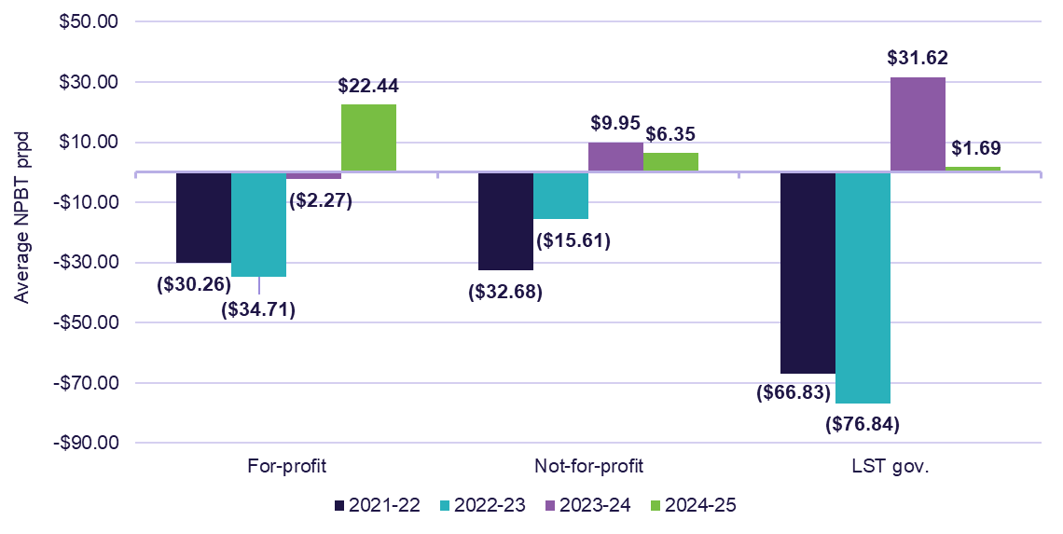

Chart 1.8: Residential care average NPBT prpd, by quartile and ownership type (number of providers in parentheses), 2024-25
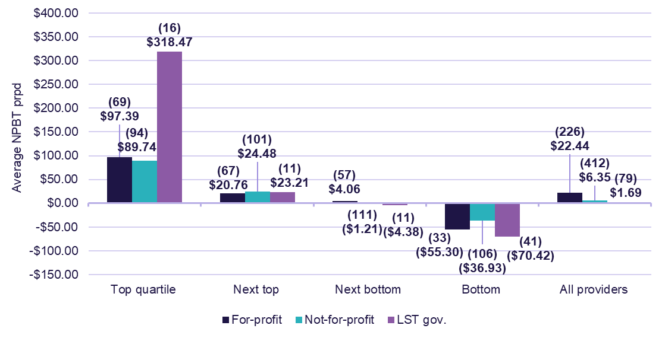

Provider location
In 2024-25, metropolitan and metropolitan and regional providers had significant increases in NPBT compared to 2023-24 (increases of $10.38 prpd and $2.50 prpd, respectively) (Table 1.10 and Table 1.11). However, regional providers reported a decline in NPBT result (decrease of $8.10 prpd) due to the impacts of the LST government providers with one-off asset revaluation increases in 2023-24, as explained in the previous section.
Table 1.10: Financial performance of residential care providers, by location, 2024-25
 | Sector | Metropolitan | Regional | Metropolitan and regional
Total income ($m) | $34,282.0 | $22,930.9 | $4,801.4 | $6,549.7
Total expenses ($m) | $33,390.6 | $22,159.1 | $4,725.5 | $6,506.1
EBITDA ($m) | $2,367.7 | $1,748.7 | $318.5 | $300.5
NPBT ($m) | $891.5 | $771.9 | $76.0 | $43.6
EBITDA (prpd) | $32.43 | $35.69 | $32.54 | $21.12
NPBT (prpd) | $12.21 | $15.75 | $7.76 | $3.07
EBITDA margin | 6.9% | 7.6% | 6.6% | 4.6%
NPBT margin | 2.6% | 3.4% | 1.6% | 0.7%

Table 1.11: Summary income and expense statement prpd, by location, 2024-25
 | Sector | Metropolitan | Regional | Metropolitan and regional
Income
Recurrent income
Care income | $301.90 | $296.48 | $334.61 | $298.06
Everyday living income | $81.30 | $83.38 | $75.98 | $77.80
Accommodation & finance income | $53.90 | $53.61 | $55.72 | $53.66
Total recurrent income | $437.10 | $433.47 | $466.30 | $429.52
Total non-recurrent income | $32.41 | $34.47 | $24.32 | $30.88
Total income | $469.51 | $467.94 | $490.62 | $460.40
Expenses
Recurrent expenses
Care expenses | $260.20 | $255.51 | $283.87 | $260.05
Everyday living expenses | $70.56 | $68.04 | $83.92 | $70.06
Accommodation & finance expenses | $46.72 | $47.58 | $51.29 | $40.61
Administration expenses | $54.03 | $52.25 | $57.74 | $57.62
Total recurrent expenses | $431.50 | $423.37 | $476.82 | $428.34
Total non-recurrent expenses | $25.80 | $28.82 | $6.04 | $28.99
Total expenses | $457.30 | $452.19 | $482.86 | $457.33
Recurrent result | $5.60 | $10.10 | ($10.52) | $1.18
Non-recurrent result | $6.61 | $5.65 | $18.28 | $1.89
NPBT | $12.21 | $15.75 | $7.76 | $3.07
When considering the average NPBT results by quartile for 2024-25 (Chart 1.9 and Chart 1.10):
- in the top quartile, metropolitan and regional providers ($184.35 prpd) outperformed regional ($115.46) and metropolitan providers ($91.81).
- in the bottom quartile, regional providers (loss of $59.94 prpd) recorded the lowest average NPBT compared to metropolitan providers (loss of $41.46) and metropolitan and regional providers (loss of $30.06).
In 2024-25, the proportion of metropolitan providers in the top quartile was 26.7%, while the minority were in the bottom quartile (19.0%) (Chart 1.10). Comparatively, the proportion of regional providers in the top quartile was 24.4%, while the bottom quartile had the largest proportion (33.6%).
Chart 1.9: Residential care average NPBT prpd, by location, 2021-22 to 2024-25
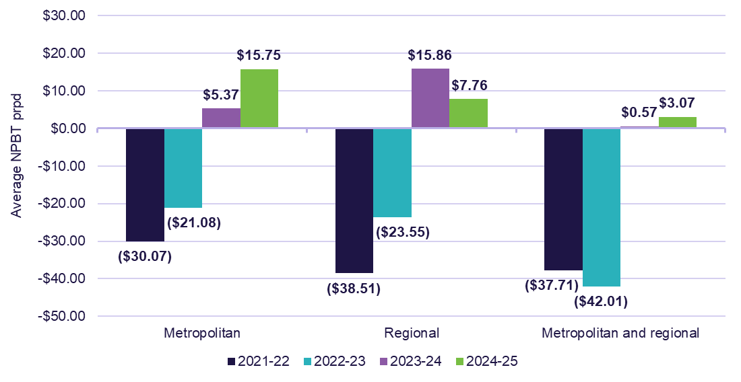
Chart 1.10: Residential care average NPBT prpd, by quartile and location (number of providers in parentheses), 2024-25
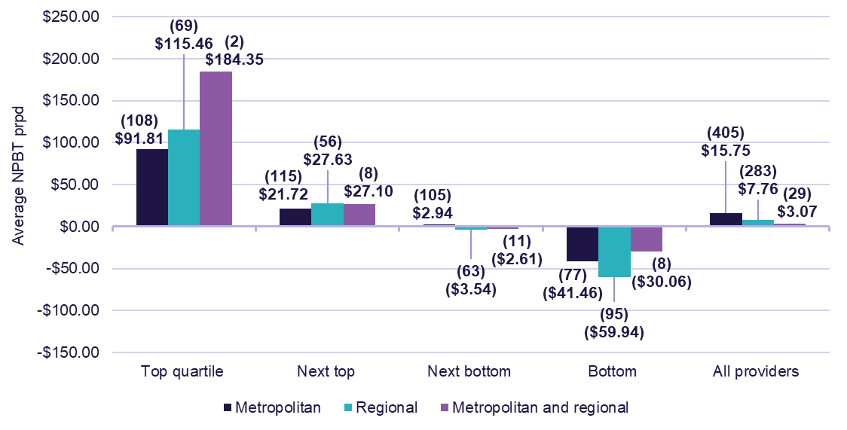

Provider scale
In 2024-25, all provider types by scale reported increases in their NPBT from 2023-24. Providers with a single service reported the highest NPBT ($19.96 prpd) compared to other scale types (Table 1.12 and Table 1.13). Providers with 20 and more services however had the lowest NPBT ($8.17 prpd).
Table 1.12: Financial performance of residential care providers, by scale, 2024-25
 | Sector | Single service | 2 to 6 services | 7 to 19 services | 20 or more services
Total income ($m) | $34,282.0 | $5,845.8 | $6,907.4 | $7,172.8 | $14,356.0
Total expenses ($m) | $33,390.6 | $5,600.9 | $6,670.9 | $7,019.1 | $14,099.6
EBITDA ($m) | $2,367.7 | $479.8 | $525.6 | $396.5 | $965.8
NPBT ($m) | $891.5 | $244.9 | $236.4 | $153.7 | $256.5
EBITDA (prpd) | $32.43 | $39.10 | $36.40 | $26.58 | $30.77
NPBT (prpd) | $12.21 | $19.96 | $16.38 | $10.30 | $8.17
EBITDA margin | 6.9% | 8.2% | 7.6% | 5.5% | 6.7%
NPBT margin | 2.6% | 4.2% | 3.4% | 2.1% | 1.8%
Table 1.13: Summary income and expense statement prpd, by scale, 2024-25
 | Sector | Single service | 2 to 6 services | 7 to 19 services | 20 or more services
Income
Recurrent income
Care income | $301.90 | $308.73 | $306.79 | $312.41 | $291.98
Everyday living income | $81.30 | $78.76 | $83.12 | $80.35 | $81.91
Accommodation & finance income | $53.90 | $61.82 | $58.32 | $54.08 | $48.69
Total recurrent income | $437.10 | $449.31 | $448.23 | $446.84 | $422.58
Total non-recurrent income | $32.41 | $27.09 | $30.15 | $34.03 | $34.76
Total income | $469.51 | $476.41 | $478.39 | $480.87 | $457.34
Expenses
Recurrent expenses
Care expenses | $260.20 | $260.93 | $269.90 | $267.08 | $252.18
Everyday living expenses | $70.56 | $73.44 | $73.98 | $70.14 | $68.07
Accommodation & finance expenses | $46.72 | $53.38 | $51.95 | $44.95 | $42.55
Administration expenses | $54.03 | $51.35 | $53.38 | $63.51 | $50.87
Total recurrent expenses | $431.50 | $439.10 | $449.20 | $445.68 | $413.66
Total non-recurrent expenses | $25.80 | $17.35 | $12.81 | $24.90 | $35.50
Total expenses | $457.30 | $456.45 | $462.01 | $470.57 | $449.17
Recurrent result | $5.60 | $10.22 | ($0.97) | $1.16 | $8.92
Non-recurrent result | $6.61 | $9.74 | $17.35 | $9.14 | ($0.75)
NPBT | $12.21 | $19.96 | $16.38 | $10.30 | $8.17
When considering the average NPBT results by quartile for 2024-25 (Chart 1.11 and Chart 1.12):
- in the top quartile, providers with 2 to 6 services had the highest average NPBT ($115.63 prpd) and providers with 20 or more services reported the lowest average NPBT ($82.95).
- in the bottom quartile, providers with a single service reported the largest loss (loss of $68.42 prpd), and providers with 20 or more services reported the smallest loss (a loss of $22.79).
In 2024-25, 29.2% of providers with a single service were in the top quartile. Comparatively, 3.8% of providers operating 20 or more services were in the top quartile, while 50.0% were in the next bottom quartile.
Chart 1.11: Residential care average NPBT prpd, by scale, 2021-22 to 2024-25
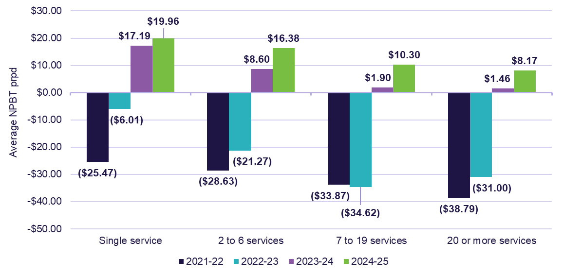
Chart 1.12: Residential care average NPBT prpd, by quartile and scale (number of providers in parentheses), 2024-25
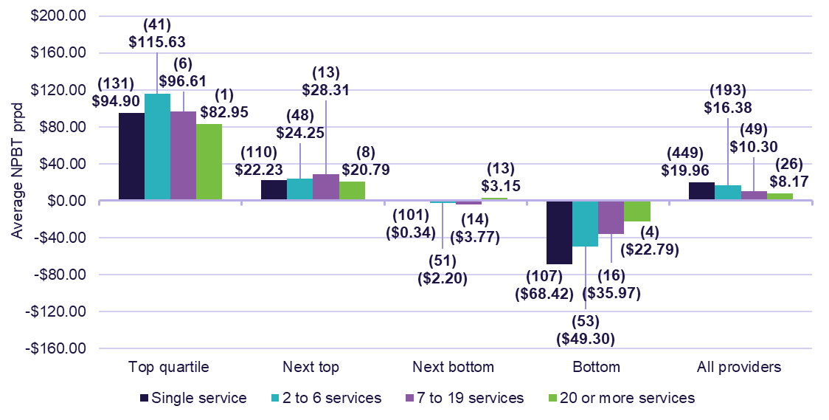

Financial position (balance sheet)

Balance sheet
Methodology: Balance sheet information in FRAACS
The FRAACS publishes balance sheet analysis drawn from the audited General Purpose Financial Statements (submitted by providers as part of their ACFR reporting obligations) which is at the approved provider level. This approach aims to provide a more accurate reflection of a provider's operations and enhance transparency by offering a clearer representation of the sector's financial position.
When reading this chapter, it should be noted that LST government approved providers and approved providers that do not provide any residential aged care services have been excluded from the balance sheet analysis.
For all previous figures, including ratios and accommodation payment figures, refer to the 1.6 RC and AP balance sheet tab in the FRAACS data extract.
Data reference: Balance sheet segment analysis
Refer to Appendix E for the approved provider balance sheet information for 2024-25, with assets and liabilities classified to the ‘Residential segment’ (where possible), and all un-segmented assets and liabilities classified to ‘Other’. Other can include non-residential care assets and liabilities, such as for Independent Living Units (ILUs) and home care.

Sector results
The balance sheet position of approved providers was stronger at 30 June 2025, when compared to 30 June 2024 (Table 1.14).
At a sector level:
- total assets were $114.5 billion, an increase of $12.3 billion (12.0%) on 30 June 2024 ($102.2 billion).
- total liabilities were $88.3 billion, an increase of $8.8 billion (11.1%) on the 30 June 2024 result ($79.4 billion). This included $48.0 billion in RADs, up $5.9 billion on 30 June 2024 ($42.2 billion).
- total equity was $26.2 billion, an increase of $3.4 billion (15.0%) on 30 June 2024 ($22.8 billion).

Table 1.14 Balance sheet at 30 June 2025 for approved providers (excluding LST government providers), with comparison to
30 June 2024
 | 30 June 2023 ($m) | 30 June 2024 ($m) | 30 June 2025 ($m) | Change from 30 June 2024 (%)
Assets
Current assets
Cash and cash equivalents | $7,113.7 | $8,893.1 | $10,947.2 | ▲ 23.1%
Financial assets | $4,745.4 | $4,761.9 | $6,874.4 | ▲ 44.4%
Trade receivables less provision doubtful debts | $1,175.0 | $1,145.0 | $1,396.4 | ▲ 22.0%
Refundable resident loans receivable – RADs ² | $884.1 | $761.1 | $775.3 | ▲ 1.9%
Refundable resident loans receivable – retirement ILUs | $16.3 | $16.5 | $31.3 | ▲ 89.7%
Loans receivable related parties | $3,157.3 | $3,708.7 | $5,007.9 | ▲ 35.0%
Loans receivable non-related parties | $29.6 | $61.0 | $12.2 | ▼ 80.0%
Other current assets | $1,230.1 | $983.7 | $1,291.1 | ▲ 31.2%
Total current assets | $18,351.4 | $20,331.1 | $26,335.8 | ▲ 29.5%
Non-current assets
Financial assets | $3,149.5 | $4,221.6 | $3,423.5 | ▼ 18.9%
Loans receivable related parties | $5,283.4 | $6,337.4 | $6,245.7 | ▼ 1.4%
Loans receivable non-related parties | $67.1 | $155.9 | $145.8 | ▼ 6.5%
Capital work in progress | $2,133.9 | $2,088.5 | $2,390.3 | ▲ 14.5%
Property plant and equipment | $37,309.2 | $37,678.7 | $39,399.9 | ▲ 4.6%
Right-of-use asset | $3,559.8 | $4,594.7 | $4,858.5 | ▲ 5.7%
Investment properties | $18,974.3 | $21,970.5 | $25,978.3 | ▲ 18.2%
Intangibles – bed licenses ³ | $995.0 | $87.3 | $0.0 | N/A
Intangibles – goodwill | $3,116.2 | $3,711.6 | $4,330.1 | ▲ 16.7%
Intangibles – other | $164.5 | $171.6 | $139.3 | ▼ 18.8%
Other non-current assets | $788.0 | $860.0 | $1,225.0 | ▲ 42.4%
Total non-current assets | $75,540.9 | $81,877.8 | $88,136.3 | ▲ 7.6%
Total assets | $93,892.3 | $102,208.9 | $114,472.1 | ▲ 12.0%
Liabilities
Current liabilities
Refundable resident loans – RADs ² | $24,613.5 | $27,476.8 | $31,840.2 | ▲ 15.9%
Refundable resident loans – retirement ILUs | $7,789.5 | $8,151.0 | $9,293.0 | ▲ 14.0%
External borrowings – related parties | $2,069.8 | $2,287.3 | $1,634.7 | ▼ 28.5%
External borrowings – non-related parties | $1,366.6 | $882.1 | $629.7 | ▼ 28.6%
Employee benefits and provisions | $2,730.9 | $3,056.6 | $3,470.7 | ▲ 13.5%
Unspent HCP funds | $288.5 | $187.9 | $138.6 | ▼ 26.2%
Unspent CHSP grants | $205.3 | $118.7 | $70.9 | ▼ 40.3%
Lease liabilities | $348.4 | $338.3 | $437.4 | ▲ 29.3%
Other current liabilities | $5,043.3 | $4,691.7 | $6,136.6 | ▲ 30.8%
Total current liabilities | $44,455.9 | $47,190.4 | $53,651.8 | ▲ 13.7%
Non-current liabilities
Refundable resident loans – RADs ² | $12,827.2 | $14,681.5 | $16,169.8 | ▲ 10.1%
Refundable resident loans – retirement ILUs | $6,931.4 | $7,941.1 | $8,442.8 | ▲ 6.3%
External borrowings – related parties | $1,615.3 | $1,406.5 | $1,353.7 | ▼ 3.8%
External borrowings – non-related parties | $2,615.7 | $2,084.1 | $1,961.0 | ▼ 5.9%
Employee benefits | $411.4 | $444.7 | $511.2 | ▲ 15.0%
Lease liabilities | $3,482.8 | $4,479.3 | $4,770.2 | ▲ 6.5%
Other liabilities | $1,182.9 | $1,211.0 | $1,426.7 | ▲ 17.8%
Total non-current liabilities | $29,066.80 | $32,248.2 | $34,635.50 | ▲ 7.4%
Total liabilities | $73,522.60 | $79,438.6 | $88,287.30 | ▲ 11.1%
Net assets (equity) | $20,369.70 | $22,770.30 | $26,184.80 | ▲ 15.0%
Notes:
- Results prior to 2022-23 use the previous balance sheet methodology and therefore are not presented in this table. The 2022-23 data have been analysed and presented using a consistent methodology with that used for 2023-24 and onwards, to support comparability of results. For more information, refer to the 1.6 RC and AP balance sheet tab in the FRAACS data extract.
- The $48.8 billion in RADs held at the sector level in 2024-25 does not include $68.7 million of RADs held by Multi-Purpose Services.
- In line with the government’s decision to assign residential aged care places directly to people, residential aged care providers were required to amortise all bed license assets by 1 July 2025, therefore, a result of $0 will be seen in the years for 2024-25 and onwards. For more information, refer to the Insights box on page 33.

Insights: The sector’s net equity position increased, with continued growth in RADs and ILUs
At 30 June 2025, the sector’s assets increased by 12.0% from 30 June 2024, exceeding the growth in liabilities (up 11.1%), which resulted in a net increase in provider’s equity position (up 15.0%).
The primary contributor to the increase in liabilities was RADs (up 13.9%) and ILUs (up 10.2%), which accounted for 74.5% of total liabilities in 2024-25.
The balance sheet indicates the above deposits were predominantly invested in:
- current financial assets, specifically cash and cash equivalents, financial assets, and loans receivable from related parties, which collectively increased by 31.5%, and accounted for 19.9% of total assets in 2024-25, and
- non-current assets, specifically property, plant, and equipment and investment properties, which collectively increased by 9.6%, and accounted for 57.1% of total assets in 2024-25.
  - The usage of RADs deposits on these non-current assets is aligned to the permitted uses for RADs under section 310 of the Aged Care Act 2024 and section 310-30 of the Aged Care Rules 2025, which allows providers to use RADs for generating interest income or invest in new residential aged care facilities. Under the legislation, these permitted uses include capital expenditure and related debts, investments, and loans.

Results by provider ownership type
The balance sheet position of for-profit providers and not-for-profit providers differed at 30 June 2025 (Table 1.15). When considering the:
- asset position of providers, for-profit providers held significantly less in investment properties (2.4% of total assets) than not-for-profit providers (30.8% of total assets), as for-profit providers tend to lease more (10.7% in right-of-use assets, compared to 1.6% for not-for-profits).
  - Additionally, for-profit providers held more in current and non-current related party loans receivable (27.0% of total assets), compared to not-for-profit providers (3.0% of total assets).
- debt position of providers, liabilities were largely attributed to RADs and ILUs:
  - for-profit providers held the majority of their liabilities in RADs (68.3% of total liabilities), while RADs accounted for less than half of not-for-profit providers’ liabilities (46.6% of total liabilities).
  - for-profit providers held significantly less in current and non-current retirement ILUs loans (0.9% of total liabilities), compared to not-for-profit providers (30.7% of total liabilities).
- equity position of providers, for-profit providers reported less equity ($1.1 billion), than not-for-profit providers ($25.0 billion).
  - While for-profit providers have reported a lower equity position than not-for-profit providers, this is still an improvement of $1.2 billion on the 30 June 2024 equity balance (negative $92.8 million)
Table 1.15: Balance sheet at 30 June 2025 for approved providers, by ownership type (excluding LST government providers)
 | Sector ($m) | For-profit ($m) | Not-for-profit ($m)
Assets
Current assets
Cash and cash equivalents | $10,947.2 | $3,347.0 | $7,600.3
Financial assets | $6,874.4 | $602.0 | $6,272.4
Trade receivables less provision doubtful debts | $1,396.4 | $492.7 | $903.7
Refundable resident loans receivable – RADs 1 | $775.3 | $648.0 | $127.3
Refundable resident loans receivable – retirement ILUs | $31.3 | $0.0 | $31.3
Loans receivable related parties | $5,007.9 | $3,718.9 | $1,289.0
Loans receivable non-related parties | $12.2 | $0.0 | $12.2
Other current assets | $1,291.1 | $210.1 | $1,081.0
Total current assets | $26,335.8 | $9,018.7 | $17,317.1
Non-current assets
Financial assets | $3,423.5 | $451.3 | $2,972.2
Loans receivable related parties | $6,245.7 | $5,104.6 | $1,141.1
Loans receivable non-related parties | $145.8 | $0.2 | $145.6
Capital work in progress | $2,390.3 | $824.1 | $1,566.2
Property plant and equipment | $39,399.9 | $9,911.8 | $29,488.1
Right-of-use asset | $4,858.5 | $3,514.2 | $1,344.4
Investment properties | $25,978.3 | $789.4 | $25,188.8
Intangibles – goodwill | $4,330.1 | $2,493.2 | $1,836.9
Intangibles – other | $139.3 | $38.7 | $100.6
Other non-current assets | $1,225.0 | $569.6 | $655.4
Total non-current assets | $88,136.3 | $23,697.0 | $64,439.3
Total assets | $114,472.1 | $32,715.7 | $81,756.4
Liabilities
Current liabilities
Refundable resident loans – RADs ¹ | $31,840.2 | $15,620.8 | $16,219.4
Refundable resident loans – retirement ILUs | $9,293.0 | $163.5 | $9,129.5
External borrowings – related parties | $1,634.7 | $1,150.2 | $484.4
External borrowings – non-related parties | $629.7 | $330.4 | $299.3
Employee benefits and provisions | $3,470.7 | $906.7 | $2,563.9
Unspent HCP funds | $138.6 | $0.2 | $138.5
Unspent CHSP grants | $70.9 | $0.0 | $70.9
Lease liabilities | $437.4 | $271.2 | $166.3
Other current liabilities | $6,136.6 | $1,589.4 | $4,547.2
Total current liabilities | $53,651.8 | $20,032.4 | $33,619.4
Non-current liabilities
Refundable resident loans – RADs ¹ | $16,169.8 | $5,937.3 | $10,232.5
Refundable resident loans – retirement ILUs | $8,442.8 | $136.1 | $8,306.7
External borrowings – related parties | $1,353.7 | $1,080.2 | $273.6
External borrowings – non-related parties | $1,961.0 | $336.4 | $1,624.6
Employee benefits | $511.2 | $111.9 | $399.3
Lease liabilities | $4,770.2 | $3,566.3 | $1,203.9
Other liabilities | $1,426.7 | $372.1 | $1,054.6
Total non-current liabilities | $34,635.5 | $11,540.3 | $23,095.2
Total liabilities | $88,287.3 | $31,572.7 | $56,714.6
Net assets (equity) | $26,184.8 | $1,143.0 | $25,041.8
Note:
1. The $48.8 billion in RADs held at the sector level in 2024-25 does not include $68.7 million of RADs held by Multi-Purpose Services.

Balance sheet performance ratios
Balance sheet performance ratios provide a measure of the financial health of providers through analysis of their profitability, liquidity and efficiency as well as their net worth. Definitions for the balance sheet performance ratios are in the Glossary.

Current ratio
The current ratio is a measure of a provider’s ability to meet short-term liabilities using short-term assets. The current ratio for all providers was 0.49 at 30 June 2025, an increase of 0.06 from 30 June 2024 (Table 1.16). This increase was mainly driven by an increase in the cash balance (with a corresponding increase in RADs). Providers have $0.49 of current assets for every $1.00 of current liabilities.
For-profit providers had a lower current ratio (0.45) than not-for-profit providers (0.52) at 30 June 2025, as they reported greater borrowings to related parties resulting in lower current financial assets, and higher current liabilities. For-profit providers current ratio increased, up 0.09 from 30 June 2024. Not-for-profit providers’ current ratio also increased slightly, up 0.04 from 30 June 2024. Consistent with previous years, this is primarily driven by the high value of financial assets held by not-for-profit providers.
Table 1.16: Current ratio for approved providers (excluding LST government providers) at 30 June 2025, with comparison to 30 June 2024
 | 30 June 2023 | 30 June 2024 | 30 June 2025 | Change from 30 June 2024
Approved providers | 0.41 | 0.43 | 0.49 | ▲ 0.06
For-profit providers | 0.30 | 0.36 | 0.45 | ▲ 0.09
Not-for-profit providers | 0.48 | 0.48 | 0.52 | ▲ 0.04

Equity to total assets and debt to total assets
A provider’s assets can be financed through equity or debt (liabilities). The equity ratio (equity to total assets) and debt ratio (debt to total assets), which should sum to 1, can be used to understand a provider’s financial stability, risk profile, and ability to repay debts. At 30 June 2025, the equity ratio remained broadly consistent when compared to 30 June 2024 (0.23, up from 0.22), as did the debt ratio (0.77, down from 0.78) (Table 1.17). An equity ratio of 0.23 means that 23.0% of providers’ assets are financed by equity and the remainder by debt. A debt ratio of more than 1.0 indicates that an organisation has a higher debt level than the value of its assets.
At 30 June 2025, for-profit providers equity ratio has increased when compared to 30 June 2024 (up 0.03). This is primarily attributed to lower financial assets, property, plant and equipment and investment properties for for-profit providers when compared to not-for-profit, as for-profit providers tend to show a preference for leasing. For-profit providers also tend to pay out dividends to their shareholders and have greater borrowings to related parties, resulting in lower equity and higher liabilities. The equity ratio for not-for-profit providers remained broadly consistent when compared to 30 June 2024 (down 0.01).
Table 1.17: Equity to total assets and debt to total assets ratios for approved providers (excluding LST government providers) at 30 June 2025, with comparison to 30 June 2024
 | 30 June 2023 | 30 June 2024 | 30 June 2025 | Change from 30 June 2024
Equity to total assets
Approved providers | 0.22 | 0.22 | 0.23 | ▲ 0.01
For-profit providers | (0.01) | 0.00 | 0.03 | ▲ 0.03
Not-for-profit providers | 0.31 | 0.32 | 0.31 | ▼ 0.01
Debt to total assets
Approved providers | 0.78 | 0.78 | 0.77 | ▼ 0.01
For-profit providers | 1.01 | 1.00 | 0.97 | ▼ 0.03
Not-for-profit providers | 0.69 | 0.68 | 0.69 | ▲ 0.01

Accommodation payments and contributions
Non-supported and partially supported aged care residents need to make an accommodation deposit/payment or contribution (with the remainder supported through government funding).
Residents can make their accommodation payment as:
- a lump sum:
- a refundable accommodation deposit (RAD) if they are non-supported
- a refundable accommodation contribution (RAC) if they are partially supported
- a daily payment:
- a daily accommodation payment (DAP) if they are non-supported
- a daily accommodation contribution (DAC) if they are partially supported, or
- a combination of both a) and b).
RADs/RACs received by residential aged care providers can be used to generate income, in line with permitted uses, until they are payable to the resident upon their exit from the service.
Data reference: Residential aged care payments and contributions
- Data presented in the charts below include new residents with an entry date into a residential aged care service in 2024-25.
- The sector results below include only new residents who are non-supported or partially supported through government funding, as fully supported residents do not make payments or contributions to their selected accommodation.
- LST government providers are included in the data presented in this section.

New resident choice of payment or contribution

Sector results
At a sector level, the preference for RAD/RACs continued to increase, with 42.1% of new residents choosing to pay a RAD/RAC in 2024-25 (up from 40.1% in 2023-24) (Chart 1.13). There was an inverse relationship in the preference for DAP/DACs (37.8% chose to pay a DAP/DAC in 2024-25, down from 40.0% in 2023-24). This is likely driven by the Maximum Permissible Interest Rate (MPIR), which is used to calculate the DAP/DAC payment, increasing from mid-2022 until early 2025. This made DAPs/DACs higher and less attractive when compared to RAD/RACs.
Chart 1.13: Resident method of accommodation payment, by partially supported, non-supported, and total residents, 2021-22 to 2024-25
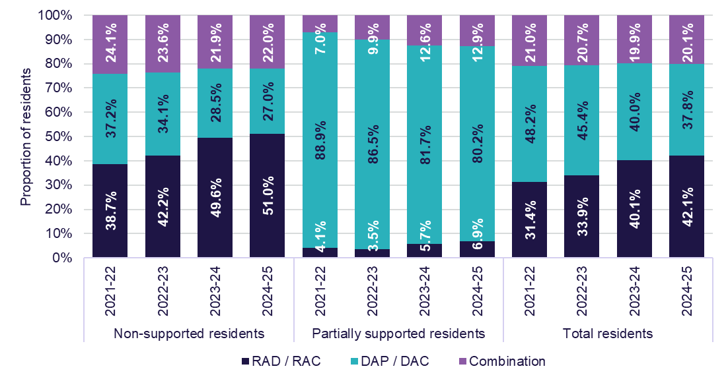

Results by provider ownership type and location
There was little variation in residents’ choice of payment method by ownership type and location in 2024-25.
Consistent with previous years, the proportion of new residents in for-profit providers choosing a RAD/RAC was higher (46.2%) than the proportion of new residents in not-for-profit (39.3%) or LST government providers (40.5%) (Chart 1.14). The proportion of new residents choosing a RAD/RAC increased in not-for-profit and LST government providers, but remained consistent for for-profit providers, with the preference for a DAP/DAC decreasing for not-for-profit and LST government providers.
Also consistent with previous years, the proportion of new residents choosing a RAD/RAC increased for all location types. The proportion choosing a RAD/RAC was higher in metropolitan areas (43.7%) than the proportion of new residents in regional (39.5%) or remote areas (34.7%) (Chart 1.15).

Chart 1.14: Resident choice of payment method, by ownership type, 2021-22 to 2024-25
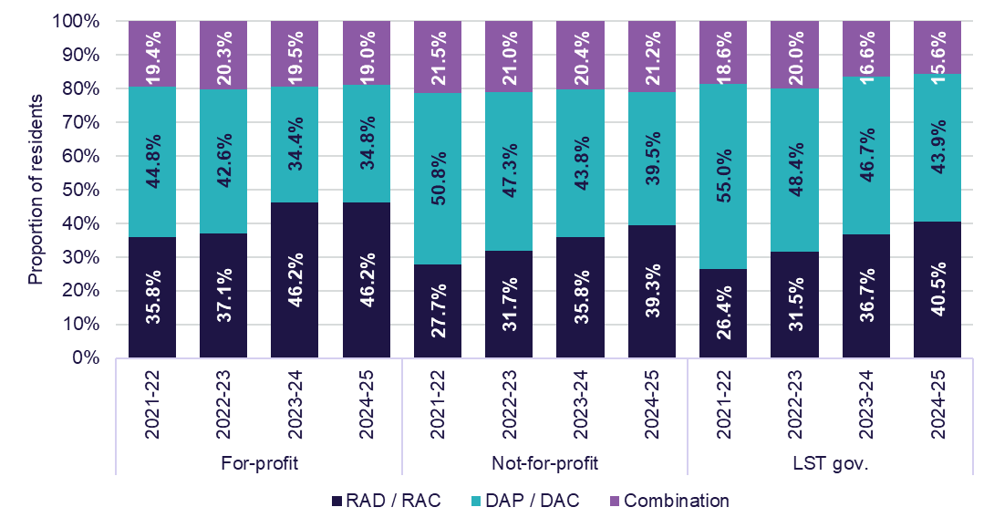
Chart 1.15: Resident choice of payment method, by location, 2021-22 to 2024-25
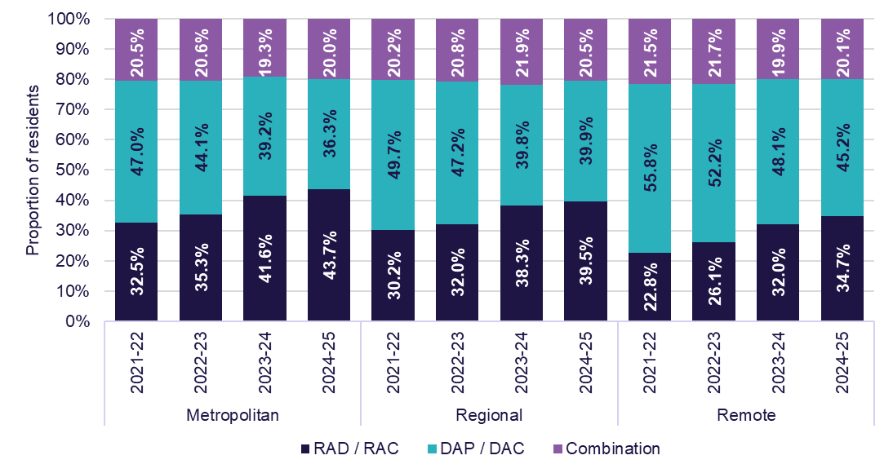

Accommodation deposit prices

Sector results
From 1 January 2025, the maximum RAD a provider could charge without prior approval from IHACPA was $750,000. For prices above $750,000, IHACPA must approve the maximum before it can be published. Incoming residents can negotiate a lower price than what is published, with the outcome being the ‘agreed price’.
At a sector-level, in 2024-25, the average:
- published price was $539,000 (up from $501,000 in 2023-24), and
- agreed price was $470,000 (up from $451,000 in 2023-24).
Insights: Impacts of the Aged Care Taskforce reforms
Residential care providers can set a RAD price, without approval from IHACPA, up to a level known as the maximum room price. On 1 January 2025, there was an increase to this maximum room price, from $550,000 to $750,000. This was the first maximum room price change since it was set at $550,000 in 2014.
As expected, this policy change has resulted in an increase in the average agreed accommodation price for residents entering residential care. Table 1.18 highlights trends in agreed prices for non-supported residents who entered care, before and after the policy change on 1 January 2025.
Table 1.18: Agreed room price for non-support residents who entered residential care in 2024-25
 | Jul – Dec 2024 | Jan – Jun 2025
Above $550,000 and below $750,000 | 13.3% | 20.3%
Exactly $750,000 | 2.2% | 5.5%
These impacts can also be seen through a larger increase in the total sector value of RADs held at 30 June 2025 (up $6.2 billion from 30 June 2024) compared to the increase between 30 June 2023 and 30 June 2024 ($4.6 billion) (Table 1.20).
Further measures announced in the government response to the Aged Care Taskforce that will continue to support providers to improve their accommodation results from 2025-26, include:
- annual indexation on 1 July of the maximum room price a provider can charge without approval from IHACPA. On 1 July 2025, the maximum room price increased from $750,000 to $758,627
- requiring providers to retain 2.0% per annum of RAD/RAC deposits for up to five years from 1 November 2025
- requiring providers to index DAPs twice per year by the consumer price index for residents that enter care on or after 1 November 2025.

Results by provider ownership type and location
Consistent with prior years, in 2024-25, there was variability in published and agreed accommodation prices based on provider ownership type and location (Table 1.19):
- for-profit providers had consistently higher published ($587,000) and agreed ($490,000) prices than not-for-profit providers ($528,000 for published, and $464,000 for agreed) and LST government providers ($352,000 for published, and $345,000 for agreed).
- providers in metropolitan areas had consistently higher published ($593,000) and agreed ($504,000) prices than providers in regional areas ($430,000 for published, and $386,000 for agreed) and remote areas ($306,000 for published, and $319,000 for agreed).
Table 1.19: Average agreed and published accommodation prices (lump sum equivalent), at sector-level and by ownership type and location, 2021-22 to 2024-25 ¹
 |  | 2021-22 | 2022-23 | 2023-24 | 2024-25
All providers | Published | $472,000 | $488,000 | $501,000 | $539,000
All providers | Agreed | $425,000 | $438,000 | $451,000 | $470,000
All providers | Difference | $47,000 | $50,000 | $50,000 | $69,000
Ownership type
For-profit | Published | $504,000 | $522,000 | $539,000 | $587,000
For-profit | Agreed | $439,000 | $452,000 | $466,000 | $490,000
For-profit | Difference | $65,000 | $70,000 | $73,000 | $97,000
Not-for-profit | Published | $461,000 | $476,000 | $490,000 | $528,000
Not-for-profit | Agreed | $421,000 | $435,000 | $448,000 | $464,000
Not-for-profit | Difference | $40,000 | $41,000 | $42,000 | $64,000
LST gov. | Published | $352,000 | $357,000 | $354,000 | $352,000
LST gov. | Agreed | $325,000 | $333,000 | $341,000 | $345,000
LST gov. | Difference | $27,000 | $24,000 | $13,000 | $7,000
Location
Metropolitan | Published | $517,000 | $535,000 | $550,000 | $593,000
Metropolitan | Agreed | $458,000 | $472,000 | $485,000 | $504,000
Metropolitan | Difference | $59,000 | $63,000 | $65,000 | $89,000
Regional | Published | $380,000 | $393,000 | $402,000 | $430,000
Regional | Agreed | $352,000 | $363,000 | $373,000 | $386,000
Regional | Difference | $28,000 | $30,000 | $29,000 | $44,000
Remote ² | Published | $321,000 | $324,000 | $313,000 | $306,000
Remote ² | Agreed | $274,000 | $291,000 | $307,000 | $319,000
Remote ² | Difference | $47,000 | $33,000 | $6,000 | ($13,000)
Note:
- Published and agreed prices are estimated average values at the midpoint of the respective financial year. The figures are then aggregated and rounded to the nearest thousand. As such they are not a simple average.
- In 2024-25, the average agreed price was higher than the average published price in remote areas. This is because a high proportion of agreed prices were in the upper range of published prices. It does not reflect any individual room price being agreed at a price that is above the published price for that room.

Value of RADs held
Since the introduction of RADs in 2014-15, the total value of RADs, number of RADs, and the average RAD value have continually increased. Since 2021-22, RADs held (which includes any RACs) have increased by $13.4 billion, up 38.2% (Table 1.20).
- The total value of RADs held increased, up 14.6% from 30 June 2024.
- The total number of RADs increased, up 7.7% from 30 June 2024.
- The average RAD value increased, up 6.4% from 30 June 2024.
Table 1.20: Total value and number of RADs held in the sector, and average RAD value, 30 June 2022 to 30 June 2025, with comparison to 30 June 2024
 | 30 June 2022 | 30 June 2023 | 30 June 2024 | 30 June 2025 | Change from 30 June 2024 (%)
RADs held ($m) | $35,003.6 | $37,541.1 | $42,185.2 | $48,359.6 | ▲ 14.6%
RADs held (number) | 100,010 | 102,470 | 107,548 | 115,847 | ▲ 7.7%
Average RAD  value | $350,001.4 | $366,361.6 | $392,245.7 | $417,443.7 | ▲ 6.4%
Note: The above RADs balance includes RADs held by both residential providers and multi-purpose services and does not include RADs receivable.

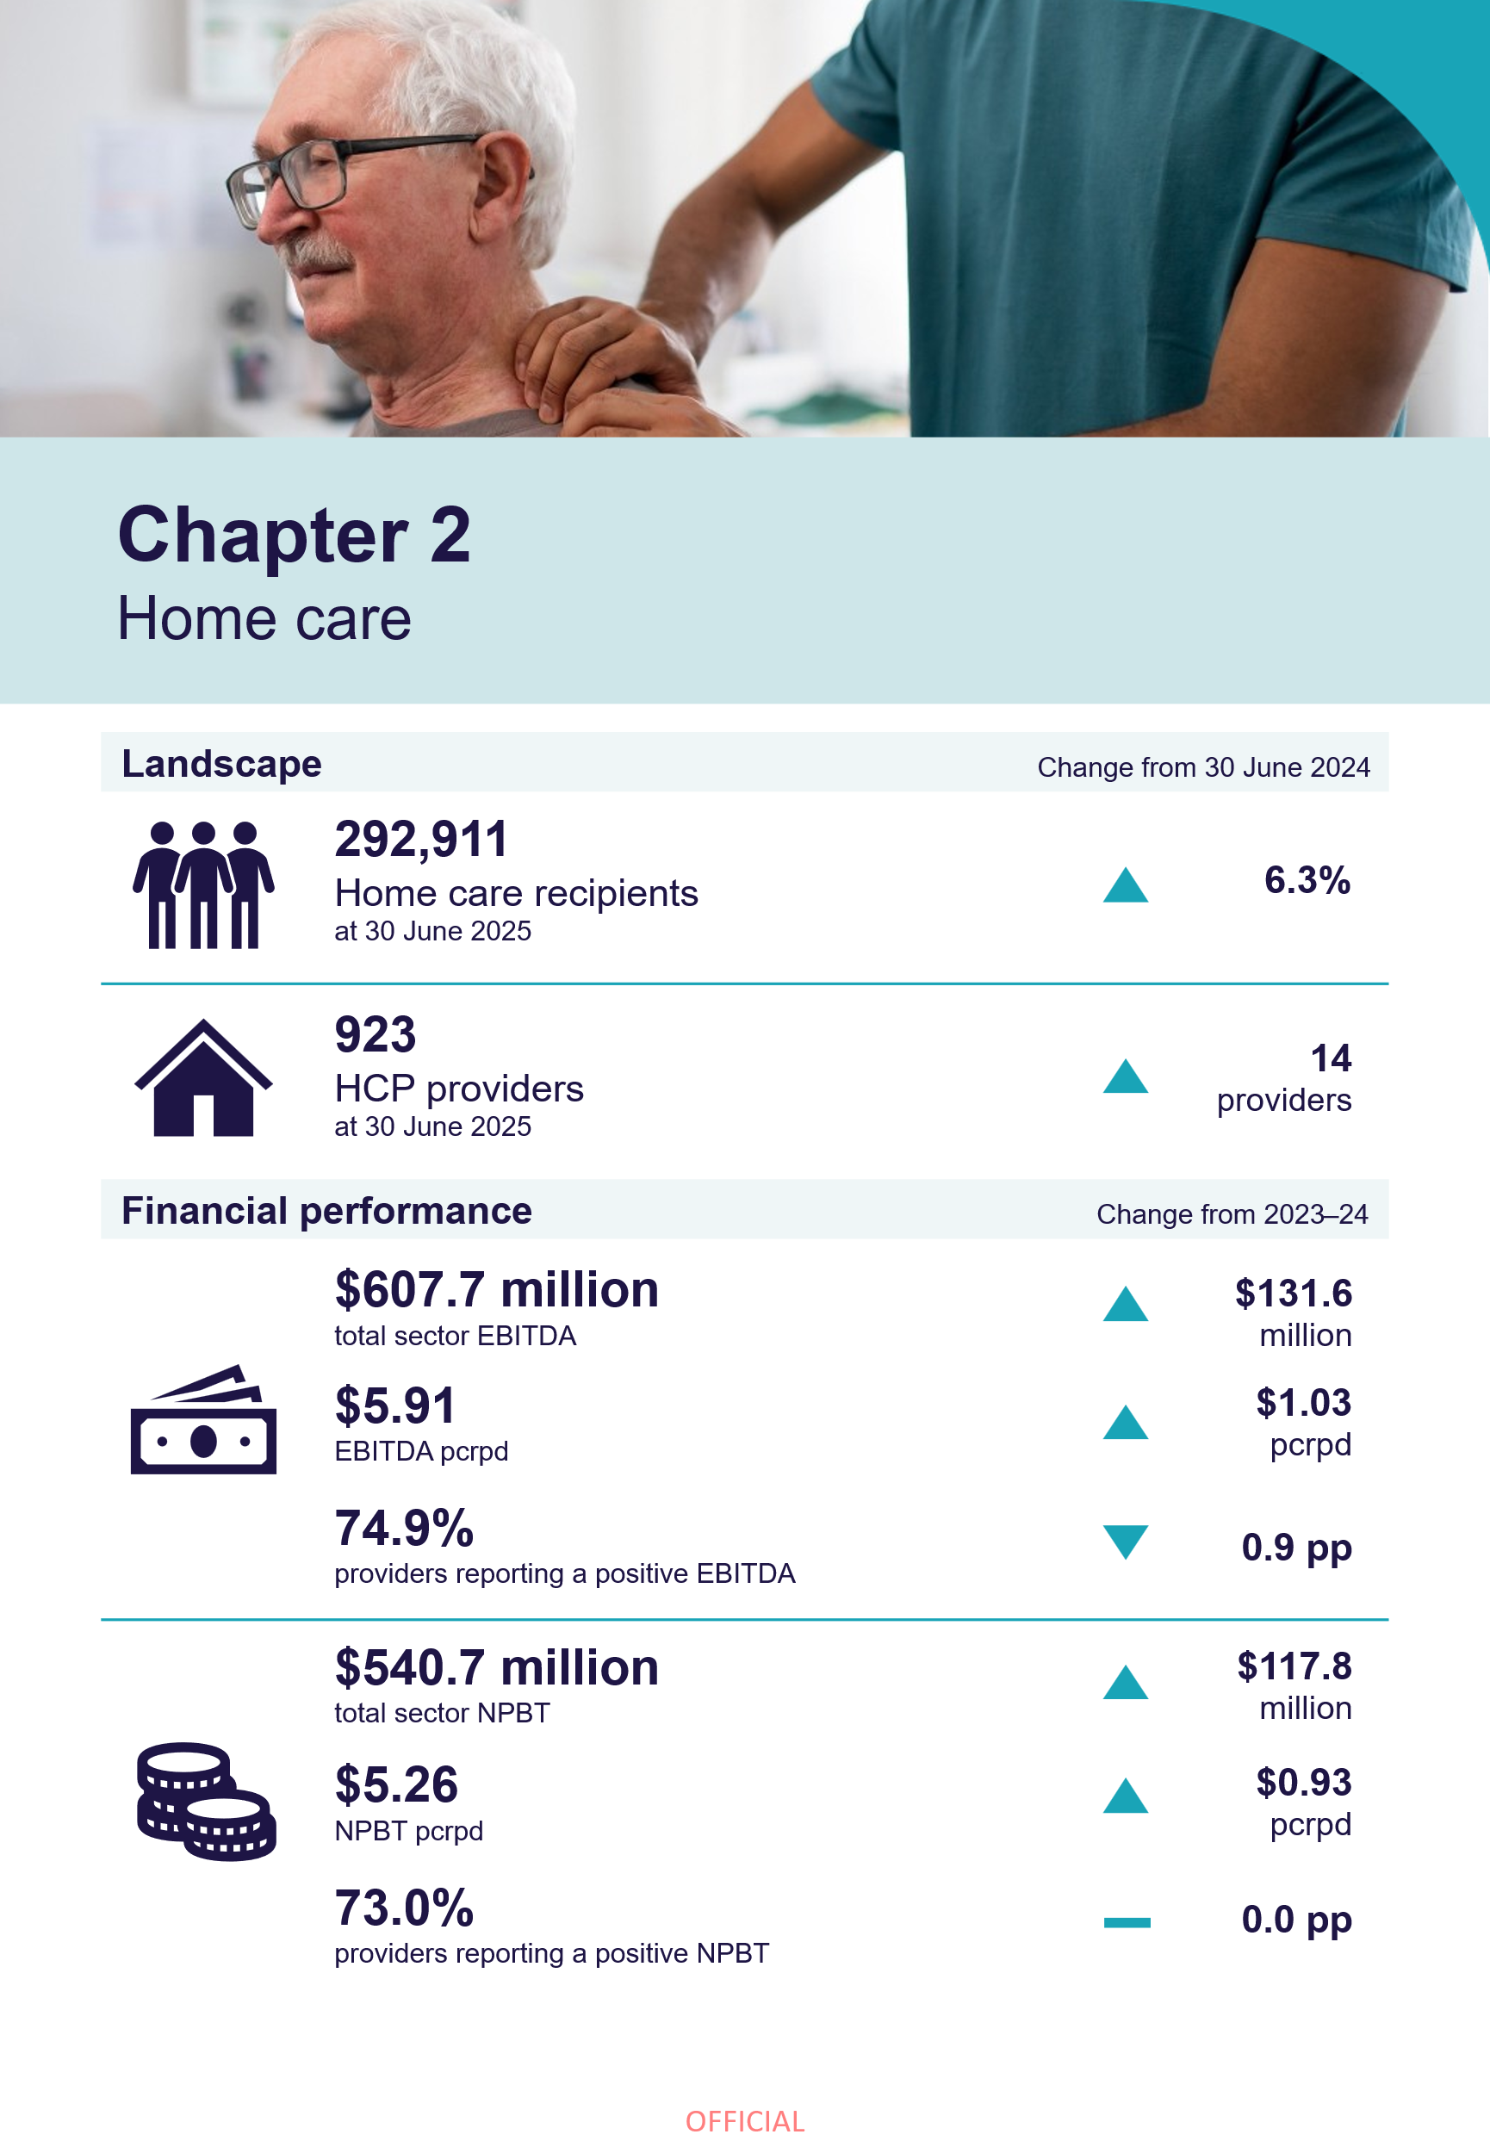

Home care

Home care landscape

Home care recipients and providers
The broad trends in home care recipients and providers, as reported in the FRAACS reports from 2020-21 onwards, continued in 2024-25. These trends reflect the preferences of older people to remain in their homes for longer.
These included:
- an increase in home care recipient numbers, from 275,486 recipients at 30 June 2024, to 292,911 recipients at 30 June 2025 (Table 2.1).
- an increase in the median length of time accessing home care services, from 20.4 months in 2023-24, to 23.0 months in 2024-25.
- an increase in the number of HCP providers, from 909 providers at 30 June 2024, to 923 providers at 30 June 2025 (Table 2.2).
Data reference: Length of time accessing care and care recipient exits
Refer to the 2.1 HC landscape tab in the FRAACS data extract for data on:
- length of time accessing home care services by year of exit
- cumulative proportion of home care recipients leaving home care during their first year by year of entry.
Table 2.1: HCP recipients, 30 June 2022 to 30 June 2025
 | 30 June 2022 | 30 June 2023 | 30 June 2024 | 30 June 2025
Total recipients | 215,743 | 258,374 | 275,486 | 292,911
Culturally and Linguistically Diverse recipients | 64,192 | 78,536 | 85,079 | 91,895
Aboriginal and Torres Strait Islander recipients | 5,773 | 7,879 | 8,775 | 9,580
HCP level
Level 1 | 11,677 | 13,439 | 14,792 | 12,833
Level 2 | 88,993 | 103,676 | 111,996 | 106,911
Level 3 | 67,053 | 87,447 | 90,908 | 106,791
Level 4 | 48,020 | 53,812 | 57,790 | 66,376
Location ^{1, 2}
Metropolitan | 152,729 | 155,034 | 167,502 | 179,755
Regional | 63,014 | 55,674 | 55,815 | 39,994
Metropolitan and regional | - | 47,666 | 52,169 | 73,162
Ownership type ²
For-profit | 71,563 | 94,613 | 106,908 | 117,253
Not-for-profit | 131,980 | 150,942 | 155,923 | 163,446
LST gov. | 12,200 | 12,819 | 12,655 | 12,212
Notes:
- From 2023-24, providers have been classified as a metropolitan provider if they had more than 70% of their care recipients in metropolitan areas, and a regional provider if they had more than 70% of their care recipients in regional areas. Providers who do meet either of these criteria are classified as a metropolitan and regional provider. Before this, the classification was based on the location of the services (outlets) through which providers delivered services. For more information, refer to the Methodology box on page 76.
- Allocation of care recipients to location and ownership types in this table is based on the location and ownership type of the provider from which care recipients receive their services.
Table 2.2: HCP providers, 30 June 2022 to 30 June 2025
 | 30 June 2022 | 30 June 2023 | 30 June 2024 | 30 June 2025
Total providers | 916 | 923 | 909 | 923
Location
Metropolitan | 521 | 557 | 549 | 566
Regional | 313 | 326 | 320 | 312
Metropolitan and regional | 82 | 40 | 40 | 45
Ownership type
For-profit | 334 | 349 | 349 | 362
Not-for-profit | 473 | 471 | 461 | 463
LST gov. | 109 | 103 | 99 | 98

Financial performance

Sector results

Data reference: Terms used in this section of the report and the home care income statement
The following terms are used throughout this section:
- internal care services refer to services provided by staff directly employed by the home care provider.
- external care services refer to services delivered by sub-contractors or brokered client services engaged by the home care provider.
Refer to Appendix H for the complete income statement for the home care sector.
Between 2021-22 and 2022-23, the home care sector experienced a decline in profitability, with NPBT dropping from $4.29 pcrpd in 2020-21, to $2.78 in 2021-22, and to $2.17 in 2022-23 (Table 2.3 and Table 2.4). However, the financial performance of the home care sector improved in 2023-24 and 2024-25, with a NPBT result of $4.33 pcrpd in 2023-24, up to $5.26 in 2024-25.
In 2024-25, at a sector level:
- total income was $8.8 billion, up 18.7% from 2023-24 ($7.4 billion).
  - This was equivalent to $85.81 pcrpd, up 12.7% from $76.11 in 2023-24.
  - Care recipient contributions (basic daily fee, income tested fees and other client fees) accounted for $191.4 million or 2.2% of total income (down from $206.9 million or 2.8% in 2023-24).
- total expenditure was $8.3 billion, up 18.2% from 2023-24 ($7.0 billion).
  - This was equivalent to $80.55 pcrpd, up 12.2% from $71.78 in 2023-24.
- the EBITDA result was $607.7 million, up 27.7% from 2023-24 ($476.1 million).
  - This was equivalent to $5.91 pcrpd, up 21.2% from $4.88 in 2023-24.
  - The EBITDA margin at the sector level was 6.9%, an increase of 0.5 pp from the 2023-24 result (6.4%).
- the NPBT result was $540.7 million, up 27.8% from 2023-24 ($423.0 million).
  - This was equivalent to $5.26 pcrpd, up 21.4% from $4.33 in 2023-24.
  - 73.0% of HCP providers reported a positive NPBT, consistent with 2023-24.
Table 2.3: Summary of financial performance of HCP providers, 2021-22 to 2024-25, with comparison to 2023-24
 | 2021-22 | 2022-23 | 2023-24 | 2024-25 | Change from 2023-24
Total income ($m) | $4,689.8 | $5,787.2 | $7,427.9 | $8,818.5 | ▲ 18.7%
Total expenses ($m) | $4,492.4 | $5,601.5 | $7,004.9 | $8,277.7 | ▲ 18.2%
EBITDA ($m) | $240.1 | $236.1 | $476.1 | $607.7 | ▲ 27.7%
NPBT ($m) | $197.4 | $185.7 | $423.0 | $540.7 | ▲ 27.8%
EBITDA (pcrpd) | $3.38 | $2.76 | $4.88 | $5.91 | ▲ 21.2%
NPBT (pcrpd) | $2.78 | $2.17 | $4.33 | $5.26 | ▲ 21.4%
EBITDA margin | 5.1% | 4.1% | 6.4% | 6.9% | ▲ 0.5 pp
NPBT margin | 4.2% | 3.2% | 5.7% | 6.1% | ▲ 0.4 pp
Table 2.4: Income and expense statement pcrpd, 2021-22 to 2024-25, with comparison to 2023-24
 | 2021-22 | 2022-23 | 2023-24 | 2024-25 | Change from 2023-24 (%)
Income
Provision of internal care services | $28.75 | $28.72 | $30.61 | $31.51 | ▲ 3.0%
Provision of external care services | $14.61 | $15.88 | $20.45 | $27.57 | ▲ 34.8%
Care management service fees ¹ | $10.89 | $11.38 | $13.50 | $14.84 | ▲ 9.9%
Package management service fees | $7.62 | $7.87 | $9.29 | $10.34 | ▲ 11.3%
Exit amounts deducted ² | $0.06 | $0.03 | - | - | N/A
COVID-19 funding ³ | $0.26 | $0.04 | $0.10 | - | N/A
Other income ⁴ | $3.74 | $3.73 | $2.17 | $1.56 | ▼ 28.4%
Total income | $65.94 | $67.64 | $76.11 | $85.81 | ▲ 12.7%
Expenses
Internal care services expenses
Employee and agency staff labour costs | $18.81 | $18.21 | $20.21 | $21.59 | ▲ 6.8%
Other internal direct care services expenses | $2.00 | $1.52 | $1.40 | $1.35 | ▼ 3.7%
Total internal care services expenses | $20.81 | $19.73 | $21.61 | $22.93 | ▲ 6.1%
External care services expenses
Sub-contracted or brokered client services | $10.83 | $12.82 | $14.68 | $19.55 | ▲ 33.2%
Other external direct service expenses | $8.53 | $8.62 | $9.44 | $10.20 | ▲ 8.1%
Total external care services expenses | $19.36 | $21.44 | $24.12 | $29.75 | ▲ 23.4%
Total care services expenses | $40.17 | $41.17 | $45.73 | $52.68 | ▲ 15.2%
Care management expenses | $7.24 | $7.24 | $7.56 | $7.71 | ▲ 2.1%
Administration and support expenses
Administration and support labour expenses | $10.54 | $11.53 | $11.95 | $12.51 | ▲ 4.7%
Other administration and support expenses | $2.96 | $3.26 | $4.01 | $4.55 | ▲ 13.5%
Total administration and support expenses | $13.50 | $14.78 | $15.96 | $17.07 | ▲ 6.9%
Depreciation and interest costs | $0.60 | $0.59 | $0.54 | $0.65 | ▲ 19.8%
COVID-19 expenses ³ | $0.41 | $0.12 | $0.04 | - | N/A
Motor vehicle expenses | $0.69 | $0.67 | $0.65 | $0.70 | ▲ 7.2%
Other expenses | $0.55 | $0.90 | $1.30 | $1.73 | ▲ 33.6%
Total expenses | $63.16 | $65.47 | $71.78 | $80.55 | ▲ 12.2%
NPBT | $2.78 | $2.17 | $4.33 | $5.26 | ▲ 21.4%
Notes:
- Provision of care/services and management fees charged to recipients includes income recognised from recipients’ HCP and private home care recipients. This includes government subsidies and supplements, recipient contributions in the form of the basic daily fee, income tested care fees, and private contributions.
- Exit amounts ceased on 31 December 2022.
- From 2024-25, income and expenses associated with COVID-19 or other outbreaks have been removed as standalone items in the ACFR. Associated income and expenses are captured across remaining items as appropriate.
- Other income includes other sources of income generated from running home care services such as state and territory payments, trust distribution, donations and bequests, interest earned on investments, insurance and gains from the sale of assets.

Insights: Drivers of improved profitability
In 2024-25, overall sector profitability improved as increases in income (18.7%) exceeded increases in expenses (18.2%), when compared to 2023-24.
The growth in income was driven by:
- 5.3% increase in claim entitlement days from 2023-24 to 2024-25, which reflects an increase in allocated HCPs
- 3.7 pp increase in use of HCPs from 82.7% in 2023-24 to 86.4% in 2024-25, which measures the proportion of the HCP entitlement used by each recipient
- 3.1% increase in the home care subsidy from 1 July 2024.
The growth in expenses was primarily driven by growth in labour costs due to the associated increase in labour hours (higher claim days and utilisation) and hourly pay rates for home care workers following the FWC ACWVC decisions.

Insights: Care management fees and expenses
In 2024-25, income from care management fees represented 17.3% of total income for the sector (a small decrease from 17.7% in 2023-24). However, the sector-level cost to providers of delivering care management was only 9.6% (a decrease from 10.5% from 2023-24). These results indicate that home care providers may be using margins on care management services to cross-subsidise losses in other services.
Under the Support at Home program, which commenced on 1 November 2025, 10% of each participant's ongoing quarterly budget is allocated to the provider's care management account to fund care management. Care management funding is pooled at the service delivery branch level, together with care management funding from other participants in the same branch. This fixed 10% on care management income is intended to optimise outcomes for participants while ensuring every dollar is maximised to the delivery of care.
It will mean that providers will need to price all services reasonably, as they will no longer be able to use margins on care management services to cross-subsidise losses in other services.

In 2024-25, the NPBT result continued to vary considerably across the sector. The average NPBT for providers in the top quartile improved from $14.69 pcrpd in 2023-24, up to $15.79 in 2024-25 (Chart 2.1). Providers in the next top quartile showed notable improvement, however a decrease in results is observed in the bottom two quartiles. In 2024-25, the average NPBT for providers in the bottom quartile was a loss of $4.95 pcrpd, down from a loss of $4.64 in 2023-24.
While the overall proportion of profitable providers (positive NPBT) remained at 73.0% across the two financial years, one in 10 providers went from being unprofitable to profitable between 2023-24 and 2024-25, and vice versa. When breaking down provider movement across the period:
- of the 600 providers who were profitable in 2024-25, 86 (14.3%) were not profitable in 2023-24.
  - Additionally, 22 (53.7%) of the 41 providers new to reporting in 2024-25 were profitable in their first year, indicating a supportive regulatory environment for providers entering the home care sector.
- of the 222 providers who were not profitable in 2024-25, 85 (38.3%) providers were profitable in 2023-24. A further 19 (8.6%) providers reported for the first financial year in 2024-25.
Chart 2.1: HCP providers average NPBT pcrpd, by quartile (number of providers in parentheses), 2021-22 to 2024-25
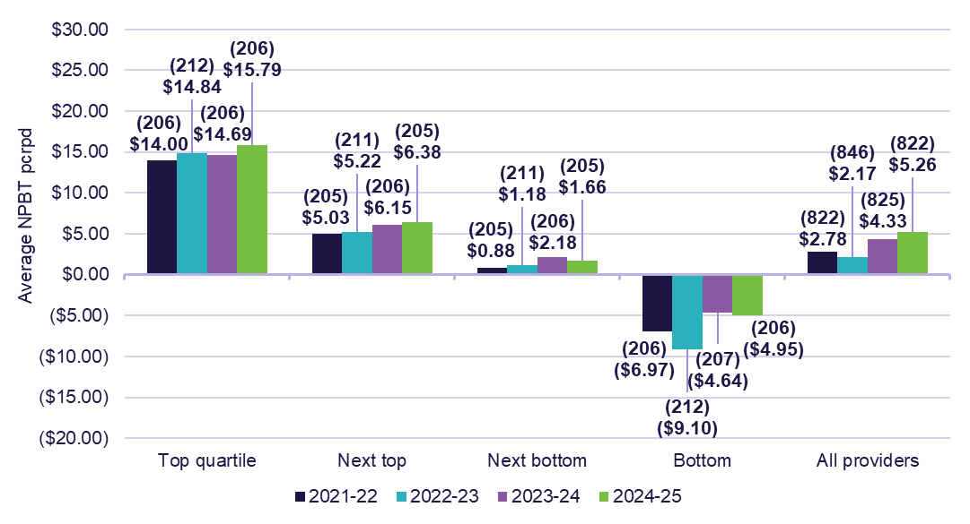

Insights: Changes to unspent funds
From 1 September 2021, unspent government subsidy for HCPs accrues in a Home Care Account set up for care recipients by Services Australia. These funds are available for providers to use for care and services provided to the care recipient. Some providers also have access to the Provider Held Portion of unspent funds accrued prior to 1 September 2021. These funds will be used to meet needs of care recipients or be returned to the government on exit.
As per data extracted from Services Australia, at 30 June 2025 there was
$4.1 billion in unspent HCP funds (up by $0.5 billion from 30 June 2024), including:
- $3.8 billion of unspent funds in the Home Care Account held by Services Australia (up $0.6 billion)
- $0.3 billion in the Provider Held Portion of unspent funds (down $0.1 billion).
Providers also self-report changes in their Home Care Account balance and Provider Held Portion of unspent funds through the ACFR (Table 2.5). This data varies from that extracted from Services Australia (above) due to the timing of data collection and the coverage of the FRAACS data (97.9% of HCP providers in 2024-25) and enables an understanding of the inflows and outflows of government subsidies and supplements and client contributions for HCP services.
Table 2.5: Unspent Australian Government subsidy for HCPs, 2024-25
 | Total ($m) | Percentage of total inflow
Home Care Account balance plus unspent package funds opening balance | $3,632.0
Government subsidies and supplements | $9,425.2 | 96.1%
Client fees – basic daily fee | $10.5 | 0.3%
Client fees – income tested care fees | $143.6 | 1.5%
Client fees – other | $37.3 | 0.4%
Funds transferred in with new clients | $175.2 | 1.8%
Funds transferred out – another provider | $122.5 | 1.3%
Funds transferred out – client / estate | $21.3 | 0.2%
Funds transferred out – Australian Government | $505.0 | 5.1%
Package funds spent | $8,701.0 | 88.8%
Home Care Account balance plus unspent package funds closing balance | $4,074.1

Results by provider ownership type, location, and scale
Insights: Margins on internal and external care services
Over recent years, use of external care services has increased significantly (22.2% of sector income in 2021-22 to 32.1% in 2024-25), while use of internal care services has decreased (43.6% of sector income in 2021-22 to 36.7% in 2024-25). This has been driven by many factors, including workforce shortages for direct care roles, particularly in regional and remote areas, and the increase in models of delivery in which home care providers run a no- or low-direct care service model.
Despite improving over time, the margins on the delivery of these external care services have continued to run at a loss, while margins on internal (direct care) services have held broadly steady (Chart 2.2). This means that providers who are reliant on external care services are disproportionately impacted.
In 2024-25, for-profit providers reported significant growth in their external care services, with these services accounting for 42.4% of total income (up 8.7 pp from 2023-24). Over the same period, not-for-profits reported a 2.8 pp increase in use of external care services, and LST government providers reported a 2.5 pp decrease.
The increase in the use of these services, combined with the sustained losses in delivery of these services, contributed to for-profit providers reporting a smaller increase in NPBT ($0.44 pcrpd), when compared to not-for-profit ($1.18) and LST government ($1.20) providers.
Chart 2.2: Margins on internal and external care services, 2021-22 to 2024-25
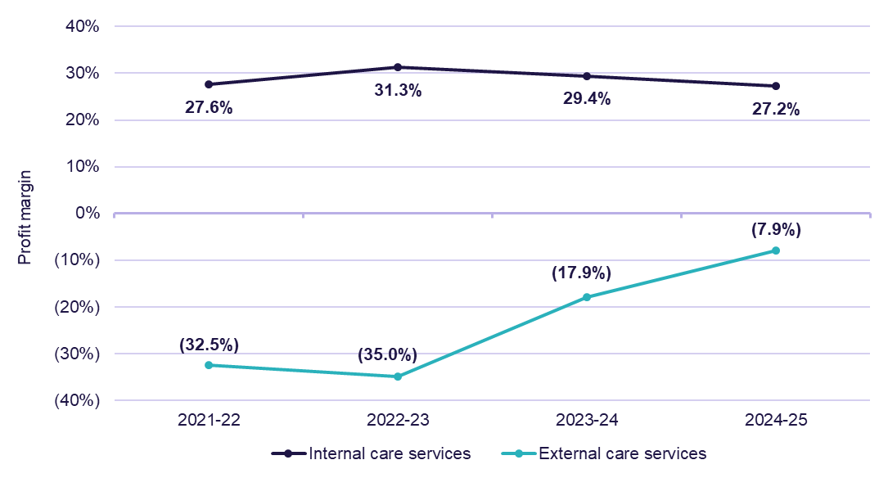

Provider ownership type
Financial performance of not-for-profit and LST government providers improved from 2023-24 to 2024-25, while for-profit providers declined. However, for-profit providers continue to outperform not-for-profit and LST government providers. When reviewing NPBT results by ownership type (Table 2.6 and Table 2.7):
- for-profit providers had the highest NPBT, with the figure increasing from $5.71 pcrpd in 2023-24 to $6.15 in 2024-25 (up $0.44). However, there was a decline in the NPBT margin, due to the growth in expenses (30.2%) exceeding the growth in income (29.2%). Expense growth was primarily driven by a 44.7% increase in external care service expenses, up $11.97 pcrpd day from 2023-24.
- not-for-profit providers saw an increase in net profitability, from $3.70 pcrpd in 2023-24 to $4.89 in 2024-25 (up $1.18). The income growth for these providers was primarily driven by a 22.5% increase in income received for external care services ($35.26 in 2024-25), and a combined 9.4% increase in care management service fees and package management services fees (total of $26.77 in 2024-25).
- LST government providers reported the largest increase in NPBT, from $1.04 pcrpd in 2023-24 to $2.25 in 2024-25 (up $1.20). This was primarily driven by a 78.4% increase in other income, with a small number of providers reporting a large increase in other income.
Table 2.6: Summary of financial performance of HCP providers, by ownership type, 2024-25
 | Sector | For-profit | Not-for-profit | LST gov.
Total income ($m) | $8,818.5 | $3,536.6 | $4,932.0 | $349.9
Total expenses ($m) | $8,277.7 | $3,292.1 | $4,645.6 | $340.0
EBITDA ($m) | $607.7 | $271.3 | $325.5 | $10.9
NPBT ($m) | $540.7 | $244.5 | $286.3 | $9.9
EBITDA (pcrpd) | $5.91 | $6.83 | $5.55 | $2.46
NPBT (pcrpd) | $5.26 | $6.15 | $4.89 | $2.25
EBITDA margin | 6.9% | 7.7% | 6.6% | 3.1%
NPBT margin | 6.1% | 6.9% | 5.8% | 2.8%

Table 2.7: Financial performance of HCP providers pcrpd, by ownership type, 2024-25
 | Sector | For-profit | Not-for-profit | LST gov.
Income
Internal care services | $31.51 | $27.24 | $35.26 | $20.15
External care services | $27.57 | $37.73 | $20.52 | $29.57
Care management service fees | $14.84 | $13.60 | $15.61 | $15.66
Package management service fees | $10.34 | $8.97 | $11.16 | $11.68
Other income | $1.56 | $1.43 | $1.59 | $2.33
Total income | $85.81 | $88.97 | $84.14 | $79.39
Expenses
Internal care services | $22.93 | $18.68 | $26.26 | $16.98
External care services | $29.75 | $38.76 | $23.36 | $33.53
Care management | $7.71 | $6.66 | $8.13 | $11.67
Admin costs and support expenses | $17.07 | $14.96 | $18.75 | $13.70
Other expenses and non-direct costs | $3.08 | $3.76 | $2.76 | $1.27
Total expenses | $80.55 | $82.82 | $79.26 | $77.15
NPBT | $5.26 | $6.15 | $4.89 | $2.25
In line with the EBITDA results, in 2024-25 the average NPBT results improved for all ownership types from 2023-24. For-profit providers results increased by $0.44 pcrpd from 2023-24, not-for-profit providers increased by $1.18, and LST government increased by $1.20 (Chart 2.3).
When considering the average NPBT results for 2024-25 (Chart 2.4), by quartile:
- in the top quartile, for-profit providers ($16.92 pcrpd) outperformed not-for-profit providers ($15.22) and LST government providers ($14.04).
- in the bottom quartile, not-for-profit providers (a loss of $4.59 pcrpd) recorded a smaller loss compared to for-profit providers (a loss of $6.93) and LST government providers (a loss of $7.02).
For-profit providers had a relatively even proportion of providers across the top two quartiles (31.9% for the top quartile and 28.7% for the next top quartile), and a minority were in the bottom quartile (16.1%). Not-for-profit providers’ proportions were also relatively even in each quartile range, with the highest proportion being in the bottom quartile (29.1%).
Chart 2.3: HCP providers average NPBT pcrpd, by ownership type, 2021-22 to 2024-25
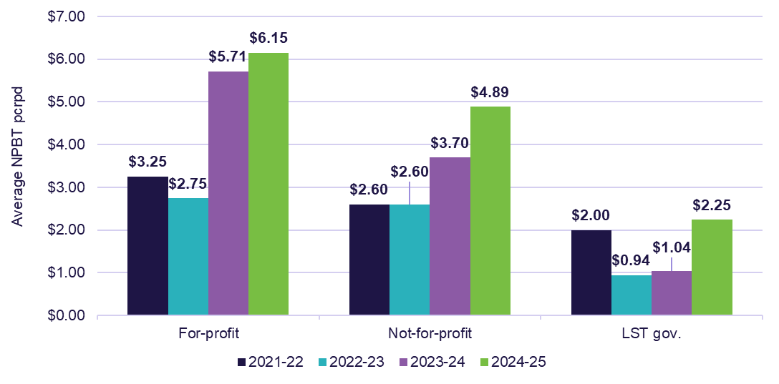
Chart 2.4: HCP providers average NPBT pcrpd, by quartile and ownership type (number of providers in parentheses), 2024-25
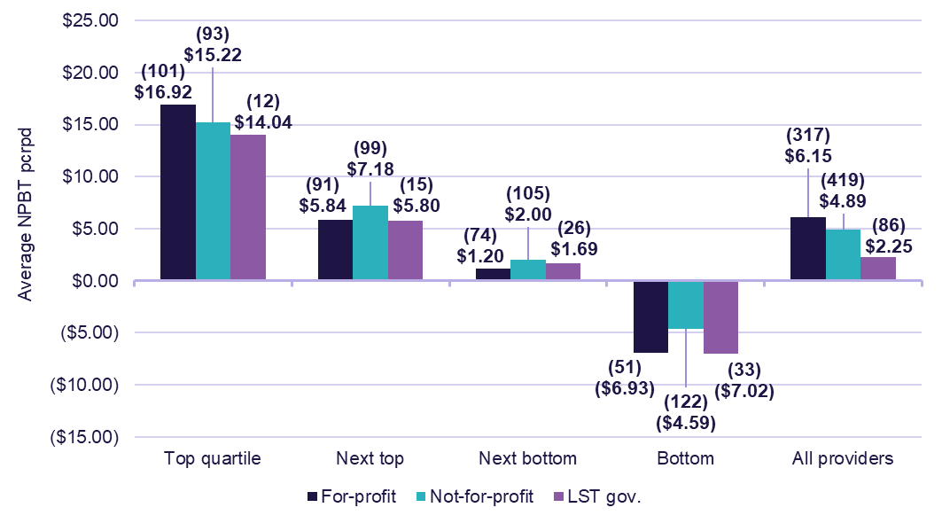

Provider location
In 2024-25, metropolitan providers, on average, were the most profitable providers by location type, with a NPBT result of $6.14 pcrpd (Table 2.8 and Table 2.9). Comparatively, providers in metropolitan and regional areas recorded a NPBT result of $4.64 pcrpd, and regional providers reported a profit result of $3.17.
Methodology: Assignment of providers to a location
From the 2023-24 FRAACS, HCP providers are assigned to locations based on the location of the care recipients (or the HCPs) they service. As the location of care recipients is accurately captured by providers, this method also improves the meaningfulness of the data.
In previous financial years of FRAACS reporting, HCP providers were assigned to locations based on the location of their services (home care outlets). As a result, Chart 2.5 compares NPBT results by provider location over 2023-24 and 2024-25, as these results are not comparable with previous years.
However, all previous figures are available in the 2.3 HC results (provider type) tab in the FRAACS data extract.
Table 2.8: Financial performance of HCP providers, by location, 2024-25
 | Sector | Metropolitan | Regional | Metropolitan and regional
Total income ($m) | $8,818.5 | $4,894.8 | $963.9 | $2,959.8
Total expenses ($m) | $8,277.7 | $4,559.8 | $924.7 | $2,793.3
EBITDA ($m) | $607.7 | $365.0 | $44.1 | $198.6
NPBT ($m) | $540.7 | $335.0 | $39.3 | $166.5
EBITDA (pcrpd) | $5.91 | $6.69 | $3.56 | $5.54
NPBT (pcrpd) | $5.26 | $6.14 | $3.17 | $4.64
EBITDA margin | 6.9% | 7.5% | 4.6% | 6.7%
NPBT margin | 6.1% | 6.8% | 4.1% | 5.6%

Table 2.9: Financial performance of HCP providers pcrpd, by location, 2024-25
 | Sector | Metropolitan | Regional | Metropolitan and regional
Income
Internal care services | $31.51 | $32.32 | $31.92 | $30.14
External care services | $27.57 | $29.79 | $19.15 | $27.10
Care management service fees | $14.84 | $15.23 | $14.28 | $14.42
Package management service fees | $10.34 | $10.27 | $10.07 | $10.53
Other income | $1.56 | $2.14 | $2.42 | $0.37
Total income | $85.81 | $89.75 | $77.85 | $82.56
Expenses
Internal care services | $22.93 | $23.71 | $24.28 | $21.28
External care services | $29.75 | $32.44 | $22.21 | $28.27
Care management | $7.71 | $7.83 | $8.79 | $7.15
Admin costs and support expenses | $17.07 | $16.52 | $16.36 | $18.15
Other expenses and non-direct costs | $3.08 | $3.11 | $3.03 | $3.06
Total expenses | $80.55 | $83.61 | $74.68 | $77.92
NPBT | $5.26 | $6.14 | $3.17 | $4.64
In 2024-25, the average NPBT results improved for metropolitan providers (up $1.50 pcrpd), and metropolitan and regional (up $0.39) from 2023-24, while regional providers remained broadly consistent (down $0.09) (Chart 2.5).
When considering the average NPBT results for 2024-25 (Chart 2.6), by quartile:
- in the top quartile, metropolitan providers ($18.08 pcrpd) outperformed regional ($17.08), and metropolitan and regional providers ($12.86).
- in the bottom quartile, regional providers (a loss of $6.65 pcrpd) recorded a larger loss compared to metropolitan providers (a loss of $4.73), and metropolitan and regional providers (a loss of $4.36).
In 2024-25, 22.3% of regional providers were in the top quartile, while 33.5% were in the bottom quartile. Comparatively, 26.3% of metropolitan providers were in the top quartile, while only 20.1% were in the bottom quartile. This difference in distribution of providers by location type across the quartiles drove the variance in overall average NPBT results between metropolitan and regional providers.
Chart 2.5: HCP providers average NPBT pcrpd, by location, 2023-24 to 2024-25
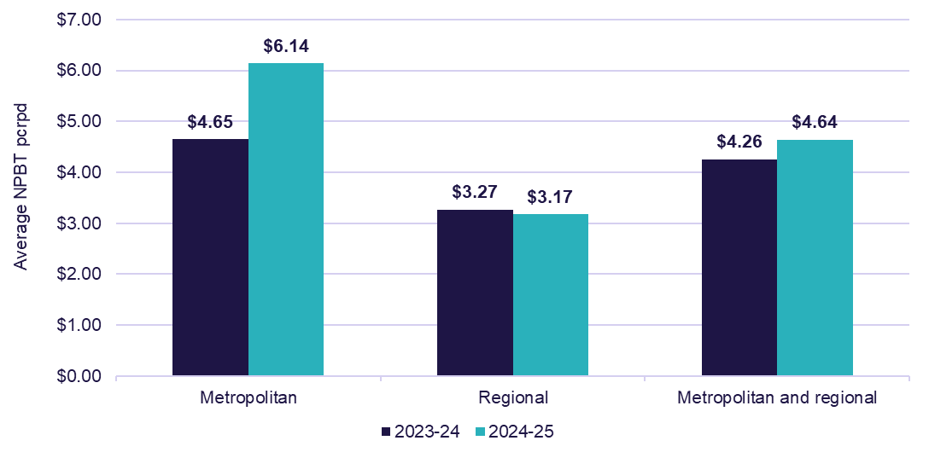
Chart 2.6: HCP providers average NPBT pcrpd, by quartile and location (number of providers in parentheses), 2024-25
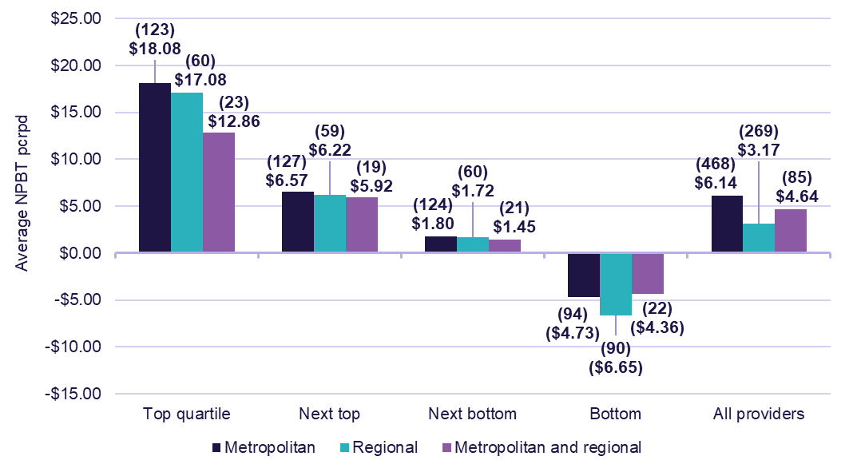

Provider scale
In 2024-25, providers that serviced 101 to 500 HCPs reported the highest average NPBT by provider scale, with a result of $5.78 pcrpd (Table 2.10). Comparatively, those that serviced 501 or more HCPs reported an average NPBT result of $5.09 pcrpd, and those that serviced 1 to 100 HCPs reported a result of $4.94 pcrpd.
Methodology: Determining the ‘scale’ of a provider
From the 2023-24 FRAACS, the scale of home care providers has been determined by the number of home care recipients (i.e. the number of HCPs) they service. As the number of care recipients serviced more accurately reflects a provider’s operating scale, this method improves the meaningfulness of the data.
This is a departure from previous years of FRAACS reporting, where the scale of HCP providers was based on the number of services (home care outlets) the provider operated. As a result, Chart 2.7 compares NPBT results by provider location over 2023-24 and 2024-25, as these results are not comparable with previous years. However, all previous figures are available in the 2.3 HC results (provider type) tab in the FRAACS data extract.
Table 2.10: Financial performance of HCP providers, by scale, 2024-25
 | Sector | 1 to 100 HCPs | 101 to 500 HCPs | 501 or more HCPs
Total income ($m) | $8,818.5 | $588.9 | $2,377.1 | $5,852.5
Total expenses ($m) | $8,277.7 | $556.6 | $2,222.4 | $5,498.8
EBITDA ($m) | $607.7 | $35.9 | $170.9 | $400.8
NPBT ($m) | $540.7 | $32.3 | $154.7 | $353.7
EBITDA (pcrpd) | $5.91 | $5.50 | $6.38 | $5.77
NPBT (pcrpd) | $5.26 | $4.94 | $5.78 | $5.09
EBITDA margin | 6.9% | 6.1% | 7.2% | 6.8%
NPBT margin | 6.1% | 5.5% | 6.5% | 6.0%

Table 2.11: Financial performance of HCP providers pcrpd, by scale, 2024-25
 | Sector | 1 to 100 HCPs | 101 to 500 HCPs | 501 or more HCPs
Income
Internal care services | $31.51 | $44.02 | $36.02 | $28.59
External care services | $27.57 | $18.63 | $24.49 | $29.59
Care management service fees | $14.84 | $13.89 | $14.96 | $14.87
Package management service fees | $10.34 | $9.83 | $10.56 | $10.30
Other income | $1.56 | $3.89 | $2.70 | $0.90
Total income | $85.81 | $90.26 | $88.73 | $84.26
Expenses
Internal care services | $22.93 | $32.46 | $26.68 | $20.59
External care services | $29.75 | $21.85 | $27.70 | $31.28
Care management | $7.71 | $9.11 | $8.24 | $7.38
Admin costs and support expenses | $17.07 | $17.28 | $16.71 | $17.19
Other expenses and non-direct costs | $3.08 | $4.61 | $3.62 | $2.73
Total expenses | $80.55 | $85.32 | $82.96 | $79.17
NPBT | $5.26 | $4.94 | $5.78 | $5.09
In 2024-25, the average NPBT results improved for all providers by scale (Chart 2.7).
When considering the average NPBT results for 2024-25 (Chart 2.8), by quartile:
- in the top quartile, providers with 1-100 HCPs had the highest average NPBT ($20.30 pcrpd), compared to 101-500 HCPs ($18.34) and 501 or more HCPs ($14.34) (Chart 2.5).
- in the bottom quartile, providers with 1-100 HCPs had the lowest average NPBT (a loss of $8.08 pcrpd), compared to 101-500 HCPs (a loss of $5.83) and 501 or more HCPs (a loss of $3.87).
Similar to the breakdown of NPBT results by location and quartile, the difference in distribution of providers by scale across the quartiles drove the variance in overall average NPBT results. In 2024-25, 24.9% of providers that serviced 1-100 HCPs were in the top quartile, while 33.2% were in the bottom quartile. Comparatively, 24.7% of providers that serviced 101-500 HCPs were in the top quartile, while 18.9% were in the bottom quartile.
Chart 2.7: HCP providers average NPBT pcrpd, by scale, 2023-24 to 2024-25
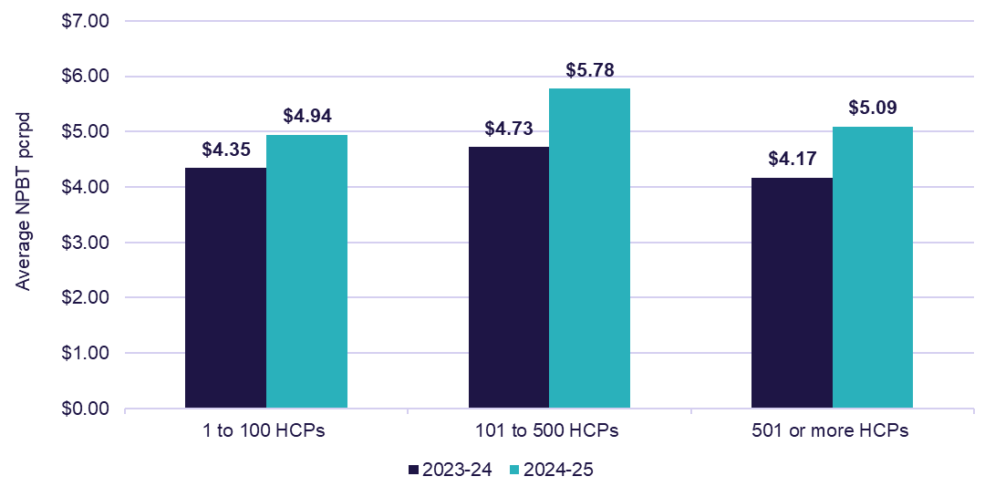
Chart 2.8: HCP providers average NPBT pcrpd, by quartile and scale (number of providers in parentheses), 2024-25
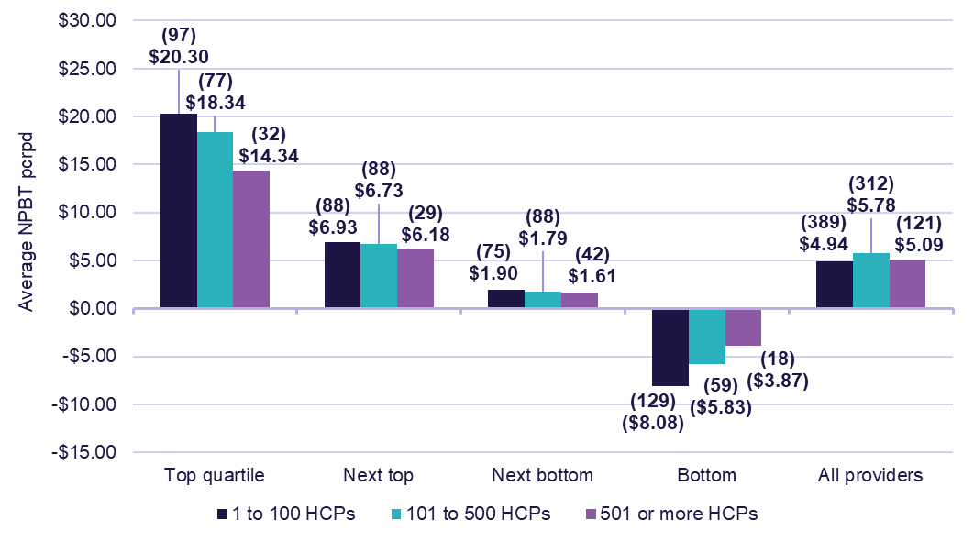
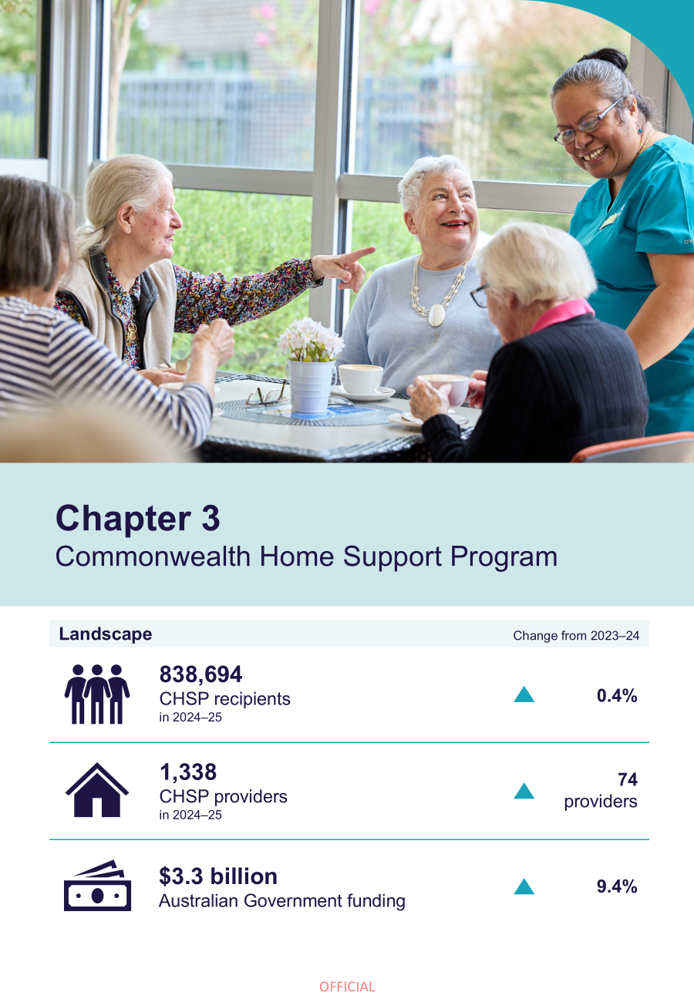

Commonwealth Home Support Program (CHSP)

CHSP landscape

CHSP recipients and providers
The trends in the demographic landscape of CHSP recipients and CHSP providers, as reported in the FRAACS reports from 2021-22 onwards, remained consistent in 2024-25.
These included:
- a slight increase in CHSP recipient numbers, from 834,981 recipients in 2023-24, to 838,694 recipients in 2024-25 (Table 3.1).
- an increase in the number of CHSP providers, from 1,264 providers in 2023-24, to 1,338 providers in 2024-25 (Table 3.2).
Table 3.1: Number of CHSP recipients, 2021-22 to 2024-25
 | 2021-22 | 2022-23 | 2023-24 | 2024-25
Total CHSP recipients | 818,228 | 816,132 | 834,981 | 838,694
Culturally and Linguistically Diverse CHSP recipients | 166,830 | 165,694 | 167,035 | 168,376
Aboriginal and Torres Strait Islander CHSP recipients | 22,452 | 22,630 | 24,003 | 23,894
Table 3.2: Providers of CHSP, by ownership type, 2021-22 to 2024-25
 | 2021-22 | 2022-23 | 2023-24 | 2024-25
Total CHSP providers | 1,407 | 1,334 | 1,264 | 1,338
For-profit | 149 | 116 | 107 | 195
Not-for-profit | 938 | 942 | 894 | 876
LST gov. | 304 | 276 | 263 | 267

Financial summary

Expenditure
In 2024-25, government funding for CHSP services was $3.3 billion, an increase from $3.0 billion in 2023-24 (Chart 3.1).
Chart 3.1: Australian Government expenditure and budgeted expenditure for service delivery of CHSP, 2021-22 to 2028-29
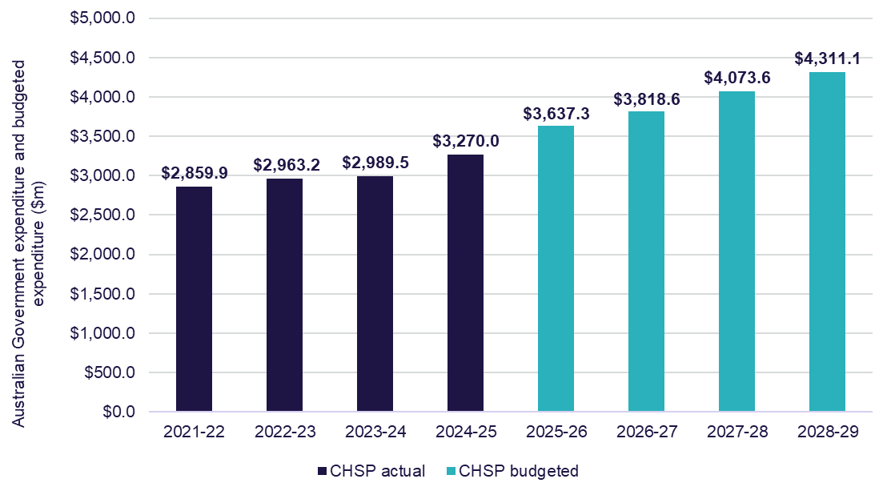
In 2024-25, the largest service types by expenditure were (Table 3.3):
- domestic assistance with $691.2 million (21.6% of total expenditure), up $127.6 million from 2023-24
- social support with $531.7 million (16.6% of total expenditure), up $29.6 million from 2023-24
- allied health and therapy services with $367.4 million (11.5% of total expenditure), up $74.1 million from 2023-24.
Table 3.3: CHSP expenditure by service type, 2021-22 to 2024-25, with comparison to 2023-24
 | 2021-22 ($m) | 2022-23 ($m) | 2023-24 ($m) | 2024-25 ($m) | Change from 2023-24 (%)
Social support ¹ | $513.5 | $535.4 | $502.1 | $531.7 | ▲ 5.9%
Domestic assistance | $558.4 | $573.6 | $563.6 | $691.2 | ▲ 22.7%
Nursing | $292.8 | $302.0 | $315.1 | $329.0 | ▲ 4.4%
Respite ² | $336.6 | $357.3 | $322.6 | $326.1 | ▲ 1.1%
Allied health and therapy services | $283.6 | $294.1 | $293.3 | $367.4 | ▲ 25.3%
Personal care | $219.8 | $225.4 | $219.6 | $232.1 | ▲5.7%
Transport | $212.8 | $218.0 | $224.3 | $231.7 | ▲ 3.3%
Home modifications and maintenance ³ | $183.1 | $190.3 | $200.1 | $250.9 | ▲ 25.4%
Meals & other food services ⁴ | $99.3 | $108.6 | $116.6 | $136.1 | ▲ 16.6%
Sector support and development | $42.9 | $34.6 | $31.4 | $32.0 | ▲ 2.0%
Assistance with care and housing | $22.9 | $14.7 | $6.8 | $6.9 | ▲ 1.6%
Specialised support services ⁵ | $59.5 | $59.5 | $53.0 | $49.0 | ▼ 7.5%
Goods, equipment and assistive technology | $12.2 | $12.7 | $13.1 | $13.9 | ▲ 5.4%
Total expenditure ⁶ | $2,837.4 | $2,926.2 | $2,861.5 | $3,197.9 | ▲ 11.8%
Notes:
- Social support includes social support group and social support individual.
- Respite includes centre-based respite, cottage respite and flexible respite.
- Home modifications and maintenance are two separate services in CHSP.
- Meals and other food services are two separate services in CHSP.
- Specialised support services provide services that meet the specialised needs of older people living at home with a particular condition such as dementia or vision impairment.
- The figures in Table 3.3 represent funding spent on core CHSP services by service type, and do not sum to the total expenditure shown in Chart 3.1, as those figures include total grant funding and funding provided to a separate key project, geat2GO, which is also funded through CHSP appropriations.



Future trends in aged care

Demand for aged care
The government has a significant role in stewarding the aged care market to ensure people in Australia have access to the aged care services they need now and into the future. To do this, the government monitors demand and capital investment (refer to Capital investment in section 1.2) to ensure the aged care market provides the range of services people in Australia need and expect in the places where they need them. The historic data and future projections outlined in this chapter highlight the growing demand for aged care services in Australia and the need for continued investment in the sector, particularly through capital works, to increase the availability of services for older people.
Data reference: Aged care usage and demand estimates
- Population data, which underpins projections, has been sourced from the ABS medium series Population Projections.
- The charts below include data labels for the total values only, to support readability.
Refer to the 4.1 Population drivers and 4.2 Projections tabs in the FRAACS data extract for additional data on:
- number of people aged 70 years and over, by age cohort
- proportion of people using residential care and home care, by gender
- use of residential care and home care, by age group and gender
- demand for residential and home care services, by care type.

Drivers for increasing demand for aged care services

Ageing population
Demand for aged care services will increase with the ageing of the population. Over the next 20 years, the number of people aged 70 years and over in Australia will increase by approximately 2.2 million (62.4%) (Chart 4.1). During this time, the proportion of people aged 85 years and over in this cohort will increase by 7.1 pp (from 17.4% in 2025 to 24.5% in 2045).

Chart 4.1: Number of people aged 70 years and over, by age cohort, 2025 to 2045
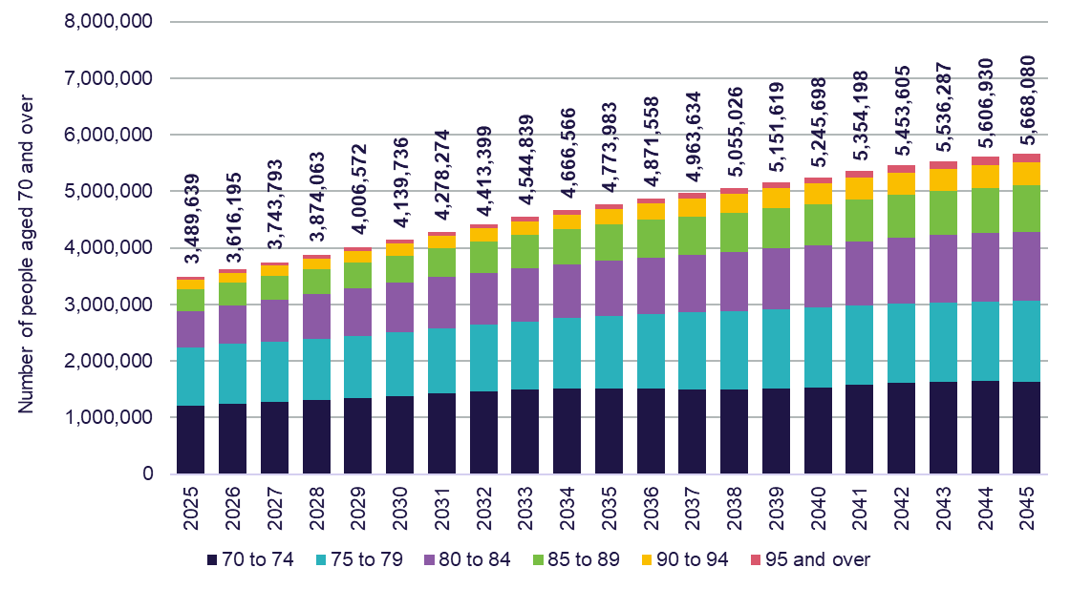

Increasing use of aged care with age
The proportion of people accessing aged care services increases significantly with age. At age 80, the proportion of people accessing aged care or seeking access to aged care is 18.4% for females and 12.2% for males (Chart 4.2 and Chart 4.3).
By age 90, this increases to 56.3% for females and 43.2% for males.
Chart 4.2: Proportion of females using aged care, by age and service, 30 June 2025
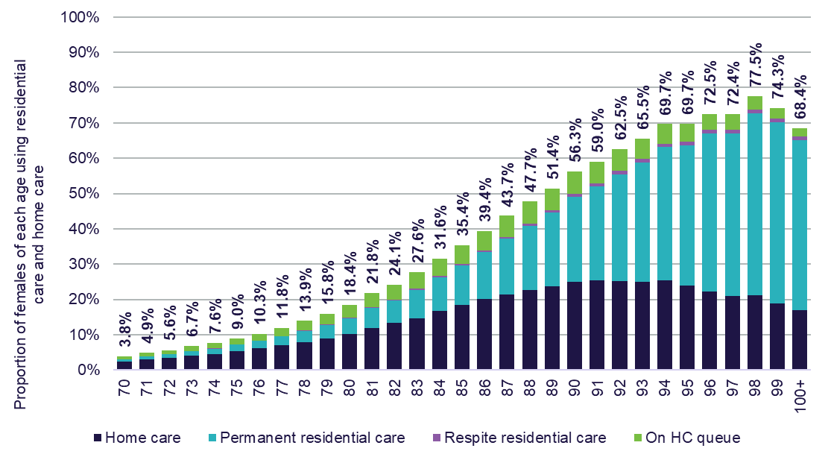
Chart 4.3: Proportion of males using aged care, by age and service, 30 June 2025
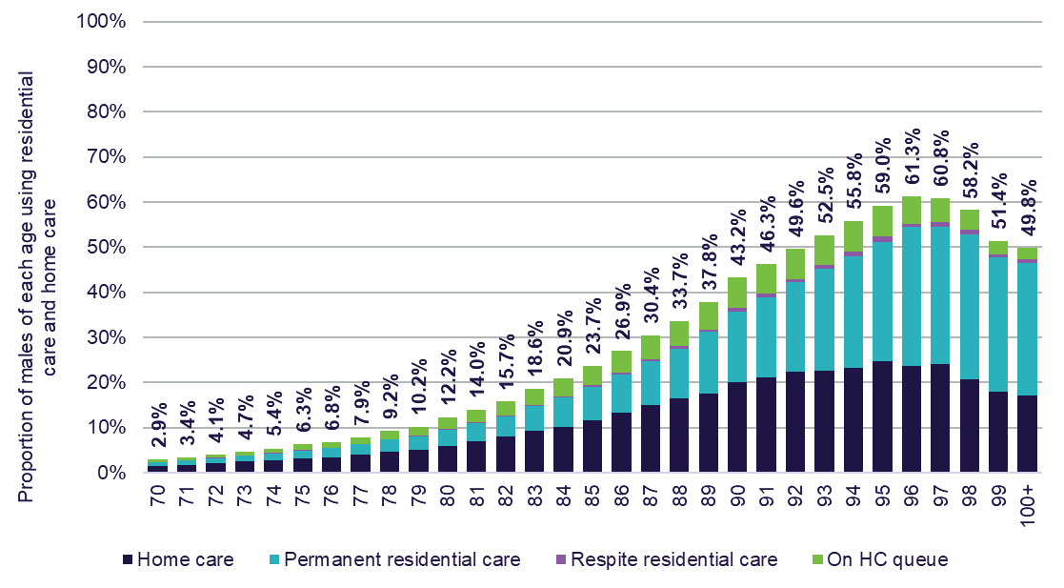

Preference for home care over residential aged care
Over the past 20 years, there has been a significant increase in the proportion of older people using home care (from 1.4% of 70 to 99 years olds in 2005, to 8.1% in 2025) (Chart 4.4). This increase corresponds with a marked expansion in the number of HCPs made available. Over the same period, residential aged care use declined by 1.8 pp, reflecting the preference of older people to remain at home and access home care services. As a result, the proportion of people receiving residential aged care (as a proportion of all people receiving aged care services) has decreased from 84.3% to 41.3% over this 20-year period.
Chart 4.4: Use of aged care services for people aged 70 to 99 years, by residential aged care and home care, 2005 to 2025
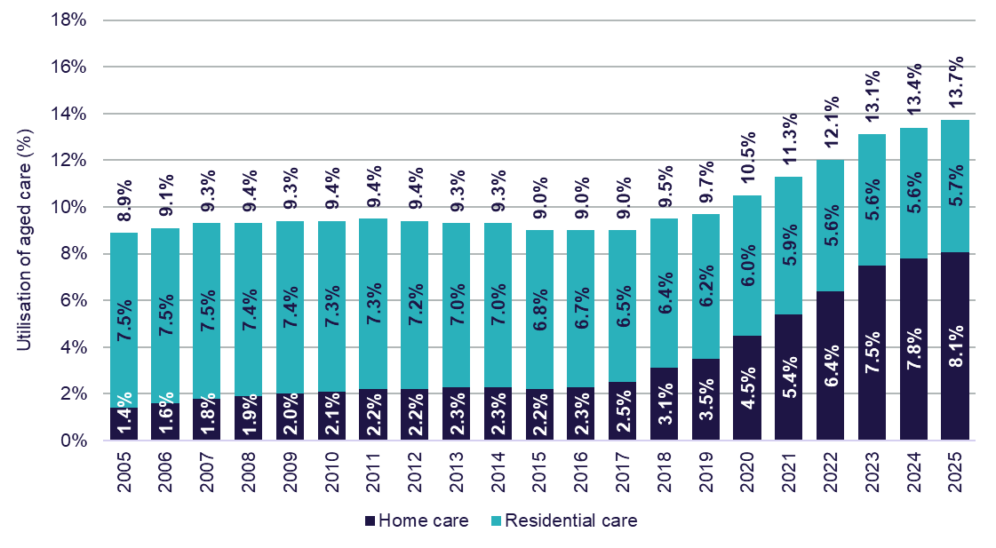

Projections of demand for aged care services
Data reference: Residential and home care demand estimates
- These projections are underpinned by the ABS single-year-age and sex population projections.
- Estimates of future demand for residential aged care and home care services have been updated from previous published estimates, and changes to demand projections are driven by changes in the rates of age-specific utilisation of aged care services.
Over the next 20 years (from 2025 to 2045), the average year-on-year increase in:
- residential aged care (permanent and respite) demand is approximately 10,400 residents per year, resulting in approximately 412,000 people in residential aged care by 2045. This represents an average annual growth rate of 3.6% over this time (Chart 4.5)
- home care demand is approximately 30,800 people per year, resulting in approximately 1,800,000 people seeking access to home care by 2045. This represents an average annual growth rate of 2.1% over this time (Chart 4.6).

Chart 4.5: Projected use of residential care, 2025 to 2045
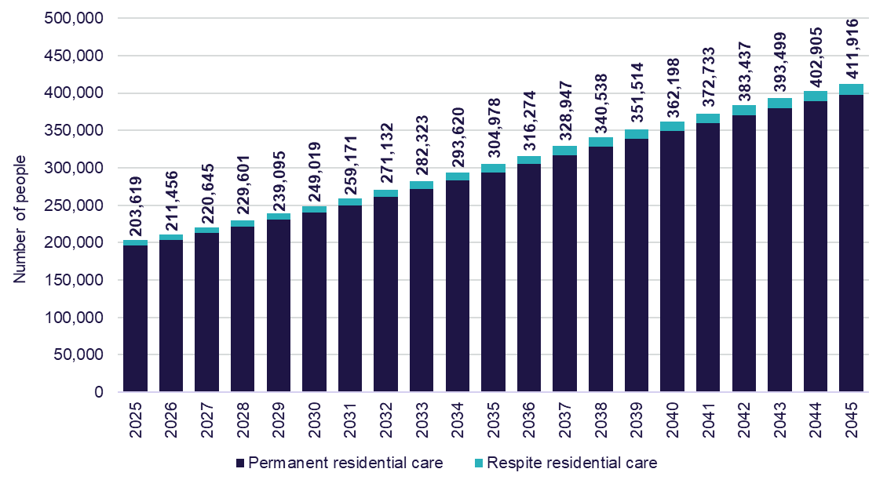
Chart 4.6: Projected demand for in-home aged care, 2025 to 2045
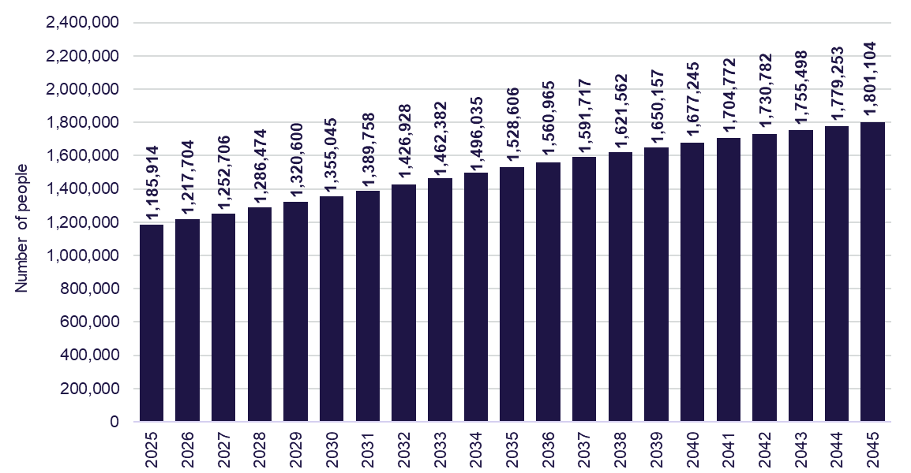
Note: The demand for in-home aged care total figure includes older people in a HCP (or Support at Home place from 2025-26), those on the queue for a HCP (or Support at Home place from 2025-26), and those receiving care through the CHSP.

Glossary
Term | Definition
Accommodation supplement | A government funded means tested supplement payable on behalf of residents who receive permanent residential aged care and do not have the capacity to pay the full cost of their accommodation.
Aged Care Financial Report (ACFR) | An annual reporting template used to collect financial and prudential data from registered providers. Data collected through the ACFR is published through the FRAACS reports and data extracts.  The ACFR consolidates information previously reported through the Annual Prudential Compliance Statement, the Survey of Aged Care Homes, the Home Care Financial Report and the Short-Term Restorative Care Financial Report.
Aged Care Act 1997 (Cth) (the Act) | Supported by subordinate legislation, the Act was the primary legislation governing the provision of aged care services in 2024-25.  The Australian Government introduced new legislation (the Aged Care Bill 2024) which passed Parliament on 25 November 2024, and the Aged Care Act 2024 (Cth) and Aged Care Rules 2025 commenced on 1 November 2025.
Approved provider | Is an organisation approved by the Secretary of the department to provide residential care, home care or flexible care under the Aged Care Act 1997 (Cth) (noting this legislation was in force in 2024-25).
Australian National Aged Care Classification  (AN-ACC) | The Australian Government provides subsidies for care approved residential aged care providers through the AN-ACC funding model. The AN-ACC model commenced in October 2022.
Care management | Care management is mandatory and ensures home care recipients receive the appropriate level of support for their care needs. It may include ensuring a care recipient receives safe and effective personal and/or clinical care, organising the delivery of services, and ensuring the supports they receive are safe.  In 2024-25, providers were not to charge more than 15% of the government subsidy for care management.
Care minutes | Care minutes refers to the amount of care time older people who live in government-funded residential aged care services receive from registered nurses, enrolled nurses, and personal care workers and assistants in nursing. Mandatory care minutes requirements are in place for residential aged care providers.
Commonwealth Home Support Program (CHSP) | CHSP is an entry-level in-home aged care support program that helps older people to live independently at home. CHSP providers are not required to complete the ACFR. The department monitors CHSP providers through an annual grant acquittal process.
Claim days | Refers to the total number of days of government subsidised residential aged care delivered in the year, as per claims submitted to Services Australia by providers.
Daily Accommodation Contribution (DAC) and Daily Accommodation Payment (DAP) | A DAC is an amount paid by a supported resident as a contribution toward their accommodation costs in a residential aged care service, calculated on a daily basis and paid periodically.  A DAP is an amount paid by a non-supported resident towards their accommodation costs in a residential aged care service calculated on a daily basis and paid periodically.
Earnings Before Interest, Tax, Depreciation and Amortisation (EBITDA) and EBITDA margin | EBITDA is a useful measure of profitability because it excludes items such as interest and tax expenditure (which may vary based on the financing decisions and tax structures) and non-cash expenses (which may vary based on the size and age of services). It can be used to compare organisations with each other and against industry averages. The formulae used in this report are:  - EBITDA (residential care) = NPBT + Interest Expense + Depreciation on Building + Depreciation on Other Assets + Amortisation of Bed Licenses + Amortisation of Goodwill and Other Intangibles + Impairment loss + Fair value losses on financial assets + Fair value loss & asset revaluation decrease of other assets - Fair value gains on financial assets - Fair value gain & asset revaluation increase of other assets.  - EBITDA (home care) = NPBT + Depreciation + Interest expense.  EBITDA margin shows the EBITDA generated for each dollar of revenue earned. It is calculated as EBITDA divided by total revenue.
General Purpose Financial Report (GPFR) | An audited financial report submitted by providers with their ACFR. While the ACFR provides a greater level of detail, the GPFR is audited and used to verify information provided in the ACFR.
Home Care Package (HCP) and HCP Program | The HCP Program delivered HCPs, tailored to meet the care needs of those receiving care at home. The package is coordinated by an approved home care provider, with funding provided by the government (with some contributions from the recipient). HCPs range from level 1 to 4 and are assigned based on an individual’s level of need, where Level 1 is for basic care needs, and Level 4 is for high care needs.  The HCP Program was replaced by the Support at Home program on 1 November 2025.
Independent Health and Aged Care Pricing Authority (IHACPA) | An independent government agency that uses data to set fair pricing in the delivery and funding of public health and aged care services across Australia. IHACPA provides advice to the government on the sector average efficient cost for delivering care and ensures AN-ACC funding is in line with the costs of delivering care. IHACPA also assesses applications from providers for room prices above the maximum accommodation payment amount.
Location (providers) | For the purposes of FRAACS reports, providers are assigned to one of three location groups – metropolitan providers, regional providers, or providers across metropolitan and regional areas.  The location of residential care providers is based on where the majority (over 70%) of their services are provided.  The location of home care providers is based on where the majority (over 70%) of their care recipients (or HCPs) are located.
Maximum Permissible Interest Rate (MPIR) | The MPIR is the Australian Government-set interest rate used by residential aged care facilities to calculate DAPs. It determines how much a resident pays if they choose to make an ongoing daily payment rather than a lump-sum RAD.  DAP = (Agreed room price x MPIR) ÷ 365.  While the MPIR changes every quarter, the rate that applies to a specific resident is locked in on the day they enter the aged care home. The calculation method is specified in s301-5 of the Aged Care Rules 2025.
Modified Monash Model (MMM) | The MMM defines whether a location is metropolitan, rural, remote or very remote. The model measures remoteness and population size on a scale – MM 1 (major city) to MM 7 (very remote).
Net Profit Before Tax (NPBT) and NPBT margin | NPBT is determined by revenue minus expenses for the period, except for taxes. The NPBT result includes depreciation, amortisation, and interest expenses, giving a more complete picture of profitability. It also reflects the impact on profitability of financing decisions (like debt) and capital investments (like equipment).  NPBT margin shows the profitability generated on each dollar of revenue. It is calculated as NPBT divided by total revenue.
Package management | Under the HCP Program, package management covered the ongoing administration and organisational activities associated with ensuring the smooth delivery of a HCP. In 2024-25, providers were not to charge more than 15% of the government subsidy for package management.
Recurrent result and recurrent margin | The recurrent result is the profit made by a provider from regular, ongoing operations, excluding exceptional or one‑off items (e.g., increases or decreases in assets due to revaluations and donations).  The recurrent margin is the percentage margin earned from those recurrent results relative to revenue.
Refundable Accommodation Contribution (RAC) and Refundable Accommodation Deposit (RAD) | A RAC is an amount paid as a lump sum by a partially supported resident as a contribution toward their accommodation costs in a residential aged care service.  A RAD is an amount paid as a lump sum by a non-supported resident for their accommodation costs in a residential aged care service.
Scale (providers) | The scale of residential aged care providers is determined by the number of services (homes) they operate.  The scale of HCP providers is determined by the number of home care recipients (or HCPs) they service.
Support at Home program | The Support at Home program replaced the HCP Program and the Short-Term Restorative Care Program on 1 November 2025, with the introduction of the Aged Care Act 2024.
Fully supported, partially supported and non-supported residents | Fully supported residents are those who have been assessed (based on a means test) as eligible for full government assistance with their care and accommodation costs. Supported residents only pay a basic daily fee.  Partially supported residents are those who have been assessed as eligible for government assistance with their care costs but can make a part contribution to their accommodation costs. Partially supported residents pay a basic daily fee and accommodation contribution.  Non-supported residents are those who have been assessed (based on a means test) as able to pay the full cost of their accommodation and contribute toward their care costs. Non-supported residents pay a basic daily fee, accommodation payment and means tested care fee (but may still receive some assistance with care costs).
Unspent funds | From 1 September 2021, unspent government subsidies for HCPs are accrued in Home Care Accounts set up for care recipients by Services Australia. These funds are available for providers to use for care and services provided to the care recipient.  Some providers also have access to the Provider Held Portion of unspent funds accrued prior to 1 September 2021, which can also be used for a care recipient’s care and services.

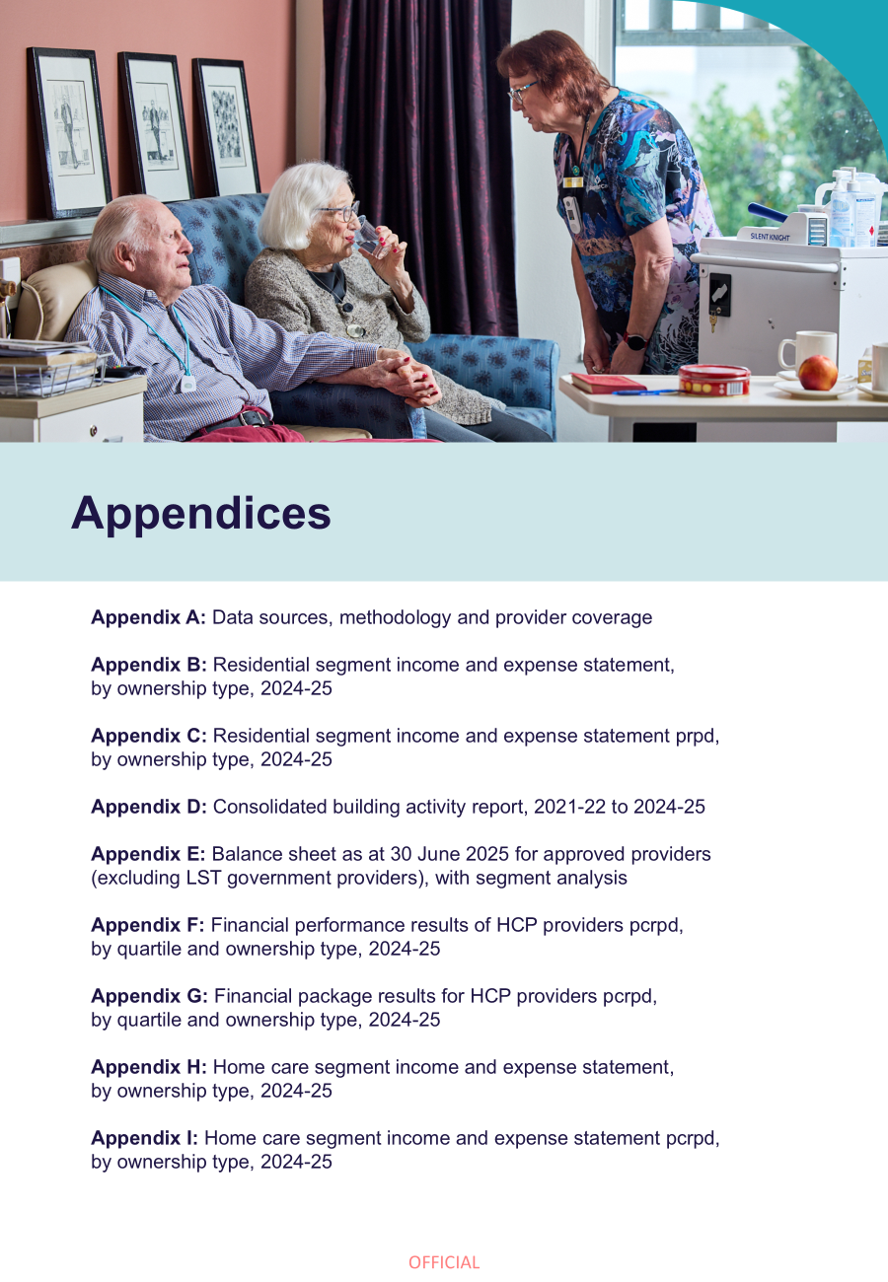

Appendices

Appendix A

Data sources
This 2024-25 FRAACS report presents and analyses financial data provided by aged care providers through the ACFR and other data held by the department. The Accountability Principles 2014, made under section 96-1 of the Aged Care Act 1997, require approved providers to submit a financial report (the ACFR) in a form approved by the Secretary of the department.
Providers are responsible for submitting accurate information, and ensuring their ACFR is signed by:
- a director of the body corporate or a member of the provider’s governing body (if they are a for-profit or not-for-profit provider).
- one of the approved provider’s key personnel (if they are a state, a territory, an authority of a state or territory or a local government authority).
For providers of residential aged care, the ACFR must also be accompanied by an audited GPFR and accompanying audit opinion.
The department undertakes a data validation and analysis process on all data submitted by aged care providers prior to publication.
Data sources included in the 2024-25 FRAACS are shown below.
Segment | Data sources
Residential aged care providers | - ACFR submissions  - GPFR submissions  - QFR submissions  - Annual Survey of Aged Care Homes (SACH), and  - Aged care accommodation prices (My Aged Care website, Aged Care Entry Record)
Home Care Package providers | - ACFR submissions
CHSP providers | - CHSP Data Exchange
Future trends | - ABS medium series population projections
Other data | - 2024-25 Report on the Operation of the Aged Care Act 1997

Methodology notes
- 17 providers reported data in the ACFR for a non-standard financial year. Data collected for these providers was taken from the 2023-24 ACFR (consistent with the approach used in previous FRAACS reports).
- National Aboriginal and Torres Strait Islander Flexible Aged Care (NATSIFAC) program providers do not currently report financial data via ACFRs or GPFRs, therefore data for this program is not included in the 2024-25 FRAACS.
- Multi-Purpose Services (MPS) or providers under the Short-term Restorative Care (STRC) Program are only required to complete the Annual Prudential Compliance Statement (APCS) component of the ACFR where they choose to collect a RAD from their clients. STRC providers must complete an income and expense statement. However, analysis of this data is not included in this report.

Provider coverage
Figure 6.1: Residential care and HCP provider numbers, coverage, and composition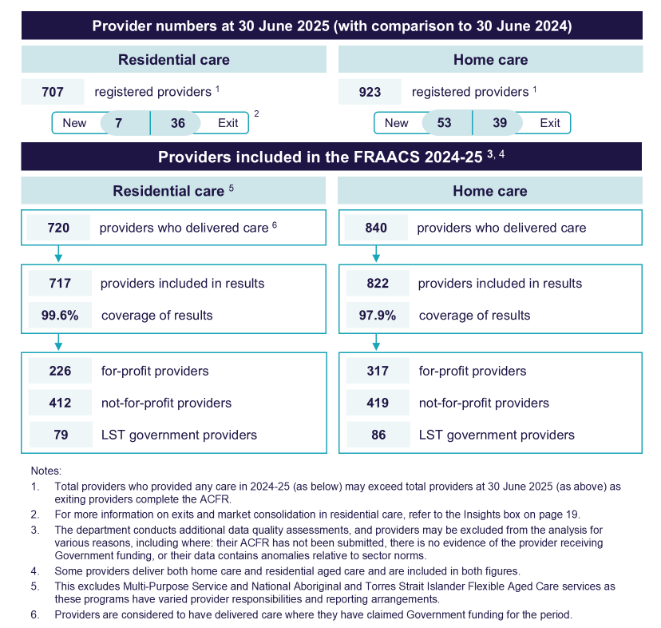

Appendix B
Table 6.1: Residential segment income and expense statement, by ownership type, 2024-25
 | For-profit ($m) | Not-for-profit ($m) | LST gov. ($m) | All providers ($m)
Income
Recurrent income
Care income
Subsidies and supplements (Australian Government) | $7,485.3 | $12,478.5 | $744.4 | $20,708.3
Subsidies and supplements (state / territory) | $2.1 | $39.1 | $219.3 | $260.5
Resident fees – means-tested care fee | $401.9 | $521.6 | $19.5 | $943.0
Grants – recurrent | $2.7 | $37.3 | $10.1 | $50.1
Other care income | $37.6 | $40.1 | $4.1 | $81.7
Total care income | $7,929.5 | $13,116.6 | $997.4 | $22,043.6
Everyday living income
Subsidies and supplements (Australian Government) | $332.1 | $530.5 | $25.2 | $887.9
Basic daily fee | $1,665.7 | $2,720.7 | $147.3 | $4,533.7
Extra service fees | $117.8 | $33.8 | $0.1 | $151.8
Additional service fees | $167.2 | $157.0 | $0.0 | $324.2
Other everyday living income | $9.9 | $27.6 | $0.9 | $38.5
Total everyday living income | $2,292.8 | $3,469.7 | $173.6 | $5,936.1
Accommodation and finance income
Subsidies and supplements (Australian Government) | $639.1 | $1,083.1 | $48.0 | $1,770.2
Subsidies and supplements (state / territory) | $0.0 | $30.2 | $15.1 | $45.3
Daily accommodation payments | $403.7 | $767.1 | $30.7 | $1,201.5
Accommodation charges | $24.8 | $20.8 | $2.9 | $48.5
Interest received – accommodation bonds | $57.2 | $38.9 | $14.4 | $110.5
Other accommodation income | $9.6 | $47.0 | $3.6 | $60.2
Interest and investment income | $361.8 | $317.7 | $20.1 | $699.6
Total accommodation and finance income | $1,496.3 | $2,304.8 | $134.8 | $3,935.8
Total recurrent income | $11,718.6 | $18,891.1 | $1,305.8 | $31,915.5
Non-recurrent income
Donations, bequests and fundraising | $0.9 | $17.9 | $0.6 | $19.4
Fair value gains on financial assets | $0.0 | $39.8 | $0.6 | $40.5
Fair value gain / asset revaluation increase – other assets | $79.3 | $5.7 | $68.1 | $153.1
Capital grants (Australian Government, state and territory) | $2.8 | $141.0 | $11.3 | $155.2
Reversal of prior period impairment | $0.1 | $1.5 | $0.0 | $1.5
Realised gains on disposal of assets | $163.0 | $43.2 | $0.0 | $206.1
Effect of adoption of AASB 16 leases – RADs only | $868.3 | $686.5 | $2.7 | $1,557.5
Other non-recurrent income | $64.8 | $153.0 | $15.5 | $233.3
Total non-recurrent income | $1,179.1 | $1,088.5 | $98.9 | $2,366.6
Total income | $12,897.8 | $19,979.6 | $1,404.7 | $34,282.0
Expenses
Recurrent expenses
Care expenses
Employee labour costs
Registered nurses | $1,404.9 | $2,425.4 | $235.2 | $4,065.5
Enrolled nurses | $231.0 | $494.4 | $211.8 | $937.2
Personal care staff / assistants in nursing | $3,612.9 | $6,304.3 | $168.2 | $10,085.4
Care management staff | $118.2 | $283.8 | $43.9 | $445.9
Allied health | $36.4 | $91.7 | $11.7 | $139.7
Diversional therapy / lifestyle / recreation / activities officer | $123.2 | $274.3 | $23.1 | $420.6
Total employee labour costs | $5,526.6 | $9,873.9 | $693.8 | $16,094.3
Agency labour costs
Registered nurses | $120.1 | $307.5 | $40.5 | $468.1
Enrolled nurses | $11.0 | $31.4 | $17.7 | $60.2
Personal care staff / assistants in nursing | $174.7 | $330.8 | $18.2 | $523.7
Care management staff | $0.6 | $4.1 | $0.5 | $5.3
Allied health | $101.0 | $182.2 | $7.7 | $290.9
Diversional therapy / lifestyle / recreation / activities officer | $1.8 | $0.9 | $0.1 | $2.8
Total agency labour costs | $409.3 | $857.0 | $84.6 | $1,350.9
Total direct care labour costs | $5,935.9 | $10,730.9 | $778.4 | $17,445.2
Care consumables expenses
Medical supplies | $79.3 | $162.4 | $11.5 | $253.3
Incontinence supplies | $58.2 | $98.9 | $4.9 | $162.0
Nutritional supplements | $17.4 | $30.5 | $2.0 | $49.8
Health living expenses | $1.8 | $2.4 | $0.2 | $4.3
Other resident services and consumables | $52.7 | $66.3 | $6.3 | $125.2
Total care consumables expenses | $209.4 | $360.5 | $24.8 | $594.6
Other direct care expenses
Workcover premium (care employee labour) | $141.0 | $255.1 | $12.4 | $408.6
Payroll tax (care employee labour) | $286.7 | $2.9 | $0.5 | $290.1
Quality, compliance and training external costs | $22.5 | $48.2 | $1.8 | $72.5
Chaplaincy / pastoral care | $0.3 | $27.5 | $0.2 | $28.0
Staff housing - property costs (agency) | $0.5 | $3.5 | $0.5 | $4.5
Staff housing - property costs (non-agency) | $0.0 | $4.0 | $0.9 | $4.9
Other direct care expenses | $58.1 | $84.2 | $8.1 | $150.4
Total other direct care expenses | $509.2 | $425.4 | $24.3 | $959.0
Total care expenses | $6,654.5 | $11,516.8 | $827.6 | $18,998.8
Everyday living expenses
Catering expenses
Employee and agency labour costs | $548.6 | $1,008.3 | $69.6 | $1,626.4
Consumables | $356.2 | $617.4 | $34.8 | $1,008.4
Contract services – internal | $6.0 | $80.6 | $22.0 | $108.6
Contract services – outsourcing | $87.8 | $212.5 | $4.0 | $304.3
Total catering expenses | $998.6 | $1,918.8 | $130.3 | $3,047.7
Cleaning expenses
Employee and agency labour costs | $200.1 | $329.3 | $40.8 | $570.2
Consumables | $44.3 | $79.1 | $5.5 | $129.0
Contract services – internal | $0.5 | $5.6 | $7.6 | $13.7
Contract services – outsourcing | $60.4 | $112.6 | $2.9 | $175.9
Total cleaning expenses | $305.4 | $526.6 | $56.7 | $888.8
Laundry expenses
Employee and agency labour costs | $148.5 | $131.0 | $7.7 | $287.2
Consumables | $15.4 | $25.7 | $1.5 | $42.6
Contract services – internal | $2.5 | $12.8 | $3.6 | $18.9
Contract services – outsourcing | $24.7 | $65.7 | $7.4 | $97.9
Total laundry expenses | $191.1 | $235.3 | $20.2 | $446.6
Utilities | $203.5 | $371.1 | $19.9 | $594.5
Motor vehicle expenses | $4.4 | $12.8 | $1.5 | $18.7
Other everyday living expenses
Workcover premium (everyday living employee labour) | $22.3 | $36.9 | $1.6 | $60.8
Payroll tax (everyday living employee labour) | $46.8 | $0.3 | $0.2 | $47.3
Quality, compliance and training external costs | $3.1 | $6.8 | $0.1 | $10.0
Other everyday living expenses | $25.2 | $11.4 | $1.2 | $37.7
Total other everyday living expenses | $97.4 | $55.4 | $3.1 | $155.9
Total everyday living expenses | $1,800.4 | $3,120.0 | $231.7 | $5,152.0
Administration expenses
Corporate recharge | $536.4 | $1,405.0 | $89.5 | $2,030.9
Employee and agency labour costs | $375.3 | $484.9 | $37.1 | $897.3
Workcover premium (aged care home admin employee labour) | $18.6 | $39.6 | $1.1 | $59.4
Payroll tax (aged care home admin employee labour) | $31.4 | $0.2 | $0.1 | $31.8
Fringe benefits tax | $2.2 | $0.4 | $0.1 | $2.7
Quality, compliance and training external costs | $12.8 | $33.4 | $0.8 | $47.0
Insurances | $37.1 | $91.3 | $3.2 | $131.6
Other administration costs | $380.2 | $338.5 | $25.7 | $744.4
Total administration expenses | $1,394.0 | $2,393.4 | $157.5 | $3,945.0
Accommodation and finance expenses
Employee and agency labour costs | $13.1 | $13.7 | $2.1 | $28.9
Depreciation – building | $153.1 | $622.5 | $118.3 | $893.9
Depreciation – right of use assets AASB 16 | $242.6 | $56.0 | $0.3 | $298.9
Depreciation – other assets | $204.2 | $306.4 | $11.4 | $522.0
Amortisation | $2.3 | $4.6 | $0.0 | $6.9
Refurbishment costs | $4.5 | $14.4 | $1.2 | $20.0
Rent for buildings – not captured by AASB 16 | $118.4 | $13.5 | $1.3 | $133.2
Interest expenses – lease liabilities AASB 16 | $191.0 | $46.1 | $0.0 | $237.1
Interest paid (RAD / bond) | $90.6 | $71.5 | $1.8 | $163.8
Financing interest | $79.9 | $50.9 | $1.0 | $131.8
Routine maintenance expenses
Employee and agency labour costs | $68.6 | $160.6 | $12.0 | $241.2
Repairs and maintenance | $164.8 | $387.9 | $18.5 | $571.2
Contract services – internal | $2.9 | $4.1 | $6.5 | $13.5
Contract services – outsourcing | $21.5 | $53.6 | $2.6 | $77.8
Total routine maintenance expenses | $257.8 | $606.3 | $39.5 | $903.7
Workcover premium (accommodation employee labour) | $1.9 | $4.5 | $0.1 | $6.6
Payroll tax (accommodation employee labour) | $4.8 | $0.1 | $0.0 | $4.9
Other accommodation expenses | $30.9 | $27.1 | $1.4 | $59.3
Total accommodation and finance expenses | $1,395.2 | $1,837.5 | $178.4 | $3,411.1
Total recurrent expenses | $11,244.0 | $18,867.6 | $1,395.3 | $31,506.9
Non-recurrent expenses
Fair value losses on financial assets | $0.4 | $0.8 | $0.1 | $1.3
Fair value loss / asset revaluation decreases on other assets | $7.0 | $6.6 | $0.0 | $13.5
Amortisation / impairment of bed licenses | $64.4 | $6.1 | $0.1 | $70.6
Impairment loss | $11.5 | $18.4 | $0.0 | $29.9
Realised losses on disposal of assets | $2.3 | $19.3 | $0.1 | $21.6
Effect of adoption of AASB 16 leases – RADs only | $866.1 | $673.1 | $2.7 | $1,541.8
Other non-recurrent expenses | $90.2 | $112.2 | $2.6 | $205.0
Total non-recurrent expenses | $1,041.8 | $836.4 | $5.5 | $1,883.6
Total expenses | $12,285.8 | $19,704.0 | $1,400.7 | $33,390.6
NPBT | $611.9 | $275.6 | $4.0 | $891.5

Appendix C
Table 6.2: Residential segment income and expense statement prpd, by ownership type, 2024-25
 | For-profit | Not-for-profit | LST gov. | All providers
Income
Recurrent income
Care income
Subsidies and supplements (Australian Government) | $274.47 | $287.58 | $316.37 | $283.61
Subsidies and supplements (state / territory) | $0.08 | $0.90 | $93.18 | $3.57
Resident fees – means-tested care fee | $14.74 | $12.02 | $8.30 | $12.91
Grants – recurrent | $0.10 | $0.86 | $4.29 | $0.69
Other care income | $1.38 | $0.92 | $1.72 | $1.12
Total care income | $290.76 | $302.29 | $423.87 | $301.90
Everyday living income
Subsidies and supplements (Australian Government) | $12.18 | $12.23 | $10.72 | $12.16
Basic daily fee | $61.08 | $62.70 | $62.59 | $62.09
Extra service fees | $4.32 | $0.78 | $0.06 | $2.08
Additional service fees | $6.13 | $3.62 | $0.02 | $4.44
Other everyday living services income | $0.36 | $0.64 | $0.40 | $0.53
Total everyday living income | $84.07 | $79.96 | $73.79 | $81.30
Accommodation and finance income
Subsidies and supplements (Australian Government) | $23.43 | $24.96 | $20.40 | $24.24
Subsidies and supplements (state / territory) | $0.00 | $0.70 | $6.42 | $0.62
Daily accommodation payments | $14.80 | $17.68 | $13.03 | $16.45
Accommodation charges | $0.91 | $0.48 | $1.23 | $0.66
Interest received – accommodation bonds | $2.10 | $0.90 | $6.13 | $1.51
Other accommodation income | $0.35 | $1.08 | $1.54 | $0.82
Interest and investment income | $13.27 | $7.32 | $8.53 | $9.58
Total accommodation and finance income | $54.86 | $53.12 | $57.28 | $53.90
Total recurrent income | $429.69 | $435.37 | $554.93 | $437.10
Non-recurrent income
Donations, bequests and fundraising | $0.03 | $0.41 | $0.24 | $0.27
Fair value gains on financial assets | $0.00 | $0.92 | $0.27 | $0.55
Fair value gain / asset revaluation increase – other assets | $2.91 | $0.13 | $28.96 | $2.10
Capital grants (Australian Government, state and territory) | $0.10 | $3.25 | $4.81 | $2.12
Reversal of prior period impairment | $0.00 | $0.03 | $0.00 | $0.02
Realised gains on disposal of assets | $5.98 | $0.99 | $0.00 | $2.82
Effect of adoption of AASB 16 leases – RADs only | $31.84 | $15.82 | $1.14 | $21.33
Other non-recurrent income | $2.37 | $3.53 | $6.60 | $3.20
Total non-recurrent income | $43.24 | $25.09 | $42.02 | $32.41
Total income | $472.93 | $460.45 | $596.95 | $469.51
Expenses
Recurrent expenses
Care expenses
Employee labour costs
Registered nurses | $51.52 | $55.90 | $99.94 | $55.68
Enrolled nurses | $8.47 | $11.39 | $90.00 | $12.84
Personal care staff / assistants in nursing | $132.47 | $145.29 | $71.48 | $138.13
Care management staff | $4.33 | $6.54 | $18.66 | $6.11
Allied health | $1.34 | $2.11 | $4.96 | $1.91
Diversional therapy / lifestyle / recreation / activities officer | $4.52 | $6.32 | $9.82 | $5.76
Total employee labour costs | $202.65 | $227.55 | $294.86 | $220.42
Agency labour costs
Registered nurses | $4.40 | $7.09 | $17.22 | $6.41
Enrolled nurses | $0.41 | $0.72 | $7.52 | $0.82
Personal care staff / assistants in nursing | $6.41 | $7.62 | $7.72 | $7.17
Care management staff | $0.02 | $0.10 | $0.22 | $0.07
Allied health | $3.70 | $4.20 | $3.25 | $3.98
Diversional therapy / lifestyle / recreation / activities officer | $0.07 | $0.02 | $0.03 | $0.04
Total agency labour costs | $15.01 | $19.75 | $35.95 | $18.50
Total direct care labour costs | $217.65 | $247.31 | $330.82 | $238.92
Care consumables expenses
Medical supplies | $2.91 | $3.74 | $4.90 | $3.47
Incontinence supplies | $2.13 | $2.28 | $2.08 | $2.22
Nutritional supplements | $0.64 | $0.70 | $0.83 | $0.68
Health living expenses | $0.07 | $0.06 | $0.07 | $0.06
Other resident services and consumables | $1.93 | $1.53 | $2.66 | $1.72
Total care consumables expenses | $7.68 | $8.31 | $10.54 | $8.14
Other direct care expenses
Workcover premium (care employee labour) | $5.17 | $5.88 | $5.28 | $5.60
Payroll tax (care employee labour) | $10.51 | $0.07 | $0.22 | $3.97
Quality, compliance and training external costs | $0.83 | $1.11 | $0.75 | $0.99
Chaplaincy / pastoral care | $0.01 | $0.63 | $0.07 | $0.38
Other DC exp - staff housing - property costs (agency) | $0.02 | $0.08 | $0.20 | $0.06
Other DC exp - staff housing - property costs (non-agency) | $0.00 | $0.09 | $0.37 | $0.07
Other direct care expenses | $2.13 | $1.94 | $3.45 | $2.06
Total other direct care expenses | $18.67 | $9.80 | $10.34 | $13.13
Total care expenses | $244.00 | $265.42 | $351.69 | $260.20
Everyday living expenses
Catering expenses
Employee and agency labour costs | $20.11 | $23.24 | $29.56 | $22.28
Consumables | $13.06 | $14.23 | $14.77 | $13.81
Contract services – internal | $0.22 | $1.86 | $9.35 | $1.49
Contract services – outsourcing | $3.22 | $4.90 | $1.69 | $4.17
Total catering expenses | $36.62 | $44.22 | $55.37 | $41.74
Cleaning expenses
Employee and agency labour costs | $7.34 | $7.59 | $17.33 | $7.81
Consumables | $1.63 | $1.82 | $2.33 | $1.77
Contract services – internal | $0.02 | $0.13 | $3.22 | $0.19
Contract services – outsourcing | $2.22 | $2.60 | $1.21 | $2.41
Total cleaning expenses | $11.20 | $12.14 | $24.11 | $12.17
Laundry expenses
Employee and agency labour costs | $5.44 | $3.02 | $3.28 | $3.93
Consumables | $0.56 | $0.59 | $0.63 | $0.58
Contract services – internal | $0.09 | $0.29 | $1.52 | $0.26
Contract services – outsourcing | $0.91 | $1.52 | $3.15 | $1.34
Total laundry expenses | $7.01 | $5.42 | $8.58 | $6.12
Utilities | $7.46 | $8.55 | $8.46 | $8.14
Motor vehicle expenses | $0.16 | $0.29 | $0.64 | $0.26
Other everyday living expenses
Workcover premium (everyday living employee labour) | $0.82 | $0.85 | $0.70 | $0.83
Payroll tax (everyday living employee labour) | $1.71 | $0.01 | $0.08 | $0.65
Quality, compliance and training external costs | $0.11 | $0.16 | $0.03 | $0.14
Other everyday living expenses | $0.92 | $0.26 | $0.50 | $0.52
Total other everyday living expenses | $3.57 | $1.28 | $1.31 | $2.13
Total everyday living expenses | $66.01 | $71.90 | $98.47 | $70.56
Administration expenses
Corporate recharge | $19.67 | $32.38 | $38.02 | $27.81
Employee and agency labour costs | $13.76 | $11.18 | $15.76 | $12.29
Workcover premium (aged care home admin employee labour) | $0.68 | $0.91 | $0.47 | $0.81
Payroll tax (aged care home admin employee labour) | $1.15 | $0.01 | $0.04 | $0.43
Fringe benefits tax | $0.08 | $0.01 | $0.03 | $0.04
Quality, compliance and training external costs | $0.47 | $0.77 | $0.36 | $0.64
Insurances | $1.36 | $2.10 | $1.38 | $1.80
Other administration costs | $13.94 | $7.80 | $10.90 | $10.19
Total administration expenses | $51.12 | $55.16 | $66.95 | $54.03
Accommodation and finance expenses
Employee and agency labour costs | $0.48 | $0.32 | $0.89 | $0.40
Depreciation – building | $5.62 | $14.35 | $50.27 | $12.24
Depreciation – right of use assets AASB 16 | $8.90 | $1.29 | $0.13 | $4.09
Depreciation – other assets | $7.49 | $7.06 | $4.84 | $7.15
Amortisation | $0.08 | $0.11 | $0.01 | $0.09
Refurbishment costs | $0.16 | $0.33 | $0.50 | $0.27
Rent for buildings – not captured by AASB 16 | $4.34 | $0.31 | $0.57 | $1.82
Interest expenses – lease liabilities AASB 16 | $7.00 | $1.06 | $0.02 | $3.25
Interest paid (RAD / bond) | $3.32 | $1.65 | $0.74 | $2.24
Financing interest | $2.93 | $1.17 | $0.41 | $1.81
Routine maintenance expenses
Employee and agency labour costs | $2.51 | $3.70 | $5.08 | $3.30
Repairs and maintenance | $6.04 | $8.94 | $7.86 | $7.82
Contract services – internal | $0.11 | $0.10 | $2.75 | $0.19
Contract services – outsourcing | $0.79 | $1.24 | $1.11 | $1.07
Total routine maintenance expenses | $9.45 | $13.97 | $16.80 | $12.38
Workcover premium (accommodation employee labour) | $0.07 | $0.10 | $0.06 | $0.09
Payroll tax (accommodation employee labour) | $0.17 | $0.00 | $0.01 | $0.07
Other accommodation expenses | $1.13 | $0.62 | $0.59 | $0.81
Total accommodation and finance expenses | $51.16 | $42.35 | $75.83 | $46.72
Total recurrent expense | $412.29 | $434.83 | $592.94 | $431.50
Non-recurrent expenses
Fair value losses on financial assets | $0.01 | $0.02 | $0.04 | $0.02
Fair value loss / asset revaluation decreases on other assets | $0.26 | $0.15 | $0.00 | $0.19
Amortisation / impairment of bed licenses | $2.36 | $0.14 | $0.03 | $0.97
Impairment loss | $0.42 | $0.42 | $0.00 | $0.41
Realised losses on disposal of assets | $0.08 | $0.44 | $0.02 | $0.30
Effect of adoption of AASB 16 leases – RADs only | $31.76 | $15.51 | $1.14 | $21.12
Other non-recurrent expenses | $3.31 | $2.59 | $1.09 | $2.81
Total non-recurrent expenses | $38.20 | $19.28 | $2.32 | $25.80
Total expenses | $450.49 | $454.10 | $595.26 | $457.30
NPBT | $22.44 | $6.35 | $1.69 | $12.21

Appendix D
Table 6.3: Consolidated building activity report, 2021-22 to 2024-25 ^{1, 2, 3}
 | 2021-22 | 2021-22 | 2022-23 | 2024-25
Total building work
Estimated builds completed ($m) | $1,104.9 | $1,169.1 | $1,671.1 | $1,166.8
Estimated builds in progress ($m) | $2,713.2 | $2,434.8 | $2,556.2 | $2,963.0
Proportion of homes with builds completed (%) | 8.5% | 8.8% | 10.1% | 10.4%
Proportion of homes with builds in progress (%) | 6.8% | 5.7% | 7.1% | 7.8%
Proportion of homes with builds planned (%) | 4.0% | 2.8% | 3.0% | 2.6%
New building work
Estimated new builds completed ($m) | $600.8 | $727.4 | $1,195.6 | $579.2
Estimated new builds in progress ($m) | $1,518.8 | $1,540.3 | $1,423.3 | $1,910.4
Proportion of homes with new builds completed (%) | 0.7% | 0.9% | 0.9% | 0.5%
Proportion of homes with new builds in progress (%) | 1.5% | 1.2% | 0.6% | 0.7%
Proportion of homes with new builds planned (%) | 0.8% | 0.5% | 0.4% | 0.6%
Rebuilding work
Estimated rebuilds completed ($m) | $276.1 | $220.6 | $151.1 | $266.7
Estimated rebuilds in progress ($m) | $777.0 | $447.7 | $506.9 | $281.3
Proportion of homes with rebuilds completed (%) | 0.4% | 0.4% | 0.2% | 0.2%
Proportion of homes with rebuilds in progress (%) | 0.7% | 0.5% | 0.5% | 0.5%
Proportion of homes with rebuilds planned (%) | 0.5% | 0.4% | 0.3% | 0.3%
Upgrading work
Estimated upgrades completed ($m) | $228.0 | $220.8 | $324.4 | $320.9
Estimated upgrades in progress ($m) | $417.5 | $446.8 | $626.0 | $771.4
Proportion of homes with upgrades completed (%) | 7.5% | 7.6% | 9.0% | 9.7%
Proportion of homes with upgrades in progress (%) | 4.6% | 4.2% | 6.0% | 6.6%
Proportion of homes with upgrades planned (%) | 2.7% | 1.9% | 2.3% | 1.7%
Notes:
- Expenditure data is collected from the ACFR and building approvals data from the ABS.
- Only 26% of residential aged care providers responded to at least one building and capital investment question in the 2024-25 ACFR.
- Categories presented are not mutually exclusive and providers may sit across categories. For example, a provider may have one service undertaking upgrades and another undertaking a rebuild.

Appendix E
Table 6.4: Balance sheet as at 30 June 2025 for approved providers (excluding LST government providers), with segment analysis
 | 30 June 2025 ($m) | Residential segment ($m) ¹ | Other ($m)
Assets
Current assets
Cash and cash equivalents | $10,947.2 |  | $10,947.2
Financial assets | $6,874.4 |  | $6,874.4
Trade receivables less provision doubtful debts | $1,396.4 |  | $1,396.4
Refundable resident loans receivable – RADs ² | $775.3 | $775.3
Refundable resident loans receivable – retirement ILUs | $31.3 |  | $31.3
Loans receivable related parties | $5,007.9 | $4,440.2 | $567.7
Loans receivable non-related parties | $12.2 |  | $12.2
Other current assets | $1,291.1 |  | $1,291.1
Total current assets | $26,335.8
Non-current assets
Financial assets | $3,423.5 |  | $3,423.5
Loans receivable related parties | $6,245.7 | $5,483.5 | $762.3
Loans receivable non-related parties | $145.8 |  | $145.8
Capital work in progress | $2,390.3 | $1,331.2 | $1,059.1
Property plant and equipment | $39,399.9 | $31,097.5 | $8,302.4
Right-of-use asset | $4,858.5 | $4,259.7 | $598.8
Investment properties | $25,978.3 | $254.5 | $25,723.7
Intangibles – goodwill | $4,330.1 | $4,221.9 | $108.2
Intangibles – other | $139.3 | $55.7 | $83.6
Other non-current assets | $1,225.0 |  | $1,225.0
Total non-current assets | $88,136.3
Total assets | $114,472.1
Liabilities
Current liabilities
Refundable resident loans – RADs ² | $31,840.2 | $31,840.2
Refundable resident loans – retirement ILUs | $9,293.0 |  | $9,293.0
External borrowings – related parties | $1,634.7 | $1,091.6 | $543.1
External borrowings – non-related parties | $629.7 | $457.1 | $172.6
Employee benefits and provisions | $3,470.7 | $2,415.8 | $1,054.9
Unspent HCP funds | $138.6 |  | $138.6
Unspent CHSP grants | $70.9 |  | $70.9
Lease liabilities | $437.4 | $314.8 | $122.6
Other current liabilities | $6,136.6 |  | $6,136.6
Total current liabilities | $53,651.8
Non-current liabilities
Refundable resident loans – RADs ² | $16,169.8 | $16,169.8
Refundable resident loans – retirement ILUs | $8,442.8 |  | $8,442.8
External borrowings – related parties | $1,353.7 | $834.7 | $519.0
External borrowings – non-related parties | $1,961.0 | $596.6 | $1,364.3
Employee benefits | $511.2 | $316.3 | $194.9
Lease liabilities | $4,770.2 | $4,181.6 | $588.6
Other liabilities | $1,426.7 |  | $1,426.7
Total non-current liabilities | $34,635.5
Total liabilities | $88,287.3
Net assets (equity) | $26,184.8
Notes:
- Assets and liabilities have been classified to the residential segment wherever possible, with all un-segmented assets classified to Other. Other can include non-residential care assets and liabilities such as for Independent Living Units and home care.
- The $48.8 billion in RADs held at the sector level in 2024-25 does not include $68.7 million of RADs held by Multi-Purpose Services.

Appendix F
Table 6.5: Financial performance results of HCP providers pcrpd, by quartile and ownership type, 2024-25
 | Top quartile | Next top | Next bottom | Bottom | All providers
For-profit
Number of providers | 99 | 89 | 79 | 50 | 317
Provision of internal care services | $50.15 | $18.72 | $20.70 | $46.40 | $27.24
Provision of external care services | $21.40 | $48.40 | $37.85 | $21.54 | $37.73
Client / case management fees charged | $14.91 | $12.80 | $13.40 | $16.24 | $13.60
Admin and management of packages | $10.68 | $8.74 | $7.92 | $11.81 | $8.97
Other income | $3.60 | $0.90 | $0.51 | $3.42 | $1.43
Total expenses | $83.57 | $83.56 | $79.07 | $107.64 | $82.82
NPBT | $17.17 | $6.00 | $1.31 | ($8.23) | $6.15
Not-for-profit
Number of providers | 95 | 101 | 105 | 118 | 419
Provision of internal care services | $35.38 | $35.98 | $34.64 | $35.39 | $35.26
Provision of external care services | $20.11 | $22.30 | $21.36 | $18.54 | $20.52
Client / case management fees charged | $16.57 | $15.54 | $15.34 | $14.91 | $15.61
Admin and management of packages | $12.07 | $10.59 | $10.92 | $10.87 | $11.16
Other income | $2.12 | $1.02 | $1.77 | $1.16 | $1.59
Total expenses | $71.27 | $78.28 | $82.11 | $85.46 | $79.26
NPBT | $14.98 | $7.16 | $1.92 | ($4.58) | $4.89
LST gov.
Number of providers | 12 | 15 | 21 | 38 | 86
Provision of internal care services | $26.42 | $30.42 | $16.17 | $21.82 | $20.15
Provision of external care services | $15.38 | $22.30 | $34.55 | $28.57 | $29.57
Client / case management fees charged | $17.34 | $17.87 | $15.39 | $14.23 | $15.66
Admin and management of packages | $9.62 | $11.99 | $12.16 | $11.49 | $11.68
Other income | $2.30 | $0.80 | $3.14 | $0.96 | $2.33
Total expenses | $57.02 | $77.54 | $79.56 | $82.79 | $77.15
NPBT | $14.04 | $5.84 | $1.85 | ($5.73) | $2.25
All providers
Number of providers | 206 | 205 | 205 | 206 | 822
Provision of internal care services | $40.21 | $25.91 | $27.57 | $35.63 | $31.51
Provision of external care services | $20.45 | $37.37 | $29.12 | $19.38 | $27.57
Client / case management fees charged | $16.02 | $14.00 | $14.54 | $15.00 | $14.84
Admin and management of packages | $11.54 | $9.54 | $9.76 | $10.99 | $10.34
Other income | $2.63 | $0.95 | $1.35 | $1.35 | $1.56
Total expenses | $75.14 | $81.32 | $80.67 | $87.34 | $80.55
NPBT | $15.70 | $6.46 | $1.66 | ($4.98) | $5.26

Appendix G
Table 6.6: Financial package results for HCP providers pcrpd, by quartile and ownership type, 2024-25
 | Top quartile | Next top | Next bottom | Bottom | All providers
For-profit
Number of providers | 99 | 89 | 79 | 50 | 317
Total revenue per recipient | $100.74 | $89.56 | $80.38 | $99.41 | $88.97
Total expenses per recipient | $83.57 | $83.56 | $79.07 | $107.64 | $82.82
NPBT | $17.17 | $6.00 | $1.31 | ($8.23) | $6.15
Not-for-profit
Number of providers | 95 | 101 | 105 | 118 | 419
Total revenue per recipient | $86.25 | $85.43 | $84.03 | $80.88 | $84.14
Total expenses per recipient | $71.27 | $78.28 | $82.11 | $85.46 | $79.26
NPBT | $14.98 | $7.16 | $1.92 | ($4.58) | $4.89
LST gov.
Number of providers | 12 | 15 | 21 | 38 | 86
Total revenue per recipient | $71.06 | $83.38 | $81.41 | $77.06 | $79.39
Total expenses per recipient | $57.02 | $77.54 | $79.56 | $82.79 | $77.15
NPBT | $14.04 | $5.84 | $1.85 | ($5.73) | $2.25
All providers
Number of providers | 206 | 205 | 205 | 206 | 822
Total revenue per recipient | $90.85 | $87.78 | $82.34 | $82.36 | $85.81
Total expenses per recipient | $75.14 | $81.32 | $80.67 | $87.34 | $80.55
NPBT | $15.70 | $6.46 | $1.66 | ($4.98) | $5.26

Appendix H
Table 6.7: Home care segment income and expense statement, by ownership type, 2024-25
 | For-profit ($m) |  | Not-for-profit ($m) |  | LST gov. ($m) | All providers ($m)
Income
Direct care services | $1,082.6 |  | $2,066.9 |  | $88.8 | $3,238.3
Domestic | $743.4 |  | $1,440.6 |  | $64.9 | $2,249.0
Nursing | $53.5 |  | $123.4 |  | $3.9 | $180.7
Allied health | $22.4 |  | $94.9 |  | $3.0 | $120.2
Other | $263.3 |  | $408.0 |  | $17.1 | $688.4
Sub-contracted services | $1,499.8 |  | $1,203.0 |  | $130.3 | $2,833.2
Domestic | $717.3 |  | $348.4 |  | $54.5 | $1,120.3
Nursing | $31.1 |  | $27.3 |  | $6.0 | $64.4
Allied health | $227.6 |  | $209.9 |  | $16.5 | $454.0
Other | $523.7 |  | $617.4 |  | $53.3 | $1,194.4
Care management service fees | $540.7 |  | $915.0 |  | $69.0 | $1,524.7
Package management service fees | $356.6 |  | $654.1 |  | $51.5 | $1,062.2
Other income | $56.9 |  | $92.9 |  | $10.3 | $160.1
Total income | $3,536.6 |  | $4,932.0 |  | $349.9 | $8,818.5
Expenses
Internal direct service costs
Labour cost – internal direct care – employee | $651.1 |  | $1,388.7 |  | $65.2 | $2,105.0
Registered nurses | $29.4 |  | $95.1 |  | $4.4 | $128.8
Enrolled nurses | $8.1 |  | $18.3 |  | $1.4 | $27.8
Personal care staff / other unlicensed nurses | $585.3 |  | $1,153.0 |  | $52.6 | $1,791.0
Allied health | $7.9 |  | $63.9 |  | $2.5 | $74.2
Other employee staff | $20.5 |  | $58.4 |  | $4.4 | $83.2
Labour cost – internal direct care – agency care staff | $22.9 |  | $57.2 |  | $0.5 | $80.6
Registered nurses | $0.5 |  | $2.1 |  | $0.0 | $2.6
Enrolled nurses | $0.0 |  | $0.5 |  | $0.0 | $0.5
Personal care staff / other unlicensed nurses | $18.5 |  | $30.6 |  | $0.2 | $49.3
Allied health | $1.3 |  | $17.2 |  | $0.2 | $18.7
Other employee staff | $2.5 |  | $6.9 |  | $0.0 | $9.5
Payroll tax – care staff | $30.2 |  | $2.5 |  | $0.2 | $32.9
Care related expenses | $27.0 |  | $62.9 |  | $4.5 | $94.3
Motor vehicle expenses | $9.0 |  | $60.8 |  | $1.6 | $71.4
Other internal direct service costs | $11.6 |  | $27.9 |  | $4.5 | $43.9
Total internal direct service costs expenses | $751.7 |  | $1,600.1 |  | $76.4 | $2,428.2
External direct service costs
Sub-contracted or brokered client services – external direct care service cost | $1,158.1 |  | $748.8 |  | $102.4 | $2,009.2
Registered nurses | $19.6 |  | $20.0 |  | $4.1 | $43.7
Enrolled nurses | $2.1 |  | $1.8 |  | $1.2 | $5.0
Personal care staff / other unlicensed nurses | $778.2 |  | $336.9 |  | $59.0 | $1,174.1
Allied health | $234.5 |  | $232.8 |  | $17.4 | $484.7
Other sub-contracted / brokered staff | $123.6 |  | $157.4 |  | $20.7 | $301.7
Consumables | $60.3 |  | $177.4 |  | $12.1 | $249.9
Home modifications | $35.8 |  | $51.4 |  | $6.9 | $94.1
Client capital purchases | $105.5 |  | $189.0 |  | $15.2 | $309.6
Transport services | $31.0 |  | $50.6 |  | $5.7 | $87.2
Commission / brokerage fee / franchisee fee | $41.4 |  | $16.8 |  | $0.0 | $58.2
Other external direct service costs | $108.6 |  | $135.2 |  | $5.5 | $249.3
Total external direct service costs expenses | $1,540.7 |  | $1,369.1 |  | $147.8 | $3,057.6
Care management
Wages and salaries – care management staff | $251.0 |  | $464.5 |  | $50.7 | $766.2
Payroll tax – care management staff | $9.4 |  | $1.0 |  | $0.1 | $10.5
Motor vehicle expenses | $4.2 |  | $11.0 |  | $0.7 | $15.9
Total care management expenses | $264.7 |  | $476.5 |  | $51.4 | $792.6
Administration and support
Wages and salaries – administration & non-care staff | $278.1 |  | $458.1 |  | $30.6 | $766.8
Workers compensation insurance | $33.0 |  | $54.4 |  | $1.2 | $88.6
Payroll tax – administration and non-care staff | $12.9 |  | $1.3 |  | $0.2 | $14.4
Administration costs and management fees | $270.5 |  | $585.3 |  | $28.4 | $884.2
Education / training & quality control expenses | $10.5 |  | $12.4 |  | $0.6 | $23.5
General insurances | $8.9 |  | $9.8 |  | $0.3 | $18.9
Rent, utilities, and property outgoings | $27.3 |  | $32.3 |  | $1.4 | $61.0
IT and communication expenses | $47.7 |  | $46.9 |  | $2.7 | $97.4
Corporate recharge | $19.3 |  | $378.8 |  | $18.1 | $416.3
Other administration costs | $156.8 |  | $105.1 |  | $5.3 | $267.2
Depreciation expenses | $13.6 |  | $36.5 |  | $0.9 | $51.1
Interest expenses | $13.2 |  | $2.7 |  | $0.0 | $15.9
Total administration and support expenses | $621.4 |  | $1,138.3 |  | $61.3 | $1,821.1
Other expenses | $113.6 |  | $61.7 |  | $3.1 | $178.3
Total expenses | $3,292.1 |  | $4,645.6 |  | $340.0 | $8,277.7
NPBT | $244.5 |  | $286.3 |  | $9.9 | $540.7

Appendix I
Table 6.8: Home care segment income and expense statement pcrpd, by ownership type, 2024-25
 | For-profit | Not-for-profit | LST gov. | All providers
Income
Direct care services | $27.24 | $35.26 | $20.15 | $31.51
Domestic | $18.70 | $24.58 | $14.73 | $21.88
Nursing | $1.35 | $2.10 | $0.88 | $1.76
Allied health | $0.56 | $1.62 | $0.67 | $1.17
Other | $6.63 | $6.96 | $3.87 | $6.70
Sub-contracted services | $37.73 | $20.52 | $29.57 | $27.57
Domestic | $18.05 | $5.94 | $12.37 | $10.90
Nursing | $0.78 | $0.47 | $1.36 | $0.63
Allied health | $5.73 | $3.58 | $3.75 | $4.42
Other | $13.17 | $10.53 | $12.09 | $11.62
Care management service fees | $13.60 | $15.61 | $15.66 | $14.84
Package management service fees | $8.97 | $11.16 | $11.68 | $10.34
Other income | $1.43 | $1.59 | $2.33 | $1.56
Total income | $88.97 | $84.14 | $79.39 | $85.81
Expenses
Internal direct service costs
Labour cost – internal direct care – employee | $16.38 | $23.69 | $14.79 | $20.48
Registered nurses | $0.74 | $1.62 | $0.99 | $1.25
Enrolled nurses | $0.20 | $0.31 | $0.32 | $0.27
Personal care staff / other unlicensed nurses | $14.73 | $19.67 | $11.94 | $17.43
Allied health | $0.20 | $1.09 | $0.56 | $0.72
Other employee staff | $0.52 | $1.00 | $0.99 | $0.81
Labour cost – internal direct care – agency care staff | $0.58 | $0.98 | $0.11 | $0.78
Registered nurses | $0.01 | $0.04 | $0.00 | $0.03
Enrolled nurses | $0.00 | $0.01 | $0.00 | $0.01
Personal care staff / other unlicensed nurses | $0.46 | $0.52 | $0.05 | $0.48
Allied health | $0.03 | $0.29 | $0.05 | $0.18
Other employee staff | $0.06 | $0.12 | $0.01 | $0.09
Payroll tax – care staff | $0.76 | $0.04 | $0.05 | $0.32
Care related expenses | $0.68 | $1.07 | $1.03 | $0.92
Motor vehicle expenses | $0.23 | $1.04 | $0.35 | $0.70
Other internal direct service costs | $0.29 | $0.48 | $1.01 | $0.43
Total internal direct service costs expenses | $18.91 | $27.30 | $17.33 | $23.63
External direct service costs
Sub-contracted or brokered client services – external direct care service cost | $29.13 | $12.77 | $23.23 | $19.55
Registered nurses | $0.49 | $0.34 | $0.93 | $0.43
Enrolled nurses | $0.05 | $0.03 | $0.26 | $0.05
Personal care staff / other unlicensed nurses | $19.58 | $5.75 | $13.39 | $11.42
Allied health | $5.90 | $3.97 | $3.95 | $4.72
Other sub-contracted / brokered staff | $3.11 | $2.68 | $4.69 | $2.94
Consumables | $1.52 | $3.03 | $2.75 | $2.43
Home modifications | $0.90 | $0.88 | $1.57 | $0.92
Client capital purchases | $2.65 | $3.22 | $3.44 | $3.01
Transport services | $0.78 | $0.86 | $1.28 | $0.85
Commission / brokerage fee / franchisee fee | $1.04 | $0.29 | $0.01 | $0.57
Other external direct service costs | $2.73 | $2.31 | $1.24 | $2.43
Total external direct service costs expenses | $38.76 | $23.36 | $33.53 | $29.75
Care management
Wages and salaries – care management staff | $6.32 | $7.92 | $11.50 | $7.46
Payroll tax – care management staff | $0.24 | $0.02 | $0.02 | $0.10
Motor vehicle expenses | $0.11 | $0.19 | $0.15 | $0.15
Total care management expenses | $6.66 | $8.13 | $11.67 | $7.71
Administration and support
Wages and salaries – administration & non-care staff | $7.00 | $7.82 | $6.93 | $7.46
Workers compensation insurance | $0.83 | $0.93 | $0.27 | $0.86
Payroll tax – administration and non-care staff | $0.32 | $0.02 | $0.04 | $0.14
Administration costs and management fees | $6.81 | $9.99 | $6.45 | $8.60
Education / training & quality control expenses | $0.26 | $0.21 | $0.13 | $0.23
General insurances | $0.22 | $0.17 | $0.06 | $0.18
Rent, utilities, and property outgoings | $0.69 | $0.55 | $0.32 | $0.59
IT and communication expenses | $1.20 | $0.80 | $0.62 | $0.95
Corporate recharge | $0.49 | $6.46 | $4.12 | $4.05
Other administration costs | $3.94 | $1.79 | $1.19 | $2.60
Depreciation expenses | $0.34 | $0.62 | $0.21 | $0.50
Interest expenses | $0.33 | $0.05 | $0.00 | $0.15
Total administration and support expenses | $15.63 | $19.42 | $13.92 | $17.72
Other expenses | $2.86 | $1.05 | $0.70 | $1.73
Total expenses | $82.82 | $79.26 | $77.15 | $80.55
NPBT | $6.15 | $4.89 | $2.25 | $5.26

Previous FRAACS and feedback
Previous FRAACS publications are available on the department’s website. The FRAACS will evolve over time, and the department is committed to working with the sector to inform future publications. Feedback is welcome and should be directed to QFS.FRAACS@health.gov.au.
Start a conversation about aged care
Transforming aged care laws to put the rights of older people first.
Visit MyAgedCare.gov.au
Phone 1800 318 209 (Aged care reform free-call phone line)
For translating and interpreting services, call 131 450 and ask for 1800 318 209.
To use the National Relay Service, visit nrschat.nrscall.gov.au/nrs to choose your preferred access point on their website, or call the NRS Helpdesk on 1800 555 660.

Note: Care minutes data in this report is drawn from data reported by providers through the ACFR and may differ from results published in the Quarterly Financial Snapshot or Care minutes dashboard.

