DISABILITY REFORM MINISTERIAL COUNCIL (DRMC)
Sydney – 19 June 2026
COMMUNIQUÉ
Commonwealth, state and territory Disability Ministers met on 19 June 2026 in Sydney and online for the second Disability Reform Ministerial Council (DRMC) meeting of the year.
Disability Ministers noted apologies from the Hon Lizzie Blandthorn MP who was represented by officials and the Hon Jinson Charls MLA who was represented by the Hon Steven Edgington MLA.
Disability Ministers discussed the DRMC Work Plan aligning reform priorities and ministerial commitments over the next 18 months and agreed to update the Disability Reform Roadmap.
Ministers considered cross-jurisdictional efforts to better support people with disability to access appropriate accommodation:
- Ms Jane Spring AM, Chair of the Australia’s Disability Strategy Advisory Council, provided advice to Disability Ministers on the shared national responsibility for homes and living reform for people with disability under the Strategy.
- Disability Ministers were briefed on the proposed approach to commencing consultation and design of commissioning Supported Independent Living (SIL). Ministers noted the importance of a collaborative approach across governments to SIL commissioning and the ongoing work to address Specialist Disability Accommodation (SDA) eligibility for transitioning participants living in ageing housing stock.
- Disability Ministers discussed current National Disability Insurance Scheme (NDIS) market pressures and approach to coordinated national action to address current and emerging risks, including actions over the immediate and longer-term. Disability Ministers tasked the Market Stewardship Disability Senior Officials Working Group to develop a coordinated national response to NDIS market viability risks, including identifying priority gaps for further action, with a report back to Disability Ministers by October 2026.

Ministers discussed ongoing work on key reform efforts:
- Ms El Gibbs and Mr Dougie Herd, Co-Chairs of the NDIS Reform Advisory Committee, presented the Committee’s first 6-monthly report and discussed priorities. Disability Ministers noted the report and acknowledged the contribution of the Co‑Chairs and members in providing advice on the implementation of reforms including new framework planning. Disability Ministers and the Co-Chairs discussed priority areas of reform for the Committee’s 2026-27 workplan.
- Disability Ministers noted progress of the new framework planning rule-making and planned sector and public engagement, and the importance of effective consultation with states and territories and with the disability community.
- Disability Ministers discussed the establishment of the NDIS Reform Technical Advisory Group (TAG) and agreed its Terms of Reference.
- Disability Ministers received an update on the NDIA’s Annual Pricing Review Report and their recommended price settings for 2026/27.
- Disability Ministers noted the progress and outcomes of the Fraud Fusion Taskforce and National Disability Insurance Agency integrity transformation programs, highlighting the continued need for legislative reform to strengthen NDIS integrity and participant safety. Disability Ministers were briefed on the close cooperation on this issue between states and territories.
- Disability Ministers reinforced their shared commitment to improving outcomes for children and families and discussed progress on the implementation of the Thriving Kids program across jurisdictions including feedback from families, providers and stakeholders.
Disability Ministers agreed the 2025 DRMC Annual Report to National Cabinet and refreshed Terms of Reference which reflect its revised priorities. The report outlines key achievements of 2025 and priorities for 2026. The five priorities align with the substantial reform agenda underway to improve outcomes for Australians with disability: A sustainable NDIS, Thriving Kids Implementation, System and Market Stewardship, Australia’s Disability Strategy 2021-2031, and Community Capacity and Advocacy.
Disability Ministers agreed the Disability Royal Commission National Monitoring and Reporting Framework.
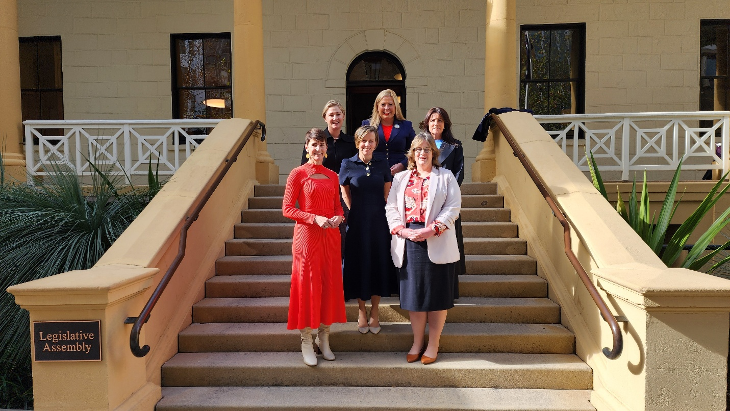
Back: Minister Camm (Qld); Minister Hildyard (SA); Minister Palmer (Tas)
Front: Minister Washington (NSW); Minister McAllister (Minister for the NDIS); Minister Orr (ACT)
Minister Beazley (WA) joined online. Apologies: Minister Blandthorn (Vic); Minister Charls (NT)

