Childhood immunisation
Information kit for
health professionals
  - June 2026
Contents
About the health professionals’ kit 2
Common questions from parents and carers 3
Conversation approaches to childhood immunisation 3
Talking points for conversations with parents and carers 4
Following up on children who have missed scheduled vaccines 5
Immunisation clinical support 5
Posters, brochures, videos, stickers 6
Resources for Aboriginal and Torres Strait Islander people 10
Easy Read resources 14
Newsletter article 16
Social posts 17

About the health professionals’ kit
Research has shown that a consistent recommendation from a health professional plays an important role in parents’ decisions about childhood vaccination. Health professionals are vital for communicating the benefits and safety of childhood immunisation and providing reassurance that vaccinating their children is the right thing to do.
The resources in this kit are designed to support you in conversations with parents and carers about childhood immunisation.
Resources included in this kit:
- key messages
- answers to common questions from parents and carers
- support for conversation approaches to childhood immunisation
- following up on children who have missed scheduled vaccines
- immunisation clinical support
- communication resources
- newsletter article
- social posts.
As a health provider sometimes giving parents the chance to share their concerns and addressing each concern directly can give parents the reassurance they need to understand that vaccines are safe and the schedule has been carefully planned to give children the best protection when they need it. This will help bring herd immunity back to the Australian community.

More information
For more information, visit the Department of Health, Disability and Ageing website.
For any queries about the resources in this kit, please email immunisationcomms@health.gov.au.
Information for parents, resources and campaign materials can be found on the Department of Health, Disability and Ageing’s Childhood immunisation hub.
Easy read information for accessibility purposes can be found on the Department of Health, Disability and Ageing’s website.
Disease specific information can be found at:
- Childhood immunisation video hub
- Sharing Knowledge About Immunisation website

Common questions from parents and carers
Although most Australian parents and carers choose to vaccinate their children, it’s natural to have questions about vaccination. Visit the Your questions answered page on the Department of Health, Disability and Ageing website for frequently asked questions and answers covering:
- How vaccines work
- Vaccine safety
- Side effects
- Vaccine-preventable diseases
- Vaccination schedule
- About the National Immunisation Program (NIP)
- Disease specific information (video hub)
- Easy read information for accessibility purposes

Conversation approaches to childhood immunisation
There is a range of resources available to support health professionals with the conversations they have with parents and carers about childhood immunisations.
Visit the Childhood immunisation campaign resources hub to find posters, information brochures, fact sheets, social media tiles and other resources to support your communication with parents.
This includes a series of helpful video resources to help parents and carers understand the diseases we vaccinate against and the NIP schedule. These are available from the Childhood immunisation video hub.
The Sharing Knowledge About Immunisation (SKAI) communication support tools are designed to aid and inspire conversations about vaccination for pregnant women, parents of young children and families. They were developed by the National Centre for Immunisation Research and Surveillance (NCIRS), in partnership with the University of Sydney and other collaborators.
- The health professional tools are designed to help you meet the needs of all parents, whether they are ready to vaccinate, have questions or intend to decline vaccination altogether.
- The parents page provides information and resources to support parents in making vaccination decisions for their family.

Talking points for conversations with parents and carers
Topic | Message
Routine childhood immunisation | - Childhood immunisation is a safe and effective way to protect children from serious diseases. Immunisation helps children stay healthy by preventing serious infections.  - The National Immunisation Program (NIP) provides free vaccines at scheduled times to infants and children between birth and the age of 4 to protect them against serious diseases.
The National Immunisation Program schedule | - The timing of each dose of every vaccine in the Childhood immunisation schedule is carefully planned to safely protect babies and children when they need it most.  - All diseases we vaccinate against on the NIP schedule can be serious for children and the community. We still vaccinate against rare diseases like polio to prevent the diseases re-emerging in Australia.  - Aboriginal and Torres Strait Islander children, and children with certain medical conditions, are recommended to receive extra vaccines for free under the National Immunisation Program (NIP).
Timing and catch up | - Vaccinating on time and in line with the National Immunisation Program schedule gives the best protection. Delaying vaccines means your child is unprotected for longer than intended.  - It’s easy to catch up on missed vaccinations. There is no need to repeat the doses already received and there is no need to get extra doses.
Side effects and safety | - Almost all reactions are minor and usually go away within a few days. These are mostly injection site reactions and show the immune system is responding to the vaccine. Serious side effects from immunisation are rare.  - In Australia, the Therapeutic Goods Administration (TGA) checks vaccines for safety and effectiveness before they’re approved and keeps monitoring them once they’re in use.
Common questions and more information | - Visit the Your Questions Answered page on the childhood immunisation website for further frequently asked questions and answers.  - Video resources have been developed to help parents and carers understand the diseases we vaccinate against and the NIP schedule. These are available from the Childhood immunisation video hub.

Following up on children who have missed scheduled vaccines
Reports from the Australian Immunisation Register (AIR) can be accessed to assist in identifying children at your practice who have missed scheduled vaccines at a certain age (AIR010A report). Reports covering due and overdue children by locality and by vaccination provider (AIR011A and AIR011B) are also available.
Health professionals can use these reports to track the vaccination status of children, implement reminder and recall systems, and consider opportunities to deliver more accessible and flexible vaccination services for harder-to-reach children.
More information about AIR reports can be accessed from the Services Australia website.

Immunisation clinical support
There is a range of information, resources and tools available on the Department of Health, Disability and Ageing website to support clinical practice and the delivery of immunisation services. This includes:
- The Australian Immunisation Handbook
- The National Immunisation Program schedule
- Catch-up vaccination resources
- Reports from the Australian Immunisation Register
- Program advice for providers
- National Centre for Immunisation Research and Surveillance tools, resources and services
For more information visit Immunisation clinical support.
Contacts for state and territory immunisation health services can be found on the Department of Health, Disability and Ageing website.

Posters, brochures, videos, stickers
The table below outlines the resources available to support childhood immunisation communication and engagement.
Resource | Preview | Link | Suggested use
Poster | 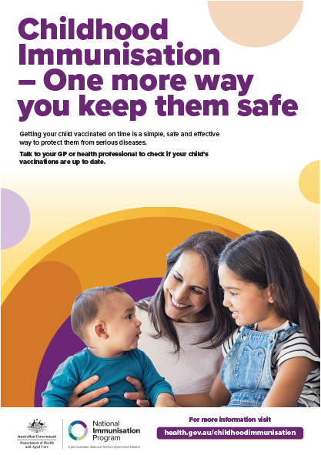 | Download the poster | Print and display poster in reception or waiting areas.
Brochure | 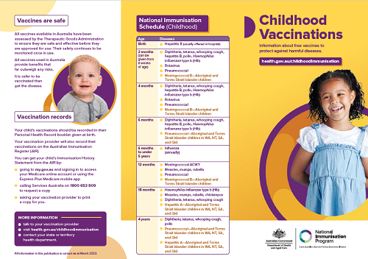 | Download the brochure or order free hard copies by contacting National Mailing and Marketing:  Email: health@nationalmailing.com.au  Phone: 02 6269 1080  Quote the order ID IT0329, the quantity of the resource you wish to order and provide your delivery address.  You can also download an A4 translated version of the brochure. The translated languages are: Arabic, Assyrian, Simplified Chinese, Traditional Chinese, Hazaragi, Karen, Khmer, Korean, Persian/Farsi, Punjabi, Tibetan, Thai and Vietnamese. | Display brochure in reception or waiting areas. Hand out to parents and carers.
Magnet | 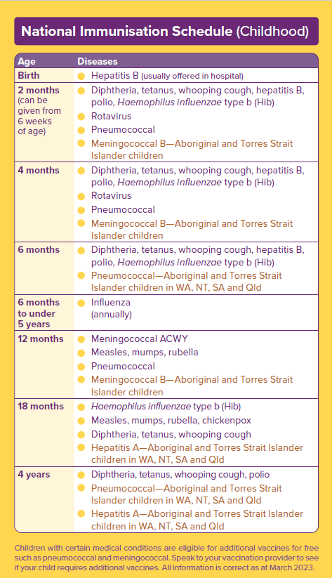 | Download the magnet information or order free magnets by contacting National Mailing and Marketing:  Email: health@nationalmailing.com.au  Phone: 02 6269 1080  Quote the order ID IT0302, the quantity you wish to order and provide your delivery address. | Hand out to parents and carers.
Frequently Asked Questions | 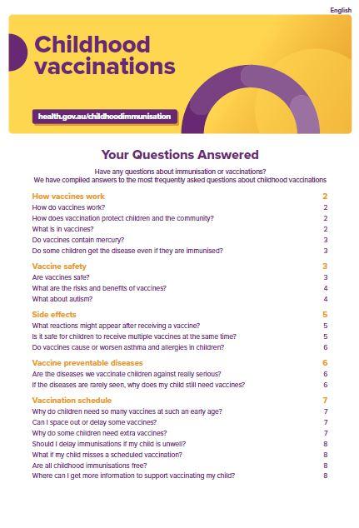 | Download the FAQ  You can also download a translated version of the FAQ  The translated languages are: Arabic, Assyrian, Simplified Chinese, Traditional Chinese, Hazaragi, Karen, Khmer, Korean, Persian/Farsi, Punjabi, Thai and Vietnamese. | Refer parents to the FAQs available on the website.
About the National Immunisation Program (NIP) |  | Download the National Immunisation Program information sheet. | Print and hand out to parents and carers.
Animation 1 | Why timing is important  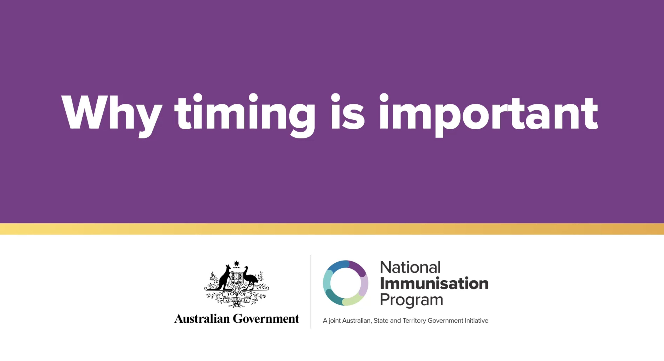 | View on the website | Share on your social media channels from YouTube
Animation 2 | How vaccines work  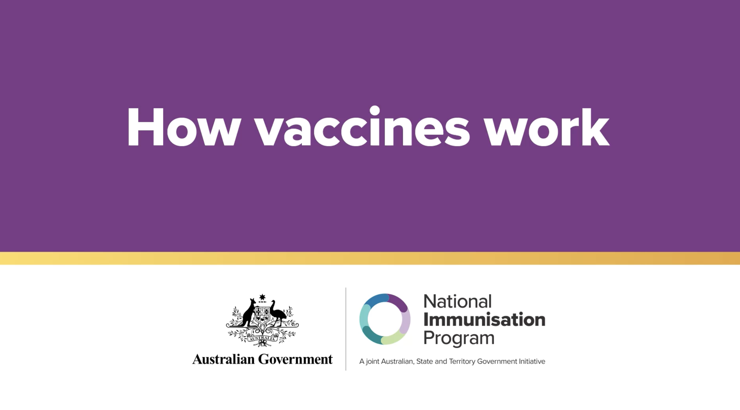 | View on the website | Share on your social media channels from YouTube
Animation 3 | Simple and safe  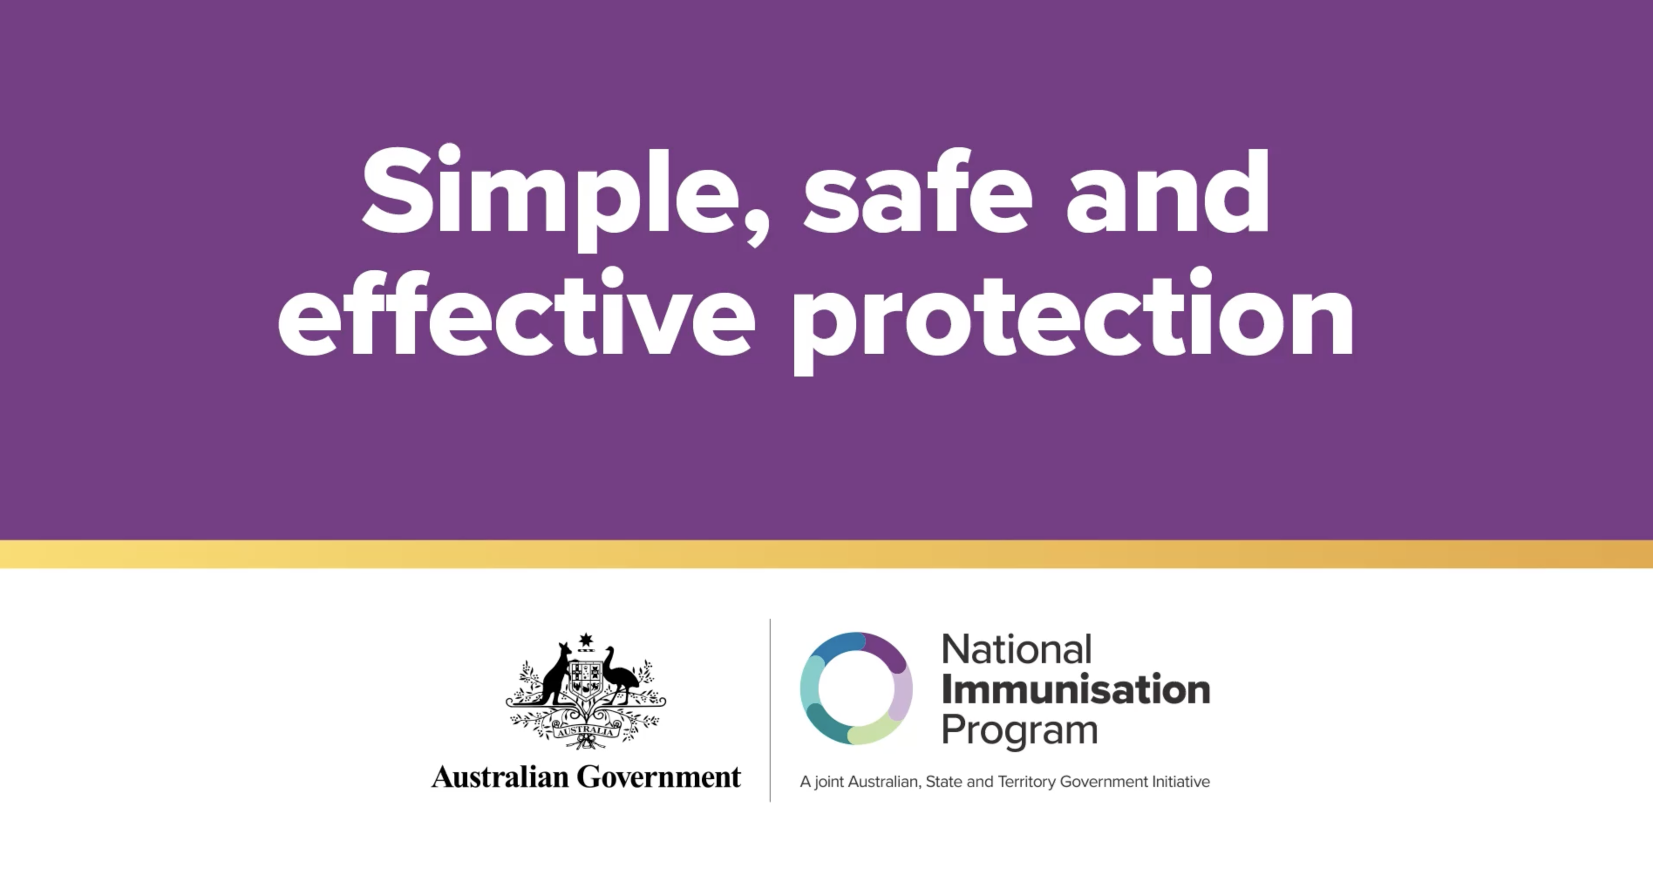 | View on the website | Share on your social media channels from YouTube
Animation 4 | How vaccines work for pregnancy and newborns  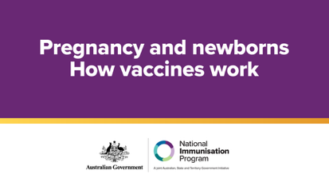 | View on the website | Share on your social media channels from YouTube
Video | Health professionals on the importance of routine childhood vaccination  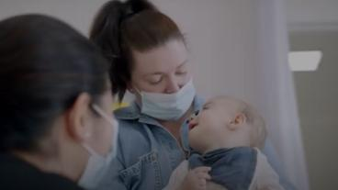 | View on the website | Share on your social media channels from YouTube
Video | Health professionals on the safety of routine childhood vaccination  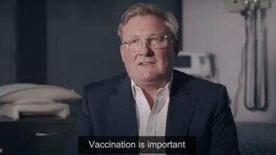 | View on the website | Share on your social media channels from YouTube
Case study | Parents speak about routine childhood vaccination  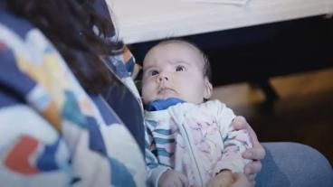 | View on the website | Share on your social media channels from YouTube
Case study | Rhiannon shares Lucy’s story, to warn other parents about the serious risks of flu  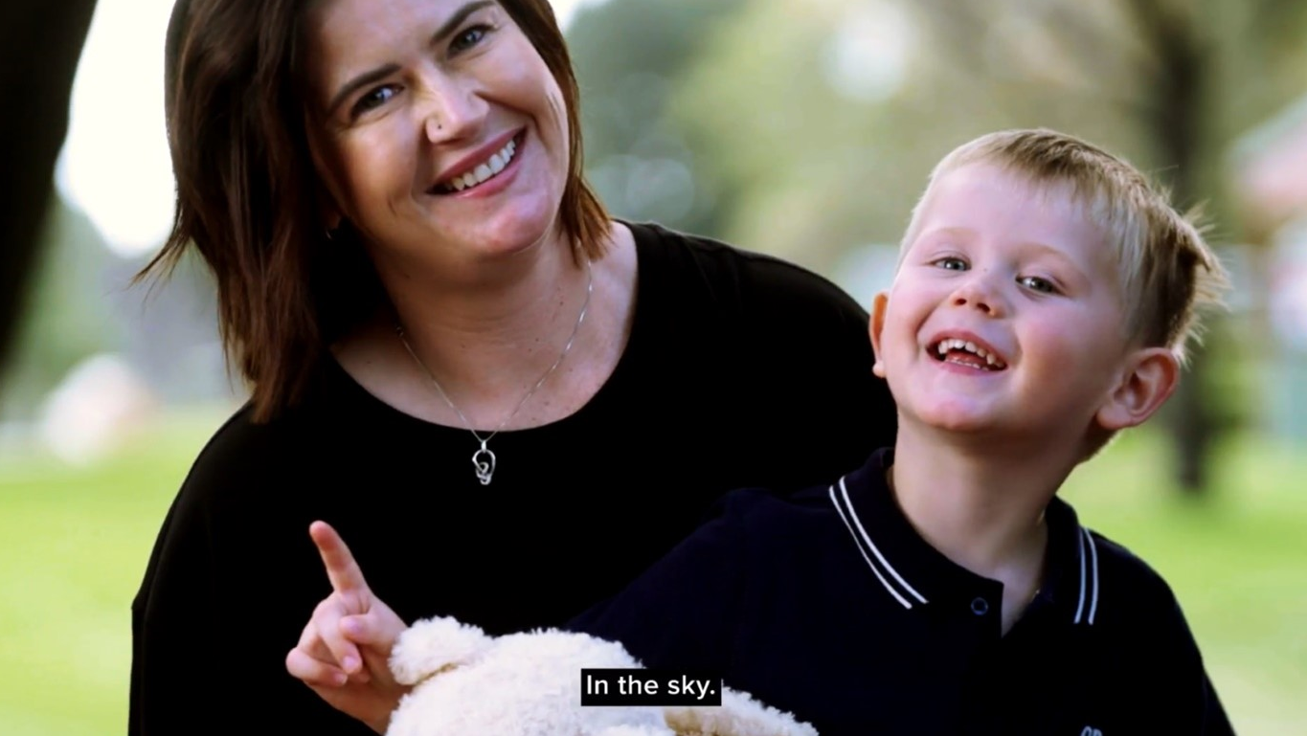 | View on the website | Share on your social media channels from YouTube
Case study | Paralympic swimmer Brenden Hall’s story – chickenpox can be serious in children  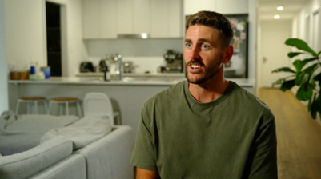 | View on the website | Share on your social media channels from YouTube
Case study | Carly shares Mabel’s story to raise awareness about the serious risks of pneumococcal disease and the importance of vaccination  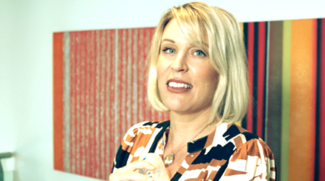 | View on the website | Share on your social media channels from YouTube
Milestone stickers | 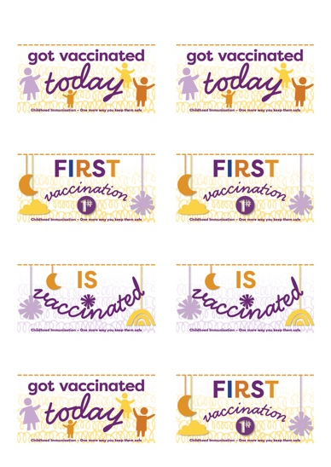 | Download vaccination milestone sticker sheet | Print these on sticky labels using your office printer and peel off to give to parents/children when they receive their vaccination.
Milestone cards | 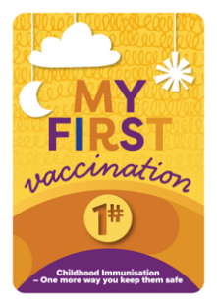  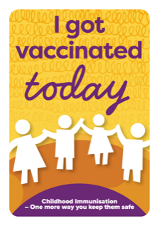  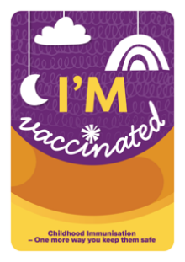 | Download vaccination milestone cards | Print these on cards to provide to parents to take a photo with their child after their vaccination appointment.

Resources for Aboriginal and Torres Strait Islander people
Resource | Preview | Link | Suggested use
Poster 1 | 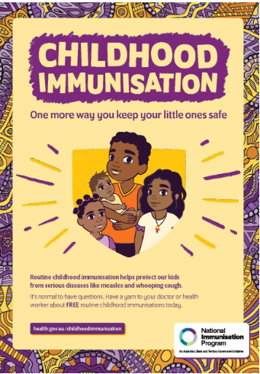 | Download poster 1 | Print and display poster in reception or waiting areas.
Poster 2 | 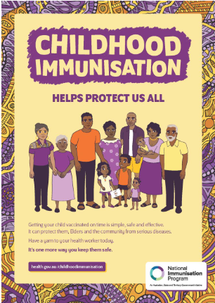 | Download poster 2 | Print and display poster in reception or waiting areas.
Adaptable poster | 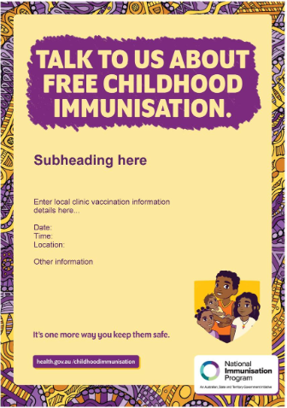 | Download the adaptable poster | This poster for Aboriginal and Torres Strait Islander Health services and clinics can be adapted to promote local clinic vaccination information.
Height chart | 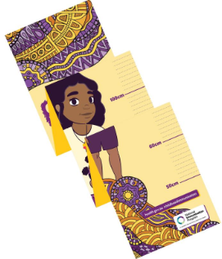 | Download the height chart or order free printed copies by contacting National Mailing and Marketing:  Email: health@nationalmailing.com.au  Phone: 02 6269 1080  Quote the order ID IT0331, the quantity you wish to order and provide your delivery address. | This height chart is for display in Aboriginal and Torres Strait Islander Health services and clinics to promote local vaccinations.
Animation 1 | One more way you keep them safe  This animation for Aboriginal and Torres Strait Islander families explains all you need to know about childhood vaccinations.  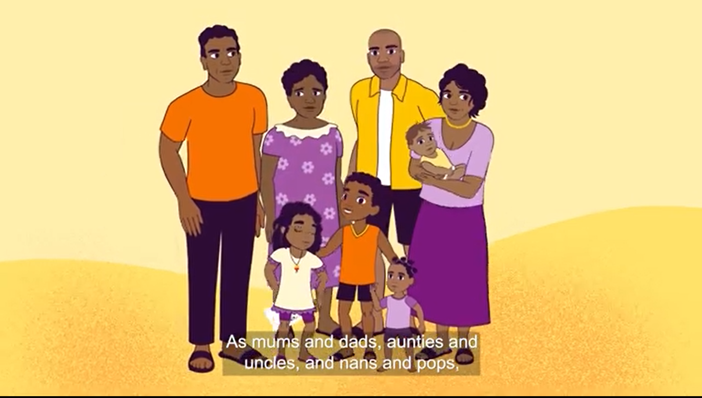 | View on the website | Share on your social media channels from YouTube
Animation 2 | Vaccines are safe  This short animation for Aboriginal and Torres Strait Islander families explains that vaccines have been carefully tested, to protect us from diseases.  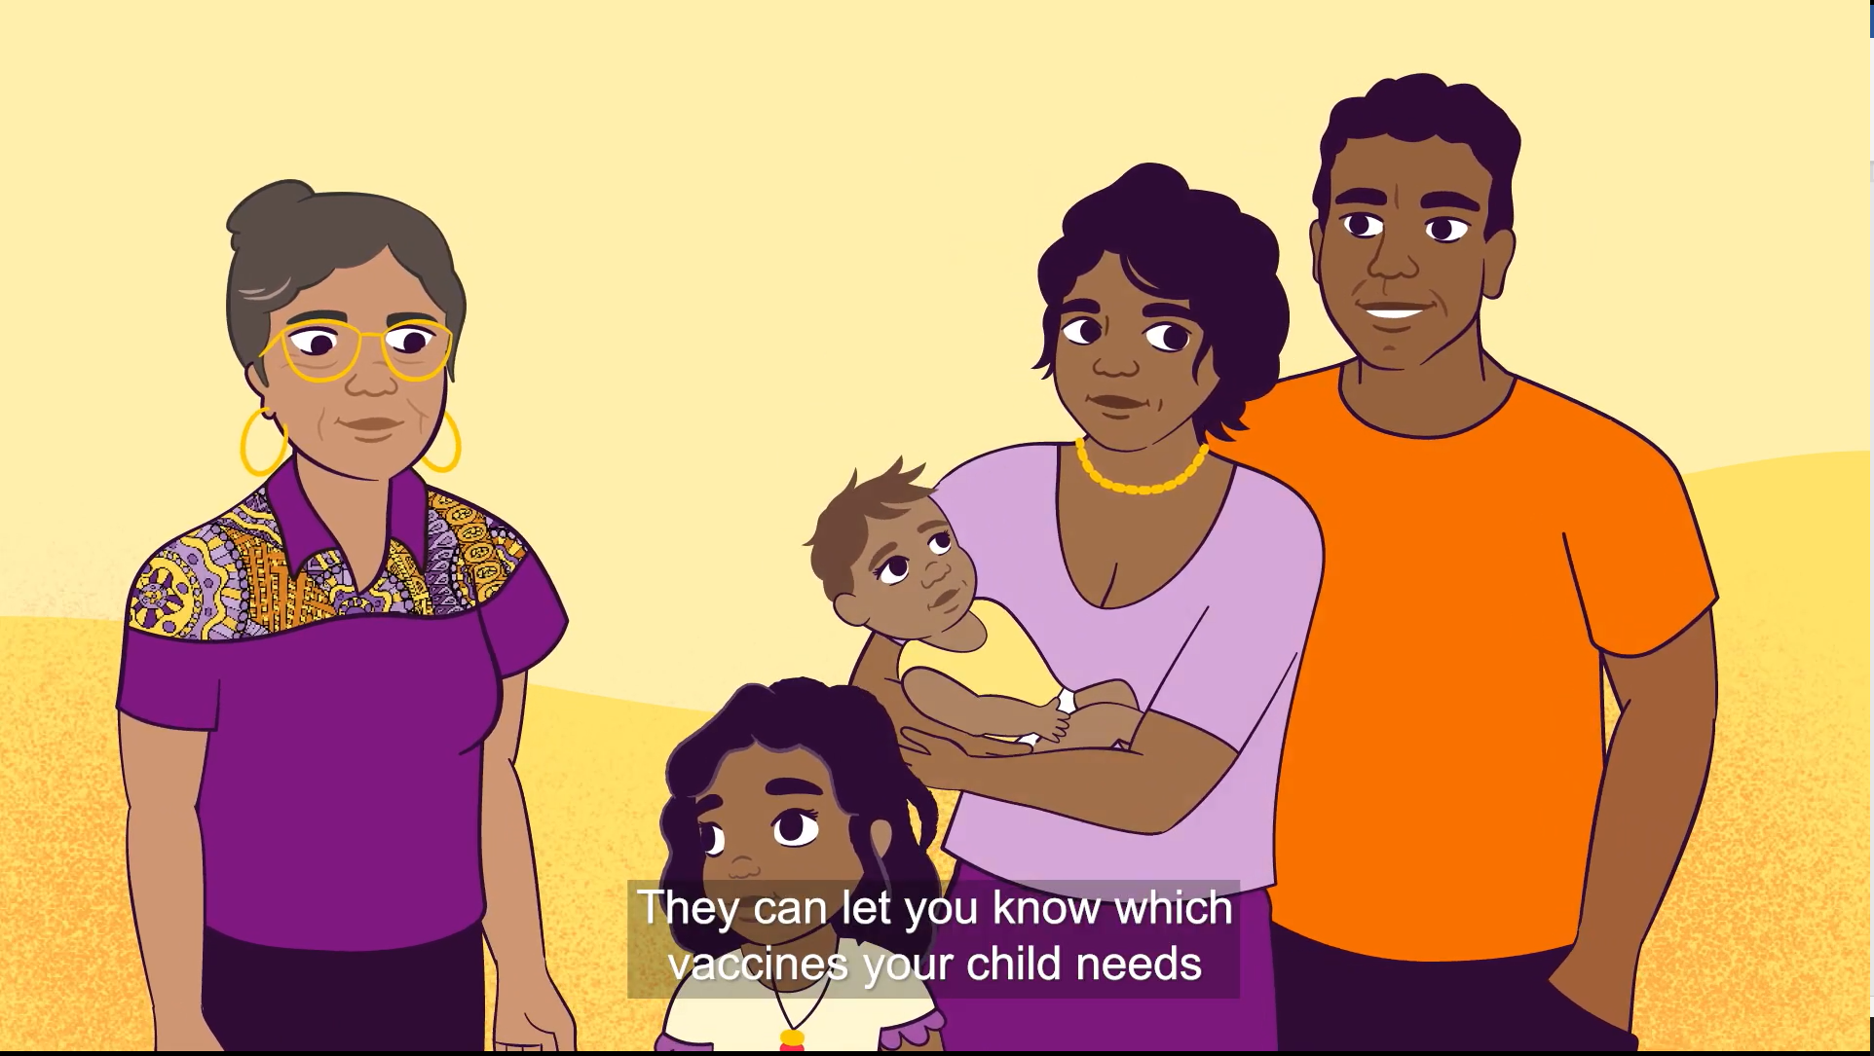 | View on the website | Share on your social media channels from YouTube
Animation 3 | Immunisation protects us like a shield  This short animation explains how vaccination provides protection against diseases that can make little ones very sick.  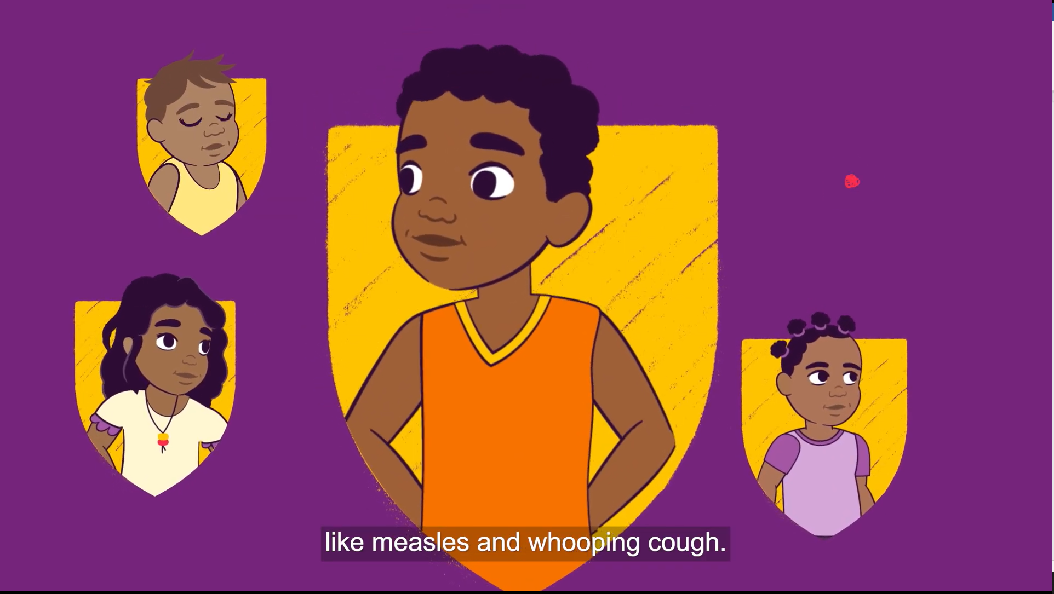 | View on the website | Share on your social media channels from YouTube
Video | Health worker Irene talks about how getting immunised can protect your children.  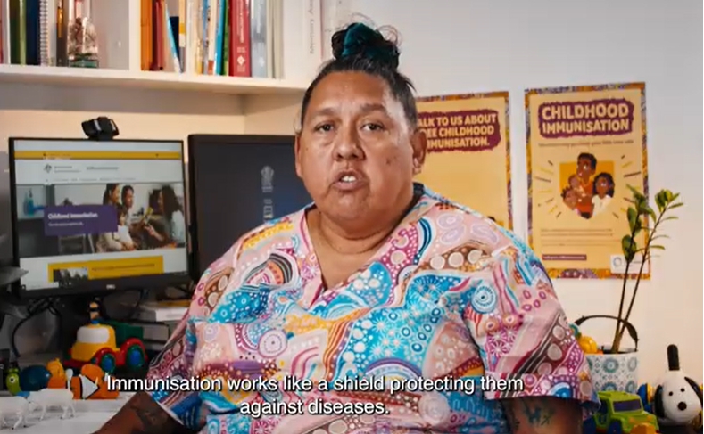 | View on the website | Share on your social media channels from YouTube
Video | Health worker Florianna talks about why children need to be immunised.  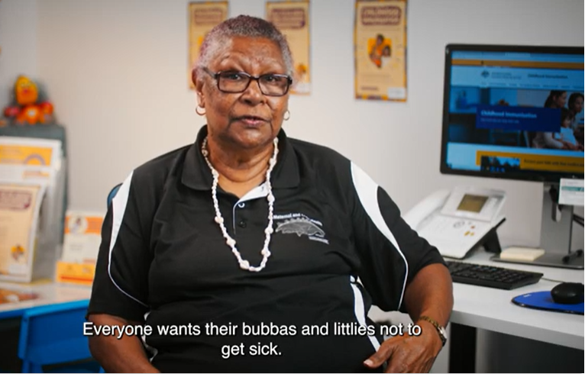 | View on the website | Share on your social media channels from YouTube
Video | Nurse Kristy addresses common questions from parents.  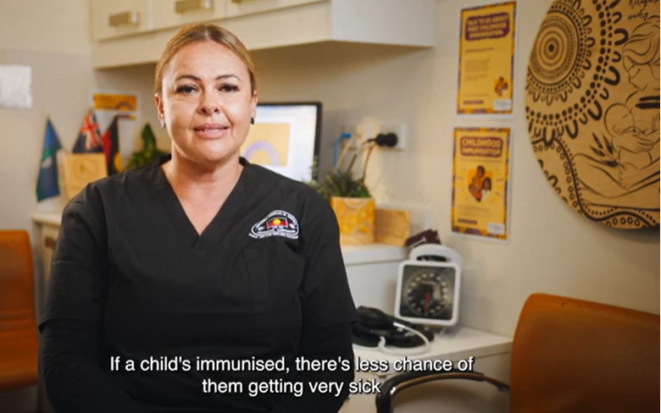 | View on the website | Share on your social media channels from YouTube
Video | Nurse Tisha explains why childhood immunisations are so important.  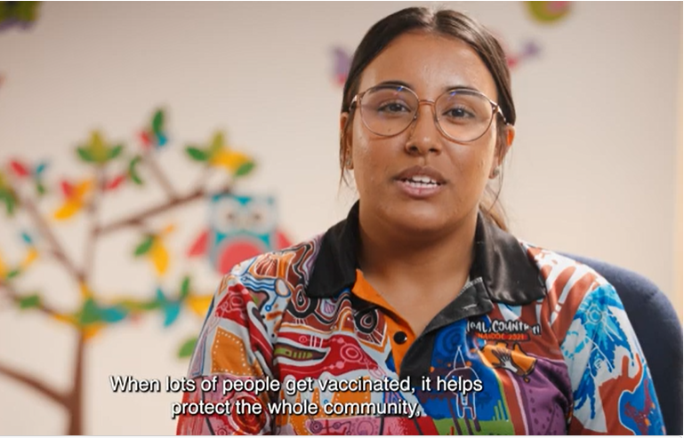 | View on the website | Share on your social media channels from YouTube

Easy Read resources
An Easy Read is a handout combining text and imagery to explain information in a simplified way. Easy Read is a way to present information for people who are not familiar with English, or who have low literacy or a learning disability.
Resource | Preview | Link | Suggested use
What are vaccines for children | 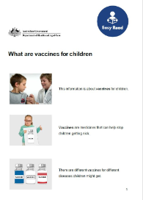 | View on the website | Print, share and display resources in waiting areas
Why it is important for children to get vaccines | 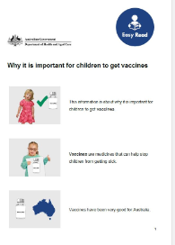 | View on the website | Print, share and display resources in waiting areas
How to get a vaccine for your child | 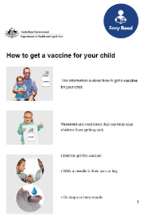 | View on the website | Print, share and display resources in waiting areas
Side effects from vaccines | 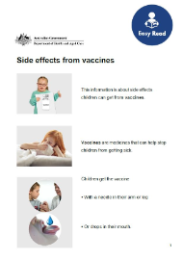 | View on the website | Print, share and display resources in waiting areas
What vaccines children should have | 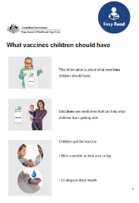 | View on the website | Print, share and display resources in waiting areas
Vaccines are safe for children | 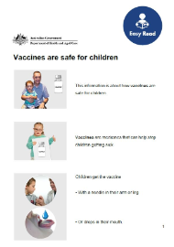 | View on the website | Print, share and display resources in waiting areas
Getting more than 1 vaccine at a time | 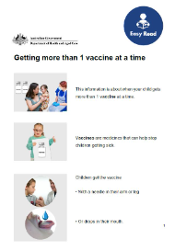 | View on the website | Print, share and display resources in waiting areas

Newsletter article
The article below can be published on your website or in newsletters.

Are your child’s vaccinations up to date?
From the moment they’re born, most babies can fight the germs they encounter every day, but there are some serious and life-threatening diseases they are not protected from.
Vaccines under the National Immunisation Program (NIP) are a free, safe and effective way to protect children from preventable diseases, such as measles, whooping cough and diphtheria.
The childhood immunisation schedule is carefully planned to protect babies and children from as young as possible, and when they need it most.
Vaccinating on time with the schedule gives the best protection from preventable diseases. Delaying a vaccine appointment means your child is unprotected for longer than needed.
You can see if your child is up to date by:
- viewing the NIP schedule to see which immunisations are recommended at specific times
- checking your child’s immunisation history via your myGov Medicare online account.
For more information, talk to your trusted health professional or visit health.gov.au/childhoodimmunisation.

Social posts
The image tiles and captions below can be published on your preferred social channels. These, along with additional tiles, are available for download on the Department of Health, Disability and Ageing website.
Caption | Image
Australia’s National Immunisation Program provides free vaccines to protect children against serious diseases.  The program’s schedule has recommended vaccines for your child from birth to 4 years to help protect against diseases such as:  - whooping cough  - meningococcal (ACWY)  - measles  - diphtheria  - pneumococcal.  Find out more about the childhood immunisation schedule at health.gov.au/childhoodimmunisation | 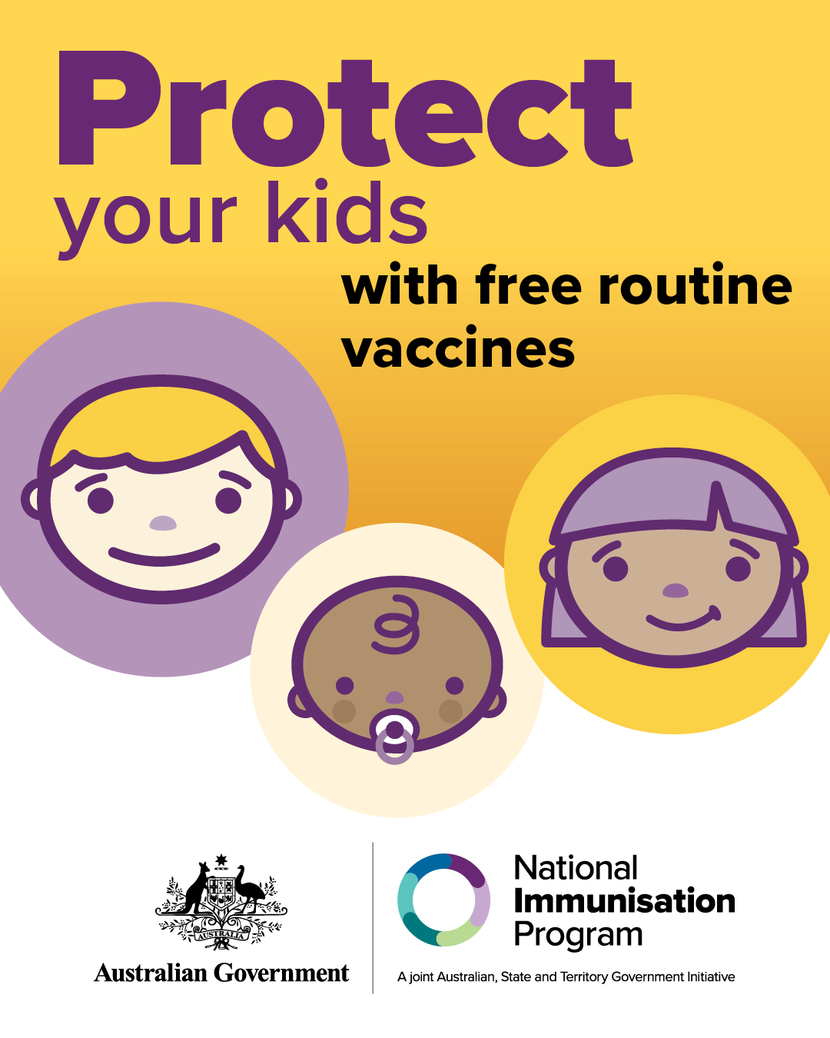
Are your child’s vaccinations up to date?  For the best protection, babies and children need to get their vaccinations on time.  The National Immunisation Program provides free vaccines to babies and children at scheduled times from birth to 4 years.  For more information, including how to check if your child’s vaccinations are up to date, visit health.gov.au/childhoodimmunisation | 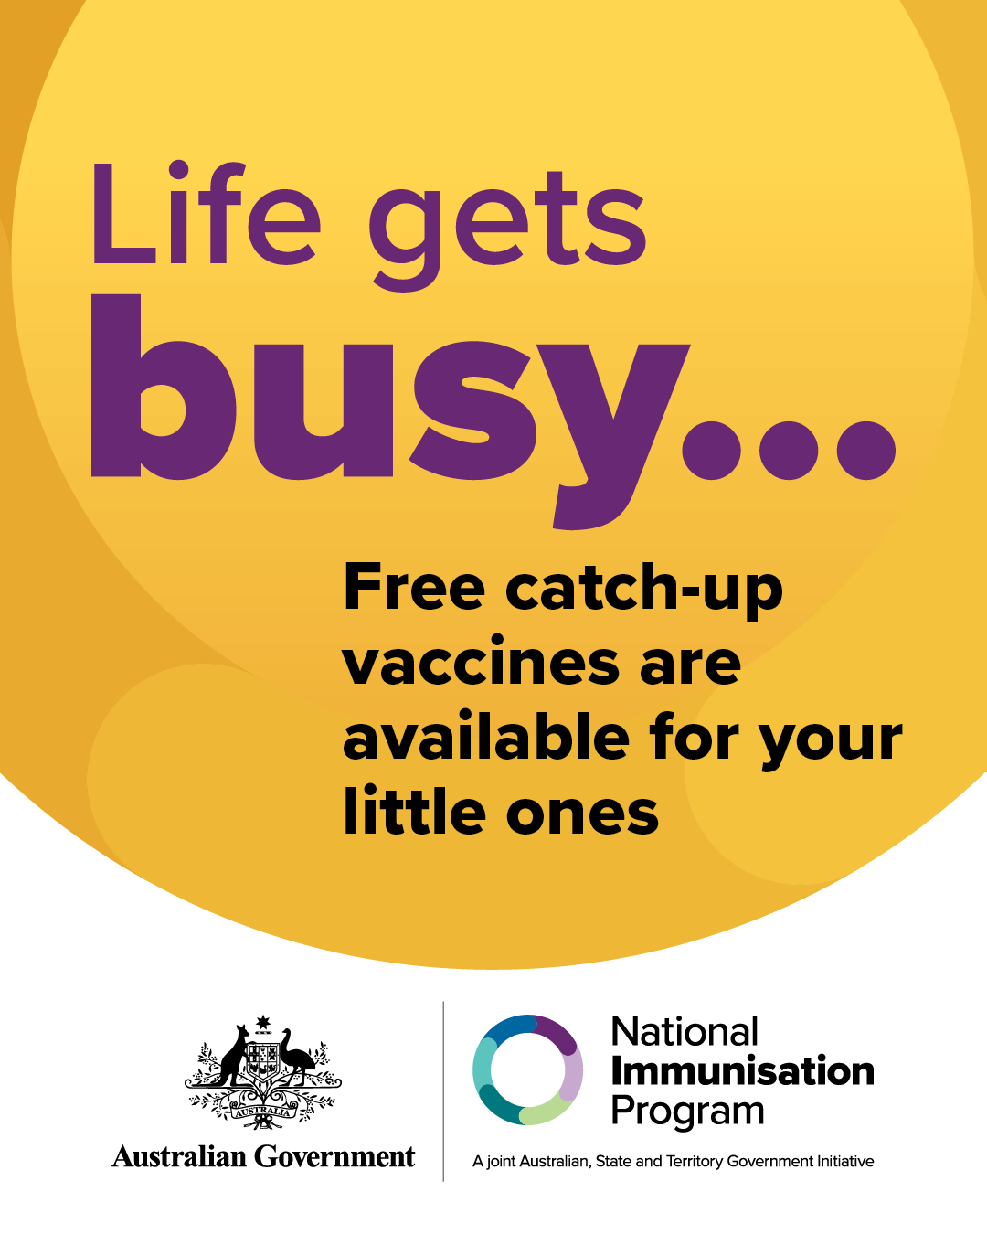
The National Immunisation Program schedule 🗓️ outlines the childhood vaccinations recommended for all children in Australia.  On time vaccination means children are protected from serious disease with stronger immune systems. Skipping and delaying vaccines means children are unprotected for longer than needed.  To learn more, visit health.gov.au/childhoodimmunisation | 