BONDED RETURN OF SERVICE SYSTEM (BROSS)
Participant User Guide
Withdrawing from the bonded medical program - student
June 2026

Withdrawing from the Program as a student
Once you agree to be a participant in the Program you can withdraw at any time, but you will forfeit your place in your medical course. Universities are prohibited from transferring students to unencumbered Commonwealth Supported Place (CSP)s or full fee paying places.
If you withdraw or are dismissed from your medical course before graduating, you will not be required to repay the cost of your CSP. However, you must log into BRoSS and action your withdrawal to ensure that the system notifies us and your record is updated accordingly.
You are responsible for your student contribution amount or HECS-HELP loan. Your student contribution amount is the part of your tuition that you must pay. You can pay this amount upfront or, if you are eligible, defer it with a HECS-HELP loan. Further advice on your individual income and HELP repayments can be obtained from the Department of Education www.studyassist.gov.au.

Withdrawing from the Program after you graduate
If you complete your medical course, you will be required to repay the cost of your CSP, less a pro-rata proportion for any RoSO completed.
Repayment amounts are recoverable as a debt due to the Commonwealth and interest may be applied. How much you will have to repay depends on the CSP values in the years you studied, and whether you completed any RoSO.
The CSP value for each year of the medical course is available on the Department of Education website at Funding Clusters and Indexed Rates - Department of Education, Australian Government. You will need to refer to the Commonwealth contribution amount for the funding cluster that includes medicine for each year you attended university.
You can request a withdrawal estimate in BRoSS at any time. Requesting an estimate will not start your withdrawal from the Program. It is for information only.
To get an accurate repayment estimate, you must:
- Ensure your medical course timeframe in BRoSS is correct. Any advanced standing, deferrals or repeated years at university will impact your repayment calculation.
- Make sure every eligible RoSO is properly entered, activated, and completed in BRoSS. Your repayment estimate will reduce pro-rata based on the amount of eligible RoSO recorded.
You can also work out your repayment estimate using the formula in section 17 of the Health Insurance (Bonded Medical Program) Rule 2020 (Rule).
- Your ‘total repayment amount’ is the total of the CSP amounts for every semester you were enrolled past the census date in your medical course.
- To work out your ‘total repayment amount’:
  - Use the funding cluster data from the Department of Education.
  - Data is available for both current and previous years.
  - For each year you studied, look up the Commonwealth contribution amount for the funding cluster that covers medicine.

How to request a withdrawal
You can request a ‘Withdrawal” by clicking ‘My dashboard’ page, open the ‘Manage my agreement’ accordion on the bottom left side of the dashboard.
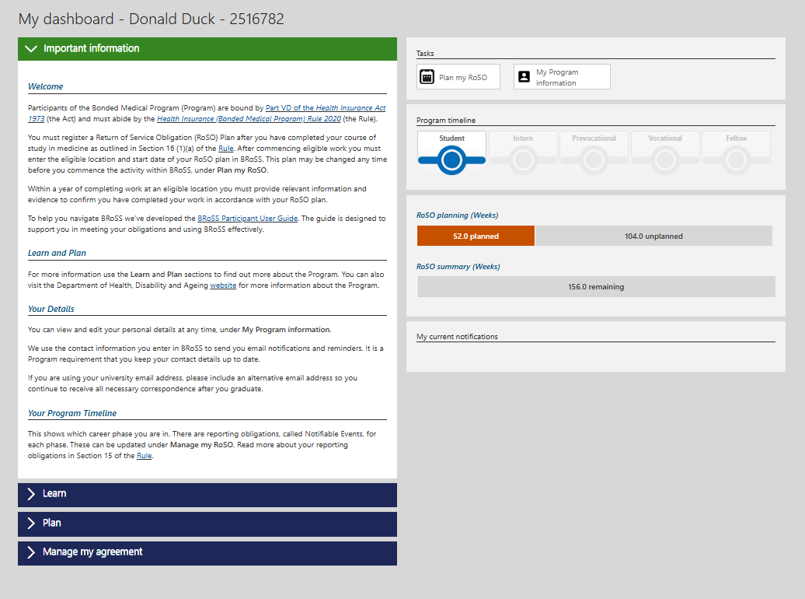

The ‘Manage my agreement’ accordion will open. Click on the ‘Withdraw from the Program’ button.
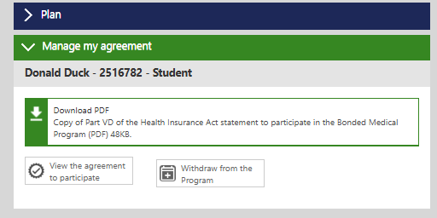
Once you have clicked on the ‘Withdraw from the Program’ button the ‘Estimate: Withdraw from the Program’ page will open. Enter the ‘University withdrawal date’ and click ‘Next’.
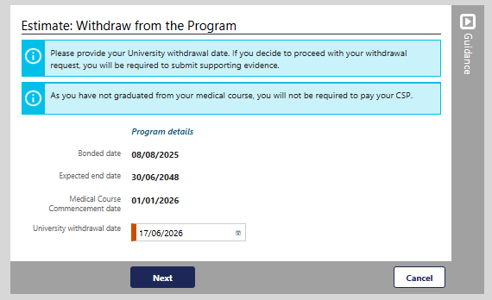
If you decide to proceed with your withdrawal request, you must:
- submit supporting evidence
- ensure your contact details are up to date
- advise of any time extensions to your medical course.

In the ‘Estimated: Withdraw from the Program’ page, you can download a repayment estimation report that contains information about your withdrawal. Click ‘Close’ once reviewed.
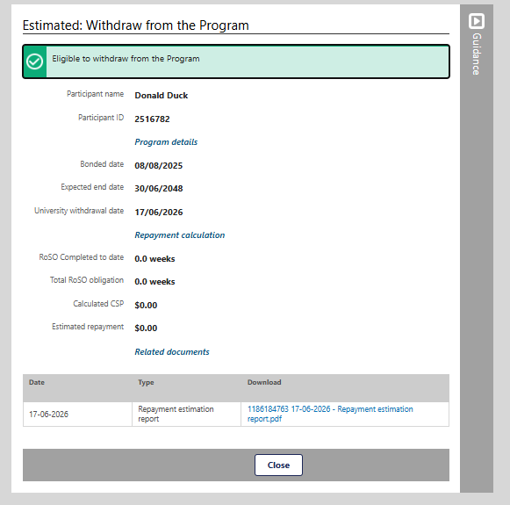
You will return to the ‘My dashboard’ page. If you would like to continue with your withdrawal request, open your ‘Manage my agreement’ accordion and then click on the ‘Withdraw from the Program’ button.

The ‘View: withdraw from the Program’ page will open. Continue with your withdrawal by clicking on the ‘Withdraw’ button.
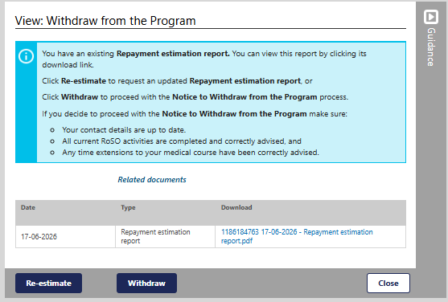
Please Note: You can get a ‘Re-estimate of your withdrawal amount at any time without formally withdrawing from the Program
After clicking on the ‘Withdraw’ button, the pop-up ‘Warning’ page will show. Click ‘OK’ to continue with your withdrawal from the Program.
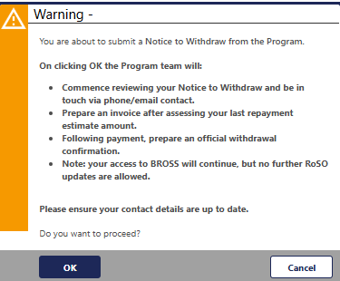
Clicking ‘Cancel’ will take you back to the ‘Manage my RoSO’ page

The ‘Advise: Withdraw from the Program’ page will allow you to update and complete your withdrawal request. Please select the reason for request and upload your supporting evidence. If you select ‘Other reason’ you are required to provide additional information in the text field.
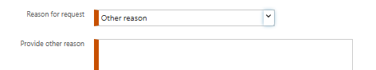
Once completed click ‘Next’ to submit the request.
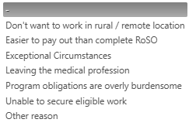
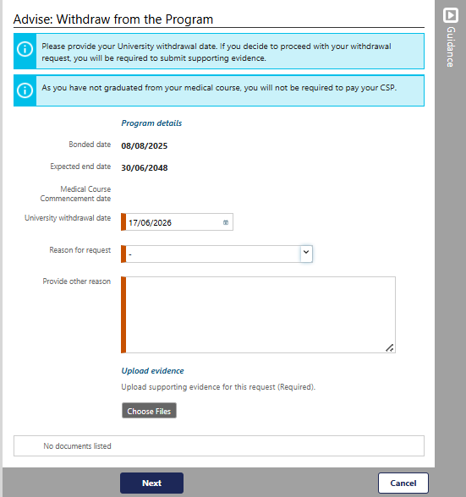

After clicking ‘Next’ the ‘Advised: Withdrawal from the Program’ page will show your Withdrawal information that has been submitted for assessment. We will review your withdrawal request and contact you if further evidence is required.
You can cancel your withdrawal request by emailing BondedMedicalProgram@health.gov.au with your details and the reason for cancellation.

