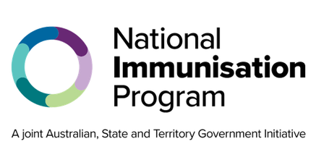
National Immunisation Program

Pneumococcal schedule for adults
Program advice for health professionals

Key points
- From 1 July 2026, the 21-valent pneumococcal conjugate vaccine (21vPCV), Capvaxive®, will be introduced on the National Immunisation Program (NIP) and the adult immunisation schedule updated.
- Capvaxive® will replace Prevenar 13® and Pneumovax 23® on the NIP for adults.
- The pneumococcal vaccine, Capvaxive®, is recommended and free through the NIP for:
  - Adults aged 65 years and over.
  - Aboriginal and Torres Strait Islander adults aged 25 years and over.
  - Adults aged 18 years and over with specified medical conditions that increase their risk of severe disease.
- Eligible adults who have previously received a dose of any other pneumococcal vaccine are recommended to receive a dose of Capvaxive® at least 12 months after their last dose.
- For clinical recommendations, vaccination providers are encouraged to refer to the pneumococcal chapter of the Australian Immunisation Handbook.
- These changes lower the age at which people are recommended for pneumococcal vaccination, simplify the vaccine schedule, and cover more strains of the disease.

Which adults are recommended a pneumococcal vaccine
The pneumococcal vaccine, Capvaxive®, is recommended for:
- Adults aged 65 years and over.
- Aboriginal and Torres Strait Islander adults aged 25 years and over.
- Adults aged 18 years and over with specified medical conditions that increase their risk of severe disease.

Adults aged 65 years and over
A single dose of Capvaxive® is recommended and free through the NIP for eligible adults aged 65 years and over.

Aboriginal and Torres Strait Islander adults 25 years and over
A single dose of Capvaxive® is recommended and free through the NIP for Aboriginal and Torres Strait Islander adults aged 25 years and over.

Adults aged 18 years and over with specified medical risk conditions
A single dose of Capvaxive® is recommended and free through the NIP for eligible adults aged 18 years and over with a specified medical condition at diagnosis. See Australian Immunisation Handbook Table. Risk conditions for pneumococcal vaccination and eligibility for NIP funding.

Repeat vaccination for adults
65 years and over
Adults aged 65 years and over who have previously received a dose of any other pneumococcal vaccine are recommended to receive a dose of Capvaxive® at least 12 months after their last dose.
Adults aged 18–64 years who receive a dose of Capvaxive® due to a specified medical risk condition do not need another dose at 65 years of age.
Aboriginal and Torres Strait Islander
Aboriginal and Torres Strait Islander adults aged 25 years and over who have previously received a dose of any other pneumococcal vaccine are recommended to receive a dose of Capvaxive® at least 12 months after their last dose.
Aboriginal and Torres Strait Islander adults aged 18–24 years who receive a dose of Capvaxive® due to a specified medical risk condition do not need another dose at 25 years of age.
Specified medical conditions
Adults aged 18 years and over with specified medical risk conditions who have previously received a dose of any other pneumococcal vaccine are recommended to receive a dose of Capvaxive® at least 12 months after their last dose.
Children diagnosed with a risk condition before 18 years of age who received a dose of Prevenar 20® are recommended to receive a dose of Capvaxive® at 18 years of age.
Adults aged 65 years and over and Aboriginal and Torres Strait Islander adults aged 25 years and over who develop a risk condition and have already received a dose of Capvaxive® as part of the adult program do not need another dose.

Co-administration of vaccines
Adults can receive a pneumococcal vaccine at the same time as, or separate to, other vaccines, such as zoster, seasonal influenza, RSV and COVID-19 vaccines. There may be advantages of co-administering vaccines, including maximising coverage and ensuring vaccines are received on time. Refer to the Australian Immunisation Handbook for further information.

Vaccine efficacy and safety
Evidence from clinical trials found that Capvaxive® is safe in adults.
Pneumococcal vaccines are not routinely recommended for pregnant women. Women of child-bearing age who have a risk condition for pneumococcal disease are normally recommended to receive a vaccine either:
- before a planned pregnancy, or
- as soon as practicable after delivery.
Breastfeeding women can receive pneumococcal vaccines.

Side effects
Common side effects include mild pain at the injection site, fatigue, and headaches. These side effects usually last for a few days and go away without any treatment. Serious side effects, such as severe allergic reaction, are rare.

Contraindications
The only contraindications to pneumococcal vaccines are anaphylaxis after:
- a previous dose of any pneumococcal vaccine.
- any component of a pneumococcal vaccine.

Administration errors and adverse events
Ensure you are administering the correct vaccine to your patient. You must notify all adverse events and vaccine administration errors through the reporting mechanisms in your state or territory.
Refer to the Australian Immunisation Handbook for guidance on vaccine administration errors.
Australian Immunisation Register
Check the Australian Immunisation Register (AIR) before administering any vaccine. You should report all immunisations to the AIR to ensure complete and accurate records. For more information, go to servicesaustralia.gov.au/hpair.

Keep up to date
Read the advice in this factsheet in conjunction with the Australian Immunisation Handbook at immunisationhandbook.health.gov.au.
Subscribe to the NIP updates email update service. Search ‘NIP updates’ on health.gov.au.

Quick reference
Adult pneumococcal schedule
65 years and over | 1 dose of Capvaxive
Aboriginal and Torres Strait Islander 25 years and over | 1 dose of Capvaxive
18 years and over with an eligible medical condition* | 1 dose of Capvaxive at diagnosis
* See Australian Immunisation Handbook Table. Risk conditions for pneumococcal vaccination and eligibility for NIP funding

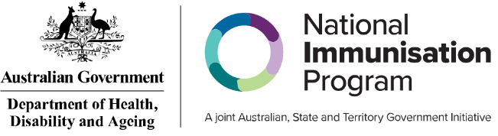
State and territory health department contact numbers:
ACT 02 5124 9800 | SA 1300 232 272
NSW 1300 066 055 | TAS 1800 671 738
NT 08 8922 8044 | VIC immunisation@health.vic.gov.au
WA 08 9321 1312 | QLD Contact your local Public Health Unit

This information is current as of June 2026

