Surgical guides and biomodels post-listing review
  - Department report – DRAFT May 2026

Contents
Executive Summary 3
Purpose 4
Background 4
Scope 4
Process 4
Sources of evidence 5
Findings of the review 6
Stage 1: clinical review and PL eligibility 6
Monitoring the condition 8
Stage 2: review of benefits 11
Proposed outcomes 14

Executive Summary
The Department conducted a post‑listing review of surgical guides and biomodels (SGB) to assess their ongoing eligibility for inclusion on the Prescribed List (PL), their comparative clinical and cost‑effectiveness and determine the appropriate benefit settings.
SGB are non-implantable, single-use devices used in surgical planning and decision making both pre- and intra-operatively. Since listing on the PL in 2013–14, utilisation has grown rapidly. Concerns regarding growth in claims, variation in clinical use and uncertainty about appropriate PL eligibility resulted in SGB being selected as 1 of 4 topics for the pilot of the department’s formalised post‑listing review framework.
The review was conducted in 2 stages, supported by external health technology assessment (HTA) reports, analysis of claims data, stakeholder consultation and advice from the Medical Device and Human Tissue Product Advisory Committee (MDHTAC) and the General Surgery Expert Clinical Advisory Group (GSECAG).
Stage 1 focused on clinical use and effectiveness, evidence of use, utilisation patterns and alignment with PL eligibility requirements. The review found that SGB are commonly used in craniomaxillofacial (CMF) surgery and standard clinical practice for some complex procedures involving implantable devices. Evidence supporting the use of SGB was limited for simpler procedures and surgeries not involving implantation. The review concluded that SGB generally meet PL eligibility criteria when used in complex CMF procedures.
In response to the findings, the Department implemented a condition on claims for SGB from February 2024. The condition restricted eligible claims and limited the number of SGB to no more than 3 of each SGB per procedure. Analysis of post‑implementation data demonstrated a reduction in claims, separations and benefits paid for SGB. Use in conjunction with implantable devices remained broadly consistent. Following MDHTAC advice, the condition was amended in July 2025 to allow any combination of 6 SGB claims per procedure.
Stage 2 of the review examined the comparative cost‑effectiveness of SGB and options for benefit setting. The HTA found the evidence was insufficient to demonstrate cost‑effectiveness due to limited and low‑quality comparative evidence, the complexity of SGB use and inconsistent reporting of costs and outcomes. While some studies suggest potential reductions in operating time for complex CMF procedures, the evidence did not support differentiation of PL benefits based on clinical effectiveness.
MDHTAC considered a range of options, including removing SGB for dental implant surgery from the PL, establishing benefits relative to clinical effectiveness and further aligning PL benefits with public sector or international prices. MDHTAC noted that removal of SGB for dental implant surgery is not appropriate at this time as they can be a component of complex CMF procedures. Additionally, MDHTAC noted that existing PL reforms had already resulted in substantial benefit reductions and recommended no further changes be made.
Considering MDHTAC’s advice, reductions in claims and expenditure and the available evidence, the department proposes no further changes to PL benefits for SGB at this time. The department will continue to monitor SGB claiming patterns to ensure the condition remains aligned with its policy intent.

Purpose
The purpose of the surgical guides and biomodels (SGB) post-listing review was to determine:
- eligibility for inclusion of SGB in the Prescribed List
- comparative cost effectiveness of SGB to determine the appropriate benefit settings.
The purpose of this department report is to provide a summary of the review process and outcomes.

Background
SGB are non-implantable, single-use devices used in surgical planning and decision making both pre- and intra-operatively.
For specific definitions used in the review, see the stage 1 and stage 2 reports.
In the 2021–22 Federal Budget, the Australian Government announced an investment of $22 million over four years to improve the PL and its arrangements. A process for formalised post-listing reviews was introduced as part of the reforms aimed at safeguarding the settings of the PL.
SGB were identified as 1 of the 4 topics suitable to pilot the post-listing review framework. Reasons for the review included:
- rapid growth in claims – PL benefits paid by health insurers rose from $1.6 million in 2016–17 to $20.6 million in 2021–22
- stakeholder reports suggesting some overuse and inappropriate use
- uncertainty about eligibility on the PL – whether the devices are considered essential to implanting another device
- uncertainty about comparative clinical effectiveness and cost-effectiveness.

Scope
Devices in the following PL groups are in scope for the review:
- 07.02.02 – Cranium
- 07.02.05 – Mandible, Maxilla and Temporomandibular Joint (TMJ)
- 07.02.07 – Orbit
- 07.02.09 – Anatomical biomodels.
The scope of the review covered all PL devices in these categories. Devices on the PL can change overtime. Specific billing codes and devices within these PL groups may have changed during the review timeframe.

Process
The review was completed in 2 stages. Each stage had different research questions, included an external HTA consultant report and was subject to advice from the MDHTAC and the GSECAG. The Terms of Reference (ToR) for each stage are listed below.
Stage 1
- Analyse the role in clinical practice of SGB currently listed on the PL, including future trends in clinical use.
- Review the evidence base for the use of SGB currently listed on the PL, with a focus on comparative clinical effectiveness and their clinical benefits.
- Consider the current utilisation of SGB listed on the PL.
- Based on the findings of ToR 1, 2 and 3, advise if SGB meet the eligibility criteria for listing on the PL. Findings regarding eligibility may differ between products and clinical circumstances.
Stage 2
- Subject to the findings of ToR 4, review the cost-effectiveness of SGB currently listed on the PL.

Sources of evidence
The review considered multiple sources of evidence. A description of each source is in the table below.
Source | Description
External HTA consultant report: Stage 1 (March 2023) | Review of clinical evidence for SGB. Included desktop review, stakeholder input, sponsor submissions, data analysis and a systematic review.
External HTA consultant report: Stage 2 (August 2025) | Assessed comparative cost-effectiveness and provides options for benefit setting.
Stakeholder consultation (throughout the review) | Stakeholders were invited to provide information to inform stage 1 and stage 2 as well as provide feedback on draft HTA consultant reports. Input included formal submissions, advice from clinical experts, communications about compliance issues and relevant literature.
Expert clinical advice (throughout the review) | Expert clinical advice on the clinical use of SGB and impacts of the condition on claims.
Internal data analysis | Review of Hospital Casemix Protocol (HCP1) data on total number of SGB claimed, co-claimed devices and number of separations where SGB were claimed.
MDHTAC and ECAG advice (throughout the review) | In confidence expert advice on stage 1 and stage 2 draft reports, and advice on the review direction. Advice on outcomes for the department to consider.

Findings of the review

Stage 1: clinical review and PL eligibility
  - Findings
The department engaged an external HTA consultant (consultant) to:
- Analyse the role in clinical practice of SGB currently listed on the PL, including future trends in clinical use.
- Review the evidence base for the use of SGB currently listed on the PL, with a focus on comparative clinical effectiveness and clinical benefits.
- Consider the current utilisation of SGB listed on the PL.
- Based on the findings of ToR 1, 2 and 3, advise if SGB meet the eligibility criteria for listing on the PL. Findings regarding eligibility may differ between products and clinical circumstances. Billing codes and product names as per July 2022 PL.
The department invited stakeholders to provide information and evidence to inform the external consultant report. Stakeholders were invited to comment on the draft report in November 2022. The external consultant finalised the report in March 2023. The stage 1 report is available on our website.
The report found:
- Most stakeholders, including surgeons consider SGB standard of care for complex craniomaxillofacial (CMF) surgery. However, surgeons and peak bodies report minimal clinical benefit in simple procedures which may not justify the cost. Surgeons suggested that recent growth in use is driven by improved patient outcomes.
- The systematic review—despite its limited quality, small sample sizes, and focus on a single product (ProPlan/TruMatch)—shows that virtual surgical planning using SGB generally delivers improved or comparable outcomes to the comparator group, including in accuracy, operative time, ischaemia time and complication rates.
- Broader literature identified through the desktop review similarly supports the use of 3D-printed guides and biomodels across CMF, dental implant, orthopaedic, cardiovascular and ear, nose and throat contexts. Noting that these technologies produce non-inferior outcomes and may enhance surgical efficiency and accuracy, though high-quality comparative studies remain scarce.
- Utilisation of SGB has grown rapidly since PL listing in 2013-14, doubling on average each year and reaching 7,488 items used in 2020-21, with high item use per patient in a small but increasing subset of cases.
- Use has broadened beyond the plastic and reconstructive category, with 28% of total utilisation in 2020-21 occurring in other PL categories.
- SGB are generally considered eligible for continued listing on the PL for complex CMF surgeries. However, there is insufficient evidence to support their current listings for other types of surgeries. The table below outlines the assessment against the eligibility criteria.
Criteria | Surgical Guides |  |  | Biomodels
The product must be entered and current on the Australian Register of Therapeutic Goods (ATRG) | Met |  |  | Met
The product must be provided to a person as part of an episode of hospital treatment or hospital-substitute treatment | Met |  |  | Met
A Medicare benefit must be payable for the professional service associated with the provision of the device or product (or the provision of the product is associated with podiatric treatment by an accredited podiatrist) | Met*  * It is difficult to determine how PL benefits for SGB align with MBS items when item numbers do not specify implant procedures. |  | Met*  * It is difficult to determine how PL benefits for SGB align with MBS items when item numbers do not specify implant procedures.
The device or product is essential and specifically designed as an integral single-use aid for implanting a device or product. | Not met when used in procedures that do not involve implantation of a device or product.  Met when used for complex CMF procedures.  Not met when used for simpler procedures. |  |  | Not met when used in procedures that do not involve implantation of a device or product.  Met when used for complex CMF procedures.  Not met when used for simpler procedures.
The product has been compared to alternative products on the PL or alternative treatments and  - assessed as being, at least, of similar clinical effectiveness; and  - the cost of the product is relative to its clinical effectiveness. | Insufficient evidence to determine if this criterion is met.  The evidence for comparative clinical or cost effectiveness is limited. The review found support for clinical effectiveness of SGB, in general, at least for complex CMF surgeries. | Insufficient evidence to determine if this criterion is met.  The evidence for comparative clinical or cost effectiveness is limited. The review found support for clinical effectiveness of SGB, in general, at least for complex CMF surgeries.

The report provided a range of options for the department to consider. The department presented the report to MDHTAC in September 2023.

MDHTAC agreed that the billing codes for SGB needs to be specifically restricted to CMF. MDHTAC advised the department to review billing codes for SGB in respect of placing a condition restricting PL reimbursement to the use of the devices in CMF and oral surgery (jaw and facial reconstructions), involving implantation of an implantable device, and limiting the claims to no more than 3-4 SGB per procedure.

For any other type of surgery (e.g. orthopaedic), sponsors will be required to apply for listing of the device in that specific category and provide the satisfactory data to demonstrate the device is both essential for implantation of an implantable device and leads to improved clinical outcomes.

It was noted that MBS item descriptors do not generally define complex and simple surgeries, but there are some MBS items that indicate the use of the device as part of the implantation procedure.
  - Stage 1 Outcome
The department placed a condition on claims for SGB in November 2023 to reflect the findings of stage 1. The department delayed implementation of the condition until 1 February 2024 so scheduled procedures could proceed without patients incurring unexpected out-of-pocket costs.

The department published a frequently asked questions document in February 2024 and committed to monitoring the impact of the condition.

Monitoring the condition
Following stage 1, the department monitored the condition to identify any unintended consequences and address these with adjustments to the condition. Monitoring included:
- consultation with stakeholders
  - formal consultation on the condition
  - feedback from clinical experts and associations
- reviewing HCP1 claim and separation data for SGB.

Stakeholder consultation
In March 2024, the department completed consultation on the requirement that implantable devices listed in ‘sub-category 07.03 – Dental Implants’ be ‘explicitly identified in the product name or description of the billing code for the surgical guide or biomodel’. The department considered stakeholder submissions and continued to monitor and review the condition.

In addition to the formal consultation stakeholders provided feedback about the condition impacting on hospitals and some complex procedures. The department worked with clinical stakeholders to further understand the impact of the condition on workflows and patient care.

Data analysis
The department reviewed HCP1 claims data comparing claims for SGB for date matched time periods pre and post the February 2024 condition. The data was extracted on 1 May 2025 for a 6-month analysis and on 28 August 2025 for a 12-month analysis.
6-month data analysis
The 6-month data analysis showed:
- an overall reduction in claims for SGB and separations where surgical guides and biomodels were claimed
- a reduction in separations where SGB were claimed without an implantable device
- a reduction in separations with claims for 2 and 3 SGB
- an increase in separations with claims for 6 SGB
- a reduction in separations and number of SGB claimed with any devices from 07.03.03.03 – implants and fixtures.
The department presented a 6-month data analysis to MDHTAC at the May 2025 meeting. MDHTAC noted the data demonstrates:
- changes in claiming of the PL benefits for surgical guides and biomodels. The data indicated that there were still claims paid for greater than 6 SGB per procedure, indicating that in addition to reimbursing the PL benefits, private health insurers have paid ex gratia for the gaps over the cap.
- overall, there was slight reduction in claiming of benefits for SGB (however the data show variability in claims across different combinations).
MDHTAC agreed that the current condition should be amended to ensure it is fit for purpose. MDHTAC advised the department to consider keeping the cap of 6 SGB that may be claimed per procedure. But instead of having the cap of 3 surgical guides and 3 biomodels per procedure, to allow claiming any combination of SGB under the cap of 6. The department implemented this change in the 1 July 2025 PL update.
MDHTAC also discussed the need for restricting PL claims for SGB to complex procedures only. It was noted that this option had already been investigated in 2024, when the condition was initially imposed. There is no published definition of a complex CMF procedure. Stakeholders (particularly private hospitals) have expressed significant concerns and objections regarding non-specific conditions which would require manual processing of the claims, increasing the administrative burden. Therefore, when making decisions about placing a condition on a billing code or benefit group, the department aims to refer to specific and relevant MBS item/s, or to the specific subcategories/groups/subgroups on the PL. Whilst there are no easily identifiable MBS items specifically for complex CMF procedures, the department continues to work with expert clinicians to look at ways in which the condition could more accurately target these procedures.
MDHTAC noted the complexity and difficulty in developing an implementable condition reflecting claiming for use of surgical guides and biomodels in complex procedures, although asked the department to continue investigating such options.
12-month data analysis
The department completed a 12-month data analysis on claims and separations post the February 2024 condition in October 2025. The 12-month analysis followed the similar patterns as the 6-month analysis demonstrating a 32% reduction is claims for surgical guides, a 21% reduction in claims for biomodels and a 28% reduction in device claims overall. Figure 1 compares claiming patterns of surgical guides and biomodels (combined) per separation pre and post the condition. Claims for 2, 3 and 4 SGB combined have reduced, claims for 5 and 6 SGB combined, have increased. Claims for greater than 7 SGB have decreased.
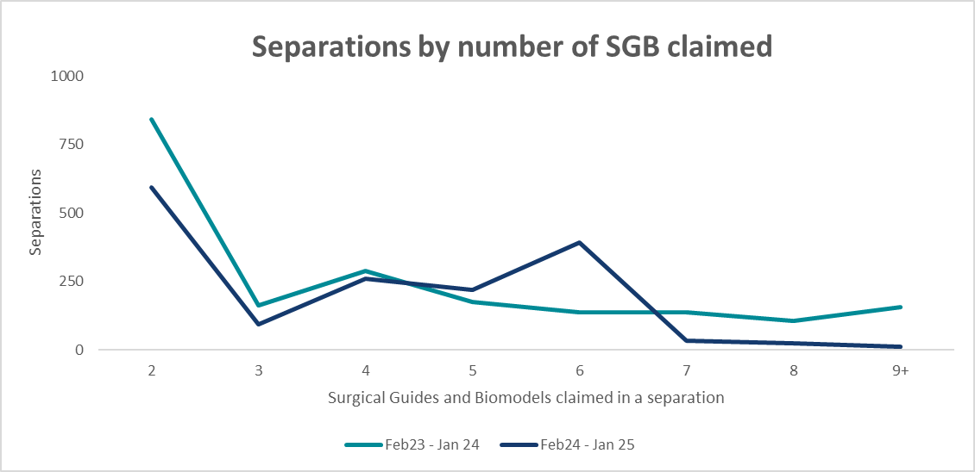
Figure 1: separations by number of surgical guides and biomodels claimed in a separation.
Figure 2 compares separations co-claimed with a device from 07.03.03.03 – implants and fixtures pre and post the condition. Despite an overall reduction in device claims, the number of SGB claimed in combination with a device from 07.03.03.03 remained relatively stable.
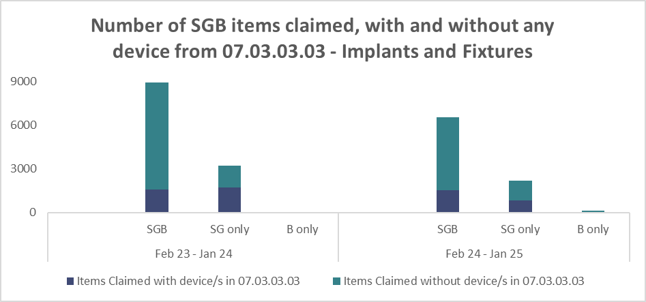
Figure 2: number of SGB claimed, with and without any device from 07.07.03.03 – Implants and Fixtures¹.
The department sought targeted stakeholder feedback on the 12-month data analysis. Stakeholders shared the following anecdotal evidence about SGB claims and supply:
- some sponsors have compassionately supplied additional surgical guides and/or biomodels above the cap
- some insurers provide ex-gratia payments for devices claimed above the cap
- some insurers reject ex-gratia payments for devices claimed above the cap
- some hospitals have absorbed the cost of extra devices above the cap
- conditions can create uncertainty for hospitals.
We anticipate any further data analysis would be feasible from mid-2027 onwards.

Stage 2: review of benefits
At the December 2024 MDHTAC meeting, the department advised MDHTAC that stage 2 of the review had commenced.
The department engaged an external HTA consultant to:
- Review the evidence for the use of SGB currently listed on the PL, with a focus on cost-effectiveness to nominated comparator in complex and non-complex CMF procedures.
- Conduct an appropriate economic analysis of the devices in scope:
  - Surgical guides used for implanting a device in CMF procedures on the PL.
  - Biomodels used for implanting a device in CMF procedures on the PL.
  - SGB in combination for implanting a device in CMF procedures on the PL.
- Subject to findings from ToRs 1-2, provide recommendations on appropriate benefits for surgical guides and biomodels on the PL.
Targeted stakeholders contributed information to inform stage 2 of the review in December 2024. The department published the draft report for stakeholder feedback in April 2025 and provided the report to MDHTAC for its May 2025 meeting. The external consultant delivered the final report in August 2025. The stage 2 report is available on our website.
The report found:
- The evidence for SGB is difficult to interpret due to the complexity of the intervention, which often includes virtual surgical planning, multiple 3D printed components and patient matched implants used in combination. This makes it challenging to attribute observed clinical outcomes specifically to the physical guides or biomodels.
- Most studies did not clearly describe the type or number of surgical guides or biomodels used, limiting the ability to link findings to devices on the PL.
- Evidence is concentrated in orthognathic osteotomies and maxilla and mandibular reconstructions, which are complex CMF procedures within scope of the review. By contrast, dental implant surgery, generally considered a simple procedure, represents a large proportion of the published literature but does not demonstrate clear added value from surgical guides or biomodels.
- For other CMF indications identified in Stage 1 as appropriate for surgical guide use, there is little evidence on cost effectiveness. These surgeries are rare and highly individualised, making prospective comparative studies difficult and limiting the likelihood of future high-quality trials.
- Costs associated with SGB generally exceed those of usual care, however, reporting is inconsistent and often does not separate device costs from virtual surgical planning costs.
- No reliable data was identified to show that patient matched surgical guides or biomodels are more effective or safer than conventional techniques. This limits the ability to determine whether current PL benefit levels reflect their clinical value and underscores the need for higher quality evidence.
- Randomised controlled trials indicate that SGB may reduce operative time in complex CMF procedures. However, similar benefits were not observed for simpler procedures, such as dental implant surgery (where this is not part of a complex CMF procedure involving facial reconstruction or correction of significant jaw deformities). This raises questions about their value in settings with lower complexity.
The report outlined several options for the department to consider. The department sought MDHTAC’s advice on these options at the May 2025 meeting. MDHTAC advised the department to consider the following options (noting that not all options were discussed in detail at that meeting):
- Remove SGB for dental implant surgery from the PL.
- Establish benefits relative to the clinical effectiveness of SGB.
- Align PL benefits for SGB with the public sector or with internationally reimbursed prices.
The department considered the options advised by MDHTAC and sought further advice on those options as well as other options in the stage 2 external consultant report at the December 2025 MDHTAC meeting:
Remove surgical guides and biomodels for dental implant surgery from the PL.
- MDHTAC agreed it may have merit to keep SGB designed for dental implants on the PL when used in complex procedures and advised the department to consider this further. This option was considered in the context of defining complex CMF procedures, noting that dental implants can form part of some complex CMF procedures. There is no agreed definition of complex procedures, so removing these items from the PL is not a viable option at this time.
- MDHTAC noted that further consideration by GSECAG is required to explore whether the condition can reference specific MBS items. This issue has been considered previously. While several MBS items may be relevant to complex CMF procedures, the department will further discuss this with GSECAG and continue exploring the feasibility of linking the condition to specific MBS items. This work will form part of the ongoing monitoring of the condition.

Establish benefits relative to the clinical effectiveness of surgical guides and biomodels.
- Both external HTA consultant reports found there was not enough high‑quality evidence to determine the cost‑effectiveness of surgical guides and biomodels. The department may reconsider this option in the future if higher‑quality evidence on clinical effectiveness and comparative costs becomes available.
Align PL benefits for surgical guides and biomodels with the public sector or with internationally reimbursed prices.
The department considered:
- benefits for most surgical guides and biomodels were reduced by the recent PL reforms public sector price benchmarking
- data on device claims from different PL product groups demonstrated most claims are for devices in group 07.02.05.07 - Mandible, Maxilla and TMJ
- targeted stakeholder feedback about use and claiming patterns for SGB.
MDHTAC noted the department has already implemented public sector price benchmarking under the PL reforms and agreed there should not be further changes to the benefits payable for surgical guides and biomodels listed on the PL. The following table shows the benefit reductions under the reforms.
PL Product Group | Benefit March 2022 | Current Benefit April 2026 | Percentage reduction
07.02.02.04 - Cranium | $2,584 | $1315 | 49%
07.02.05.07 -  Mandible, Maxilla and TMJ | $2,584 | $1450 – 1,495* | 44%
07.02.07.05 - Orbit | $2,584 | $2,584 | No change
07.02.09 - Anatomical Biomodel | $1,950 | $1,762 | 10%
*The current benefit for item 07.02.05.07 - Mandible, Maxilla and TMJ is either $1,450 or $1,495.
These reductions, as well as reductions in the total number of claims, have reduced the overall private health insurance spend on SGB.
Figures 3 demonstrates the reduction in total item benefit amount for SGB over the past 4 financial years. Compared to 23/24 financial year the total PL benefit amount for SGB in 24/25 reduced by 18.25%.
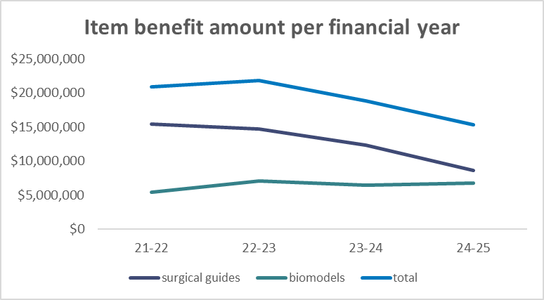
Figure 3: item benefit amount per financial year.
Figure 4 demonstrates the reduction in private health insurance spend for SGB over the past 4 financial years. Compared to 22/23 the private health insurance spend on SGB has decreased by 19.24%.
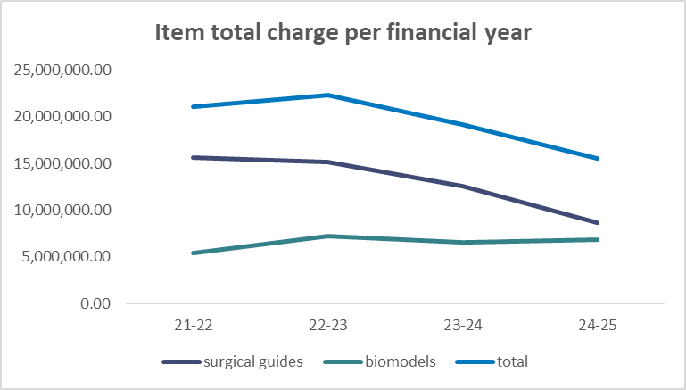
Figure 4: item total charge amount per financial year².
As per MDHTAC advice the department considered if specific MBS item numbers were relevant to complex CMF procedures. The department reviewed data on MBS items numbers and SGB claims and sought expert clinical advice on MBS item numbers claimed in complex procedures. The department sought GSECAG advice at the March 2026 meeting. The GSECAG advised that MBS item numbers are not a suitable coding system to determine when more than 6 surgical guides and biomodels could be claimed as they do not define procedural complexity. The department considered GSECAG’s advice and will not progress this further at this time.

Proposed outcomes
The department considered MDHTAC’s advice and proposed no further changes to the PL benefits for surgical guides and biomodels. A further review of CMF splints is outlined in the post listing review annual workplan.
The department will monitor data on claims for SGB to ensure the condition continues to meet the policy intent. Any further updates will be provided on our webpage.

Data extracted from HCP1 on 28 August 2025. Data completeness for each year: separations 95.4% (2023), 91% (2024) and 44.6% (2025); protheses items 92% (2023), 87.3% (2024) and 41.6% (2025).
Data extracted from HCP1 on 5 March 2026. Data completeness 2024-25 financial year: 90%

