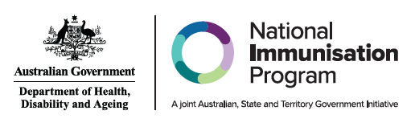

Administration of RSV vaccines and monoclonal antibodies by age group or cohort
Age group or cohort | RSV vaccines for adults |  | RSV monoclonal antibodies for infants and children
Age group or cohort | Abrysvo® 0.5mL  (Pfizer)  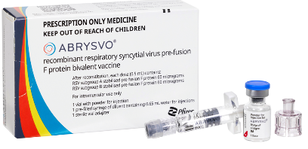 | Arexvy® 0.5 mL  (GSK)  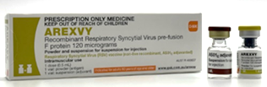 | Beyfortus™ (Nirsevimab) 0.5 mL (Purple) (Sanofi)  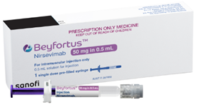 | Beyfortus™ (Nirsevimab) 1 mL (Blue)  (Sanofi)  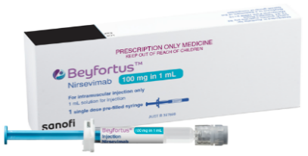
Women from 28 weeks pregnancy | NIP FUNDED | DO NOT USE | DO NOT USE | DO NOT USE
Infants and children <24 months | DO NOT USE | DO NOT USE | STATE & TERRITORY  FUNDED | STATE & TERRITORY  FUNDED
Aboriginal and Torres Strait Islander  people ≥60 years | AVAILABLE PRIVATELY  BASED ON CLINICAL DECISION | NIP FUNDED | DO NOT USE | DO NOT USE
Adults 60-74 years  (can consider vaccination) | AVAILABLE PRIVATELY  BASED ON CLINICAL DECISION | AVAILABLE PRIVATELY  BASED ON CLINICAL DECISION | DO NOT USE | DO NOT USE
Adults ≥75 years | AVAILABLE PRIVATELY  BASED ON CLINICAL DECISION | NIP FUNDED | DO NOT USE | DO NOT USE
Adults with medical risk conditions that increase risk of severe RSV disease  - 50-59 years (can consider vaccination)  - ≥60 years (recommended vaccination) | AVAILABLE PRIVATELY  BASED ON CLINICAL DECISION | AVAILABLE PRIVATELY  BASED ON CLINICAL DECISION | DO NOT USE | DO NOT USE

Note: NIP FUNDED indicates vaccine is NIP funded. DO NOT USE indicates product is NOT recommended for that group. STATE & TERRITORY FUNDED indicates funded under a state and territory program. AVAILABLE PRIVATELY indicates product only available through private prescription and is not funded. For further information including dosage and administration, refer to the Australian Immunisation Handbook chapter – Respiratory syncytial virus (RSV)

Information current as of May 2026

