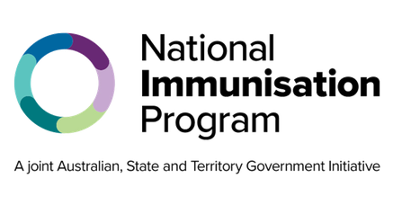
National Immunisation Program
RSV vaccination for older people Consumer fact sheet

About Respiratory syncytial virus
Respiratory syncytial virus (RSV) is a common virus that can cause a range of severe respiratory illnesses such as bronchiolitis and pneumonia.
RSV is spread through droplets from an infected person’s cough or sneeze. The droplets can be inhaled by others or land on surfaces where the virus can live for several hours.
Symptoms of RSV disease include:
- runny nose
- fever
- coughing, wheezing, or difficulty breathing
- earache and sinus pain.

When to get an RSV vaccine
You can get an RSV vaccine at any time of the year, but it is recommended to get it before the start of the RSV season where possible.
Infections are most common in the cooler months of autumn and winter, usually between April and September. The RSV season peaks in June and July, often before flu season.

People aged 75 and over and
Aboriginal and Torres Strait Islander people 60 years and over
If you are 75 years and over, or an Aboriginal or Torres Strait Islander person aged 60 years and over, the RSV vaccine, Arexvy®, is recommended and free through the National Immunisation Program (NIP).

Adults 60 to 74 years or people 50 and over with medical conditions that increase their risk of severe RSV disease
If you are 60 to 74 years or are aged 50 and over with a medical condition that increases your risk of severe RSV disease, you can consider RSV vaccination. You can buy a vaccine privately through general practices or pharmacies, but you cannot claim the cost or be reimbursed through the NIP or state or territory vaccination programs.
RSV vaccination is especially important for older adults
RSV infection can cause serious complications and lead to hospitalisation. Even healthy adults can get very sick from RSV. Vaccination is the best protection against severe RSV disease.
RSV hospitalisation rates increase with age, and people aged 75 years and over are likely to have the greatest benefit from vaccination.
Currently, only one dose of RSV vaccine is recommended for older adults. Protection lasts for at least 2 years.

Other recommended vaccines
You can safely get an RSV vaccination at the same time as, or separate from, other recommended vaccines, such as COVID-19, influenza, shingles, and pneumococcal vaccines. Speak with your doctor about your eligibility for other recommended free NIP vaccines.

Side effects
You may experience minor side effects from an RSV vaccination such as mild pain, redness or swelling where the injection was given, tiredness and headaches. These usually last for just a few days and go away without any treatment. Serious side effects, such as severe allergic reaction, are rare.

RSV vaccine safety
RSV vaccines are both safe and effective. The Therapeutic Goods Administration tests all vaccines, products, and medicines before they are approved for use in Australia.
Where to get RSV vaccines and how to book a vaccination appointment
Vaccination appointments for RSV vaccines can be booked at a range of health services including:
- general practices
- local council immunisation clinics (available in some states and territories)
- community health centers
- Aboriginal health services
- participating pharmacies
Not all these health services will have the free
NIP RSV vaccine. Check with your preferred health service to find out if they are available and when you can book your vaccination appointment.
Some states and territories may have free RSV vaccine programs for other groups. Check with your state health department to find out where
and how to book an appointment.

Australian Immunisation Register
Your health professional should always check the Australian Immunisation Register (AIR) before giving you a vaccine. They must also report to the AIR all the immunisations they give to ensure your immunisation history is complete and accurate.

More information
To find out more about RSV disease and vaccines, go to:
- the Healthdirect RSV disease information page at healthdirect.gov.au/respiratory-syncytial-virus-rsv
- the Department of Health, Disability and Ageing RSV vaccine page at health.gov.au/topics/immunisation/vaccines/respiratory-syncytial-virus-rsv-vaccine
- your state or territory health department website or trusted health professional.

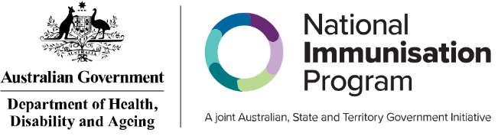
State and territory health department contact numbers:
ACT 02 5124 9800 | SA 1300 232 272
NSW 1300 066 055 | TAS 1800 671 738
NT 08 8922 8044 | VIC immunisation@health.vic.gov.au
WA 08 9321 1312 | QLD Contact your local Public Health Unit

This information is current as of May 2026

