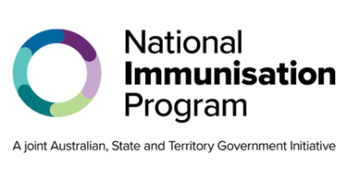
National Immunisation Program

RSV vaccination for older people

Frequently asked questions

What is RSV?
Respiratory syncytial virus (RSV) is a common virus that affects the upper and lower respiratory system. It can cause a range of severe respiratory illnesses such as bronchiolitis and pneumonia.

How do I catch RSV?
RSV is spread through droplets from an infected person’s cough or sneeze. The droplets can be inhaled by others or land on surfaces where the virus can live for several hours.
Symptoms of RSV disease include:
- runny nose
- fever
- coughing, wheezing or difficulty breathing
- earache and sinus pain.

How common is RSV?
RSV is a very common illness, but it can cause serious complications and lead to hospitalisation. Even otherwise healthy adults can become very unwell – vaccination is the best protection against severe RSV disease. RSV hospitalisation rates increase with age and people 75 years and over can have the greatest benefit from receiving a vaccine.

Who should get an RSV vaccine?
The RSV vaccine, Arexvy®, is recommended and free through the National Immunisation Program (NIP) for:
- adults aged 75 years and over
- Aboriginal and Torres Strait Islander people 60 years and over.

Adults aged 60 to 74 years and people 50 years and over with medical conditions that increase their risk of severe RSV disease can consider vaccination.

When should I get an RSV vaccine?
You can get an RSV vaccine at any time of year, but it is recommended to get it before the start of the RSV season where possible. Infections are most common in the cooler months of autumn and winter, usually between April and September. The RSV season peaks in June and July, often before flu season.

How many RSV vaccine doses do I need?
Currently, only one dose of the RSV vaccine is recommended for older adults, and protection lasts at least 2 years.

When is the RSV vaccine available through the NIP?
The RSV vaccine for older people are available for free through the NIP from 15 May 2026.

Who can get a free RSV vaccine under the NIP?
Adults aged 75 and over and Aboriginal and Torres Strait Islander people 60 years and over can receive a free RSV vaccine through the NIP. To be able to access free NIP vaccines you must hold, or be eligible for, a Medicare card.

Will my state or territory have free RSV vaccines for other groups?
State and territory governments may have RSV programs for other groups. For more information or advice, refer to your state or territory immunisation health service.

How do I get an RSV vaccine if I am not eligible for a free one?
If you are not eligible for a free vaccine through the NIP or a state or territory program, you can purchase RSV vaccines on the private market. The cost cannot be reimbursed through the NIP. Talk to your trusted health professional about whether an RSV vaccine is recommended for you and how much it will cost.

Where can I get an RSV vaccine?
You can book an appointment for an RSV vaccine at a range of health services including:
- general practices
- local council immunisation clinics (available in some states and territories)
- community health centres
- Aboriginal health services
- participating pharmacies.
Not all of these health services will have free NIP vaccines. Check with your preferred health service to find out if they are available and when you can book your vaccination appointment.

I already paid for an RSV vaccine. Can I get my money back?
No, you cannot be reimbursed if you paid for an RSV vaccine and are now eligible to receive it for free through the NIP or state or territory program. This is because the NIP does not retrospectively cover vaccines given before eligibility begins.

Do I still need to get the vaccine if I have already had RSV?
Yes, an RSV vaccine may still be recommended even if you have had RSV. Speak with your trusted health professional to see if it is recommended for you.

Is the RSV vaccine safe?
The RSV vaccine is both safe and effective. The Therapeutic Goods Administration assesses all vaccines, products, and medicines before they are approved for use in Australia.

Are there any side effects from the RSV vaccine?
Common side effects from the RSV vaccine include mild pain, redness or swelling where the injection was given, fatigue and headaches. These side effects usually last for a few days and go away without any need for treatment. Serious side effects, such as a severe allergic reaction, are rare.

Can I have the RSV vaccine at the same time as other vaccines?
Yes, you can safely receive the RSV vaccine at the same time as, or separate from, other recommended vaccines such as influenza, COVID-19, shingles, and pneumococcal vaccines. Speak with your health professional about your eligibility for other recommended free NIP vaccines.

Where can I get more information about the RSV vaccine?
To find out more about the RSV vaccine and immunisation programs, go to:
- our campaign website at health.gov.au/winter-vaccinations
- the Department of Health, Disability and Aged Care at health.gov.au/immunisation
- your state or territory health department website or trusted health professional.

State and territory health department contact numbers:
ACT 02 5124 9800 | SA 1300 232 272
NSW 1300 066 055 | TAS 1800 671 738
NT 08 8922 8044 | VIC immunisation@health.vic.gov.au
WA 08 9321 1312 | QLD Contact your local Public Health Unit
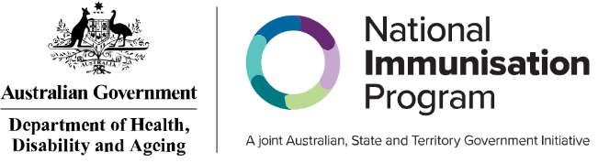

This information is current as of May 2026

