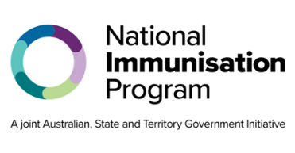
National Immunisation Program

RSV maternal vaccination

Program advice for health professionals

Key points
- The National Immunisation Program (NIP) provides the free maternal RSV vaccine Abrysvo® to eligible women from 28 weeks of pregnancy.
- States and territories are offering the infant Beyfortus™ (nirsevimab) RSV monoclonal antibody. This product is covered through state and territory RSV infant protection programs. Questions about access should be directed to state and territory health departments.
- RSV vaccines and the RSV monoclonal antibody can be safely administered with other recommended vaccines or COVID-19 vaccines based on an individual benefit-risk assessment.

About Respiratory syncytial virus (RSV)
Respiratory syncytial virus (RSV) is a common virus that causes upper and lower respiratory tract infection.
While it may be a mild disease for some, it can cause serious illness and hospitalisation in otherwise healthy children and adults. Effects can range from colds to severe conditions such as bronchiolitis in children and pneumonia.
RSV is spread through droplets from an infected person’s cough or sneeze. The droplets can be inhaled by others or land on surfaces where the virus can live for several hours.

Who should receive an RSV vaccine

Pregnant women
A single dose of Abrysvo® is recommended from 28 weeks of pregnancy and is funded through the NIP for eligible women. Abrysvo® can be administered at any time of year provided it is at an appropriate point in the pregnancy.
Arexvy® must not be administered to pregnant women. Abrysvo® is the only RSV vaccine approved for use in pregnant women.
Abrysvo® can be safely co-administered with other recommended maternal vaccines or COVID-19 vaccines based on an individual benefit-risk assessment.
The maternal RSV vaccine given during pregnancy is primarily to protect infants. Women who are breastfeeding but not pregnant are not recommended to receive RSV vaccination.
While there are no safety concerns, there is no evidence that protection is passed to the infant through breastfeeding.
Advice on repeat vaccination during subsequent pregnancies will be provided in future as more data becomes available.

Who should receive an RSV monoclonal antibody

Infants and children
Abrysvo® and Arexvy® must not be administered to infants and children.
Infants <8 months are recommended to receive a single dose of Beyfortus™ (nirsevimab) monoclonal antibody if:
- the mother did not receive an RSV vaccine during pregnancy, or
- they were born within 2 weeks after the mother receiving an RSV vaccine, or
- they have a condition or circumstance that increases their risk of severe RSV disease.
Administration of nirsevimab is likely to be most effective when given shortly after birth for infants born just before or during the RSV season.
Children ≥8 to 24 months who have certain risk conditions for severe RSV disease are recommended to receive nirsevimab before their second RSV season.

Currently, nirsevimab is not recommended for infants during the first 6 months of life if:
- the mother received an RSV vaccine at an appropriate time during pregnancy, and
- the infant does not have a risk condition for severe RSV disease.
Questions about the RSV monoclonal antibody and RSV infant protection program eligibility should be directed to state and territory health departments.
Infants and children can safely receive nirsevimab on its own or at the same appointment as other routine childhood vaccinations.

RSV vaccine and RSV monoclonal antibody safety
Clinical trials of RSV vaccines and the RSV monoclonal antibody have found them to be both safe and effective.
Common side effects include mild pain, redness or swelling where the injection was given, fatigue and headaches. These side effects usually last for a few days and go away without any treatment. Serious side effects, such as severe allergic reaction, are rare.

Contraindications
The only contraindications to RSV vaccines and the RSV monoclonal antibody are anaphylaxis after:
- a previous dose of the same vaccine or monoclonal antibody
- any component of an RSV vaccine or monoclonal antibody.

Adverse events or administration errors
You must notify all adverse events and vaccine or monoclonal antibody administration errors through the reporting mechanisms in your state or territory.
Ensure you are administering the correct product for your patient. Private stock incorrectly given instead of NIP or state or territory stock cannot be claimed or reimbursed. Consider storing vaccines for different cohorts on separate shelves to prevent errors.

Australian Immunisation Register
Check the Australian Immunisation Register (AIR) before administering an RSV vaccine or RSV monoclonal antibody. You should report all RSV maternal and infant immunisations to the AIR to ensure complete and accurate records. For more information, go to servicesaustralia.gov.au/hpair.

Keep up to date
Read the advice in this factsheet in conjunction with the Australian Immunisation Handbook at immunisationhandbook.health.gov.au
Subscribe to the NIP update email update service. Search ‘NIP updates’ on health.gov.au

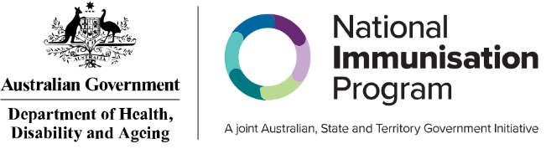
State and territory health department contact numbers:
ACT 02 5124 9800 | SA 1300 232 272
NSW 1300 066 055 | TAS 1800 671 738
NT 08 8922 8044 | VIC immunisation@health.vic.gov.au
WA 08 9321 1312 | QLD Contact your local Public Health Unit

This Information is current as of May 2026

