Referral pathway for allied health treatment for eligible disabilities
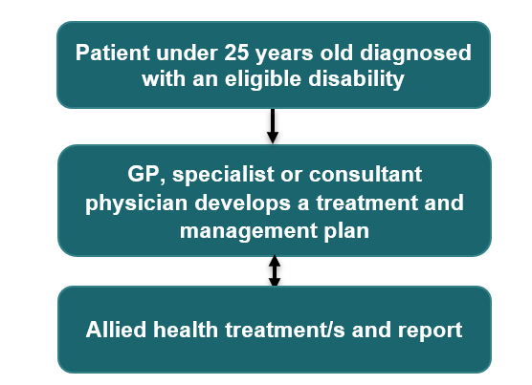

Restrictions or requirements
- Eligible disabilities are listed on MBSOnline at explanatory note MN.10.3.

Referrals
- A referral for treatment from the GP, specialist or consultant physician (doctor) must be provided to the allied health professional.
- When referring patients to allied health treatment services, any of the following relevant MBS item numbers must be used:
  - GPs – item 139 or telehealth item 92142.
  - specialist or consultant physicians - item 137 or telehealth item 92141.

Treatment services
- A course of treatment covers up to 10 allied health treatment services. One course of treatment can be requested per referral.
- A maximum of 20 treatment services from eligible allied health professionals can be claimed per patient per lifetime.
- A report must be prepared for the referring doctor after each course of treatment.

Further information
- Further information on relevant items can be found on MBSOnline under M10 items and explanatory note MN.10.2 and MN.10.3.

Please note that the information provided is a general guide only. It is ultimately the responsibility of treating practitioners to use their professional judgment to determine the most clinically appropriate services to provide, and then to ensure that any services billed to Medicare fully meet the eligibility requirements outlined in the legislation.
This sheet is current as of the last updated date and does not account for MBS changes since that date.

