Referral pathway for allied health assessment for eligible disabilities
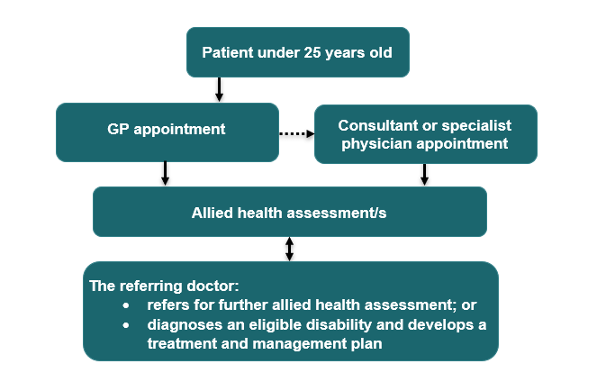

Requirements
- Eligible disabilities are listed on MBSOnline at explanatory note MN.10.3.

Referrals
- If the GP diagnoses an eligible disability during the initial consultation, they can develop a treatment and management plan without further referrals.
- Alternatively, the GP may:
  - refer the patient to allied health assessment services to assist them in making a diagnosis, or
  - refer the patient to a specialist or consultant physician, who can also refer the patient to allied health assessment services if required.
- When referring patients to allied health assessment services, any of the following relevant MBS items must be used:
  - GPs - attendance items 3 to 47 or telehealth items 91790, 91800 to 91802, 91890 and 91891.
  - Specialists or consultant physicians – attendance items 104, 105, 107, 108, 110, 116, 119, 122, 128, 131, 296, 297, 299, 300, 302, 304, 306, 308, 310, 312, 314, 316, 318, 319, 320, 324, 326, 328, 330, 332, 334, 336, 338, 341, 342, 343, 344, 345, 346, 347 or 349, or telehealth items 91822 to 91831, 91833, 91836 to 91839, 91868-91884, 92437 or 92455 to 92457.
- The allied health professional can refer to another allied health professional to assist with the assessment; however, the referring GP, specialist or consultant physician must agree.

Assessment services
- Up to 8 allied health assessment services are available per lifetime. Up to four of these services can be provided to the patient on the same day.
- A report must be prepared for the referring GP, specialist or consultant physician after the final assessment service.
- The assessment services are to assist the referring GP, specialist or consultant physician with their diagnosis and/or to contribute to a treatment and management plan.

Further information
- Further information on relevant items can be found on MBSOnline under M10 items and explanatory note MN.10.1.

Please note that the information provided is a general guide only. It is ultimately the responsibility of treating practitioners to use their professional judgment to determine the most clinically appropriate services to provide, and then to ensure that any services billed to Medicare fully meet the eligibility requirements outlined in the legislation.
This sheet is current as of the last updated date shown and does not account for MBS changes since that date.

