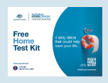
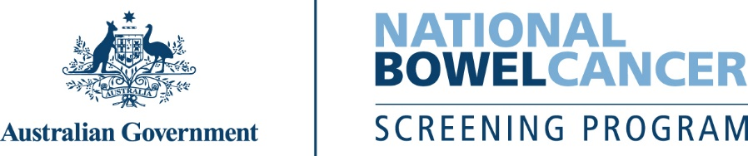
C221 – 7/2025 – English – Sample letter only

<First name>, it’s almost time to do your free bowel screening test.
Your free bowel screening test kit will arrive in the mail soon.

It’s important you do the test because...
- Your risk of developing bowel cancer increases as you get older.
- Bowel cancer is one of the most common cancers and biggest cancer killers in Australia.
- Bowel cancer can occur without symptoms. This test can find the early warning signs.
- If found early, more than 90% of bowel cancer cases can be successfully treated.
Please do the test – it’s quick, clean and easy
Everything you need is inside the kit, including detailed instructions.
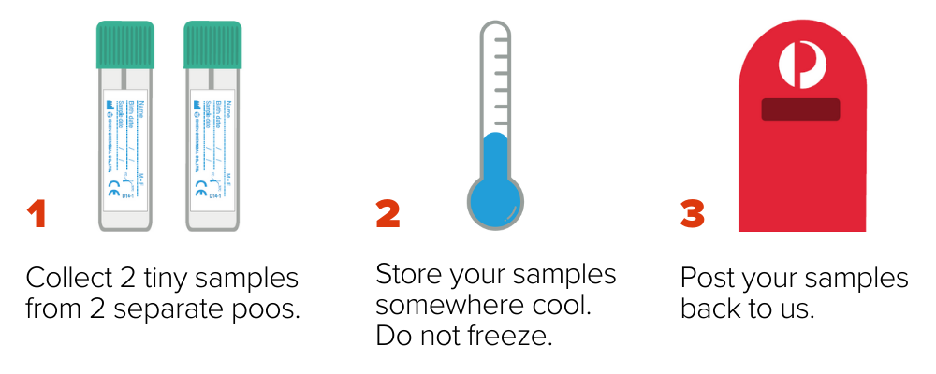
To update your details, delay your test, or opt out of the program, go to
www.ncsr.gov.au/manage-participation.

For more information about bowel cancer screening:
- scan this QR code to visit www.health.gov.au/nbcsp
- call the National Cancer Screening Register on 1800 627 701.
How we use your personal information www.ncsr.gov.au/privacy.

