
C001 – 7/2025 – English – Sample letter only
Do this test and return it within 2 weeks or as soon as possible.

<First name>, it’s time to do your free bowel screening test.

Join millions of Australians who do the bowel screening test every 2 years
- Bowel cancer takes more lives than breast, skin or prostate cancer – with age the biggest risk factor.
- It can develop without symptoms or a family history of bowel cancer, so it’s important you do the test even if you feel fit and healthy.
- If found early, over 90% of bowel cancer cases can be successfully treated.
Please do the test – it’s quick, clean and easy
Everything you need is inside the kit, including detailed instructions.
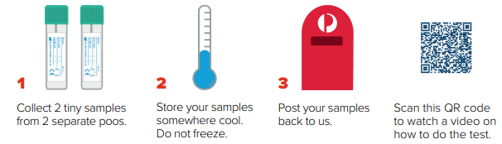
Your result will be mailed to you and your doctor within 4 weeks after you post your samples.
Don’t forget to do the test – put this letter on the fridge and your kit near the toilet.

For more information about bowel cancer screening:
- scan this QR code to visit www.health.gov.au/nbcsp
- call the National Cancer Screening Register on 1800 627 701.
How we use your personal information www.ncsr.gov.au/privacy.

