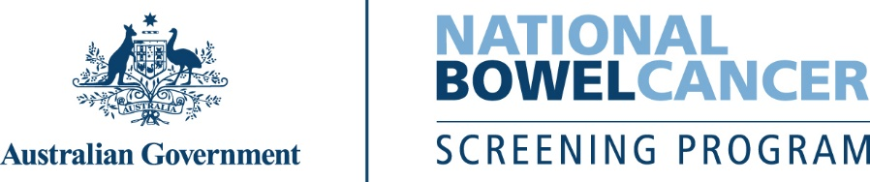
C001LC – 7/2025 – English – Sample letter only
Do this test and return it within 2 weeks or as soon as possible.

<First name>, it’s time to do your free bowel screening test.

Doing this test could save your life.
- Bowel cancer takes more lives than breast, skin or prostate cancer – with age the biggest risk factor.
- It can develop without symptoms or a family history of bowel cancer, so it’s important you do the test, even if you feel fit and healthy.
- If found early, over 90% of bowel cancer cases can be successfully treated.
Please do the test – it’s quick, clean and easy
Everything you need is inside the kit, including detailed instructions.
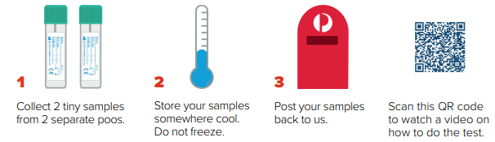
Your result will be mailed to you and your doctor within 4 weeks after you post your samples.
The Program ends at age 74, so this is the last kit we will send you. If you have ongoing concerns about bowel cancer, please talk to your doctor who is best placed to advise on future screening options in the context of your individual health situation.
Don’t forget to do the test – put this letter on the fridge and your kit near the toilet.

For more information about bowel cancer screening:
- scan this QR code to visit www.health.gov.au/nbcsp
- call the National Cancer Screening Register on 1800 627 701.
How we use your personal information www.ncsr.gov.au/privacy.

