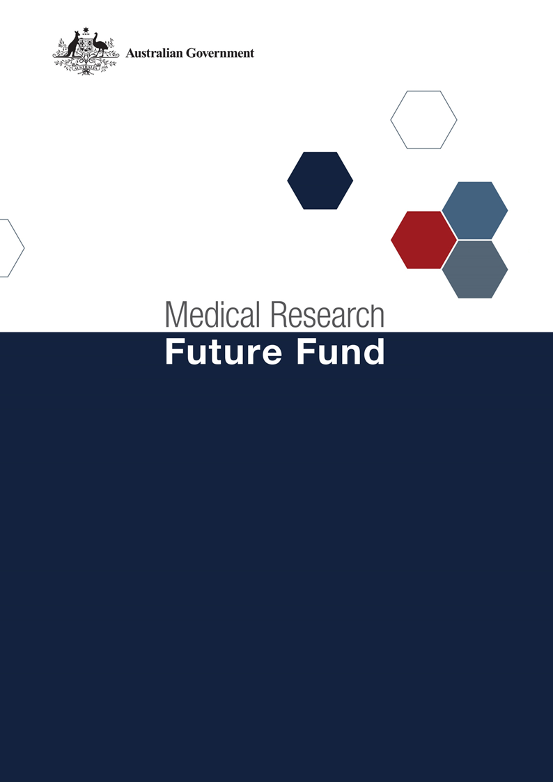

MRFF Indigenous Health Research Fund
2026 Grant Opportunity
National Consultation Report
15 April 2026
Table of Contents

Introduction 2
Community participation and submissions 2
Responses to national consultation submissions 4

Introduction
The Medical Research Future Fund (MRFF) is a $24.83 billion long-term investment supporting Australian health and medical research. The MRFF aims to transform health and medical research and innovation to improve lives, build the economy and contribute to health system sustainability. The MRFF’s Indigenous Health Research Fund (IHRF) was established by the Australian Government in 2019, with a $160 million commitment over 11 years from 2018–19 to 2028–29, for research to improve the health of Aboriginal and/or Torres Strait Islander people.
The Productivity Commission’s first review of the progress on the National Agreement on Closing the Gap recommended putting the principle of self-determination into practice for government programs. In alignment with this recommendation, the IHRF’s next grant opportunity will award $28.5 million through an open and competitive process to an Aboriginal and/or Torres Strait Islander Community-Controlled program to:
- Conduct a review to assess progress of the IHRF towards its vision and priorities
- Develop strategic priorities for the research investment, informed by this review
- Run one, or more, open and competitive processes, to identify and select Aboriginal and/or Torres Strait Islander health and medical research projects
- Partner with the successful projects to provide funding and support to ensure their success in tackling health issues facing Aboriginal and Torres Strait Islander peoples
A Working Group of the NHMRC-MRFF Indigenous Advisory Group, Chaired by Professor Yvette Roe, was formed in July 2025 to provide advice to the Department of Health, Disability and Ageing (the Department) on design of the grant opportunity.
A national public consultation occurred from 17 October 2025 to 28 November 2025 that sought feedback from the community on the key sections of the draft grant opportunity guidelines (objectives, outcome, assessment criteria, and additional glossary definitions) and on the draft assessment scoring matrix. Formal feedback was provided through written submissions to the Department’s consultation hub. Informal feedback through other channels was also considered in preparation of this report.

Community participation and submissions
The following questions were provided on the consultation hub to guide submissions:
- The aim is to help empower Aboriginal and Torres Strait Islander community-controlled research to accelerate positive impact on health outcomes for Aboriginal and Torres Strait Islander peoples, does the design of the grant opportunity achieve this?
- Are the objectives and outcomes appropriate or how could these be improved?
- Is the wording of the assessment criteria and scoring matrix appropriate or how could these be improved?
- Do you have any other comments or suggestions on the draft grant opportunity?
The CEO of the Health and Medical Research Office in the Department, Ms Natasha Ploenges, and the Chair of the Working Group hosted a webinar on 10 November 2025 to provide an opportunity for the community to gain a greater understanding of the purpose of the grant opportunity and ask questions, prior to providing written submissions to the consultation.
The webinar was attended by 50 stakeholders from across Australia. A diverse range of stakeholders participated including those from universities, medical research institutes, Aboriginal Community Controlled Health Organisations, peak bodies, and community members.
At the close of the consultation period, 8 written submissions were received representing medical research institutes, peak bodies and Indigenous-owned businesses.
Feedback was also provided through the webinar, from the NHMRC-MRFF Indigenous Advisory Group that provides strategic advice on Aboriginal and Torres Strait Islander health and health research issues, and from attendees to the 2025 convocation of the OCHRe network - the national network of Aboriginal and Torres Strait Islander health researchers.
Feedback was broadly supportive of the grant opportunity’s aim to implement the principle of self-determination through funding a community-controlled program to support research. Considerable feedback was provided on ways to improve the grant opportunity, reflecting strong engagement and a diversity of perspectives. While many suggestions aligned, others differed, indicating varied views on how to improve the design of the grant opportunity.
The Working Group and the Department considered all responses from the national consultation, and where relevant, revised the design of the grant opportunity. A summary of the feedback, responses and actions from the Working Group and the Department are outlined below. The feedback is listed in no particular order.

Responses to national consultation submissions
Reference  Number | Submission Feedback / Themes | Action by the Working Group and Department
 | The lead organisation of the program must be an Aboriginal and Torres Strait Islander Community-Controlled Organisation (ACCO). If the lead ACCO is unable to be an MRFF Eligible Organisation, at least one partner organisation or institution must be an MRFF Eligible Organisation to provide support and so the ACCO can apply to the grant opportunity.  This is because ACCOs must be prioritised in the allocation of funding for research that impacts Aboriginal and Torres Strait Islander communities. Genuine leadership and decision-making cannot be fully realised through indirect or secondary partnerships, as superficial inclusion. | The Working Group considers the current guidelines to be comprehensive in ensuring that the funded program will genuinely be community-controlled and is confident that the Grant Assessment Committee can identify any tokenistic applications. However, the Working Group acknowledges the need to strengthen the grant opportunity further to prevent superficial or symbolic inclusion of leadership from Community-Controlled organisations. To support this, the scoring matrix will be updated to include that demonstrating comprehensive representation from Community-Controlled organisations within the project team will contribute to scoring.
 | Consider awarding this funding to an existing respected organisation through a non-competitive process rather than an open competitive approach. | The Working Group appreciates that there are respected organisations that could run this program. However, as advised by the Department, the grant opportunity is to have a competitive and merit based process in alignment with the Commonwealth Grants Rules and Principles 2024 (CGRPs) to allow for the best possible program to be funded.
 | Ensure the grant opportunity guidelines include a definition of what a Community-Controlled organisation is. | The grant opportunity guidelines includes a definition in the glossary that aligns with the definition in Clause 44 of the National Agreement on Closing the Gap.
 | Ensure Indigenous-owned businesses are eligible to lead or participate meaningfully in the program. | The Working Group recognises the importance of research partnering with Indigenous-owned businesses. The grant opportunity guidelines will include Indigenous-owned businesses in the list of examples of partnering organisations and will be emphasised in the objective.
 | ACCOs should be involved in all stages of the program to ensure Aboriginal and Torres Strait Islander leadership and governance, and so that the research projects are in connection with these organisations, reinforcing the role of building the community-controlled sector. | The Working Group agrees that ACCOs should be involved throughout all activities of the program. Wording will be added to the guidelines to emphasise that the program is to involve ACCOs in all stages of the program and lead where appropriate– noting that the program will determine the projects to be funded.
 | The grant opportunity guidelines should ensure that funding can be used for the costs to run the program (particularly for ACCOs that will not have funding streams to cover this and may need to develop or outsource the needed skills).  The guidelines should also detail how much funding is to be used for each activity of the program and how much is to be provided to the selected research projects. | The Working Group appreciates that ACCOs may not have funding streams to cover the costs to administer the program. To provide clarity, the guidelines will include wording that the costs to deliver the program are considered Direct Research Costs and can be covered by the funding from the grant.  To provide autonomy for applicants and to allow for innovative applications, the timing and funding for the program’s activities are to be determined by the applicant - including how much of the grant funds are expected to be provided to research projects.
 | There is concern that some of the grant funding will be used to conduct activities that are thought to be typically done by government, such as reviewing the IHRF and running processes to select projects, instead of being provided for research – and that conducting these activities will also postpone research investment. | The intent of the grant opportunity is to fund a single, cohesive program that integrates all activities under community-control. This approach is to ensure self-determination in setting priorities, allocating funding, and guiding implementation, rather than these steps being undertaken separately by government.  This aligns with other similar MRFF grant opportunities, such as the 2024 BioMedTech Incubator grant opportunity, where funding is provided to an entity to conduct strategic planning and project selection to achieve coordinated, impactful outcomes.
 | Assuming the funded program introduces new processes and systems (such as information technology systems) to support its delivery, it is recommended that future grants be considered to make the program ongoing. This would ensure these new processes and systems continue to be utilised rather than being wasted.  Having the program be ongoing would align with the National Agreement on Closing the Gap that requires a shift from transactional, time-limited grants to system-level reform grounded in shared decision-making, sector strengthening, and long-term, sustainable funding structures led by Aboriginal and Torres Strait Islander peoples. | The guidelines allow applicants to utilise, or build on, existing infrastructure or processes to deliver the program. Innovative approaches that may not require building information technology systems are also in scope.  However, the Working Group agrees with the feedback and the Department has noted the advice of the benefits of sustained funding for the program.  This grant opportunity is a one-off grant opportunity. Noting that the grant length is up to 7 years, a decision on there being a subsequential grant opportunity or ongoing funding would be a future decision for government.
 | Ensure that the funded program works closely with and complements other existing similar programs and builds on existing infrastructure where possible.  The program should have a genuine national approach, utilise national governance structures instead of duplicating these, and work closely with the OCHRe network, ACCOs and health and medical research institutes across the nation. | Wording will be added to the objective in the grant opportunity guidelines to ensure the program has a national approach that works with organisations with a national remit and utilises existing national governance structures.
 | The objectives of the grant opportunity should include clear expectations for financial governance and conflict of interest management, embedding principles of data sovereignty and co-design, and require an independent review of outcomes to assess impact and inform future policy directions. | Wording will be added to the objective to ensure the program implements conflict of interest management and financial governance processes in selecting and funding projects, and embeds the principles of data sovereignty and Aboriginal and Torres Strait Islander leadership.  Conducting an evaluation of the program has also been added as an activity in the objective.
 | There is concern that some organisations—such as ACCOs—are unable to access funding through the Australian Government’s Research Block Grant programs, which cover the systemic costs of research and training. | The Working Group acknowledges this as a barrier faced by such organisations, and this is noted by the Department. As per a previous action, the guidelines will include wording to make it clear that grant funding can be used for the costs to deliver the program.  Regarding changes to the Research Block Grant programs, this is a broader policy matter and is beyond the scope of this grant opportunity.
 | Ensure that the research projects funded through the program:  - prioritise funding projects led by Aboriginal and Torres Strait Islander researchers  - demonstrate how community priorities have informed the proposed project  - are not duplicative or rehashing previous research  - can be translated and implemented to result in tangible benefits for Aboriginal and Torres Strait Islander people  - have evaluation built into their design | Wording will be added to the objective in the grant guidelines to ensure that, in the development of the Strategic Priorities Investment Plan, the funded program prioritises projects led by Aboriginal and Torres Strait Islander researchers, and ensures that the funded projects are complementary and not duplicative, have tangible benefits that are a priority for the community, and have a plan to be translated, implemented and evaluated.
 | Aboriginal and/or Torres Strait Islander researchers in tertiary academic sectors (such as universities and medical research institutes) should not be excluded. | No amendments have been made as the current wording does not exclude researchers from academic organisations being supported by the program.
 | Ensure the guidelines are clear in that the program can provide support for capacity and capability building of Aboriginal and Torres Strait Islander researchers and ensuring activities have cultural integrity.  Workforce capacity building in the community-controlled sector should also be prioritised through this grant opportunity. | Wording will be added to the objective to make it clear that the program can conduct capacity and capability building activities with a focus on community-based researchers and support their career development.
 | There should be a dedicated health economics stream aimed at building capacity within Aboriginal and Torres Strait Islander community-based organisations to demonstrate economic impact and sustainability. | The Working Group recognises the importance of health economics research. However, the research to be funded will be determined by the program and health economics research is not excluded.
 | Questions about what data will be available for conducting the review of IHRF, and concerns that many grants will not be completed yet. | Wording will be added to make it clear that the review is to be conducted using public data, for the program to contact IHRF grantees for further information if needed, and that it is noted that many projects will still be ongoing. Information such as progress reports will not be provided to the program as these are confidential documents.
 | For the following point in Assessment Criterion 1: “demonstrate how a review of the research literature, and Aboriginal and/or Torres Strait Islander health research prioritisation frameworks and support initiatives, have informed the proposed project”.  The importance of reviewing outputs was recognised - however, it was questioned why the organisation is requested to do this to inform a self-determining process for research commissioning? | Performing a review of existing research literature and prioritisation frameworks is not intended to limit self-determination. Rather, it intends to ensure that the proposed program builds on existing knowledge, avoids duplication, and is aligned with nationally recognised priorities and initiatives.
 | Assessment Criterion 3 focuses on the ‘team’ not ‘organisation’. There is concern that there does not appear to be criteria for an organisation to offer an organisation’s track record in research commissioning, as this criterion focusses on the track record of individuals.  There is also concern that there does not appear to be considerations for what might happen if individuals of the funded organisation move to a different organisation. | The Department appreciates this feedback. However, as with all MRFF grant opportunities, the focus is on who will run the project and how they will do it rather than an organisation’s reputation. Keeping in mind that individuals can demonstrate in their application their track record in research commissioning.  If an individual on the grant application is to leave the program, or be replaced, then a variation request will need to be submitted in line with the MRFF grant variation policy.
 | There is currently no requirement within the application criteria to outline or assess the applicant’s existing infrastructure with an ACCO to deliver this opportunity. | The applicant’s availability of existing infrastructure, or the ability to establish infrastructure, to successfully deliver the program will be added to Assessment Criterion 3 and the scoring matrix.
 | There were several suggestions to add wording to the assessment criteria or scoring matrix to repeat or emphasise points from the objective wording in the grant opportunity guidelines. | As the assessment criteria and scoring matrix provides broader assessment direction and references, and is read in conjunction with, the detailed objective and outcome wording during assessment, it was decided that repeating such wording within the criteria and matrix is unnecessary.
 | Suggested amendments to Assessment Criterion 1 of the assessment matrix to ensure that the supported research projects are a priority for Aboriginal and/or Torres Strait Islander communities, and to make it optional rather than mandatory that the program contributes to the Priority Reforms of the National Agreement on Closing the Gap. | This criterion in the assessment matrix will be amended to include the words that the funded research must be a priority for Aboriginal and/or Torres Strait Islander communities. However, the Working Group recommended having the program contribute to the Priority Reforms of the National Agreement on Closing the Gap which will remain as this is seen as achievable and important.
 | Suggest removing the word ‘rapidly’ from the following point in the assessment matrix:  ‘will rapidly and significantly improve health outcomes for Aboriginal and/or Torres Strait Islander people’  As a rapid improvement in a research outcome is a subjective measure. | This feedback is appreciated. However, the wording is retained to emphasise that there is an urgent need to improve health outcomes.
 | There should be coordination and collaboration with the Coalition of Peaks to promote the IHRF grant opportunity within the community-controlled sector. | The Department appreciates this offer and will work with key stakeholders, including the Coalition of Peaks, to promote the grant opportunity.

