
Evaluation of the Preterm Birth Prevention Program – Interim Report
Pregnancy, birth and baby
9 March 2026

Nous Group acknowledges Aboriginal and Torres Strait Islander peoples as the First Australians and the Traditional Custodians of Country throughout Australia. We pay our respect to Elders past and present, who maintain their culture, Country and spiritual connection to the land, sea and community.
This artwork was developed by Marcus Lee Design to reflect Nous Group’s Reconciliation Action Plan and our aspirations for respectful and productive engagement with Aboriginal and Torres Strait Islander peoples and communities.
Disclaimer:
Nous Group (Nous) has prepared this report for the benefit of Department of Health, Disability and Ageing (the Client).
The report should not be used or relied upon for any purpose other than as an expression of the conclusions and recommendations of Nous to the Client as to the matters within the scope of the report. Nous and its officers and employees expressly disclaim any liability to any person other than the Client who relies or purports to rely on the report for any other purpose.
Nous has prepared the report with care and diligence. The conclusions and recommendations given by Nous in the report are given in good faith and in the reasonable belief that they are correct and not misleading. The report has been prepared by Nous based on information provided by the Client and by other persons. Nous has relied on that information and has not independently verified or audited that information.
© Nous Group

Contents
1 Background and context 1
2 Evaluation methodology 5
3 Interim findings | Appropriateness 12
4 Interim findings | Efficiency and effectiveness of implementation 26
5 Interim findings | Outcomes and impact 45
6 Interim findings | Lessons learned 63
Appendix A Overview of the National Program 67
Appendix B Evaluation approach – Program logic 77
Appendix C Key Evaluation Questions and data matrix 85
Appendix D Supporting information 90
Appendix E Strategy alignment of the National Program 92
Appendix F ‘Every Week Counts’ Round 1 outputs 96
Appendix G AIHW data and notes 105

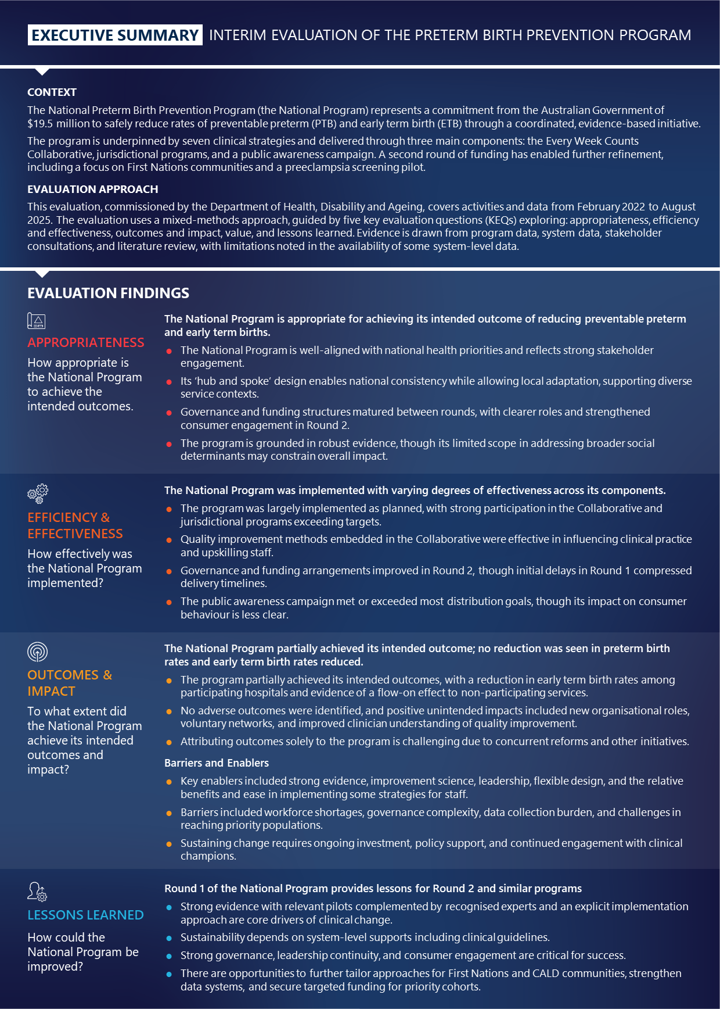
[Detailed image description:
Executive Summary
This image is an executive summary of the interim evaluation report of the preterm birth prevention program. It provides an overview of the National Program’s context, evaluation approach, findings, and the lessons learned.
Context
- National Preterm Birth Prevention Program: Represents a commitment from the Australian Government of $19.5 million to reduce rates of preventable preterm birth (PTB) and early term birth (ETB) through a coordinated, evidence-based initiative.
- Program Components: Includes seven clinical strategies delivered through three main components: Every Week Counts Collaborative, jurisdictional programs, and a public awareness campaign. A second round of funding focuses on First Nations communities and a preeclampsia screening pilot.
Evaluation Approach
- Commissioned by: Department of Health, Disability and Ageing.
- Coverage: Activities and data from February 2022 to August 2025.
- Methodology: Mixed-methods approach guided by five key evaluation questions (KEQs) exploring appropriateness, efficiency and effectiveness, outcomes and impact, value, and lessons learned. Evidence is drawn from program data, system data, stakeholder consultations, and literature review.
Evaluation Findings
Appropriateness:
- The program is well-aligned with national health priorities and reflects strong stakeholder engagement.
- ‘Hub and spoke’ design enables national consistency while allowing local adaptation.
- Governance and funding structures matured between rounds, with clearer roles and strengthened consumer engagement.
- Grounded in robust evidence, though limited scope in addressing broader social determinants may constrain impact.
Efficiency and Effectiveness:
- Implemented with varying degrees of effectiveness across components.
- Strong participation in the Collaborative and jurisdictional programs exceeding targets.
- Quality improvement methods were effective in influencing clinical practice and upskilling staff.
- Governance and funding arrangements improved in Round 2, though initial delays compressed delivery timelines.
- Public awareness campaign met or exceeded most distribution goals, though impact on consumer behaviour is less clear.
Outcomes and Impact:
- Partially achieved intended outcomes, with a reduction in early term birth rates among participating hospitals.
- No adverse outcomes identified, with positive unintended impacts including new organisational roles, voluntary networks, and improved clinician understanding of quality improvement.
- Attribution of outcomes solely to the program is challenging due to concurrent reforms and other initiatives.
Barriers and Enablers:
- Key enablers: strong evidence, improvement science, leadership, flexible design, and ease of implementing strategies.
- Barriers: workforce shortages, governance complexity, data collection burden, and challenges in reaching priority populations.
- Sustaining change requires ongoing investment, policy support, and continued engagement with clinical champions.
Lessons Learned:
Round 1 Lessons: Provides insights for Round 2 and similar programs.
- Strong evidence with relevant pilots complemented by recognised experts and an explicit implementation approach are core drivers of clinical change.
- Sustainability depends on system-level supports including clinical guidelines.
- Strong governance, leadership continuity, and consumer engagement are critical for success.
- Opportunities exist to tailor approaches for First Nations and CALD communities, strengthen data systems, and secure targeted funding for priority cohorts.
End of detailed image description]

Background and context
This section outlines the background, context and purpose of the evaluation, and an overview of the National Preterm Birth Prevention Program (the National Program), including its history and evolutions.

Background and purpose of the National Program
Preterm birth (PTB) is the leading cause of death and disability in children,, a common cause of additional medical, obstetric and social issues,, and poses significant costs to the Australian Government. Globally, PTB complications were responsible for approximately 900,000 deaths, of which three-quarters could be prevented with cost-effective interventions. Nearly one in three Australian babies are born in the 14-day ETB period and that figure has been rising in recent years., Approximately 8.4 per cent of babies are born between 20 and 36 weeks, and this has remained steady between 2010 (8.3 per cent) and 2023 (8.4 per cent). The National Program was developed in response to a need for an intervention to safely lower the rate of preterm birth.
The Australian Government invested $13.7 million for Round 1 of the National Preterm Birth Prevention Program (the National Program), which was delivered over three years from 2021-22 to 2023-24, and $5.8 million over two years from 2024-25 to 2025-26 for Round 2. The National Program’s overall objectives are to ensure maternity care providers and expectant parents are aware of the risk of, and actions available to prevent early term birth (ETB) and preterm birth. PTB is defined as births occurring before 37 weeks’ gestation, and ETB is defined as births occurring between 37- and 39-weeks’ gestation. The main aim of the National Program is to safely lower the rate of PTB (including a focus on ETB in Round 2) across Australia and was underpinned by seven clinical strategies (refer to Section A.1). Further detail on each component of the National Program is provided in Appendix A.

The National Program built on existing pilots in Australian jurisdictions
The National Program was informed by evidence from a pilot project in Western Australia and subsequent National Health and Medical Research Council (NHMRC) grant to extend the pilot to other Australian jurisdictions, summarised in Figure 1. These projects aimed to safely reduce PTB rates in Australian jurisdictions. The WA pilot and subsequent national pilot successfully reduced PTB rates.
Figure 1 | The National Program (Round 1 and 2) was initiated after the WA pilot and NHMRC grant
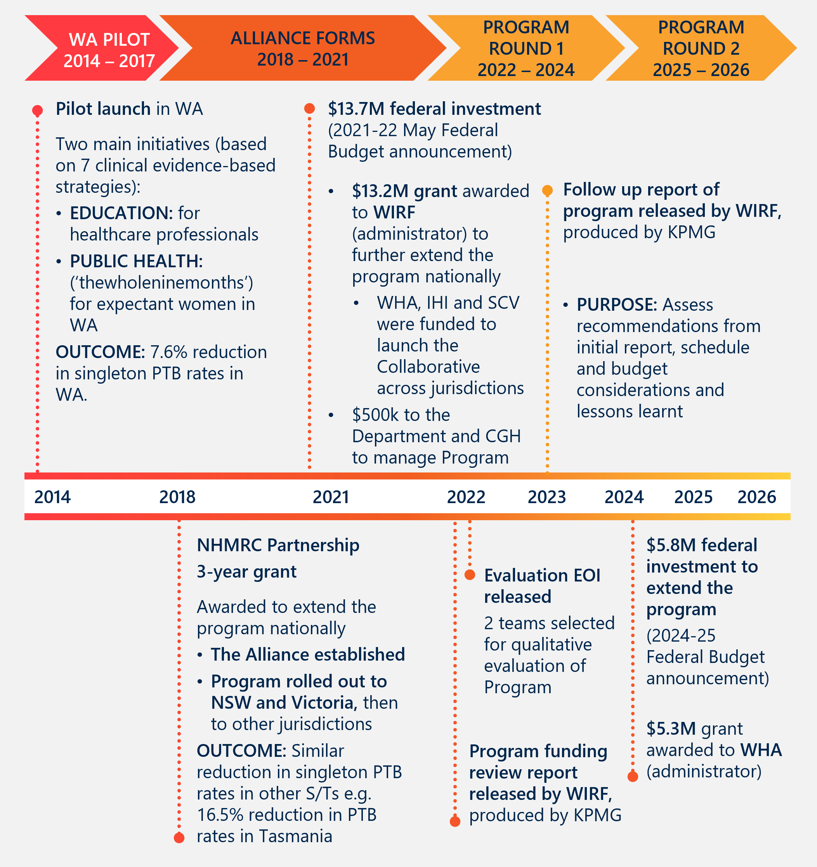

The National Program balanced national consistency with local flexibility through a ‘hub and spoke’ design, anchored by seven clinical strategies
The National Program was a national education, quality improvement and health promotion campaign, underpinned by seven clinical strategies. The main aim of the National Program was to safely lower the rate of PTB (including a focus on ETB in Round 2) across Australia by 20 per cent. The National Program included three key components: ‘The Every Week Counts’ National Collaborative (the Collaborative), jurisdictional programs, and the ‘Every Week Counts’ public awareness campaign. Clinical and consumer expert input, media promotion, program evaluation, and resources development were nationally and centrally coordinated by the Alliance, in partnership with Women’s Healthcare Australasia (WHA) and Institute of Healthcare Improvement (IHI).
Jurisdictional leads provided tailored support to local maternity services (including both services participating and not participating in the Collaborative), as well as ran educational and out-reach activities in their jurisdiction. Activities were tailored to the local context and aligned to National Program objectives. See Appendix A for further detail on the National Program’s design.
National Program | Round 1
Round 1 of the National Program was delivered from February 2022 to June 2024 and aimed to reduce PTB rates by 20 per cent across Australia during this time, as outlined in the grant guidelines. Performance Reporting for Round 1 describes a focus on both PTB and ETB, adjusting the aim of the National Program “to improve the health outcomes of mothers and babies by safely reducing preterm and early term birth across Australia by 20 per cent.“ For Round 1, funding was provided to the Women and Infants Research Foundation (WIRF) to implement the Australian Preterm Birth Prevention Alliance’s (the Alliance’s) program nationally, in collaboration with WHA, IHI, and Safer Care Victoria (SCV).
Round 1 of the National Program consisted of three key components outlined in Table 1 below.
Table 1 | Key components of Round 1 of the National Program
Component | Purpose
The Every Week Counts National Collaborative (The Collaborative) | The Collaborative was led by WHA in partnership with IHI. The Collaborative is based on IHI’s Breakthrough Series Collaborative model, and underpinned by a package of evidence-based changes aimed to address PTB. Maternity services interested in implementing changes were engaged and collectively collected and shared data on changes to determine if they led to improved outcomes. 59 hospitals that represented 49 health services participated in the Collaborative in Round 1. See Appendix A.2 for additional detail.
Jurisdictional programs | Implemented by Jurisdictional Lead organisations (Jurisdictional Leads), the jurisdictional programs consisted of educational and out-reach activities for non-participating services, and support for Collaborative initiatives across each jurisdiction. See Appendix A.3 for additional detail.
‘Every Week Counts’ public awareness campaign | Led by the Alliance, the ‘Every Week Counts’ public awareness campaign consisted of social media and marketing initiatives aimed at health care providers, women and the Australian public. See Appendix A.4 for additional detail.
Across Round 1, internal evaluations and reviews were conducted by National Program partners and informed the design and governance of Round 2.
National Program | Round 2
Round 2 of the National Program (renamed to Australian Preterm and Early Term Birth Prevention Program) commenced in February 2025 and concludes in June 2026, with a $5.8 million investment from the Australian Government. For Round 2, WHA was funded to implement the National Program in collaboration with the Alliance and support from IHI. A focus on both ETB and PTB were included in the grant guidelines.
Round 2 continued to deliver the Round 1 key components, including the Collaborative, the jurisdictional programs, and the ‘Every Week Counts’ public awareness campaign. Round 2 also included three defined areas of focus, or ‘Pillars’. Participating hospitals are invited to select their focus on one or more of three main Pillars of work that best suit their needs. These are:
- Safe and Effective Preterm Birth Prevention – Early risk identification and commencement of appropriate preventative care
- Early Term Birth Prevention – Safely decreasing early term birth by reducing planned birth before 39 weeks where there is no medical or obstetric indication
- Partnering with First Nations Communities to provide culturally safe care.
Round 2 also introduced a pilot project to identify the enablers and barriers of implementation of a screening protocol for preterm preeclampsia in early pregnancy. This is being piloted in nine sites across Australia, representing varied clinical care settings.
The National Program is outlined in greater detail in Appendix A.

Evaluation of the National Program
Evaluations present an opportunity for accountability and learning. The Department commissioned Nous Group (Nous) to design and deliver the evaluation of the National Program, which considers National Program activities and data collected between February 2022 and June 2026. The purpose of the evaluation is to consider the design and delivery of the National Program, to determine the extent to which intended outcomes have been achieved.
This Interim Report covers the period between February 2022 and August 2025. It is structured to present learnings from Round 1 and early insights from Round 2 of the National Program to inform subsequent implementation.

Evaluation methodology
This section outlines core components of the evaluation design (outlined in greater detail in the Evaluation Plan); further details are provided in Appendix B.
The evaluation methodology for the National Program considers the five KEQs and applies a mixed-methods approach that draws on quantitative and qualitative data. An overarching summary of the methodology is provided in Figure 2.
Figure 2 | Overview of evaluation methodology
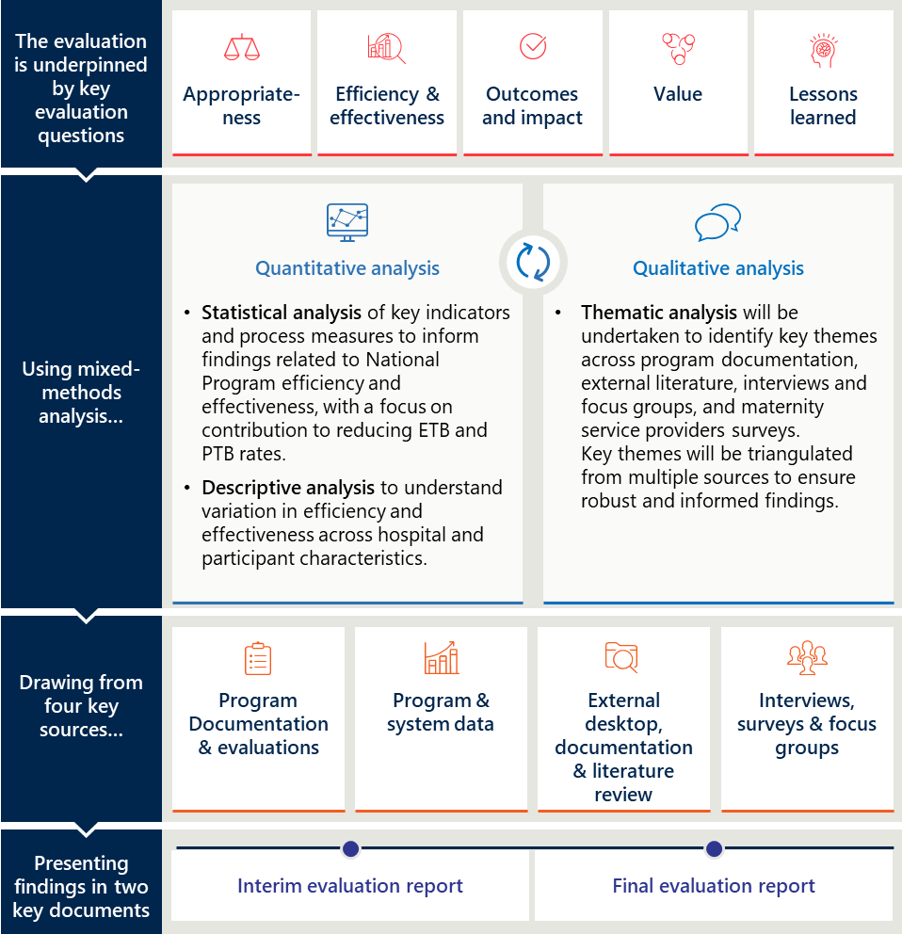

The evaluation is founded on program theory, and its analysis is guided by realist and training evaluation approaches
Nous’ evaluation draws from a variety of evaluation approaches to ensure the overall evaluation is fit for purpose. The evaluation uses program theory and the Kirkpatrick-Phillips model to ensure a clear, logical and thorough conceptualisation of the National Program. This conceptualisation is tested using Key Evaluation questions and realist evaluation theory to ensure contextual factors are appropriately accounted for in our evaluation.

Program theory
Nous’ evaluation is underpinned by a theory of change and program logic, describing how the National Program is intended to effect change. The theory of change (shown in Figure 3) describes the underlying mechanisms through which the National Program intends to safely reduce the number of ETB and PTB. The theory of change includes adjustments between National Program rounds.
The program logic clearly describes the relationship between the inputs, activities and outputs of the National Program and the intended outcomes. The program logic is presented at Appendix B.
Figure 3 | Theory of change,
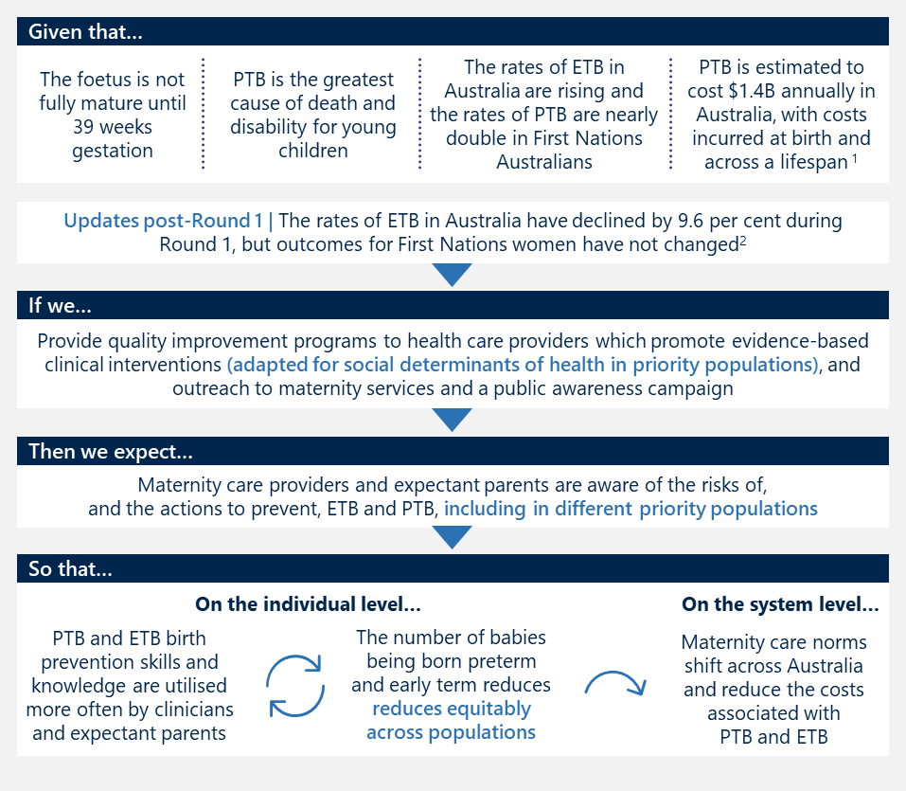

Key Evaluation Questions
The program theory of the National Program is tested through five Key Evaluation Questions (KEQs). Figure 4 presents these questions and summarises the extent to which these can be answered for each round of the National Program in this Interim Report, subsequent reports will address outstanding questions. 0 presents both the KEQs and supporting evaluation questions.
Figure 4 | Extent to which the Interim Report answers key evaluation question
Key evaluation questions | Round 1 | Round 2
- Appropriateness  How appropriate is the National Program to achieve the intended outcomes? | 100% | 50%
2. Efficiency and effectiveness  How effectively was the National Program implemented? | 100% | 25%
3. Outcomes and impact  To what extent did the National Program achieve its intended outcomes and impact? | 75% | 0%
4. Value  To what extent did the National Program provide value-for-money through effective funding arrangements? | 0% | 0%
5. Lessons learned  How could the National Program be improved? | 100% | 0%

Evaluation of training
As a range of National Program activities are focused on capability building, we are also drawing on the Kirkpatrick-Phillips Model (the KPM) to conceptualise the evaluation. The KPM provides an ordered structure to outcomes of capability building activities across the following categories:
- Learner reaction | to explore the learning experience.
- Knowledge, skills and planned action | to explore knowledge and skill transfer and intention to apply.
- Application of skills | to explore knowledge and skill application in a real-world setting.
- Impact | to explore outcomes for consumers.
- Return on investment | to explore system level impacts.

Realist approach
The evaluation applies a realist lens to assess the National Program. Evaluations that take a realist lens ask what works, for whom, and in what circumstances? This approach ensures a focus of the evaluation in addressing these KEQs is examining how program activities interact with the delivery context to achieve outcomes.

A variety of evidence informed report development
This evaluation draws evidence from several sources, including interviews, desktop research, and program reporting. For the Interim Report, the quantitative data has been assessed through statistical analysis.

Stakeholder engagement
Table 2 outlines the stakeholders engaged via interviews to inform the development of the Interim Report.
Table 2 | Stakeholders interviewed
Group | Stakeholder group
Australian Government | Department of Health, Disability and Ageing:  - Family Health and Safety Section  - First Nations Division  - Chief Psychiatrist  - Office of the National Rural Health Commissioner
Alliance | - Chair and Deputy Chair  - Alliance Head Office representatives
Implementation partners | - Women and Infants Research Foundation (WIRF)  - Women’s Healthcare Australasia (WHA)  - Institute for Healthcare Improvement (IHI)  - Safer Care Victoria (SCV)
Alliance Jurisdictional institutions | - Royal Women’s Hospital (Victoria)/Safer Care Victoria (SCV)  - Menzies School of Health Research (Northern Territory)  - Clinical Excellence Queensland (Queensland)  - Clinical Excellence Commission (New South Wales)  - Royal Hobart Hospital (Tasmania)  - South Australian Health and Medical Research Institute and SA Health (South Australia)  - Head Office, University of WA (Western Australia)
Professional colleges and associations | - Royal Australian and New Zealand College of Obstetricians and Gynaecologists (RANZCOG)
Peaks | - Congress of Aboriginal and Torres Strait Islander Nurses and Midwives  - National Aboriginal Community Controlled Health Organisation (NACCHO)
Research organisations | - Women and Babies Research

Documents and data
This draft Interim Report documents evaluation findings regarding Round 1 and emerging findings for Round 2 of the National Program drawing on available data sources including:
- National Program data (defined as data collected by WHA from services participating in the Collaborative, as well as WHA Benchmarking Maternity Care (BMC) Indicators from maternity services participating in the Collaborative and a selection of other maternity services across Australia for the same time period) from Round 1 and before the National Program was implemented (July 2019–June 2024)
- Health system data (refers to the broader Australian health system, and is defined as data from the AIHW’s National Perinatal Data Collection (NPDC)) from a proportion of Round 1 and before the National Program was implemented (2018-2023)
- Available program documentation across Round 1 and Round 2
- External documentation and literature of best-practice evidence for ETB and PTB, and relevant national and international strategies aligned and relevant to the National Program
- Summaries of unpublished independent research and evaluations conducted as part of the National Program for Round 1.

Scope and limitations of available data for this Interim Report
Limitations of the evidence used to develop this report are outlined in Table 3.
Table 3 | Limitations and scope of data sources available for this Interim Report
Source | Scope of available data
Stakeholder consultations | - Nous conducted two rounds of consultations with all listed stakeholder groups, and representatives from Jurisdictional Leads in Western Australia, New South Wales (NSW), Victoria (Vic), Queensland (Qld), Australian Capital Territory (ACT), South Australia (SA) and Tasmania (Tas). Representatives from the Northern Territory (NT) were not available.  - Additional insights from staff ‘on the ground’ will be included in the final round of consultations in 2026.
National Program data  (program data) | - WHA BMC Indicators data for Round 1 (July 2019–June 2024) has been included in this report. This includes BMC Indicators for services participating Collaborative and for a selection of other maternity services across Australia not participating in the Collaborative. Process measures for all services participating in the Collaborative are also included.  - The WHA BMC dataset includes only public hospitals and singleton births.  - For simplicity, ‘program data’ refers to all WHA data provided, which is inclusive of services involved and not involved in the Collaborative (i.e., outside of the National Program) for the same time period.  - Note: WHA’s dataset has been included to complement AIHW data, as WHA provides more recent data, and therefore reflects a greater portion of the Round 1 implementation period.
Health system data  (system data) | - AIHW data for part of Round 1 and prior (2018-2023) data has been included in this report.
Desktop and literature review | - Jurisdictional Reporting was not available at the time for writing; this will be included in the Final Evaluation Report (2026).

Interim findings | Appropriateness
This section outlines interim findings relating to the appropriateness of the National Program to achieve the intended outcomes (KEQ 1).

Findings KEQ 1:
How appropriate is the National Program to achieve the intended outcomes?
The National Program is appropriate for achieving its intended outcome of reducing preventable preterm and early term births. While the National Program’s clinical focus is robust, its limited scope in addressing broader social determinants may constrain its overall impact.
This conclusion is supported by two key factors:
- Strategically aligned evidence-based design
The National Program was grounded in a robust evidence base, incorporating proven clinical strategies and improvement methodology. It was aligned with existing women’s health and maternity care strategies, including through targeting priority populations. These elements were present across Rounds 1 and 2.
- Operational fit and adaptability
The National Program leveraged existing networks and its flexible ‘hub and spoke’ design enabled consistent national messaging while allowing local adaptation. Governance and funding arrangements, though initially complex, have been improved to enhance implementation efficiency.

Australia’s maternity service landscape is diverse, and inequitable health outcomes exist across population groups
The National Program operates within a complex national landscape, with differences in healthcare infrastructure, workforce availability, and models of maternity care. The design of the National Program, detailed in Section 1 and Appendix A, aimed to be responsive to the diversity in maternity service delivery by providing nationally consistent guidance that can be tailored to different needs of different jurisdictions, maternity services and especially in Round 2, population groups. Australia’s 2020 PTB rate (8.2 births per 100 live births) are slightly higher than many OECD countries, such as Canada (7.9), UK (8.0), New Zealand (7.5) and Finland (5.6) at the same time.
Maternity services are delivered through various models of care by a range of health professionals. Maternity services are planned and provided by state and territory governments in collaboration with public and private health services. Each maternity service may offer one or more models, classified into 11 categories, defined by provider type, continuity of care, and care setting. Care models differ by region, with public, private, and shared models offering different levels of continuity and access. The four most common models include public hospital maternity care, midwifery group practice caseload care, shared care, and private obstetrician specialist care.
Approximately 30 per cent of Australians live in rural and remote locations. Rural and remote populations face significant health disadvantages, including limited service access, higher disease burden, and difficulty attracting skilled professionals. Health risks begin early, with babies in these regions more likely to be born preterm, of low birthweight and with increased rates of infant mortality. Women in these areas often lack access to continuity of care and carer, particularly where services are distant or fragmented. Women may travel long distances or relocate for care, incurring financial, emotional, and cultural costs.
Multiple social determinants of health impact maternal health, which can influence preterm and early term birth rates. The National Program’s scope is appropriately focused and relatively narrow, focusing on factors that maternity services can influence during the pregnancy stage only. However, there are multiple pre-pregnancy and pregnancy factors that can influence maternal and baby health, including risk for early term and PTB. This includes access to culturally safe healthcare; housing and environmental conditions; nutrition and food security; health behaviours; racism, discrimination and effects of colonisation; social support; and gender inequity and violence.,
Maternal and infant outcomes vary across populations, including among First Nations and CALD communities. First Nations mothers and babies face poorer outcomes than non-Indigenous Australians due to complex interactions between health and social determinants, especially in rural areas. In 2023, 13.8 per cent of babies born to First Nations mothers were born preterm, which compared to 8.0 per cent of babies born preterm to non-Indigenous mothers. Babies born to women from CALD backgrounds are also at an increased risk of adverse pregnancy and birth outcomes, including preterm birth, and stillbirth, and make up one-third of births in Australia yearly.

The National Program was appropriately designed for its operating context
The National Program’s ‘hub and spoke’ design enabled consistent national messaging while allowing maternity services to tailor implementation to local needs across Australia’s diverse health service landscape. It generally aligned with national health priorities and was built on strong evidence, including seven proven clinical strategies and the IHI Breakthrough Series (BTS) Collaborative model. Continuous improvement principles informed design changes between rounds to better support diverse service contexts.

The National Program’s ‘hub and spoke’ design was appropriate for enabling nation-wide learning and tailored responses across maternity services
The variation in service availability and model characteristics must be considered when designing and implementing national strategies or programs, as local contexts significantly influence both care delivery and maternal health outcomes. The National Program’s design enabled consistent messages to be shared across Australia, while maternity services were able to focus implementation efforts according to local need. In both rounds, the national Collaborative structure and national leadership provided a central coordination point for media promotion, consumer input, clinical expert input, and developing and providing resources for participating maternity services. National stakeholders brought diverse expertise in areas such as quality improvement, maternity data, clinical research, and implementation science, while jurisdictional leads and expertise within maternity teams brought an understanding of how to tailor the strategies for their local services.
The National Program design included flexibility in response to the variation across the country, by enabling Jurisdictional Leads and maternity services to tailor how the seven clinical strategies were adapted to their services’ settings. In Round 1 and 2, Jurisdictional Leads were responsible for providing additional support to services in their jurisdictions, including those participating in the Collaborative and services which were not, as aligned to their state or territory context. These roles were similar in both rounds, though more detailed in Round 2. Consulted Jurisdictional Lead representatives noted this flexibility was appropriate given the restricted workforce capacity to implement multiple changes at once.
The flexible approach meant that maternity services’ activities differed in Round 1.
For example, not all maternity service teams collected all process measures, and measures were collected in either weekly or fortnightly frequencies. For example, 5 of the 9 process measures for Round 1 Collaborative participants were optional, and were collected by less than half of maternity services.
The flexible approach also meant that Jurisdictional Leads conducted different types of outreach activities in Round 1.
Outreach activities included roadshows, education sessions and forums – in public, and a small number of private, hospitals and maternity services. An example list is included in Appendix D.1. In Round 1, SA also ran a separate whole-of-state project alongside the Collaborative, the ‘SA Health Preterm Birth Prevention Project’. This included a state-wide rollout of six of the National Program elements in all Local Health Networks (LHNs), including those not participating in the Collaborative. Note that SA did not support nor implement one of the seven clinical strategies (Use of vaginal progesterone for a prior history of spontaneous PTB), due to “equivocal evidence to support vaginal progesterone use for history-based indications.”
Across both rounds, jurisdictions, such as Tasmania and SA, continued to tailor their approaches based on local population needs. For example, Tasmania has focused both rounds on continuity of care for disadvantaged populations.
In Round 2, flexibility was enhanced further by providing participating hospitals a choice for their participation, by focusing between three ‘Pillars’, or areas of focus.
These included preterm birth prevention, early term birth prevention and partnering with First Nations communities. Stakeholders engaged noted Round 2’s three-Pillar structure offered additional flexibility for sites, though could also result in additional efforts as the Pillars functioned separately. One stakeholder noted: “Breaking it into three Pillars has pros and cons. It offers flexibility for sites to focus on specific gaps rather than the whole program.”
At the time of writing, Round 2 initiatives were underway; different jurisdictions were leading different ‘Pillars’ nationally, influencing the tailored activities for each jurisdiction. For example, the NT lead, Menzies School of Health Research (Menzies), had distinct deliverables relating to the First Nations Pillar at a national and jurisdictional level, including attending the Yarning Circle, planning and implementing training for strategies applicable in the Top End, and face-face engagement with a specific Aboriginal Community-Controlled Health Organisation (ACCHO) (Danila Dilba Health Service Child and Family Health) team to invite and encourage their enrolment in the Collaborative.
Note:
- The appropriateness of Round 2’s design will be included in the Final Evaluation Report (2026). Round 2 is early in its implementation and so advantages and disadvantages of the new structure are not yet clear.
- Nous’ consultations with maternity services to collect primary data were not scheduled to be complete by the time of writing this report. Consultations in early 2026 will provide insights on what worked well, for whom, and why, to be included in the Final Evaluation Report (2026).

The National Program was aligned to, and contributes to the progress of, existing national priorities and strategies
The National Program’s aim to reduce early and PTB results in direct and indirect contributions to the progress of multiple Australian Government policies, including the National Women’s Health Strategy, the Woman-centred Care: Strategic Directions for Australian Maternity Services, and the National Stillbirth Action and Implementation Plan. Alignment of the National Program to key Australian polices is described in Table 18 in Appendix E.
The Alliance also partnered with the Stillbirth Centre of Research Excellence (CRE) to ensure consistent and evidence-based advice is provided to women and maternity care professionals. The Alliance and CRE issued a joint position statement on timing of birth, which included links to additional documents. The National Program is unique, with few other comparable national prevention initiatives globally, and no other programs that are both, national, government-funded and implemented with the singular aim of strategically lowering the rate of early birth across its population.
The National Program’s design across Rounds 1 and 2 aligns with key Australian Government health strategies by directly targeting priority populations, such as First Nations women and those living in rural and regional areas. Round 2 introduces a specific focus on First Nations communities as a Pillar. The National Program may also benefit other priority groups, this will be further explored in consultations for the Final Report.

The National Program’s design was evidence-based
The National Program is evidence-based, founded on the effectiveness of population-based cohort initiative pilots, seven clinical strategies, and a proven change methodology. The seven strategies used in Round 1 of the National Program are clinically proven to reduce PTB, and the National Program was piloted in Western Australia and then the Australia Capital Territory., , ,
In addition, the National Program used an evidence-based approach to change to embed the clinical strategies in practice. IHI’s BTS Collaborative model was selected as the method to produce improvement in clinical practice. IHI’s BTS Collaborative model is a proven method designed to produce rapid and effective improvements in clinical practice across healthcare facilities. This approach involves creating a package of evidence-based changes known to be effective in improving outcomes, then helping hospital teams to collect and share data to understand if changes they are making at each hospital are leading to better outcomes. Components of the model are explored in Section 4.3.
The design of both rounds of the National Program also included the voices of consumes. Both Round 1 and Round 2 include a Consumer Advisory Group to provide input on the design of materials. This inclusion aligns with the National Program’s focus on improving information to consumers to support proactive consumer choices.

Evidence and principles of continuous improvement informed changes in clinical focus and design between Round 1 and 2
The National Program was underpinned by an explicit application of continuous improvement principles. This included IHI’s BTS Collaborative model, such as the Plan-Do-Study-Act (PDSA) cycles, as well as regular data-driven reviews. These principles were equally applied to program administration, where leadership systematically used data, feedback, and iterative testing to improve broader program design and governance. As a result, additional design changes between the rounds were made in response to an internal evaluation. These design changes included the enhanced and separated focus on three ‘Pillars’ and the addition of a preeclampsia pilot, both of which are based on evidence. Additional changes were made to data collection during Round 1 and in advance of Round 2, also in response to evidence.
Additional clinical focus areas were introduced in Round 2 based on emerging evidence, including:
- Pillar focus | Partnering with First Nations communities: Significant disparities persist among PTB rates amongst First Nations women and their families and a focus on partnering with First Nations communities was included as one of three Pillars in Round 2. Development of a Driver Diagram was led by two First Nations researchers, informed by Yarning Circle conversations in early 2025 (see Appendix D.2 for additional detail), and based on the RISE Framework.
- Pillar focus | Delineation between early term and preterm birth: Rounds 1 and 2 of the initiative built on the WA pilot, with Round 2 refining strategies to separately target early term and preterm births. This reflected the early impact findings of the National Program, and included focusing respectively on reducing early interventions and enhancing early risk identification and care.
- Preeclampsia pilot: The preeclampsia pilot was introduced in response to emerging evidence that supports the effectiveness of aspirin for women identified at risk of developing preterm pre-eclampsia., A recent study also found that preeclampsia is a significant factor contributing to the intergenerational risk of PTB among First Nations women. The preeclampsia pilot is running alongside the National Program as a separate activity. See Appendix A.5 for additional detail on the pilot.
Content, data collection and measurement, were also enhanced in Round 2, including:
- The Collaborative’s change package was updated in response to an internal review conducted at the end of Round 1. Measures were refined to make these easier and more consistent to capture across staff; for example, progesterone prescription for shortened cervix was reportedly dropped due to data collection challenges for frontline staff. Data collection frequency was also changed from weekly to fortnightly.
- The tools and platforms used for data collection and sharing were also updated in Round 2 so that they were more usable.

The design of the National Program’s administrative arrangements was complex
The design of the National Program’s funding and governance structures introduced additional complexity (compared to a simple direct grant to a delivery organisation) through the use of an administering organisation. WIRF administered Round 1 and WHA administered Round 2.
This approach was undertaken to support access to a professional entity that the Australian Government would otherwise not be able to directly fund. Established in 2018, the Alliance is a sub-committee of the Perinatal Society of Australia and New Zealand (PSANZ). The Alliance’s Steering Committee consists of the ten Chief Investigators of the NHMRC Partnership Grant (APP1151853); two members from each jurisdiction; special members as required of Working Groups; a midwife; a consumer representative; a marketing and media person; and a person with fund-raising expertise. The Department awarded the grant to an administrating organisation, who was then able to fund the Alliance members directly.
Both governance and funding arrangements evolved and improved between Round 1 and Round 2.

Funding for Round 1 and Round 2 was administered through a grant process and a selected institution
The Department funded an administering body with a grant via the Community Grants Hub to implement the National Program for both rounds. This grant was then distributed to program partners, including the Alliance, WHA, IHI and SCV (Round 1 only), as well as to Jurisdictional Leads, to run the Collaborative, jurisdictional activities and the public awareness campaign.
Funding varied both in amount and administration approaches between Round 1 and Round 2. In Round 1 (delivered from February 2022 to June 2024), the Department provided $13.7 million. SCV was a partner organisation involved in the national coordination and design of the National Program in Round 1 and led the Victorian jurisdictional programs in both rounds. The funding distribution in Round 1 is shown in Figure 5.
Figure 5 | Round 1 funding distributed by WIRF ($M)
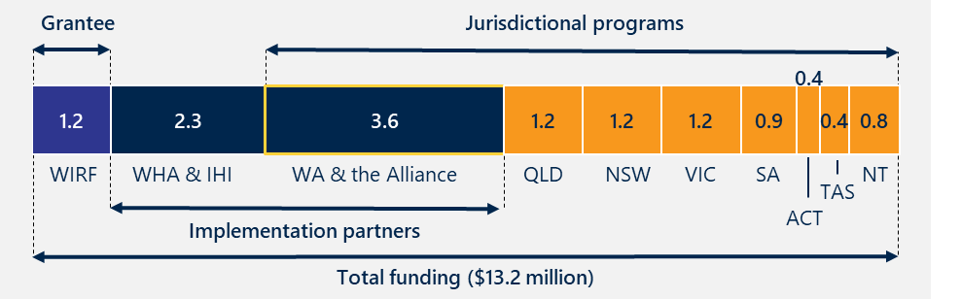
In Round 1, the administrating institution (WIRF) was not directly involved in the delivery of the National Program, and so the funding arrangement introduced an additional layer of administrative complexity. In Round 2, this complexity was reduced as the administrative institution (WHA) was directly involved in implementation and governance.
For Round 2 (to be delivered between February 2025 June 2026), the Department provided $5.3 million via a grant process to WHA to implement the National Program, in collaboration with the Alliance, and with support from IHI (see Figure 6). The following section explores how effective the funding arrangements were in both rounds. Variations in both allocation and administration of funding between rounds also influenced the scope of work possible, which is further explored in Section 4.1.
Figure 6 | Round 2 funding distributed by WHA ($M)
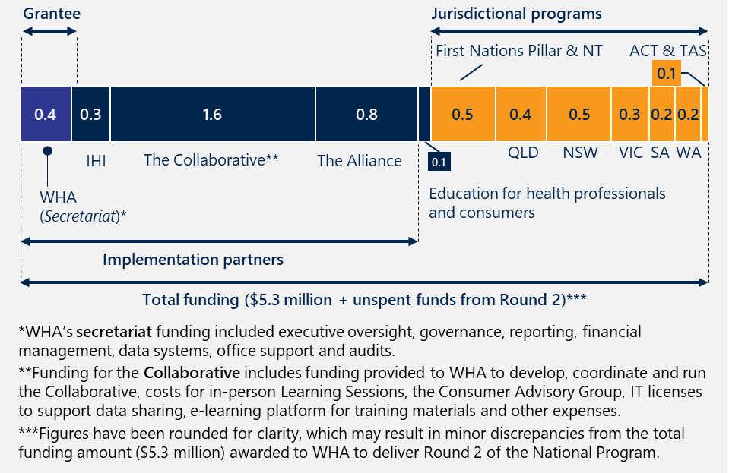
Some organisations also provided in-kind support.
In Round 1, SCV provided additional co-investment in a national Collaborative, providing improvement advisors (IA) to complement the WHA/IHI team, a funded consumer representative, a midwifery advisory and administrative support, together with resources to enable an additional 15 hospital teams from Victoria to participate. This enabled a larger number of hospitals enrolled in the Collaborative to receive the same levels of support with no cost implications for the Australian Government. Note that in late 2023, due Victorian Government budget measures, some of the positions that were provided by SCV as in-kind support were then funded by the jurisdictional funding allocated to Victoria for the final year of the National Program. Clinical Excellence Queensland (CEQ), NSW Clinical Excellence Commission (CEC) & WA Health also provided in-kind support to assist in the coaching of 52 teams.
In-kind support is also being provided by some organisations in Round 2, but a quantification was not available for reporting at the time of writing.
In-kind support signals both a strength and vulnerability of the National Program’s sustainability. It reflects both strong stakeholder commitment, buy-in and alignment with the National Program’s goals, as well as the fragility of in-kind financial support, which can be impacted by external budget pressures. The need for institutionalised resourcing and other suggestions for sustainability are addressed in Section 5.6.

Round 1 and Round 2 governance structures were complex and were iteratively adjusted
The governance structures of the National Program involved multiple committees comprising of key individuals representing distinct and relevant expertise. Governance structures leveraged the existing committee structure of the Alliance (Steering and Executive Committees). In both Round 1 and Round 2, the National Program was governed by an overarching committee, comprising of key partners and representatives, and supported by subcommittees. Governance structures were refined during Round 1 to reduce complexity and role duplication. The governance structures shifted in Round 2 to reflect the Pillar-focussed design. The consumer advisory group was also strengthened and expanded in Round 2 in response to feedback.
Good governance is increasingly recognised as a critical contributor to the effectiveness of public health campaigns and initiatives. The National Program’s governance structures were considered against Nous’ Five Pillars of Governance, which include structure, accountability, leadership, integrity and engagement. These Pillars have been adapted from existing models, frameworks and guidelines, and note that the best governance systems serve organisations in the following ways:
- Providing clarity and efficiency regarding structures and processes.
- Defining and allocating accountability for decision-making, roles and responsibilities.
- Setting direction from leadership regarding mission, strategy and/ or culture.
- Maintaining the integrity of governance.
- Fostering effective engagement internally and with other key stakeholders.
The Terms of Reference for Round 1 and Round 2 outlined the role, functions and membership of the National Program Committee (also known as the National Preterm Birth Prevention Program 2022-2024 Oversight Committee). Both documents clearly outlined the accountability and leadership, and stakeholders noted that the culture within the committees was positive.

Round 1 | Governance structures were complex and required restructuring of roles and responsibilities for clarity
Governance structures in Round 1 of the National Program were streamlined following feedback and an independent audit commissioned by WIRF that identified overlapping committee roles and an excessive frequency of meetings post-setup. In response, leaders established a single overarching governance committee (the National Program Committee) which reduced duplication and enabled a more appropriate meeting cadence with the Department. Stakeholders identified that these changes to the members, scope and function of the governance structures were understood by those involved but not explicitly clear to external stakeholders. Nous also subsequently provided ‘lessons learned’ to the Department as part of a Progress Report in late 2024 regarding governance improvement opportunities. Many of these recommendations also appear to be adopted in Round 2 of the National Program. The updated governance structures in Round 1 are summarised in Figure 7.
Figure 7 | Refined Round 1 governance structures
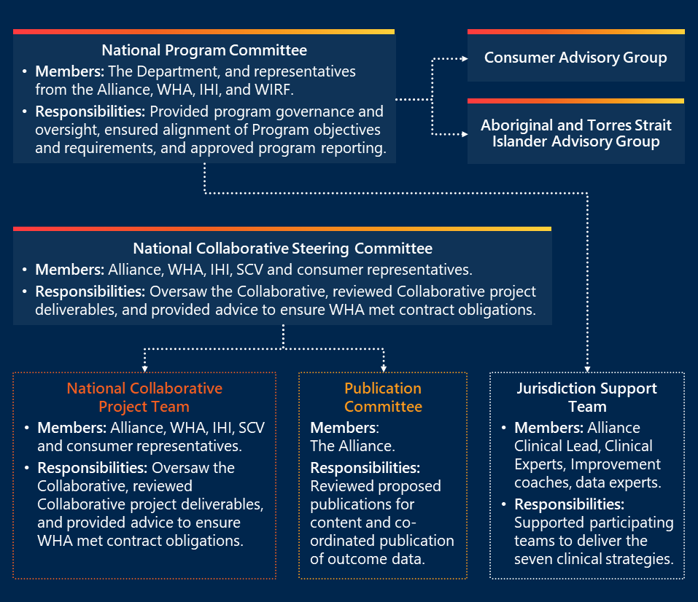

Round 2 | Governance structures were broadened and strengthened by an involved administering body
WHA’s role as both the administering body and key implementation partner supported a clear governance structure in Round 2. Whereas the administering body (WIRF) in Round 1 was responsible for funding and contract management only, WHA is involved in both the Steering Committee and National Project Team, and therefore responsible for content and delivery and accountable to the Department. The administering body’s deep involvement and existing understanding of the National Program reportedly contributed to clearer leadership, governance and associated accountability structures.
Round 2 governance structure reflected the new three Pillars by including additional expert working groups for each Pillar. As outlined in Figure 8 four work streams were also introduced, and the two advisory groups present in Round 1 were strengthened. At the time of writing, Round 2 is early stages of implementation and the appropriateness of these additional working sessions is not yet clear.
Figure 8 | Governance structures for Round 2 matured with a focus on select Pillars and work streams
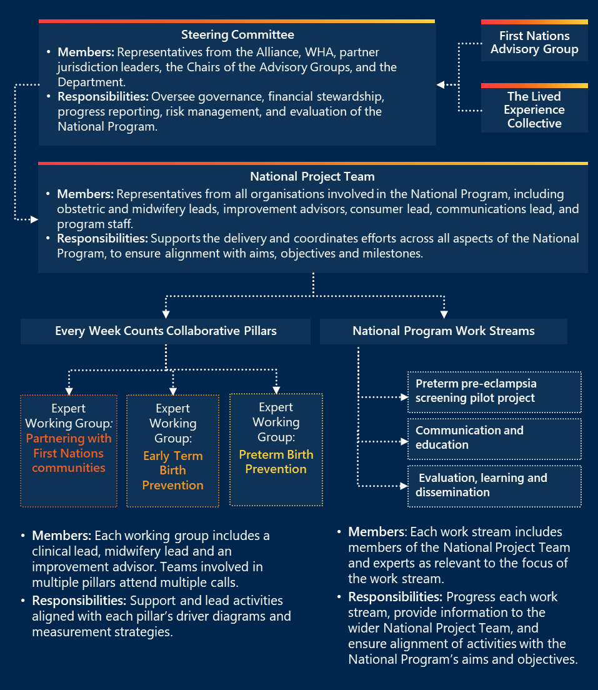
A review found consumer advisory governance could be improved in Round 1.
An independent evaluation of Round 1 found consumer engagement was generally positive but could be improved. The report made seven key recommendations, including increasing consumer lead FTE, sharing recruitment examples, exploring consistent remuneration, promoting cultural and socio-economic diversity, and ensuring appropriate support systems. Administrators of Round 2 actively reviewed the evaluation’s findings and responded to these recommendations. The Consumer Advisory Group (CAG), re-titled in Round 2 as the ‘Lived Experience Collective’, has a clearer scope, is more actively embedded into the National Program, and intend to meet formally on six occasions. Its members are remunerated for their time and track any in-kind support. See Appendix D.3 for additional detail.

Interim findings | Efficiency and effectiveness of implementation
This section outlines interim findings relating to the efficiency and effectiveness of the National Program to achieve the intended outcomes (KEQ 2).

Findings KEQ 2:
How effectively was the National Program implemented?
The National Program was implemented with varying degrees of effectiveness across its components. The conclusion is supported by the following factors:
- Strategically aligned implementation
The National Program was largely implemented as planned, with strong participation in the Collaborative and jurisdictional programs exceeding targets. Educational outreach efforts, including roadshows and virtual sessions, were reportedly well received. The public awareness campaign met or exceeded most distribution goals, though its impact on consumer behaviour is less clear.
- Effective change methodology
Quality improvement methods embedded in the Collaborative were effective influencing clinical practice and upskilling staff, as well as fostering motivation to improve ways of working. Services and jurisdictions adapted activities to local needs, although some strategies were more difficult to implement.
- Adaptive administrative approaches
Lengthy administration subcontracting processes in Round 1 compressed delivery timelines, however, governance and funding arrangements improved in Round 2. Round 2 saw clearer roles and stronger collaboration and more efficient administration of funding.

Round 1 of the National Program largely effectively implemented strategies to reduce the rate of PTB
The National Program was largely implemented as designed, with administrative arrangements representing the primary area of less effective implementation.

Core elements of the National Program were largely implemented as planned

Participation in the Collaborative and Jurisdictional Programs met or exceeded implementation goals
Participation in the Collaborative and in the jurisdictional programs exceeded the intended aims, or goals (recorded as performance indicators in Progress Reports). The intentions and implementation of each activity is summarised in Table 4.
Table 4 | Reach and implementation of the Collaborative and Jurisdictional Programs (Round 1)
Component 1: The Collaborative
Activity / output | Goal | Implementation
Collaborative enrolment | 30 hospitals | The Collaborative was attended by 59 hospitals that represented 49 health services. In-kind support from SCV enabled 22 additional hospitals to participate (included in the total of 59). The 59 hospitals encompassed an estimated 54% of Australian public live births.
Learning Sessions | 90% attendance of participating teams | An average of 213 individuals attended each of the three Learning Session 1, and between 94% and 100% of teams attended each.
Final Showcase Event | 80% of participating teams are represented | 44 of 49 teams attended (90% of participating teams)  287 attendees (190 were hospital participants; other attendees included First Nations Leaders, consumers, Department representatives)
PDSA | 85% of teams undertaking tests of change (PDSA) | 903 PDSAs documented in total, with the percentage of teams increasing from 76% in reporting period 2 to 94% in reporting period 5. Note, additional PDSAs undertaken were not formally documented in LifeQi.
Monthly coaching calls/sessions | 85% of teams attending | Between 76-86% of teams attended across Round 1.
Collaborative reporting | 85% of teams reporting | Between 85% and 96% of teams reported data monthly on the National Collaborative Measures.

Component 2: Jurisdictional programs
Activity / output | Goal | Implementation
Outreach activities in public hospitals and maternity services | 5-10 hospital training sessions per jurisdiction | Over 70 educational sessions, roadshows and/or site visits, including to rural, regional and metropolitan sites. This included but was not limited to:  - Education activities, or ‘roadshow’ events, held at 5 or more hospitals at NT, SA, Qld, WA, NSW, each.  - Presentations at forums, webinars and meetings, such as the Tasmanian Maternity Network meeting (Tasmania), Gestational Diabetes webinar (Victoria), Smoking Cessation Webinar (Victoria), GP Obstetrician Educational events (SA); MFM & Obstetrics Symposium (Queensland); GPEx Education and Clinical Refresher Seminars (South Australia).  - Face-to-face community consultation Yarning Groups (Northern Territory).
Jurisdictional support of the Collaborative | 2-5 meetings with stakeholders per jurisdiction  Learning Session attendance of jurisdictional leads | Clinical leads attended Learning Sessions 1-3 and the Showcase Event.  Multiple meetings attended (see above).
Note: At the time of writing, Round 2 was in the early stages of implementation. Reach of the Collaborative in Round 2 will be included in the Final Evaluation Report (2026).

Implementation of the public awareness component largely met intended distribution aims, though its influence was not measured
The public awareness campaign was aimed at both clinicians and the general public. The National Program reportedly met or exceeded all its performance measures (which were largely consumer-focused), with the exception of social media engagement and print magazine distribution. These are outlined in Table 5. A range of magazines, media releases, newspaper articles (print and digital) and social media posts were developed and distributed, and these primarily focussed on consumers. Clinicians also received resources and communications that showcased Collaborative activities underway in hospitals and health services.
However, the digital marketing was strongly focused on WA rather than nationally. Additionally, the quality and influence of the public awareness campaign on consumers and clinicians did not appear to be measured. For additional detail on the implementation this campaign, see Appendix F.
Table 5 | Reach and implementation of the public awareness campaign (Round 1)
Component 3: The public awareness campaign
Activity or output | Goal | Implementation
Magazine | 150,000 printed ‘Whole Nine months’ magazines distributed per annum between February 2022 – June 2024 | Four editions of the magazine were published and a total of 230,000 printed magazines distributed across Australia in newspapers, medical centres and consumer representative organisations.
News articles and media releases | 12 media releases published between February 2022 – June 2024 | - ~13 online news articles published  - ~7 printed news articles published  - ~3 television news features  - ~3 radio segments  - 16 media releases across Round 1 were released by the Alliance.
Social engagement | 360,000 social media interactions and user engagements on Twitter, Facebook, and Instagram per annum between February 2022 – June 2025. | 25,200 impressions on Twitter between 1 July 2022 – 31 December 2022  147,318 unique views of social media interactions and user engagements across Facebook and Instagram.
Education resources | Number of education resources disseminated (‘Let’s Talk Timing of Birth’ and ‘Every Week Counts’) | 14,500 total copies of both brochures were distributed across Australia.
Digital marketing (via advertising, social media and media articles) | 500,000 impressions | - ~532,700 impressions from one home page takeover of the West Australian.  - ~666,700 impressions from three targeted displays.  - ~947,000 exposures from four insertions in the West Australian.

Uptake of the clinical strategies varied, and was particularly strong for three strategies
The rate of the seven clinical strategies being implemented by services participating in the Collaborative varied between strategies, as reported in the weekly to fortnightly process measures collected by WHA. Three of the seven clinical strategies were implemented, on average, more than 70 per cent of time across the duration of Program 1 by participating teams. Some strategies, such as smoking cessation and ensuring continuity of care, were more difficult to implement and/or record, and so showed lower rates. There were no process measures for two of the clinical strategies. Table 6 details the average rate of the process being conducted across the duration of Round 1, and key factors reported by stakeholders to influence implementation.
The Alliance also reported that by the end of Round 1 (30 June 2024) 88 per cent of teams (43 of 49) showed an improvement in 1 or more of the Collaborative measures, demonstrating increase in the uptake of the evidence-based interventions.
Table 6 | Implementation of the clinical strategies across Round 1 (data collected ~September 2022-March 2024)
Clinical strategy | Average rate across corresponding process measure | Factors influencing implementation
1. No pregnancy to be ended until at least 39 weeks’ unless there is an obstetric or medical justification | Across the 51 reporting teams, 83% of women with a planned birth between 37.0-38.6 weeks' gestation had an appropriate medical or obstetric indication is recorded  (Process measure 5.) | Supporting factors included:  - established decision support processes, such as booking systems that trigger senior clinician and clinical reviews and multidisciplinary huddles to ensure structured decision making for any birth planned before 39 weeks. However, some services reported incorporating electronic booking processes to replace verbal and handwritten forms were difficult to complete and track.  - improved scheduling  - strengthened reporting of medical indications.
2. Measurements of the length of the cervix at mid-pregnancy scans | Across the 45 reporting teams, 92% of women had a recorded cervix length measurement documented as part of the mid pregnancy ultrasound scan (19-20 week anatomy scan)  (Process measure 3.) | Challenges included:  - managing multiple steps, such as education for GPs and sonographers  - timely reporting and response for clinical reports and patient files.  Supporting factors included:  - engagement and education sessions with local ultrasound providers and sonographers to ensure reliable reporting  - information brochures, videos, and discussion guides for women to increase awareness and support informed decision making.
3. Use of natural vaginal progesterone for short cervix | Across the 40 reporting teams, 73% of women with a recorded cervix length of less than 25mm by transvaginal imaging were prescribed progesterone  (Process measure 4.) | Some services did not adopt this strategy, as a small number of obstetricians considered the evidence base and parameters of progesterone for prior history of a short cervix less robust. This measure was also dropped during Round 1 due to data collection challenges, and was not included in Round 2.  Supporting factors included:  - documented referral pathways  - clinical protocols developed with prescribers and local pharmacies to ensure the progesterone is readily available.
4. Insertion of surgical cervical cerclage in women already taking progesterone and in whom the cervix continues to shorten |  | The Collaborative did not include a process measure to assess implementation of this strategy.
5. Use of vaginal progesterone for prior history of spontaneous preterm birth |  | The Collaborative did not include a process measure to assess implementation of this strategy.  Some services did not adopt this strategy, as a small number of obstetricians considered the evidence base less robust. As previously noted, the SA jurisdiction did not support nor implement this clinical strategy.
6. Women who smoke should be identified and offered Quitline support | Across the 23 reporting teams, 48% of women received a smoking cessation intervention  (Process measure 8.1) | Few teams reported on this, as many services had reported working on smoking cessation system prior to the Round 1.  Challenges included:  - Reluctance to discuss, due to “not wanting to feel like they're harassing women”.  Supporting factors include:  - improving screening for smoking at antenatal visits, such as the use of breath carbon monoxide monitoring devices.  - offering nicotine replacement therapy and providing referrals.
7. To access continuity of care from a health professional during pregnancy where possible | Across the 14 reporting teams, 44% of women who identified as being at risk for preterm or early term birth were provided with antenatal continuity of care  (Process measure 7.)  Note: The difficulty measuring the strategy resulted in teams choosing to collect alternative measures. | Challenges included:  - maintaining continuity due to staff leave, clinical rotations and the need to escalate care.  - allocating sufficient time to collaborate with First Nations communities to develop culturally appropriate continuity of care models.  - providing adequate time and resources to develop relationships, and co-design resources where multiple languages were preferred across diverse population groups.  Key supports included:  - redistributing resources to set up PTB clinics staffed consistently by midwifery and/or medical teams.  - providing access to a First Nations-led continuity of care models for First Nations women  - improving rostering and booking processes.

Collaborative, jurisdictional programs and the public awareness campaign provide relatively broad reach

Round 1 of National Program had a limited focus on priority populations; this was enhanced in Round 2
Round 1 of the National Program included some focus on First Nations communities in specific regions, such as the Northern Territory. The National Program raised awareness through media coverage, including radio and news articles, and hosted a Showcase Event featuring presentations from services working with First Nations communities and a panel of First Nations leaders. First Nations experts were invited to share strategies for improving maternity care at Learning Sessions. In the NT, a locally led initiative developed a roadmap for better outcomes. The Top End Alliance is also developing a community-driven, strengths-based public health campaign that encourages all women including First Nations women to take control of their pregnancy care, understand importance pregnancy milestones and better engage with health care providers. However, participating maternity services commented that there could have been a greater focus on First Nations and CALD mothers as part of the National Program.
Other priority populations were not specifically targeted in Round 1 or 2, though rural and remote maternity services have been included in the Collaborative and through the jurisdictional outreach activities.
A focus on partnering with First Nations communities was added as a Pillar in Round 2. At the time of writing, activities are underway and have not yet been progressed to allow for comment on the efficiency of this Pillar. However, there may be further opportunities to ensure access to services, care delivery and discharge practices consider the holistic needs of individual women, including their social demographics and experiences to reduce preventable PTB.

Coverage of the Collaborative component of National Program was largely metropolitan and regional in both Rounds
Maternity services who participated in the Collaborative came from across all states and territories, and from range of metropolitan areas to very remote communities. A mapping by the Modified Monash Model (MMM) of all participating maternity services, including those that withdrew, finds that almost half (48 per cent) of maternity services in Round 1 were metropolitan (MMM1). This was slightly reduced (37 per cent) in Round 2, where approximately 22 per cent were regional centres (MMM2). Both Rounds included maternity services from small rural towns (MMM5) and very remote regions (MMM7). See Figure 9 and
Table 7 for a summary of maternity services in both Rounds.
Of the participating services in Round 1 and Round 2, 69.8 per cent and 67 per cent respectively, were in the three most populous states of NSW, Vic and Qld, with each jurisdiction having at least one hospital included.
Accordingly, the heavy concentration of services in NSW, Vic and Qld may overrepresent metropolitan and regional experiences, potentially masking challenges faced in remote and rural areas, or other jurisdictional challenges. If most data come from densely populated areas, outcomes may reflect system-level efficiencies not achievable in low-resource settings, leading to biased conclusions about program effectiveness.
Figure 9 | Mapping of sites participating in the Collaborative in both Rounds
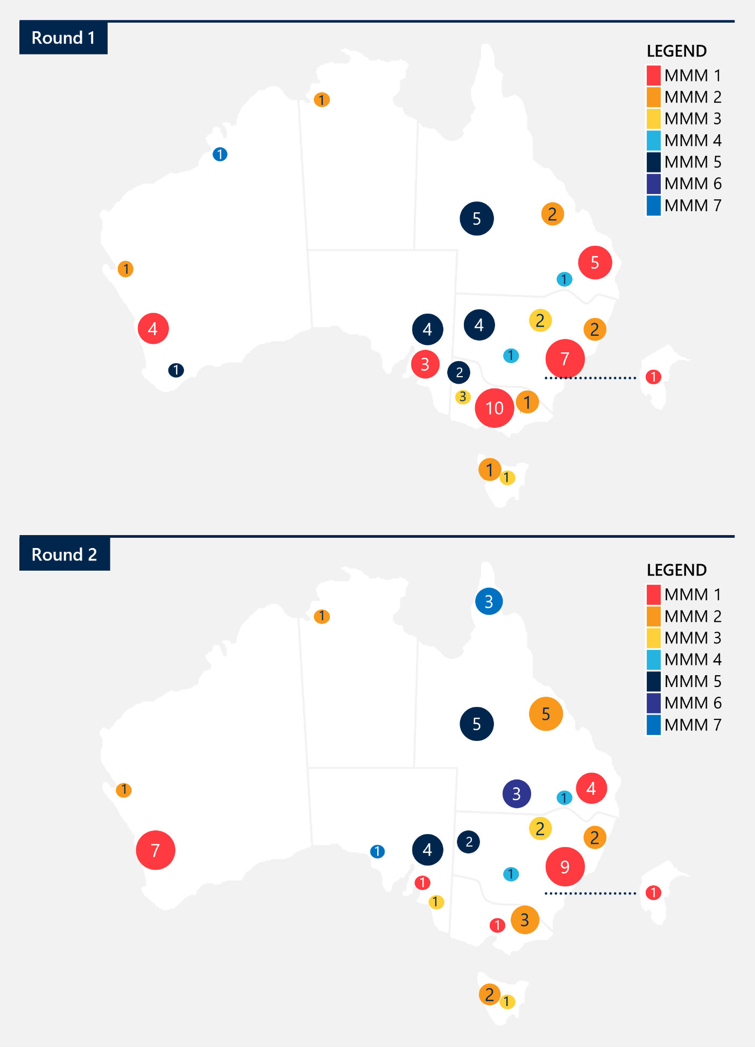

Table 7 | Mapping of sites participating in the Collaborative in both Rounds by MMM
MMM level | Number of sites in Round 1 | Number of sites in Round 2
1 | 30 | 23
2 | 10 | 14
3 | 4 | 4
4 | 2 | 2
5 | 16 | 11
6 | 0 | 3
7 | 1 | 4
Total | 63 | 61

The jurisdictional programs provided additional coverage to services participating and not participating in the Collaborative
The Jurisdictional Leads were responsible for supporting both services in the Collaborative and those not participating, by delivering tailored education sessions and other supports. Note the responsibilities varied slightly between Round 1 and Round 2 and are outlined in the Appendix A.3. In Round 1, each Jurisdictional Lead facilitated a range of sessions in both metropolitan and regional locations. For example, the NT Jurisdictional Lead partnered with remote community health centres, governing bodies and councils across Darwin, East Arnhem Land, Tiwi Islands (Wurrumiyanga) and Katherine Hospital and the Big Rivers Region, and facilitated four in-person community yarning groups.
Note: The total number of participants involved, and locations attended as part of the jurisdictional programs was not available for the writing of this report. Details of the jurisdictional programs for Round 2 will be available in the Final Report (2026).

The public awareness campaign contributed to the reach of the National Program
While the Collaborative and jurisdictional programs primarily engaged clinical staff (such as obstetricians, midwives and other members of hospital teams), the public awareness campaign expanded the reach of the National Program beyond clinical settings. It targeted consumers, especially women and expectant parents, with the intention of enabling them to make informed decisions about birth timing and options. The public awareness campaign was publicly accessible, and so reached consumers, clinical staff involved in the Collaborative and staff from non-participating maternity services. .
As previously summarised in Table 5, Round 1 of the campaign’s reach exceeded its distribution goals. It included approximately 25 media releases and news articles, multiple digital campaigns that generated over 2 million impressions, and social media engagement that generated over 147,000 unique views. Appendix F includes additional detail about the reach and outputs of the campaign.
At the time of writing, Round 2 of the campaign is in early stages of delivery and not available for comment. The Round 2 Communications Strategy was drafted in July 2025 by the Communications Strategy Working Group, for approval by the Steering Committee. Given that the Round 2 Program runs for 15 months, this represents a relatively late start to communications planning. However, many online resources developed by the Alliance and Jurisdictional Leads in Round 1 were made available online via the Australian Preterm Birth Prevention Alliance’s webpage for shared use across Round 2. The Preterm Birth Alliance Instagram account was also developed, with the first post in March 2024.

The National Program was perceived as effective and high quality by participating staff

The Collaborative was effective in upskilling staff at participating maternity services
A standard staff survey question captured regularly from a sample of 10 staff at participating maternity services asked how much they agree with the statement, “I understand the strategies for and benefits of safely reducing preterm and early term birth” (Process Measure 6). On average, 82 per cent of sampled staff said they ‘strongly agreed.’ The average increased from 78 per cent in the first year (October 2022-June 2023) to 85 per cent in the second year (July 2023- February 2024, last reported). Note that no surveys were completed before the Collaborative commenced, and so a true indication of increased understanding is not available.
Additional positive reports of the quality of the Collaborative are included Section 4.3.

The Collaborative Learning Sessions were seen as ‘excellent’
Maternity services attended three Learning Sessions as part of Round 1, which were also perceived as high quality. On average across the three sessions:
- 95 per cent of participants strongly agreed or agreed the overall quality of the event was excellent
- 93 per cent of participants strongly agreed or agreed their learning objectives were met
- 96 per cent of participants strongly agreed or agreed that the event will help them make positive change in their workplace.
Additionally, a Collaborative Showcase Event was held in March 2024 to present the results achieved and spreading learnings from the Collaborative to the wider maternity sector. Almost all (89 per cent) of participants responding to the evaluation survey ‘agreed’ or ‘strongly agreed’ that the overall quality of the event was ‘excellent’.

The events implemented as part of the jurisdictional program were broadly seen as high quality
Jurisdictional Leads led various roadshows and education events, which were reportedly well received by participants. For example:
- Victoria’s jurisdictional outreach included virtual education sessions, such as a Gestational Diabetes webinar (144 clinicians attended) and a Smoking Cessation webinar (63 clinicians attended). More than 80 per cent of participants at events ‘agreed’ or ‘strongly agreed’ that the event will help to create positive change in their workplace.
- Queensland’s jurisdictional outreach included roadshow activities in Longreach, Cairns, Roma, Mount Isa and Hervey Bay. Survey feedback after the education session demonstrated that more than 80 per cent of participants ‘agreed’ or ‘strongly agreed’ that they understood the seven strategies to safely reducing preterm and early term birth.
Note: Nous received and reviewed the collated National Program Progress Reports, but has not received the jurisdictional summaries which highlighted all survey findings.

There is limited evidence of the effectiveness of the communications campaign
The influence of the public awareness campaign on consumers has not been examined by Nous or others, to our knowledge. Consumer perceptions will be included in the Final Report (2026). Note that Collaborative Process Measure 3 (percentage of women who reported being involved as much as they wanted in decision making related to their treatment and care) was used as a proxy measure for public awareness of the campaign. Over the reported period, an average of 92 per cent of women surveyed at the participating services reported being involved as much as they wanted in decision making related to their treatment and care. There was a small increase from 89 per cent in the first year (September 2022- June 2023) to 93 per cent in the second year of the National Program (July 2023-December 2024).

The efficiency and effectiveness of administrative arrangements improved between rounds
Both governance and funding arrangements hindered the delivery of the National Program in Round 1, though were improved in Round 2.

Governance structures were clarified across Round 1 and are reportedly effective in Round 2

Tensions and ineffective ways of working disrupted governance processes in Round 1
Governance and administration processes were disrupted in Round 1 due to tensions and ineffective ways of working between subcontractors, the Alliance and the financial administrator (WIRF). As the administrator, WIRF held responsibility for governance, funding arrangements, and reporting, but it did not engage in the National Program's day-to-day design or delivery. Delivery of the National Program was completed by the Alliance, WHA, IHI and SCV, as well as the Jurisdictional Leads. WIRF was not a member of the National Collaborative Steering Committee nor the National Program Committee, which complicated its oversight role. WIRF reportedly relied on goodwill and direct contracts with jurisdictions to ensure accountability and oversight of fund usage. Stakeholders suggested establishing multiple points of contact and clarifying the responsibilities and involvement of administrators and program partners clearly in writing to prevent similar governance issues.

The financial administrator was involved in implementation in Round 2, which enhanced the effectiveness of its governance
Most stakeholders reported the Round 2 financial administrator’s (WHA’s) existing relationships with key stakeholders, particularly their synergy with the Alliance, supported effective coordination of roles, broader stakeholder engagement and supported transparency and efficiency of activity progress with participating teams. Jurisdictions report feeling “very well supported”, with key leaders viewed as “accessible, knowledgeable and encouraging”, and the overall governance as “very well run”. WHA leveraged its existing data infrastructure, which support faster contract finalisation for Jurisdictional Leads, and provided participating maternity services teams with timely access to data.

The funding arrangements involved lengthy negotiations in Round 1 and were more streamlined in Round 2

Contracting inefficiencies shortened the implementation period in Round 1
In Round 1, stakeholders reported lengthy negotiations occurred between the grantee/financial administrator (WIRF) and implementation partners, which impacted the timing and efficiency of sub-contract and service agreement finalisation. Issues around ownership of the National Program’s Intellectual property in Round 1 reportedly contributed to the lengthy finalisation of contracts and transfer of funds, resulting in shortened timeframes for delivery of activities and services.
The contracting process reduced the delivery window, but the effectiveness of the delivery was not substantially impacted by the shortened timeframe. Many health departments would not allow positions to be advertised prior to agreements being signed, and the activities of the Collaborative were delayed by three months and commenced in April 2022. Expectations to deliver on National Program activities and outputs remained in place across a shorter timeframe, reportedly creating pressure across the network. The delay reportedly reduced the service delivery window, and delayed the recruitment of clinical lead staff, and an underspend was reported in some jurisdictions. In some cases, the underspend was redirected towards other activities. No further delays were reported and all components of tasks relating to the Collaborative and jurisdictional programs were reported as completed in the final Progress Report 5; evaluations are underway.
Note that the funding agreements for program activities between the financial administrator and Jurisdictional Leads were not made available for Round 1.

Funding was more efficiently administrated in Round 2, though the smaller allocation restrained some activities
In line with the intention to embed sustainable change, Round 2 included a smaller funding amount for the National Program, with an approximate 58 per cent decrease compared to Round 1. Funding was allocated to jurisdictions according to the clinical expertise offered. Jurisdictions contributing to national Pillar guidance were provided additional funding for the additional time and expertise.
Funding was reportedly distributed in a timely way by WHA as the grantee / financial administrator of Round 2. Funding agreements for Program activities in jurisdictions are clearly outlined. Due to the smaller funding available, some stakeholders noted that not all required dedicated roles to support implementation could be funded as they were in Round 1. As in Round 1, in-kind support was provided, with some jurisdictions adding additional FTE for key roles and reporting working later hours to prepare data.
The relative level of support provided to non-Collaborative sites in Round 2 was also reduced, with fewer coaching calls and roadshows planned. This reduction in funding is likely indicative of the initial high levels of effort required to implement a new change, and the subsequent need for continued efforts while transitioning to sustainably maintaining changes. Note that this messaging around reduced funding has not been explicitly outlined and was not reflected in conversations with stakeholders in Round 2. Also note that given the early stages of implementation at the time of writing, the effectiveness of Round 2’s funding allocation is not yet clear.

Several key mechanisms were reported to help embed best practice through the Collaborative
Engagement with key stakeholders involved in the National Program in Round 1 and/or Round 2, and an independent review of the Round 1 ‘Every Week Counts’ Collaborative, highlighted several key mechanisms that contributed to the effectiveness of the National Program. These were particularly relevant to Round 1 and were also consistent with key stakeholders’ views of progress made to date for Round 2.
The Collaborative incorporated program components that are central to the IHI BTS Collaborative model design and have been identified as common attributes of successful collaboratives.
At the time of writing, there was limited evidence available to comment on the effectiveness of the jurisdictional activities (Component 2) and the public health awareness campaign (Component 3) of the National Program. The jurisdictional programs, by design, also supported activities and efforts of the Collaborative, and so delineation is not quite feasible.
Table 8 | Key mechanisms that helped embed best practice across rounds
Mechanism description | Round
Change Methodology | Quality improvement methods embedded in the Collaborative were reported to be effective in influencing clinical staff behaviour.  IHI’s BTS Collaborative model methods applied across Round 1 and 2 of the Collaborative were reported to be effective methods of learning. Using the Kirkpatrick Phillips hierarchy, learners found participation in BTS Collaborative model elements positive and relevant to their role, and supported acquisition and enhancement of skills and knowledge. Stakeholders consulted reported that the methods helped foster cohesive local health service teams, collaboration across different health service teams and opportunities for reflection on progress – all effective ingredients to support behaviour change in practice.  An independent review, involving a survey of 88 participants (representing 43 of the 59 hospitals) in Round 1 of the Collaborative highlighted particularly effective components of the use of IHI’s BTS Collaborative model as part of the National Program’s Collaborative.  - Learning Sessions generated motivation and built capability in clinical and improvement processes. During the Collaborative, teams came together in person for three face-to-face Learning Sessions. Participants valued learning about both improvement science, such as PDSA cycles, and acquiring detailed knowledge of the clinical strategies. Participants appreciated the Learning Sessions for sparking enthusiasm and motivation, especially through sharing ideas. Survey respondents rated the Learning Sessions and the resources provided as the most useful elements of the BTS Collaborative model, with 83 per cent agreeing that they were ‘extremely’ or ‘very useful’. One midwife participant noted, “You kind of get to a point where … I'm not really progressing... And then you'd go to a learning session, and you'd be like, yes, like, I'm inspired. I'm doing this. I'm doing that. I've heard this and seen that.”  - Regular data collection, reflection and benchmarking encouraged teams to improve. The requirement to regularly enter process and outcome data into an online data platform, along with data discussions at coaching calls and at Learning Sessions, were useful mechanisms that supported teams to reflect on their progress.  - PDSA (Plan-Do-Study-Act) cycles facilitated structured improvement. The process of planning and implementing these cycles reportedly helped teams test and refine changes. However, time constraints limited formal recording, which is reflected in just over half of respondents (53 per cent) rating the PDSA as ‘extremely useful’ or ‘very useful’.  - Hub and spoke model provided effective support, effective for the flexibility needed nationally. The national central team provided clinical expertise, resources, and oversight, while local leads tailored support to health service contexts. Following an initial phase of role clarification, the national team reported a strong, high-performing partnership underpinned by a shared purpose. One participant noted, “It wasn't like you could streamline the processes across the country to ensure this is how it's done, because it really is very different around the jurisdictions and from hospital to hospital.”  - Teamwork, shared purpose and cross collaboration were enabling for multidisciplinary teams. The BTS Collaborative model reportedly developed a sense of a shared purpose between multidisciplinary clinicians, with participants describing being “part of something bigger”. This shared sense of purpose facilitated both collaboration between teams from different services, as well as teamwork within maternity services. One participant noted, “…it was multidisciplinary, and … we all pulled in the same direction, which doesn't happen that often”. | 1
Events and sessions effectively spread key messages and were well received by participants.  Both virtual and in-person events were reportedly well received by participants and were part of both the Collaborative and jurisdictional activities. These included education sessions, roadshow activities and other outreach activities. The three Collaborative Learning Sessions were well received and have been previously described above. Other examples include the jurisdictional education sessions and the Collaborative Showcase event. | 1
Data | Improvements in data collection, literacy and sharing enabled transparency and real time feedback to help generate buy-in.  In both rounds, participants reported the data collection assisted participants to understand status and progress, as well as providing a level of peer-review or benchmarking for improvement, and in some cases sparking a competitive element as an incentive to progress work.  Data collection mechanisms were improved in Round 2 to improve usability and knowledge sharing between sites. Two key improvements to data collection and sharing were made in Round 2 that were assessed as positive by participants engaged by Nous:  - New tools and platforms enhanced usability of data collection: The feedback from Round 1 suggested that LifeQI was not as user-friendly as anticipated, so more familiar tools, such as Excel, Power Bi and Teams, were used instead. Data collection frequency shifted from weekly to fortnightly. Collectively, this reportedly improved reporting compliance and ease of use.  - New data dashboards enhanced transparency and motivation: A new dashboard allowed teams to view hospital or aggregated data groups within the Pillars. This reportedly created “a sense of friendly competition” and “piqued curiosity”. Maternity services staff were able to access shared resources (noted below) and data across Pillars via the use of Microsoft Teams. This reportedly motivated performance of sites and adherence to the clinical strategies, with one stakeholder noting, “shared data creates a sense of friendly competition… It aligns with the collaborative philosophy.”  - Enhanced data literacy: As a result of the additional use of data, data literacy was also improved across clinical staff involved in the reporting. | 2
Shared Resources | Shared resources helped develop efficiencies to generate additional knowledge sharing.  During Round 1, Jurisdictional Leads developed education materials tailored to local needs. A suite of resources was created, including presentations, slideshows, and materials for health professionals and families on the seven strategies (such as webinars, brochures, posters, and videos). Resources developed by jurisdictions and hospital teams were shared and adapted locally.  In Round 2, a Microsoft Teams platform was introduced to support resource sharing across jurisdictions and services. Clinical teams accessed and contributed to a central repository of resources, ideas, and dashboards, promoting collaboration and transparency. Teams built on tested strategies, reducing duplication and accelerating implementation.  Across both rounds, shared resources reportedly enhanced knowledge exchange. An independent review found that sharing insights and tools sped up improvement and reduced time spent developing materials like policies and patient brochures. | 1 and 2

Interim findings | Outcomes and impact
This section outlines interim findings relating to the outcomes and impact of the National Program (KEQ 3). Note that outcomes are available for Round 1 only. The data in this section includes Round 1 program data from WHA (inclusive of July 2019 – June 2024) and partial Round 1 system data from AIHW (inclusive of 2018 – 2023).

Finding KEQ 3:
To what extent did the National Program achieve its intended outcomes and impact?
The National Program did not achieve its primary aim of reducing PTB rates. The National Program partially achieved its intended outcomes, with measurable reductions in ETB rates and broader systemic benefits.
- Reduced rates of ETB across participating sites
Round 1 data shows a reduction in ETB rates among services participating in the Collaborative. However, there were no statistically significant differences pre-post the National Program, nor between services participating and not participating in the Collaborative on key outcomes. No adverse outcomes were reported, reinforcing the safety and effectiveness of the National Program’s implementation. However, the PTB rates were not measurably reduced between pre- and post- Round 1.
- Broader positive impacts
The National Program generated several unintended but positive impacts. These included the creation of new organisational roles, the development of voluntary networks, and improved clinician understanding of quality improvement principles.
- Limitations to attribution and sustainability challenges
Attributing outcomes to the National Program remains challenging due to concurrent policy reforms, demographic shifts, and other health initiatives, including those which commenced prior to the National Program. Stakeholders emphasised that sustaining the National Program’s impact will require system-level support, ongoing workforce investment, and continued engagement with clinical champions to embed improvements long-term.

The intended outcomes of the National Program were partially achieved in Round 1, with a reduction in early term births
Round 1 of the Collaborative reached an estimated 54 per cent of Australian public live births
As discussed in Section 4.1.2, the National Program had a broad reach. Maternity services participating in Round 1 of the Collaborative reportedly represented 54 per cent of public births.
Early term rates decreased from pre-National Program to the end of Round 1
The Alliance and researchers have undertaken analysis indicating a reduction in ETB across Round 1, which was published by The Lancet Obstetrics, Gynaecology, & Women’s Health after the first draft of this report. Analysis included 458,542 births between the period October 1, 2022, to June 30, 2024. The analysis found that ETB rate in participating hospitals decreased from 30.63 per cent in the pre-Collaborative period to 27.69 per cent in the third and final Collaborative time period (9.60% decrease; 0·90, 0·89–0·92; p<0·0001), with no further decrease in preterm birth rates.
There are some differences in findings between Nous’ analysis and the Alliance regarding the rates of ETB within Collaborative sites, which may be due to methodological differences in statistical analysis. These will be explored further in the Final Evaluation Report due in 2026.
Note that the remainder of this section refers to Nous’ analysis of WHA data.
Nous’ analysis of WHA Maternity Services Benchmarking data also shows a decrease in the ETB rate across maternity services participating in the Collaborative. There was no difference in PTB rates, including before 37 completed weeks gestation or before 32 weeks gestation, between sites participating and not participating in the Collaborative.
Figure 10 shows the indicative pre-post change in average birth rates across services participating and not participating in the Collaborative. Note that there is a visible downward trend in ETB rates for services that did participate in the Collaborative, during the time of the Collaborative. This suggests the Collaborative may have played a role in influencing a reduction in ETB rates. This trend was not visible for PTB rates within the same services. There is also substantial variance in average rates across each month for services not participating in the Collaborative, reflecting the smaller number of services that did not participate in the Collaborative. The trendline for each graph was calculated using the data for the specific and separate time periods of: before the Collaborative, and during the Collaborative. Hence, there are two separate and slightly disconnected trendlines for each graph to enable visual comparison of differences in trends before and after the Collaborative.
Overall, when not disaggregating for participation in the Collaborative, and modelling the monthly average rates, there was no change in ETB, PTB and the rate of babies born before 32 weeks gestation for the sample, including between the period before the National Program (July 2019) and in the final month of Round 1 (June 2024).
Figure 10 | Indicative pre-post change in average rates of ETB, by participation in the Collaborative, for all women
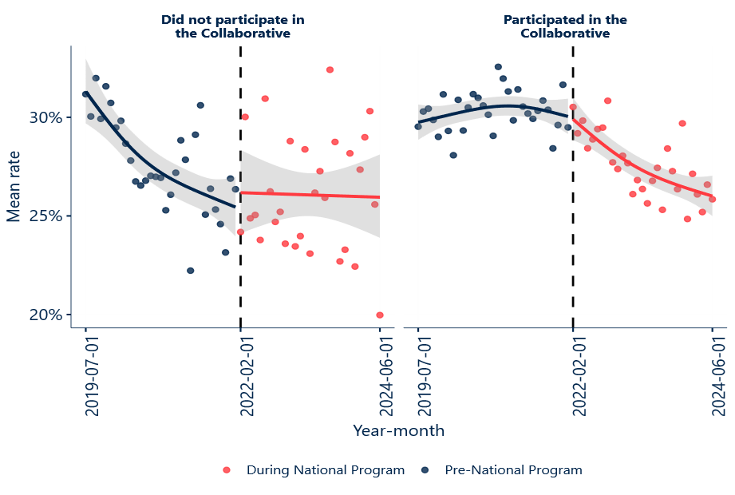
These relationships were then formally evaluated statistically, by computing the differences-in-differences estimate (i.e., the difference in average pre-post rates for ETB and PTB rates between sites who participated in the Collaborative and those which did not) from a generalised additive model (GAM) using Parametric g-Computation. The high-level findings were as follows:
- The average pre-post change in monthly average ETB rates associated with participation in the Collaborative was -0.01 (95% CI: -0.03 to +0.005).
- The average pre-post change in monthly average rate of births before 32 weeks gestation (PTB) associated with participation in the Collaborative was +0.002 (95% CI: -0.0002 to +0.004).
- The average pre-post change in monthly average rate of births before 37 weeks gestation (PTB) associated with participation in the Collaborative was +0.006 (95% CI: -0.0009 to +0.01).
Since the 95 per cent confidence intervals include both positive and negative values, we cannot be confident that participation in the Collaborative is associated with a reduction or otherwise in average monthly ETB or PTB rates. However, this aggregated analysis represents only a preliminary statistical investigation into the WHA indicator data, and further analysis is required to understand if these findings hold across other levels of aggregation/disaggregation (such as at the site or cluster level) and alternative statistical methodologies if additional data was available (such as raw count data to enable the usage of Poisson regression with offset terms).
Note additional cohort-based differences are not included in this report. See comments below:
- Differences between jurisdictions, by participation in the Collaborative: The data provided by WHA was de-identified and included aggregated jurisdictions. That is, WHA data was grouped using the following combinations to further protect confidentiality and minimise re-identification risk: ACT and NSW; NT and SA; Tas and Vic. True jurisdictional comparison was not available, and preliminary analysis shows no differences in the rates of change in ETB and PTB across aggregated jurisdictions. Analysis of AIHW data in the following section shows some differences between jurisdictions on ETB rates.
- Differences between public and private services, by participation in the Collaborative: All WHA benchmarking data is for public hospitals, and so comparison between public and private services is not feasible for the Interim Report.
Greater reductions in ETB rates were seen in SA, VIC and WA in 2022-23
Analysis of AIHW data shows that the age standardised rates of ETB between 2022-2023 (during Round 1 of the National Program) reduced in some jurisdictions more than others. There appears two trends for jurisdictions illustrated in Figure 11 and described below:
- Small variations before the National Program, with a sharper reduction during the National Program | Age standardised rates of ETB across SA, Vic, and WA plateaued in the years before the National Program and then dropped by one to two points during the National Program.
- Mixed trends before and during the National Program | New South Wales exhibited small changes during this time though already had lower rates of ETB. Qld, ACT and NT had fluctuating ETB rates prior to the start of National Program, with slight improvements during the National Program. Rates in Tas varied across the five years before returning to the 2019 rate during the National Program.
Figure 11 | Age standardised rate of total ETB across states and territories (S/T)
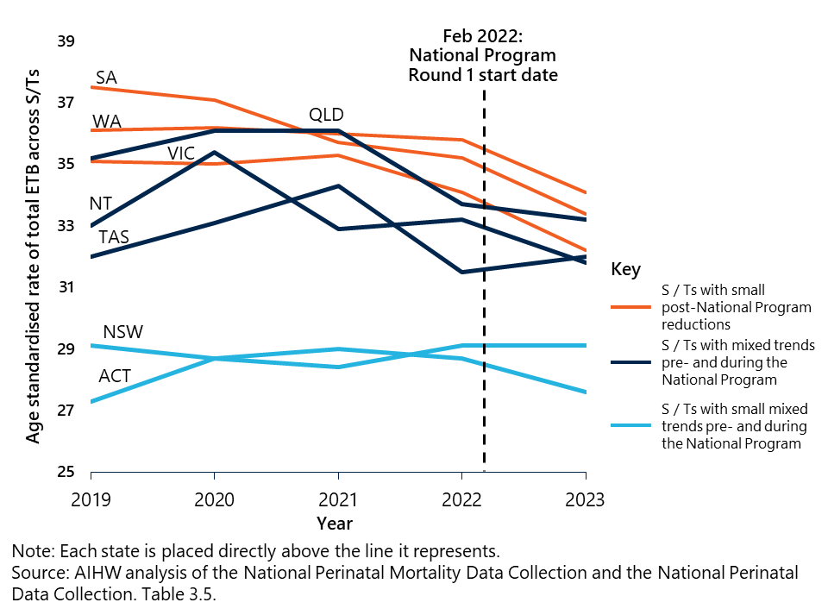
There were few differences in outcomes between services participating and not participating in the Collaborative
Nous’ analysis also shows that there were some differences in the implementation of select clinical strategies across Round 1 between Collaborative and non-participating sites. Smoking cessation rates increased overall across all services between pre-National Program (July 2019) and the end of Round 1 (June 2024). This indicates that a greater rate of women who were smoking stopped smoking during their pregnancy. The rate of change was greater with Collaborative services than non-participation services, as highlighted in orange in Figure 12. Analysis of AIHW data found that the age standardised rate of mothers who smoked during the first 20 weeks of pregnancy and after 20 weeks of pregnancy has continually reduced since 2020, from 12.9 per cent and 10.2 per cent in 2020, to 11.3 per cent and 8.4 per cent in 2023, respectively. However, note that the impact to vaping on tobacco spoking in pregnancy data has not yet been assessed by AIHW. See Appendix G for additional data notes.
Note that the corresponding Collaborative process measures, summarised in Section 4.1, suggested that measurement and implementation of smoking cessation activities were difficult. It can be assumed that additional measures, such as the National Program’s public awareness campaign, changing consumer behaviours and other sector changes (such as the introduction of vaping), may have contributed to the change in rates.
As shown in Figure 12, there was no change in ETB rates, PTB rates, nor in other implementation measures, including early planned caesarean rates and continuity of care rates, between services participating and not participating in the Collaborative.
There was also no overall difference in these measures when not disaggregating for Collaborative participation, between pre-National Program (July 2019) and the end of Round 1 (June 2024). There was no change in the rates of adverse outcomes, both overall and between Collaborative and non-participating services, as explored in the following section.
Despite this data, anecdotally, stakeholders have reported that there was a ‘flow on effect’ between services participating and not participating in the Collaborative, with materials and learning shared between staff directly and indirectly through natural staff turnover. The National Program intended to have a broad influence, and this inbuilt into the design of the jurisdictional programs and public awareness campaign of the National Program. Additional analysis using different methods may provide an alternative finding.
Figure 12 | Comparison of birth outcomes, implementation measures and adverse outcomes across services participating and not participating in the Collaborative
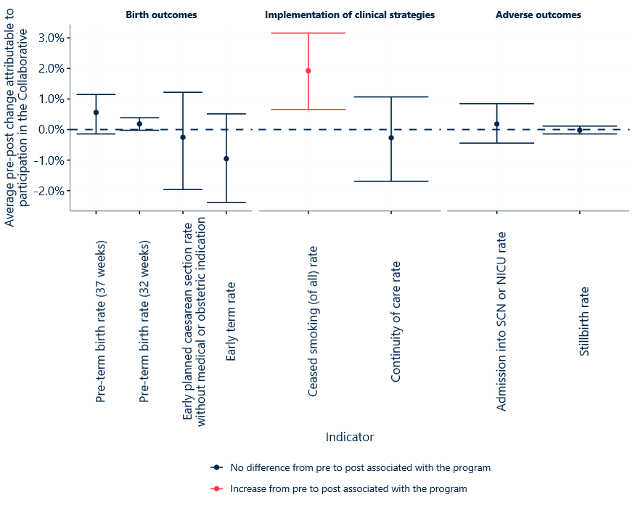Care must be taken considering the upwards trend of caesarean section birth rates due to maternal choice which have continued nationally for ETB
Analysis of AIHW data found that the upwards trend of births by caesarean section due to maternal choice in the absence of any obstetric, medical, surgical or psychological indications has continued an upwards trend for ETB and births after 39 weeks gestation. ETB rates have increased from 3.3 in 2021 to 3.9 in 2023 (age standardised rate). However, PTB c caesarean sections have remained relatively constant between 2018-2023, at an age standardised rate of 0.2 across these years. Care must be taken if using these data to assess whether the National Program has been successful in ‘Optimising the time of birth by avoidance of unnecessary delivery before about 39 weeks’ gestation unless there is medical or obstetric justification’. This data item does not capture the reason for the timing of the birth, only the reason for the method of birth being a caesarean section. Most jurisdictions are unable to quantify the impact of this issue from the data available in their perinatal data collections; however, based on clinical advice, it is thought that the impact could be substantial. Further, clinical indications for early delivery, such as fetal compromise, may not always be recorded as the main indication for caesarean section if a caesarean section was already planned earlier in the antenatal period. See Appendix G for additional notes about the use of this data.

The National Program did not appear to adversely influence other related outcomes
Stillbirth rates and SCN/NICU admission rates were included in as ‘balancing measures’ to detect any unintended adverse consequences that might arise elsewhere in the system as a result of the National Program’s efforts to reduce PTB. Analysis of the WHA data found that there was no increase in the stillbirth rate or admission into SCN/NICU across all included maternity services. Further analysis also showed there was no difference in these measures between services participating in the Collaborative and those not participating. Note that AIHW have reported increasing stillbirth rates in recent years – the stillbirth rate in 2023, at 8.7 per 1,000 births, was the highest reported in over twenty years. Nous’ analysis of AIHW data similarly found an increase in stillbirths for babies born to both First Nations and non‑Indigenous mothers; however, this increase was confined to babies born at less than 37 weeks’ gestation and does not suggest an influence of the National Program.
Analysis of AIHW data shows that admission into the SCN and NICU did increase slightly between 2022 and 2023, however, this does not form part of clear increasing or decreasing trend over time and is less than a 1 per cent change.

Key stakeholders identified unintended, positive outcomes of Round 1 of the National Program
Stakeholders identified positive outcomes of the National Program, indirectly related to the intended outcome of lowering preterm and early term birth. As Round 2 is early in its implementation, any other unintended outcomes will be reported in the Final Evaluation Report (2026).
Unintended outcomes that were detrimental or negative were not reported by stakeholders. Unintended, positive outcomes reported included:
- Development of new organisational roles or structures: The National Program reportedly drove the establishment of new specific divisions focussed on maternal health, within some organisations involved in the National Program’s delivery.
- Voluntary establishment of networks focused on patient care that supported sustainability between rounds: Voluntary networks were established by some stakeholders to sustain program efforts in the lead up to Round 2 after Round 1, and to focus on continuity of care models. WHA and SCV led a network that continued to support Collaborative participants maintain connections with other Collaborative participants and enabled ongoing access to Life Quality Improvement data (LifeQI data). Another network focussed on continuity of care models from a midwife or other health clinicians, with key learnings shared with the broader Collaborative across Learning Sessions.
- Greater understanding of quality improvement processes: Some stakeholders reported that the Collaborative’s quality improvement methodology was beneficial more broadly, uplifting staff capability on how to implement change through the processes learned. This was also highlighted in a separate review of Round 1 – some respondents described benefits of the knowledge gained through learning about improvement methods and understanding the need to collaborate to achieve change. One obstetrician noted, “I will never in my entire life try and do change on my own again”.
- Additional consumer-led insights shared with clinicians: An independent report found involvement of consumer representatives positively impacted clinical practice, clinicians’ learning and understanding, and the overall experience of the Collaborative. Here, consumer input was linked to:
  - challenging clinician beliefs and assumptions on women’s knowledge, needs and key considerations for their care
  - improved clinician-to-patient communication across the type of language used, and information and the format of documentation provided to consumers
  - recognition of the power and value of consumer input and consumer stories, which encouraged some clinicians to consider consumer perspectives both within the outside of the Collaborative.

Attribution of impact to the National Program itself is difficult, given the many other initiatives in this space
The National Program was not implemented as a randomised controlled trial limiting the ability to strictly test case-effect relationships. There are a range of reasons underpinning this decision including:
- Randomising sites into control groups was not appropriate due to widespread implementation and national education/media campaigns.
- Staff often worked across both Collaborative and non-Collaborative hospitals, and the hospitals themselves differed significantly in structure.
While other clinical changes might have influenced outcomes, the National Program’s research team did not identify any major national shifts during the study period. This paired with the strong existing evidence of effectiveness for the seven clinical strategies in Round 1 provide a sound theoretical rationale for attributing impacts to the National Program.
There are several other policy, demographic, socio-economic changes that may have occurred at the same time as the National Program, making attribution challenging. Other factors which may contribute to changes in early and preterm birth rates include:
- Increasing maternal age: This includes the increasing proportion of women who gave birth over 40 years of age. Even after adjustment for confounders, advanced maternal age (40 years and over) was associated with preterm birth.
- Smaller sample size and associated biases: Australia's fertility rate has dropped since the National Program commenced, including to 1.51 per woman in 2024, the lowest rate recorded and well below replacement levels.
- Increase in antenatal care: By 2023, 79 per cent of mothers accessed antenatal care in the first trimester, up from 61 per cent in 2013. Early and frequent antenatal visits are protective against adverse birth outcomes.
- Influence of other policies: The NSW Select Committee on Birth Trauma released 43 recommendations in 2024, calling for trauma-informed care, better midwife ratios, and publicly funded homebirth services. NSW Health committed to 42 of these recommendations and has accelerated key initiatives, including expanding continuity of care models; embedding trauma-informed maternity care; Improving consent and information provision; and supporting women with pregnancy complications. The National Program also aligns with other Australian policies and initiatives (see Appendix D.3) whose efforts and progress to date may directly or indirectly contribute to preterm and early term birth rates in the observed period.
- Other pre-pregnancy, health and lifestyle factors, such as stress, diet, physical activity (note evidence is mixed and additional research is required). Though strong evidence for the seven clinical strategies exists, PTB is the result of many different aetiologies, and as such may require multiple interventions targeted to different subgroups based on risk stratification and prognostic profiling.
Note: This report does not control for age and other illnesses as part of the analysis of WHA data. This section is an overview of the multiple factors that are or may influence preterm birth rates in Australia, reflecting the complexity of the causes of preterm birth.

Stakeholders identified barriers and enablers to achieving the intended outcomes
Under the principles of continuous improvement (improvement science), the Alliance and implementation partners sought to address any barriers identified in Round 1 in Round 2, while enablers were strengthened.
At the time of writing, implementation of Round 2 is early and ongoing, though emerging distinct enablers and barriers were noted by some stakeholders. Table 9 and Table 10 provide a consolidated summary of enablers and barriers, respectively, many of which have been identified in other report sections as indicated in the tables.
Table 9 | Enablers of implementation across Rounds 1 and/or 2
Enablers of implementation | Round | Report section
Credibility and Evidence | Strong evidence and credible sources encouraged the uptake of the clinical strategies.  - The credibility and visibility of high-profile medical experts and researchers was pivotal in enabling implementation of the Collaborative. Their involvement fostered trust and respect, which in turn helped generate interest and commitment from executives and senior medical decision-makers.  - The National Program translated clinical research into practice relatively quickly – well within the sector standard of 17 years. | 1 & 2 | Section 3.2.3
Improvement Science | Embedded improvement science facilitated cohesive relationships, quality improvement, and capability uplift across participating teams.  - IHI’s BTS Collaborative model, particularly the Learning Sessions, regular reflection and benchmarking, supported cohesive relationships, quality improvement, and capability uplift across participating teams.  - Round 2 has continued to use IHI’s BTS Collaborative model. | 1 & 2 | Section 4.1.3
Leaders at All Levels | Strong clinical and implementation leadership across levels enabled tailored delivery of the strategies.  - “Local champions”, executive sponsors, and senior clinical leaders, particularly midwives, played pivotal roles in driving implementation, resource allocation, and data collection. Executive support ensured protected time, approval of new clinical processes, and sustained commitment.  - Senior obstetric leaders were especially influential in promoting clinical strategies and navigating complex decisions around birth timing.  - A midwife noted that “the medical buy in is really important. If you can get your consultants on board, and willing to champion that change and try and get the people that are resistant to that change on board, …that's what helped us to make the biggest changes.” | 1 & 2 | NA
Flexible Design | The National Program’s flexible design allowed jurisdictions and services to adapt activities to local contexts, increasing relevance.  - Jurisdictional outreach activities in both rounds were shaped by clinical leads and tailored to service and population needs. The potential for ‘siloed’ work was raised by some stakeholders and will be further explored in consultations for input into the Final Evaluation Report (2026).  Note: Implementation of Round 2 is still in its early stages, and outcomes are yet to be fully realised. | 1 & 2 | Section 3.2
Relative Advantage | The ease of implementation and ‘relative advantage’ increased uptake of some strategies.  - Introducing some clinical strategies to regular practice was seen to come with advantages, such as efficiencies, which positively influenced uptake. Most survey respondents found the Collaborative’s change package was better than existing practice (82 per cent). | Round 1 | NA
Table 10 | Barriers to implementation across Rounds 1 and/or 2
Barriers to implementation | Round | Report section
Service Resource Constraints | Structural constraints varied across maternity service types and influenced implementation capacity.  - Larger hospitals reportedly faced slower change processes and challenges in standardising care across large workforces, while smaller ones lacked resources available for project support. Health services and jurisdictions with more sophisticated data infrastructure or the capacity to change existing data systems, were able to collect and analyse data for the Collaborative easier and faster than other services.  - Additionally, the successful implementation of clinical strategies relies on access to a dense network of services, including, for example, ultrasound technology, primary care coordination, and maternity infrastructure. Consequently, some services experienced challenges with measuring cervical length due to multiple implementation steps. | 1 & 2 | NA
Complexity of Clinical Strategies | Complex clinical strategies were more difficult to implement.  - Smoking cessation and cervical length screening were reportedly harder to implement due to resource and coordination demands. For example, smoking cessation required additional monitoring, and time to discuss smoking status and smoking cessation strategies, while measuring cervical length required educating sonographers and General Practitioners (GPs) and timely reports.  - One midwife noted that “... Anything that was going to create more work for them, people straight away disengaged”. The change package was updated in Round 2, and its complexity has not yet been explored due to early stages of implementation. | 1 | Section 4.1
Governance Complexity | Shifting and complex governance structures slowed decision-making.  - Initial governance of Round 1 created confusion around roles and responsibilities, which slowed decision-making and involvement with key stakeholders. Stakeholders reported administrative, sub-contracting and funding delays, and compressed delivery timelines.  - Unclear expectations around audits and intellectual property also impacted implementation of the National Program and reported to strain collaboration between some stakeholders. | 1 | Section 3.3 and 4.2
Workforce Shortages | Sustained implementation of the National Program was hindered by midwifery and medical workforce shortages, staff turnover, and competing clinical priorities.  - Several services reported needing to discontinue participation in Round 1 due to significant resource constraints. The turnover of key staff, including Jurisdictional Leads and midwifery personnel, disrupted the National Program’s momentum and continuity.  - Additionally, the absence of formal onboarding processes for new staff made it difficult for services to maintain consistent engagement in quality improvement activities. Some services shifted focus to consumer-facing work, further limiting capacity for QI delivery. | 1 | NA
Data Collection Requirements | Manual and often time-intensive data collection processes were an additional burden and impeded by other tasks.  - Data collection, especially manual collection of indicators, was reported as burdensome and time-intensive in some jurisdictions, with limited guarantee of accuracy. Some stakeholders sought for clarity on whether the range of indicators collected could be reduced to decrease administrative burden. At times, the burden impacted data quality, especially in jurisdictions with limited data infrastructure.  - One midwife noted, “As much as I really loved participating… it was a huge burden on top of my workload to be collecting that data…. But when you had to go through multiple systems to collect that data....I'm still having to go through 4 different programs to review those births in their entirety.”  - The data burden was addressed and reduced in Round 2. | 1 | Section 4.3
Limited Timeframe | The shorter timeframes and smaller funding allocation may potentially impact outcome achievement and the depth of engagement with First Nations communities.  - Some stakeholders noted that the available time in Round 2 is not sufficient for maternity services to appropriately and deeply engage with their local First Nations communities to develop the relationships required for effective and culturally safe partnerships to lower PTB. As a result, PTB rates are not included as an outcome on the First Nations Pillar Driver Diagram.  - Some stakeholders noted that the outcomes of activities may not be evident by the end of the Round 2 reporting period. | 2 | Section 4.2

The National Program is designed to have a sustainable impact on clinical services, however, evidence of its success is limited
The Collaborative leverages IHI’s BTS Collaborative model to drive rapid, scalable, evidence-based improvements across participating maternity services. The approach is not only about implementing clinical strategies, but about embedding behaviour that “creates sustainable improvement towards a collective aim”.
“While there is a targeted issue and targeted support then you can get people into a room and work together, but once the circus has left town [staff] may revert to what they did before...”
– Jurisdictional lead
The National Program has demonstrated early success in shifting clinical practice, though stakeholders in Round 1 and Round 2 highlighted that sustaining these gains requires policy and system shifts and ongoing support across diverse implementation settings. Additionally, change requires time, with observable changes often taking years, and the National Program is relatively early in its stages of implementation.
Some stakeholders noted that sustaining change in clinical settings is difficult, particularly where clinicians work independently. Goodwill, while highly effective in facilitating change, is not guaranteed and can fade following the commencement of initiatives and learning activities.
Stakeholders made the below suggestions to enhance sustainability of the change. These are framed using the COM-B model, a behaviour change framework that proposes three necessary components (capability, opportunity and motivation) for any behaviour (B) to occur. Capability refers to an individual’s psychological and physical ability to participate in an activity. Opportunity refers to external factors that make a behaviour possible. Motivation refers to the conscious and unconscious cognitive processes that direct and inspire change.
Capability
- Data literacy and integrated data-based feedback: Stakeholders noted that data was key to “win the hearts and minds of frontline clinicians”. Stakeholders suggested that sustained change is fostered by ongoing data feedback, integration of data into governance meetings, and improving data literacy among clinicians. Some maternity services staff identified that including regular reporting on key process and outcome measures used during the Collaborative could support the sustainability of clinical strategies.
- Updated protocols, guidelines and aligned national professional and institutional support: Stakeholders suggested that support by professional colleges, such as in the form of clinical guidelines, can build sustainable capability by standardising expectations and reducing ambiguity. Multiple professional colleges were involved in the National Program, but have not formally endorsed or developed clinical guidelines that align with the clinical strategies of the National Program. One stakeholder noted, “…sustainability is at risk without policy reform. Smaller jurisdictions are more vulnerable to competing priorities. Grants cannot continue indefinitely—system-level change is needed.” In addition, evidence is undecided on the sustainability of professionals’ adherence to guidelines in medical practice, suggesting that additional supports are likely needed.
Opportunity
- Ongoing community engagement and co-designed models of care: Particularly for First Nations communities, sustainability requires co-designed, culturally safe models of care – such as Birthing on Country – supported by trusted relationships and wraparound care. The RISE framework supports the development of these models, particularly for First Nations communities.
- Ongoing and predictable investment in workforce to support additional activities: Stakeholders reported consistent investment is required to sustain quality improvement initiatives, which require additional system capacity and data collection. The time limited nature of grant-based programs, while beneficial, do not allow for long-term workforce and activity planning. Ensuring safe staffing levels and high-quality care environment are critical enablers of change.
- Systems infrastructure updates to mandate processes: Staff engaged in an independent review recognised that infrastructure could limit the sustainability of change at some services, and noted that embedding change into processes, or creating mandatory data fields would be beneficial.
Motivation
- Clinical champions to continue momentum: Staff and clinical champions play a critical role in maintaining reflective motivation. Staff highlighted the importance of staff and clinical champions in continuing momentum and focus. Staff interviewed as part of an external review noted, “We've tried to put changes in place that aren't dependent on the person, but are more systems change, and they've been quite successful. But I think without having that person to continually drive and really push people and remind people and be there as a constant, it's very difficult to continue without those sort of clinical champions. So even though you try and shift it from being person-centric, it is still … important to have those champions around to continually remind people.”

Interim findings | Lessons learned
This section outlines interim findings relating to lessons learned, primarily from Round 1, that apply to Round 2 and to improve the sustainability of the National Program.

Findings KEQ 5:
How could the National Program be improved?
The National Program can be improved by embedding successful practices into existing health system structures to ensure sustainability, and tailoring initiatives more explicitly to priority populations. The National Program can also be improved by strengthening its governance, leadership, and consumer engagement.
Lessons from Round 1 have informed Round 2, but further improvements depend on sustaining changes and deepening partnerships with First Nations communities and other underserved groups. Enhanced data systems and flexible program design will also support continuous improvement and equitable outcomes.
The evaluation has identified broad and specific lessons learned from Round 1 that apply to Round 2 of the National Program, and lessons related to broader National Program improvement, including with regards to how to drive program sustainability. These lessons look to build on the existing strengths of the National Program and are described below.

Lessons from Round 1 have been applied to Round 2
The most effective elements of Round 1 were grounded in strong clinical evidence, credible leadership, and explicit change approaches, as noted in Figure 13. These elements accelerated the translation of research into practice through clinician and executive engagement. The use of improvement science, particularly the IHI BTS Collaborative model, fostered collaboration, capability uplift, and reflective practice across services. These methods were retained in Round 2 (including continuity of Alliance leadership), to build on Round 1’s successes.
Figure 13 | Effective Round 1 elements of the National Program
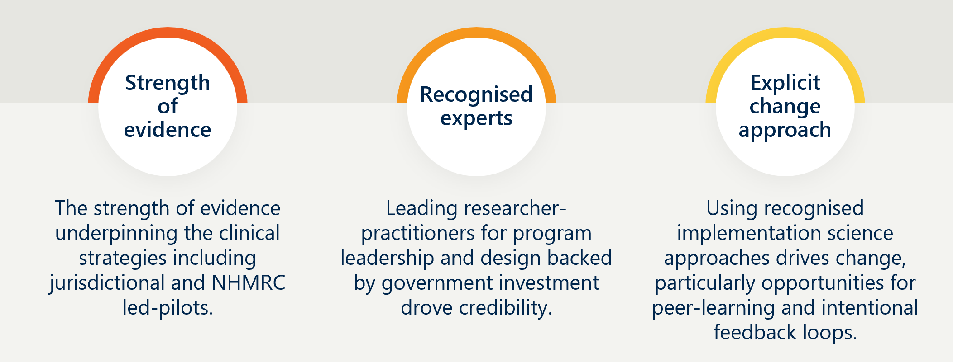
The implementation of Round 1 also revealed several opportunities for improvement. These opportunities were to address complex governance arrangements including improvements in consumer engagement, and inefficient data collection. Governance structures were clarified, with an initial indication of success being the more efficient distribution of funding. In addition, consumer engagement was strengthened through the Lived Experience Collective. These changes show emerging outcomes of improved collaboration and accountability.

The National Program could be improved through system integration focused on sustainability
Stakeholder engagements highlighted the importance of embedding the successes of the National Program into existing structures. The Waters of System Change highlights the common elements for system change as structural (policies, practices, resource flows), relational (relationships and connections, and power dynamics), and transformative (mental models). The current focus of the National Program relies on relational and transformative elements to drive the change in structural elements. To sustain improvements, the National Program has an opportunity to embed changes into existing systems. Stakeholders emphasised the need to update clinical guidelines, mandate data fields, and align with national professional bodies to institutionalise improvements. Without these structural supports, the risk of reverting to old practices remains high once initial momentum fades.

The National Program could be improved through additional priority population tailoring
Round 2 has strengthened the National Program’s focus on priority populations with a pillar of work for First Nations peoples. To date, the implementation has been partially successful with improved engagement. However, there are some limitations around relationship building with reporting back to community limited at the time of writing. In addition, there are opportunities to better understand the effectiveness of the National Program on other priority populations, including women from culturally and linguistically diverse backgrounds, women living in rural and remote areas, young mothers (especially teenagers), and those experiencing social disadvantage or complex psychosocial needs. By increasing the explicit focus on priority groups, in line with better practice, the National Program would better promote equitable ETB and PTB outcomes.

Specific emerging lessons
In addition to the broad lessons, there are a range of smaller, specific lessons which are summarised in Table 11.
Table 11 | Emerging lessons learned from Round 1 and 2
Program design and structure
Lesson | Description and implications
Flexible design enables local adaptation | The adaptable structure allowed local tailoring to need, aiding uptake in diverse settings. This flexibility was balanced with peer-learning for standardisation.
Peer learning strengthens engagement | Collaborative fostered cross-site sharing and team cohesion. The BTS Collaborative model effectively in built and sustained capability and motivation.
Governance and leadership
Lesson | Description and implications
Leadership mix and continuity matter | A deliberate mix of clinical and operational leadership at national, jurisdictional and service levels was critical. Midwifery leads and local champions played pivotal roles in maintaining momentum. Champions introduce critical person risks that need to be managed through succession planning.
Relationships accelerate delivery | Pre-existing ties between partners enabled faster contracting, clearer governance, and smoother rollout; especially valuable in time-limited contexts.
Clear governance ensures accountability | Defined roles, contracts, and decision-making authority improved coordination in Round 2. Future programs should maintain strong governance frameworks.
Consumer and community engagement
Lesson | Description and implications
Consumer input improves care | Involving people with lived experience influenced clinician behaviour and improved communication, documentation, and materials – this was particularly the case where consumer representation included priority populations.
Equitable care in rural and remote regions requires additional considerations | Additional adjustments and considerations are required for services in regional, rural and remote regions, which often do not have access to the same infrastructure and resources as their metropolitan counterparts. Additional focus on underserved communities will also benefit the evidence needed in this space.
First Nations partnership needs investment | Engaging First Nations communities as partners must be embedded early and supported throughout implementation. This partnership should be consistent and aligned with best practice, for example post-consultation outcomes should be shared with communities consulted. Improvements were achieved in Round 2 though limitations in engagement timeframes reduced impact.
Data and measurement
Lesson | Description and implications
Data supports improvement | Accessible, timely data provides reinforcing feedback for effective changes contributing to motivation and continual improvement.
- Overview of the National Program
This section provides additional context about the National Program across Round 1 and Round 2, and includes overviews of:
- the seven strategies that underpinned the National Program in Round 1, and extending to preterm preeclampsia screening implementation pilot in Round 2
- the three National Program components to drive this change, including the Collaborative (Component 1), jurisdictional programs (Component 2), and the ‘Every Week Counts’ public awareness campaign (Component 3).
- Evidence-based clinical strategies underpinned the National Program
Across Round 1 and Round 2, the National Program was underpinned by seven clinical strategies, as pictured in Figure 14. An eighth strategy was introduced as a pilot program in Round 2. This involved the prescription of aspirin for women identified as being at risk of developing preterm preeclampsia, explained further in Section A.5.
Figure 14 | Seven clinical strategies of the National Program
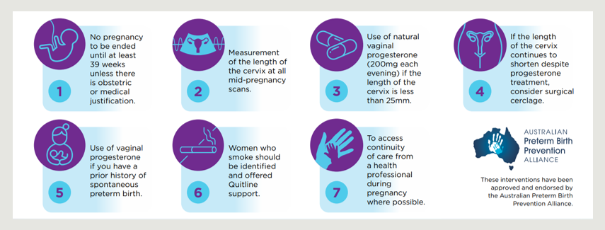
[Detailed image description:
This infographic outlines seven clinical guidelines to prevent preterm birth, endorsed by the Australian Preterm Birth Prevention Alliance. The guidelines cover timing of birth, routine measurement of cervical length in mid‑pregnancy, use of vaginal progesterone based on cervix length, consideration of cervical cerclage when risk remains, progesterone use for women with a prior history of spontaneous preterm birth, smoking cessation support during pregnancy, and access to continuity of care from a health professional where possible.
End of detailed image description]
- Component 1: The Collaborative
The Collaborative was based on IHI’s Breakthrough Series (BTS) Collaborative model, which is designed to produce rapid and effective improvements in clinical practice across healthcare facilities. IHI’s BTS Collaborative model is designed to help organisations close the gap between knowledge and action, by creating a structure in which organisations can easily learn from each other and from recognised experts to make improvements. The Collaborative involved recruiting multidisciplinary teams from maternity services across Australia, who then attended Learning Sessions with experts and other participating teams. Teams also received regular coaching and advice, along with access to their peers to share learnings. Data was collected to analyse the impact of the Collaborative.
Round 1: In Round 1, the Collaborative was delivered across over 60 participating hospitals from 49 healthcare services. WHA, IHI and SCV developed the Collaborative program design, in line with the standard BTS Collaborative model methodology, outlined in Figure 15 SCV’s in-kind support enabled additional 22 hospitals to be enrolled in the Collaborative.
Figure 15 | The Collaborative Model for Round 1

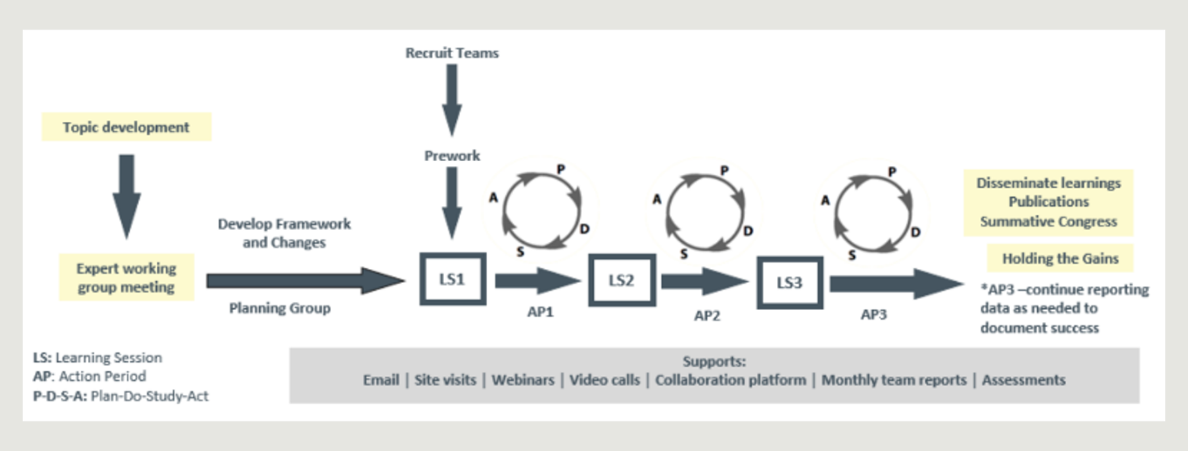
[Detailed image description:
This is a flowchart illustrating the process from topic development to learning sessions and action periods, including Plan‑Do‑Study‑Act cycles for Round 1 of the National Program. The process begins with topic development and expert working group input, followed by framework development and pre‑work for participating teams.
Teams then progress through a series of learning sessions and action periods, supported by repeated Plan‑Do‑Study‑Act cycles. Ongoing supports, such as site visits, webinars, and reporting, are shown throughout the process, with dissemination of learnings, publications, and sustaining gains occurring at the final stage.
End of detailed image description]
Round 2: At the time of writing, Round 2 of the Collaborative was being delivered to over 40 participating hospitals. Round 2 of the Collaborative has leveraged learnings from Round 1, and was designed by IHI with input from WHA and the Alliance. Key dates in the series are outlined in Figure 16.
Figure 16 | The Collaborative Model for Round 2
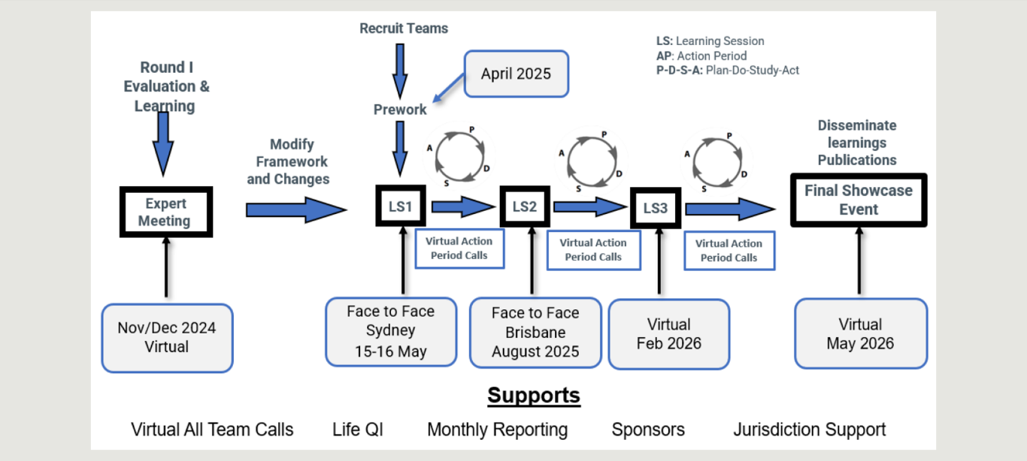
[Detailed image description:
This is a flowchart depicting the project timeline from an expert meeting to a final showcase event, with learning sessions and action periods for Round 2 of the National Program.
The process begins with Round 1 evaluation and learning activities and a virtual expert meeting in late 2024, followed by recruitment of teams and pre‑work activities in early 2025. Teams then progress through a sequence of learning sessions and action periods, supported by Plan‑Do‑Study‑Act cycles, virtual action period calls, and a mix of face‑to‑face and virtual learning events held between May 2025 and February 2026.The timeline concludes with dissemination of learnings through publications and a virtual final showcase event in May 2026, with ongoing supports such as reporting, sponsorship, and jurisdiction support shown throughout.
End of detailed image description]
- Component 2: Jurisdictional programs
Jurisdictional Lead organisations (Jurisdictional Leads) included hospitals, registered charities, research institutes, and government agencies. These were nominated by the National Program partners to run educational and outreach activities and support Collaborative initiatives across each jurisdiction. Jurisdictional Leads received grant funds from the grant recipient (WIRF in Round 1 and WHA in Round 2) and were responsible for supporting learning across maternity services in their jurisdictions, including Collaborative participants and non-participants. The responsibilities shifted slightly between Round 1 and Round 2, reflecting the updated design of the National Program.
Round 1: The Jurisdictional Leads were responsible for conducting four main initiatives:
- establish a team to oversee jurisdictional program activities
- provide clinical leadership and support for hospitals enrolled in the Collaborative
- engage with stakeholders such as remote community health centres and First Nations Communities (depending on the jurisdiction)
- conduct outreach and educational activities in public hospitals regardless of their enrolment in the Collaborative
- evaluate jurisdictional data (depending on the capacity of teams).
Jurisdictional Leads were responsible for providing additional support to services in their jurisdictions, through a range of data collection, education and outreach activities, as seen in Figure 17.
Figure 17 | Jurisdictional Lead activities in Round 1
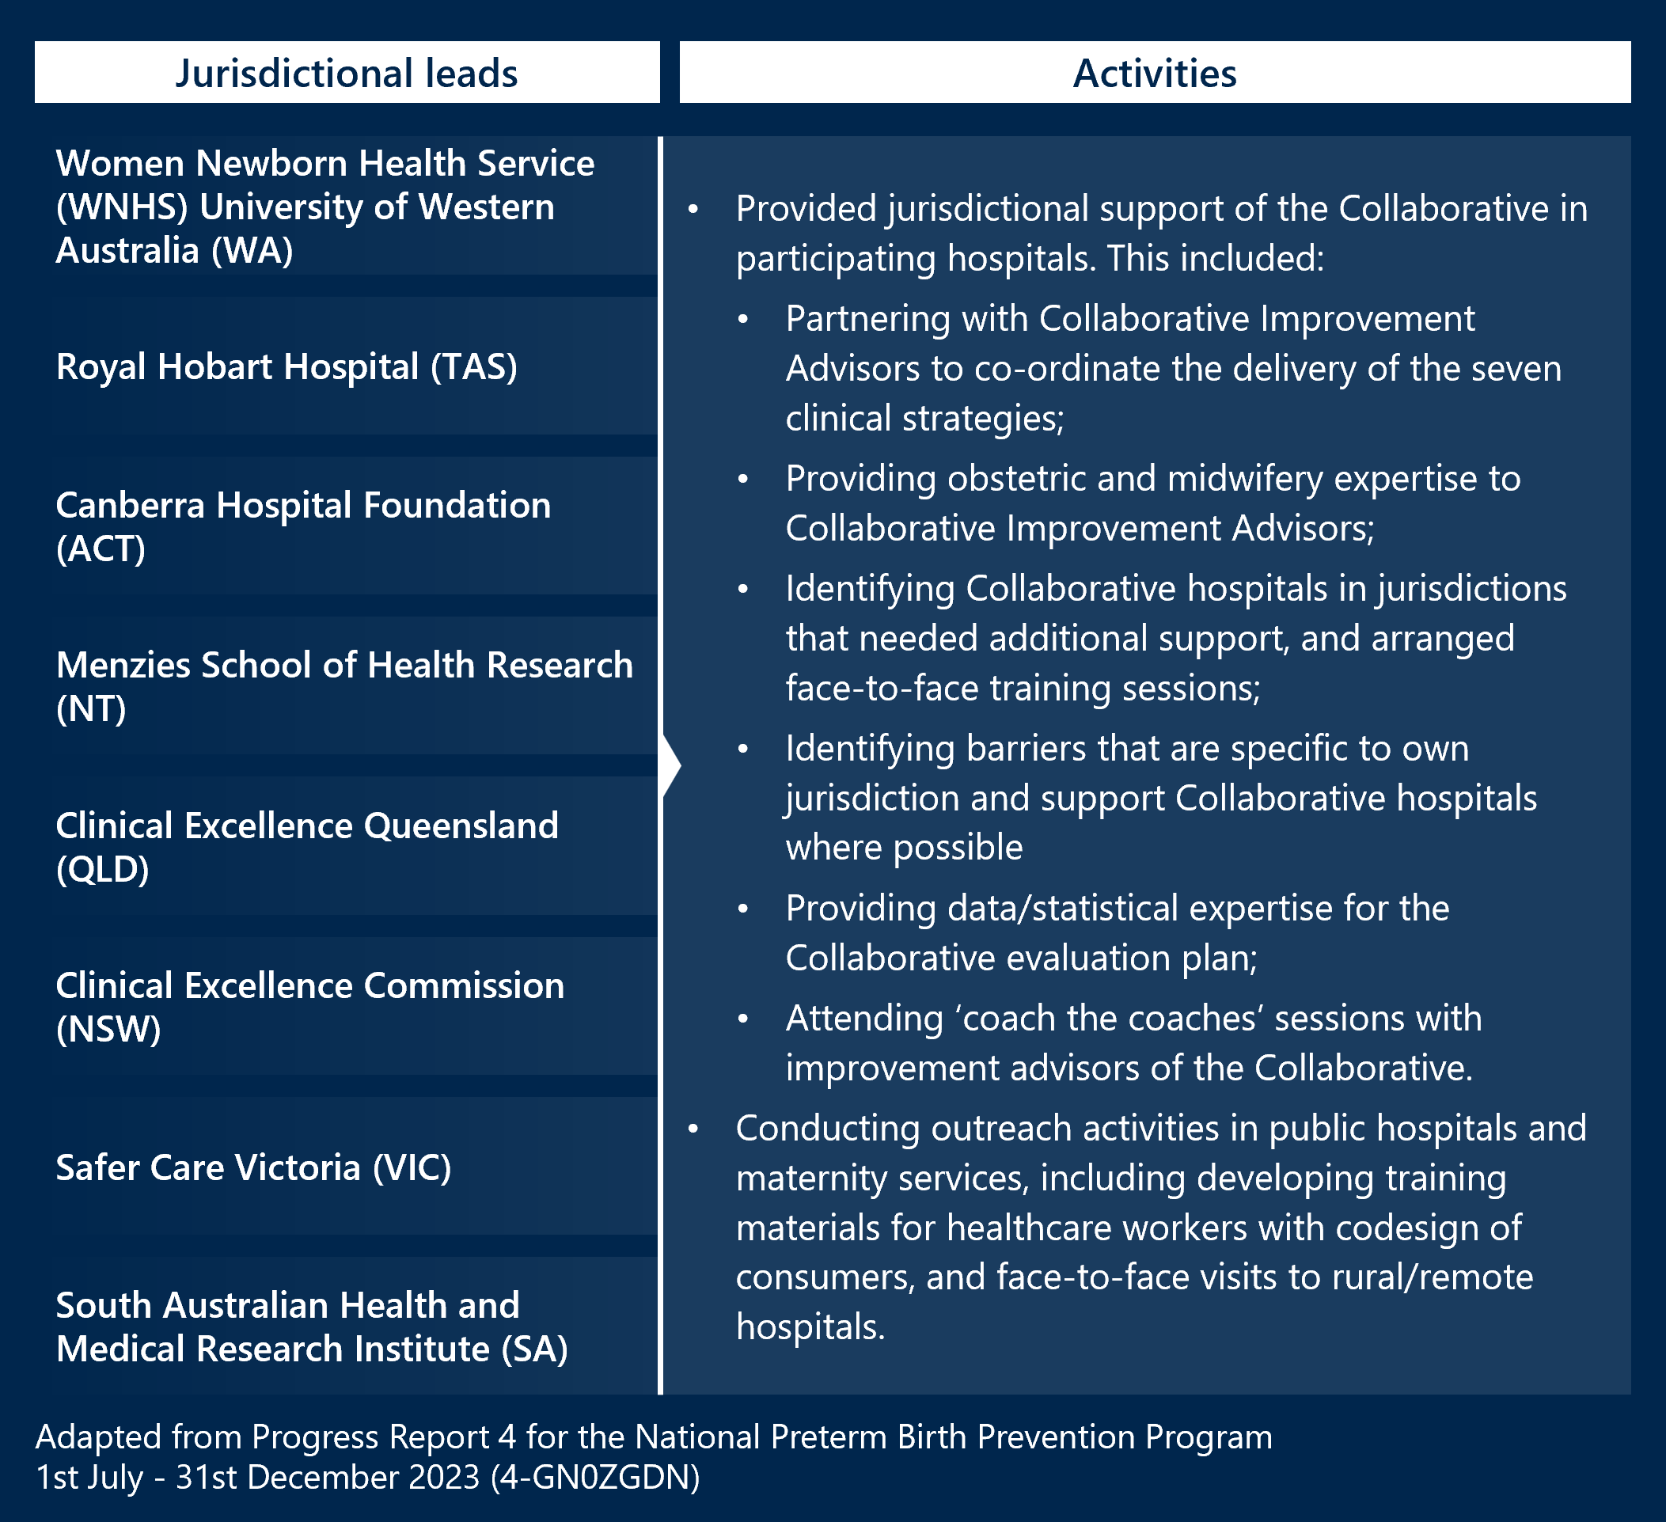
[Detailed image description:
This figure presents a table listing jurisdictional leads and activities in Round 1 of the National Program.
- Jurisdictional leads included:
- Women Newborn Health Service (WNHS)
- University of Western Australia (WA)
- Royal Hobart Hospital (TAS)
- Canberra Hospital Foundation (ACT)
- Menzies School of Health Research (NT)
- Clinical Excellence Queensland (QLD)
- Clinical Excellence Commission (NSW)
- Safer Care Victoria (VIC)
- South Australian Health and Medical Research Institute (SA)
Activities:
- Provided jurisdictional support of the Collaborative in participating hospitals. This included:
- Partnering with Collaborative Improvement Advisors to co‑ordinate the delivery of the seven clinical strategies;
- Providing obstetric and midwifery expertise to Collaborative Improvement Advisors;
- Identifying Collaborative hospitals in jurisdictions that needed additional support, and arranged face‑to‑face training sessions
- Identifying barriers that are specific to own jurisdiction and support Collaborative hospitals where possible
- Providing data/statistical expertise for the Collaborative evaluation plan;
- Attending ‘coach the coaches’ sessions with improvement advisors of the Collaborative.
- Conducting outreach activities in public hospitals and maternity services, including developing training materials for healthcare workers with codesign of consumers, and face‑to‑face visits to rural/remote hospitals.
These were adapted from Progress Report 4 for the National Preterm Birth Prevention Program, 1st July – 31st December 2023 (4‑GNOZGDGN)
End of detailed image description]
Round 2: Responsibilities in Round 2 remained similar to Round 1 for the Jurisdictional Leads, however, some were also responsible for developing specific materials related to the three Pillars. Leads were also responsible for disseminating and promoting public health campaign materials developed for the National Program. This role was not specified in Round 1.
Jurisdictional Lead organisations were provided grants in Round 2 based on a set of performance indicators, outlined in Figure 18.
Figure 18 | Jurisdictional Lead activities in Round 2
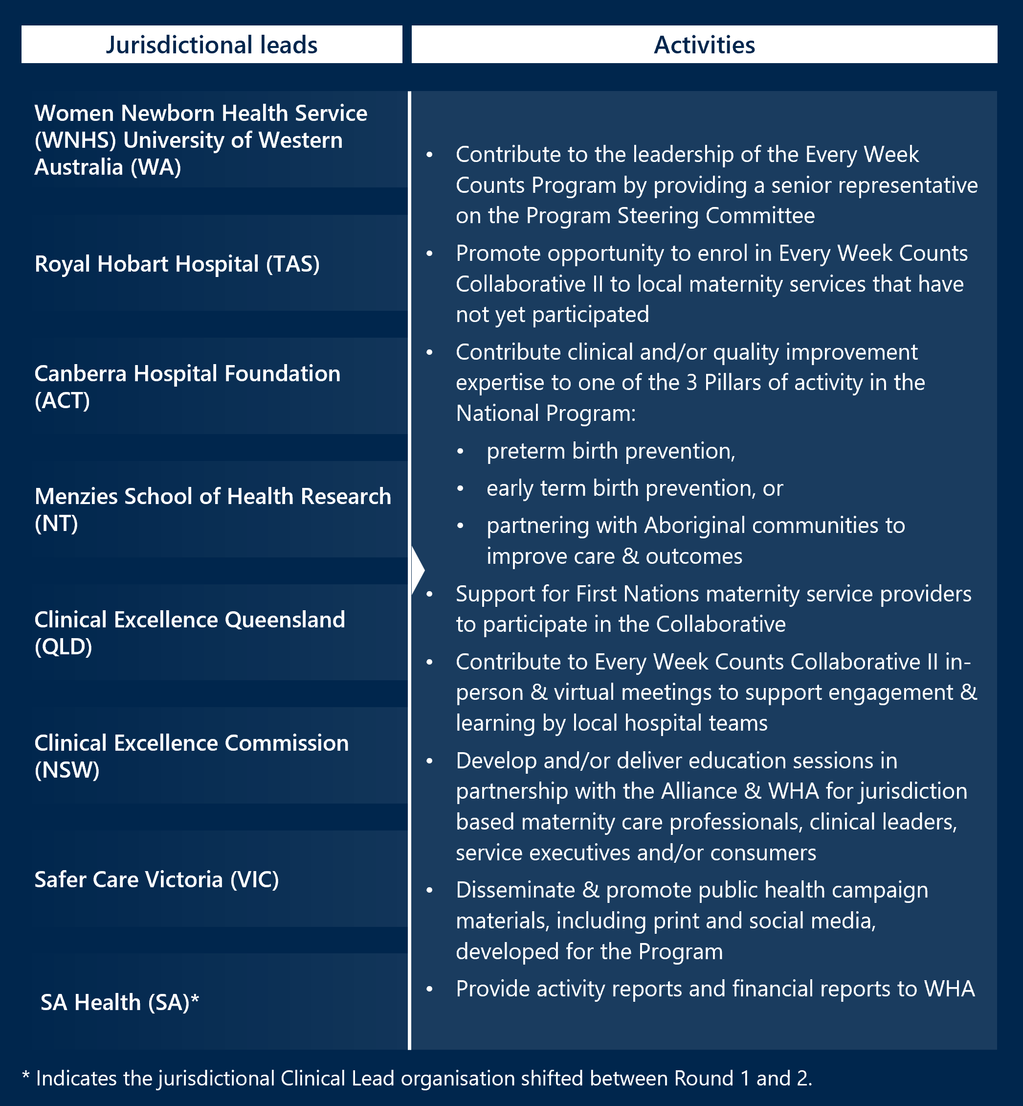
- Component 3: ‘Every Week Counts’ public awareness campaign
The National Program included a social media and marketing campaign aimed at health care providers, women and the Australian public. Promotional materials (such as newsletters, the Every Week Counts website, and information sheets) delivered through this campaign aimed to promote discussion around the timing of birth, increase awareness of early term and PTB reduction strategies, and promote the success of Collaborative activities.
Round 1: In Round 1, the public awareness campaign was developed and delivered by the Alliance Head Office. A Communications Plan was developed in collaboration with the Alliance’s Media and Communications Manager and was approved by the Project Steering Committee on 8 September 2022. Excerpts from the plan are included in Figure 19 Figure 20below for reference.
Figure 19 | Overview of the Round 1 Communications Plan
Aims | Audiences and Channels
- Harness existing leaders in the sector to build will and drive to change, both within participating services as well as outside and beyond the life of the Collaborative  - Build awareness of, and confidence in, the IHI methodology as a mechanism for widescale adoption of evidence-based practice including key decision makers in hospitals, and state and federal governments  - Strengthen the Australian Preterm Birth Prevention Alliance’s profile as a leading expert group on safely preventing preterm and early term birth  - Position WHA, IHI and SCV as leaders in the delivery of quality improvement initiatives in maternity and healthcare, respectively. | Collaborative Participating Teams -  Channels: Email, Life QI  External Stakeholders -  Channels:  - Project update (Shared via email, social media post & page hosted on WHA website)  - Videos – Content recorded at Learning Sessions - Interviews, sections from presentations  - Media releases, website (WHA+ Partner organisations), conferences, articles,  - Content for stakeholder newsletters and editorial to share on websites and social media platforms (consistent use of relevant hashtags)

Round 2: In Round 2, public awareness campaign has been planned by the Alliance Head Office and WHA, with support from Jurisdictional Leads to disseminate promotional materials. A Communications Strategy was developed and approved at the Steering Committee meeting on 29 July 2025, outlined in Figure 20 below. Note that text has been transcribed directly from the strategy.
Compared to Round 1, the Round 2 Communications Strategy offered greater detail and demonstrates ongoing refinement of the National Program – it includes expanded roles and responsibilities, clearer and more detailed audience segmentation, and introduced more structured timing and process steps.
Figure 20 | Overview of the Round 2 Communications Strategy
Aims and Objectives | Target Audiences
- Develop and promote consistent use of key messages  - Empower consumers through informed decision making  - Monitor engagement and measure impact  - Drive uptake, use, and visibility of co-designed resources  - Foster culturally safe and respectful engagement | Consumers  - Women aged between 18-44 years from English-speaking, First Nations (targeted focus women, families, community leaders and elders) or Culturally and Linguistically Diverse backgrounds, and are pregnant or planning to become pregnant  Clinicians  - At hospitals that are involved in the Collaborative during Round 2  - Providing care to pregnant women at any maternity service, including: midwives, obstetricians, GPs providing antenatal care, sonographers, and Aboriginal health workers

- Component 4: Preterm Preeclampsia Screening Implementation Pilot (Round 2 only)
An additional schedule of work was included in the Round 2 to test implementation across different settings of preterm preeclampsia screening and prescribing of low dose aspirin to women who test positive. The aim of the Preterm Preeclampsia Screening Implementation Pilot (the Pilot) is to inform a national rollout of the new screening test, and findings will be summarised in a report.
Nine pilot sites have been invited to participate from diverse maternity care settings, ranging from remote First Nations communities, rural and regional maternity services, to the tertiary care setting.
The scope of the pilot is to:
- Codesign and test an implementation plan for screening for preterm preeclampsia at 11-14 weeks gestation to guide low dose aspirin commencement if screened positive to be at high risk.
- Identify and document the barriers and enablers of implementing preterm preeclampsia screening across varied care settings and providers.
- Develop templates for consumer resources suitable for local adaptation to assist women in making informed decisions about participating in this screening.
The pilot is being overseen and administrated by the Alliance and WHA, with support by an Expert Working Group; key responsibilities of participating stakeholders are outlined in Table 12 pilot itself is unfunded, and each party will bear its own costs associated with participation.
The Pilot’s Project Plan was approved in July 2025. At the time of writing, the Pilot is in early stages of implementation.
Table 12 | Stakeholder roles within the preterm preeclampsia screening implementation pilot
Stakeholder | Role in the Pilot
The Alliance | Provides clinical leadership and oversight for the Pilot Project, as the Pilot Clinical Lead.
WHA | Ensures effective governance and offers administrative support, as the Program Administrator.
Expert Working Group (EWG) | Supports implementation of preterm preeclampsia screening at pilot sites, contributes to consumer resource development, and help identify enablers and barriers to implementation.
EWG Chair | Leads the project and makes decisions in consultation with the Preterm Birth Prevention Program Co-Chairs (Prof John Newnham and Dr Barb Vernon), ensuring delivery aligns with the Project Plan and promotes shared learning.
Pilot Sites | Implements preterm preeclampsia screening to the extent possible and identifies enablers and barriers to implementation. This includes delivering training as required for clinical staff, and sharing insights and learnings for purposes of the evaluation.

- Evaluation approach – Program logic
A program logic establishes an easily understandable relationship between program activities and the intended outcomes of the National Program. The program logic captures the work of the BTS Collaborative model, the public awareness campaign and jurisdictional programs of work, highlighting expected changes and outcomes across three broad categories of stakeholders: women and children, providers and the health system. The program logic for the National Program is displayed overleaf.
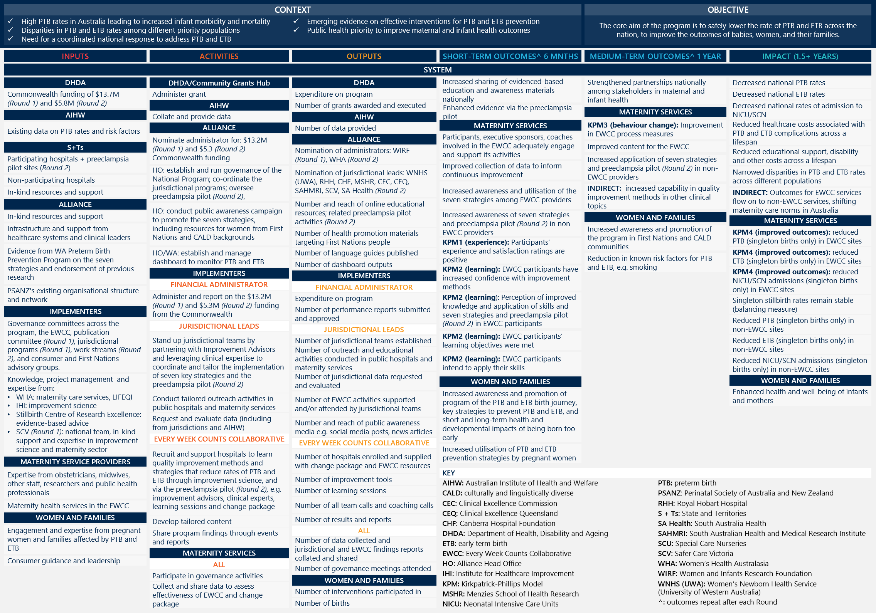
[Detailed image description:
Context
- High PTB rates in Australia leading to increased infant morbidity and mortality
- Disparities in PTB and ETB rates among different priority populations
- Need for a coordinated national response to address PTB and ETB
- Emerging evidence on effective interventions for PTB and ETB prevention
- Public health
Objective
The core aim of the National Program is to safely lower the rate of PTB and ETB across the nation, to improve the outcomes of babies, women, and their families.
Inputs
DHDA
- Australian Government funding of $13.7M (Round 1) and $5.8M (Round 2)
AIHW
- Existing data on PTB rates and risk factors
S+Ts
- Participating hospitals + preeclampsia pilot sites (Round 2)
- Non-participating hospitals
- In-kind resources and support
Alliance
- In-kind resources and support
- Infrastructure and support from healthcare systems and clinical leaders
- Evidence from WA Preterm Birth Prevention Program on the seven strategies and endorsement of previous research
- PSANZ's existing organisational structure and network
Implementers
- Governance committees across the National Program, the EWCC, publication committee (Round 1), jurisdictional programs (Round 1), work streams (Round 2), and consumer and First Nations advisory groups.
- Knowledge, project management and expertise from:
- WHA: maternity care services, LIFEQI
- IHI: improvement science
- Stillbirth Centre of Research Excellence: evidence-based advice
- SCV (Round 1): national team, in-kind support and expertise in improvement science and maternity sector
Maternity service providers
- Expertise from obstetricians, midwives, other staff, researchers and public health professionals
- Maternity health services in the EWCC
Women and families
- Engagement and expertise from pregnant women and families affected by PTB and ETB
- Consumer guidance and leadership

Activities
DHDA/Community Grants Hub
- Administer grant
AIHW
- Collate and provide data
Alliance
- Nominated administrator for: $13.2M (Round 1) and $5.3 (Round 2) Australian Government funding
- HO: establish and run governance of the National Program; co-ordinate the jurisdictional programs; oversee preeclampsia pilot (Round 2)
- HO: conduct public awareness campaign to promote the seven strategies, including resources for women from First Nations and CALD backgrounds
- HO/WA: establish and manage dashboard to monitor PTB and ETB
Implementers
Financial administrator
- Administer and report on the $13.2M (Round 1) and $5.3M (Round 2) funding from the Australian Government
Jurisdictional leads
- Stand up jurisdictional teams by partnering with Improvement Advisors and leveraging clinical expertise to coordinate and tailor the implementation of seven key strategies and the preeclampsia pilot (Round 2)
- Conduct tailored outreach activities in public hospitals and maternity services
- Request and evaluate data (including from jurisdictions and AIHW)
Every week counts collaborative
- Recruit and support hospitals to learn quality improvement methods and strategies that reduce rates of PTB and ETB through improvement science, and via the preeclampsia pilot (Round 2), e.g. improvement advisors, clinical experts, learning sessions and change package
- Develop tailored content
- Share program findings through events and reports
Maternity services
All
- Participate in governance activities
- Collect and share data to assess effectiveness of EWCC and change package

Outputs
DHDA
- Expenditure on program
- Number of grants awarded and executed
AIHW
- Number of data provided
Alliance
- Nomination of administrators: WIRF (Round 1), WHA (Round 2)
- Nomination of jurisdictional leads: WNHS (UWA), RHH, CHF, MSHR, CEC, CEQ, SAHMRI, SCV, SA Health (Round 2)
- Number and reach of online educational resources; related preeclampsia pilot activities (Round 2)
- Number of health promotion materials targeting First Nations people
- Number of language guides published
- Number of dashboard outputs
Implementers
Financial administrator
- Expenditure on program
- Number of performance reports submitted and approved
Jurisdictional leads
- Number of jurisdictional teams established
- Number of outreach and educational activities conducted in public hospitals and maternity services
- Number of jurisdictional data requested and evaluated
- Number of EWCC activities supported and/or attended by jurisdictional teams
- Number and reach of public awareness media e.g. social media posts, news articles
Every week counts collaborative
- Number of hospitals enrolled and supplied with change package and EWCC resources
- Number of improvement tools
- Number of learning sessions
- Number of all team calls and coaching calls
- Number of results and reports
All
- Number of data collected and jurisdictional and EWCC findings reports collated and shared
- Number of governance meetings attended
Women and families
- Number of interventions participated in
- Number of births

Short-term outcomes 6 months
- Increased sharing of evidenced-based education and awareness materials nationally
- Enhanced evidence via the preeclampsia pilot
Maternity services
- Participants, executive sponsors, coaches involved in the EWCC adequately engage and support its activities
- Improved collection of data to inform continuous improvement
- Increased awareness and utilisation of the seven strategies among EWCC providers
- Increased awareness of seven strategies and preeclampsia pilot (Round 2) in non-EWCC providers
- KPM1 (experience): Participants’ experience and satisfaction ratings are positive
- KPM2 (learning): EWCC participants have increased confidence with improvement methods
- KPM2 (learning): Perception of improved knowledge and application of skills and seven strategies and preeclampsia pilot (Round 2) in EWCC participants
- KPM2 (learning): EWCC participants’ learning objectives were met
- KPM2 (learning): EWCC participants intend to apply their skills
Women and families
- Increased awareness and promotion of program of the PTB and ETB birth journey, key strategies to prevent PTB and ETB, and short and long-term health and developmental impacts of being born too early
- Increased utilisation of PTB and ETB prevention strategies by pregnant women

Medium-term outcomes 1 year
- Strengthened partnerships nationally among stakeholders in maternal and infant health
Maternity services
- KPM3 (behaviour change): Improvement in EWCC process measures
- Improved content for the EWCC
- Increased application of seven strategies and preeclampsia pilot (Round 2) in non-EWCC providers
- Indirect: increased capability in quality improvement methods in other clinical topics
Women and families
- Increased awareness and promotion of the National Program in First Nations and CALD communities
- Reduction in known risk factors for PTB and ETB, e.g. smoking

Impact (1.5+ years)
- Decreased national PTB rates
- Decreased national ETB rates
- Decreased national rates of admission to NICU/SCN
- Reduced healthcare costs associated with PTB and ETB complications across a lifespan
- Reduced educational support, disability and other costs across a lifespan
- Narrowed disparities in PTB and ETB rates across different populations
- Indirect: Outcomes for EWCC services flow on to non-EWCC services, shifting maternity care norms in Australia
Maternity services
- KPM4 (improved outcomes): reduced PTB (singleton births only) in EWCC sites
- KPM4 (improved outcomes): reduced ETB (singleton births only) in EWCC sites
- KPM4 (improved outcomes): reduced NICU/SCN admissions (singleton births only) in EWCC sites
- Singleton stillbirth rates remain stable (balancing measure)
- Reduced PTB (singleton births only) in non-EWCC sites
- Reduced ETB (singleton births only) in non-EWCC sites
- Reduced NICU/SCN admissions (singleton births only) in non-EWCC sites
Women and families
- Enhanced health and well-being of infants and mothers

Key:
AIHW: Australian Institute of Health and Welfare
CALD: culturally and linguistically diverse
CEC: Clinical Excellence Commission
CEQ: Clinical Excellence Queensland
CHF: Canberra Hospital Foundation
DHDA: Department of Health, Disability and Ageing
ETB: early term birth
EWCC: Every Week Counts Collaborative
HO: Alliance Head Office
IHI: Institute for Healthcare Improvement
KPM: Kirkpatrick-Phillips Model
MSHR: Menzies School of Health Research
NICU: Neonatal Intensive Care Units
PTB: preterm birth
PSANZ: Perinatal Society of Australia and New Zealand
RHH: Royal Hobart Hospital
S + Ts: State and Territories
SA Health: South Australia Health
SAHMRI: South Australian Health and Medical Research Institute
SCU: Special Care Nurseries
SCV: Safer Care Victoria
WHA: Women’s Health Australasia
WIRF: Women and Infants Research Foundation
WNHS (UWA): Women’s Newborn Health Service (University of Western Australia)
End of detailed image description]

- Key Evaluation Questions and data matrix
The key evaluation questions and data matrix below provides a summary of the data sources the evaluation will use to answer the KEQs and research questions
Key Evaluation Question
1. Appropriateness
How appropriate is the National Program to achieve the intended outcomes (Round 1 and Round 2)?
Research Questions
1.1 What is critical to understand about the context in which the National Program was implemented?
1.2 How appropriate is the National Program’s design? (And in consideration of different services, across public and private settings, and for priority populations as identified in the National Women’s Health Strategy 2020-2030, Woman-Centred Care: Strategic Directions for Australian Maternity Services, and the National Stillbirth Action and Implementation Plan). What are the key features, enabling factors or challenges to overcome?
1.3 How appropriate was the design of the funding arrangements and governance structures, and why?
1.4 To what extent was the National Program evidence-based?
Table 13 | Data sources for KEQ 1
Q | Program Documents | External Literature | Program Data | System Data | Stakeholder Engagements | Maternity Services Survey | Prior Evaluations
1.1 | ü | ü |  |  | ü
1.2 | ü | ü |  |  | ü | ü | ü
1.3 | ü |  |  |  | ü |  | ü
1.4 | ü | ü |  |  | ü |  | ü

Key Evaluation Question
2. Efficiency and Effectiveness
How effectively was the National Program implemented (Round 1 and Round 2)?
Research Questions
2.1 How effective was the National Program in reducing the rate of preterm and early-term birth in participating maternity services? What worked well and what could have been improved?
2.2 How effective and efficient were the governance structures to guide the National Program in an objective and transparent way? Why?
2.3 How effective were funding arrangements, and why?
2.4 How did the strategies adopted by each maternity service and jurisdiction differ? How were they the same? Were any strategies more successful than others, and why? (incl. for particular services, across public and private settings, regions and cohorts).
2.5 What were the key mechanisms and/or approaches that helped embed best practice? Were specific mechanisms adopted more firmly than others, and if so, why?
Table 14 | Data sources for KEQ 2
Q | Program Documents | External Literature | Program Data | System Data | Stakeholder Engagements | Maternity Services Survey | Prior Evaluations
2.1 |  |  | ü | ü | ü | ü | ü
2.2 | ü | ü |  |  | ü |  | ü
2.3 | ü |  | ü |  | ü |  | ü
2.4 | ü |  | ü |  | ü | ü | ü
2.5 | ü |  |  |  | ü | ü | ü

Key Evaluation Question
3. Outcomes and Impact
To what extent did the National Program achieve its intended outcomes and impact
(Round 1 and 2)?
Research Questions
3.1 What are the key outputs from Round 1 and Round 2? What was the national reach and coverage of the National Program?
3.2 To what extent were intended outcomes achieved in Round 1 and Round 2, and why? This includes across jurisdictions, participating services, across public and private settings, regions and for population cohorts, including First Nations communities.
3.3 What unintended outcomes, if any, were observed, and why did they occur?
3.4 What were the barriers and enablers to achieving intended outcomes? How were the barriers addressed?
3.5 To what extent can observed outcomes be contributed back to the National Program itself, which element of the National Program, and why?
3.6 To what extent did the implementation of the National Program improve the preventative care for preterm and early-term birth in maternity services that did not participate in the National Program (i.e. was there a flow-on effect?).
3.7 To what extent did the National Program contribute to government policy and progress against the Woman-Centred Care: Strategic Directions for Australian Maternity Services?
3.8 How sustainable are the outcomes achieved through the National Program, and why? Does this vary across implementation settings or elements of the National Program?
Table 15 | Data sources for KEQ 3
Q | Program Documents | External Literature | Program Data | System Data | Stakeholder Engagements | Maternity Services Survey | Prior Evaluations
3.1 |  |  | ü | ü | ü | ü
3.2 |  |  | ü | ü | ü | ü | ü
3.3 |  |  | ü | ü | ü |  | ü
3.4 | ü |  | ü |  | ü | ü | ü
3.5 |  |  | ü | ü | ü | ü
3.6 |  |  | ü | ü | ü |  | ü
3.7 | ü | ü |  |  | ü
3.8 | ü |  | ü |  | ü | ü | ü

Key Evaluation Question
4. Value
To what extent did the National Program provide value-for-money through effective funding arrangements?
Research Questions
4.1 How did the National Program complement other existing preterm and early-term birth prevention strategies, initiatives and programs?
4.2 How efficiently was each element of the National Program administered through National Program funding?
4.3 To what extent has the National Program embedded change for sustainable system impact?
4.4 How cost effective was the National Program (Round 1)?
Table 16 | Data sources for KEQ 4
Q | Program Documents | External Literature | Program Data | System Data | Stakeholder Engagements | Maternity Services Survey | Prior Evaluations
4.1 | ü |  | ü |  | ü | ü
4.2 | ü | ü | ü |  | ü |  | ü
4.3 |  |  |  |  | ü | ü
4.4 |  |  |  |  |  |  | ü

Key Evaluation Question
5. Lessons learned
How could the National Program be improved?
Research Questions
5.1 Are there any lessons from Round 1 (2022 to 2024) that can be applied for Round 2 (2024-2026)? How did Round 1 of the National Program impact the delivery of Round 2 of the National Program (positively or negatively)? Were any efficiencies or improvements observed (for whom, across which jurisdictions and services, across public and private settings and cohorts)?
5.2 How could the National Program be improved based on lessons learned? What are the options for improving the sustainability of the National Program outcomes, with consideration across jurisdictions, services, regions, across public and private settings, and cohorts?
Table 17 | Data sources for KEQ 5
Q | Program Documents | External Literature | Program Data | System Data | Stakeholder Engagements | Maternity Services Survey | Prior Evaluations
5.1 | ü |  | ü | ü | ü | ü
5.2 | ü | ü | ü |  | ü | ü | ü

- Supporting information
- Round 1 Jurisdictional program activity examples
Across each jurisdiction, the aim of the outreach events was to educate staff about the seven clinical strategies. Examples undertaken by each Jurisdictional Lead team in Round 1 are included below as examples:
- New South Wales held a forum on the 21st of February 2024 with 250 healthcare workers from both Collaborative and non-Collaborative hospitals, including many from rural New South Wales sites.
- Northern Territory facilitated multiple face-to-face community consultation Yarning Circles in Darwin, Katherine, Nhulunbuy and Wurrumiyanga (Tiwi Islands).
- Queensland provided an education session to private obstetricians in QLD regarding the seven interventions of the National Program.
- South Australia conducted a regional educational roadshow, including events at Barossa Hills Fleurieu LHN (BHFLHN), Flinders Upper North LHN (FUNLHN), Limestone Coast LHN (LCLHN), Riverland Mallee Coorong Local Health Network (RMCLHN), Yorke and Northern LHN (YNLHN).
- Tasmania medical lead incorporated data into monthly meetings at Royal Hobart Hospital that has now become core business.
- Victoria provided two virtual education sessions and rolled out the Preterm Birth Prevention Education Program in metropolitan Melbourne and regionally to a total of 570 attendees.
- Western Australia’s Prof John Newnham (Clinical lead of WA) joined with other jurisdictions for outreach activities including information sessions at Thursday Island with CEQ; presenting on the National Program to the Private Obstetric Alliance in May 2024 with CEQ; presenting with SCV at Melbourne and Bendigo outreach events.
- Round 2 Yarning Circle
The Round 2 Yarning Circle was held in March 2025 in Brisbane and led by Professor Cath Chamberlain from the University of Melbourne. The Yarning Circle’s aim was to seek advice from First Nations leaders and experts on critical next steps for maternity services across Australia, to ensure all First Nations women and families have access to culturally safe, trauma-informed maternity care. Attendees included representatives from national organisations, such as National Aboriginal Community Controlled Health Organisation (NACCHO), as well as representatives from organisations based in NSW, NT, Qld, SA, Vic, and WA.
Learnings from the Yarning Circle informed the Driver Diagram of the First Nations Pillar, which is based on the RISE Framework’s four Pillars to drive reform, including: (1) Redesign the health service; (2) Invest in the workforce; (3) Strengthen families; and, (4) Embed Aboriginal and/or Torres Strait Islander community governance and control.
- Round 2 Consumer Advisory: The Lived Experience Collective
The Lived Experience Collective includes a diverse range of women with lived experience, including First Nations representatives, who will meet formally six times over Round 2 of the National Program and are remunerated for their time, and track any in-kind support.
Key responsibilities include to:
- provide insights and feedback across all communications, including social media posts, and documents developed by the Collaborative
- proactively reach out to their own networks to gather additional feedback on work
- facilitate and participate in focus groups on key areas relevant to early term and PTB, including gestational diabetes, preeclampsia, and general screening.
- Strategy alignment of the National Program
The National Program is broadly aligned with national maternal initiatives relevant to PTB and is likely to complement their implementation. The National Program was developed within a women-focussed policy context, with a number of Australia women’s health strategies having recently been released. Table 18 summaries National Program strategy alignment across improving maternal health, use of best-practice and evidence-based initiatives, and ensuring culturally safe and informed care, including to address inequities faced by First Nations communities.
Table 18 | Australian PTB prevention strategies adjacent to the National Program
Strategy | National Program’s contribution to strategy
National Women’s Health Strategy 2020-2030 | The National Program’s aim to safely lower the rate of PTB aligns with Priority Area 1 - Maternal, sexual and reproductive health, as PTB is a cause of adverse maternal and neonatal outcomes.
Woman-Centred Care: Strategic Directions for Australian Maternity Services 2019 | The National Program strongly contributes to six out of 12 Strategic Directions, and the values and principles to advance evidence-based, collaborative, and woman-focused approaches to maternity-care. This includes across:  - Strategic Direction 1 – Ensure evidence underpins the design, development and provision of services and continuous quality improvement.  - Strategic Direction 2 – Service providers implement measures to reduce the rates of stillbirth and maternal and neonatal morbidity and mortality in partnership with women.  - Strategic Direction 3 – Develop and implement culturally safe, evidence-based models of care in partnership with Aboriginal and Torres Strait Islander people and communities.  - Strategic Direction 6 – Respect women’s choices, experiences and outcomes and use woman-reported data to inform quality improvement in maternity care.  - Strategic Direction 7 – Promote a positive maternity workforce culture based on interdisciplinary collaboration and communication.  - Strategic Direction 9 – Improve availability of high quality evidence-based, easily understood information about choices in care and associated outcomes during the perinatal period.
National Stillbirth Action and Implementation Plan 2020 | The National Program intersects with the first priority area of this plan. That is, the National Program also focusses on supporting women to stop smoking in pregnancy and shared decision-making around the timing of birth. This is outlined in Action Area 1 (Implementing best practice in stillbirth prevention) of Priority Area 1 (Ensuring high quality stillbirth prevention and care).
National Medical Workforce Strategy 2021–2031 | The National Program contributes broadly with Priority Three (Reform the training pathways) of this strategy, with a specific focus on improving health care professional awareness and education on culturally safe care on maternity health and PTB prevention, especially for First Nations women. Specifically, it aligns with Action 15 of Priority Three, which involves culturally safe training, training in cultural safety, and expertise in Aboriginal and Torres Strait Islander health.
National Agreement on Closing the Gap | The National Program aligns broadly with this strategy, specifically with Outcome 2 (Aboriginal and Torres Strait Islander Children are born healthy and strong). Key areas of alignment include providing culturally safe care, supporting Birthing on Country models of care, addressing maternal smoking, and support to partner and grow the First Nations maternal health workforce.
National Aboriginal and Torres Strait Islander Health Workforce Strategic Framework and Implementation Plan 2021-2031 | The National Program aligns broadly with one of the strategic directions of the implementation plan. Specifically, it aligns with Strategic Direction 1: Aboriginal and Torres Strait Islander people are represented and supported across all health disciplines, roles and functions. For example, the National Program involves First Nations lived experience representatives (via the First Nations Advisory Group) to provide guidance to participating services, and also includes activities to uplift the capability and capacity of health professionals through Learning Sessions with First Nations experts.
National Aboriginal and Torres Strait Islander Health Plan 2021-2031 | The National Program contributes to the delivery of culturally safe care to address the needs of First Nations mothers, families and babies. For example, the Collaborative partners with First Nations Elders and communities to deliver and develop services that offer First Nations women access to First Nations-led, continuous maternity care. The Collaborative has provided tools and resources to help services improve the cultural safety of their services.  The National Program particularly aligns with the following focus areas:  - Objective 4.2. – Deliver targeted, needs-based and community-driven activities to support healthy babies.  - Priority 4: Health promotion – such as birthing on Country services, and culturally safe, accessible and affordable reproductive and antenatal care to help prevent preterm birth.
Stronger Rural Health Strategy 2018-2028 | The National Program largely aligns to strengthen the quality of the rural workforce and its aims to deliver more multidisciplinary, team-based models in care. However, the National Program does not align specifically across the Stronger Rural Health Strategy’s incentives, targeted funding and bonding arrangements.
Cultural Respect Framework for Aboriginal and Torres Strait Islander Health 2016-2026 | The National Program aligns broadly with most domains of this framework.  The National Program’s partnerships with First Nations Elders and communities and the First Nations Advisory group for the Collaborative, aligns with:  - Domain 1: Whole-of-organisation approach (focus area: governance and leadership)  - Domain 5: Stakeholder partnerships and collaboration in commitment (focus area: Stakeholder engagement and relationships)  The National Program’s First Nations-specific initiatives guided by First Nations health professionals, such as Dr Kiarna Brown, aligns with:  - Domain 3: Workforce development and training (focus area: Aboriginal and Torres Strait leadership)  - Domain 4: Consumer participation and engagement (focus area: Consumer informed performance measurement and evaluation)  The National Program’s Learning Sessions with First Nations experts to improve the experiences and outcomes of maternity care for First Nations women, their families and communities, aligns with:  - Domain 6 Data, planning, research and evaluation (focus area Data, Information and planning).

- ‘Every Week Counts’ Round 1 outputs
The National Program delivered a range of promotional materials for the ‘Every Week Counts’ public awareness campaign across Round 1. Promotion occurred across various advertising and news organisations, and social media channels. The campaign reportedly met or exceeded performance measures specific to this campaign.
A selection of printed materials from Round 1 are included in Figure 21 below for reference. Note that key materials were centrally developed by the Alliance, while others were developed by Jurisdictional Leads for the tailored needs of jurisdictions. For example, the See, Stop, Scan campaign, included in Figure 21, was developed by the Child and Maternal Health Division, Menzies School of Health Research in the NT, and focuses on select strategies, including continuity of care, smoking cessation and scans.
Table 19 provides an overview of the reach of the outputs of the campaign, and

Table 20 provides an overview of the number of outputs that were delivered, as reported in the National Program Progress Reports.
Figure 21 | Examples of print materials as part of the public awareness campaign
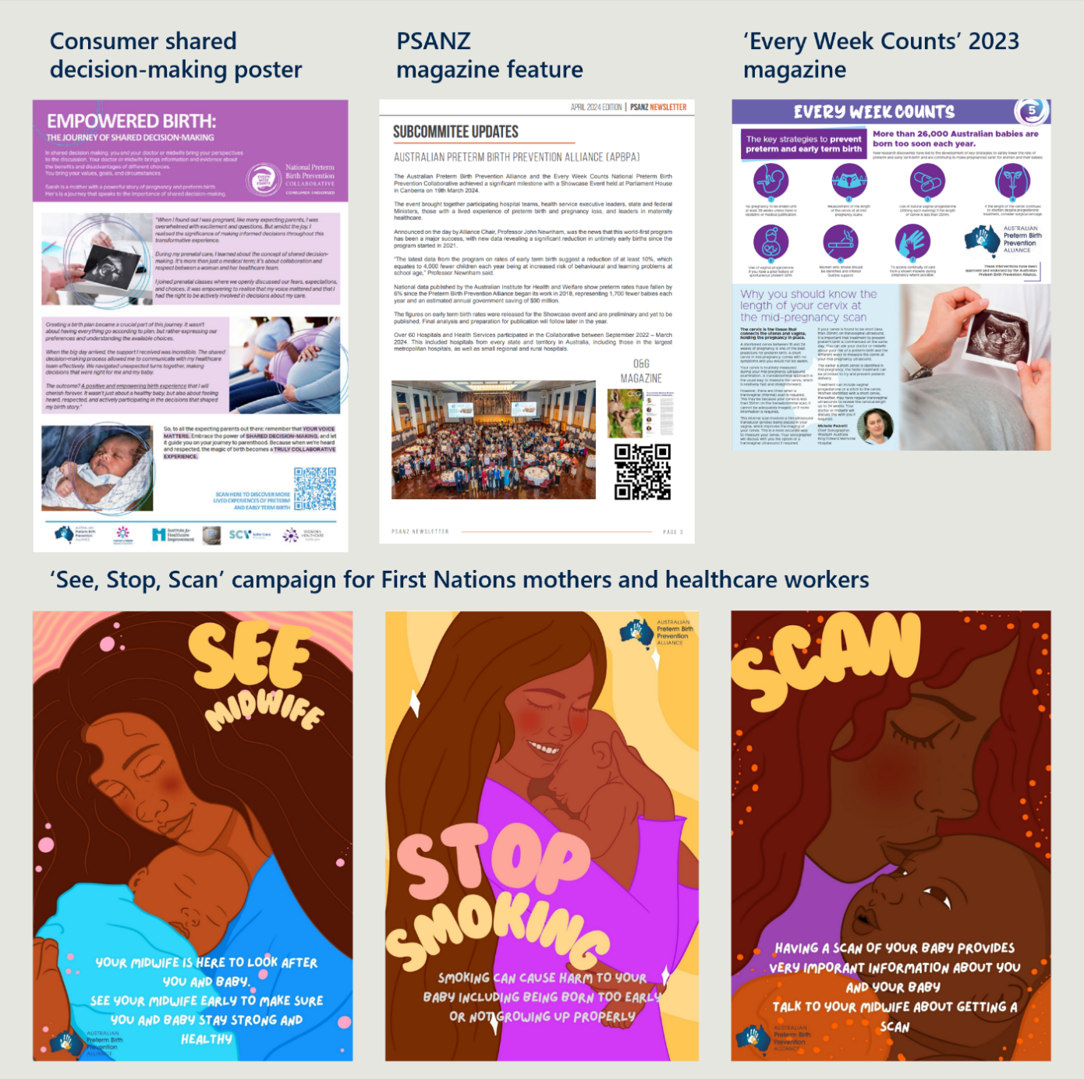
Table 19 | Reach of outputs for the public awareness campaign across Round 1
Advertising
Type | Duration | Total impressions | Social reach | Clicks | Views
Homepage takeover (The West Australian) | July 2022–December 2022 | 532,698 | N/A | 177 | N/A
Ripple native campaign 1 | July 2022–December 2022 | 1,700,000 | N/A | 1,643 | N/A
Ripple native campaign 2 | 2 June 2023–20 June 2023 | 1,055,092 | N/A | 1,719 | N/A
Ripple Native campaign 3 | 14 June 2024–30 June 2024 | 910, 757 | N/A | 1,642 | N/A
Native content campaign | 2 June 2023–23 June 2023 | N/A | 21,000 | N/A | 8, 187
Targeted display campaign 1 | 26 May 2023–23 June 2023 | 194,235 | N/A | 185 | N/A
Targeted display campaign 2 | 14 June 2024–30 June 2024 | 138,888 | N/A | 138 | N/A
7News display | 26 June 2024–11 July 2024 | 666,742 | N/A | 451 | N/A
Social media
Type | Duration | Total impressions | Social reach | Clicks | Views
Social engagement campaign 1 | July 2022–December 2022 | 38,000 | 37,714 | 3, 437 | N/A
Social engagement campaign 2 | 2 June 2023–23 June 2023 | 74,040 | 21,056 | 2,896 | N/A
Social engagement campaign 3 | 17 November 2023–8 December 2023 | N/A | 32,924 | 1,674 | 1,761
Social engagement campaign 4 | 14 June 2024–5 July 2024 | 103,438 | 55,624 | 4,636 | N/A
Twitter | 1 July 2022–31 December 2022 | 25,200 | N/A | N/A | N/A
YouTube channel | May 2023–present | N/A | N/A | N/A | 1,106

Online and print media articles
Type | Duration | Total impressions | Social reach | Clicks | Views
Perth Now News Article | July 2022–December 2022 | N/A | 38,000 | N/A | 7,741
The West Australian Article | 17 November 2023–8 December 2023 | N/A | 34,900 | N/A | 4,089
The West Australian Article | 14 June 2024–5 July 2024 | N/A | 55,000 | N/A | 10,193
Two paper insertions in the West Australian | May 2023–June 2023 | 665,000 | N/A | N/A | N/A
Two paper insertions in the West Australian | June 2024–July 2024 | 282,000 | N/A | N/A | N/A
Additional online and print media articles: The Australian, National Indigenous Times, NT News, UWA News, ANJM, AMA |  |  | Additional online media print articles were circulated, but reach/ views not available or collected.

Table 20 | Number of outputs for the public awareness campaign across Round 1
Consumer-specific resources
Output | Number of outputs | Duration / date | Comments
Magazine | 230,000 printed copies | February 2022–June 2024 | Magazines were distributed across Australia via newspapers, medical centres, and consumer representative organisations
Every Week Counts National Collaborative Newsletter | 5 editions | February 2022–June 2024 | This newsletter was sent to key Collaborative partners and stakeholders across Round 1
‘Let’s Talk Timing of Birth’ & ‘Every Week Counts’ brochures | 14,500 copies | February 2022–June 2024 | N/A
Consumer shared decision-making brochure | 1 | February 2022–June 2024 | N/A
Consumer shared decision-making poster | 1 | February 2022–June 2024 | N/A
‘Progesterone Use In Pregnancy’ tri-fold brochure | 1 | January 2023–June 2023 | N/A
Consumer Advisory Group supporting material: Collaborative consumer engagement map | 1 | July 2023–December 2023 | N/A
Consumer Advisory Group supporting material: Empowered Birth: The Journey of Shared Decision-Making | 1 | July 2023–December 2023 | N/A

Media
Output | Number of outputs | Duration / date | Comments
Media and op releases | 7 | July 2023–December 2022 | N/A
Media and op releases | 6 | January 2023–June 2023 | N/A
Media and op releases | 3 | July 2023–December 2023 | N/A
Media and op releases | 9 | January 2024–June 2024 | N/A
Media and print clippings | 4 | January 2023–June 2023 | N/A
Home page takeover | 1 | July 2022–December 2022 | This was done for ‘The West Australian’
Online media articles - ABC Online | 1 | March 2024 | ABC Online
Online media articles - NT News | 2 | Date not available | NT News
Online media articles - National Indigenous Times | 2 | May 2022  March 2023 | National Indigenous Times
Online media articles - Perth Now | 1 | Date not available | Perth Now
Online media articles - The West Australian | 4 | July 2022  June 2023  November 2023  June 2024 | The West Australian
Newspaper insertions | 4 | - Two during June 2024–July 2024  - Two during May 2023–June 2023 | Insertions were included in ‘The West Australian’
Newspaper print - The Australian | 1 | Date unknown | The Australian
Newspaper print - Koori Mail | 1 | November 2024 | Koori Mail
Newspaper print - Gelong Advertiser | 1 | September 2023 | Gelong Advertiser
Newspaper print - Torres News | 1 | May 2024 | Torres News
Newsletter / Journal feature articles - PSANZ newsletter: | 1 | December 2023 | RANZCOG newsletter: One three-page feature article
Newsletter / Journal feature articles - | 1 | April 2024 | PSANZ newsletter: One feature article. A link to this feature article was included in the Royal Australian and New Zealand College of Obstetricians and Gynaecologists (O&G) Magazine
Newsletter / Journal feature articles - UWA News: Online blog post | 1 | December 2022 | UWA News: Online blog post
Newsletter / Journal feature articles - ANJM: Online article (falls outside of Round 1) | 1 | November 2024 | ANJM: Online article (falls outside of Round 1)
Newsletter / Journal feature articles - AMA: Online article | 1 | December 2022 | AMA: Online article
Television news - 7 News | 1 | 2023 (month unknown) | 7 News
Television news - ABC TV (national) | 1 | 2024 (month unknown) | ABC TV (national)
Television news - ABC TV (Canberra) | 1 | March 2024 | ABC TV (Canberra)
Radio - 6PR Perth Today (10 mins) | 1 | June 2022 | 6PR Perth Today (10 mins)
Radio - Drivetime Radio (27 minutes) | 1 | November 2022 | Drivetime Radio (27 minutes)
Radio - ABC Radio National (16 min) | 1 | March 2024 | ABC Radio National (16 min)
Videos created by Alliance | 4 | January 2023–June 2023 | N/A
Advertisements
Output | Number of outputs | Duration / date | Comments
Ripple native advertisements | Campaign one: 4 types of advertisements | July 2022–December 2022 | N/A
Ripple native advertisements | Campaign two: 2 types of advertisements | 2 June 2023–29 June 2023 | N/A
Ripple native advertisements | Campaign three: 4 types of advertisements | 14 June 2024–30 June 2024 | N/A
Targeted displays | 3 | This occurred across:  - 26 May 2023–23 June 2023  - 14 June 2024–30th June 2024  - 26th June 2024–11th July 2024 | N/A
Other
Output | Number of outputs | Duration / date
National program exhibitor stalls | 5 | - November 2022: The inaugural Western Australian Safer Baby Bundle Learning Forum (Perth)  - 2023: King Edward Memorial Hospital (WA) for World Prematurity Day  - 2023: Royal Darwin Hospital (NT)  - February 2024: The inaugural Every Week Counts: NSW Preterm Birth Prevention and Safer Baby Bundle Forum (Sydney)  - 2024: King Edward Memorial Hospital (WA) for World Prematurity Day

- AIHW data and notes
AIHW data was analysed as part of the development of this report. For clarity, all notes pertaining to the AIHW data have been included in this section, and have been considered in the interpretation of the analysis findings.
Please access the PDF copy of this report to view accessible versions of these AIHW data tables.

Table 2.12 - Women who gave birth, by number of antenatal visits, 2018 to 2023
Year | Disaggregation | Description | Number | Per cent | Age stand. Rate
2018 | Smoked | Total | 21497 | 7.2 | 10.2
2019 | Smoked | Total | 20784 | 7.0 | 10.1
2020 | Smoked | Total | 19908 | 6.8 | 10.2
2021 | Smoked | Total | 13649 | 6.4 | 9.6
2022 | Smoked | Total | 12292 | 6.1 | 9.0
2023 | Smoked | Total | 15040 | 5.5 | 8.4

(a) Women who gave birth at 32 weeks or more gestation to a live birth or a stillbirth, with known number of antenatal visits (includes women with no antenatal care).
(b) Excludes records for which gestational age was not stated or unknown.
(c) Denominator includes women with a not stated number of antenatal visits. As a result, percents may not sum to 100.
(d) For the ACT, in many cases, early antenatal care provided by the woman’s general practitioner is not reported.
(e) For NT, ‘Not stated’ includes antenatal care where attendance is evident by the availability of antenatal screening results, but the total number of antenatal visits is unknown.
(f) Data excludes ACT in 2023. Care should be taken when comparing data across time.
(g) Data for births occurring during the 2022 calendar year are based on complete data for 7 jurisdictions and a compilation of data for the ACT. The ACT's data consists of their 2022 data for January to October, supplemented by their 2021 data for November and December. Care should be taken if comparing data across time.
Notes
1. Results based on very small numbers (fewer than 5 events) are not published (n.p.). Results based on denominators of less than 100 are not published (n.p.) for reliability reasons.
Source: AIHW analysis of the National Perinatal Data Collection.

Table 2.28 - Women who gave birth by caesarean section, by main reason for caesarean section
 |  |  | Pre term  Gestational age < 37 weeks |  |  | Early term  37-38 weeks gestational age |  |  | Term  Gestational age ≥ 39 weeks
Year | Disaggregation | Description | Number | Per cent | Age stand. Rate | Number | Per cent | Age stand. Rate | Number | Per cent | Age stand. Rate
2018 | All other | Total | 8533 | 11.0 | 12.2 | 27726 | 35.7 | 34.3 | 36240 | 46.7 | 47.3
2018 | Maternal choice in the absence of any obstetric, medical, surgical, psychological indications | Total | 173 | 0.2 | 0.2 | 2595 | 3.3 | 3.2 | 2365 | 3.0 | 2.8
2018 | Not applicable | Total | 0 | 0.0 | 0.0 | 0 | 0.0 | 0.0 | 0 | 0.0 | 0.0
2018 | Not stated | Total | 4 | 0.0 | 0.0 | 20 | 0.0 | 0.0 | 25 | 0.0 | 0.0
2019 | All other | Total | 8271 | 10.5 | 12.0 | 28272 | 36.0 | 34.9 | 36877 | 46.9 | 47.0
2019 | Maternal choice in the absence of any obstetric, medical, surgical, psychological indications | Total | 140 | 0.2 | 0.2 | 2652 | 3.4 | 3.2 | 2305 | 2.9 | 2.6
2019 | Not applicable | Total | 0 | 0.0 | 0.0 | 0 | 0.0 | 0.0 | 0 | 0.0 | 0.0
2019 | Not stated | Total | 7 | 0.0 | 0.0 | 12 | 0.0 | 0.0 | 10 | 0.0 | 0.0
2020 | All other | Total | 8051 | 10.1 | 11.3 | 28522 | 35.8 | 35.3 | 37591 | 47.2 | 46.9
2020 | Maternal choice in the absence of any obstetric, medical, surgical, psychological indications | Total | 146 | 0.2 | 0.2 | 2748 | 3.4 | 3.2 | 2537 | 3.2 | 2.9
2020 | Not applicable | Total | 0 | 0.0 | 0.0 | 0 | 0.0 | 0.0 | 0 | 0.0 | 0.0
2020 | Not stated | Total | 9 | 0.0 | 0.0 | 27 | 0.0 | 0.0 | 82 | 0.1 | 0.1
2021 | All other | Total | 8486 | 9.8 | 11.2 | 30286 | 35.1 | 34.1 | 40855 | 47.4 | 47.5
2021 | Maternal choice in the absence of any obstetric, medical, surgical, psychological indications | Total | 171 | 0.2 | 0.2 | 3138 | 3.6 | 3.3 | 3161 | 3.7 | 3.6
2021 | Not applicable | Total | 0 | 0.0 | 0.0 | 0 | 0.0 | 0.0 | 0 | 0.0 | 0.0
2021 | Not stated | Total | 11 | 0.0 | 0.0 | 31 | 0.0 | 0.0 | 47 | 0.1 | 0.1
2022 | All other | Total | 9912 | 10.0 | 11.5 | 34455 | 34.6 | 33.5 | 46613 | 46.9 | 46.9
2022 | Maternal choice in the absence of any obstetric, medical, surgical, psychological indications | Total | 217 | 0.2 | 0.2 | 3931 | 4.0 | 3.6 | 4166 | 4.2 | 4.1
2022 | Not applicable | Total | 0 | 0.0 | 0.0 | 0 | 0.0 | 0.0 | 0 | 0.0 | 0.0
2022 | Not stated | Total | 8 | 0.0 | 0.0 | 44 | 0.0 | 0.0 | 110 | 0.1 | 0.1
2023 | All other | Total | 11023 | 9.7 | 11.2 | 37865 | 33.2 | 32.4 | 54706 | 47.9 | 47.7
2023 | Maternal choice in the absence of any obstetric, medical, surgical, psychological indications | Total | 254 | 0.2 | 0.2 | 4706 | 4.1 | 3.9 | 5426 | 4.8 | 4.5
2023 | Not applicable | Total | 0 | 0.0 | 0.0 | 0 | 0.0 | 0.0 | 0 | 0.0 | 0.0
2023 | Not stated | Total | 18 | 0.0 | 0.0 | 39 | 0.0 | 0.0 | 65 | 0.1 | 0.1

(a) Data excludes Vic in 2018, 2019, 2020 and 2021 as well as the first 6 months of 2022. Data also excludes NT in 2021. Care should be taken when comparing data across time.
(b) Excludes records for which gestational age was not stated or unknown.
(c) Per cents and age standardised rates were calculated using all women who gave birth by caesarean section as the denominator for each year.
(d) Because of differences in definitions used and methods of data collection, care should be taken when comparing data across time.
(e) Care must be taken if using these data to assess whether the Strategy has been successful in “Optimising the time of birth by avoidance of unnecessary delivery before about 39 weeks’ gestation unless there is medical or obstetric justification”. This data item does not capture the reason for the timing of the birth, only the reason for the method of birth being a caesarean section. Therefore, the caesareans recorded with a reason of “Maternal choice in the absence of any obstetric, medical, surgical, psychological indications” include cases with medical or obstetric reasons for early delivery. Most jurisdictions are unable to quantify the impact of this issue from the data available in their perinatal data collections; however, based on clinical advice, it is thought that the impact could be substantial. Further, clinical indications for early delivery, such as fetal compromise, may not always be recorded as the main indication for caesarean section if a caesarean section was already planned earlier in the antenatal period
(f) Term includes babies born at 39 weeks or greater. As a result ‘term’ counts here may not match national reporting, where ‘term’ is limited to 37 to 41 weeks’ gestation.
(g) Data for births occurring during the 2022 calendar year are based on complete data for 7 jurisdictions and a compilation of data for the ACT. The ACT's data consists of their 2022 data for January to October, supplemented by their 2021 data for November and December. Care should be taken if comparing data across time.
Notes
1. Results based on very small numbers (fewer than 5 events) are not published (n.p.). Results based on denominators of less than 100 are not published (n.p.) for reliability reasons.
2. For multiple births, the method of birth of the first-born baby was used.
Source: AIHW analysis of the National Perinatal Data Collection.

Table 3.5 - Births, by gestational age and birth status, 2018 to 2023
 |  |  |  | Pre term  Gestational age < 37 weeks |  |  | Early term  37-38 weeks gestational age |  |  | Term  Gestational age ≥ 39 weeks
Year | State and territory of usual residence | Disaggregation | Description | Number | Per cent | Age stand. Rate | Number | Per cent | Age stand. Rate | Number | Per cent | Age stand. Rate
2018 | NSW | Live births | Total | 7086 | 7.3 | 8.2 | 26855 | 27.7 | 28.0 | 62199 | 64.3 | 63.0
2018 | NSW | Stillbirths | Total | 537 | 0.6 | 0.7 | 47 | 0.0 | 0.0 | 45 | 0.0 | 0.1
2018 | NSW | Total | Total | 7625 | 7.9 | 8.9 | 26903 | 27.8 | 28.1 | 62247 | 64.3 | 63.1
2018 | VIC | Live births | Total | 6380 | 8.2 | 8.8 | 26869 | 34.6 | 35.9 | 43873 | 56.4 | 54.2
2018 | VIC | Stillbirths | Total | 535 | 0.7 | 1.0 | 29 | 0.0 | 0.0 | 20 | 0.0 | 0.0
2018 | VIC | Total | Total | 6936 | 8.9 | 9.9 | 26896 | 34.6 | 35.9 | 43893 | 56.5 | 54.3
2018 | QLD | Live births | Total | 5044 | 8.4 | 9.2 | 20524 | 34.0 | 35.5 | 34380 | 57.0 | 54.5
2018 | QLD | Stillbirths | Total | 335 | 0.6 | 0.7 | 20 | 0.0 | 0.0 | 23 | 0.0 | 0.0
2018 | QLD | Total | Total | 5375 | 8.9 | 9.9 | 20544 | 34.1 | 35.6 | 34403 | 57.0 | 54.6
2018 | SA | Live births | Total | 1706 | 8.9 | 9.6 | 6753 | 35.1 | 35.5 | 10621 | 55.3 | 54.1
2018 | SA | Stillbirths | Total | 119 | 0.6 | 0.8 | 9 | 0.0 | 0.1 | 7 | 0.0 | 0.1
2018 | SA | Total | Total | 1822 | 9.5 | 10.3 | 6762 | 35.2 | 35.5 | 10628 | 55.3 | 54.2
2018 | WA | Live births | Total | 2930 | 8.9 | 10.1 | 11207 | 33.9 | 34.8 | 18659 | 56.5 | 54.3
2018 | WA | Stillbirths | Total | 207 | 0.6 | 0.7 | 14 | 0.0 | 0.0 | 10 | 0.0 | 0.1
2018 | WA | Total | Total | 3134 | 9.5 | 10.8 | 11221 | 34.0 | 34.9 | 18669 | 56.5 | 54.4
2018 | TAS | Live births | Total | n.p. | n.p. | n.p. | n.p. | n.p. | n.p. | n.p. | n.p. | n.p.
2018 | TAS | Stillbirths | Total | n.p. | n.p. | n.p. | n.p. | n.p. | n.p. | n.p. | n.p. | n.p.
2018 | TAS | Total | Total | 563 | 10.2 | 10.8 | 1962 | 35.5 | 36.7 | 3004 | 54.3 | 52.5
2018 | NT | Live births | Total | 420 | 11.1 | 11.5 | n.p. | n.p. | n.p. | n.p. | n.p. | n.p.
2018 | NT | Stillbirths | Total | 42 | 1.1 | 1.3 | n.p. | n.p. | n.p. | n.p. | n.p. | n.p.
2018 | NT | Total | Total | 461 | 12.2 | 12.8 | 1258 | 33.3 | 34.6 | 2061 | 54.5 | 52.6
2018 | ACT | Live births | Total | 391 | 7.4 | 7.4 | n.p. | n.p. | n.p. | n.p. | n.p. | n.p.
2018 | ACT | Stillbirths | Total | 34 | 0.6 | 0.9 | n.p. | n.p. | n.p. | n.p. | n.p. | n.p.
2018 | ACT | Total | Total | 424 | 8.0 | 8.2 | 1397 | 26.4 | 28.1 | 3474 | 65.6 | 63.8
2019 | NSW | Live births | Total | 6839 | 7.1 | 7.9 | 27432 | 28.4 | 29.0 | 61577 | 63.8 | 62.3
2019 | NSW | Stillbirths | Total | 542 | 0.6 | 0.7 | 48 | 0.0 | 0.1 | 43 | 0.0 | 0.0
2019 | NSW | Total | Total | 7389 | 7.7 | 8.6 | 27484 | 28.5 | 29.1 | 61623 | 63.9 | 62.4
2019 | VIC | Live births | Total | 6163 | 7.9 | 9.0 | 26758 | 34.4 | 35.1 | 44345 | 56.9 | 55.0
2019 | VIC | Stillbirths | Total | 543 | 0.7 | 0.9 | 48 | 0.1 | 0.1 | 24 | 0.0 | 0.0
2019 | VIC | Total | Total | 6708 | 8.6 | 9.8 | 26806 | 34.4 | 35.1 | 44369 | 57.0 | 55.1
2019 | QLD | Live births | Total | 5196 | 8.6 | 9.3 | 20418 | 33.9 | 35.2 | 34225 | 56.8 | 54.7
2019 | QLD | Stillbirths | Total | 400 | 0.7 | 0.8 | 30 | 0.0 | 0.0 | 22 | 0.0 | 0.1
2019 | QLD | Total | Total | 5596 | 9.3 | 10.1 | 20448 | 33.9 | 35.2 | 34247 | 56.8 | 54.7
2019 | SA | Live births | Total | 1588 | 8.3 | 9.6 | 7017 | 36.9 | 37.4 | 10311 | 54.2 | 52.3
2019 | SA | Stillbirths | Total | 104 | 0.5 | 0.6 | 5 | 0.0 | 0.1 | 7 | 0.0 | 0.0
2019 | SA | Total | Total | 1686 | 8.9 | 10.2 | 7022 | 36.9 | 37.5 | 10318 | 54.2 | 52.4
2019 | WA | Live births | Total | 2840 | 8.6 | 10.0 | 11431 | 34.8 | 36.0 | 18345 | 55.8 | 53.1
2019 | WA | Stillbirths | Total | 200 | 0.6 | 0.8 | 19 | 0.1 | 0.1 | 12 | 0.0 | 0.1
2019 | WA | Total | Total | 3042 | 9.3 | 10.8 | 11450 | 34.9 | 36.1 | 18357 | 55.9 | 53.1
2019 | TAS | Live births | Total | 482 | 8.4 | 9.9 | n.p. | n.p. | n.p. | n.p. | n.p. | n.p.
2019 | TAS | Stillbirths | Total | 32 | 0.6 | 0.7 | n.p. | n.p. | n.p. | n.p. | n.p. | n.p.
2019 | TAS | Total | Total | 516 | 9.0 | 10.7 | 1800 | 31.3 | 32.0 | 3434 | 59.7 | 57.2
2019 | NT | Live births | Total | n.p. | n.p. | n.p. | 1185 | 32.9 | 33.0 | n.p. | n.p. | n.p.
2019 | NT | Stillbirths | Total | n.p. | n.p. | n.p. | 0 | 0.0 | 0.0 | n.p. | n.p. | n.p.
2019 | NT | Total | Total | 422 | 11.7 | 12.7 | 1185 | 32.9 | 33.0 | 1992 | 55.3 | 54.3
2019 | ACT | Live births | Total | 383 | 6.9 | 7.7 | n.p. | n.p. | n.p. | n.p. | n.p. | n.p.
2019 | ACT | Stillbirths | Total | 27 | 0.5 | 0.9 | n.p. | n.p. | n.p. | n.p. | n.p. | n.p.
2019 | ACT | Total | Total | 410 | 7.4 | 8.4 | 1556 | 28.2 | 27.3 | 3555 | 64.4 | 64.3
2020 | NSW | Live births | Total | 6441 | 6.9 | 7.7 | 26564 | 28.3 | 28.6 | 60129 | 64.1 | 62.7
2020 | NSW | Stillbirths | Total | 574 | 0.6 | 0.8 | 55 | 0.1 | 0.1 | 45 | 0.0 | 0.0
2020 | NSW | Total | Total | 7017 | 7.5 | 8.5 | 26622 | 28.4 | 28.7 | 60179 | 64.1 | 62.8
2020 | VIC | Live births | Total | 5728 | 7.5 | 8.1 | 26046 | 34.2 | 34.9 | 43661 | 57.4 | 55.9
2020 | VIC | Stillbirths | Total | 594 | 0.8 | 1.1 | 36 | 0.0 | 0.1 | 18 | 0.0 | 0.0
2020 | VIC | Total | Total | 6304 | 8.3 | 9.1 | 26082 | 34.3 | 35.0 | 43680 | 57.4 | 55.9
2020 | QLD | Live births | Total | 4880 | 8.2 | 9.1 | 20801 | 35.0 | 36.1 | 33260 | 56.0 | 53.9
2020 | QLD | Stillbirths | Total | 413 | 0.7 | 0.9 | 22 | 0.0 | 0.1 | 25 | 0.0 | 0.0
2020 | QLD | Total | Total | 5293 | 8.9 | 9.9 | 20823 | 35.1 | 36.1 | 33285 | 56.0 | 53.9
2020 | SA | Live births | Total | 1543 | 8.3 | 9.0 | n.p. | n.p. | n.p. | n.p. | n.p. | n.p.
2020 | SA | Stillbirths | Total | 109 | 0.6 | 0.7 | n.p. | n.p. | n.p. | n.p. | n.p. | n.p.
2020 | SA | Total | Total | 1652 | 8.9 | 9.7 | 6788 | 36.4 | 37.1 | 10191 | 54.7 | 53.2
2020 | WA | Live births | Total | 2759 | 8.7 | 9.7 | 11067 | 35.0 | 36.1 | 17604 | 55.6 | 53.4
2020 | WA | Stillbirths | Total | 198 | 0.6 | 0.7 | 13 | 0.0 | 0.0 | 11 | 0.0 | 0.0
2020 | WA | Total | Total | 2960 | 9.4 | 10.4 | 11080 | 35.0 | 36.2 | 17615 | 55.6 | 53.5
2020 | TAS | Live births | Total | 480 | 8.5 | 9.0 | n.p. | n.p. | n.p. | n.p. | n.p. | n.p.
2020 | TAS | Stillbirths | Total | 25 | 0.4 | 0.5 | n.p. | n.p. | n.p. | n.p. | n.p. | n.p.
2020 | TAS | Total | Total | 505 | 8.9 | 9.5 | 1850 | 32.8 | 33.1 | 3289 | 58.3 | 57.4
2020 | NT | Live births | Total | n.p. | n.p. | n.p. | n.p. | n.p. | n.p. | 2007 | 54.3 | 51.8
2020 | NT | Stillbirths | Total | n.p. | n.p. | n.p. | n.p. | n.p. | n.p. | 0 | 0.0 | 0.0
2020 | NT | Total | Total | 433 | 11.7 | 12.8 | 1257 | 34.0 | 35.4 | 2007 | 54.3 | 51.8
2020 | ACT | Live births | Total | 340 | 6.4 | 6.5 | n.p. | n.p. | n.p. | n.p. | n.p. | n.p.
2020 | ACT | Stillbirths | Total | 32 | 0.6 | 1.0 | n.p. | n.p. | n.p. | n.p. | n.p. | n.p.
2020 | ACT | Total | Total | 373 | 7.0 | 7.5 | 1447 | 27.1 | 28.7 | 3519 | 65.9 | 63.8
2021 | NSW | Live births | Total | 6905 | 6.8 | 7.4 | 28357 | 28.1 | 28.3 | 65108 | 64.4 | 63.4
2021 | NSW | Stillbirths | Total | 554 | 0.5 | 0.7 | 56 | 0.1 | 0.1 | 34 | 0.0 | 0.0
2021 | NSW | Total | Total | 7483 | 7.4 | 8.1 | 28423 | 28.1 | 28.4 | 65156 | 64.5 | 63.5
2021 | VIC | Live births | Total | 5899 | 7.3 | 8.1 | 27604 | 34.4 | 35.3 | 46230 | 57.5 | 55.6
2021 | VIC | Stillbirths | Total | 557 | 0.7 | 1.0 | 39 | 0.0 | 0.0 | 32 | 0.0 | 0.0
2021 | VIC | Total | Total | 6434 | 8.0 | 9.0 | 27643 | 34.4 | 35.3 | 46262 | 57.6 | 55.7
2021 | QLD | Live births | Total | 5032 | 8.0 | 8.7 | 21772 | 34.5 | 36.1 | 35796 | 56.7 | 54.2
2021 | QLD | Stillbirths | Total | 436 | 0.7 | 0.9 | 43 | 0.1 | 0.1 | 21 | 0.0 | 0.0
2021 | QLD | Total | Total | 5467 | 8.7 | 9.7 | 21815 | 34.6 | 36.1 | 35817 | 56.8 | 54.2
2021 | SA | Live births | Total | 1666 | 8.3 | 9.3 | 6966 | 34.7 | 35.7 | 11316 | 56.3 | 54.3
2021 | SA | Stillbirths | Total | 117 | 0.6 | 0.6 | 15 | 0.1 | 0.1 | 10 | 0.0 | 0.1
2021 | SA | Total | Total | 1784 | 8.9 | 9.9 | 6981 | 34.7 | 35.7 | 11326 | 56.4 | 54.4
2021 | WA | Live births | Total | 2935 | 8.6 | 9.6 | 11766 | 34.5 | 35.9 | 19188 | 56.3 | 53.7
2021 | WA | Stillbirths | Total | 178 | 0.5 | 0.7 | 13 | 0.0 | 0.0 | 9 | 0.0 | 0.0
2021 | WA | Total | Total | 3114 | 9.1 | 10.3 | 11779 | 34.6 | 36.0 | 19197 | 56.3 | 53.8
2021 | TAS | Live births | Total | 527 | 8.6 | 8.3 | 1953 | 32.0 | 34.1 | 3586 | 58.8 | 56.9
2021 | TAS | Stillbirths | Total | 21 | 0.3 | 0.5 | 7 | 0.1 | 0.3 | 0 | 0.0 | 0.0
2021 | TAS | Total | Total | 548 | 9.0 | 8.8 | 1960 | 32.2 | 34.3 | 3586 | 58.8 | 56.9
2021 | NT | Live births | Total | 368 | 9.6 | 10.4 | n.p. | n.p. | n.p. | n.p. | n.p. | n.p.
2021 | NT | Stillbirths | Total | 56 | 1.5 | 1.8 | n.p. | n.p. | n.p. | n.p. | n.p. | n.p.
2021 | NT | Total | Total | 426 | 11.1 | 12.3 | 1202 | 31.3 | 32.9 | 2215 | 57.6 | 54.8
2021 | ACT | Live births | Total | 379 | 6.8 | 7.1 | n.p. | n.p. | n.p. | n.p. | n.p. | n.p.
2021 | ACT | Stillbirths | Total | 27 | 0.5 | 0.4 | n.p. | n.p. | n.p. | n.p. | n.p. | n.p.
2021 | ACT | Total | Total | 406 | 7.3 | 7.4 | 1555 | 27.9 | 29.0 | 3607 | 64.8 | 64.7
2022 | NSW | Live births | Total | 6456 | 6.9 | 7.6 | 26769 | 28.7 | 29.0 | 59425 | 63.7 | 62.5
2022 | NSW | Stillbirths | Total | 533 | 0.6 | 0.8 | 51 | 0.1 | 0.1 | 35 | 0.0 | 0.1
2022 | NSW | Total | Total | 7002 | 7.5 | 8.3 | 26826 | 28.8 | 29.1 | 59470 | 63.7 | 62.6
2022 | VIC | Live births | Total | 5560 | 7.4 | 8.0 | 25597 | 33.9 | 34.0 | 43673 | 57.9 | 56.7
2022 | VIC | Stillbirths | Total | 565 | 0.7 | 1.2 | 40 | 0.1 | 0.1 | 33 | 0.0 | 0.1
2022 | VIC | Total | Total | 6119 | 8.1 | 9.1 | 25637 | 34.0 | 34.1 | 43706 | 57.9 | 56.8
2022 | QLD | Live births | Total | 4919 | 8.1 | 8.9 | 20116 | 33.0 | 33.6 | 35445 | 58.1 | 56.0
2022 | QLD | Stillbirths | Total | 506 | 0.8 | 1.3 | 26 | 0.0 | 0.1 | 35 | 0.1 | 0.1
2022 | QLD | Total | Total | 5426 | 8.9 | 10.2 | 20142 | 33.0 | 33.7 | 35480 | 58.1 | 56.1
2022 | SA | Live births | Total | 1582 | 8.1 | 9.1 | 6754 | 34.7 | 35.2 | 10984 | 56.4 | 54.7
2022 | SA | Stillbirths | Total | 134 | 0.7 | 1.0 | 8 | 0.0 | 0.0 | 7 | 0.0 | 0.0
2022 | SA | Total | Total | 1717 | 8.8 | 10.1 | 6762 | 34.7 | 35.2 | 10991 | 56.5 | 54.7
2022 | WA | Live births | Total | 2851 | 8.9 | 10.3 | 11020 | 34.4 | 35.7 | 17919 | 56.0 | 53.1
2022 | WA | Stillbirths | Total | 200 | 0.6 | 0.8 | 18 | 0.1 | 0.1 | 9 | 0.0 | 0.0
2022 | WA | Total | Total | 3051 | 9.5 | 11.1 | 11038 | 34.5 | 35.8 | 17928 | 56.0 | 53.1
2022 | TAS | Live births | Total | n.p. | n.p. | n.p. | n.p. | n.p. | n.p. | 3514 | 59.3 | 58.0
2022 | TAS | Stillbirths | Total | n.p. | n.p. | n.p. | n.p. | n.p. | n.p. | 0 | 0.0 | 0.0
2022 | TAS | Total | Total | 529 | 8.9 | 10.4 | 1879 | 31.7 | 31.5 | 3514 | 59.3 | 58.0
2022 | NT | Live births | Total | 406 | 11.2 | 11.3 | n.p. | n.p. | n.p. | n.p. | n.p. | n.p.
2022 | NT | Stillbirths | Total | 46 | 1.3 | 1.6 | n.p. | n.p. | n.p. | n.p. | n.p. | n.p.
2022 | NT | Total | Total | 452 | 12.5 | 12.9 | 1163 | 32.1 | 33.2 | 2004 | 55.4 | 53.9
2022 | ACT | Live births | Total | 377 | 6.9 | 7.2 | n.p. | n.p. | n.p. | n.p. | n.p. | n.p.
2022 | ACT | Stillbirths | Total | 22 | 0.4 | 1.0 | n.p. | n.p. | n.p. | n.p. | n.p. | n.p.
2022 | ACT | Total | Total | 401 | 7.4 | 8.1 | 1473 | 27.1 | 28.7 | 3569 | 65.6 | 63.2
2023 | NSW | Live births | Total | 6278 | 7.0 | 7.9 | 25524 | 28.4 | 29.0 | 57277 | 63.8 | 62.2
2023 | NSW | Stillbirths | Total | 559 | 0.6 | 0.9 | 46 | 0.1 | 0.1 | 36 | 0.0 | 0.0
2023 | NSW | Total | Total | 6840 | 7.6 | 8.7 | 25574 | 28.5 | 29.1 | 57317 | 63.9 | 62.2
2023 | VIC | Live births | Total | 5508 | 7.5 | 8.8 | 23299 | 31.9 | 32.2 | 43462 | 59.6 | 57.4
2023 | VIC | Stillbirths | Total | 620 | 0.8 | 1.4 | 38 | 0.1 | 0.1 | 37 | 0.1 | 0.1
2023 | VIC | Total | Total | 6128 | 8.4 | 10.3 | 23337 | 32.0 | 32.2 | 43499 | 59.6 | 57.5
2023 | QLD | Live births | Total | 4568 | 7.9 | 8.5 | 18605 | 32.0 | 33.2 | 34464 | 59.2 | 57.2
2023 | QLD | Stillbirths | Total | 488 | 0.8 | 1.1 | 39 | 0.1 | 0.1 | 24 | 0.0 | 0.1
2023 | QLD | Total | Total | 5056 | 8.7 | 9.6 | 18644 | 32.0 | 33.2 | 34488 | 59.3 | 57.2
2023 | SA | Live births | Total | 1408 | 7.7 | 8.2 | 5961 | 32.5 | 33.4 | 10765 | 58.7 | 56.6
2023 | SA | Stillbirths | Total | 180 | 1.0 | 1.7 | 9 | 0.0 | 0.1 | 6 | 0.0 | 0.0
2023 | SA | Total | Total | 1588 | 8.7 | 9.9 | 5970 | 32.6 | 33.4 | 10771 | 58.8 | 56.7
2023 | WA | Live births | Total | 2583 | 8.6 | 9.9 | 9879 | 32.9 | 34.1 | 17282 | 57.6 | 55.0
2023 | WA | Stillbirths | Total | 213 | 0.7 | 1.0 | 14 | 0.0 | 0.1 | 11 | 0.0 | 0.0
2023 | WA | Total | Total | 2796 | 9.3 | 10.9 | 9893 | 33.0 | 34.1 | 17293 | 57.7 | 55.0
2023 | TAS | Live births | Total | 494 | 8.7 | 9.2 | n.p. | n.p. | n.p. | n.p. | n.p. | n.p.
2023 | TAS | Stillbirths | Total | 36 | 0.6 | 0.7 | n.p. | n.p. | n.p. | n.p. | n.p. | n.p.
2023 | TAS | Total | Total | 530 | 9.4 | 9.9 | 1708 | 30.2 | 32.0 | 3413 | 60.4 | 58.1
2023 | NT | Live births | Total | 331 | 9.8 | 10.9 | 1050 | 31.1 | 31.8 | 1957 | 57.9 | 55.5
2023 | NT | Stillbirths | Total | 41 | 1.2 | 1.7 | 0 | 0.0 | 0.0 | 0 | 0.0 | 0.0
2023 | NT | Total | Total | 372 | 11.0 | 12.7 | 1050 | 31.1 | 31.8 | 1957 | 57.9 | 55.5
2023 | ACT | Live births | Total | 373 | 7.2 | 9.5 | n.p. | n.p. | n.p. | n.p. | n.p. | n.p.
2023 | ACT | Stillbirths | Total | 47 | 0.9 | 1.2 | n.p. | n.p. | n.p. | n.p. | n.p. | n.p.
2023 | ACT | Total | Total | 420 | 8.1 | 10.7 | 1376 | 26.6 | 27.6 | 3368 | 65.2 | 61.8

(a) Data for stillbirths for 2018 to 2022 are from the National Perinatal Mortality Data Collection (NPMDC). Data for stillbirths for 2023 are from the National Perinatal Data Collection (NPDC) and are preliminary data only.
(b) Data for Live births are from the National Perinatal Data Collection.
(c) Total births comprise live births and stillbirths from the National Perinatal Data Collection (NPDC). The sum of Stillbirths (from the National Perinatal Mortality Data Collection (NPMDC)) and Live births (from the NPDC) may not equal total births. This is due to discrepancies between the two collections.
(d) NPDC data for births occurring during the 2022 calendar year are based on complete data for 7 jurisdictions and a compilation of data for the ACT. The ACT's data consists of their 2022 data for January to October, supplemented by their 2021 data for November and December. Care should be taken if comparing data across time and jurisdictions.
(e) Data provision on perinatal deaths in South Australia since 2022 is improved compared with historical data. Care should be taken if comparing data across time and jurisdictions.
(f) Births within the scope of the NPDC (births from 20 weeks' gestation or of at least 400 grams birthweight) include terminations of pregnancy. Terminations of pregnancy can be recorded either as stillbirths or, less commonly, as live births (neonatal deaths). They include terminations for any indication, one of which may be the presence of a pregnancy complication such as preterm rupture of membranes that is inconsistent with long-term fetal survival, as well as maternal medical conditions, fetal congenital anomalies and maternal psychosocial reasons. In 2022, 41 per cent of perinatal deaths in Australia (excluding Western Australia and Tasmania) were following a termination of pregnancy, with similar proportions occurring in 2019 to 2021. Care should therefore be exercised when interpreting the data presented in this table.
(g) Data are by place of usual residence of the mother. Data exclude Australian non-residents‚ residents of external territories and records where state/territory of residence was not stated.
(h) Totals for each State and Territory cannot be reconciled by individual jurisdictions as data are collected by place of birth but are published here by place of residence.
(i) Per cents and age standardised rates were calculated using all births in the state or territory of residence. Denominator excludes ‘Not stated’ for all disaggregation’s.
(j) Excludes records for which gestational age was not stated or unknown.
(k) Preterm births may include a small number of births of less than 20 weeks' gestation.
(l) Term includes babies born at 39 weeks' or greater. As a result ‘term’ counts here may not match national reporting, where ‘term’ is limited to 37 to 41 weeks’ gestation.
Notes
1. Historical data may not match previously published data due to resupplies and revision.
2. Results based on very small numbers (fewer than 5 events) are not published (n.p.). Results based on denominators of less than 100 are not published (n.p.) for reliability reasons.
Source: AIHW analysis of the National Perinatal Mortality Data Collection and the National Perinatal Data Collection.

Table 3.6 - Babies of First Nations mothers, by gestational age and birth status, 2018 to 2023.
 |  |  |  | Pre term  Gestational age < 37 weeks |  |  | Early term  37-38 weeks gestational age |  |  | Term  Gestational age ≥ 39 weeks
Year | Indigenous status | Disaggregation | Description | Number | Per cent | Age stand. Rate | Number | Per cent | Age stand. Rate | Number | Per cent | Age stand. Rate
2018 | First Nations | Live births | Total | 1790 | 0.6 | 1.0 | 4800 | 1.6 | 2.7 | 7206 | 2.4 | 4.4
2018 | First Nations | Stillbirths | Total | 140 | 0.0 | 0.1 | 8 | 0.0 | 0.0 | 13 | 0.0 | 0.0
2018 | First Nations | Total | Total | 1930 | 0.6 | 1.1 | 4808 | 1.6 | 2.7 | 7219 | 2.4 | 4.4
2018 | Non-Indigenous | Live births | Total | 22711 | 7.5 | 7.9 | 92171 | 30.5 | 30.2 | 171448 | 56.7 | 53.0
2018 | Non-Indigenous | Stillbirths | Total | 1715 | 0.6 | 0.7 | 119 | 0.0 | 0.0 | 100 | 0.0 | 0.0
2018 | Non-Indigenous | Total | Total | 24434 | 8.1 | 8.6 | 92291 | 30.5 | 30.2 | 171551 | 56.8 | 53.0
2019 | First Nations | Live births | Total | 1781 | 0.6 | 1.0 | 4957 | 1.6 | 2.8 | 7576 | 2.5 | 4.6
2019 | First Nations | Stillbirths | Total | 129 | 0.0 | 0.1 | 12 | 0.0 | 0.0 | 10 | 0.0 | 0.0
2019 | First Nations | Total | Total | 1911 | 0.6 | 1.1 | 4969 | 1.6 | 2.8 | 7586 | 2.5 | 4.6
2019 | Non-Indigenous | Live births | Total | 22104 | 7.3 | 7.8 | 92462 | 30.7 | 30.2 | 170187 | 56.5 | 52.6
2019 | Non-Indigenous | Stillbirths | Total | 1771 | 0.6 | 0.7 | 141 | 0.0 | 0.0 | 111 | 0.0 | 0.0
2019 | Non-Indigenous | Total | Total | 23884 | 7.9 | 8.5 | 92607 | 30.7 | 30.3 | 170301 | 56.5 | 52.6
2020 | First Nations | Live births | Total | 1881 | 0.6 | 1.2 | n.p. | n.p. | n.p. | n.p. | n.p. | n.p.
2020 | First Nations | Stillbirths | Total | 154 | 0.1 | 0.1 | n.p. | n.p. | n.p. | n.p. | n.p. | n.p.
2020 | First Nations | Total | Total | 2036 | 0.7 | 1.3 | 5051 | 1.7 | 2.9 | 7516 | 2.5 | 4.9
2020 | Non-Indigenous | Live births | Total | 20720 | 7.0 | 7.3 | 90851 | 30.8 | 30.3 | 166538 | 56.5 | 52.4
2020 | Non-Indigenous | Stillbirths | Total | 1848 | 0.6 | 0.8 | 134 | 0.0 | 0.1 | 102 | 0.0 | 0.0
2020 | Non-Indigenous | Total | Total | 22571 | 7.7 | 8.1 | 90988 | 30.9 | 30.4 | 166646 | 56.5 | 52.4
2021 | First Nations | Live births | Total | 2024 | 0.6 | 1.3 | 5390 | 1.7 | 3.2 | 8055 | 2.6 | 5.0
2021 | First Nations | Stillbirths | Total | 175 | 0.1 | 0.1 | 18 | 0.0 | 0.0 | 12 | 0.0 | 0.0
2021 | First Nations | Total | Total | 2207 | 0.7 | 1.4 | 5410 | 1.7 | 3.2 | 8068 | 2.6 | 5.0
2021 | Non-Indigenous | Live births | Total | 21688 | 6.9 | 7.0 | 95699 | 30.5 | 29.8 | 179062 | 57.0 | 52.7
2021 | Non-Indigenous | Stillbirths | Total | 1773 | 0.6 | 0.7 | 162 | 0.1 | 0.1 | 96 | 0.0 | 0.0
2021 | Non-Indigenous | Total | Total | 23480 | 7.5 | 7.7 | 95870 | 30.5 | 29.9 | 179171 | 57.0 | 52.8
2022 | First Nations | Live births | Total | 2016 | 0.7 | 1.3 | 5368 | 1.8 | 3.1 | 8050 | 2.7 | 5.3
2022 | First Nations | Stillbirths | Total | 178 | 0.1 | 0.2 | 13 | 0.0 | 0.0 | 9 | 0.0 | 0.0
2022 | First Nations | Total | Total | 2196 | 0.7 | 1.4 | 5383 | 1.8 | 3.1 | 8059 | 2.7 | 5.3
2022 | Non-Indigenous | Live births | Total | 20607 | 7.0 | 7.2 | 89323 | 30.2 | 29.4 | 168497 | 56.9 | 52.6
2022 | Non-Indigenous | Stillbirths | Total | 1869 | 0.6 | 0.9 | 142 | 0.0 | 0.0 | 114 | 0.0 | 0.0
2022 | Non-Indigenous | Total | Total | 22494 | 7.6 | 8.1 | 89469 | 30.2 | 29.4 | 168621 | 56.9 | 52.7
2023 | First Nations | Live births | Total | 2028 | 0.7 | 1.3 | n.p. | n.p. | n.p. | n.p. | n.p. | n.p.
2023 | First Nations | Stillbirths | Total | 185 | 0.1 | 0.2 | n.p. | n.p. | n.p. | n.p. | n.p. | n.p.
2023 | First Nations | Total | Total | 2213 | 0.8 | 1.5 | 5358 | 1.9 | 3.3 | 8491 | 3.0 | 5.6
2023 | Non-Indigenous | Live births | Total | 19545 | 6.9 | 7.2 | 82150 | 28.9 | 28.2 | 164014 | 57.7 | 53.2
2023 | Non-Indigenous | Stillbirths | Total | 1997 | 0.7 | 1.0 | 142 | 0.0 | 0.0 | 120 | 0.0 | 0.0
2023 | Non-Indigenous | Total | Total | 21546 | 7.6 | 8.1 | 82296 | 29.0 | 28.3 | 164139 | 57.8 | 53.2

(a) Data for stillbirths for 2018 to 2022 are from the National Perinatal Mortality Data Collection (NPMDC). Data for stillbirths for 2023 are from the National Perinatal Data Collection (NPDC) and are preliminary data only.
(b) Data for Live births are from the National Perinatal Data Collection.
(c) Total births comprise live births and stillbirths from the National Perinatal Data Collection (NPDC). The sum of Stillbirths (from the National Perinatal Mortality Data Collection (NPMDC)) and Live births (from the NPDC) may not equal total births. This is due to discrepancies between the two collections.
(d) Excludes records for which gestational age or Indigenous status were not stated or unknown.
(e) Preterm births may include a small number of births of less than 20 weeks' gestation.
(f) Data provision on perinatal deaths in South Australia since 2022 is improved compared with historical data. Care should be taken if comparing data across time and jurisdictions.
(g) Births within the scope of the NPDC (births from 20 weeks' gestation or of at least 400 grams birthweight) include terminations of pregnancy. Terminations of pregnancy can be recorded either as stillbirths or, less commonly, as live births (neonatal deaths). They include terminations for any indication, one of which may be the presence of a pregnancy complication such as preterm rupture of membranes that is inconsistent with long-term fetal survival, as well as maternal medical conditions, fetal congenital anomalies and maternal psychosocial reasons. In 2022, 41 per cent of perinatal deaths in Australia (excluding Western Australia and Tasmania) were following a termination of pregnancy, with similar proportions occurring in 2019 to 2021. Care should therefore be exercised when interpreting the data presented in this table.
(h) The AIHW uses 'First Nations people' to refer to Aboriginal and/or Torres Strait Islander people in this table.
(i) Per cents and age standardised rates were calculated using all births. Denominator excludes records for which gestational age was not stated or unknown.
(j) Term includes babies born at 39 weeks' or greater. As a result ‘term’ counts here may not match national reporting, where ‘term’ is limited to 37 to 41 weeks’ gestation.
(k) Data for births occurring during the 2022 calendar year are based on complete data for 7 jurisdictions and a compilation of data for the ACT. The ACT's data consists of their 2022 data for January to October, supplemented by their 2021 data for November and December. Care should be taken if comparing data across time.
Notes
1. Historical data may not match previously published data due to resupplies and revision.
2. Results based on very small numbers (fewer than 5 events) are not published (n.p.). Results based on denominators of less than 100 are not published (n.p.) for reliability reasons.
Source: AIHW analysis of the National Perinatal Mortality Data Collection and the National Perinatal Data Collection.

Table 3.19 - Live births, by admission to an SCN or NICU
 |  |  | Pre term  Gestational age < 37 weeks |  |  | Early term  37-38 weeks gestational age |  |  | Term  Gestational age ≥ 39 weeks
Year | Disaggregation | Description | Number | Per cent | Age stand. Rate | Number | Per cent | Age stand. Rate | Number | Per cent | Age stand. Rate
2018 | Admitted | Total | 11839 | 6.9 | 7.5 | 10020 | 5.8 | 6.4 | 9977 | 5.8 | 6.1
2018 | Not admitted | Total | 2945 | 1.7 | 1.8 | 49050 | 28.4 | 28.9 | 87688 | 50.8 | 48.6
2018 | Not stated | Total | 33 | 0.0 | 0.0 | 503 | 0.3 | 0.3 | 690 | 0.4 | 0.4
2019 | Admitted | Total | 11577 | 6.7 | 7.5 | 10087 | 5.8 | 6.3 | 9803 | 5.7 | 5.8
2019 | Not admitted | Total | 2934 | 1.7 | 1.8 | 48996 | 28.3 | 28.7 | 88528 | 51.1 | 49.4
2019 | Not stated | Total | 34 | 0.0 | 0.0 | 560 | 0.3 | 0.3 | 652 | 0.4 | 0.3
2020 | Admitted | Total | 10808 | 6.4 | 7.2 | 10317 | 6.1 | 6.7 | 9707 | 5.7 | 6.1
2020 | Not admitted | Total | 2852 | 1.7 | 1.7 | 48126 | 28.3 | 28.6 | 86482 | 50.9 | 49.0
2020 | Not stated | Total | 31 | 0.0 | 0.0 | 653 | 0.4 | 0.4 | 818 | 0.5 | 0.4
2021 | Admitted | Total | 10698 | 6.1 | 6.8 | 9877 | 5.6 | 6.1 | 9667 | 5.5 | 5.7
2021 | Not admitted | Total | 3143 | 1.8 | 1.9 | 50496 | 28.6 | 29.2 | 91658 | 51.9 | 49.8
2021 | Not stated | Total | 25 | 0.0 | 0.0 | 468 | 0.3 | 0.3 | 499 | 0.3 | 0.2
2022 | Admitted | Total | 10492 | 6.1 | 6.9 | 9186 | 5.3 | 5.8 | 9548 | 5.5 | 5.9
2022 | Not admitted | Total | 3185 | 1.9 | 1.9 | 48642 | 28.3 | 28.3 | 90785 | 52.8 | 51.0
2022 | Not stated | Total | 17 | 0.0 | 0.0 | 84 | 0.0 | 0.1 | 104 | 0.1 | 0.1
2023 | Admitted | Total | 10187 | 6.2 | 7.0 | 8990 | 5.5 | 6.0 | 10359 | 6.3 | 6.6
2023 | Not admitted | Total | 2837 | 1.7 | 1.8 | 43836 | 26.6 | 27.0 | 88370 | 53.7 | 51.7
2023 | Not stated | Total | 2 | 0.0 | 0.0 | 11 | 0.0 | 0.0 | 10 | 0.0 | 0.0

(a) Data excludes NSW and WA for all years, and NT in 2021. Care should be taken when comparing data across time.
(b) Includes liveborn babies only.
(c) Excludes records for which gestational age was not stated or unknown.
(d) Per cents and age standardised rates were calculated using all liveborn babies. Denominator excludes records for which gestational age was not stated or unknown.
(e) Term includes babies born at 39 weeks or greater. As a result ‘term’ counts here may not match national reporting, where ‘term’ is limited to 37 to 41 weeks’ gestation.
(f) Data for births occurring during the 2022 calendar year are based on complete data for 7 jurisdictions and a compilation of data for the ACT. The ACT's data consists of their 2022 data for January to October, supplemented by their 2021 data for November and December. Care should be taken if comparing data across time.
Notes
1. Results based on very small numbers (fewer than 5 events) are not published (n.p.). Results based on denominators of less than 100 are not published (n.p.) for reliability reasons.
2. Babies who were transferred between hospitals and subsequently admitted to an SCN or NICU may not be included as 'admitted' in these data.
Source: AIHW analysis of the National Perinatal Data Collection.

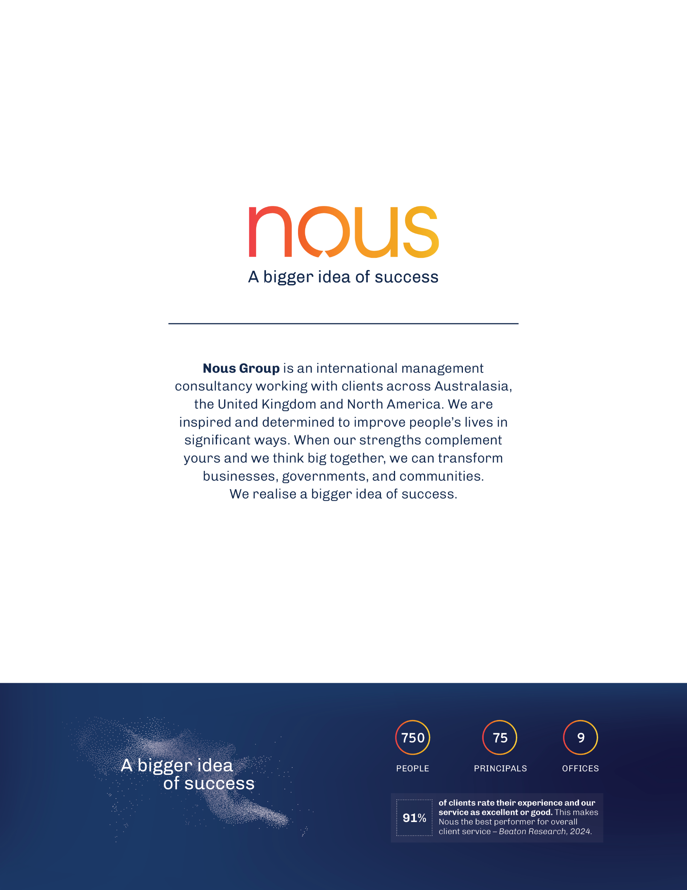

Hannah Chang et al., Preventing preterm births: analysis of trends and potential reductions with interventions in 39 countries with very high human development index, Lancet, 19 January 2013
Roberto Romero, Sudhansu Dey, and Susan Fisher, Preterm labour: one syndrome, many causes. Science, 15 August 2014
Ibid.
John Newnham et al., The health and educational costs of preterm birth to 18 years of age in Australia. The Australian & New Zealand journal of obstetrics & gynaecology, February 2022
Ibid.
World Health Organisation (WHO), Preterm birth, 10 May 2023 (accessed 20 August 2025), https://www.who.int/news-room/fact-sheets/detail/preterm-birth
Australian Preterm Birth Alliance, Every Week Counts Magazine, 2 June 2023, p 2.
AIHW analysis of the National Perinatal Data Collection, Australia's mothers and babies, Gestational Age, 2010-2023 (accessed February 2026), https://www.aihw.gov.au/reports/mothers-babies/australias-mothers-babies/contents/baby-outcomes/gestational-age
Ibid.
This includes grant funding of $5.329 million to WHA, Community Grants Hub grant administration, and evaluation funding.
Australian Preterm Birth Prevention Alliance, Alliance Recommendation to Government, 2021.
For consistency, this document refers to both rounds as the ‘National Program’.
Surveys for maternity services will be conducted and analysed in Stage 3 of the evaluation.
Figure reference 1: John Newnham, et al. The health and educational costs of preterm birth to 18 years of age in Australia. Australian and New Zealand Journal of Obstetrics and Gynaecology. 2022
Figure reference 2: John Newnham, Barbara Vernon, Sarah Ward, et al. Reducing rates of preterm and early-term singleton births safely in Australia: results of the national prevention programme. The Lancet Obstetrics, Gynaecology, & Women’s Health. 2025.
Cost-effectiveness assessment and cost-benefit analysis is out of scope for the evaluation conducted by Nous. However, there is an existing evaluation and study that will report on cost-effectiveness of Round 1 in 2025 and these results will be cited and referenced in the Final Evaluation Report in 2026, if available.
International NGO Training and Research Centre (INTRAC), Realist Evaluation, 2017 (accessed 4 September 2024), https://www.intrac.org/wpcms/wp-content/uploads/2017/01/Realist-evaluation.pdf
Note that WHA’s 2024-25 clinical benchmarking program included 146,342 women who gave birth across more than 110 public maternity units across Australia.
WHO, Indicator: Births, preterm, rate per 100 live births, 2020, (accessed August 2025), https://www.who.int/data/gho/data/indicators/indicator-details/GHO/preterm-birth-rate-per-100-live-births
Australian Institute of Health and Welfare (AIHW), Australia’s mothers and babies, 31 July 2025, (accessed August 2025), https://www.aihw.gov.au/reports/mothers-babies/australias-mothers-babies/contents/maternity-models-of-care
Ibid.
Habtamu Mellie Bizuayehu et al., Maternal residential area effects on preterm birth, low birth weight and caesarean section in Australia: A systematic review, Midwifery, August 2023, https://doi.org/10.1016/j.midw.2023.103704
Cited in: Australian College of Midwives, et al., Second Edition National Consensus Framework for Rural Maternity Services, 2025.
Catherine August, The impact of social determinants of health of Australian Indigenous women on access and engagement in maternal child health services, Journal of advanced nursing, 2023, https://doi.org/10.1111/jan.15493
Public Health Association of Australia, Maternal Mortality, Social Determinants and Sustainable Development Goals: Policy Position Statement, September 2024, p 2, https://www.phaa.net.au/common/Uploaded%20files/SIG%20documents/International%20Health%20SIG/PPS%202024/1002%20-%20Int%20Health%20-%20Maternal%20Mortality...%20SDGs%20-%202024.pdf
Mahrokh Dolatian et al., Preterm delivery and psycho-social determinants of health based on World Health Organization model in Iran: a narrative review, Global journal of health science, 4 November 20212, https://ccsenet.org/journal/index.php/gjhs/article/view/21324
AIHW, Australia’s mothers and babies, 31 July 2025 (accessed 14 August 2025), https://www.aihw.gov.au/reports/mothers-babies/australias-mothers-babies/contents/focus-population-groups/first-nations-mothers-and-babies
Shae Karger et al., Identifying Longer-Term health Events and Outcomes and Health Services Use of Low Birthweight CALD Infants in Australia, Matern Child Health J, 18 November 2023, https://link.springer.com/article/10.1007/s10995-023-03819-w
Nous Group interviews, conducted between July – August 2025.
Key activities included developing or updating guidelines and referral pathways, consumer engagement and co-design of resources, maternity staff surveys to identify gaps in knowledge, statewide clinical education, and a touchpoint analysis to identify current practice and gaps in referral pathways, models of care and consumer resources.
Belinda Nitschke, Amy Earl, Rebecca Smith, SA Preterm Birth Prevention Project: Final Report 2023-2024, Government of South Australia, provided to Nous in August 2024.
The NSW lead is responsible for early term birth Pillar and NT is responsible for the First Nations Pillar, while the Alliance Head Office is responsible for preterm birth Pillar.
Menzies School of Health Research, Activity Work Plan and Performance Report for period 1 February 2025 – 30 June 2025, provided by WHA to Nous in August 2025.
Australian Preterm Birth Alliance, Every Week Counts Magazine, 2 June 2023.
Statement from the Stillbirth Centre of Research Excellence with the Australian Preterm Birth Prevention Alliance Joint Position Statement on Timing of Birth, January 2023, accessed September 2025, https://learn.stillbirthcre.org.au/wp-content/uploads/2023/08/SBB_Timing-of-Birth-Joint-Statement_20Mar1333-1.pdf
Australian Preterm Birth Prevention Alliance, Internal communications with Nous Group (provided June - August 2025).
John Newnham et al., Reducing preterm birth by a statewide multifaceted program: an implementation study, American journal of obstetrics and gynaecology, May 2017, https://pubmed.ncbi.nlm.nih.gov/27890647/
Roberto Orefice et al., Preventing early births in a regional tertiary maternity unit: Evaluating preterm and early term birth rates before and after implementation of the Preterm Birth Prevention Initiative in the Australian Capital Territory, The Australian & New Zealand journal of obstetrics & gynaecology, 24 March 2024, https://pubmed.ncbi.nlm.nih.gov/33759176/
John Newnham et al., Reducing preterm birth: An expert’s perspective, American Journal of Obstetrics and Gynaecology, May 2017, https://www.ajog.org/article/S0002-9378(16)32063-4/fulltext
Australian Commission on Safety and Quality in Health Care, reducing preterm and planned early term births, n.d. (accessed 20 May 2025), https://www.safetyandquality.gov.au/our-work/healthcare-variation/user-guide-reviewing-clinical-variation/case-studies/reducing-preterm-and-planned-early-term-births
Institute for Healthcare Improvement (IHI), The Breakthrough Series: IHI’s Collaborative Model for Achieving Breakthrough Improvement, 2003 (accessed 20 May 2025), https://www.ihi.org/resources/white-papers/breakthrough-series-ihis-collaborative-model-achieving-breakthrough
Kiarna Brown, Carina Cotaru & Michael Binks, A retrospective, longitudinal cohort study of trends and risk factors for preterm birth in the Northern Territory, Australia, BMC Pregnancy Childbirth, 5 January 2024, https://bmcpregnancychildbirth.biomedcentral.com/articles/10.1186/s12884-023-06164-6
Sue Kildea et al., Implementing Birthing on Country services for Aboriginal and Torres Strait Islander families: RISE Framework, Women and Birth, Women and Birth, October 2019, https://doi.org/10.1016/j.wombi.2019.06.013.
Helen Atkinson, Progress Report 5 for the National Preterm Birth Prevention Program 1st January – 30th June 2024 (4-GN0ZGDN), n.d., pp 64-65.
Stephanie Roberge et al., Aspirin for the prevention of preterm and term preeclampsia: systematic review and metanalysis, American Journal of Obstetrics and Gynaecology, March 2018, https://www.ajog.org/article/S0002-9378(17)32326-8/fulltext
Wang, Yixiao et al., Aspirin for the prevention of preeclampsia: A systematic review and meta-analysis of randomized controlled studies, Frontiers in Cardiovascular Medicine, 9 November 2022, https://doi.org/10.3389/fcvm.2022.936560
Holger W Unger et al., Intergenerational risk of preterm birth in First Nations Australians: a population-based cohort study from the Northern Territory, Australia. BMC Pregnancy Childbirth, 24 December 2024, https://doi.org/10.1186/s12884-024-07053-2
The Alliance was funded under WA, as the Alliance is a professional entity formally recognise as a sub-committee of the Perinatal Society of Australia and New Zealand (PSANZ). Funding for WA & the Alliance includes funding for the ‘Every Week Counts’ public awareness campaign, as it was run by the Alliance.
A total of ~$700,000 was underspent in Round 2, as reported by WHA. This was incorporated into funding for FY 2025/26 of Round 2 of the National Program. The breakdown of funding between jurisdictions and implementation partners is therefore an estimate.
Helen Atkinson, Progress Report 5 for the National Preterm Birth Prevention Program 1st January – 30th June 2024 (4-GN0ZGDN), n.d., p 6.
Helen Atkinson, Progress Report 4 for the National Preterm Birth Prevention Program 1st July - 31st December 2023 (4-GN0ZGDN), n.d., p 6.
Helen Atkinson, Progress Report 5 for the National Preterm Birth Prevention Program 1st January – 30th June 2024 (4-GN0ZGDN), n.d., p 12.
Klara Schulmann et al., The role of governance in shaping health system reform: a case study of the design and implementation of new health regions in Ireland, BMC Health Services Research, 3 May 2024, https://doi.org/10.1186/s12913-024-11048-2
Australian Preterm Birth Alliance, National Preterm Birth Prevention Program 2022-2024 Oversight Committee Terms of Reference, June 2022.
WHA, National Preterm and Early Term Birth Prevention Program Steering Committee – Terms of Reference.
Lauren Carpenter et al., National Preterm Birth Prevention Collaborative: Consumer engagement evaluation, final report, University of Melbourne, 2025.
While 63 hospitals in total enrolled to participate in the Collaborative, due to staff shortages and workload pressure, three teams withdrew from the Collaborative in 2022 and one metropolitan hospital in early 2024.
Helen Atkinson, Progress Report 5 for the National Preterm Birth Prevention Program 1st January – 30th June 2024 (4-GN0ZGDN), n.d.
As of Progress Report 5; note Progress Report 4 suggested >90% attendance.
As of Progress Report 4; noted Progress Report 2 suggested >90% of teams.
Helen Atkinson, Progress Report 5 for the National Preterm Birth Prevention Program 1st January – 30th June 2024 (4-GN0ZGDN), n.d., pp 34-35.
Note that not all maternity services reported data on each indicator, nor consistently so, and so the results may represent a selection bias.
Helen Atkinson, Progress Report 5 for the National Preterm Birth Prevention Program 1st January – 30th June 2024 (4-GN0ZGDN), n.d., p 20.
The average percentage of the measure reported across all maternity services, across all time periods reported against for Round 1 (~September 2022-March 2024). Data provided by Women’s Healthcare Australia (WHA) Benchmarking Team, 1 July 2025.
Planned birth includes induction of labour and prelabour c-section. An appropriate indication is to be defined by the local hospital. This measure then captures whether an indication deemed to be appropriate by the service has been recorded. Teams may access a summary of evidence-based indications for early birth disseminated by the Alliance to support local agreement on appropriate indications for birth before 39 weeks.
Ibid.
Alison Brown and Brad Astbury, Communication Interim Findings, University of Melbourne, 2025.
National Preterm Birth Prevention Collaborative, in Progress Report 5 (01 January 2024 – 30 June 2024) (4-GN0ZGDN)., n.d.
Ibid.
Alison Brown and Brad Astbury, Communication Interim Findings, University of Melbourne, 2025.
National Preterm Birth Prevention Collaborative, in Progress Report 5 (01 January 2024 – 30 June 2024) (4-GN0ZGDN)., n.d.
Alison Brown and Brad Astbury, Communication Interim Findings, University of Melbourne, 2025 (accessed August 2025).
National Preterm Birth Prevention Collaborative, in Progress Report 5 (01 January 2024 – 30 June 2024) (4-GN0ZGDN)., n.d.
Alison Brown and Brad Astbury, Communication Interim Findings, University of Melbourne, 2025.
National Preterm Birth Prevention Collaborative, in Progress Report 5 (01 January 2024 – 30 June 2024) (4-GN0ZGDN)., n.d.
Ibid.
National Preterm Birth Prevention Collaborative, in Progress Report 5 (01 January 2024 – 30 June 2024) (4-GN0ZGDN)., n.d.
Helen Atkinson, Progress Report 5 for the National Preterm Birth Prevention Program 1st January – 30th June 2024 (4-GN0ZGDN), n.d.
Note that Round 1 included continuity of care from a ‘midwife’ instead of ‘health professional’.
Helen Atkinson, Progress Report 5 for the National Preterm Birth Prevention Program 1st January – 30th June 2024 (4-GN0ZGDN), n.d.
Ibid.
Alison Brown and Brad Astbury, Communication Interim Findings, University of Melbourne, 2025.
Ibid.
Helen Atkinson, Progress Report 5 for the National Preterm Birth Prevention Program 1st January – 30th June 2024 (4-GN0ZGDN), n.d.
This is the Top End chapter of the Australian Preterm Birth Prevention Alliance, based in Garramilla, Darwin in Larrakia Country.
Nous analysis of data provided by WHA
Nous analysis of data provided by WHA
Four additional news articles on the National Program were released across July – Sept 2024, which occurs outside of Round 1.
Information available to Nous Group regarding communications to August 2025.
Australian Preterm Birth Prevention Alliance, Home, n.d., (accessed August 2025), https://pretermalliance.com.au/
Helen Atkinson, Progress Report 3 for the National Preterm Birth Prevention Program 1st January 2023 – 30th June 2023 (4-GN0ZGDN), n.d.
Helen Atkinson, Progress Report 4 for the National Preterm Birth Prevention Program 1st July - 31st December 2023 (4-GN0ZGDN), n.d.
Helen Atkinson, Progress Report 5 for the National Preterm Birth Prevention Program 1st January – 30th June 2024 (4-GN0ZGDN), n.d.
The Qld Jurisdictional Lead provided preeclampsia expertise for the pilot, the NT Jurisdictional Lead provided clinical leadership for the First Nations Pillar and NSW Jurisdictional Lead provided clinical leadership across the early term birth Pillar.
Alison Brown and Brad Astbury, Communication Interim Findings, University of Melbourne, 2025.
Institute for Healthcare Improvement (IHI), The Breakthrough Series: IHI’s Collaborative Model for Achieving Breakthrough Improvement, 2003 (accessed 20 May 2025), https://www.ihi.org/resources/white-papers/breakthrough-series-ihis-collaborative-model-achieving-breakthrough
Alison Brown and Brad Astbury, Communication Interim Findings, University of Melbourne, 2025.
Ibid.
The Collaborative was led by WHA and overseen by the Collaborative Steering Committee. This brought together senior representatives of WHA, the Alliance, the IHI, SCV and a consumer representative to make decisions related to the delivery of the National Collaborative, identify and respond to any emerging issues in the delivery of the Collaborative.
Note: Early signs point to sustained effectiveness of the Collaborative in Round 2.
Note that the Power Bi dashboard was reported to be set up in final reporting period of Round 1, but was reported by stakeholders to have positively benefited participants in Round 2.
Alison Brown and Brad Astbury, Communication Interim Findings, University of Melbourne, 2025.
Helen Atkinson, Progress Report 5 for the National Preterm Birth Prevention Program 1st January – 30th June 2024 (4-GN0ZGDN), n.d.
John Newnham, et al., Reducing rates of preterm and early-term singleton births safely in Australia: results of the national prevention programme, The Lancet Obstetrics, Gynaecology, & Women’s Health, Volume 0, October 2025
WHA Indicator: Total number of live born babies born between 37 and 39 completed weeks of gestation (excluding neonatal transfers in) (excludes stillbirths, babies born at 39.0 weeks or more)
WHA Indicator: Total number of singleton live born babies born before 37 completed weeks gestation excluding neonatal transfers in
Nous analysis of data supplied by WHA
95% confidence intervals were calculated using a robust bootstrapping approach with R = 10,000 resamples.
AIHW analysis of the National Perinatal Mortality Data Collection and the National Perinatal Data Collection. Table 3.5. See the appendix for the full list of notes pertaining to this data.
AIHW analysis of the National Perinatal Mortality Data Collection and the National Perinatal Data Collection. Table 3.5. See the appendix for the full list of notes pertaining to this data.
WHA Indicator Total number of women who have ceased smoked before 20 weeks’ gestation, of the total number of women who have smoked before 20 weeks’ gestation (singleton births)
AIHW analysis of the National Perinatal Data Collection, Table 2.15 and Table 2.16. Note that data excludes NSW in 2021 and 2022 and excludes ACT in 2023. For WA, ‘Smoked’ includes occasional smoking. ‘Did not smoke’ includes ‘Not determined’ average number of tobacco cigarettes smoked per day in first 20 weeks of pregnancy. Smoking status was determined at multiple locations and times and is therefore difficult to report accurately at time of birth. Care should be taken when comparing data across time. See the appendix for additional notes.
WHA Indicator: Caesarean section rate – early planned without medical or obstetric indication (planned caesarean sections performed at less than 39 weeks gestation without an obstetric or medical indication – defined as material choice, previous caesarean section, previous severe perineal trauma, previous shoulder dystocia) (singleton births), of the total number of women who gave singleton birth by any method
WHA Indicator: All women who received continuity of care (note in a midwifery caseload model of care from a named carer) (singleton births), of the total number of women who gave birth
Nous analysis of data supplied by WHA.
AIHW analysis of the National Perinatal Data Collection. Table 2.28. Note: Data excludes Vic in 2018, 2019, 2020 and 2021 as well as the first 6 months of 2022. Data also excludes NT in 2021. Care should be taken when comparing data across time. Excludes records for which gestational age was not stated or unknown. Term includes babies born at 39 weeks or greater. As a result ‘term’ counts here may not match national reporting, where ‘term’ is limited to 37 to 41 weeks’ gestation. See appendix for additional notes on the data.
AIHW analysis of the National Perinatal Data Collection. Table 2.28. Note: Data excludes Vic in 2018, 2019, 2020 and 2021 as well as the first 6 months of 2022. Data also excludes NT in 2021. Care should be taken when comparing data across time. Excludes records for which gestational age was not stated or unknown. Term includes babies born at 39 weeks or greater. As a result ‘term’ counts here may not match national reporting, where ‘term’ is limited to 37 to 41 weeks’ gestation. See appendix for additional notes on the data.
AIHW data notes provided to Nous Group.
AIHW data notes provided to Nous Group.
Nous analysis of WHA data. Note SCN/NICU rate includes: Admission of inborn singleton term baby to special care nursery (SCN) or neonatal intensive care nursery (NICU) for reasons other than birth defect/congenital anomaly (note: defined as term baby for 37.0 weeks, babies born at less than 37 weeks gestation are excluded), of the total number of singleton babies born at 37 completed weeks or more without birth defect/congenital anomaly. Note stillbirth rate includes: babies born at >20 weeks gestation (singleton births) by any method.
AIHW, Australia's mothers and babies, Preliminary perinatal deaths, 2023 , accessed 23 February 2026
The age standardised rate of stillbirths increased from 0.1 in 2018 to 0.2 in 2023 for First Nations mothers and from 0.7 to 1.0 in that same time period for non-Indigenous mothers. AIHW analysis of the National Perinatal Data Collection. Table 3.6. See appendix for additional notes on the data.
AIHW analysis of the National Perinatal Data Collection. Table 3.19. Note: (a) Data excludes NSW and WA for all years, and NT in 2021. Care should be taken when comparing data across time. (b) Includes liveborn babies only. (c) Excludes records for which gestational age was not stated or unknown. (d) Per cents and age standardised rates were calculated using all liveborn babies. Denominator excludes records for which gestational age was not stated or unknown. (e) Term includes babies born at 39 weeks or greater. As a result ‘term’ counts here may not match national reporting, where ‘term’ is limited to 37 to 41 weeks’ gestation. (f) Data for births occurring during the 2022 calendar year are based on complete data for 7 jurisdictions and a compilation of data for the ACT. The ACT's data consists of their 2022 data for January to October, supplemented by their 2021 data for November and December. Care should be taken if comparing data across time.
Alison Brown and Brad Astbury, Communication Interim Findings, University of Melbourne, 2025.
Lauren Carpenter et al., National Preterm Birth Prevention Collaborative: Consumer engagement evaluation, final report, University of Melbourne, 2025.
John Newnham, et al., Reducing rates of preterm and early-term singleton births safely in Australia: results of the national prevention programme, The Lancet Obstetrics, Gynaecology, & Women’s Health, Volume 0, October 2025
AIHW, Data tables: National Perinatal Data Collection annual update data visualisations 2023, 31 July 2025, https://www.aihw.gov.au/reports/mothers-babies/australias-mothers-babies/data
Australian Institute of Family Studies, Births in Australia, December 2024 (accessed August 2025), https://aifs.gov.au/research/facts-and-figures/births-australia-2024
AIHW, Australia’s mothers and babies, Antenatal care, 28 November 2025 (accessed 10 February 2026), https://www.aihw.gov.au/reports/mothers-babies/australias-mothers-babies/contents/antenatal-period/antenatal-visits
Florent Fuchs et al., Effect of maternal age on the risk of preterm birth: A large cohort study. PloS one, 31 January 2018, https://doi.org/10.1371/journal.pone.0191002
Parliament of NSW, Birth Trauma, May 2024, https://www.parliament.nsw.gov.au/lcdocs/inquiries/2965/FINAL%20Birth%20Trauma%20Report%20-%2029%20April%202024.pdf
Institute of Medicine (US) Committee on Understanding Premature Birth and Assuring Healthy Outcomes, Preterm Birth: Causes, Consequences, and Prevention, 2007, https://www.ncbi.nlm.nih.gov/books/NBK11361/
Jeff A Keelan & John P Newnham, Recent advances in the prevention of preterm birth, F1000Research, 2017, https://doi.org/10.12688/f1000research.11385.1
Alison Brown and Brad Astbury, Communication Interim Findings, University of Melbourne, 2025.
Zoë Slote Morris, Steven Wooding & Jonathan Grant, The answer is 17 years, what is the question: understanding time lags in translational research, Journal of the Royal Society of Medicine, December 2011, https://pmc.ncbi.nlm.nih.gov/articles/PMC3241518/
Alison Brown and Brad Astbury, Communication Interim Findings, University of Melbourne, 2025.
Alison Brown and Brad Astbury, Communication Interim Findings, University of Melbourne, 2025.
Alison Brown and Brad Astbury, Communication Interim Findings, University of Melbourne, 2025.
Alison Brown and Brad Astbury, Communication Interim Findings, University of Melbourne, 2025.
Alison Brown and Brad Astbury, Communication Interim Findings, University of Melbourne, 2025.
Examples of these include educating sonographers about appropriate reporting, educating GPs involved in shared care about responding to findings, timely entering of reports into health service patient files and responding to clinical reports. Outlined in: Alison Brown and Brad Astbury, Communication Interim Findings, University of Melbourne, 2025.
Alison Brown and Brad Astbury, Communication Interim Findings, University of Melbourne, 2025.
Alison Brown and Brad Astbury, Communication Interim Findings, University of Melbourne, 2025.
IHI, Every Week Counts National Collaborative, March 2025 Getting Started: Information Pack for Hospitals, March 2025; provided by IHI to Nous.
Reema Harrison et al., Where Do Models for Change Management, Improvement and Implementation Meet? A Systematic Review of the Applications of Change Management Models in Healthcare. Journal of healthcare leadership, 12 March 2021, https://doi.org/10.2147/JHL.S289176
Susan Michie, Maartje M van Stralen & Robert West, The behaviour change wheel: A new method for characterising and designing behaviour change interventions. Implementation Science, 23 April 2011, https://implementationscience.biomedcentral.com/articles/10.1186/1748-5908-6-42
Alison Brown and Brad Astbury, Communication Interim Findings, University of Melbourne, 2025.
Stephanie M C Ament et al., Sustainability of professionals’ adherence to clinical practice guidelines in medical care: a systematic review, BMJ Open, 29 December 2015, https://pubmed.ncbi.nlm.nih.gov/26715477/
National Institute for Health and Care Research, Maternity services: evidence to support improvement, Health and Social Care Services Research, May 2023, https://evidence.nihr.ac.uk/collection/maternity-services-evidence-to-support-improvement/
Alison Brown and Brad Astbury, Communication Interim Findings, University of Melbourne 2025.
Alison Brown and Brad Astbury, Communication Interim Findings, University of Melbourne, 2025.
John Kania, Mark Kramer & Peter Senge, The Water of Systems Change, n.d., Accessed 24 October 2025, https://www.fsg.org/resource/water_of_systems_change/
See for example: Australian College of Midwives, Australian College of Rural and Remote Medicine, Congress of Aboriginal and Torres Strait Islander Nurses and Midwives, Maternity Consumer Network, National Association of Aboriginal and Torres Strait Islander Health Workers and Health Practitioners, National Rural Health Alliance, Office of the National Rural Health Commissioner, Royal Australian College of General Practitioners, Royal Australian and New Zealand College of Obstetricians and Gynaecologists, Rural Doctors’ Association of Australia, Rural Workforce Agency Network 2025. Second Edition National Consensus Framework for Rural Maternity Services.
Australian Preterm Birth Prevention Alliance, Every Week Counts Magazine, 2025, https://everyweekcounts.com.au/wp-content/uploads/2025/06/130625_Every-Week-Counts-Magazine_2025.pdf
IHI, The Breakthrough Series: IHI’s Collaborative Model for Achieving Breakthrough Improvement, IHI Innovation Series white paper. Boston: Institute for Healthcare Improvement, 2003 (accessed September 2024), https://www.ihi.org/resources/white-papers/breakthrough-series-ihis-collaborative-model-achieving-breakthrough
Ibid.
Helen Atkinson, Progress Report 4 for the National Preterm Birth Prevention Program (01 July 2023 – 31 December 2023), 2024.
Institute for Healthcare Improvement (IHI), The Breakthrough Series: IHI’s Collaborative Model for Achieving Breakthrough Improvement, 2003 (accessed 20 May 2025), https://www.ihi.org/resources/white-papers/breakthrough-series-ihis-collaborative-model-achieving-breakthrough
Helen Atkinson, Progress Report 4 for the National Preterm Birth Prevention Program (01 July 2023 – 31 December 2023), n.d.
Adapted from Activity Work Plan (AWP) and Performance Report Template received from WHA.
Draft Communication Strategy, Australian Preterm Birth and Early Term Birth Prevention Program, 2025.
The Preterm and Early Term Birth Prevention Program, Memorandum of Understanding: Pre-eclampsia screening pilot, 2025-26 (received August 2025).
outcomes repeat after each Round.
outcomes repeat after each Round.
Helen Atkinson, Progress Report 5 for the National Preterm Birth Prevention Program 1st January – 30th June 2024 (4-GN0ZGDN), n.d.
Feedback demonstrated that 95 per cent of respondents ‘agreed’ or ‘strongly agreed’ to understanding the benefits of the seven strategies at the completion of the roadshow compared with 58 per cent at the commencement of the session.
Sue Kildea et al., Implementing Birthing on Country services for Aboriginal and Torres Strait Islander families: RISE Framework, Women and Birth, Women and Birth, October 2019, https://doi.org/10.1016/j.wombi.2019.06.013.
Nous consultation with implementation partners, conducted July-August 2025
Australian Government Department of Health, National Women’s Health Strategy 2020-2030, April 2019, (accessed 21 May 2025), https://www.health.gov.au/sites/default/files/documents/2021/05/national-women-s-health-strategy-2020-2030_0.pdf
Australian Government Department of Health, Woman-centred care: Strategic Directions for Australian Maternity Services, August 2019, (accessed 21 May 2025), https://www.health.gov.au/sites/default/files/documents/2019/11/woman-centred-care-strategic-directions-for-australian-maternity-services.pdf
Australian Government Department of Health, National Stillbirth Action and Implementation Plan, 2020, (accessed 21 May 2025), https://www.health.gov.au/sites/default/files/documents/2021/03/national-stillbirth-action-and-implementation-plan.pdf
Australian Government Department of Health, National Medical Workforce Strategy 2021-2031, March 2022, (accessed 30 May 2025), https://www.health.gov.au/sites/default/files/documents/2022/03/national-medical-workforce-strategy-2021-2031.pdf
National Indigenous Australians Agency (NIAA), Outcome 2: Aboriginal and Torres Strait Islander children are born healthy and strong, n.d., (accessed 14 August 2025), https://www.niaa.gov.au/2023-commonwealth-closing-gap-implementation-plan/delivering-outcomes-and-targets/outcome-2-aboriginal-and-torres-strait
Australian Government Department of Health, National Aboriginal and Torres Strait Islander Health Workforce Strategic Framework and Implementation Plan 2021-2031, March 2022, (accessed 30 May 2025), https://www.health.gov.au/sites/default/files/documents/2022/03/national-aboriginal-and-torres-strait-islander-health-workforce-strategic-framework-and-implementation-plan-2021-2031.pdf
Australian Government Department of Health, National Aboriginal and Torres Strait Islander Health Plan 2021-2031, December 2021, (accessed 30 May 2025), https://www.health.gov.au/sites/default/files/2025-01/national-aboriginal-and-torres-strait-islander-health-plan-2021-2031_0.pdf
Progress Report 5 for the National Preterm Birth Prevention Program 1st January – 30th June 2024 (4-GN0ZGDN), n.d. p 53.
Ibid.
Australian Government Department of Health, Stronger Rural Health Strategy, May 2018 (accessed 30 May 2025), https://www.health.gov.au/topics/rural-health-workforce/stronger-rural-health-strategy
Australian Health Ministers’ Advisory Council, Cultural Respect Framework for Aboriginal and Torres Strait Islander Health 2016–2026, 1 January 2016 (accessed 30 May 2025).
This reached 24 per cent of expecting parents or parents with young children in WA and generated a readership of 50,000 for this target group.
This reached 19 per cent of women aged 25 years and older and generated a readership of 193,000 for this target group. The initial insertions conducted in May – June 2023 were tailored to expecting parents or parents with young children as it involved machine learning and targeting audiences via keywords and relevant topics. However, the product used was phased out in June 2024, resulting in a broader target audience for these insertions.

