Commonwealth, State and Territory Disability Ministers met on 22 May in Canberra and online for the first DRMC meeting of 2026.

Disability Ministers congratulated the appointment of the Hon Katrine Hildyard MP as the new South Australian Minister for Human Services.

Ministers discussed the NDIS reform agenda and timeline arising from measures announced in the 2026–27 Commonwealth Budget. Ministers noted the extensive nature of the proposed NDIS reforms, and that ongoing information and detail will support proper consideration and clear communication with people with disability, their families and carers.

Ministers noted that reforms to improve the sustainability of the scheme must ensure the NDIS and the broader disability ecosystem continues to meet the needs and aspirations of people with disability, their families and carers to live full and inclusive lives as valued members of the community.

Ministers welcomed the Commonwealth’s previously stated commitment to genuine partnership with states and territories and recognised the importance of DRMC as the key forum for joint stewardship

Minister McAllister updated ministers on the Commonwealth’s staged approach to implementation, including some measures commencing after passage of the Bill and some subject to consultation and engagement with the disability community.

Minister McAllister provided an update on the legislation before Parliament.
Minister McAllister noted the National Disability Insurance Scheme Amendment (Securing the Future of the NDIS) Bill 2026, introduced on 14 May, implements the 2026–27 Budget measures and supports a more sustainable NDIS.

Ms Natalie Wade, Associate Commissioner, at the NDIS Quality and Safeguards Commission, provided an update to Ministers on progress toward mandatory registration of Supported Independent Living providers and platform providers from July 2026.

Ms El Gibbs and Mr Dougie Herd, co-chairs of the NDIS Reform Advisory Committee (RAC), gave an update to Ministers on community views and concerns on the reform agenda and an effective approach to engaging with people with lived experience through implementation. Disability Ministers noted the previous advice of the RAC to publish a roadmap for NDIS reform, delay rollout of the New Framework Planning to allow for further consultation and participant-centred implementation, and to proceed with mandatory registration of providers based on risk-related safeguarding.

Ministers discussed the significant Commonwealth roadmap for NDIS reform throughout the remainder of 2026, including the cadence and approach to the Disability Reform Ministerial Council meetings.

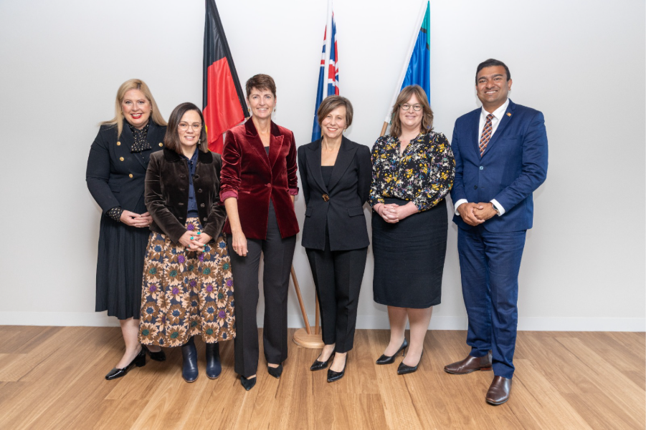
Image – Clockwise from left:
Minister Hildyard (SA), Minister Blandthorn (Vic), Minister Washington (NSW), Minister McAllister (Minister for the NDIS), Minister Orr (ACT), Minister Charls (NT).
Minister Camm (QLD), Minister Beazley (WA), Minister Palmer (TAS) joined the meeting online.

