PORTFOLIO SUPPLEMENTARY ADDITIONAL ESTIMATES STATEMENTS 2025–26
APPROPRIATION BILL (NO. 5) 2025-2026
AND
APPROPRIATION BILL (NO. 6) 2025-2026
Health, Disability and Ageing portfolio
EXPLANATIONS OF SUPPLEMENTARY ADDITIONAL ESTIMATES 2025–26
© Commonwealth of Australia 2026
ISBN: 978-1-76007-500-2
Online ISBN: 978-1-76007-501-9
This publication is available for your use under a Creative Commons Attribution 4.0 International licence, with the exception of the Commonwealth Coat of Arms, third-party content and where otherwise stated. The full licence terms are available from http://creativecommons.org/licenses/by/4.0/legalcode.

Use of Commonwealth of Australia material under Creative Commons Attribution 4.0 International licence requires you to attribute the work (but not in any way that suggests that the Commonwealth of Australia endorses you or your use of the work).
Commonwealth of Australia material used ‘as supplied’
Provided you have not modified or transformed Commonwealth of Australia material in any way including, for example, by changing the Commonwealth of Australia text; calculating percentage changes; graphing or charting data; or deriving new statistics from published statistics – then the Commonwealth of Australia prefers the following attribution:
Source: The Commonwealth of Australia.
Derivative material
If you have modified or transformed Commonwealth of Australia material, or derived new material from those of the Commonwealth of Australia in any way, then the Commonwealth of Australia prefers the following attribution:
Based on Commonwealth of Australia data.
Use of the Coat of Arms
The terms under which the Coat of Arms can be used are set out on the Department of the Prime Minister and Cabinet website (see www.pmc.gov.au/
honours-and-symbols/commonwealth-coat-arms)
Other uses
Enquiries regarding this licence and any other use of this document are welcome at:
Corporate Communication Branch, Department of Health. Disability and Ageing GPO Box 9848, Canberra ACT 2601, or via email to: corporatecomms@health.gov.au

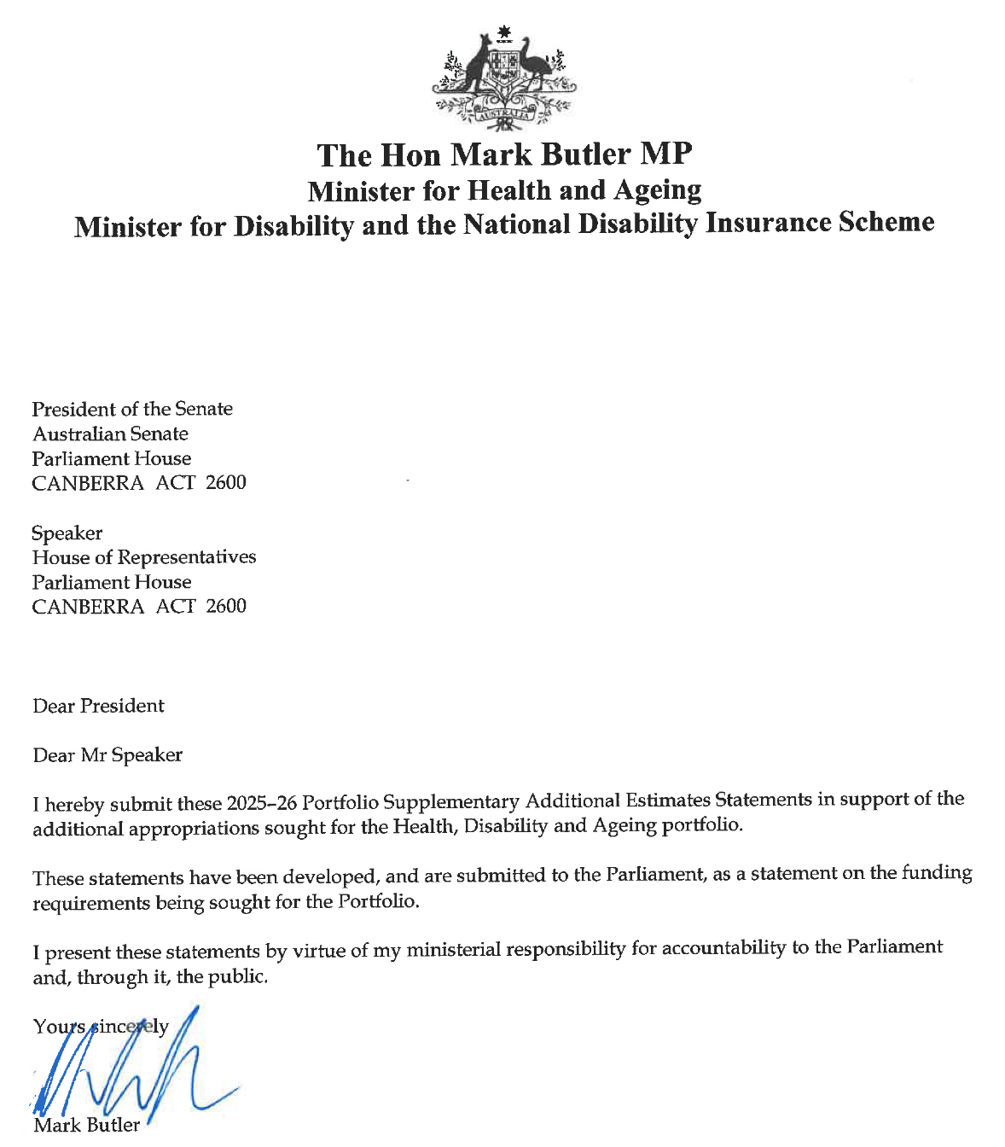

Abbreviations and conventions
The following notations may be used:
NEC/nec not elsewhere classified
- nil
.. not zero, but rounded to zero
na not applicable (unless otherwise specified)
nfp not for publication
$m $ million
Figures in tables and in the text may be rounded. Figures in text are generally rounded to one decimal place, whereas figures in tables are generally rounded to the nearest thousand. Discrepancies in tables between totals and sums of components are due to rounding.
Enquiries
Should you have any enquiries regarding this publication please contact David Hicks, Chief Financial Officer, Department of Health, Disability and Ageing on (02) 5132 4495.
Links to Portfolio Budget Statements (including Portfolio Additional Estimates Statements and Portfolio Supplementary Additional Estimates Statements) can be located on the Australian Government Budget website at www.budget.gov.au.

User guide
to the
Portfolio Supplementary Additional Estimates
Statements

User guide
The purpose of the 2025–26 Portfolio Supplementary Additional Estimates Statements (PSAES) is to inform Senators, Members of Parliament and the public of the proposed allocation of additional resources to government outcomes by entities within the portfolio.
The PSAES facilitate understanding of the proposed appropriations in Appropriation Bill (No. 5) 2025-2026 and Appropriation Bill (No. 6) 2025-2026. In this sense the PSAES is declared by the Appropriation Acts to be a ‘relevant document’ to the interpretation of the Acts according to section 15AB of the Acts Interpretation Act 1901.
Appropriation Bill (No. 5) 2025-2026, which follows on from Appropriation Act (No. 1) tabled at Budget and Appropriation Act (No. 3) tabled at Additional Estimates, will provide additional expenditure authority for the ordinary annual services of government in respect of the 2025-26 financial year.
Appropriation Bill (No. 6) 2025-2026, which follows on from Appropriation Act (No. 2) tabled at Budget and Appropriation Act (No. 4) tabled at Additional Estimates, will provide additional expenditure authority in respect of the 2025-26 financial year for capital works and services, payments to or for the states, territories and local government authorities, and new administered outcomes not authorised in specific legislation.

Contents
Overview of additional appropriations xi
Department of Health, Disability and Ageing 1
Entity measures table 4
Supplementary additional estimates and variations 7
Australian Centre for Disease Control 13
Entity measures table 16
Supplementary additional estimates and variations 17

Overview of additional appropriations sought for the portfolio
Additional estimates are being sought for:

- Department of Health, Disability and Ageing
- Australian Centre for Disease Control.

Explanations of the additional estimates in 2025–26 for these entities are detailed in their respective sections of the PSAES.

Entities not required to prepare a PSAES will report any changes in their resources since the 2025–26 Budget as part of the 2026–27 Budget.

Department of Health, Disability and Ageing
Entity Supplementary Additional Estimates Statements

Department of Health, Disability and Ageing
Entity measures table 4
Supplementary additional estimates and variations 7

Department of Health, Disability and Ageing

Entity measures table
Table 1.1 summarises new Government measures taken since the 2025–26 Additional Estimates.
Table 1.1: Department of Health, Disability and Ageing 2025–26 Supplementary additional estimates measures
 | Outcome/  Program | 2025–26  $'000 | 2026–27  $'000 | 2027–28  $'000 | 2028–29  $'000
Boosting Productivity - Promoting Research, Development and Innovation ^{(a) (b) (c)}
Cross Portfolio
Department of Health, Disability and Ageing
Administered payments | 1.1 | - | 4,868 | 951 | -
Departmental payments | 1 | - | 9,812 | - | -
National Health and Medical Research Council
Departmental payments | 1.1 | - | 12,962 | 11,292 | -
Total payments |  | - | 27,642 | 12,243 | -
Closing the Gap - further investments ^{(a) (b) (c)}
Cross Portfolio
Department of Health, Disability and Ageing
Administered payments | 1.2 | - | 4,613 | 4,566 | 4,762
 | 1.3 | (36) | 1,057 | 784 | 468
 | 1.4 | - | - | - | -
 | 1.6 | - | - | - | -
Departmental payments | 1 | 36 | 743 | 752 | 55
Department of the Treasury
Administered payments |  | (2,300) | 2,000 | 2,100 | 2,200
Total payments |  | (2,300) | 8,413 | 8,202 | 7,485
Health Protection ^{(d)}
Department of Health, Disability and Ageing
Administered capital payments | 1.8 | 20,000 | 67,070 | 69,454 | 70,838
Administered payments |  | - | 15,388 | 16,187 | 14,439
Departmental payments | 1 | - | 4,700 | 4,780 | 4,840
Australian Centre for Disease Control
Departmental payments | 1 | - | - | - | -
Department of the Treasury
Administered payments | 1 | - | 12,500 | 28,000 | 28,000
Total payments |  | 20,000 | 99,658 | 118,421 | 118,117

Table 1.1: Department of Health, Disability and Ageing 2025–26 Supplementary additional estimates measures (continued)
 | Outcome/  Program | 2025–26  $'000 | 2026–27  $'000 | 2027–28  $'000 | 2028–29  $'000
National Health Reform Agreement – hospital funding and Commonwealth investment in the public hospital system ^{(a)}
Department of Health, Disability and Ageing
Administered payments | 1.1 | - | 14,795 | 65,865 | 21,957
 | 2.1 | - | - | (280,717) | (495,440)
 | 2.6 | - | - | 2,000 | -
Departmental payments | 2 | - | 1,520 | 230,259 | 485,440
National Health Funding Body
Departmental payments |  | - | 1,830 | 1,563 | 840
Departmental capital payments |  | - | 150 | - | -
Australian Commission on Safety and Quality in Health Care
Departmental payments | 1 | - | 2,104 | 1,515 | 638
Independent Health and Aged Care Pricing Authority
Departmental payments | 1 | - | 1,000 | 1,030 | -
Department of the Treasury
Administered payments |  | - | 3,435,407 | 3,987,217 | 4,848,793
Total payments |  | - | 3,456,806 | 4,008,732 | 4,862,228
Securing the National Disability Insurance Scheme for Future Generations ^{(a) (c)}
Department of Health, Disability and Ageing
Administered payments | 4.1 | - | 12,434 | 9,191 | 5,566
 | 4.2 | - | - | - | -
Departmental payments | 1 | - | 105 | 251 | 13
 | 3 | 385 | 1,130 | 1,150 | 1,167
 | 4 | 2,467 | 47,683 | 7,429 | 1,986
National Disability Insurance Agency
Departmental payments | 1.1 | - | (1,880,972) | (7,302,035) | (11,785,943)
 | 1.2 | - | 747,921 | 48,833 | 37,867
NDIS Quality and Safeguards Commission
Administered payments | 1.1 | - | (5,225) | (5,321) | (5,392)
Departmental payments | 1.2 | - | 45,654 | 50,568 | 52,793
Departmental capital payments |  | - | 682 | - | -
Total payments |  | 2,852 | (1,030,588) | (7,189,934) | (11,691,943)
Related receipts
NDIS Quality and Safeguards Commission |  | - | - | (7,591) | (8,996)

Table 1.1: Department of Health, Disability and Ageing 2025–26 Supplementary additional estimates measures (continued)
 | Outcome/  Program | 2025–26  $'000 | 2026–27  $'000 | 2027–28  $'000 | 2028–29  $'000
Strengthening Medicare ^{(a)} ^{(e)}
Department of Health, Disability and Ageing
Administered payments | 1.1 | - | 6,010 | 3,846 | -
 | 1.4 | - | 13,648 | 13,857 | 417
 | 1.5 | - | - | - | -
 | 1.6 | 15,000 | 250,728 | 237,752 | 320,146
 | 1.7 | - | 59,018 | 59,651 | 611
 | 2.1 | - | (53,803) | (74,262) | 72,250
 | 2.3 | - | (12,174) | (48,890) | (95,915)
 | 2.6 | - | 2,871 | 1,423 | 1,319
 | 3.3 | - | - | (4,100) | (4,100)
Departmental payments | 1 | 151 | 19,074 | 14,402 | 10,945
 | 2 | - | 15,550 | 18,875 | 10,815
Australian Digital Health Agency
Departmental payments | 1.1 | - | 282,608 | 275,205 | -
Department of the Treasury
Administered payments |  | - | 20,872 | 21,331 | 24,801
Total payments |  | 15,151 | 604,402 | 519,090 | 341,289
Prepared on a Government Financial Statistics (Underlying Cash) basis. Figures displayed as a
negative (-) represent a decrease in funds and a positive (+) represent an increase in funds.

^{(a)} Part of the costs of this measure will be met from within existing resources.
^{(b)} This is a Cross Portfolio measure. The full measure description and package details appear in 2026–27 Budget Paper 2 under Cross Portfolio.
^{(c)} Part of the funding for this measure has already been provided for by the Government.
^{(d)} Includes $299.9m in capital funding over five years from 2025–26.
^{(e)} Part of this measure was originally announced in the 2025–26 Budget and has been fully reversed by Strengthening Medicare announced in the 2026–27 Budget. The above financial figures reflect the current net fiscal impact of the measure.

Supplementary additional estimates and variations
The following table details the changes to the resourcing for the Department of Health, Disability and Ageing at Supplementary Additional Estimates, by outcome. The following table details the estimates and variations resulting from new measures and any other variations (if applicable) since the 2025–26 Additional Estimates in Appropriation Bills
(No. 5 and No. 6).
Table 1.2: Supplementary additional estimates and variations to outcomes from measures and other variations
 | Outcome/  Program | 2025–26  $'000 | 2026–27  $'000 | 2027–28  $'000 | 2028–29  $'000
Outcome 1
Administered
Annual appropriations
Measure - Boosting Productivity - Promoting Research, Development and Innovation | 1.1 | 8,175 | 12,175 | 9,875 | 9,875
Measure - Closing the Gap - further investments | 1.2, 1.3, 1.4, 1.6 | (36) | 5,670 | 5,350 | 5,230
Measure - Health Protection | 1.8 | 20,000 | 67,070 | 69,454 | 70,838
Measure - National Health Reform Agreement – hospital funding and Commonwealth investment in the public hospital system | 1.1 | - | 14,795 | 65,865 | 21,957
Measure - Strengthening Medicare | 1.1, 1.4, 1.5, 1.6,1.7 | 15,000 | 292,637 | 291,315 | 214,989
Other Variations
(net increase) | 1.3 | 15,399 | - | - | -
Net impact on appropriations for  Outcome 1 (administered) |  | 58,538 | 392,347 | 441,859 | 322,889
Departmental
Measure - Boosting Productivity - Promoting Research, Development and Innovation |  | - | 9,812 | - | -
Measure - Closing the Gap - further investments |  | 36 | 43 | 43 | 55
Measure - Health Protection |  | - | 4,700 | 4,780 | 4,840
Measure - Securing the National Disability Insurance Scheme for Future Generations |  | - | 105 | 251 | 13
Measure - Strengthening Medicare |  | 151 | 237 | 304 | -
Net impact on appropriations for  Outcome 1 (departmental) |  | 187 | 14,897 | 5,378 | 4,908
Total net impact on  appropriations for Outcome 1 |  | 58,725 | 407,244 | 447,237 | 327,797

Table 1.2: Supplementary additional estimates and variations to outcomes from measures and other variations (continued)
 | Outcome/  Program | 2025–26  $'000 | 2026–27  $'000 | 2027–28  $'000 | 2028–29  $'000
Outcome 2
Administered
Annual appropriations
Measure - National Health Reform Agreement – hospital funding and Commonwealth investment in the public hospital system | 2.1, 2.6 | - | - | (278,717) | (495,440)
Measure - Strengthening Medicare | 2.1, 2.3, 2.6 | - | (63,106) | (121,729) | (22,346)
Other Variations
(net increase) | 2.3 | 1,137 | - | - | -
Net impact on appropriations for  Outcome 2 (administered) |  | 1,137 | (63,106) | (400,446) | (517,786)
Departmental
Measure - National Health Reform Agreement – hospital funding and Commonwealth investment in the public hospital system |  | 1,746 | 3,439 | 3,505 | 3,558
Measure - Strengthening Medicare |  | - | 15,550 | 18,875 | 10,815
Net impact on appropriations for  Outcome 2 (departmental) |  | 1,746 | 3,439 | 3,505 | 3,558
Total net impact on  appropriations for Outcome 2 |  | 2,883 | (59,667) | (396,941) | (514,228)

Table 1.2: Supplementary additional estimates and variations to outcomes from measures and other variations (continued)
 | Outcome/  Program | 2025–26  $'000 | 2026–27  $'000 | 2027–28  $'000 | 2028–29  $'000
Outcome 3
Administered
Annual appropriations
Measure - Strengthening Medicare | 3.3 | - | - | (4,100) | (4,100)
Net impact on appropriations for  Outcome 3 (administered) |  | - | - | (4,100) | (4,100)
Departmental
Measure - Securing the National Disability Insurance Scheme for Future Generations |  | 385 | 1,130 | 1,150 | 1,167
Net impact on appropriations for  Outcome 3 (departmental) |  | 385 | 1,130 | 1,150 | 1,167
Total net impact on  appropriations for Outcome 3 |  | 385 | 1,130 | (2,950) | (2,933)

Table 1.2: Supplementary additional estimates and variations to outcomes from measures and other variations (continued)
 | Outcome/  Program | 2025–26  $'000 | 2026–27  $'000 | 2027–28  $'000 | 2028–29  $'000
Outcome 4
Administered
Annual appropriations
Measure - Securing the National Disability Insurance Scheme for Future Generations | 4.1 | - | 12,434 | 9,191 | 5,566
Other Variations
(net increase) | 4.1 | 598,063 | (254,594) | (4,338,707) | (7,278,488)
Net impact on appropriations for  Outcome 4 (administered) |  | 598,063 | (242,160) | (4,329,516) | (7,272,922)
Departmental
Measure - Securing the National Disability Insurance Scheme for Future Generations |  | 2,467 | 8,432 | 5,716 | -
Net impact on appropriations for  Outcome 4 (departmental) |  | 2,467 | 8,432 | 5,716 | -
Total net impact on  appropriations for Outcome 4 |  | 600,530 | (233,728) | (4,323,800) | (7,272,922)
Prepared on a resourcing (i.e. appropriations available) basis.

The following tables detail the Supplementary Additional Estimates sought for the Department of Health, Disability and Ageing through Appropriation Bills (No. 5 and
No. 6).
Table 1.3: Appropriation Bill (No. 5) 2025–2026
 | 2024–25  Available ^{(a)}  $'000 | 2025–26  Budget ^{(b)}  $'000 | 2025–26  Revised  $'000 | Sup.  Additional  Estimates  $'000 | Sup. Additional Estimates Reduction  $'000
Administered items
Outcome 1
Health Policy, Access and Support | 7,636,647 | 8,535,077 | 8,573,651 | 38,574 | -
Outcome 2
Individual Health Benefits | 1,963,770 | 2,149,113 | 2,150,250 | 1,137 | -
Outcome 3
Ageing and Aged Care | 5,641,381 | 6,630,876 | 6,630,876 | - | -
Outcome 4
Disability and Carers | 736,217 | 38,119,272 | 38,717,335 | 598,063 | -
Total administered | 15,978,015 | 55,434,338 | 56,072,112 | 637,774 | -
Departmental items
Outcome 1
Health Policy, Access and Support | 598,517 | 553,374 | 553,561 | 187 | -
Outcome 2
Individual Health Benefits | 226,655 | 224,453 | 226,199 | 1,746 | -
Outcome 3
Ageing and Aged Care | 926,721 | 865,773 | 866,158 | 385 | -
Outcome 4
Disability and Carers | 17,813 | 93,083 | 95,550 | 2,467 | -
Total departmental | 1,769,706 | 1,736,683 | 1,741,468 | 4,785 | -
Total administered  and departmental | 17,747,721 | 57,171,021 | 57,813,580 | 642,559 | -
^{(a)} 2024–25 available appropriation is included to allow a comparison of this year's appropriation with what
was made available for use in the previous year. Available appropriation is the amount available to be
drawn down, and is equal to: Budget Appropriation + Additional Estimates Appropriation + Advance to the Finance Minister - section 51 withholdings - administrative quarantines +/- Machinery of Government transfers.
^{(b)} Includes measures published in the Explanatory Memorandum to the Appropriation Bills (No. 1)
2025–2026 and Appropriation Bills (No. 2) 2025–2026.

Table 1.4: Appropriation Bill (No. 6) 2025–2026
 | 2024–25  Available ^{(a)}  $'000 | 2025–26  Budget ^{(b)}  $'000 | 2025–26  Revised  $'000 | Sup.  Additional  Estimates  $'000 | Sup. Additional Estimates Reduction  $'000
Non-operating
Administered assets and liabilities | 70,080 | 135,278 | 155,278 | 20,000 | -
Total non-operating | 70,080 | 135,278 | 155,278 | 20,000 | -
Total other services | 70,080 | 135,278 | 155,278 | 20,000 | -
^{(a)} 2024–25 available appropriation is included to allow a comparison of this year's appropriation
with what was made available for use in the previous year. Available appropriation is the amount
available to be drawn down, and is equal to: Budget Appropriation + Additional Estimates
Appropriation + Advance to the Finance Minister - section 51 withholdings - administrative
quarantines +/- Machinery of Government transfers.
^{(b)} Includes measures published in the Explanatory Memorandum to the Appropriation Bills (No. 1)
2025–2026 and Appropriation Bills (No. 2) 2025–2026.

Australian Centre for Disease Control
Entity Supplementary Additional Estimates Statements

Australian Centre for Disease Control
Entity measures table 16
Supplementary additional estimates and variations 17

Australian Centre for Disease Control

Entity measures table
Table 1.1 summarises new Government measures taken since the 2025–26 Additional Estimates.
Table 1.1: Australian Centre for Disease Control 2025–26 Supplementary additional estimates measures
This section is not applicable to the Australian Centre for Disease Control.

Supplementary additional estimates and variations
The following table details the changes to the resourcing for the Australian Centre for Disease Control at Supplementary Additional Estimates, by outcome. The following table details the estimates and variations resulting from new measures and any other variations (if applicable) since the 2025–26 Additional Estimates in Appropriation Bills (No. 5 and
No. 6).
Table 1.2: Supplementary additional estimates and variations to outcomes from measures and other variations
 | Program | 2025-26  $'000 | 2026-27  $'000 | 2027-28  $'000 | 2028-29  $'000
Outcome 1 |  | -
Administered
Annual appropriations
Other Variations
(net increase) | 1.1 | 7,852 | - | - | -
Net impact on appropriations for Outcome 1 (administered) |  | 7,852 | - | - | -
Departmental
Annual appropriations
Other Variations
(net increase) | 1.1 | 249 | - | - | -
Net impact on appropriations for Outcome 1 (departmental) |  | 249 | - | - | -
Total net impact on appropriations for Outcome 1 |  | 8,101 | - | - | -
Prepared on a resourcing (i.e. appropriations available) basis.

The following tables detail the Supplementary Additional Estimates sought for the Australian Centre for Disease Control through Appropriation Bills (No. 5 and No. 6).
Table 1.3: Appropriation Bill (No. 5) 2025–2026
 | 2024-25  Available  $'000 | 2025-26  Budget  $'000 | 2025-26  Revised  $'000 | Sup.  Additional Estimates  $'000 | Sup. Additional Estimates Reduction  $'000
Administered items
Outcome 1
Australian Centre for Disease Control | - | 80,100 | 87,952 | 7,852 | -
Total administered | - | 80,100 | 87,952 | 7,852 | -
Departmental items
Outcome 1
Australian Centre for Disease Control | - | 26,300 | 26,549 | 249 | -
Total departmental | - | 26,300 | 26,549 | 249 | -
Total administered and departmental | - | 106,400 | 114,501 | 8,101 | -
Table 1.4: Appropriation Bill (No. 6) 2025–2026
This section is not applicable to the Australian Centre for Disease Control.

Glossary
For references to terminology please refer to the Portfolio Glossary in the Health, Disability and Ageing 2026–27 Portfolio Budget Statements.

