BONDED RETURN OF SERVICE SYSTEM (BROSS)
Participant User Guide
Updating your Medical Course Timeframe
May 2026

Updating your Medical Course Timeframe
Your university enters the standard length of your medical course into your BRoSS record.
If your enrolment changes at any stage during your studies, you must update BRoSS. This includes:
- Getting advanced standing, so you graduate early.
- Failing a course and repeating a semester or year.
- Deferring your studies or taking a leave of absence.
Your medical course timeframe in BRoSS must match your actual enrolment so that your Commonwealth Supported Place (CSP) calculates correctly.
How to update your medical course timeframe
From your BRoSS dashboard, click on My Program Information.
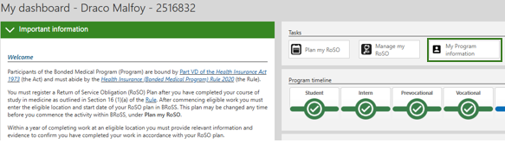
Open the Medical Course Timeframe accordion.
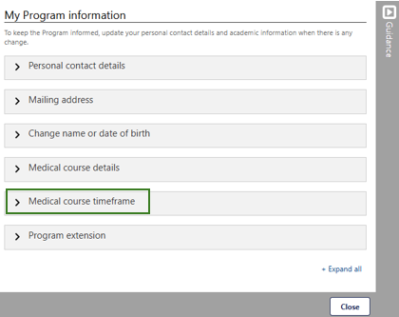

Under this accordion, you will see:
Length of course: Standard length of your medical course in years. This cannot be changed. As long as the Current academic Program table and the Expected medical course completion date are correct for your attendance, then your record is correct.
Expected medical course completion date: This will update if you make changes in the Current academic Program table. For example, if you updated the table to reflect a full year deferral, your Expected medical course completion date would automatically extend by a year.
Actual medical course completion date: This field will only appear once you graduate. It will show the date you entered in your Completion of medical course advisory.
Current academic Program table: You must update this to reflect your actual attendance. You can:
- Add years.
- Remove years.
- Edit your attendance for any given year (full year, half year only, full year deferred).
Note:
- You cannot choose 'full year deferred' in the last year of your table unless you add an extra year first.
- You will need to upload supporting evidence for any changes. Your evidence must clearly show your enrolment status for the period you are changing. Official correspondence such as a letter or email from your university would be considered acceptable evidence.
