Council of Elders Biographies 2026

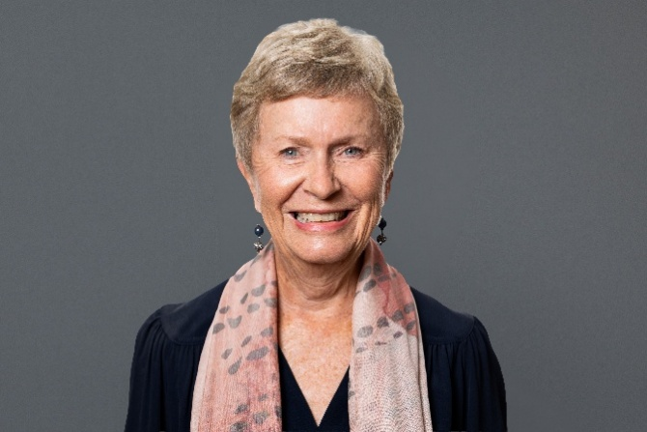
Anne Burgess AM
Anne is the Chair of the Council of Elders. She is passionate about ageing well and is currently Deputy Chair of the Older Persons Advocacy Network and Chair of Aged Rights Advocacy Service.
Anne is also Chair of the Aged Care Transition Taskforce and a member of the National Aged Care Advisory Council.
With more than 40 years’ experience leading areas of government focused on social justice, she has a particular interest in community engagement. Anne brings experience to the role of Chair from her career as a senior public servant in South Australia. This included roles as Director of Office for Women and Director of Mental Health and a 2-year term as Acting Commissioner for Equal Opportunity South Australia.
In 2021, Anne was appointed as a Member of the Order of Australia (AM) for significant service to mental health, gender equality and older people.
Anne wants to ensure that the voices and lived experiences of older people are valued and respected in the planning and delivery of aged care reforms.

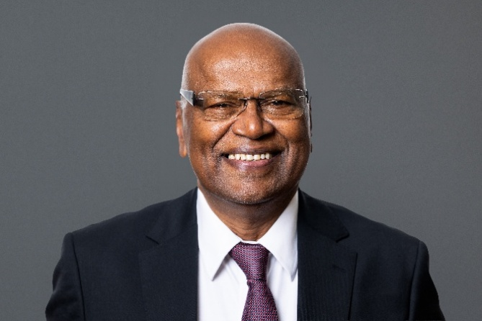
Dr Ponniah Anandajayasekeram
Dr Ananda is a retired Agricultural Economist with more than 4 decades of professional experience in research, training, development and advocacy, largely in international settings. He is a Melbourne-based member of the culturally and linguistically diverse (CALD) community and currently serves as the Board Chair of the Southern Migrant and Refugee Centre (Victoria). He is also a member of the Darebin City Council’s Welcoming Cities Reference Group.
Dr Ananda previously served as President of the Tamil Senior Citizens Fellowship (Vic) Inc. and was a member of the Regional Advisory Council of the Victorian Multicultural Commission. He has also contributed as a member of the Healthy Ageing Advisory Committee of the Federation of Ethnic Communities’ Councils of Australia (FECCA) and the Policy Development Group of Council on the Ageing (COTA) Victoria.
In 2025, Dr Ananda was inducted into the Victorian Multicultural Honour Roll in recognition of his exceptional and lasting contributions to multiculturalism in Victoria.
Dr Ananda volunteers with several organisations that support older people and works closely with multicultural groups and community organisations to address community-based issues, particularly around healthy ageing. He strongly believes that everyone deserves a healthy and dignified life at every stage.

Associate Professor John Cullen AM
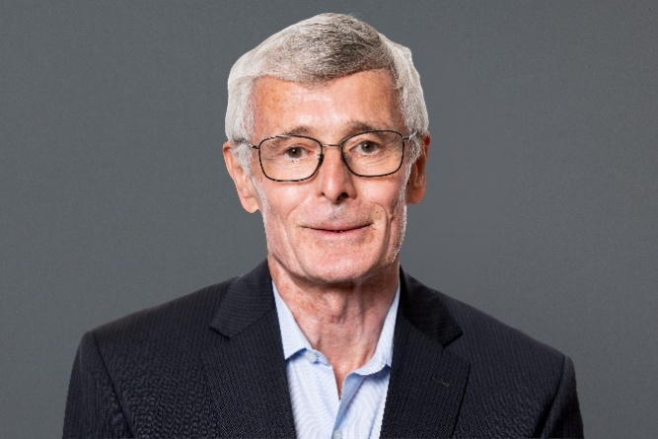
Associate Professor John Cullen AM is a practising geriatrician based in Sydney’s inner west. He has over 40 years’ experience developing, managing and delivering health services for older people in hospital, community and residential aged care settings.
John has been the Clinical Director for Aged Health, Rehabilitation and Chronic Care with the Sydney Local Health District since 1997 and has provided clinical support to the Aged Care Assessment Program since its establishment in the mid-1980s.
John is passionate about delivering aged care health services to regional and remote communities via telehealth and outreach services. He also has an interest in community aged health services and the transitions between hospital and community care, dementia support and management programs and inreach health services to people in residential aged care.
In 2024, John was appointed as a Member of the Order of Australia (AM) for contributions to geriatric medicine as a clinician, researcher, innovator and advocate.

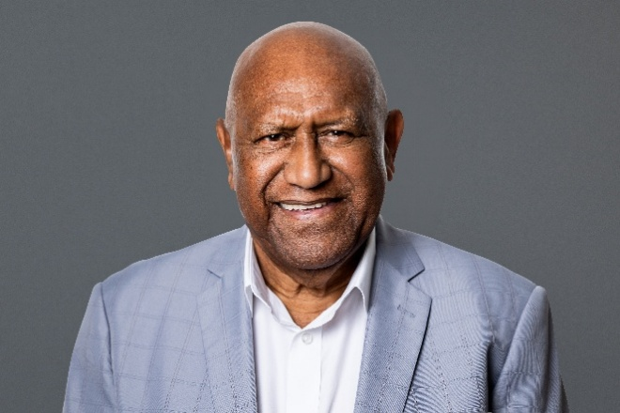
Mr William (Uncle Benny) Hodges
Uncle Benny Hodges is blessed with both Aboriginal (Waanyi – Garawa heritage) and Torres Strait Islander heritage (Bam Le – Kulkalgal heritage). Born and bred on Gimwoy Wulunbara Yidinji Country (Cairns in Far North Queensland), one of his cultural obligations is to always look after and respect his Elders. He lives in the ACT (Ngunnawal – Ngambri Country).
Uncle Benny has more than 30 years’ experience in engagement in Aboriginal and Torres Strait Islander affairs and was recently named ACT NAIDOC 2024 Elder of the Year.
Uncle Benny is passionate about the health and well-being of older Aboriginal and Torres Strait Islander people and all older Australians. He is keen to continue advocating and supporting the Council’s work.

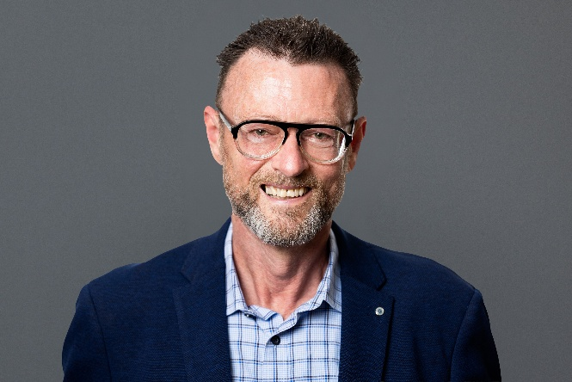
Mr Russell Westacott
Russell lives in rural NSW and is a human rights advocate with 40 years’ experience working with vulnerable and marginalised individuals and communities.
In the mid-1980s, he worked at the grassroots level providing outreach and counselling to those impacted by HIV, particularly vulnerable and at-risk men living on the streets of Sydney. In the early 2000s he worked at New York’s largest HIV community-based organisation and contributed to policy and lobbying efforts at city, state and US federal levels. Rusell returned to Australia as Director of Client Services at the AIDS Council of NSW.
As Chief Executive Officer of Seniors Rights Service for a decade from 2011, Russell was instrumental in growing the organisation’s reach and was active in developing the Older Person’s Advocacy Network (OPAN). He contributed to the development of an international convention for the rights of older people and participated in the United Nations Open-ended Working Group on Ageing. Russell actively advocated for aged care policy change and was one of the founding members of the peak cross-sector body, Elder Abuse Action Australia.
In recent years Russell played a primary caring role for his husband who sadly passed away in November 2024 and continues to be the primary carer of his ageing mother who is an aged care recipient.

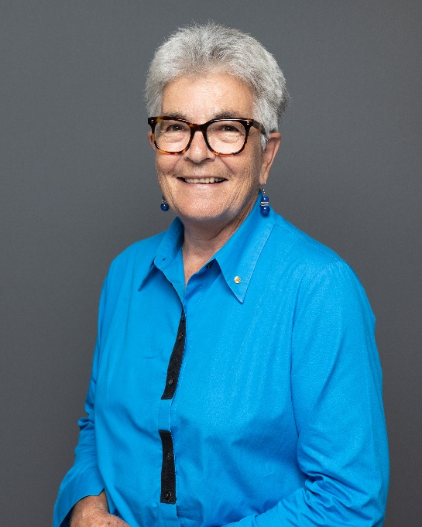
Ms Marilyn Beaumont OAM
Born in Canberra in 1951, Marilyn has spent her life deeply connected to family and community. She brings more than 57 years of experience working across Australia in general and mental health nursing, residential aged care, community nursing and on health service boards and leading public policy campaigns.
Marilyn’s advocacy at state and federal levels has included representing nurses through the Australian Nursing and Midwifery Federation (ANMF), health and aged care workforce reform, the needs of gay, lesbian and gender diverse communities and women’s health. In 2017, Marilyn was awarded an Order of Australia Medal (OAM) for her services to women’s health and other communities.
Drawing on her experience with family in supporting parents through home care, residential aged care and end‑of‑life care, she brings a deeply personal perspective to her work. Now living in a small NSW rural community, Marilyn serves on the Board of Banksia Villages Pty Ltd where she chairs the Care Governance Committee. Marilyn and her partner are also navigating ageing at home, informed by first-hand experience withthe Commonwealth Home Support Program. Marilyn maintains strong community connections and frequently supports others to explore aged care options, often helping them work through fears or misconceptions, particularly about residential aged care.
Marilyn is committed to ensuring older Australians’ voices shape policy and practice.

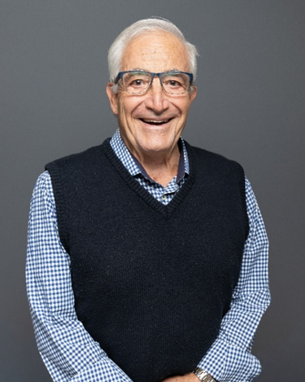
Mr Fred (Federico) Marrone
Fred has lived in the Northern Territory for 54 years and has contributed extensively to community, multicultural and aged care leadership. He has served on more than 24 organisations, including ministerial appointments and key governance roles.
Fred has been appointed to the NT Multicultural Education Coordinating Committee, served on the Australia Day Council and held aged care board roles with Regis Aged Care in Darwin and the NT Aged Care Board. In 2025, Fred was appointed to 2 additional aged care boards. As a carer for his wife living with dementia, Fred brings important lived experience to his advocacy.
Fred previously served as an Alderman on the Darwin City Council from 2008 to 2012. He represented the Council on the Council on the Ageing (COTA) NT Board and contributed to committees such as the Community Benefit Fund, the Agents and Licensing Board and the Human Research Ethics Committee at Charles Darwin University. Fred has also served on several public and Catholic secondary college boards.
Across 5 decades, Fred has held numerous leadership roles in multicultural clubs, sporting organisations, and community groups as President, Vice President, Chair, and board member. He is also an active member of Probus, engaging closely with older Territorians.

Mr Warren Martens
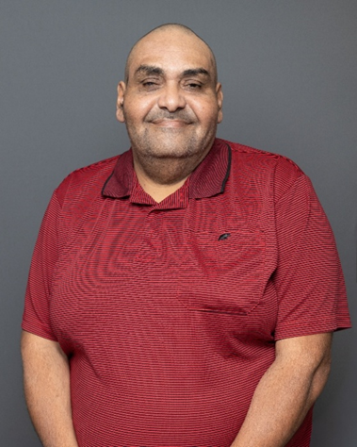
Warren Martens is a proud Gungganji man and custodian from Far North Queensland. He is recognised for his strong advocacy in disability reform, cultural leadership and community wellbeing. Uncle Warren has served on the First Nations NDIS Shareholder Group and the NDIS Participant Reference Group, ensuring disability supports are culturally safe and accessible for First Nations people.
As a board member of the North Queensland Land Council, Uncle Warren contributes to land protection and Traditional Owner governance. In health he advises the First Nations My Medicare Project and works with Macquarie University to strengthen culturally informed disability and community health services.
Uncle Warren also supports a national Social Determinants of Health project focused on peer-led support, data sovereignty and culturally safe care for Indigenous people living with disability or chronic illness. His leadership reflects a lifelong commitment to preserving Gungganji culture and strengthening community futures.

Ms Ann Robinson
Ann Doreen Robinson is an aged care and nursing professional with more than 40 years of experience across residential aged care, community health and specialist continence services. Holding a Master of Nursing (Continence), she has worked as a Registered Nurse, Clinical Nurse Consultant and Director of Nursing, leading accreditation processes, multidisciplinary teams and quality improvement initiatives.
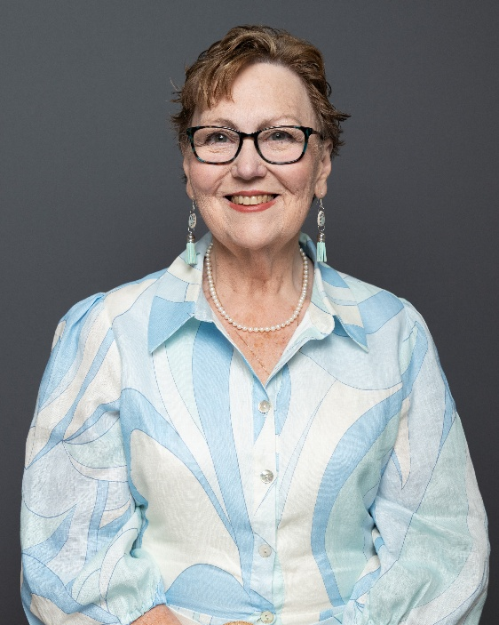
Ann has contributed to national and state professional bodies, including serving as National Secretary of Australian Nurses for Continence and Chair of the Nurses for Continence Interest Group SA. These roles strengthened her expertise in governance, policy development and advocacy for older Australians.
A passionate advocate for dignified continence care, Ann has also worked closely with multicultural and Muslim communities through Dr Maghadaji’s Urogynaecology Clinic, delivering culturally sensitive support and education.
Her professional work is deeply informed by her lived experience as a long-term carer for both her parents, giving her first-hand understanding of the challenges families face navigating aged care systems.
Now living in a coastal regional town in South Australia, Ann remains actively involved in her community through her church, choir and volunteer activities. She is frequently sought out by older residents and families for informal guidance, reflecting her ongoing commitment to supporting ageing Australians with dignity and respect.

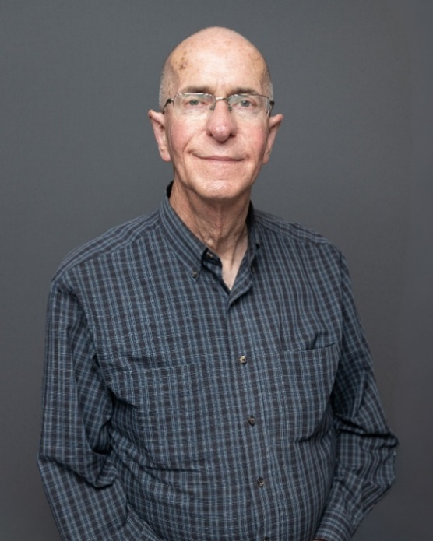
Mr Bruce Nelson
Bruce Nelson is a highly experienced nursing professional recognised for his leadership in aged care, mental health and community support. With a career spanning clinical management, counselling, education and organisational leadership, Bruce has guided individuals and teams through complex challenges while helping services achieve high standards of care.
He has managed suicide prevention services as the sole clinician and manager at Newcastle Safe Haven and has contributed to the Rural Counsellor and Suicide Prevention Outreach Teams. As a qualified Mental Health First Aid Instructor, he has delivered training and presented to Statewide Mental Health Grand Rounds. Bruce maintains up to date expertise in aged care reforms, palliative care and mental health, supported by specialised training in Death Midwifery.
Bruce has held senior roles in aged care, including Executive Officer of a large residential facility where he oversaw capital works, accreditation processes and the development of innovative therapeutic programs such as award-winning Laughter Therapy, Art Therapy, and Companion Animal initiatives. He is also trained in workplace training and assessment, trauma-informed care, positive psychology, workplace safety and clinical supervision, and has previously tutored third year nursing students at the University of Newcastle.
Now based in West Ulverstone on Tasmania’s North-West Coast, Bruce works nationally as a clinical supervisor, volunteers with the Hospice Care Association, and is the primary carer for an elderly woman with complex medical needs. His career reflects a deep dedication to compassionate care, ethical practice and the wellbeing of diverse community members.

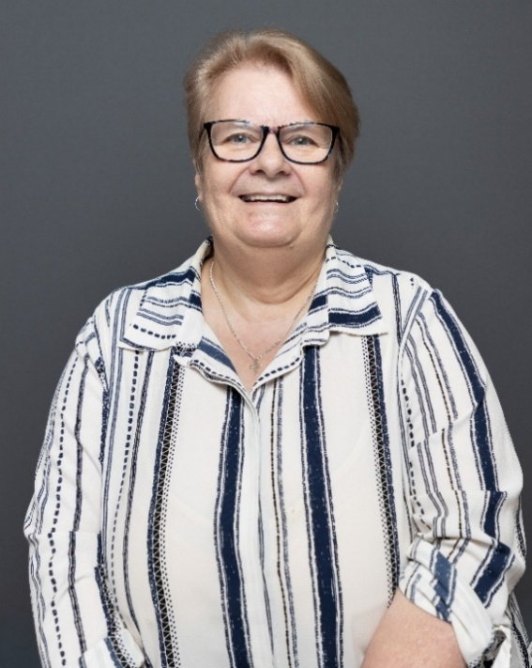
Ms Pam Hegarty
Pam Hegarty is a retired registered nurse with 53 years of experience in aged care across community, home care and residential settings. Her career spans roles as an aged care nurse consultant, member of the Aged Care Assessment Service, case manager for Short Term Restorative Care and Home Care Packages, and qualified Advance Care Planning consultant. In retirement, she continues to support older people in her community to navigate My Aged Care and plan for their future needs.
Pam is passionate about ensuring older Australians can remain at home safely or access equitable residential care. She enjoys engaging with older citizens, advocating for their needs and strengthening communication between communities and policymakers. As a member of the Aged Care Ambassadors Committee in Ballarat, she contributes to local advocacy and community education.
Living in a rural retirement village and as a gay woman, Pam brings important lived experience to her work, including an understanding of the unique challenges faced by LGBTIQ+ seniors and older people in regional areas. She remains committed, informed and deeply motivated to support positive change in the aged care sector.

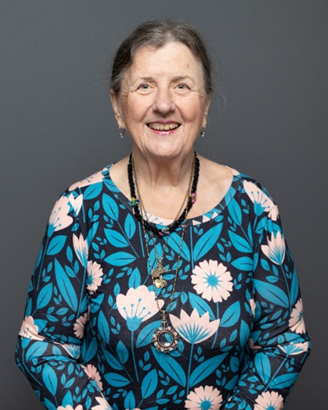
Ms Robyn Abrahams
Robyn Abrahams is a retired Registered Nurse, Registered Midwife and Intensive Care Nurse with more than 40 years of experience across clinical care, health administration and education. She contracted polio at age 3 during the 1950s epidemics and later developed Post Polio Syndrome, shaping both her professional path and her lifelong advocacy for people with disability and older Australians.
At age 40, Robyn returned to university, completing postgraduate studies in education and management at the University of Melbourne, which led to senior roles in health leadership and training. She is a mother 2 two, grandmother of 6, and was the primary carer for her parents for many years, strengthening her understanding of aged care from both professional and personal perspectives.
Since retiring at 64 following a stroke, Robyn has dedicated herself to advocacy. She serves on the National Older Person’s Reference Group of OPAN, is a board member of the Australian Federation of Disability Organisations (AFDO) and is Vice President of Post Polio Victoria. She has also contributed to research and advisory work with NARI, AAG, Peninsula Health and St Vincent’s Public Hospital Melbourne.
Robyn brings a unique perspective as someone who has lived with disability since childhood, worked as a health professional and navigated ageing independently. She is committed to promoting dignity, best-practice care and equitable systems for all older Australians.

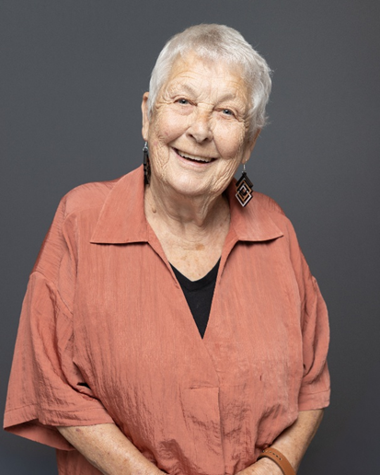
Dr Barbara Buzzard
Dr Buzzard is a retired university lecturer who resides in WA, having lived and worked in the United Kingdom and Canada over several decades. She is a longstanding advocate for improving aged care in Australia, with a particular passion for dementia care and the experiences of older people in regional communities.
Having engaged with healthcare systems abroad and with the WA aged care system since the 1990s, she brings extensive lived experience as a caregiver, service recipient and community representative. Dr Buzzard has provided in-home care to her sisters and has spent years supporting family members living in dementia wards, giving her deep insight into service gaps and the need for tailored, compassionate care. She regularly engages with assessors, government representatives and healthcare providers to raise concerns, contribute feedback and drive system improvements.
Dr Buzzard is committed to ensuring older Australians’ voices shape the future of aged care policy and practice.

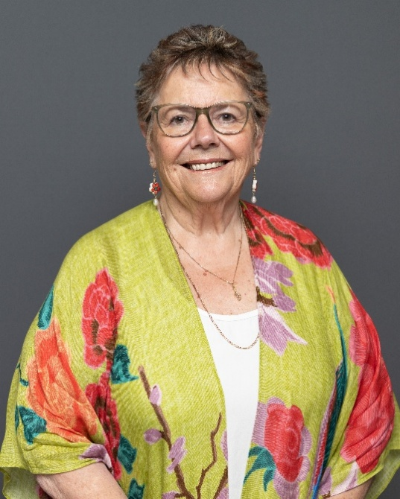
Ms Roberta (Bobbie) Kidd
Roberta ‘Bobbie’ Kidd brings decades of experience in education, community service and aged care engagement, grounded in her lived experience of ageing. With a fifty-year teaching career across both rural and metropolitan Western Australia, she has worked with learners of all ages and led numerous community initiatives, festivals, choirs and intergenerational programs.
Bobbie is an active member of the Melville Cares Consumer Committee and a founding organiser of CareSong, a dementia-friendly singing group that promotes joy and connection for older people. She is deeply involved in life at Frederick Guest Village, where she organises community activities, supports neighbours, and helps establish programs such as Coffee & Chat to strengthen social connection and advocacy.
Her personal experiences with disability, home care services and supporting family through health and end-of-life challenges have strengthened her commitment to compassion, inclusion and respectful aged care. Bobbie seeks to contribute to the Council of Elders to ensure that older Australians, especially those who struggle to speak up, have their voices heard and reflected in the shaping of aged care policy and reform.

