
Workforce Intelligence Report
Health Workforce Taskforce
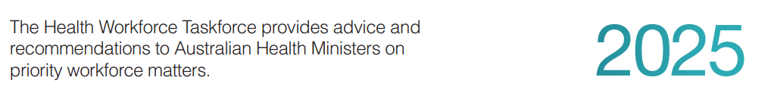

Contents
Executive summary 3
The current state of the post-pandemic health workforce 3
Retention, attrition and re-entry 4
Innovative models to address acute, pandemic-related workforce pressures 4
Summary 5
Introduction and scope 6
Project design and methods 7
Project 1: The current state of the post-pandemic health workforce 8
Project 2: Retention, attrition and re-entry 9
Methods 9
Key findings from the review 9
Drivers of workforce attrition 9
Effective strategies for retention 10
Design principles for effective strategies 10
Re-entry to the workforce 10
Implications 10
Project 3 Innovative models to address acute, pandemic-related workforce pressures 11
Primary Health Network results 11
Jurisdiction results 12
Appendices 17
Appendix 1a. Project 1: summary graphs of current state and projections of identified post-pandemic registered health workforce 17
Appendix 1b. Project 1: current and projected state of the post-pandemic health workforce for nurses 18
Appendix 1c. Project 1: current state of the post-pandemic health workforce for medical practitioners 18
Appendix 1d. Project 1: current state of the post-pandemic health workforce for allied health 19
Appendix 2. Project 2: literature review on staff retention, attrition and re-entry strategies 20
Appendix 3a. Project 3: Innovative models to address acute, pandemic-related workforce pressures 26
Appendix 3b. Innovative models to address acute, pandemic-related workforce pressures – summary collection form 39
References 42

Executive summary

The Health Workforce Taskforce (the Taskforce) provides advice and recommendations to Australian Health Ministers on priority workforce matters.
It develops and oversees workforce strategies designed to meet Australia’s current and future health service needs.
In 2022, the Taskforce established the Workforce Intelligence Tiger Team (Tiger Team) to investigate the impact of the COVID-19 pandemic on health workforce pressures in the Australian healthcare system. This report builds on existing understanding of the health workforce by providing key insights into workforce retention, attrition and re-entry patterns, and innovative models that helped address workforce pressures during the pandemic. It consolidates evidence and learnings drawn from the experiences of Australia’s health system during this period.
The Commonwealth, state and territory governments worked together across three projects – the current state of the workforce, retention and attrition, and innovative models – to explore the current health workforce, movement patterns and models used during the pandemic.

The current state of the post-pandemic health workforce
In collaboration with all Australian states and territories and key stakeholders, the Commonwealth undertook an exploratory overview of the post-pandemic health workforce. This analysis found that the health workforce is growing across Australia. The compound annual growth rate (CAGR) for nurses is projected to be 2.5% through to 2035, and the registered allied health workforce will grow from 193,000 to 290,000 during the same period. While the headcount for medical practitioners is also projected to rise, the full-time-equivalent (FTE) per practitioner is expected to decrease. The results of this subproject are attached (Appendices 1a-d).

These findings are drawn from modelling undertaken by the Commonwealth in November 2023, which informed the principles and themes presented in this report. Subsequently, the Commonwealth has published detailed supply and demand modelling on the nursing (July 2024), general practitioner (August 2024) and psychiatry (June 2025) workforce which will be followed by other medical specialties and allied health. These projections can be accessed via the Department of Health and Aged Care’s web page: Supply and Demand (health.gov.au).
This report draws on the original Tiger Team modelling, with similar themes and trends emerging from the more recent projections.

Retention, attrition and re-entry
Victoria, in consultation with the Commonwealth, completed a literature review identifying global and domestic factors affecting attrition, as well as effective retention strategies. Key issues identified include high workloads, limited career advancement opportunities and staff burnout.
The literature highlighted three key principles – specificity, employee voice and organisational commitment – to design effective retention and re-entry strategies. Strategies using these principles were found to enhance flexible working arrangements and other employee benefits and boost domestic and international recruitment. The literature review and key findings (Appendix 2) recommend that interventions be specific to a cohort, that workers should have an active voice in the design of policies, and that policies receive strong commitment from organisations and not rely on the individual.

Innovative models to address acute, pandemic-related workforce pressures
New South Wales and the Commonwealth collaborated with the other jurisdictions to identify pandemic-driven innovations across Primary Health Networks (PHN) and state and territory health departments. Over 60 innovative models across 27 professions were documented. The analysis found that successful innovations were underpinned by six key factors: technology, culture, funding, champions, governance and partnerships. These factors were ‘glued’ together by the collective urgency of the pandemic which fostered rapid innovation and flexible service models (Appendix 3).
Recognising that health workforce pressures are a critical priority, the Commonwealth and state and territory governments undertook concurrent, additional work on analysing the state of the workforce and bringing forward recommendations to address these workforce pressures. This includes the release of the Independent Review of Overseas Health Practitioner Regulatory Settings (Kruk Review) in August 2023. Implementation of its recommendations, which include detailed modelling to inform health workforce planning, is underway.
Some strategies being deployed to address the issues identified include improving the attractiveness of general practice, an independent review of scopes of practice, supporting PHNs to expand workforce incentive programs in thin markets, a review of distribution mechanisms, and support for the Single Employer Model trial.



Summary
The pandemic exacerbated existing pressures on Australia’s health workforce. Despite this impact, Australia’s registered health workforce is growing and is projected to continue doing so, although patterns differ by jurisdiction and profession. This report identifies several principles of good strategy design – specificity, employee voice, and organisational commitment – that can strengthen future retention, re-entry, and attrition strategies.
The Tiger Team also identified overarching success factors – technology, culture, funding, leadership, governance and partnerships – that can guide jurisdictions and PHNs in addressing both pandemic and ongoing workforce pressures. These lessons remain relevant as governments and health services work to ensure Australians receive the right care, at the right time, from the right team and in the right place.

Introduction and scope

The Workforce Intelligence Tiger Team (WITT) was established by the Health Workforce Taskforce in 2022 to build a national evidence base on the factors influencing health workforce retention, attrition and re-entry.
The initiative was developed in response to growing concerns about workforce pressures across Australia’s health systems, particularly following the COVID-19 pandemic, which placed extraordinary pressure on service delivery and highlighted long-standing vulnerabilities in workforce planning, distribution and wellbeing.
The WITT project aims to strengthen the evidence available to health ministers and policymakers by:
- describing the current state of the post-pandemic health workforce, including supply trends, workforce distribution and projected growth to 2035
- understanding why health professionals leave, stay or return to practice, and identifying the key drivers of retention and attrition
- synthesising existing workforce retention and re-entry strategies across jurisdictions to identify effective, transferable approaches
- collating innovative workforce models that were introduced during the pandemic to address workforce pressures
- assessing which strategies and models could be embedded in future practice to improve workforce sustainability.

Project design and methods
The project examined workforce initiatives and data covering 2019 to mid-2023, capturing both pandemic-response measures and long-term workforce development strategies. It focused on the registered and non-registered health workforce across nursing, midwifery, medical and allied health professions, within public, private and community health services.
Three interrelated subprojects were undertaken:
- Current state of the post pandemic health workforce | An exploratory national overview of workforce supply and distribution, based on modelling conducted by the Commonwealth Department of Health and Aged Care (Appendices 1a-d).
- Retention, attrition and re-entry | An exploratory national overview of workforce supply and distribution, based on modelling conducted by the Commonwealth Department of Health and Aged Care (Appendices 1a-d)).
- Innovative models to address acute, pandemic-related workforce | A cross-jurisdictional analysis led by New South Wales and the Commonwealth, identifying over 60 innovative workforce models developed during the COVID-19 pandemic and their key success factors (Appendix 3a) return to the workforce, and what strategies are most effective (Appendix 2).
Together, these subprojects provide complementary perspectives on the state of the health workforce, the effectiveness of retention and re-entry strategies, and the innovative models that can inform future planning.

Project 1: The current state of the post-pandemic health workforce
This section summarises national workforce modelling completed by the Commonwealth Department of Health and Aged Care in November 2023. It provides the quantitative baseline for the report, showing how Australia’s health workforce is projected to grow and change between 2017 and 2035 across nursing, midwifery, medical and allied health professions. These projections help explain where workforce pressures are emerging and which regions or professions are most affected.

A rapid investigation of registered professions – including nursing, midwifery, medical and allied health – examined workforce supply data from 2017 to 2035. Non-registered health professions, such as social work, speech pathology and sonography, were initially in scope. However, significant data gaps prevented reliable projections within the project’s timeframe. A more comprehensive analysis of registered health professions will proceed under the Kruk Review, with non-registered under consideration by HWT.
All states and territories validated the interim supply projections based on the assumption that graduates from the previous five years held constant. Findings showed continued growth across all registered health professions nationally.
The nursing workforce is projected to grow at a compound annual growth rate (CAGR) of 2.5%, with the Northern Territory expected to have the highest growth rate in nurses through to 2035. Tasmania is projected to have the highest number of FTE nurses per 1,000 population. However, the atypical growth in Tasmania from 2020-22 is unlikely to continue.
Future projections are expected to align more closely with trends in other jurisdictions. Following a steady national decline in midwives, projections show an annual increase in headcount by about 0.4% compound growth to 2035.
While the number of individual midwives is expected to increase, the FTE total is expected to fall as dual registrants continue to work significant nursing hours, and midwife-only registrants continue to work predominantly part-time. This trend of increasing numbers (headcount) with a decrease in FTE is also projected for medical practitioners nationally, based on the trend toward lower average hours worked per week. Registered allied health profession headcounts are projected to rise at a CAGR of 3.0%.
However, projections depend on modelling assumptions and may vary between jurisdictions due to differing population needs and workforce models. Summary graphs are provided (see Appendices 1a-d).

Project 2: Retention, attrition and re-entry
This section summarises a literature review led by Victoria in collaboration with the Commonwealth. It examines global and national evidence on workforce retention, attrition and re-entry, identifying key factors driving workforce pressures and strategies to improve retention outcomes.

Methods
The project collated data from 25 health services reporting 67 retention strategies. External consultants were engaged to conduct focus groups with health leaders and front-line staff, and to develop a framework to guide health system and hospital leadership in designing their own in-house retention strategies. This additional deliverable was included after the review made clear that there are many examples of lists of retention strategies, but little in the way of instructions on how to identify a possible cause of attrition and design a targeted strategy against it.

Key findings from the review
The review confirmed that the COVID-19 pandemic intensified existing workforce pressures both nationally and internationally. All jurisdictions contributed evidence on current strategies to support retention and re-entry and reduce attrition. Victoria combined jurisdiction responses with the literature to better understand the evolving workforce context and to identify factors that could assist with both strategic and on-the-ground initiatives. (See Appendix 2 for the full literature review.)

Drivers of workforce attrition
Healthcare workers leave the profession for three main reasons:
- high workloads
- lack of advancement opportunities
- burnout.
High workloads and staff burnout are closely linked. Both are driven by a mismatch between healthcare demand and available staffing resources. A lack of advancement opportunities is more systemic and relates to the limited career mobility experienced by many nurses and allied health practitioners.

Effective strategies for retention
Evidence indicates that health services can use a combination of the following strategies to reduce attrition:
- flexible working arrangements
- recruitment of international staff (who tend to have lower attrition rates)
- employee wellbeing programs
- employee recognition programs
- support for staff upskilling and professional development
- targeted financial incentives such as scholarships and bursaries.
Conversely, untargeted incentives, such as bonuses and incentive payments, do not improve retention in the long term. Programs designed without consultation or a clearly defined target group are also unlikely to achieve their intended outcomes.

Design principles for effective strategies
Jurisdictions can apply three key principles to guide the design of effective retention strategies.
- Specificity – interventions should target a defined workforce cohort (for example, early-career nurses or rural health workers)
- Employee voice – healthcare workers should have an active role in policy design and consultation processes
- Organisational commitment – successful strategies require strong commitment from organisations such as health services and governments, rather than relying on the individual.

Re-entry to the workforce
To encourage former healthcare workers to return to paid employment, the review found that access to flexible return-to-work programs that prioritise work-life balance were essential. Returning staff also required explicit professional and social support tailored to new working methods. Further information on the types of strategies collected as part of the review are provided in Appendix 2.

Implications
The literature demonstrates that retention and re-entry are most effective when underpinned by measurable organisational change. Strategies that address systemic causes – workload, burnout and career stagnation – deliver longer-term benefits than one-off incentives.
Successful initiatives share three defining characteristics: specificity, employee voice and organisational commitment.
Full data sources, citations and methodological details are provided in Appendix 2: Literature review – staff retention and re-entry strategies.

Project 3 Innovative models to address acute, pandemic-related workforce pressures
This section, led by New South Wales and the Commonwealth, summarises findings from the WITT 1.4 survey of jurisdictions and PHNs. It reviews the pandemic-era innovations that expanded workforce capacity and maintained care delivery during acute shortages. It highlights cross-jurisdictional examples of models and the system-level factors, such as leadership, technology and collaboration, that enabled rapid change. Detailed jurisdictional data and case studies are provided in Appendix 3a.
All jurisdictions and eight PHNs collaborated to identify and evaluate innovative models developed during the pandemic. More than 60 models across 27 professions were documented. These initiatives strengthened workforce capacity and service delivery by leveraging clear governance, collaborative partnerships, supplemental funding, adaptive cultures, and technology. The urgency of the pandemic acted as a catalyst, gluing’ together enabling factors such as leadership, collaboration and innovation.
All jurisdictions collaborated to capture and analyse new workforce initiatives and models of care implemented during the COVID-19 pandemic to alleviate acute health workforce pressures. The results of this jurisdictional collaboration identified two overarching themes: building workforce capacity and capability and expanding health services. These findings provide practical examples of how innovative models can help address ongoing workforce challenges and outline macro-level principles to inform planning for future public health emergencies.
State and territory health services and PHNs collected over 60 innovative workforce models.
These models cover 27 health professions that worked in various teams and across in-person and virtual modalities. Jurisdictions and PHNs assessed the effectiveness of each model presented to identify key learnings from their implementation that could guide future adaptation. The analysis of PHN-led innovations revealed four key themes:
- improving access to mental health services
- supporting vaccination delivery
- enhancing care navigation
- establishing out-of-hospital triage and monitoring systems.

Primary Health Network results
PHNs faced significant challenges during the pandemic, including increased demand for mental health services, vaccination rollout, and continuity of care for vulnerable populations. They developed and implemented a range of innovative models to meet these challenges effectively.

Mental health service access
PHNs were confronted with both emerging and worsening mental health needs during the pandemic. PHNs developed models focused on providing approachable services, particularly for young people and those with the highest need. Recruitment was a particular challenge, and one solution involved establishing tertiary surge teams to meet urgent demand for youth mental health services. This temporary uplift strategy successfully boosted the capacity of one organisation to assess and treat more young people while improving system integration. The model specifically targeted the mental health and wellbeing of young people aged 12-25 by fast-tracking the provision of additional clinical care.

Vaccinations and vaccinators
Vaccination was a key concern for PHNs during the pandemic. Developing and managing accessible vaccination services for community members, particularly vulnerable and high-risk populations, was crucial to achieving positive community health outcomes.
Many of the solutions for rapidly vaccinating the population focused on reaching housebound people. This consideration was often coupled with jurisdictions’ approaches to broaden accreditation to increase the number of providers (see below). For example, a partnership between a regional disability care coordination service, general practitioners and pharmacists facilitated COVID-19 vaccinations for people who were housebound, including those receiving other medical treatments or experiencing significant mental health issues. This model enabled 147 highly vulnerable people to receive vaccinations they otherwise could not access while fostering new connections among service providers and clients.
Another innovative approach involved training registered nurses in resident aged care facilities (RACFs) to become adult nurse immunisers. This initiative expanded the pool of qualified vaccinators, reduced pressure on hospitals and general practices, and strengthened infection control capacity within aged care.

Care navigation and out-of-hospital triage
PHNs developed improved approaches for care navigation that supported both doctors and their patients. These models reduced avoidable emergency presentations by integrating health monitoring technology with telehealth systems and home visits.
Investment was also made in building accessible systems to help patients understand and navigate care pathways. Some PHNs implemented GP hotlines and interdisciplinary models to facilitate the use of services at the right time. One example was the COVID-19 GP Advice Line, which provided a COVID-19 advice ‘hotline’ for GPs on managing the care of patients diagnosed with COVID-19. Several PHNs also implemented remote monitoring models, allowing clinicians to monitor patients across large geographic areas, enabling timely triage and escalation when needed.

Jurisdiction results

Building capacity
Optimising the expertise of qualified professionals helped health services manage complex, high-scope and emerging areas of care, while also enabling trained team members to support ongoing care needs in jurisdiction health services. Collaboration between government and non-government organisations (NGOs) with available workforce and comparable skills provided mutual advantages by quickly increasing workforce capacity across health settings.
The sourcing of people to fill assistant or non-qualified roles involved organisational partnerships between health agencies, NGOs and other non-health government branches with underutilised workforce. Redeploying workforce with comparable skills provided mutual advantages for health agencies and the organisations where workers were being sourced and quickly created additional capacity for work in existing and new health settings. At the same time, it offered an opportunity for non-health organisations to contribute directly to the pandemic response, maintain financial equity, and improve team culture and wellbeing through the intrinsic benefits of helping others.
Successful partnerships combined local knowledge and onboarding processes with centrally coordinated capability training to expedite work readiness. Changes to legislation, award determinations and credentialing processes enabled the transfer of staff between organisations, the introduction of new roles, and expanded scopes of practice within existing roles.
For example, New South Wales implemented the St John’s Ambulance (SJA) Funding Grant for the COVID-19 response. This agreement between NSW Health and the St John’s Ambulance Service provided operational workforce support to the NSW Health pandemic response. The SJA workforce significantly increased surge capacity across New South Wales, supporting COVID-19 vaccination clinics, quarantine hotels, airport screening and public hospitals.

Building capability
Strategies to build workforce capability involved expanding scopes of practice for registered and non-registered health professionals. Successful strategies combined published evidence with local service data to determine which workforce groups were best suited for expansion.
For example, one community care ‘walk-in’ model was transitioned into a nurse-led, multi-disciplinary team to expand emergency service capacity and reduce preventable admissions. This model was enabled by expanded capabilities for nurses and allied health professionals to assess, collaborate and refer to appropriate in-hospital and primary health services. Innovative models were also supported by changes to legislation, awards and credentialing that supported existing health workforce to deliver the right care at the right time and place.

Expanding services
Strong, operational leadership, underpinned by clear governance and policies, enabled the workforce to make decisions and deliver safe care. Jurisdictions combined published evidence and local service data to determine which services to expand and which models to adapt to meet evolving community needs.
Technology played a critical enabling role, allowing jurisdictions to deliver services at scale. At the same time, standardising procedures supported consistent adoption across sites and helped staff make timely clinical decisions.
For example, the Queensland Ambulance Service’s (QAS) established ‘fever clinics’ to assist Queensland Health with community COVID-19 testing. These clinics provided temporary, in-field health services during case surges, increasing the system’s test and treatment capacity. To achieve this, QAS upskilled and redeployed administration and patient transport officers, as well as permanent and casual paramedics, to testing and fever clinic support roles.

New models
The targeted creation of new models by jurisdictions and PHNs enabled the Australian public to navigate their care journey and access services more effectively. Successful models harnessed technology to identify at-risk patient groups, initiate preventative actions and support care navigation and purposeful service use to reduce hospital admissions and facilitate safe discharge. By embracing local knowledge and onboarding processes in combination with centrally implemented core capability training, they expedited work readiness. Statewide, centralised systems for recruitment, rostering, communication and training also enhanced service and workforce utilisation.
An example of an effective model is New South Wales’s Rapid Assessment Intervention and Discharge from the Emergency Department (RAID-ED) service. This interdisciplinary allied health model, embedded within hospital emergency departments, facilitates safe, supported, early discharge from emergency departments back to the patient’s home and reduces avoidable admissions, particularly for those who are elderly. The RAID-ED service is now permanently embedded into a tertiary hospital in New South Wales. Evaluation findings showed that the service reduced the average length of stay in emergency departments by 34-74 mins, decreased admission rates by 0.3 to 1.5% and increased overall patient throughput in the emergency department.


Key success factors
The analysis identified seven key factors that contributed to successful PHN and jurisdiction health service models:
- Technology
- Culture
- Funding
- Champions/leadership
- Governance
- Partnerships
- Collective urgency during the pandemic.
These factors expanded service capacity and enabled health professionals to work a greater amount of time at the top of their scope of practice and in novel areas of care.
Strong, operational leadership was a consistent feature across successful models. Clear governance and policies empowered workforce to make informed decisions and deliver safe, timely and high-quality care. Effective models also harnessed technology to identify at-risk patient groups, initiate preventive actions and support care navigation. Supplementary funding supported the initial piloting of innovative models and helped sustain innovative programs once proven to be effective.
Partnerships across jurisdictions and PHNs were another critical enabler. Strong networks and collaborative relationships ensured resources such as staff, equipment and vaccines could be mobilised quickly and equitably.
Workforce that had flexible and adaptive cultures and who embraced new and emerging technologies were able to substantially extend their reach, which would have been otherwise limited by physical space or geographical distance. Fit-for-purpose virtual services offered an approachable option for young people and those needing health services to accelerate referrals while reducing demands on emergency departments. These factors better-enabled health professionals to work a greater amount of time at the top of their scope of practice or in novel areas of care.
In summary, the key success factors for primary health service and jurisdiction models that build capacity and capability – both within existing services and through new innovations – include the presence of local champions, clear governance, collaborative partnerships, supplemental funding, adaptive cultures, and effective use of technology (Figure 1).
The collective urgency of a public health emergency, such as the COVID-19 pandemic, was a powerful catalyst for engagement and coordination across all organisational levels. This urgency ‘glued’ the key success principles together to support new ways and models of working. As a result, health services were able to deliver the right care, at the right time, by the right team and in the right place. These principles continue to hold relevance for driving ongoing health workforce innovation and system reform beyond the pandemic context.

Figure 1. Key success factors for innovation in PHN and jurisdiction health services
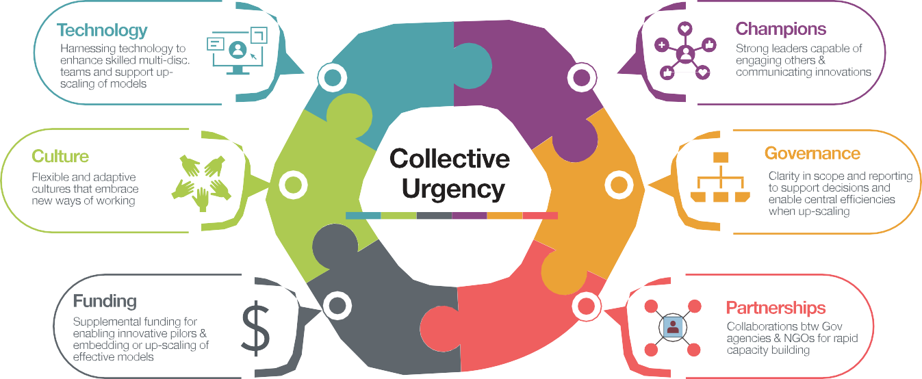

Appendices

Appendix 1a. Project 1: summary graphs of current state and projections of identified post-pandemic registered health workforce
Graph 1. Projected number of practitioners by professional group Department of Health and Aged Care, November 2023
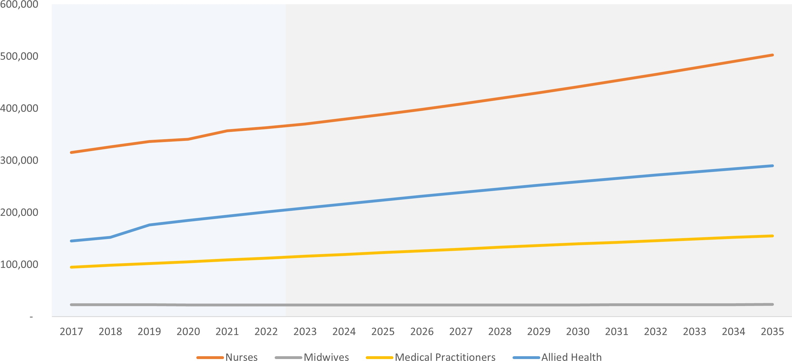
Graph 2. Projected number of practitioners (FTE) by profession group | Department of Health and Aged Care, November 2023
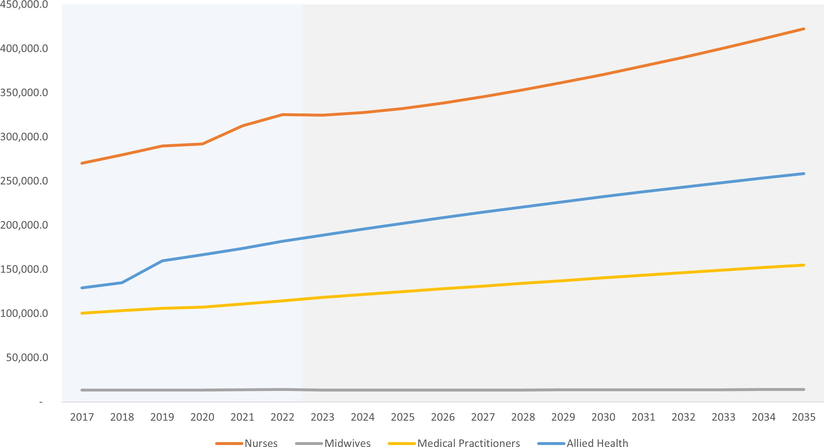

Appendix 1b. Project 1: current and projected state of the post-pandemic health workforce for nurses
- The number of nurses in Australia is projected to rise from 363,000 in 2022 to 503,000 in 2035, with a compound annual growth rate of 2.5%.
- The number of nurses in Victoria is expected to overtake the NSW figure by 2023.
- Despite a dip in the number of nurses in the Northern Territory in 2022, the Northern Territory is expected to have the highest growth rate of 3.2% per year until 2035.
- Tasmania is projected to have the highest nursing FTE per 1,000 population, with a figure of 19.4 by 2035, followed by Victoria and South Australia. However, the atypical growth in Tasmania from 2020-22 is unlikely to continue. Future projections are expected to align more closely with trends in other jurisdictions.
- New South Wales is projected to have the lowest nursing FTE per 1,000 population, with a figure as low as 10.3 in 2025, rising to 11.5 by 2035.
Graph 3. Projected nursing FTE per 1,000 by jurisdiction Department of Health and Aged Care, November 2023
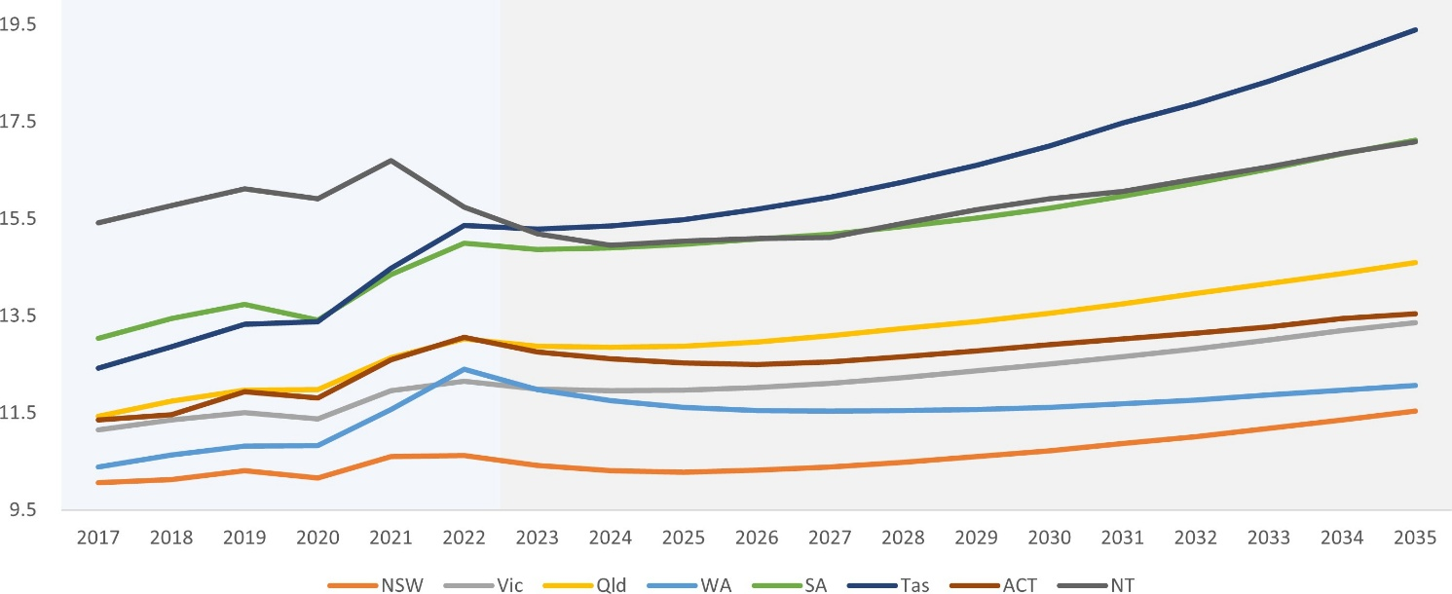

Appendix 1c. Project 1: current state of the post-pandemic health workforce for medical practitioners
- The number of medical practitioners in Australia is projected to rise from 112,000 in 2022 to 155,000 in 2035.
- The average FTE per medical practitioner fell from 1.05 in 2017 to 1.02 in 2022. This figure is projected to fall further, with an average of 1.00 FTE per medical practitioner in 2035.
- Tasmania is projected to have a significant increase in medical FTE per 1,000 population, from 4.8 in 2022 to 7.3 by 2035. However, the atypical growth in Tasmania from 2020-22 is unlikely to continue. Future projections are expected to align more closely with trends in other jurisdictions.
- New South Wales and Victoria are projected to have the lowest medical FTE per 1,000 population, with figures of 4.6 and 4.7, respectively, by 2035.
Graph 4. Projected medical FTE per 1,000 by jurisdiction Department of Health and Aged Care, November 2023
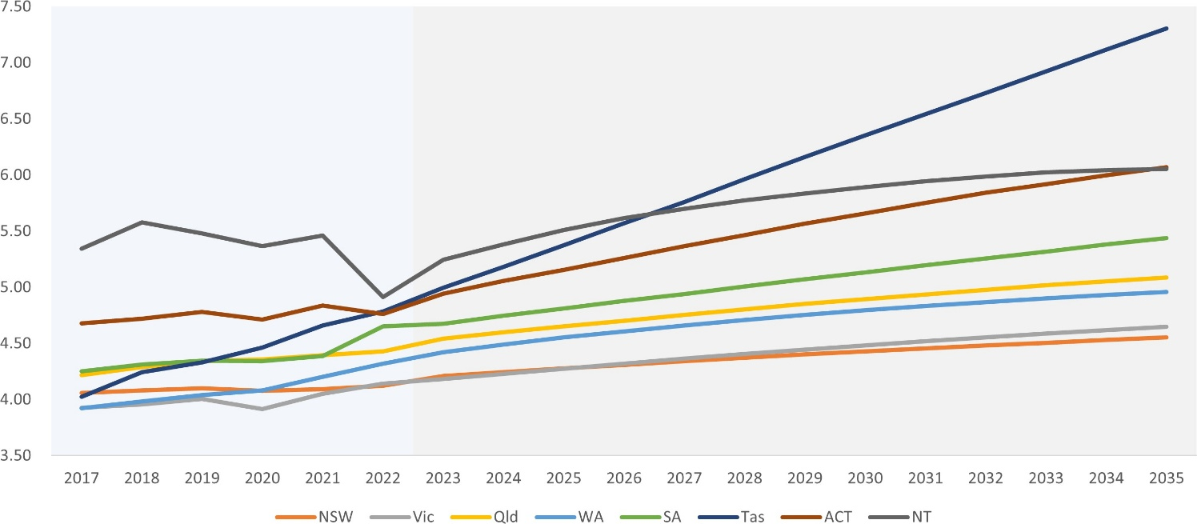

Appendix 1d. Project 1: current state of the post-pandemic health workforce for allied health
- The number of allied health practitioners in Australia is projected to rise from 193,000 in 2021 to 290,000 in 2035, with a compound annual growth rate of 3.0%.
- Tasmania is projected to experience a significant increase in allied health FTE per 1,000 population, from
- 4.6 in 2017 to 6.4 in 2021, projecting to 10.3 FTE per 1,000 by 2035. However, the atypical growth in Tasmania from 2020-22 is unlikely to continue. Future projections are expected to align more closely with trends in other jurisdictions.
Graph 5. Projected allied health FTE per 1,000 by jurisdiction Department of Health and Aged Care, November 2023
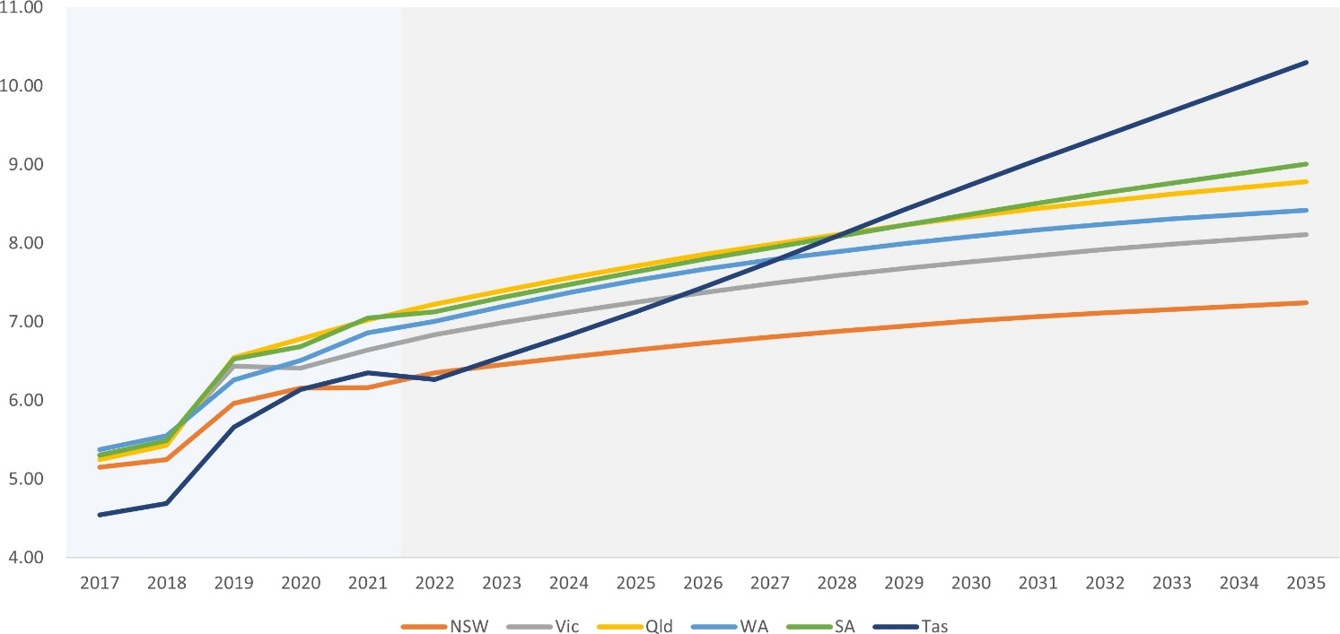

Appendix 2. Project 2: literature review on staff retention, attrition and re-entry strategies

Purpose and scope
The Workforce Intelligence Tiger Team (WITT) was established as part of the Health Workforce Taskforce to develop a national evidence base on workforce retention, attrition and re-entry strategies and to improve the use of existing workforce resources.
The WITT 1.2 project, led by Victoria in collaboration with the Commonwealth, reviewed academic and grey literature to identify drivers of workforce attrition, effective retention and re-entry strategies, and transferable lessons for Australia’s health system.

Background and impact of COVID-19
High levels of voluntary attrition (workers deciding to leave a workforce or profession) have been an international issue in healthcare for many years. Attrition affects every profession within the healthcare system, including nursing staff, physicians, and non-clinical workers [1-6]. Australia is no exception to this issue, with high levels of attrition reported nationally [7-9]. Healthcare professions experience higher levels of burnout, workplace stress and sickness compared to many other sectors [10, 11]. From a health system efficacy perspective, these high attrition rates are associated with poorer patient outcomes and substantially increase costs [1, 2, 12].
During the COVID-19 pandemic, health systems across the world were impacted by unprecedented surges in demand, stretching capacity and exhausting frontline healthcare workers [13-15]. After more than three years of sustained pressure, research indicates that the risk of widespread workforce attrition is higher than ever.
In Australia, 13.5% of nurses and midwives, 8.3% of doctors and 9.8% of allied health staff working in hospitals reported an intent to resign [16]. A separate survey of 400 emergency nurses found that 50% intended to leave within five years [17].
Similar trends have been observed internationally. In Canada, post-pandemic data showed that one in ten early career registered nurses (RNs) indicated that they were very likely to leave the profession [18]. The International Council of Nurses reported that 20% of national nursing associations saw an increase in nurses leaving the workforce [19]. In the United States, frontline clinical staff reported high levels of anxiety, depression and stress [14, 20, 21].

Burnout and workforce stress
Burnout, characterised by emotional exhaustion, psychological distress, low engagement and a low sense of professional accomplishment, remains one of the leading causes of attrition. Healthcare workers are particularly susceptible to burnout, with pre-pandemic reports reaching as high as 50% of surveyed staff [32]. At the Mayo clinic, increases in burnout and decreases in job satisfaction correlated with reduction in FTE [33] in physicians. Physicians experiencing burnout were twice as likely to leave their job and 5 times more likely to leave medicine altogether [34].
The pandemic did not necessarily create new issues but has exacerbated existing ones. Globally, healthcare workers are facing greater workplace stress than ever before, and this is reflected in increased turnover intentions across countries and health systems [13, 15, 22-24].

Factors influencing attrition
The attrition of experienced healthcare workers is a serious issue both nationally and internationally and requires organisational and government intervention. To design effective interventions, it is essential to understand the factors driving workforce turnover.
A survey of 3,000 Australian Nursing and Midwifery Federation (ANMF) members reported an increase in elements such as ‘work intensification’ – higher workloads with less time to do the job – and a decrease in workplace climate and personal wellbeing [9]. High workloads have significant negative effects on patient outcomes. For example, a study in the United Kingdom’s National Health Service (NHS) found that adding one additional patient to a nurse’s workload increased the likelihood of another patient dying by 7% [25].
Of the 3,000 ANMF members surveyed, between one quarter and a third of respondents indicated they were thinking of leaving the profession, although a follow-up survey 12-months later found only 4% had actually done so. High workload remains one of the most commonly cited factors influencing intent to leave.
An international survey of nurses identified workload, inexperience, perceived staffing adequacy and job satisfaction as major predictors of turnover, with inexperience playing a significant role [26]. Retention and attrition are also closely linked to age and length of tenure, with younger and less experienced nurses more likely to leave the profession [27-29].
It is important to note that measuring turnover is difficult. Most studies use ‘intent to leave’ as a proxy for actual attrition, however the two do not always align [30]. Even so, intent to leave data serves as a useful indicator of overall dissatisfaction and workforce wellbeing at the time of measurement. These factors are consistent with qualitative research, such as interviews with nurses in the United Kingdom who re-entered the profession after career breaks. The two most common reasons for leaving were work-life balance becoming unmanageable and a lack of career progression options [1].
Similar factors were reported in other clinical professions. For example, emergency medicine technicians and paramedics leave the workforce for different reasons, with fewer paramedics reporting an intent to stay. Common themes include the need for better pay and seeking more career advancement [31]. Higher levels of job dissatisfaction were associated with increased likelihood of leaving in English physicians [3].

Burnout as a key driver
Occupational burnout is multifaceted and can be measured with validated tools such as the Maslach Burnout Inventory (MBI) [4]. In a longitudinal cohort study of primary care clinicians in the United States, 53% of respondents reported burnout symptoms, which were later associated with increased clinician turnover. Importantly, the authors stressed that turnover is multifactorial. It reflects not only the push of burnout and stress but also the pull of career mobility and opportunities for professional growth.
Workload, especially since COVID-19, has increased contributing to higher levels of burnout in Australian physicians [35]. For United States healthcare workers, COVID-related workplace stress and burnout compounded an already stressful profession, with one in five physicians and two in five nurses reporting their intent to leave their practice [15].

Strategies to increase retention
An experienced, high-performing, and satisfied workforce is key to building a thriving healthcare system. Allowing high attrition levels to persist risks a workforce that is overly reliant on supply pipelines from new graduates and international recruitment, losing critical sector knowledge, overburdening training programs and leading to poorer patient outcomes. Government and organisational interventions are therefore critical to improving staff retention.
Retention programs range from small, location-specific interventions to system-wide reforms, however, the effectiveness of these programs can vary. A review of international academic and grey literature provides a rich data source for a broad suite of retention policies.

Workplace environment and leadership
Broadly, the recommendations for interventions target the same areas cited as reasons for voluntary attrition, including workloads, job satisfaction, career mobility and burnout. Interestingly, although competitive remuneration and benefits are cited as a key contributor to increasing retention [19, 36], other reports have indicated that salaries are not necessarily as critical for retention as might be assumed [37].
Throughout the literature, profession-specific themes emerged. For example, common recommendations for nursing specifically noted the work social environment. A meta-analytic review [37] found that positive relationships with leadership and strong social networks, including mentoring, were associated with better retention. Similarly, a survey of United States registered nurses showed that a sense of belonging and community contributed significantly to a decision to stay [36]. From a policy perspective, these findings highlight the value of supportive work environments and emotionally intelligent leadership. Such environments can be fostered through leadership training programs [38], team building initiatives [39] or encouraging the use of nurse managers as monitors of workplace conditions [40].

Tailored strategies by cohort
Retention strategies are most effective when tailored to specific cohorts. For example, younger nurses are more susceptible to voluntary attrition [28, 41], and as such, benefit from targeted interventions such as peer-support groups [42] or guided support programs which ease the transition to clinical practice [43, 44]. Another cohort with high voluntary attrition is rural and regional healthcare workers, where successful retention includes recruitment from rural populations or encouraging rural clinical placements [45, 46].

Systemic interventions
Although personal interventions – such as discussion groups [47] or mindfulness programs [48] – may provide temporary relief, they do not address the underlying causes of clinical burnout or psychological distress. Indeed, during the pandemic, much focus was placed on increasing the ‘resilience’ of frontline healthcare workers as a way of improving wellbeing, but these policies place undue burden on the individual and are a superficial response to the issue [49]. Instead, organisational commitment is required for the system-level changes necessary if increasing retention is the goal [50].
A notable example comes from the United States, where a multicentre trial assessed interventions aimed at reducing clinician burnout. The study found that changes to workflows and targeted quality improvement projects were more likely to reduce burnout than changes to communications [51]. These initiatives targeted specific workflow limitations and points-of-annoyance present in the healthcare settings, and so directly improved the experiences of those staff members effected.
Broader system reforms have also demonstrated value. For instance, hospitals recognised for their ‘excellence in nursing’ under the American Nurses Credentialing Centre Magnet Recognition Program are consistently linked to higher job satisfaction and reduced staff turnover among nurses [36, 53, 54]. Three Australian hospitals have been awarded this designation: Princess Alexandra Hospital (Brisbane), Sir Charles Gairdner Hospital (Perth) and St Vincent’s Private Hospital (Sydney) [52]. The working conditions in these hospitals are characterised by high autonomy of scheduling, control of practice, organisational support and collegial interaction.
Importantly, the most successful interventions were quantifiable changes to working conditions, which were possible only due to top-down commitment. The impact of system-wide interventions, requiring strong organisational commitment, is further highlighted in research from the United States and the United Kingdom [11, 55].

Retention policy
It is beyond the scope of this report to detail the multitude of retention policy recommendations published in academic and policy literature. However, comprehensive examples can be found in major publications by the United States surgeon general [32], the National Academy of Sciences in the United States [34], the Royal Society of Canada [18], the Health Foundation in the United Kingdom [56] and the Deeble Institute of Health Policy Research in Australia [50].
Rather than being applied as generic templates, retention interventions should be designed collaboratively with the professions they aim to support. This ensures that healthcare workers can be heard and actively involved with mechanisms to improve workplace culture [9, 57].

Returning to the workforce
There is comparatively less research available on the experiences and needs of returning workers. Much of the existing literature focuses on support measures for employees returning to work following a planned or unplanned leave of absence, such as after workplace injury or following parental leave [58-61]. These studies provide valuable insights into how to support workers’ reintegration and improve long-term retention.
However, this report focuses primarily on workers returning to clinical practice following voluntary attrition. The Australian Health Practitioners Regulation Agency has developed a series of ‘return to practice’ frameworks for registered professions to follow when returning after a set period outside the workforce (generally five years). Professionals who hold relevant qualifications but have left their clinical profession are often regarded as a ‘potential workforce’ that can be re-engaged in times of high demand, such as during the COVID-19 pandemic [62].

Structured refresher programs
Several examples of structured refresher programs exist for healthcare workers seeking to transition back to clinical practice [63-65]. These programs reintroduce participants back to the clinical environment and provide education on new technologies, procedures and treatment plans that may have arisen since the healthcare worker left. These programs are often targeted towards those who have left the profession but are now seeking re-employment in a clinical setting. For those seeking to re-enter nursing in Australia, several universities offer return-to-practice programs, which contain academic and clinical components. These programs have attracted a high level of interest since being established [66].

Considering extenuating circumstances
Not all returning workers actively seek re-employment, but many may consider re-entry if the conditions are suitable. For instance, a 2007 Australian literature review found that the typical re-entry registered nurse was a 40-year-old female with school-aged children. This group valued family-friendly shifts and a paid and on-the-job refresher course which considers familial responsibilities and ongoing peer support [67]. Similar findings emerged in a United Kingdom study of 17 nurses who had re-entered the profession, which identified flexible and family-friendly working arrangements as key factors influencing return decisions [68].
Strategies to drive re-entry recruitment cannot focus solely on the initial steps of transitioning a healthcare worker back into the workforce. Many of those who choose to return will have left initially due to burnout, limited career progression or inflexible scheduling. Without addressing these systemic workplace issues which contributed to that decision to leave, the outcome may remain the same.

Conclusion
High levels of workforce attrition have long been a challenge for health systems worldwide, representing a substantial financial and personal cost for those affected. The COVID-19 pandemic exacerbated existing problems, pushing an already overworked workforce past previous thresholds. As a result, there are now global reports of healthcare worker shortages, high attrition levels and widening service gaps.
In the face of these predictions, there is more interest than ever in the tools, strategies and interventions which aim to stem the flow of our healthcare workforce and entice back those who have already left.
What is clear from international literature is that there is a wealth of recommendations and policies, with a range of benefits and costs. However, the most consistent conclusion across the literature is that successful retention and re-entry programs share three defining characteristics.
- Specificity: interventions are tailored to address the specific needs of defined workforce cohorts rather than applying one-size-fits-all approaches.
- Employee voice: healthcare workers are engaged as active contributors in policy design, ensuring that strategies respond to their lived experiences and professional needs.
- Organisational change: successful retention and re-entry recruitment occurs when there is a strong organisational commitment to the improvement of working conditions, and a willingness to address the systemic issues which are driving these attrition levels.
This review is not intended to be an exhaustive investigation of all available literature, nor is it intended to provide a definitive list of interventions to be implemented in the Australian system. Rather, it provides a synthesis of recurring evidence and guiding principles that can inform the design of effective workforce strategies in the Australian local, state and federal health systems.
To best utilise this framework, the next recommended action is a broad consultation process, drawing together representatives from health system leadership and employee groups, to design a list of locale- and profession-specific retention mechanisms for policymaker consideration.

Appendix 3a. Project 3: Innovative models to address acute, pandemic-related workforce pressures

Jurisdictional data collection Project summary
The WITT 1.3 project conducted a national survey of Australian health services to identify and compare workforce retention and re-entry strategies implemented between 2019 and 2023. Each jurisdiction was asked to submit examples of retention and re-entry incentives and strategies implemented in health services. To ensure consistency across submissions, WITT provided a standardised data collection template (Appendix 3b) and an online form accessible to all participating health services.

Data collection

Respondents
A total of 25 distinct health services provided 67 different strategies. Responses were received from jurisdictional departments (such as VicHealth) and individual health services. All Australian health jurisdictions from three states and one territory contributed to the analysis and feedback on this snapshot.
Responses were provided by the following jurisdictions:
- Victoria – Albury Wodonga Health, Alfred Health, Bairnsdale Regional Health Service, Bass Coast Health, Eastern Health, Gippsland Southern Health Service, Goulburn Valley Health, Kerang District Health, Kilmore District Health, Melbourne Health, Peninsula Health, Peter MacCallum Cancer Institute, The Royal Women’s Hospital, West Gippsland Healthcare Group, West Wimmera Health Service
- New South Wales – NSW Health, Wagga Wagga Base Hospital, Murrumbidgee Local Health District, Hunter New England Local Health District, NSW Health Rural Health Workforce Incentive Scheme, Sydney Children’s Hospitals Network, Western Sydney Local Health District, South-eastern Sydney Local Health District
- Australian Capital Territory – The Canberra Hospital, ACT Health
- South Australia – SA Health.

Facilities and professions targeted by retention strategies
Most retention strategies focused on public health facilities (approximately 71%). Smaller proportions targeted state-wide health facilities (around 8%) and community-based facilities (7%). The remainder targeted a mix of rural health services, private health services and international recruitment.
Across all submissions, the targeted professional groups included:
- nurses and midwives (~73%)
- medical practitioners (~36%)
- allied health practitioners (~52%)
- registered health professionals (other, ~21%)
- non-registered health professionals (~21%)
- retired, registered health professionals (~3%)
- retired, non-registered health professionals (~1%)
- other (~19%).
Many strategies applied across multiple workforce groups. The workforce are further broken down by speciality where possible. The most frequently targeted specialities were emergency, perioperative, theatre, aged care, mental health, allied health specialties and corporate staff. Appendix 1 provides a breakdown of strategy alignment to setting, workforce and speciality.
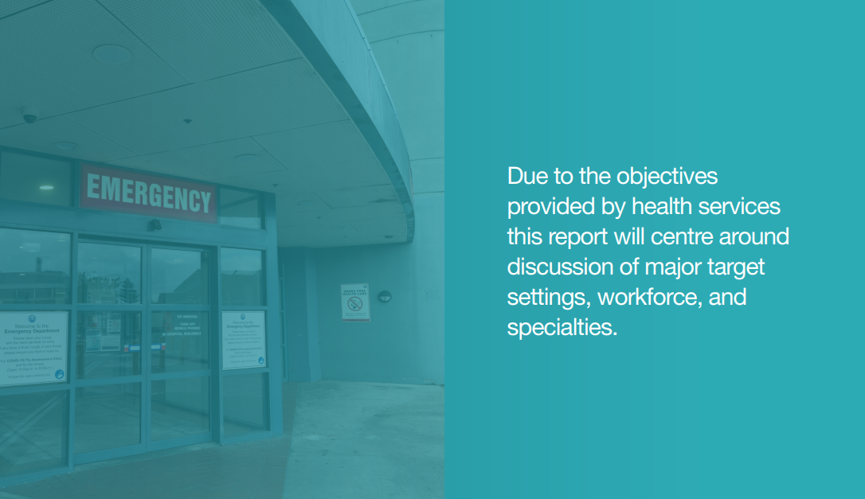

Findings

Overview of strategies
Due to the large number of respondents, there was a degree of overlap between some strategies while other, similar strategies, produced notable differences. This section summarises the cross-cutting themes across strategies, rather than describing each program individually.
Health services reported six major drivers for retention strategies.
- Staff burnout
Staff burnout was one of the primary reasons for attrition, with staff reporting feeling overworked and stressed in their daily roles. Stress for health care workers who worked directly with patients was higher due to the emotional toll of direct patient contact. Many of the staff who experienced burnout felt that there wasn’t enough support for them in their role, leading to them feeling overworked. The repetitious nature of many roles was also a contributing factor to burnout.
- Career stagnation
Career stagnation was a key reason for attrition, with lack of career progression (promotion, leadership and further responsibilities), further education (formal and informal education) and opportunity (movement to new area or practice, secondment) most reported.
- Limited opportunities in rural health services
Rural health services were finding that they were losing early career staff to perceived greater opportunities in larger metropolitan health services. Primary reported reasons for leaving rural health services were ease of access to opportunities, concerns about career stagnation and access to further education.
- Staff moving to private practice
There were 2 main reasons for staff moving to private practice: higher compensation and a better work life balance.
- Lack of satisfaction with management
Health services that reported lower staff satisfaction with management (in internal staff surveys) also reported higher attrition rates. These rates improved when staff satisfaction scores improved. Common underlying issues included a lack of managerial support, limited promotion and development opportunities, and rosters that did not align with staff-work needs. As such, a disconnect between the requirements of staff and management was an indicator of staff attrition.
- COVID-19
The COVID-19 pandemic had a direct impact on staff attrition in health services. It provided a unique multiplier of stress on all healthcare workers, increasing workplace stress and public critique. It intensified existing issues and increased their magnitude.

Commonalities between strategies
Across the 67 strategies submitted by health services, several common themes emerged. The most frequent focus areas were upskilling current staff (24 strategies), staff wellbeing (19 strategies), supporting staff workloads (16 strategies), and improving job security (eight strategies). Together, these themes highlight a shared emphasis on building capability, reducing burnout and increasing stability within the workforce.

Upskilling current staff
Providing staff with opportunities to upskill was another highly effective approach to retain staff. These methods required clear advice and guidance on pathways and careers that employees could take in their current role, alongside good advertising of the opportunities available. Two approaches included:
- leadership training empowering long-time staff to pass down information and responsibility to junior staff
- direct financial support or concessions for formal and academic study options.
Both upskilling pathways enabled staff to easier realise their ambitions and therefore improved job satisfaction, a metric directly linked to retention.

Staff wellbeing
Strategies that focused on improving staff wellbeing were among the most common and successful strategies, both in relation to staff outcomes and the effort/cost of implementation. These strategies had a lower cost to implement than others while demonstrating higher rates of success. Key initiatives included:
- providing access to free and confidential mental health support services, delivered on-site or virtually to increase flexibility
- providing additional staff support and becoming more sensitive to the mental health of employees
- offering support that addressed burnout, particularly during the COVID-19 pandemic
- introducing or expanding flexible working arrangements, to improve work-life balance and reduce stress and burnout
- celebrating staff achievements to promote a culture of appreciation and recognition.

Supporting staff workloads
Strategies to reduce workload pressures typically fell into three categories:
- increasing the number of staff working at any one time to reduce the load per person
- supporting more senior staff rather than junior staff, allowing senior staff members to provide guidance and advice on uncommon situations in the workplace
- implementing technological solutions such as electronic aids, electronic medical records, knowledge portals and virtual assistance.
Virtual staff were utilised by one health service in particular, a unique strategy that is expanded upon below.
A number of health services adopted preventative approaches, identifying and addressing workload issues before they escalated. Due to the preventative nature of these strategies, it is difficult to derive a baseline figure of attrition to measure success. Additionally, several health services adopted multiple strategies simultaneously, which made assessment of individual strategy effects challenging.

Improving job security
Improving job security was one of the key strategies identified to improve staff retention. Health services found that staff were more likely to remain when they had confidence in the continuity of their employment.
Approaches included:
- Extending fixed term contracts or converting them to ongoing positions, gave staff greater peace of mind and security. Many employees who wished to continue at the health service had begun looking for new work due to a lack of job security.
- Transitioning casual employees to permanent part-time roles led to similar improvements.
- Supporting international staff by ensuring appropriate visa and sponsorship arrangements, enabled them to continue working with the health service for a longer period and reduced attrition.
- Retaining international graduates by offering employment within the health service after graduation reduced attrition.

Time since implementation
Most of the strategies described were ongoing initiatives. Of the 67 strategies submitted, 42 were still in progress at the time of reporting. These were either recently implemented or extended due to their initial success.
In total, 17 programs were no longer active. Of these, some were time-limited initiatives that achieved their objectives and were awaiting renewal, while others had been discontinued after not delivering their intended results.
The duration and timing of strategies varied considerably. Six programs began in 2020, during the early stages of the pandemic, while the majority began more recently – 23 in 2022 and 16 in 2023.
This pattern suggests that many health services are prioritising short-term retention strategies to respond to workforce pressures intensified by the COVID-19 pandemic, while maintaining a focus on longer-term solutions

Effectiveness and outcomes
The following section outlines the strategies reported as effective by health services and summarises their observed outcomes. Many of the strategies were still being implemented or reviewed at the time of reporting, so outcomes should be considered indicative rather than conclusive. Several strategies demonstrated measurable success in reducing attrition and improving staff engagement.

Flexible working arrangements
Strategies that improved flexibility and work-life balance were among the most successful. Following implementation, many health services reported high staff retention, including long-term staff, resulting in preservation of institutional knowledge. While there was a slight reduction in overall hours worked for most staff members, there was still an overall increase in hours worked when compared to replacing staff with new hires.

International recruitment
Staff recruited internationally had higher retention rates compared to locally sourced staff. Although there were additional costs and requirements with international staff, these workers often filled roles with high turnover and difficult-to-recruit roles. For example, one health service recruited 151 international staff and saw successful retention of 148 of those staff 12 months later (98% retention rate).

Employee wellbeing programs
There were three major types of wellbeing strategies:
- on-site psychologist/counselling services, provided free of charge to staff
- strategies targeting specific groups of people that face additional hardships in the workplace, including people of colour, members of the LGBTIQA+ community, and women
- specified locations to provide respite to staff, such as lounges and lunching areas.
These strategies reduced attrition by lowering staff stress, increasing happiness at work and reducing staff burnout. Many programs achieved sustained success through high participation rates and positive feedback in staff wellbeing survey results. As a result, they have continued to receive support following their initial trial periods and, in many cases, have expanded beyond their initial scope. For example, one health service reported a decline in staff reporting ‘high stress levels’ from 26% to 19% in one year due to staff wellbeing programs.

Employee recognition
Employee recognition programs that championed staff commitment and contributions were also well received. These programs created a more positive working environment by showing appreciation for staff efforts. One health service reported that, among staff who left post-implementation, an increased number stated that they were happy with their role and had left for other reasons. Overall, employee recognition strategies led to a 4% reduction in staff reporting ‘high stress’ over a 12-month period.

Improving opportunities for staff to specialise
Allowing staff to focus on the parts of their work they find the most rewarding proved to be a highly effective retention strategy. One health service, for example, created dedicated midwife roles by separating midwifery from the general medicine ward. This change led to a marked improvement in the retention of midwives.

Scholarships and bursaries
While many financial incentives demonstrated limited success, scholarships and bursaries were a notable exception. This is largely because public sector financial bonuses and incentives cannot compete with those offered in the private sector. Health services reported that funded opportunities for further study were particularly valued by staff and contributed to improved staff retention.

Redeployment of staff
Redeploying staff into new or evolving roles, rather than making positions redundant, also proved effective in reducing attrition and was well received by health services.

Upskilling current staff
Staff who were offered opportunities to upskill – either via formal study or industry training programs – were more likely to stay. Retention remained high throughout study periods, and most staff continued working within their organisation after completing their training. For example, one program supporting enrolled nurse (EN) graduates to transition into RN roles reduced EN attrition from 50% to 0% in the year it was implemented.

Support from senior staff
When senior staff provided support to more junior staff, attrition rates dropped markedly, and staff reported feeling respected and heard by management. A positive secondary effect was a reduction in staff error rates, as junior staff felt comfortable asking for assistance from more experienced members of the team. One health service reported that 60% of staff felt that their clinical skills and confidence improved following implementation of this strategy.

Supporting staff in rural areas
Health services reported that rural staff members often felt under supported. Providing additional support and attention to staff in these areas led to an increase in retention rates, indicating the importance of feeling appreciated. Such strategies were quite common amongst health services and consistently demonstrated success in strengthening workforce stability.

Strategies with potential
Strategies prompting staff who have retired or moved on to new ventures to return to the health service saw moderate success for short-term staffing. While returning staff were able to perform effectively compared with new recruits, they only returned for brief periods of time, limiting overall retention.
Referral-based recruitment strategies also proved useful in filling vacant positions quickly with qualified candidates. Although early feedback was positive, most health services indicated that implementation was too recent to accurately assess long-term retention outcomes compared with other recruitment methods.

Ineffective strategies
Not all retention strategies produced successful outcomes. Many initiatives were still under review at the time of reporting and could not yet be classified as successful or unsuccessful. Some strategies continued beyond their initial implementation period due to partial or short-term success, while others were discontinued after failing to achieve the expected results.
A commonly cited example of limited effectiveness was the use of retention bonus payments. Health services that provided a one-off cash bonus to staff who stayed for a set period reported that these incentives did not deliver the long-term results they were hoping for. In most cases, staff who intended to leave did so after receiving the bonus, while others were not influenced by the financial incentive at all. This led to high staff retention in the short term but not the long term.

Implementation requirements
All strategies had different implementation requirements depending on their design, workforce context and resource needs. This section outlines the key activities, communication approaches and organisational supports that contributed to successful implementation.

Key activities

Internal communications
Effective internal communication was essential to staff awareness and engagement. Strategies were unlikely to succeed if staff were unaware of changes affecting them. Health services therefore used a range of communication methods, including:
- print media – posters, flyers and newsletters
- digital media – email, Teams and other internal communications platforms
- social media – LinkedIn and internal staff social media
- direct promotion – management promoting directly with staff, hosting events to advertise the initiatives (townhalls, lunches, morning teas) and staff sharing the information directly with other staff members.

External communications
Some strategies – particularly those focused on recruitment and public engagement – required external communications. Strategies included:
- traditional media – such as news outlets, billboards, radio and TV
- social media – targeted campaigns on LinkedIn, Facebook and Instagram
- social advertising and events – targeted campaigns particularly effective for regional and rural health services with strong community networks; attendance at careers and trade expos to help reach a wider audience
- engagements with schools and universities – site tours and promotion through community clubs, places of worship, gyms, sporting facilities and concert halls producing a lot of community engagement and promotion of retention and recruitment strategies.

Discussions with staff
Open discussion with staff allowed employees to ask questions, express concerns and understand how changes would affect their work. Health services also found that including staff early in the process – by seeking feedback and adapting strategies accordingly – improved overall participation and program uptake. These strategies helped reduce stress around the changes, reduce resistance to change and increase uptake of the strategy.

Collaboration with external parties
Some strategies relied on collaboration with an external party for implementation. These partners commonly included educational institutions such as universities, government bodies, and consultancies or other private companies. While the involvement of external parties helped reduce internal resourcing requirements, it often came at a greater financial cost.

Structure
Several strategies required changes to team structures to enable effective implementation. In some cases, staff were reorganised into smaller, more specialised areas. These changes require organisational and human resource support to manage redeployment and ensure staff are appropriately placed. Similarly, redeploying staff into new roles rather than making positions redundant requires human resource support and involvement.

Training programs
The implementation of many strategies required staff who were motivated to upskill and continue learning. A lack of professional development opportunities was frequently identified as a key reason for staff attrition.
Training programs generally fell into two categories:
- Management training – focused on strengthening leadership skills and workplace inclusion. This included sensitivity training to support groups who may require additional support such as, people with disabilities, members of the LGBTIQA+ community, immigrant populations, Indigenous Australians and neurodivergent peoples. It also improved succession planning, equipping managers to collaborate more effectively with staff.
- Staff training and upskilling – focused on changing policies around leave to support additional learning, including by providing exam leave and additional study leave, physical space for staff to conduct their learning and increasing opportunities for staff to undertake their study.

Recruitment
Many strategies focused on recruiting new staff with the goal of improving long-term retention. Health services reported two kinds of approaches:
- International recruitment – international staff had lower attrition than local staff and could be employed to fill skillset gaps. However, onboarding international employees required additional administrative support.
- Graduate and early-career recruitment – hiring directly from educational institutes also improved retention rates and was a common target for recruitment strategies.

Extending contracts
Several initiatives targeted job security by offering extensions for interns and early career doctors, graduate nurses and early career allied health professionals. Human resources teams were required to implement this strategy, for example, to rewrite clauses and reissue contracts with new dates, or clauses. However, these strategies carry some risk if health services don’t contract the right staff.

Financials
Many strategies involved a financial component, either as a direct financial incentive or some form of financial support for their implementation. Examples included scholarships, bursaries and retention bonuses, which were either provided directly or supported by a health department. Further detail on the financial aspects of these incentives is provided in the section below.
Many initiatives were associated with financial costs, either due to the time and materials required to implement them or due to direct, per-use costs of incentive programs. Project timelines were also impacted by funding availability and approval processes.
Health services reported 39 programs that included financial incentives. These covered a large range of actions, such as bonuses, scholarships, bursaries, relocation incentives and gifts. Thirteen of these programs received government funding, which correlated with the uptake of programs.
The most common incentives were scholarships or bursaries (eight programs), relocation incentives
(eight programs) and financial bonuses (five programs). Many financial incentives saw high success rates, with staff responding well to this approach to retention. Financially supported initiatives showed mixed results. While some strategies, particularly those funding education or training, delivered strong outcomes, others, such as one-off cash bonuses, produced only short-term improvements in retention.

Financial incentives
Successful incentives shared several characteristics, described below.

Educational incentives
Some programs included strategies focussing on facilitating staff access to further personal development and education opportunities. These included the provision of grants, scholarships and bursaries or compensation for the costs of educational materials. Staff frequently identified a lack of learning opportunities as a reason for leaving, so funding further study improved job satisfaction and retention.

Monetary bonuses
Direct cash bonuses were used to support relocation of staff to areas of unmet demand and cash bonuses for referral of new staff. Cash rebates covering commuting costs were also implemented in some cases to encourage participation of staff from a wider geographical range. While retention bonuses (for staff members who remain within a health service for a specified period) were effective in the short term, staff who were intending to leave the health service still did so following the payment of their bonus.

Gifts and recognition
Some programs offered gifts, such as shopping vouchers and travel vouchers, or events, such as lunches and morning teas, to show appreciation to staff members for their work.

Additional leave entitlements
Health services also offered additional forms of leave, such as mental health leave, additional parental leave and study/educational leave. These additional leave entitlements improve the work life balance of staff members.

Costs of implementation
The financial costs of implementing projects varied widely between health services. Some organisations provided detailed costing breakdowns, while others noted no additional expenses.
Forty-one programs stated there were no additional direct costs of implementation, although this may have excluded time and labour costs. Therefore, while some strategies indicate ‘no cost’ there is an inferred opportunity cost associated with every strategy no matter how minor.
Among the 25 strategies that provided detailed cost data, the average monthly cost was approximately
$27,000 however some strategies indicated costs as low as $50. Larger health services tended to report higher costs for similar projects due to scale.
Due to these factors, the report does not provide a standard cost estimate for implementation. Instead, each health service should assess the likely financial implications of adopting similar strategies, taking into account its workforce size, priorities and available resources.

Challenges
Each project reported specific challenges during implementation, ranging from staffing the project to getting executive buy-in. The following themes were consistently identified across health services.

Staffing projects and initiatives
Successful implementation required staff to plan, deliver and evaluate each project. This often meant redeploying internal staff movement, assigning additional responsibilities to existing staff, hiring new staff, or employing an external company to manage project implementation. Some projects required specific skills and knowledge that would be costly and challenging to acquire in the market, leading internal recruitment to generally be the preferred approach. However, each method was associated with its own costs, benefits and challenges.

Resources
Most health services reported that limited funding and administrative resources constrained project delivery. Some organisations had to take shortcuts to finish the project with the available funding. The administrative workload – such as preparing collateral, evidence, detailed and approval documentation – often delayed the project or placed additional pressure on teams.

Currency of information
Several services noted the importance of timely information and up-to-date data when designing retention strategies. If implementation was delayed for too long after identifying an issue, the strategy sometimes failed to address the problem effectively. Projects needed to ensure that the evidence base remained relevant to the problem at the time of implementation.

Connectivity
Connectivity issues, particularly in rural areas, are a challenge that needs to be considered in the planning phase of the strategy. If a solution is connectivity reliant, then appropriate measures need to be put in place to ensure that the solution will work as intended in the area(s) of implementation.

Time constraints
Many projects were subject to strict funding deadlines, which placed constraints on the team. Appropriate planning is required to ensure the solution can be delivered in the appropriate timeframe.

Uptake of programs and strategies
Some initiatives encountered challenges in gaining support from both management and end users. Without leadership endorsement, funding, promotion and implementation of the solution can be difficult and slow. On the other hand, if the buy in challenges those whom the solution attempts to assist, there can be barriers to successful change, including poor response rates, push back from staff and lack of engagement. A common example reported by health services involved the introduction of flexible staffing hours for nurses. While designed to give nurses greater control over their working hours, these efforts resulted in challenges getting staff to fill undesirable shifts such as night shifts. As a result, health services faced scheduling gaps and inconsistent staffing coverage.

Example strategies
Health services developed several unique strategies that fell outside the main thematic categories described in this report but demonstrated strong potential for improving retention and workforce capability. The following examples illustrate creative and effective approaches to improving staff attrition.

Virtual nurse assistants – supporting staff
With increasing numbers of early career nurses entering the workforce, one health service implemented a virtual nurse assistant (VNA) to provide additional clinical support. The program connected bedside nurses with experienced remote clinical nurse coordinators who offered virtual guidance on the functions of general assessment, triage, emergency department-focussed assessment and reassessment, treatment and care. It also supported nurses transitioning into rural or regional roles for the first time as well as nurses working temporarily in a health service (such as agency nurses).
Implementation required a full-time project manager and several clinical nurse coordinators, with a total project cost of around $500,000. The tasks required in the implementation of this project included:
- establishing a steering committee to provide governance over the project
- developing a training and education plan to enable clinical skills and virtual technology adoption at an intermediate level for the clinical nurse expert and frontline clinician
- delivering foundational training module(s) to standardise assessment processes between the clinical expert and frontline nurse
- evaluating the model and program outcomes.
The service identified three main challenges:
- adoption and utilisation of the technology by staff
- connectivity of health service sites to the network
- change management across health services.
User feedback was overwhelmingly positive, with satisfaction scores averaging 4.75/5. The service also reported high uptake among rural and early career clinicians, and early evidence that agency staff were returning for extended placement due to the support they received from the VNA service.

Standalone midwifery unit – employee specialisation
A rural health service sought to improve retention among midwives by creating a standalone midwifery unit separate from their standard inpatient units. This change enabled midwives to work exclusively within their speciality area, improving job satisfaction. This project helped to build capacity and leadership within maternity services.
The project cost was approximately $100,000, covering business case development, community consultation and operational transition. Key implementation activities included:
- developing a business case that detailed financial impacts
- consulting with the affected community
- obtaining support and endorsement from the board
- appointing a manager for the new unit and standalone midwifery positions
- involvement the Australian Nursing & Midwifery Federation (ANMF), including a change impact statement and consultation on the split of the units.
Despite initial challenges, such as startup costs, operating costs and negotiations with industry representatives, early outcomes were positive with an increase in internal and external applications.

Strategies supporting early-career staff
Three health services implemented initiatives aimed specifically at supporting early career staff, expanding graduate programs and providing clarifying career pathways. The initiatives focused on transition, resilience, authentic leadership, commitment and support. By providing extra support to these staff, they were able to learn and grow in the health service and hence were less likely to seek this leadership and growth in other health services.
Key implementation elements included:
- revising contracts for graduates and interns
- increasing the number of supernumerary staff to assist newer staff members
- offering dedicated rotations for early career staff to explore their areas of interest
- developing managerial frameworks to support the more flexible roles of early career staff
- consultations with educational institutions to assess the effectiveness of the program(s).
These strategies faced challenges such as securing additional staff when required, management workload, and difficulty accommodating the requirements of all staff due to personal differences and requirements. However, outcomes were highly positive. One health service reported a retention rate of approximately 90% and another reported a drop in their attrition rate from 50% to zero upon program implementation. This demonstrates that flexibility and support were major drivers for staff retention.

Conclusion
Health services across Australia have implemented a diverse range of strategies to improve workforce retention, from financial incentives to staff wellness plans. While financial incentives have delivered positive short-term outcomes, the evidence suggests that longer-term retention is better achieved through strategies that help staff feel valued, supported and able to grow into future roles.
Health services found that the uptake of strategies was often challenging, particularly in high pressure environments. Reducing staff burnout and workplace stress emerged as a prerequisite for the success of other strategies, with staff wellbeing improvement consistently linked to lower attrition.
These findings also indicate a need for systematic evaluation of strategies through cost-benefit analysis. This would enable health services to more effectively measure, compare and rank the effectiveness of different initiatives across health services.
Many services also provided information related to recruitment and workforce acquisition rather than retention. Although retention strategies can mitigate workforce pressures, they cannot fully resolve understaffing that is already present.
Responses were predominantly received from health services in New South Wales and Victoria, with fewer contributions from regional and rural areas. Many of these organisations reported that their immediate focus remains on securing the right staff, with retention efforts being strengthened once workforce stability is achieved.

Appendix 3b. Innovative models to address acute, pandemic-related workforce pressures – summary collection form

Summary collection form
Thank you for completing this form for the Health Workforce Intelligence Tiger Team (WITT) Project 1.3. The purpose of this template is to collect examples of retention and re-entry incentives and strategies across the jurisdictions implemented between 2019 and now.
Please:
- Use the example descriptors in the template to guide a consistent understanding of information requested across jurisdictions. Key definitions are provided below the template.
- Complete a separate form for each retention and re-entry strategy.

Retention and re-entry strategy summary
Name of strategy
Targeted setting/s for use of the workforce | (Pls delete options that do not apply or comment as appropriate)  - Community Facility  - Public Health Facility  - Private Health Facility  - Private/NGO Facility  - Home based  - Statewide  - Multiple (Pls list)  - Other (Pls Comment)
Location | - Name of specific hospital/service  - Regions (i.e., LHN)  - Statewide
Workforce/s involved  (Please delete options that do not apply and write the specialty for each profession involved as indicated)
  Profession | Sub/Specialty
  Nurse/Midwife
  Medical Practitioner
  Allied Health professionals
  Registered Health Professional (other than listed above)
  Non-Registered Health Professional
  (Retired) Registered Health Practitioner
  (Retired) Non-Registered Health Practitioner
  Other (Please Comment)
Provide a short description of the strategy including its purpose (e.g., to build capacity, fill need, support potential future need)? | Click or tap here to enter text.
Were financial incentives (e.g., scholarships and bursaries) used in the strategy? If so, please describe briefly | Click or tap here to enter text.
Implementation activities & requirements | Click or tap here to enter text.
Implementation costs | Please include communication strategy.
Challenges to implementation? | Click or tap here to enter text.
Why was the strategy needed? | Click or tap here to enter text.
Duration (Dates in use) | Please list dates the strategy was being implemented (date-to-date).
Comment regarding the effectiveness/reception of the strategy | Attach program evaluation if available  Were the intended outcomes achieved?  Did the program have unintended (beneficial or adverse) consequences?
Outcome | Program continuation  Expansion/extension of funding  Program cessation  Program review in progress.
Attachment | Please attach available additional information (e.g., program  overview, webpage, brochure, government paper).
General Comments | Click or tap here to enter text.

Key definitions:

Strategy
A plan designed to achieve long-term overarching goals.

Subspecialty /specialist
A specialist has completed an accredited medical degree and vocational training in a chosen medical field and has gained registration with the Medical Board as a specialist.
A subspecialist practitioner focuses on one aspect of their discipline, for example, a general practitioner who only works in a skin or travel clinic, or an allied health practitioner who only works with patients with a specific range of diagnosis or health problems.

Communication strategy
A communication strategy is a two-way process that involves clear messages, delivered via appropriate platforms by the government/relevant body that is tailored for diverse and targeted audiences.

References
- Garside, J., et al., Explaining nursing attrition through the experiences of return-to-practice students: a mixed-methods study. Br J Nurs, 2021. 30(8): p. 490-496.
- Woodward, K.F. and M. Willgerodt, A systematic review of registered nurse turnover and retention in the United States. Nurs Outlook, 2022. 70(4): p. 664-678.
- Hann, M., D. Reeves, and B. Sibbald, Relationships between job satisfaction, intentions to leave family practice and actually leaving among family physicians in England. Eur J Public Health, 2011. 21(4): p. 499-503.
- Willard-Grace, R., et al., Burnout and Health Care Workforce Turnover. Ann Fam Med, 2019. 17(1): p. 36-41.
- Buchan, J. and L. Aiken, Solving nursing shortages: a common priority. J Clin Nurs, 2008. 17(24): p. 3262-8.
- Dyrbye, L.N., et al., Estimating the Attributable Cost of Physician Burnout in the United States. Ann Intern Med, 2019. 171(8): p. 600-601.
- Halcomb, E. and S. Bird, Job Satisfaction and Career Intention of Australian General Practice Nurses: A Cross-Sectional Survey. J Nurs Scholarsh, 2020. 52(3): p. 270-280.
- Foster, K., et al., Workplace stressors, psychological well-being, resilience, and caring behaviours of mental health nurses: A descriptive correlational study. Int J Ment Health Nurs, 2020. 29(1): p. 56-68
- Holland, P.J., T.L. Tham, and F.J. Gill, What nurses and midwives want: Findings from the national survey on workplace climate and well-being. Int J Nurs Pract, 2018. 24(3): p. e12630.
- Ruotsalainen, J., et al., Systematic review of interventions for reducing occupational stress in health care workers. Scand J Work Environ Health, 2008. 34(3): p. 169-78.
- Brand, S.L., et al., Whole-system approaches to improving the health and wellbeing of healthcare workers: A systematic review. PLoS One, 2017. 12(12): p. e0188418.
- Li, Y. and C.B. Jones, A literature review of nursing turnover costs. J Nurs Manag, 2013. 21(3): p. 405-18.
- Poon, Y.R., et al., A global overview of healthcare workers' turnover intention amid COVID-19 pandemic: a systematic review with future directions. Hum Resour Health, 2022. 20(1): p. 70.
- Rodriguez, R.M., et al., Academic Emergency Medicine Physicians' Anxiety Levels, Stressors, and Potential Stress Mitigation Measures During the Acceleration Phase of the COVID-19 Pandemic. Acad Emerg Med, 2020. 27(8): p. 700-707.
- Sinsky, C.A., et al., COVID-Related Stress and Work Intentions in a Sample of US Health Care Workers. Mayo Clin Proc Innov Qual Outcomes, 2021. 5(6): p. 1165-1173.
- Holton, S., et al., Immediate impact of the COVID-19 pandemic on the work and personal lives of Australian hospital clinical staff. Aust Health Rev, 2021. 45(6): p. 656-666.
- Cornish, S., S. Klim, and A.M. Kelly, Is COVID-19 the straw that broke the back of the emergency nursing workforce? Emerg Med Australas, 2021. 33(6): p. 1095-1099.
- Royal Society of Canada, Investing in Canada’s Nursing Workforce Post-Pandemic: A Call to Action. 2022.
- International Council of Nurses, International Council of Nurses policy brief: The global nursing shortage and Nurse Retention. 2021.
- Elbay, R.Y., et al., Depression, anxiety, stress levels of physicians and associated factors in Covid-19 pandemics. Psychiatry Res, 2020. 290: p. 113130.
- Lai, J., et al., Factors Associated With Mental Health Outcomes Among Health Care Workers Exposed to Coronavirus Disease 2019. JAMA Netw Open, 2020. 3(3): p. e203976.
- Raso, R., J.J. Fitzpatrick, and K. Masick, Nurses' Intent to Leave their Position and the Profession During the COVID-19 Pandemic. J Nurs Adm, 2021. 51(10): p. 488-494.
- Kantorski, L.P., et al., Intention to leave Nursing during the COVID-19 pandemic. Rev Lat Am Enfermagem, 2022. 30: p. e3613.
- Schug, C., et al., Sick Leave and Intention to Quit the Job among Nursing Staff in German Hospitals during the COVID-19 Pandemic. Int J Environ Res Public Health, 2022. 19(4).
- Aiken, L.H., et al., Nurse staffing and education and hospital mortality in nine European countries: a retrospective observational study. Lancet, 2014. 383(9931): p. 1824-30.
- Burmeister, E.A., et al., Determinants of nurse absenteeism and intent to leave: An international study. J Nurs Manag, 2019. 27(1): p. 143-153.
- Li, J., et al., Reward frustration at work and intention to leave the nursing profession--prospective results from the European longitudinal NEXT study. Int J Nurs Stud, 2011. 48(5): p. 628-35.
- Flinkman, M. and S. Salantera, Early career experiences and perceptions - a qualitative exploration of the turnover of young registered nurses and intention to leave the nursing profession in Finland. J Nurs Manag, 2015. 23(8): p. 1050-7.
- Rudman, A., P. Gustavsson, and D. Hultell, A prospective study of nurses' intentions to leave the profession during their first five years of practice in Sweden. Int J Nurs Stud, 2014. 51(4): p. 612-24.
- Rittenhouse, D.R., et al., No exit: an evaluation of measures of physician attrition. Health Serv Res, 2004.
- 39(5): p. 1571-88.
- Rivard, M.K., et al., Intentions and Motivations for Exiting the Emergency Medical Services Profession Differ Between Emergency Medical Technicians and Paramedics. J Allied Health, 2020. 49(1): p. 53-59.
- U.S. Surgeon General, Addressing Health Worker Burnout: The U.S. Surgeon General’s Advisory on Building a Thriving Health Workforce, U.S.S. General, Editor. 2022.
- Shanafelt, T.D., et al., Longitudinal Study Evaluating the Association Between Physician Burnout and Changes in Professional Work Effort. Mayo Clin Proc, 2016. 91(4): p. 422-31.
- National Academies of Sciences, E., and Medicine., Taking Action Against Clinician Burnout: A Systems Approach to Professional Well-Being. 2019, The National Academies Press: Washington (DC).
- Munira Z. Gunja, Stressed Out and Burned Out: The Global Primary Care Crisis — Findings from the 2022 International Health Policy Survey of Primary Care Physicians. 2022, Commonwealth Fund.
- Reinhardt, A.C., T.G. Leon, and A. Amatya, Why nurses stay: Analysis of the registered nurse workforce and the relationship to work environments. Appl Nurs Res, 2020. 55: p. 151316.
- Nei, D., L.A. Snyder, and B.J. Litwiller, Promoting retention of nurses: A meta-analytic examination of causes of nurse turnover. Health Care Manage Rev, 2015. 40(3): p. 237-53.
- Cowden, T., G. Cummings, and J. Profetto-McGrath, Leadership practices and staff nurses' intent to stay: a systematic review. J Nurs Manag, 2011. 19(4): p. 461-77.
- Krivanek, M.J., et al., Implementing TeamSTEPPS to Facilitate Workplace Civility and Nurse Retention. J Nurses Prof Dev, 2020. 36(5): p. 259-265.
- Duffield, C. and L. O'Brien-Pallas, The causes and consequences of nursing shortages: a helicopter view of the research. Aust Health Rev, 2003. 26(1): p. 186-93.
- Ten Hoeve, Y., J. Brouwer, and S. Kunnen, Turnover prevention: The direct and indirect association between organizational job stressors, negative emotions and professional commitment in novice nurses. J Adv Nurs, 2020. 76(3): p. 836-845.
- Coyne, D., A. Tuer, and J. McCulloh Nair, Novice Nurse Support Group: A Pilot Study. J Nurses Prof Dev, 2020. 36(1): p. 12-32.
- McDonald, A.W. and P. Ward-Smith, A review of evidence-based strategies to retain graduate nurses in the profession. J Nurses Staff Dev, 2012. 28(1): p. E16-20.
- Salt, J., G.G. Cummings, and J. Profetto-McGrath, Increasing retention of new graduate nurses: a systematic review of interventions by healthcare organizations. J Nurs Adm, 2008. 38(6): p. 287-96.\
- Russell, D., et al., Interventions for health workforce retention in rural and remote areas: a systematic review. Hum Resour Health, 2021. 19(1): p. 103.
- Allen, P., et al., 'It's mostly about the job' - putting the lens on specialist rural retention. Rural Remote Health, 2020. 20(1): p. 5299.
- West, C.P., et al., Intervention to promote physician well-being, job satisfaction, and professionalism: a randomized clinical trial. JAMA Intern Med, 2014. 174(4): p. 527-33.
- Beckman, H.B., et al., The impact of a program in mindful communication on primary care physicians. Acad Med, 2012. 87(6): p. 815-9.
- Udod, S., M. MacPhee, and P. Baxter, Rethinking Resilience: Nurses and Nurse Leaders Emerging From the Post-COVID-19 Environment. J Nurs Adm, 2021. 51(11): p. 537-540.
- Deeble Institute, Towards a thriving healthcare workforce, D.I.f.H.P. Research, Editor. 2022.
- Linzer, M., et al., A Cluster Randomized Trial of Interventions to Improve Work Conditions and Clinician Burnout in Primary Care: Results from the Healthy Work Place (HWP) Study. J Gen Intern Med, 2015. 30(8): p. 1105-11.
- Centre for Clinical Effectiveness, Evidence Snapshot: Magnet Hospital Program. 2019.
- Kutney-Lee, A., et al., Changes in patient and nurse outcomes associated with magnet hospital recognition. Med Care, 2015. 53(6): p. 550-7.
- Stone, L., et al., Benchmarking nurse outcomes in Australian Magnet(R) hospitals: cross-sectional survey. BMC Nurs, 2019. 18: p. 62.
- Panagioti, M., et al., Controlled Interventions to Reduce Burnout in Physicians: A Systematic Review and Meta-analysis. JAMA Intern Med, 2017. 177(2): p. 195-205.
- Buchan, J., et al., A critical moment : NHS staffing trends, retention and attrition. Research February 2019. 2019, London: The Health Foundation. 36 pages : illustrations (colour).
- El Koussa, M., et al., Factors influencing physicians' choice of workplace: systematic review of drivers of attrition and policy interventions to address them. J Glob Health, 2016. 6(2): p. 020403.
- Attoe, C., et al., Returning to clinical work and doctors' personal, social and organisational needs: a systematic review. BMJ Open, 2022. 12(5): p. e053798.
- Choi, K., et al., Time to return to work following workplace violence among direct healthcare and social workers. Occup Environ Med, 2020. 77(3): p. 160-167.
- Covell, C.L., et al., Mapping the peer-reviewed literature on accommodating nurses' return to work after leaves of absence for mental health issues: a scoping review. Hum Resour Health, 2020. 18(1): p. 36.
- Hulcombe, J., S. Capra, and G. Whitehouse, How well has part-time work on return from maternity leave been accepted in the workplace? Learnings from allied health professional managers in Queensland Health. Aust Health Rev, 2021.
- Noorland, S.A., T. Hoekstra, and M.O. Kok, The experiences and needs of re-entering nurses during the COVID-19 pandemic: A qualitative study. Int J Nurs Stud Adv, 2021. 3: p. 100043.
- Davidhizar, R.E. and D. Bartlett, Re-entry into the registered nursing work force: we did it! J Contin Educ Nurs, 2006. 37(4): p. 185-90.
- Green, M.S., et al., Success and Challenge When Returning to Clinical Practice: A Case Series in Anesthesiologist Re-Entry. Anesthesiol Res Pract, 2019. 2019: p. 3531968.
- Burns, H.K., et al., Returning nurses to the workforce: developing a fast track back program. Nurs Forum, 2006. 41(3): p. 125-32.
- Dragon, N., Returning to the fold: Re-entry to nursing practice. Australian Nursing and Midwifery Journal, 2019. 26(7): p. 11-13.
- Long, J. and S. West, Returning to nursing after a career break: Elements of successful re-entry. Australian Journal of Advanced Nursing, 2007. 25.
- Barriball, K.L., et al., Evaluation of Return to Practice: the views of nurse returnees from three NHS Hospital Trusts. J Nurs Manag, 2007. 15(4): p. 433-41.

