



Monitoring of self-collection in the National Cervical Screening Program

Summary pack

QUARTERLY REPORT – Q4 2025
Professor Dorota Gertig, NCSR Medical Director Dr. Farhana Sultana, Epidemiologist
Jack Davies, Business and Data Analyst

February 2026



EXECUTIVE SUMMARY

SCEE appears to be targeting more vulnerable groups including those under-screened
National SC Uptake: Increased to 49%, despite declining HPV test volumes
By Age: Uptake rose across all age groups, highest in 70–74 years at 56%
By State/Territory: Uptake also increased across all S & T; highest in Tasmania at 61%
By SEIFA Quintile: Uptake increased across all quintiles; highest in Quintile 1 (lowest) at 51%
By Remoteness (ARIA): Uptake rose in all areas; highest in very remote areas at 69%
Never/Under screened (30–74 yrs): Increased uptake in the hard-to-reach groups with the uptake being slightly higher in under-screened at 62%
HPV Positivity Rate: Remains higher for SC samples compared to CC samples
Follow-Up After HPV 16/18: 81% had colposcopy within 6 months of HPV 16/18 positive result and it was similar in CC & SC
LBC Follow-Up (SC non-16/18): 84% had an LBC after a SC HPV non-16/18 positive result
Switching to SC: 39.0% of people who screened in 2025 switched from CC to SC

Page 2 Monitoring of Self-Collection in the National Cervical Screening Program

SELF-COLLECT UPTAKE- SCEE PERIOD
Since the Self-Collection Eligibility Expansion (SCEE) in July 2022, the proportion of self-collected HPV tests has steadily increased each quarter.

450,000
Total count and % of all HPV screening tests reported as self-collect vs total count of clinician collected in each quarter
48.60% 49.11%

50%

400,000
45.92%
42.65%
45%

350,000
300,000
250,000
200,000
150,000
100,000
50,000
0

9.90%

13.13% 15.72%

23.91%
19.61%

27.08%

33.83% 37.41%
29.64%
40.37% 40%
35%
30%
25%
20%
15%
10%
5%
0%

Q3 Q4 Q1 Q2 Q3 Q4 Q1 Q2 Q3 Q4 Q1 Q2 Q3 Q4 2023 2024 2025
CC SC % SC
Page 3 Monitoring of Self-Collection in the National Cervical Screening Program

SELF-COLLECT BY AGE GROUP- SCEE PERIOD

The proportion of tests that were self-collected continued to rise across all age groups, highest in the 70-74 years age group.

Page 4
60%
55%
50%
45%
40%
35%
30%
25%
20%
15%
10%
5%
0%
Q3 Q4 | Q1 | Q2 Q3 | Q4 | Q1 | Q2 Q3 | Q4 | Q1 | Q2 Q3 | Q4
2022 |  | 2023 |  |  | 2024 |  |  | 2025

Monitoring of Self-Collection in the National Cervical Screening Program
55.18%
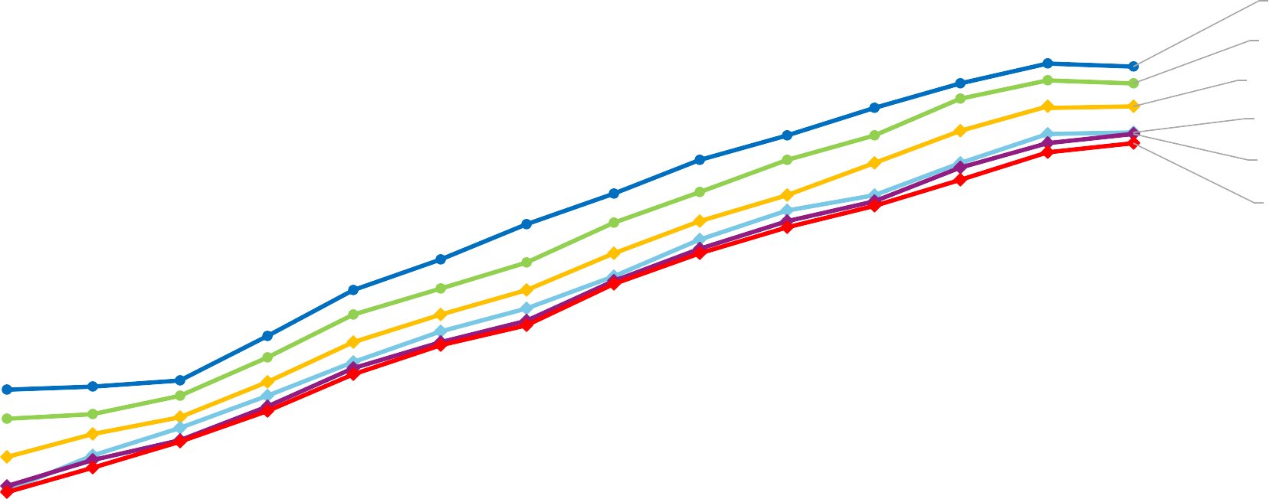
53.43%
50.80%
47.99%
47.75%
46.71%
70-74 yrs
60-69 yrs
50-59 yrs
25-29 yrs
40-49 yrs
30-39 yrs

SELF-COLLECT BY STATE OR TERRITORY- SCEE PERIOD

The proportion of tests that were self-collected continued to rise across all states, highest in Tasmania.

Page 5
65%
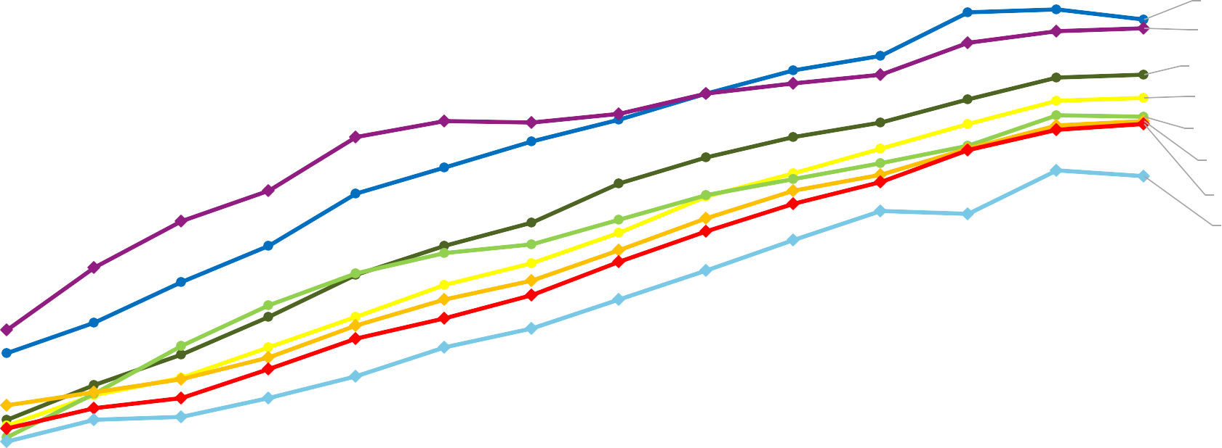
60%
55%
50%
45%
40%
35%
30%
25%
20%
15%
10%
5%
0%
Q3 Q4 | Q1 | Q2 | Q3 | Q4 | Q1 | Q2 | Q3 | Q4 | Q1 | Q2 | Q3 | Q4
2022 |  | 2023 |  |  |  | 2024 |  |  |  | 2025

Monitoring of Self-Collection in the National Cervical Screening Program
59.63%
58.54%
52.82%
49.88%
47.53%
47.00%
46.60%
40.03%
TAS NT VIC WA SA QLD NSW ACT

SELF-COLLECT BY SEIFA QUINTILE- SCEE PERIOD

The proportion of tests that were self-collected continued to rise across all quintiles; highest in SEIFA quintile 1.

60%
55%
50%
45%
40%
35%
30%
25%
20%
15%
10%
5%
0%
51.44%
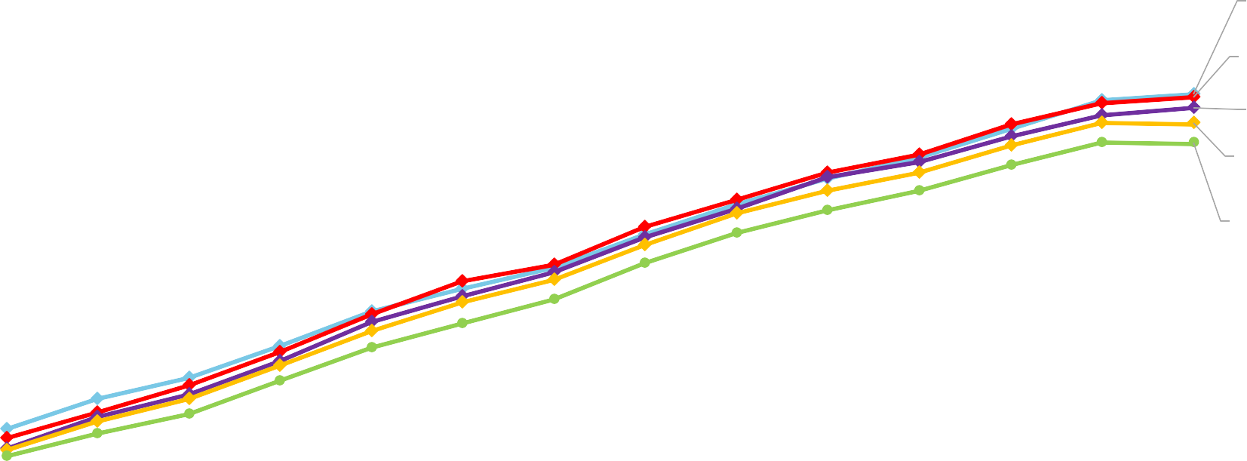
51.00%
49.85%
48.03%
45.63%
SEIFA quintile 1
SEIFA quintile 2
SEIFA quintile 3
SEIFA quintile 4
SEIFA quintile 5

A small number of geocodes are unknown and being resolved so numbers may change slightly.
Q3 Q4 | Q1 | Q2 | Q3 | Q4 | Q1 | Q2 | Q3 | Q4 | Q1 | Q2 | Q3 | Q4
2022 |  | 2023 |  |  |  | 2024 |  |  |  | 2025

Page 6 Monitoring of Self-Collection in the National Cervical Screening Program

SELF-COLLECT BY ARIA REMOTENESS INDEX- SCEE PERIOD

The proportion of tests that were self-collected continued to rise for all remoteness areas; highest uptake in very remote areas.

70%
65%
60%
55%
50%
45%
40%
35%
30%
25%
20%
15%
10%
5%
0%

A small number of geocodes are unknown and being resolved so numbers may change slightly.
Q3 Q4 | Q1 | Q2 Q3 | Q4 | Q1 | Q2 Q3 | Q4 | Q1 | Q2 Q3 | Q4
2022 |  | 2023 |  |  | 2024 |  |  | 2025

67.47%
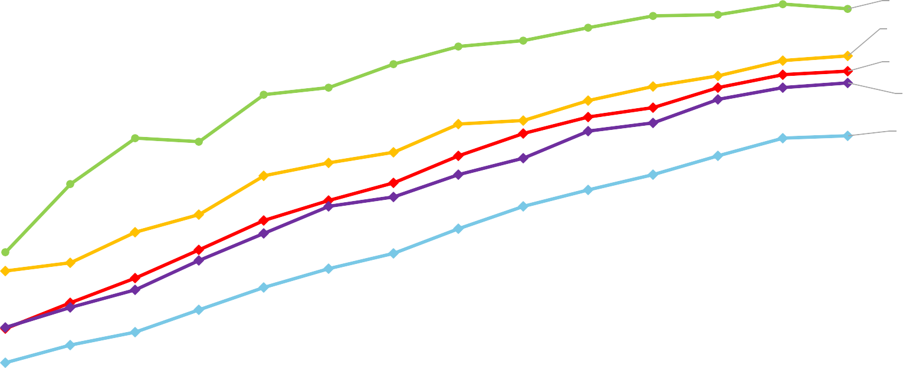
59.66%
57.08%
55.18%
46.24%
Very remote
Remote
Inner regional Outer regional Major cities

Page 7 Monitoring of Self-Collection in the National Cervical Screening Program

SELF-COLLECT BY SCREENING HISTORY- SCEE PERIOD
Never screened:
No prior screening test and aged 30-74 years
70%
60.13%
60%
50%
40%
30%
20%
10%
0%
Q3 Q4 Q1 Q2 Q3 Q4 Q1 Q2 Q3 Q4 Q1 Q2 Q3 Q4
2022
2023
2024
2025
Under screened:
>2 years overdue and aged 30-74 years
70%
60%
50%
40%
30%
20%
10%
0%
63.25%
Q3 Q4 Q1 Q2 Q3 Q4 Q1 Q2 Q3 Q4 Q1 Q2 Q3 Q4
2022
2023
2024
2025
There was a consistent increase in uptake in both never-screened and under-screened individuals; higher uptake in under-screened.

Page 8 Monitoring of Self-Collection in the National Cervical Screening Program | Q3 2024

ANY HPV POSITIVITY BY COLLECTION METHOD- FULL PERIOD


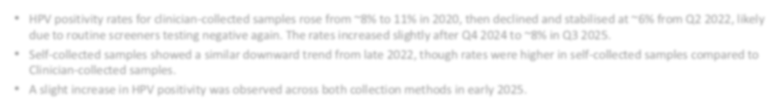
20%
Any HPV positivity in each quarter by collection method
- HPV positivity rates for clinician-collected samples rose from ~8% to 11% in 2020, then declined and stabilised at ~6% from Q2 2022, likely
due to routine screeners testing negative again. The rates increased slightly after Q4 2024 to ~8% in Q3 2025.
- Self-collected samples showed a similar downward trend from late 2022, though rates were higher in self-collected samples compared to Clinician-collected samples.
- A slight increase in HPV positivity was observed across both collection methods in early 2025.
19%
18%
Positivity rate for any type of HPV
17%
16%
15%
14%
13%
12%
11%
10%
9%
8%
7%
6%
5%

9.91%

8.40%

Year and quarter period
Q4 | Q1 | Q2 Q3 | Q4 | Q1 | Q2 Q3 | Q4 | Q1 | Q2 Q3 | Q4 | Q1 | Q2 Q3 | Q4 | Q1 | Q2 Q3 | Q4 | Q1 | Q2 Q3 | Q4 | Q1 | Q2 Q3 | Q4 | Q1 | Q2 Q3 | Q4
2017 |  | 2018 |  |  | 2019 |  |  | 2020 |  |  | 2021 |  |  | 2022 |  |  | 2023 |  |  | 2024 |  |  | 2025

% any HPV CC % any HPV SC

Page 9 Monitoring of Self-Collection in the National Cervical Screening Program

1ST COLPOSCOPY AFTER PRIMARY HPV 16/18 POSITIVE RESULT
BY COLLECTION METHOD – SCEE PERIOD

Collection method | First HPV16/18 positive result on a primary screening test  (1 Jul 2022 – 31 Dec 2025) (n) | Colposcopy within 6 months  of 16/18 pos result (n, %) | Colposcopy by 31 Dec 2025  after 16/18 pos result (n, %)
Clinician-collected | 25,417 | 20,549 (80.8%) | 23,549 (92.6%)
Self-collected | 19,605 | 15,962 (81.4%) | 17,902 (91.3%)
Total | 45,022 | 36,511 (81.1%) | 41,451 (92.1%)

- 81.4% had a colposcopy follow-up within 6 months of an HPV 16/18 positive result.
- Colposcopy follow-up was similar for CC and SC at 6 months (81.1% vs 81.7%; p=0.171) but significantly higher in CC compared to SC by 30 September 2025 (92.5% vs 91.2%; p<0.001).

Page 10 Monitoring of Self-Collection in the National Cervical Screening Program

1ST LBC FOLLOW-UP AFTER PRIMARY SELF-COLLECT
HPV NOT 16/18 POSITIVE RESULT – SCEE PERIOD

Collection method | First HPV not 16/18 positive result on a primary screening test (1 Jul 2022 – 31 Dec 2025) (n) | Any LBC  (all reasons included) within 6 months (n, %) | Any LBC  (all reasons included) by 30 Sep 2025 (n, %)
Self-collected | 72,845 | 61,130 (83.9%) | 65,181 (89.4%)
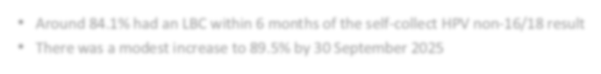
- Around 84.1% had an LBC within 6 months of the self-collect HPV non-16/18 result
- There was a modest increase to 89.5% by 30 September 2025

Page 11 Monitoring of Self-Collection in the National Cervical Screening Program

SWITCH FROM CLINICIAN-COLLECTION TO SELF-COLLECTION FOR EACH CALENDAR YEAR

40%
35%
30%
25%
20%
15%
10%
5%
0%
39.1%

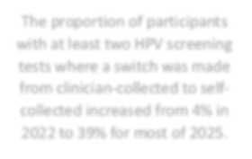
31.2%
18.6%
4.1%
0.0% 0.0% 0.0% 0.0% 0.1%
The proportion of participants with at least two HPV screening tests where a switch was made from clinician-collected to self-collected increased from 4% in 2022 to 39% for most of 2025.
2017* 2018 2019 2020 2021 2022 2023 2024 2025

2017* includes only December 2017

Denominator: Count of all participants with two HPV screening tests with the more recent HPV test reported in the year that i t was performed.
Numerator: Count of all participants with two HPV screening tests where the collection method in the most recent HPV test was SC and the collection method in the prior screening test was CC.

Page 12 Monitoring of Self-Collection in the National Cervical Screening Program

