Public consultation for a new National Oral Health Plan

Summary report December 2025

Introduction
This paper presents a summary of the public consultation activities undertaken in 2025 to help us develop the next National Oral Health Plan (the Plan).

Public consultation in 2025
We undertook two public consultation activities in 2025:
- focus groups with Aboriginal and Torres Strait Islander consumers and oral health providers about what’s important for First Nations oral health and what should be in the Plan. These consultations were conducted by an independent facilitator, First Peoples Health Consulting from June 2025 – September 2025.
- a public survey on the draft Framework for the Plan to test the draft Vision, Principles, Focus Areas and Outcomes for the next 10 years. The survey ran during September 2025, with some submissions received in October 2025.
We’d like to thank everyone who took the time to give feedback.

How we collected feedback
During the public consultation period, we collected feedback in three different ways:

Engagement with Aboriginal and Torres Strait Islander people
- First Peoples Health Consulting engaged with Aboriginal and Torres Strait Islander people on behalf of the Department of Health, Disability and Ageing. This included 102 consumers, practitioners, and National Aboriginal Community Controlled Health Organisation (NACCHO) Affiliates and members and one independent Aboriginal Medical Service.
- First Peoples Health Consulting partnered with NACCHO to coordinate input from its Affiliates and member services.
- First Peoples Health Consulting was also supported by the Indigenous Dental Association of Australia (IDAA), the national peak body representing Aboriginal and Torres Strait Islander oral health practitioners.

We ran a public survey
This was on the draft Framework underpinning the new Plan. We released the draft Framework for the new Plan in September 2025 on the department’s consultation hub. It was for consumers, health professionals, students or anyone with an interest in oral health. We were especially interested in responses from dental or oral health providers or people studying dental or oral health. We received 235 responses.

We received written submissions to the survey
In addition to the 235 completed survey responses, we also received 21 written submissions. Written submissions were from individuals and organisations with an interest in oral health, including providers, advocacy groups, healthcare professionals and academics.

Reviewing feedback from the public consultation
We took the following steps to review feedback from the public consultation.
- Review of feedback from Aboriginal and Torres Strait Islander people,
We reviewed information from the engagement with Aboriginal and Torres Strait Islander consumers, health care providers and organisations delivering oral health care. We looked for ways to improve the Plan in response to feedback.
- Review of responses to the survey. We collected and organised all the survey data to find common themes in people’s responses. We also looked for specific ideas on how to improve the Plan.
- Review of written submissions to the public survey. We looked for common themes and ideas on how to improve the Plan.

Aboriginal and Torres Strait Islander engagement themes
SUMMARY OF FINDINGS
This engagement brought together the voices of Aboriginal and Torres Strait Islander consumers, practitioners, and services to inform the new Plan. It was guided by community empowerment and cultural authority.
It identified priority statements that reflect the aspirations, expertise, and lived experience of Aboriginal and Torres Strait Islander peoples.
While strengths in the sector are acknowledged, the findings also highlight that oral health systems are challenged by systemic racism, funding inequities, workforce shortages and fragmented models of care.
The six priority statements outlined below are not isolated but woven together like strands of a dilly bag. Each relies on and strengthens the others, reflecting a holistic Aboriginal and Torres Strait Islander perspective. Addressing them collectively avoids siloed approaches and ensures reform is strong, coherent and enduring.
Engagement activities also included feedback from the National Aboriginal Community controlled Health Organisation (NACCHO) and the Indigenous Dental Association of Australia (IDAA). These contributions strengthened and consolidated the evidence base by bringing together the authority of the community-controlled health sector and the expertise of the Aboriginal and Torres Strait Islander oral health workforce.
Together, these priorities set an oral health reform agenda that is strengths based, community led and culturally grounded. They recognize the resilience, leadership and innovation of Aboriginal and Torres Strait Islander peoples while responding to the impacts of long-standing under-investment and systemic inequity.
Priority 1: cultural safety and anti-racism
Aboriginal and Torres Strait Islander people receive oral health care that is:
• culturally safe
• community-led
• free from racism
• anchored in cultural authority
• designed in partnership with Aboriginal and Torres Strait Islander people from inception
• accountable to Aboriginal and Torres Strait Islander people.
Cultural safety is foundational to quality and equity in oral health, requiring systemic accountability across policy, accreditation, workforce training and service delivery.
Priority 2: oral health workforce
Strengthen Aboriginal and Torres Strait Islander leadership and representation across the oral health workforce by creating culturally safe, supported pathways into education, employment and professional development.
This includes:
• expanding roles for Aboriginal and Torres Strait Islander Health Practitioners and health workers
• creating identified positions to further embed Aboriginal and Torres Strait Islander leadership
• fostering visible role models
• embedding career pathways that promote and encourage advancement, continuity and retention.
Identified positions create dedicated avenues for Aboriginal and Torres Strait Islander peoples to lead the transformation of oral health services, ensuring cultural safety is at the forefront of practice.
Priority 3: sustainable investment in community-based care
Aboriginal and Torres Strait Islander people must have equitable access to culturally safe oral health care, supported by sustainable, needs-based funding that embeds oral health as a core component of comprehensive primary health care.
Where services cannot be directly delivered through ACCHOs/AMS, Aboriginal and Torres Strait Islander people should be prioritised within public dental services to ensure continuity of culturally safe and accessible care.
Priority 4 Access to care
Aboriginal and Torres Strait Islander people have the right to oral health care that is accessible, community driven and culturally safe within their own communities.
True access goes beyond physical distance; it must also address factors such as wait times, infrastructure, workforce availability and flexible care hours for those unable to attend during standard opening times.
Reform must prioritise the voices of Aboriginal and Torres Strait Islander people and ensure services meet their holistic needs throughout the life course.
Priority 5: Promotion and prevention
Oral health promotion and prevention must be prioritised through culturally safe, community-led and inter-generational approaches that:
• embed Aboriginal and Torres Strait Islander cultural determinants of health
• strengthen the preventive health workforce
• are supported by flexible funding and systemic reforms addressing the broader social and environmental determinants of oral health.
Priority 6: aboriginal and torres strait islander partnerships and co-design
Strengthen oral health partnerships by embedding Aboriginal and Torres Strait Islander leadership, cultural governance and genuine co-design at every level of the system.
Partnerships must move beyond ad hoc, transactional arrangements toward enduring, community-led collaborations that are culturally governed, equitable and sustainable.

Online public survey feedback themes

Feedback on the draft framework
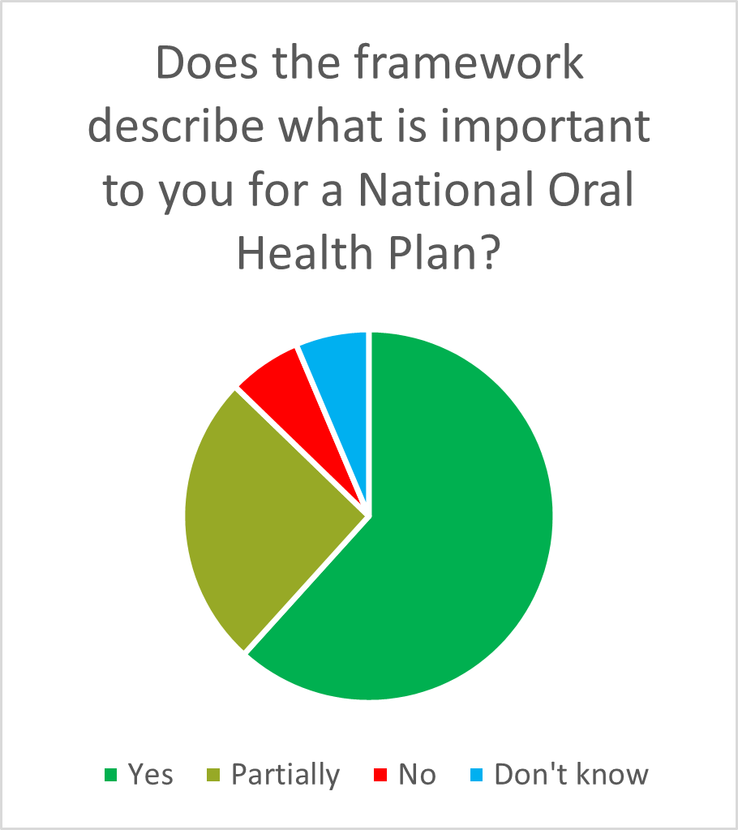
Most people who responded were happy with the draft Framework which set out a vision, principles, focus areas and outcomes for the next ten years. A small number of respondents felt the Framework needed a different approach.
Some survey respondents felt the Framework needed to be more purposeful in its language and intent.
Some survey respondents wanted more information about:
- how we will implement the plan and monitor its progress
- how the plan will be resourced
- who will be accountable.

Most survey respondents felt the framework described what is important to them for a National Oral Health Plan. Many respondents felt the Plan should set out clear implementation pathways and methods for monitoring performance. Multiple other suggestions were provided, including recognising populations with high oral health needs and increasing funding for oral health care.

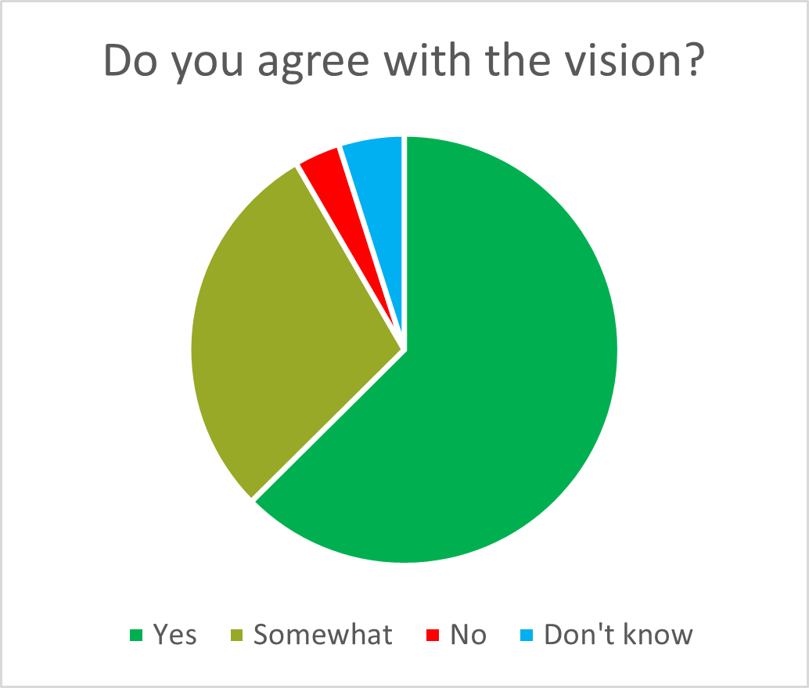
Feedback on the vision
While most survey respondents agreed with the draft vision of “Better oral health”, we received many suggestions for improvement.
Feedback indicated the draft vision could be more purposeful and have a greater equity lens.

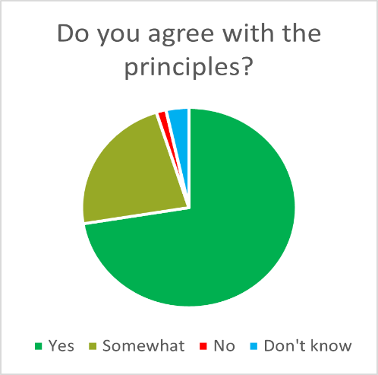
Feedback on the principles
Most survey respondents agreed with the draft principles that will underpin the Plan.
We received feedback that a greater focus on equity and cultural safety was needed. This feedback aligned with findings from the Aboriginal and Torres Strait Islander engagement.
Feedback also noted some overlapping principles.

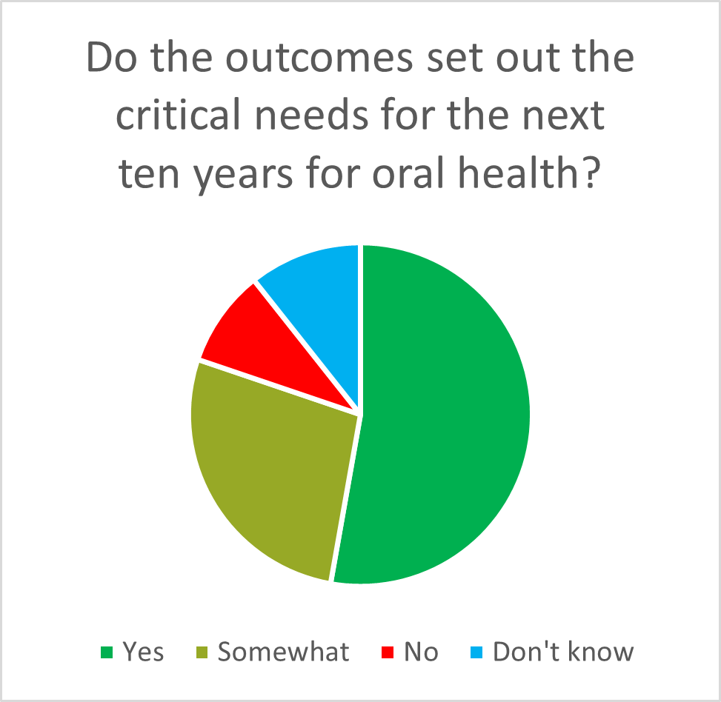
Feedback on the outcomes
The majority of survey respondents felt that the draft outcomes set out the critical needs for the next 10 years for oral health. A significant proportion of respondents had suggestions for improvement, including:
- addressing affordability of oral health care
- boosting emphasis on prevention and health promotion
- acknowledging complex workforce challenges
- the need for specific, measurable outcomes
- focusing on children and paediatric oral health in outcome measures, along with other specific population groups.
Respondents also provided practical ideas for improving oral health, including identifying:
- the need for culturally safe, trauma-informed care
- increasing access to treatment under general anaesthesia for children with a clinical need
- collaboration across health disciplines
- embedding oral health in primary care, health education and broader chronic disease management

Themes from submissions to the public survey
We received submissions from several peak bodies representing health professions, consumer advocacy organisations, academic organisations and groups, and from some individual academics and dental practitioners.
Most submissions supported the Framework and sought to provide suggestions for improvements. Most submissions agreed closely with feedback from the online survey and the Aboriginal and Torres Strait Islander engagement.
Several submissions expressed interest in how the outcomes could be achieved, and advised that detail on implementation, funding models, measurable targets and accountability would strengthen the Plan. Some submissions were disappointed that these elements were not set out in the draft Framework.
Recurrent themes from submissions included:
- the links between oral health and the rest of the body, and the role of the non-oral health workforce in oral health promotion and disease prevention
- the importance of preventative oral health care – for example regular check ups – in reducing costs for consumers and governments
- roles of GPs, in relation to managing the associated physical and mental health impacts of poor oral health and referring appropriately for treatment
- ongoing engagement with Aboriginal and Torres Strait Islander people as a priority
- cultural safety as a core component for improving oral health
- strong agreement that water fluoridation is a key strength of the way Australia supports oral health
- advice that the draft Vision should be strengthened, particularly to reflect the importance of improving equity in oral health
- advice on the importance of aligning research with oral health clinical practice and policy
- support for improving oral health data and research.
In addition, some submissions:
- sought the establishment of a Chief Dental Officer or a Chief Oral Health Officer role
- identified practical ways in which the non-oral health sector could be better equipped to embed oral health as part of routine care, in particular nursing and midwifery and general practice
- provided suggestions for funding mechanisms or changes aiming to improve the affordability of oral health care
- advised that cultural safety should be embedded as a Principle for the Plan
- identified pressure points and resourcing limitations for oral health training and professional development
- provided information and resources to support development of the Plan, including policy documents, examples of technological solutions and suggestions for wording changes to the draft Framework.

What happens next?
We are using the feedback to make changes to the draft Framework and shape the content of the Plan. All changes will be agreed by the Governance Group overseeing the development of the Plan.
Health Minsters will decide on the final Plan in 2026.

Nest, C. & Veasey, A. 2025. The Dilly Bag of Priorities: Interwoven Voices of First Nations People for Oral Health Reform – National Oral Health Plan 2025-2034. First Nations Consultation Report. Bundjalung Country, Australia. www.gullidala.org

