Setting up Thriving Kids

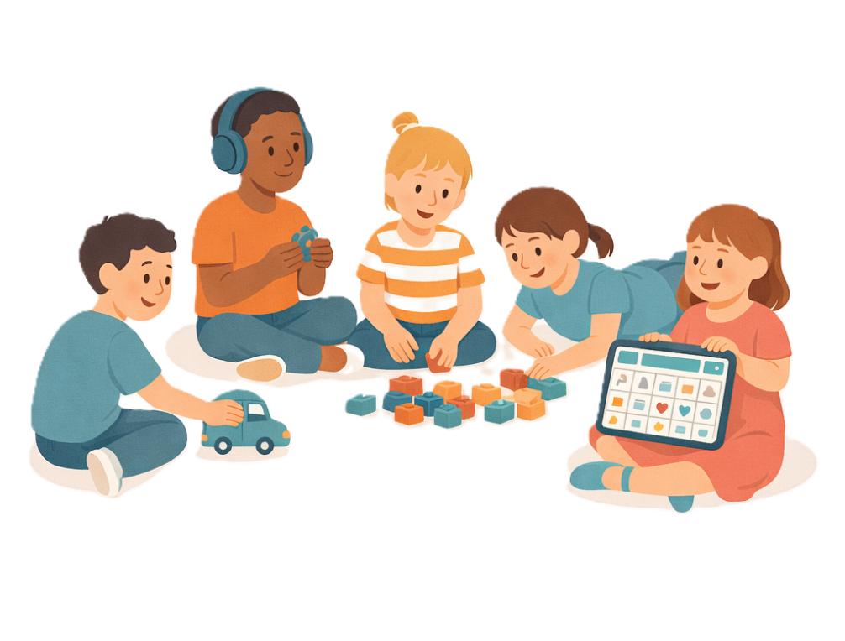
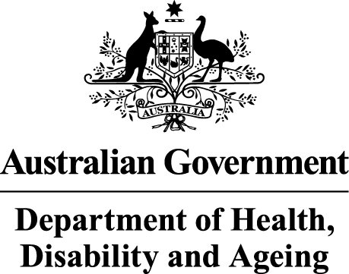 | The Australian Government Department of Health Disability and Ageing wrote this.  We say DHDA for short.  When you see the word we it means DHDA.
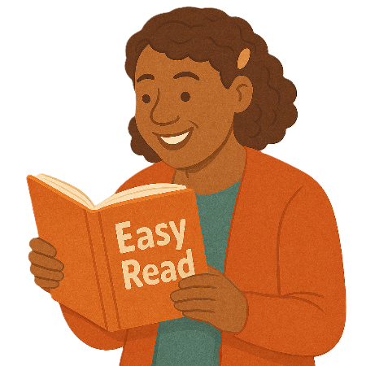 | We wrote this in an easy to read way.  We use pictures to explain some ideas.
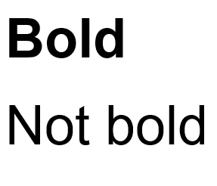 | We have some words in bold.  This means the letters are thicker and darker.  These are important words.
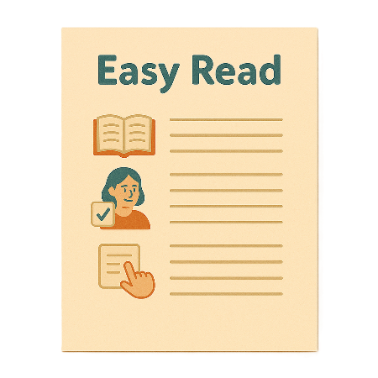 | This is an Easy Read summary of another document.  This means it has the most important ideas.
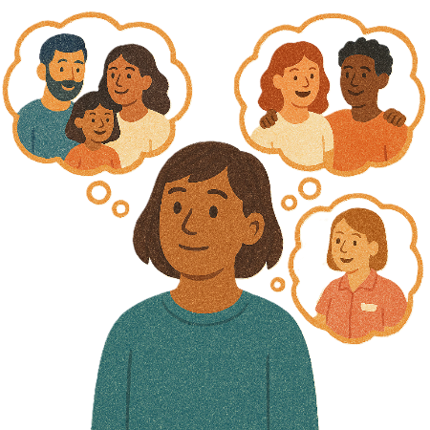 | You can ask for help to read this document.  You can ask  - A friend  - Family members  - A support person.
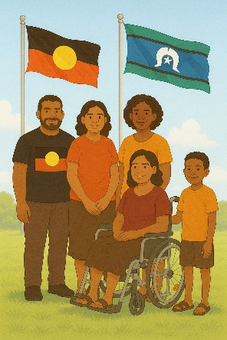 | We recognise Aboriginal and Torres Strait Islander people as the Traditional Owners of the land we live on.
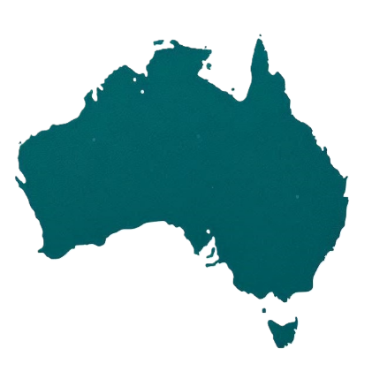 | They were the first people to live on and use the  - Land  - Waters.

Contents

What is Thriving Kids | 5
Thriving Kids Supports and Services | 8
What state and territory governments will do | 16
What the Australian Government will do | 18
Making Thriving Kids services | 20
Working together | 26
More information | 27

What is Thriving Kids

 | All governments are working together to make Thriving Kids.  That means the  - Australian Government  - State and territory governments  They have agreed what Thriving Kids will be.
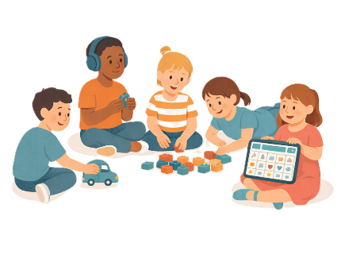 | Thriving Kids will have  - Brand new supports  - Some supports now that will be made better  It will be different to the NDIS.  It will support children who  - Are 8 years old and younger  - Have developmental delays  - Have autism  - Need some support.  It will also support families and carers.
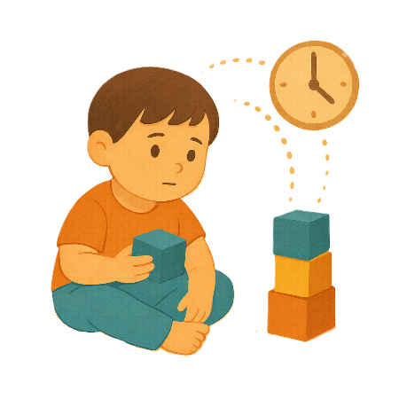 | Development delays are when  - Someone might be slower to develop than other people their age.  They might need extra help with  - Talking  - Moving  - Their emotions.
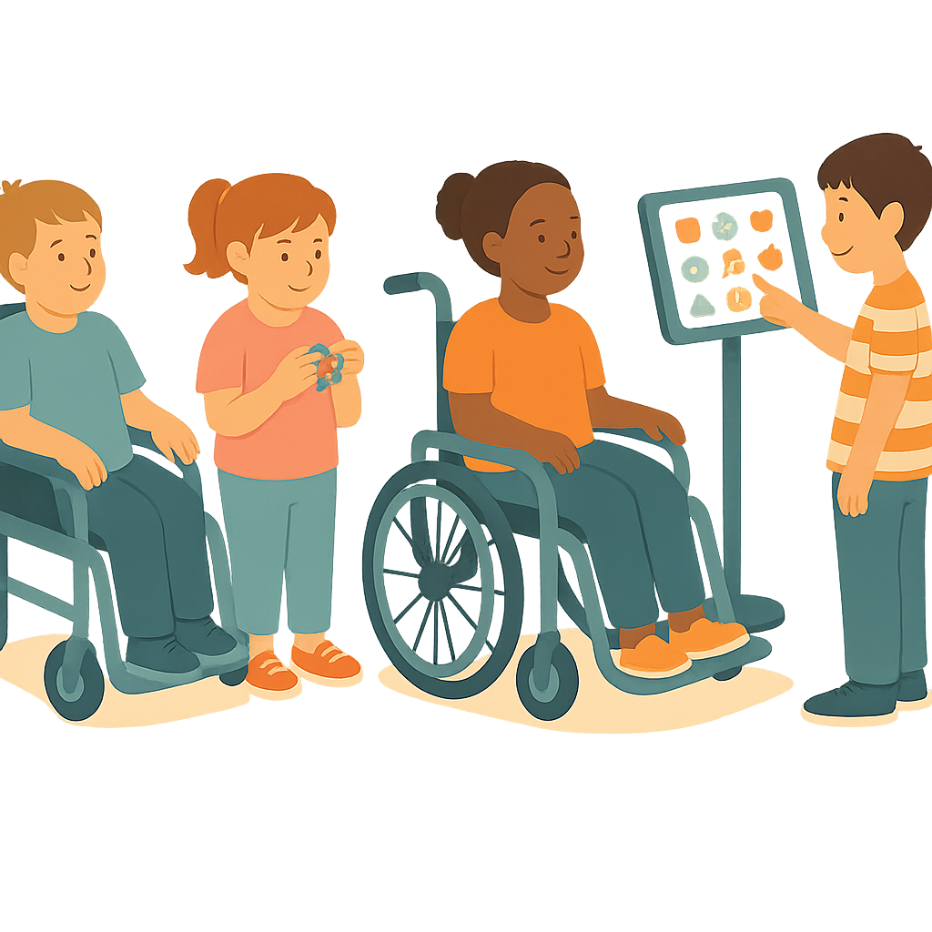 | Children who need lots of support will still be on the NDIS.
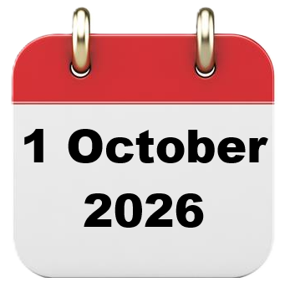 | Thriving Kids services will start on  - 1 October 2026
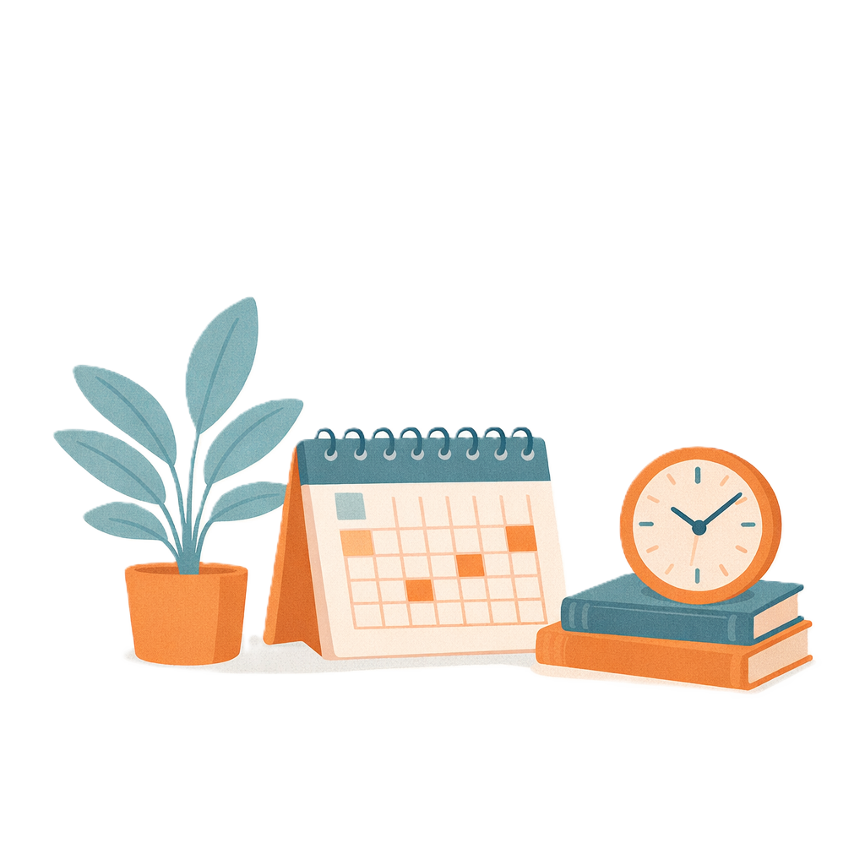 | It will take time for all services to be able to be used.  There will be more as time goes on.
 | Everything for Thriving Kids will be ready by  - 1 January 2028
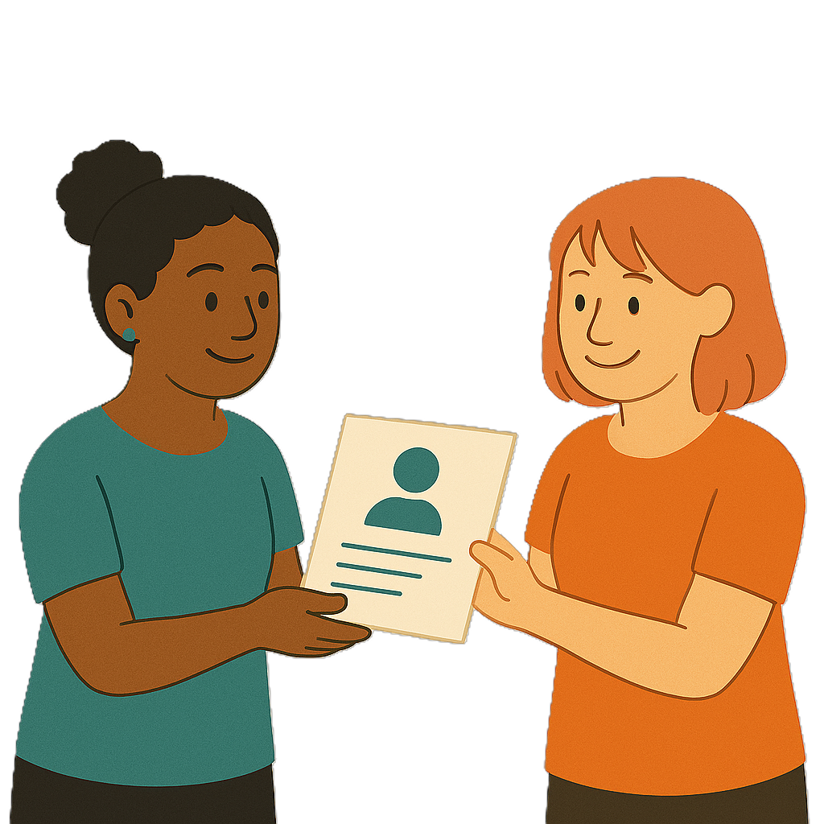 | We will share more information with you when it is closer to starting.

Thriving Kids Supports and Services

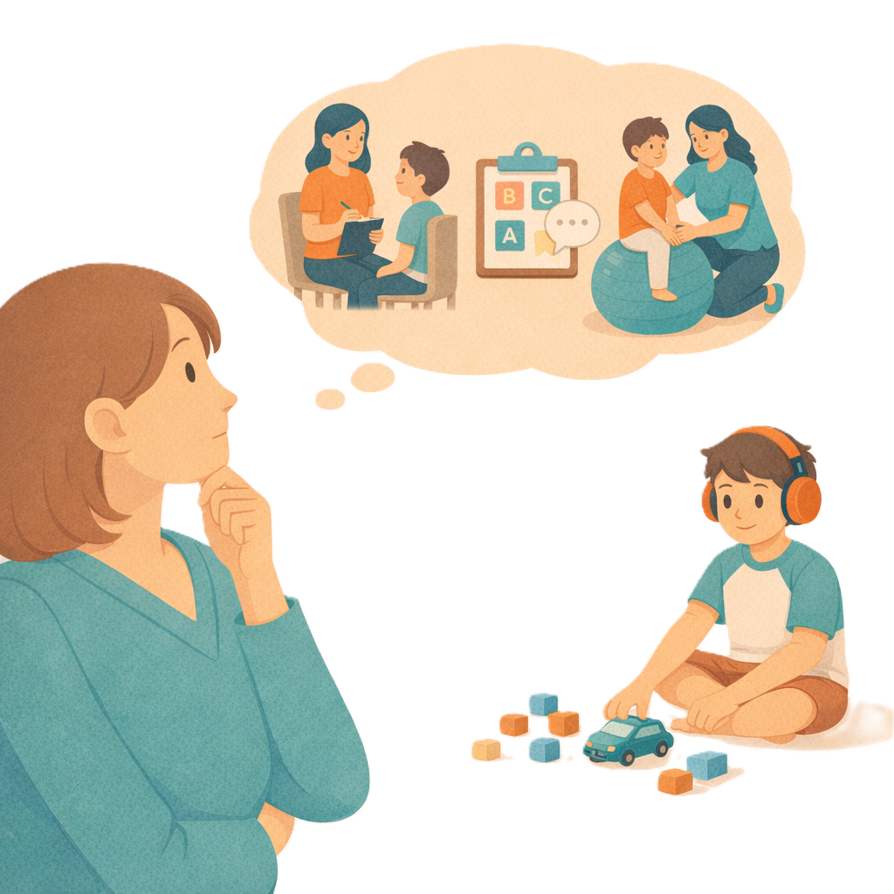 | Thriving Kids will have different types of services and supports.  It will have  - More of some services there are now  - Brand new services.
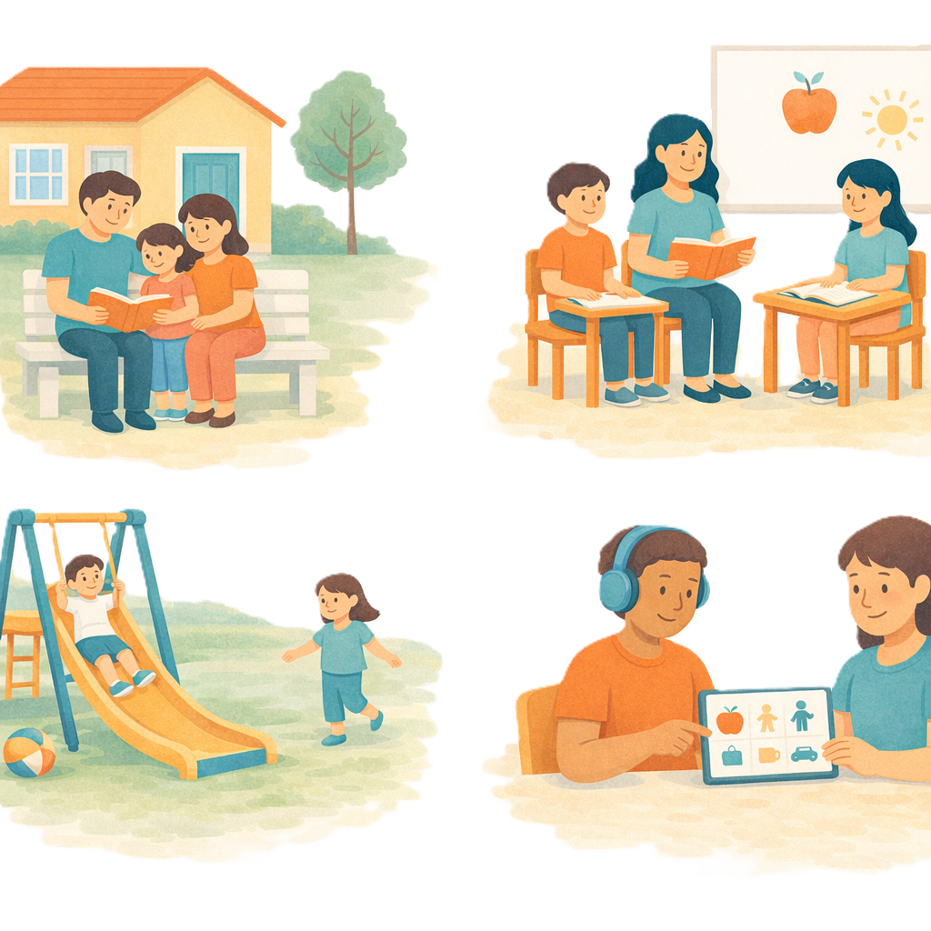 | The supports will happen where children  - Live  - Learn  - Play.
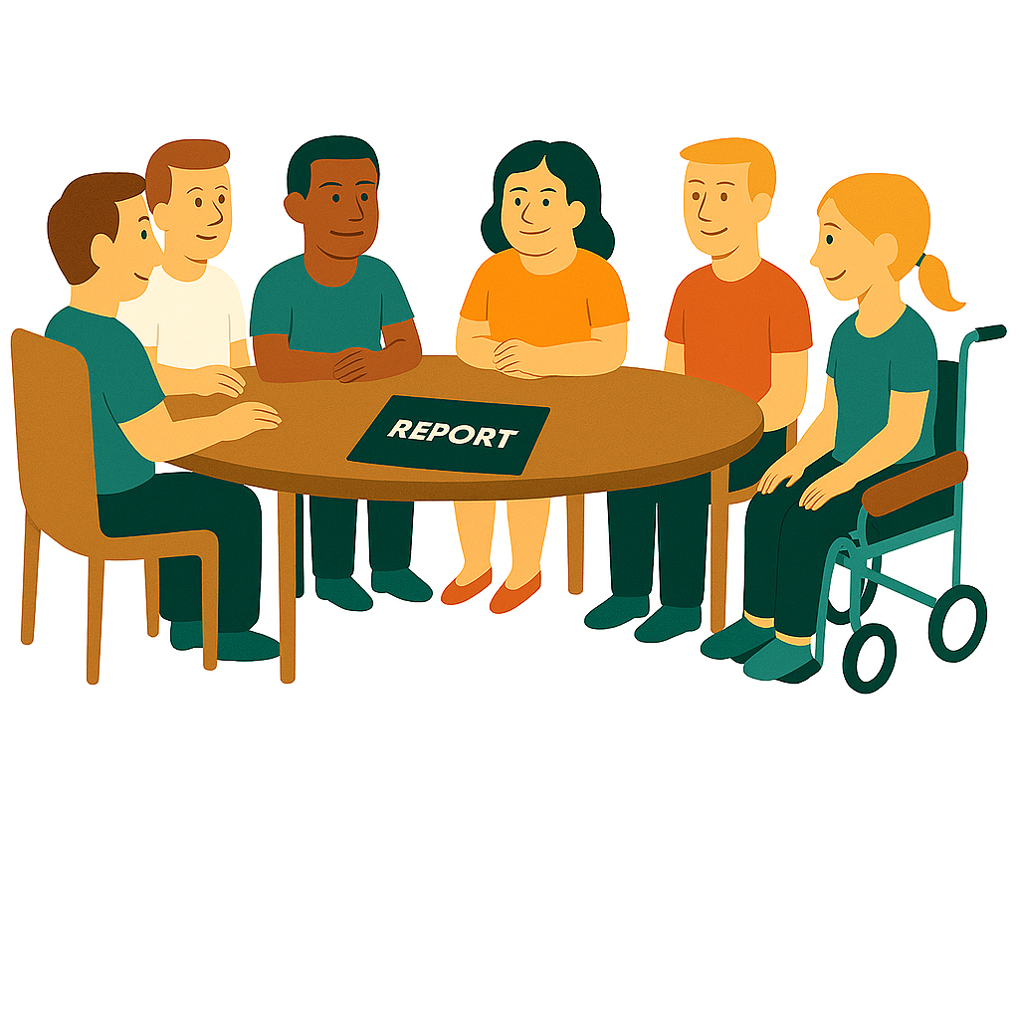 | The Thriving Kids Advisory Group  - Helped with what Thriving Kids will do.
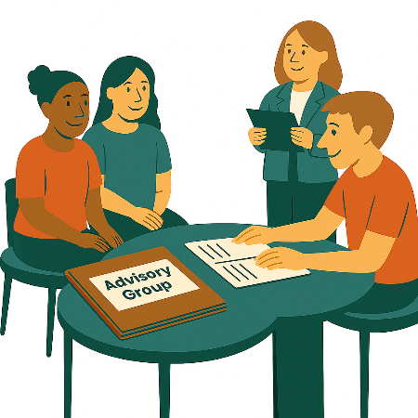 | An advisory group is a group of people who  - Share their expertise  - Go to meetings  - Help make decisions.  Expertise is knowing a lot about something.
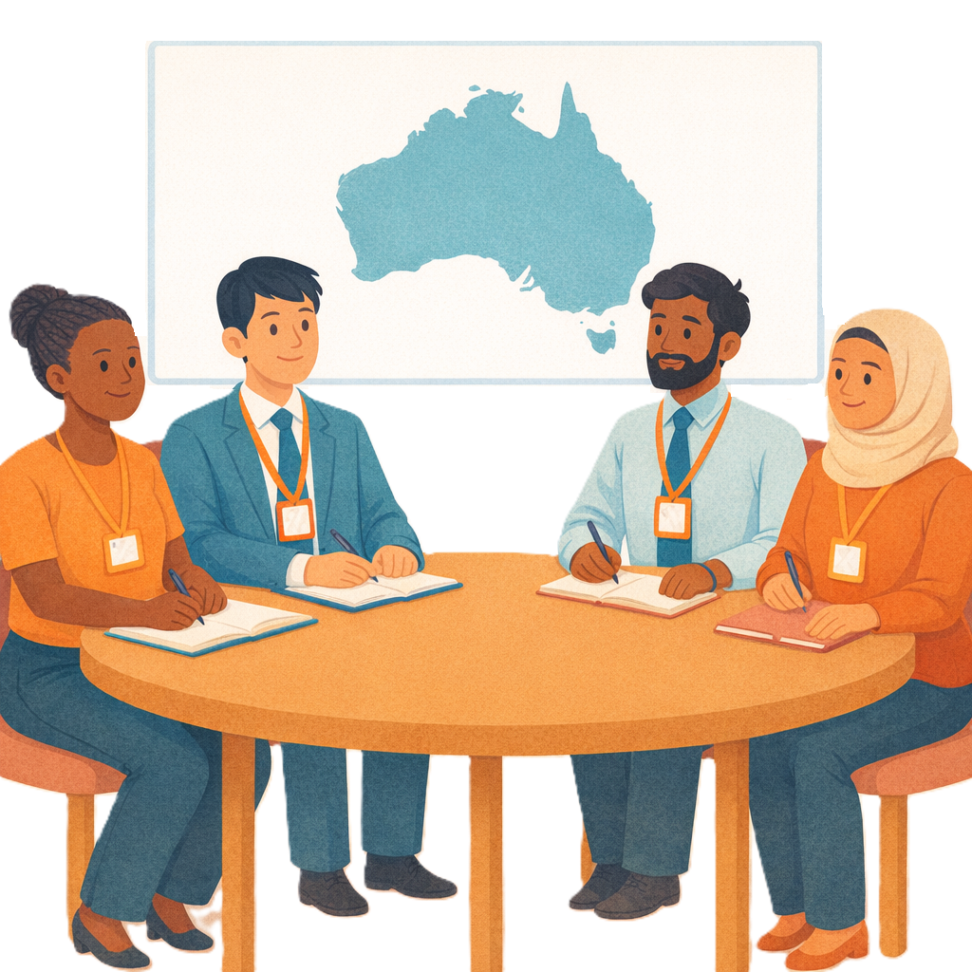 | They made a national model.  This  - Says all the things Thriving Kids will do  - Will be the same for all of Australia.
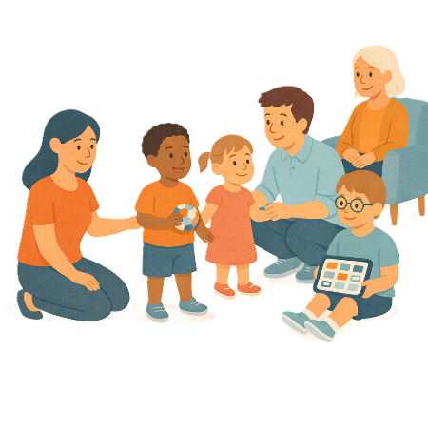 | The national model  - Has ways to check if children have developmental delays early
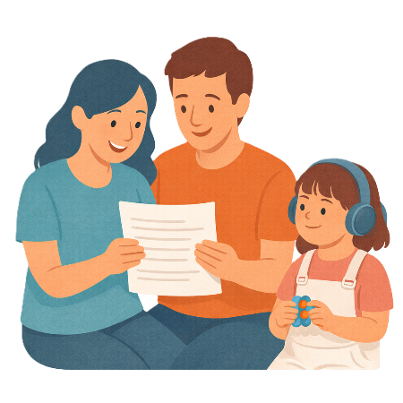 | - Gives parents and carers  - Information  - Advice  The information will be easy to find.  It will help people know what supports they may be able to get.
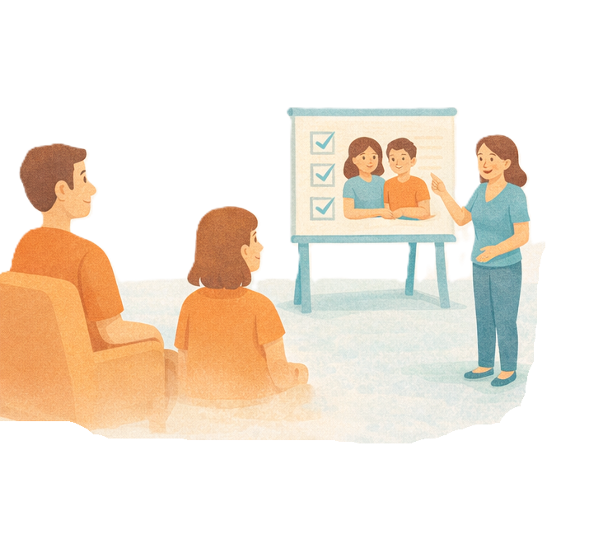 | - Have supports for parents  These supports will help families to help their child grow.  Families will learn  - Skills  - Understanding  - Confidence.  Confidence means knowing you can do something.
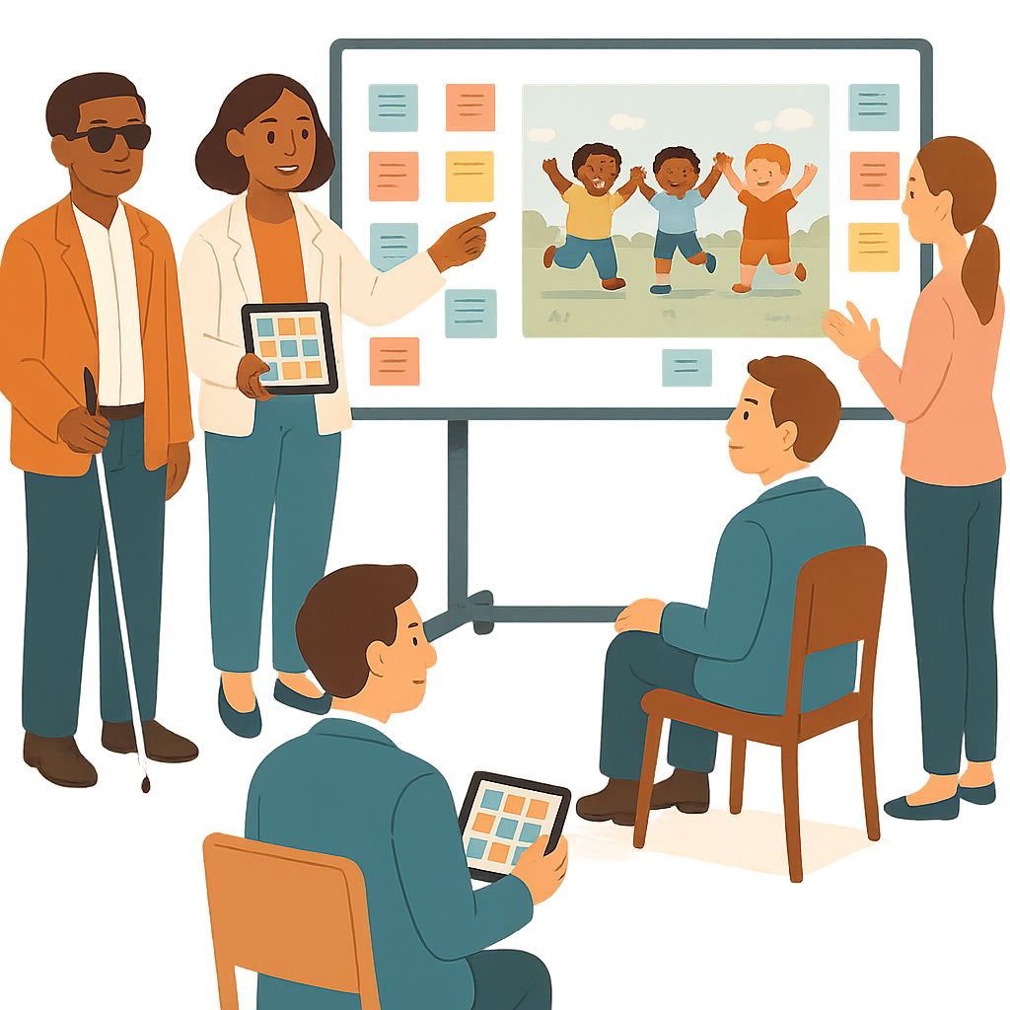 | - Have Targeted Supports  These are extra supports for the  - Families  - Children  That need them.  Allied health workers will give targeted supports
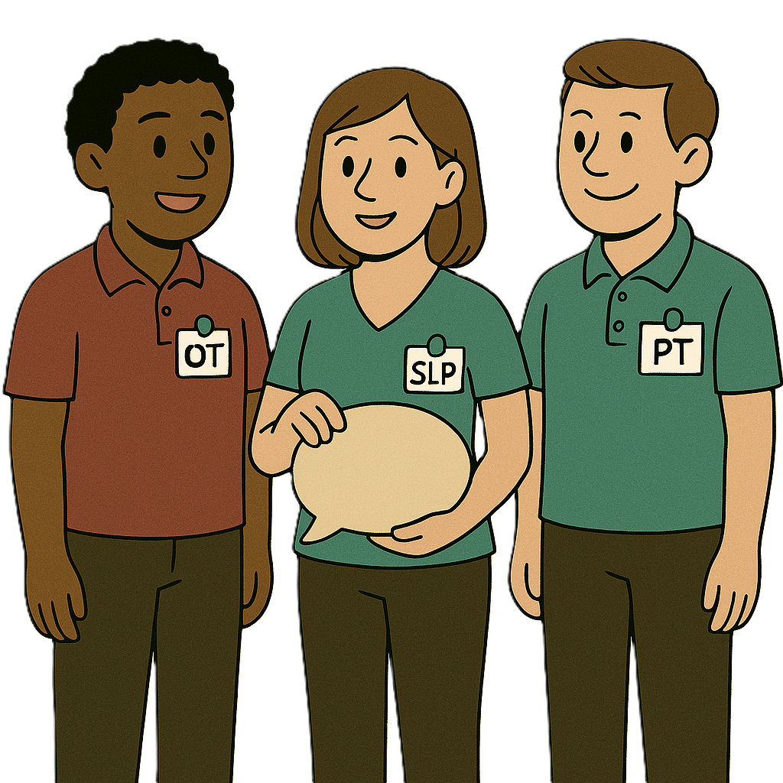 | Allied health workers support people with their health.  They can be people like occupational therapists.  We call them OT for short.
 | All Thriving Kids supports and services will follow principles.  Principles  - Are beliefs  - Say how it should work.
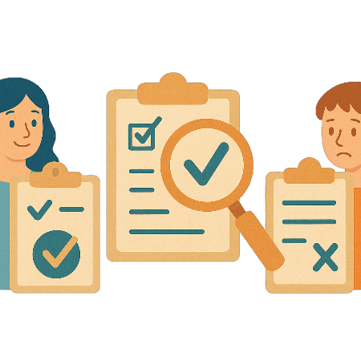 | All supports and services will need to  - Use evidence  Evidence is proof that something is true.
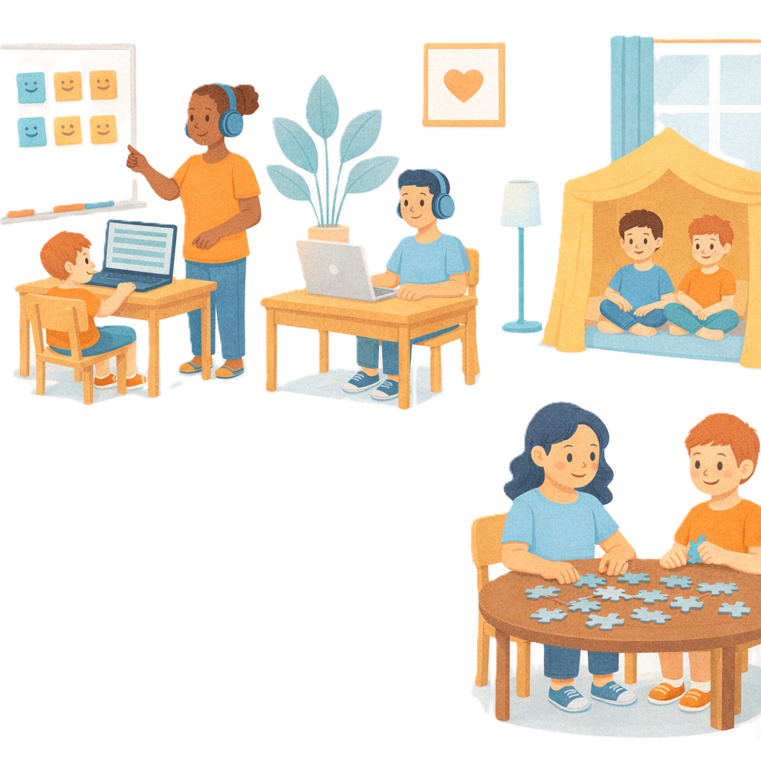 | - Be neuro affirming  Neuro affirming means  - Understand some peoples brains work differently  - Accept people for who they are.  Neuro affirming does not try to change people to fit in.  It changes things around them so people can do their best.
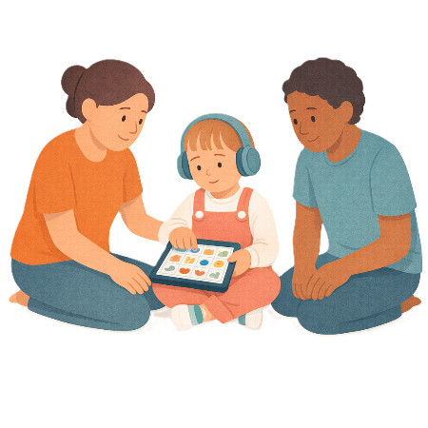 | - Be what the child needs  This can be called child centred.
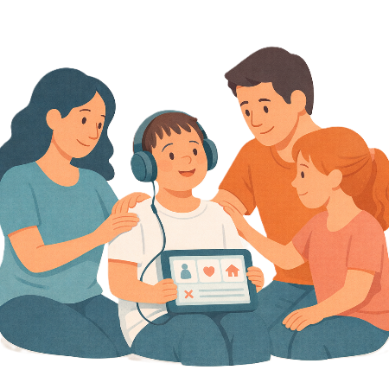 | - Be what the family needs  This can be called family centred.
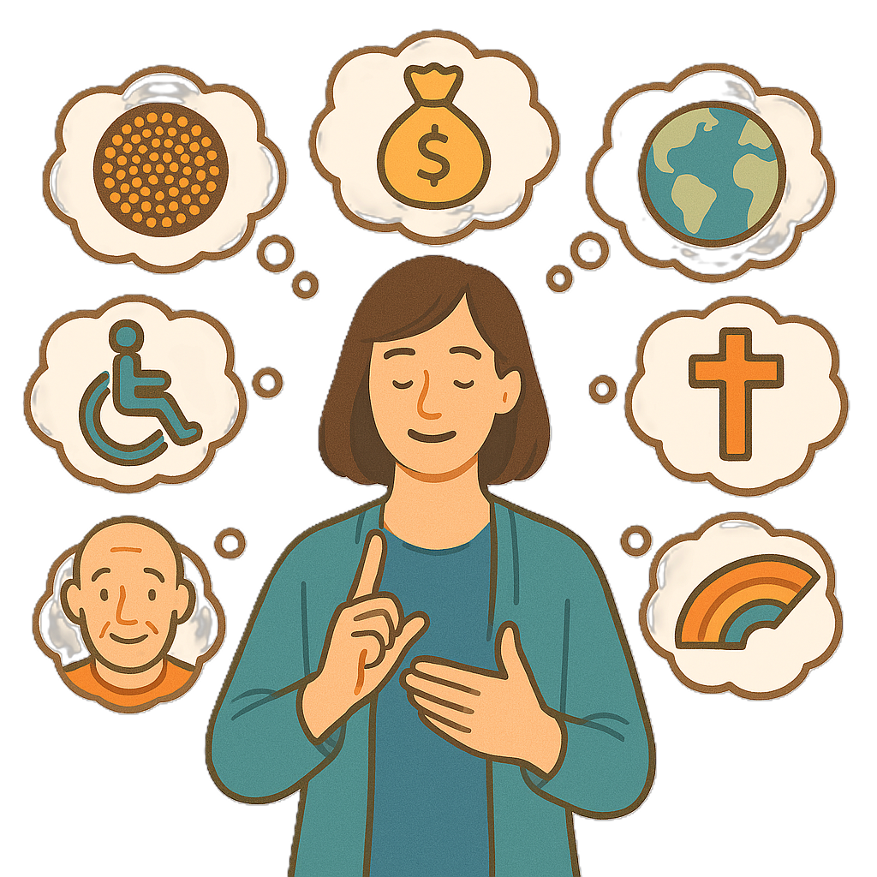 | Thriving Kids supports and services need to  - Support people with disability and the different parts of who they are.  This is called intersectionality.  Like
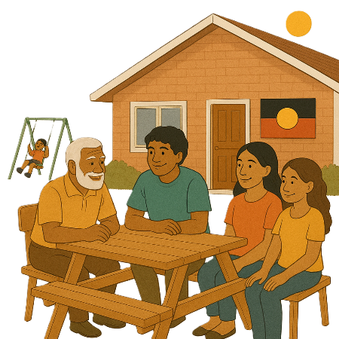 | - First Nations people
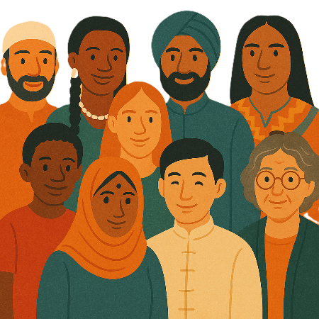 | - People from different cultures
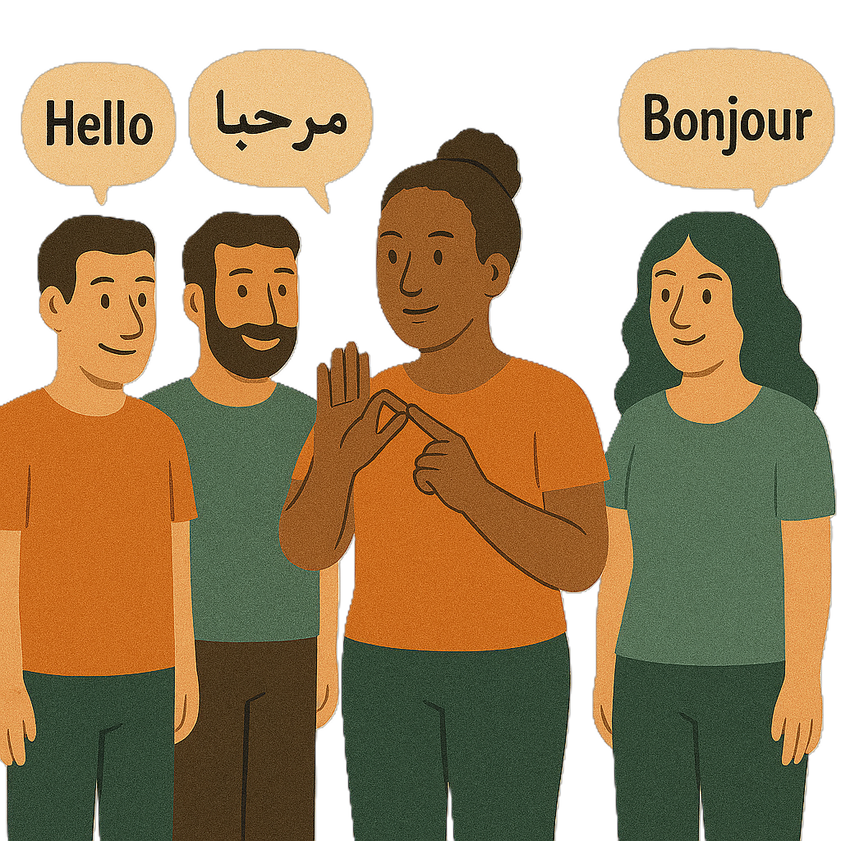 | - People who speak different languages
 | - LGBTQIA+ communities
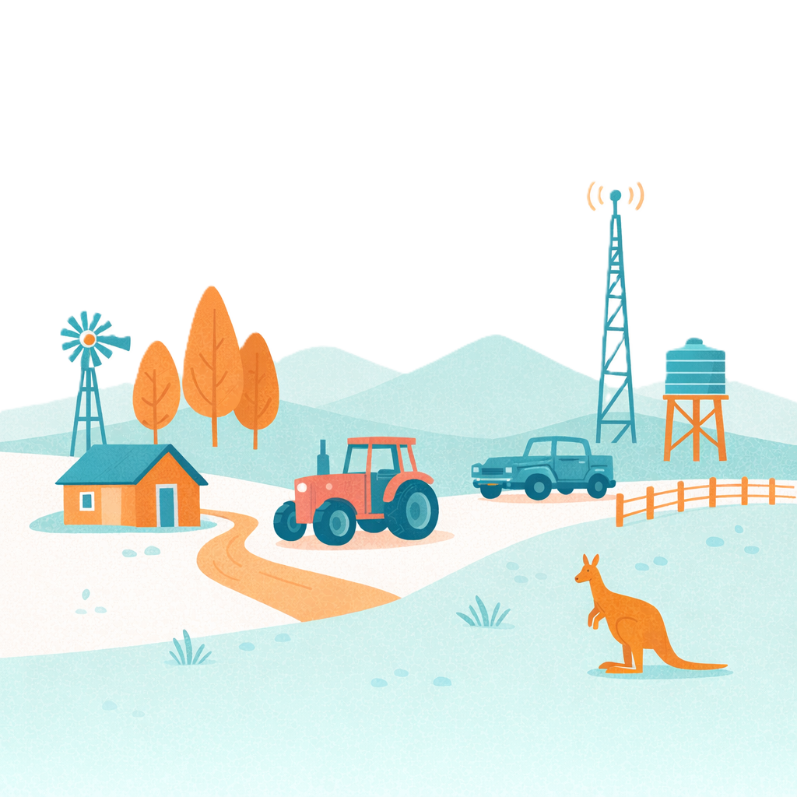 | - People who live in areas that are  - Regional  - Rural  - Remote

What the state and territory governments will do

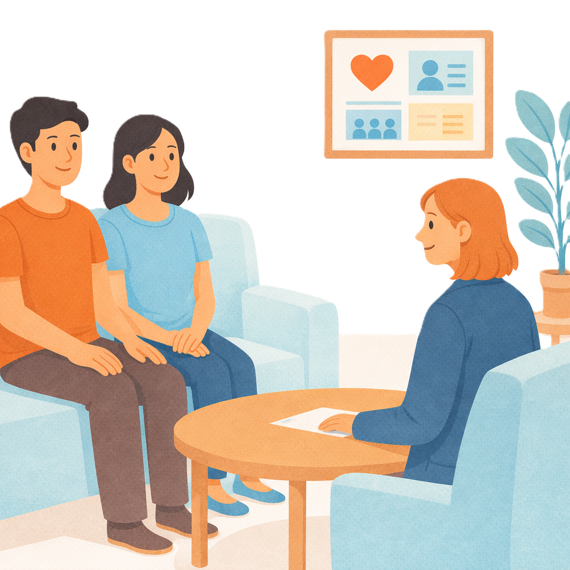 | The state and territory governments will have  - Supports for parents
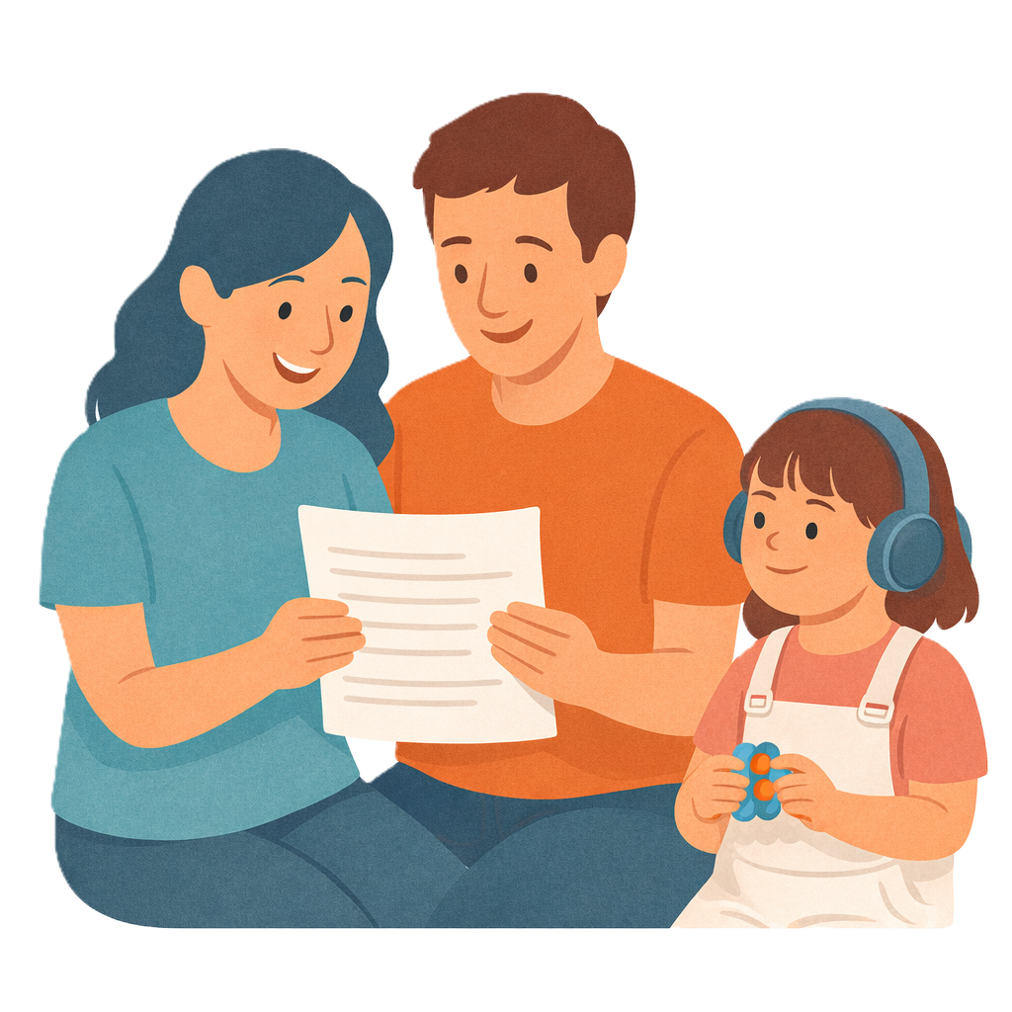 | - Information for their communities  This could be different for each community.
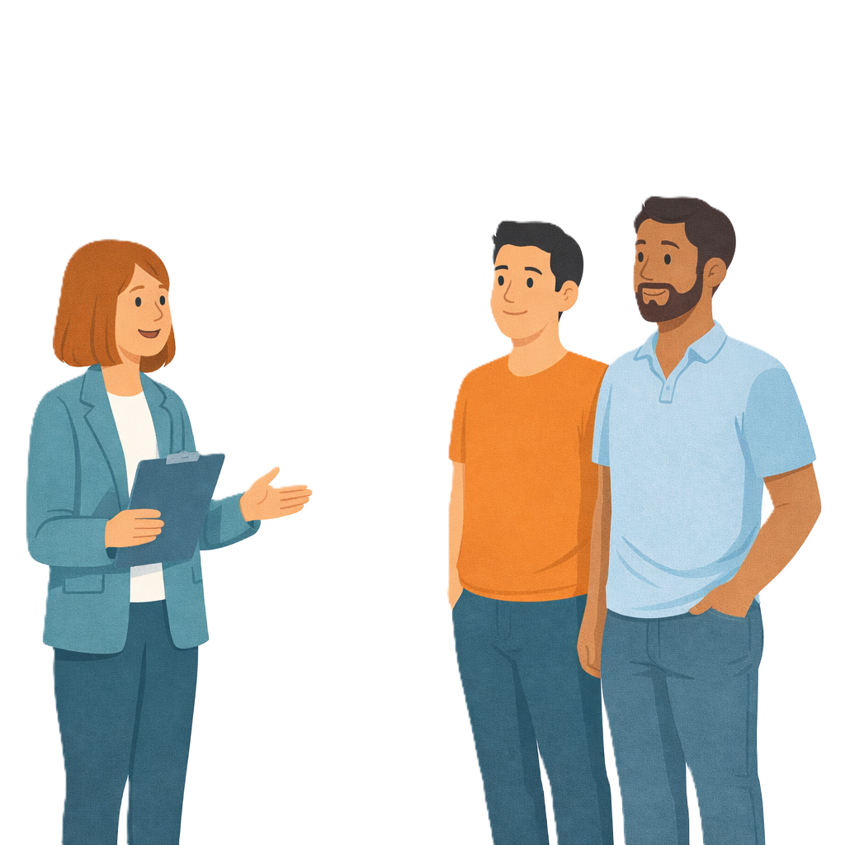 | - Advice
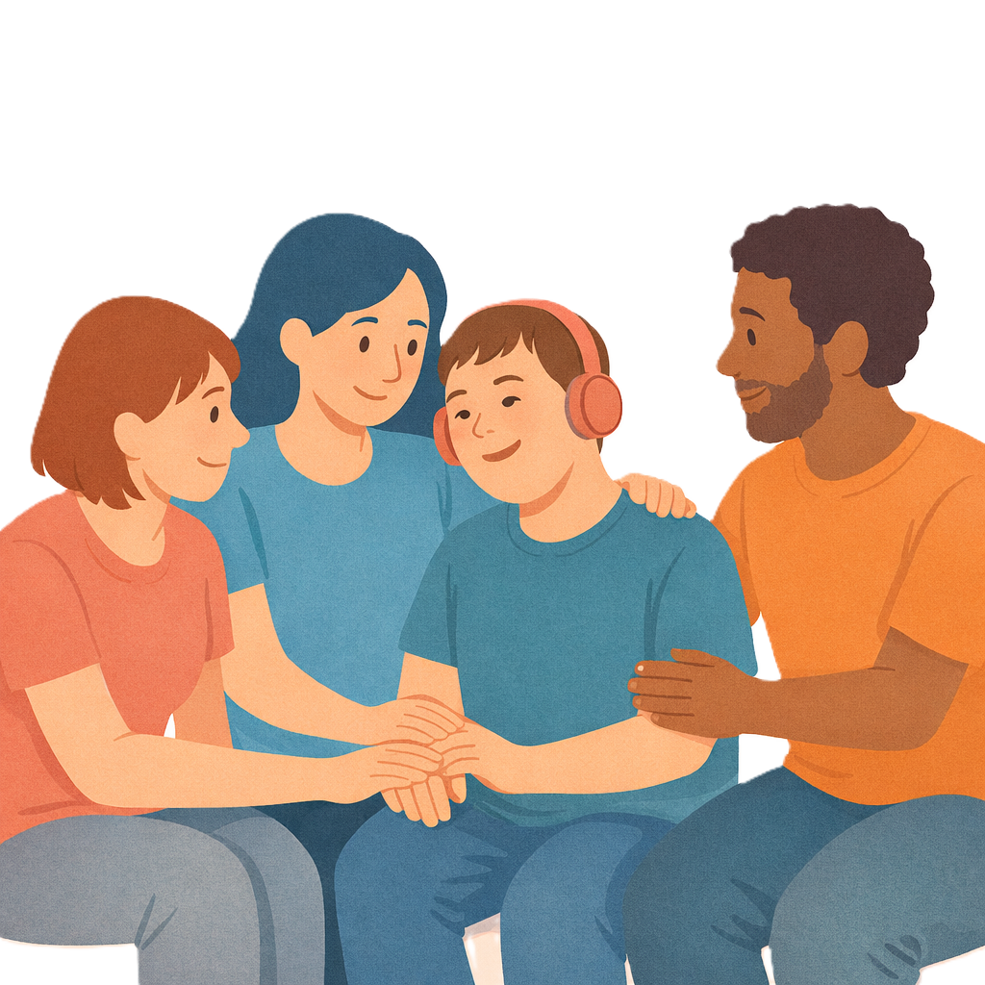 | - Supports to help families get support through Thriving Kids
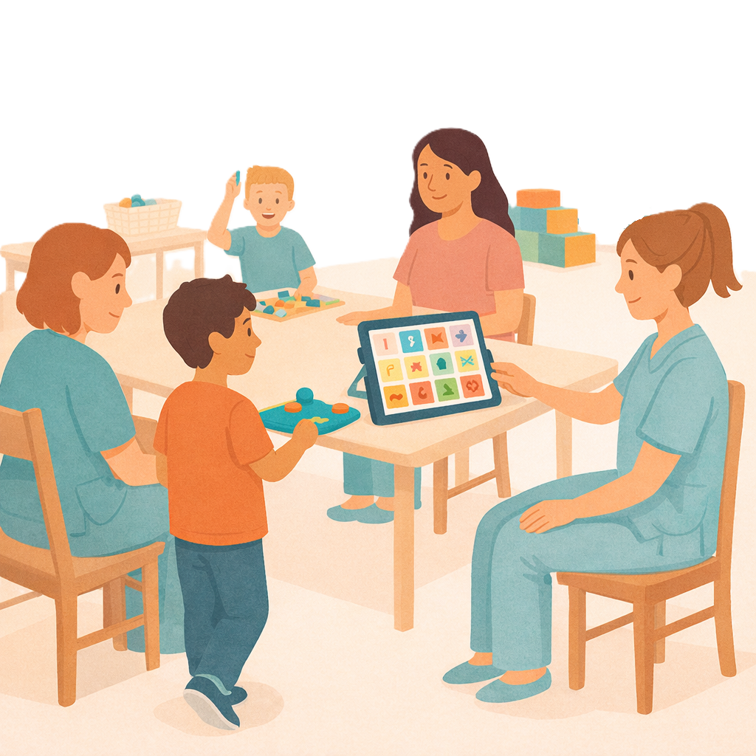 | - Allied health workers for Targeted Supports.

What the Australian Government will do

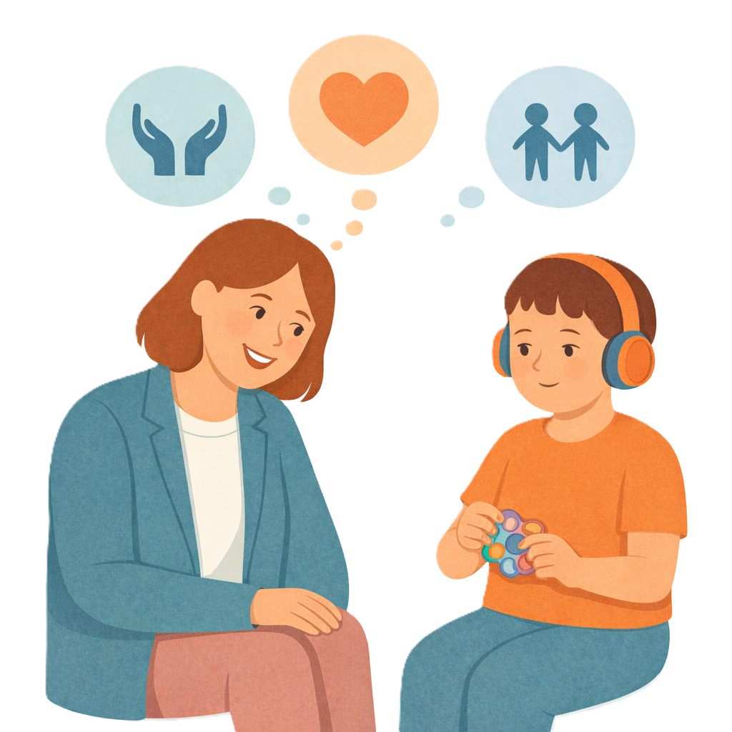 | The Australian Government will  - Share information and awareness  Awareness means more people know about something.
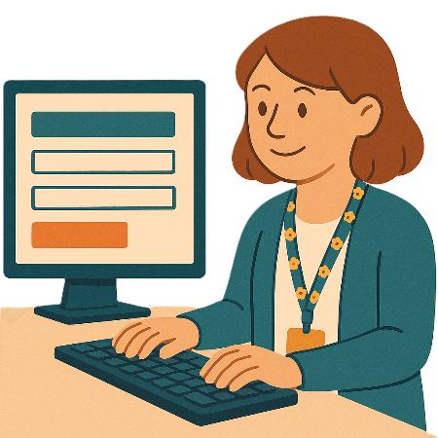 | - Have websites for parents to get information and advice
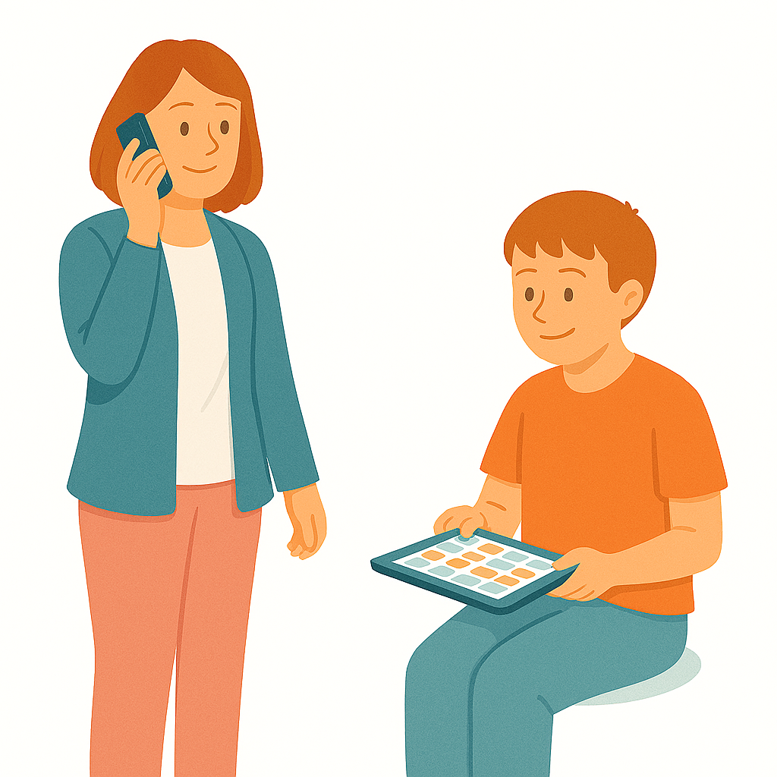 | - Have phone numbers parents can call for information and advice
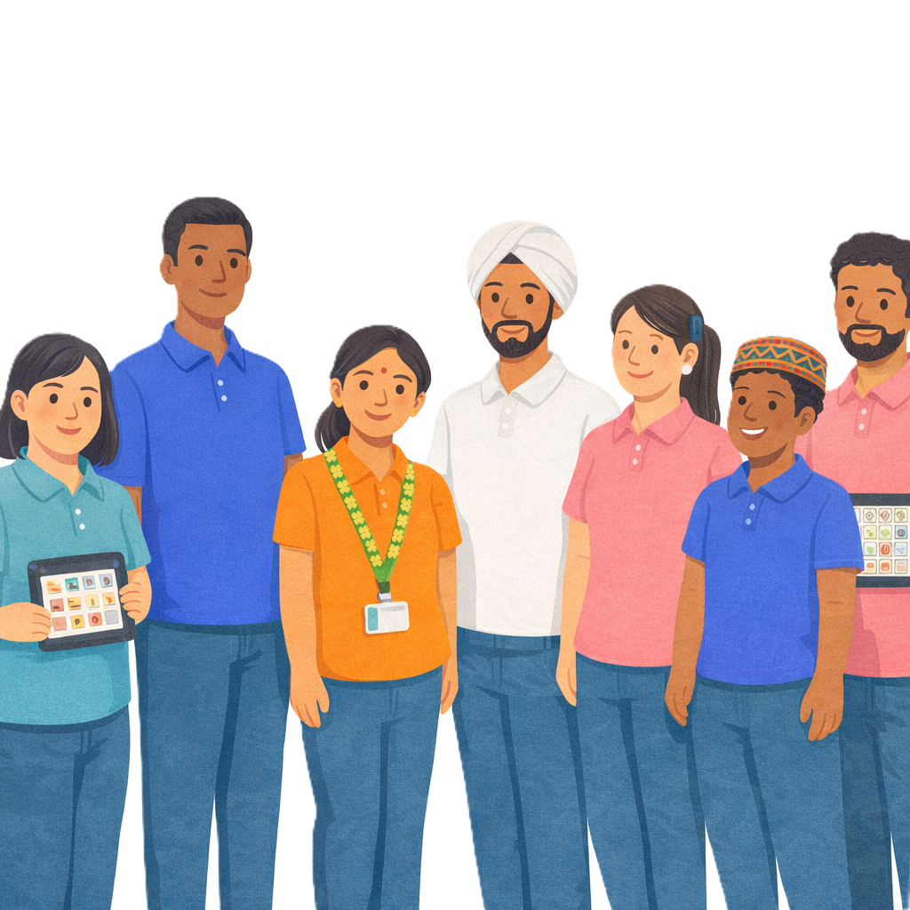 | - Make sure workers can support families
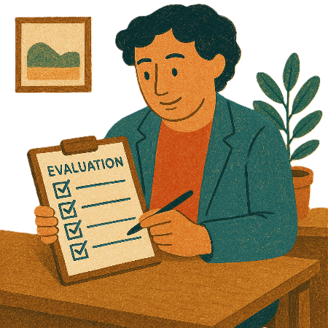 | - Do an evaluation of Thriving Kids.  Evaluation means you look at what  - Went well  - Could be done better.  You can do an evaluation of a  - Service  - Program  - Plan.

Making Thriving Kids services

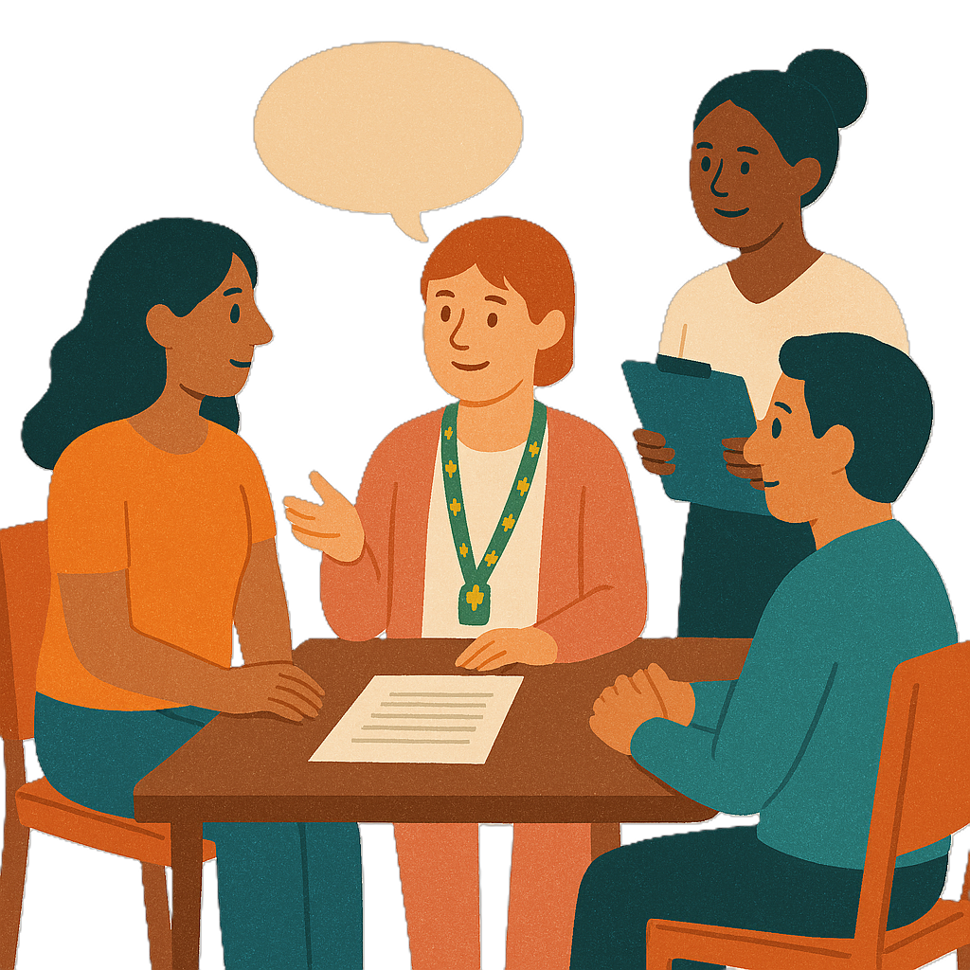 | The community will help make Thriving Kids services by being part of  - Consultations  Consultation is the governments way of working with the disability community.  It makes sure that the government is listening to communities.  This helps the government make better plans to support people with disability.
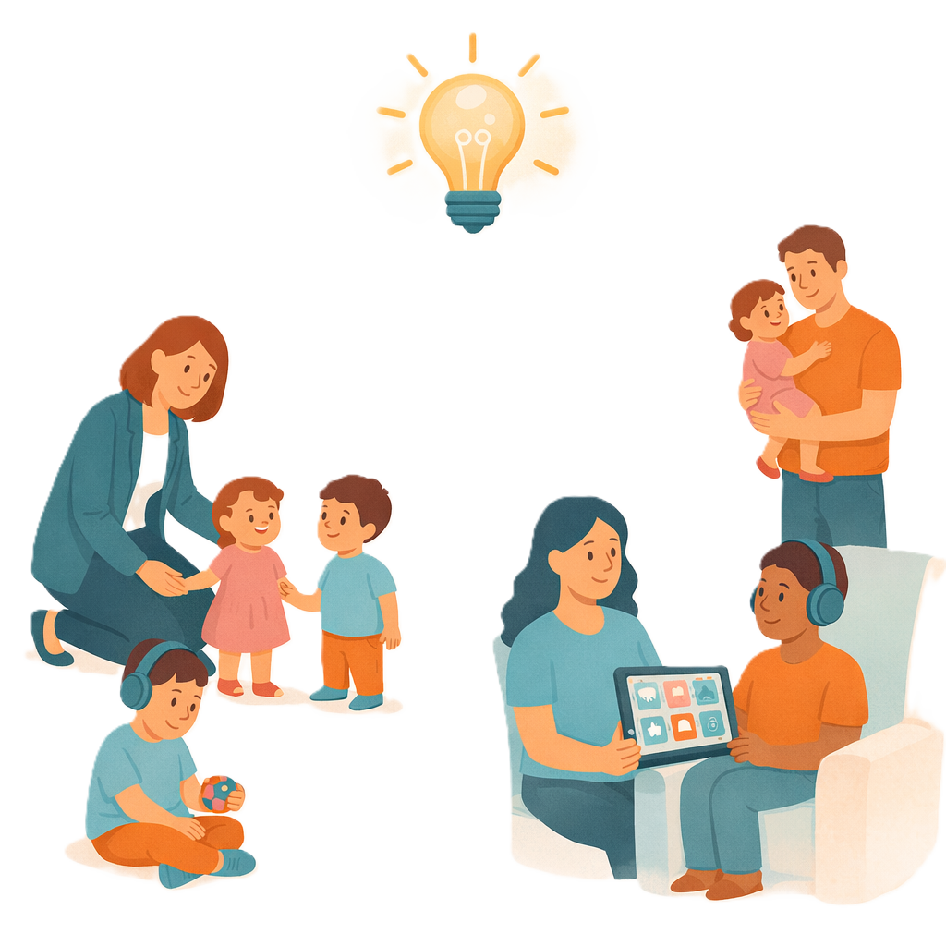 | - Engagements  Engagement means the community can share their ideas with the government.
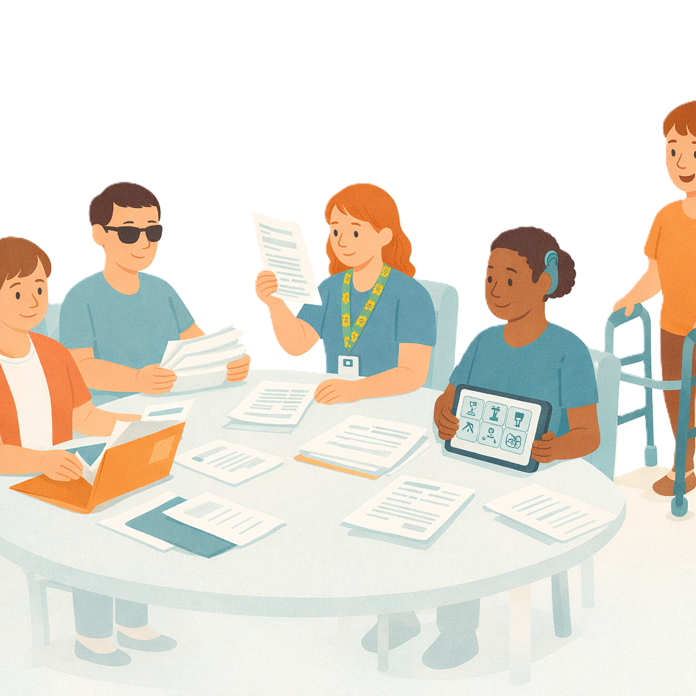 | The Australian Government will hear from different groups to make Thriving Kids like  - Talking to decision making groups
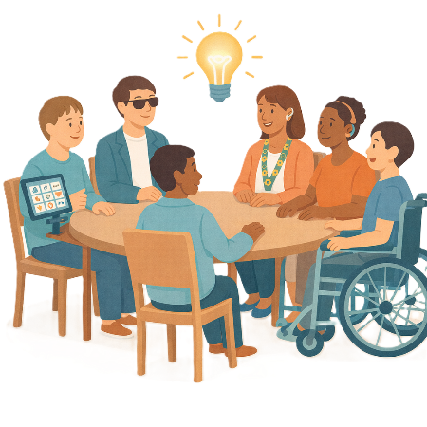 | - Listening to people with lived experience  Lived experience is when you know what  - It feels like to have a disability  - Helps  - Makes it harder.  This can include  - Parents  - Carers
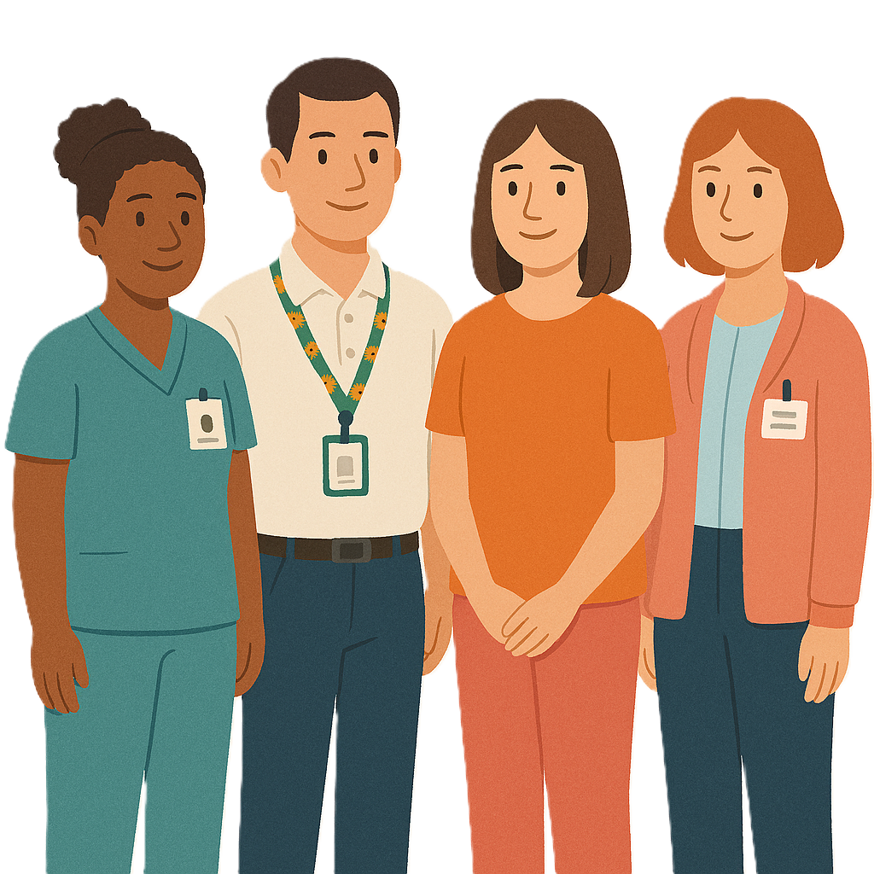 | - Talking to providers  This will help make sure we can  - Test ideas  - Make sure things work in real life.
 | You can go to the website to see engagement happening in your state or territory.  www.health.gov.au/our-work/thriving-kids  It might not be in Easy Read.
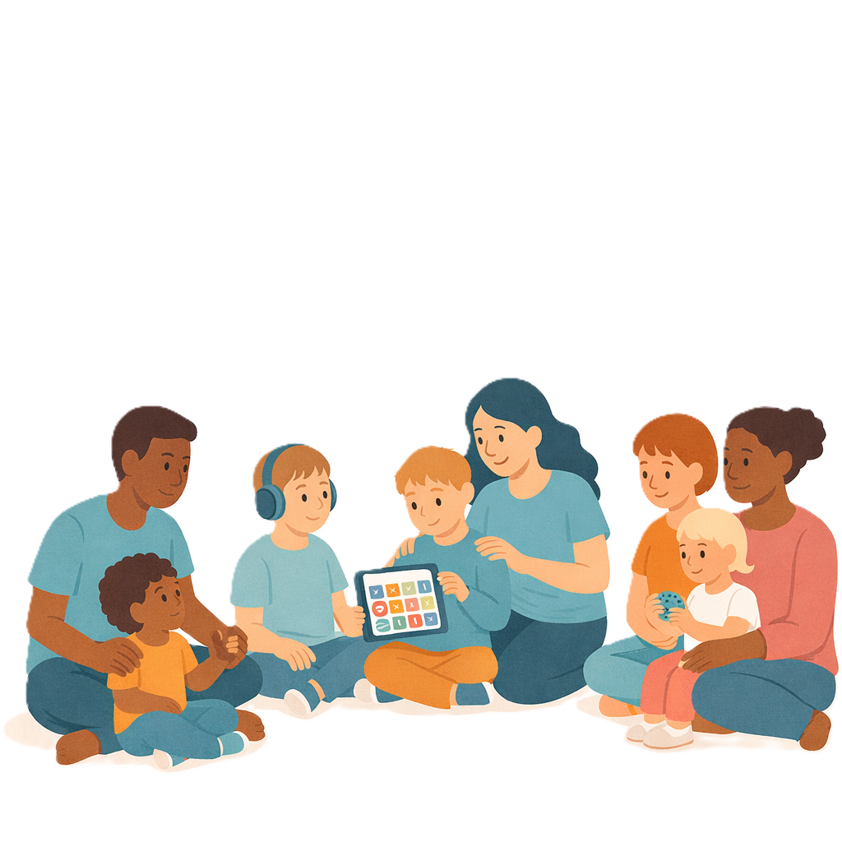 | The Australia Government will listen to ideas from  - Parents  - Families  - Carers
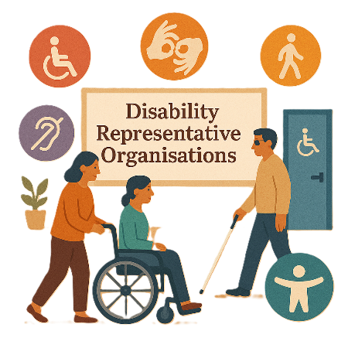 | - Disability Representative Organisations  We call them DROs for short.
- Community service providers

Providers get money to help support you.
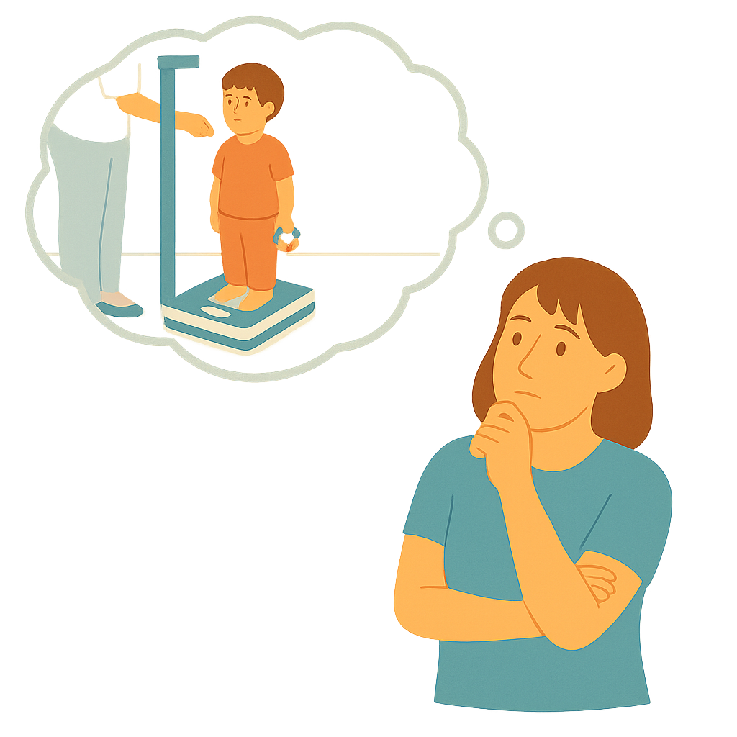 | - People who know a lot about  - How children grow
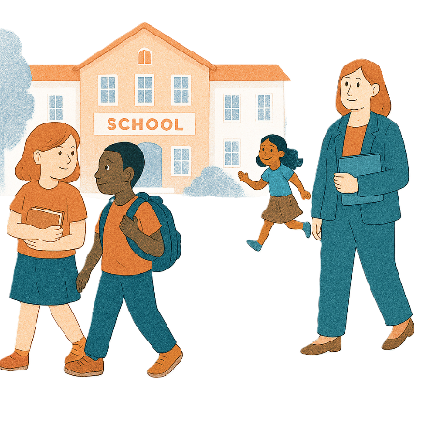 | - Education
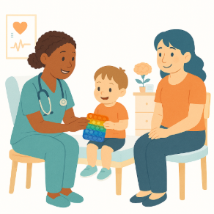 | - Health
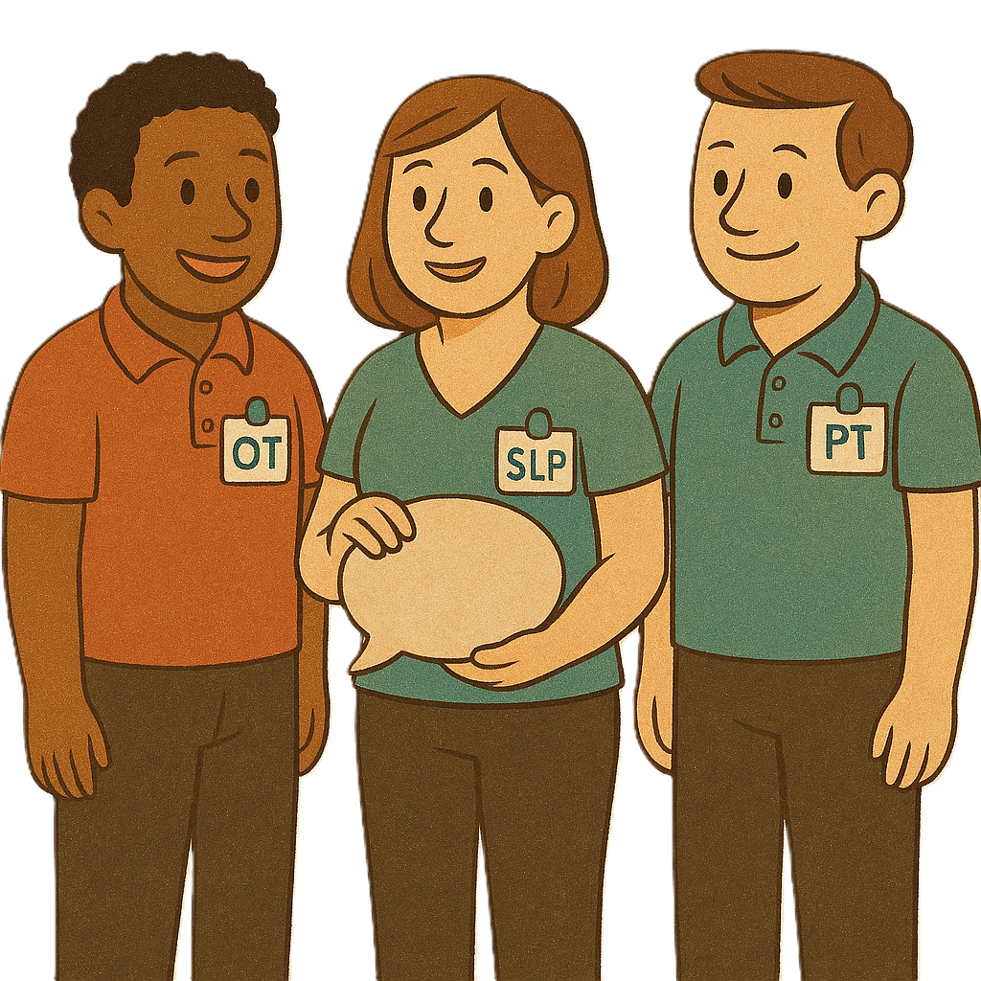 | - How allied health workers can help
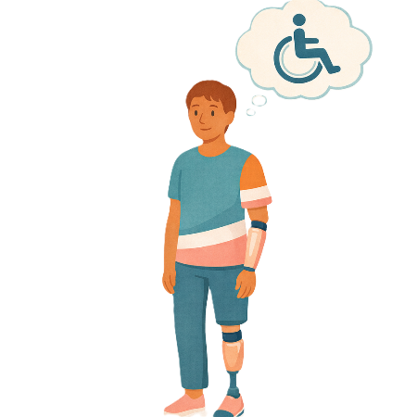 | - Disability
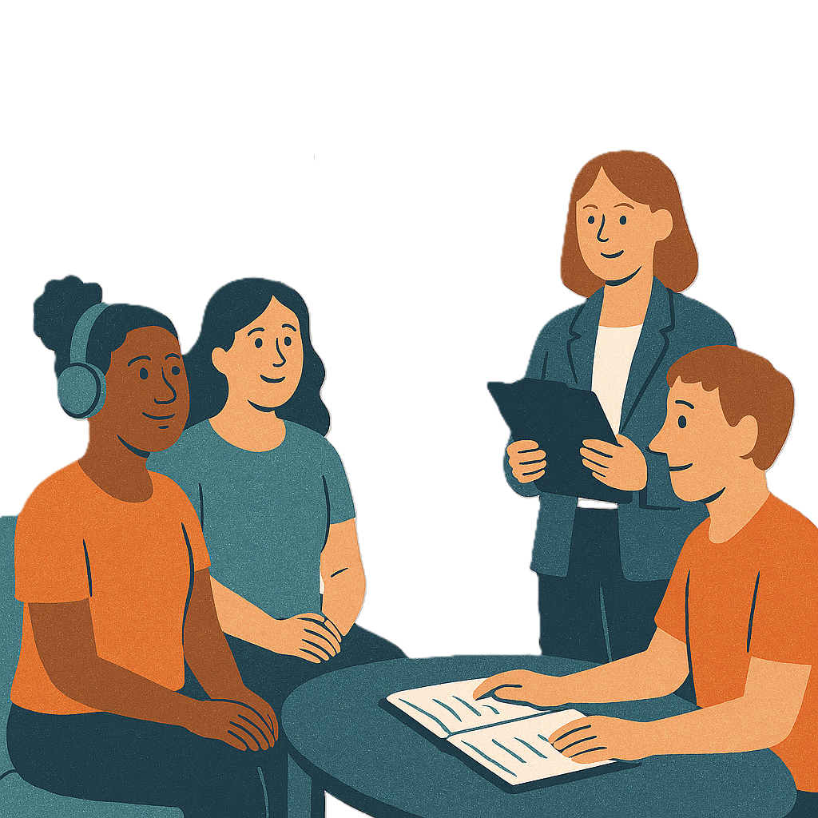 | - Experts
 | - People who speak different languages
 | - People from different cultures
 | - First Nations people.

Working together

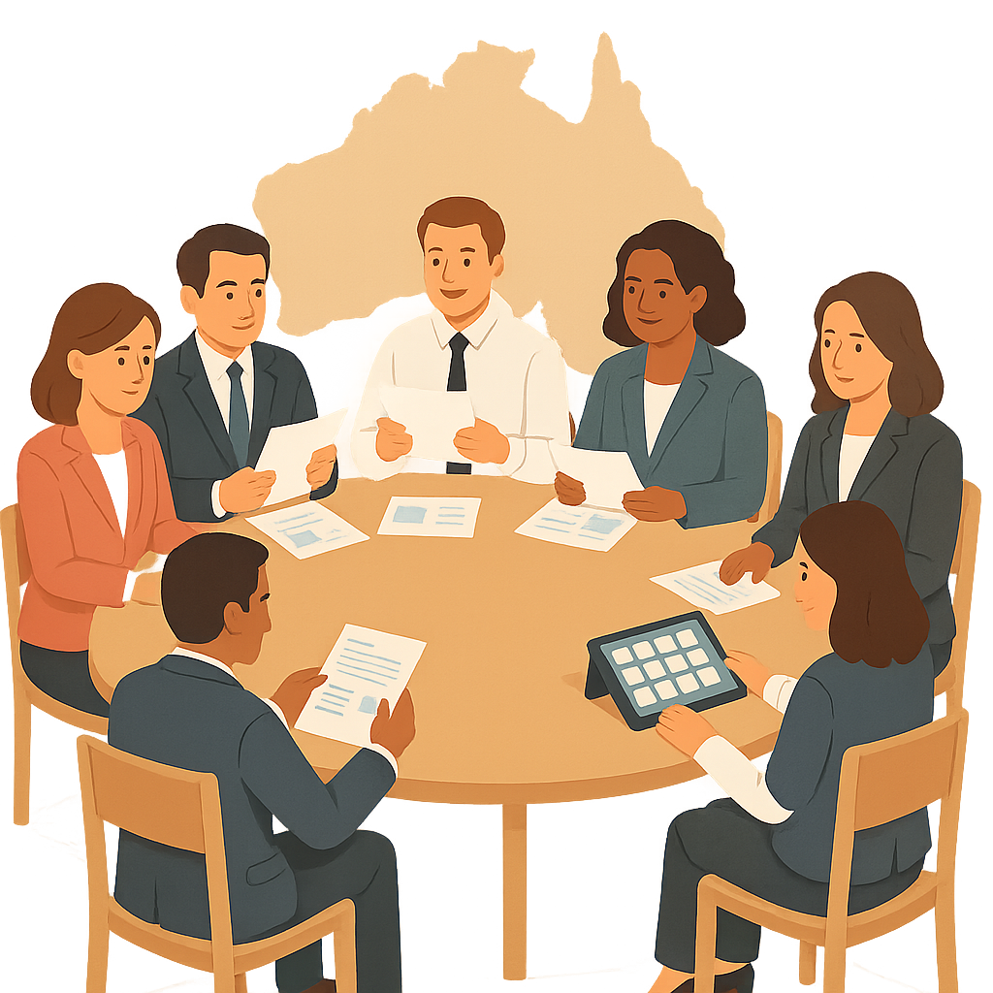 | The Australian Government will keep working with  - All state and territory governments
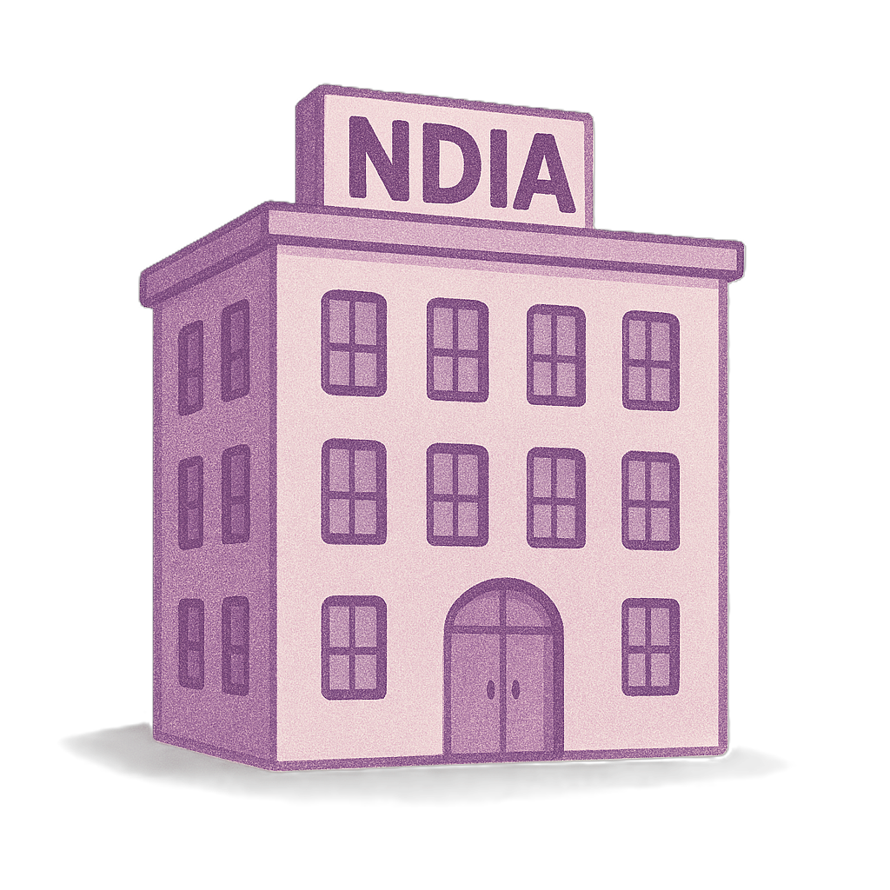 | - National Disability Insurance Agency  We call it NDIA for short.  They look after the NDIS.
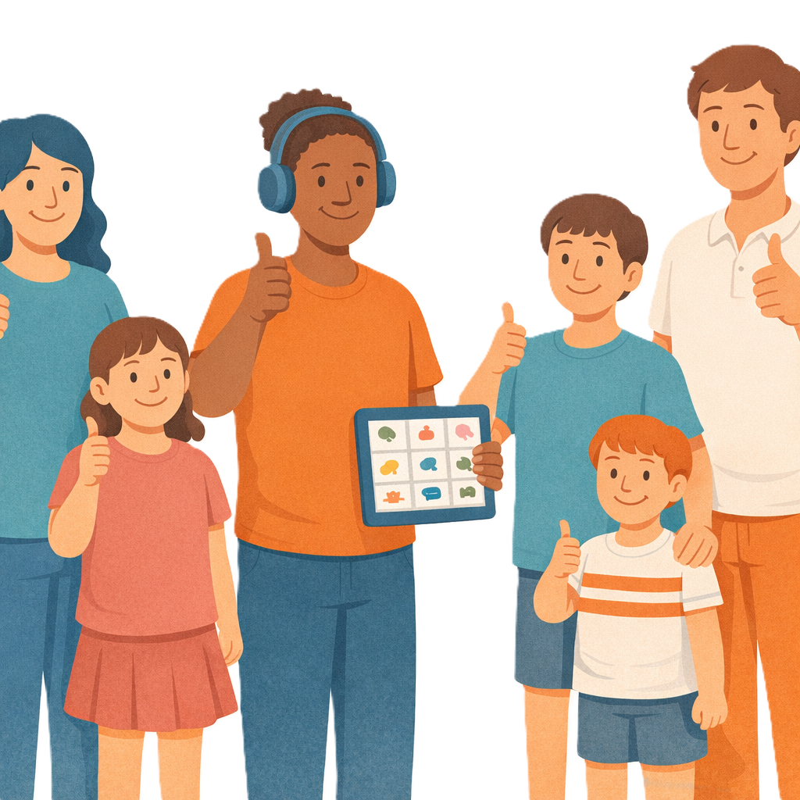 | This will help make sure people with disability get the supports they need.

More information

You can go to our website to look at more information about Thriving Kids

www.health.gov.au/our-work/thriving-kids

It might not be in Easy Read.
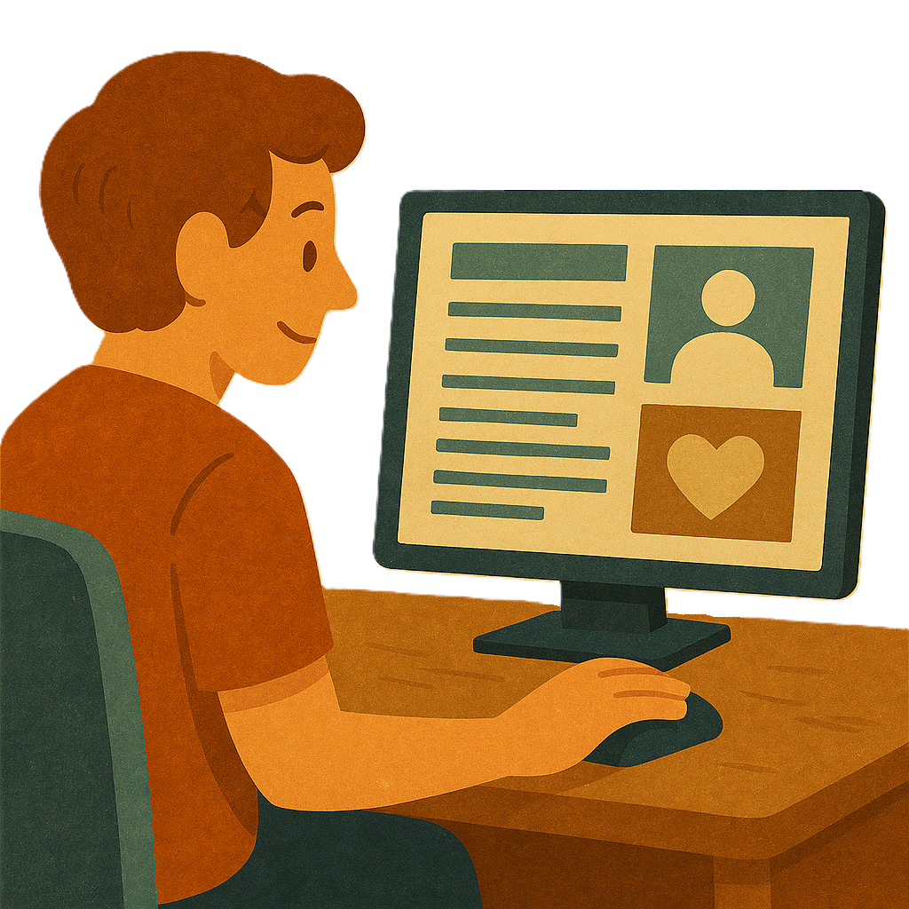 | The website will say all the things we want to make better for children who  - Are 8 years old and younger  - Have developmental delays  - Have autism.  It will help the changes happen smoothly.

Some images in this Easy Read were made using AI.
You must not share or copy any of the images without permission.
April 2026.

