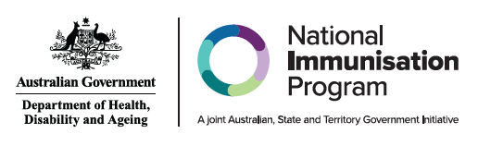
Administration of RSV vaccines and monoclonal antibodies by age group or cohort
Age group or cohort | RSV vaccines for adults |  | RSV monoclonal antibodies for infants
Age group or cohort | Abrysvo® 0.5mL  (Pfizer)  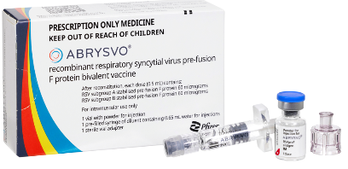 | Arexvy® 0.5 mL  (GSK)  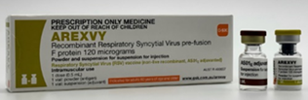 | Beyfortus™ (Nirsevimab) 0.5 mL (Purple) (Sanofi)  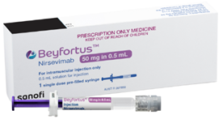 | Beyfortus™ (Nirsevimab) 1 mL  (Blue) (Sanofi)  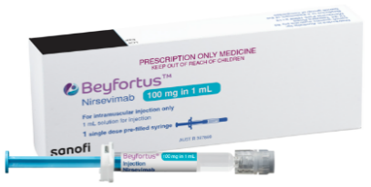
Women from 28 weeks pregnancy | NIP FUNDED | DO NOT USE | DO NOT USE | DO NOT USE
Infants & children ≤24 months | DO NOT USE | DO NOT USE | STATE & TERRITORY  FUNDED | STATE & TERRITORY  FUNDED
Adults 60-74 years  Adults with medical conditions that increase risk of severe RSV | AVAILABLE PRIVATELY  BASED ON CLINICAL DECISION | AVAILABLE PRIVATELY  BASED ON CLINICAL DECISION | DO NOT USE | DO NOT USE
Adults ≥75 years  Aboriginal and Torres Strait Islander people ≥60 years | AVAILABLE PRIVATELY  BASED ON CLINICAL DECISION | NIP FUNDED | DO NOT USE | DO NOT USE
Note: NIP FUNDED indicates vaccine is NIP funded. DO NOT USE indicates product is NOT recommended for that group. STATE & TERRITORY FUNDED indicates funded under a state and territory program. AVAILABLE PRIVATELY indicates product only available through private prescription and is not funded. For further information including dosage and administration, refer to the Australian Immunisation Handbook chapter – Respiratory syncytial virus (RSV)
Information current as of April 2026

