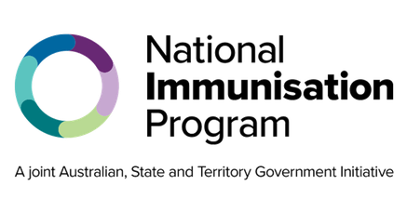
National Immunisation Program

RSV for older Australians Program advice for health professionals

Key points
- The National Immunisation Program (NIP) provides the RSV vaccine, Arexvy®, for free to adults aged 75 years and over and Aboriginal and Torres Strait Islander adults aged 60 years and over.
- Adults aged 60 to 74 years and those who have medical conditions that increase their risk of severe RSV disease may consider privately purchasing RSV vaccines. However, these cannot be claimed through the NIP.
- Older adults can receive RSV vaccines at the same time as, or separate from, other vaccines such as COVID-19, influenza, zoster, and pneumococcal vaccines. There are practical advantages of
co-administration, including benefits in maximizing coverage and ensuring vaccines are received on time.
- Arexvy® can be administered to eligible patients as soon as the vaccine is available. Most vaccination providers should have stock of Arexvy® by mid-May 2026.

About respiratory syncytial virus
Respiratory syncytial virus (RSV) is a common virus that causes upper and lower respiratory tract infection. It is spread through droplets from an infected person’s cough or sneeze. The droplets can be inhaled by others or land on surfaces where the virus can live for several hours.
While it may be a mild disease for some, it can cause serious illness, complications, and hospitalisation in otherwise healthy adults.

When to administer RSV vaccines
RSV vaccines can be given at any time of the year. Vaccination should be offered to patients before the start of the RSV season, where possible.
Infections most commonly occur in autumn and winter, usually between April and September. The RSV season peaks in June and July, often before influenza season.

People aged 75 and over and Aboriginal and Torres Strait Islander people 60 years and over
A single dose of the RSV vaccine, Arexvy®, is free and recommended for adults aged 75 and over and Aboriginal and Torres Strait Islander people aged 60 years and over.

Adults aged 60 to 74 years and people with medical conditions that increase their risk of severe RSV disease
Adults aged 60 to 74 years and those with medical conditions that increase their risk of severe RSV disease can consider privately purchasing a vaccine. However, the cost cannot be claimed through the NIP.

Co-administration of vaccines
Older adults can receive RSV vaccines at the same time as, or separate from, other vaccines, such as COVID-19, influenza, zoster, and pneumococcal vaccines. There may be advantages of co-administering vaccines, including maximising coverage and ensuring vaccines are received on time. Check the Australian Immunisation Handbook for further information.

Repeat RSV vaccination
Currently, only a single dose is recommended. Protection lasts for at least two years.
Recommendations on the need for any subsequent doses will be provided when data is available.

RSV vaccine safety and efficacy
Research has found Arexvy® to be both safe and effective.
RSV hospitalisation rates increase with age, and people aged 75 years and over are likely to have the greatest benefit from vaccination.

Side effects
Common side effects from an RSV vaccination include mild pain, redness or swelling where the injection was given, fatigue, headaches, and muscle pain. These side effects usually last for a few days and go away without any treatment. Serious side effects, such as severe allergic reaction, are rare.

Contraindications
The only contraindications to RSV vaccines are anaphylaxis after:
- a previous dose of the same vaccine
- any component of an RSV vaccine.
RSV vaccines and RSV monoclonal antibody by age group or cohort
Age group or cohort | Abrysvo® 0.5mL (Pfizer) | Arexvy® 0.5mL (GSK) | Beyfortus™ (nirsevimab) 0.5/1.0 mL (Sanofi)
Women from 28 weeks pregnancy | NIP funded | DO NOT USE | DO NOT USE
Infants & children ≤24 months | DO NOT USE | DO NOT USE | State & territory funded
Adults 60 to 74 years & those with medical conditions that increase risk of severe RSV | Available privately based on clinical decision | Available privately based on clinical decision | DO NOT USE
Adults ≥75 years Aboriginal and Torres Strait Islander people ≥60 years | Available privately based on clinical decision | NIP funded | DO NOTUSE

Administration errors and adverse events
Ensure you are administering the correct product for your patient. Consider storing vaccines separate shelves to prevent errors. See the clinical guidance on RSV immunisation product administration errors for more information.
You must notify all adverse events and RSV vaccine administration errors through the reporting mechanisms in your state or territory.

Australian Immunisation Register
Check the Australian Immunisation Register (AIR) before administering an RSV vaccine. You should report all RSV immunisations to the AIR to ensure complete and accurate records. For more information, go to servicesaustralia.gov.au/hpair.

Keep up to date
Read the advice in this factsheet in conjunction with the Australian Immunisation Handbook at immunisationhandbook.health.gov.au.
Subscribe to the NIP update email update service. Search ‘NIP updates’ on health.gov.au.

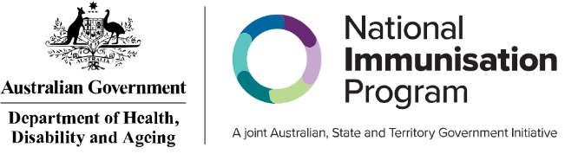
State and territory health department contact numbers:
ACT 02 5124 9800 | SA 1300 232 272
NSW 1300 066 055 | TAS 1800 671 738
NT 08 8922 8044 | VIC immunisation@health.vic.gov.au
WA 08 9321 1312 | QLD Contact your local Public Health Unit
This information is current as of April 2026

