THE MY AGED CARE QUALITY LEARNING FRAMEWORK FOR THE SCREENING AND Assessment WORKFORCE v2.1

Document Version Control
Revised | March 2026
Version Number | 2.1
Prepared by | Department of Health, Disability and Ageing
Owner | Navigation and Access Branch

Foreword
The Department of Health, Disability and Ageing (the department) is responsible for the management and functioning of My Aged Care, the main access point to the government-funded aged care system in Australia. An important component of this system is information and preliminary screening, and assessment services under the Single Assessment System. The assessment process determines eligibility for an aged care needs assessment and access to government-funded aged care services. The department engages Services Australia and Healthdirect Australia to deliver information and screening services, and the Single Assessment System organisations to deliver assessment services nationally.
As a result, the department is responsible for ensuring the information, screening and Single Assessment System workforce (as defined in the My Aged Care Workforce Learning Strategy) has the required capabilities to undertake their roles within their My Aged Care operational environment. The department develops, maintains, and provides quality training resources that ensure currency of skills, knowledge, and capabilities within the My Aged Care screening and Single Assessment System workforce and the ongoing development and verification of these capabilities.
In developing the My Aged Care Quality Learning Framework for screening and Single Assessment System organisations (QLF), the department acknowledges the significant consultation undertaken through the development of previous training strategies and further acknowledges consultation undertaken with the screening and Single Assessment System workforce on the 2017 My Aged Care Personal Capability Report, the 2022 review of My Aged Care Learning and Training, re-establishment of the My Aged Care Training Reference Group in 2022 which ceased in 2024, and the Lead Educator Network. The Lead Educator Network continues to be a regular and invaluable consultation mechanism for the department, with every Single Assessment System organisation represented in the network.
This document should be read in conjunction with the My Aged Care Workforce Learning Strategy.
Note: The Quality Learning Framework does not include the capability requirements for Residential Aged Care funding assessors or Aboriginal and Torres Strait Islander Assessment Organisations (implemented in August 2025). Separate contextualised training is provided for these specific workforces which is not covered in this document.
This document should be read in conjunction with the My Aged Care Workforce Learning Strategy.
Contents
Foreword 3
Figures 4
Tables 4
1. Introduction to the Quality Learning Framework (QLF) 5
2. Vision for the QLF 6
3. Purpose of the QLF 6
4. Quality linkages that support the QLF 7
5. The My Aged Care capabilities for the screening and Single Assessment System workforce 8
5.1 Mapping of the My Aged Care capabilities for the screening and Singe Assessment System workforce 9
5.2 Capability in My Aged Care screening and assessment 9
5.3 Personal capability 10
5.4 Capabilities and contextualised knowledge 11
5.5 Capabilities and on-the-job training 12
6. MAClearning system 13
7. The blended learning model 14
8. Learning pathways 15
8.1 Minimum training requirements 15
8.2 Recognition of current capabilities 15
8.3 Role-specific learning pathways 15
8.4 Training for other roles within the My Aged Care screening and Single Assessment System workforce 17
9. On-the-job training 17
10. MAClearning online learning 18
10.1 Learning content creation 18
10.2 Training (TRN) environment 19
11. Learner appraisal system 20
11.1 Appraisal strategies 20
11.2 Appraisal activities 21
11.3 Rubrics and appraisal measures 21
11.4 Moderation and Quality Assurance 22
11.5 Outcome of appraisal activity submissions 22
11.6 Appeal 23
12. Learning completion 23
12.1 Non-compliance with completion 24
13. Additional training 24
14. Evaluation methodologies – ensuring the quality of the QLF 24
14.1 Evaluation methodology reviews 25
14.2 Evaluating training and learning outcomes 25
15. Feedback and continuous improvement 27
15.1 Validation sources 27
15.2 Updates to element and appraisal content 28
15.3 Risk Management 28
Glossary 29

Figures
Figure 1 - Overview of the Quality Learning Framework - guiding learning outcomes 8
Figure 2 - Capability in My Aged Care screening and assessment 11
Figure 3 - Personal capability 12
Figure 4 - CSS Learning Pathway 17
Figure 5 - ACSO Learning Pathway 17
Figure 6 - Assessor Learning Pathway 18

Tables
Table 1 - Kirkpatrick Model for Training Evaluations 25
Table 2 - Evaluation Methods and Tools 26

Introduction to the Quality Learning Framework (QLF)
Australia’s aged care system provides government-subsidised support for older people needing assistance with daily living, ranging from in-home care to residential aged care. My Aged Care screening and Single Assessment System assessment organisations play an integral role in providing older people and their supporters information on and access to government-funded aged care services. As a result, a skilled and capable workforce is required to deliver these specialised services.
The My Aged Care Quality Learning Framework for screening and assessment organisations (QLF) details the training standards required to achieve effective learning outcomes for the My Aged Care screening and Single Assessment System workforce. It guides effective learning outcomes for the workforce and sets the overall expectations for training so that consistent, reliable, and high-quality screening and assessment services are provided nationally for older people.
The QLF sets out the 12 capabilities expected of the My Aged Care screening and Single Assessment System workforce to effectively undertake their roles. It demonstrates the breadth of learning and training required of each role and outlines how the capabilities are integrated with the many My Aged Care resources that guide the workforce in their daily work.
The QLF underpins the My Aged Care Workforce Learning Strategy which defines the My Aged Care screening and Single Assessment System workforce and outlines the required capabilities, qualifications and minimum training requirements for the workforce, set and supported by the Department of Health, Disability and Ageing (the department).
The strategy and the QLF, together, inform and guide the provision of quality learning and training for the My Aged Care screening and Single Assessment System workforce. They establish processes by which the workforce can attain and maintain the capabilities they require, including the mechanisms for how capabilities are verified through online learning, on-the-job training, and learner appraisal activities.
Building and maintaining a client-centric, high-performance, and continuous improvement culture requires ongoing commitment and collaboration across the department and the My Aged Care screening and Single Assessment System workforce.

Vision for the QLF
The QLF is designed to guide screening and assessment organisations through the learning and training requirements set by the department, acknowledging the complexity of the work undertaken in these areas.
This ensures the workforce is appropriately trained and skilled to deliver consistent, reliable and high-quality My Aged Care screening and assessment services to older people and their supporters throughout Australia.
The QLF supports the My Aged Care screening and Single Assessment System workforce with the ongoing development, maintenance, and review of quality learning resources to ensure currency and capability, using a continuous improvement and collaborative approach. This includes regular and timely engagement with the Lead Educator Network (LEN) to receive advice and feedback on training process to inform continuous improvement.

Purpose of the QLF
The purpose of the QLF is to achieve and maintain consistency in training and learning across dispersed workforces delivering different, but connected, My Aged Care screening and assessment services.
The QLF defines the capabilities required to undertake a screening or assessment role in My Aged Care and links the quality standards and guidelines in relation to the minimum training requirements for the workforce.
The QLF:
- Provides the overarching context for which training needs to be developed and delivered to the My Aged Care screening and Single Assessment System workforce.
- Outlines the capabilities required of each person in the My Aged Care screening and Single Assessment System workforce to undertake their role
- Supports the capabilities outlined in the Workforce Learning Strategy with indicators that articulate how the capabilities are applied in the workplace.
- Details how the capabilities are related to aged care policy and program intent, including relevant legislative requirements.
- Provides an overview of the blended learning model and the required learning pathways for implementing minimum training requirements (as outlined in detail in the Workforce Learning Strategy).
- Clarifies the essential role of supervisors in on-the-job training and supporting learner appraisal activities.
- Links the capabilities and indicators to the MAClearning elements.
- Details guiding principles for the development of the learning resources.
- Identifies how the department will incorporate a continuous improvement approach to all learning content, through ongoing collaboration with the workforce.
Figure 1 provides an overview of how the QLF guides the learning outcomes for the My Aged Care screening and Single Assessment System workforce to ensure the provision of consistent, reliable, and high-quality screening and assessment services nationally for older people.
Figure 1 - Overview of the Quality Learning Framework - guiding learning outcomes
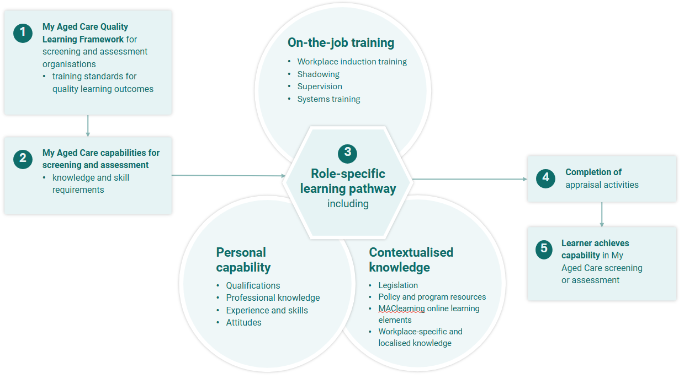

Quality linkages that support the QLF
The department’s ongoing focus on quality is reflected throughout the QLF. The QLF has been developed to ensure all screening and Single Assessment System workforce roles align with respective quality measures, including consumer-focused principles of the Aged Care Quality Standards, as set out in the Aged Care Assessment Quality Framework, the My Aged Care Contact Centre (contact centre), and Aged Care Specialist Officer (ACSO) quality score cards, and the appraisal activity rubrics that confirm a workforce member has been certified by the department as fully trained in, and capable of fulfilling, their My Aged Care role.
Quality underpins the development of all departmental training resources for the screening and Single Assessment System workforce to ensure a high standard of contextualised knowledge and capability is maintained.
Consistent with the My Aged Care Assessment Manual and the Aged Care Assessment Quality Framework, assessors will undertake self-audits and reflections to support the development of skills and capabilities to deliver a high-quality assessment experience for every client. These capabilities are reflected in the development of a quality client support plan by an assessor.
The department regularly monitors screening and assessment activities, highlighting an increased focus on quality measures and outcomes in My Aged Care.
The department has developed a suite of example support plan documents that aim to support assessors to develop high quality support plans and enhance capability across assessment organisations.
Similarly, ongoing quality assurance discussions occur with the organisations that manage screening workforces to ensure quality remains a strong focus for Contact Centre Customer Solutions Specialists (CSSs) and Services Australia (ACSOs).

The My Aged Care capabilities for the screening and Single Assessment System workforce
Significant consultation, through the My Aged Care Personal Capability Report in 2017, the review of My Aged Care learning and training in 2022, and previous training strategies, has informed the development of the current 12 My Aged Care capabilities for the screening and Single Assessment System workforce.
The My Aged Care capabilities for the screening and Single Assessment System workforce highlight the specific and contextualised knowledge and skills required to work within this workforce. The capabilities inform the minimum learning and training requirements for each role. Through their role-specific learning pathway, learners demonstrate their ability to undertake their role effectively, in a way that upholds the integrity of the My Aged Care system and meets the required capabilities.
The 12 My Aged Care capabilities for the screening and Single Assessment System workforce are:
- Manage the client journey - contribute to the continuity of the client's aged care journey.
- Navigate My Aged Care - help the client and their support network to navigate My Aged Care.
- Use technology - competently use technology to support the client through their My Aged Care journey.
- Work ethically and legally - apply an understanding of legislative frameworks and guidelines that inform actions and decisions in relation to My Aged Care.
- Communicate - communicate effectively with the client and their support network.
- Support wellness and reablement - use a wellness and reablement approach in assessment, planning and service recommendations *
- Record information - record accurate client information within the relevant My Aged Care portals.
- Conduct quality assessments - apply knowledge, assess, use judgement and make decisions in relation to client needs, goals and recommendations *
- Respond to vulnerability - identify and respond to vulnerability in a trauma-informed way.
- Provide client-centred care - provide and deliver a client-centred approach that is respectful of diversity.
- Display resilience - practise self-care and know where to get support if needed.
- Lead by example - actively engage in own and/or others’ performance and development. **
* Capabilities six and eight apply only to the aged care Single Assessment System workforce.
** Capability 12 reflects the skill sets of those managing and training staff in screening and assessment organisations.
Under each of the 12 capabilities sit multiple capability indicators that further define the knowledge and skills required to undertake a screening or assessment role in My Aged Care.

5.1 Mapping of the My Aged Care capabilities for the screening and Singe Assessment System workforce
Mapping documents for the My Aged Care capabilities for the screening and Single Assessment System workforce are available on request from the department by emailing myagedcare.capability@health.gov.au.
These documents show how the MAClearning online training content and appraisal activities for each role-specific learning pathway, including quizzes, are mapped to each capability. The appraisal activities are related to each capability and formally test a learner’s knowledge, their ability to apply knowledge and skills in the workplace, and their ability to undertake their role. Appraisal activities are verified by the department and the learner’s organisation, submitted through MAClearning for final appraisal.
Successful completion of a role-specific learning pathway, including appraisal activities, demonstrates that the learner meets the required My Aged Care capabilities for the screening and Single Assessment System workforce and has the knowledge, skills, and ability to undertake their screening or assessment role in My Aged Care.

5.2 Capability in My Aged Care screening and assessment
There are three domains that inform capability in My Aged Care screening and assessment and attainment of the 12 My Aged Care capabilities for the screening and Single Assessment System workforce:
- Personal capability
- Contextualised knowledge
- On-the-job training.
Essentially, a learner will need to be:
- Considered suitable for the role by their organisation
- Able to gain the contextualised knowledge needed for the role, and
- Able to practically apply their knowledge and skills in the workplace.
Figure 2 provides a visual representation of the domains of learner capability that are required for a person to undertake a My Aged Care screening or assessment role.
Figure 2 - Capability in My Aged Care screening and assessment
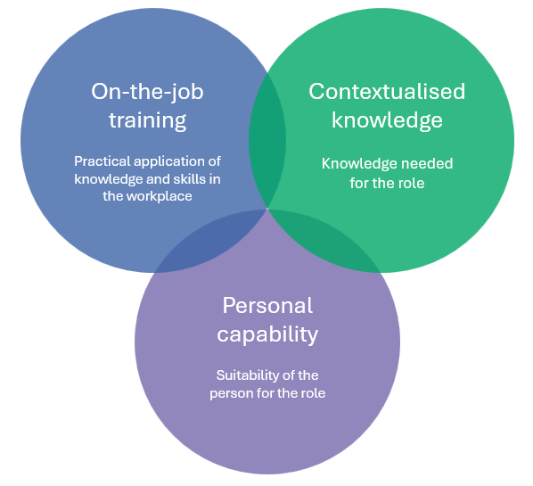
A learner’s capability in My Aged Care screening or assessment is determined through formal appraisal activities that test their knowledge, skills, and ability to undertake their role. The appraisal activities are based on the My Aged Care capabilities for the screening and Single Assessment System workforce, reflect the use of a blended learning model, and are verified by the department and the learner’s organisation.

5.3 Personal capability
Personal capability is defined as ‘the unique combination of respectful behaviours, attitudes and values, qualifications, experience and professional knowledge (know-how) and networks (know-who) of an individual to achieve their goals.’
The department recognises and acknowledges the personal capability – the unique skills, knowledge, experience and qualifications - that each person brings to their My Aged Care screening or assessment role.
Figure 3 provides a visual representation of personal capability.
Figure 3 - Personal capability
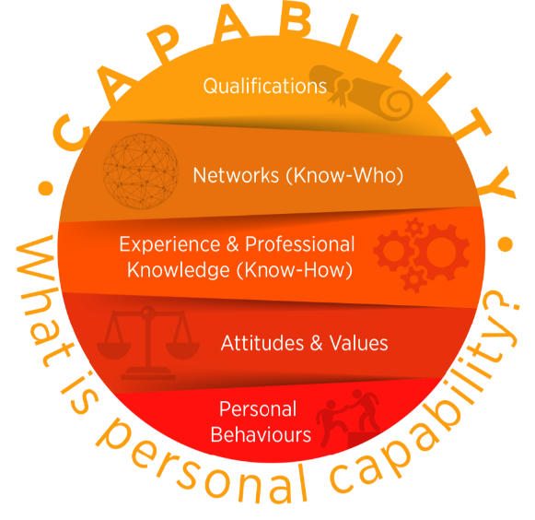
Without contextualised knowledge and on-the-job training, personal capability alone is insufficient for a learner to undertake their role successfully.

5.4 Capabilities and contextualised knowledge
Legislation, a range of key policy and program resources, and MAClearning online learning provides the contextualised knowledge required to work in the My Aged Care screening and Single Assessment System workforce and informs the My Aged Care capability requirements.
An essential component of contextualised knowledge for learners is also gained from on-the-job training within the workplace, including workplace-specific induction training, shadowing experienced colleagues, and learning about workplace cultures, values, and expectations.
The following contextualised knowledge resources underpin the My Aged Care capabilities for screening and assessment:
- Aged Care Act 2024 and the Aged Care Rules 2025
- Aged Care Assessment Manual which is based on the legislative requirements for aged care needs assessment
- Aged Care Assessment Quality Framework which sets the quality standard expected for aged care assessment
- Knowledge Management System which includes current process instruction and information about My Aged Care and must be used by the screening workforce to guide their interactions.
- mandatory MAClearning learning elements and quizzes, developed by the department, which provide current, consistent, and contextualised information for the national My Aged Care screening and Single Assessment System workforce, based on current legislation, policies, procedures, and guidelines.
- Aged Care Gateway Portals, Aged Care Assessor app, system user guides, and the Government Provider Management System (GPMS).
Without contextualised knowledge, personal capability and on-the job training together are insufficient for a learner to undertake their role successfully.
Refer to the capability indicators above which identify the specific knowledge and skills required of the screening and Single Assessment System workforce.

5.5 Capabilities and on-the-job training
On-the-job training is key to ensuring a learner can apply their contextualised knowledge and skills to their screening or assessment role in the workplace.
The following on-the-job activities and workplace resources support practical skills development and application so that learners can meet the required My Aged Care capabilities for screening and assessment:
- on-the-job shadowing and/or mentoring
- supervision and support in the workplace
- My Aged Care Contact Centre Score Card and performance indicators in contractual requirements which reflect Consumer Experience objectives
- ACSO Score Card and performance indicators in the program agreement which reflect Consumer Experience objectives
- training to use the appropriate My Aged Care systems and tools e.g. Integrated Assessment Tool (IAT), Aged Care Gateway Portals
- completion of the IAT and development of a Support Plan that meets the requirements set out in the Aged Care Assessment Manual.
Trainers and supervisors have an integral role in supporting learners through their role-specific learning pathway. This includes the completion of appraisal activities in the workplace.
Without on-the-job training, personal capability and contextualised knowledge together are insufficient for a learner to undertake their role successfully.

MAClearning system
MAClearning is the learning management system used to deliver the department’s online learning to the My Aged Care screening and Single Assessment System workforce. MAClearning is also the department’s repository for recording the learning history and certification of learners who have completed a role-specific learning pathway. MAClearning was launched in 2023 and replaced the previous MACLE system.
MAClearning provides an opportunity to:
- manage and update all online learning resources that have been developed for the My Aged Care screening and Single Assessment System workforce
- assign the My Aged Care screening and Single Assessment System workforce role-specific learning pathways
- monitor adherence to mandatory learning requirements
- publish and evaluate learner data as required e.g. compliance reports to monitor learning completion, and
- establish a continuous improvement approach to all learning resources
MAClearning will provide the workforce with:
- learning pathways for each role within the workforce – tailored learning to meet the specific needs of the different roles in the My Aged Care workforce
- interactive learning experiences – to enable learners to access various learning and appraisal content and tools depending on their learning pathway
- user hierarchy – allows managerial staff to administer and monitor training progress for their team
- evidence of competency – system generated certificates and/or transcripts issued with Continuing Professional Development (CPD) hours (if applicable)
- analytics and reporting – to facilitate tracking of learner progress and training completion, and measuring the effectiveness of training programs through live reporting of multiple user metrics, including learner progress, completion and compliance
- a platform for document upload – to enable departmental quality review and appraisal of learner capability, and
- a centralised location to receive learner and supervisor feedback – supporting the department to continuously improve the learning content and appraisal tools.
The department is responsible for managing the operations and administration of MAClearning. To ensure the integrity of the system, multiple user types have been established to ensure appropriate access controls.
MAClearning will automatically assign learners with their specific learning pathway on registration, based on their job role. Each screening and assessment organisation is responsible for nominating new staff for registration on MAClearning into the appropriate job role/s and ensuring they complete the required mandatory learning linked to all assigned job roles.

The blended learning model
All members of the screening and Single Assessment System workforce are required to successfully undertake mandatory role-specific training, using a blended learning approach.
The blended learning model comprises:
- on-the-job training delivered in the workplace through workplace trainers and/or supervisors including:
  - Organisation-specific induction training e.g. WHS training
  - On-the-job shadowing and/or mentoring including My Aged Care Systems training
  - training to use the Aged Care systems e.g. online Integrated Assessment Tool (IAT) and the Aged Care Gateway Contact Centre and assessor portals
  - oversight and monitoring of completion of a mandatory learning pathway, set by the department
- mandatory online learning, developed by the department, on the My Aged Care Learning Management System (MAClearning)
- Successful completion of appraisal activities in the workplace to validate learner capabilities, endorsed by a workplace supervisor in the learner’s organisation
- Any additional formal training recommended by the department or the learner’s organisation, for example organisation-specific mandatory training, transition training.
Organisations delivering My Aged Care screening and assessment services are responsible for allowing adequate time for learners to undertake the learning pathway set by the department in the Workforce Learning Strategy. Learners will also have access to guides, manuals and other resources, located on the department’s website to support them. The department regularly releases updated guides to support each learning pathway.
The blended model of learning ensures all screening and Single Assessment System workforce members nationally are appropriately and consistently trained, well equipped, and capable of undertaking their role in My Aged Care.

Learning pathways

8.1 Minimum training requirements
Minimum training requirements for successful completion of each role-specific learning pathway have been set by the department and are outlined in detail in the Workforce Learning Strategy.

8.2 Recognition of current capabilities
It is acknowledged that many people who have worked in the aged care field have existing skills, knowledge, experience, and qualifications. However, due to the unique context of My Aged Care, qualifications and experience alone do not exempt a person from undertaking the minimum training requirements of their learning pathway.
Recognition of prior learning and current learner capabilities is not currently available for learners. Refer to the Workforce Learning Strategy for more information.

8.3 Role-specific learning pathways
Role-specific learning pathways have been created by the department for each screening and Single Assessment System workforce role, using the blended learning model. Learning is sequenced through several phases to give learners the best opportunity to acquire the necessary knowledge and skills and build the capability required for their roles, as outlined in the Workforce Learning Strategy.
A role-specific learning pathway is assigned to a learner on registration in the MAClearning system and must be successfully completed for the learner to be certified as capable of undertaking their role.
The learner’s organisation is responsible for monitoring their learning progress and currency, and a learning pathway must be completed within the specified timeframe (see the Workforce Learning Strategy), unless the department has been notified of the need for an extension for a learner. The department routinely monitors a learner’s progress and compliance with learning requirements and escalates any issues to the learner’s organisation if necessary.
A learning pathway can be completed over a shorter timeframe than specified in the learning pathway at the discretion of the organisation if the learner is demonstrating competence in all aspects of their role-specific learning pathway.
Figures 4, 5 and 6 show the learning pathways for each My Aged Care screening and Single Assessment System workforce role. The Workforce Learning Strategy provides more detailed information on the role-specific learning pathways and mandatory training requirements for learners.

Figure 4 - CSS Learning Pathway
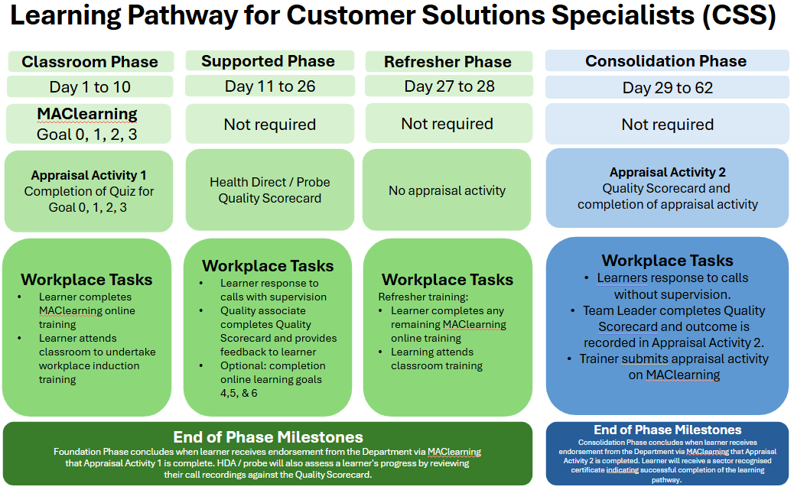

Figure 5 - ACSO Learning Pathway
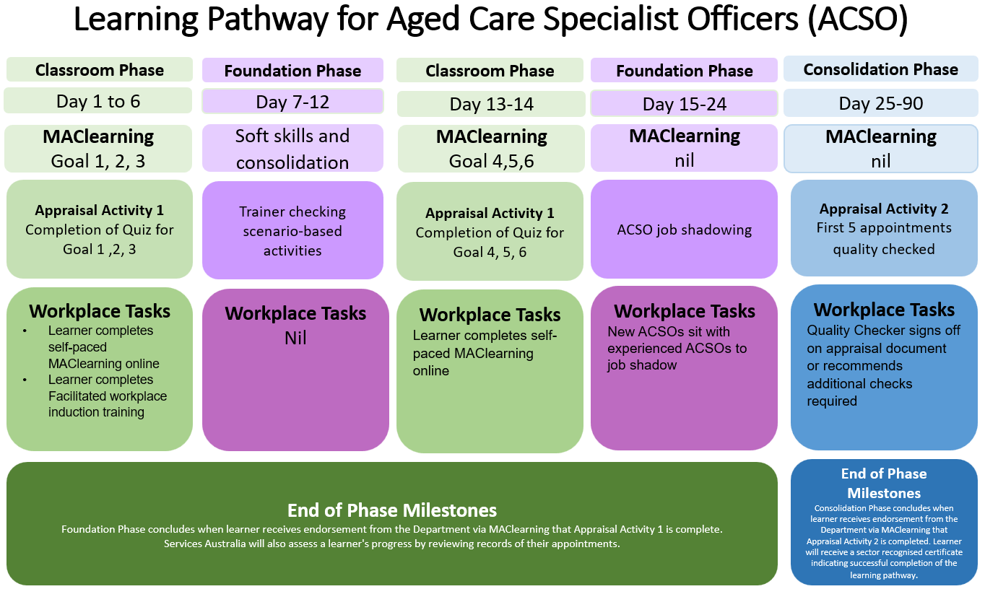

Figure 6 - Assessor Learning Pathway
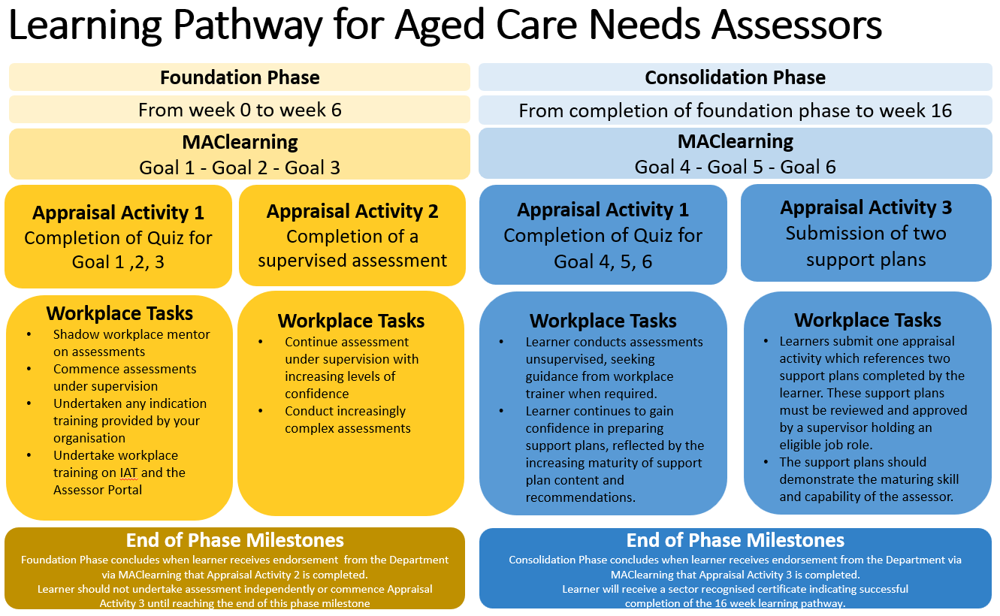

8.4 Training for other roles within the My Aged Care screening and Single Assessment System workforce
It is acknowledged that other important roles, such as administration, are important to the functioning of some screening and assessment organisations. Learning resources, such as learning elements within MAClearning, are available to those not in a screening or assessment role to assist with professional development and understanding of My Aged Care.
These learners can be registered in MAClearning and will have access to all learning goals and elements, but there are currently no mandatory training requirements for those in non-screening and assessment roles under the QLF. A sector-recognised certificate of completion will not be provided.

On-the-job training
An integral part of learning for the My Aged Care screening and Single Assessment System workforce relies on appropriate and structured on-the-job training. Screening and assessment organisations are required to deliver on-the-job training, especially in the early phases of learning.
On-the-job training may include:
- mandatory learning specific to the organisation
- induction training
- group learning
- observation of existing staff
- shadowing more experienced staff
- ‘buddy’ systems, and
- supervision of role-specific workplace tasks.
The intention of on-the-job training is to familiarise new staff with their role and support them through each phase of their learning pathway. There are no specific tasks, timelines or mandatory learning activities set by the department for on-the-job training, other than completion of the learner’s role-specific learning pathway.
Organisations are responsible for ensuring adequate on-the-job training and support has been provided to new staff, recognising the complexities of working within My Aged Care and the knowledge and skills required of a screening or assessment role.
Successful completion of both on-the-job training and online learning is essential. Online learning and completion of appraisal activities alone is not enough to fulfil the learning requirements of the screening and Single Assessment System workforce.
The department supports on-the-job training for learners with a range of resources, such as the Learner and Supervisor Guide for assessment organisations, appraisal activity rubrics, and improved quality standard guidelines for the submission of appraisal activities.
Organisations should consider the learner’s suitability for the role, based on the progress and completion of their role-specific learning pathway.

MAClearning online learning
MAClearning online learning complements on-the-job training and provides the screening and Single Assessment System workforce with a single source of current and contextualised learning resources (elements) to build and maintain capability.
Using MAClearning, registered learners can access learning content in an interactive online experience. As the learning pathway for each learner registered in MAClearning is tailored to each role type, some learning elements apply to all members of the screening and Single Assessment System workforce, while some are specifically designed for a role type.

10.1 Learning content creation
MAClearning online learning elements are directly related and mapped to each of the My Aged Care capabilities for the screening and Single Assessment System workforce, noting capabilities six and eight apply only to the aged care Single Assessment System workforce. Capability 12 reflects the skill sets of those managing and training staff in screening and assessment organisations.
Mapping ensures that capability requirements relating to knowledge can be met through the online learning elements, as well as on-the-job training and appraisal activity completion.
Each role-specific learning pathway determines the goals and elements to be completed by an individual learner. MAClearning goals include a collection of individual learning elements which comprise online learning (content), learning activities (quizzes or scenarios), and appraisal activities (workplace evidence and observations) for application on-the-job with workplace trainers and supervisors.
The online learning elements reflect current legislation, procedures, guidelines, and practices and are built with the intention of providing a single source of current and contextualised information for the national My Aged Care screening and Single Assessment System workforce.
In the development of all learning content, four design principles are used:
- Scaffolded Learning – Online elements are sequenced so that each new topic builds on existing knowledge, workplace experience, and earlier learning.
- Application of Knowledge – Learning content is grounded in the tasks and responsibilities of the My Aged Care workforce. Learners engage with examples, case studies that reflect authentic workplace situations.
- Interactive Learning – Online content includes knowledge checks and interactive elements that prompts learners to explore and understand core concepts.
- Scenario-Based Learning – Learners work through scenarios that allow them to apply knowledge and system processes applicable to real-world situations.
The online learning component of a role-specific learning pathway is integral to the blended learning model. It is intended to be completed gradually over multiple phases of learning in a sequenced manner across the learning pathway. This ensures optimal learning outcomes for the learner with the application of knowledge and skills to practice.
Once a learner has been registered in MAClearning, learning content can be accessed at any time, even after training has been completed. This supports the workforce by providing an up-to-date resource to refer to.

10.2 Training (TRN) environment
The TRN is a systems training environment that learners can access to practice applying their learning and knowledge to practice. This is particularly helpful for induction training as the TRN system simulates the actual system and is updated with any scheduled systems releases. A TRN environment is available for each role type e.g. Aged Care Gateway contact centre portal for CSSs and ACSOs; Aged Care Gateway assessor portal for assessors.

Learner appraisal system
Another integral part of the training process for the screening and Single Assessment System workforce is appraising whether the learner has attained the required knowledge, skills and capabilities to undertake their role.
Organisations that manage screening and assessment workforces must verify that the learner meets the departmental learning requirements of their role-specific learning pathway, as well as their own organisational requirements. A component of the learning, through formal appraisal activities, is verified by the department.
The appraisal system has been designed to ensure that the appraisal activities are:
- Fit for purpose
- Consistently and fairly applied and
- Based on key learning principles.

11.1 Appraisal strategies
Appraisal strategies are developed based on the nature of the capability required and the core tasks or activities underpinning each capability. Appraisal activities are designed to allow a learner to demonstrate their contextualised knowledge and ability to apply their knowledge and skills in the workplace and therefore demonstrate their ability to meet the required capabilities and undertake their screening or assessment role.
The following appraisal strategies will be utilised for the Aged Care screening and Single Assessment System workforce:
- Formative appraisals – knowledge checks in the form of online quizzes and activities that are not included in determining knowledge retention. These guide the learner and informally get learners to think more deeply about a particular topic.
- Summative appraisals – online quizzes that test a learner’s understanding of learning content. Results of these will be recorded in MAClearning.
- Workplace appraisals – tasks, activities, practical application, conversations, workplace observations, and workplace evidence. These provide the learner and the appraiser with indicators as to progress towards, and attainment of the required capabilities.
Appraisal strategies verify and validate that learners have met the identified capability indicators for their role and are developed and validated in consultation with My Aged Care subject matter experts.
The appraisal strategies are designed by considering the following:
- the needs of learners
- the requirements and practices of their workplace
- the specifications for each capability and
- legislative regulations and requirements.
These appraisal strategies lead to the selection of specific appraisal tools that are mapped to the core capabilities. The use of multiple appraisal strategies ensures capability attainment is fully evidenced with all capabilities and capability indicators having been met, and the learner validated to undertake their specific role in My Aged Care.

11.2 Appraisal activities
Learning content will be supplemented with a range of online and offline appraisal activities based on workforce roles, as outlined in the Workforce Training Strategy and each role-specific learning pathway.
Appraisal activities have been designed and developed for each learning pathway to verify the application of a learner’s knowledge in practice and demonstrate that the learner meets the required capabilities to undertake their role. Each appraisal activity has been mapped to the My Aged Care capabilities for the screening and Single Assessment System workforce.
Dependant on the learner’s learning pathway, appraisal activities may include:
- Quizzes linked to online learning
- Verification that an assessor can capably undertake an assessment under supervision
- Verification that a CSS or ACSO undertaking screening is capable of meeting the required quality standards and job-role requirements
- Evidence in the form of a workplace document that demonstrates that the learner can capably undertake their role. E.g. support plans for assessors, quality scorecards for CSSs/ACSOs.
More detailed information on appraisal activities is in the Workforce Learning Strategy.

11.3 Rubrics and appraisal measures
Key to a transparent and consistent system for verifying capability attainment is the need to define what ‘good’ or ‘acceptable’ looks like.
A rubric determines the required standard and quality for an appraisal activity to be deemed satisfactory. A rubric (or marking sheet or staff solution) is developed for each appraisal activity, based on mandatory compliance and quality standards, in line with other important documents such as the self-audit tool for assessment work and Quality Score Cards for screening work.
Appraisers (who may include workplace supervisors, depending on the appraisal activity) will use these rubrics to appraise each learner submission. A satisfactory outcome indicates the learner has met the required mandatory and quality standards set for that appraisal activity.
Rubric templates will be stored on the department’s records management system. Completed templates will be stored with the learner’s submitted evidence in MAClearning.
Learners and organisations are provided with the rubrics to support the submission of appraisal activities that meet the mandatory compliance and quality requirements.

11.4 Moderation and Quality Assurance
Moderation between appraisers of appraisal activities is important to ensure consistency and fairness in the review of learner submissions. Departmental appraisers regularly undertake moderation, ensuring the effectiveness of the appraisal system.
Moderation allows for appraisal decisions to be collaboratively shared and contrasted to ensure consistency and fairness of the appraisal process. Samples of various appraisal activities, their rubrics, and examples of submitted learner appraisal activities will be used in moderation.
Outcomes and feedback from moderation will support the department to continuously improve the learning program, with appraisers providing insights on learner submissions in relation to the appraisal activities and capabilities.
To support continuous improvement and provide quality assurance, the department will undertake periodic audits of submitted appraisal activities and provide feedback to screening and assessment organisations where necessary. This work complements the role of the Quality Assurance team within the department that monitors and reviews quality standards within assessment organisations on an ongoing basis.

11.5 Outcome of appraisal activity submissions
Outcomes for submitted appraisal activities are managed in the MAClearning system. Appraisers, using the rubrics, review each learner submission in two main areas:
- Quality- to ensure that the learner’s submissions meet the mandatory and quality standards set by the department, including the Aged Care Assessment Manual, Aged Care Assessment Quality Framework, Contact Centre and ACSO Quality Score Cards
- Compliance- to ensure that administrative detail, signatures, certifications, MAClearning elements and goals have been fully and accurately completed
The department has recently implemented a greater focus on quality, over compliance, outcomes for submitted appraisal activities. Appraisers must be satisfied that a learner submission meets the required quality and compliance criteria fully. This means the standards expected by the department must be met by the learner for them to be deemed capable of undertaking their role within the screening and Single Assessment System workforce.
Learners are notified within MAClearning of the outcome of their appraisal activity submissions. Resubmissions will be requested by the appraiser if the submission does not meet the required standard. Learners are strongly encouraged to seek support, if needed, from their workplace and use the guides provided by the department to work through their learning pathway. The department can be contacted on myagedcare.capability@health.gov.au if further discussion is needed.

11.6 Appeal
If a learner or supervisor disagrees with the department’s appraisal review decision, they have the right to appeal to the department to reconsider the outcome.
An appeal involves a second review of the appraisal activity submission by a different appraiser from the initial appraiser. This ensures that an appeal is considered fairly and impartially against the review criteria and that the process is independent, transparent, and complete. The outcome of the appeal will be considered final.
To request an appeal, an email should be sent to myagedcare.capability@health.gov.au. The department aims to complete all appeals within 10 business days of submission.
More detailed information on the learner appraisal system for the screening and Single Assessment System workforce can be found in the Workforce Learning Strategy.

Learning completion
All aspects of a learner’s role-specific learning pathway must be completed within the specified timeframe. Learners cannot continue to work within the My Aged Care screening and Single Assessment System workforce if they do not successfully complete their mandatory learning.
As learners work through their learning pathways, their progress of element and goal completions and outcomes for their appraisal activities will be recorded in the MAClearning system. Learners and supervisors can access the MAClearning system at any time to check their progress and access information about their learning pathway.
Screening and assessment organisations must support learners through their role-specific learning pathway and allocate sufficient time to learning tasks. A learner is considered fully trained and capable of undertaking their role independently when they have completed their learning pathway and been issued with a My Aged Care screening and Single Assessment System workforce sector-recognised certificate and/or transcript. The sector-recognised certificate/transcript will allow transferability across the workforce.
Learners are responsible for downloading a copy of their certificate/transcript and maintaining their own records, as they may be required to provide this as evidence if they change organisations.
The department is responsible for ensuring national consistency in learning outcomes for the My Aged Care screening and Single Assessment System workforce. The department supports the screening and Single Assessment System workforce to use the MAClearning system and the blended learning model and keeps a record of all learning completions in MAClearning.

12.1 Non-compliance with completion
The department closely monitors compliance with completion timeframes for all learning pathways and escalates any non-compliance issues to the learner’s organisation. Screening and assessment organisations must advise the department of any concerns regarding the timely completion of a learner’s required learning pathway so that the department can work with the organisation towards a solution.

Additional training
Periodically, the department will release additional training and will advise if this training will be mandatory or optional. Additional mandatory training may be required in cases such as aged care reform updates or system releases to ensure currency of information for the screening and Single Assessment System workforce. The department will advise organisations as soon as practicable of any additional mandatory training requirements.
Additional training may be offered for professional development if a training need or an opportunity to expand current knowledge and skills has been identified or suggested by anyone within the screening and Single Assessment System workforce or within the department.
Recommendations for additional training considerations can be made at any time by emailing myagedcare.capability@health.gov.au.

Evaluation methodologies – ensuring the quality of the QLF
Evaluation is important to ensure a system of training is working as it should. Evaluation methods may include evaluation of learning content, appraisal strategies, data integrity, and governance. Sources of evaluation information for the My Aged Care screening and Single Assessment System workforce will include:
- Learners
- Workplace trainers, supervisors, and education officers
- Learning appraisers
- Lead Educator Network (LEN) and
- Quality and performance indicator data.
A range of feedback mechanisms will be introduced through the QLF. All learners, organisations, appraisers, and other key stakeholders are encouraged to provide feedback at any time by emailing myagedcare.capability@health.gov.au, with formal evaluation feedback sought periodically, initiated by the department.

14.1 Evaluation methodology reviews
The evaluation methodologies will be reviewed annually, and regular reporting will provide ongoing feedback as to the effectiveness of the system. This will then inform decisions regarding the need for changes or improvements to processes or learning content, utilising a continuous improvement approach.

14.2 Evaluating training and learning outcomes
Evaluation is an important component of any training system. Evaluation of the training provided to the My Aged Care screening and Single Assessment System workforce ensures that the intended learning and training outcomes set out in the QLF, and through the My Aged Care capabilities, are being met.
The department has chosen to adopt the Kirkpatrick model for training evaluations of the My Aged Care screening and Single Assessment System workforce.
Table 1 - Kirkpatrick Model for Training Evaluations
Level | Description
Level 1 Reaction | To what degree learners react favourably to the learning or appraisal activities
Level 2 Learning | To what degree participants acquire the intended knowledge, skills, and attitudes, based on their participation in the learning
Level 3 Behaviour | To what degree learners apply the capabilities they acquire when they do their job.
Level 4 Results | To what degree targeted outcomes occur as a result of the learning
Level 1 evaluations consist of short surveys that ensure learners have completed key tasks and to gauge their reaction to the content or the assessment process. Immediate learner feedback is critical in ensuring ongoing improvements can be made.
Level 2 evaluations ascertain the extent to which a learner can recall information or have learnt a new skill. Evaluations at this level determine the learner’s level of engagement with the learning material and how they are applying their knowledge to practice.
Level 3 evaluations determine the extent to which learners have transferred and applied their knowledge and skills back at work. Follow up surveys and feedback from the learners and their workplace supervisors are typically used for these. Level 3 evaluations are typically conducted several months after initial learning and assessments take place.
Level 4 evaluations focus on whether organisation outcomes have been attained and the degree to which new behaviours and capabilities are now embedded in the workforce. More difficult to measure, Level 4 evaluations require feedback from senior stakeholders.
The QLF includes a series of appraisal and evaluation tools that cover the gamut of Kirkpatrick’s 4 levels.
Table 2 below summarises the evaluation methods and tools that are used to evaluate the effectiveness of the QLF and training for the My Aged Care screening and Single Assessment System workforce.
Table 2 - Evaluation Methods and Tools
Evaluation Level | Methods / Tools | Timing/trigger for evaluation
Reaction | Feedback from learners – short surveys within MAClearning | At the end of each learning goal.
Learning | Post-test | At the end of each learning goal.
Behaviour | Appraisers’ observations of and feedback to learners  Supervisor observations  Interviews, stickability surveys | 12 months after initial learning is completed. Time is dependent on learning pathway. Can also occur as part of periodic reviews of training approach.
Results | Engagement with Assessment Assurance section of the department as part of assessment quality monitoring. | Annually

Methods / Tools | Purpose | Timing/trigger for evaluation
Surveys | Feedback is requested from learners to gauge learner experience with learning content and appraisal tools. | At the end of each learning goal.
Lead Educator Network | Discussion occurs to obtain feedback on the Workforce Learning Strategy and QLF. | Annually, more frequently during times of reform or change or when raised by LEN.
Organisation feedback | Feedback is requested from organisations to determine if the training is meeting their needs. | 24 months; more frequently during times of reform or change.
Templates for each of these methods are stored in the department’s record management system.

Feedback and continuous improvement
The department will maintain an evaluation process and feedback loop post-delivery and post-appraisal once the learner is on-the-job to determine the efficacy of its training of the screening and Single Assessment System workforce. This will also inform a continuous improvement approach to training.
Regular and timely engagement with the Lead Educator Network (LEN) is critical to maintaining a consistent national approach to training, informing continuous improvement and validating proposed changes. Feedback on training content, process and pathway from LEN members to the Department is essential to making effective improvements.

15.1 Validation sources
Appraisal strategies and activities will continue to be validated to ensure they measure learner skill, knowledge, and capability. The following sources will be utilised to validate appraisal strategies, tools, and judgements:
- Feedback from:
  - learners obtained through MAClearning
  - members of the Lead Educator Network
  - supervisors, trainers and educators within screening and single assessment system organisations
  - departmental appraisers
  - relevant sections and branches within the department
- Learner and supervisor satisfaction surveys, and
- Internal moderation meetings.

15.2 Updates to element and appraisal content
Element and appraisal content are updated, based on changes to programs, policies, legislation, and feedback from learners and supervisors within screening and assessment organisations, and departmental colleagues.
Screening and assessment organisations are encouraged to advise the department of additional training needs that may be able to be incorporated into MAClearning online learning to support national consistency in knowledge and skills and professional development opportunities.
Feedback on appraisal activities and learning content can be provided to the department for consideration by emailing: myagedcare.capability@health.gov.au.
Director approval is required before any changes are made to online learning elements and appraisal content in the MAClearning system. A record of this approval is saved in Content Manager (the department’s record-keeping system).

15.3 Risk Management
Risk management matters are governed by the department’s own overarching risk management policies and procedures. High-risk areas are regularly reviewed to ensure effective performance of the system and the workforce.
As part of the department’s Risk Management Plan, all identified risks are documented, risk ratings assigned, and mitigation strategies developed, with planning reviewed regularly.

Glossary
Term | Definition
Appraisals, appraisal activities | Activities that learners complete to be appraised on their understanding of the learning content and their practical readiness to perform the required work and determine if they have achieved a specific capability.
Blended learning model | A learning model that uses a combination of various learning and appraisal methods (online, face to face and on-the-job learning) to deliver the required learning.
Capability | Capability in My Aged Care screening and assessment comprises personal capability, contextualised knowledge, and the ability to apply knowledge and skills in the workplace.
Evaluation Tools | Tools that assess the effectiveness of the learning process, learning content, and the Quality Learning Framework. Feedback received from these tools will support the department to continually improve the learning program.
Learner | Individuals who are undertaking the learning outlined in the My Aged Care Workforce Learning Strategy.
Learning appraisers | Appraisers who appraise learner submissions and determine whether the required standard has been met.
MAClearning elements | Online learning content that covers a particular area of learning. Multiple learning elements usually need to be completed to achieve a goal within MAClearning.
MAClearning goal | Goals are made up of learning elements that need to be completed to achieve compliance/completion for that defined goal. A goal may consist of one or more elements.
MAClearning platform/system | The MAClearning platform/system is the department’s online learning management system which provides a single source of information contextualised to the My Aged Care screening and Single Assessment System workforce and repository for online learning content, learning pathways, and learner data such as completions, assessment results and certifications.



